Supplementary Material for the article:
“Detection and phase I metabolism of the 7-azaindole-derived synthetic cannabinoid 5F-AB-P7AICA including a preliminary pharmacokinetic evaluation”
Journal Name: Drug Testing and analysis
Authors: Arianna Giorgetti^{1,2}, Lukas Mogler^{2,3}, Belal Haschimi^{2,3}, Sebastian Halter^{2,3}, Florian Franz^{2,3}, Folker Westphal⁴, Svenja Fischmann⁴, Jan Riedel⁵, Michael Pütz⁵, Volker Auwärter^{2,3*}
¹Legal Medicine and Toxicology, University-Hospital of Padova, Italy
²Institute of Forensic Medicine, Forensic Toxicology, Medical Center - University of Freiburg, Germany
³Faculty of Medicine, University of Freiburg, Germany
⁴State Bureau of Criminal Investigation Schleswig-Holstein, Kiel, Germany
⁵Federal Criminal Police Office, Forensic Science Institute, Äppelallee 45, 65203 Wiesbaden, Germany.
*Corresponding author:
Volker Auwärter
tel.: +49 761 203 6862
fax: +49 761 203 6826
e-mail: volker.auwaerter@uniklinik-freiburg.de

Figure S1. GC-MS spectrum of a ‘research chemical’ and proposed fragmentation pattern for 5F-AB-P7AICA.

Figure S2. ATR-IR analysis of 5F-AB-P7AICA solid (entire scan range).

Figure S3. ATR-IR analysis of 5F-AB-P7AICA solid (partial scan range).

Figure S4. ATR-IR analysis of 5F-AB-P7AICA (CHCl3) GC-sIR (entire scan range).

Figure S5. ATR-IR analysis of 5F-AB-P7AICA (CHCl3) GC-sIR (partial scan range).
Figure S6. ATR-IR: 5F-AB-P7AICA neat (entire scan range).

Figure S7. ATR-IR: 5F-AB-P7AICA neat (partial scan range).

Figure S8. Raman: 5F-AB-P7AICA solid at λ = 785 nm (entire scan range).

Figure S9. Raman: 5F-AB-P7AICA solid at λ = 785 nm (partial scan range).
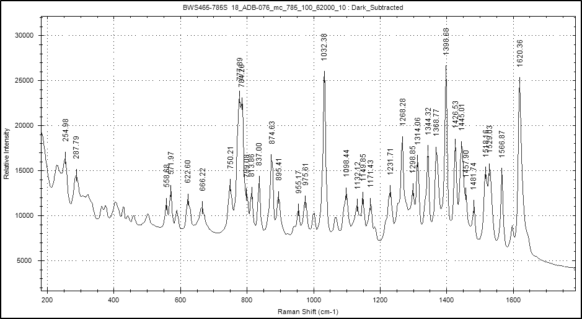

Figure S10. Raman: 5F-AB-P7AICA solid at λ = 1064 nm (entire scan range).
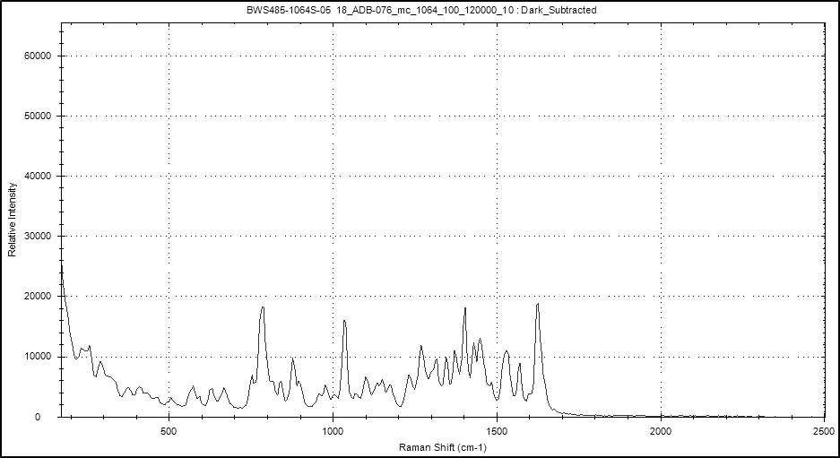

Figure S11. Raman: 5F-AB-P7AICA solid at λ = 1064 nm (partial scan range).
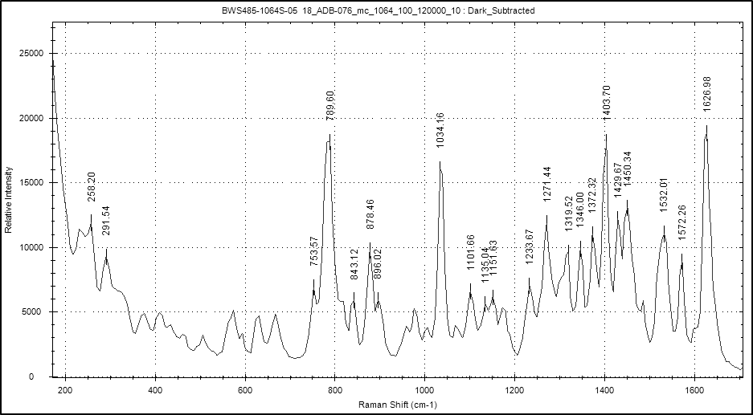

Figure S12. ¹H-NMR (500 MHz, 297 K, DMSO-d₆): 5F-AB-P7AICA.
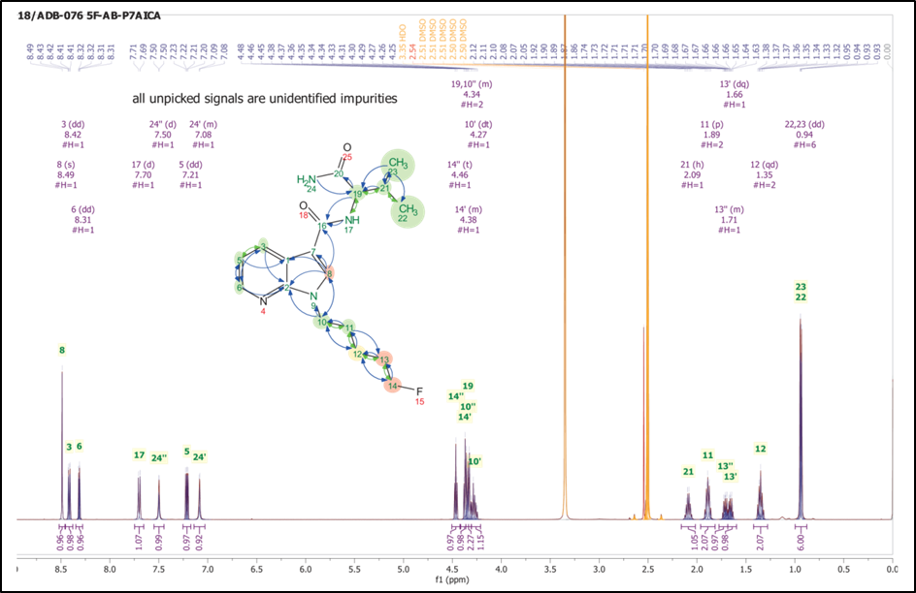

Figure S13. ¹H-NMR (500 MHz, 297 K, DMSO-d₆): 5F-AB-P7AICA (enlarged signals).
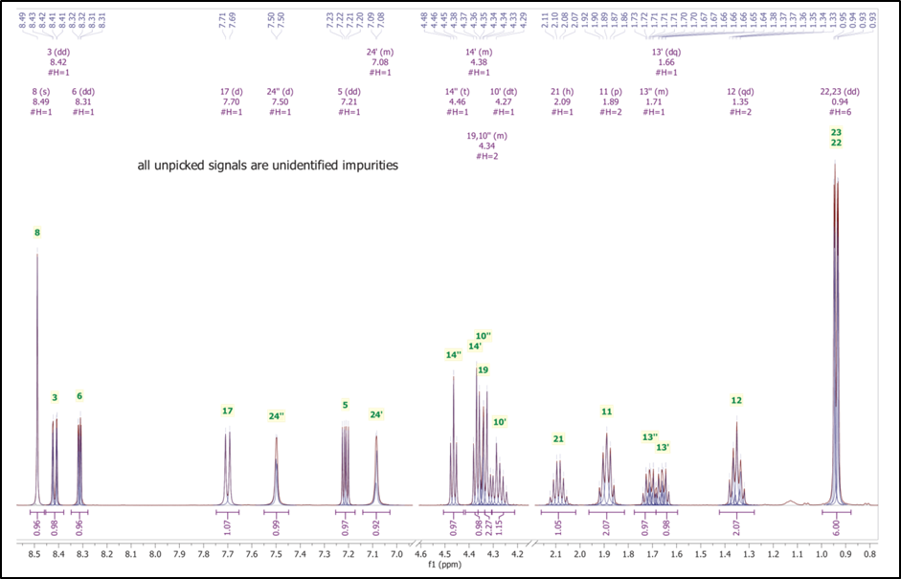
Figure S14. ¹³C-APT-NMR (125 MHz, 297 K, DMSO-d₆): 5F-AB-P7AICA.
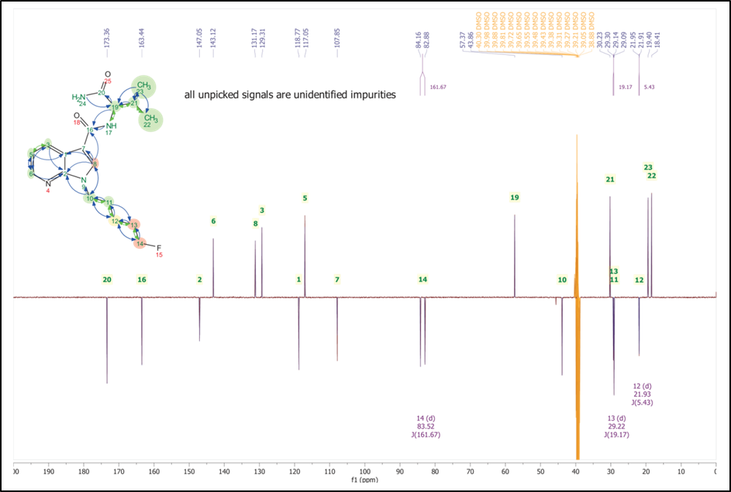

Figure S15. ¹³C-APT-NMR (125 MHz, 297 K, DMSO-d₆): 5F-AB-P7AICA (enlarged signals).
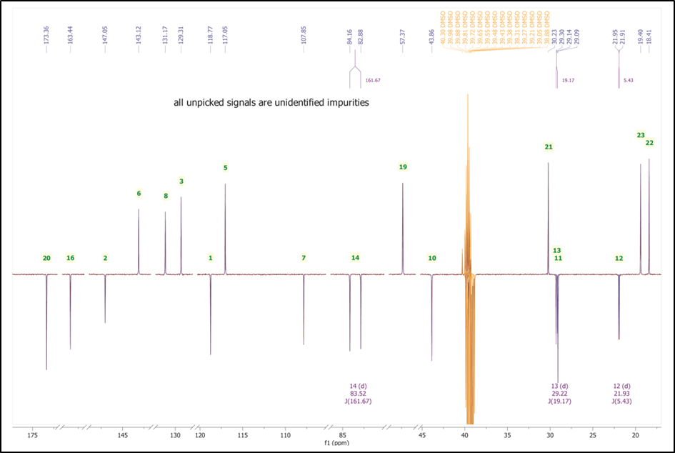
Figure S16. Peak list and assignments of 5F-AB-P7AICA signals.
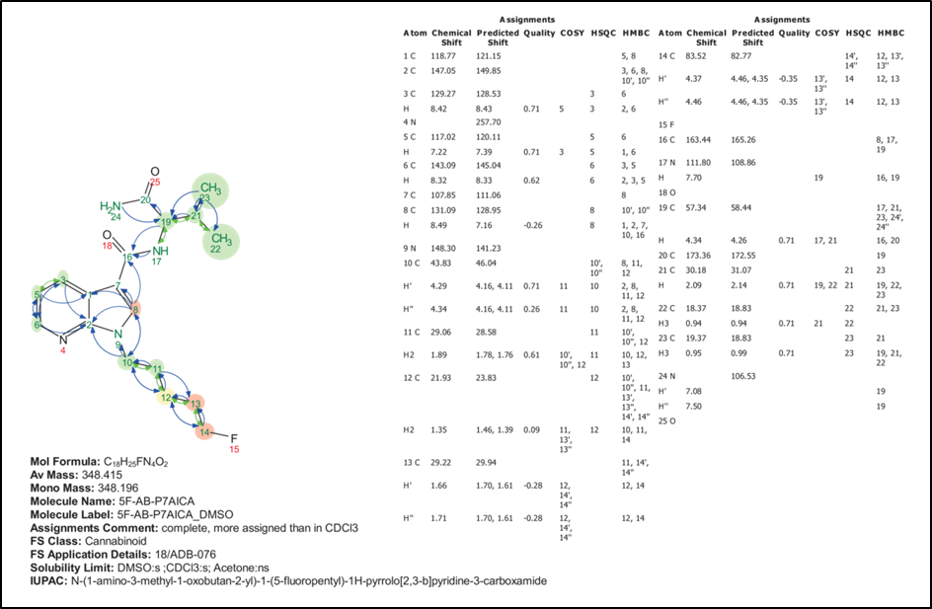
Table S1. Optimized mass spectrometric parameters of the multiple reaction monitoring (MRM) ion transitions of 5F-AB-P7AICA in the order of their intensities beginning with the most intensive transition.

Q1 Mass [Da] | Q3 Mass [Da] | DP [V] | EP [V] | CE [V] | CXP [V]
349.09 | 233 | 95 | 10 | 27 | 25
349.09 | 304 | 95 | 10 | 35 | 25
349.09 | 145 | 95 | 10 | 54 | 35

Table S2. Specific mass transitions of the detected metabolites in the order of their retention time (RT) included in the sMRM method used for the analysis of urine samples. *: not detected in vivo.
ID | Q1 | Q3 | RT | ID | DP | EP | CE | CXP
M01 | 381 | 249 | 1.2 | Dihydroxylation | 95 | 10 | 54 | 35
M01 | 381 | 145 | 1.2 | Dihydroxylation | 95 | 10 | 27 | 25
M02 | 363 | 247 | 1.2 | Defluorination + OH | 95 | 10 | 27 | 25
M02 | 363 | 145 | 1.2 | Defluorination + OH | 95 | 10 | 27 | 35
M03 | 381 | 249 | 1.4 | Dihydroxylation | 95 | 10 | 54 | 35
M03 | 381 | 145 | 1.4 | Dihydroxylation | 95 | 10 | 27 | 25
M04 | 365 | 249 | 2 | Hydroxylation | 95 | 10 | 54 | 35
M04 | 365 | 145 | 2 | Hydroxylation | 95 | 10 | 54 | 35
M05 | 347 | 231 | 2.1 | Hydrolytic defluorination | 95 | 10 | 27 | 25
M05 | 347 | 145 | 2.1 | Hydrolytic defluorination | 95 | 10 | 54 | 35
M06 | 365 | 233 | 2.1 | Hydroxylation | 95 | 10 | 27 | 25
M06 | 365 | 145 | 2.1 | Hydroxylation | 95 | 10 | 54 | 35
M07 | 365 | 249 | 2.3 | Hydroxylation | 95 | 10 | 27 | 25
M07 | 365 | 145 | 2.3 | Hydroxylation | 95 | 10 | 54 | 35
M08* | 365 | 249 | 2.5 | Hydroxylation | 95 | 10 | 27 | 25
M08* | 365 | 145 | 2.5 | Hydroxylation | 95 | 10 | 54 | 35
M09 | 365 | 233 | 3 | Hydroxylation | 95 | 10 | 27 | 25
M09 | 365 | 145 | 3 | Hydroxylation | 95 | 10 | 54 | 35
M10* | 347 | 233 | 3.8 | Dehydrogenation | 95 | 10 | 27 | 25
M10* | 347 | 145 | 3.8 | Dehydrogenation 3_2 | 95 | 10 | 54 | 35
M11 | 347 | 233 | 4.3 | Dehydrogenation 2_1 | 95 | 10 | 27 | 25
M11 | 347 | 145 | 4.3 | Dehydrogenation 2_2 | 95 | 10 | 54 | 35
M00 | 349 | 233 | 4.6 | 5F-AB-P7AICA 1 | 95 | 10 | 27 | 25
M00 | 349 | 145 | 4.6 | 5F-AB-P7AICA 2 | 95 | 10 | 54 | 35
M00 | 349 | 304 | 4.6 | 5F-AB-P7AICA 3 | 95 | 10 | 35 | 25
M12* | 329 | 213 | 5.1 | F-Elimination 1 | 95 | 10 | 23 | 20
M12* | 329 | 145 | 5.1 | F-Elimination 2 | 95 | 10 | 54 | 35
M13 | 350 | 233 | 5.4 | Amide hydrolysis 1 | 95 | 10 | 27 | 25
M13 | 350 | 145 | 5.4 | Amide hydrolysis 2 | 95 | 10 | 54 | 35
M13 | 350 | 304 | 5.4 | Amide hydrolysis 3 | 95 | 10 | 35 | 25
M13 | 350 | 213 | 5.4 | Amide hydrolysis 4 | 95 | 10 | 23 | 20

Table S3. Detected in vitro metabolites of 5F-AB-P7AICA in pooled human liver microsome (pHLM) samples (triplicates) in order of their retention times (RT). RSD: relative standard deviation . 5FP: 5F-pentyl chain; VA: valine amide. -: LC–qToF-MS analysis was not possible.
ID | RT [min] | Metabolic reaction | Location of metabolic reaction | Mean area | Ranking position | Mean ratio  [%] | RSD  [%] | Calculated  [M+H]+ | Ion formula | Mass error  [ppm]
M01 | 1.2 | Dihydroxylation | 5FP + VA | 3.38E+04 | #13 | 65% | 2% | 381.1933 | C₁₈H₂₆FN₄O₄⁺ | -
M02 | 1.2 | Defluorination + OH | 5FP | 7.82E+04 | #10 | 33% | 6% | 363.2026 | C₁₈H₂₇N₄O₄⁺ | -4.7
M03 | 1.4 | Dihydroxylation | 5FP + VA | 9.02E+04 | #08 | 21% | 5% | 381.1933 | C₁₈H₂₆FN₄O₄⁺ | -
M04 | 2 | Hydroxylation | 5FP | 1.11E+06 | #03 | 25% | 3% | 365.1983 | C₁₈H₂₆FN₄O₃⁺ | -3.4
M05 | 2.1 | Hydrolytic defluorination | 5FP | 7.83E+05 | #05 | 24% | 3% | 347.2078 | C₁₈H₂₇N₄O₃⁺ | -3.0
M06 | 2.1 | Hydroxylation | VA | 8.37E+05 | #04 | 100% | 16% | 365.1983 | C₁₈H₂₆FN₄O₃⁺ | 0.2
M07 | 2.3 | Hydroxylation | 5FP | 4.29E+06 | #01 | 16% | 2% | 365.1983 | C₁₈H₂₆FN₄O₃⁺ | 0.3
M08 | 2.5 | Hydroxylation | 5FP | 4.99E+05 | #06 | 33% | 9% | 365.1983 | C₁₈H₂₆FN₄O₃⁺ | 3.7
M09 | 3 | Hydroxylation | VA | 1.38E+06 | #02 | 55% | 1% | 365.1983 | C₁₈H₂₆FN₄O₃⁺ | -1.9
M10 | 3.9 | Dehydrogenation | VA | 5.81E+04 | #11 | 45% | 4% | 347.1878 | C₁₈H₂₄FN₄O₂⁺ | -4.1
M11 | 4.3 | Dehydrogenation | VA | 1.34E+05 | #07 | 65% | 7% | 347.1878 | C₁₈H₂₄FN₄O₂⁺ | -2.4
M00 | 4.6 | 5F-AB-P7AICA |  | 4.18E+07 | #00 | 49% | 3% | 349.2034 | C₁₈H₂₆FN₄O₂⁺ | -1.2
M12 | 5.1 | F-elimination | 5FAP | 8.47E+04 | #09 | 40% | 2% | 329.1972 | C₁₈H₂₅N₄O₂⁺ | 1.1
M13 | 5.4 | Amide hydrolysis | VA | 3.48E+04 | #12 | 43% | 9% | 350.1874 | C₁₈H₂₅FN₃O₃⁺ | -3.5

Figure S17. Relative peak areas of parent compound and metabolites in an authentic urine sample (sample #04). Each substance is shown as a percentage compared to the most abundant signal (M00, 5F-AB-P7AICA).
Figure S18. Total Ion Chromatogram showing parent compound and metabolites in an authentic urine sample (sample #04).
Figure S19. Enhanced product ion (EPI) spectra of 5F-AB-P7AICA metabolites detected in authentic urine samples after treatment with β-glucuronidase (black) compared to corresponding signals in pooled human liver microsome (pHLM) samples (blue).
Proposed structural formulae and fragmentation are shown for each compound along with their molecular formulae and single-protonated masses. The EPI scans were recorded with a declustering potential of 90 V, entrance potential of 10 V and collision energy of 35 V with a collision energy spread of ± 15 V

