Appendix S2

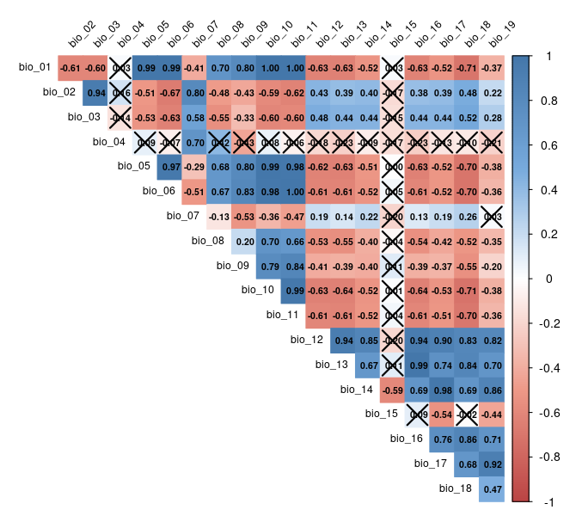
Fig. S2-1. Correlation coefficient matrix created using R ‘corrplot’ package. Colors correspond to the magnitude of Person correlation coefficients. Crosses correspond to not significant coefficients (P > 0.05).

Tab. S2-1. A summary of model implementation settings
Model | Parameters | Values | Description
BRT | learningRate | 0.01, 0.001 | shrinkage or the weight applied to individual trees
BRT | treeComplexity | if presence <250: 1, otherwise 5 | the complexity of individual trees, depth of branches in a single tree
BRT | bagFraction | 0.70 | proportion of data used for training in cross-validation
BRT | minTrees | 5000 | Minimum number of trees to be scored as a "usable" model
BRT | maxTrees | 20000 | Maximum number of trees in model set
BRT | tries | 50 | Number of times to try to train a model with a particular set of tuning parameters.
 | n.folds | 5 | Number of cross-validation folds
RF | numTrees | 5000, 7500, 20000 | Number of trees to grow.

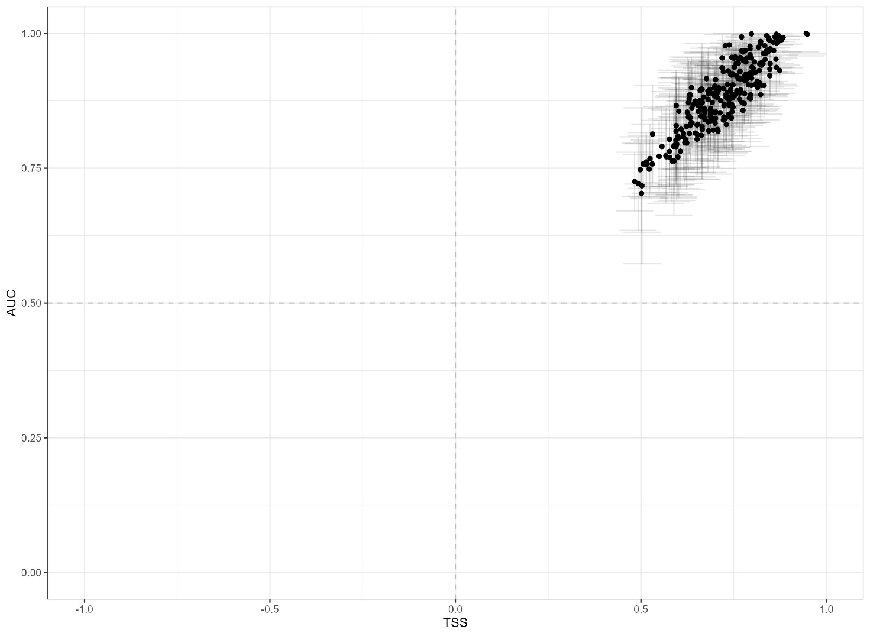
Fig. S2-2. Species distribution model performance measured with TSS and AUC metrics. Each point represents the mean metric value across pseudo-absence replicates and model algorithms for a given species.

Tab. S2-2. Estimated regression parameters, confidence intervals, P-values, numbers of observations, and the R-squared values for the LM with interaction between growth forms and bioclimatic variables: mean_imp ~ growth*var

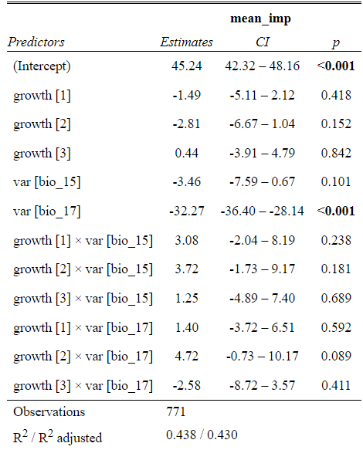

Tab. S2-3. Estimated regression parameters, confidence intervals, P-values, random effects, numbers of observations, and the R-squared values for the LMM: SS ~ climate + (1|species).
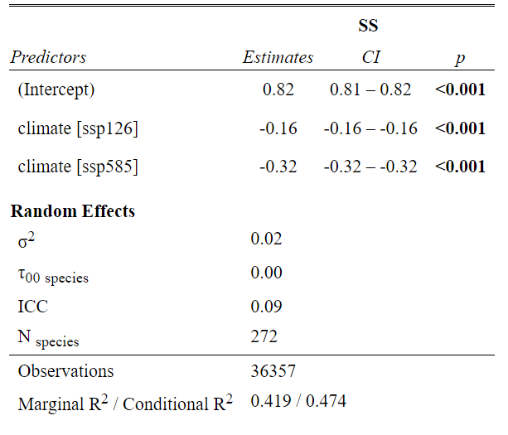

Tab. S2-4. Estimated regression parameters, confidence intervals, P-values, random effects, numbers of observations, and the R-squared values for the LMM with interaction between scenarios and growth forms: SS ~ climate*growth + (1|species). Cr: crustose, Fo: foliose, Fr: fruticose, Sq: squamulose.

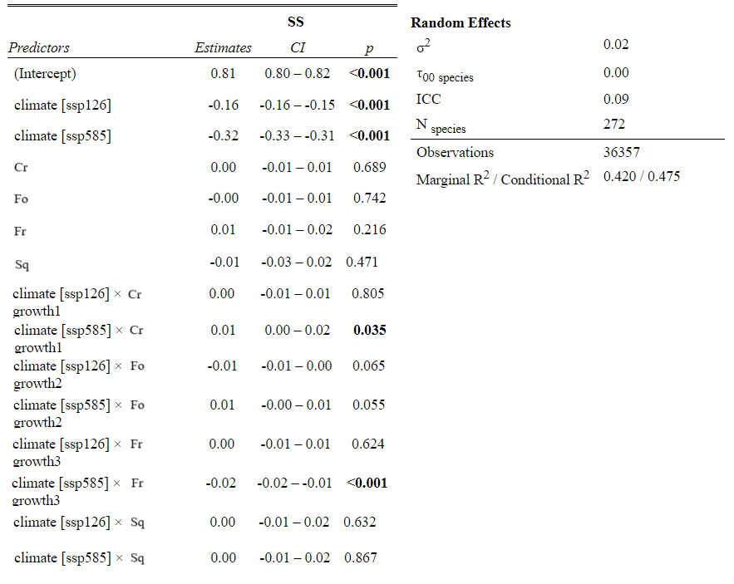
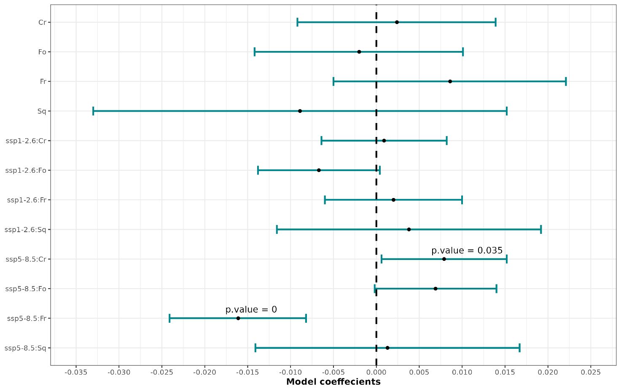
Fig. S2-3. Estimates of the LMM including the interactions between scenarios and growth forms (Cr: crustose, Fo: foliose, Fr: fruticose, Sq: squamulose). Only p.values < 0.05 are shown. Intercepts, SSP1-2.6 and SSP5-8.5 estimates are indicated in Tab. S2-3.

Tab. S2-5. Estimated regression parameters, confidence intervals, P-values, random effects, numbers of observations, and the R-squared values for the LMM with interaction between scenarios and temperature affinity: SS ~ climate*temp+ (1|species).
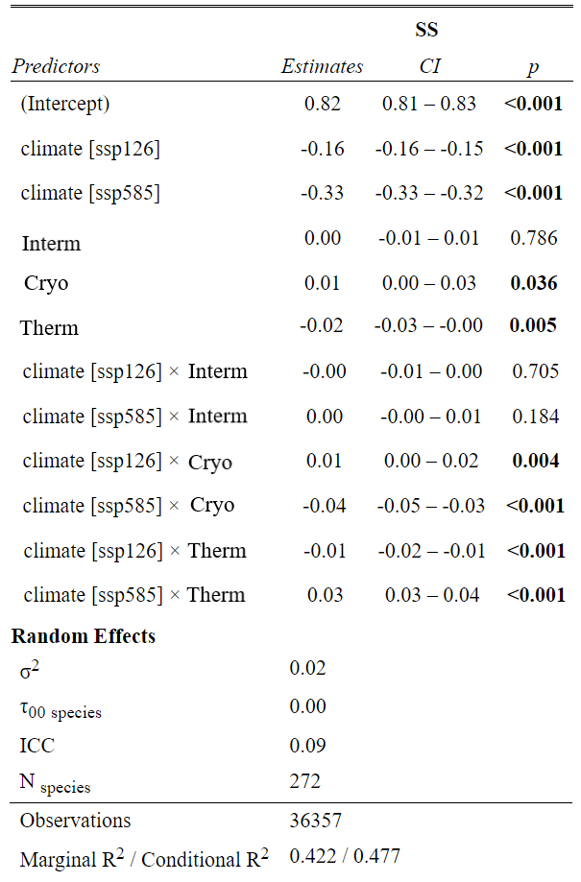

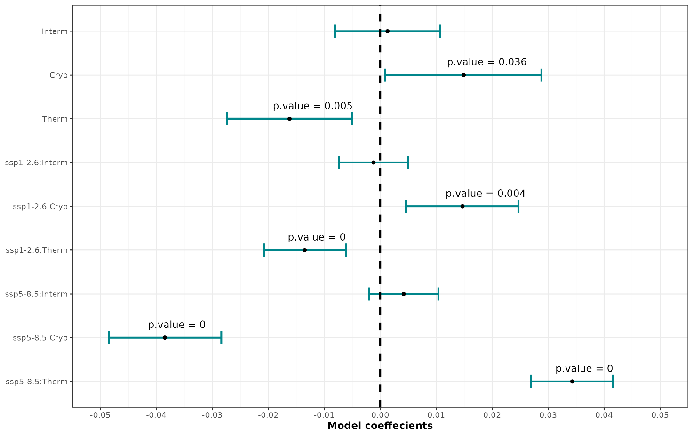Fig. S2-4. Estimates of the LMM including the interactions between scenarios and temperature affinity. Only p.values < 0.05 are shown. Intercepts, ssp1-2.6 and ssp5-8.5 estimates are indicated in Tab. S2-4.

