SUPPORTING INFORMATION
Film morphology
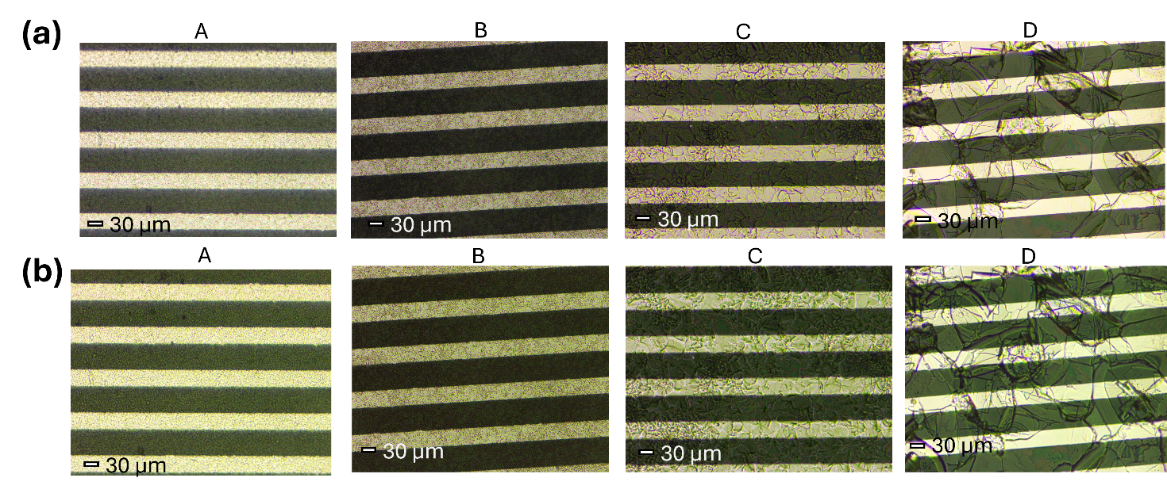
Figure S1: Optical images (a) 0° polarization, (b) 90° polarization

Comparison of the mean grain area estimated with AFM and SEM. With both techniques, the trend is maintained. The SEM is a micrometre-scale technique and overestimates the grain dimensions of smaller crystallites, possibly because not all the grain boundaries are well resolved. The AFM map for sample C presents several grains cut at the edges of the map, which decreases the average calculated crystallite area, while for sample D the maximum scanning area of the AFM is not sufficient to include a full crystallite.
Sample | AFM crystallites area (μm²) | SEM crystallites area (μm²)
A | 0.7 | 2.6
B | 1.3 | 5.9
C | 57 | 180
D | n/a | 4700
Table S1: crystal area extracted watershed analysis of AFM and SEM maps

Dark sheet resistance and UV photocurrent
The sheet resistance is extracted from the linear fit of the IV curves, and it is defined as R_{s}=R*W/L, with R resistance, W channel width, and L channel length.
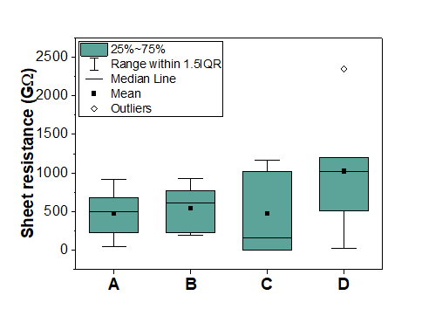
Figure S2: Sheet resistance of the films. The devices are biased at 5 V.

Photocurrent transient times
Table of the rise and fall times of the UV-induced photocurrent. We define τ_{rise} as the time interval needed to increase the current from 10% to 90% of its maximum value, and τ_{fall} as the time interval needed to decrease from 90% to 10%.
Sample | τ_{rise} (ms) | τ_{fall} (ms)
A | 1.04 ± 0.04 | 5.72 ± 0.05
B | 0.66 ± 0.04 | 4.40 ± 0.05
C | 0.52 ± 0.04 | 0.92 ± 0.04
D | 1.16 ± 0.06 | 4.94 ± 0.05
Table S2: rise and fall times

Energy gap and excitonic binding energy of the studied films extracted by the Elliot fit of the photocurrent spectra
Sample | E_{g} (eV) | E_{b} (eV)
A | 2.74 $±$ 0.07 | 0.06 $±$ 0.01
B | 2.85 $±$ 0.07 | 0.06 $±$ 0.01
C | 2.84 $±$ 0.07 | 0.05 $±$ 0.01
D | 2.83 $±$ 0.07 | 0.08 $±$ 0.01
Table S3: energy gap and excitonic binding energy

XRF spectra analysis
The fit was performed using PyMCA program¹. The spectrum was fitted using the MCA Hypermet function. As a preliminary operation, we identified the peaks as belonging to the following elements: Ar, Ca, Cr, Ni, Cu, Br, Sr, Zr, Mo, Ag, Au, Pb. The reason for multiple unexpected elements is the fact that the x-ray beam penetrates through the sample and therefore the substrate and the apparatus behind will contribute to the XRF signal as well. To account for self-absorption losses, the sample was modelled as a multilayer matrix (1.3 µm perovskite/26 nm Au/ 7 nm Cr/ 1 mm glass). To obtain an exact quantification of the concentrations of the components, the Au contacts were used as a reference. This was possible in the regions of the maps where there were visible contacts. For the map regions without contacts, the extrapolation was performed from the fundamental beam parameters, where the photon flux was adjusted to match the data obtained with the Au-reference calibrated fit. However, it is important to note that even when the photon flux is not calibrated, the relative concentration of components can be compared anyway.
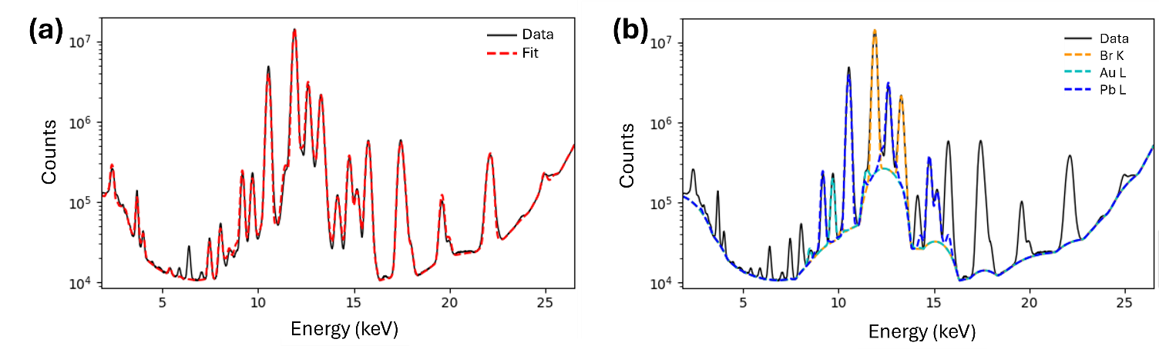
Figure S3: (a) Fit of the XRF spectrum. (b) Peaks of the relevant materials in the sample.

Chemical compositional analysis
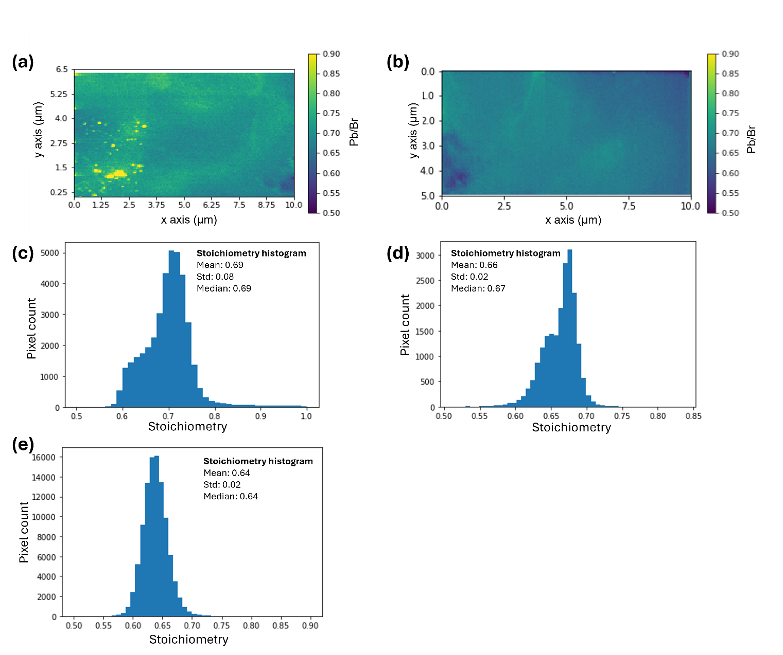
Figure S4: Stoichiometry samples (a) C and (b) D. Histogram of the pixel count in the stoichiometry maps of samples (c) C, (d) D and (e) A.
A uniform stoichiometry is observed for both samples. Sample C shows no relevant variations between grains and grain boundaries, while sample D shows a uniform stoichiometry in all the crystallites. In Figure S4a, some aggregates with higher stoichiometry located on the electrode are attributed to the perovskite-gold chemical reaction taking place under high radiation fluxes. Indeed, the extremely high photon fluxes involved at the ESRF ID16b beamline (~10¹⁸ ph s⁻¹ mm⁻²) are several orders of magnitude higher than the ones usually involved in the medical field (10⁶ to 10⁹ ph s⁻¹ mm⁻²).² (PEA)₂PbBr₄ has been demonstrated to be stable under X-ray fluxes compatible with clinical purposes³ and under 5MeV proton beams⁴. In general, gold is considered a good electrical contact for perovskites; however, it is known to diffuse into it.^{12–14} Therefore, the authors suggest preferring other electrode materials when dealing with operative devices.
The average stoichiometry of samples is 0.69 ± 0.02 for sample C and 0.66 ± 0.02 for sample D, in accordance with the theoretical value of 0.65 for the expected triclinic structure.

GIWAXS
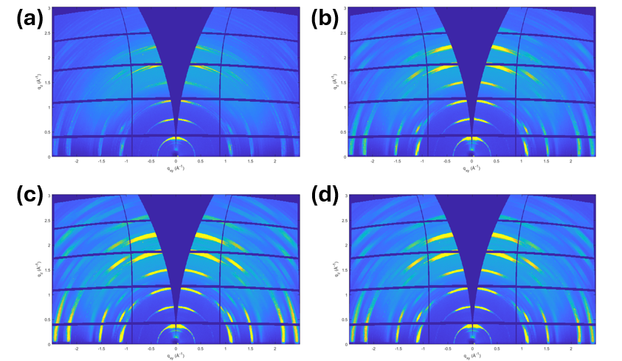
Figure S5: GIWAXS of sample type A at different incident angles (a) 0.04°, (b) 0.10°, (c) 0.16°, (d) 0.22°.

Experimental setup for XBIC and XRF at ESRF ID16b beamline
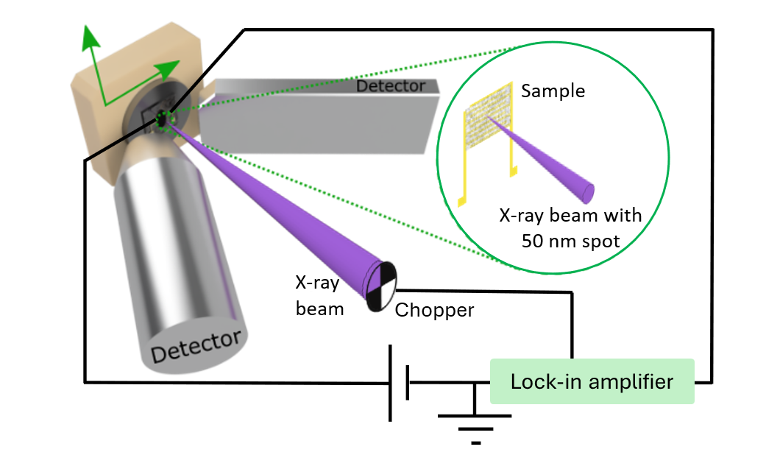
Figure S6: Experimental setup for XRF and XBIC maps used in the ID16b beamline at ESRF

Simultaneous XRF and XBIC nano-mapping
XBIC maps do not provide a quantitative analysis of the collected charges. Moreover, in morphologically inhomogeneous samples, relevant transport data can be hidden in the difference in absorption of the material. Therefore, here we followed the procedure described by Ossig et al.⁵.
Each point of the raw XBIC (XBIC_{raw}) signal was corrected for topological variations, exploiting the simultaneous XRF measurements
$$XBIC=\frac{{XBIC}_{raw}}{1-exp⁡(-\sum_{i}{α_{i}m_{i}) }}$$
Where $α_{i}=μ_{i}/ρ_{i}$is the X-ray attenuation coefficient and $m_{i}$ is the mass density of the absorbing element $i$, in this case Pb and Br.
The corrected XBIC signal is then converted to CCE as follows:
$$CCE=\frac{n_{e/h}^{coll}}{n_{e/h}^{gen}}=\frac{n_{e/h}^{coll}}{CN_{ph}^{in}}=\frac{\frac{XBIC}{q}}{βN_{ph}^{in}}$$
Where $n_{e/h}^{coll}$ and $n_{e/h}^{gen}$ are the collection and generation rates of electron-hole pairs, $n_{ph}^{in}$ is the rate of incident photons and $q$ is the elementary charge. $β$is a material constant defined as the ratio of electron/hole pair generated per incoming incident photon:
$β =$ $\frac{n_{e/h}^{gen}}{n_{ph}^{in}}≈\frac{E_{abs}}{αE_{g}}$
In this case, $E_{abs}$ is the energy deposited in the material per incident photon and was calculated by Beer-Lambert’s law, $E_{g}$ is the energy gap, and $α$ accounts for the efficiency of electron/hole pair generation in the material and it is usually approximated empirically $α≈3$.
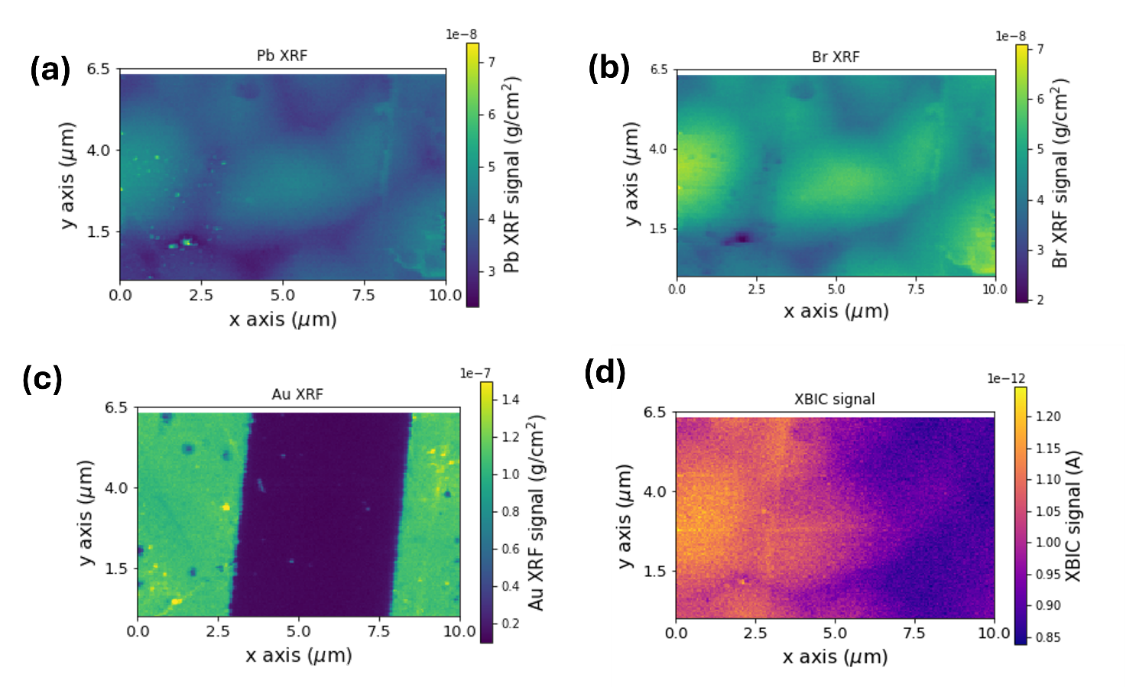
Figure S7: XRF maps taken in the same area of (a) Pb, (b) Br, and (c) Au. The Au signal was used to locate the electrodes and the interdigitated channel. (d) XBIC raw signal was acquired simultaneously in the same area.
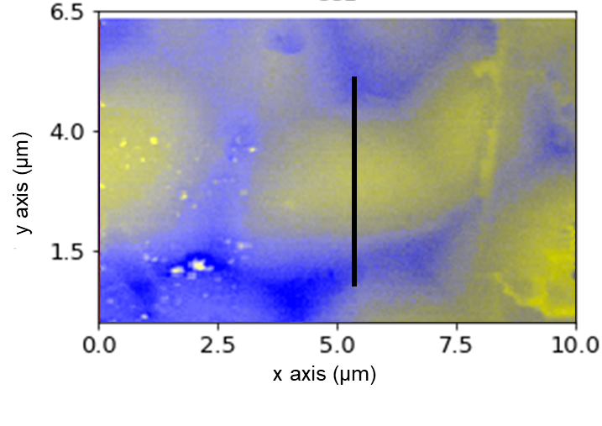
Figure S8 shows the superposition of the Pb XRF (yellow color) and CCE (blue color) maps, and a black line indicates the position of the profile reported in Figure 5c. The superimposed image is obtained by summing the red-green-blue (RGB) values of the XRF and CCE normalized pixels, as described in detail by Verdi et al.⁶ We assign the color yellow to the Pb XRF signal and blue to the CCE, therefore the resulting pixel color represents the dominating signal. In case of signals with similar intensity (i.e. correlated) the pixels would become grey/white. We observe that the CCE signal is lower inside the crystallites (Pb-rich) and higher in the grain boundary (poor in Pb).
Figure S8: Composite map of the Pb XRF (yellow) and CCE (blue) signals

Figure S9: (a) Br XRF and (b) CCE maps of sample A. (c) Br XRF and (d) CCE maps of sample D. Electrodes are drawn with vertical black lines.

KPFM measurements
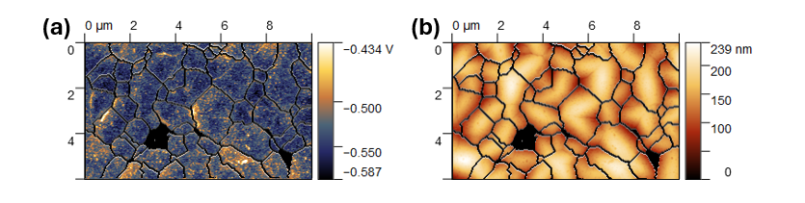
Figure S10: (a) KPFM map shown in figure 6a with superimposed grain edges obtained from (b) watershed segmentation performed on AFM morphology
The map was cut to exclude an area where the watershed mask was not optimal. Also, it is visible in Figure S11a that the grain boundaries result in a localized increase that can extend in the proximity of the interface and are not masked by the watershed mask (areas circled in green). Moreover, the picture shows at least one grain boundary visible in the morphology, but not highlighted by the watershed mask (purple circle). Therefore, the actual value of the potential of the crystalline grains may be even more negative with respect to the reported one. However, this influences only the surface potential value extracted in the crystalline grains, while the considerations on the grain boundaries are unaffected.

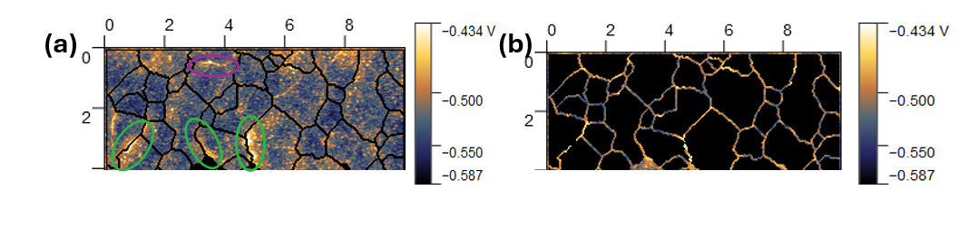
Figure S11: (a) KPFM masked with a watershed mask to calculate the average KPFM value inside the crystalline grains (b) KPFM masked with an inverted watershed mask to calculate the average KPFM value in the grain boundaries

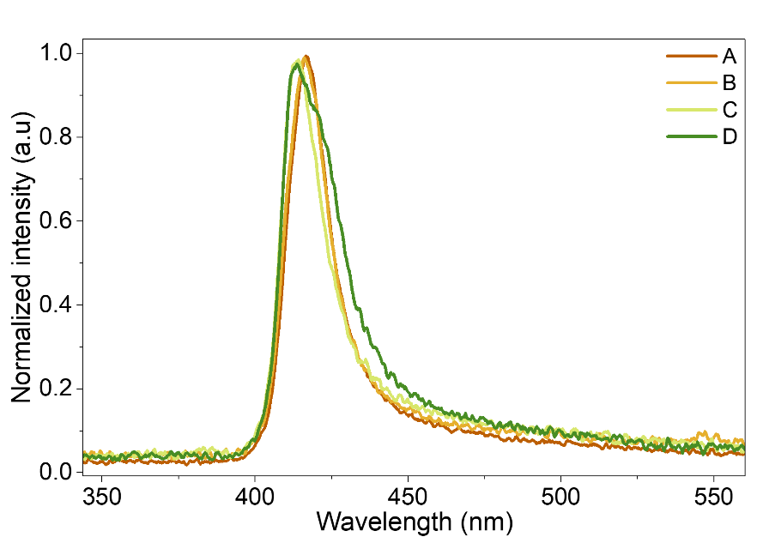
Figure S12: Photoluminescence spectra of type A, B, C and D perovskite thin films.

Bibliography
1. Solé, V. A., Papillon, E., Cotte, M., Walter, Ph. & Susini, J. A multiplatform code for the analysis of energy-dispersive X-ray fluorescence spectra. Spectrochimica Acta Part B: Atomic Spectroscopy 62, 63–68 (2007).
2. Pan, L., He, Y., Klepov, V. V., De Siena, M. C. & Kanatzidis, M. G. Perovskite CsPbBr3 Single Crystal Detector for High Flux X-Ray Photon Counting. IEEE Transactions on Medical Imaging 41, 3053–3061 (2022).
3. Lédée, F., Ciavatti, A., Verdi, M., Basiricò, L. & Fraboni, B. Ultra-Stable and Robust Response to X-Rays in 2D Layered Perovskite Micro-Crystalline Films Directly Deposited on Flexible Substrate. Advanced Optical Materials 10, 2101145 (2022).
4. Napolitano, G. et al. Impact of Device Architecture on Proton Detection Efficiency in 2D Perovskite Thick Film Detectors. Small n/a, e12236.
5. Ossig, C. et al. X-ray Beam Induced Current Measurements for Multi-Modal X-ray Microscopy of Solar Cells. JoVE 60001 (2019) doi:10.3791/60001.
6. Verdi, M. et al. X-Ray Nanoanalysis Revealing the Role of Electronically Active Passivation Layers in Perovskite X-Ray film Detectors. Advanced Electronic Materials 9, 2201346.

