Supplementary Material

Sustainable Recovery of Rare Earth Elements from Aqueous Media Using Fruit Pomaces: Adsorption Performance, Thermodynamics, and Environmental Assessment
Salvatore Giovanni Michele Raccuia¹, Emanuele Zanda¹, Clemente Bretti¹, Mauro Formica², Eleonora Macedi², Andrea Melchior³, Marilena Tolazzi³, Alberto Pettignano⁴, Nicola Muratore⁴, Davide Lascari⁴, Edoardo Teresi ⁵, Cristian Chiavetta ⁶, Giovanna De Luca¹, Anna Irto¹, Concetta De Stefano¹, Paola Cardiano¹, Gabriele Lando¹

¹Dipartimento di Scienze Chimiche, Biologiche, Farmaceutiche e Ambientali, Università degli Studi di Messina, 98168, Messina, Italy;
²Dipartimento di Scienze Pure e Applicate, Università degli Studi di Urbino “Carlo Bo”, 61029, Urbino, Italy;
³Dipartimento Politecnico di Ingegneria e Architettura, Laboratorio di Tecnologie Chimiche, Università di Udine, 33100, Udine, Italy;
⁴Dipartimento di Fisica e Chimica– Emilio Segré, Università di Palermo, I-90128 Palermo, Italy;
⁵Dipartimento di Ingegneria Civile, Chimica, Ambientale e dei Materiali "DICAM", Università di Bologna, 40121, Bologna, Italy;
⁶Dipartimento Sostenibilità (SSPT), ENEA, 00123, Roma, Italy.

Tables
Table S1. Numerical values calculated during the screening of the sorption capacity of all the tested BP, GP and OP-based materials towards Nd³⁺ and Dy³⁺.
ID | Adsorbent | q_{e} ª Nd³⁺ | q_{e} ª Dy³⁺
A | RAW BP | 0.115 ± 0.006 | 0.076 ± 0.004
B | BP LYO | 0.084 ± 0.004 | 0.038 ± 0.002
C | BP LYO H₂O | 0.183 ± 0.009 | 0.189 ± 0.009
D | BP H₂O | 0.274 ± 0.014 | 0.270 ± 0.014
E | BP HNO₃ | 0.211 ± 0.010 | 0.220 ± 0.011
F | RAW OP | 0.155 ± 0.008 | 0.140 ± 0.007
G | OP H₂O | 0.092 ± 0.005 | 0.116 ± 0.006
H | OP HNO₃ | 0.071 ± 0.003 | 0.091 ± 0.005
I | RAW GP | 0.098 ± 0.005 | 0.099 ± 0.005
J | GP H₂O | 0.130 ± 0.006 | 0.109 ± 0.005
K | GP HNO₃ | 0.071 ± 0.004 | 0.114 ± 0.006
ª in mmol/g ± std. dev.;

Table S2. Parameters of PFO kinetic equation for the adsorption of Nd³⁺ and Dy³⁺ from aqueous solutions at pH = 5.0 and t = 25 °C.
M³⁺ | Adsorbent | q_{e} ª | k₁ ^{b} | R² | RMSE^{c}
Nd³⁺ | RAW OP | 0.11 ± 0.01 | 1.24 ± 0.25 | 0.9481 | 0.0076
Nd³⁺ | GP H₂O | 0.07 ± 0.01 | 0.41 ± 0.06 | 0.9576 | 0.0050
Nd³⁺ | BP H₂O | 0.25 ± 0.01 | 0.07 ± 0.01 | 0.9819 | 0.0118
Dy³⁺ | RAW OP | 0.12 ± 0.01 | 1.23 ± 0.24 | 0.9567 | 0.0078
Dy³⁺ | GP H₂O | 0.08 ± 0.01 | 0.28 ± 0.05 | 0.9553 | 0.0063
Dy³⁺ | BP H₂O | 0.25 ± 0.01 | 0.12 ± 0.01 | 0.9407 | 0.0225
ª mmol/g ± std. dev; ^{b} 1/min ± std. dev; ^{c} Root Mean Square Error, mmol/g.

Table S3. Parameters of PGO kinetic equation for the adsorption of Nd³⁺ and Dy³⁺ from aqueous solutions at pH = 5.0 and t = 25 °C.
M³⁺ | Adsorbent | q_{e} ª | k_{n} ^{b} | n ^{c} | R² | RMSE^{d}
Nd³⁺ | RAW OP | 0.12 ± 0.01 | 1271 ± 3512 | 4 ± 1 | 0.9886 | 0.0036
Nd³⁺ | GP H₂O | 0.08 ± 0.01 | 0.28 ± 0.05 | 1 ± 1 | 0.9741 | 0.0039
Nd³⁺ | BP H₂O | 0.29 ± 0.03 | 0.12 ±0.02 | 2 ± 1 | 0.9915 | 0.0079
Dy³⁺ | RAW OP | 0.23 ± 0.20 | 6·10¹⁰±1·10¹⁰ | 15 ± 22 | 0.9929 | 0.0032
Dy³⁺ | GP H₂O | 0.11 ± 0.01 | 625 ± 968 | 4 ± 1 | 0.9987 | 0.0011
Dy³⁺ | BP H₂O | 0.40 ± 0.11 | 6.00 ± 4.78 | 5 ± 1 | 0.9919 | 0.0083
ª mmol/g ± std. dev; ^{b} [(1/min)(g·mmol)^{(n-1)})]± std. dev; ^{c} general order of adsorption; ^{d} Root Mean Square Error, mmol/g.

Table S4. Parameters of DEM kinetic equation for the adsorption of Nd³⁺ and Dy³⁺ from aqueous solutions at pH = 5.0 and t = 25 °C.
M³⁺ | Adsorbent | q_{e} ª | $α$^{b} | k_{p1} ^{c} | k_{p2} ^{c} | R² | RMSE^{d}
Nd³⁺ | RAW OP | 0.12 ± 0.01 | 0.22 ± 0.04 | 0.07 ± 0.01 | 1.94 ± 0.35 | 0.9912 | 0.0031
Nd³⁺ | GP H₂O | 0.07 ± 0.01 | 0.20 ± 0.14 | 0.05 ± 0.07 | 0.60 ± 0.20 | 0.9658 | 0.0045
Nd³⁺ | BP H₂O | 0.26 ± 0.08 | 0.82 ± 0.06 | 0.05 ± 0.01 | 430 ± 1 | 0.9807 | 0.0094
Dy³⁺ | RAW OP | 0.13 ± 0.01 | 0.19 ± 0.02 | 0.03 ± 0.01 | 1.66 ± 0.20 | 0.9928 | 0.0032
Dy³⁺ | GP H₂O | 0.09 ± 0.01 | 0.44 ± 0.02 | 0.02 ± 0.01 | 0.94 ± 0.13 | 0.9997 | 0.0011
Dy³⁺ | BP H₂O | 0.27 ± 0.11 | 0.65 ± 0.03 | 0.05 ± 0.01 | 0.74 ± 0.13 | 0.9987 | 0.0083
ª mmol/g ± std. dev; ^{b} (0 < $α$ < 1); ^{c} 1/min ± std. dev; ^{d} Root Mean Square Error, mmol/g.

Table S5. Parameters of the Boyd’s model for the systems under analysis.
Adsorbent | Metal | Slope (min⁻¹) | Intercept | R²
OP RAW | Dy³⁺ | 0.012±0.002 | 0.885±0.08 | 0.8556
OP RAW | Nd³⁺ | 0.002±0.001 | 0.389±0.04 | 0.3912
GP H₂O | Dy³⁺ | 0.003±0.001 | 0.176±0.03 | 0.7467
GP H₂O | Nd³⁺ | 0.009±0.003 | 0.108±0.02 | 0.3968
BP H₂O | Dy³⁺ | 0.005±0.001 | 0.153±0.051 | 0.6156
BP H₂O | Nd³⁺ | 0.007±0.001 | 0.132±0.06 | 0.7882
BP H₂O | La³⁺ | 0.010±0.001 | 0.187±0.09 | 0.7894
± std. dev

Table S6. Freundlich isotherm parameters for the Nd³⁺, Dy³⁺ and La³⁺ ions from aqueous solutions adsorption onto RAW OP, GP H₂O and BP H₂O at t = 25°C, pH_{i} = 3.0 to 5.0, low ionic strength (absence of ionic medium) and in NaNO₃ 0.10 mol/dm³.
M³⁺ | Adsorbent | pH_{i}ª | pH_{e}^{b} | K_{F}^{c} | n | R² | RMSE^{d}
Nd³⁺ | RAW OP | 5.0 | 4.1 | 0.22 ± 0.02 | 5.1 ± 0.9 | 0.9625 | 0.0107
 | GP H₂O | 5.0 | 4.0 | 0.22 ± 0.02 | 2.5 ± 0.3 | 0.9763 | 0.0062
 | BP H₂O | 5.0 | 3.4 | 0.53 ± 0.05 | 3.2 ± 0.5 | 0.9523 | 0.0249
 | BP H₂O | 5.0 ^{e} | 3.6 | 0.32 ± 0.02 | 2.2 ± 0.2 | 0.9749 | 0.0075
La³⁺ | BP H₂O | 5.0 | 3.6 | 0.49 ± 0.05 | 3.5 ± 0.5 | 0.9441 | 0.0279
 | BP H₂O | 5.0 ^{e} | 3.4 | 0.27 ± 0.03 | 3.4 ± 0.8 | 0.9384 | 0.0167
Dy³⁺ | RAW OP | 5.0 | 4.1 | 0.21 ± 0.02 | 4.7 ± 0.8 | 0.9641 | 0.0084
 | GP H₂O | 5.0 | 4.0 | 0.26 ± 0.04 | 2.3 ± 0.4 | 0.9217 | 0.0108
 | BP H₂O | 5.0 | 3.2 | 0.59 ± 0.05 | 2.4 ± 0.3 | 0.9668 | 0.0216
 | BP H₂O | 5.0 ^{e} | 3.4 | 0.23 ± 0.03 | 3.1 ± 0.8 | 0.9215 | 0.0159
Nd³⁺ | BP H₂O | 4.0 | 3.3 | 0.41 ± 0.05 | 5 ± 1 | 0.9293 | 0.0223
Dy³⁺ | BP H₂O | 4.0 | 3.6 | 0.36 ± 0.05 | 6 ± 1 | 0.8766 | 0.0296
Nd³⁺ | BP H₂O | 3.0 | 2.9 | 0.27 ± 0.02 | 9 ± 3 | 0.9948 | 0.0065
Dy³⁺ | BP H₂O | 3.0 | 2.9 | 0.21 ± 0.01 | 13 ± 2 | 0.9884 | 0.0068
ª initial pH value of REE ions solutions; ^{b} mean pH value at adsorption equilibrium; ^{c} mmol/g (dm³/mmol)^{1/n} ± std. dev.; ^{d} Root Mean Square Error; ^{e} adsorption isotherm carried out in NaNO₃ 0.10 mol/dm³.

Table S7. TEA of producing 1 kg of Bergamot Pomace H₂O
Material and cost input | B1 | S1 | S2 | S3 | Unit
Bergamot pomace H₂O | 4.16 | 4.16 | 1.04 | 1.04 | kg
Drying electricity consumptionª | 11.96 | 1.40 | 2.99 | 0.35 | kWh
Grinding electricity consumption ª | 0.023 | 0.023 | 0.006 | 0.006 | kWh
Centrifuge electricity consumption ª | 0.14 | 0.14 | 0.04 | 0.04 | kWh
Deionized water ^{b} | 166.66 | 166.66 | 41.67 | 41.67 | dm³
Nitric acid (0.1 mol/dm³) (for regeneration) ^{c} | - | - | 0.75 | 0.75 | dm³
Material and cost output
€/kg of BP H₂O | 13.64 | 10.47 | 3.79 | 2.99
€/kg Ln | 194.80 | 149.54 | 54.10 | 42.74
ª Electricity cost was based on €0.30/kWh, the average supply costs to non-domestic customers, low voltage (Arera, relazione annuale 2023-2024); ^{b} deionized water cost: laboratory inventory, €60 for 1000 dm3 filter, 0.06 €/dm³; ^{c} nitric acid cost: Merck.com, €100 for 1 dm³ of 10 mol/dm³ nitric acid solution, €0.5/0.1 mol/dm³.

Figures

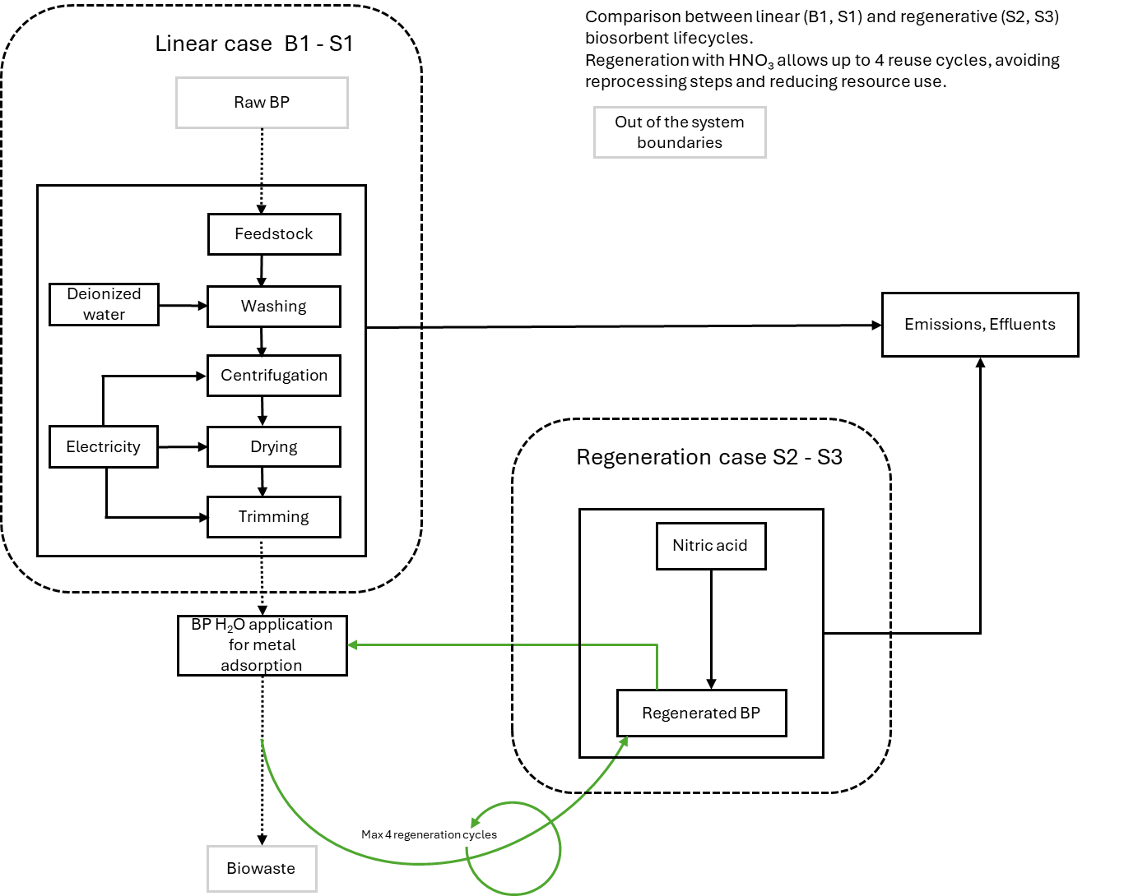
Figure S1. Flow diagram of the system boundaries and life cycle stages across the four scenarios considered.
a) GP H₂O | b) RAW OP
Figure S2. ATR FT-IR spectra of: a) GP H₂O (black line) [1], GP H₂O + Nd³⁺ (red line), GP H₂O + Dy³⁺ (blue line); b) RAW OP (black line) [1], RAW OP + Nd³⁺ (red line), RAW OP + Dy³⁺ (blue line).

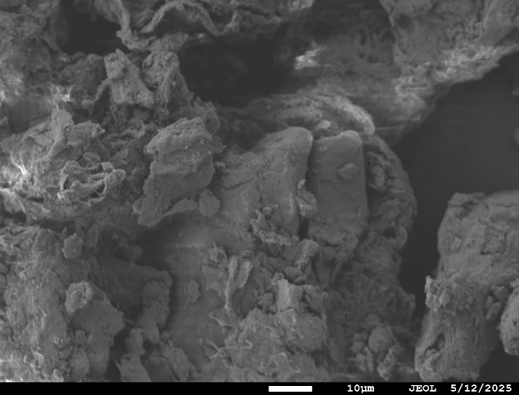 |  | 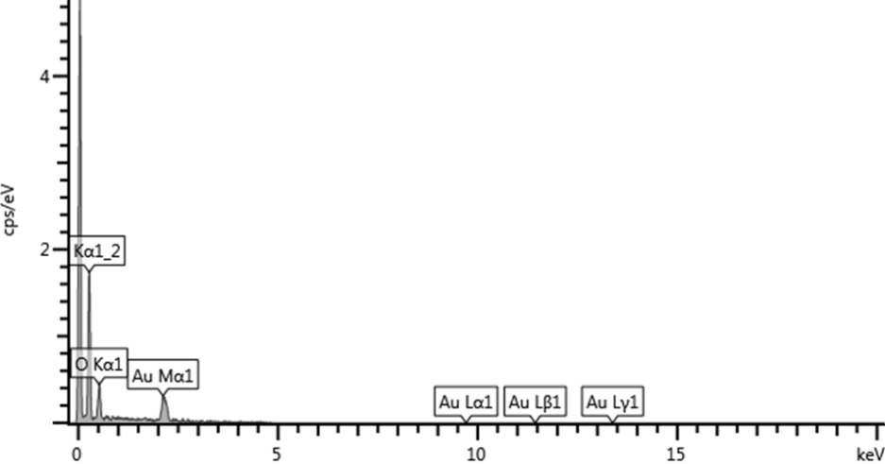
a)
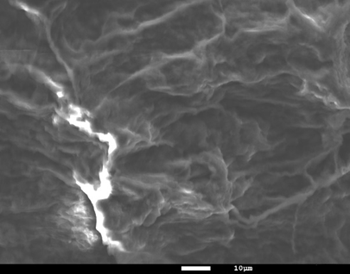 |  | 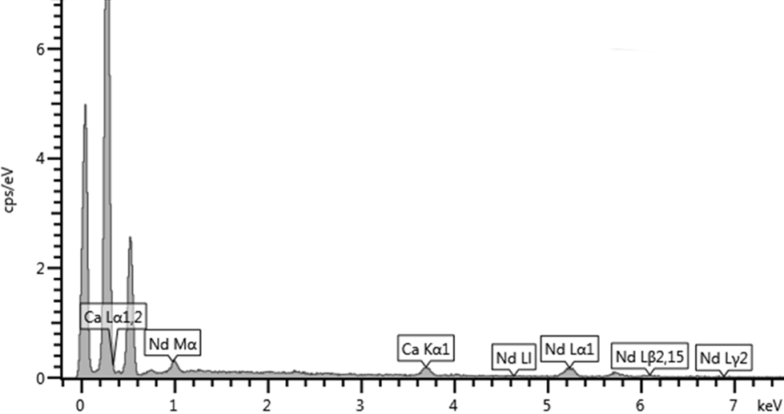
b)
 | 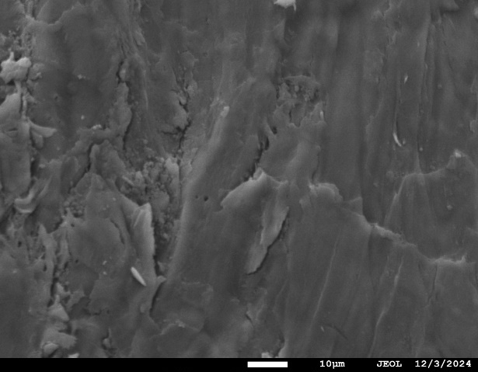 | 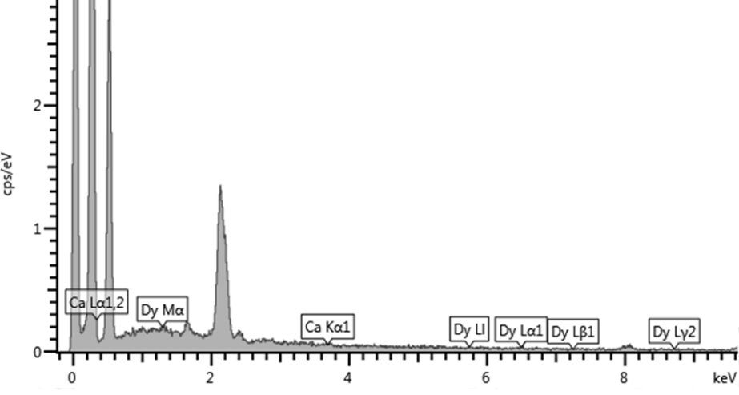
c)
Figure S3. SEM images of a) OP RAW before adsorption experiments and after adsorption of b) Nd, c) Dy. On the right the elemental analysis.

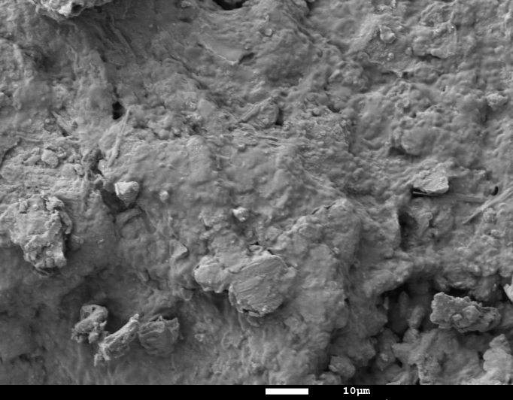 | 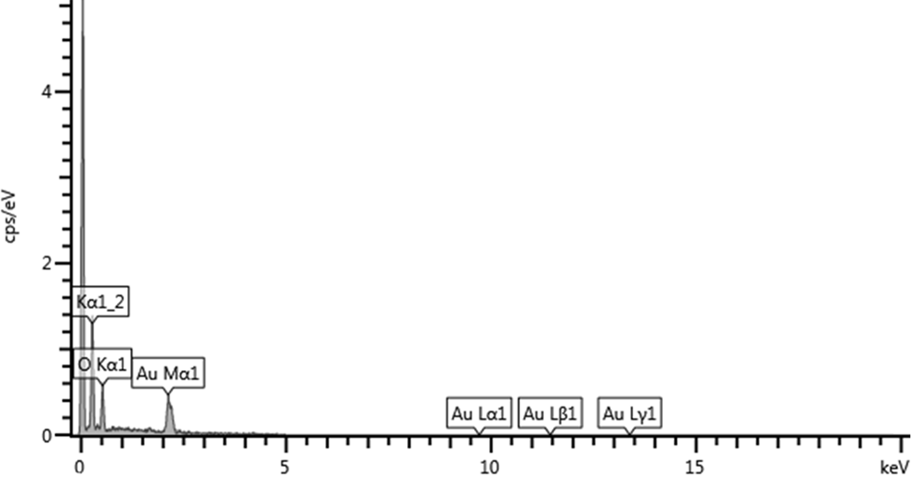
a)
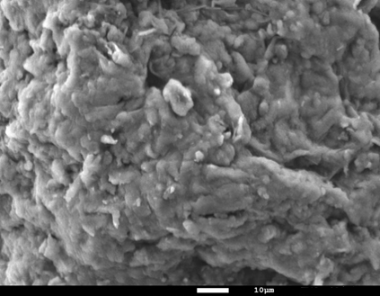 | 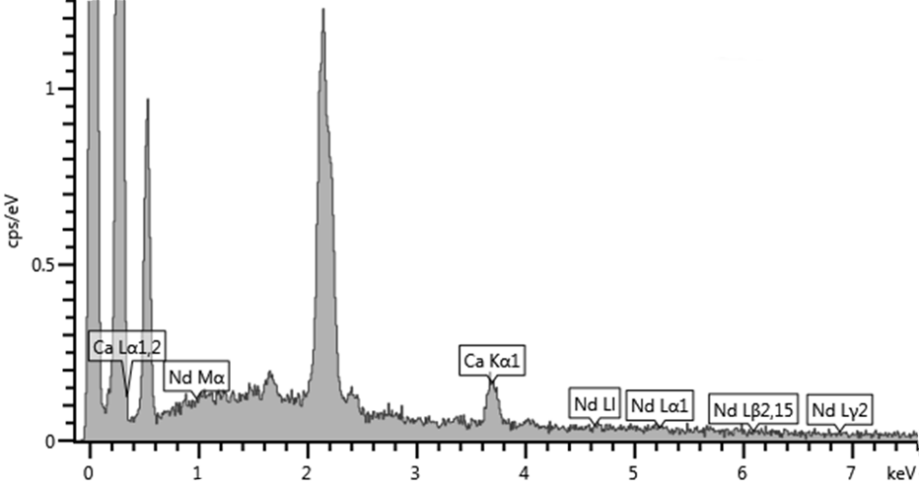
b)
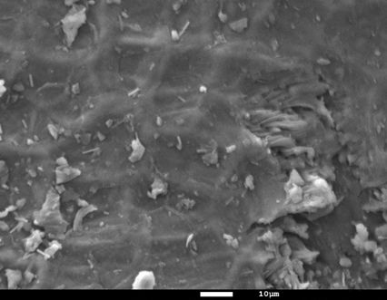 | 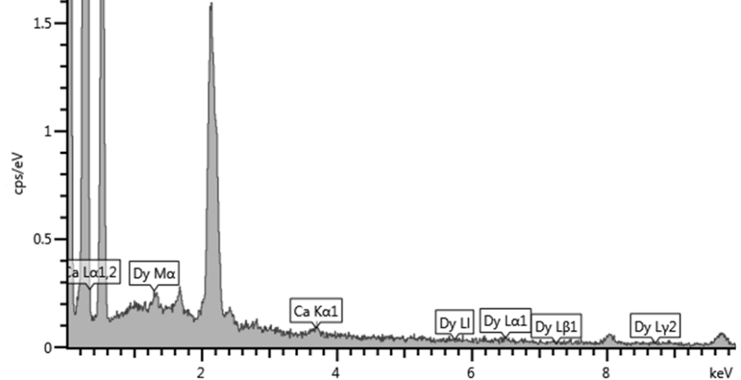
c)
Figure S4. SEM images of a) GP H₂O before adsorption experiments and after adsorption of b) Nd, c) Dy. On the right is the elemental analysis.

a) Nd³⁺ | b) Dy³⁺
Figure S5. PFO kinetics of adsorption of Nd³⁺ (a) and Dy³⁺ (b) ions on BP H₂O (△), RAW OP (□), and GP H₂O (○) adsorbents at low ionic strength and t = 25°C.

a) | b)
Figure S6. PGO kinetics of adsorption of Nd³⁺ (a) and Dy³⁺ (b) ions on BP H₂O (△), RAW OP (□), and GP H₂O (○) adsorbents at low ionic strength and t = 25°C.

a) | b)
Figure S7. DEM kinetics of adsorption of Nd³⁺ (a) and Dy³⁺ (b) ions on BP H₂O (△), RAW OP (□), and GP H₂O (○) adsorbents at low ionic strength and t = 25°C.
Figure S8. PSO kinetics of adsorption of La³⁺ on BP H₂O (Δ) at low ionic strength and t = 25°C.

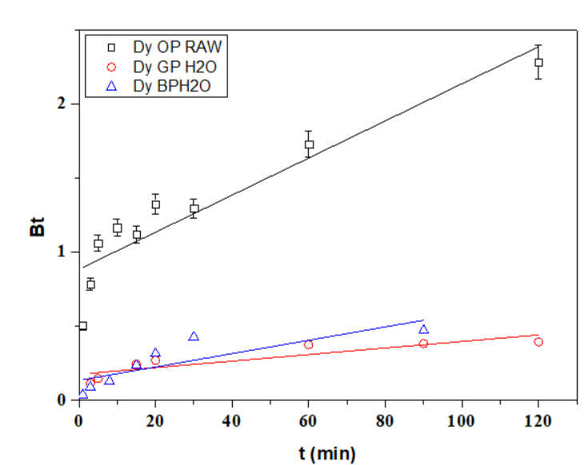 | 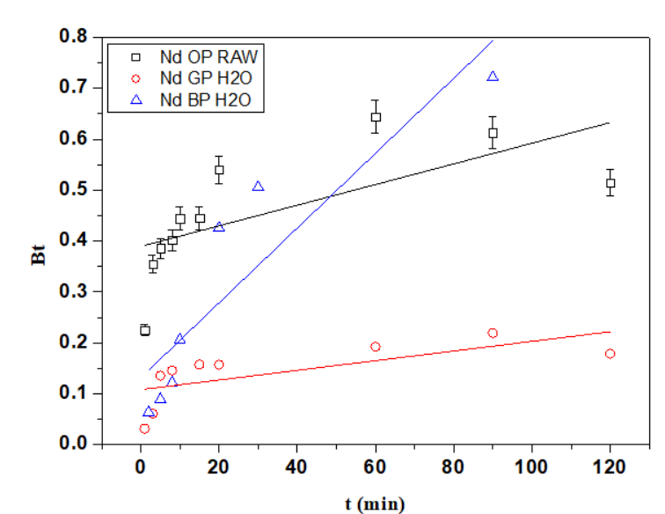
Dy | Nd
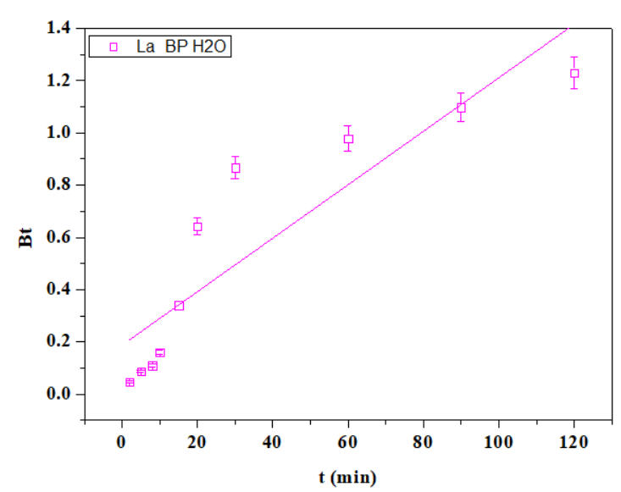
La
Figure S9. B_{t} vs. t scatter plots for Dy (upper left), Nd (upper right), and La (lower left) and fitting with the Boyd’s kinetics model (straight lines) at low ionic strength and t = 25°C.

Figure S10. Adsorption isotherms of Dy³⁺ onto BP H₂O in aqueous solutions, at t = 25°C, pH = 5.0, 0.10 mol/dm³ in NaNO₃ (○) and without ionic medium (△). The experimental data were processed using the Langmuir (solid line) and Freundlich (dotted line) models.

Figure S11. Adsorption isotherms of Nd³⁺ onto BP H₂O in aqueous solutions, at t = 25°C, pH = 5.0, 0.10 mol/dm³ in NaNO₃ (○) and without ionic medium (△). The experimental data were processed using the Langmuir (solid line) and Freundlich (dotted line) models.
Figure S12. Adsorption isotherms of La³⁺ onto BP H₂O in aqueous solutions, at t = 25°C, pH = 5.0, 0.10 mol/dm³ in NaNO₃ (○) and without ionic medium (△). The experimental data were processed using the Langmuir (solid line) and Freundlich (dotted line) models.

The results obtained, in terms of q_{e} of adsorption and desorption for the four cycles, are depicted in the histograms reported in Figures S13 (a-f).
RAW OP (Figures S13a and S13b) exhibited qₑ values of 0.1509 mmol/g for Nd³⁺ and 0.1224 mmol/g for Dy³⁺ in the first cycle, but capacities dropped by more than half after the first regeneration. A similar trend was observed for q_{des}, which progressively decreased over the cycles, indicating a reduced desorption capacity. GP H₂O (Figures S12c and S12d) started at 0.1125 mmol/g (Nd³⁺) and 0.1029 mmol/g (Dy³⁺) and showed a gradual decline in both qₑ and q_{des} across the cycles. BP H₂O (Figures S13e and S13f) maintained significantly higher and more stable capacities, with qₑ decreasing only from 0.3194 to 0.2586 mmol/g for Nd³⁺ and from 0.3086 to 0.2697 mmol/g for Dy³⁺. In this case, q_{des} consistently matched qₑ in all cycles, showing no loss of desorption capacity over time.

a) Nd³⁺, RAW OP | b) Dy³⁺, RAW OP
c) Nd³⁺, GP H₂O | d) Dy³⁺, GP H₂O
e) Nd³⁺, BP H₂O | f) Dy³⁺, BP H₂O
Figure S13. q_{e} values determined by using the different biomass samples for various REEs adsorption/desorption steps.

References
[1] S.G.M. Raccuia, E. Zanda, C. Bretti, M. Formica, E. Macedi, A. Melchior, M. Tolazzi, M. Sanadar, D. Lascari, G. De Luca, A. Irto, C. De Stefano, P. Cardiano, G. Lando, Molecules, 29 (2024) 5735.

