Appendix
Table A. List of the labels and their features
 | Logo | Label name | Description
1 | 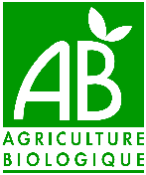 | Agriculture Biologique | AB is a French national logo for organic and high-quality food products, ensuring respect for biodiversity, the preservation of natural resources, and animal welfare.
2 | 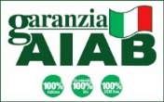 | AIAB Italia (Granzia AIAB Italia) | An Italian label for organic agricultural products of Italian origin, promoting sustainability and ensuring animal welfare, biodiversity, and soil conservation.
3 | 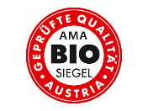 | AMA-Biosiegel | The AMA-Biosiegel is Austria’s national organic label, introduced by Agrarmarkt Austria (AMA) to promote transparency, traceability, and high standards in organic farming and food production, in compliance with EU Organic regulations.
4 | 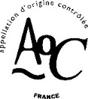 | Appellation d'origine contrôlée (AOC) | The label signifies that the products meet the criteria for the Protected Designation of Origin (PDO) and ensures the protection of the denomination within French territory.
5 | 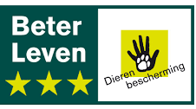 | Beter Leven | The Beter Leven (Better Life) label is a Dutch animal welfare certification that uses a one- to three-star system to indicate the level of welfare standards applied in meat, dairy, and egg production.
6 | 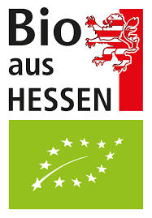 | Bio aus Hessen | Organic from Hesse, a label from the Hesse region in Germany, ensures compliance with organic farming standards and guarantees a traceable regional origin.
7 |  | Bio Cohérence | The French organic label was created by a collective of producers, organic stores, and consumers to support organic farming, animal welfare, biodiversity, and waste management.
8 | 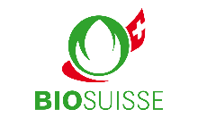 | Bio Suisse | The label for organically produced products from Switzerland focuses on conserving biodiversity, protecting soil fertility, and promoting sustainable water management.
9 | 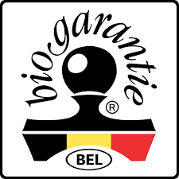 | Biogarantie | The Biogarantie label is Belgium’s national organic certification, ensuring compliance with EU standards and emphasizing sustainability, transparency, and local production in food and non-food products.
10 | 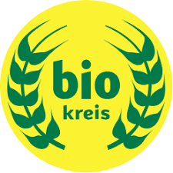 | Biokreis | It is a German organic label that goes beyond EU rules by promoting regional cycles, biodiversity, animal welfare, and fair partnerships in farming and food processing.
11 | 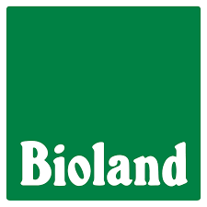 | Bioland | German organic certification promoting sustainable agriculture, animal welfare, biodiversity preservation, and the protection of natural resources, including air, water, and soil.
12 | 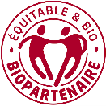 | Biopartenaire | The French organic certification focuses on promoting organic farming and fair-trade practices. It also emphasizes animal health and welfare, biodiversity preservation, the development of renewable energy, and the maintenance of soil fertility.
13 | 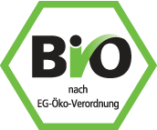 | Bio-Siegel | The Bio-Siegel is Germany’s official state organic label, introduced by the Federal Ministry of Food and Agriculture, certifying compliance with EU Organic regulation and identifying food produced without synthetic chemicals or GMOs.
Table A (continued)
 | Logo |  | Label name | Description
14 | 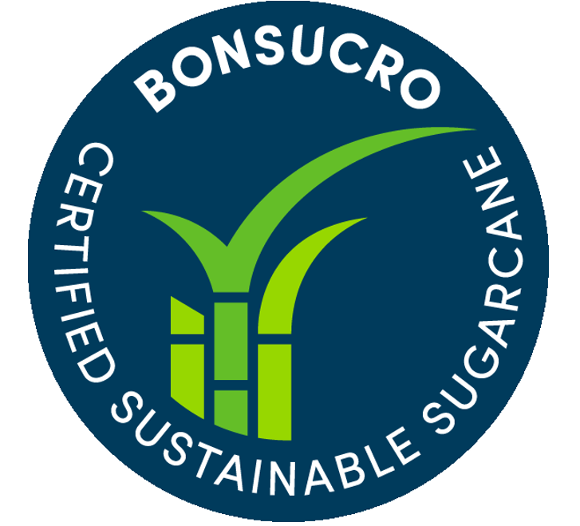 | Bonsucro |  | It is a global certification for the sugarcane sector, headquartered in London, that promotes sustainable production through standards on environmental protection, fair labor, and supply chain traceability.
15 | 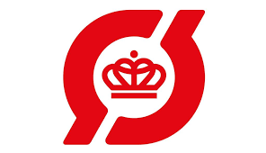 | Danish Ø-mark |  | The Danish Ø-mark (Red Ø-label) is Denmark’s official organic certification, guaranteeing compliance with EU Organic rules alongside stricter national controls to ensure trust and high standards in organic food production.
16 | 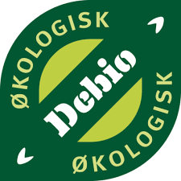 | Debio |  | This label is Norway’s official organic certification, guaranteeing that products are produced according to clear rules for ecology and sustainability.
17 | 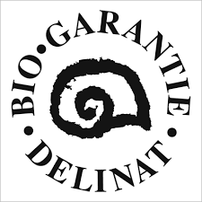 | Delinat Bio Garantie |  | The Delinat Bio Garantie is a Swiss private organic certification with stricter standards than EU rules, focusing on biodiversity, ecological vineyard management, and sustainable wine production
18 | 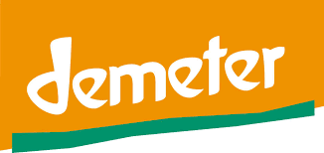 | Demeter |  | It is an international certification founded in Germany, ensuring compliance with biodynamic farming principles and emphasizing soil fertility, biodiversity, and holistic farm management.
19 | 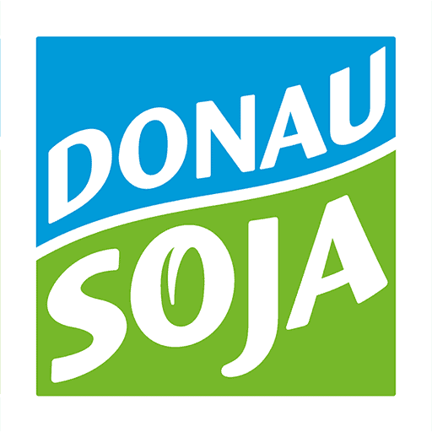 | Donau Soja |  | The Austrian-origin label for soy-based foods guarantees European, GMO-free production while integrating strong environmental and social safeguards. Its standards cover soil, water, and air protection, biodiversity conservation, prevention of deforestation and ecosystem conversion, and compliance with human and labor rights.
20 | 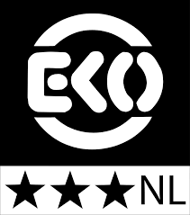 | EKO |  | The EKO label is the Dutch organic certification, ensuring compliance with EU rules while promoting additional goals such as fair trade, biodiversity, and transparent production.
21 |  | EU Organic |  | EU Organic farming rules apply to agricultural products grown using sustainable cultivation systems, covering the entire production process from seeds to final food products. They aim to promote environmental protection, biodiversity, animal welfare, and consumer trust in organic products.
22 | 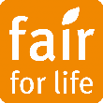 | Fair for life |  | A Swiss fair-trade agricultural certification that respects human rights and fair labor conditions, promotes biodiversity and ecosystem conservation, and advances sustainable agriculture through organic farming standards and the protection of water, air, and soil.
23 |  | Fair trade |  | The Fairtrade label is a global certification originating in the UK, emphasizing ethical production, better living conditions for producers, and sustainability through soil and water conservation, biodiversity protection, and reduced deforestation and emissions.
24 | 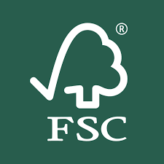 | Forest Stewardship Council (FSC) |  | FSC Certification promotes responsible forest management worldwide, ensuring environmental sustainability, social benefits, and economic viability. It emphasizes sustainable forestry, prevention of deforestation, biodiversity conservation, and climate change mitigation.

Table A (continued)
 | Logo | Label name | Description
25 | 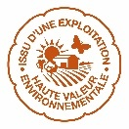 | Haute Valeur Environmental (HVE) | A French certification that guarantees high environmental standards in agriculture, emphasizing biodiversity conservation, soil and water protection, and reducing the overall environmental footprint of food production.
26 |  | IP-Suisse | The label of Swiss association of farmers produces agricultural products in a sustainable and environmentally friendly manner, promoting biodiversity, protecting natural habitats, ensuring animal welfare, and safeguarding water resources.
27 | 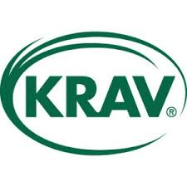 | KRAV | It is Sweden’s leading organic label, with high standards for animal welfare, biodiversity, social responsibility, and climate impact.
28 | 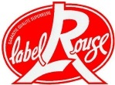 | Label Rouge | The French label for a wide range of meat products ensures high quality, improved production standards, compliance with organic farming practices, and strict animal welfare requirements.
29 | 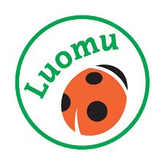 | Luomuliitto | The Ladybird label is a Finnish organic certification identifying products from family farms and promoting ecological sustainability, local production, and farmer solidarity.
30 |  | Nature et Progrès | Nature & Progrès is a French collective certification ensuring environmentally sustainable food and cosmetic products, with strict standards on organic farming, soil and water preservation, biodiversity protection, and animal welfare.
31 | 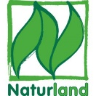 | Naturland | The label from a leading German organic agriculture association certifies food, textiles, and cosmetics, ensuring organic farming, climate and biodiversity protection, and sustainable soil and water resources management.
32 | 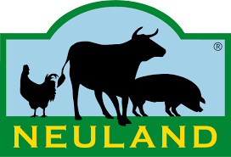 | Neuland | It is a German certification created by farmers’ and animal welfare organizations, focusing on high welfare standards, outdoor husbandry, regional feed, and sustainable farming.
33 | 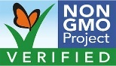 | Non-GMO | The Non-GMO Project Verified label is a North American certification ensuring products are made without GMOs, with third-party testing and strict supply chain traceability.
34 |  | On the way to PlanetProof | It is a Dutch sustainability certification covering food, flowers, plants, and dairy, focusing on environment, biodiversity, climate, animal welfare, and resource efficiency.
35 | 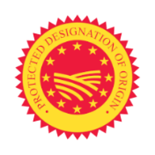 | Protected designation of origin (PDO) | A European geographical indication label that certifies local food products entirely produced, processed, and prepared in a specific region using traditional methods, ensuring their quality and characteristics are uniquely linked to their place of origin.
36 | 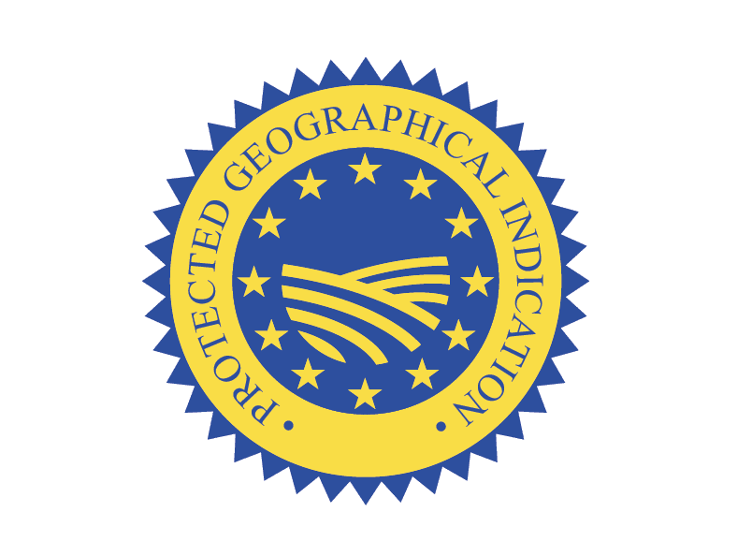 | Protected Geographical Indications (PGI) | An EU certification ensures that at least one stage of production, processing, or preparation occurs in a specific geographical area. It supports local economies, preserves cultural heritage, and assures consumers of the authenticity and high quality of regional products.

Table A (continued)
 | Logo | Label name | Description
37 | 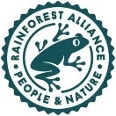 | Rainforest alliance | An international sustainable agriculture certification that guarantees high standards for environmental protection, fair working conditions, and community well-being, with a strong focus on biodiversity, soil and water conservation, waste management, and sustainable farming practices.
38 |  | QS-GAP | The QS-GAP Standard is a German certification under the QS system, ensuring good agricultural practices with strict requirements for food safety, traceability, environmental protection, and responsible resource use.
39 | 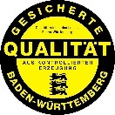 | Quality Label Baden-Württemberg | The Quality Label Baden-Württemberg (QZBW) is a German regional certification guaranteeing sustainably produced, predominantly regional products of verified quality, with additional controls on environmental standards and animal welfare.
40 | 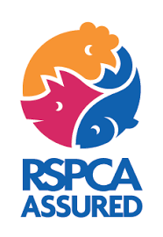 | RSPCA Assured | It is a UK animal welfare certification ensuring that meat, fish, dairy, and eggs come from animals raised, transported, and slaughtered under higher welfare standards than the legal minimum.
41 | 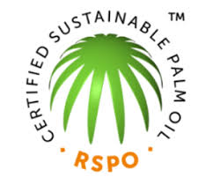 | RSPO Certified Sustainable Palm Oil | This label is an international certification on sustainable palm oil, founded in Malaysia and Switzerland, promoting environmentally responsible production, forest and biodiversity protection, fair labor, and supply chain traceability.
42 | 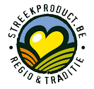 | Streekproduct | The Streekproduct label is a Belgian regional certification highlighting traditional, locally produced foods with strong regional identity, guaranteeing authenticity, origin, and cultural heritage.
43 |  | Traditional Specialty Guaranteed (TSG) | The TSG label is an EU certification focusing on traditional production methods or composition without linking products to a specific origin, promoting diversification and guaranteeing preparation methods rather than origin.
44 | 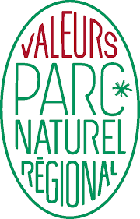 | Valeurs Parc naturel régional | It is a French certification promoting products and services that support local heritage, biodiversity conservation, sustainable farming, and regional development within natural parks.

Table B. Ecosystem Services with representative keywords
 | Ecosystem Services | Keywords
1 | Food | Crops, fruits, vegetables, food, meat, livestock, fish, farming, agriculture, food security, aquaculture, food safety, dairy
2 | Water | Drinking water, irrigation water, industrial water, freshwater, aquifers, groundwater, water purification, watershed, surface water, rainwater,
3 | Raw materials | Timber, fiber, plant materials, wood, biomass, cotton, bamboo, biofuels, fuelwood, resins
4 | Genetic resources | Genetic resources, gene pool, genetic diversity, native breed, breeding, extinction, rare breed, genetic material, genetic heritage, seed variety, heritage breed, biodiversity
5 | Medicinal resources | Biochemicals, medicinal compounds, natural medicines, pharmacological products, herbal remedies, essential oils
6 | Ornamental resources | Decorative plants, flowers, ornamental plants, bonsai, garden plants
7 | Air quality regulation | Capture dust, air purification, pollutant, windbreak, particulate matter/PM, SO₂, ozone, VOCs, deposition, air filtration,
8 | Climate regulation | Greenhouse gases (GHG), emissions, deforestation, climate change, carbon sink, carbon storage, sequestration, windbreak, CO2 emission, blue carbon, peatlands, albedo, evapotranspiration, mangroves, seagrass, wetlands, carbon footprint, methane, nitrogen oxides (Nox), nitrogen dioxide (NO₂), nitric oxide (NO)
9 | Moderation of extreme events | Flood moderation, extreme events, storm, drought, riparian buffer, riparian zone, storm surge, landslide prevention, buffer strips, HCV, high conservation value
10 | Regulation of water flows | Natural drainage, drought prevention, water flow, runoff control, flood mitigation, buffer strip, buffer, loss of water, riparian zone, infiltration, baseflow, groundwater recharge, retention, detention, permeability, floodplain, HCV, high conservation value
11 | Waste treatment | Waste, residual, wastewater, filtration, recycling, biodegradable packaging, residue, disposable, buffer strip, buffer, purification, riparian zone, water purification, decomposition, denitrification, nutrient removal, bioremediation, phytoremediation, compostable, zero waste
12 | Erosion prevention | Deforestation, soil preservation, soil retention, riparian zone, vegetation cover, erosion control, erosion, overgrazing, buffer strips, buffer, fallow land, windbreak, pasture conservation, cover crops, hedgerows, contour farming, terracing, mulching, ground cover, reforestation, HCV, high conservation value
13 | Maintenance of soil fertility | Soil life, fertility, fertilizer, crop rotation, nutrients, soil formation, compost, nitrogen, nitrogen fixation, soil biodiversity, soil stability, soil organic matter, nourishing, mineral fertilizer, nitrate, fallow land, humus, microbial biomass, green manure, biofertilizer, vermicompost
14 | Pollination | Beehive, pollinator, beekeeper, bees, beekeeping, apiaries, hive, wildflower, fallow land, flower strips, hedgerows, nesting habitat, solitary bees, bumblebees, nectar plants, pollen sources

Table B (continued)
 | Ecosystem Services | Keywords
15 | Biological control | Biological control, natural enemies, pest control, predator, parasitoids, integrated pest management (IPM), habitat diversification, beetle banks, hedgerows, trap crops
16 | Maintenance of life cycle of migratory species | Nursery, wetland, wildlife corridor, migratory species, habitat, nesting sites, flyway, stopover sites, spawning grounds, wildlife crossing, breeding grounds, HCV, high conservation value, biodiversity
17 | Maintenance of genetic diversity | Gene pool, flora, fauna, GMO-free, GMO, local biodiversity, endemic species, wildlife, biodiversity, genetic diversity, extinction, rare breed, native breed, species, endangered species, species-rich, seed banks, landraces, gene bank
18 | Aesthetic information | Landscape, scenic views, natural landscape, natural heritage, HCV, high conservation value, viewscape, scenic quality, tranquility, natural beauty
19 | Opportunities for recreation and tourism | Ecotourism, tourism, national parks, hiking, recreation, trails, birdwatching, kayaking, camping, nature trails
20 | Inspiration of culture, art and design | Cultural heritage, origin, geographical origin, local economy, traditional practices, art, symbols, high conservation value, HCV indigenous people, folklore, craftsmanship, traditional knowledge, cultural landscapes
21 | Spiritual experience | Spiritual, sacred, religious, rituals, beliefs, HCV, high conservation value, sacred groves, pilgrimage, holy sites, ritual forests
22 | Information for cognitive development | Education, training, eco-education, knowledge, awareness, workshop

Table C. Ecolabel Rules and Their Contribution to Biodiversity Conservation within the DPSIR Framework
Responses= rules | Driver | Pressure | State | Impact | Label names
Using GMO-free or non-GMO materials and products. | Х |  | Х |  | EU Organic, AB, AIAB Italia, AMA-Biosiegel, Bio aus Hessen, Bio Suisse, Biogarantie, Biokreis, Bioland, Biopartenaire, Bio-Siegel, Danish Ø-mark, Delinat Bio Garantie, Demeter, Donau Soja, EKO, Fair for Life, Fairtrade, FSC, IP-Suisse, KRAV, Label Rouge, Luomuliitto, Nature et Progrès, Naturland, Neuland, Non-GMO, Debio, Rainforest alliance, Valeurs Parc
Use only organic materials and inputs; inputs from industrial agriculture are prohibited (e.g., chicken manure from cage farming). |  | Х |  |  | EU Organic, AB, AIAB Italia, AMA-Biosiegel, Bio aus Hessen, Bio Suisse, Biogarantie, Biokreis, Bioland, Biopartenaire, Bio-Siegel, Danish Ø-mark, Delinat Bio Garantie, Demeter, EKO, KRAV, Luomuliitto, Naturland, Debio
Prohibition of chemically synthesized allopathic veterinary medicinal products, including antibiotics and boluses of synthesized allopathic chemical molecules, for preventive animal treatment; prohibition of feed additives such as antibiotics and hormones. |  | Х |  |  | EU Organic, AB, AIAB Italia, AMA-Biosiegel, Bio aus Hessen, Bio Suisse, Biogarantie, Biokreis, Bioland, Biopartenaire, Bio-Siegel, Danish Ø-mark, Delinat Bio Garantie, Demeter, KRAV, Luomuliitto, Naturland, Debio, Bio Suisse, Bio Cohérence
Animal welfare requirements: husbandry practices must ensure appropriate stocking densities, adequate housing conditions, and guaranteed access to outdoor areas. |  | Х |  |  | EU Organic, AB, AIAB Italia, AMA-Biosiegel, Beter Leven, Bio aus Hessen, Bio Suisse, Bio Suisse, Biogarantie, Biokreis, Bioland, Biopartenaire, Bio-Siegel, Danish Ø-mark, Delinat Bio Garantie, Demeter, EKO, IP-Suisse, KRAV, Label Rouge, Luomuliitto, Naturland, Neuland, Debio, RSPCA Assured, Valeurs Parc
Limitation on livestock numbers to minimize overgrazing, prevent soil erosion, and reduce pollution caused directly by animals or through manure spreading. |  | Х | Х |  | EU Organic, AB, AIAB Italia, AMA-Biosiegel, Beter Leven, Bio aus Hessen, Bio Suisse, Bio Suisse, Biogarantie, Biokreis, Bioland, Biopartenaire, Bio-Siegel, Danish Ø-mark, Delinat Bio Garantie, Demeter, KRAV, Label Rouge, Luomuliitto, Naturland, Debio,
Apiaries must be kept at a sufficient distance from contamination sources and conventional intensive farming. |  | Х |  |  | EU Organic, AB, AIAB Italia, AMA-Biosiegel, Bio aus Hessen, Bio Suisse, Biogarantie, Biokreis, Bioland, Biopartenaire, Bio-Siegel, Danish Ø-mark, Delinat Bio Garantie, Demeter, EKO, KRAV, Luomuliitto, Naturland, Debio, Bioland
Feeding range of bees: Within a radius of 1.5–3 kilometers, nectar and pollen sources must consist primarily of forests and other natural vegetation; in arable and horticultural areas, only organically grown plants are permitted. |  | Х | Х |  | KRAV, Luomuliitto
Pollination protection: Bees and other pollinating insects must be safeguarded by regulating the timing of plant protection product applications, which may only occur from two hours before sunset until three hours after sunset. |  | Х |  |  | Bio Cohérence
Table C (continued)
Responses= rules | Driver | Pressure | State | Impact | Label names
Honey extraction, harvesting, and storage must be carried out without chemicals or repellents. |  | Х |  |  | Valeurs Parc
Protect surface and groundwater through buffer strips, pollution prevention measures, and restrictions on direct livestock access. |  | Х | Х |  | Fair for Life, Bio Suisse, Naturland, IP -Suisse, Bio Cohérence, HVE, On the way to PlanetProof
Water extraction limitation: at least 50% of the average low-flow rate must be maintained after withdrawal, and excessive use of water resources must be prevented. |  | Х |  |  | Biokreis, Bioland, Delinat Bio Garantie,FSC, HVE, IP-Suisse, KRAV, Nature et Progrès, Naturland
Irrigation water must be recycled, treated (e.g., by filtration or disinfection), and reused to minimize discharge and improve water quality. |  | Х |  |  | HVE, Nature et Progrès, On the way to PlanetProof
Prohibition of using non-renewable (fossil) water resources. |  | Х |  |  | Bio Suisse, Bioland
Irrigation and water distribution infrastructure must be properly designed, regularly monitored, and maintained to prevent losses and ensure efficiency (e.g., avoiding leaks, erosion, salinization, and minimizing evaporation losses). |  | Х | Х | X | Demeter, Rainforest alliance, Fair trade, Naturland, On the way to PlanetProof, KRAV
Apply water conservation practices through efficient irrigation techniques and appropriate scheduling based on crop requirements, rainfall, and soil type, using crop-specific methods to prevent waste and overuse. |  | Х |  | X | Fair for Life, HVE, KRAV, Valeurs Parc, Demeter, Fair trade,
Water reservoirs must be managed to minimize evaporation and biological contamination. |  | Х |  | X | On the way to PlanetProof
Waste and by-products from plant and animal production must be minimized, reused, or recycled wherever possible, particularly as inputs in plant and livestock production. |  | Х |  |  | EU Organic, AB, AIAB Italia, AMA-Biosiegel, Bio aus Hessen, Bio Suisse, Biogarantie, Biokreis, Bioland, Biopartenaire, Bio-Siegel, Danish Ø-mark, Delinat Bio Garantie, IP-Suisse, Demeter, EKO, KRAV, Luomuliitto, Naturland, Debio, Nature et Progrès
Waste materials must be managed and disposed of in an environmentally appropriate manner to avoid risks to human health and the environment; burning of waste is prohibited. |  | Х |  |  | Forest Stewardship Council (FSC), Donau Soja, Rainforest alliance, On the way to PlanetProof
Packaging must follow ecological criteria: unnecessary packaging must be avoided, and when used, it must consist entirely of biodegradable or recyclable materials. |  | Х |  |  | Nature et Progrès, Bio Suisse, Fair for Life, On the way to PlanetProof, Valeurs Parc
Table C (continued)
Responses= rules | Driver | Pressure | State | Impact | Label names
The use of human sewage, sludge, or sewage water in production and processing activities is strictly prohibited. |  | Х |  |  | Rainforest alliance, QS-GAP, Biokreis, Bioland,Baden-Württemberg, Debio, Naturland, On the way to PlanetProof, Valeurs Parc, Bio Cohérence
All wastewater, including processing and farm wastewater, must be treated appropriately to ensure no substantial risk to human health or the environment. |  | Х |  | X | Fair for Life, Rainforest alliance, Demeter, QS-GAP
The discharge of wastewater containing added nutrients from irrigation processes is strictly prohibited. |  | Х |  |  | on the way of plant prof
The use of synthetic fertilizers, chemical pesticides, herbicides, and petrochemical-derived products must be avoided. Hazardous agrochemicals are strictly prohibited. Producers must monitor and continuously reduce the use of agrochemicals and pesticides. |  | Х |  |  | AMA-Biosiegel, Valeurs Parc, Fair trade, Donau Soja, Rainforest alliance,FSC, Bonsucro, Nature et Progrès, Bio Cohérence, Bio Suisse, Naturland, HVE, IP-Suisse, On the way to PlanetProof, Fair for Life
Where permitted, agrochemicals must be applied only at the recommended dose and in a manner that minimizes risks to air, soil, and water. The use of plant protection products in hedgerows, copses, and within a 3-meter buffer strip is prohibited. |  | Х |  |  | Bonsucro, On the way to PlanetProof, IP-Suisse, RSPO
Aerial spraying of pesticides is prohibited. Where plant protection products are applied in open fields, an approved drift-reducing technique achieving at least 75% drift reduction is mandatory. |  | Х |  |  | Donau Soja, On the way to PlanetProof
Integrated Pest Management (IPM) is mandatory, including monitoring and targeted treatment. Pest control must prioritize ecological methods such as crop rotation, temporary fallow, mechanical and physical practices, biological control (e.g., natural enemies, sticky traps), and the use of resistant crop varieties to break pest cycles. |  | Х | Х |  | EU Organic, AB, AIAB Italia, AMA-Biosiegel, Bio aus Hessen, Bio Suisse, Biogarantie, Biokreis, Bioland, Biopartenaire, Bio-Siegel, Danish Ø-mark, Delinat Bio Garantie, Demeter, EKO, KRAV, Luomuliitto, Naturland, Debio, Fair for Life, IP-Suisse, Rainforest alliance, Fair trade, Bonsucro, HVE, On the way to PlanetProof, QS-GAP
Mineral nitrogen fertilizers of fossil or synthetic origin are not permitted. Other mineral fertilizers should be avoided; if strictly necessary, only low-solubility types may be used to reduce pollution risks. |  | Х |  |  | EU Organic, AB, AIAB Italia, AMA-Biosiegel, Bio aus Hessen, Bio Suisse, Biogarantie, Biokreis, Bioland, Biopartenaire, Bio-Siegel, Danish Ø-mark, Delinat Bio Garantie, Demeter, EKO, KRAV, Luomuliitto, Naturland, Debio, Nature et Progrès

Table C (continued)
Responses= rules | Driver | Pressure | State | Impact | Label names
The total nitrogen application must not exceed 170 kg/ha/year (or 110 kg/ha/year under Naturland standards), calculated on the average utilized agricultural area and based on the farm’s nitrogen balance. |  | Х |  |  | EU Organic, AB, AIAB Italia, AMA-Biosiegel, Bio aus Hessen, Bio Suisse, Biogarantie, Biokreis, Bioland, Biopartenaire, Bio-Siegel, Danish Ø-mark, Delinat Bio Garantie, Demeter, EKO, KRAV, Luomuliitto, Naturland, Debio,Baden-Württemberg, QS-GAP, KRAV, HVE, Naturland, IP-Suisse
Empty pesticide containers and residues must be disposed of in an environmentally safe manner (e.g., returned to suppliers or delivered to authorized incineration plants) and must not be reused for any purpose. |  | Х |  |  | IP-Suisse
Collection of wild products (e.g., mushrooms) must not affect the stability of natural habitats or the long-term maintenance of the harvested species in the collection area. |  | X | Х |  | EU Organic, AB, AIAB Italia, AMA-Biosiegel, Bio aus Hessen, Bio Suisse, Biogarantie, Biokreis, Bioland, Biopartenaire, Bio-Siegel, Danish Ø-mark, Delinat Bio Garantie, Demeter, EKO, KRAV, Luomuliitto, Naturland, Debio
Plant varieties must be chosen according to organic production system requirements, with priority given to traits such as disease resistance and adaptation to diverse local soil and climate conditions. |  | Х | Х |  | EU Organic, AB, AIAB Italia, AMA-Biosiegel, Bio aus Hessen, Bio Suisse, Biogarantie, Biokreis, Bioland, Biopartenaire, Bio-Siegel, Danish Ø-mark, Delinat Bio Garantie, Demeter, EKO, KRAV, Luomuliitto, Naturland, Debio
Animal breeds shall be selected with regard to genetic diversity, adaptation to local conditions, breeding value, longevity, vitality, and resistance to diseases and health problems. |  | Х | Х |  | EU Organic, AB, AIAB Italia, AMA-Biosiegel, Bio aus Hessen, Bio Suisse, Biogarantie, Biokreis, Bioland, Biopartenaire, Bio-Siegel, Danish Ø-mark, Delinat Bio Garantie, Demeter, EKO, Luomuliitto, Naturland, Debio
Farmers must protect rare, threatened, and endangered species on the farm by strictly prohibiting their gathering, hunting, or fishing, as well as any form of illegal hunting or fishing. |  | Х | Х |  | Donau Soja, Fair trade,FSC, Rainforest alliance
The introduction of alien invasive species is prohibited. Regeneration and restoration activities must prioritize the use of native species and local genotypes adapted to the ecosystem. |  | Х | Х |  | Fair trade,FSC, On the way to PlanetProof, Rainforest alliance
Tillage practices must minimize soil degradation. Large-scale deep tillage (>10 cm) in vineyards is prohibited, as is frequent tilling, hoeing, or ripping of vineyard soils. Surface tillage in vineyards is also prohibited. Measures must be taken to avoid soil salinization. |  | Х |  |  | Bio Cohérence, Delinat Bio Garantie, On the way to PlanetProof

Table C (continued)
Responses= rules | Driver | Pressure | State | Impact | Label names
A balanced crop rotation should be implemented to promote soil fertility and reduce pesticide and herbicide use. At least 20% of the crop rotation must consist of soil-improving or nutrient-accumulating crops, such as grain legumes, green manures, fallow land, crop residues with spontaneous cover crops, sod, or pasture. At least 25% of the main crops in the cultivation plan must consist of restorative crops. |  | Х | Х |  | IP-Suisse, Fair trade, Donau Soja, Nature et Progrès, Valeurs Parc, Fair for Life, On the way to PlanetProof, Bio Suisse, Biokreis, Bioland, Naturland, KRAV, Bio Cohérence
To prevent soil compaction, tractors and other equipment must be fitted with low-pressure tires or a tire inflation pressure control system. These requirements apply to both owned equipment and contractors’ equipment. |  | Х |  |  | On the way to PlanetProof
A minimum vegetative cover (e.g., grassing of perennial crops, winter or rainy season cover crops) must be maintained to protect soils during vulnerable periods. |  | Х | Х |  | Bio Cohérence, Fair trade, Demeter, Donau Soja, FSC, IP-Suisse, On the way to PlanetProof, QS-GAP,Baden-Württemberg, Rainforest alliance
At least 7–10% of the farm’s utilized agricultural area must be dedicated to non-productive biodiversity features, such as hedges, buffer strips, trees, fallow land, and other semi-natural habitats. |  | Х | Х |  | Bio Cohérence, Bio Suisse, HVE, Demeter, Donau Soja, EKO, Fair trade, IP-Suisse, On the way to PlanetProof, Rainforest alliance
Productive and native trees and shrubs (e.g., wild fruit, hazel, tree-lined avenues) must be maintained, and cutting of hedges and trees during the bird breeding and rearing season is prohibited. |  | Х | Х |  | KRAV
Farms must maintain agro-ecological infrastructures (e.g., hedges, wooded strips, ponds, wetlands, ecological corridors, refuge areas) to support biodiversity and landscape connectivity. |  | Х | Х |  | Bio Cohérence
Buffer strips must be created, or uncultivated areas preserved. Isolation of plots at risk (e.g., neighboring plots under non-organic agriculture likely to receive synthetic chemical treatments) must be ensured by planting hedges, establishing embankments, or maintaining sufficiently wide paths or ditches, with a recommended separation distance of around 5 m. |  | Х | Х |  | Bio Cohérence, Demeter, Bio Suisse, HVE, KRAV, On the way to PlanetProof
Table C (continued)
Responses= rules | Driver | Pressure | State | Impact | Label names
A minimum 10-metre vegetated buffer zone, where no pesticides or fertilizers are used, must be established along waterways and field edges to reduce pesticide drift, protect water quality, prevent erosion, soil loss, and nutrient input, and enhance aquatic biodiversity. Where an equivalent barrier (e.g., a hedge or embankment) is already in place, the required 10-metre buffer may be adjusted accordingly. |  | Х | Х |  | Fair trade, Rainforest alliance, RSPO, Demeter, Naturland
Wetlands must be protected by a minimum 25-foot uncultivated buffer, applied to the greatest extent operationally feasible. |  | Х | Х |  | Demeter
Land fragmentation must be minimized, and existing ecological corridors must be maintained and preserved. For example, dams must be designed to be passable for trout and other native fish species. |  | Х | Х |  | Biokreis, Donau Soja
Farmers must maintain the continued existence of naturally occurring native species and genotypes and prevent biodiversity loss through appropriate habitat management. |  |  | Х |  | Biokreis, Donau Soja,FSC, HVE, IP-Suisse, KRAV, On the way to PlanetProof, Valeurs Parc
Farms must maintain biotope structures, retreats, and shelters for flora and fauna, including ponds and other habitat features. Mechanical weed control (e.g., harrowing) is not permitted in small habitat areas, as these areas provide important cover for ground-nesting birds. |  | Х | Х |  | Biokreis, Donau Soja,FSC, HVE, IP-Suisse, KRAV, On the way to PlanetProof, Valeurs Parc
The clearing of primary ecosystems, such as virgin forests, wetlands, peatlands, grasslands, riparian areas, or steep slopes for agricultural use is prohibited. |  | Х | Х |  | Bioland, Demeter, Donau Soja, Fair for Life, KRAV, Naturland
Landscape management: Farmers are obliged to conserve and, where necessary, recreate structural elements of the landscape, such as hedges, borders, wetlands, oligotrophic grasslands, and other ecological features. |  |  | Х | Х | Naturland
Erosion caused by wind, water, or agricultural activities must be prevented by fast-growing trees or shrubs planted as windbreaks, or artificial windbreaks constructed. Steep areas must be maintained, re-vegetated, or terraced to prevent erosion. |  | Х | Х | Х | Bio Suisse, On the way to PlanetProof, Rainforest alliance, RSPO
Table C (continued)
Responses= rules | Driver | Pressure | State | Impact | Label names
At pasture, the area around water troughs must be managed to prevent excessive poaching of the land by animals. |  | Х |  |  | RSPCA Assured
Materials must have a specific geographic origin, from a defined region, country, or the EU. | Х |  | Х |  | AB, AIAB Italia, AMA-Biosiegel, AOC, Beter Leven, Bio aus Hessen, Bio Cohérence, Bio Suisse, Biogarantie, Biokreis, Bioland, Donau Soja, HVE, IP-Suisse, Label Rouge, Luomuliitto, Neuland, Debio, PDO, PGI, Streekproduct, Valeurs Parc
Energy must be used efficiently, for example through the proper maintenance of processing equipment. Farmers must pursue energy savings and prioritize the use of renewable energy sources. | Х | Х |  |  | Fair trade, Nature et Progrès
The clearing or destruction of forests and high conservation value (HCV) areas for agricultural use is prohibited; such areas must be protected. |  | Х | Х |  | Bio Suisse, Bonsucro, Delinat Bio Garantie, Demeter, Fairtrade,FSC, KRAV, Naturland, Rainforest alliance, RSPO
Air pollution impacts must be minimized and monitored (e.g., by using effective air filters and cleaner fuels). |  | Х |  |  | Fair for Life
Farmers must minimize GHG emissions by reducing fossil fuel use, adopting renewable energy and precision farming practices, and keeping emissions below 40 kg CO₂eq per ton of cane. | Х | Х |  |  | Bonsucro, Donau Soja, Fair for Life, RSPO, Fair trade, IP-Suisse,
Farmers must protect and enhance carbon sinks by increasing sequestration, avoiding deforestation, and preventing harm to ecosystems that store carbon. |  | Х | Х | Х | Fair for Life, Fair trade
The amount of heavy metals added to arable land through fertilizers, soil enhancers, and liming materials must be limited. |  | Х |  |  | KRAV
The use of coal is prohibited due to its toxic emissions during combustion and the significant energy required for its production. | Х | Х |  |  | Nature et Progrès
Transport based on non-renewable energies (particularly fossil fuels and agrofuels) must be reduced. | Х | Х |  |  | Nature et Progrès, Bioland
Farmers must apply fuel-saving practices, such as efficient machinery use, reduced trips, optimized operations, and efficient heating/cooling. | Х | Х |  |  | Fair for Life

