Table S1 – PAUSS items from the PANSS (they were selected to cover the 3 main ASD domains as defined in the DSM-IV-TR criteria: i.e., difficulties in social interaction, difficulties in communication, and restricted/repetitive/stereotyped patterns of behavior).

Autism behavioral clusters  (DSM-IV-TR) | PANSS items | Original PANSS descriptions
Deficits in social interaction  Deficits in communication  Restricted/repetitive/stereotyped patterns of behavior | Blunted affect (N1)  Poor rapport (N3)  Passive/apathetic social withdrawal (N4)  Difficulty in abstract thinking (N5)  Lack of spontaneity/flow of conversation (N6)  Stereotyped thinking (N7)  Mannerisms and posturing (G5)  Preoccupation (G15) | “Diminished emotional responsiveness as characterized by a reduction in facial expression, modulation of feelings and communicative gestures”.  “Lack of interpersonal empathy, openness in conversation and sense of closeness, interest or involvement with the interviewer”.  “Diminished interest and initiative in social interactions due to passivity, apathy, anergy or avolition”.  “Impairment in the use of the abstract-symbolic mode of thinking”.  “Reduction in the normal flow of communication associated with apathy, avolition, defensiveness or cognitive deficit”.  “Decreased fluidity, spontaneity and flexibility of thinking, as evidenced in rigid, repetitious or barren thought content”.  “Unnatural movements or posture as characterized be an awkward, stilted, disorganized, or bizarre appearance”.  “Absorption with internally generated thoughts and feelings and with autistic experiences to the detriment of reality orientation and adaptive behavior”.

Note – PAUSS = PANSS Autism Severity Score; PANSS = Positive And Negative Syndrome Scale; ASD = Autism Spectrum Disorder; DSM-IV-TR = Diagnostic and Statistical Manual of mental disorders, IV Edition, Text Revised.

Table S2 – The clinical/sociodemographic schedule of the Pr-EP program.

The sociodemographic/clinical schedule includes information on gender, citizenship, ethnic group, migration, age at entry, education (in years), civil status, living status, employment status, source of referral, DUP (in weeks), family history for psychosis, past hospitalization, past compulsory admission, past specialist contact. Past suicide attempt, current substance abuse, pharmacological therapy (antipsychotic, antidepressant, mood stabilizer, and benzodiazepine dose), psychosocial interventions (total number of individual psychotherapy, family psychoeducation, and case management sessions), and DSM-5 diagnosis.
Moreover, we collected information on:
+) “suicide attempt”, defined as potentially injurious, self-inflicted behavior without a fatal outcome for which there was (implicit or explicit) evidence of intent to die (Silverman et al., 2007).
+) Service disengagement, defined as complete lack of contact or untraceable for at least 3 months despite a need of treatment (Robson & Greenwood, 2022).
+) Current suicidal ideation, defined as a score of ≥ 2 on item 4 (“Suicidality”) of the Brief Psychiatric Rating Scale (BPRS), corresponding to “at least to occasional suicidal thinking without specific plans” (Pelizza et al., 2024).
+) Functional recovery, defined as “return to work/school” as proposed by Silva and Restrepo (2019).

Note – Pr-EP = Parma Early Psychosis; DUP = Duration of Untreated Psychosis.

+) Pelizza L, Di Lisi A, Leuci E, Quattrone E, Palmisano D, Pellegrini C, Pellegrini P, Paulillo G, Pupo S, Menchetti M (2024) Suicidal thinking and behavior in young people at Clinical High Risk for Psychosis: psychopathological considerations and treatment response across a 2-year follow-up study. Suicide Life Threat Behav October 19. https://doi.org/10.1111/sltb.13136.
+) Robson E, Greenwood K (2022) Rates and predictors of disengagement and strength of engagement for people with a first episode of psychosis using early intervention services: a systematic review of predictors and meta-analysis of disengagement rates. Schizophr Bull Open 3: sgac012. https://doi.org/10.1093/schizbullopen/sgac012.
+) Silva MA, Restrepo D (2019) Functional recovery in schizophrenia. Rev Colomb Psiquiatr (Engl Ed) 48: 252-260. https://doi.org/10.1016/j.rcp.2017.08.004.
+) Silverman MM, Berman AL, Sanddal ND, O’carroll PW, Joiner TE (2007) Rebuilding the tower of Babel: a revised nomenclature for the study of suicide and suicidal behaviors - part 2: suicide-related ideations, communications, and behaviors. Suicide Life Threat Behav 37: 264-277. https://doi.org/10.1521/suli.2007.37.3.264.

Table S3 – Iter-item correlation matrix for individual PAUSS items in the SSD total sample (n=170): the Cronbach’s α statistic.

PAUSS items | N1 Blunted affect | N3 Poor rapport | N4 Social withdrawal | N5 Abstract thinking | N6 Flow of conversation | N7 Stereotyped thinking | G5 Mannerisms | G15 Preoccupation
N1 Blunted affect | - | -.005 | -.004 | .039 | .199 | .049 | .223 | .267
N3 Poor rapport | -.005 | - | .998 | .465 | .434 | .504 | .216 | -.003
N4 Social withdrawal | -.004 | .998 | - | .464 | .433 | .503 | .215 | -.002
N5 Abstract thinking | .039 | .465 | .464 | - | .788 | .845 | .283 | .072
N6 Flow of conversation | .199 | .434 | .433 | .788 | - | .799 | .202 | -.008
N7 Stereotyped thinking | .049 | .504 | .503 | .845 | .799 | - | .260 | -.056
G5 Mannerisms | .223 | .216 | .215 | .283 | .202 | .260 | - | .210
G15 Preoccupation | .267 | -.003 | -.002 | .072 | -.008 | -.056 | .210 | -
Cronbach’s α=.792 (n=170) – 8 items

Note - PAUSS = PANSS Autism Severity Scores; SSD = Schizophrenia Spectrum Disorder. Spearman’s rank correlation coefficients are reported. Correlation coefficients ≥.40 were considered as relevant (in bold) (Kastner et al., 2015).

Table S4 – Kaplan-Meier analysis results: comparison on 2-year time-to-event outcome incidence rate among the two SSD subgroups.

SSD  subgroup | Number of events | cumulative proportion surviving at the time |  | Mean (in months) for 2-year service disengagement incidence rate
SSD  subgroup | Number of events | Estimate | SE | Estimate | SE | 95% CI
 |  |  |  |  |  | Lower bound | Upper bound
SSD/PAUSS-  SSD/PAUSS+  (Overall) | 34 (30.4%)  5 (8.6%)  39 (22.9%) | .696  .914  - | .043  .037  - | 20.29  22.78  21.14 | .553  .552  .420 | 19.21  21.69  20.32 | 21.38  23.86  21.96
Log Rank (Mantel-Cox) |  |  |  | Χ² | df | p
 |  |  |  | 9.435 | 1 | .002
SSD  subgroup | Number of events | cumulative proportion surviving at the time |  | Mean (in months) for 2-year new hospitalization rate
SSD  subgroup | Number of events | Estimate | SE | Estimate | SE | 95% CI
 |  |  |  |  |  | Lower bound | Upper bound
SSD/PAUSS-  SSD/PAUSS+  (Overall) | 30 (26.8%)  17 (29.3%)  47 (27.6%) | .692  .690  - | .048  .062  - | 20.75  20.48  20.68 | .504  .720  .412 | 19.76  19.03  19.87 | 21.74  21.90  21.48
Log Rank (Mantel-Cox) |  |  |  | Χ² | df | p
 |  |  |  | .015 | 1 | .904
SSD  subgroup | Number of events | cumulative proportion surviving at the time |  | Mean (in months) for 2-year new suicide attempt incidence rate
SSD  subgroup | Number of events | Estimate | SE | Estimate | SE | 95% CI
 |  |  |  |  |  | Lower bound | Upper bound
SSD/PAUSS-  SSD/PAUSS+  (Overall) | 5 (4.5%)  2 (3.4%)  7 (4.1%) | .952  .964  - | .021  .025  - | 23.42  23.56  23.47 | .252  .303  .195 | 22.93  22.97  23.09 | 23.92  24.16  23.85
Log Rank (Mantel-Cox) |  |  |  | Χ² | df | p
 |  |  |  | .117 | 1 | .733

Note. SSD = Schizophrenia Spectrum Disorder; PAUSS = PANSS Autism Severity Scores; SSD/PAUSS+ = SSD patients with PAUSS score of ≥ 30; SSD/PAUSS- = SSD patients without PAUSS score of ≥ 30; SE = Standard Error; 95% CI = 95% Confidence Intervals; Log Rank = Logarithm Rank Test; X²= Chi-Square test; df = degrees of freedom; p = statistical value. Significant statistical p values are in bold.

Figure S1 – Survival functions: comparisons on 2-year time-to-event outcome incidence rates among the two SSD subgroups.

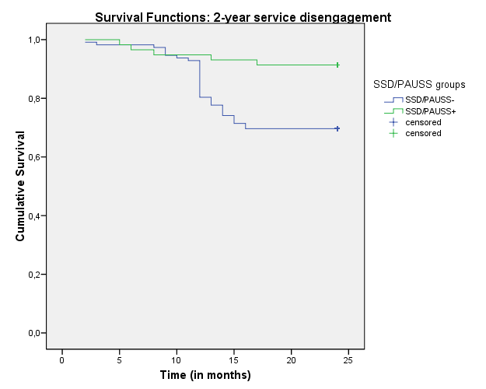

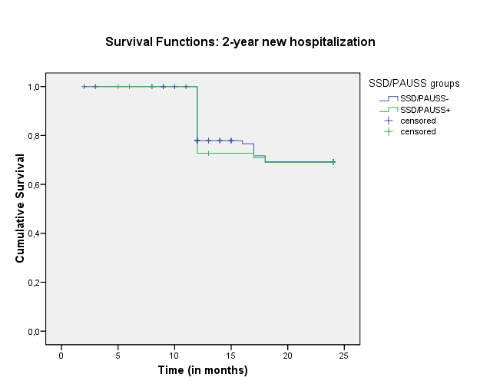

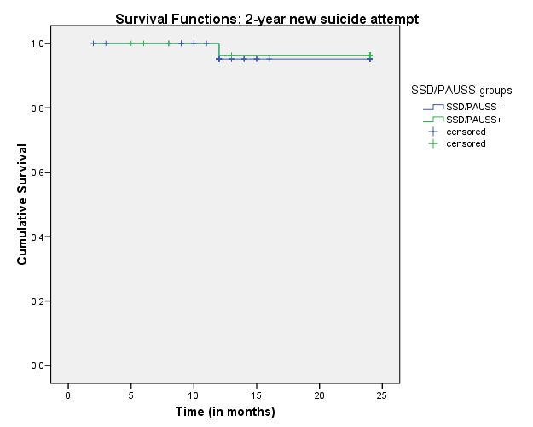

Note. SSD = Schizophrenia Spectrum Disorder; PAUSS = PANSS Autism Severity Scores; SSD/PAUSS+ = SSD patients with PAUSS score of ≥ 30; SSD/PAUSS- = SSD patients without PAUSS score of ≥ 30.

Table S5 - Binary logistic regression analysis results for 2-year not time-to-event outcome variables in the two SSD subgroups.

Dependent variable  (n=158) | FEP/PAUSS-  (n=103) | FEP/PAUSS+  (n=55) | Statistic test
Dependent variable  (n=158) | FEP/PAUSS-  (n=103) | FEP/PAUSS+  (n=55) | B (SE) | HR | 95% CI |  | p
 |  |  |  |  | Lower Higher |  | p
1-year current suicidal ideation  1-year functional recovery  1-year GAF functional remission  1-year HoNOS functional remission  1-year PANSS symptomatic remission | 22 (21.4%)  53 (51.5%)  46 (44.7%)  70 (68.0%)  50 (48.5%) | 17 (30.9%)  25 (45.5%)  24 (43.6%)  34 (61.8%)  6 (10.9%) | -.499 (.378)  .241 (.335)  .042 (.336)  .270 (.349)  2.042 (.475) | .607  .786  1.042  1.310  7.704 | .289  .408  .539  .661  3.035 | 1.274  1.516  2.016  2.595  19.559 | .187  .473  .902  .439  .001
Dependent variable  (n=131) | FEP/PAUSS-  (n=78) | FEP/PAUSS+  (n=53) | Statistic test
Dependent variable  (n=131) | FEP/PAUSS-  (n=78) | FEP/PAUSS+  (n=53) | B (SE) | HR | 95% CI |  | p
 |  |  |  |  | Lower Higher |  | p
2-year current suicidal ideation  2-year functional recovery  2-year GAF functional remission  2-year HoNOS functional remission  2-year PANSS symptomatic remission | 8 (10.3%)  60 (76.9%)  47 (60.3%)  60 (80.8%)  47 (60.3%) | 5 (9.4%)  45 (84.9%)  34 (64.2%)  47 (8.7%)  19 (35.8%) | .093 (.600)  -.523 (.468)  -.166 (.368)  -.623 (520)  .998 (.368) | 1.097  1.687  .847  .536  2.713 | .338  .674  .412  .193  1.318 | 3.557  4.227  1.744  1.486  5.583 | .877  .264  .653  .231  .007

Note. SSD = Schizophrenia Spectrum Disorder; PAUSS = PANSS Autism Severity Scores; SSD/PAUSS+ = SSD patients with PAUSS score of ≥ 30; SSD/PAUSS- = SSD patients without PAUSS score of ≥ 30; GAF = Global Assessment of Functioning; HoNOS = Health of the Nation Outcome Scale; PANSS = Positive And Negative Syndrome Scale; B = regression coefficient, SE = Standard Error; HR = Hazard Ratio; 95% CI = 95% confidence intervals for HR; p = statistical significance. Significant statistical p values are in bold. Cumulative incidence rates are reported.
Current suicidal ideation = BPRS item 4 score of ≥ 2; Functional recovery = return to work/school; GAF functional remission = GAF score of ≥ 60; HoNOS functional remission = HoNOS item 9, 10, and 11 subscores of ≤ 2; PANSS symptomatic remission = PANSS item P1, P2, P3, N1, N4, N6, G5, G9 scores of ≤ 3.

Figure S2 – Profile plots: mixed ANOVA results on psychopathological and outcome parameters across the 2-year follow-up period in the two SSD subgroups.

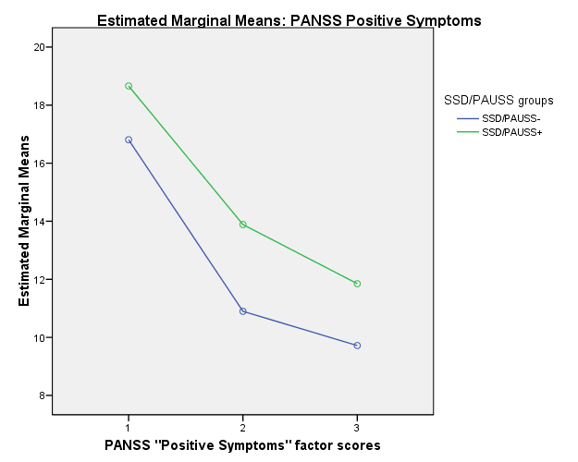

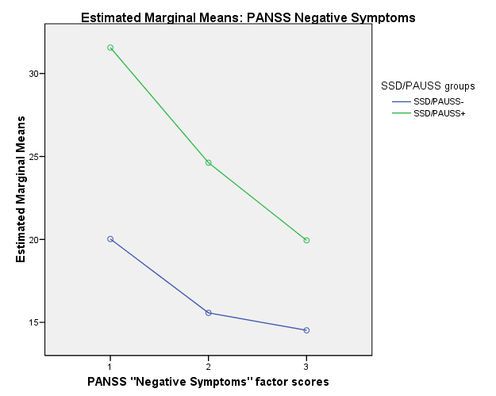

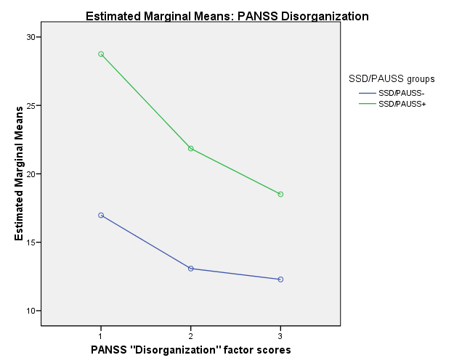

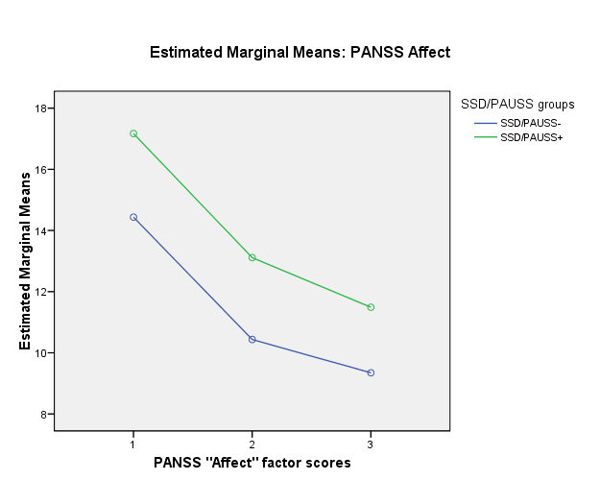

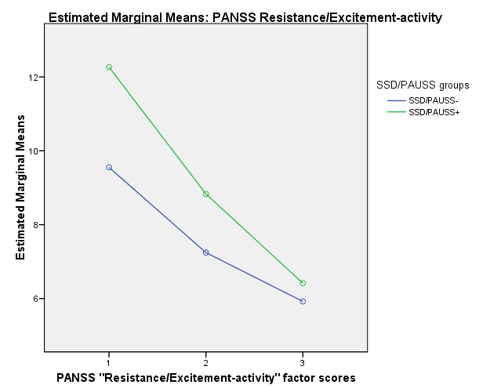

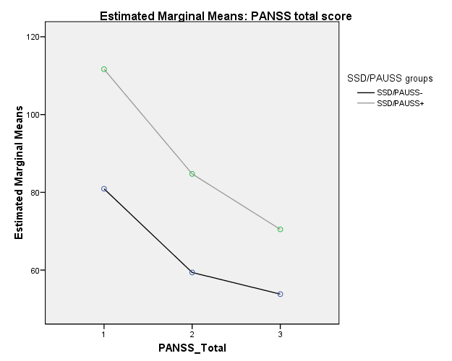

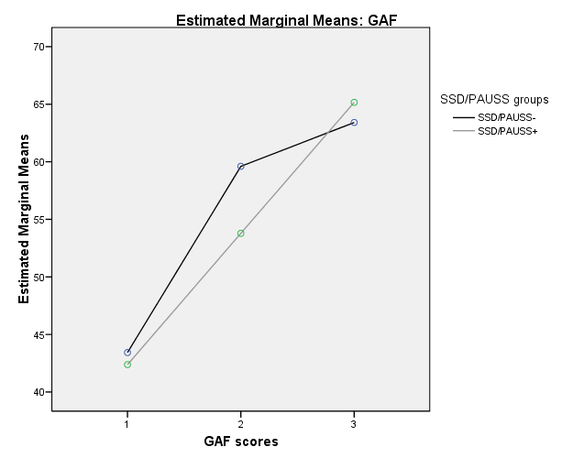

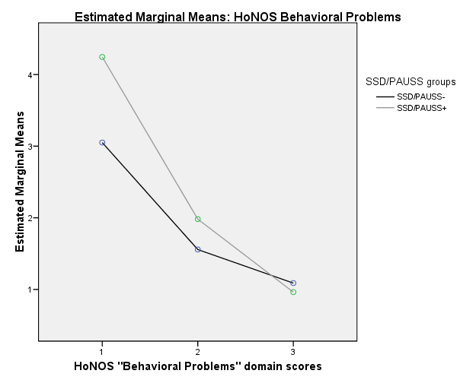

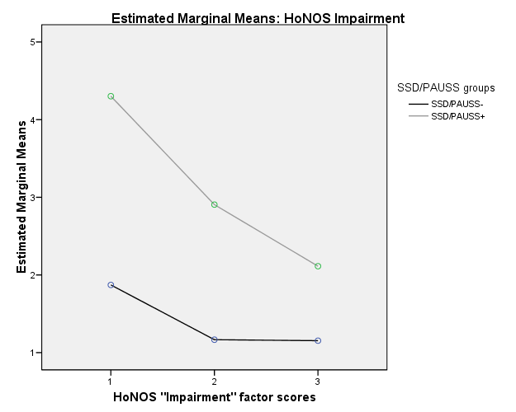

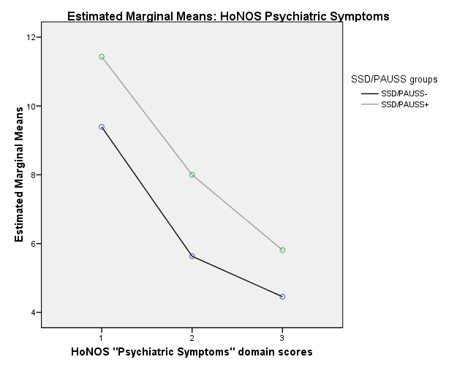

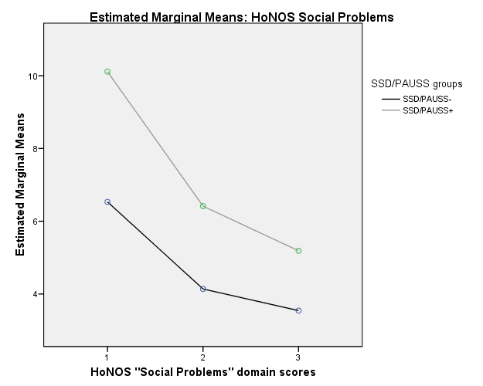

Note - ANOVA = analysis of variance; SSD = Schizophrenia Spectrum Disorder; PANSS = Positive And Negative Syndrome Scale; PAUSS = PANSS Autism Severity Scores; SSD/PAUSS+ = SSD patients with PAUSS score of ≥ 30; SSD/PAUSS- = SSD patients without PAUSS score of ≥ 30; PANSS = Positive And Negative Syndrome Scale; GAF = Global Assessment of Functioning; T0 = baseline assessment; T1 = 1-year assessment time; T2 = 2-year assessment time.

Table S6 – Proportion of observed concordance of SSD/PAUSS+ participants across the 2-year follow-up period: the k statistic.

Variable | T1 SSD/PAUSS+  participants | T2 SSD/PAUSS+  participants
T0 SSD/PAUSS+ participants (n=58) | 19 (34.5%)  k = .330 | 10 (18.9%)  k = .170

Note – PAUSS = PANSS Autism Severity Scores; SSD = Schizophrenia Spectrum Disorder; SSD/PAUSS+ = SSD patients with PAUSS score of ≥ 30; T0 = baseline assessment time; T1 = 1-year assessment time; T2 = 2-year assessment time. Frequencies, percentages, and Cohen’s k values are reported. K values of > .610 are considered as good (Fleiss et al., 2003).

Table S7 – Linear regression analysis results for T0-T2 delta PAUSS score by specialized treatment components of the Pr-EP program in the SSD total group across the 2-year follow-up period.

T0-T2 PAUSS  (n=170) | B | SE | Β | t | p | 95% CI for B  Lower Upper |  | R² = .889  F _{[df = 10]} = 104.807  p = .001
Constant  T0 equivalent dose of risperidone (mg/day)  T1 equivalent dose of risperidone (mg/day)  T2 equivalent dose of risperidone (mg/day)  T2 number of individual psychotherapy sessions  T2 number of family psychoeducation sessions  T2 number of case management sessions  T0-T2 PANSS Disorganization factor score  T0-T2 PANSS Negative symptoms factor score  T0-T2 HoNOS “Cognitive problems” item score  T0-T2 HoNOS “Social Problems” domain score | .853  -.180  -.167  -.099  -.048  .034  .022  .389  .643  1.778  .062 | .713  .115  .143  .128  .022  .036  .009  .071  .057  .291  .094 | -  -.063  -.059  -.036  -.073  .032  .081  .278  .559  .229  .024 | 1.196  -1.565  -1.166  -2.179  -.776  .947  2.490  5.479  11.226  6.116  .664 | .234  .120  .246  .031  .439  .346  .014  .001  .001  .001  ,508 | -.559  -.407  -.450  -.353  -.091  -.037  .005  .248  .529  1.203  -.124 | 2.264  .048  .116  .154  -.004  .105  .040  .529  .756  2.354  .248 | R² = .889  F _{[df = 10]} = 104.807  p = .001

Note – PAUSS = PANSS Autism Severity Scores; SSD = Schizophrenia Spectrum Disorder; SSD/PAUSS+ = SSD patients with PAUSS score of ≥ 30; Pr-EP = Parma Early Psychosis; T0 = baseline assessment time; T2 = 2-year assessment time; PANSS = Positive And Negative Syndrome Scale; HoNOS = Health of the Nation Outcome Scale; B = unstandardized coefficient; SE = Standard Error; β = standardized coefficient; t = t-test value; p = statistical significance; Bonferroni corrected p values are reported; 95% CI = 95% Confidence Interval for B; R² = R-squared or coefficient of determination, F = statistic test value for linear regression analysis. Statistically significant p values are in bold.

