Supplementary information
Alicia Sanz-Royo, Gabriele Terlato, Ana B. Marín-Arroyo

Taxonomic analysis

The faunal assemblage of the Aurignacian Delta level of El Castillo is dominated by carnivores, where dental remains are the most abundant elements. For this reason, their taxonomic assessment is based mainly on dentition. On the contrary, ungulates are scarce, and the representation of appendicular skeleton is higher.

- Order Carnivora Bowdich, 1821

  - Family Ursidae Fischer, 1817

Ursus spelaeus Rosenmuller, 1794

A minimum of 34 individuals have been identified as Ursus spelaeus, based on teeth morphology and size. The diagnostic morphological characters are presented in Supplementary Table 1 and 2, as well as the metric comparison with other brown and cave bears from European Late Pleistocene sites.

Ursus spelaeus | Ursus arctos | El Castillo
M¹
Posterior part wider than the anterior part (3) |  | Posterior part wider than the anterior
Well-developed metastyle and parastyle, generally oriented outwards (3, 5, 6) | Small metastyle and parastyle, generally vertical (1, 2, 3, 4, 5, 6) | Well-developed metastyle and parastyle, generally oriented outwards
Presence of parastyle (1) | Absent or smaller parastyle than U. spealeus (1) | Parastyle always present: small but well-differentiated
Abundant cusps in the  metacone and metaconule area (1) | Absent or scarce cusps in the metacone and metaconule area (1) | Abundant cusps in the  metacone and metaconule area
Metaconule always present (1) | Metaconule normally present, sometimes absent (1) | Presence of metaconule
Lingual cingulum generally well-developed (1, 6) | No cingulum (1, 6) | Lingual cingulum well developed
Subtriangular lingual cusps and  wide transversely (1) | Subtriangular lingual cusps and  narrower than U. spelaeus (1) | Wide and subtriangular lingual cusps
M²
Metacone generally double, sometimes simple (1, 6) | Metacone generally simple (1) | Simple metacone and sometimes double
Marked separation between metaconule and hypocone (1) | Absent or slight separation between metaconule and hypocone (1) | Marked separation between metaconule and hypocone
Generally, complex hypocone (1, 7) | Generally, simple hypocone (1) | Complex hypocone
Supplementary Table 1. Morphological characters for the upper molars of Ursus spelaeus, Ursus arctos and the teeth from El Castillo analyzed in this work. References: 1) Torres Pérez-Hidalgo (1988); 2) Kurtén (1955); 3) García (2003); 4) Crégut-Bonnoure et al. (2011); 5) Argant (1989); 6) Grandal-d'Anglade (1993); 7) Rabal-Garcés (2013).
Ursus spelaeus | Ursus arctos | El Castillo
M₁
Large protoconid (1) | Small and wide protoconid (1) | Protoconid similar to  U. spelaeus
Complex metaconid (1) | Normally, simple metaconid (1) | Complex metaconid (2-3 cusps)
Complex entoconid (≥2 cusps) (1, 6, 7) | Simple entoconid or with a small cusp associated (1) | Complex entoconid
Presence of hypoconulid (1, 6, 7) |  | Presence of hypoconulid
Longitudinal groove of the talonid reaches the posterior edge of the tooth (1) | Longitudinal groove of the talonid does not reach the posterior edge of the tooth (1) | Longitudinal groove of the talonid similar to U. arctos
Normally, presence of cingulum (1, 6) | Without or almost non-existent cingulum (1) | Small cingulum
M₂
Short and robust protoconid, sometimes complex (1, 6) | Simple protoconid (1) | Short and robust protoconid, divided into ≥2 cusps
Complex metaconid, divided into several cusps (1, 6, 7) | Simple metaconid, sometimes double (1) | Complex metaconid, with several cusps
Marked narrowing between trigonid and talonid (1, 2, 6) | Narrowing between trigonid and talonid less marked than in  U. spelaeus (1, 2) | Marked narrowing between trigonid and talonid
Small cusp in the paracone (1) | No cusps in paracone area (1) | Sometimes cusp in the paracone, sometimes flat
Complex entoconid (≥2 cusps)  (1, 3, 4, 6, 7) | Normally, doubled entoconid (3, 5) | Entoconid with 2 or more cusps
Hypoconulid developed with an internal cusp (1,6) | Simple hypoconid: no hypoconulid  or accessory cusps (1) | Complex hypoconid, with hypoconulid and internal cusp
Supplementary Table 2. Diagnostic morphological characters described for the lower molars of Ursus spelaeus, Ursus arctos and the teeth from El Castillo analyzed in this work. References: 1) Torres Perez-Hidalgo (1988); 2) Kurtén (1959); 3) García (2003); 4) Torres et al. (2005); 5) Crégut-Bonnoure et al. (2011); 6) Grandal-d'Anglade (1993); 7) Rabal-Garcés (2013).

The advanced wear of an upper P⁴ has not allowed its morphological description within the upper dentition. Although there are not abundant metric data about this tooth of U. arctos and U. spelaeus in the Iberian Late Pleistocene, the available measurements suggest that the El Castillo specimen is close to U. spelaeus (Supplementary Figure 1). In general, upper molars from El Castillo show a morphology like U. spelaeus (Supplementary Table 1). The M¹ have a prominent cusp in the paracone, with a developed parastyle and metaconule, as cave bears. The cingulum is generally well-developed, sometimes even along the whole lingual surface. Towards the posterior part, there are abundant small cusps, typical of cave bears (Torres Pérez-Hidalgo, 1984), although this is only observed in teeth without marked wear. In the M² we have observed simple metacones. Although this character is more typical of brown bears, this morphology has also been documented in other close cave bear populations, such as those recovered from Ekain (Guipúzcoa) (Torres Pérez-Hidalgo, 1984). Metrically, upper molars are comparable to other Late Pleistocene European cave bears (Supplementary Figure 1). However, three M² of senile individuals show a smaller size, more similar to the brown bear size, probably because of its advanced wear.
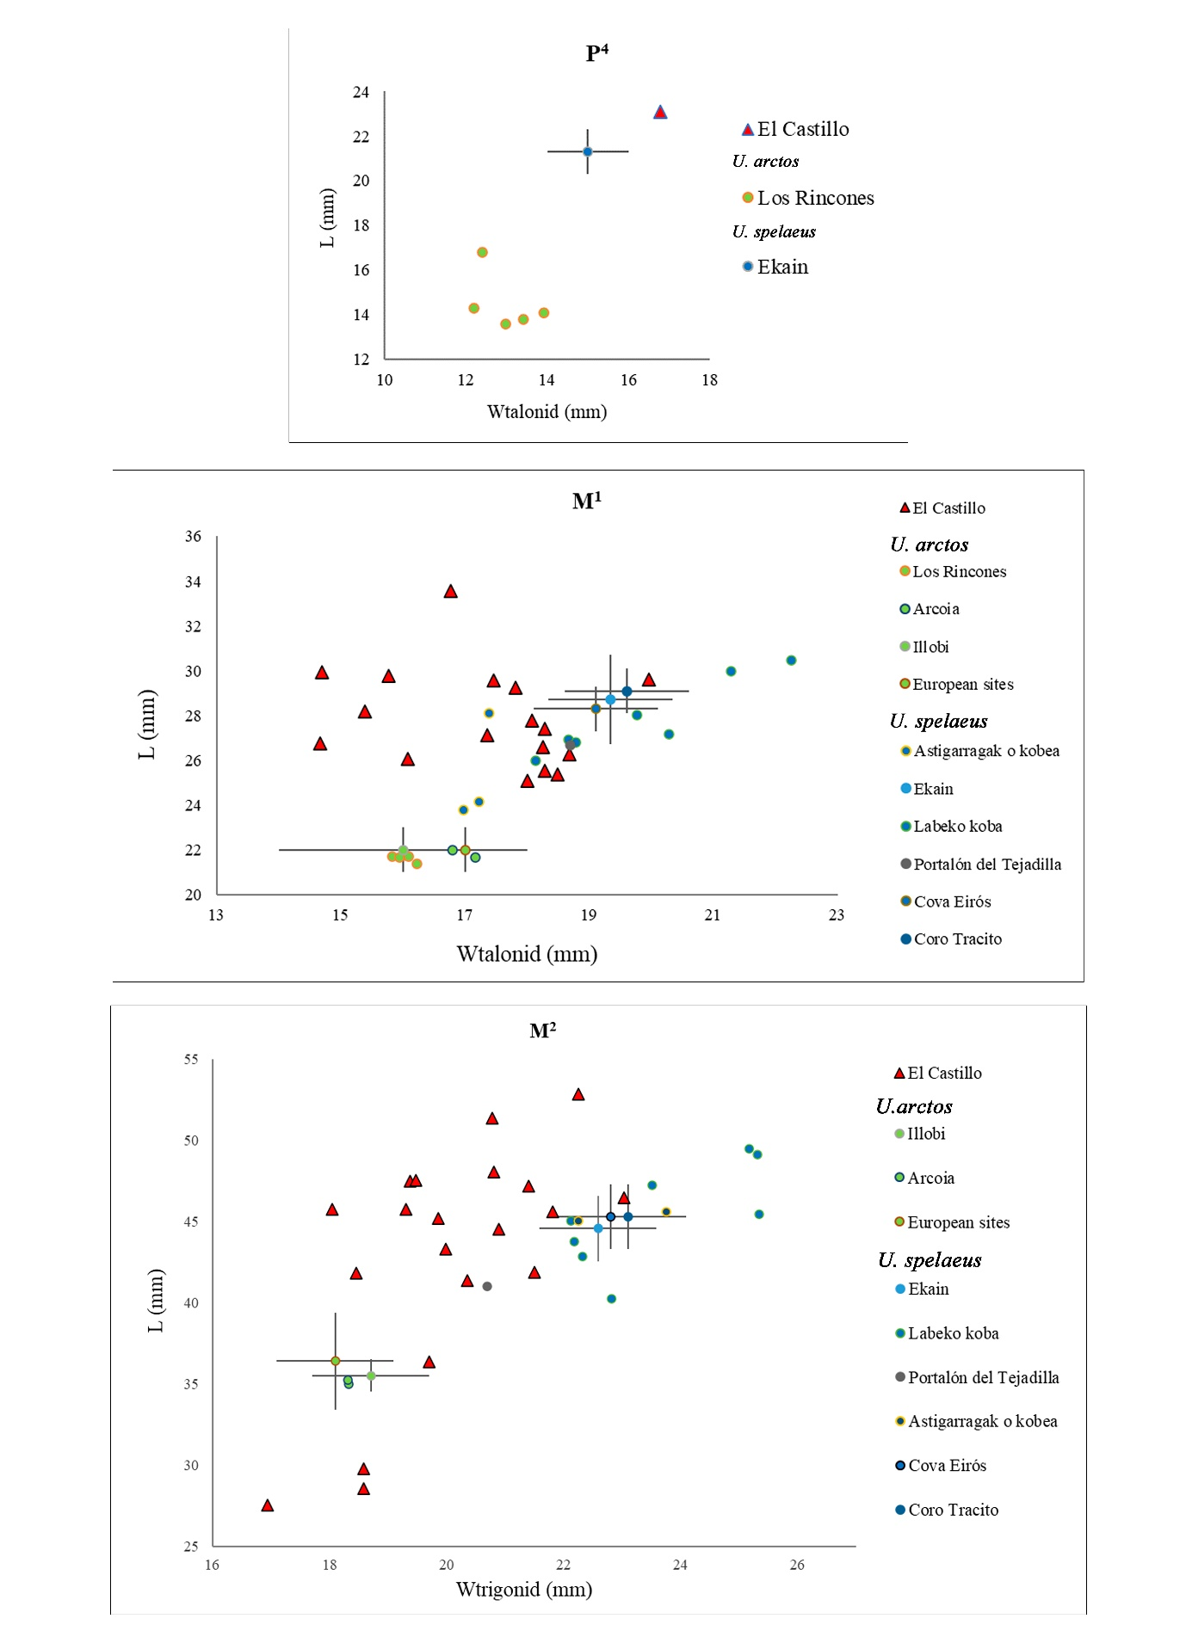
Supplementary Figure 1. Bivariate plots with the length (L) and width (W) of upper ursid teeth from El Castillo compared with European Ursus spelaeus and Ursus arctos from Late Pleistocene (Grandal-d'Anglade, 1993; Rabal-Garcés, 2013; Villaluenga, 2013; Sauqué et al., 2014; García Vázquez, 2015; Sala et al,, 2020; Villalba et al., 2021) (metric raw data in SI3).
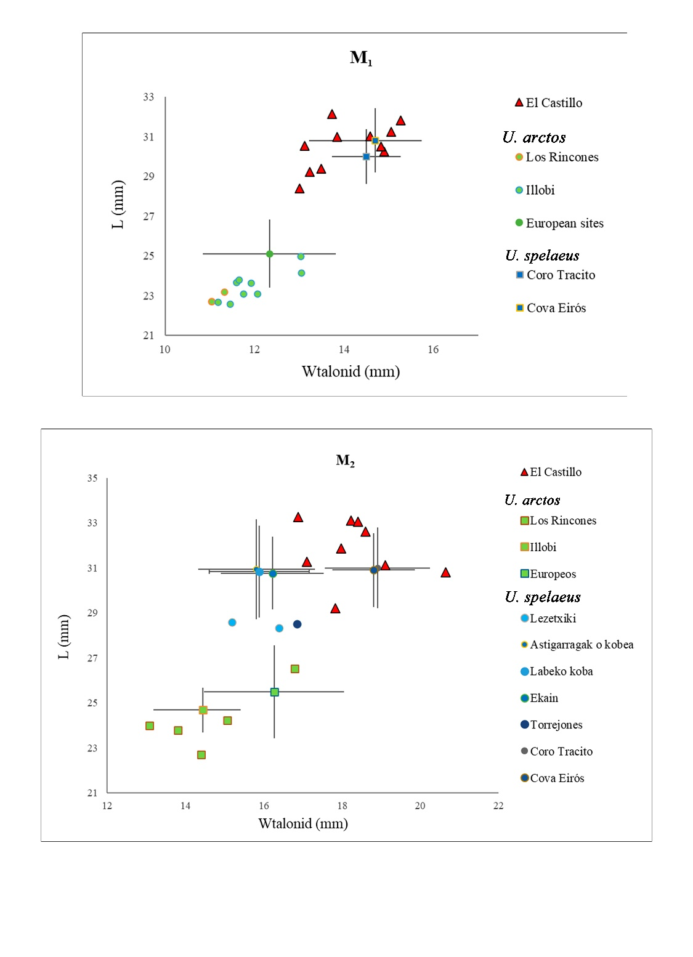
Supplementary Figure 2. Bivariate plots with the length (L) and width (W) of lower ursid molars from El Castillo compared with European Ursus spelaeus and Ursus arctos from Late Pleistocene (Grandal-d'Anglade, 1993; Rabal-Garcés, 2013; Villaluenga, 2013; Sauqué et al., 2014; Sala et al,, 2020; Villalba et al., 2021) (metric raw data in SI3).

In general, the morphology of the lower molars resembles U. spelaeus (Supplementary Table 2). In lower M₁, the protoconid is large, and in teeth without advanced wear stage a cingulum is observed, which has an important development in some specimens, even presenting a small cusp (typical of cave bears). However, in El Castillo, we have not observed that the longitudinal groove of the talonid reaches the posterior edge of the tooth, a common characteristic in this species. In those lower M₂ without marked wear, a small
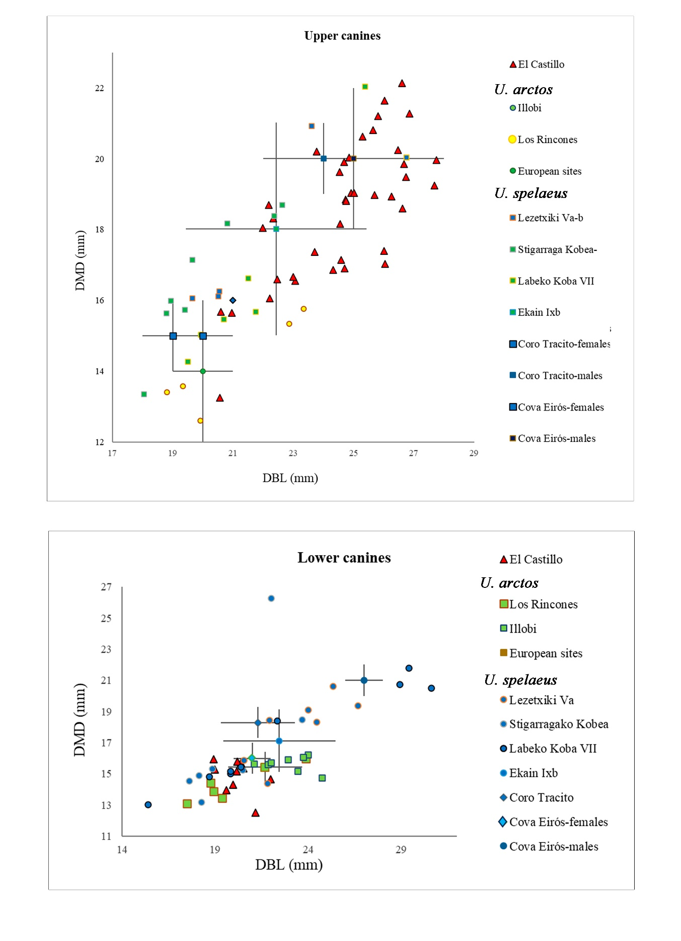
Supplementary Figure 3. Bivariate plots with the mesio-distal diameter (DMD) and bucco-lingual diameter (DBL) of ursid canines from El Castillo compared with European Ursus spelaeus and Ursus arctos from Late Pleistocene (Grandal-d'Anglade, 1993; Rabal-Garcés, 2013; Villaluenga, 2013; Sauqué et al., 2014; Villalba et al., 2021) (metric raw data in SI3).
cusp has been observed in the paracone area, while in U. arctos this area is flatter (Torres Pérez-Hidalgo, 1984). As in U. spelaeus, the protoconid is a robust and triangular cusp, and (except in specimens with marked wear) two or more cusps are frequently observed.
Metrically, these teeth are well-differentiated from other European brown bear populations and are included within the group of U. spelaeus (Supplementary Figure 2).

The morphology of the canines is not commonly used to differentiate between these two species since they hardly show differences. However, metric data can contribute to this differentiation (Supplementary Figure 3). Metrically, upper canines from El Castillo are comparable with the size of U. spelaeus, except for a tooth displaced towards U. arctos size. Nevertheless, this tooth shows an advanced wear that could influence to this fact. Lower canines are also metrically similar to U. spelaeus (Figure 5.4.12). Nevertheless, some specimens appear between the metric ranges of both species. These teeth showed anomalous wear, which could influence these results. This abnormal wear in the bear canines has also been observed in other European sites and is related to the search for some nutritious parts of plants located underground, such as roots and tubers (Ramírez-Pedraza et al., 2022). It must be taken into account that bear canines have significant sexual dimorphism, being larger in males than in females (Koby, 1949; Kurtén, 1955; 1969), so it is also possible that these smaller teeth belong to females.

Regarding the postcranial skeleton, which is notably less represented, the size of the remains also suggests their belonging to the species U. spelaeus.

  - Family Hyaenidae Gray, 1821

Crocuta spelaea Goldfuss, 1823

Although some postcranial elements have been recovered, the presence of this species in El Castillo is based on dental remains, with a minimum of eight individuals. These remains display the typical morphology and size of C. spelaea.

  - Family Canidae Fischer, 1817

Canis lupus Linnaeus, 1758

Three individuals have been identified as wolves based on dental elements. Morphological (Supplementary Table 3) and metrical features (SI4) allow us to assign these dental remains to Canis lupus. The size of lower P₄ and M₁, and one upper canine are well-differentiated to C. alpinus. However, one lower canine is between wolf and cuon, and a second one is closer to C. alpinus size, although this tooth showed advanced wear that could influence its smallest size (Supplementary Figure 4 and 5).

Element | Cuon alpinus | Canis lupus | El Castillo
Lower P₄ | Presence of paraconid (1) | No paraconid (1) | No paraconid
Lower M₁ | Underdeveloped metaconid and narrow talonid (1) | Well-developed metaconid and wide talonid,  with hypoconulid (1) | Well-developed metaconid  and wide talonid
Mandibule | Small diasteme between P₂₋₃ (2) | Normally, large diasteme  between P₂₋₃ (2) | Large diasteme
Mandibule | Middle mental foramen  below P₂ (2) | Middle mental foramen below  the diasteme of P₁₋₂ (2) | Position of middle mental foramen as C. lupus
Mandibule | Posterior mental foramen below the posterior part of P₃ (2) | Posterior mental foramen below the anterior part of P₃ (2) | Position of posterior mental foramen as C. lupus
Humerus | Oblique trochlea towards  its medial side (3) | Upper edge of trochlea kept straight towards its medial end (3) | Trochlea similar to C. lupus
Supplementary Table 3. Morphological characters described to differentiate between Canis lupus and Cuon alpinus. References: 1) Sanchis et al. (2020); 2) Pérez-Ripoll et al. (2010); 3) Pionnier-Capitan et al. (2011).

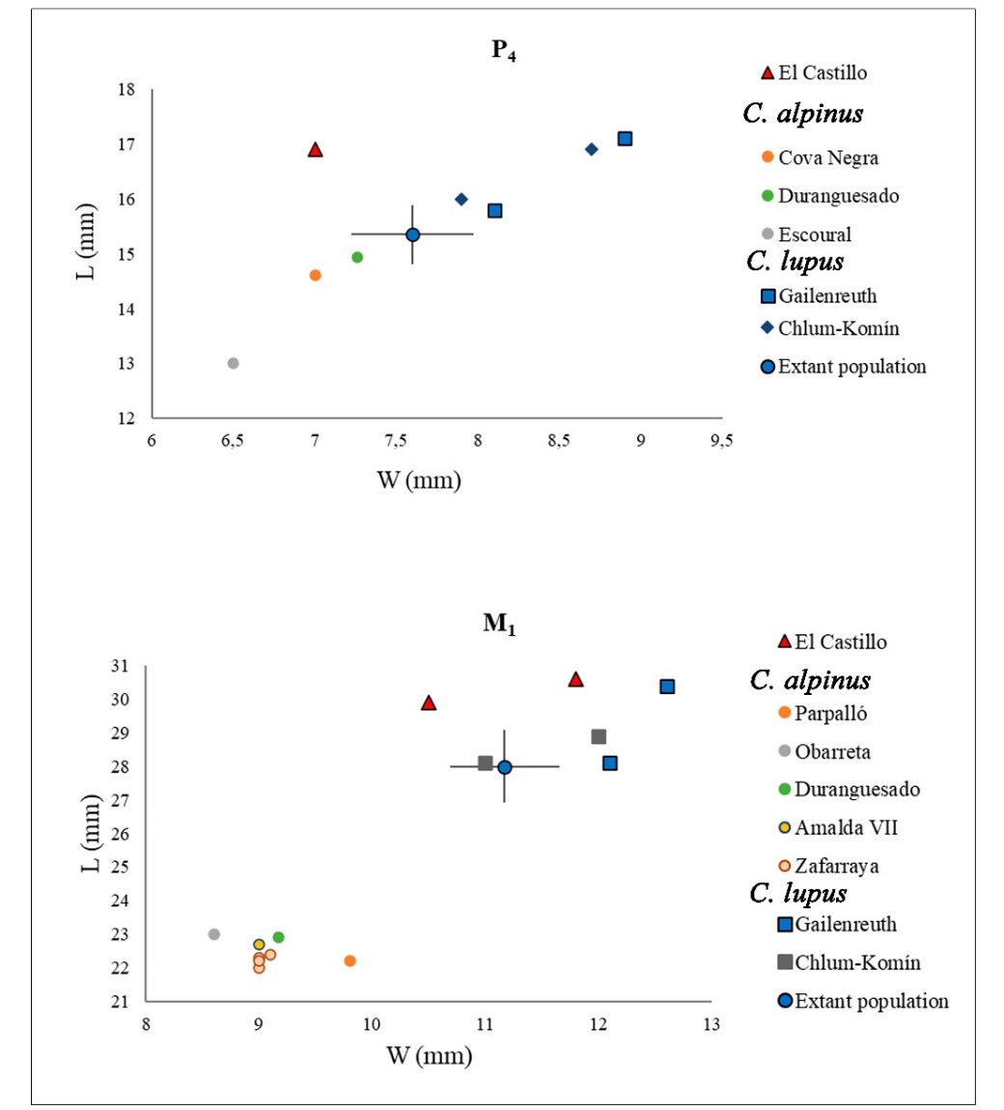
Supplementary Figure 4. Bivariate plots with the length (L) and width (W) of lower P₄ and M₁ of wolves from El Castillo compared with European Canis lupus and Cuon alpinus from Late Pleistocene (Castaños, 1988; Altuna, 1990; Cardoso, 1992; Martínez Valle, 1996; Barroso et al., 2006; Pérez-Ripoll et al., 2010; Baryshnikov, 2015; Sanchis and Villaverde, 2020) (metric raw data in SI4).
Supplementary Figure 5. Bivariate plots with the mesio-distal diameter (DMD) and bucco-lingual diameter (DBL) of wolf canines from El Castillo compared with European Canis lupus and Cuon alpinus from Late Pleistocene (Pérez-Ripoll et al., 2010; Baryshnikov, 2015; Alvarez-Lao et al., 2020; Sanchis and Villaverde, 2020) (metric raw data in SI4).

Vulpes vulpes Linnaeus, 1758

A minimum of three individuals have been identified as Vulpes vulpes. The morphology and size of remains are more compatible with this species than with Vulpes lagopus, which is generally smaller (Boessneck and von der Driesch, 1973; Altuna, 2004;).

  - Family Felidae Fischer, 1817

Panthera pardus Linnaeus, 1758

A minimum of three individuals have been calculated based on dental elements, which show the typical morphology of leopards (Ghezzo and Rook, 2015), similar to those recovered at Los Rincones site (Zaragoza) (Sauqué and Cuenca-Bescós, 2013). Furthermore, metrically, the teeth are within the group of leopards, clearly separated from the larger cave lion (Supplementary Figure 6 and 7).

Supplementary Figure 6. Bivariate plots with the mesio-distal diameter (DMD), and bucco-lingual diameter (DBL) of leopard canines from El Castillo compared with Iberian Panthera pardus and Panthera spelaea from Late Pleistocene (Cáceres et al., 1993; Barroso et al., 2006; Sauqué and Cuenca-Bescós, 2013; Sanchis et al., 2015; Alvarez-Lao et al., 2020) (metric raw data in SI5).

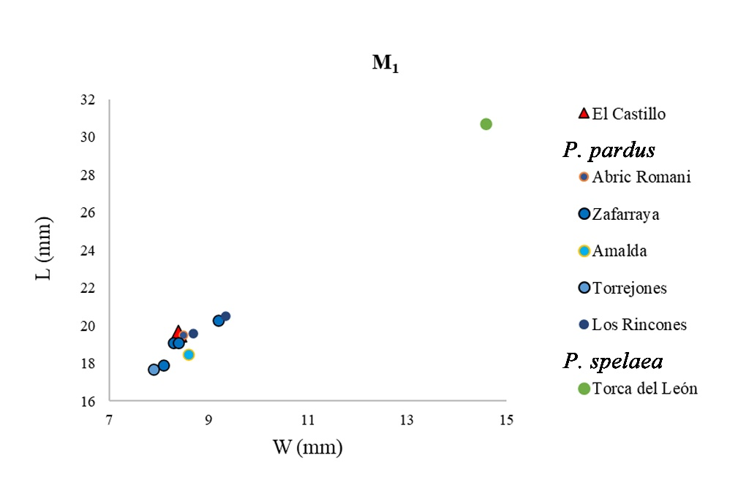
Supplementary Figure 7. Bivariate plot with the length (L) and width (W) of lower M₁ of leopard from El Castillo compared with Iberian Panthera pardus and Panthera spelaea from Late Pleistocene (Cáceres et al., 1993; Barroso et al., 2006; Sauqué and Cuenca-Bescós, 2013; Sauqué et al., 2014; Sanchis et al., 2015; Alvarez-Lao et al., 2020; Sala et al., 2021) (metric raw data in SI5).

Panthera cf. spelaea Goldfuss, 1810

A lower P₃₋₄ shows the typical morphology of a large felid and has a large size, clearly separated from leopards and close to a cave lion from a close paleontological site (Supplementary Figure 8). Therefore, this specimen has been proposed as Panthera cf. spelaea, a species not previously identified at this level by Castaños (2018)

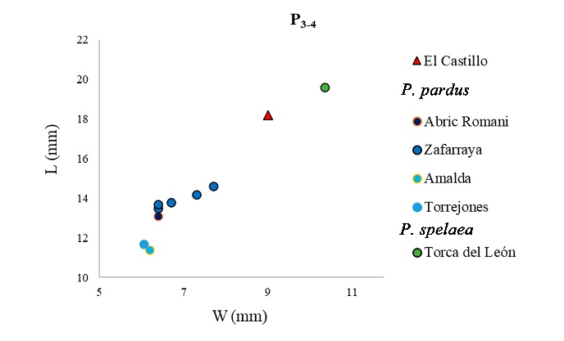
Supplementary Figure 8. Bivariate plot with the length (L) and width (W) of lower P₃₋₄ of Panthera cf. spelaea from El Castillo compared with Iberian Panthera pardus and Panthera spelaea from Late Pleistocene (Cáceres et al., 1993; Barroso et al., 2006; Sanchis et al., 2015; Alvarez-Lao et al., 2020; Sala et al., 2021) (metric raw data in SI6).
- Order Artiodactyla Owen, 1848

  - Family Bovidae Gray, 1821

Bos primigenius Bojanus, 1825 and Bison priscus Bojanus, 1825

Distinguishing between the genus Bos and Bison is sometimes not easy because the anatomical differences among bovines are limited and the metric data usually might have a substantial overlap. In this work, it has been possible to identify the species Bos primigenius from the distal epiphysis of a tibia. Although the measurements taken in the epiphysis do not contribute to the differentiation between Bos and Bison (Supplementary Figure 9), the morphology is diagnostic. This specimen has the two articular facets for the malleolus together, typical of Bos primigenius, while in Bison priscus, they appear separated and isolated (Buitrago, 1992; Gee, 1993; Sala et al., 2010). The remains recovered in El Castillo could not be identified to species level, being grouped as Bos/Bison sp.

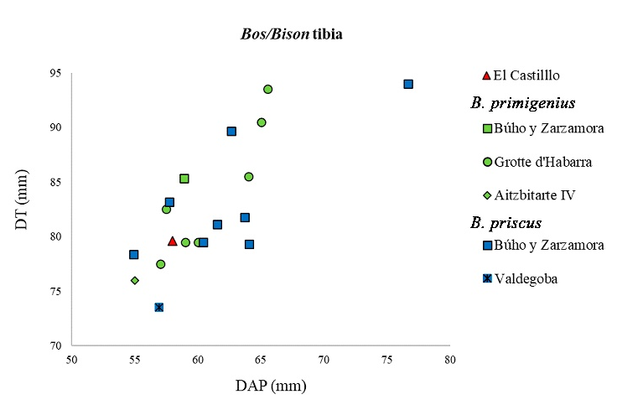
Supplementary Figure 9. Bivariate plot with the transversal diameter (DT) and antero-posterior diameter (DAP) of the distal epiphysis of Bos primigineus tibia from El Castillo compared with Spanish and European Bos primigineus and Bison priscus from Late Pleistocene (Prat et al., 2003; Sala et al., 2010; Arceredillo et al., 2016) (metric raw data in SI7).

Rupicapra rupicapra Linnaeus, 1758

One individual of R. rupicapra has been identified at El Castillo, which is only represented by the postcranial skeleton.

  - Family Cervidae Goldfuss, 1820

Cervus elaphus Linnaeus, 1758

A minimum of four individuals of C. elaphus have been identified. Following the morphological criteria for distinguishing between Cervus and Dama (Lister, 1996) and considering that fallow deer has not been documented in the Cantabrian region during this period, the presence of Dama dama in El Castillo has been ruled out. Although the presence of reindeer has been documented in some sites in Northern Iberia, neither the morphology nor the size of the specimens studied suggest their presence in El Castillo.

  - Family Suidae Gray, 1821

Sus scrofa Linnaeus, 1758

The sample comprises only two teeth, which show a typical morphology and size of S. scrofa.

- Order Perissodactyla Owen, 1848

  - Family Equidae Gray, 1821
Equus ferus Linnaeus, 1758

Generally, the differentiation between Equus ferus and Equus hydruntinus is defined by a combination of metric (typically, E. hydruntinus is smaller than E. ferus) and morphological criteria. However, this differentiation is complicated and controversial due to the high morphometric variability between species and an overlap in the measurements. The equid remains of El Castillo are large in size and show a morphology associated with the caballine line (Eisenmann et al., 1988; Sanz-Royo et al., 2020). In addition, a third phalanx has been compared with the one recovered at Los Rincones sites, belonging to an E. hydruntinus, and it has been concluded that the El Castillo specimen is more similar to E. ferus. This, together with the absence (to date) of E. hydruntinus in the Cantabrian region, suggests that the equid remains from El Castillo correspond to E. ferus.

References

Altuna, J. 1972. Fauna de mamíferos de los yacimientos prehistóricos de Guipúzcoa. Con catálogo de los mamíferos cuaternarios del Cantábrico y del Pirineo occidental. Munibe, 1-464.
Altuna, J. 1990. Caza y alimentación procedente de macromamíferos durante el Paleolítico de Amalda. In: Altuna, J., Baldeón, A., Mariezkurrena, K. La Cueva de Amalda (Zestoa, País Vasco): Ocupaciones paleolíticas y postpaleolíticas, Colección Barandiarán 4, 149-192.
Altuna, J. 2004. Estudio biométrico de Vulpes vulpes y Alopex lagopus. Contribución a su diferenciación en los yacimientos paleolíticos cantábricos. Munibe 56, 45-59.
Altuna, J. 2004. Estudio biométrico de Vulpes vulpes y Alopex lagopus. Contribución a su diferenciación en los yacimientos paleolíticos cantábricos. Munibe 56, 45-59.
Álvarez-Lao, D., Álvarez-Vena, A., Ballesteros, D., García, N., Laplana, C. 2020. A cave lion (Panthera spelaea) skeleton from Torca del León (NW Iberia): Micromammals indicate a temperate and forest environment corresponding to GI-11 (MIS 3). Quaternary Science Reviews 229, 106123.
Arceredillo, D. 2016. Análisis paleobiológico de los ungulados del Pleistoceno superior de Castilla y León (España). BAR International Series.
Argant, A. 1989. Carnivores quaternaires de Bourgogne. Diplôme de Doctorat presente devant l’Université Claude Bernard, Lyon 1.
Barroso, C., Riquelme, J.A., Moigne, A.M., Banes, L. 2006. Les faunes de grands mammifères du Pléistocène supérieur de la Grotte du Boquete de Zafarraya. Étude Paléontologique, Paléoécologique et Archéozoologique. In: Barroso, C., de Lumley, H., (ed). La grotte du Boquete de Zafarraya, Málaga, Andalousie, Sevilla, 675-891.
Baryshnikov, G.F. 2015. Late Pleistocene Canidae remains from Geographical Society Cave in the Russian Far East. Russian J. Theriol. 14 (1), 65-83.
Boessneck, J., von der Driesch, A. 1973. Die jungpleistozanen Tierknochenfunde aus der Brillenhohle. In: Riek, G. (Ed.), Das Palaolithikum der Brillenhohle bei Blaubeuren (Schwabische Alb). Müller & Graff, Stuttgart.
Buitrago, A.M. 1992. Estudio de los Artiodáctilos del yacimiento del Pleistoceno medio de Pinilla del Valle (Madrid), Departamento de Biología Animal. Universidad Complutense de Madrid, Madrid.
Cáceres, I., Canyelles, J., Esteban, M., Giralt, S., Gonzalez, F., Huguet, R., Ibañez, N., Lorenzo, C., Mata, M., Pinto, A., Revilla, A., Rosell, J., Santiago, A., Segura, E., Vallverdú, J., Zaragoza, J. 1993. Estudi d'un exemplar de Panthera pardus i un de Panthera leo spelaea localitzats a l'Abric Romaní (Capellades, Anoia) i analisi de la problematica dels carnívors en aquest jaciment. Estrat. 6, 31-41.
Cardoso, J.L. 1992. Cuon alpinus europaeus dans le Pléistocène du Portugal. Ciências da Terra (UNL) 11, 11-76.
Castaños, P.M. 1988. Mamíferos prehistóricos de Vizcaya. Caja de Ahorros Vizcaina, Bilbao.
Castaños, P.M. 2018. El Castillo: historia de una fauna olvidada. La fauna de las excavaciones históricas (1910-1914) de la cueva de El Castillo (Puente Viesgo, Cantabria). Santander. In: Monografías del Museo de Prehistoria y Arqueología de Cantabria (1).
Crégut-Bonnoure, E., Slimak, L., Lewis, J.E., Brochier, J.E. 2011. Nouvelles données sur les sites pléistocènes et holocènes è Ursus arctos du Vaucluse (Sud-Est de la France). Quaternaire Hors-Série 4, 147–183.
Eisenmann, V., Alberdi, M. T., De Giuli, C., Staesche, C. 1988. Collected papers after the “New York International Hipparion Conference, 1981”. In: Woodburne, M., Sondaar, P. (Eds.), Studying fossil horses. 1 Methodology, 1-7.
García, N. 2003. Osos y otros carnívoros de la Sierra de Atapuerca. Fundación Oso de Asturias, 575.
García Vázquez, A. 2015. Caracterización del oso pardo (Ursus arctos L.) fósil en el NW de la Península Ibérica: datos morfométricosy moleculares. PhD. Universidade da Coruña
Gee, H. 1993. The distinction between postcranial bones of Bos primigenius Bojanus, 1827 and Bison priscus Bojanus, 1827 from the British Pleistocene and the taxonomic status of Bos and Bison. J. Quat. Sci. 8, 79-92.
Ghezzo, E., Rook, L. 2015. The remarkable Panthera pardus (Felidae, Mammalia) record from Equi (Massa, Italy): Taphonomy, morphology, and paleoecology. Quaternary Science Reviews 110, 131-151. doi:10.1016/j.quascirev.2014.12.0.
Grandal-d’Anglade, A. 1993. El Oso de las Cavernas en Galicia: el yacimiento de Cova Eirós. O Castro: Laboratorio Xeoloxico de Laxe, pp. 285. A Coruña.
Kurtén, B. 1955. Sex dimorphism and size trends in the Cave Bear. Acta Zoologica Fennica 90, 1-47.
Kurtén, B. 1969. Sexual dimorphism in fossil mammals. In: Westerman, G.E.G. (Ed.), Sexual Dimorphism in Fossil Metazoa and Taxonomic Implications. E. Schweizerbart’sche Verlagsbuchhandlung, Stuttgart, pp. 226-233.
Lister, A.M. 1996. The morphological distinction between bones and teeth of Fallow Deer (Dama dama) and red deer (Cervus elaphus). Int. J. Osteoarchaeol. 6, 119-143.
Martínez Valle, R. 1996. Fauna del Pleistoceno superior en el País Valenciano: aspectos económicos, huella de manipulación y valoración paleoambiental. PhD. Universitat de Valencia.
Pérez-Ripoll, M.P., Morales Pérez, J. V., Sanchis Serra, A., Aura Tortosa, J.E., Sarrión Montañana, I. 2010. Presence of the genus Cuon in upper Pleistocene and initial Holocene sites of the Iberian Peninsula: new remains identified in archaeological contexts of the Mediterranean region. Journal of Archaeological Science 37, 437-450. doi:10.1016/j.jas.2009.10.008.
Pionnier-Capitan, M., Bemilli, C., Bodu, P., Célérier, G., Ferrié, J.G., Fosse, P., Garcià, M., Vigne, J.D. 2011. New evidence for Upper Palaeolithic small domestic dogs in South-Western Europe. Journal of Archaeological Science 38, 2123-2140. doi:10.1016/j.jas.2011.02.028.
Prat, F., Delpech, F., Cancel, N., Guadelli, J.-L., Slott-Moller, R. 2003. Le Bison des steppes, Bison priscus Bojanus, 1827, de la grotte d'Habarra à Arudy (Pyrénées-Atlantiques). Paléo, Revue d'Archéologie Préhistorique 15 - Cahier spécial, 1-102.
Rabal-Garcés, R. 2013. Estudio paleontológico de Ursus spelaeus rosenmuller, 1794 del Pleistoceno superior de Coro Tracito (Tella, Huesca, España). PhD. Universidad de Zaragoza.
Ramírez-Pedraza, I., Baryshnikov, G.F., Prilepskaya, N.E., Belyaev, R.I., Pappa, S., Rivals, F. 2022. Paleodiet and niche partitioning among the easternmost European cave bears based on tooth wear analysis. Historical Biology 34, 1063-1071. doi:10.1080/08912963.2021.1960324.
Sala, N., Pantoja, A., Arsuaga, J.L., Alagaba, M. 2010. Presencia de bisonte (Bison priscus Bojanus, 1827) y uro (Bos primigenius, Bojanus, 1827) en las cuevas del Búho y de la Zarzamora. Munibe (Antropología-Arkeología) 61, 43-55.
Sala, N., Pablos, A., Gómez-Olivencia, A., Sanz, A., Villalba, M., Pantoja-Pérez, A., Laplana, C., Arsuaga, J.L., Algaba, M. 2020. Central Iberia in the middle MIS 3. Paleoecological inferences during the period 34–40 cal kyr BP. Quaternary Science Reviews 228.
Sala, N., Pablos, A., Rodríguez-Hidalgo, A., Arriolabengoa, M., Alcaraz-Castaño, M., Cubas, M., Posth, C., Nägele, K., Pantoja-Pérez, A., Arlegi, M., Rodríguez-Almagro, M., Conde-Valverde, M., Cuenca-Bescós, G., Arribas,A., Gómez-Olivencia,A. 2021. Cueva de los Torrejones revisited. New insights on the paleoecology of inland Iberia during the Late Pleistocene. Quaternary Science Reviews 253, 106765.
Sanchis, A., Gómez-Olivencia, A., Real, C., Pérez, L., Duarte, E., de la Rasilla, M., Fernández Peris, J., Villaverde, V., Pérez Ripoll, M. 2020. Pleistocene dhole (genus Cuon) populations from the Iberian Peninsula: morphometry, taxonomy and evolution. Relations hommes – canidés de la Préhistoire aux périodes modernes, 141-158. doi:10.46608/dana3.9782381490120.9.
Sanchis, A., Tormo, C., Sauqué, V., Sanchis, V., Díaz, R., Ribera, A., Villaverde, V. 2015. Pleistocene leopards in the Iberian Peninsula: New evidence from palaeontological and archaeological contexts in the Mediterranean region. Quaternary Science Reviews 124, 175-208
Sanchis, A., Villaverde, V. 2020. Restos postcraneales de Cuon en el Pleistoceno superior (MIS 3) de la Cova de les Malladetes (Barx, Valencia). In: Homenaje al Profesor Manuel Pérez Ripoll. Sagvntvm-Extra 21.
Sanz-Royo, A., Sanz, M., Daura, J. 2020. Upper Pleistocene equids from Terrasses de la Riera dels Canyars (NE Iberian Peninsula): The presence of Equus ferus and Equus hydruntinus based on dental criteria and their implications for palaeontological identification and palaeoenvironmental reconstruction. Quaternary International 566-567, 78-90. doi:10.1016/j.quaint.2020.06.026.
Sauqué, V., Cuenca-Bescos, G. 2013. The Iberian Peninsula, the last European refugium of Panthera pardus LINNAEUS 1758 during the Upper Pleistocene. Quaternaire 24 (1), 35-48.
Sauqué, V., Rabal-Garcés, R., Cuenca-Bescós, G. 2014. Carnivores from Los Rincones, a leopard den in the highest mountain of the Iberianrange (Moncayo, Zaragoza, Spain). Hist. Biol.
Torres Pérez-Hidalgo, T. 1984. Ursidos del Pleistoceno-Holoceno de la Península Ibérica. Ph.D. thesis. Universidad Politécnica de Madrid, 653 pp.
Torres Pérez-Hidalgo, T. 1988. Osos (Mammalia, Carnivora, Ursidae) del Pleistoceno de la Península Ibérica. Boletín Geológico y Minero de España, publicación especial 99, 1-314.
Villalba de Alvarado, M., Collado Giraldo, H., Arsuaga, J.L., Bello Rodrigo, J.R., van Heteren, A.H., Gómez-Olivencia, A. 2021. Looking for the earliest evidence of Ursus arctos Linnaeus, 1758 in the Iberian Peninsula: the Middle Pleistocene site of Postes cave. Boreas.
Villaluenga, A. 2013. La evaluación de los úrsidos en medioskársticos de la Cornisa Cantábrica. Estudio tafonómico de conjuntosarqueológicos y paleontológicos del Pleistoceno superior y Holoceno. España. PhD. University of Vasque Country, pp. 921.

