Supporting Information
Fully Passive Electrochemical Oxygen Sensor Enabled with Organic Electrochemical Transistor

Lia Giulia D’Amico‡, Chenhong Zhang‡, Francesco Decataldo, Vito Vurro, Marta Tessarolo, Isacco Gualandi, Federica Mariani, Erika Scavetta, Tobias Cramer* and Beatrice Fraboni

Table S1. OECT geometries. Geometry of the macroscopic and microscopic OECTs: channel width (W) and length (L), gate side ($l_{G}$), distance between gate and channel (d) and width of the gold pads ($W_{Au}$).
Geometry | W (µm) | L (µm) | $l_{G}$ (mm) | d (mm) | $W_{Au}$ (mm)
Macroscopic | 2000 | 2000 | 9 | 1 | 3
Microscopic | 100 | 50 | 0.45 | 1 | 0.6

Appendix S1: Calibration of the PEDOT:PSS-based Organic Electrochemical Transistor for oxygen sensing.
The optimization of sensor performance relies on ensuring that calibration data is extracted under conditions that minimize device drift and hysteresis. Figure S1a presents three trans-characteristic curves of the same device used in the calibration experiment of Figure 1f, acquired in air. Despite some hysteresis between the forward and backward sweeps, the sequence demonstrates stable I(V) scans. However, current drift under constant bias is a well-documented issue in PEDOT:PSS-based devices. To minimize current drift and bias stress effects, calibration points are derived from pulsed experiments. The time-transient response under pulsed conditions is more stable than continuous I(V) scans due to the reduced DC stress. This approach also exploits the higher oxygen sensitivity of de-doped PEDOT:PSS when a pulsed gate bias of V_{G} = 0.8 V is applied.
The experimental procedure involves stabilizing the oxygen concentration in the chamber and applying 40 sequences of five gate pulses each. Figure S1b demonstrates the excellent overlap of transient responses at a given oxygen concentration, confirming the sensor's reliability and reproducibility in distinguishing varying oxygen levels.
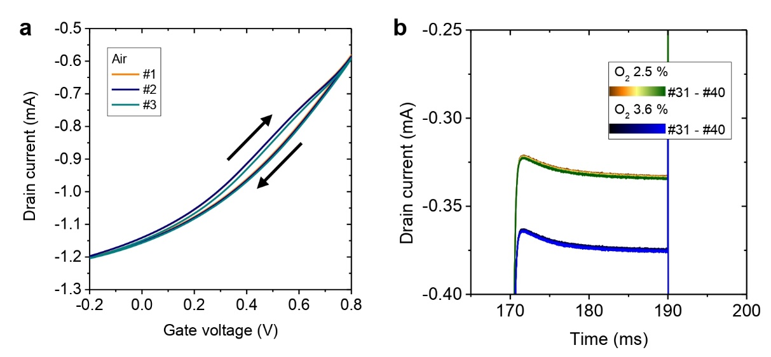
Figure S1. Electrical response of the PEDOT:PSS-based Organic Electrochemical Transistor shown in Figure 1f (“air” conditions, oxygen concentration 21 %): (a) Transfer characteristics measured at a constant drain voltage (V_{D} = -0.3 V); (b) Zoomed-in view of the final pulse in each sequence.

Appendix S2: Evaluation of thermal and shot noise.
Shot noise is due to the discrete nature of electronic charges and is quantified by: $σ_{shot}=\sqrt{2e|I|Δf}$. Here the maximum current flowing in the OECT is approximately 1 mA and the bandwidth is 100 Hz. Therefore, we estimate the shot noise as $σ_{shot,max}≈0.6$ nA. The power spectral density as $S_{shot}=2e|I|=3.2×{10}^{-22}A^{2}Hz^{-1}$.
Thermal current noise is evaluated as $σ_{thermal}=\sqrt{4k_{B}TΔf/R}$ . Measuring resistances in the range of 1 kΩ with bandwidth of 100 Hz at room temperature we estimate $σ_{thermal,max}≈0.04$ nA. The maximum power spectral density $S_{thermal}=4k_{B}T/R=1.7×{10}^{-23}A^{2}Hz^{-1}$.
The previous calculations show that in most cases, these errors can be neglected in comparison with the sampling error for OECTs.

Appendix S3: Model for the OECT energy consumption.
Consider a voltage pulse applied at time t=0 to the gate of an OECT. If a constant negative voltage is applied between the drain and source (V_{D} < 0), the current in the channel changes exponentially from I_{i} to I_{s}. The transient curve for t > 0 of the drain current is described by the following expression:
$I_{D}\left(t\right)= I_{s}\left(V_{G}\right)+ΔI\left(1-f\frac{τ_{e}}{τ_{RC}}\right)e^{-t/τ_{RC}}\underset{→}{τ_{e}≪τ_{RC}} I_{s}+ΔIe^{-t/τ_{RC}}$ (1)
in which τ_{RC} denotes the characteristic RC time constant describing the ionic transport into the channel, $τ_{e}$ the characteristic time constant describing the electronic transport into the channel, I_{s} the saturation current, I_{i} the drain current at V_{G}=0 V and ${(I}_{s}-I_{i})=ΔI$. In PEDOT:PSS OECT device, ionic transport is much slower than electronic transport and from now τ_{RC} will be denoted by τ only for simplicity.
The average current measured during the sampling interval t_{s} is:
$$\overline{I_{D}}\left(t_{s}\right)=\frac{1}{t_{s}}\int_{0}^{t_{s}}{I_{D}\left(t\right)⋅dt=}\frac{1}{t_{s}}\int_{0}^{t_{s}}{I_{s}+ΔIe^{-\frac{t}{τ_{RC}}}⋅dt}$$
$=I_{s}+\frac{1}{t_{s}}ΔI\int_{0}^{t_{s}}{e^{-t/τ}}dt=I_{s}+\frac{ΔI}{t_{s}}(-τe^{-t_{s}/τ}+τ)=I_{s}\left(V_{G}\right)+ΔI\left.\frac{τ}{t_{s}}\right.\left(1-e^{-t_{s}/ τ}\right)$ (2)
Defining the measurements error as $σ_{s}\left(t_{s}\right)=I_{s}-\overline{I_{D}}\left(t_{s}\right)$ we obtain:
$σ_{s}\left(t_{s}\right)=I_{s}-\overline{I_{D}}\left(t_{s}\right)=\left|-ΔI⋅\frac{τ}{t_{s}}\left(1-e^{-\frac{t_{s}}{τ}}\right)\right|$ (3)
Next, we consider the energy U consumed in a single sensor readout. The most significant contribution comes from Joule heating occurring due to the current flow through the OECT channel. From the transient OECT current we obtain:
$U\left(t_{s}\right)=\int_{0}^{t_{s}}{P(t)⋅dt}=\int_{0}^{t_{s}}{I_{D}\left(t\right)V_{D}⋅dt}=V_{D}\int_{0}^{t_{s}}{\left(I_{s}+ΔIe^{-t/τ}\right)dt}= V_{D}\left(I_{s}t_{s}+ΔI(τ-τe^{-t_{s}/τ}\right)=V_{D}\left[I_{s}t_{s}+ΔIτ\left(1-e^{-\frac{t_{s}}{τ}}\right)\right]$ (4)
Now we combine Equation 3 and 4 to remove the dependence from the parameter t_{s}:
$$\left\{\begin{aligned}σ_{s}\left(t_{s}\right)=\frac{ΔI∙τ}{t_{s}}\left(1-e^{-t_{s}/τ}\right) \\ U\left(t_{s}\right){=V}_{D}\left[I_{s}t_{s}+ΔIτ\left(1-e^{-\frac{t_{s}}{τ}}\right)\right]\end{aligned}\right.$$
U(t_{s}) can be inverted using the Lambert W function. Convert U(t_{s}) in a form $f\left(t_{s},U\right)e^{f\left(t_{s},U\right)}=w → f\left(t_{s},U\right)=W\left(w\right)$. We rearrange Equation 4:
$$U=V⋅I⋅t_{s}+V⋅ΔI⋅τ⋅- V⋅ΔI⋅τ⋅\left(e^{-ts/τ}\right)$$
$$V⋅ΔI⋅τ⋅e^{-ts/τ}=V⋅I⋅t_{s}+V⋅ΔI⋅τ-U$$
We multiply and divide by $e^{ts/τ}$ and $V⋅I⋅τ$, respectively:
$$\frac{V⋅ΔI⋅τ}{V⋅I⋅τ}=e^{ts/τ}\left(\frac{V⋅I⋅t_{s}+V⋅ΔI⋅τ-U}{V⋅I⋅τ}\right)$$
$$\frac{ΔI}{I}=e^{ts/τ}\left(\frac{t_{s}}{τ}+\frac{ΔI}{I}-\frac{U}{V⋅I⋅τ}\right)$$
We multiply by $exp\left(\frac{ΔI}{I}-\frac{U}{V⋅I⋅τ}\right)$:
$$\frac{ΔI}{I}⋅exp\left(\frac{ΔI}{I}-\frac{U}{V⋅I⋅τ}\right)=\left(\frac{t_{s}}{τ}+\frac{ΔI}{I}-\frac{U}{V⋅I⋅τ}\right)⋅exp\left(\frac{t_{s}}{τ}+\frac{ΔI}{I}-\frac{U}{V⋅I⋅τ}\right)$$
We now use the Lambert function$W\left(x\right): f\left(W\right)=W\left(x\right)⋅e^{W\left(x\right)}$ defining:
$$x= \frac{ΔI}{I}⋅exp\left(\frac{ΔI}{I}-\frac{U}{V⋅I⋅τ}\right)$$
$$\frac{t_{s}}{τ}+\frac{ΔI}{I}-\frac{U}{V⋅I⋅τ}=W\left(x\right)=W\left\{\frac{ΔI}{I}⋅exp\left(\frac{ΔI}{I}-\frac{U}{V⋅I⋅τ}\right)\right\}$$
Then we obtain:
$$t_{s}=\frac{U}{V⋅I}-\frac{ΔI⋅τ}{I}+τ⋅W\left\{\frac{ΔI}{I}⋅exp\left(\frac{ΔI}{I}-\frac{U}{V⋅I⋅τ}\right)\right\}$$
$$=\frac{U-V⋅ΔI⋅τ+V⋅I⋅τ⋅W\left\{\frac{ΔI}{I}⋅exp\left(\frac{ΔI}{I}-\frac{U}{V⋅I⋅τ}\right)\right\}}{V⋅I}$$
Finally, we substitute $t_{s}(U)$ in Equation 3 to obtain $σ_{s}\left(t_{s}(U)\right)=σ_{s}(U)$$$σ_{s}\left(U\right)=\frac{ΔI∙τ}{t_{s}(U)}\left(1-e^{-t_{s}(U)/τ}\right)$$
$$=\frac{V⋅I⋅ΔI∙τ}{U-V⋅ΔI⋅τ+V⋅I⋅τ⋅W\left\{\frac{ΔI}{I}⋅exp\left(\frac{ΔI}{I}-\frac{U}{V⋅I⋅τ}\right)\right\}}⋅$$
$$⋅\left(1-exp\left[-\frac{U-V⋅ΔI⋅τ+V⋅I⋅τ⋅W\left\{\frac{ΔI}{I}⋅exp\left(\frac{ΔI}{I}-\frac{U}{V⋅I⋅τ}\right)\right\}}{V⋅I⋅τ}\right]\right)$$
An approximate linearised solution is obtained for $t_{s}≫τ$:
$$\left\{\begin{aligned}σ_{s}\left(t_{s}\right)=\frac{ΔI∙τ}{t_{s}}\left(1-e^{-t_{s}/τ}\right)\underset{→}{t_{s}≫τ}\frac{ΔI∙τ}{t_{s}} \\ U\left(t_{s}\right)=V_{D}It_{s}+V_{D}ΔIτ\left(1-e^{-t_{s}/τ}\right)\underset{→}{t_{s}≫τ}V_{D}I_{s}t_{s}+V_{D}ΔIτ\end{aligned}\right.$$
$$t_{s}\left(U\right)=\frac{U-V_{D}ΔIτ}{V_{D}I_{s}}$$
$$σ_{t_{s}≫τ} \left(U\right)=\frac{I_{s}⋅V_{D}ΔIτ}{U-V_{D}ΔIτ}$$

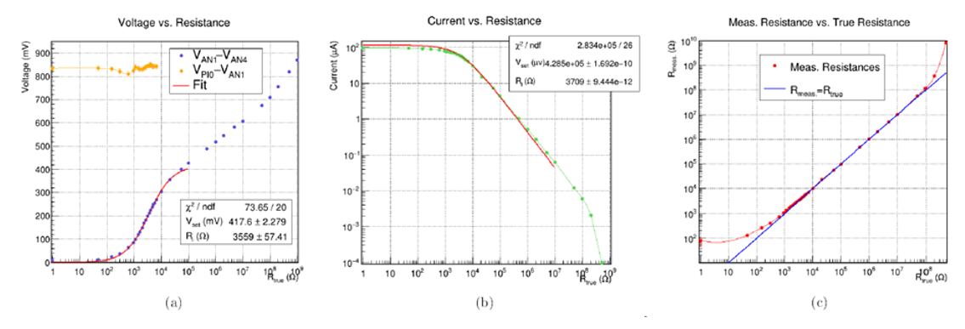
Figure S2. Evaluation of NHS3152 current and resistance measurement accuracy. Different resistors ranging from 1 Ω to 1 GΩ were connected to the NHS3152 microcontroller analog pins (AN1 and AN4) and powered by a cellphone NFC signal for measurements. (a) Voltages are produced by the chip’s DAC to drive the channel current (V_{AN1}-V_{AN4}) and gate (V_{PIO0}-V_{AN1}) as a function of the channel resistance. The DAC is not feedback-controlled and its output is dependent on the current. For OECT channel characterizations we measure therefore the provided voltage with the chip's internal ADC and the current with the I2D to calculate the OECT channel resistance. The potential at the digital pin VPIO0 is not affected by the current and is therefore well suited to drive the OECT gate. (b) Current measured at pin AN4 with the I2D as a function of resistance. The data shows the capability to measure currents in the range of 250 µA down to a few nA. (c) Measured resistance vs. true resistance of the DUT (in red); the blue line corresponds to the ideal condition Rmeas = Rtrue. The data demonstrates that stable resistance measurements with an error < 1% are feasible in the range between 5 kΩ and 10 MΩ.

Appendix S4: Programming of the NHS3152 microcontroller and NFC operation
For the wireless measurement, we used the commercial integrated circuit NHS3152 (starter kit). The NHS3152 is equipped with a power management unit (PMU) able to provide a voltage of up to 3.6 V and up to 1.72 V (in fully passive mode). For the readout of the OECT oxygen sensor, the analog pins AN1 and AN4 were connected to the source and drain electrode. The digital pin PI0 serves to power and provide positive potential to the gate electrode during readout. The NHS3152 board was programmed using the LPC-Link2 board and the MCUXpresso Integrated Development Environment (IDE). The code used for polarizing the electrodes and the measurement of the channel resistance is available upon request and sent by the corresponding author. In particular, the following parameters are essential for the measurement:
- DAC bits (defined at line 69) are used to set the voltage between pins AN1 and AN4. Ideally, the highest value possible should be set (4000) keeping the current lower than 250 µA.
- I2Dintegration_Time (line 72) defines the integration time for the current measurement. This value should consider the range of resistance under measure. Small resistance can be measured with low integration time (due to high current) around 5ms. Conversely, an integration time (around 20ms) must be used for measuring low currents (high resistance values).
- Averaging (line 234) is used to set the number of measurements averaged at each readout.
- Chip_Clock_System_BusyWait_ms() is a function used for introducing a delay between subsequent steps.
A flexible PCB for the NHS3152 with antenna and connectors as shown in Fig. 4a was purchased from the company Bioage (http://www.bioage-srl.com/).

Appendix S5: Isopropanol lift-off process for PEDOT:PSS deposition and OECT channel fabricaton
The isopropanol lift-off process is based on the observation that isopropanol is a milder solvent compared to acetone. Its less aggressive nature helps preserve the epoxy resin-based negative photoresist (mr-DWL5 from Micro Resist Technology GmbH), which is used to encapsulate the gold leads. Although it is widely known that acetone efficiently removes the positive photoresist (Microposit S1818 from Micro Resist Technology GmbH), we found that isopropanol can achieve comparable results when the lift-off time is extended to four hours and combined with a mild sonication after the lift-off to remove photoresist residuals. The results of the two approaches are illustrated in Figure S3. Panels (a) highlight the damage (indicated by white arrows) caused by acetone immersion (1 hour) to the negative photoresist, alongside the poor resolution of the PEDOT:PSS pads in the channel (marked by the green arrow). In contrast, panels (b) demonstrate that isopropanol immersion (4 hours) does not damage the negative photoresist and yields higher PEDOT:PSS channel resolution. Furthermore, the performance of the three-terminal device, as shown in panels (c) and (d), is comparable for both lift-off processes.
In conclusion, the optimized lift-off procedure with isopropanol significantly enhances the encapsulation of gold leads and improves the stability and resolution of the PEDOT:PSS channel, offering an alternative to the acetone-based method.
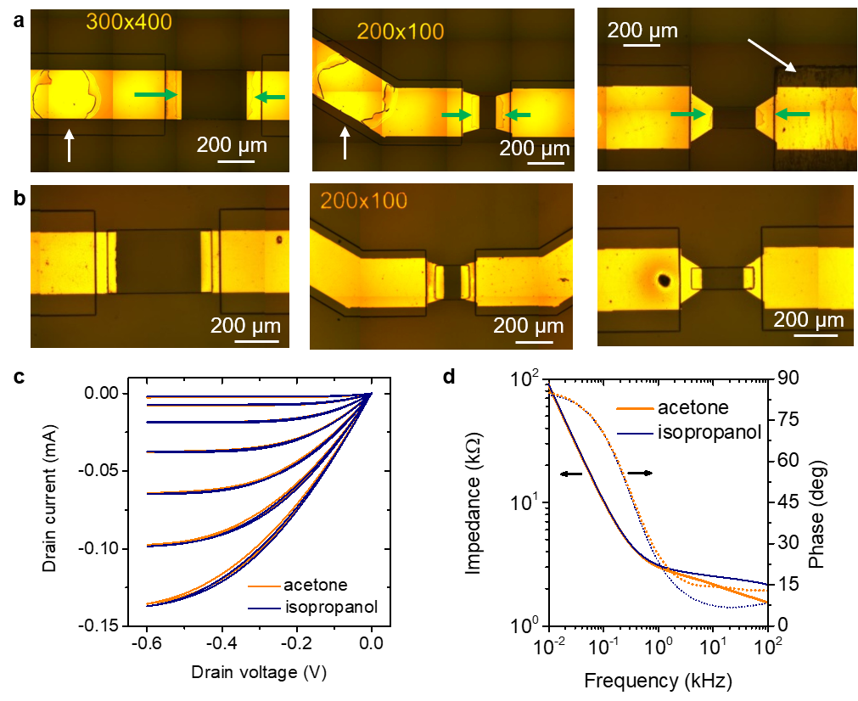
Figure S3: Comparison of the lift-off processes using acetone (ACE) and isopropanol (IPA): (a) Optical images of the PEDOT:PSS channel following lift-off in acetone, showing damage to the negative photoresist (white arrows) and partial removal of the PEDOT:PSS channel (green arrows); (b) Optical images after the optimized lift-off process using isopropanol, demonstrating intact negative photoresist and improved PEDOT:PSS channel resolution; (c) Output characteristic of the Organic Electrochemical Transistor in PBS 1x, employing a standard Ag/AgCl wire as gate electrode and channel with width 100 µm and length 200 µm; (d) Impedance spectrum of the PEDOT:PSS channel (100 µm x 200 µm) measured with a 50 mV modulation.

