Supplementary Material of ‘The SPEEDY-NEMO intermediate complexity coupled model’

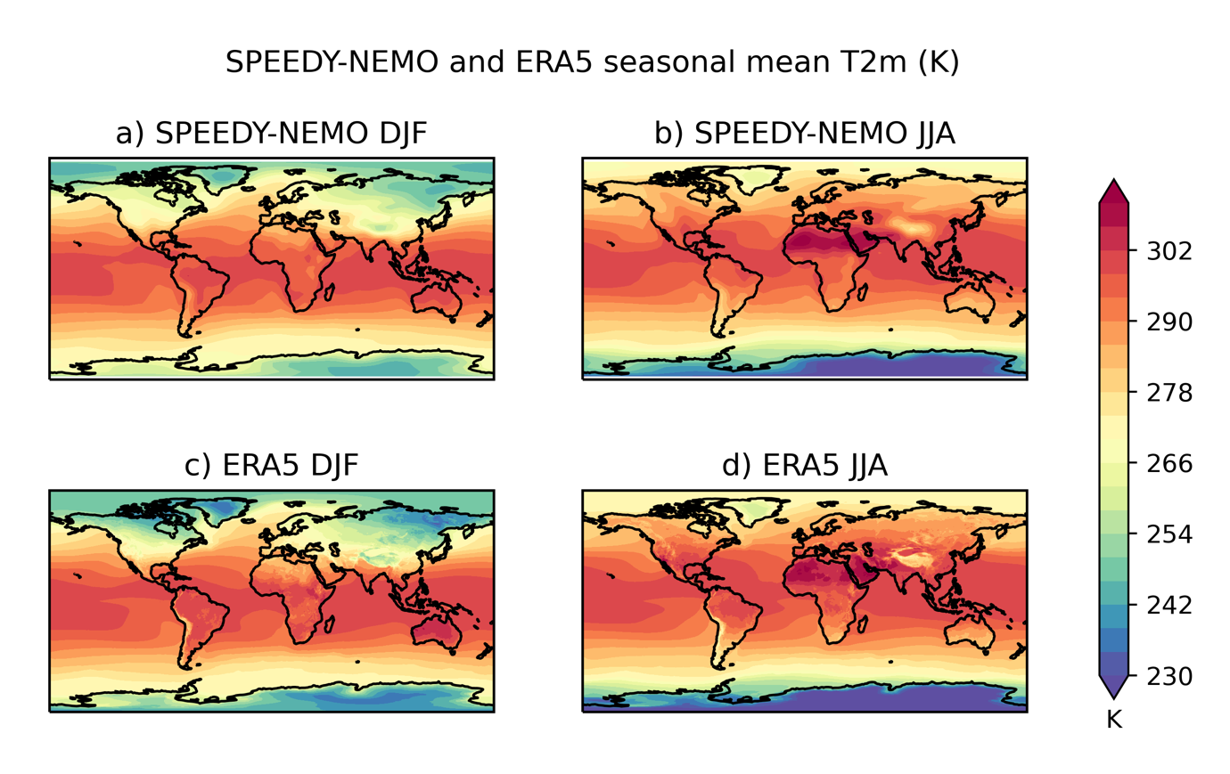
Figure S1: Climatology of near-surface air temperature (K) in a) DJF and b) JJA for the SPEEDY-NEMO model and the c-d) the ERA5 reanalysis

