HEMATOPOIETIC STEM CELL TRANSPLANTATION DISRUPTS AGE-RELATED GUT MICROBIOTA SIGNATURES IN PEDIATRIC AND ADULT RECIPIENTS

Davide Leardini^{1,+}, Marcello Roberto^{2,+}, Sara Roggiani^{3,4*}, Edoardo Muratore¹, Marco Fabbrini³, Gianluca Storci², Enrica Tomassini², Elisa Dan², Angela Schipani², Serena De Matteis², Barbara Sinigaglia², Daria Messelodi², Nicola Salvatore Bertuccio², Arcangelo Prete¹, Patrizia Brigidi³, Francesca Bonifazi^{2,°}, Riccardo Masetti^{1,°}

¹ Pediatric Hematology and Oncology, IRCCS Azienda Ospedaliero-Universitaria di Bologna, Bologna, Italy;
² IRCCS Azienda Ospedaliero-Universitaria di Bologna, Bologna Italy;
³ Human Microbiomics Unit, Department of Medical and Surgical Sciences, University of Bologna, Bologna, Italy.
⁴ Department of Pharmacy and Biotechnology, University of Bologna, Bologna, Italy.

+ these two authors contributed equally as first authors;
° these two authors contributed equally as last authors;
* corresponding author.

Correspondence:
Sara Roggiani, Human Microbiomics Unit, Department of Medical and Surgical Sciences, University of Bologna, Bologna, Italy. Department of Pharmacy and Biotechnology, University of Bologna, Bologna, Italy. sara.roggiani3@unibo.it.

Supplementary Material

- Supplementary Text 1: Compositional shifts occur after HSCT depleting the age-related signature
- Supplementary Text 2: Impact of antibiotic prophylaxis on post-transplant diversity and GM composition
- Supplementary Table 1: Comparison of baseline characteristics in patients developing or not developing grade II-IV aGvHD. HCT: hematopoietic cell transplantation.
- Supplemental Figure 1. Distribution of gut microbiota diversity by patient age (in years). Scatter plot showing data for samples collected before allo-HSCT (A) and for those collected at neutrophil engraftment (B). Gut microbiota diversity was computed using two metrics: Shannon entropy (left panels) and Faith’s Phylogenetic Diversity (Faith’s PD, right panels).
- Supplementary Figure 2: Gut microbiota phyla and families differentially represented before HSCT and at neutrophils engraftment in adults and pediatric patients.
- Supplementary Figure 3: Gut microbiota genera differentially represented before HSCT and at neutrophils engraftment in adults and pediatric patients.
- Supplementary Figure 4. Gut microbiota genera differentially represented before HSCT and at neutrophil engraftment in adult and pediatric patients, with or without antibiotic prophylaxis.
- Supplementary Figure 5: Silhouette analysis supported the use of K-means clustering with k = 6.
- Supplementary Figure 6: Gut microbiota genera characterizing the clusters obtained by applying K-means clustering.
- Supplementary Figure 7: Gut microbiota families and genera differentially represented before HSCT in adults and younger patients who developed no or low-grade aGvHD and clinically significant aGvHD.

Supplementary Text 1: Compositional shifts occur after HSCT depleting the age-related signature

At the phylum level the most abundant taxa were Firmicutes (mean relative abundance ± standard error of the mean: 63.4% ± 24.4%), Bacteroidota (13% ± 18.5%), Proteobacteria (10.5% ± 18.9%) and Actinobacteriota (10% ± 13.1%). Before HSCT, older patients exhibited significantly higher proportion of Proteobacteria compared to younger ones (Wilcoxon test, p < 0.01) (Supplementary Figure 2A). A similar pattern was observed at neutrophil engraftment, though it only approached statistical significance (p = 0.09). Conversely, younger patients tended to have higher abundances of Actinobacteriota compared to older ones before HSCT (p < 0.08). Following HSCT, both groups showed a decline in Actinobacteriota, with this trend being more pronounced in older (p < 0.07). At the time of neutrophils engraftment, adults exhibited higher proportions of Bacteroidota than younger ones (p = 0.04). The most abundant families characterizing the GM of the whole cohort were Lachnospiraceae (18% ± 14.2%), Ruminococcaceae (10.5% ± 12%), Bacteroidaceae (9.7% ± 15.8%), Streptococcaceae (8.7% ± 12.6%), and Enterobacteriaceae (8.5% ± 15.5%). Before undergoing HSCT, distinct differences in GM composition were evident between age groups. Older patients exhibited higher abundances of Butyricicoccaceae, Staphylococcaceae, Coriobacteriaceae, Enterobacteriaceae, Vibrionaceae, Erwiniaceae, Yersiniaceae, Pseudomonadaceae and Morganellaceae, while younger displayed higher levels of Bifidobacteriaceae. However, such age-dependent differences largely disappeared following HSCT, except for a sustained increase in older for Enterobacteriaceae, Alteromonadaceae, Vibrionaceae, Erwiniaceae, Yersiniaceae and Morganellaceae (p < 0.05). GM profiles at engraftment revealed notable similarities between younger and older patients’ family level composition. Both groups demonstrated significant reductions in Butyricicoccaceae, [Eubacterium] coprostanoligenes group, Oscillospiraceae, Clostridiaceae, Ruminococcaceae, Lachnospiraceae, Veillonellaceae, Bifidobacteriaceae, Monoglobaceae, Coriobacteriaceae, Anaerovoracaceae, Peptostreptococcaceae, Christensenellaceae and Erysipelatoclostridiaceae (Wilcoxon test, p ≤ 0.03). Conversely, Staphylococcaceae, Carnobacteriaceae, Bacillaceae and Enterococcaceae increased in both groups post-HSCT (p ≤ 0.03). At a the genus level. Post-HSCT, unique patterns emerged in each age group. Older patients experienced an increase in Bacteroidaceae, Anaerovoracaceae, Erysipelatoclostridiaceae and Acidaminococcaceae, whereas Streptococcaceae expanded exclusively in the younger cohort (p < 0.05) (Supplementary Figure 2B). A significant decrease in abundance was noted post-HSCT for both cohorts across genera including Agathobacter, Blautia, Ruminococcus, Roseburia, Clostridium sensu stricto 1, Butyricicoccus, [Eubacterium] hallii group, Staphylococcus, Tyzzerella, Faecalibacterium, [Ruminococcus] torques group, Bifidobacterium, Subdoligranulum, NK4A214 group, Anaerostipes, Lachnospiraceae NK3A20 group, Bacillus, Colidextribacter, Lachnospiraceae NK4A136 group, Monoglobus, Lachnospiraceae UCG−008, Veillonella, Dorea, Collinsella, Oscillibacter, Christensenellaceae R−7 group, Romboutsia, Erysipelotrichaceae UCG−003, [Eubacterium] eligens group, Dialister, Lachnoclostridium, [Ruminococcus] gnavus group (p ≤ 0.09). Conversely, both groups showed significant increases in Bacillus, Enterococcus, Granulicatella, Staphylococcus, Lacticaseibacillus, Levilactobacillus, [Clostridium] innocuum group, Lactobacillus, Lactococcus, and Limosilactobacillus post-HSCT (p ≤ 0.09). At neutrophil engraftment, older patients exhibited further increases in Ruminococcus, Clostridium sensu stricto 1, Flavonifractor, Enterobacter, Klebsiella, Salmonella, Weissella, Citrobacter, and Bacteroides. In contrast, younger patients showed an increase in Merdibacter (p ≤ 0.03). Additionally, this group also experienced an increase in Streptococccus and a decrease in Erysipelatoclostridium (p < 0.05) (Supplementary Figure 3).

Supplementary Text 2: Impact of antibiotic prophylaxis on post-transplant diversity and GM composition

To investigate the impact of antibiotic prophylaxis on GM diversity and composition, we classified the samples based on age (≥15 years or <15 years), timepoint (pre- and post-HSCT), and the administration of antibiotic prophylaxis. Alpha diversity was assessed as previously described, using both Shannon diversity and Faith’s phylogenetic diversity indices (Supplementary Figure 4A). The analysis revealed that patients aged ≥15 years who received antibiotic prophylaxis exhibited significantly higher levels of GM diversity before HSCT compared to their corresponding samples collected at neutrophil engraftment and to pre-HSCT samples from children under 15 years who also received antibiotics (Wilcoxon test, p < 0.03). Additionally, younger patients who did not receive antibiotic prophylaxis experienced a reduction in alpha diversity following HSCT (p ≤ 0.005). According to the Shannon diversity index, pediatric patients who received antibiotics exhibited lower GM diversity after HSCT compared to those who did not receive antibiotics (p ≤ 0.05). Since we previously demonstrated that GM composition varies according to both timepoint and age, we employed a comprehensive multivariable model to specifically assess the impact of antibiotic prophylaxis on GM composition. To this end, we integrated antibiotic prophylaxis as an additional fixed effect and applied MaAsLin2 to simultaneously evaluate the effects of age, timepoint, and antibiotic prophylaxis on GM composition at the genus level. This analysis identified significant associations between antibiotic prophylaxis and the relative abundances of several genera, including Faecalitalea, Lachnospiraceae UCG-008, Enterococcus, Peptoclostridium, Terrisporobacter, Holdemanella, Intestinibacter, Bacillus, and Sellimonas (p ≤ 0.05). Further pairwise comparisons using Wilcoxon tests within the same categories used for alpha diversity revealed distinct trends (Supplementary Figure 4B). Faecalitalea showed an increasing trend in younger patients who did not receive antibiotics after HSCT (Wilcoxon test, p = 0.08). Lachnospiraceae UCG-008 significantly decreased after HSCT in older subjects receiving antibiotics and remained lower than levels observed in those who did not receive antibiotics before HSCT (p ≤ 0.05). Enterococcus was significantly higher at neutrophil engraftment in older patients who received antibiotics compared to their pre-HSCT samples, and was also elevated in younger patients who did not receive antibiotics compared to both their pre-HSCT samples and those who did receive antibiotics (p ≤ 0.008). Peptoclostridium and Intestinibacter decreased from pre-HSCT to neutrophil engraftment in patients under 15 years of age who did not receive antibiotics (p ≤ 0.03), with a similar decreasing trend observed for Terrisporobacter (p = 0.08). Bacillus increased at neutrophil engraftment in both older patients who received antibiotics and younger ones who did not, when compared to their respective pre-HSCT samples (p ≤ 0.003). No significant differences were observed for Sellimonas and Holdemanella across the groups.

Supplementary Table 1: Comparison of baseline characteristics in patients developing or not developing grade II-IV aGvHD. HCT: hematopoietic cell transplantation.

Characteristic | No grade II-IV aGvHD (n=61) | Grade II-IV aGvHD  (n=27) | p value
Age at allo-HCT, y (± SD) | 17.1 ± 24.9 | 17.7 ± 23.5 | 0.789
Male sex, n (%) | 32 (52) | 14 (52) | 0.958
Disease, n (%) |  |  | 0.625
Acute myeloid leukemia | 24 (39) | 8 (30)
Acute lymphoblastic leukemia | 13 (21) | 10 (37)
Myelodysplastic syndrome or myeloproliferative neoplasm | 9 (15) | 3 (11)
Non-Hodgkin’s lymphoma | 3 (5) | 2 (7)
Chronic myeloid leukemia | 3 (5) | 0
Juvenile Myelomonocytic Leukemia | 1 (2) | 1 (4)
Nonmalignant disease | 8 (13) | 3 (11)
Stem cell source (%) |  |  | 0.899
unmodified BM | 33 (54) | 15 (56)
unmodified PBSC | 28 (46) | 12 (44)
Type of donor (%) |  |  | 0.195
Unrelated | 49 (80) | 17 (63)
Identical sibling | 6 (10) | 6 (22)
HLA-haploidentical sibling | 6 (10) | 4 (15)
Intensity of conditioning (%) |  |  | 0.232
Myeloablative | 30 (49) | 17 (63)
Reduced intensity | 31 (51) | 10 (37)
Antibiotic prophylaxis (%) |  |  | 0.106
no | 34 (56) | 10 (37)
yes | 27 (44) | 17 (63)
Type of nutrition (%) |  |  | 0.384
Enteral | 15 (25) | 4 (15)
Parenteral | 41 (67) | 22 (81)
Combined | 5 (8) | 1 (4)
Disease status |  |  | 0.268
CR | 38 (62) | 18 (67)
non-CR | 23 (38) | 9 (33)

Supplemental Figure 1. Distribution of gut microbiota diversity by patient age (in years). Scatter plot showing data for samples collected before allo-HSCT (A) and for those collected at neutrophil engraftment (B). Gut microbiota diversity was computed using two metrics: Shannon entropy (left panels) and Faith’s Phylogenetic Diversity (Faith’s PD, right panels).

Supplementary Figure 2: Gut microbiota phyla and families differentially represented before HSCT and at neutrophils engraftment in adults and pediatric patients. Boxplots showing the relative abundance (%) distribution of phyla (A) and families (B) of the gut microbiota differentially represented in samples from patients greater than/equal to 15 years before HSCT (“PRE_AD”) or at neutrophils engraftment (“TAKE_AD”) and from patients less than 15 years of age before HSCT (“PRE_PED”) or at neutrophils engraftment (“TAKE_PED”). Wilcoxon test, * p value ≤ 0.05; ** p value ≤ 0.01; *** p value ≤ 0.001; **** p value ≤ 0.0001; ° p value ≤ 0.09.
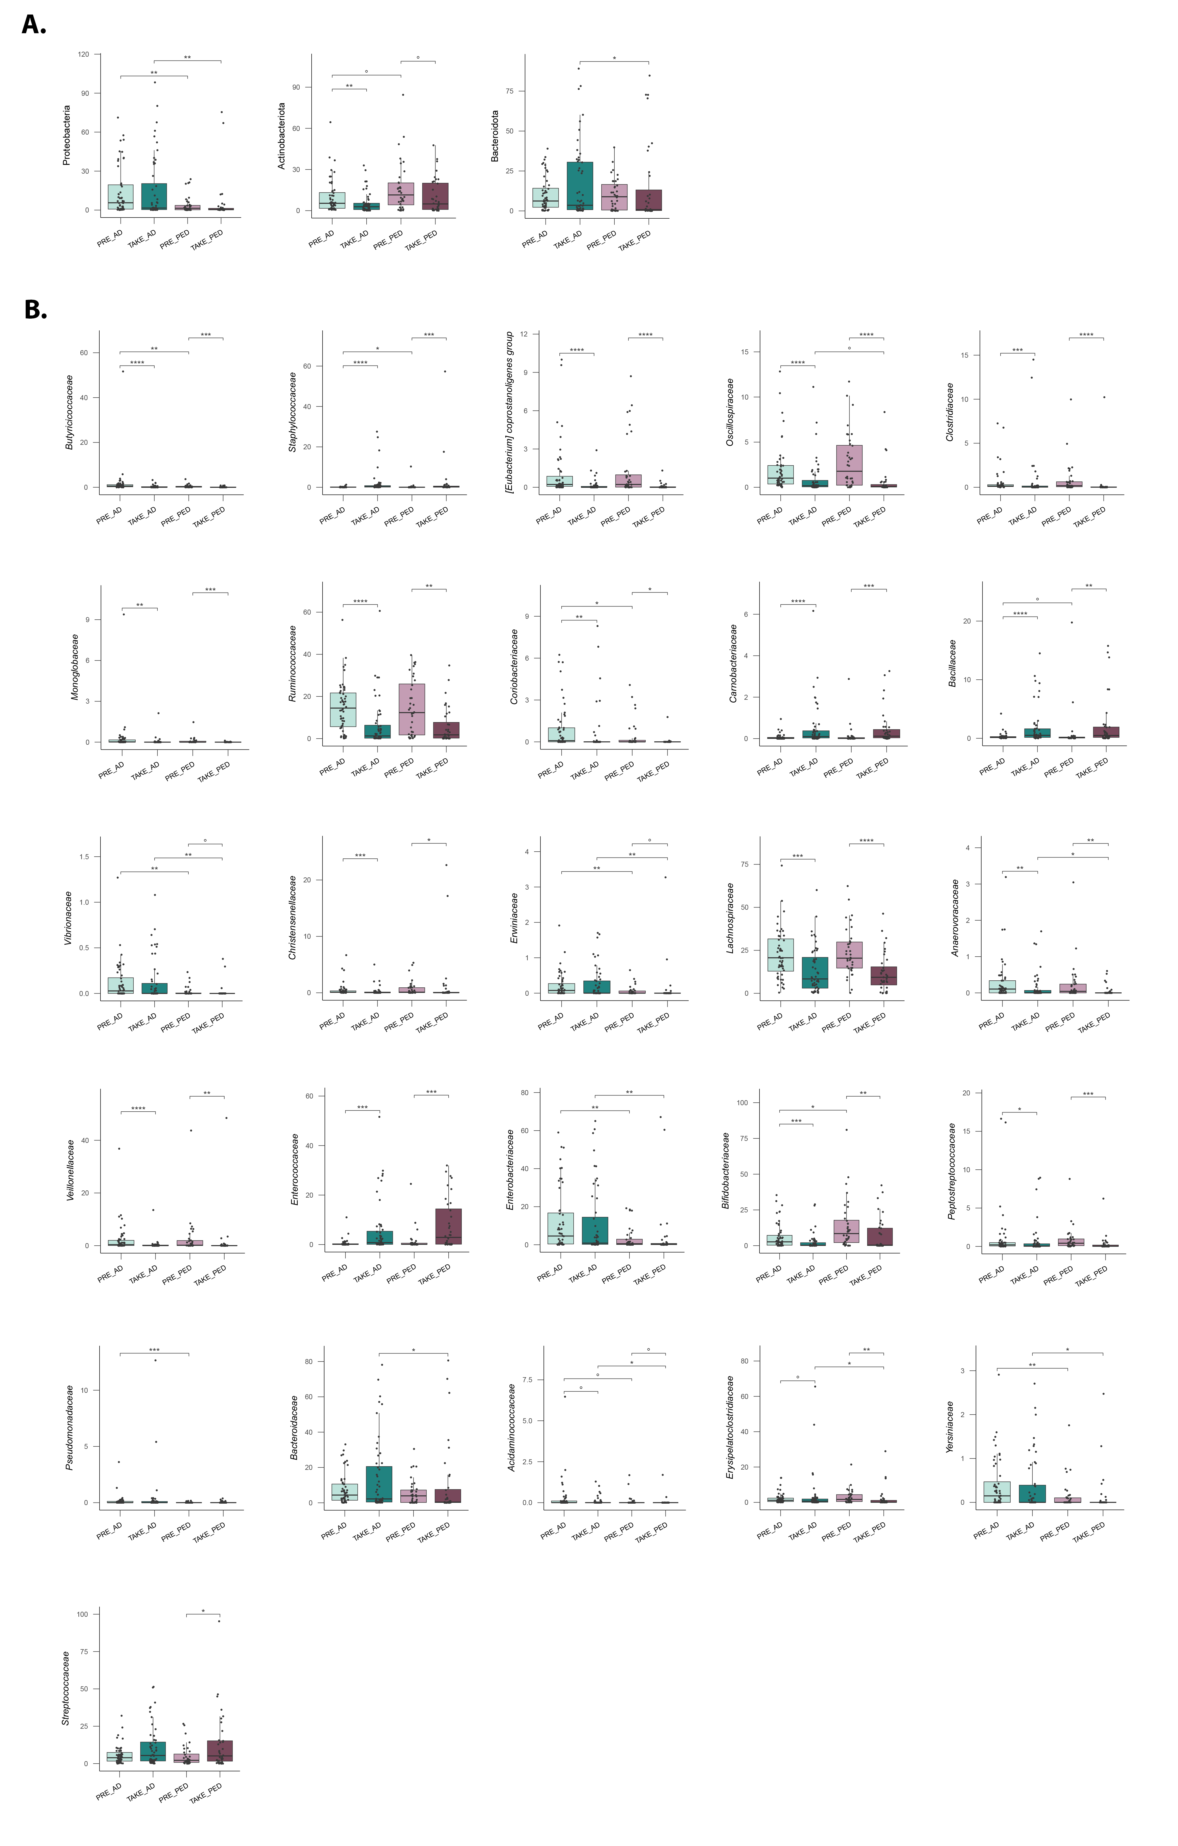
Supplementary Figure 3: Gut microbiota genera differentially represented before HSCT and at neutrophils engraftment in adults and pediatric patients. Boxplots showing the relative abundance (%) distribution of genera of the gut microbiota differentially represented in samples from patients greater than/equal to 15 years before HSCT (“PRE_AD”) or at neutrophils engraftment (“TAKE_AD”) and from patients less than 15 years of age before HSCT (“PRE_PED”) or at neutrophils engraftment (“TAKE_PED”). Wilcoxon test, * p value ≤ 0.05; ** p value ≤ 0.01; *** p value ≤ 0.001; **** p value ≤ 0.0001; ° p value ≤ 0.09.
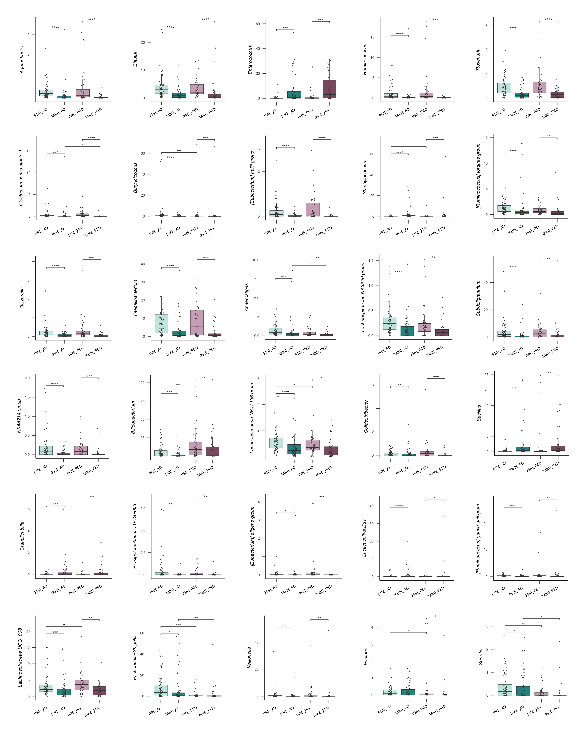

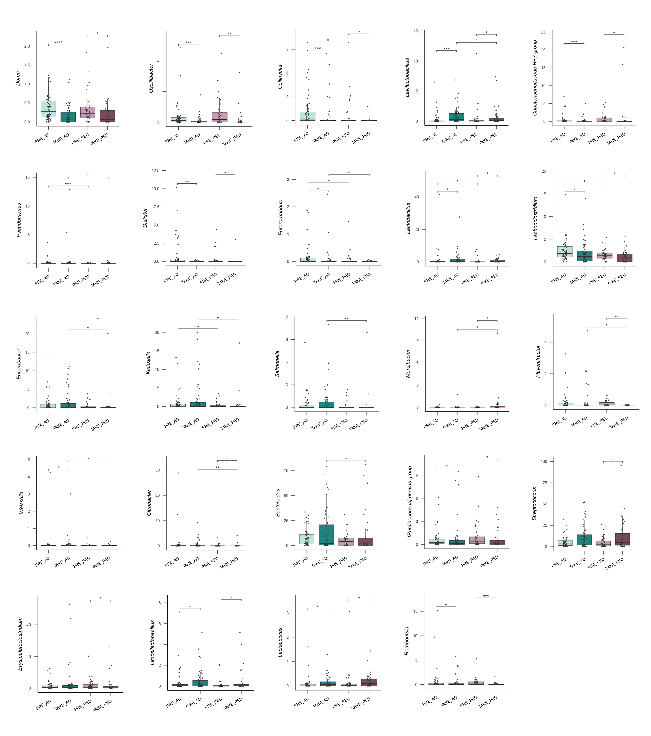

Supplementary Figure 4. Gut microbiota genera differentially represented before HSCT and at neutrophil engraftment in adult and pediatric patients, with or without antibiotic prophylaxis. Boxplots show the relative abundance (%) of gut microbiota genera differentially represented in samples from adult patients (≥15 years) before HSCT who received (“Ab_PRE_AD”) or did not receive (“noAb_PRE_AD”) antibiotic prophylaxis, and at neutrophil engraftment in those who received (“Ab_TAKE_AD”) or did not receive (“noAb_TAKE_AD”) antibiotic prophylaxis. Data from pediatric patients (<15 years) are also shown, including samples collected before HSCT from those who received (“Ab_PRE_PED”) or did not receive (“noAb_PRE_PED”) antibiotic prophylaxis, and at neutrophil engraftment from those who received (“Ab_TAKE_PED”) or did not receive (“noAb_TAKE_PED”) antibiotic prophylaxis. Wilcoxon test, * p value ≤ 0.05; ** p value ≤ 0.01; *** p value ≤ 0.001; **** p value ≤ 0.0001; ° p value ≤ 0.09.

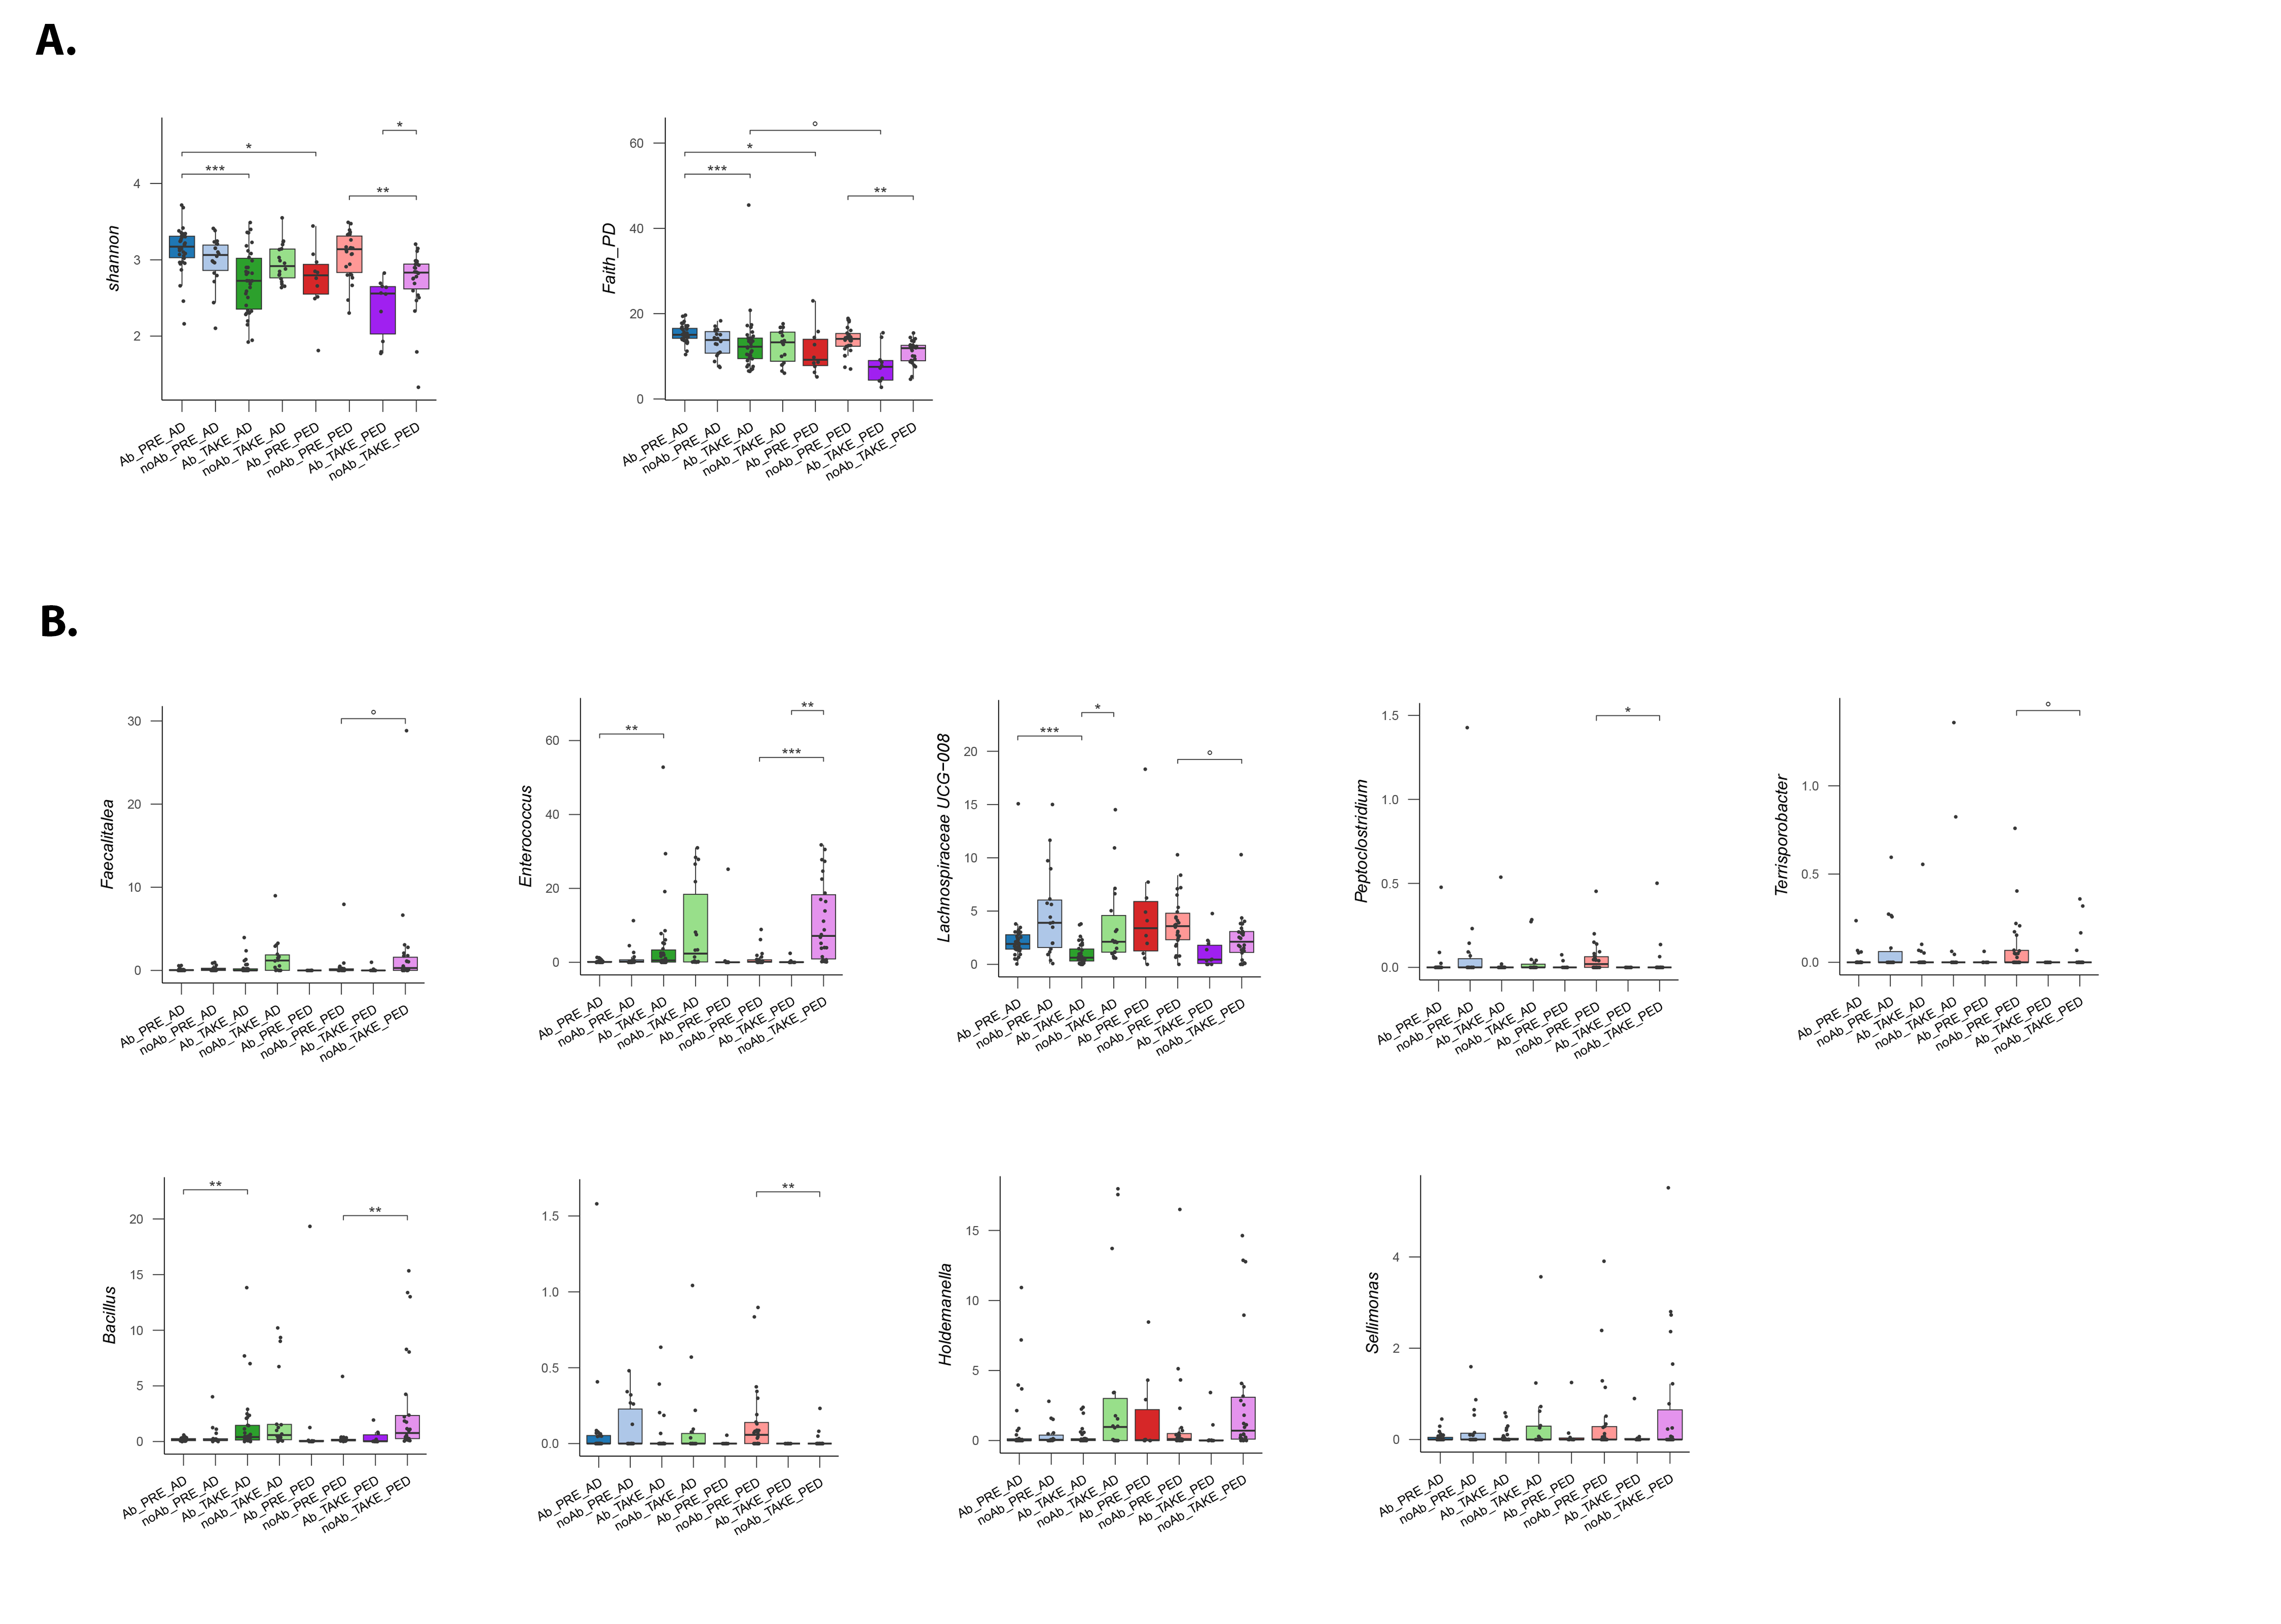

Supplementary Figure 5: Silhouette analysis supported the use of K-means clustering with k = 6. Silhouette analysis for K-means clustering with k equal to 6, the average silhouette width was 0.12 (above the chosen threshold of 0.10).

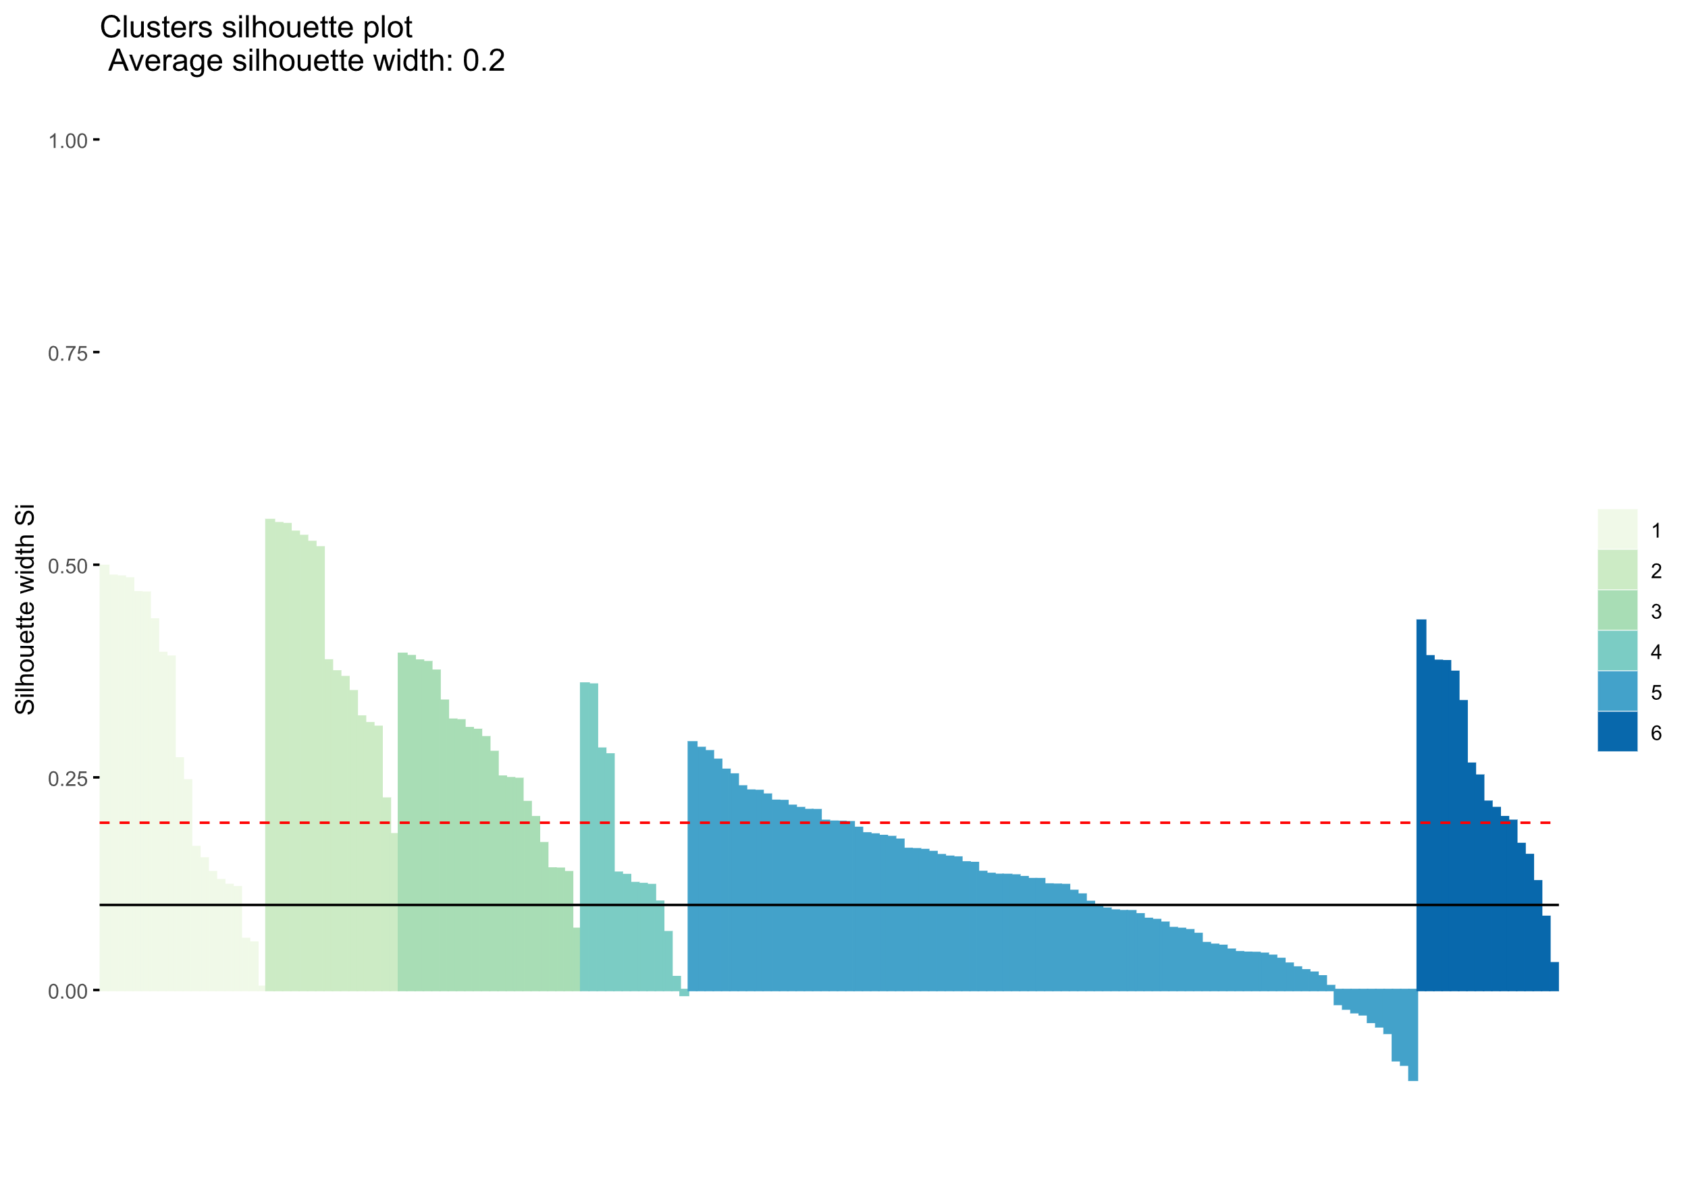

Supplementary Figure 6: Gut microbiota genera characterizing the clusters obtained by applying K-means clustering. Boxplots depicting the relative abundance (%) of gut microbiota genera identified by the Boruta feature selection algorithm as significant. These genera are differentially represented across six clusters derived from K-means clustering of samples collected either before HSCT or at neutrophil engraftment from patients greater than/equal to 15 years and from patients less than 15 years of age. Wilcoxon test, * p value ≤ 0.05; ** p value ≤ 0.01; *** p value ≤ 0.001; **** p value ≤ 0.0001; ° p value ≤ 0.09.
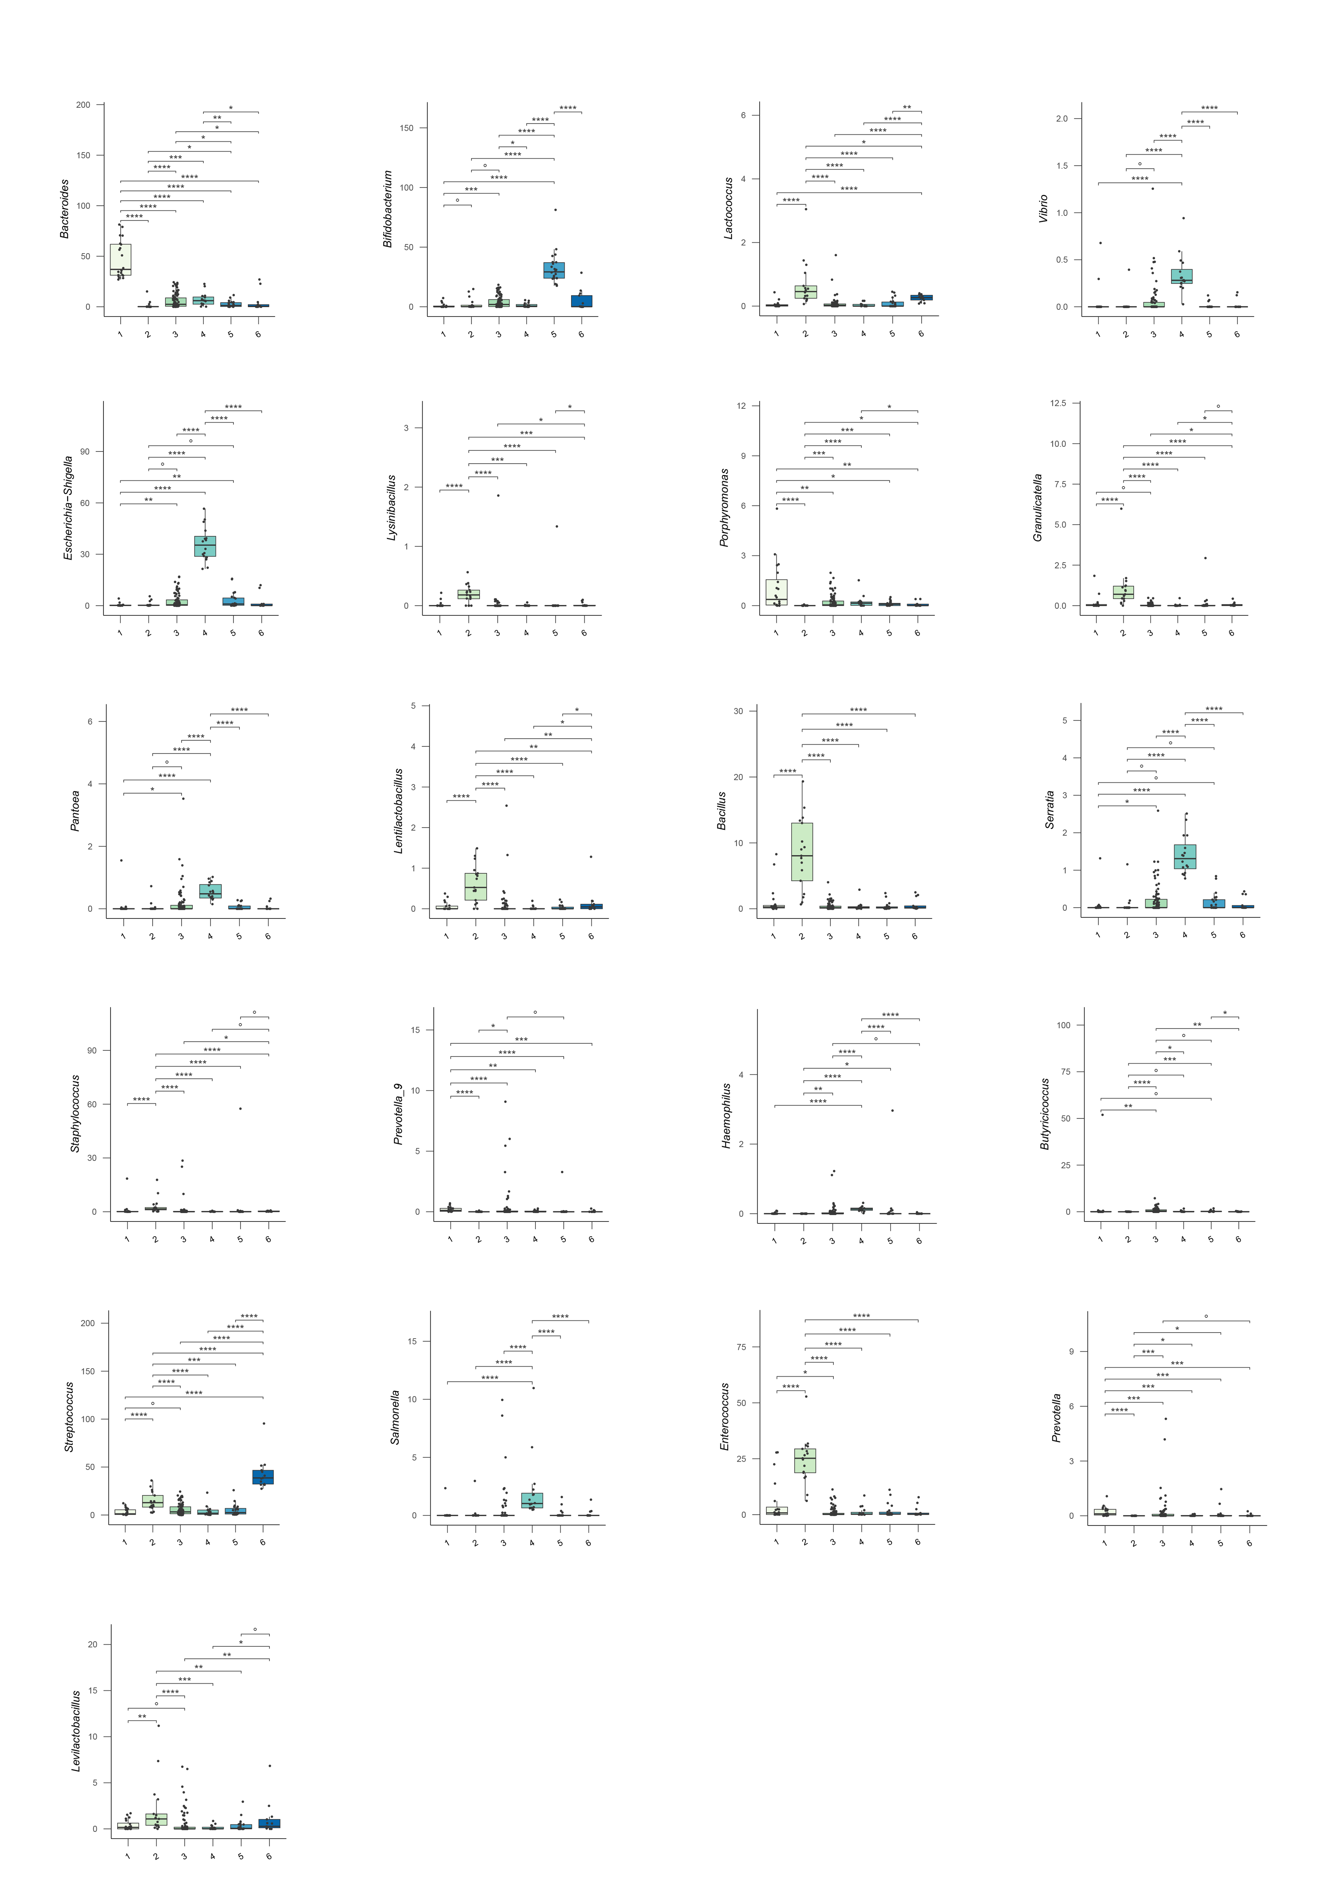

Supplementary Figure 7: Gut microbiota families and genera differentially represented before HSCT in adults and younger patients who developed no or low-grade aGvHD and clinically significant aGvHD. Boxplots showing the relative abundance (%) distribution of families and genera of the gut microbiota differentially represented between samples from adult patients who developed no or grade 1 aGvHD before HSCT (“GvHD[0-1]_AD”) and with grade 2 to 4 aGvHD before HSCT (“GvHD[2-4]_AD”) and those from younger patients with grade 2 to 4 aGvHD before HSCT before HSCT (“GvHD[0-1]_PED”) and with grade 2 to 4 aGvHD before HSCT (“GvHD[2-4]_PED”). Wilcoxon test, * p value ≤ 0.05; ** p value ≤ 0.01; *** p value ≤ 0.001; **** p value ≤ 0.0001; ° p value ≤ 0.09.

