Appendix S1 - Comparison of canopy openness evolution over time across treatments

Supplementary material to the paper:
Sabatini, F. M., M. D. Musciano, and A. Chiarucci. 2025. “Using Yearly Resolved Time‐Series to Disentangle Interannual Variability, Directional Change, and Pseudoturnover in Plant Community Composition.” Journal of Vegetation Science e70052. https://doi.org/10.1111/jvs.70052

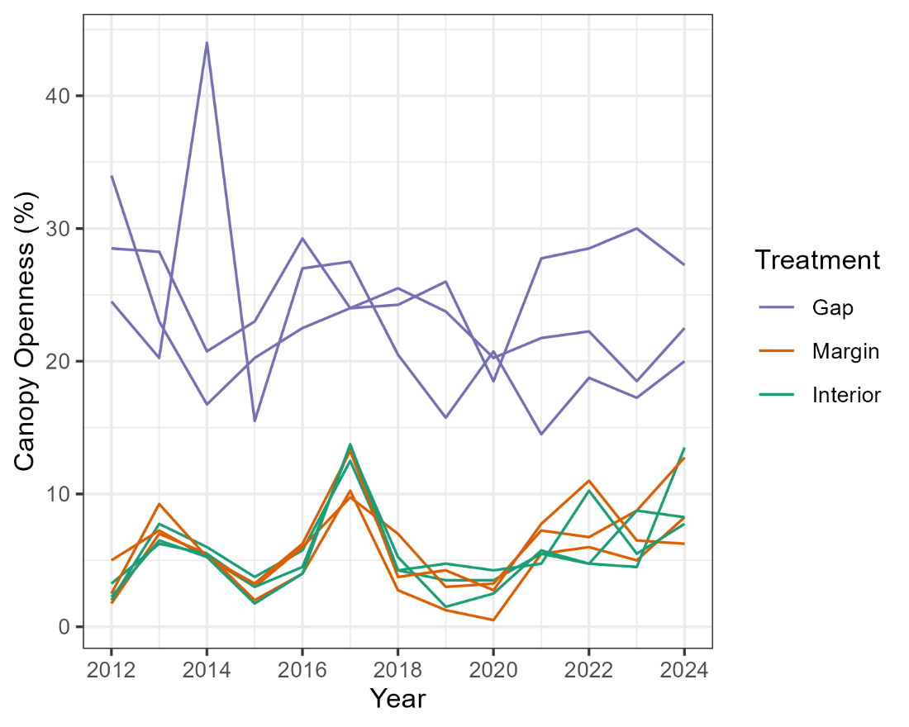
Appendix S1 - Comparison of canopy openness evolution over time in herb layer quadrats resampled for thirteen consecutive years in three treatments: canopy gap, canopy gap margin and forest interior. Each line represents an individual quadrat.

