Supplementary materials
Table S1. Characteristics of the studies included in the meta-analysis. The study numbers corresponding to the forest plot representation are indicated in square brackets. The numbers and letters in parentheses indicate the follow-up included. The sample size (N) refers to the number of animals subjected to methane emission measurement.
Author | Year | N | Study | Equipment | Treatment | Posology | Time points | CH₄ emission measurement
Alvarez-Hess et al. [1a, 1b] | 2019 | 32 | Randomised design | SF-6 | Canola oil (PUFA) | 0.80 kg/day | 35 days | g/day  g/kg DMI  g/kg ECM
Bayat et al.  [2] | 2015 | 4 | Crossover | SF-6 | Camelina oil  (PUFA) | 60 g/kg DMI | 42 days | g/day  g/kg DMI  g/kg milk
Bayat et al.  [3a, 3b, 3c, 3d] | 2017 | 5 | Crossover | SF-6 | Myristic acid  Rapeseed oil  Safflower oil  Linseed oil  (PUFA) | 50 g/kg DMI | 22 days | g/day  g/kg ECM
Bayat et al.  [4a, 4b] | 2017 | 4 | Crossover | SF-6 | Sunflower oil (PUFA) | 50 g/kg DMI | 22 days | g/day  g/kg ECM
Bayat et al.  [5] | 2022 | 8 | Crossover | Respiration Chambers | Garlic-citrus extract and essential oil in pellet  (EO) | 20 g/day | 21 days | g/day  g/kg DMI  g/kg milk  g/kg ECM
Benchaar et al.  [6a, 6b, 6c] | 2016 | 8 | Crossover | SF-6 | Cinnamon oil  Cinnamaldehyde  (EO)  Monensin | 50 mg/kg DMI  24 mg/kg DMI | 28 days | g/day  g/kg DMI
Benchaar et al.  [7a, 7b, 7c] | 2019 | 8 | Crossover | SF-6 | Oregano oil  Carvacrol  (EO)  Monensin | 50 mg/kg DMI  24 mg/kg DMI | 28 days | g/day  g/kg DMI
Benchaar et al.  [8] | 2024 | 32 | Randomised design | Respiration chambers | Mixture of essential oil Agolin  (EO) | 1 g/day | 112 days | g/day  g/kg DMI  g/kg milk  g/kg ECM
Benchaar et al.  [9a, 9b] | 2015 | 12 | Crossover | Respiration chambers | Linseed oil  (PUFA) | 4% DMI | 35 days | g/day  g/kg DMI  g/kg milk  g/kg ECM
Chiung et al.  [10a, 10b] | 2011 | 20 | Crossover | SF-6 | Linseed  (PUFA) | 150 g/kg DMI | 21 days | g/day  g/kg DMI
Darabighane et al.  [11a, 11b] | 2021 | 4 | Crossover | SF-6 | Micture of sunflower and fish oil 2:1 w/w  (PUFA) | 30 g/kg DMI | 35 days | g/day  g/kg milk  g/kg ECM
Haisan et al.  [12] | 2014 | 8 | Crossover | SF-6 | 3-NOP | 2.5 g/day | 28 days | g/day  g/kg DMI
Hamilton et al.  [13a, 13b] | 2010 | 12 | Randomised design | Respiration chambers | Monensin | 600 mg/day | 14 days  60 days | g/day
Hassanat et al.  [14a, 14b, 14c] | 2021 | 12 | Crossover | Respiration chambers | Linseed oil  (PUFA) | 2% DMI  3% DMI  4% DMI | 35 days | g/day  g/kg DMI  g/kg milk  g/kg ECM
Hollmann et al.  [15a, 15b, 15c] | 2012 | 6 | Crossover | Respiration chambers | Coconut oil  (PUFA) | 1.3% DMI  2.7% DMI  3.3% DMI | 35 days | g/day  g/kg DMI
Hristov et al.  [16a, 16b, 16c] | 2013 | 8 | Crossover | SF-6 | Origanum vulgare leaf  (EO) | 250 g/cow  500 g/cow  750 g/cow | 20 days | g/day  g/kg DMI
Hristov et al.  [17a, 17b, 17c, 17d, 17e, 17f] | 2015 | 36 | Randomised design | SF-6  GreenFeed | 3-NOP | 40 mg/kg DMI  60 mg/kg DMI  80 mg/kg DMI | 98 days | g/day
Khurana et al.  [18] | 2023 | 14 | Randomised design | Respiration chambers | Garlic-citrus extract 50% and limestone and vegetable oil 50%  (EO) | 44 g/day | 18 days | g/day  g/kg DMI  g/kg ECM
Kliem et al.  [19a, 19b] | 2019 | 4 | Crossover | Respiration chambers | Linseed extruded  Calcium salt of palm and linseed oil  (PUFA) | 500 g/day | 28 days | g/day  g/kg DMI  g/kg milk
Livingstone et al.  [20a, 20b] | 2015 | 4 | Crossover | Respiration chambers | Linseed extruded  (PUFA) | 50 g/kg DMI | 28 days | g/day  g/kg DMI  g/kg milk
Maigaard et al.  [21a, 21b, 21c, 21d, 21e, 21f. 21g. 21h] | 2024 | 48 | Crossover | GreenFeed | 3-NOP | 76 mg/kg DMI | 126 days | g/day  g/kg DMI  g/kg ECM
Martin et al.  [22a, 22b, 22c, 22d, 22e, 22f] | 2016 | 8 | Crossover | SF-6 | Linseed  (PUFA) | 5% DMI  10%DMI  15% DMI | 28 days | g/day  g/kg DMI  g/kg milk
Martin et al.  [23a, 23b, 23c] | 2021 | 4 | Crossover | Respiration chambers | Corn oil and wheat starch  Algae marine  Palm oil hydrogenated  (PUFA) | 920 g/day  310 g/day  630 g/day | 28 days | g/day  g/kg DMI  g/kg milk  g/kg ECM
Martin et al.  [24a, 24b, 24c] | 2008 | 8 | Crossover | SF-6 | Linseed crude  Linseed extruded  Linseed oil  (PUFA) | 5.7% DMI | 28 days | g/day  g/kg DMI  g/kg milk  g/kg ECM
Melgar et al.  [25] | 2021 | 40 | Randomised design | GreenFeed | 3-NOP | 60 mg/kg DMI | 105 days | g/day  g/kg DMI  g/kg milk  g/kg ECM
Munoz et al.  [26a, 26b] | 2024 | 40 | Crossover | SF-6 | 3-NOP  Cottonseed oil (PUFA) | 1.9 g  1.75 kg/day DMI | 56 days | g/day  g/kg DMI  g/kg milk  g/kg ECM
Munoz et al.  [27a, 27b, 27c] | 2021 | 60 | Randomised design | SF-6 | Cottonseed oil  Rapeseed oil  Linseed oil  (PUFA) | 48% DMI  20% DMI  20%DMI | 189 days | g/day  g/kg DMI  g/kg milk
Pirondini et al.  [28a, 28b] | 2015 | 4 | Crossover | Respiration chambers | Fish oil with low starch  Fish oil with high starch  (PUFA) | 0.80% DMI | 26 days | g/day  g/kg DMI  g/kg milk  g/kg ECM
Silvestre et al.  [29] | 2023 | 48 | Randomised design | GreenFeed | Mixture of essential oil Agolin  (EO) | 10 g/day | 70 days | g/day  g/kg DMI  g/kg milk  g/kg ECM
Storlien et al.  [30] | 2017 | 4 | Crossover | SF-6 | Rapessed crushed  (PUFA) | 10% | 21 days | g/day  g/kg DMI  g/kg ECM
Tondini et al. [31] | 2024 | 40 | Randomised design | GreenFeed | Capsicum oleoresin 3.5% Eugenol 9.5% Cinnamaldehyde 5.5%  (EO) | 1.2 g | 21 days | g/day  g/kg DMI  g/kg milk  g/kg ECM
Van Gastelen et al.  [32a, 32b, 32c, 32d] | 2020 | 16 | Randomised design | Respiration chambers | 3-NOP | 51 mg/kg DMI | 27 days  55 days  83 days  111 days | g/day  g/kg DMI  g/kg ECM
Van Wasemael et al.  [33a, 33b] | 2020 | 20 | Randomised design | GreenFeed | 3-NOP | 80 g/kg DMI | 98 days | g/day  g/kg DMI  g/kg milk
Williams et al.  [34] | 2020 | 8 | Crossover | Respiration chambers | Cottonseed oil  (PUFA) | 800 g/day | 21 days | g/day  g/kg DMI  g/kg ECM

Table S2. Features of the three levels model applied for PUFA g/day methane emission (I² = 94.54%; AIC = 6.017; BIC = 17.489; Log likehood = 4.991).

Covariate | β coefficient | ES | p-value | CI low level | CI high level | ES corrected | p-value corrected
Intercept | -0.0763 | 0.3248 | 0.8142 | -0.7129 | 0.5602 | 0.231 | 0.753
Equipment (SF-6) | -0.1069 | 0.0856 | 0.2005 | -0.2774 | 0.0582 | 0.0819 | 0.216
Study type (randomised design) | 0.0861 | 0.2373 | 0.7166 | -0.3789 | 0.5512 | 0.165 | 0.649
Time days | 0 | 0.0013 | 0.9753 | -0.0026 | 0.0025 | 0.000288 | 0.911
Crude protein | 0.011 | 0.0018 | 0.5313 | -0.0024 | 0.0046 | 0.000825 | 0.297
NDF | -0.008 | 0.0008 | 0.3442 | -0.0024 | 0.0008 | 0.000589 | 0.269

Table S3. Outcome of leave-one-out validation of the model of PUFA in g/day of methane emission (τ2 level 2 (within study) = 0.0336; τ2 level 3 (between studies) = 0.0059).
Leave-one-out validation of g/day methane emission
ID study left out | τ2 level 2 (within study) | τ2 level 3 (between studies) | AIC | BIC | Log Likehood | ΔAIC | ΔBIC | Δlog Likehood
1a | 0.01979167 | 0.01979167 | 7.719543 | 18.929122 | 4.140229 | 1.702543 | 1.440122 | -0.850771
1b | 0.01974384 | 0.01974384 | 7.657674 | 18.867253 | 4.171163 | 1.640674 | 1.378253 | -0.819837
2 | 0.01978392 | 0.01978392 | 7.695669 | 18.905248 | 4.152166 | 1.678669 | 1.416248 | -0.838834
3a | 0.01964797 | 0.01964797 | 7.508043 | 18.717622 | 4.245979 | 1.491043 | 1.228622 | -0.745021
3b | 0.01978504 | 0.01978504 | 7.703359 | 18.912938 | 4.148321 | 1.686359 | 1.423938 | -0.842679
3c | 0.01971097 | 0.01971097 | 7.60481 | 18.814389 | 4.197595 | 1.58781 | 1.325389 | -0.793405
3d | 0.01973652 | 0.01973652 | 7.638785 | 18.848364 | 4.180608 | 1.621785 | 1.359364 | -0.810392
4a | 0.01988014 | 0.01988014 | 7.8295 | 19.039079 | 4.08525 | 1.8125 | 1.550079 | -0.90575
4b | 0.01982612 | 0.01982612 | 7.748027 | 18.957606 | 4.125986 | 1.731027 | 1.468606 | -0.865014
9a | 0.01958738 | 0.01958738 | 7.451045 | 18.660624 | 4.274477 | 1.434045 | 1.171624 | -0.716523
9b | 0.01976118 | 0.01976118 | 7.698453 | 18.908032 | 4.150774 | 1.681453 | 1.419032 | -0.840226
10a | 0.01886856 | 0.01886856 | 6.313566 | 17.523145 | 4.843217 | 0.296566 | 0.034145 | -0.147783
10b | 0.01944709 | 0.01944709 | 7.260379 | 18.469958 | 4.36981 | 1.243379 | 0.980958 | -0.62119
11a | 0.01914425 | 0.01914425 | 6.793624 | 18.003203 | 4.603188 | 0.776624 | 0.514203 | -0.387812
11b | 0.01952219 | 0.01952219 | 7.322192 | 18.531771 | 4.338904 | 1.305192 | 1.042771 | -0.652096
14a | 0.01978994 | 0.01978994 | 7.706869 | 18.916448 | 4.146566 | 1.689869 | 1.427448 | -0.844434
14b | 0.01978629 | 0.01978629 | 7.721012 | 18.930591 | 4.139494 | 1.704012 | 1.441591 | -0.851506
14c | 0.01875493 | 0.01875493 | 6.390707 | 17.600286 | 4.804646 | 0.373707 | 0.111286 | -0.186354
15a | 0.01952254 | 0.01952254 | 7.35648 | 18.566059 | 4.32176 | 1.33948 | 1.077059 | -0.66924
15b | 0.01825599 | 0.01825599 | 5.614615 | 16.824194 | 5.192693 | -0.402385 | -0.664806 | 0.201693
15c | 0.01660529 | 0.01660529 | 2.981884 | 14.191463 | 6.509058 | -3.035116 | -3.297537 | 1.518058
19a | 0.0196227 | 0.0196227 | 7.439738 | 18.649317 | 4.280131 | 1.422738 | 1.160317 | -0.710869
19b | 0.01971095 | 0.01971095 | 7.578942 | 18.788521 | 4.210529 | 1.561942 | 1.299521 | -0.780471
20a | 0.01956689 | 0.01956689 | 7.39427 | 18.603849 | 4.302865 | 1.37727 | 1.114849 | -0.688135
20b | 0.01962936 | 0.01962936 | 7.476081 | 18.68566 | 4.261959 | 1.459081 | 1.19666 | -0.729041
22a | 0.01913337 | 0.01913337 | 6.498037 | 17.969935 | 4.750982 | 0.481037 | 0.480935 | -0.240018
22b | 0.01913337 | 0.01913337 | 6.498037 | 17.969935 | 4.750982 | 0.481037 | 0.480935 | -0.240018
22c | 0.01913337 | 0.01913337 | 6.498037 | 17.969935 | 4.750982 | 0.481037 | 0.480935 | -0.240018
22d | 0.01913337 | 0.01913337 | 6.498037 | 17.969935 | 4.750982 | 0.481037 | 0.480935 | -0.240018
22e | 0.01913337 | 0.01913337 | 6.498037 | 17.969935 | 4.750982 | 0.481037 | 0.480935 | -0.240018
22f | 0.01913337 | 0.01913337 | 6.498037 | 17.969935 | 4.750982 | 0.481037 | 0.480935 | -0.240018
23a | 0.01894519 | 0.01894519 | 6.612719 | 17.822298 | 4.693641 | 0.595719 | 0.333298 | -0.297359
23b | 0.01955135 | 0.01955135 | 7.429879 | 18.639458 | 4.285061 | 1.412879 | 1.150458 | -0.705939
23c | 0.01989276 | 0.01989276 | 7.846994 | 19.056573 | 4.076503 | 1.829994 | 1.567573 | -0.914497
24a | 0.01933441 | 0.01933441 | 7.130533 | 18.340112 | 4.434733 | 1.113533 | 0.851112 | -0.556267
24b | 0.01911222 | 0.01911222 | 6.8721 | 18.081679 | 4.56395 | 0.8551 | 0.592679 | -0.42705
24c | 0.01102657 | 0.01102657 | -8.494553 | 2.715026 | 12.247276 | -14.511553 | -14.773974 | 7.256276
26 | 0.01911039 | 0.01911039 | 6.737627 | 17.947206 | 4.631187 | 0.720627 | 0.458206 | -0.359813
27a | 0.01978015 | 0.01978015 | 7.702362 | 18.911941 | 4.148819 | 1.685362 | 1.422941 | -0.842181
27b | 0.01987436 | 0.01987436 | 7.822498 | 19.032077 | 4.088751 | 1.805498 | 1.543077 | -0.902249
27c | 0.01983329 | 0.01983329 | 7.770236 | 18.979815 | 4.114882 | 1.753236 | 1.490815 | -0.876118
28a | 0.01913571 | 0.01913571 | 6.884805 | 18.094385 | 4.557597 | 0.867805 | 0.605385 | -0.433403
28b | 0.01916348 | 0.01916348 | 6.907761 | 18.11734 | 4.546119 | 0.890761 | 0.62834 | -0.444881
30 | 0.01913337 | 0.01913337 | 6.498037 | 17.969935 | 4.750982 | 0.481037 | 0.480935 | -0.240018
34 | 0.01913337 | 0.01913337 | 6.498037 | 17.969935 | 4.750982 | 0.481037 | 0.480935 | -0.240018

Table S4. Features of the three levels model applied for PUFA g/kg DMI methane emission (I² = 90.9%; AIC = -1.741445; BIC = 7.342509; Log likehood = 8.870722).

Covariate | β coefficient | ES | p-value | CI low level | CI high level | ES corrected | p-value corrected
Intercept | -0.1432 | 0.3154 | 0.6497 | -0.7615 | 0.475 | 0.245 | 0.588
Equipment (SF-6) | 0.0664 | 0.0932 | 0.4763 | -0.1163 | 0.2491 | 0.122 | 0.614
Study type (randomised design) | -0.0529 | 0.2128 | 0.8038 | -0.470 | 0.3642 | 0.124 | 0.717
Time days | 0.0002 | 0.0011 | 0.8134 | -0.0018 | 0.0023 | 0.000703 | 0.780
Crude protein | 0.0005 | 0.0015 | 0.7239 | -0.0024 | 0.0034 | 0.00105 | 0.668
NDF | -0.0002 | 0.0009 | 0.8008 | -0.0019 | 0.0015 | 0.000479 | 0.692

Table S5. Outcome of leave-one-out validation of the model of PUFA in g/kg DMI of methane emission (τ2 level 2 (within study) = 0.004048; τ2 level 3 (between studies) = 0.021653).
Leave-one-out validation of g/kg DMI methane emission
ID study left out | τ2 level 2 (within study) | τ2 level 3 (between studies) | AIC | BIC | Log Likehood | ΔAIC | ΔBIC | Δlog Likehood
1a | 0.012911321 | 0.012911321 | 0.281820192 | 9.0101598 | 7.85909 | 2.023265192 | 1.6676508 | -1.011632
1b | 0.012822084 | 0.012822084 | 0.143896224 | 8.8722359 | 7.928052 | 1.885341224 | 1.5297269 | -0.94267
2 | 0.012363041 | 0.01236304 | -0.622508891 | 8.1058307 | 8.311254 | 1.118936109 | 0.7633217 | -0.559468
9a | 0.012874326 | 0.012874326 | 0.192330275 | 8.9206699 | 7.903835 | 1.933775275 | 1.5781609 | -0.966887
9b | 0.012704721 | 0.01270472 | -0.055899814 | 8.6724398 | 8.02795 | 1.685545186 | 1.3299308 | -0.842772
10a | 0.012903825 | 0.012903825 | 0.248537997 | 8.9768776 | 7.875731 | 1.989982997 | 1.6343686 | -0.994991
10b | 0.009879745 | 0.009879745 | -4.900946272 | 3.8273934 | 10.450473 | -3.159501272 | -3.5151156 | 1.579751
14a | 0.012936024 | 0.012936024 | 0.309892953 | 9.0382326 | 7.845054 | 2.051337953 | 1.6957236 | -1.025668
14b | 0.012705761 | 0.012705761 | -0.041321988 | 8.6870176 | 8.020661 | 1.700123012 | 1.3445086 | -0.850061
14c | 0.011896319 | 0.011896319 | -1.299888411 | 7.4284512 | 8.649944 | 0.441556589 | 0.0859422 | -0.220778
15a | 0.012445843 | 0.012445843 | -0.397879853 | 8.3304598 | 8.19894 | 1.343565147 | 0.9879508 | -0.671782
15b | 0.012842002 | 0.012842002 | 0.171108114 | 8.8994477 | 7.914446 | 1.912553114 | 1.5569387 | -0.956276
15c | 0.012643831 | 0.012643831 | -0.11880893 | 8.6095307 | 8.059404 | 1.62263607 | 1.2670217 | -0.811318
19a | 0.012768057 | 0.012768058 | 0.007894963 | 8.7362346 | 7.996053 | 1.749339963 | 1.3937256 | -0.874669
19b | 0.012742119 | 0.012742119 | -0.045951125 | 8.6823885 | 8.022976 | 1.695493875 | 1.3398795 | -0.847746
20a | 0.012778256 | 0.012778256 | 0.043949568 | 8.7722892 | 7.978025 | 1.785394568 | 1.4297802 | -0.892697
20b | 0.012810246 | 0.012810247 | 0.103602894 | 8.8319425 | 7.948199 | 1.845047894 | 1.4894335 | -0.922523
22a | 0.012304768 | 0.012304768 | -1.447648634 | 7.6363051 | 8.723824 | 0.293796366 | 0.2937961 | -0.146898
22b | 0.012304768 | 0.012304768 | -1.447648634 | 7.6363051 | 8.723824 | 0.293796366 | 0.2937961 | -0.146898
22c | 0.012304768 | 0.012304768 | -1.447648634 | 7.6363051 | 8.723824 | 0.293796366 | 0.2937961 | -0.146898
22d | 0.012304768 | 0.012304768 | -1.447648634 | 7.6363051 | 8.723824 | 0.293796366 | 0.2937961 | -0.146898
22e | 0.012304768 | 0.012304768 | -1.447648634 | 7.6363051 | 8.723824 | 0.293796366 | 0.2937961 | -0.146898
22f | 0.012304768 | 0.012304768 | -1.447648634 | 7.6363051 | 8.723824 | 0.293796366 | 0.2937961 | -0.146898
23a | 0.01216541 | 0.01216541 | -1.087545454 | 7.6407942 | 8.543773 | 0.653899546 | 0.2982852 | -0.326949
23b | 0.012841939 | 0.012841939 | 0.140111211 | 8.8684508 | 7.929944 | 1.881556211 | 1.5259418 | -0.940778
23c | 0.012846349 | 0.012846349 | 0.165820961 | 8.8941606 | 7.91709 | 1.907265961 | 1.5516516 | -0.953632
24a | 0.007963697 | 0.007963697 | -9.222135817 | -0.4937962 | 12.611068 | -7.480690817 | -7.8363052 | 3.740346
24b | 0.011530657 | 0.011530657 | -2.097974485 | 6.6303651 | 9.048987 | -0.356529485 | -0.7121439 | 0.178265
24c | 0.01173442 | 0.01173442 | -1.533451325 | 7.1948883 | 8.766726 | 0.207993675 | -0.1476207 | -0.103996
26 | 0.012785021 | 0.012785021 | 0.049170877 | 8.7775105 | 7.975415 | 1.790615877 | 1.4350015 | -0.895307
27a | 0.012569917 | 0.012569917 | -0.229852378 | 8.4984872 | 8.114926 | 1.511592622 | 1.1559782 | -0.755796
27b | 0.012810948 | 0.012810948 | 0.118303182 | 8.8466428 | 7.940848 | 1.859748182 | 1.5041338 | -0.929874
27c | 0.012830602 | 0.012830602 | 0.147534796 | 8.8758744 | 7.926233 | 1.888979796 | 1.5333654 | -0.944489
28a | 0.012589236 | 0.012589237 | -0.191619428 | 8.5367202 | 8.09581 | 1.549825572 | 1.1942112 | -0.774912
28b | 0.011971051 | 0.01197105 | -1.073353932 | 7.6549857 | 8.536677 | 0.668091068 | 0.3124767 | -0.334045
30 | 0.012304768 | 0.012304768 | -1.447648634 | 7.6363051 | 8.723824 | 0.293796366 | 0.2937961 | -0.146898
34 | 0.012304768 | 0.012304768 | -1.447648634 | 7.6363051 | 8.723824 | 0.293796366 | 0.2937961 | -0.146898

Table S6. Features of the three levels model applied for PUFA g/kg milk methane emission (I² = 90.84%; AIC = 10.27118; BIC = 17.39416; Log likehood = 2.864408).
Covariate | β coefficient | ES | p-value | CI low level | CI high level | ES corrected | p-value corrected
Intercept | -0.4749 | 0.6240 | 0.4467 | -1.698 | 0.7482 | 0.700 | 0.533
Equipment (SF-6) | -0.1335 | 0.1593 | 0.4021 | -0.4458 | 0.1788 | 0.220 | 0.593
Study type (randomised design) | -1.5995 | 1.5292 | 0.2956 | -4.5967 | 1.3977 | 1.690 | 0.403
Time days | 0.0115 | 0.0107 | 0.2843 | -0.0095 | 0.0324 | 0.0127 | 0.421
Crude protein | 0.0009 | 0.0021 | 0.6769 | -0.0032 | 0.005 | 0.00188 | 0.701
NDF | -0.0006 | 0.0012 | 0.6032 | -0.0029 | 0.0017 | 0.000735 | 0.461

Table S7. Outcome of leave-one-out validation of the model of PUFA in g/kg milk of methane emission (τ2 level 2 (within study) = 0.0027479; τ2 level 3 (between studies) = 0.023388).
Leave-one-out validation of g/milk methane emission
ID study left out | τ2 level 2 (within study) | τ2 level 3 (between studies) | AIC | BIC | Log Likehood | ΔAIC | ΔBIC | Δlog Likehood
2 | 0.02387567 | 0.02387567 | 14.732389 | 21.3981 | 0.6338055 | 4.461209 | 4.00394 | -2.2306025
9a | 0.02404535 | 0.02404535 | 14.868195 | 21.5339 | 0.5659023 | 4.597015 | 4.13974 | -2.2985057
9b | 0.0221045 | 0.0221045 | 13.616973 | 20.28268 | 1.1915137 | 3.345793 | 2.88852 | -1.6728943
11a | 0.02243738 | 0.02243738 | 13.817238 | 20.48294 | 1.0913809 | 3.546058 | 3.08878 | -1.7730271
11b | 0.02271608 | 0.02271608 | 13.976559 | 20.64227 | 1.0117207 | 3.705379 | 3.24811 | -1.8526873
14a | 0.024023 | 0.024023 | 14.852417 | 21.51812 | 0.5737914 | 4.581237 | 4.12396 | -2.2906166
14b | 0.02251476 | 0.02251476 | 13.924559 | 20.59027 | 1.0377203 | 3.653379 | 3.19611 | -1.8266877
14c | 0.02115244 | 0.02115244 | 13.014927 | 19.68063 | 1.4925367 | 2.743747 | 2.28647 | -1.3718713
19a | 0.02381976 | 0.02381975 | 14.685633 | 21.35134 | 0.6571834 | 4.414453 | 3.95718 | -2.2072246
19b | 0.02375407 | 0.02375408 | 14.635428 | 21.30113 | 0.6822861 | 4.364248 | 3.90697 | -2.1821219
20a | 0.02330407 | 0.02330407 | 14.35874 | 21.02445 | 0.8206302 | 4.08756 | 3.63029 | -2.0437778
20b | 0.02289366 | 0.02289366 | 14.086421 | 20.75213 | 0.9567894 | 3.815241 | 3.35797 | -1.9076186
22a | 0.02258747 | 0.02258748 | 13.802849 | 20.92582 | 1.0985753 | 3.531669 | 3.53166 | -1.7658327
22b | 0.02258747 | 0.02258748 | 13.802849 | 20.92582 | 1.0985753 | 3.531669 | 3.53166 | -1.7658327
22c | 0.02258747 | 0.02258748 | 13.802849 | 20.92582 | 1.0985753 | 3.531669 | 3.53166 | -1.7658327
22d | 0.02258747 | 0.02258748 | 13.802849 | 20.92582 | 1.0985753 | 3.531669 | 3.53166 | -1.7658327
22e | 0.02258747 | 0.02258748 | 13.802849 | 20.92582 | 1.0985753 | 3.531669 | 3.53166 | -1.7658327
22f | 0.02258747 | 0.02258748 | 13.802849 | 20.92582 | 1.0985753 | 3.531669 | 3.53166 | -1.7658327
23a | 0.02218146 | 0.02218147 | 13.545062 | 20.21077 | 1.2274688 | 3.273882 | 2.81661 | -1.6369392
23b | 0.02402627 | 0.02402628 | 14.852085 | 21.51779 | 0.5739577 | 4.580905 | 4.12363 | -2.2904503
23c | 0.02384599 | 0.02384599 | 14.742972 | 21.40868 | 0.6285142 | 4.471792 | 4.01452 | -2.2358938
24a | 0.02296318 | 0.02296318 | 14.044881 | 20.71059 | 0.9775594 | 3.773701 | 3.31643 | -1.8868486
24b | 0.0221 | 0.0221 | 13.888554 | 20.55426 | 1.055723 | 3.617374 | 3.1601 | -1.808685
24c | 0.01214185 | 0.01214185 | 4.257909 | 10.92362 | 5.8710455 | -6.013271 | -6.47054 | 3.0066375
26 | 0.02340869 | 0.0234087 | 14.521179 | 21.18689 | 0.7394106 | 4.249999 | 3.79273 | -2.1249974
27a | 0.02395731 | 0.0239573 | 14.805203 | 21.47091 | 0.5973987 | 4.534023 | 4.07675 | -2.2670093
27b | 0.023726 | 0.023726 | 14.65653 | 21.32224 | 0.6717352 | 4.38535 | 3.92808 | -2.1926728
27c | 0.02398264 | 0.02398264 | 14.821503 | 21.48721 | 0.5892486 | 4.550323 | 4.09305 | -2.2751594
28a | 0.02287787 | 0.02287787 | 14.142295 | 20.808 | 0.9288524 | 3.871115 | 3.41384 | -1.9355556
28b | 0.02172854 | 0.02172855 | 13.430983 | 20.09669 | 1.2845085 | 3.159803 | 2.70253 | -1.5798995

Table S8. Features of the three levels model applied for PUFA g/kg ECM methane emission (I² = 85.78%; AIC = 10.27118; BIC = 17.39416; Log likehood = 2.864408).
Covariate | β coefficient | ES | p-value | CI low level | CI high level | ES corrected | p-value corrected
Intercept | -0.0525 | 0.4290 | 0.9026 | -0.7883 | 0.8933 | 0.417 | 0.907
Equipment (SF-6) | -0.0758 | 0.0936 | 0.4177 | -0.2592 | 0.1076 | 0.952 | 0.461
Study type (randomised design) | -0.0911 | 0.2203 | 0.6793 | -0.5229 | 0.3408 | 0.144 | 0.561
Time days | 0.0011 | 0.0063 | 0.866 | -0.0113 | 0.0135 | 0.00529 | 0.850
Crude protein | 0.0015 | 0.0014 | 0.2836 | -0.0013 | 0.0043 | 0.000898 | 0.253
NDF | -0.0012 | 0.0008 | 0.1282 | -0.0028 | 0.0004 | 0.000757 | 0.206

Table S9. Outcome of leave-one-out validation of the model of PUFA in g/kg ECM of methane emission (τ2 level 2 (within study) = 0.011481; τ2 level 3 (between studies) = 0.011362).
Leave-one-out validation of g/kg ECM methane emission
ID study left out | τ2 level 2 (within study) | τ2 level 3 (between studies) | AIC | BIC | Log Likehood | ΔAIC | ΔBIC | Δlog Likehood
1a | 0.010737592 | 0.010737591 | 3.692167 | 10.357874 | 6.153916 | 3.60880485 | 3.151538 | -1.804403
1b | 0.010737591 | 0.010737592 | 3.692167 | 10.357874 | 6.153916 | 3.60880485 | 3.151538 | -1.804403
3a | 0.010940877 | 0.010940877 | 3.774877 | 10.440584 | 6.112561 | 3.69151485 | 3.234248 | -1.845758
3b | 0.010921784 | 0.010921783 | 3.787534 | 10.45324 | 6.106233 | 3.70417185 | 3.246904 | -1.852086
3c | 0.010921784 | 0.010921783 | 3.787534 | 10.45324 | 6.106233 | 3.70417185 | 3.246904 | -1.852086
3d | 0.010921784 | 0.010921783 | 3.787534 | 10.45324 | 6.106233 | 3.70417185 | 3.246904 | -1.852086
4a | 0.011081407 | 0.011081407 | 4.019586 | 10.685293 | 5.990207 | 3.93622385 | 3.478957 | -1.968112
4b | 0.010201721 | 0.010201721 | 2.531648 | 9.197355 | 6.734176 | 2.44828585 | 1.991019 | -1.224143
9a | 0.011192985 | 0.011192984 | 4.125647 | 10.791354 | 5.937176 | 4.04228485 | 3.585018 | -2.021143
9b | 0.011113189 | 0.011113189 | 3.9285 | 10.594206 | 6.03575 | 3.84513785 | 3.38787 | -1.922569
11a | 0.010573002 | 0.010573001 | 3.395895 | 10.061601 | 6.302053 | 3.31253285 | 2.855265 | -1.656266
11b | 0.010222251 | 0.010222251 | 3.085617 | 9.751324 | 6.457191 | 3.00225485 | 2.544988 | -1.501128
14a | 0.011237477 | 0.011237477 | 4.192656 | 10.858363 | 5.903672 | 4.10929385 | 3.652027 | -2.054647
14b | 0.010305874 | 0.010305875 | 3.224202 | 9.889909 | 6.387899 | 3.14083985 | 2.683573 | -1.57042
14c | 0.008890644 | 0.008890643 | 1.538307 | 8.204014 | 7.230846 | 1.45494485 | 0.997678 | -0.727473
23a | 0.011094098 | 0.011094097 | 4.0247 | 10.690407 | 5.98765 | 3.94133785 | 3.484071 | -1.970669
23b | 0.010860766 | 0.010860767 | 3.712446 | 10.378153 | 6.143777 | 3.62908385 | 3.171817 | -1.814542
23c | 0.01092101 | 0.010921009 | 3.799644 | 10.465351 | 6.100178 | 3.71628185 | 3.259015 | -1.858141
24a | 0.011177772 | 0.011177772 | 4.100929 | 10.766636 | 5.949536 | 4.01756685 | 3.5603 | -2.008783
24b | 0.010973064 | 0.010973063 | 3.950347 | 10.616054 | 6.024826 | 3.86698485 | 3.409718 | -1.933493
24c | 0.004798607 | 0.004798606 | -8.766913 | -2.101206 | 12.383456 | -8.85027515 | -9.307542 | 4.425137
26 | 0.010730883 | 0.010730883 | 3.521487 | 10.187194 | 6.239256 | 3.43812485 | 2.980858 | -1.719063
28a | 0.011067633 | 0.011067633 | 3.999634 | 10.665341 | 6.000183 | 3.91627185 | 3.459005 | -1.958136
28b | 0.009298216 | 0.009298216 | 2.262587 | 8.928294 | 6.868706 | 2.17922485 | 1.721958 | -1.089613
30 | 0.010345061 | 0.010345061 | 2.332392 | 9.455366 | 6.833804 | 2.24902985 | 2.24903 | -1.124515
34 | 0.010345061 | 0.010345061 | 2.332392 | 9.455366 | 6.833804 | 2.24902985 | 2.24903 | -1.124515

Table S10. Outcome of leave-one-out validation of the model of 3-NOP in g/day methane emission (τ2 level 2 (within study) = 0.00333; τ2 level 3 (between studies) = 0.006193).
Leave-one-out validation model 3-NOP in g/day methane emission
ID study left out | τ2 level 2 (within study) | τ2 level 3 (between studies) | AIC | BIC | Log Likehood | ΔAIC | ΔBIC | Δlog Likehood
12 | 0.009169491 | 0.009169492 | -12.504506 | -8.521577 | 10.252253 | 7.226634 | 7.031473 | -3.613317
17a | 0.011191699 | 0.011191699 | -5.773423 | -1.790493 | 6.886711 | 13.957717 | 13.762557 | -6.978859
17b | 0.011124418 | 0.011124418 | -5.896369 | -1.91344 | 6.948184 | 13.834771 | 13.63961 | -6.917386
17c | 0.011013831 | 0.011013831 | -6.154503 | -2.171574 | 7.077252 | 13.576637 | 13.381476 | -6.788318
17d | 0.01129883 | 0.01129883 | -5.514948 | -1.532019 | 6.757474 | 14.216192 | 14.021031 | -7.108096
17e | 0.010881054 | 0.010881052 | -6.146523 | -2.163594 | 7.073261 | 13.584617 | 13.389456 | -6.792309
17f | 0.010801868 | 0.010801868 | -6.276404 | -2.293475 | 7.138202 | 13.454736 | 13.259575 | -6.727368
21a | 0.010766191 | 0.01076619 | -5.929477 | -1.946548 | 6.964739 | 13.801663 | 13.606502 | -6.900831
21b | 0.010427758 | 0.010427758 | -6.274146 | -2.291217 | 7.137073 | 13.456994 | 13.261833 | -6.728497
21c | 0.011445495 | 0.011445495 | -5.474449 | -1.49152 | 6.737225 | 14.256691 | 14.06153 | -7.128345
21d | 0.011478537 | 0.011478537 | -5.41934 | -1.436411 | 6.70967 | 14.3118 | 14.116639 | -7.1559
21e | 0.01106257 | 0.01106257 | -5.644214 | -1.661285 | 6.822107 | 14.086926 | 13.891765 | -7.043463
21f | 0.010888575 | 0.010888575 | -5.828131 | -1.845202 | 6.914065 | 13.903009 | 13.707848 | -6.951505
21g | 0.011562917 | 0.011562917 | -5.192705 | -1.209776 | 6.596353 | 14.538435 | 14.343274 | -7.269217
21h | 0.011353629 | 0.011353629 | -5.536606 | -1.553677 | 6.768303 | 14.194534 | 13.999373 | -7.097267
25 | 0.011113177 | 0.011113177 | -5.682726 | -1.699796 | 6.841363 | 14.048414 | 13.853254 | -7.024207
26 | 0.010060269 | 0.01006027 | -8.137106 | -4.154177 | 8.068553 | 11.594034 | 11.398873 | -5.797017
32a | 0.011031727 | 0.011031727 | -6.054575 | -2.071646 | 7.027287 | 13.676565 | 13.481404 | -6.838283
32b | 0.009696483 | 0.009696483 | -8.076099 | -4.09317 | 8.038049 | 11.655041 | 11.45988 | -5.827521
32c | 0.009999702 | 0.009999702 | -7.607557 | -3.624628 | 7.803779 | 12.123583 | 11.928422 | -6.061791
32d | 0.009696483 | 0.009696483 | -8.076099 | -4.09317 | 8.038049 | 11.655041 | 11.45988 | -5.827521
33a | 0.010780214 | 0.010780213 | -6.101504 | -2.118575 | 7.050752 | 13.629636 | 13.434475 | -6.814818
33b | 0.010868851 | 0.01086885 | -5.992888 | -2.009959 | 6.996444 | 13.738252 | 13.543091 | -6.869126

Table S11. Outcome of leave-one-out validation of the model of 3-NOP in g/kg of DMI methane emission (τ2 level 2 (within study) = 0; τ2 level 3 (between studies) = 0.0054).
Leave-one-out validation model 3-NOP in g/kg of DMI methane emission
ID study left out | τ2 level 2 (within study) | τ2 level 3 (between studies) | AIC | BIC | Log Likehood | ΔAIC | ΔBIC | Δlog Likehood
12 | 0.005531904 | 0.005531904 | -9.87788 | -7.0531333 | 9.93894 | 0.13511 | -0.2354253 | -0.06756
21a | 0.010739913 | 0.010739913 | 1.2922631 | 4.1170099 | 4.353868 | 11.3052531 | 10.9347179 | -5.652632
21b | 0.011416883 | 0.011416882 | 1.6438666 | 4.4686134 | 4.178067 | 11.6568566 | 11.2863214 | -5.828433
21c | 0.011240885 | 0.011240885 | 1.3201768 | 4.1449236 | 4.339912 | 11.3331668 | 10.9626316 | -5.666588
21d | 0.010633826 | 0.010633827 | 0.7270925 | 3.5518393 | 4.636454 | 10.7400825 | 10.3695473 | -5.370046
21e | 0.01142125 | 0.01142125 | 1.6369838 | 4.4617306 | 4.181508 | 11.6499738 | 11.2794386 | -5.824992
21f | 0.011469634 | 0.011469634 | 1.6284755 | 4.4532223 | 4.185762 | 11.6414655 | 11.2709303 | -5.820738
21g | 0.011430963 | 0.011430962 | 1.5824002 | 4.407147 | 4.2088 | 11.5953902 | 11.224855 | -5.7977
21h | 0.007100998 | 0.007100998 | -2.5850269 | 0.2397199 | 6.292513 | 7.4279631 | 7.0574279 | -3.713987
25 | 0.007261099 | 0.007261099 | -1.6688126 | 1.1559342 | 5.834406 | 8.3441774 | 7.9736422 | -4.172094
26 | 0.010371917 | 0.010371917 | -0.4181577 | 2.4065891 | 5.209079 | 9.5948323 | 9.2242971 | -4.797421
32a | 0.011269834 | 0.011269834 | 1.4688689 | 4.2936157 | 4.265566 | 11.4818589 | 11.1113237 | -5.740934
32b | 0.011269834 | 0.011269834 | 1.4688689 | 4.2936157 | 4.265566 | 11.4818589 | 11.1113237 | -5.740934
32c | 0.011386499 | 0.011386499 | 1.5629832 | 4.38773 | 4.218508 | 11.5759732 | 11.205438 | -5.787992
32d | 0.011386499 | 0.011386499 | 1.5629832 | 4.38773 | 4.218508 | 11.5759732 | 11.205438 | -5.787992
33a | 0.011328542 | 0.011328542 | 1.6044456 | 4.4291924 | 4.197777 | 11.6174356 | 11.2469004 | -5.808723
33b | 0.011454426 | 0.011454426 | 1.5874964 | 4.4122431 | 4.206252 | 11.6004864 | 11.2299511 | -5.800248

Table S12. Features of the three levels model applied for 3-NOP g/kg of ECM methane emission (I² = 84.1%; AIC = 2.577516; BIC = 2.090707; Log likehood = 7.711242.

Covariate | β coefficient | ES | p-value | CI low level | CI high level | ES corrected | p-value corrected
Intercept | -5.6153 | 4.2412 | 0.1855 | -13.9278 | 2.6973 | 4.31 | 0.328
Equipment (Respiration chambers) | -0.9612 | 0.8745 | 0.2717 | -2.6752 | 0.7527 | 1.06 | 0.459
Equipment (SF-6) | 3.6717 | 2.2446 | 0.1019 | -0.7276 | 8.0709 | 2.61 | 0.294
Study type (randomised design) | -1.2968 | 0.7061 | 0.0663 | -2.6808 | 0.0871 | 0.994 | 0.327
Time days | 0.0026 | 0.0009 | 0.0048* | 0.0008 | 0.0045 | 0.00076 | 0.109
Crude protein | -0.0292 | 0.0143 | 0.041* | -0.0572 | -0.0012 | 0.0223 | 0.339
NDF | 0.0353 | 0.0215 | 0.1015 | -0.0069 | 0.0775 | 0.0277 | 0.329

Table S13. Outcome of leave-one-out validation of the model of 3-NOP in g/kg of ECM methane emission (τ2 level 2 (within study) = 0.0010; τ2 level 3 (between studies) = 0.001754).
Leave-one-out validation 3-NOP in g/kg of ECM methane emission
ID study left out | τ2 level 2 (within study) | τ2 level 3 (between studies) | AIC | BIC | Log Likehood | ΔAIC | ΔBIC | Δlog Likehood
21a | 0.001365918 | 0.00136592 | 5.788052 | 3.9138876 | 6.105974 | 3.210536 | 1.8231806 | -4.500706
21b | 0.00054859 | 0.000548569 | 3.486962 | 1.6127972 | 7.256519 | 0.909446 | -0.4779098 | -6.801796
21c | 0.001010206 | 0.001010238 | 5.091257 | 3.2170919 | 6.454372 | 2.513741 | 1.1263849 | -5.197501
21d | 0.000744237 | 0.00074427 | 4.234817 | 2.3606525 | 6.882591 | 1.657301 | 0.2699455 | -6.053941
21e | 0.001168669 | 0.001168807 | 5.409499 | 3.5353344 | 6.29525 | 2.831983 | 1.4446274 | -4.879259
21f | 0.001241176 | 0.001241186 | 5.561887 | 3.6877223 | 6.219056 | 2.984371 | 1.5970153 | -4.726871
21g | 0.000272071 | 0.000272065 | 1.721859 | -0.1523057 | 8.13907 | -0.855657 | -2.2430127 | -8.566899
21h | 0.000525171 | 0.000525191 | 3.150416 | 1.2762511 | 7.424792 | 0.5729 | -0.8144559 | -7.138342
25 | 0.000877212 | 0.000877238 | 0.577516 | 0.1447972 | 7.711242 | -2 | -1.9459098 | -9.711242
26 | 0.000877241 | 0.000877214 | 0.577516 | 0.1447972 | 7.711242 | -2 | -1.9459098 | -9.711242
32a | 0.000654937 | 0.000654944 | 5.22145 | 3.3472852 | 6.389275 | 2.643934 | 1.2565782 | -5.067308
32b | na | na | na | na | na | na | na | na
32c | 0.001656889 | 0.001656851 | 6.178814 | 4.3046494 | 5.910593 | 3.601298 | 2.2139424 | -4.109944
32d | 0.001662244 | 0.001662411 | 6.1773 | 4.3031356 | 5.91135 | 3.599784 | 2.2124286 | -4.111458

Table S14. Features of the three levels model applied for EO g/day methane emission (I² = 59.77%; AIC = 6.87023; BIC = 3.35517; Log likehood = 5.56489).

Covariate | β coefficient | ES | p-value | CI low level | CI high level | ES corrected | p-value corrected
Intercept | 0.7765 | 0.6687 | 0.2456 | -0.5342 | 2.0872 | 0.7240 | 0.4770
Equipment (Respiration chambers) | 0.0602 | 0.2356 | 0.7985 | -0.4017 | 0.5220 | 0.2370 | 0.8420
Equipment (SF-6) | 4.6848 | 4.2148 | 0.2664 | -3.5761 | 12.9457 | 4.5500 | 0.4900
Study type (randomised design) | 5.2781 | 4.7449 | 0.2660 | -4.0217 | 14.5779 | 5.1300 | 0.4900
Time days | -0.0142 | 0.0143 | 0.3182 | -0.0422 | 0.0137 | 0.0153 | 0.5220
Crude protein | -0.0117 | 0.0105 | 0.2648 | -0.0323 | 0.0089 | 0.0113 | 0.4880
NDF | -0.0096 | 0.0083 | 0.2464 | -0.0258 | 0.0066 | 0.0090 | 0.4790

Table S15. Outcome of leave-one-out validation of the model of EO in g/day of methane emission (τ2 level 2 (within study) = 0.009022; τ2 level 3 (between studies) = 0).
Leave-one-out validation EO in g/day of methane emission
ID study left out | τ2 level 2 (within study) | τ2 level 3 (between studies) | AIC | BIC | Log Likehood | ΔAIC | ΔBIC | Δlog Likehood
5 | 0.00124691 | 0.00124690 | 8.51002300 | 5.38552600 | 3.74498900 | 1.63979800 | 2.03035900 | -1.81989800
6a | 0.00325824 | 0.00325818 | 13.70461500 | 8.18126400 | 2.14769300 | 6.83439000 | 4.82609700 | -3.41719400
6b | 0.00214723 | 0.00214722 | 13.15669300 | 7.63334200 | 2.42165300 | 6.28646800 | 4.27817500 | -3.14323400
7a | 0.00142762 | 0.00142762 | 12.57385500 | 7.05050400 | 2.71307200 | 5.70363000 | 3.69533700 | -2.85181500
7b | 0.00238468 | 0.00238470 | 13.17622700 | 7.65287700 | 2.41188600 | 6.30600200 | 4.29771000 | -3.15300100
8 | 0.00000000 | 0.00000000 | 7.89384600 | 2.37049600 | 5.05307700 | 1.02362100 | -0.98467100 | -0.51181000
16a | 0.00287012 | 0.00287012 | 12.01099700 | 6.48764600 | 2.99450200 | 5.14077200 | 3.13247900 | -2.57038500
16b | 0.00000000 | 0.00000000 | 7.71212300 | 2.18877200 | 5.14393800 | 0.84189800 | -1.16639500 | -0.42094900
16c | 0.00000000 | 0.00000000 | 9.69705300 | 4.17370200 | 4.15147400 | 2.82682800 | 0.81853500 | -1.41341300
18 | na | na | na | na | na | na | na | na
29 | 0.00000000 | 0.00000000 | 7.89384600 | 2.37049500 | 5.05307700 | 1.02362100 | -0.98467200 | -0.51181000
31 | 0.00000000 | 0.00000000 | 7.89384600 | 2.37049500 | 5.05307700 | 1.02362100 | -0.98467200 | -0.51181000

Table S16. Features of the three levels model applied for EO g/kg DMI methane emission (I² = 60.13%; AIC = 5.221584; BIC = 1.706526; Log likehood = 6.389208).

Covariate | β coefficient | ES | p-value | CI low level | CI high level | ES corrected | p-value corrected
Intercept | 0.8581 | 0.6349 | 0.1765 | -0.3863 | 2.1025 | 0.8580 | 0.177
Equipment (Respiration chambers) | 0.0398 | 0.2329 | 0.8644 | -0.4166 | 0.4962 | 0.0298 | 0.8640
Equipment (SF-6) | 5.0106 | 4.0328 | 0.2141 | -2.8935 | 12.9148 | 5.0100 | 0.214
Study type (randomised design) | 5.6581 | 4.5364 | 0.2123 | -3.2331 | 14.5493 | 5.660 | 0.212
Time days | -0.0152 | 0.0137 | 0.2664 | -0.0421 | 0.0116 | -0.0102 | 0.266
Crude protein | -0.0125 | 0.0101 | 0.2154 | -0.0322 | 0.0073 | -0.0125 | 0.215
NDF | -0.0104 | 0.0079 | 0.187 | -0.0258 | 0.0050 | -0.0104 | 0.187

Table S17. Outcome of leave-one-out validation of the model of EO in g/kg DMI of methane emission (τ2 level 2 (within study) = 0.009031; τ2 level 3 (between studies) = 0).
Leave-one-out validation g/kg DMI of methane emission
ID study left out | τ2 level 2 (within study) | τ2 level 3 (between studies) | AIC | BIC | Log Likehood | ΔAIC | ΔBIC | Δlog Likehood
5 | 0.001959 | 0.001959 | 7.863170 | 4.738673 | 4.068415 | 2.641586 | 3.032147 | -2.320793
6a | 0.003573 | 0.003573 | 12.961067 | 7.437716 | 2.519467 | 7.739483 | 5.731190 | -3.869741
6b | 0.002366 | 0.002366 | 12.292414 | 6.769063 | 2.853793 | 7.070830 | 5.062537 | -3.535415
7a | 0.002454 | 0.002454 | 12.238174 | 6.714823 | 2.880913 | 7.016590 | 5.008297 | -3.508295
7b | 0.002230 | 0.002230 | 12.087223 | 6.563872 | 2.956389 | 6.865639 | 4.857346 | -3.432819
8 | 0.000000 | 0.000000 | 6.296210 | 0.772859 | 5.851895 | 1.074626 | -0.933667 | -0.537313
16a | 0.003168 | 0.003168 | 11.492936 | 5.969585 | 3.253532 | 6.271352 | 4.263059 | -3.135676
16b | 0.000012 | 0.000012 | 7.560068 | 2.036717 | 5.219966 | 2.338484 | 0.330191 | -1.169242
16c | 0.000624 | 0.000624 | 10.641876 | 5.118525 | 3.679062 | 5.420292 | 3.411999 | -2.710146
18 | na | na | na | na | na | na | na | na
29 | 0.000000 | 0.000000 | 6.296210 | 0.772859 | 5.851895 | 1.074626 | -0.933667 | -0.537313
31 | 0.000000 | 0.000000 | 6.296210 | 0.772859 | 5.851895 | 1.074626 | -0.933667 | -0.537313

Figure S1. Forest plot of the use of PUFA for g/day of methane emission in lnRR percentage with the application of the model.
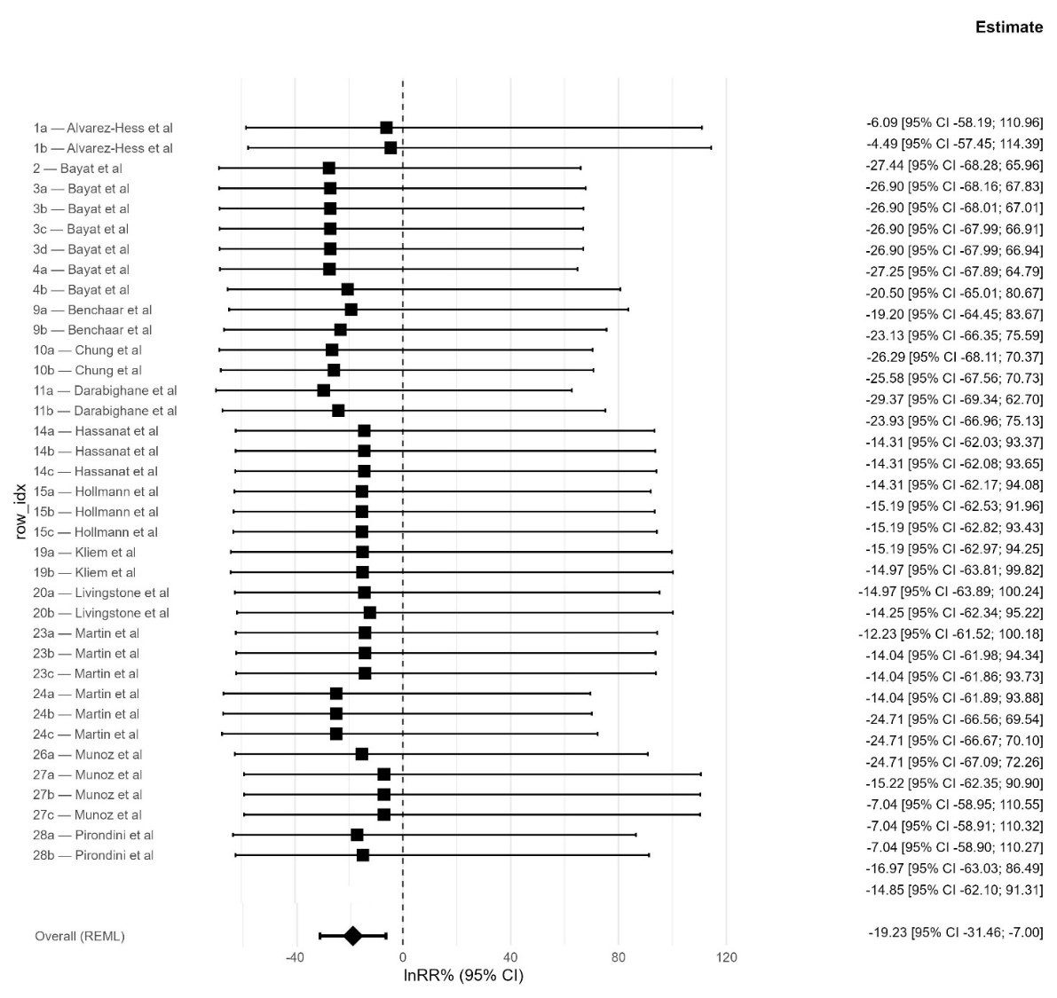
Figure S2. Forest plot of the use of PUFA for g/kg DMI of methane emission in lnRR percentage with the application of the model.
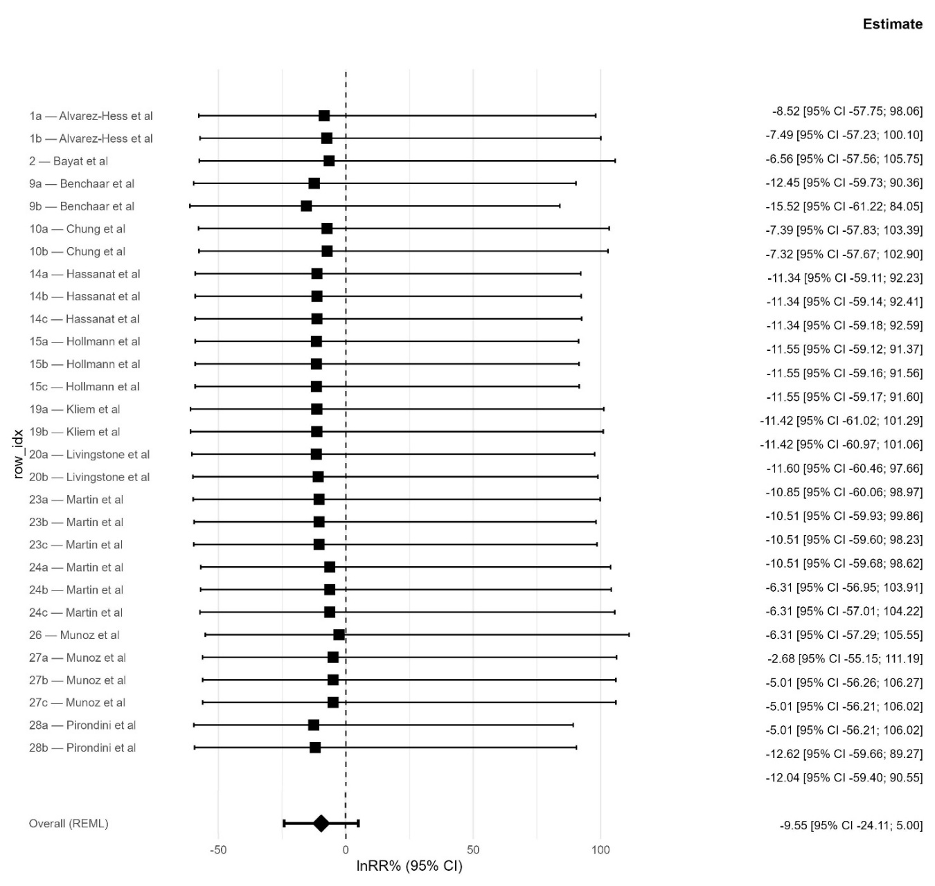
Figure S3. Forest plot of the use of PUFA for g/kg milk of methane emission in lnRR percentage with the application of the model.

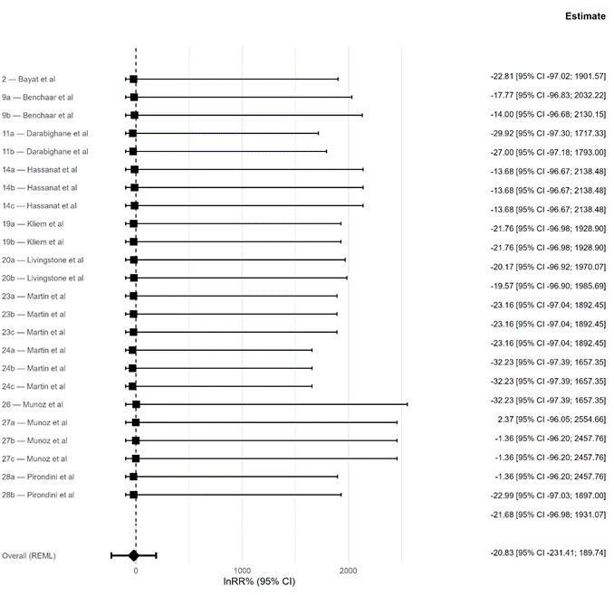

Figure S4. Forest plot of the use of PUFA for g/kg ECM of methane emission in lnRR percentage with the application of the model.

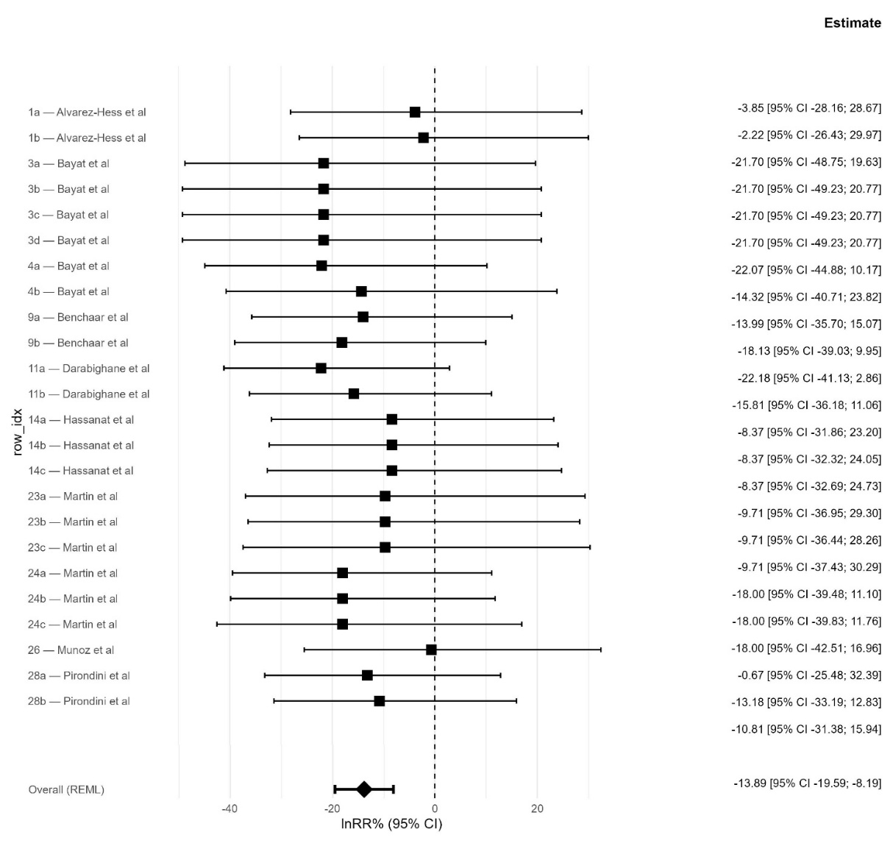
Figure S5. Forest plot of the use of 3-NOP for g/day methane emission in lnRR percentage without the application of the model.
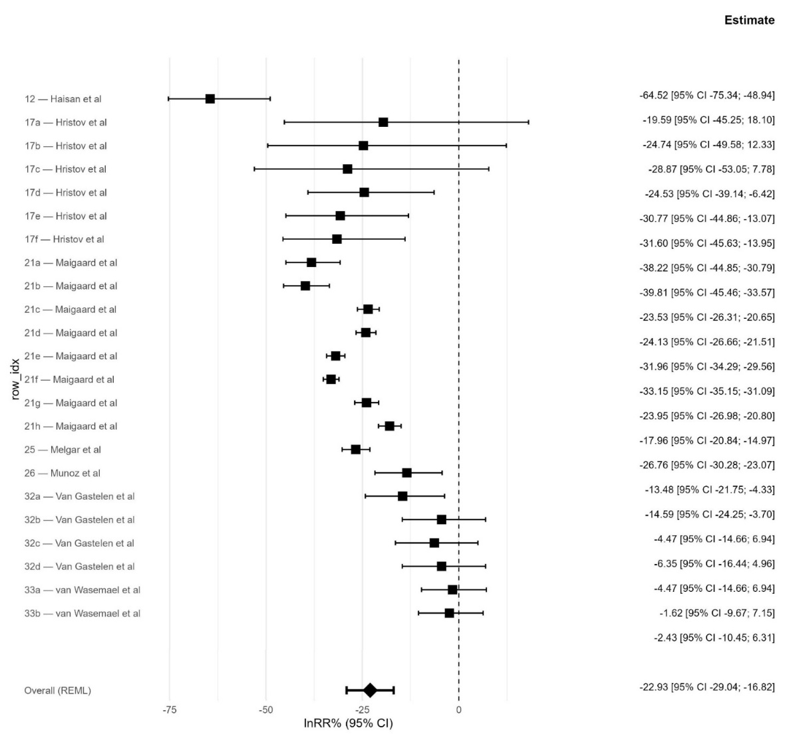
Figure S6. Forest plot of the use of 3-NOP for g/kg of DMI methane emission in lnRR percentage without the application of the model.
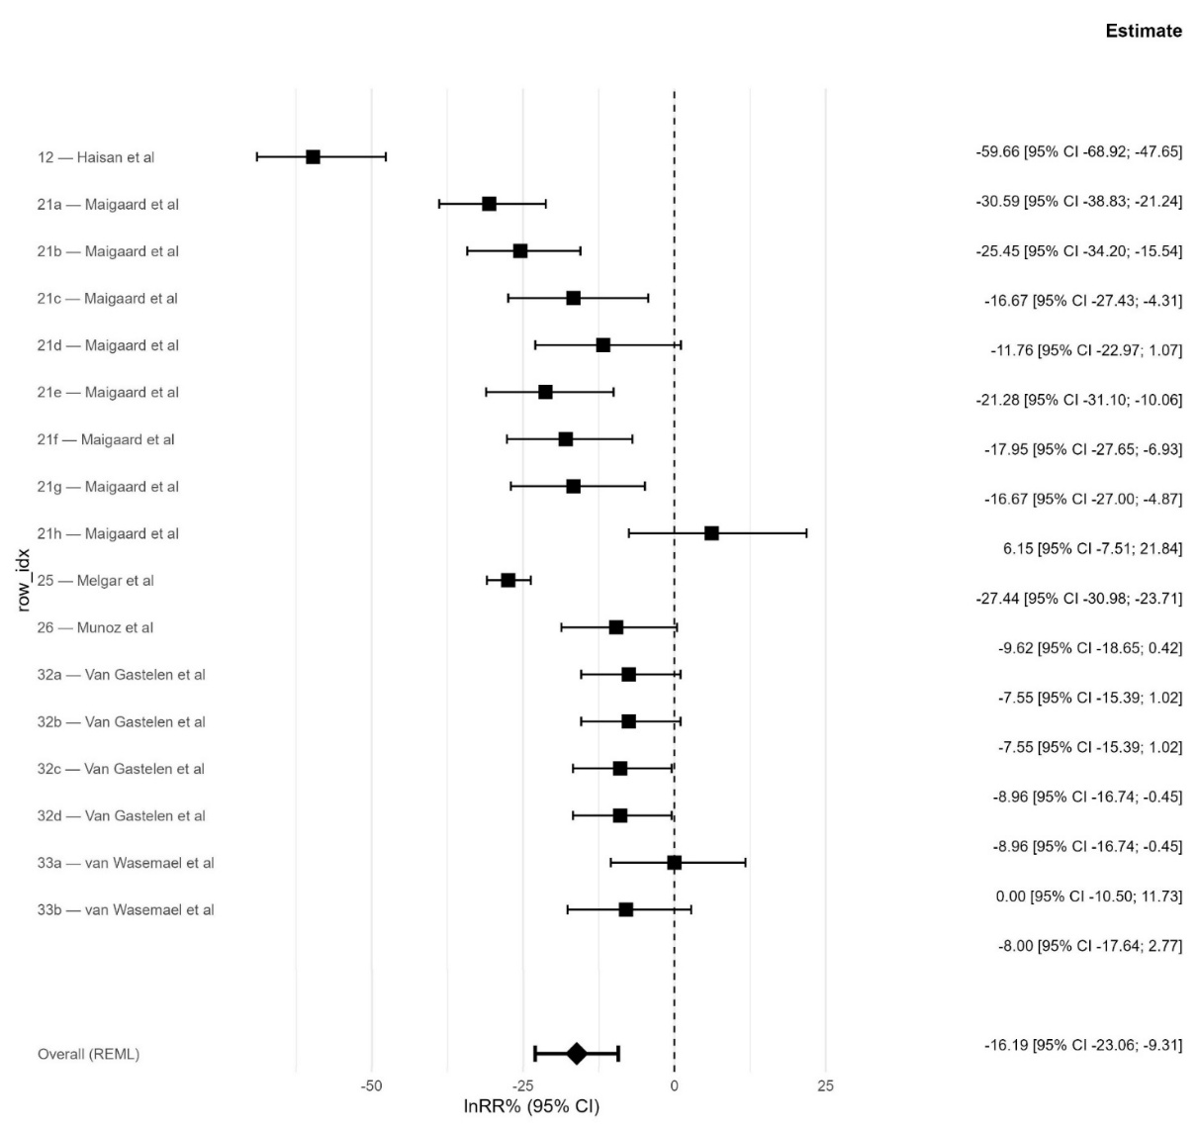
Figure S7. Forest plot of the use of 3-NOP for g/kg of ECM methane emission in lnRR percentage with the application of the model.
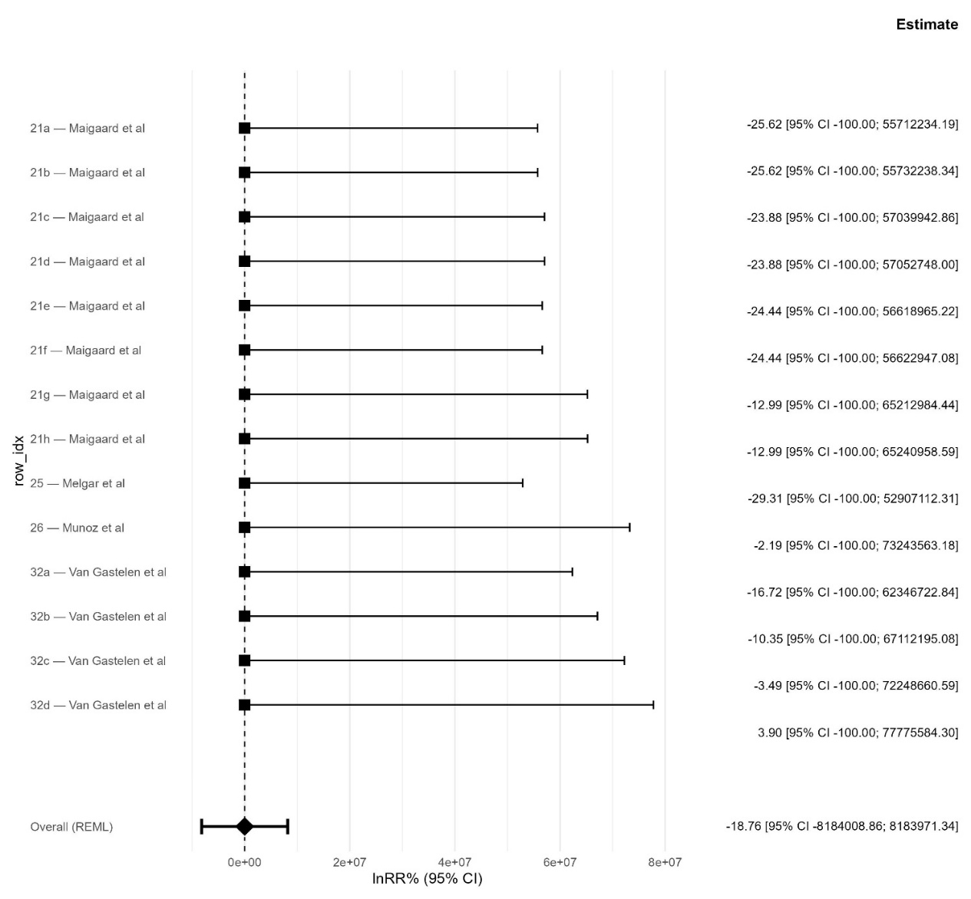

Figure S8. Forest plot obtained through meta-analysis of the use of EO in reduction of g/day methane emission with no three levels model application due to a not presence of statistically significant covariates for the correction of effect sizes.

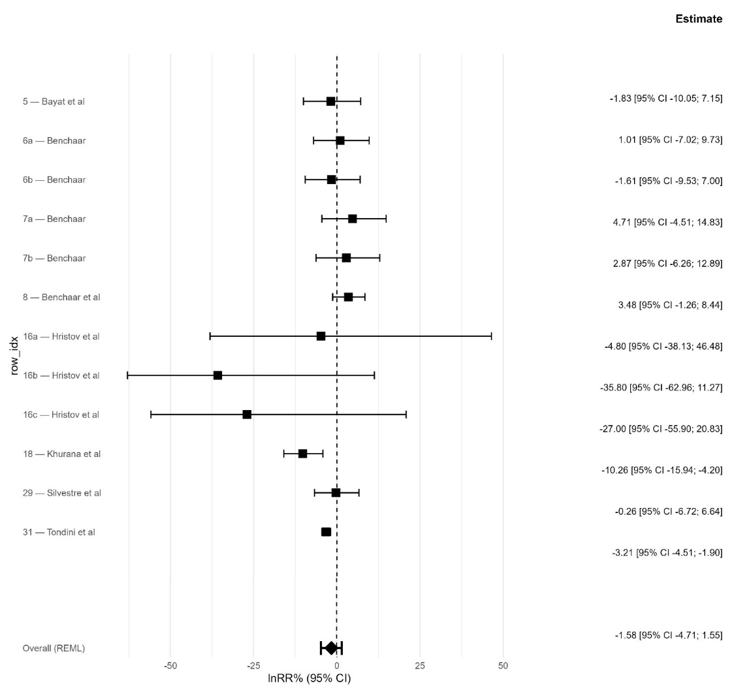
Figure S9. Forest plot of the use of EO for g/day of methane emission in lnRR percentage with the application of the model.
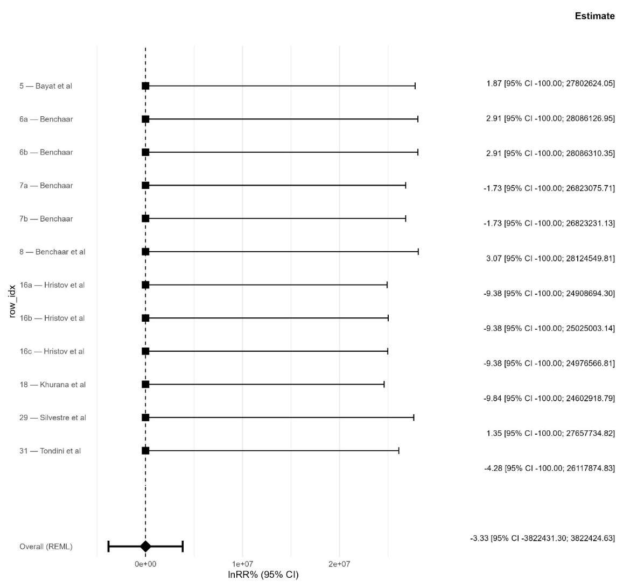

Figure S10. Forest plot obtained through meta-analysis of the use of EO in reduction of g/kg DMII methane emission with no three levels model application due to a not presence of statistically significant covariates for the correction of effect sizes.
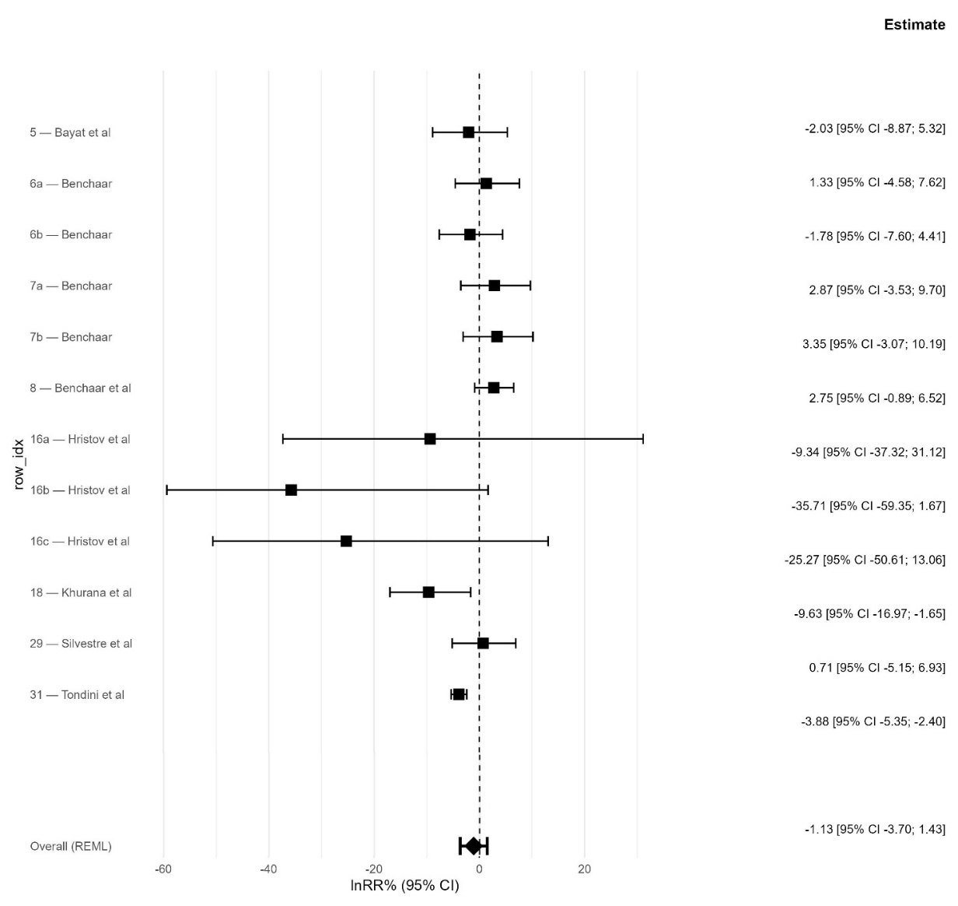
Figure S11. Forest plot of the use of EO for g/kg DMI of methane emission in lnRR percentage with the application of the model.
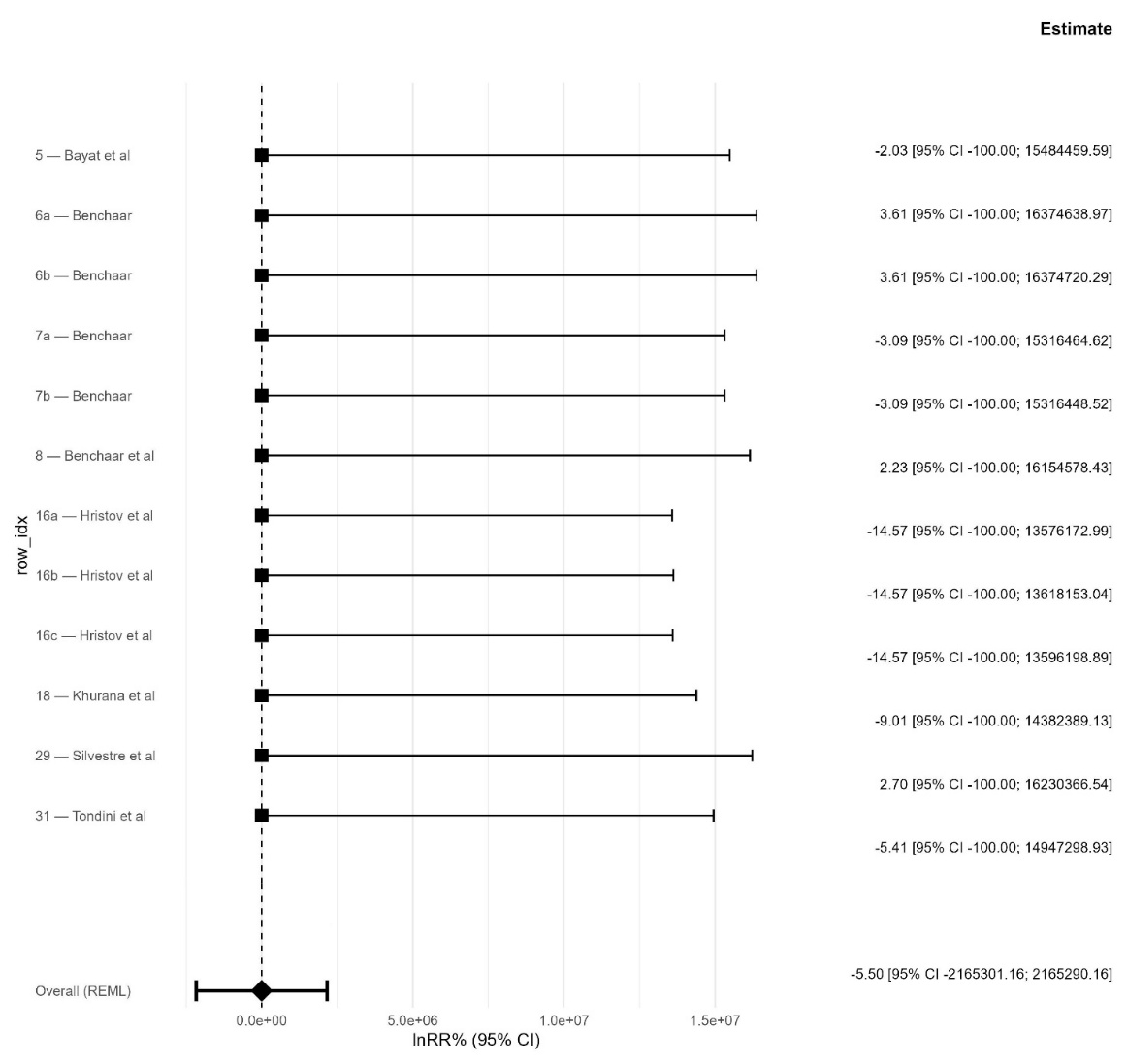
Figure S12. Forest plot obtained through meta-analysis of the use of EO in reduction of g/kg of milk methane emission with no three levels model application due to the low numbers of study available.

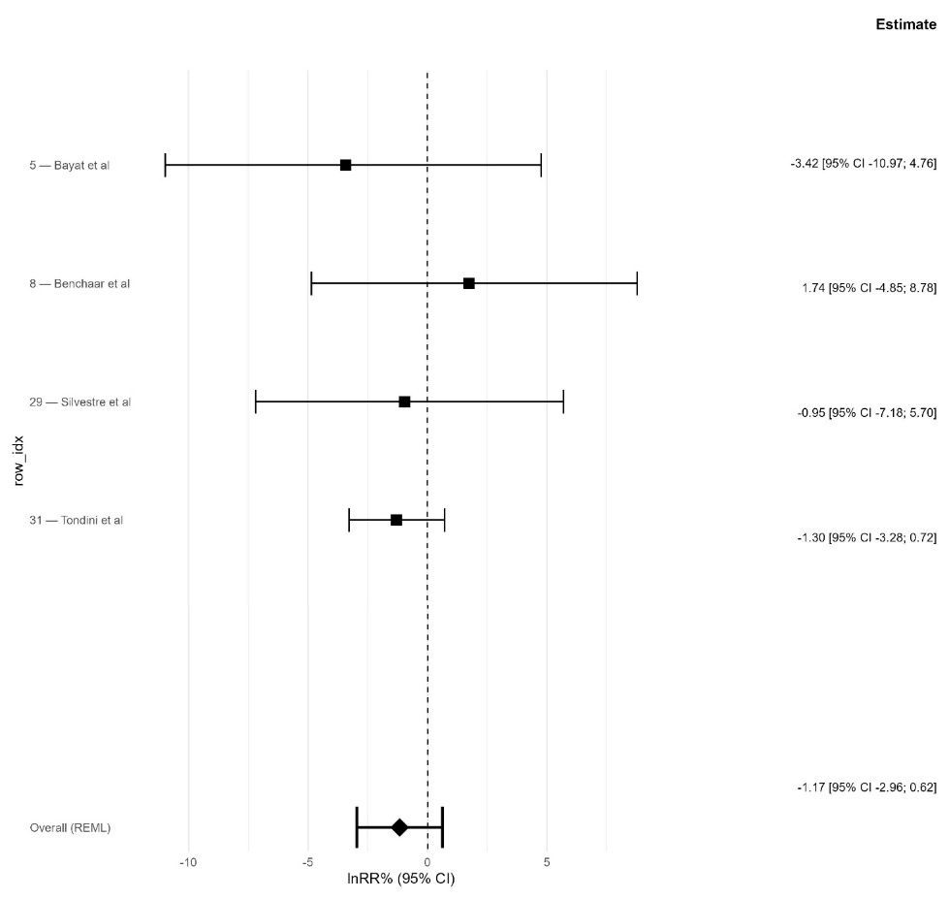
Figure S13. Forest plot obtained through meta-analysis of the use of EO in reduction of g/kg ECM methane emission with no three levels model application due to the low numbers of study available.

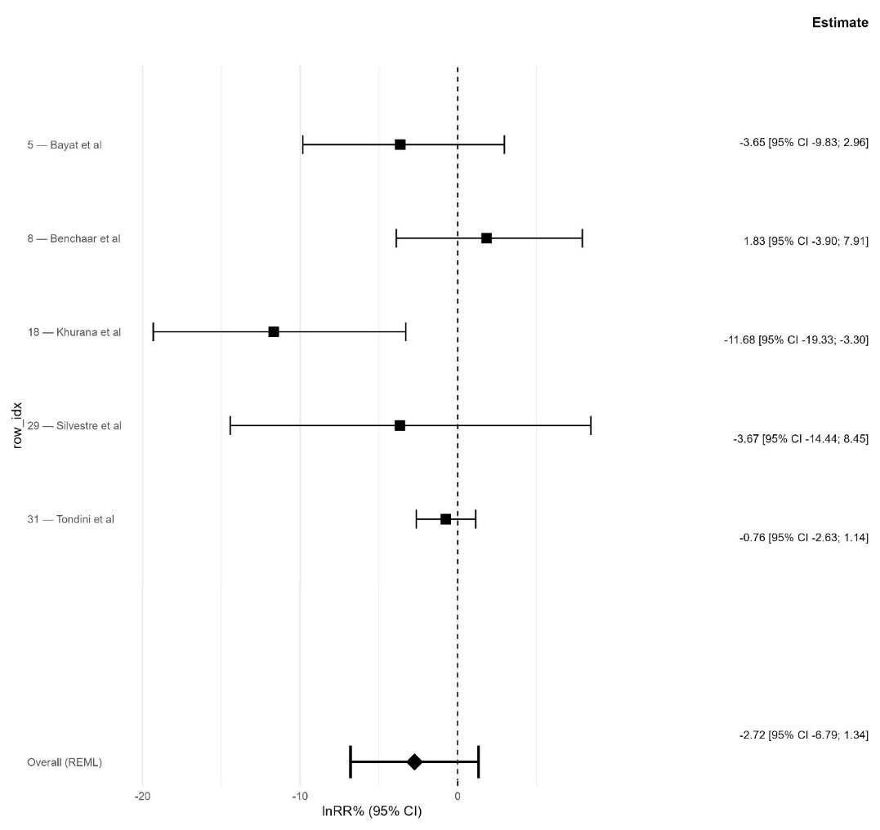
Figure S14. Forest plot obtained through meta-analysis of the use of Monensin in reduction of g/day methane emission with no three levels model application due to a too small sample size.

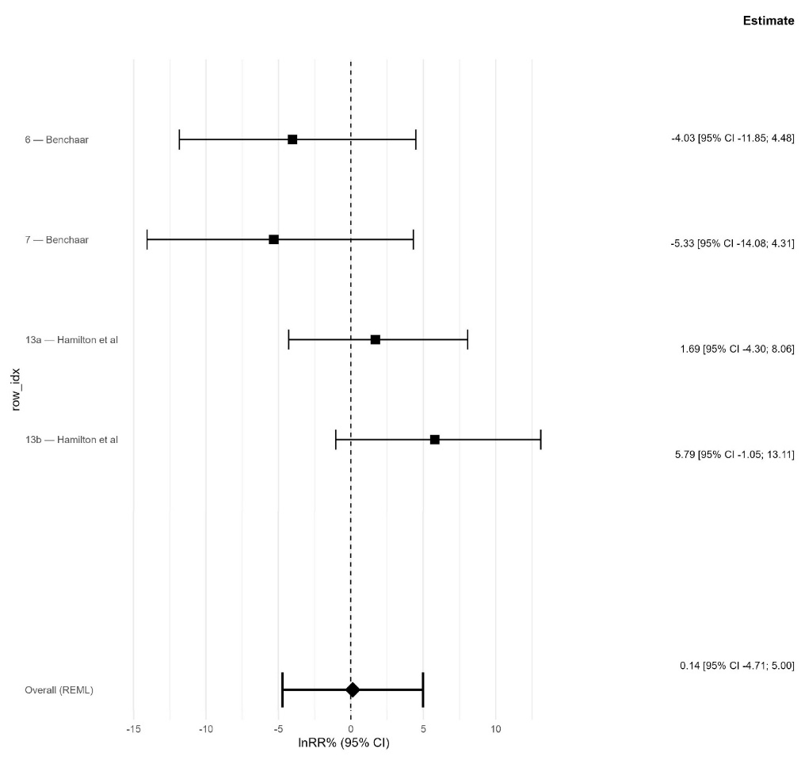
Figure S15. Forest plot obtained through meta-analysis of the use of Monensin in reduction of g/kg DMI methane emission with no three levels model application due to a too small sample size.
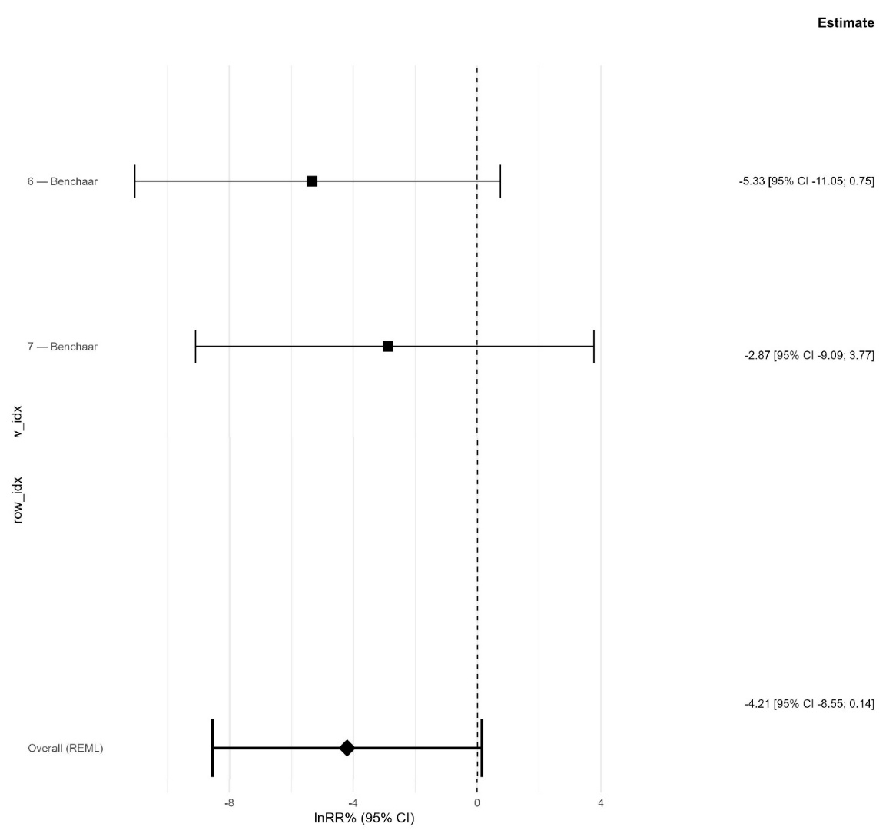
REFERENCES OF SUPPLEMENTARY MATERIALS

Alvarez-Hess, P. S., Williams, S. R. O., Jacobs, J. L., Hannah, M. C., Beauchemin, K.
A., Eckard, R. J., et al. (2019). Effect of dietary fat supplementation on methane
emissions from dairy cows fed wheat or corn. J. Dairy Sci. 102, 2714–2723. doi: 10.3168/
jds.2018-14721

Bayat, A. R., Kairenius, P., Stefanski, T., Leskinen, H., Comtet-Marre, S., Forano, E.,et al. (2015). Effect of camelina oil or live yeast (Saccharomyces cerevisiae) on ruminal methane production, rumen fermentation, and milk fatty acid composition in lactating cows fed grass silage diets. J. Dairy Sci. 98, 3166–3181. doi: 10.3168/jds.2014-7976

Bayat, A. R., Tapio, I., Vikki, J., Shingfield, K. J., and Leskinen, H. (2017a). Plant oil
supplements reduce methane emissions and improve milk fatty acid composition in
dairy cows fed grass silage-based diets without affecting milk yield. J. Dairy Sci. 101,
1136–1151. doi: 10.3168/jds.2017-13545

Bayat, A. R., Ventto, L., Kairenius, P., Stefanski, T., Leskinen, H., Tapio, I., et al.
(2017b). Dietary forage to concentrate ratio and sunflower oil supplement alter rumen
fermentation, ruminal methane emissions, and nutrient utilization in lactating cows.
Transl. Anim. Sci. 1, 277–286. doi: 10.2527/tas2017.0032

Bayat, A. R., Vikki, J., Razzaghi, A., Leskinen, H., Kettunen, H., Khurana, R., et al.
(2022). Evaluating the effects of high-oil rapeseed cake or natural additives on methane
emissions and performance of dairy cows. J. Dairy Sci. 105, 2. doi: 10.3168/jds.2021-
20537

Benchaar, C. (2016). Diet supplementation with cinnamon oil, cinnamaldehyde, or
Monensin does not reduce enteric methane production of dairy cows. Animal. 10, 418–
425. doi: 10.1017/S175173111500230X

Benchaar, C. (2019). Feedign oregano oil and its main component carvacrol does not
affect ruminal fermentation, nutrient utilization, methane emissions, milk production,
or milk fatty acid composition of dairy cows. J. Dairy Sci. 103, 1516–1527. doi: 10.3168/
jds.2019-17230

Benchaar, C., and Hassanat, F. (2024). Diet supplementation with a mixture of
essential oils: effects on enteric methane emissions, apparent total-tract nutrient
digestibility, nitrogen utilization, and lactational performance. J. Dairy Sci. 108,
3560–3572. doi: 10.3168/jds.2024-25447

Benchaar, C., Hassanat, F., Martineau, R., and Gervais, R. (2015). Linseed oil
supplementation to dairy cows fed diets based on red clover silage or corn silage:
effects on methane production, rumen fermentation, nutrient digestibility, N balance,
and milk production. J. Dairy Sci. 98, 79993–78008. doi: 10.3168/jds.2015-9398

Chung, Y. H., He, M. L., McGinn, S. M., McAllister, T. A., and Beauchemin, K. A.
(2011). Linseed suppresses enteric methane emissions from cattle fed barley silage, but
not from those fed grass hay. Anim. Feed Sci. Technol. 166, 321–329. doi: 10.1016/
j.anifeedsci.2011.04.022

Darabighane, B., Tapio, I., Ventto, L., Kairenius, P., Stefanski, T., Leskinen, H., et al.
(2021). Effects of starch level and a mixture of sunflower and fish oils on nutrient intake
and digestibility, rumen fermentation, and ruminal methane emissions in dairy cows.
Animals. 11, 1310. doi: 10.3390/ani11051310

Haisan, J., Sun, Y., Guan, L. L., Beauchemin, K. A., Iwaasa, A., Duval, S., et al. (2014).
The effects of feeding 3-nitrooxyproanol on methane emissions and productivity of
Holstein cows in mid lactation. J. Dairy Sci. 97, 3110–3119. doi: 10.3168/jds.2013-7834

Hamilton, S. W., DePeters, E. J., McGarvey, J. A., Lathrop, J., and Mitloenher, F. M.
(2010). Greenhouse gas, animal performance, and bacterial population structure
responses to dietary Monensin fed to dairy cows. J. Environ. Qual. 39, 106–114.
doi: 10.2134/jeq2009.0035

Hassanat, F., and Benchaar, C. (2021). Corn silage-based diet supplemented with
increasing amounts of linseed oil: effects on methane production, rumen fermentation,
nutrient digestibility, nitrogen utilization, and milk production of dairy cows. J. Dairy
Sci. 104, 5375–5390. doi: 10.3168/jds.2020-18853

Hollmann, M., Powers, W. J., Fogiel, A. C., Liesman, J. S., Bello, N. M., and Beede, D.
K. (2012). Enteric methane emissions and lactational performance of Holstein cows fed
different concentrations of coconut oil. J. Dairy Sci. 95, 2602–2615. doi: 10.3168/
jds.2011-4896

Hristov, A. N., Lee, C., Cassidy, T., Heyler, K., Tekippe, J. A., Varga, G. A., et al.
(2013a). Effect of Origanum vulgare L. leaves on rumen fermentation, production, and
milk fatty acid composition in lactating dairy cows. J. Dairy Sci. 96, 1189–1202.
doi: 10.3168/jds.2012-5975

Hristov, A. N., Oh, J., Firkins, J. L., Dijkstra, J., Kenbreab, E., Waghorn, G., et al.
(2013b). Mitigation of methane and nitrous oxide emissions from animal operations: a
review of enteric methane mitigation options. J. Anim. Sci. 91, 5045–5069. doi: 10.2527/
jas.2013-6583

Hristov, A. N., Oh, J., Giallongo, F., Frederick, T. W., Harper, M., Weeks, H. L., et al.
(2015). An inhibitor persistently decreased enteric methane emission from dairy cows
with no negative effect on milk production. Proc. Natl. Acad. U.S.A. 25 112, 10663–
10668. doi: 10.1073/pnas.1504124112

Khurana, R., Brand, T., Tapio, I., and Bayat, A. R. (2023). Effect of a garlic and citrus
extract supplement on performance, rumen fermentation, methane production, and
rumen microbiome of dairy cows. J. Dairy Sci. 106, 4608–4621. doi: 10.3168/jds.2022-
22838

Kliem, K. E., Humphries, D. J., Kirton, P., Givens, D. I., and Reynolds, C. K. (2019).
Differential effects of oilseed supplements on methane production and milk fatty acid
concentrations in dairy cows. Animal. 13, 309–317. doi: 10.1017/S1751731118001398

Livingstone, K. M., Humphries, D. J., Kirton, P., Kliem, K. E., Givens, D. I., and
Reynolds, C. K. (2015). Effects of forage type and extruded linseed supplementation on
methane production and milk fatty acid composition of lactating dairy cows. J. Dairy
Sci. 98, 4000–4011. doi: 10.3168/jds.2014-8987

Maigaard, M., Weisbjerg, M. R., Johansen, M., Walker, N., Ohlsson, C., and Lund, P.
(2024). Effects of dietary fat, nitrate, 3-nitrooxypropanol and their combinations on
methane emission, feed intake, and milk production in dairy cows. J. Dairy Sci. 107,
220–241. doi: 10.3168/jds.2023-23420

Martin, C., Coppa, M., Fougere, H., Bougouin, A., Baumont, R., Eugene, M., et al.
(2021). Diets supplemented with corn oil and wheat starch, marine algae, or
hydrogenated palm oil modulate methane emissions similarly in dairy goats and
cows, but not feeding behavior. Anim. Feed Sci. Technol. 272, 114783. doi: 10.1016/
j.anifeedsci.2020.114783

Martin, C., Ferlay, A., Mosoni, O., Rochette, Y., Chilliard, Y., and Doreau, M. (2016).
Increasing linseed supply in dairy cow diets based on hay or corn silage: effect on
enteric methane emission, rumen microbial fermentation, and digestion. J. Dairy Sci.
99, 3445–3456. doi: 10.3168/jds.2015-10110

Martin, C., Rouel, J., Jouany, J. P., Doreau, M., and Chilliard, Y. (2008). Methane
output and diet digestibility in response to feeding dairy cows crude linseed, extruded
linseed, or linseed oil. J. Anim. Sci. 86, 2642–2650. doi: 10.2527/jas.2007-0774

Melgar, A., Lage, C. F. A., Nedelkov, K., Raisanen, S. E., Stefanoni, H., Fetter, M. E.,
et al. (2021). Enteric methane emission, milk production, and composition of dairy
cows fed 3-nitrooxypropanol. J. Dairy Sci. 104, 357–366. doi: 10.3168/jds.2020-18908

Munoz, C., Munoz, I. A., Rodriguez, R., Urrutia, N. L., and Ungarfeld, E. M. (2024).
Effect of combining the methanogenesis inhibitor 3-nitrooxypropanol and cottonseeds
on methane emission, feed intake, and milk production of grazing dairy cows. Animal.
18, 101203. doi: 10.1016/j.animal.2024.101203

Munoz, C., Villalobos, R., Peralta, A. M. T., Morales, R., Urrutia, N. L., and
Ungerfeld, E. M. (2021). Long-term and carryover effects of supplementation with
whole oilseeds on methan emission, milk production and milk fatty acid profile of
grazing dairy cows. Animals. 11, 2978. doi: 10.3390/ani11102978

Pirondini, M., Colomcini, S., Mele, M., Malagutti, L., Rapetti, L., Galassi, G., et al.
(2015). Effect of dietary starch concentration and fish oil supplementation on milk yield
and composition, diet digestibility, and methane emissions in lactating dairy cows. J.
Dairy Sci. 98, 357–372. doi: 10.3168/jds.2014-8092

Silvestre, T., Martins, L. F., Cueva, S. F., Wasson, D. E., Stepanchenko, N., Raisanen,
S. E., et al. (2023). Lactational performance, rumen fermentation, nutrient use
efficiency, enteric methane emissions, and manure greenhouse gas-emitting potential
in dairy cows fed a blend of essential oils. J. Dairy Sci. 106, 7661–7674. doi: 10.3168/
jds.2022-23181

Storlien, T. M., Prestlokken, E., Beauchemin, K. A., McAllister, T. A., Iwaasa, A., and
Harstrad, O. M. (2017). Supplementation with crushed rapeseed causes reduction of
methane emissions from lactating dairy cows on pasture. Anim. Prod. Sci. 57, 81–89.
doi: 10.1071/AN15287

Tondini, S. M., Bayat, A. R., Khelil-Arfa, H., Blanchard, A., and Yanez-Ruiz, D. R.
(2024). Effect of a blend of cinnamaldehyde, eugenol and capsicum oleoresin on
methane emission and lactation performance of Nordic Red dairy cows fed grass silagebased
diets. Livest. Sci. 284, 105494. doi: 10.1016/j.livsci.2024.105494

Van Gastelen, S., Dijkstra, J., Binnendijk, G., Duval, S. M., Heck, J. M. L.,
Kindermann, M., et al. (2020). 3-nitrooxypropanol decreases methane emissions and
increase hydrogen emissions of early lactation dairy cows, with associated changes in
nutrient digestibility and energy metabolism. J. Dairy Sci. 103, 8074–8093. doi: 10.3168/
jds.2019-17936

Van Wesemael, D., Vandaele, L., Ampe, B., Cattrysse, H., Duval, S., Kindermann, M.,
et al. (2020). Reducing enteric methane emissions from dairy cattle: two ways to
supplement 3-nitrooxypropanol. J. Dairy Sci. 102, 1780–1787. doi: 10.3168/jds.2018-
14534

Williams, S. R. O., Hannah, M. C., Eckard, R. J., Wales, W. J., and Moate, P. J. (2020).
Supplementing the diet of dairy cows with fat or tannin reduces methane yield, and
additively when fed in combination. Animal. 14, 464–472. doi: 10.1017/
S1751731120001032

