APPENDIX

Descriptive statistics for similarity
In complement to our main analysis, we here present univariate statistics on our similarity measure Sim. The following table reports the mean of Sim at the year of the call by call, by field, and in total, along with t-tests for the difference in mean similarity across groups, for the set of potential applicants found using subject categories.
In the overall dataset, the difference in mean similarity between Applicants and Non-Applicants equals 0.97, and is significant at conventional levels (p<0.01); while the difference in mean similarity between Winners and Non-Winning Applicants equals -0.03, and is not significant (p>0.1).
The results for the comparison between Applicants and Non-Applicants hold across all fields with statistical significance (p<0.01), while the negative difference in average mean between Winners and Non-Winning Applicants is statistically significant for call in Physics (p<0.05) and Chemistry (p<0.1), while is not statistically significant in all other fields.
The difference between Applicants and Non-Applicants is positive in 19 out of 21 calls, achieving statistical significance in all the 19 calls for which it is positive. The difference is instead negative in 2 out of 21 calls (RMX18 and RB13), but without statistical significance. The difference between Winners and Non-Winning Applicants is negative in 13 out of 21 calls, with statistical significance in only 1 of it (EM16, p<0.1), positive in 7 out of 21 calls, never with statistical significance. One call (IRT11) has only 1 winner and thus cannot be tested for difference in means.

Table 1: Descriptive statistics.
 |  |  | Applicants  vs  Non-Applicants |  |  |  |  | Non-Winning Applicants  vs  Winners
 | Non-Applicants | Applicants | Δ | σ |  | Non-Winning  Applicants | Winners | Δ | σ
Call
AM13 | -0.08 | 0.82 | 0.90 | 0.12 | *** | 0.86 | 0.48 | -0.38 | 0.27
BD15 | -0.05 | 1.48 | 1.52 | 0.12 | *** | 1.49 | 1.38 | -0.11 | 0.59
EM11 | -0.24 | 0.18 | 0.43 | 0.19 | ** | 0.16 | 0.26 | 0.10 | 0.31
EM16 | 0.07 | 0.58 | 0.51 | 0.13 | *** | 0.64 | 0.25 | -0.38 | 0.21 | *
GMT14 | -0.07 | 1.13 | 1.20 | 0.15 | *** | 1.24 | 0.43 | -0.82 | 0.61
IIS11 | -0.24 | 1.95 | 2.19 | 0.11 | *** | 1.90 | 2.42 | 0.52 | 0.63
IRT11 | -0.42 | 1.80 | 2.21 | 0.20 | *** | 1.90 | 0.24 | . | .
KF10 | -0.37 | -0.09 | 0.28 | 0.13 | ** | -0.08 | -0.16 | -0.08 | 0.41
RB13 | 0.04 | -0.07 | -0.12 | 0.08 |  | -0.07 | -0.12 | -0.05 | 0.22
RBP14 | 0.04 | 0.99 | 0.96 | 0.17 | *** | 0.97 | 1.07 | 0.10 | 0.25
RE10 | -0.32 | 1.12 | 1.44 | 0.11 | *** | 1.11 | 1.31 | 0.20 | 0.42
RIT10 | -0.32 | 2.04 | 2.36 | 0.12 | *** | 2.05 | 1.98 | -0.07 | 0.45
RIT15 | 0.01 | 2.36 | 2.34 | 0.12 | ** | 2.42 | 1.93 | -0.49 | 0.42
RIT17 | 0.00 | 3.00 | 3.00 | 0.19 | *** | 2.94 | 3.14 | 0.20 | 0.52
RMA11 | -0.23 | 1.43 | 1.67 | 0.11 | *** | 1.50 | 0.88 | -0.62 | 0.43
RMA15 | -0.05 | 1.06 | 1.11 | 0.11 | ** | 1.11 | 0.74 | -0.37 | 0.27
MX18 | 0.02 | -0.12 | -0.14 | 0.14 |  | -0.11 | -0.23 | -0.12 | 0.34
SB12 | 0.15 | 0.44 | 0.29 | 0.12 | ** | 0.40 | 0.62 | 0.21 | 0.20
SB16 | 0.26 | 0.49 | 0.23 | 0.13 | * | 0.52 | 0.35 | -0.17 | 0.26
SBE13 | 0.31 | 0.87 | 0.55 | 0.09 | *** | 0.90 | 0.56 | -0.34 | 0.26
SE13 | -0.06 | 1.03 | 1.09 | 0.16 | *** | 1.02 | 1.10 | 0.08 | 0.30
Field
ICT | -0.11 | 1.59 | 1.70 | 0.06 | *** | 1.57 | 1.69 | 0.12 | 0.23
ENG | 0.00 | 1.22 | 1.21 | 0.04 | *** | 1.22 | 1.20 | -0.02 | 0.15
PHYS | 0.01 | 0.90 | 0.88 | 0.05 | *** | 0.93 | 0.63 | -0.30 | 0.14 | **
CHEM | 0.07 | 0.67 | 0.60 | 0.04 | *** | 0.69 | 0.46 | -0.23 | 0.14 | *
MED | 0.10 | 0.24 | 0.14 | 0.05 | *** | 0.24 | 0.21 | -0.03 | 0.12
BIO | 0.08 | 0.50 | 0.42 | 0.05 | *** | 0.49 | 0.53 | 0.04 | 0.18
Total | 0.00 | 0.97 | 0.97 | 0.03 | *** | 0.97 | 0.94 | -0.03 | 0.11
* p<0.10, ** p<0.05, *** p<0.01

Potential Applicants identified by journals
Table 2: Potential Applicants count: per call, per field, and total.

 | Non-Applicants | Applicants |  |  | Total
 |  | Applicants  Non-Reviewed | Reviewed  Non-Winners | Winners
Call
AM13 | 262 | 34 | 24 | 6 | 326
BD15 | 948 | 46 | 14 | 7 | 1,015
EM11 | 293 | 3 | 15 | 5 | 316
EM16 | 360 | 34 | 20 | 9 | 423
GMT14 | 778 | 32 | 18 | 8 | 836
IIS11 | 276 | 17 | 24 | 4 | 321
IRT11 | 198 | 0 | 15 | 1 | 214
KF10 | 378 | 29 | 11 | 5 | 423
RB13 | 862 | 103 | 21 | 9 | 995
RBP14 | 345 | 18 | 14 | 8 | 385
RE10 | 268 | 16 | 40 | 6 | 330
RIT10 | 256 | 14 | 28 | 8 | 306
RIT15 | 620 | 52 | 19 | 10 | 701
RIT17 | 372 | 15 | 6 | 10 | 403
RMA11 | 408 | 16 | 38 | 6 | 468
RMA15 | 702 | 31 | 43 | 10 | 786
RMX18 | 1,151 | 41 | 18 | 6 | 1,216
SB12 | 267 | 29 | 19 | 9 | 324
SB16 | 615 | 36 | 16 | 9 | 676
SBE13 | 1,373 | 42 | 33 | 8 | 1,456
SE13 | 262 | 9 | 21 | 8 | 300
Field
ICT | 2,892 | 158 | 114 | 43 | 3,207
ENG | 6,271 | 309 | 266 | 88 | 6,934
PHYS | 5,695 | 222 | 217 | 60 | 6,194
CHEM | 6,617 | 349 | 218 | 65 | 7,249
MED | 4,646 | 280 | 118 | 46 | 5,090
BIO | 4,679 | 250 | 100 | 38 | 5,067
Total | 10,994 | 617 | 457 | 152 | 12,220

Figure 2: Love plot for the matching of applicants vs non-applicants.

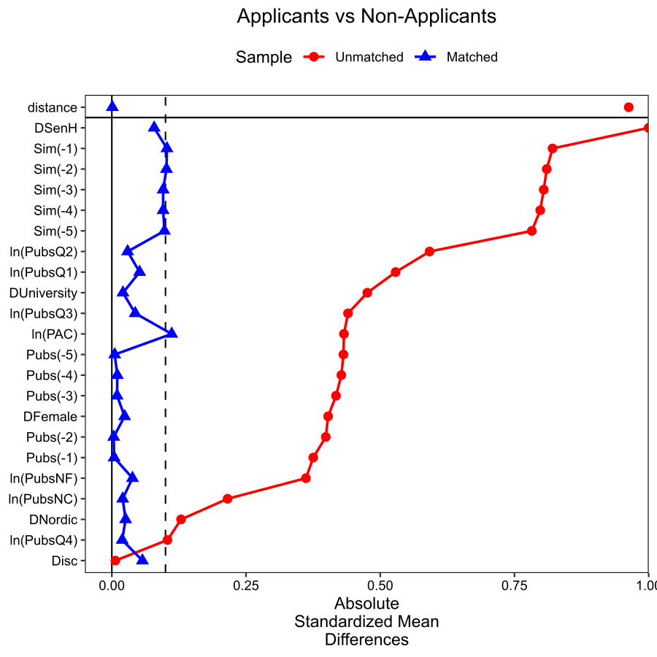

Table 5: DID results. DV: Sim(t).

Treated Group | Applicants |  | Non-Winning Applicants |  | Winning Applicants
Non-Treated Group | Non-Applicants |  | Non-Applicants |  | Non-Winning Applicants
D_{gt} | 0.198 | *** | 0.157 | *** | -0.021
 | (0.03) |  | (0.03) |  | (0.03)
Pubs(t) | -0.002 | *** | -0.002 | *** | 0.000
 | (0.00) |  | (0.00) |  | (0.00)
Year FE | YES |  | YES |  | YES
Group FE | YES |  | YES |  | YES
Intercept | 0.959 | *** | 0.885 | *** | 0.807 | ***
 | (0.02) |  | (0.02) |  | (0.02)
N | 134,420 |  | 132,748 |  | 13,486
*** p<0.01, ** p<0.05, * p<0.1

Nearest Neighbor Matching
Figure 2: Love plot for the matching of applicants vs non-applicants.
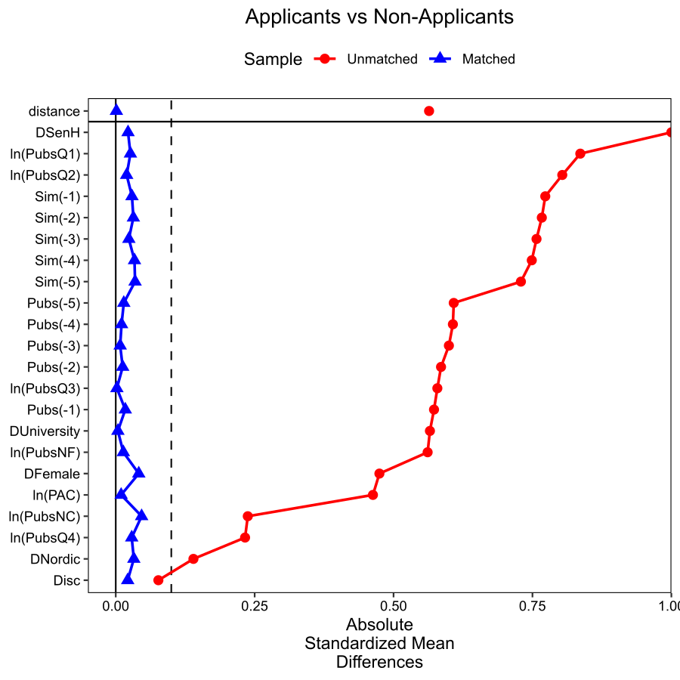

Table 5: DID results. DV: Sim(t).

Treated Group | Applicants |  | Non-Winning Applicants |  | Winning Applicants
Non-Treated Group | Non-Applicants |  | Non-Applicants |  | Non-Winning Applicants
D_{gt} | 0.114 | *** | 0.121 | *** | 0.020
 | (0.02) |  | (0.02) |  | (0.05)
Pubs(t) | 0.000 |  | -0.001 | * | 0.001
 | (0.00) |  | (0.00) |  | (0.00)
Year FE | YES |  | YES |  | YES
Group FE | YES |  | YES |  | YES
Intercept | 0.868 | *** | 0.857 | *** | 0.906 | ***
 | (0.01) |  | (0.01) |  | (0.03)
N | 26,972 |  | 23,628 |  | 3,344
*** p<0.01, ** p<0.05, * p<0.1

Non-Synthetic Control Group
Figure 2: Love plot for the matching of applicants vs non-applicants.
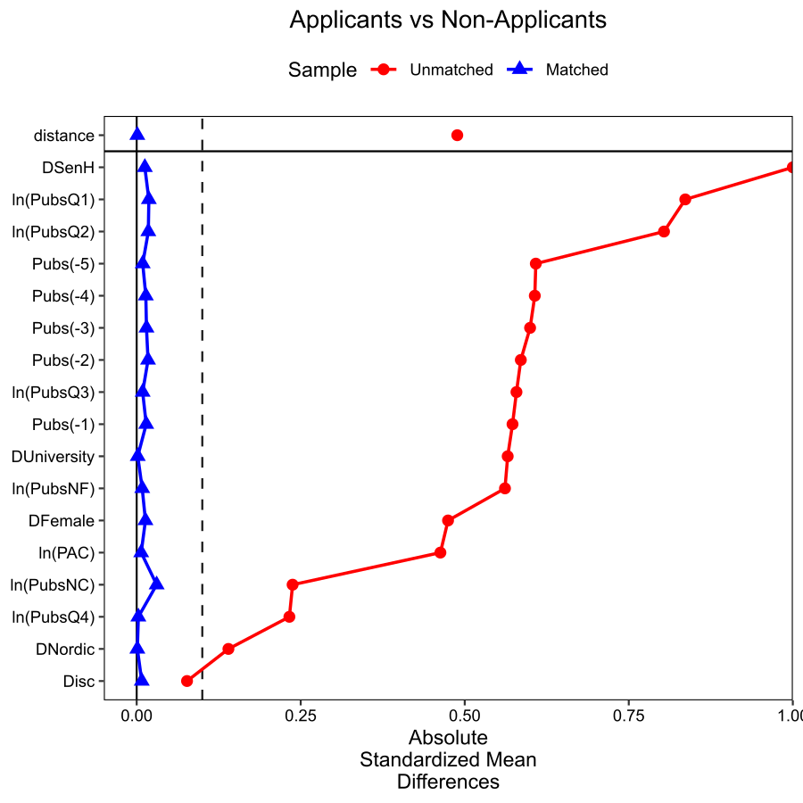

Table 5: DID results. DV: Sim(t).

Treated Group | Applicants |  | Non-Winning Applicants |  | Winning Applicants
Non-Treated Group | Non-Applicants |  | Non-Applicants |  | Non-Winning Applicants
D_{gt} | 0.043 | *** | 0.054 | *** | -0.060
 | (0.01) |  | (0.02) |  | (0.04)
Pubs(t) | -0.001 | *** | -0.001 | *** | 0.001 | *
 | (0.00) |  | (0.00) |  | (0.00)
Year FE | YES |  | YES |  | YES
Group FE | YES |  | YES |  | YES
Intercept | -0.002 |  | -0.001 |  | 0.750 | ***
 | (0.00) |  | (0.00) |  | (0.03)
N | 1,721,632 |  | 1,719,960 |  | 3,344
*** p<0.01, ** p<0.05, * p<0.1

Staggered DiD
Table: DID results. DV: Sim(t).
 | Applicants  Non-Applicants | Non-Winning Applicants  Non-Applicants | Winning Applicants  Non-Winning Applicants
D_{gt} | 0.078*** | 0.081*** | 0.024
 | (0.018) | (0.019) | (0.034)
Pubs(t) | -0.001 | -0.001* | 0.000
 | (0.000) | (0.000) | (0.001)
N | 26,972 | 23,628 | 3,344
R2 | 0.905 | 0.908 | 0.932
Adj. R2 | 0.895 | 0.898 | 0.922
R2 Within | 0.007 | 0.009 | 0.019
Adj. R2 Within | 0.006 | 0.008 | 0.006
AIC | 36,587 | 31,525 | 2,527
BIC | 57,594 | 49,740 | 5,052
RMSE | 0.434 | 0.429 | 0.312
p < 0.1, * p < 0.05, ** p < 0.01, *** p < 0.001

Figure: Plot of ATT over time.
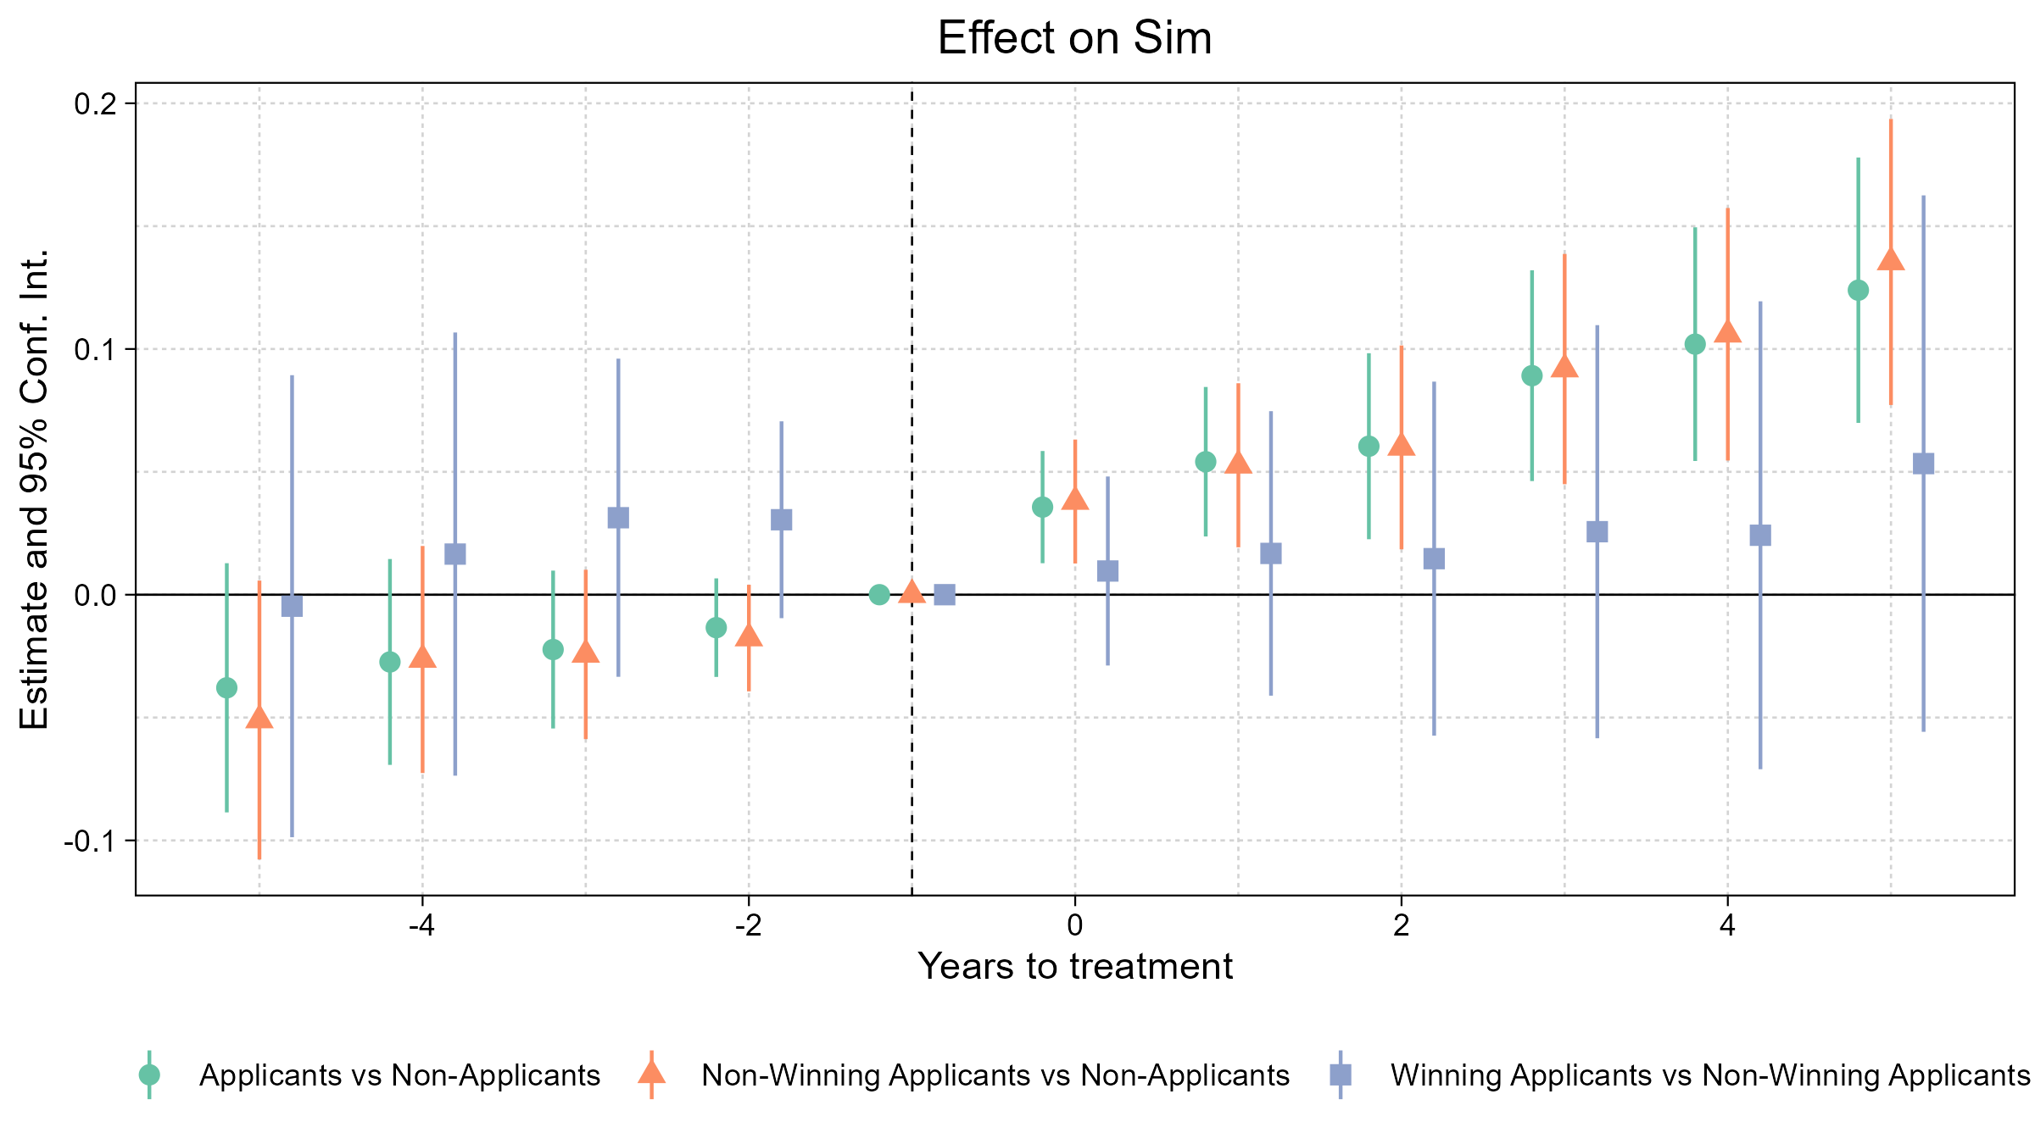

Figure: Visual representation of the overall effect.
