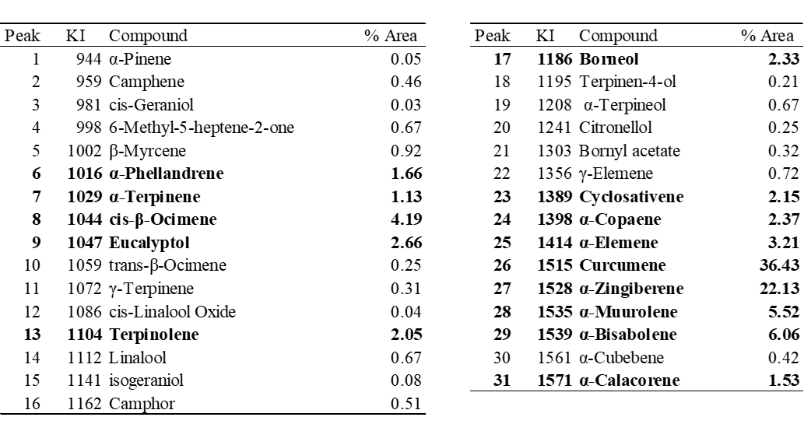
Supplementary material 1. Total ion chromatogram and identification of the volatile composition of ginger oleoresin by HS-SPME–GC-MS. KI: Kovats' retention index.

