Biodegradation of untreated plasticizers-free linear low-density polyethylene films by marine bacteria

Kejvin Bajoª, Roberta Romanoª, Boris Kolvenbach^{b}, Seyed Amirabbas Nazemi^{b}, Patrick Shahgaldian^{b}, Philippe F.-X. Corvini^{b}, Fabio Favaª, Noura Raddadiª*.

ªDepartment of Civil, Chemical, Environmental and Materials Engineering (DICAM)-University of Bologna, Italy

^{b} Institute for Ecopreneurship, School of Life Sciences, FHNW, Muttenz, Switzerland

* Corresponding author: Noura Raddadi. Department of Civil, Chemical, Environmental and Materials Engineering (DICAM), via Terracini 28, 40131 Bologna, Italy. E-mail: noura.raddadi@unibo.it

Supplementary material
Table 1 (S1) - 16S rRNA and gyrB gene sequences similarities of the seven isolates with their closest relative species.
Gene | Isolate name | Acc. No | Closest relative species | % homology | Acc. No closest relative
16S rRNA | MT8 | PQ035173 | Vreelandella titanicae BH1 | 99.36 | NR_116997.1
16S rRNA | MT11 | PQ035174 | Vreelandella titanicae BH1 | 99.71 | NR_116997.1
16S rRNA | MT1 | PQ035175 | Vreelandella venusta DSM 4743 | 99.86 | NR_042069.1
16S rRNA | MT22 | PQ035176 | Vreelandella titanicae BH1 | 99.57 | NR_116997.1
16S rRNA | MT9 | PQ035177 | Bacillus velezensis D103 | 99.64 | CP095093.1
16S rRNA | MT35 | PQ035178 | Bacillus velezensis NN-FX52 | 99.64 | MN631089.1
16S rRNA | MT18 | PQ035179 | Stenotrophomonas maltophilia SKK55 | 99.57 | CP040433.1
gyrB | MT8 | PQ096957 | Vreelandella titanicae BH1 | 99.91 | MT680914.1
gyrB | MT11 | PQ096958 | Vreelandella titanicae BH1 | 99.74 | MT680914.1
gyrB | MT1 | PQ096959 | Vreelandella venusta Hven7 | 100 | CP090951.1
gyrB | MT22 | PQ096960 | Vreelandella titanicae BH1 | 100 | MT680914.1
gyrB | MT9 | PQ096961 | Bacillus velezensis B268 | 99.83 | CP053764.1
gyrB | MT35 | PQ096962 | Bacillus velezensis B268 | 99.91 | CP053764.1
gyrB | MT18 | PQ096963 | Stenotrophomonas maltophilia SKK55 | 99.65 | CP040433.1

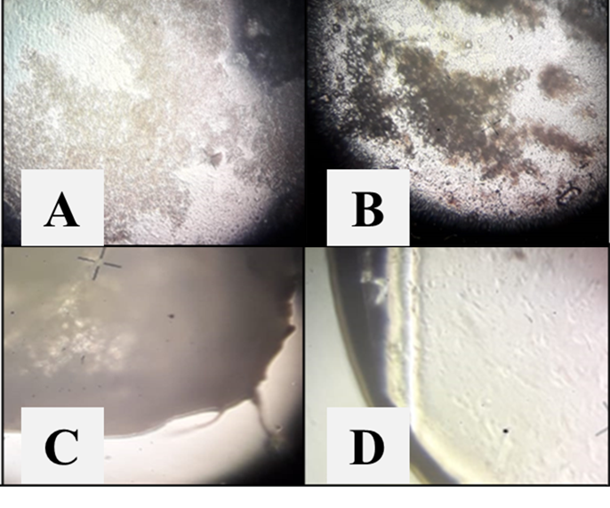
Figure 1S – Light microscopy observation of LLDPE film colonization by B. velezensis isolate MT35 (A), V. titanicae isolate MT11 (B) and B. velezensis isolate MT9 (C) after 60 days of incubation. In (D), the abiotic control is shown under the same conditions and at the same incubation time.

