SUPPLEMENTARY MATERIAL

Tissue and Salivary NMR Metabolomics in Reticular-Type Oral Lichen Planus
Giacomo Setti†, Anna Gambini†, Valeria Righi*, Adele Mucci*, Thelma A. Pertinhez, Elena Ferrari, Mariana Gallo, Brunella Biscussi, Rita Antonelli, Marco Meleti, Cristina Magnoni

Summary
Table S1. ¹H and ¹³C NMR Chemical Shifts of the metabolites identified in tissue p 2-5
Figure S1. PLS-DA scores plot and LV1 and LV2 loadings obtained from ¹H HR-MAS NMR CPMG spectra p 6
Figure S2. PLS-DA cross-validation details from deconvoluted HR-MAS NMR data obtained from tissues p 7
Figure S3. PLS-DA cross-validation details from saliva NMR data p 7

Table S1. ¹H and ¹³C NMR Chemical Shift of the metabolitesª identified in oral mucosa biopsies
 | Metabolites | δ¹Hª | δ¹³C^{b} | Assignment
1 | FA | 0.91 | 16.9 | CH₃
 |  | 0.98 | 16.9 | CH₃ (ω-3)
 |  | 1.37–1.29 | 32.4 | (CH₂)_{n}
 |  | 1.60 | 27.7 | CH₂-CH₂-C=O
 |  | 2.08 | 22.6 | CH₃CH₂CH=CH((ω-3)
 |  | 2.07–2.04 | 29.8 | CH₂CH=CH
 |  | 2.27 | 36.5 | CH₂-C=O
 |  | 2.81-2.78 | 28.4 | =CH-CH₂-CH=
 |  | 5.30-5.33 | 130.7,132.5 | -CH=CH-
2 | Leu | 0.96 (d) | 23.6 | δ-CH₃
 |  | 0.97 (d) | 24.8 | δ-CH₃
 |  | 1.71 |  | β-CH₂
 |  | 1.72 |  | γ-CH
 |  |  |  | α-CH
3 | Ile | 0.93 (t) |  | δ-CH₃
 |  | 1.01 (d) |  | γ-CH₃
 |  | 1.25 |  | γ'-CH₃
 |  | 1.45 |  | γ'-CH₃
 |  | 1.96 |  | β-CH
 |  | 3.65 |  | α-CH
4 | Val | 0.99 (d) | 19.4 | γ-CH₃
 |  | 1.04 (d) | 20.6 | γ-CH₃
 |  | 2.26 |  | β-CH
 |  | 3.60 |  | α-CH
5 | Lac | 1.33 (d) | 23.0 | CH₃
 |  | 4.11 (q) | 71.3 | CH
6 | Ala | 1.48 | 19.0 | CH₃
 |  | 3.78 |  | α-CH
7 | Ac | 1.92 (s) |  | CH₃
8 | Glu | 2.13, 2.07 |  | β-CH₂
 |  | 2.35 | 36.3 | γ-CH₂
 |  | ^{c} |  | α-CH
9 | Gln | 2.14 |  | β-CH₂
 |  | 2.44 | 33.8 | γ-CH₂
 |  | ^{c} |  | α-CH
10 | GSH | 2.15 |  | β-CH_{2glu}
 |  | 2.56 |  | γ-CH_{2glu}
 |  | ^{c} |  | α-CH
 |  | 2.95 |  | β-CH_{2cys}
 |  | 4.58 |  | α-CH_{cys}
 |  | nd |  | CH_{2gly}
11 | Asp | 2.82, 2.68 |  | β-CH₂
 |  | 3.89 |  | α-CH
12 | Lys | nd |  | γ-CH₂
 |  | 1.72 | 29.4 | δ-CH₂
 |  | 1.91 | 32.8 | β-CH₂
 |  | 3.02 | 41.9 | ε-CH₂
 |  | 3.76 | ^{c} | α-CH
13 | Cr | 3.03 (s) | 39.8 | CH₃
 |  | 3.94 (s) | 56.5 | CH₂
14 | Pro | 2.01 |  | γ-CH₂
 |  | 2.34,2.05 |  | β-CH₂
 |  | 3.40,3.31 |  | δ-CH₂
 |  | 4.13 |  | α-CH
15 | EtOH | 1.18 (t)
 |  | 3.65
16 | Cho | 3.20 (s) | 56.7 | N(CH₃)₃
 |  | 3.50 |  | NCH₂
 |  | 4.06 |  | OCH₂
17 | PC | 3.23 (s) | 56.7 | N(CH₃)₃
 |  | 3.61 |  | NCH₂
 |  | 4.17 |  | OCH₂
18 | GPC | 3.24 (s) | 56.8 | N(CH₃)₃
 |  | 3.69
 |  | 4.33
19 | Tau | 3.26 (t) | 50.4 | S-CH₂
 |  | 3.42 (t) | 38.3 | N-CH₂
20 | Gly | 3.56 (s) | 44.4 | CH₂
21 | β-Glc | 3.25 |  | 2-CH
 |  | 3.40 |  | 4-CH
 |  | 3.47 |  | 5-CH
 |  | 3.50 |  | 3-CH
 |  | 3.90, 3.73 |  | 6-CH₂
 |  | 4.65 (d) |  | 1-CH
22 | α-Glc | 3.42 |  | 4-CH
 |  | 3.53 |  | 2-CH
 |  | 3.71 |  | 3-CH
 |  | 5.24 (d) |  | 1-CH
23 | Oligo | 5.44 |  | 1'-CH and 1''-CH
24 | U | 7.90 |  | 6-CH
 |  | 5.90 |  | 5-CH
 |  | 5.92 |  | 1'-CH
 |  | 4.33 |  | 2'-CH
25 | Ur | 7.54 |  | 6-CH
 |  | 5.80 |  | 5-CH
26 | Asc | 4.52 |  | 4-CH
 |  | 4.02 |  | 5-CH
27 | Suc | 2.41 |  | CH₂
28 | Ser | 3.85 |  | α-CH
 |  | 3.95, 3.98 |  | β-CH₂
29 | Ade | 8.19 |  | 8-CH
30 | A | 8.36 |  | 8-CH
 |  | 6.09 |  | 1'-CH ribose
31 | glycerol bound in TG | 4.31, 4.10 | 64.6 | CH₂
 |  | 5.24 | 71.7 | CH
32 | F | 8.45 |  | HCOOH
33 | Tyr | 6.89 |  | 3,5-CH
 |  | 7.18 |  | 2,6-CH
34 | Phe | 7.32 |  | H-o
 |  | 7.37 |  | H-p
 |  | 7.42 |  | H-m
35 | phosphoethanolamine | 3.22 | 43.6 | CH₂N
 |  | 3.98 | 63.0 | CH₂O
36 | Scy | 3.35 |  | CH
37 | MeOH | 3.36 | 51.6 | CH₃
38 | articaine | 7.50 |  | CH (thiophene)
 |  | 4.25 |  | NCH
 |  | 3.85 |  | OCH₃
 |  | 3.10-3.01 |  | NCH₂
 |  | 2.10 |  | CH₃ (thiophene)
 |  | 1.74 |  | -CH₂CH₃
 |  | 1.71 |  | -CHCH₃
 |  | 1.00 |  | -CH₂CH₃
ª ¹H chemical shifts refer to Ala doublet at 1.48 ppm;
^{b} ¹³C chemical shifts refer to Ala at 19.0 ppm.
^{c} contributes to the 3.77, 57.2 ppm cross-peak in HSQC spectra.
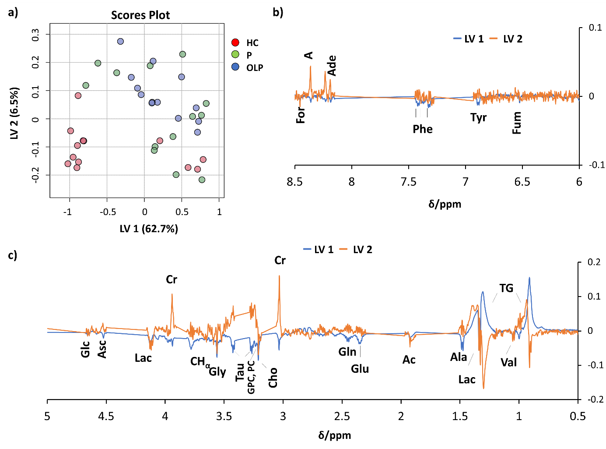
Figure S1. PLS-DA scores plot (a) and LV1 and LV2 loadings (aromatic region, b, aliphatic region, c) obtained from ¹H HR-MAS NMR CPMG spectra of HC (red), P (green), and OLP (blue) tissue samples. For: formate, A: adenosine, Ade: adenine, Phe: phenylalanine, Tyr: tyrosine, Fum: fumarate, Glc: glucose, Asc: ascorbate, Lac: lactate, Cr: creatine, CHα: signals of CHα from alanine, glutamine and glutamate, Gly: glycine, Tau: taurine, GPC: glycerophosphocholine, PC: phosphocholine, Cho: choline, Gln: glutamine, Glu: glutamate, Ac: acetate, Ala: alanine, Val: valine, TG: triglyceride.

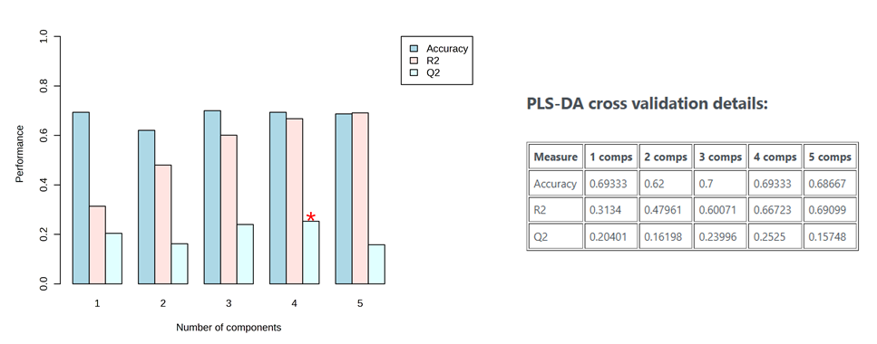
Figure S2. PLS-DA cross-validation details from deconvoluted HR-MAS NMR data obtained from tissues (Figure 3).
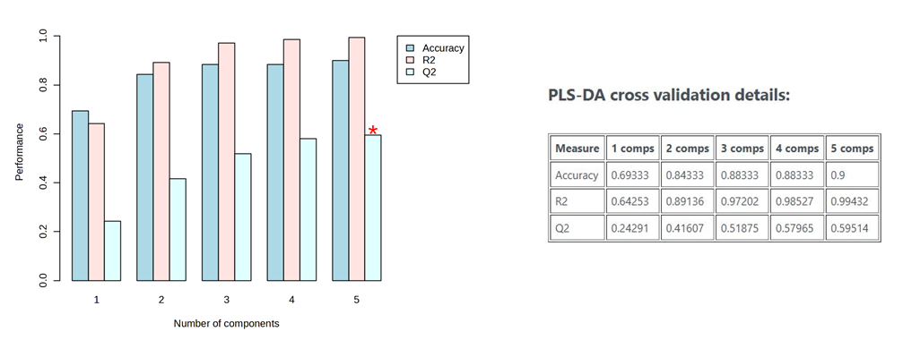

Figure S3. PLS-DA cross-validation details from saliva NMR data (Figure 4).

