Table S1 –Microcosms preparation for the BMP test.
Time | Parameter | M1 | M2 | M3 | M4 | Control
(t_{a}) | IP (g) | 2.00 ± 0.00 | - | - | - | -
(t_{a}) | PA (g) | - | 0.65 ± 0.00 | - | - | -
(t_{a}) | CS (g) | - | - | 0.65 ± 0.00 | - | -
(t_{a}) | TL (g) | - | - | - | 0.65 ± 0.00 | -
(t_{a}) | Inoculum (g) | 59.85 ± 0.65 | 59.31 ± 0.36 | 60.31 ± 0.12 | 60.77 ± 0.41 | 59.71 ± 0.06
(t_{a}) | ISR (-) | 1.64 ± 0.20 | 1.44 ± 0.10 | 1.49 ± 0.10 | 1.50 ± 0.10 | -
(t_{a}) | Total mass (g) | 61.85± 0.65 | 59.96± 0.36 | 61.42± 0.12 | 61.42± 0.41 | 59.71 ± 0.06
(t_{b}) | IP (g) | 2.00 ± 0.01 | - | - | - | -
(t_{b}) | PA (g) | - | 2.00 ± 0.01 | - | - | -
(t_{b}) | CS (g) | - | - | 2.00 ± 0.01 | - | -
(t_{b}) | TL (g) | - | - | - | 2.00 ± 0.01 | -
(t_{b}) | Inoculum (g) | 60.03 ± 0.06 | 60.03 ± 0.03 | 60.06 ± 0.05 | 60.07 ± 0.03 | 60.12 ± 0.06
(t_{b}) | ISR (-) | 1.77 ± 0.01 | 0.97 ± 0.01 | 1.03 ± 0.01 | 1.47 ± 0.01 | -
(t_{b}) | Total mass (g) | 62.03 ± 0.06 | 62.03 ± 0.03 | 62.06 ± 0.05 | 62.07 ± 0.03 | 60.12 ± 0.06
(t_{c}) | IP (g) | 0.30 ± 0.00 | - | - | - | -
(t_{c}) | PA (g) | - | 0.30 ± 0.00 | - | - | -
(t_{c}) | CS (g) | - | - | 0.30 ± 0.00 | - | -
(t_{c}) | TL (g) | - | - | - | 0.30 ± 0.00 | -
(t_{c}) | Inoculum (g) | 60.11 ± 0.13 | 60.19 ± 0.20 | 60.30 ± 0.17 | 60.19 ± 0.26 | 60.26 ± 0.32
(t_{c}) | ISR (-) | 9.99 ± 0.02 | 6.02 ± 0.02 | 7.90 ± 0.02 | 7.67 ± 0.03 | -
(t_{c}) | Total mass (g) | 60.41 ± 0.13 | 60.49 ± 0.20 | 60.60 ± 0.17 | 60.49 ± 0.26 | 60.26 ± 0.32
IP = Iris pseudacorus. PA = P. australis. CS = Carex spp. TL = Typha latifolia. Control = inoculum.
spring (t_{a}), summer (t_{b}), and autumn (t_{c}).
Data are the average of three replicates with standard errors.

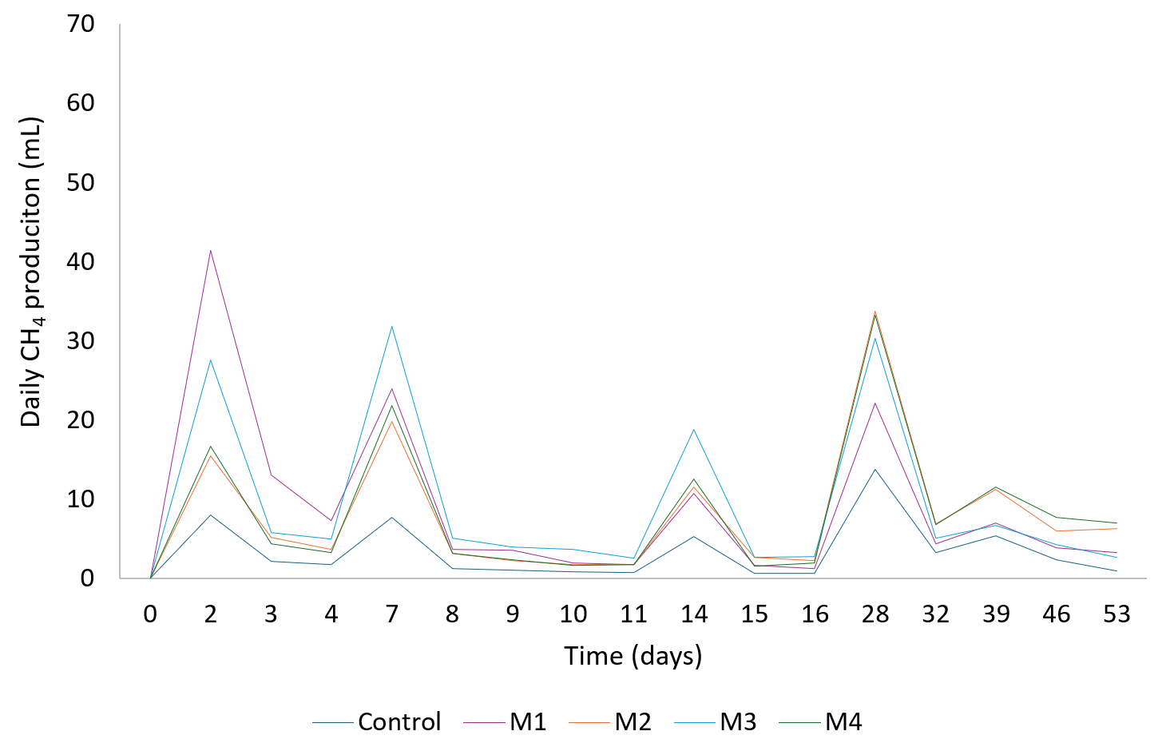
Fig. S1 – Daily CH₄ production at (t_{a}).

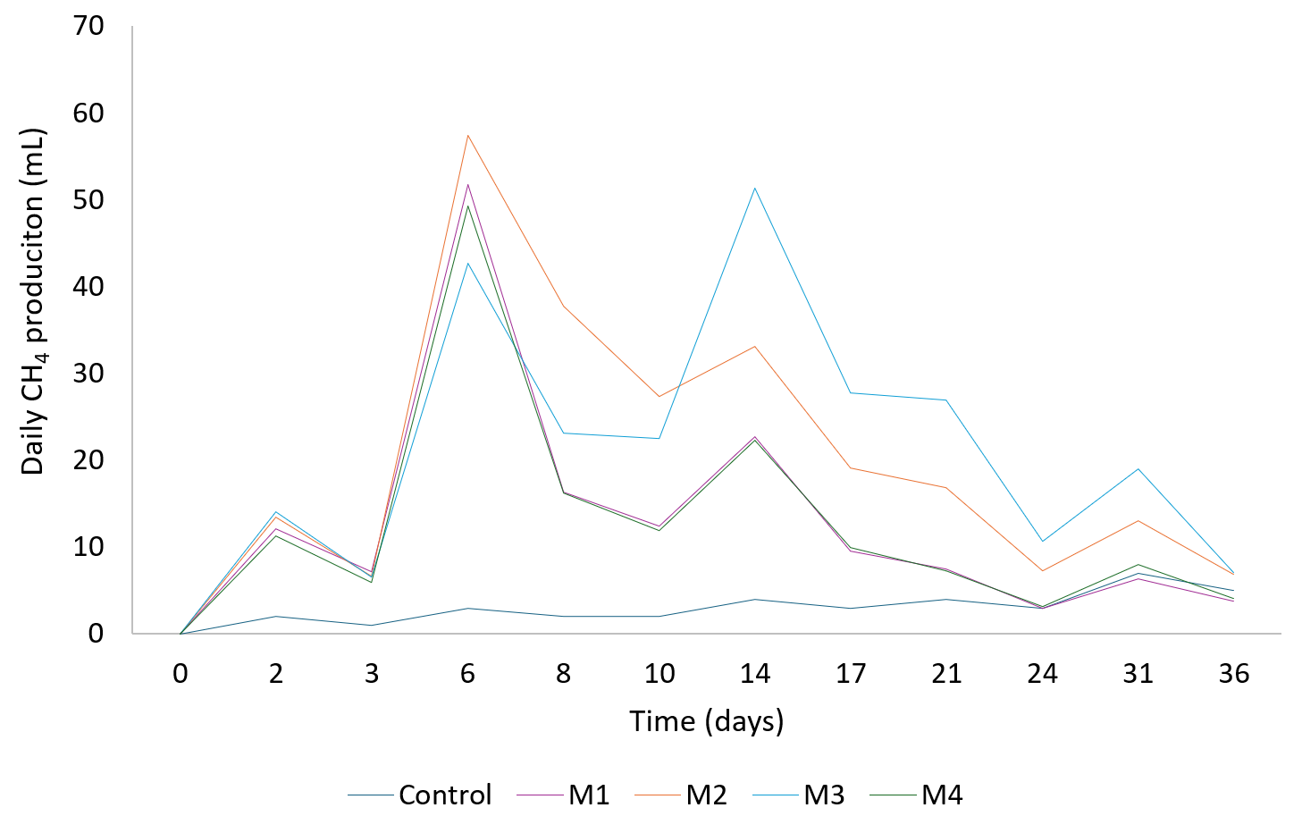
Fig. S2 – Daily CH₄ production at (t_{b}).

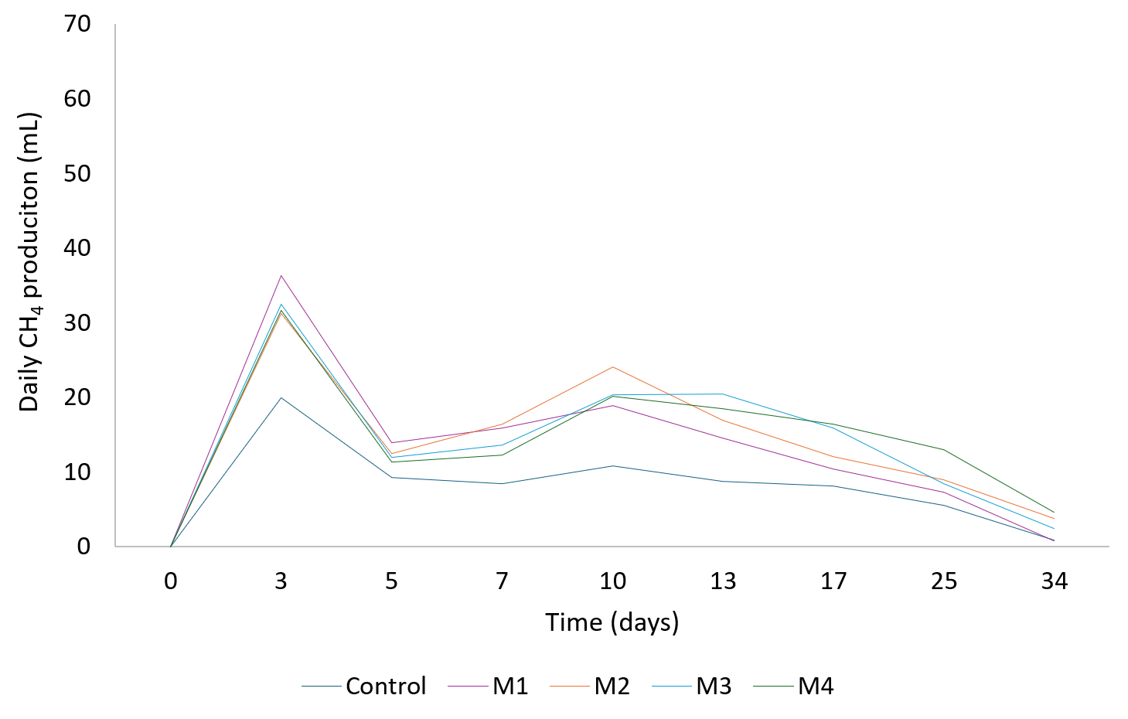
Fig. S3 – Daily CH₄ production at (t_{c}).

