Appendix S6 - Relationship between 1) delta species richness and 2) delta cover and time before correcting for pseudoturnover

Supplementary material to the paper:
Sabatini, F. M., M. D. Musciano, and A. Chiarucci. 2025. “Using Yearly Resolved Time‐Series to Disentangle Interannual Variability, Directional Change, and Pseudoturnover in Plant Community Composition.” Journal of Vegetation Science e70052. https://doi.org/10.1111/jvs.70052

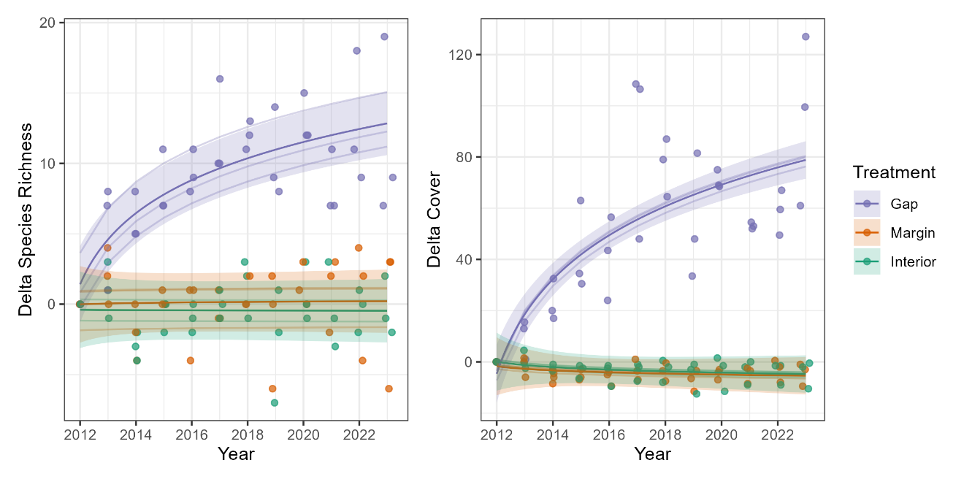
Appendix S6 – Relationship between delta species richness (left) and delta cover (right) and log-transformed delta year, as modelled through mixed effect models with first order autoregressive structure, based on compositional data without correction for pseudoturnover. Delta species richness (cover) was modelled as species richness at year t minus species richness at t0 (i.e., 2012).

