Exploring the conformational landscape through rotational spectroscopy and computational modelling: the tunneling dynamics in 2,6-diethylphenol

Marcos Juanes,^{1,+} Lorenzo Paoloni,^{2,+} Wenqin Li,¹ Antonio Picón,^{2,3} Sonia Melandri,⁴ Assimo Maris,⁴ Alberto Lesarri,^{1,}* Luca Evangelisti^{4,}*
¹ Departamento de Química Física y Química Inorgánica, Facultad de Ciencias—I.U. CINQUIMA Department, Universidad de Valladolid, Paseo de Belén 7, 47011 Valladolid, Spain. E-mail: alberto.lesarri@uva.es
² Departamento de Química, Universidad Autónoma de Madrid, 28049, Madrid, Spain.
³ Condensed Matter Physics Center (IFIMAC), Universidad Autónoma de Madrid, 28049, Madrid, Spain.
⁴ Department of Chemistry “G. Ciamician” - University of Bologna, Via F. Selmi 2, Bologna, Italy. Email: luca.evangelisti6@unibo.it

⁺These authors contributed equally

List of Table:

Table S1: Theoretical coordinates of 26EP (I)
Table S2: Theoretical coordinates of 26EP (II)
Table S3: Theoretical coordinates of 26EP (III)
Table S4: Theoretical coordinates of 26EP (IV)
Table S5: Theoretical coordinates of 26EP (V)
Table S6: Experimental rotational transition frequencies of 26EP (I)
Table S7: Experimental rotational transition frequencies of ¹³C1-26EP (I)
Table S8: Experimental rotational transition frequencies of ¹³C2-26EP (I)
Table S9: Experimental rotational transition frequencies of ¹³C3-26EP (I)
Table S10: Experimental rotational transition frequencies of ¹³C4-26EP (I)
Table S11: Experimental rotational transition frequencies of ¹³C5-26EP (I)
Table S12: Experimental rotational transition frequencies of ¹³C6-26EP (I)
Table S13 Experimental rotational transition frequencies of ¹³C10-26EP (I)
Table S14: Experimental rotational transition frequencies of ¹³C11-26EP (I)
Table S15: Experimental rotational transition frequencies of ¹³C15-26EP (I)
Table S16: Experimental rotational transition frequencies of ¹³C16-26EP (I)
Table S17: Experimental rotational transition frequencies of 26EP (II)
Table S18: Experimental rotational constants for 26EP(I) isotopologues

Table S1: Theoretical coordinates of 26EP (I)
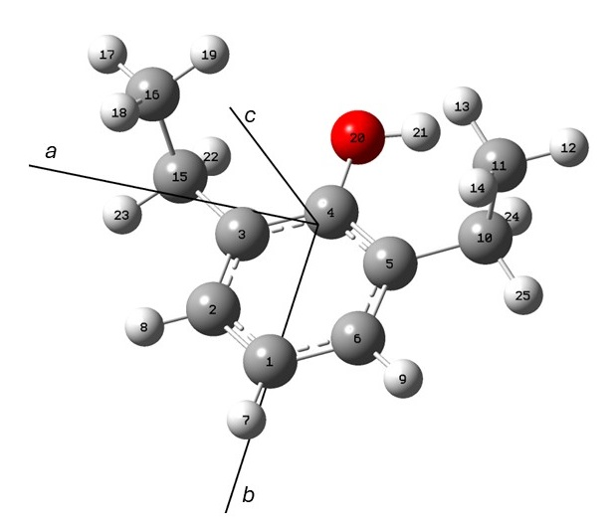
 | B3LYP-D3(BJ)/def2-TZVP
 | a/Å | b/Å | c/Å
1 | -0.016 | 2.354 | 0.205
2 | 1.187 | 1.676 | 0.065
3 | 1.225 | 0.317 | -0.229
4 | 0.007 | -0.354 | -0.377
5 | -1.220 | 0.301 | -0.241
6 | -1.208 | 1.664 | 0.049
7 | -0.024 | 3.413 | 0.427
8 | 2.124 | 2.209 | 0.179
9 | -2.153 | 2.183 | 0.152
10 | -2.523 | -0.447 | -0.360
11 | -2.887 | -1.227 | 0.910
12 | -3.828 | -1.766 | 0.785
13 | -2.113 | -1.952 | 1.171
14 | -2.991 | -0.545 | 1.754
15 | 2.529 | -0.423 | -0.354
16 | 2.878 | -1.227 | 0.903
17 | 3.830 | -1.747 | 0.781
18 | 2.958 | -0.570 | 1.771
19 | 2.108 | -1.971 | 1.110
20 | 0.078 | -1.695 | -0.661
21 | -0.804 | -2.035 | -0.840
22 | 2.483 | -1.100 | -1.210
23 | 3.323 | 0.298 | -0.558
24 | -2.502 | -1.130 | -1.219
25 | -3.318 | 0.265 | -0.585
Table S2: Theoretical coordinates of 26EP (II)
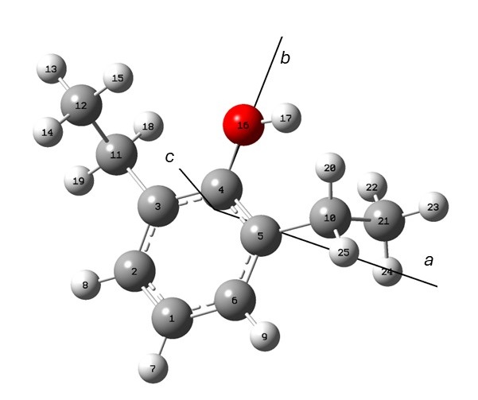
 | B3LYP-D3(BJ)/def2-TZVP
 | a/Å | b/Å | c/Å
1 | 0.015 | -2.343 | 0.003
2 | -1.147 | -1.650 | -0.307
3 | -1.184 | -0.259 | -0.310
4 | -0.007 | 0.427 | 0.004
5 | 1.179 | -0.243 | 0.316
6 | 1.166 | -1.636 | 0.313
7 | 0.022 | -3.425 | 0.004
8 | -2.051 | -2.194 | -0.555
9 | 2.079 | -2.167 | 0.559
10 | 2.452 | 0.512 | 0.602
11 | -2.453 | 0.491 | -0.610
12 | -3.152 | 1.001 | 0.655
13 | -4.069 | 1.538 | 0.404
14 | -3.413 | 0.171 | 1.314
15 | -2.501 | 1.680 | 1.207
16 | -0.075 | 1.798 | -0.013
17 | 0.766 | 2.168 | 0.269
18 | -2.232 | 1.338 | -1.262
19 | -3.129 | -0.167 | -1.158
20 | 2.258 | 1.362 | 1.269
21 | 3.158 | 1.004 | -0.668
22 | 2.513 | 1.657 | -1.259
23 | 4.068 | 1.556 | -0.424
24 | 3.430 | 0.158 | -1.300
25 | 3.127 | -0.137 | 1.160
Table S3: Theoretical coordinates of 26EP (III)
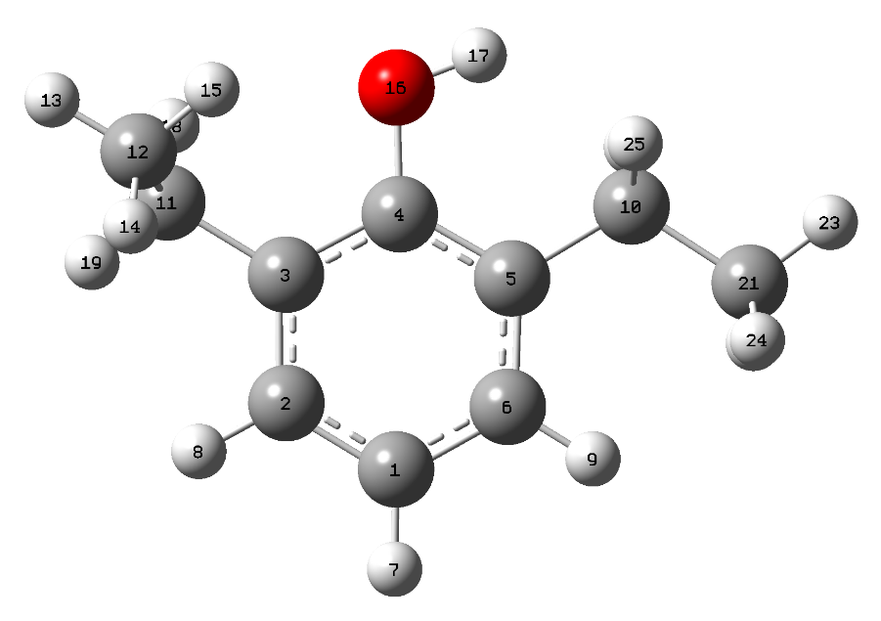
 | B3LYP-D3(BJ)/def2-TZVP
 | a/Å | b/Å | c/Å
1 | 0.262 | -2.213 | 0.045
2 | -1.019 | -1.717 | -0.140
3 | -1.255 | -0.351 | -0.267
4 | -0.156 | 0.509 | -0.201
5 | 1.150 | 0.038 | -0.017
6 | 1.336 | -1.336 | 0.105
7 | 0.426 | -3.278 | 0.140
8 | -1.861 | -2.397 | -0.192
9 | 2.333 | -1.728 | 0.249
10 | 2.289 | 1.031 | 0.040
11 | -2.647 | 0.194 | -0.436
12 | -3.230 | 0.747 | 0.870
13 | -4.240 | 1.130 | 0.714
14 | -3.275 | -0.031 | 1.633
15 | -2.613 | 1.560 | 1.252
16 | -0.418 | 1.850 | -0.328
17 | 0.404 | 2.347 | -0.300
18 | -2.642 | 0.985 | -1.188
19 | -3.292 | -0.602 | -0.814
20 | 2.296 | 1.621 | -0.885
21 | 3.681 | 0.442 | 0.241
22 | 3.946 | -0.236 | -0.569
23 | 4.426 | 1.238 | 0.268
24 | 3.747 | -0.109 | 1.179
25 | 2.097 | 1.747 | 0.851
Table S4: Theoretical coordinates of 26EP (IV)
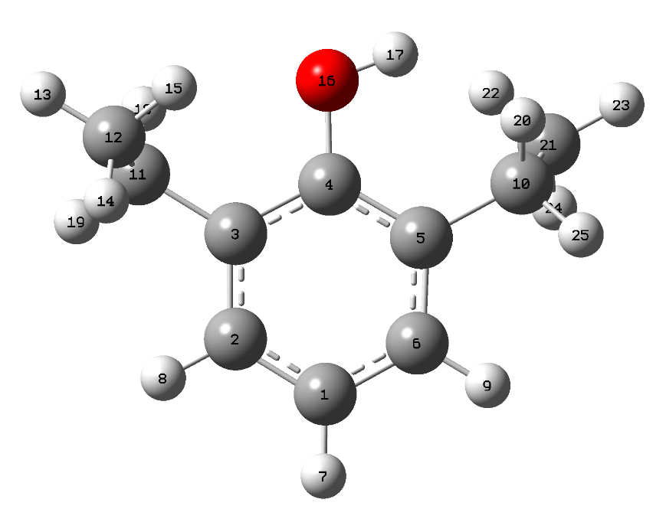
 | B3LYP-D3(BJ)/def2-TZVP
 | a/Å | b/Å | c/Å
1 | 0.243 | 2.212 | 0.040
2 | 1.324 | 1.341 | 0.108
3 | 1.154 | -0.033 | -0.015
4 | -0.147 | -0.514 | -0.206
5 | -1.252 | 0.337 | -0.275
6 | -1.032 | 1.708 | -0.151
7 | 0.399 | 3.279 | 0.134
8 | 2.317 | 1.741 | 0.257
9 | -1.879 | 2.380 | -0.208
10 | -2.650 | -0.206 | -0.433
11 | -3.241 | -0.735 | 0.880
12 | -4.248 | -1.130 | 0.728
13 | -2.625 | -1.529 | 1.306
14 | -3.295 | 0.064 | 1.619
15 | 2.292 | -1.023 | 0.045
16 | -0.277 | -1.875 | -0.318
17 | -1.193 | -2.097 | -0.514
18 | -2.676 | -0.996 | -1.194
19 | -3.291 | 0.585 | -0.823
20 | 2.083 | -1.740 | 0.845
21 | 3.679 | -0.426 | 0.246
22 | 3.749 | 0.127 | 1.184
23 | 4.428 | -1.219 | 0.275
24 | 3.948 | 0.253 | -0.564
25 | 2.279 | -1.619 | -0.871
Table S5: Theoretical coordinates of 26EP (V)
 | B3LYP-D3(BJ)/def2-TZVP
 | a/Å | b/Å | c/Å
1 | -0.005 | 2.098 | 0.000
2 | 1.197 | 1.404 | 0.000
3 | 1.228 | 0.014 | 0.000
4 | 0.002 | -0.661 | 0.000
5 | -1.225 | 0.009 | 0.000
6 | -1.205 | 1.402 | -0.000
7 | -0.007 | 3.180 | 0.000
8 | 2.127 | 1.956 | 0.000
9 | -2.137 | 1.950 | -0.000
10 | -2.505 | -0.796 | -0.000
11 | 2.503 | -0.793 | 0.000
12 | 0.066 | -2.031 | 0.000
13 | -0.822 | -2.399 | -0.000
14 | -2.511 | -1.457 | -0.876
15 | 2.488 | -1.461 | 0.866
16 | 3.796 | 0.012 | -0.000
17 | 3.875 | 0.650 | 0.882
18 | 4.656 | -0.658 | 0.000
19 | 3.875 | 0.650 | -0.882
20 | 2.488 | -1.462 | -0.866
21 | -2.511 | -1.457 | 0.876
22 | -3.801 | 0.007 | -0.000
23 | -4.661 | -0.662 | -0.000
24 | -3.873 | 0.645 | 0.882
25 | -3.873 | 0.645 | -0.882
Table S6: Experimental rotational transition frequencies of 26EP (I)
J’ | K₋₁’ | K₊₁’ | v’ | J’’ | K₋₁’’ | K₊₁’’ | v’’ | Frequency (MHz) | Residual (MHz)
4 | 1 | 4 | 0 | 3 | 1 | 3 | 1 | 5398.584 | -0.007
4 | 0 | 4 | 0 | 3 | 0 | 3 | 1 | 5549.691 | -0.005
4 | 1 | 4 | 1 | 3 | 1 | 3 | 0 | 5600.033 | 0.007
4 | 0 | 4 | 1 | 3 | 0 | 3 | 0 | 5751.138 | 0.006
4 | 2 | 3 | 0 | 3 | 2 | 2 | 1 | 5933.843 | -0.005
4 | 3 | 2 | 0 | 3 | 3 | 1 | 1 | 6062.907 | -0.009
4 | 3 | 1 | 0 | 3 | 3 | 0 | 1 | 6105.633 | -0.008
4 | 2 | 3 | 1 | 3 | 2 | 2 | 0 | 6135.308 | 0.005
4 | 3 | 2 | 1 | 3 | 3 | 1 | 0 | 6264.384 | 0.007
4 | 3 | 1 | 1 | 3 | 3 | 0 | 0 | 6307.108 | 0.007
4 | 1 | 3 | 0 | 3 | 1 | 2 | 1 | 6334.871 | -0.001
4 | 2 | 2 | 0 | 3 | 2 | 1 | 1 | 6358.798 | -0.002
4 | 1 | 3 | 1 | 3 | 1 | 2 | 0 | 6536.332 | 0.002
4 | 2 | 2 | 1 | 3 | 2 | 1 | 0 | 6560.264 | 0.003
5 | 1 | 5 | 0 | 4 | 1 | 4 | 1 | 6713.476 | 0
5 | 0 | 5 | 0 | 4 | 0 | 4 | 1 | 6803.008 | -0.005
5 | 1 | 5 | 1 | 4 | 1 | 4 | 0 | 6914.967 | 0.008
5 | 0 | 5 | 1 | 4 | 0 | 4 | 0 | 7004.497 | 0
5 | 2 | 4 | 0 | 4 | 2 | 3 | 1 | 7377.387 | -0.001
5 | 2 | 4 | 1 | 4 | 2 | 3 | 0 | 7578.837 | 0.005
5 | 4 | 2 | 0 | 4 | 4 | 1 | 1 | 7611.722 | -0.009
5 | 3 | 3 | 0 | 4 | 3 | 2 | 1 | 7613.023 | -0.003
5 | 4 | 1 | 0 | 4 | 4 | 0 | 1 | 7618.343 | -0.009
5 | 3 | 2 | 0 | 4 | 3 | 1 | 1 | 7751.951 | -0.002
2 | 0 | 2 | 0 | 1 | 0 | 1 | 1 | 2884.442 | -0.007
2 | 1 | 2 | 1 | 1 | 1 | 1 | 0 | 2894.1 | 0.008
2 | 0 | 2 | 1 | 1 | 0 | 1 | 0 | 3085.917 | 0.006
2 | 1 | 1 | 0 | 1 | 1 | 0 | 1 | 3182.139 | -0.006
2 | 1 | 1 | 1 | 1 | 1 | 0 | 0 | 3383.617 | 0.006
3 | 1 | 3 | 0 | 2 | 1 | 2 | 1 | 4059.143 | -0.009
3 | 0 | 3 | 0 | 2 | 0 | 2 | 1 | 4259.22 | -0.006
3 | 1 | 3 | 1 | 2 | 1 | 2 | 0 | 4260.612 | 0.007
3 | 2 | 2 | 0 | 2 | 2 | 1 | 1 | 4456.44 | -0.008
3 | 0 | 3 | 1 | 2 | 0 | 2 | 0 | 4460.685 | 0.006
3 | 2 | 1 | 0 | 2 | 2 | 0 | 1 | 4653.66 | -0.006
3 | 2 | 2 | 1 | 2 | 2 | 1 | 0 | 4657.917 | 0.007
3 | 1 | 2 | 0 | 2 | 1 | 1 | 1 | 4786.052 | -0.004
3 | 2 | 1 | 1 | 2 | 2 | 0 | 0 | 4855.136 | 0.006
3 | 1 | 2 | 1 | 2 | 1 | 1 | 0 | 4987.523 | 0.004
5 | 1 | 4 | 0 | 4 | 1 | 3 | 1 | 7798.279 | 0.004
5 | 4 | 2 | 1 | 4 | 4 | 1 | 0 | 7813.198 | 0.008
5 | 3 | 3 | 1 | 4 | 3 | 2 | 0 | 7814.484 | 0.005
5 | 4 | 1 | 1 | 4 | 4 | 0 | 0 | 7819.819 | 0.008
5 | 3 | 2 | 1 | 4 | 3 | 1 | 0 | 7953.413 | 0.004
5 | 1 | 4 | 1 | 4 | 1 | 3 | 0 | 7999.724 | 0
2 | 1 | 2 | 0 | 1 | 0 | 1 | 0 | 3506.473 | 0
2 | 1 | 2 | 1 | 1 | 0 | 1 | 1 | 3506.473 | 0.003
2 | 2 | 1 | 1 | 1 | 1 | 0 | 1 | 5422.202 | 0
2 | 2 | 1 | 0 | 1 | 1 | 0 | 0 | 5422.202 | -0.001
2 | 2 | 0 | 0 | 1 | 1 | 1 | 0 | 5719.899 | 0
2 | 2 | 0 | 1 | 1 | 1 | 1 | 1 | 5719.899 | -0.001
4 | 3 | 1 | 0 | 4 | 2 | 2 | 0 | 3711.632 | 0.004
4 | 3 | 1 | 1 | 4 | 2 | 2 | 1 | 3711.632 | 0.005
4 | 2 | 3 | 0 | 4 | 1 | 4 | 0 | 3806.178 | 0.018
4 | 2 | 3 | 1 | 4 | 1 | 4 | 1 | 3806.178 | 0.003
3 | 0 | 3 | 1 | 2 | 1 | 2 | 1 | 3838.658 | 0
3 | 0 | 3 | 0 | 2 | 1 | 2 | 0 | 3838.658 | -0.004
4 | 3 | 2 | 0 | 4 | 2 | 3 | 0 | 4336.657 | 0.004
4 | 3 | 2 | 1 | 4 | 2 | 3 | 1 | 4336.657 | 0
5 | 2 | 4 | 1 | 5 | 1 | 5 | 1 | 4470.031 | -0.002
5 | 2 | 4 | 0 | 5 | 1 | 5 | 0 | 4470.092 | 0.005
5 | 3 | 3 | 0 | 5 | 2 | 4 | 0 | 4572.294 | 0
5 | 3 | 3 | 1 | 5 | 2 | 4 | 1 | 4572.294 | -0.005
3 | 1 | 3 | 1 | 2 | 0 | 2 | 1 | 4681.169 | 0.002
3 | 1 | 3 | 0 | 2 | 0 | 2 | 0 | 4681.169 | -0.003
6 | 3 | 4 | 0 | 6 | 2 | 5 | 0 | 4937.141 | 0.003
6 | 3 | 4 | 1 | 6 | 2 | 5 | 1 | 4937.141 | -0.004
4 | 0 | 4 | 1 | 3 | 1 | 3 | 1 | 5329.204 | 0.013
4 | 0 | 4 | 0 | 3 | 1 | 3 | 0 | 5329.204 | 0.001
6 | 4 | 2 | 0 | 6 | 3 | 3 | 0 | 5333.26 | 0.003
6 | 4 | 2 | 1 | 6 | 3 | 3 | 1 | 5333.26 | 0.004
7 | 3 | 5 | 0 | 7 | 2 | 6 | 0 | 5440.826 | 0.004
7 | 3 | 5 | 1 | 7 | 2 | 6 | 1 | 5440.826 | -0.008
5 | 4 | 1 | 0 | 5 | 3 | 2 | 0 | 5589.606 | 0.005
5 | 4 | 1 | 1 | 5 | 3 | 2 | 1 | 5589.606 | 0.004
5 | 4 | 2 | 0 | 5 | 3 | 3 | 0 | 5771.156 | 0.009
5 | 4 | 2 | 1 | 5 | 3 | 3 | 1 | 5771.156 | 0.006
4 | 4 | 1 | 0 | 4 | 3 | 2 | 0 | 5772.436 | -0.003
4 | 4 | 1 | 1 | 4 | 3 | 2 | 1 | 5772.436 | -0.006
6 | 4 | 3 | 0 | 6 | 3 | 4 | 0 | 5808.427 | 0.01
6 | 4 | 3 | 1 | 6 | 3 | 4 | 1 | 5808.427 | 0.006
4 | 1 | 4 | 1 | 3 | 0 | 3 | 1 | 5820.526 | 0.006
4 | 1 | 4 | 0 | 3 | 0 | 3 | 0 | 5820.526 | -0.007
5 | 1 | 4 | 1 | 4 | 2 | 3 | 1 | 6490.31 | 0.003
5 | 1 | 4 | 0 | 4 | 2 | 3 | 0 | 6490.31 | 0
3 | 2 | 2 | 1 | 2 | 1 | 1 | 1 | 6696.505 | 0.001
3 | 2 | 2 | 0 | 2 | 1 | 1 | 0 | 6696.505 | 0
5 | 0 | 5 | 0 | 4 | 1 | 4 | 0 | 6733.618 | 0.006
5 | 0 | 5 | 1 | 4 | 1 | 4 | 1 | 6733.618 | -0.056
5 | 1 | 5 | 0 | 4 | 0 | 4 | 0 | 6984.309 | 0.01
5 | 1 | 5 | 1 | 4 | 0 | 4 | 1 | 6984.353 | -0.006
3 | 2 | 1 | 1 | 2 | 1 | 2 | 1 | 7680.939 | 0.001
3 | 2 | 1 | 0 | 2 | 1 | 2 | 0 | 7680.939 | 0.003
4 | 2 | 3 | 1 | 3 | 1 | 2 | 1 | 7844.298 | 0.008
4 | 2 | 3 | 0 | 3 | 1 | 2 | 0 | 7844.298 | 0.002
6 | 2 | 4 | 0 | 6 | 2 | 5 | 1 | 2188.735 | 0.007
6 | 2 | 4 | 1 | 6 | 2 | 5 | 0 | 2390.155 | -0.005
4 | 1 | 3 | 1 | 4 | 1 | 4 | 0 | 2498.201 | 0.006
2 | 1 | 2 | 0 | 1 | 1 | 1 | 1 | 2692.623 | -0.008
7 | 2 | 5 | 0 | 7 | 2 | 6 | 1 | 3315.517 | 0.009
5 | 1 | 4 | 0 | 5 | 1 | 5 | 1 | 3381.509 | 0
3 | 2 | 2 | 0 | 3 | 0 | 3 | 1 | 3491.386 | -0.005
7 | 2 | 5 | 1 | 7 | 2 | 6 | 0 | 3516.912 | -0.013
5 | 1 | 4 | 1 | 5 | 1 | 5 | 0 | 3583 | -0.004
3 | 2 | 2 | 1 | 3 | 0 | 3 | 0 | 3692.846 | 0.001
4 | 2 | 3 | 0 | 4 | 0 | 4 | 1 | 3875.556 | -0.005
4 | 2 | 3 | 1 | 4 | 0 | 4 | 0 | 4076.997 | 0
5 | 2 | 4 | 0 | 5 | 0 | 5 | 1 | 4449.891 | 0.002
6 | 1 | 5 | 0 | 6 | 1 | 6 | 1 | 4526.889 | 0.002
8 | 2 | 6 | 0 | 8 | 2 | 7 | 1 | 4563.711 | 0.008
5 | 2 | 4 | 1 | 5 | 0 | 5 | 0 | 4651.384 | 0.004
6 | 1 | 5 | 1 | 6 | 1 | 6 | 0 | 4728.343 | 0.005
8 | 2 | 6 | 1 | 8 | 2 | 7 | 0 | 4765.064 | -0.019
6 | 2 | 5 | 0 | 6 | 0 | 6 | 1 | 5177.248 | 0.001
6 | 2 | 5 | 1 | 6 | 0 | 6 | 0 | 5378.701 | 0.006
6 | 3 | 4 | 0 | 6 | 1 | 5 | 1 | 5451.293 | 0
5 | 3 | 3 | 0 | 5 | 1 | 4 | 1 | 5459.372 | -0.004
4 | 3 | 2 | 0 | 4 | 1 | 3 | 1 | 5644.614 | -0.003
6 | 3 | 4 | 1 | 6 | 1 | 5 | 0 | 5652.719 | -0.006
7 | 1 | 6 | 0 | 7 | 1 | 7 | 1 | 5654.995 | 0.004
5 | 3 | 3 | 1 | 5 | 1 | 4 | 0 | 5660.82 | -0.001
7 | 3 | 5 | 0 | 7 | 1 | 6 | 1 | 5681.273 | 0.001
9 | 2 | 7 | 0 | 9 | 2 | 8 | 1 | 5839.317 | 0.006
4 | 3 | 2 | 1 | 4 | 1 | 3 | 0 | 5846.073 | 0
7 | 1 | 6 | 1 | 7 | 1 | 7 | 0 | 5856.425 | 0
7 | 3 | 5 | 1 | 7 | 1 | 6 | 0 | 5882.673 | -0.011
7 | 2 | 6 | 0 | 7 | 0 | 7 | 1 | 6011.018 | 0
9 | 2 | 7 | 1 | 9 | 2 | 8 | 0 | 6040.805 | -0.038
8 | 3 | 6 | 0 | 8 | 1 | 7 | 1 | 6150.162 | -0.002
7 | 2 | 6 | 1 | 7 | 0 | 7 | 0 | 6212.456 | 0.005
2 | 2 | 0 | 0 | 1 | 0 | 1 | 1 | 6332.272 | -0.005
8 | 3 | 6 | 1 | 8 | 1 | 7 | 0 | 6351.525 | -0.014
8 | 2 | 7 | 1 | 8 | 0 | 8 | 0 | 7112.973 | 0.004
10 | 2 | 8 | 0 | 10 | 2 | 9 | 1 | 7065.359 | 0.01
9 | 3 | 7 | 1 | 9 | 1 | 8 | 0 | 7014.066 | -0.02
9 | 4 | 6 | 0 | 9 | 2 | 7 | 1 | 7269.983 | 0.023
8 | 4 | 5 | 0 | 8 | 2 | 6 | 1 | 7446.408 | 0.017
9 | 4 | 6 | 1 | 9 | 2 | 7 | 0 | 7471.336 | -0.026
10 | 3 | 8 | 0 | 10 | 1 | 9 | 1 | 7611.433 | 0.019
8 | 4 | 5 | 1 | 8 | 2 | 6 | 0 | 7647.789 | -0.024
9 | 1 | 8 | 0 | 9 | 1 | 9 | 1 | 7766.344 | 0.019

Table S7: Experimental rotational transition frequencies of ¹³C1-26EP(I)

J’ | K₋₁’ | K₊₁’ | v’ | J’’ | K₋₁’’ | K₊₁’’ | v’’ | Frequency (MHz) | Residual (MHz)
4 | 1 | 3 | 1 | 3 | 1 | 2 | 0 | 6517.097 | 0.003
4 | 1 | 3 | 0 | 3 | 1 | 2 | 1 | 6315.548 | -0.006
4 | 0 | 4 | 1 | 3 | 0 | 3 | 0 | 5712.215 | -0.021
4 | 1 | 4 | 1 | 3 | 1 | 3 | 0 | 5568.305 | 0.007
4 | 0 | 4 | 0 | 3 | 0 | 3 | 1 | 5510.692 | -0.004
4 | 1 | 4 | 0 | 3 | 1 | 3 | 1 | 5366.777 | 0.018
5 | 1 | 5 | 0 | 4 | 1 | 4 | 1 | 6671.259 | -0.028
5 | 0 | 5 | 0 | 4 | 0 | 4 | 1 | 6753.56 | 0.005
5 | 1 | 5 | 1 | 4 | 1 | 4 | 0 | 6872.82 | -0.007
5 | 0 | 5 | 1 | 4 | 0 | 4 | 0 | 6955.12 | 0.025
3 | 1 | 3 | 0 | 2 | 1 | 2 | 1 | 4037.165 | 0.005
3 | 0 | 3 | 1 | 2 | 0 | 2 | 0 | 4435.395 | 0.01
3 | 1 | 2 | 0 | 2 | 1 | 1 | 1 | 4776.311 | 0.003
4 | 2 | 3 | 0 | 3 | 2 | 2 | 1 | 5913.006 | 0.013
5 | 2 | 4 | 0 | 4 | 2 | 3 | 1 | 7347.098 | -0.001
5 | 2 | 4 | 1 | 4 | 2 | 3 | 0 | 7548.625 | -0.013

Table S8: Experimental rotational transition frequencies of ¹³C2-26EP(I)

J’ | K_{a}’ | K_{c}’ | J’’ | K_{a}’’ | K_{c}’’ | ν/MHz | ∆ν_{o−c}
3 | 1 | 3 | 2 | 1 | 2 | 4140.636 | 0.007
3 | 0 | 3 | 2 | 0 | 2 | 4339.139 | 0.017
3 | 1 | 2 | 2 | 1 | 1 | 4870.592 | -0.007
4 | 1 | 4 | 3 | 1 | 3 | 5472.829 | 0.002
4 | 0 | 4 | 3 | 0 | 3 | 5621.036 | -0.012
4 | 1 | 3 | 3 | 1 | 2 | 6411.93 | 0.006
2 | 0 | 2 | 1 | 0 | 1 | 2972.711 | -0.002
3 | 2 | 2 | 2 | 2 | 1 | 4540.233 | 0.004
4 | 2 | 2 | 3 | 2 | 1 | 6442.742 | -0.002
5 | 1 | 5 | 4 | 1 | 4 | 6780.369 | -0.004
5 | 0 | 5 | 4 | 0 | 4 | 6867.018 | 0
5 | 2 | 4 | 4 | 2 | 3 | 7447.318 | -0.005
5 | 3 | 3 | 4 | 3 | 2 | 7687.22 | 0.001

Table S9: Experimental rotational transition frequencies of ¹³C3-26EP(I)
J’ | K_{a}’ | K_{c}’ | J’’ | K_{a}’’ | K_{c}’’ | ν/MHz | ∆ν_{o−c}
2 | 0 | 2 | 1 | 0 | 1 | 2978.485 | 0.004
3 | 1 | 3 | 2 | 1 | 2 | 4150.979 | 0.005
3 | 0 | 3 | 2 | 0 | 2 | 4350.96 | 0.009
3 | 2 | 2 | 2 | 2 | 1 | 4546.344 | 0.013
3 | 2 | 1 | 2 | 2 | 0 | 4741.706 | -0.004
3 | 1 | 2 | 2 | 1 | 1 | 4874.712 | 0.01
4 | 1 | 4 | 3 | 1 | 3 | 5487.844 | 0
4 | 0 | 4 | 3 | 0 | 3 | 5639.443 | 0.006
4 | 2 | 3 | 3 | 2 | 2 | 6020.55 | 0.005
4 | 1 | 3 | 3 | 1 | 2 | 6420.408 | 0
4 | 2 | 2 | 3 | 2 | 1 | 6442.051 | -0.004
5 | 1 | 5 | 4 | 1 | 4 | 6800.358 | -0.009
5 | 0 | 5 | 4 | 0 | 4 | 6890.493 | -0.001
5 | 2 | 4 | 4 | 2 | 3 | 7461.22 | -0.008
5 | 1 | 4 | 4 | 1 | 3 | 7881.649 | -0.01

Table S10: Experimental rotational transition frequencies of ¹³C4-26EP(I)
J’ | K₋₁’ | K₊₁’ | v’ | J’’ | K₋₁’’ | K₊₁’’ | v’’ | Frequency (MHz) | Residual (MHz)
5 | 0 | 5 | 1 | 4 | 0 | 4 | 0 | 7002.868 | 0.017
5 | 1 | 5 | 1 | 4 | 1 | 4 | 0 | 6913.56 | -0.007
5 | 0 | 5 | 0 | 4 | 0 | 4 | 1 | 6802.084 | 0.005
5 | 1 | 5 | 0 | 4 | 1 | 4 | 1 | 6712.78 | -0.014
4 | 1 | 3 | 1 | 3 | 1 | 2 | 0 | 6534.693 | -0.021
4 | 1 | 3 | 0 | 3 | 1 | 2 | 1 | 6333.938 | -0.003
4 | 1 | 4 | 1 | 3 | 1 | 3 | 0 | 5598.838 | 0.006
4 | 0 | 4 | 0 | 3 | 0 | 3 | 1 | 5548.936 | -0.008
3 | 0 | 3 | 0 | 2 | 0 | 2 | 1 | 4258.738 | 0.005
3 | 1 | 3 | 1 | 2 | 1 | 2 | 0 | 4259.63 | 0.005
3 | 0 | 3 | 1 | 2 | 0 | 2 | 0 | 4459.501 | -0.004
3 | 1 | 2 | 0 | 2 | 1 | 1 | 1 | 4785.497 | 0.02
3 | 1 | 2 | 1 | 2 | 1 | 1 | 0 | 4986.26 | 0.009

Table S11: Experimental rotational transition frequencies of ¹³C5-26EP(I)
J’ | K_{a}’ | K_{c}’ | J’’ | K_{a}’’ | K_{c}’’ | ν/MHz | ∆ν_{o−c}
3 | 1 | 3 | 2 | 1 | 2 | 4151.059 | 0.004
3 | 0 | 3 | 2 | 0 | 2 | 4351.04 | 0.006
3 | 1 | 2 | 2 | 1 | 1 | 4874.792 | 0.007
4 | 1 | 4 | 3 | 1 | 3 | 5487.956 | 0.005
2 | 0 | 2 | 1 | 0 | 1 | 2978.537 | 0.002
3 | 2 | 1 | 2 | 2 | 0 | 4741.796 | 0.005
4 | 0 | 4 | 3 | 0 | 3 | 5639.549 | 0.001
4 | 2 | 3 | 3 | 2 | 2 | 6020.664 | 0.01
4 | 3 | 2 | 3 | 3 | 1 | 6148.507 | 0.007
4 | 1 | 3 | 3 | 1 | 2 | 6420.517 | -0.003
4 | 2 | 2 | 3 | 2 | 1 | 6442.163 | 0
5 | 1 | 5 | 4 | 1 | 4 | 6800.497 | -0.004
5 | 0 | 5 | 4 | 0 | 4 | 6890.627 | -0.005
5 | 2 | 4 | 4 | 2 | 3 | 7461.357 | -0.008
5 | 3 | 3 | 4 | 3 | 2 | 7694.924 | 0
5 | 3 | 2 | 4 | 3 | 1 | 7831.817 | -0.01
5 | 1 | 4 | 4 | 1 | 3 | 7881.799 | -0.003

Table S12: Experimental rotational transition frequencies of ¹³C6-26EP(I)
J’ | K_{a}’ | K_{c}’ | J’’ | K_{a}’’ | K_{c}’’ | ν/MHz | ∆ν_{o−c}
2 | 0 | 2 | 1 | 0 | 1 | 2972.772 | -0.009
3 | 1 | 3 | 2 | 1 | 2 | 4140.701 | 0.006
3 | 0 | 3 | 2 | 0 | 2 | 4339.166 | -0.006
3 | 1 | 2 | 2 | 1 | 1 | 4870.786 | 0.008
4 | 1 | 4 | 3 | 1 | 3 | 5472.901 | 0.005
4 | 0 | 4 | 3 | 0 | 3 | 5621.087 | 0.012
4 | 2 | 3 | 3 | 2 | 2 | 6011.211 | -0.003
4 | 1 | 3 | 3 | 1 | 2 | 6412.113 | -0.001
4 | 2 | 2 | 3 | 2 | 1 | 6443.069 | 0.002
5 | 1 | 5 | 4 | 1 | 4 | 6780.436 | -0.004
5 | 0 | 5 | 4 | 0 | 4 | 6867.037 | -0.001
5 | 2 | 4 | 4 | 2 | 3 | 7447.489 | -0.007

Table S13: Experimental rotational transition frequencies of ¹³C10-26EP(I)
J’ | K_{a}’ | K_{c}’ | J’’ | K_{a}’’ | K_{c}’’ | ν/MHz | ∆ν_{o−c}
2 | 0 | 2 | 1 | 0 | 1 | 2957.249 | 0.01
3 | 1 | 3 | 2 | 1 | 2 | 4122.758 | -0.009
3 | 0 | 3 | 2 | 0 | 2 | 4322.628 | 0.027
3 | 1 | 2 | 2 | 1 | 1 | 4836.163 | 0.01
4 | 1 | 4 | 3 | 1 | 3 | 5451.596 | -0.001
4 | 0 | 4 | 3 | 0 | 3 | 5605.048 | 0
4 | 3 | 1 | 3 | 3 | 0 | 6139.493 | 0.004
4 | 1 | 3 | 3 | 1 | 2 | 6372.095 | 0.016
4 | 2 | 2 | 3 | 2 | 1 | 6385.782 | -0.012
5 | 1 | 5 | 4 | 1 | 4 | 6756.531 | 0.009
5 | 0 | 5 | 4 | 0 | 4 | 6849.085 | -0.012
5 | 2 | 4 | 4 | 2 | 3 | 7407.585 | -0.005
5 | 1 | 4 | 4 | 1 | 3 | 7826.766 | -0.018

Table S14: Experimental rotational transition frequencies of ¹³C11-26EP(I)
J’ | K_{a}’ | K_{c}’ | J’’ | K_{a}’’ | K_{c}’’ | ν/MHz | ∆ν_{o−c}
2 | 0 | 2 | 1 | 0 | 1 | 2944.489 | 0.013
3 | 1 | 3 | 2 | 1 | 2 | 4105.498 | 0.001
3 | 0 | 3 | 2 | 0 | 2 | 4303.918 | 0
3 | 2 | 2 | 2 | 2 | 1 | 4492.371 | 0.012
3 | 1 | 2 | 2 | 1 | 1 | 4814.812 | 0
4 | 1 | 4 | 3 | 1 | 3 | 5428.762 | 0.002
4 | 0 | 4 | 3 | 0 | 3 | 5580.941 | 0.009
4 | 2 | 3 | 3 | 2 | 2 | 5950.157 | 0.003
4 | 1 | 3 | 3 | 1 | 2 | 6343.865 | -0.002
4 | 2 | 2 | 3 | 2 | 1 | 6358.264 | -0.004
5 | 1 | 5 | 4 | 1 | 4 | 6728.243 | -0.001
5 | 0 | 5 | 4 | 0 | 4 | 6819.902 | -0.01
5 | 2 | 4 | 4 | 2 | 3 | 7375.627 | -0.007

Table S15: Experimental rotational transition frequencies of ¹³C15-26EP(I)
J’ | K_{a}’ | K_{c}’ | J’’ | K_{a}’’ | K_{c}’’ | ν/MHz | ∆ν_{o−c}
2 | 0 | 2 | 1 | 0 | 1 | 2957.249 | 0.001
3 | 1 | 3 | 2 | 1 | 2 | 4122.782 | 0
3 | 0 | 3 | 2 | 0 | 2 | 4322.628 | 0.006
3 | 1 | 2 | 2 | 1 | 1 | 4836.163 | 0.004
4 | 1 | 4 | 3 | 1 | 3 | 5451.622 | 0.001
4 | 0 | 4 | 3 | 0 | 3 | 5605.092 | 0.009
4 | 2 | 3 | 3 | 2 | 2 | 5975.934 | 0.016
4 | 1 | 3 | 3 | 1 | 2 | 6372.095 | 0.001
4 | 2 | 2 | 3 | 2 | 1 | 6385.782 | -0.004
5 | 1 | 5 | 4 | 1 | 4 | 6756.531 | -0.021
5 | 0 | 5 | 4 | 0 | 4 | 6849.146 | 0.006
5 | 2 | 4 | 4 | 2 | 3 | 7407.617 | 0.004
5 | 1 | 4 | 4 | 1 | 3 | 7826.798 | -0.016

Table S16: Experimental rotational transition frequencies of ¹³C16-26EP(I)
J’ | K_{a}’ | K_{c}’ | J’’ | K_{a}’’ | K_{c}’’ | ν/MHz | ∆ν_{o−c}
4 | 1 | 4 | 3 | 1 | 3 | 5429.261 | -0.007
4 | 0 | 4 | 3 | 0 | 3 | 5581.42 | 0.001
4 | 1 | 3 | 3 | 1 | 2 | 6344.536 | -0.006
5 | 1 | 5 | 4 | 1 | 4 | 6728.856 | -0.003
3 | 1 | 3 | 2 | 1 | 2 | 4105.904 | 0.011
3 | 0 | 3 | 2 | 0 | 2 | 4304.32 | 0
3 | 1 | 2 | 2 | 1 | 1 | 4815.351 | 0.002
4 | 2 | 3 | 3 | 2 | 2 | 5950.779 | 0.003
4 | 2 | 2 | 3 | 2 | 1 | 6359.04 | -0.002
5 | 0 | 5 | 4 | 0 | 4 | 6820.498 | -0.001
5 | 2 | 4 | 4 | 2 | 3 | 7376.389 | 0.004
5 | 3 | 2 | 4 | 3 | 1 | 7731.999 | 0

Table S17: Experimental rotational transition frequencies of 26EP(II)
J’ | K₋₁’ | K₊₁’ | v’ | J’’ | K₋₁’’ | K₊₁’’ | v’’ | Frequency (MHz) | Residual (MHz)
4 | 1 | 4 | 0 | 3 | 1 | 3 | 1 | 5254.481 | -0.005
4 | 1 | 4 | 1 | 3 | 1 | 3 | 0 | 5423.381 | 0
4 | 0 | 4 | 0 | 3 | 0 | 3 | 1 | 5437.769 | -0.004
4 | 0 | 4 | 1 | 3 | 0 | 3 | 0 | 5606.668 | 0
4 | 1 | 3 | 0 | 3 | 1 | 2 | 1 | 6144.101 | -0.001
4 | 1 | 3 | 1 | 3 | 1 | 2 | 0 | 6313.002 | -0.005
3 | 1 | 3 | 0 | 2 | 1 | 2 | 1 | 3947.886 | -0.005
3 | 1 | 3 | 1 | 2 | 1 | 2 | 0 | 4116.795 | 0.001
3 | 0 | 3 | 0 | 2 | 0 | 2 | 1 | 4161.954 | -0.002
3 | 0 | 3 | 1 | 2 | 0 | 2 | 0 | 4330.861 | 0
3 | 1 | 2 | 0 | 2 | 1 | 1 | 1 | 4630.249 | 0
3 | 1 | 2 | 1 | 2 | 1 | 1 | 0 | 4799.158 | 0.001
2 | 1 | 2 | 0 | 1 | 1 | 1 | 1 | 2619.198 | -0.001
2 | 1 | 2 | 1 | 1 | 1 | 1 | 0 | 2788.111 | 0.003
2 | 0 | 2 | 0 | 1 | 0 | 1 | 1 | 2808.149 | -0.002
2 | 0 | 2 | 1 | 1 | 0 | 1 | 0 | 2977.062 | 0.002
2 | 1 | 1 | 0 | 1 | 1 | 0 | 1 | 3077.069 | 0
2 | 1 | 1 | 1 | 1 | 1 | 0 | 0 | 3245.986 | 0.006
3 | 2 | 2 | 0 | 2 | 2 | 1 | 1 | 4314.428 | 0
3 | 2 | 1 | 0 | 2 | 2 | 0 | 1 | 4466.901 | 0
3 | 2 | 2 | 1 | 2 | 2 | 1 | 0 | 4483.34 | 0.004
3 | 2 | 1 | 1 | 2 | 2 | 0 | 0 | 4635.812 | 0.002
4 | 2 | 3 | 0 | 3 | 2 | 2 | 1 | 5749.387 | 0
4 | 3 | 2 | 0 | 3 | 3 | 1 | 1 | 5849.091 | 0.003
4 | 3 | 1 | 0 | 3 | 3 | 0 | 1 | 5875.209 | 0.002
4 | 2 | 3 | 1 | 3 | 2 | 2 | 0 | 5918.29 | 0
4 | 3 | 2 | 1 | 3 | 3 | 1 | 0 | 6018 | 0.006
4 | 3 | 1 | 1 | 3 | 3 | 0 | 0 | 6044.12 | 0.006
4 | 2 | 2 | 0 | 3 | 2 | 1 | 1 | 6091.925 | -0.001
4 | 2 | 2 | 1 | 3 | 2 | 1 | 0 | 6260.827 | -0.004
5 | 1 | 5 | 0 | 4 | 1 | 4 | 1 | 6539.382 | 0
5 | 0 | 5 | 0 | 4 | 0 | 4 | 1 | 6665.029 | -0.002
5 | 1 | 5 | 1 | 4 | 1 | 4 | 0 | 6708.26 | 0
5 | 0 | 5 | 1 | 4 | 0 | 4 | 0 | 6833.908 | -0.001
5 | 2 | 4 | 0 | 4 | 2 | 3 | 1 | 7158.393 | 0
5 | 2 | 4 | 1 | 4 | 2 | 3 | 0 | 7327.283 | -0.006
5 | 4 | 2 | 0 | 4 | 4 | 1 | 1 | 7335.634 | 0.01
5 | 4 | 1 | 0 | 4 | 4 | 0 | 1 | 7338.86 | 0.01
5 | 3 | 3 | 0 | 4 | 3 | 2 | 1 | 7344.321 | 0.001
5 | 3 | 2 | 0 | 4 | 3 | 1 | 1 | 7431.63 | 0.003
5 | 4 | 2 | 1 | 4 | 4 | 1 | 0 | 7504.542 | 0.012
5 | 4 | 1 | 1 | 4 | 4 | 0 | 0 | 7507.765 | 0.009
5 | 3 | 3 | 1 | 4 | 3 | 2 | 0 | 7513.219 | -0.002
5 | 1 | 4 | 0 | 4 | 1 | 3 | 1 | 7596.701 | -0.001
5 | 3 | 2 | 1 | 4 | 3 | 1 | 0 | 7600.528 | -0.001
5 | 2 | 3 | 0 | 4 | 2 | 2 | 1 | 7737.142 | -0.003
5 | 1 | 4 | 1 | 4 | 1 | 3 | 0 | 7765.591 | -0.012
6 | 1 | 6 | 0 | 5 | 1 | 5 | 1 | 7806.247 | 0.002
6 | 0 | 6 | 0 | 5 | 0 | 5 | 1 | 7879.665 | 0.003
5 | 2 | 3 | 1 | 4 | 2 | 2 | 0 | 7906.031 | -0.017
6 | 1 | 6 | 1 | 5 | 1 | 5 | 0 | 7975.199 | 0
3 | 1 | 3 | 1 | 2 | 0 | 2 | 1 | 4702.043 | 0.005
3 | 1 | 3 | 0 | 2 | 0 | 2 | 0 | 4702.043 | 0.001
4 | 0 | 4 | 1 | 3 | 1 | 3 | 1 | 5066.585 | -0.001
4 | 0 | 4 | 0 | 3 | 1 | 3 | 0 | 5066.585 | -0.006
5 | 0 | 5 | 1 | 4 | 1 | 4 | 1 | 6477.122 | 0
5 | 0 | 5 | 0 | 4 | 1 | 4 | 0 | 6477.122 | -0.01

Table S18: Experimental rotational constants for 26EP (conformer I)
 | C1 | C2 | C3 | C4 | C5 | C6 | C9 | C10 | C11 | C12
A / MHz | 1593.8(1) | 1594.29(6) | 1581.0(1) | 1567.3(1) | 1581.2(1) | 1594.26(7) | 1593.38(7) | 1583.6(1) | 1593.42(8) | 1583.67(9)
B / MHz | 881.734(5) | 879.564(3) | 879.686(5) | 881.848(4) | 879.643(4) | 879.550(41) | 872.002(4) | 868.085(5) | 872.002(4) | 868.190(5)
C / MHz | 637.068(4) | 635.906(3) | 633.769(4) | 632.714(3) | 633.766(4) | 635.893(3) | 631.924(3) | 629.367(4) | 631.927(3) | 629.423(4)
ΔE / MHz | 100.38(1) |  |  | 100.76(1)
σ^{[b]} / kHz | 11 | 6 | 6 | 13 | 7 | 7 | 12 | 7 | 9 | 5
N^{[c]} | 13 | 17 | 12 | 16 | 13 | 15 | 13 | 13 | 13 | 12

