Supplementary Data

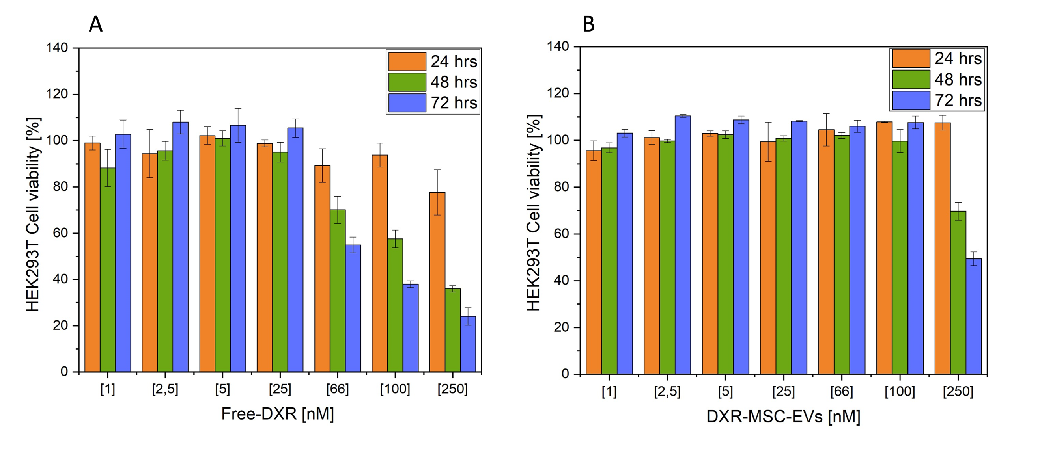

Figure S1. In vitro cytotoxicity of Free-DXR and DXR-MSC-EVs, HEK293T cells exposure to (a) Free-DXR and DXR-MSC-EVs (b) activity in the range 1-250 nM within 72 hrs.

