From waste to wealth: agromining of nickel, cobalt, and selenium from mine waste amended with sewage sludge

Plant and Soil

Mirko Salinitro¹*, Michela Schiavon², Marcin Musiałowski³, Klaudia Dębiec-Andrzejewska³, Mark G.M. Aarts¹, Elio Padoan², Benedetta Montanarini⁴, Annalisa Tassoni⁴, Antony van der Ent¹

¹ Laboratory of Genetics, Wageningen University and Research, Wageningen, the Netherlands; ² Department of Agricultural, Forest and Food Sciences, University of Turin, Grugliasco, Italy; ³ Faculty of Biology, University of Warsaw, Warsaw, Poland; ⁴ Department of Biological, Geological and Environmental Sciences, University of Bologna, Bologna, Italy; *Corresponding author

*Corresponding author: Mirko Salinitro; email: mirko.salinitro@wur.nl

Supplementary Information

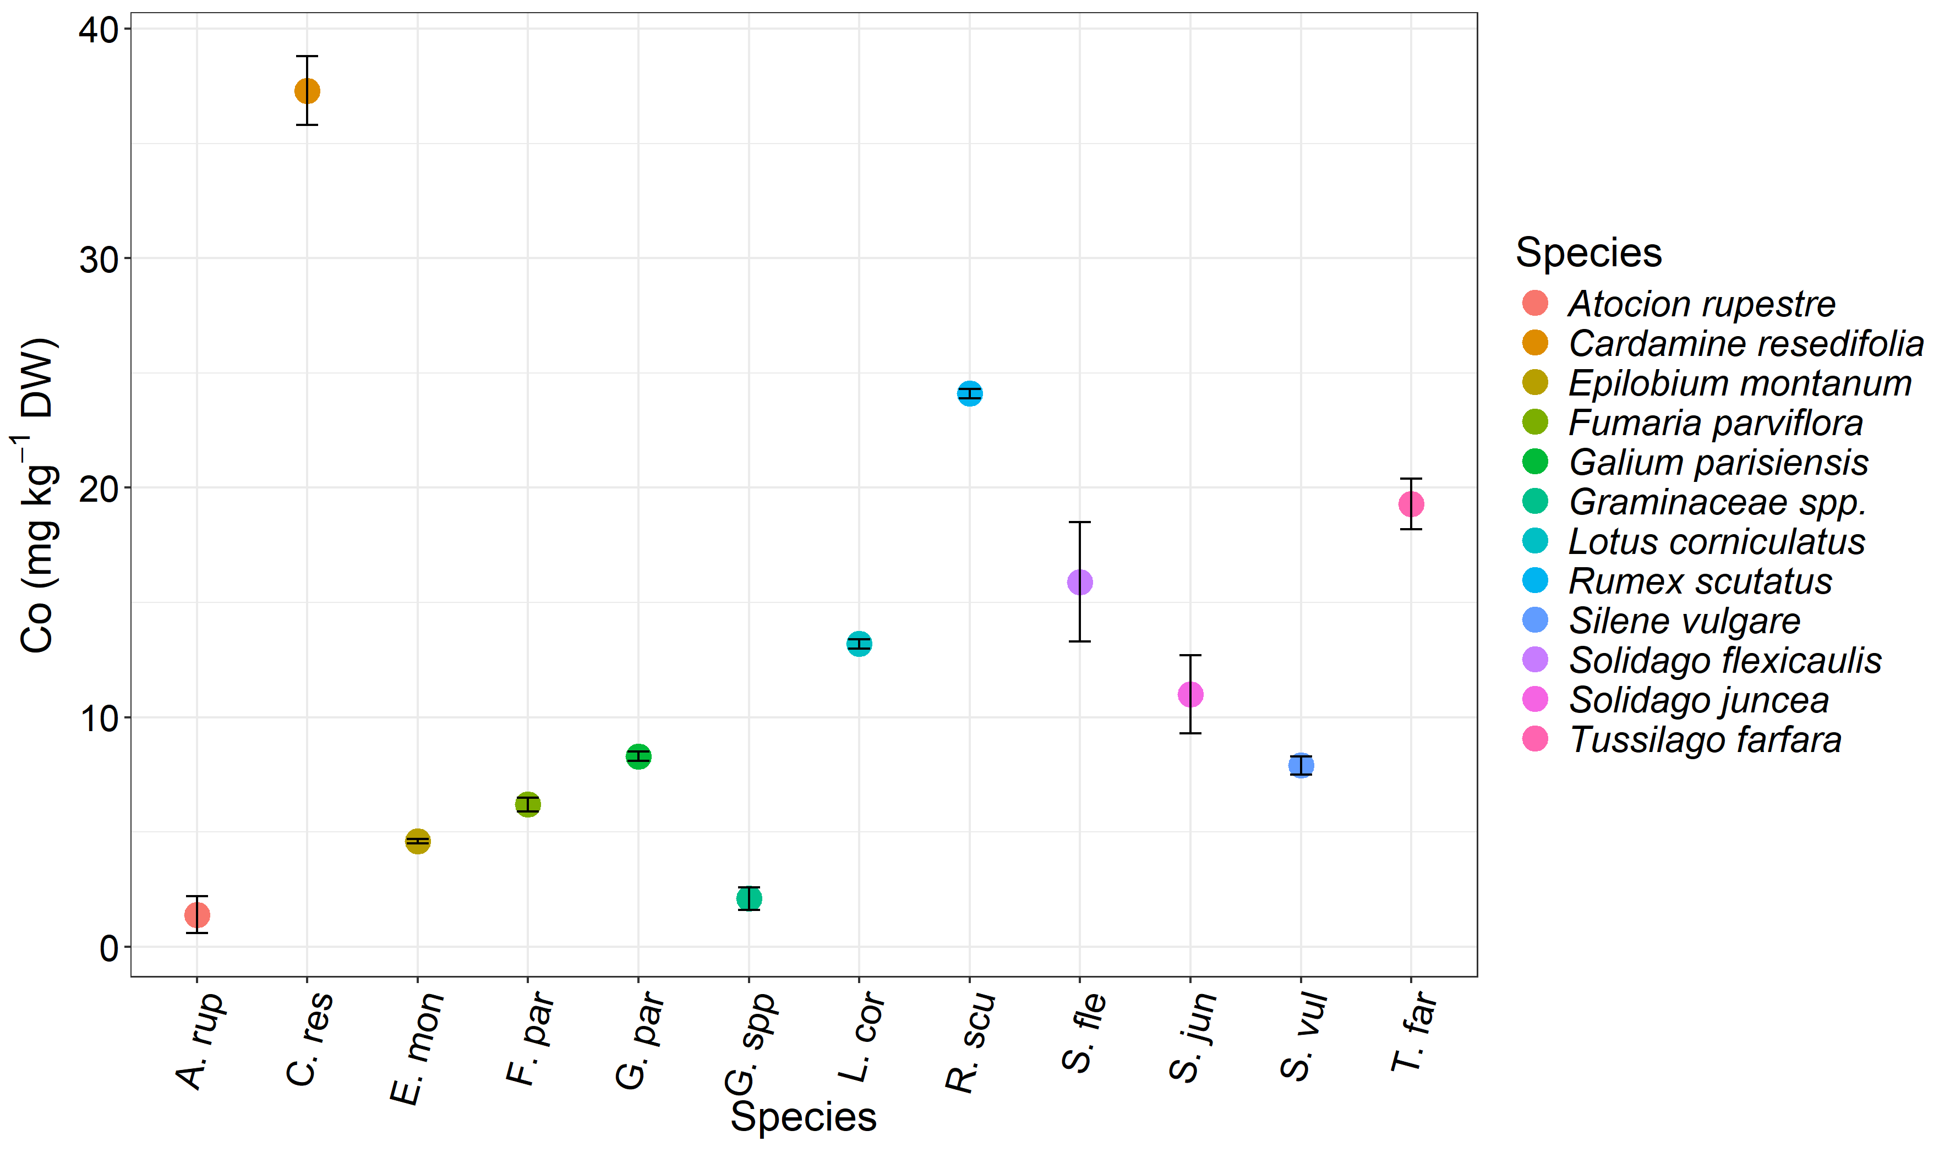
Supplementary figure S1. Cobalt accumulation in wild plants growing on CAMP mine waste (control left to natural dynamics). In the x axis the species names has been abbreviated, full names are reported in the legend. Data are the average of 4 biological replicates for each treatment (n=4).

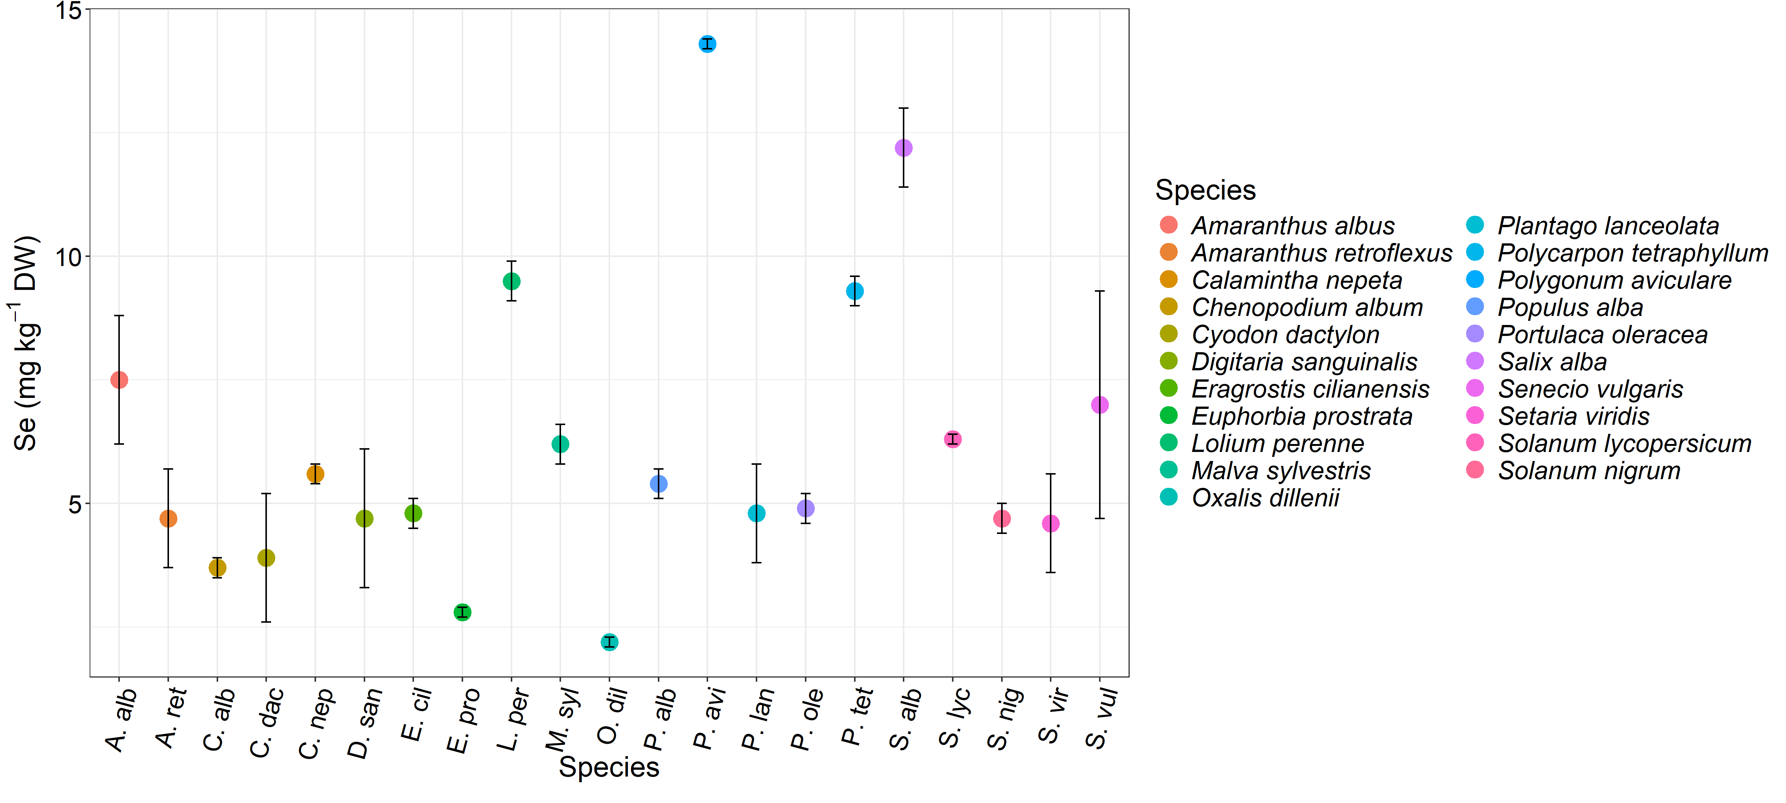

Supplementary figure S2. Selenium accumulation in wild plants growing on NORD mine waste (control left to natural dynamics). In the x axis the species names has been abbreviated, full names are reported in the legend. Data are the average of 4 biological replicates for each treatment (n=4).

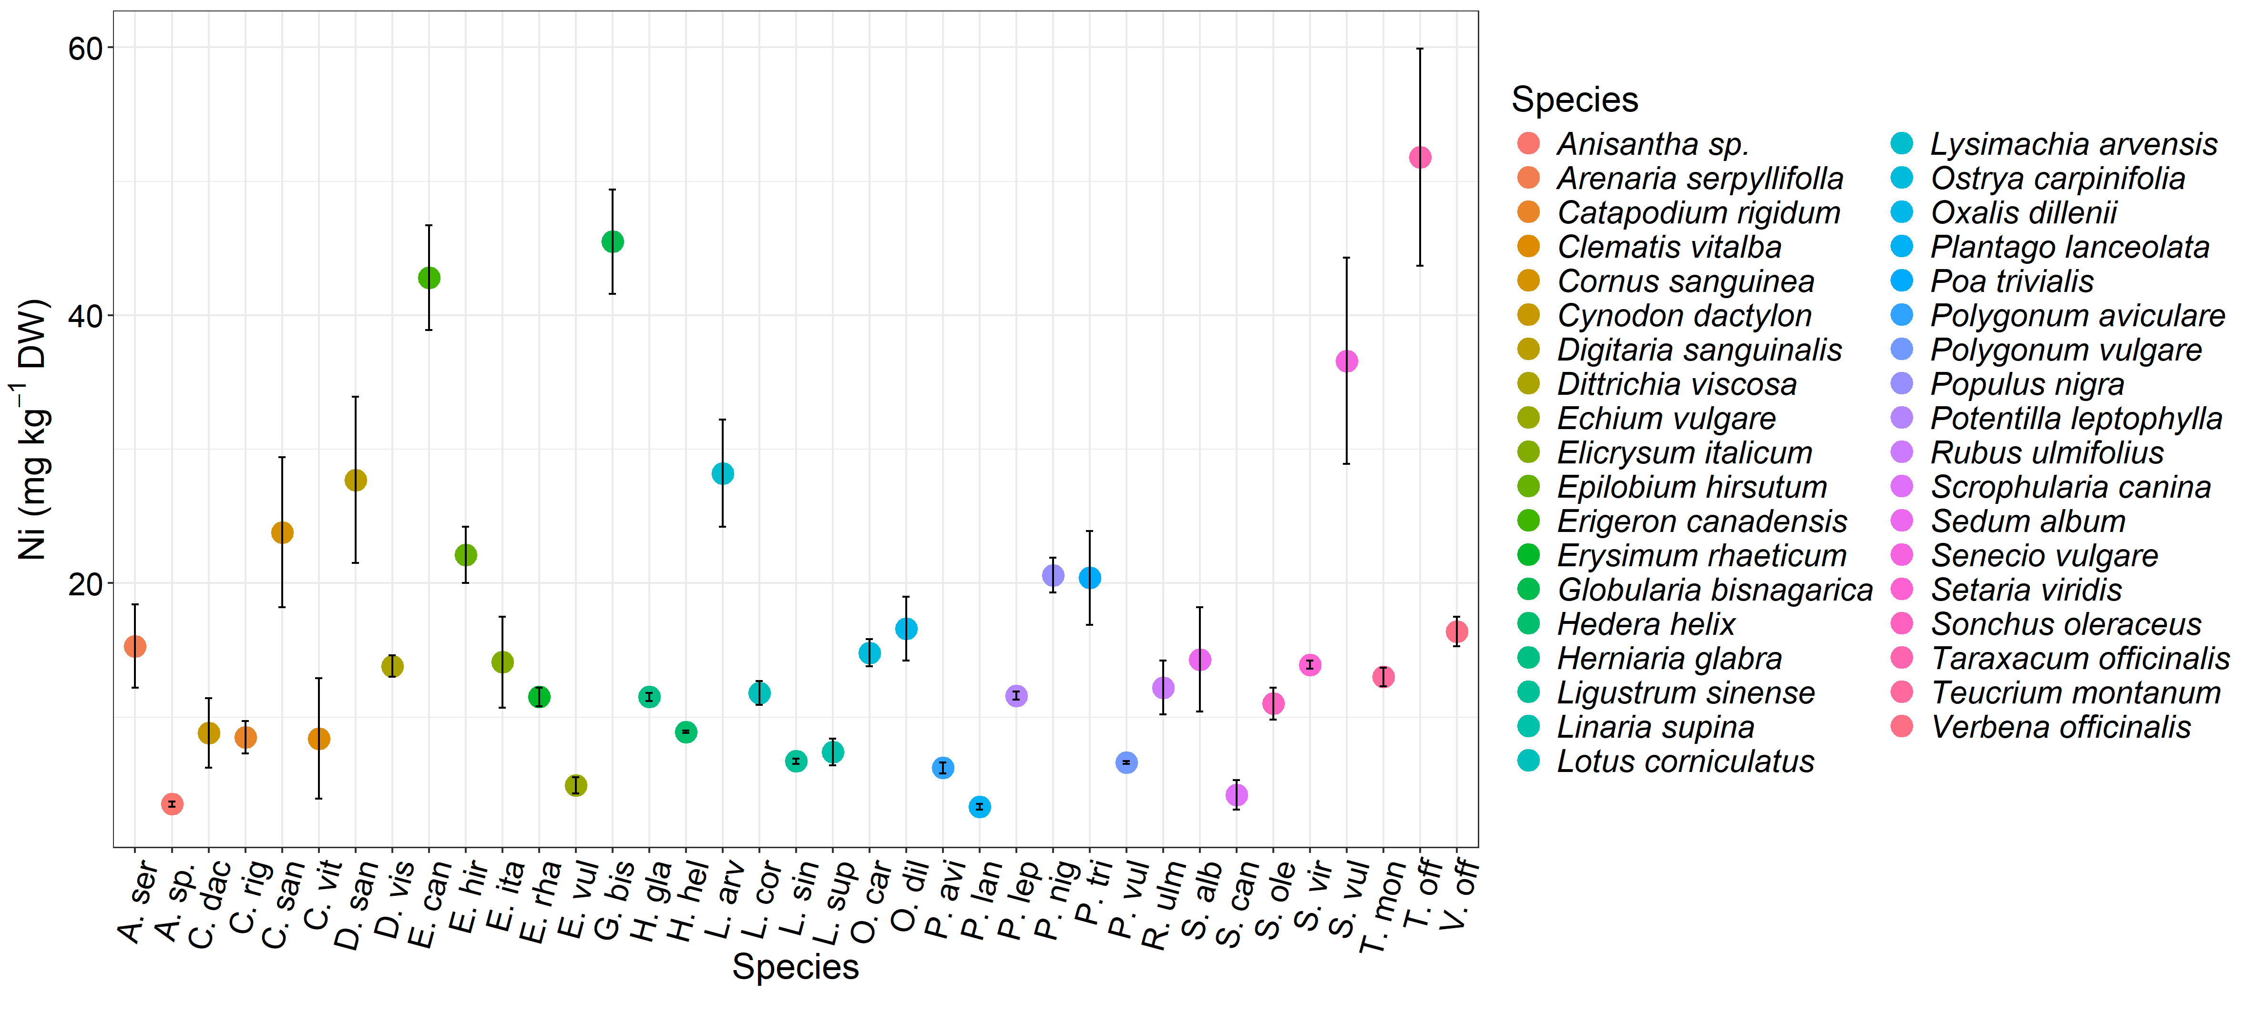

Supplementary figure S3. Nickel accumulation in wild plants growing on PRIN mine waste (control left to natural dynamics). In the x axis the species names has been abbreviated, full names are reported in the legend. Data are the average of 4 biological replicates for each treatment (n=4).

Supplementary table S1. Mine waste and sewage sludge total elment content at T0 and T1. WWTP: wastewater treatment plant; SEC, FOR and CAS: wastewater treatment plants abbreviations; SS: Sewage sludge; SS0, SS15, SS30: 0, 15, 30 kg of sewage sludge m⁻²; CAMP: Campello mine site; NORD: Cave Nord mine site; PRIN: Prinzera mine site; LOD: limit of detection. Data are the average of 4 biological replicates ± SD (n=4). Different letters indicate statistically significant differences among samples after ANOVA/Kruskal–Wallis tests, followed by Tukey HSD/Dunn’s tests, p < 0.05. Asterisk (*) indicate a significant difference for a ginven paramenter within the same treatment at T0 and T1 after Student’s/Wilcoxon Rank Sum Tests (p < 0.05). Control (T1) and SS0 (T1) are both compared with SS0 (T0).

Sewage sludge total metal content (T0)
WWTP |  | Ca (mg kg⁻¹) | Cr (mg kg⁻¹) | Mn (mg kg⁻¹) | Fe (mg kg⁻¹) | Co (mg kg⁻¹) | Ni (mg kg⁻¹) | Cu (mg kg⁻¹) | Zn (mg kg⁻¹) | Se (mg kg⁻¹) | Hg (mg kg⁻¹) | Pb (mg kg⁻¹)
SEC |  | 48700 ± 8200 ª | 90 ± 10 ª | 530 ± 60 ª | 69000 ± 7000 ª | 90 ± 20 ª | 53 ± 7 ª | 340 ± 50 ª | 1000 ± 130 ª | 3.4 ± 0.6 ª | 0.2 ± 0.2 ª | 57 ± 4 ª
CAS |  | 47600 ± 700 ª | 200 ± 30 ^{b} | 590 ± 30 ª | 25000 ± 2000 ^{b} | 5 ± 2 ^{b} | 390 ± 20 ^{b} | 400 ± 30 ª | 710 ± 40 ^{b} | 5.2 ± 0.4 ^{b} | 0.1 ± 0.3 ª | 38 ± 2 ^{b}
FOR |  | 65000 ± 2600 ^{b} | 1700 ± 730 ^{c} | 530 ± 200 ª | 40000 ± 2000 ^{c} | 3 ± 1 ^{b} | 62 ± 8 ª | 140 ± 20 ^{b} | 400 ± 8 ^{c} | 53 ± 2 ^{c} | 0.5 ± 0.4 ª | 54 ± 8 ª
Mine waste total metal content (T0)
Mine site | SS treatment | Ca (mg kg⁻¹) | Cr (mg kg⁻¹) | Mn (mg kg⁻¹) | Fe (mg kg⁻¹) | Co (mg kg⁻¹) | Ni (mg kg⁻¹) | Cu (mg kg⁻¹) | Zn (mg kg⁻¹) | Se (mg kg⁻¹) | Hg (mg kg⁻¹) | Pb (mg kg⁻¹)
CAMP | SS0 | 19000 ± 3200 | 2500 ± 1240 | 1500 ± 200 | 99000 ± 8000 | 159 ± 10 | 1140 ± 140 | 510 ± 90 | 120 ± 20 | 1.4 ± 0.3 | 0.8 ± 0.5 | 19 ± 4
CAMP | SS15 | 18000 ± 2100 | 890 ± 140 | 900 ± 100 | 62000 ± 5000 | 75 ± 5 | 620 ± 80 | 350 ± 50 | 190 ± 20 | 1.3 ± 0.3 | 0.9 ± 0.5 | 19 ± 3
CAMP | SS30 | 16000 ± 2900 | 1300 ± 670 | 810 ± 100 | 58000 ± 5000 | 91 ± 7 | 570 ± 80 | 300 ± 50 | 180 ± 20 | 1.1 ± 0.2 | 0.4 ± 0.3 | 17 ± 3
 | SS0 | 66000 ± 10200 | 20300 ± 10700 | 620 ± 200 | 45000 ± 9000 | <LOD | 50 ± 10 | 23 ± 8 | 73 ± 20 | 10.9 ± 2 | 0.7 ± 0.6 | 10 ± 2
NORD | SS15 | 50000 ± 2100 | 11150 ± 1230 | 510 ± 60 | 32000 ± 2000 | <LOD | 36 ± 2 | 47 ± 20 | 100 ± 7 | 13.6 ± 0.5 | 0.7 ± 0.4 | 23 ± 10
 | SS30 | 41000 ± 5100 | 10400 ± 5400 | 380 ± 120 | 28000 ± 5000 | <LOD | 34 ± 8 | 30 ± 4 | 90 ± 10 | 12 ± 2 | 0.4 ± 0.3 | 12 ± 1
 | SS0 | 6300 ± 1400 | 1220 ± 340 | 1040 ± 160 | 52000 ± 6000 | 90 ± 8 | 1270 ± 240 | 17 ± 6 | 62 ± 20 | <LOD | <LOD | 1.2 ± 0.6
PRIN | SS15 | 11000 ± 2900 | 680 ± 90 | 620 ± 30 | 30000 ± 2000 | 53 ± 5 | 700 ± 50 | 58 ± 6 | 115 ± 6 | 0.7 ± 0.1 | <LOD | 5 ± 1
 | SS30 | 9000 ± 1100 | 630 ± 180 | 590 ± 90 | 29000 ± 4000 | 45 ± 3 | 690 ± 130 | 59 ± 5 | 120 ± 15 | 0.6 ± 0.1 | <LOD | 5 ± 0.4
Mine waste total metal content (T1)
Mine site | SS treatment | Ca (mg kg⁻¹) | Cr (mg kg⁻¹) | Mn (mg kg⁻¹) | Fe (mg kg⁻¹) | Co (mg kg⁻¹) | Ni (mg kg⁻¹) | Cu (mg kg⁻¹) | Zn (mg kg⁻¹) | Se (mg kg⁻¹) | Hg (mg kg⁻¹) | Pb (mg kg⁻¹)
 | Control | 26000 ± 800 * | 1750 ± 60 * | 1900 ± 140 * | 113000 ± 6000 * | 166 ± 24 * | 1530 ± 80 * | 750 ± 60 * | 130 ± 5 * | 2.2 ± 0.3 * | 2.8 ± 0.4 * | 30 ± 2 *
CAMP | SS0 | 22000 ± 3200 * | 1900 ± 80 * | 1800 ± 70 * | 112000 ± 6000 * | 142 ± 22 * | 1440 ± 240 * | 690 ± 160 * | 130 ± 6 * | 1.8 ± 0.4 * | 2.4 ± 0.6 * | 24 ± 6 *
 | SS15 | 28000 ± 2000 * | 1600 ± 190 * | 1600 ± 300 * | 105000 ± 8000 * | 161 ± 25 * | 1250 ± 340 * | 740 ± 180 * | 290 ± 110 * | 2.7 ± 0.4 * | 2 ± 0.4 * | 40 ± 10 *
 | SS30 | 33000 ± 2200 * | 1440 ± 300 * | 1430 ± 180 * | 101000 ± 5000 * | 170 ± 50 * | 1050 ± 370 * | 600 ± 40 * | 480 ± 70 * | 2.8 ± 0.4 * | 2.4 ± 0.8 * | 45 ± 6 *
 | Control | 99000 ± 2700 * | 20300 ± 4100 * | 1080 ± 100 * | 66000 ± 5000 * | <LOD | 64 ± 2 * | 53 ± 7 * | 120 ± 5 * | 10.4 ± 0.8 * | 4.9 ± 1.3 * | 35 ± 8 *
NORD | SS0 | 97000 ± 9300 * | 10900 ± 5700 * | 1220 ± 110 * | 65000 ± 8000 * | <LOD | 70 ± 10 * | 50 ± 20 * | 130 ± 50 * | 10.6 ± 4.4 * | 5.6 ± 2.5 * | 40 ± 20 *
 | SS15 | 103000 ± 18000 * | 8900 ± 3100 * | 1090 ± 270 * | 67000 ± 17000 * | <LOD | 80 ± 10 * | 70 ± 20 * | 160 ± 40 * | 16.9 ± 3.8 * | 5.5 ± 2.2 * | 100 ± 10 *
 | SS30 | 92000 ± 5500 * | 10500 ± 5400 * | 1100 ± 300 * | 59000 ± 11000 * | <LOD | 121 ± 110 * | 70 ± 20 * | 170 ± 30 * | 18.2 ± 4.6 * | 4.2 ± 1.9 * | 33 ± 9 *
 | Control | 5700 ± 700 * | 2000 ± 100 * | 1220 ± 40 * | 56000 ± 2500 * | 120 ± 10 * | 1310 ± 40 * | 16 ± 3 * | 64 ± 7 * | <LOD | <LOD | 2.1 ± 0.1 *
PRIN | SS0 | 5900 ± 1100 * | 1300 ± 150 * | 1160 ± 90 * | 54000 ± 1600 * | 113 ± 2 * | 1340 ± 70 * | 15 ± 2 * | 63 ± 9 * | <LOD | <LOD | 2.6 ± 1.4 *
 | SS15 | 10400 ± 4400 * | 1170 ± 90 * | 1140 ± 200 * | 53000 ± 2000 * | 110 ± 20 * | 1240 ± 120 * | 71 ± 20 * | 160 ± 50 * | 0.6 ± 0.3 * | <LOD | 8 ± 2
 | SS30 | 14000 ± 3000 * | 1220 ± 270 * | 860 ± 120 * | 50000 ± 2500 * | 80 ± 10 * | 1170 ± 90 * | 130 ± 40 * | 270 ± 70 * | 1.4 ± 0.5 * | <LOD | 15 ± 4 *

Supplementary table S2. Mine waste and sewage sludge DTPA-extratable elment content at T0 and T1. WWTP: wastewater treatment plant; SEC, FOR and CAS: wastewater treatment plants abbreviations; SS: Sewage sludge; SS0, SS15, SS30: 0, 15, 30 kg of sewage sludge m⁻²; CAMP: Campello mine site; NORD: Cave Nord mine site; PRIN: Prinzera mine site; LOD: limit of detection. Data are the average of 4 biological replicates ± SD (n=4). Different letters indicate statistically significant differences among samples after ANOVA/Kruskal–Wallis tests, followed by Tukey HSD/Dunn’s tests, p < 0.05. Asterisk (*) indicate a significant difference for a ginven paramenter within the same treatment at T0 and T1 after Student’s/Wilcoxon Rank Sum Tests (p < 0.05). Control (T1) and SS0 (T1) are both compared with SS0 (T0).

Sewage sludge bioavailable metal(loid) content (T0)
WWTP |  | Ca (mg kg⁻¹) | Cr (mg kg⁻¹) | Mn (mg kg⁻¹) | Fe (mg kg⁻¹) | Co (mg kg⁻¹) | Ni (mg kg⁻¹) | Cu (mg kg⁻¹) | Zn (mg kg⁻¹) | Se (mg kg⁻¹)
SEC |  | 4560 ± 240 ª | 2.8 ± 2.0 ª | 48 ± 8 ª | 330 ± 10 ª | 57 ± 1 ª | 17 ± 1 ª | 136 ± 12 ª | 440 ± 20 ª | <LOD
CAS |  | 2800 ± 160 ^{b} | 6.7 ± 5.0 ª | 100 ± 5 ^{b} | 100 ± 4 ^{b} | 3 ± 1 ^{b} | 180 ± 10 ^{b} | 140 ± 9 ª | 260 ± 20 ^{b} | <LOD
FOR |  | 5500 ± 90 ^{c} | 1.5 ± 1.0 ª | 43 ± 3 ª | 190 ± 30 ^{c} | 0.4 ± 0.4 ^{c} | 7 ± 1 ^{c} | 46 ± 2 ^{b} | 130 ± 8 ^{c} | 11 ± 0.5
Mine waste bioavailable metal(loid) content (Time 0)
Mine site | SS treatment | Ca (mg kg⁻¹) | Cr (mg kg⁻¹) | Mn (mg kg⁻¹) | Fe (mg kg⁻¹) | Co (mg kg⁻¹) | Ni (mg kg⁻¹) | Cu (mg kg⁻¹) | Zn (mg kg⁻¹) | Se (mg kg⁻¹)
 | SS0 | 670 ± 20 | 1 ± 1 | 3.0 ± 0.4 | 30 ± 2 | 1 ± 0.4 | 62 ± 4 | 39 ± 3 | 8 ± 3 | <LOD
CAMP | SS15 | 2400 ± 130 | 2 ± 1 | 24 ± 3 | 170 ± 10 | 28 ± 1 | 16 ± 1 | 72 ± 7 | 220 ± 10 | <LOD
 | SS30 | 2500 ± 220 | 2 ± 1 | 25 ± 4 | 170 ± 10 | 29 ± 2 | 24 ± 1 | 77 ± 6 | 220 ± 10 | <LOD
 | SS0 | 2600 ± 80 | 2 ± 1 | 7 ± 2 | 15 ± 12 | 0.6 ± 0.6 | 2 ± 0.5 | 2 ± 0.3 | 9 ± 1 | 1.2 ± 0.1
NORD | SS15 | 3100 ± 200 | 1.0 ± 0.8 | 23 ± 2 | 100 ± 20 | 0.3 ± 0.2 | 4 ± 0.5 | 23 ± 2 | 65 ± 5 | 2.9 ± 0.2
 | SS30 | 3500 ± 150 | 1 ± 1 | 24 ± 2 | 100 ± 10 | 0.4 ± 0.3 | 4 ± 0.4 | 24 ± 2 | 66 ± 5 | 5 ± 0.3
 | SS0 | 1060 ± 20 | 0.2 ± 0.2 | 7 ± 0.2 | 0.7 ± 0.7 | 0.7 ± 0.4 | 9 ± 0.4 | 1 ± 0.6 | 7 ± 3 | <LOD
PRIN | SS15 | 1600 ± 120 | 3 ± 2 | 50 ± 4 | 50 ± 5 | 1 ± 1 | 93 ± 10 | 71 ± 7 | 130 ± 13 | <LOD
 | SS30 | 1700 ± 120 | 3 ± 3 | 50 ± 4 | 50 ± 5 | 2 ± 1 | 94 ± 7 | 71 ± 7 | 130 ± 15 | <LOD
Mine waste bioavailable metal(loid) content (Time 1)
Mine site | SS treatment | Ca (mg kg⁻¹) | Cr (mg kg⁻¹) | Mn (mg kg⁻¹) | Fe (mg kg⁻¹) | Co (mg kg⁻¹) | Ni (mg kg⁻¹) | Cu (mg kg⁻¹) | Zn (mg kg⁻¹) | Se (mg kg⁻¹)
 | Control | 300 ± 10 * | 0.05 ± 0.04 | 0.3 ± 0.3 * | 26 ± 1 * | 0.7 ± 0.1 | 53 ± 2 * | 32 ± 1 * | 5 ± 0.2 * | <LOD
CAMP | SS0 | 330 ± 50 * | 0.85 ± 0.6 | 1 ± 0.6 * | 30 ± 7 | 0.5 ± 0.1 * | 52 ± 1 * | 33 ± 2 * | 4 ± 1 * | <LOD
 | SS15 | 530 ± 10 * | 0.43 ± 0.6 | 3 ± 2 * | 65 ± 5 * | 1 ± 0.2 * | 17 ± 2 | 33 ± 1 * | 9 ± 1 * | <LOD
 | SS30 | 1000 ± 60 * | 0.24 ± 0.5 * | 5 ± 1.5 * | 110 ± 30 * | 2 ± 0.5 * | 16 ± 2 * | 36 ± 3 * | 43 ± 8 | <LOD
 | Control | 1150 ± 10 * | 1.9 ± 0.1 | 3 ± 0.7 * | 8 ± 2 | 0.1 ± 0.1 * | 0.8 ± 0.02 * | 1 ± 0.04 | 2.0 ± 0.2 * | 1.2 ± 0.1
NORD | SS0 | 980 ± 280 * | 0.16 ± 0.3 * | 4 ± 1 | 5 ± 2 | 0.1 ± 0.1 * | 2 ± 3 | 1 ± 0.3 | 5 ± 2 | 1.2 ± 0.1
 | SS15 | 1130 ± 180 * | 0.45 ± 0.8 | 3 ± 0.4 * | 12 ± 7 * | 0.5 ± 0.4 | 0.8 ± 0.3 * | 2 ± 1 * | 3.0 ± 0.6 * | 2.5 ± 0.2 *
 | SS30 | 1200 ± 170 * | 0.89 ± 0.8 | 3 ± 1 * | 17 ± 1 * | 0.2 ± 0.3 | 1 ± 0.1 * | 4 ± 1 * | 10 ± 1 * | 3.9 ± 0.3 *
 | Control | 540 ± 20 * | 0.42 ± 0.3 | 4 ± 0.5 * | 1 ± 0.3 | 0.5 ± 0.1 | 7 ± 0.2 * | 0.60 ± 0.04 | 6.0 ± 0.4 | <LOD
PRIN | SS0 | 540 ± 20 * | 0.34 ± 0.4 | 3 ± 0.2 * | 1 ± 1 | 0.4 ± 0.3 | 6 ± 1 * | 0.6 ± 0.1 | 4 ± 2 | <LOD
 | SS15 | 730 ± 20 * | 0.15 ± 0.3 * | 17 ± 8 * | 16 ± 5 * | 0.4 ± 0.4 | 20 ± 4 * | 7 ± 2 * | 11 ± 3 * | <LOD
 | SS30 | 800 ± 30 * | 0.52 ± 0.6 * | 12 ± 3 * | 30 ± 16 * | 0.5 ± 0.4 * | 27 ± 3 * | 11 ± 3 * | 16 ± 4 * | <LOD

Supplementary table S3. Hyperaccumulator plants metallome under different treatments. SS: Sewage sludge; SS0, SS15, SS30: 0, 15, 30 kg of sewage sludge m⁻²; CAMP: Campello mine site; NORD: Cave Nord mine site; PRIN: Prinzera mine site; SEC, FOR and CAS wastewater treatment plants abbreviations; LOD: limit of detection. Data are the average of 4 biological replicates ± SD (n=4). Different letters indicate statistically significant differences among samples after ANOVA/Kruskal–Wallis tests, followed by Tukey HSD/Dunn’s tests, p < 0.05. Biovailable metal(loid) content correspond to the DTPA-exctractable Ca, Cr, Mn, Fe, Co, Ni, Cu, Zn, and the AB-DTPA-extractable Se.

Mine site (species) | SS treatment | Ca (mg kg⁻¹) | Cr (mg kg⁻¹) | Mn (mg kg⁻¹) | Fe (mg kg⁻¹) | Co (mg kg⁻¹) | Ni (mg kg⁻¹) | Cu (mg kg⁻¹) | Zn (mg kg⁻¹) | Se (mg kg⁻¹) | Pb (mg kg⁻¹)
CAMP  (B. coddii) | SS0 | 32700 ± 3300 ª | 24 ± 2 ª | 140 ± 10 ª | 1200 ± 100 ª | 251 ± 8 ª | 13200 ± 900 ª | 52 ± 5 ª | 180 ± 20 ª | 1.5 ± 0.7 ª | 1.1 ± 0.1
CAMP  (B. coddii) | SS15 | 37400 ± 3700 ^{ab} | 2.0 ± 0.2 ^{b} | 1600 ± 200 ^{b} | 500 ± 50 ^{b} | 255 ± 30 ª | 490 ± 20 ^{b} | 27 ± 3 ^{b} | 160 ± 20 ª | 1.0 ± 0.3 ª | <LOD
CAMP  (B. coddii) | SS30 | 44100 ± 4400 ^{b} | 2.0 ± 0.4 ^{b} | 1100 ± 100 ^{b} | 530 ± 50 ^{b} | 148 ± 10 ª | 380 ± 50 ^{c} | 22 ± 2 ^{b} | 120 ± 10 ^{b} | 1.1 ± 0.4 ª | <LOD
NORD  (A. bisulcatus) | SS0 | 33500 ± 3300 ª | 34 ± 3 ª | 210 ± 20 ª | 430 ± 40 ª | 1 ± 0.1 ª | 7 ± 1 ª | 10 ± 1 ª | 55 ± 5 ª | 200 ± 30 ª | <LOD
NORD  (A. bisulcatus) | SS15 | 31600 ± 3200 ª | 1.0 ± 0.1 ^{b} | 110 ± 10 ^{b} | 400 ± 40 ª | 2 ± 0.5 ª | 6 ± 1 ª | 11 ± 1 ª | 44 ± 4 ^{b} | 55 ± 1 ^{b} | <LOD
NORD  (A. bisulcatus) | SS30 | 33600 ± 3400 ª | 1.0 ± 0.6 ^{b} | 110 ± 10 ^{b} | 290 ± 30 ^{b} | 1.7 ± 0.1 ª | 12 ± 1 ^{b} | 12 ± 1 ª | 41 ± 4 ^{b} | 59 ± 2 ^{c} | <LOD
PRIN  (O. chalcidica) | SS0 | 68000 ± 6800 ª | 19 ± 2 ª | 260 ± 30 ª | 750 ± 80 ª | 28 ± 4 ª | 6200 ± 1000 ª | 21 ± 2 ª | 87 ± 9 ª | 1.1 ± 0.1 ª | 0.8 ± 0.1
PRIN  (O. chalcidica) | SS15 | 63100 ± 6300 ª | 6 ± 1 ^{b} | 460 ± 50 ^{b} | 570 ± 60 ^{b} | 40 ± 2 ª | 4100 ± 200 ^{b} | 19 ± 2 ª | 98 ± 10 ª | 1.4 ± 0.2 ª | <LOD
PRIN  (O. chalcidica) | SS30 | 70900 ± 7100 ª | 6 ± 1 ^{b} | 890 ± 90 ^{c} | 390 ± 40 ^{c} | 54 ± 2 ª | 1900 ± 100 ^{c} | 23 ± 2 ª | 240 ± 20 ^{b} | 0.5 ± 0.2 ^{b} | <LOD

Supplementary table S4. Soil microbiome alpha-diversity indices under different treatments. SS: Sewage sludge; SS0, SS15, SS30: 0, 15, 30 kg of sewage sludge m⁻²; CAMP: Campello mine site; NORD: Cave Nord mine site; PRIN: Prinzera mine site. Data are the average of 2-4 biological replicates ± SD (n=2-4) Different letters indicate statistically significant differences among samples after ANOVA/Kruskal-Wallis tests, followed by Tukey HSD/Dunn’s tests, p < 0.05.

Mine site | SS treatment | Richness index | Shannon diversity index | Pielou Evenness index
CAMP | Control T0 | 65 ± 8^{ab} | 2.7 ± 0.3 ª | 0.64 ± 0.05 ª
CAMP | Control T1 | 65 ± 5 ^{ab} | 2.6 ± 0.2 ª | 0.63 ± 0.04 ª
CAMP | SS0 T1 | 68.5 ± 0.7 ª | 2.8 ± 0.1 ª | 0.67 ± 0.04 ª
CAMP | SS15 T1 | 65 ± 3 ^{ab} | 2.77 ± 0.03 ª | 0.67 ± 0.01 ª
CAMP | SS30 T1 | 50 ± 6 ^{b} | 1.9 ± 0.5 ^{b} | 0.48 ± 0.1 ^{b}
NORD | Control T0 | 26 ± 1 ^{b} | 1.31 ± 0.01 ^{b} | 0.401 ± 0.008 ^{c}
NORD | Control T1 | 54 ± 15 ª | 2.5 ± 0.3 ª | 0.64 ± 0.04 ª
NORD | SS0 T1 | 43 ± 5 ^{ab} | 2.35 ± 0.09 ª | 0.626 ± 0.005 ^{ab}
NORD | SS15 T1 | 49 ± 11 ^{ab} | 2.04 ± 0.02 ª | 0.53 ± 0.04 ^{b}
NORD | SS30 T1 | 65.5 ± 0.7 ª | 2.57 ± 0.09 ª | 0.61 ± 0.02 ^{ab}
PRIN | Control T0 | 48 ± 18 ª | 2.17 ± 0.4 ª | 0.57 ± 0.05 ª
PRIN | Control T1 | 46 ± 7ª | 2.37 ± 0.3 ª | 0.62 ± 0.06 ª
PRIN | SS0 T1 | 50 ± 3 ª | 2.589 ± 0.002 ª | 0.667 ± 0.008 ª
PRIN | SS15 T1 | 49.5 ± 0.9 ª | 2.4 ± 0.3 ª | 0.61 ± 0.06 ª
PRIN | SS30 T1 | 49.5 ± 0.7 ª | 2.06 ± 0.09 ª | 0.53 ± 0.03 ª

