Table S1 – CAARMS criteria for Clinical High Risk of Psychosis (CHR-P).

According to the CAARMS criteria (Yung et al., 2005), CHR-P condition includes: (1) “Attenuated Psychosis Symptoms” (APS) - defined as the presence of sub-threshold positive psychotic symptoms for at least 1 month during the past year; (2) “Brief Limited Intermittent Psychotic Symptoms” (BLIPS) – defined as an episode of frank psychotic symptoms that spontaneously end within a week; and (3) “Vulnerability Group” (VG) - which combines a significant decline in functioning for at least 1 month within the last 12 months with schizotypal personality disorder or a family history of psychosis in a first-degree relative.
These conditions confer high, but not inevitable risk of developing psychosis, describing young individuals manifesting potentially prodromal symptoms of psychosis. In terms of conversion to psychosis, meta-analytic results showed that the proportion of CHR-P individuals who develop a psychotic episode reached 22% at 3 years (Fusar-Poli et al., 2020).

Note. CAARMS = Comprehensive Assessment of At-Risk Mental States; CHR-P = Clinical High Risk for Psychosis.

+) Fusar-Poli P, Salazar de Pablo G, Correll CU, Meyer-Lindenberg A, Millan MJ, Borgwardt S, Galderisi S, Bechdolf A, Pfennig A, Kessing LV, van Amelsvoort T, Nieman DH, Domschke K, Krebs MO, Koutsouleris N, McGuire P, Do KQ, Arango C. (2020). Prevention of Psychosis: Advances in detection, prognosis, and ntervention. JAMA Psychiatry, 77, 755-765. https://doi.org/10.1001/jamapsychiatry.2019.4779.
+) Yung AR, Yuen HP, McGorry PD, Phillips LJ, Kelly D, Dell’Olio M, Francey SM, Cosgrave EM, Killackey E, Stanford C, Godfrey K, Buckby J. (2005). Mapping the onset of psychosis: the Comprehensive Assessment of At-Risk Mental States. Aust N Z J Psychiatry, 39, 964-971. https://doi.org/10.1080/j.1440-1614.2005.01714.x.

Table S2 - PAUSS items from the PANSS.
Autism behavioral clusters  (DSM-IV-TR) | PANSS items | Original PANSS descriptions
Deficits in social interaction  Deficits in communication  Restricted/repetitive patterns of behavior | Blunted affect (N1)  Poor rapport (N3)  Passive/apathetic social withdrawal (N4)  Difficulty in abstract thinking (N5)  Lack of spontaneity/flow of conversation (N6)  Stereotyped thinking (N7)  Mannerisms and posturing (G5)  Preoccupation (G15) | “Diminished emotional responsiveness as characterized by a reduction in facial expression, modulation of feelings and communicative gestures”.  “Lack of interpersonal empathy, openness in conversation and sense of closeness, interest or involvement with the interviewer”.  “Diminished interest and initiative in social interactions due to passivity, apathy, anergy or avolition”.  “Impairment in the use of the abstract-symbolic mode of thinking”.  “Reduction in the normal flow of communication associated with apathy, avolition, defensiveness or cognitive deficit”.  “Decreased fluidity, spontaneity and flexibility of thinking, as evidenced in rigid, repetitious or barren thought content”.  “Unnatural movements or posture as characterized be an awkward, stilted, disorganized, or bizarre appearance”.  “Absorption with internally generated thoughts and feelings and with autistic experiences to the detriment of reality orientation and adaptive behavior”.
Note – PAUSS = PANSS Autism Severity Score; PANSS = Positive And Negative Syndrome Scale; DSM-IV-TR = Diagnostic and Statistical Manual of mental disorders, IV Edition, Text Revised.

Table S3. The sociodemographic/clinical questionnaire of the PARMS program.

The sociodemographic/clinical questionnaire includes information on gender, marital status, living status, nationality, ethnic group, migration, age at entry, education (in years), employment status, source of referral, DUI, DAAP (in weeks) (Poletti et al., 2026), family history for psychosis, past hospitalization, past compulsory admission, past specialist contact, past suicide attempt, current substance abuse, pharmacological therapy (antipsychotic, antidepressant, mood stabilizer, and benzodiazepine dose), psychosocial interventions (total number of individual psychotherapy, family psychoeducation, and case management sessions), and DSM-5 diagnosis in medical records. Furthermore, we collected information on:
+) DUI, defined as the interval of time spanning from the initial, definitive onset of a mental illness until the point at which effective, evidence-based treatment is systematically initiated (Dell’osso & Altamura, 2010).
+) DAAP, defined as the cumulative period since the onset of attenuated psychotic symptoms during which an individual experiences either (a) positive symptoms within the attenuated/subthreshold range, as operationalized by the CAARMS, or (b) transient full-threshold psychotic symptoms, whether treated or untreated.
+) “suicide attempt”, defined as potentially injurious, self-inflicted behavior without a fatal outcome for which there was (implicit or explicit) evidence of intent to die (Silverman et al., 2007).
+) Service disengagement, defined as complete lack of contact or untraceable for at least 3 months despite a need of treatment (Robson & Greenwood, 2022).
+) Current suicidal ideation, defined as a score of ≥ 2 on item 4 (“Suicidality”) of the Brief Psychiatric Rating Scale (BPRS), corresponding to “at least to occasional suicidal thinking without specific plans” (Pelizza et al., 2024).
+) Functional recovery, defined as “return to work/school” as proposed by Silva and Restrepo (2019).

Note – PARMS = Parma At-Risk Mental States; DUI = Duration of Untreated Illness; DAAP = Duration of Active Attenuated Psychosis; CAARMS = Comprehensive Assessment of At-Risk Mental States.

+) Poletti M, Preti A, Raballo A. (2026). Duration of Active Attenuated Psychosis (DAAP): extending time-based illness modelling to the clinical high-risk state. Schizophr Res, 293, 27-29. https://doi.org/10.1016/j.schres.2026.03.019.
+) Dell’osso B, Altamura AC. (2010). Duration of untreated psychosis and duration of untreated illness: new vistas. CNS Spectr, 15, 238-246. https://doi.org/10.1017/s1092852900000079.
+) Pelizza L, Di Lisi A, Leuci E, Quattrone E, Palmisano D, Pellegrini C, Pellegrini P, Paulillo G, Pupo S, Menchetti M. (2024). Suicidal thinking and behavior in young people at Clinical High Risk for Psychosis: psychopathological considerations and treatment response across a 2-year follow-up study. Suicide Life Threat Behav October, 19, 13136. https://doi.org/10.1111/sltb.13136.
+) Robson E, Greenwood K. (2022). Rates and predictors of disengagement and strength of engagement for people with a first episode of psychosis using early intervention services: a systematic review of predictors and meta-analysis of disengagement rates. Schizophr Bull Open, 3: sgac012. https://doi.org/10.1093/schizbullopen/sgac012.
+) Silva MA, Restrepo D. (2019). Functional recovery in schizophrenia. Rev Colomb Psiquiatr (Engl Ed), 48, 252-260. https://doi.org/10.1016/j.rcp.2017.08.004.
+) Silverman MM, Berman AL, Sanddal ND, O’carroll PW, Joiner TE. (2007). Rebuilding the tower of Babel: a revised nomenclature for the study of suicide and suicidal behaviors - part 2: suicide-related ideations, communications, and behaviors. Suicide Life Threat Behav, 37, 264-277. https://doi.org/10.1521/suli.2007.37.3.264.

Table S4. Specialist intervention package of the PARMS program.

As recommended by current international EIP official guidelines (Schmidt et al., 2015; RER, 2023) Antipsychotic (AP) medication should be prescribed to CHR-P subjects who had (a) a rapid decline in daily functioning, (b) a sudden escalation of overt psychotic symptoms, (c) an immediate risk of suicide or severe violence, or (d) who failed to respond to psychosocial interventions. As first-line pharmacological treatment, low-dose atypical AP drugs were used (Poletti et al., 2021).
Individual psychotherapy was shaped on the model by van der Gaag and his team for young people at CHR-P, offering at least 15 sessions per year (each lasting 60 minutes) (van der Gaag et al., 2012). Family psychoeducation was adapted on the model by McFarlane for CHR-P individuals, providing at least 10-12 sessions to each family (McFarlane et al., 2016). Finally, a dedicated case-manager was also provided to each subject/family to coordinate all interventions planned, especially those aimed at promoting a recovery-oriented early rehabilitation through at least 24 sessions provided along the 2 years of follow-up (each lasting 60 minutes) (Ficarelli et al., 2021).
Note. PARMS = Parma At-Risk Mental States.

+) Schmidt, S.J., Schultze-Lutter, F., Schimmelmann, B.G., Maric, N.P., Salokangas, R.K., Riecher-Rössler, A., van der Gaag, M., Meneghelli, A., Nordentoft, M., Marshall, M., Morrison, A., Raballo, A., Klosterkötter, J., Ruhrmann, S. (2015). EPA guidance on the early intervention in clinical high-risk states of psychoses. European Psychiatry, 30, 388-404. https://doi.org/10.1016/j.eurpsy.2015.01.013.
+) Regione Emilia-Romagna (RER). (2023). Raccomandazioni regionali per la promozione della salute e del benessere in persone all’esordio psicotico, seconda edizione. Bologna: Centro Stampa della Regione Emilia-Romagna.
+) van der Gaag, M., Nieman, D.H., Rietdijk, J., Dragt, S., Ising, H.K., Klaassen, R.M., Koeter, M., Cuijpers, P., Wunderink, L., Linszen, D.H. (2012). Cognitive behavioral therapy for subjects at ultra-high risk for developing psychosis: a randomized controlled clinical trial. Schizophrenia Bulletin, 38, 1180-1188.https://doi.org/10.1093/schbul/sbs105.
+) McFarlane, W.R. (2016). Family interventions for schizophrenia and the psychoses: a review. Family Process, 55, 460-482. https://doi.org/10.1111/famp.12235.
+) Ficarelli, M.L., Troisi, E., Vignali, E., Artoni, S., Franzini, M.C., Montanaro, S., Andreoli, M.V., Marangoni, S., Ciampà, E., Erlicher, D., Pupo, S., Pelizza, L. (2021). Implementing individual and placement support for patients with severe mental illness: findings from the real world. Journal of Psychopathology, 27, 71-80. https://old.jpsychopathol.it/wp-content/uploads/2021/06/01_346_Ficarelli-1.pdf.

Figure S1. Kaplan-Meier survival functions: comparisons on 2-year time-to-event outcome incidence rates among the two CHR-P subgroups.

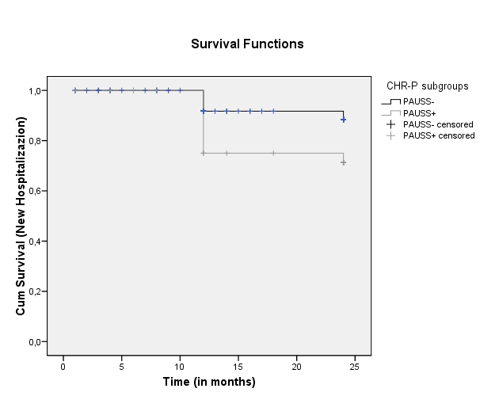

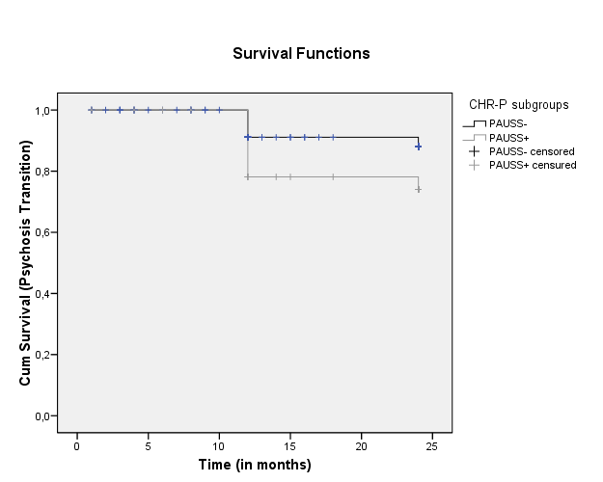

Note. CHR-P = Clinical High Risk for Psychosis; PAUSS = PANSS Autism Severity Score; PANSS = Positive And Negative Syndrome Scale; PAUSS+ = CHR-P individuals with baseline PAUSS of ≥30; PAUSS- = CHR-P individuals with baseline PAUSS of <30.

Figure S2. Mixed design ANOVA results: between-group comparisons on profile plots of statistically significant clinical and outcome parameters across the 2-year follow-up period in the two CHR-P subgroups.

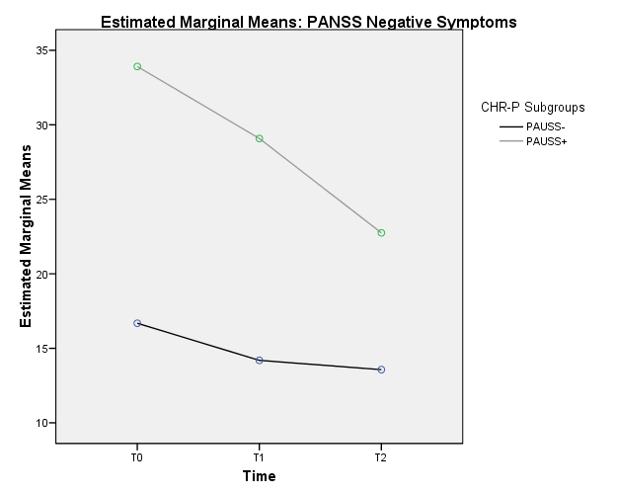

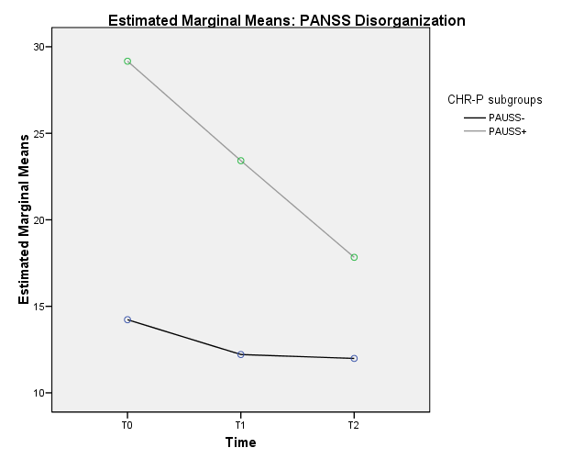

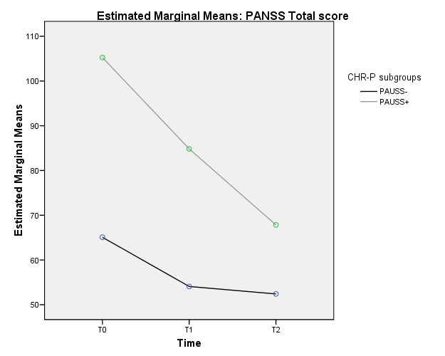

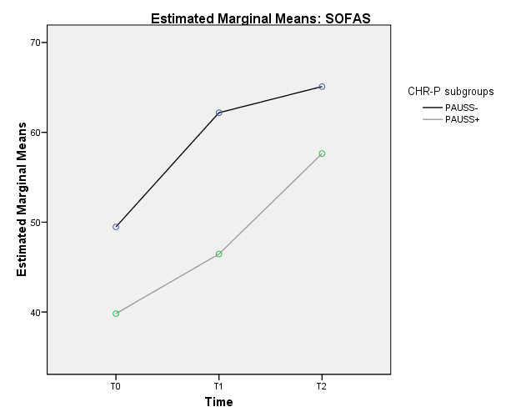

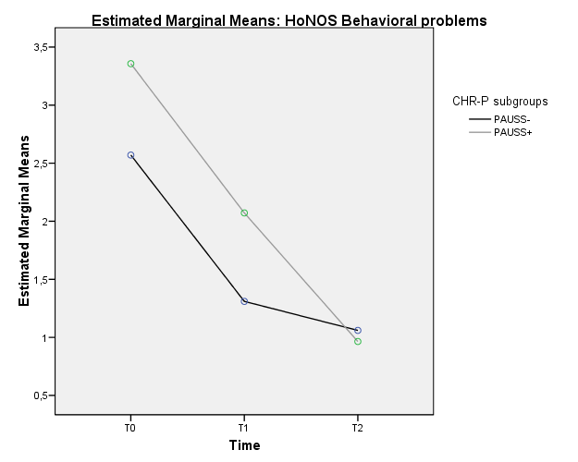

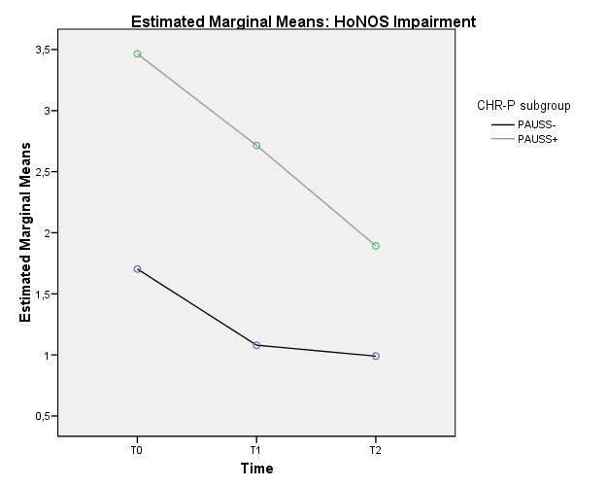

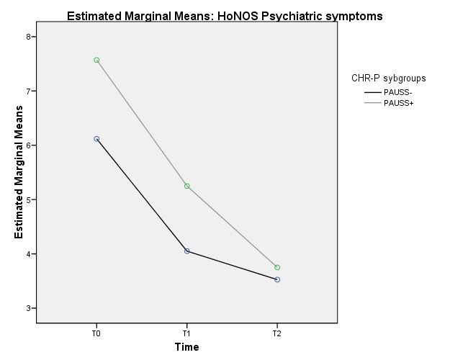

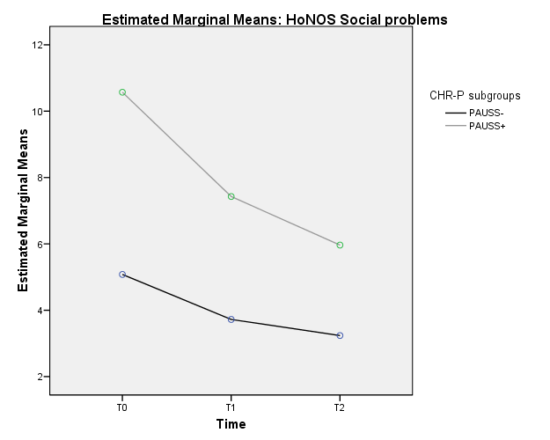

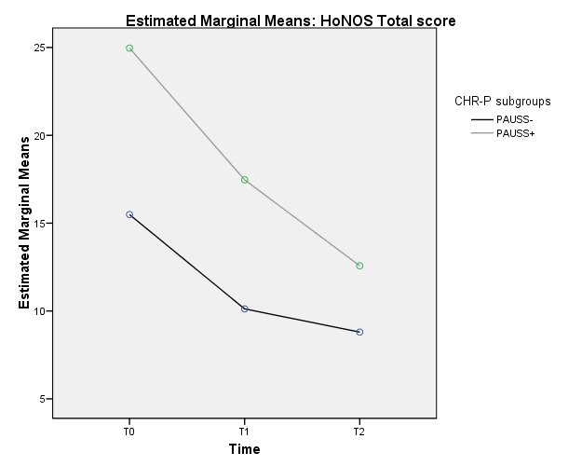

Note. ANOVA = Analysis of Variance; CHR-P = Clinical High Risk for Psychosis; PAUSS = PANSS Autism Severity Score; PANSS = Positive And Negative Syndrome Scale; PAUSS+ = CHR-P individuals with baseline PAUSS of ≥ 30; PAUSS- = CHR-P individuals with baseline PAUSS of < 30; HoNOS = Health of the Nation Outcome Scale; SOFAS = Social and Occupational Functioning Assessment Scale; T0 = baseline assessment time; T1 = 1-year assessment time; T2 = 2-year assessment time. Only CHR-P participants who concluded the 2-year follow-up period were included in the analysis.

Figure S3. Mixed design ANOVA results: between-group comparisons on profile plots of statistically significant PARMS treatment components across the 2-year follow-up period in the two CHR-P subgroups.

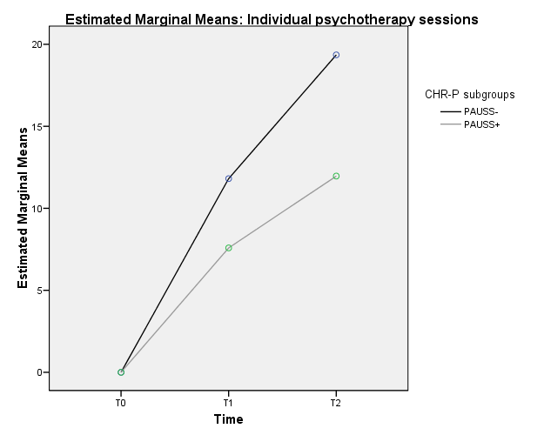

Note. ANOVA = Analysis of Variance; CHR-P = Clinical High Risk for Psychosis; PAUSS = PANSS Autism Severity Score; PANSS = Positive And Negative Syndrome Scale; PAUSS+ = CHR-P individuals with baseline PAUSS of ≥ 30; PAUSS- = CHR-P individuals with baseline PAUSS of < 30; T0 = baseline assessment time; T1 = 1-year assessment time; T2 = 2-year assessment time. Only CHR-P participants who concluded the 2-year follow-up period were included in the analysis.

