Supplementary figure and table legend

Table S1 Chemical composition of 5 mm diameter glass spheres used as an inert support for the adsorbing thin layers.
Chemical composition % w/w
SiO₂ | 61 - 67 | CaO | 5 - 10 | Na₂O | 10 - 18
Al₂O₃ | 3 - 8 | MgO | 0.5 – 3.0 | B₂O₃ | 1 - 5
Lead-free

Table S2 Data on Rosé wine (vintage 2021).
Bentonite demand | 1 g/L
Picking time | 10 October 2021
Must density | 1084 = 84°Oe
Acidity | 7.5 g/L
pH | 3.1
Added of SO₂ 3_11_2021 | 70 mg/L

Figure S1 Regeneration of spheres after use: on the left, spheres immediately after contact with wine, in the centre spheres immersed in the NaOH solution, at the bottom the beaker containing the spilt solution of NaOH and the proteins detached from the spheres, on the right, spheres after washing with water until neutral reaction.

Table S3 Glass spheres surface treatment and TiO₂ and TiO₂@SiO₂ nanosol coating.
Spheres type | nanosol TiO₂ | nanosol TiO₂@SiO₂
Untreated surface (TQ) | x | x
Acidic treatment (TA) | x | x
Basic treatment (TB) | x | x

a) |  | 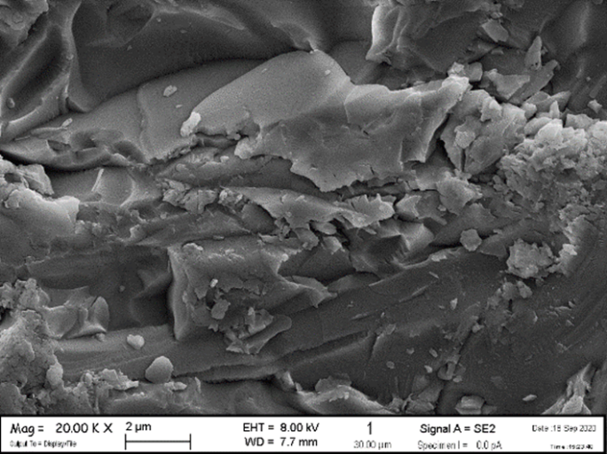  b)
Figure S2 FESEM images of glass spheres surface: a) as received; b) sandblasted surface.

a) TQ - TiO₂ | b) TQ - TiO₂@SiO₂
c) TA - TiO₂ | d) TA - TiO₂@SiO₂
e) TB - TiO₂ | f) TB - TiO₂@SiO₂
Figure S3 FESEM images of TiO2 nanosol-coated spheres: a) TQ - TiO₂, b) TQ - TiO₂@SiO₂, c) TA - TiO₂, d) TA - TiO₂@SiO₂, e) TB - TiO₂, f) TB - TiO₂@SiO₂ thin layers on spheres surface.

a) 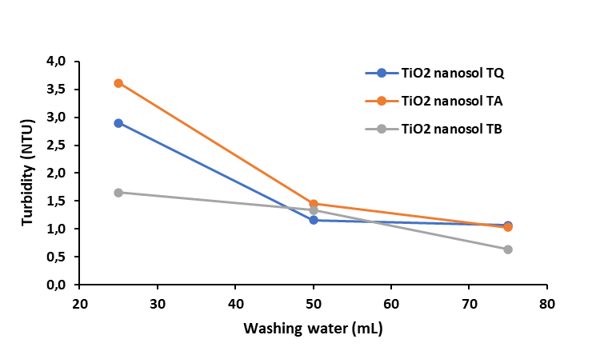
b) 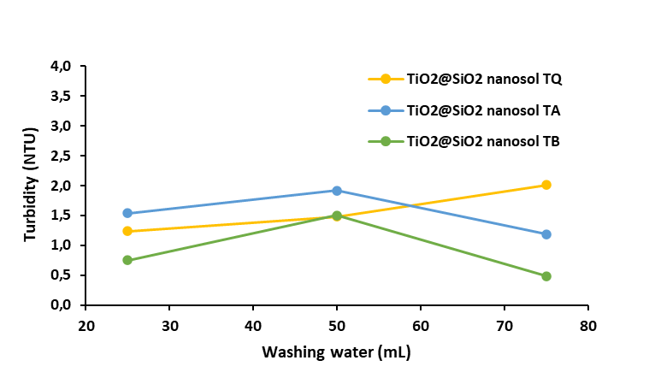
Figure S4 Turbidimetry values (NTUm) measured for the two types of TiO₂ nanosol-coated material, a) TiO₂ and b) TiO₂@SiO₂ coated samples, in the 3 washing cycles, for a total of 25, 50, and 75 mL of used water.

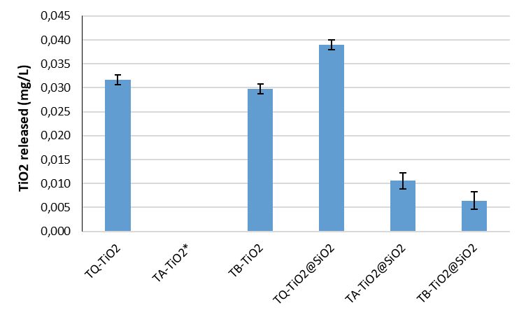
Figure S5 ICP-OES measurement of TiO₂ release in the washing water, from nanosol-coated spheres, after 3 washing cycles; *value < LOD

BSA detection in model wine solutions: HTP-BSA, ICP-OES and UV-Vis analysis
To determine if the HTS-BSA method was appropriate to measure the BSA adsorption from the model wine solutions by the TiO₂ nanosol-coated spheres treatment, we compared three methods: the HTP-BSA (Figure S6a), the ICP-OES (Figure S6b) and a UV-Vis analysis (Figure S6c) to detect the BSA absorbance at 280 nm. Figure S7 compares the BSA content measured in the six solutions after contact with the new adsorbing materials by the three techniques. It is possible to see that BSA content measured by HTP-BSA and by ICP-OES analysis have a similar trend, indicating that the TiO₂ nanosol-coating is more efficient than the TiO₂@SiO₂ nanosol. The error bar in the ICP-OES is high, due to the alcoholic content of the model wine solution that required a multi-step dilution. The BSA concentrations obtained by UV-Vis analysis resulted in an overestimation: 160 mg/L of BSA vs 140 mg/L (nominal concentration), which resulted therefore affected by a systematic error caused by the TiO₂ leakage in the solution, and an overlapping of the TiO₂ adsorption spectra at 278-280 nm to the adsorption peak of the BSA (280 nm), affecting the reading of the results. Because of this, the HTP-BSA method results, in this case, a more sensitive and direct method to measure the BSA content in the model wine solutions.

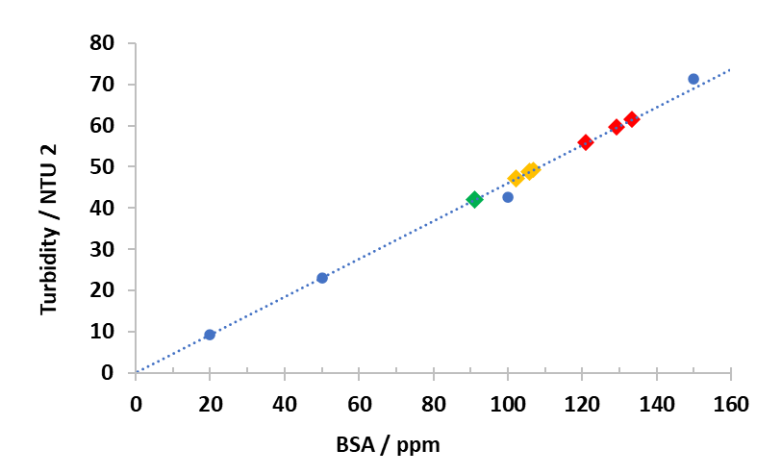
Figure S6a BSA determination by HTP-BSA method: BSA calibration curve (blue dots); BSA content after contact with the coated spheres: yellow dots: TiO₂ nanosol (BSA range 102-107 mg/L); red dots: TiO₂@SiO₂ nanosol (BSA range 121-129 mg/L); green dot: TiO₂ paste coated (BSA 91 mg/L)

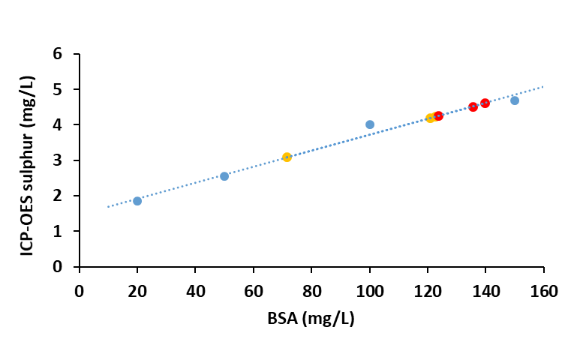
Figure S6b BSA determination by ICP-OES analysis: BSA calibration curve (blue dots); BSA content after contact with the coated spheres: yellow dots: TiO₂ nanosol; red dots: TiO₂@SiO₂ nanosol.

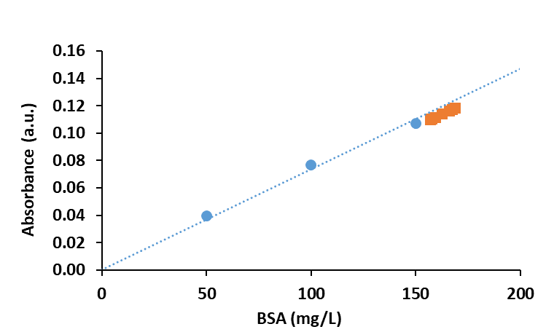
Figure S6c BSA determination by UV-Vis analysis: BSA calibration curve (blue dots); BSA content after contact with the TiO₂ nanosol-coated spheres: orange dots.

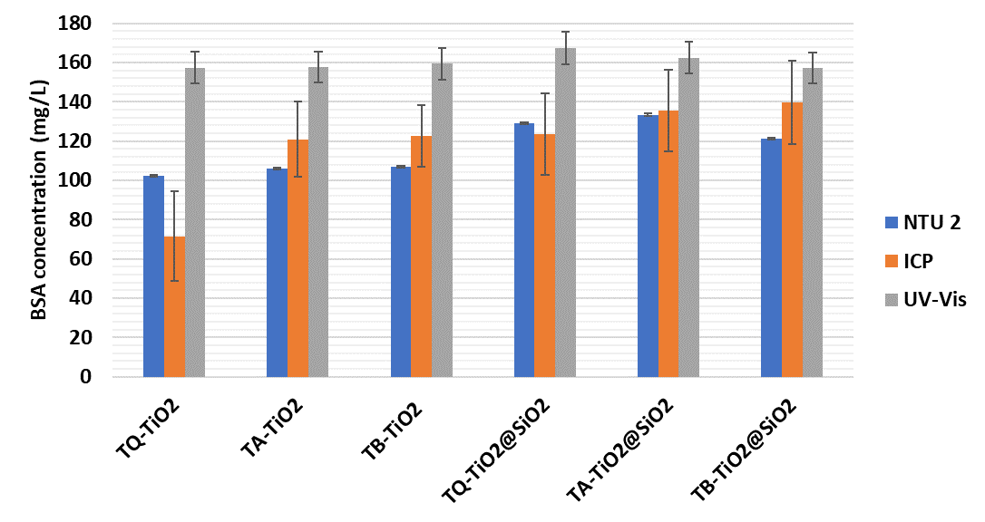
Figure S7 Comparison of the methods used for assessing the content of BSA (mg/L) of TiO₂ nanosol-coated spheres.

a)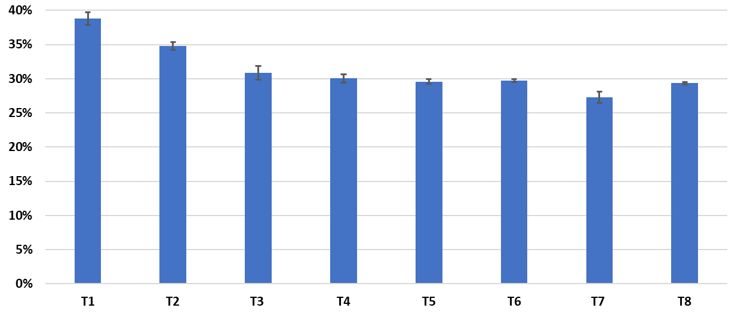
b)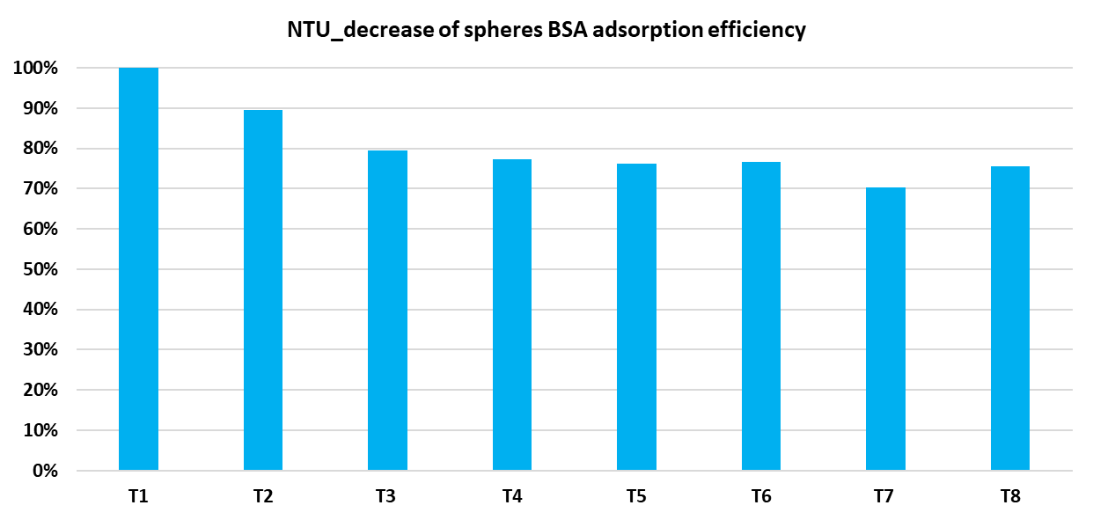
Figure S8 Adsorption capability of the TiO₂ paste-coated spheres during 8 regeneration cycles a) expressed as a percentage of BSA adsorbed, b) normalized adsorption values.
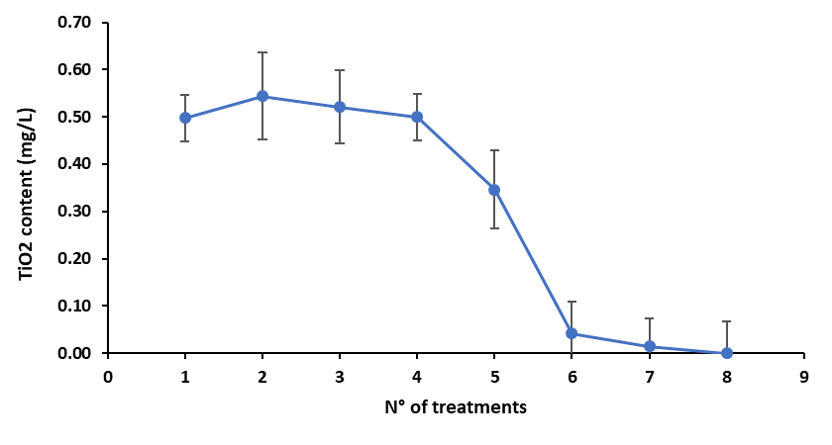
Figure S9 TiO₂ release during regeneration cycles after adsorption from the model wine solution. An ICP-OES analysis of the TiO₂ content in the treated model wine solution indicated a TiO₂ release decreasing from 0.5 mg/L to 0.04 mg/L after the 6th cycle.

Table S4 Cu and Fe ions in Rosé wine measured by ICP-OES.
 | Cu (mg/L) | Fe (mg/L) | TiO₂ (mg/L)
Rosé wine untreated | 1.40 ± 0.10 | 1.20 ± 0.07 | Low*
Rosé wine treated | 0.12 ± 0.04 | 1.1± 0.1 | 0.5 ± 0.01
* < LOD (0.01 mg/L)

