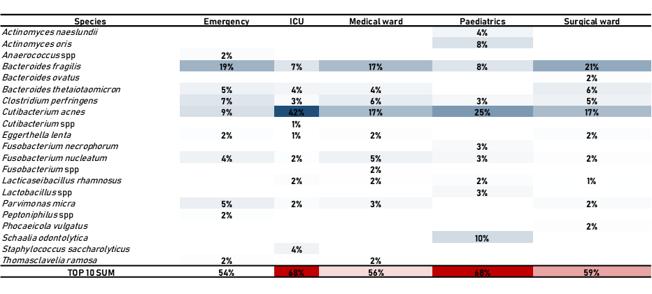Figure S2. Top 10 anaerobic isolates according to the hospital ward.

