American Journal of Clinical Dermatology: Original Research

Supplements

Title: Ritlecitinib for severe alopecia areata: a 24-week, multicentre, real-world study
Authors: Michela Starace, MD, PhD ^{1,2}, Luca Rapparini, MD ^{1,2}, Francesca Pampaloni, MD ^{1,2}, Stephano Cedirian, MD ^{1,2}, Federico Quadrelli, MD ^{1,2}, Francesca Bruni, MD, PhD ^{1,2}, Ginevra Martelli, MD ^{1,2}, Giampiero Girolomoni, MD ³, Francesco Bellinato, MD ³, Paolo Gisondi, MD ³, Giuseppe Gallo, MD ⁴, Simone Ribero, MD, PhD ⁴, Michela Ortoncelli, MD ⁴, Pietro Quaglino, MD ⁴, Luigi Gargiulo, MD ^{5,6}, Carlo Vignoli, MD ^{5,6}, Alessandra Narcisi, MD, PhD ^{5,6}, Francesca Ambrogio, MD ⁷, Caterina Foti, MD ⁷, Raffaele Dante Caposiena Caro, MD, PhD ⁸, Iris Zalaudek, MD ⁸, Angelo Valerio Marzano, MD ^{9,10}, Andrea Sechi, MD, PhD ⁹, Mauro Barbareschi, MD ^{9,10}, Luca Valtellini, MD ^{9,10}, Silvia Mariel Ferrucci, MD ⁹, Laura Diluvio, MD ¹¹, Enrico Matteini, MD ¹¹, Luca Bianchi, MD ¹¹, Mariateresa Cantelli, MD ¹², Paola Nappa, MD ¹², Carolina D’Elia, MD ¹², Valeria Boccaletti ¹³, MD, Carola Romanò, MD ¹³, Elisabetta Fulgione, MD, PhD ¹⁴, Anna Balato, MD, PhD ¹⁴, Giuseppe Argenziano, MD, PhD ¹⁴, Emanuele Trovato, MD ¹⁵, Elisa Cinotti, MD, PhD ¹⁵, Pietro Rubegni, MD, PhD ¹⁵, Federica Dall’Oglio, MD, PhD ¹⁶, Francesco Lacarrubba, MD ¹⁶, Giuseppe Micali, MD ¹⁶, Elena Pezzolo, MD ¹⁷, Francesca Caroppo, MD ^{18,19}, Anna Belloni Fortina, MD ¹⁹, Giacomo Caldarola, MD, PhD ^{20,21}, Ketty Peris, MD, PhD ^{20,21}, Lorenzo Maria Pinto, MD ^{20,21}, Calogero Pagliarello, MD, PhD ²², Riccardo Balestri, MD, PhD ²², Carlo Tomasini, MD ^{23,24}, Stefania Barruscotti MD, PhD ^{23,24}, Laura Atzori, MD ²⁵, Silvia Sanna, MD ²⁵, Lorenzo Ala, MD ²⁶, Giulio Bortone, MD ²⁶, Giovanni Pellacani, MD, PhD ²⁶, Alfredo Rossi MD, PhD ²⁶, Serena Lembo, MD, PhD ²⁷, Annunziata Raimondo, MD ²⁷, Flavia Manzo Margiotta, MD ^{28,29}, Valentina Dini, MD, PhD ²⁸, Marco Romanelli MD, PhD ²⁸, Andrea Megna, MD ³⁰, Francesca Prignano, MD, PhD ³¹, Gianmarco Silvi, MD ³¹, Oriana Simonetti, MD, PhD ³², Edoardo De Simoni, MD ³², Michela Magnano, MD, PhD ³³, Natale Schettini, MD ³⁴, ⁠⁠Alessandro Borghi, MD, PhD ³⁴, Francesca Satolli, MD ³⁵, Maria Beatrice de Felici del Giudice, MD ³⁵, Franco Rongioletti, MD ^{36,37}, Stefania Guida, MD, PhD ^{36,37}, Gianmarco Diego Bigotto, MD ^{36,37}, Cesare Filippeschi, MD ³⁸, Teresa Oranges, MD ³⁸, Greta Tronconi, MD ³⁸, Bianca Maria Piraccini, MD, PhD ³⁹.

Affiliations:
1 Dermatology Unit, IRCCS Azienda Ospedaliero-Universitaria di Bologna, Bologna, Italy.
2 Department of Medical and Surgical Sciences, Alma Mater Studiorum University of Bologna, Bologna, Italy.
3 Department of Medicine, Section of Dermatology, University of Verona, Verona, Italy.
4 Dermatology Section, Department of Medical Sciences, University of Turin, Turin, Italy.
5 Dermatology Unit, IRCCS Humanitas Research Hospital, Rozzano (MI), Italy.
6 Department of Biomedical Sciences, Humanitas University, Pieve Emanuele (MI), Italy.
7 Section of Dermatology and Venereology, Department of Precision and Regenerative Medicine and Jonian Area, University of Bari "Aldo Moro", 70124 Bari, Italy.
8 Dermatology Clinic, Hospital Maggiore of Trieste, University of Trieste, Trieste, Italy.
9 Dermatology Unit, Fondazione IRCCS Ca' Granda Ospedale Maggiore Policlinico, Milan, Italy.
10 Department of Pathophysiology and Transplantation, Università degli Studi di Milano, Milan, Italy.
11 Dermatology Unit, Policlinico Tor Vergata, University of Rome Tor Vergata, Rome, Italy.
12 Università degli Studi di Napoli Federico II, Naples, Italy.
13 Department of Dermatology, Brescia University Hospital, Brescia, Italy.
14 Dermatology Unit, University of Campania L. Vanvitelli, Naples, Italy.
15 Dermatology Unit, Department of Medical, Surgical and Neurological Sciences, University of Siena, Siena, Italy.
16 Dermatology Clinic, University of Catania, Catania, Italy.
17 Department of Dermatology, Hospital of San Bortolo, Vicenza, Italy.
18 Dermatology Unit, Department of Medicine DIMED, University of Padua, 35131 Padua, Italy.
19 Department of Womens' and Children's Health (SDB), University of Padova, 35131 Padua, Italy.
20 Dermatologia, Dipartimento Universitario di Medicina e Chirurgia Traslazionale, Università Cattolica del Sacro Cuore, Rome, Italy.
21 U.O.C. Dermatologia, Dipartimento di Scienze Mediche e Chirurgiche, Fondazione Policlinico Universitario A. Gemelli IRCCS, Rome, Italy.
22 Division of Dermatology, APSS, Trento, Italy.
23 Department of Clinical-Surgical, Diagnostic and Pediatric Sciences, University of Pavia, Pavia, Italy.
24 Dermatology Clinic, Fondazione IRCCS Policlinico San Matteo, Pavia, Italy.
25 Unit of Dermatology AOU Cagliari, Department of Medical Sciences and Public Health, University of Cagliari, Cagliari, Italy
26 Department of Dermatology and Venereology, Policlinico Umberto I, University “La Sapienza”, Rome, Italy.
27 Department of Medicine, Surgery and Dentistry “Scuola Medica Salernitana”, University of Salerno, Salerno, Italy.
28 Department of Dermatology, University of Pisa, Pisa, Italy.
29 Interdisciplinary Center of Health Science, Sant'Anna School of Advanced Studies of Pisa, Pisa, Italy.
30 Dermatology Unit, Arcispedale Santa Maria Nuova, Azienda USL-IRCCS di Reggio Emilia, Reggio Emilia, Italy.
31 Department of Health Science, Dermatology Section, Florence University, Florence, Italy.
32 Clinica Dermatologica, Dipartimento DISCLIMO, Università Politecnica delle Marche, Ancona, Italy.
33 UOC Dermatologia, Ospedale Versilia, Camaiore (LU), Italy.
34 Section of Dermatology and Infectious Diseases, Department of Medical Sciences, University of Ferrara, 44121 Ferrara, Italy.
35 Dermatology Unit, Department of Medicine and Surgery, University of Parma, Parma, Italy.
36 School of Medicine, Vita-Salute San Raffaele University, Milan, Italy.
37 Dermatology Clinic, IRCCS San Raffaele Hospital, Milan, Italy.
38 Dermatology Unit, Meyer Children's Hospital IRCCS, Florence, Italy.
39 Private Dermatology Practice, Bologna, Italy.

Corresponding Author: Luca Rapparini, Dermatology Unit, Department of Medical and Surgical Sciences, Alma Mater Studiorum, University of Bologna, Bologna, Italy.
Email: luca.rapparini2@studio.unibo.it
ORCID: 0000-0002-4029-941X
Address: Via Giuseppe Massarenti 5, 40138, Bologna, Italy
Tel: +39 0512143677

Table S1. Associated comorbidities (N = 102).
Concomitant autoimmune diseases:
- Atopy, n (%)  - Autoimmune thyroiditis, n (%)  - Celiac disease, n (%)  - Vitiligo, n (%)  - Autoimmune gastritis, n (%)  - Chronic spontaneous urticaria, n (%)  - Rheumatoid arthritis, n (%)  - Inflammatory bowel disease, n (%) | 21 (20.6%)  16 (15.7 %)  4 (3.9%)  3 (2.9%)  2 (2.0%)  1 (1.0%)  1 (1.0%)  1 (1.0%)
Other concomitant diseases:
- Hypercholesterolemia (> 200 mg/dL), n (%)  - Systemic arterial hypertension, n (%)  - Endometriosis, n (%)  - Down syndrome, n (%)  - Asperger syndrome, n (%)  - Hypertrophic cardiomyopathy, n (%)  - Hypertriglyceridaemia (> 150 mg/dL), n (%) | 15 (14.7%)  5 (4.9%)  1 (1.0%)  1 (1.0%)  1 (1.0%)  1 (1.0%)  1 (1.0%)

Table S2. Assessment of SALT.
 | SALT  overall cohort*  (mean ± SD) | SALT  severe AA cohort (50-95)#  (mean) | SALT  very severe AA cohort (≥ 95)†  (mean) | SALT adolescent cohort ª  (mean) | SALT adult cohort º  (mean)
T0 | 86.2 ± 18.5 | 68.8 | 100.0 | 84.7 | 90.0
T4w | 81.4 ± 21.9 | 63.6 | 96.7 | 78.4 | 88.3
T12w | 58.3 ± 33.9 | 36.6 | 77.5 | 50.3 | 75.1
T24w | 40.8 ± 37.1 | 21.9 | 56.3 | 32.1 | 58.8
SALT: Severity of Alopecia Tool; T0: baseline; T4w: after 4 weeks; T12w: after 12 weeks; T24w: after 24 weeks.
* N = 102; # N = 45; † N = 57; ª N = 70; º N = 32

Table S3. Assessment of the quality of life (N = 102).
 | Skindex-16  mean | HADS Depression  mean | HADS Anxiety  mean | cDLQI  mean
T0 | 48.4 | 5.4 | 6.0 | 11.5
T4w | 42.6 | 4.2 | 5.1 | 9.9
T12w | 38.3 | 4.0 | 4.9 | 7.0
T24w | 30.9 | 3.4 | 4.5 | 5.4
CDLQI: Children's Dermatology Life Quality Index; HADS: Hospital Anxiety and Depression Scale; T0: baseline; T4w: after 4 weeks; T12w: after 12 weeks; T24w: after 24 weeks.

Table S4. Abnormal laboratory investigations (N = 102).
 | T4w | T12w | T24w
Hypertriglyceridemia (>150 mg/dL) * | 2 | 7 | 5
Neutropenia (<1500 /uL) | 1 | 2 | 0
Increased CPK | 1 | 1 | 0
Hypertransaminasemia | 1 | 2 | 0
Hypercholesterolemia (>200 mg/dL) * | 4 | 4 | 5
Anemia (Hb <12 g/dL) | 2 | 2 | 4
CPK: creatinephosphokinase; Hb: hemoglobin; T4w: after 4 weeks; T12w: after 12 weeks; T24w: after 24 weeks.
* Not present at baseline

Figure S1. Flowchart illustrating the study design and technical route of the real-world retrospective analysis. Patients with severe alopecia areata treated with oral ritlecitinib 50 mg/day were enrolled according to Italian regulatory inclusion and exclusion criteria. Baseline assessments included the Severity of Alopecia Tool score, trichoscopy, evaluation of eyebrows, eyelashes and nails, quality of life and psychological scores, and laboratory tests. Patients were followed up at weeks 4, 12, and 24, and primary and secondary outcomes, as well as safety and tolerability, were assessed accordingly.

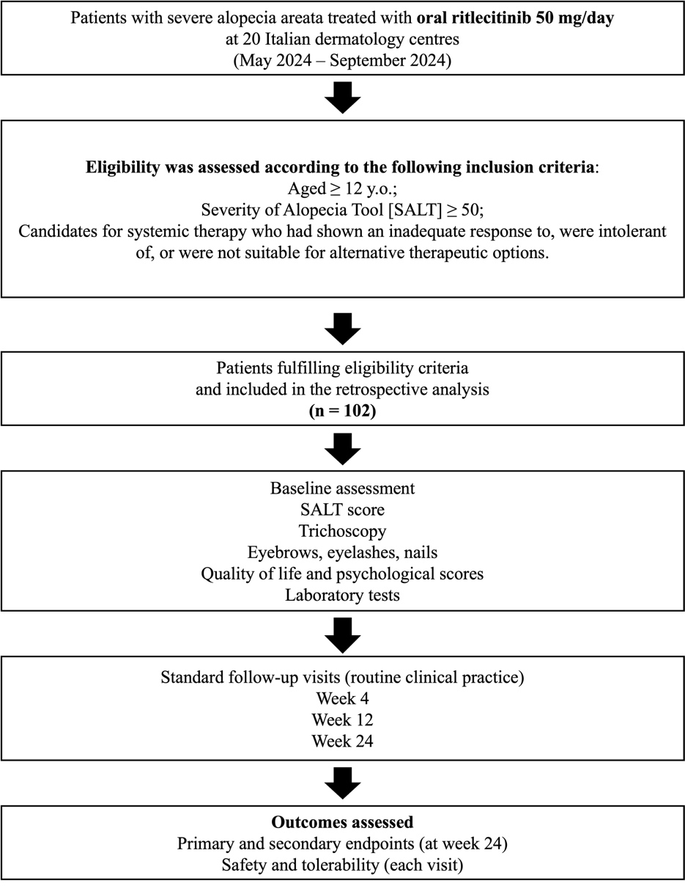

Figure S2. Sixteen-year-old patient at T0, T4w, T12w, and T24w. Clinical picture [scalp and eyebrows] and trichoscopic evaluation with 20X magnification [scalp, eyebrows, and eyelashes]. Up to T12w, the Severity of Alopecia Tool score remained 100 with only yellow dots detectable on trichoscopic evaluation; from T24w signs of hair regrowth were observed.

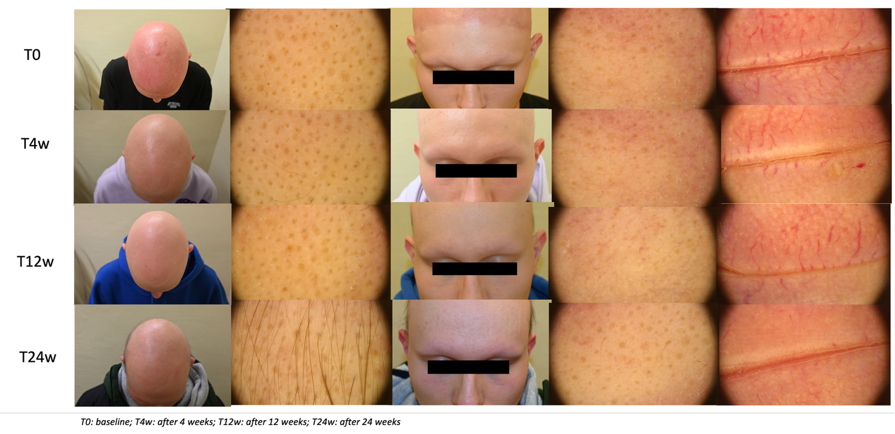

Figure S3. Forty-year-old patient previously treated with another JAK inhibitor without success. Clinical picture [scalp and eyebrows] and trichoscopic evaluation with 20X magnification [scalp, eyebrows and eyelashes]. Despite the absence of response on the scalp at T24w (Severity of Alopecia Tool = 100; yellow dots), trichoscopic evaluation revealed initial regrowth of eyebrows and eyelashes.

