Selective Hydrocracking of Polystyrene Waste over Pt- And Ru-supported Zeolite Catalysts into High Yield LPG and Ethylbenzene
Olajumoke Alabi-Babalola*^{1,2}, Edidiong Asuquo¹, Hassan Alhassawi¹, Mujtba Alnasser¹, Amal Nadri¹, Sarayute Chansai¹, Carmine D’Agostino*^{1,3}, Arthur Garforth*¹.
¹Department of Chemical Engineering, School of Engineering, University of Manchester, Oxford Road, Manchester, M13 9PL, UK.
²Department of Chemical Engineering, Obafemi Awolowo University, Ile-Ife, Nigeria
³Dipartimento di Ingegneria Civile, Chimica, Ambientale e dei Materiali (DICAM),
Alma Mater Studiorum – Universita` di Bologna, Via Terracini, 28, 40131 Bologna, Italy
Corresponding authors: *olajumoke.alabi-babalola@manchester.ac.uk; carmine.dagostino@manchester.ac.uk, arthur.garforth@manchester.ac.uk

SUPPLEMENTARY INFORMATION

S1 Polymer and catalyst characterisation
The thermogravimetric analysis (TGA) of the polymer has been determined using a TGA Q5000 (TA Instrument), crushed polymer was placed in a ceramic pan and heated at different rates of 5 to 20 $℃$ min^{–1} under nitrogen gas with a flow rate of 40 mL min^{–1} from room temperature to 600 $℃$. Nitrogen sorption isotherms at 77 K were obtained on a Micrometrics ASAP 2020 instrument. Prior to measurements, the samples (~100 mg) were degassed at 400 $℃$for 4 h using a ramp rate of 10 $℃$ min^{–1}. X-ray diffraction (XRD) patterns were recorded on a PANalytical X’Pert Pro diffractometer, which was equipped with a copper line focus X-ray tube coupled with a Nickel kβ absorber (λ = 1.542 Å). The data was collected with a 0.033$°$ 2$θ$ step size, dwell time of 450.22 s per step, in the range of 5 – 70$°$. The diffraction signal intensity is plotted against the angle of diffraction 2$θ$.
The acidity profile of the catalysts were recorded with a Microtrac MRB BELCAT II Catalyst Analyser coupled with a NH₃-calibrated thermal conductivity detector (TCD). About 100 mg of catalyst was first pre-treated under argon (Ar) flow for 1 h at 600 $℃$ (ramp 10 $℃$ min^{–1}). Subsequently, the samples were cooled, and a 7.2 vol % NH₃-Ar was adsorbed pulsewise until oversaturation occurred. Physisorbed NH₃ was removed by flowing Ar for 30 min at 40°C. Subsequently, the system was stabilized for a period of 45 min, following which NH₃ desorption measurements were taken up to 800°C. X-ray photoelectron (XPS) spectra were recorded on a Kratos AXIS Ultra DLD with a monochromated Al Kα radiation as an X-Ray source (1486.6 eV). It consists of a charge neutralizer, and a hemispherical electron energy analyser, with a base pressure less than 9.3 x 10⁻⁷ and Mg Kα X-rays used as the primary excitation. Samples were prepared by attaching copper tape to the sample bar, and about ~20-30 μg of the powdered sample was spread on the copper tape to obtain an even coverage. STEM and EDS spectra images were obtained with an FEI Talos F200X microscope consisting of an X-FEG electron source and Super-X SDD EDS detectors. The experiment was performed using an acceleration voltage of 200 kV and a beam current of approximately 200 pA. The STEM images were acquired with a HAADF detector.
Pyridine-FTIR measurements were carried out by loading about 30 mg of the bifunctional catalysts into the DRIFTS cell of a Thermo Nicolet iS50 FTIR spectrometer which is equipped with an MCT/A detector. The samples were first pretreated in Argon from ambient to 300 $℃$ at 10 $℃$.min⁻¹ at a flow rate of 50 mL.min⁻¹ to remove all contaminants and physisorbed molecules. The system was then cooled to 30 $℃$ and 64 background scans were obtained at a resolution of 4 cm⁻¹. Afterwards, the system was switched to pyridine-saturated Ar (2 -3 Torr vapour) for adsorption at 30 $℃$ for 30 min. This was followed by purging with pure Ar at a flowrate of 50 mL.min⁻¹ to remove the physiosorbed pyridine, and different spectra were obtained at 30 $℃$ and 300 $℃$ (10 $℃$.min⁻¹, hold time 30 min) respectively.
Inductively Coupled Plasma–Optical Emission Spectrometry (ICP–OES). The percentage compositions of platinum present in the catalysts were determined with the ICP-OES (Analytic Jena Plasma Quant 9000 Elite). Approximately 100 mg of catalyst samples were digested based on aqua regia [1, 2] using 12 mL of acid– hydrochloric acid (HCl):nitric acid (HNO₃) in the ratio 3:1, v/v with a microwave digester (Milestone ETHOSEASY). Afterwards, the solutions were filtered and made up to 50 mL deionized water. The samples were further conducted through a nebulizer into the spray chamber of the ICP-OES via a peristaltic pump (1 mL.min^{–1}) to produce an aerosol, which enters the argon plasma by an induction coil through which high frequency alternate current flows. The extremely high temperature (6000–10000 K) of the plasma causes collisions between the argon gas and the ionization electrons in the torch thereby causing the electrons to reach a higher excited state, thereby emitting light energy and are subsequently measured as a function of the intensity of the wavelength of the characteristic element. Calibration curve was obtained and the percentage metal compositions of the samples were measured.
Coke analysis of the spent zeolite catalysts was carried out via TGA analysis by heating about 5 mg of spent catalysts under nitrogen atmosphere up to 600 $℃$ at a rate of 10 $℃$ min⁻¹ , kept isothermal for 1 h, and further changed to air for another 1 h. The amount of coke obtained was calculated using the weight difference of the spent catalysts in nitrogen and atmospheric air with respect to the initial weight of sample.
NMR relaxation studies were carried out with a Carbon Spinsolve Bruker DMX spectrometer operating at a ¹H frequency of 43 MHz to investigate the catalysts activity and nature of interactions with selected probe molecules. Samples were prepared by soaking HY, 1Pt/Cal/HY, and 1Pt⁰HY catalysts separately in eight (8) probe solvents consisting of o-xylene, m-xylene, p-xylene, ethylbenzene, water, cyclohexane, n-octane, and squalene for 48 h. The choice of probe molecules are influenced by the nature of obtainable products from catalytic cracking of PS. The solid catalysts were dried on pre-soaked filter paper to remove any excess solvent, and later transferred into 5 mm NMR tubes. Proton NMR longitudinal T₁ and transverse T₂ relaxation times were acquired using the standard inversion recovery and Carr-Purcell-Meiboom-Gill (CPMG) techniques, respectively, as reported elsewhere [3]. Sixteen spaced recovery delays between 1 ms and 25 s for bulk fluids, and between 1 ms – 1.5 s for fluids in porous catalysts were acquired. A recycle delay of approximately 5$T_{1}$ was used between successive scans to obtain maximum signal. The CPMG pulse sequence was recorded over 16 repeat scans, echo time spacing t_{e} = 0.5 ms, to generate n echoes series corresponding to 2 × $τ$ × n total time delay (for a list of different delay times). The delay time for bulk liquids was in the range of 1 ms – 25 s, while for the fluids in porous samples, delay times are in the range of 1 ms – 0.5 s. The $T_{1}$ and $T_{2}$ relaxation time constants were obtained by fitting the experimental data obtained to Equations S1 and S2, respectively.
$M\left(t\right)= M_{0}\left[1-2exp\left(-\frac{t}{T_{1}}\right)\right] (S1)$
$$M\left(t\right)= M_{0}exp\left(-\frac{t}{T_{2}}\right) (S2)$$
where $M\left(t\right)$ is the NMR signal intensity at time $t$.

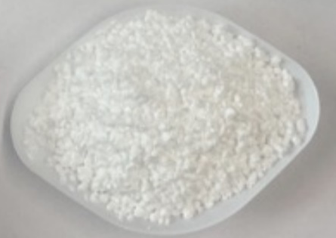
Figure S1 Post-consumer waste expanded polystyrene (EPS) sample.
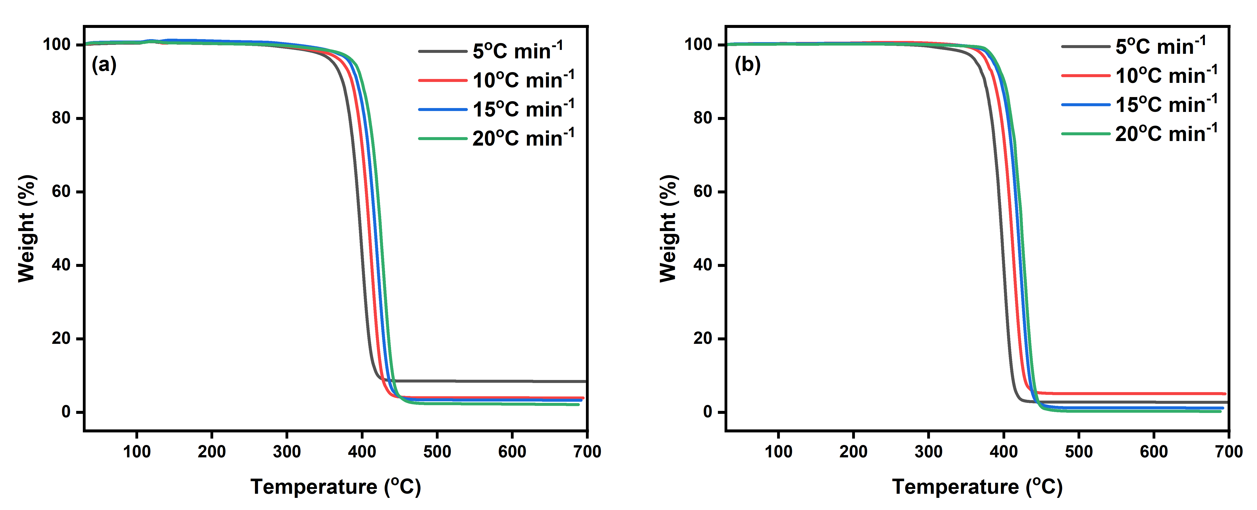
Figure S2 TGA curve of different heating rates of 5 – 20 $℃ \min^{-1}$ (a) EPS (b) VPS.
Table S1 Acidity and surface properties of catalysts
Catalysts | HY(5) | 1Pt/Cal/HY | 1Pt⁰HY | 1Ru/Cal/HY | 1Ru⁰HY | ZSM-5(30) | 1Pt/Cal/ZSM-5 | 1Pt⁰ZSM-5
Acidity  (mmol/g of NH₃) | 1.593 | 1.679 | 1.712 | 2.325 | 2.870 | 1.517 | 2.001 | 2.591
BET surface area (m² g^{–1}) | 573 | 553 | 536 |  | 438 |  | 306 | 312
t-plot micropore area (m² g^{–1}) | 516 | 489 | 483 |  | 400 |  | 216 | 214
t-plot external surface area  (m² g^{–1}) | 58 | 63 | 53 |  | 40 |  | 90 | 98
Micropore volume (cm³ g^{–1}) | 0.27 | 0.26 | 0.25 |  | 0.21 |  | 0.11 | 0.11
D-H desorption average pore diameter (4V/A) (Å) | 0.57 | 0.59 | 0.6 |  | 7.1 |  | 38.8 | 38.8
Maximum pore volume (cm³ g^{–1}) | 0.34 | 0.34 | 0.33 |  | 0.22 |  | 0.15 | 0.15
Mesopore volume (cm³ g^{–1}) | 0.07 | 0.08 | 0.08 |  | 0.02 |  | 0.04 | 0.04

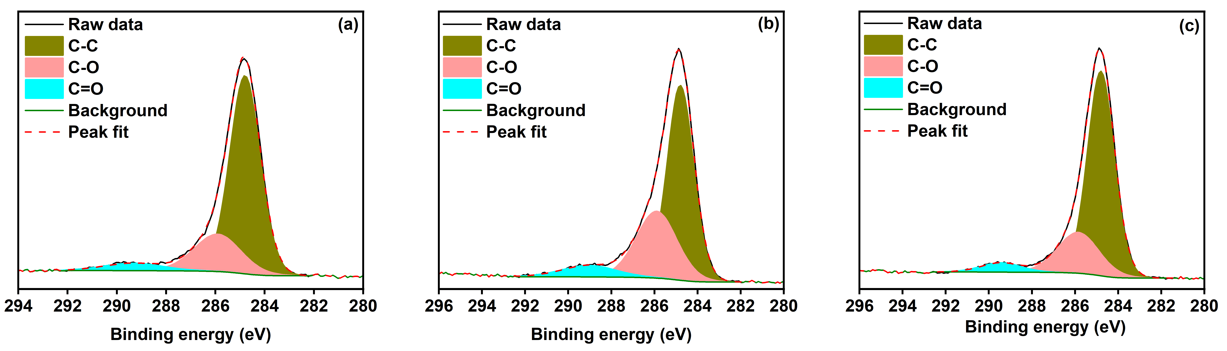
Figure S3 C 1s peaks observed in (a) HY (b) 1Pt/Cal/HY (c) 1Pt⁰HY.
Table S2 C 1s components of HY(5), 1Pt/Cal/HY, and 1Pt⁰HY catalysts
Catalyst | C-C  BE (eV) | C-O  BE (eV) | C=O  BE (eV)
HY(5) | 284.8 | 285.9 | 289.3
1Pt/Cal/HY | 284.8 | 285.9 | 289.0
1Pt⁰HY | 284.8 | 285.9 | 289.4

Table S3 Al 2p and Pt 4f components of HY(5), 1Pt/Cal/HY, and 1Pt⁰HY catalysts.
State | Al 2p  BE (eV) | Pt 4f_{7/2}  BE (eV)
HY(5) | 75.0, 75.4 | -
1Pt/Cal/HY | 74.9, 75.3 | 71.4 (Pt₂Si), 73.8 (PtO)
1Pt⁰HY | 74.7, 75.2 | 71.2 (Pt metal)
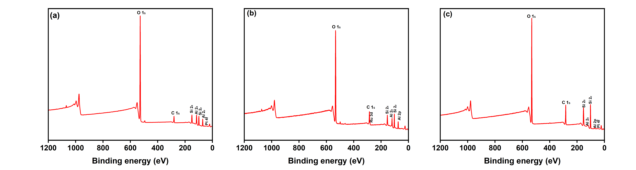
Figure S4 XPS survey spectra of (a) 1Pt⁰HY (b) 1Ru⁰HY (b) 1Pt⁰ZSM5.

Table S4 Al 2p, Pt 4f, C 1s, Ru 3d components of 1Pt⁰HY, 1Ru⁰HY, and 1Pt⁰ZSM5 catalysts.
State | Al 2p _{3/2, 1/2}  BE (eV) | Pt 4f _{7/2, 5/2} (metal)  BE (eV) | C 1s  BE (eV) | Ru 3d_{5/2, 3/2} (metal)  BE (eV)
1Pt⁰HY | 74.7, 75.2 | 71.2, 74.6
1Ru⁰HY |  |  | 284.7 (C-C), 285.6 (C-O-C) | 280.2, 284.4
1Pt⁰ZSM5 | 74.9, 75.3 | 71.4, 74.8

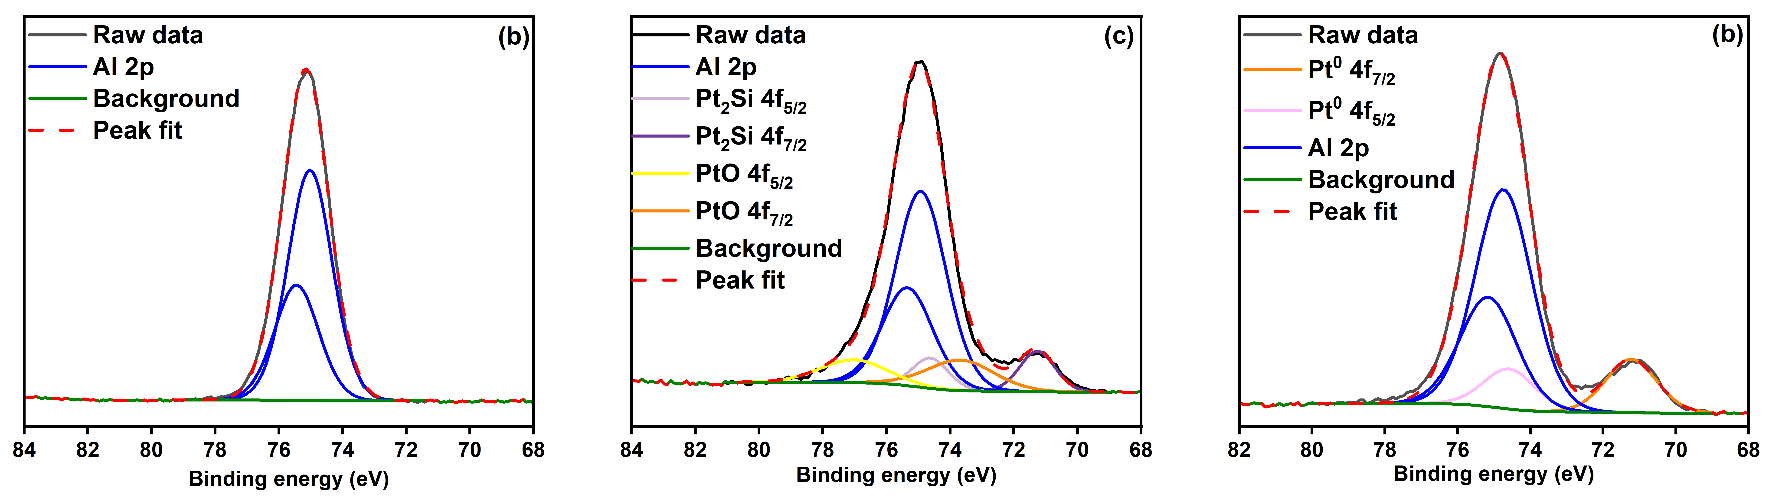
Figure S5 (a) Al 2p peak for 1Pt⁰ZHY, (b) Al 2p and Pt 4f peaks observed in 1Pt/Cal/HY (c) Al 2p and Pt 4f peaks observed in 1Pt⁰HY.
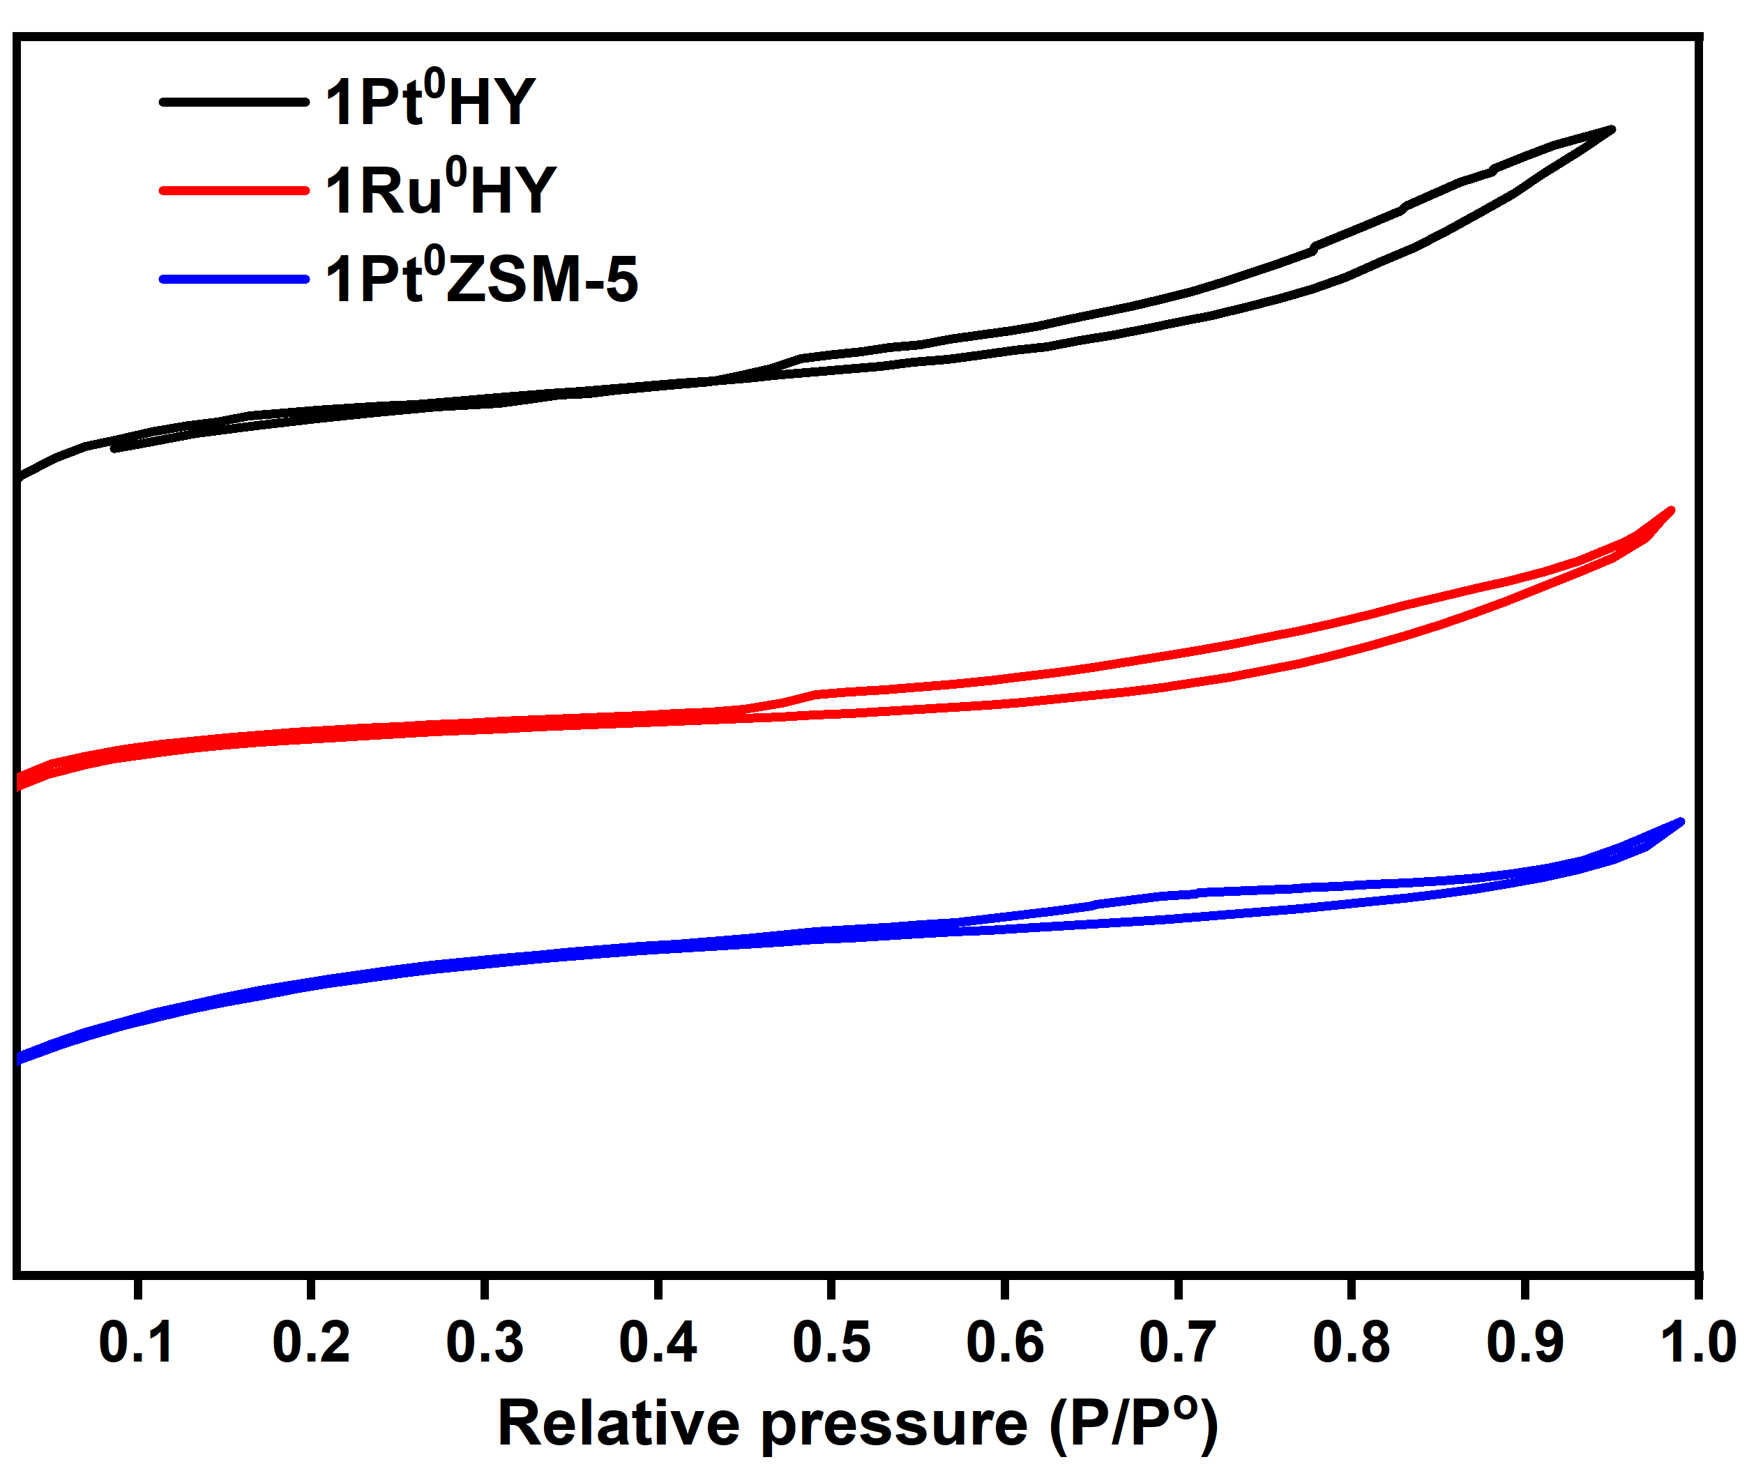
Figure S6 BET nitrogen adsorption-desorption isotherm of synthesised catalysts.
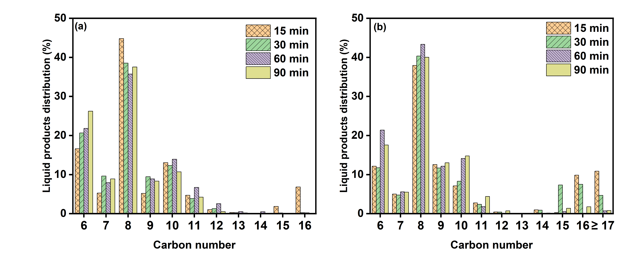
Figure S7 Liquid product distribution for EPS hydrocracking at 330 $℃$, 20 bar H₂, 10:1 polymer: catalyst ratio at different reaction times using (a) 1Pt⁰HY (b) 1Ru⁰HY catalysts.

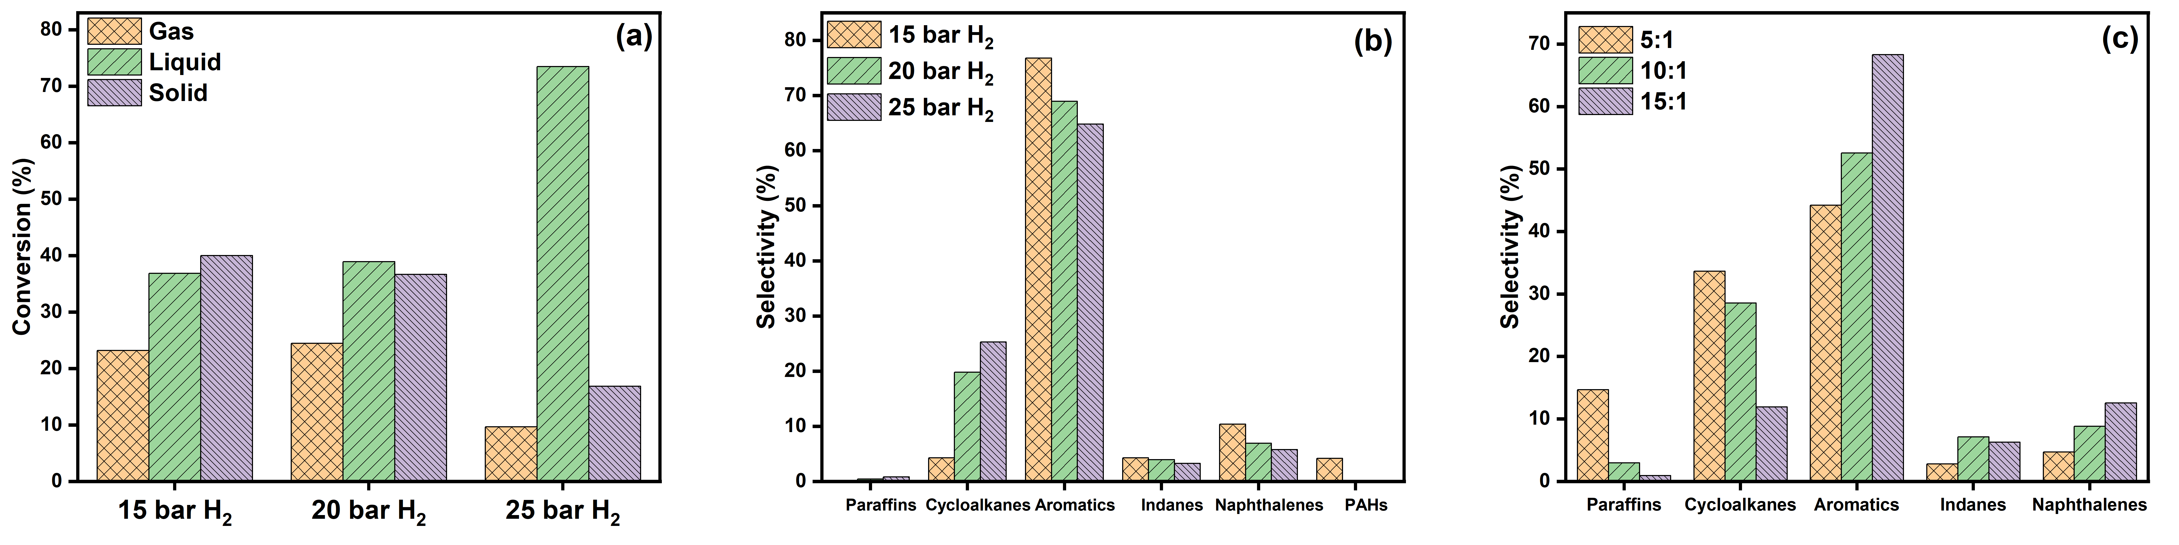
Figure S8 Effect of pressure and polymer:catalyst ratio on liquid product distribution for EPS hydrocracking using 1Pt⁰HY at 330 $℃$ (a) conversion at 15 min, 10:1 (b) selectivity at 15 min (c) selectivity at 60 min.

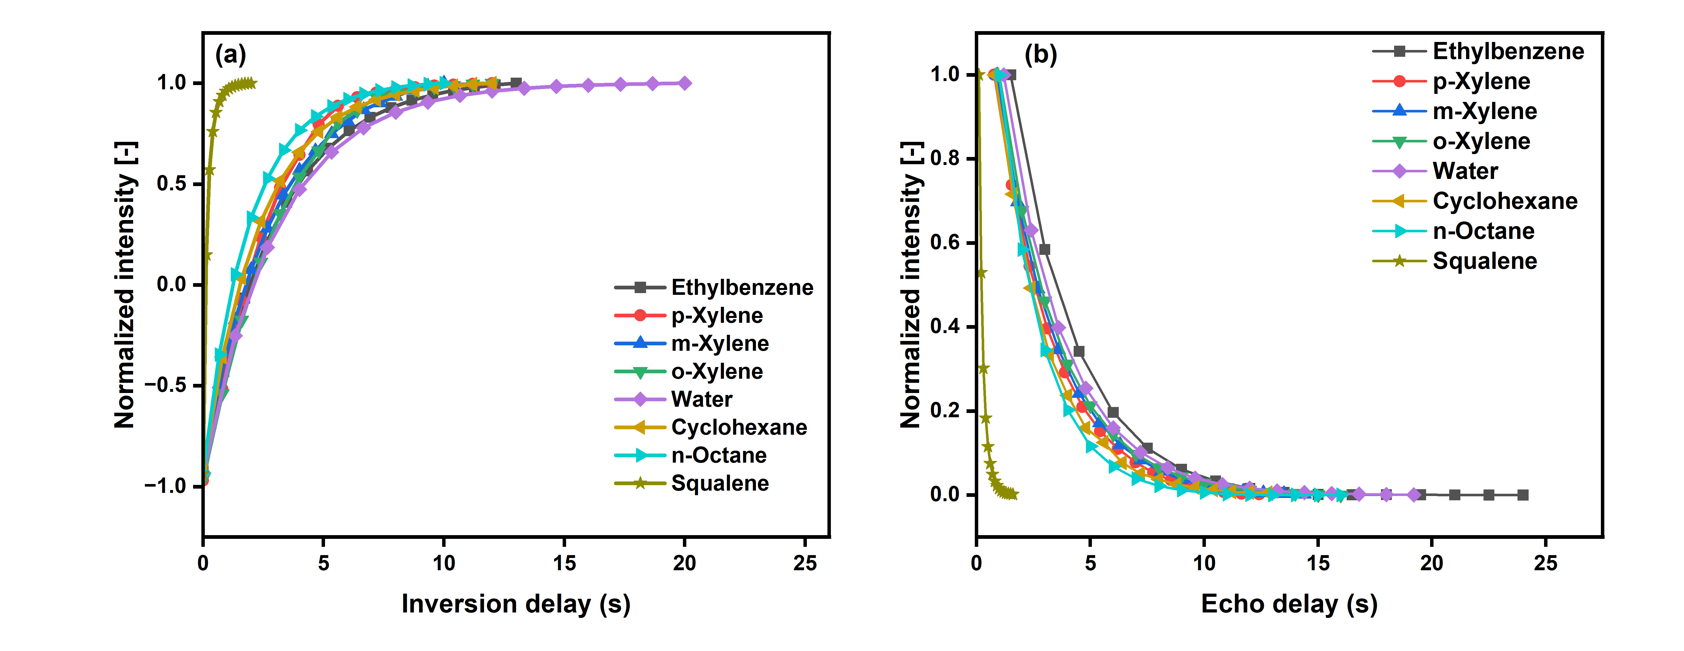
Figure S9 NMR relaxation plots of bulk liquid molecules (a) spin-lattice${ T}_{1}$ (b) spin-spin $T_{2}$

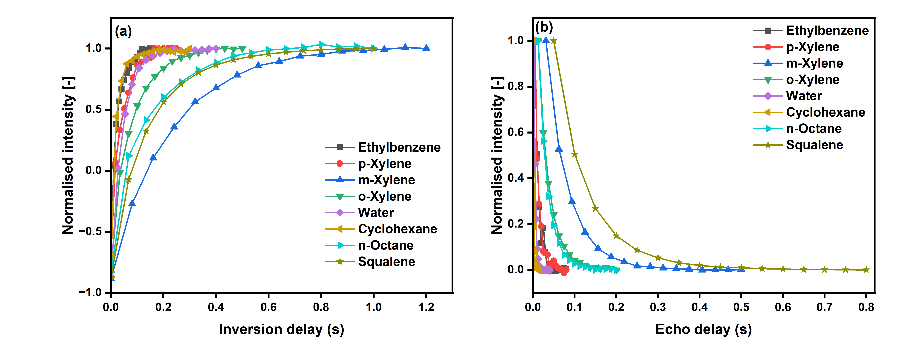
Figure S10 NMR relaxation measurements for HY molecules (a) spin-lattice${ T}_{1}$ (b) spin-spin $T_{2}$.

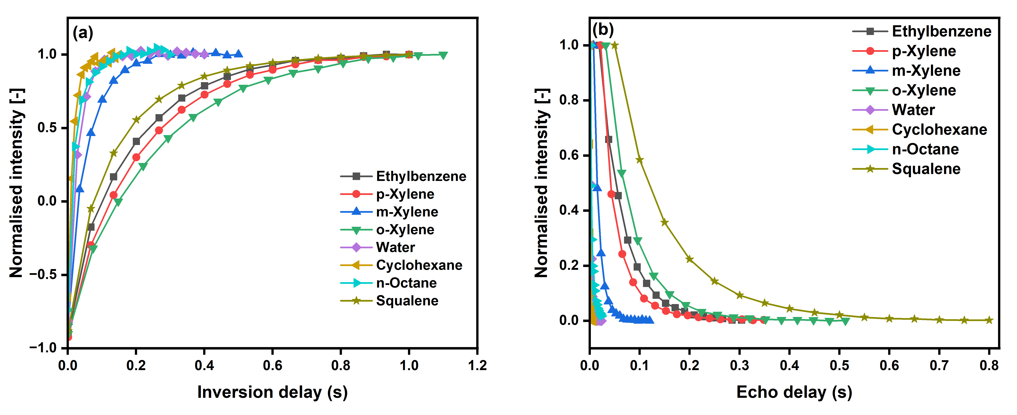
Figure S11 NMR relaxation measurements for 1Pt/Cal/HY molecules (a) spin-lattice${ T}_{1}$ (b) spin-spin $T_{2}$.

References
1. Golia, E., et al., STUDY OF THE REDUCTION OF HEAVY METAL CONCENTRATIONS IN LEAFY VEGETABLES USING MIXTURES OF COMPOST (OCEANICA POSIDONIA (L.)) AND ZEOLITE.
2. Usman, A.R., et al., Remediation of a soil contaminated with heavy metals by immobilizing compounds. Journal of Plant Nutrition and Soil Science, 2006. 169(2): p. 205-212.
3. Zhu, Q., et al., Prediction of mutual diffusion coefficients in binary liquid systems with one self-associating component from viscosity data and intra-diffusion coefficients at infinite dilution. Chemical Engineering Science, 2016. 147: p. 118-127.

