Supplementary Data
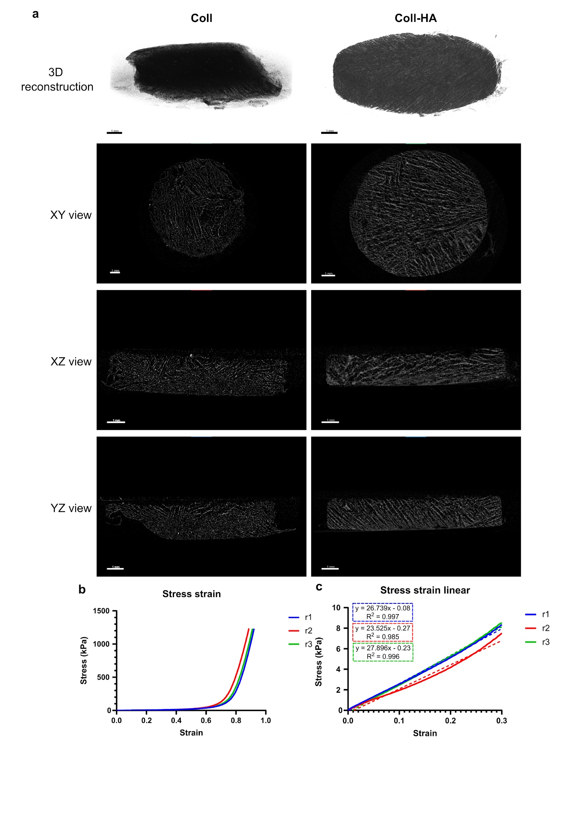
Fig. S1. (a) 3D reconstruction obtained through micro-CT of coll (left) and coll-HA scaffolds (right). Results of compression test for coll-HA scaffolds, with stress-strain curves in full compression range (b) and in linear range (30% strain) (c).

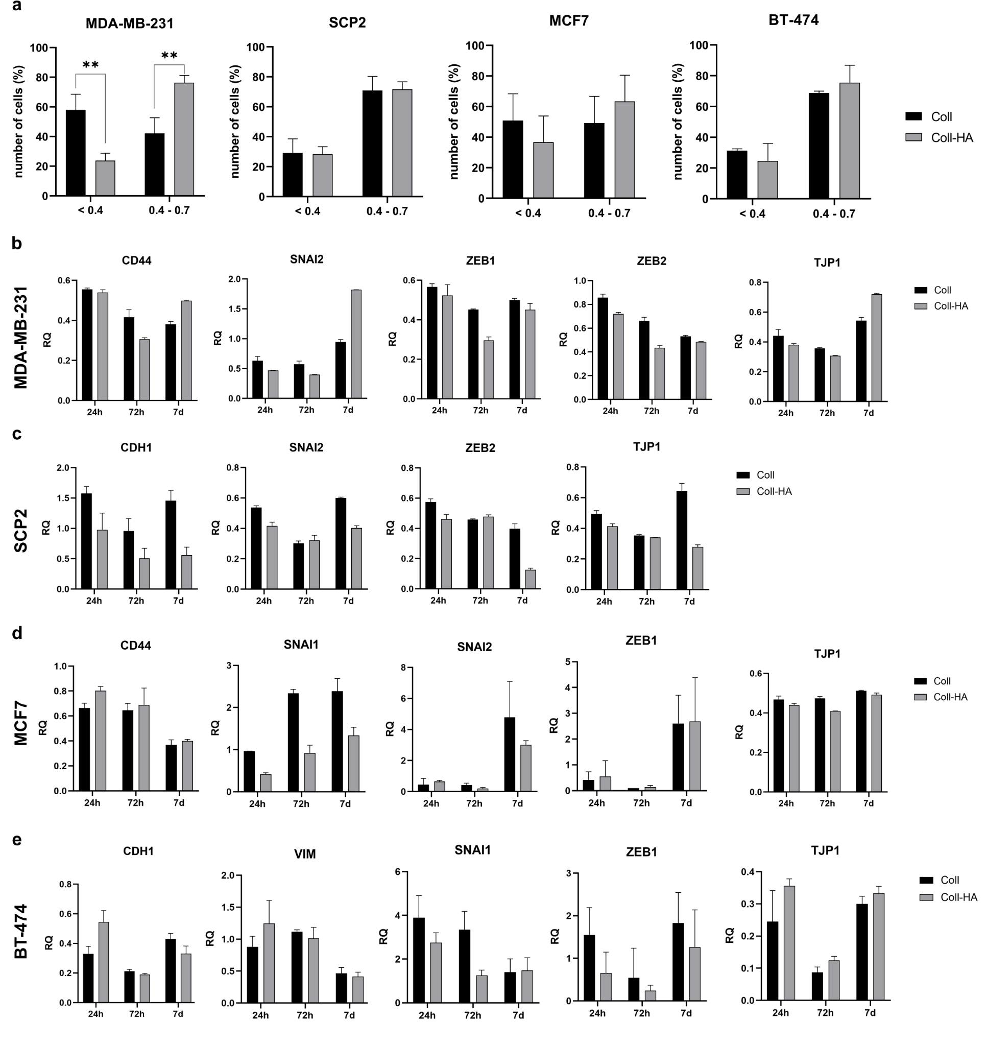
Fig. S2. (a) Circularity analysis of MDA-MB-231, SCP2, MCF7 and BT-474 cells cultured in coll and coll-HA scaffold. (b) Gene expression analysis (relative quantification, RQ) of epithelial-mesenchymal transition (EMT)-related markers in MDA-MB-231, SCP2, MCF7 and BT-474 cells cultured in 3D coll and coll-HA model at different time points (24 h, 72 h, and 7 days). Expression levels in monolayer cultures at the same time point were used as calibrators. Error bars show standard deviation (SD).

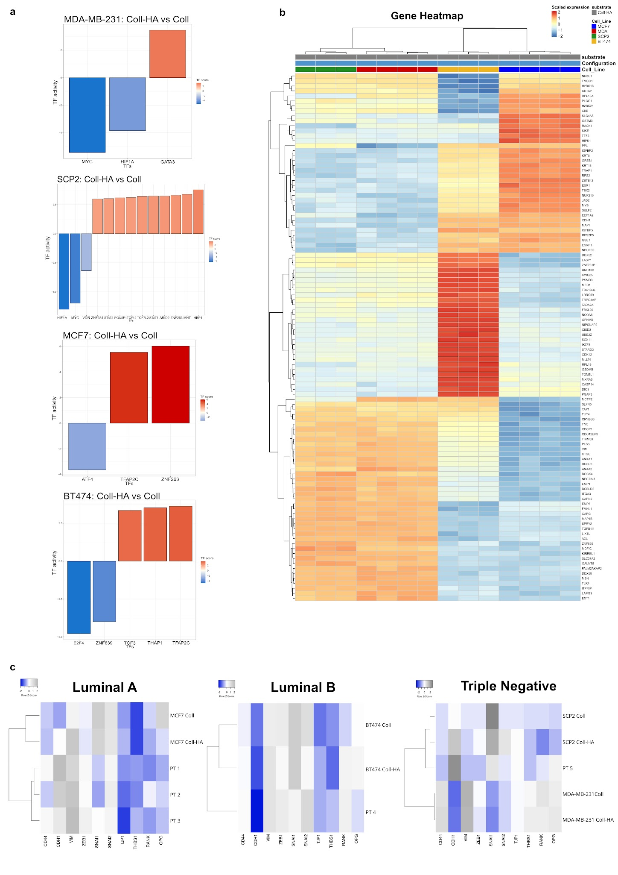
Fig. S3. (a) RNA sequencing analysis of transcription factor–regulated gene expression: bar plots show TFs with significant adjusted p-values. Scores reflect target gene regulation: >0 indicates upregulation, <0 indicates downregulation, comparing coll-HA versus coll conditions. (b) Gene expression heatmap: differential gene expression between the different cell lines in coll-HA substrates. Colors represent scaled gene expression, with red indicating significant upregulated genes and blue indicating downregulated genes. (c) Heatmap with cluster analysis of gene expression profiles in primary bone metastasis specimens from breast cancer and in breast cancer cell lines of corresponding subtypes cultured in 3D coll or coll-HA scaffolds.

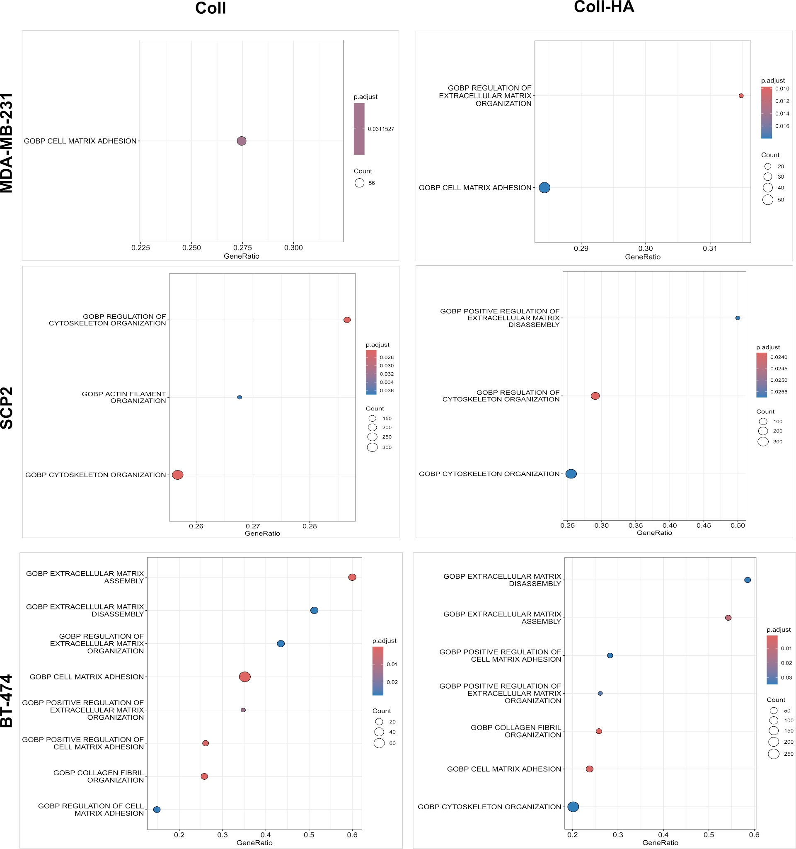
Fig. S4. Graphical representation of significantly dysregulated pathways comparing coll or coll-HA vs 2D in MDA-MB-231, SCP2, and BT474 cell lines, shown as a dot plot. Dot size represents gene count, while color represents the adjusted p-value (blue = higher significance).
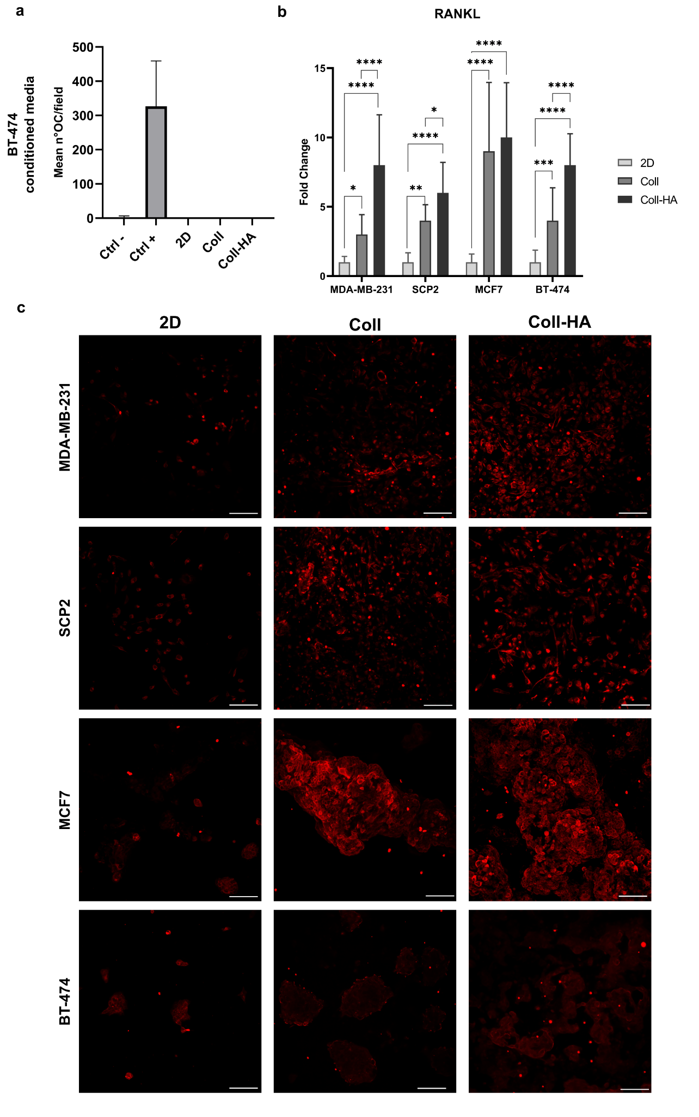
Fig. S5. (a) Mean number of osteoclasts/fields for each condition of BT-474. Differentiated osteoclasts were identified as cells positive to TRAP staining and with more than 4 nuclei. Statistical analysis was performed using one-way ANOVA followed by Tukey’s post hoc test. (b) Analysis of fold change of fluorescence positivity to RANKL in all the four cell lines in all the conditions. Statistical analysis was performed using two-way ANOVA followed by Tukey’s post hoc test. For all comparisons, statistical significance (n=3) is indicated as *P<0.05, **P<0.01, ***P<0.001, ****P<0.0001. Error bars show standard deviation (SD). (c) Immunofluorescence images of MDA-MB-231, SCP2, MCF7 and BT-474 cells cultured in 2D, on the 3D coll and 3D coll-HA models. RANKL is stained in PE. Scale bar=100 μm.

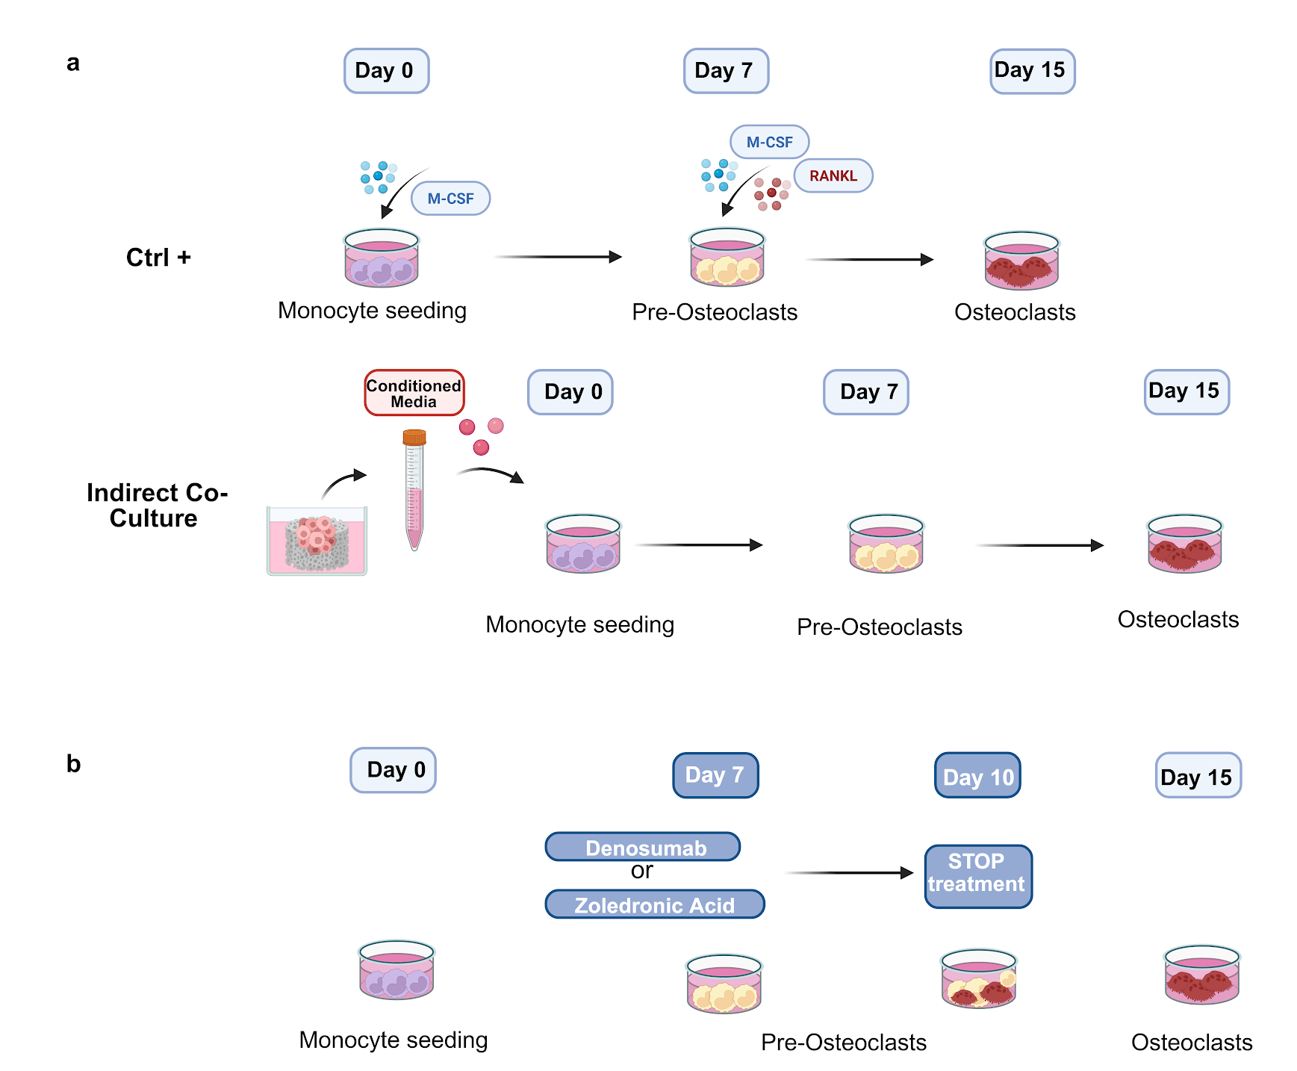
Fig. S6. Schematic Representation of Osteoclastogenesis Assay and Treatment. (a) hPBMCs were led to differentiate to differentiated osteoclasts for 15 days by adding M-CSF and RANKL (Ctrl+) or with conditioned medium from breast cancer cells cultured in 2D or 3D coll or 3D coll-HA. Conditioned medium (CM) was collected at 7 days of culture and added to complete α-MEM to obtain a CM with 20% cancer cell medium and 80% α-MEM. (b) Schematic representation of osteoclasts treatment with bone targeted drugs (Denosumab, Zoledronic Acid). Scheme designed with Biorender.com.

Cell line | Culture condition | n biological replicates | Sample IDs
MDA-MB-231 | 2D | 4 | cd_cphd_00001, cd_cphd_00004, cd_cphd_00007, cd_cphd_00028
MDA-MB-231 | 3D coll | 4 | cd_cphd_00002, cd_cphd_00005, cd_cphd_00008, cd_cphd_00029
MDA-MB-231 | 3D coll-HA | 4 | cd_cphd_00003, cd_cphd_00006, cd_cphd_00009, cd_cphd_00030
MCF7 | 2D | 4 | cd_cphd_00010, cd_cphd_00013, cd_cphd_00016, cd_cphd_00031
MCF7 | 3D coll | 4 | cd_cphd_00011, cd_cphd_00014, cd_cphd_00017, cd_cphd_00032
MCF7 | 3D coll-HA | 4 | cd_cphd_00012, cd_cphd_00015, cd_cphd_00018, cd_cphd_00033
SCP2 | 2D | 4 | cd_cphd_00019, cd_cphd_00022, cd_cphd_00025, cd_cphd_00034
SCP2 | 3D coll | 4 | cd_cphd_00020, cd_cphd_00023, cd_cphd_00026, cd_cphd_00035
SCP2 | 3D coll-HA | 4 | cd_cphd_00021, cd_cphd_00024, cd_cphd_00027, cd_cphd_00036
BT-474 | 2D | 3 | cd_cphd_00037, cd_cphd_00040, cd_cphd_00043
BT-474 | 3D coll | 3 | cd_cphd_00038, cd_cphd_00041, cd_cphd_00044
BT-474 | 3D coll-HA | 3 | cd_cphd_00039, cd_cphd_00042, cd_cphd_00045
Table S1. RNA-seq biological replicates.

Sample ID | Total Reads | STAR uniquely mapped percent (%) | rRNA rate percent (%) | Kallisto pseudoalignment percent (%)
cd_cphd_00001 | 95546 | 89.62 | 0.33 | 44.85
cd_cphd_00002 | 116656 | 83.28 | 0.37 | 44.26
cd_cphd_00003 | 115498 | 84.8 | 0.19 | 64.02
cd_cphd_00004 | 101960 | 87.53 | 0.16 | 58.77
cd_cphd_00005 | 117940 | 84.62 | 0.19 | 68.13
cd_cphd_00006 | 125932 | 83.89 | 0.16 | 61.28
cd_cphd_00007 | 105966 | 85.4 | 1.43 | 49.32
cd_cphd_00008 | 114134 | 79.95 | 0.48 | 65.61
cd_cphd_00009 | 106352 | 86.8 | 0.28 | 64.45
cd_cphd_00010 | 105016 | 88.19 | 0.26 | 47.03
cd_cphd_00011 | 102286 | 83.36 | 0.63 | 60.92
cd_cphd_00012 | 106060 | 85.87 | 0.45 | 60.75
cd_cphd_00013 | 88236 | 89.64 | 0.21 | 49.42
cd_cphd_00014 | 106416 | 84.09 | 1.08 | 62.86
cd_cphd_00015 | 108574 | 86.4 | 0.48 | 63.58
cd_cphd_00016 | 103026 | 89.62 | 1.12 | 43.84
cd_cphd_00017 | 109110 | 83.5 | 0.32 | 66.62
cd_cphd_00018 | 109042 | 85.65 | 0.6 | 66.33
cd_cphd_00019 | 79154 | 87.88 | 1.31 | 53.88
cd_cphd_00020 | 89877 | 86.22 | 0.26 | 63.35
cd_cphd_00021 | 90178 | 88.16 | 0.21 | 62.33
cd_cphd_00022 | 93576 | 88.85 | 0.22 | 52.24
cd_cphd_00023 | 91696 | 86.68 | 0.24 | 65.39
cd_cphd_00024 | 85134 | 86.87 | 0.16 | 60.78
cd_cphd_00025 | 85324 | 89.9 | 0.13 | 50.38
cd_cphd_00026 | 90586 | 87.13 | 0.22 | 65.04
cd_cphd_00027 | 85851 | 89.97 | 0.08 | 63.07
cd_cphd_00028 | 114142 | 100 | 0 | 47.63
cd_cphd_00029 | 114142 | 61.64 | 0.75 | 50.95
cd_cphd_00030 | 132114 | 35.73 | 0.18 | 29.77
cd_cphd_00031 | 118998 | 89.16 | 0.55 | 47.05
cd_cphd_00032 | 126356 | 56.23 | 0.51 | 47.1
cd_cphd_00033 | 119694 | 60.83 | 0.87 | 49.66
cd_cphd_00034 | 111102 | 18.44 | 0.62 | 14.78
cd_cphd_00035 | 134366 | 12.11 | 0.95 | 12.41
cd_cphd_00036 | 106862 | 12.51 | 12.85 | 11.43
cd_cphd_00037 | 133999 | 71.62 | 0.31 | 59.3
cd_cphd_00038 | 108600 | 31.79 | 0.14 | 22.86
cd_cphd_00039 | 124389 | 39.86 | 0.15 | 28.23
cd_cphd_00040 | 140571 | 74.8 | 0.31 | 63.44
cd_cphd_00041 | 242949 | 12.91 | 48.3 | 8.87
cd_cphd_00042 | 102270 | 32.37 | 1.8 | 23.87
cd_cphd_00043 | 153497 | 71.99 | 0.24 | 62.23
cd_cphd_00044 | 111561 | 27.12 | 0.27 | 19.82
cd_cphd_00045 | 118710 | 24.06 | 1.93 | 17.02
Table S2. RNA-seq sequencing depth and mapping quality metrics. Reported parameters include total reads, percentage of uniquely mapped reads obtained with STAR, rRNA rate, and Kallisto pseudoalignment percentage.

