Appendix
Supplementary Table 1. Demographic and baseline characteristics of the DEPICT pooled population (safety analysis set)
 | DAPA 5 mg (N=548) | DAPA 10 mg (N=566) | Placebo  (N=532)
Age, years | 42.4 (13.7) | 42.9 (13.4) | 42.9 (13.6)
Male, n (%) | 237 (43.2) | 273 (48.2) | 251 (47.2)
Race, n (%)  Caucasian  Asian  Black or African-American  Other | 474 (86.5)  59 (10.8)  9 (1.6)  6 (1.1) | 501 (88.5)  44 (7.8)  14 (2.5)  7 (1.2) | 457 (85.9)  60 (11.3)  4 (0.8)  11 (2.1)
Geographic region, n (%)  Europe  North America  Latin America  Asia/Pacific | 231 (42.2)  176 (32.1)  71 (13.0)  70 (12.8) | 265 (46.8)  195 (34.5)  56 (9.9)  50 (8.8) | 253 (47.6)  159 (29.9)  58 (10.9)  62 (11.7)
Duration of T1D*, years | 19.8 (12.0) | 19.9 (11.6) | 20.1 (12.0)
Body weight, kg | 80.0 (17.8) | 81.9 (18.1) | 81.6 (18.8)
BMI, kg/m² | 27.9 (5.5) | 28.2 (5.4) | 28.1 (5.4)
SBP, mmHg | 122 (14.4) | 122 (14.3) | 123 (14.3)
HbA1c, % | 8.48 (0.70) | 8.46 (0.67) | 8.48 (0.66)
HbA1c, mmol/mol | 69 (7.7) | 69 (7.3) | 69 (7.2)
HbA1c at randomization, n (%)  ≥7.5% and <9.0%  ≥9.0% and ≤10.5% | 421 (76.8)  127 (23.2) | 439 (77.6)  127 (22.4) | 405 (76.1)  127 (23.9)
Total baseline insulin dose†  Dose, IU  Dose/weight, IU/kg | 60.3 (36.7)  0.74 (0.41) | 60.0 (28.8)  0.72 (0.27) | 59.8 (27.5)  0.73 (0.24)
Method of insulin administration, n (%)  MDI  CSII | 352 (64.2)  196 (35.8) | 362 (64.0)  204 (36.0) | 345 (64.8)  187 (35.2)
Data are mean (SD) unless otherwise indicated; N is number of patients from the safety analysis set for each treatment arm; *Number of patients with non-missing baseline values: DAPA 5 mg (n=539), DAPA 10 mg (n=561), Placebo (n=521); †Number of patients with non-missing baseline values: DAPA 5 mg (n=548), DAPA 10 mg (n=565), Placebo (n=531); CSII, continuous subcutaneous insulin infusion; DAPA, dapagliflozin; MDI, multiple daily injections; T1D, type 1 diabetes

Supplementary Table 2. Summary of safety outcomes in the subgroups of patients with
baseline HbA1c <75 mmol/mol (<9.0%) or ≥75 mmol/mol (≥9.0%) in the pooled DEPICT-1 and -2 studies over entire study period
 | HbA1c <75 mmol/mol (<9.0%) |  |  | HbA1c ≥75 mmol/mol (≥9.0%)
 | DAPA 5 mg  (N=419) | DAPA 10 mg (N=438) | Placebo (N=404) | DAPA 5 mg  (N=129) | DAPA 10 mg  (N=128) | Placebo  (N=128)
≥1 AE | 337 (80.4) | 343 (78.3) | 298 (73.8) | 101 (78.3) | 98 (76.6) | 96 (75.0)
AE leading to study discontinuation | 33 (7.9) | 19 (4.3) | 20 (5.0) | 2 (1.6) | 11 (8.6) | 7 (5.5)
≥1 SAE | 53 (12.6) | 48 (11.0) | 32 (7.9) | 16 (12.4) | 11 (8.6) | 14 (10.9)
SAE leading to study discontinuation | 21 (5.0) | 10 (2.3) | 6 (1.5) | 1 (0.8) | 3 (2.3) | 3 (2.3)
Death | 1 (0.2)* | 0 (0.0) | 0 (0.0) | 0 (0.0) | 0 (0.0) | 1 (0.8)
Other AEs of special interest†
CV event | 2 (0.5) | 1 (0.2) | 4 (1.0) | 0 (0.0) | 4 (3.1) | 0 (0.0)
Events of renal function | 7 (1.7) | 2 (0.5) | 4 (1.0) | 0 (0.0) | 1 (0.8) | 0 (0.0)
Fracture | 12 (2.9) | 9 (2.1) | 8 (2.0) | 0 (0.0) | 2 (1.6) | 4 (3.1)
Urinary tract infection | 41 (9.8) | 23 (5.3) | 27 (6.7) | 16 (12.4) | 7 (5.5) | 12 (9.4)
Genital infection | 56 (13.4) | 52 (11.9) | 14 (3.5) | 17 (3.2) | 16 (12.5) | 4 (3.1)
Severe hypoglycaemia‡§  IR/100 patient-years | 46 (11.0)  35.33 | 39 (8.9)  27.17 | 42 (10.4)  31.55 | 7 (5.4)  7.58 | 12 (9.4)  28.08 | 11 (8.6)  32.59
Documented symptomatic hypoglycaemia‡§  IR/100 patient-years | 336 (80.2)  2510.93 | 357 (81.5)  2735.44 | 330 (81.7)  2832.83 | 104 (80.6)  1996.85 | 91 (71.1)  1869.41 | 97 (75.8)  1779.19
Adjudicated definite DKA | 16 (3.8) | 16 (3.7) | 3 (0.7) | 6 (4.7) | 4 (3.1) | 3 (2.3)

Urinary tract nfection | 41 (9.8) | 23 (5.3) | 27 (6.7) | 16 (12.4) | 7 (5.5) | 12 (9.4)
Genital infection | 56 (13.4) | 52 (11.9) | 14 (3.5) | 17 (13.2) | 16 (12.5) | 4 (3.1)
Safety was assessed in the Safety Analysis Set which included all patients who received at least one dose of study medication. Data are presented as n (%). In DEPICT-1, 55 patients were incorrectly and non-randomly allocated to the DAPA treatment arms; these patients were included in the safety analyses. *One death in the DAPA 5 mg group was due to an SAE that was not related to the study treatment. †Based on a pre-specified list of Medical Dictionary for Regulatory Activities preferred terms. ‡Based on American Diabetes Association categorisation – Severe hypoglycaemia are events requiring assistance from another person and documented symptomatic hypoglycaemia are events with typical symptoms and plasma glucose concentration ≤3.9 mmol/L. §Data for severe hypoglycaemia and documented symptomatic hypoglycaemia are presented as number of patients experiencing ≥ 1 event. AE, adverse event; CV, cardiovascular; DAPA, dapagliflozin; DKA, diabetic ketoacidosis; IR, incidence rate (exposure-adjusted); SAE, serious adverse event.

Supplementary Table 3. Summary of safety outcomes in the subgroups of patients receiving
insulin via CSII or MDI in the pooled DEPICT-1 and -2 studies over the entire study period
 | CSII |  |  | MDI
 | DAPA 5 mg  (N=196) | DAPA 10 mg (N=204) | Placebo (N=187) | DAPA 5 mg  (N=352) | DAPA 10 mg  (N=362) | Placebo  (N=346)
≥1 AE | 164 (83.7) | 158 (77.5) | 143 (76.5) | 274 (77.8) | 283 (78.2) | 251 (72.8)
AE leading to study discontinuation | 14 (7.1) | 11 (5.4) | 13 (7.0) | 21 (6.0) | 19 (5.2) | 14 (4.1)
≥1 SAE | 26 (13.3) | 24 (11.8) | 24 (12.8) | 43 (12.2) | 35 (9.7) | 22 (6.4)
SAE leading to study discontinuation | 9 (4.6) | 3 (1.5) | 5 (2.7) | 13 (3.7) | 10 (2.8) | 4 (1.2)
Death | 0 (0.0) | 0 (0.0) | 0 (0.0) | 1 (0.3)* | 0 (0.0) | 1 (0.3)
Other AEs of special interest†
CV event | 0 (0.0) | 1 (0.5) | 4 (2.1) | 2 (0.6) | 4 (1.1) | 0 (0.0)
Events of renal function | 3 (1.5) | 2 (1.0) | 4 (2.1) | 4 (1.1) | 1 (0.3) | 0 (0.0)
Fracture | 7 (3.6) | 4 (2.0) | 5 (2.7) | 5 (1.4) | 7 (1.9) | 7 (2.0)
Urinary tract infection | 23 (11.7) | 14 (6.9) | 17 (9.1) | 34 (9.7) | 16 (4.4) | 22 (6.4)
Genital infection | 29 (14.8) | 32 (15.7) | 7 (3.7) | 44 (12.5) | 36 (9.9) | 11 (3.2)
Severe hypoglycaemia‡§  IR/100 patient-years | 17 (8.7)  13.69 | 24 (11.8)  30.49 | 18 (9.6)  22.36 | 36 (10.2)  36.86 | 27 (7.5)  25.56 | 35 (10.1)  36.66
Documented symptomatic hypoglycaemia‡§  IR/100 patient-years | 161 (82.1)  2564.34 | 158 (77.5)  2572.28 | 147 (78.6)  2893.38 | 279 (79.3)  2292.78 | 290 (80.1)  2538.95 | 280 (81.2)  2437.55
Adjudicated definite DKA | 13 (6.6) | 10 (4.9) | 5 (2.7) | 9 (2.6) | 10 (2.8) | 1 (0.3)

Urinary tract nfection | 41 (9.8) | 23 (5.3) | 27 (6.7) | 16 (12.4) | 7 (5.5) | 12 (9.4)
Genital infection | 56 (13.4) | 52 (11.9) | 14 (3.5) | 17 (13.2) | 16 (12.5) | 4 (3.1)
Safety was assessed in the Safety Analysis Set which included all patients who received at least one dose of study medication. Data are presented as n (%) unless otherwise indicated. In DEPICT-1, 55 patients were incorrectly and non-randomly allocated to the DAPA treatment arms; these patients were included in the safety analyses. *One death in the DAPA 5 mg group was due to an SAE that was not related to the study treatment. †Based on a pre-specified list of Medical Dictionary for Regulatory Activities preferred terms. ‡Based on American Diabetes Association categorisation – severe hypoglycaemia are events requiring assistance from another person and documented symptomatic hypoglycaemia are events with typical symptoms and plasma glucose concentration ≤3.9 mmol/L. §Data for severe hypoglycaemia and documented symptomatic hypoglycaemia are presented as number of patients experiencing ≥ 1 event. AE, adverse event; CV, cardiovascular; DAPA, dapagliflozin; DKA, diabetic ketoacidosis; IR, incidence rate (exposure-adjusted); SAE, serious adverse event.

Supplementary Table 4. Summary of hypoglycaemia events* (safety analysis set) for the DEPICT pooled population
 | Week 24 (Short-term period) |  |  | Week 52 (Short-term + long-term period)
 | DAPA  5 mg (N=548) | DAPA  10 mg (N=566) | Placebo  (N=532) | DAPA  5 mg (N=548) | DAPA  10 mg (N=566) | Placebo  (N=532)
Hypoglycaemia events, n | 8912 | 9667 | 8851 | 15,144 | 16,772 | 15,724
Patients with ≥1 event, n (%) | 443 (80.8) | 466 (82.3) | 441 (82.9) | 458 (83.6) | 475 (83.9) | 449 (84.4)
Exposure-adjusted incidence rate, per 100 patient-years including recurrences | 3688.05 | 3832.16 | 3800.33 | 3040.42 | 3232.23 | 3331.67
Severe hypoglycaemia
Events†, n | 89 (1.0) | 94 (1.0) | 105 (1.2) | 143 (0.9) | 142 (0.8) | 150 (1.0)
Patients with ≥1 event, n (%) | 38 (6.9) | 42 (7.4) | 40 (7.5) | 53 (9.7) | 51 (9.0) | 53 (10.0)
Exposure-adjusted incidence rate, per 100 patient-years including recurrences | 36.83 | 37.26 | 45.08 | 28.71 | 27.37 | 31.78
Documented symptomatic hypoglycaemia
Events†, n | 6893 (77.3) | 7527 (77.9) | 6840 (77.3) | 11,896 (78.6) | 13,238 (78.9) | 12,238 (77.8)
Patients with ≥1 event, n (%) | 420 (76.6) | 432 (76.3) | 416 (78.2) | 440 (80.3) | 448 (79.2) | 427 (80.3)
Exposure-adjusted incidence rate, per 100 patient-years including recurrences | 2852.53 | 2983.83 | 2936.87 | 2388.33 | 2551.17 | 2593.04
Asymptomatic hypoglycaemia
Events†, n | 1575 (17.7) | 1756 (18.2) | 1581 (17.9) | 2522 (16.7) | 2857 (17.0) | 2827 (18.0)
Patients with ≥1 event, n (%) | 199 (36.3) | 241 (42.6) | 188 (35.3) | 218 (39.8) | 273 (48.2) | 218 (41.0)
Exposure-adjusted incidence rate, per 100 patient-years including recurrences | 651.78 | 696.11 | 678.83 | 506.34 | 550.59 | 599.00
Probable symptomatic hypoglycaemia
Events†, n | 132 (1.5) | 125 (1.3) | 195 (2.2) | 250 (1.7) | 254 (1.5) | 307 (2.0)
Patients with ≥1 event, n (%) | 60 (10.9) | 59 (10.4) | 65 (12.2) | 75 (13.7) | 87 (15.4) | 82 (15.4)
Exposure-adjusted incidence rate, per 100 patient-years including recurrences | 54.63 | 49.55 | 83.73 | 50.19 | 48.95 | 65.05
Relative hypoglycaemia
Events†, n | 159 (1.8) | 140 (1.4) | 115 (1.3) | 252 (1.7) | 241 (1.4) | 178 (1.1)
Patients with ≥1 event, n (%) | 50 (9.1) | 48 (8.5) | 45 (8.5) | 67 (12.2) | 61 (10.8) | 63 (11.8)
Exposure-adjusted incidence rate, per 100 patient-years including recurrences | 65.80 | 55.50 | 49.38 | 50.59 | 46.44 | 37.72
Other hypoglycaemia
Events†, n | 64 (0.7) | 25 (0.3) | 15 (0.2) | 81 (0.5) | 40 (0.2) | 24 (0.2)
Patients with ≥1 event, n (%) | 13 (2.4) | 18 (3.2) | 13 (2.4) | 20 (3.6) | 21 (3.7) | 18 (3.4)
Exposure-adjusted incidence rate, per 100 patient-years including recurrences | 26.49 | 9.91 | 6.44 | 16.26 | 7.71 | 5.09
*Includes hypoglycaemic events with onset on or after the first date/time of double-blind treatment and on or prior to the last day of short-term plus long-term treatment period plus 4 and 30 days, respectively. †Percentages are based on the total number of the events.
SAE, serious adverse event

Supplementary Figure 1: Adjusted mean (SE) change from baseline to Week 52 in body weight (kg)

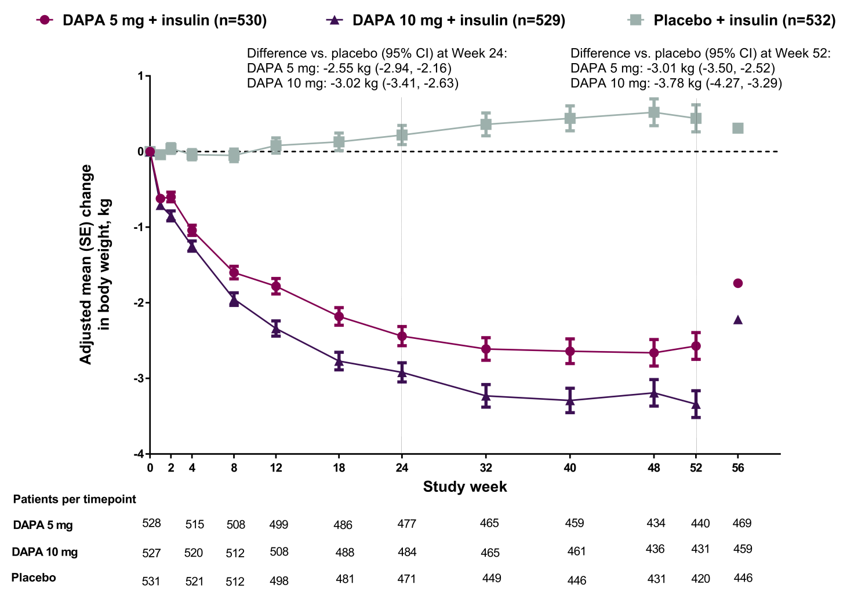
CI, confidence interval; DAPA, dapagliflozin; SE, standard error
Supplementary Figure 2: Proportion of patients with HbA1c reduction ≥0.5% from baseline to Week 52 without a severe hypoglycaemia event (full analysis set)
Severe hypoglycaemia was defined as an event resulting in unconsciousness due to hypoglycaemia or one requiring assistance of another person to administer carbohydrate, glucagon or take other corrective actions to promote neurological recovery. CI, confidence interval; DAPA, dapagliflozin; INS, insulin; PBO, placebo

