Supplementary Figure 1. Country of origin of the participants
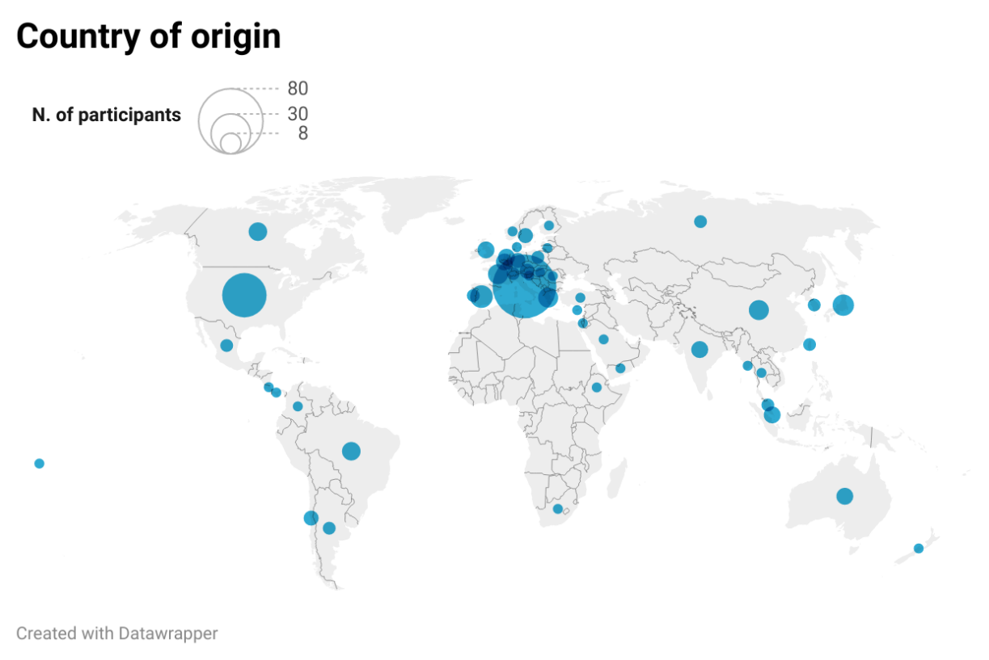

Supplementary Figure 2. Definition of adequate lymphadenectomy.
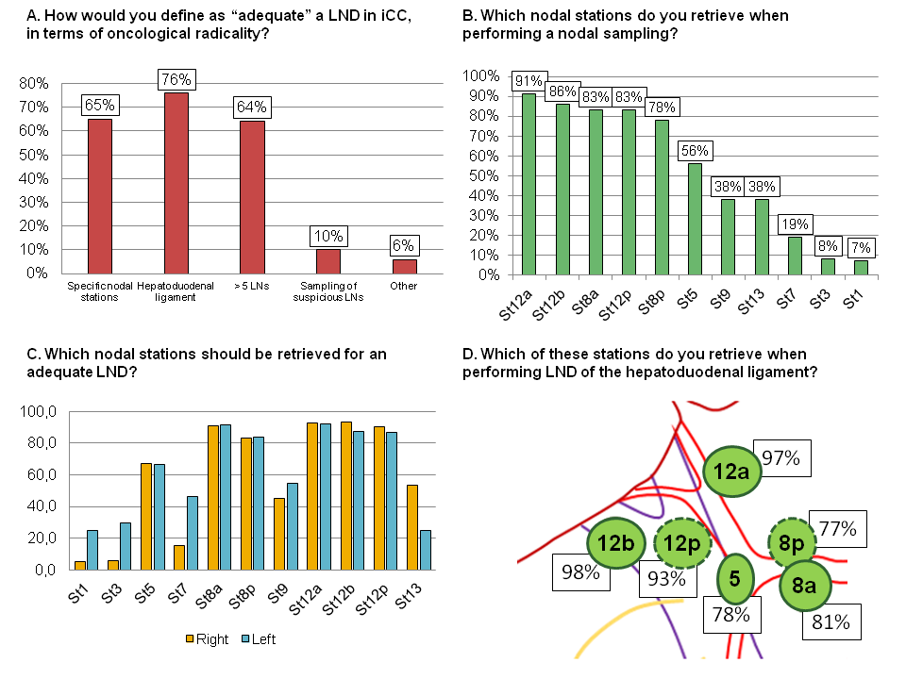
A) How would you define as “adequate” a lymphadenectomy in ICC, in terms of oncological radicality? B) Which nodal stations do you retrieve when performing a nodal sampling? C) Which nodal stations should be retrieved for an adequate lymphadenectomy? D) Which of these nodal stations do you retrieve when performing lymphadenectomy of the hepatoduodenal ligament?
ICC = intrahepatic cholangiocarcinoma; LND = lymphadenectomy

