WEB APPENDIX

Keeping the Mall Alive? Identifying Drivers of Shopping Mall Satisfaction and Survival from Customer Reviews

Web Appendix A: Examples of customer reviews for shopping malls 2
Web Appendix B: Developing measures for the PMRE attributes 3
Web Appendix C: Benchmarking different sentiment measurement methods 5
Web Appendix D: Polarity and imbalance of customer reviews 6
Web Appendix E: Additional details for Study 1 7
Web Appendix F: Additional details for Study 2 14
Web Appendix G: Leveraging customer reviews to gain managerial insights 18
References to the Web Appendix 19

Web Appendix A: Examples of customer reviews for shopping malls
Positive Reviews | Negative Reviews
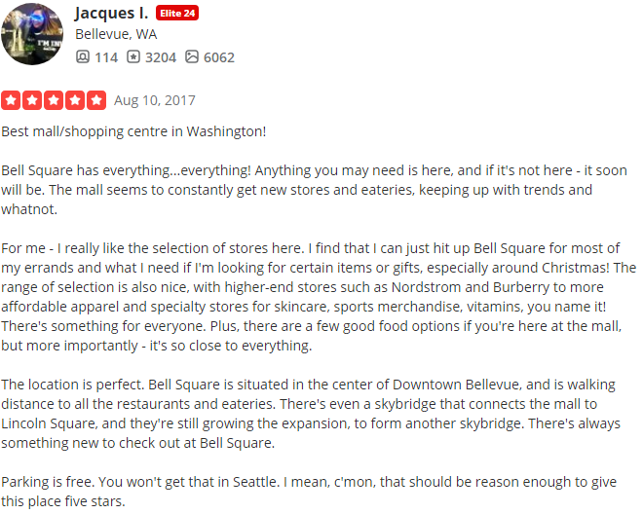  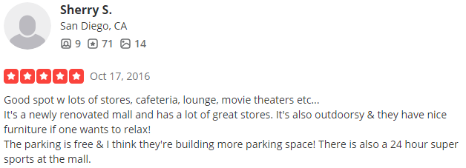  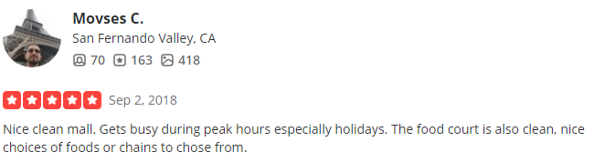  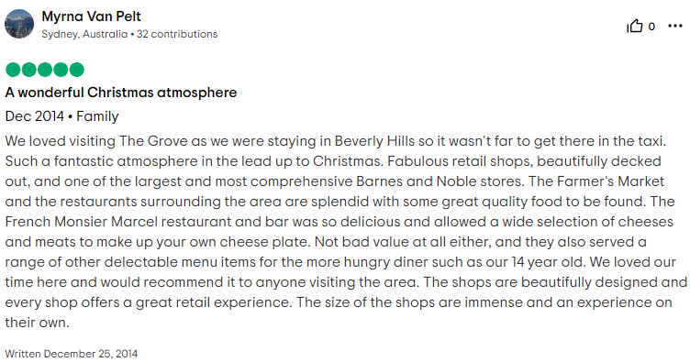  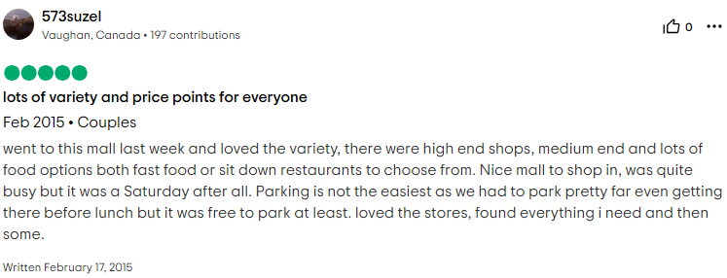 | 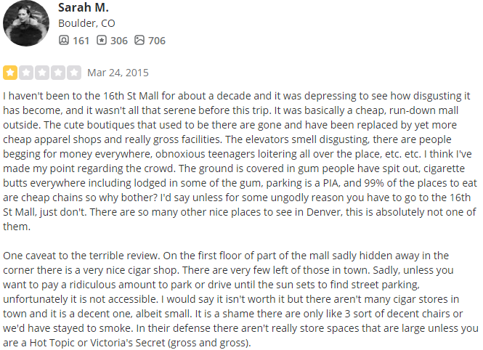  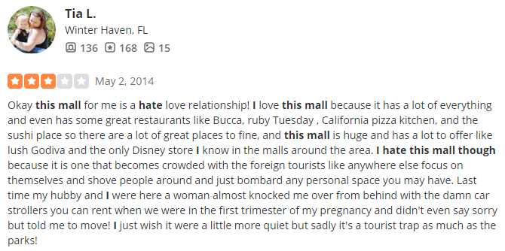  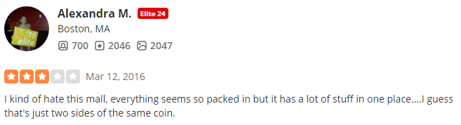  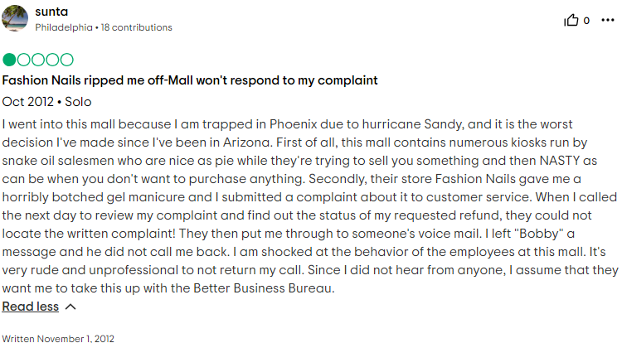  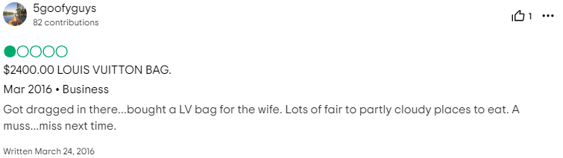

Web Appendix B: Developing measures for the PMRE attributes
To detect and quantify the five PMRE attributes in the customer reviews, we used a dictionary development process, which is described and summarized in distinct steps below.
Step 1: Creating initial term lists for the five mall attributes
We surveyed 2,554 U.K. customers, asking them to share their reflections on their experiences during a shopping trip to a retail agglomeration (i.e., shopping mall). Using open-ended survey questions, we asked these respondents to describe their shopping experience. They also provided demographic information. The sample includes respondents between the ages of 17 and 70 years, with an average of 39.2 years (SD = 13.30), and 53.2% were women. They rated the attractiveness of the retail agglomerations they had patronized with an average of 5.2 (SD = 1.40) on a 7-point rating scale (1 = “unattractive” to 7 =”attractive”; Teller and Reutterer 2008). To extract relevant expressions related to the mall attributes, we used the qualitative analysis software QSR NVIVO 11 (Krippendorff 2013). The expression extraction and analysis followed a coding scheme based on the definitions from Ailawadi and Keller (2004) and Chebat et al. (2010). To ensure intercoder reliability, the text data were analyzed independently by two coders. Their intercoder reliability exceeded 81% for all five mall attributes, as a result of the fairly standardized customer language and word choice available to describe retail agglomerations. In a second round, the coders attended to the differences in their allocations and resolved most discrepancies through discussion. The final set of coded references thus achieved 94% to 98% agreement across the mall attributes. For the expressions for which the two coders could not reach an agreement, a third coder got involved to resolve the dispute, leaving us with 653 expressions.
Step 2: Expansion of initial term lists
To extend this initial list, we added any variations in expressions (e.g., coffee-shop, coffee-place), synonyms, and antonyms (e.g., clean vs. dirty), which resulted in 623 additional expressions. We also complemented the list of expressions with brand names recurring in the survey data set using machine learning through the Open Name Entity algorithm (http://opennlp.apache.org/docs/). After manual inspection, we included 389 brand names (e.g., McDonald’s, Nike) in the dictionary for the product mix. In total, we identified 1,665 expressions.
Step 3: Refinement of term lists
Two additional coders, not knowledgeable of the aim of our study, removed any expressions that could evoke multiple interpretations or overlap across attributes. All remaining expressions were stemmed (e.g., price, prices = price*). As a further refinement step, adopting Humphreys and Wang’s (2018) suggestion for validating text mining dictionaries, we drew a random subsample of 400 reviews from Yelp and 500 reviews from TripAdvisor. We randomly selected one sentence from each review and applied the new text-mining dictionaries to identify the frequency with which the mall attributes were mentioned. By inspecting sentence-level frequency results, we also identify some cases in which the application of the dictionary leads to unexpected results. For example, “far” is indicative of mall access (e.g., “the location was far away”) and thus was originally included in the list of expressions relating to distribution as an aspect of mall access. Yet the sentence-level inspection revealed its use in other contexts too (e.g., “so far I haven’t finished with my shopping”), and thus we removed this expression.

Step 4: Extending the wordlists by propagation using seeded LDA
With a seeded latent Dirichlet analysis (LDA), across all 81,615 customer reviews from Study 1, we used the wordlists for each PMRE attribute (from Step 3) as “seeds” to predefine topics in an LDA and thereby identify more PMRE attributes related words. In a seeded LDA, the number of LDA topics is predetermined by the five PMRE attribute-related wordlists. We implemented our seeded-LDA model using the quanteda package (Benoit et al. 2018) for R and the Gibbs-LDA library for semi-supervised topic modeling, specifying seed dictionaries based on relevant wordlists (Lu et al. 2011). Again, we extracted the 1,000 most frequent words for each of the seven seeded LDA topics. Some were original (seed) words we identified in Steps 1 and 2, but the seeded LDA also identified other related words. Therefore, we repeated the manual inspection procedure from Steps 1 and 2 for all new words to remove any duplicates, as well as those categorized as unknown or unlikely to signal the respective attribute. After combining the words obtained through the seeded LDA with the previous wordlists, the five final PMRE attribute dictionaries include a total of 1,157 unique words and word stems across the PMRE attributes.
Step 5: Validation of text mining approach
To assess the classification accuracy of our approach to derive the PMRE attributes from textual data, we compare the automated, dictionary-based classifications with human perceptions. We used a random set of 50 review sentences for each PMRE attribute, from which 25 included this instrument (e.g., price and promotion) and 25 did not include the PMRE attribute. A research assistant blind to our study coded all 350 review sentences, annotating whether the sentence was referring to the respective PMRE attribute. Overall, the results confirm accuracy in predicting whether a sentence included or did not include the PMRE attribute. The overall accuracy ranged between .98 for the mall atmosphere and.88 for cross-store assortment. In none of the accuracy tables, there is an unbalanced prediction issue (i.e., the lowest F-measure for a prediction category is .88), confirming the nonexistence of prediction bias. These results affirm the accuracy of the text-mining approach for PMRE attributes.
Illustrative Dictionary Words per PMRE attribute
Mall access: access*, close together, congestion, connections, enter*, exit*, location, lots of space, minutes away, traffic*.
Mall atmosphere: aesthetic, ambiance, atmosphere, boarded up, buzzing, claustrophobic, noisy, overcrowded, spacious, vibrant.
Cross-store assortment: bar*, boutiques, café*, chains, cinema*, food court, retailers, shops, stalls, store*, assistance, atm, baby changing, facilities, opening time*, personnel, service, staff, till late.
Within-store assortment: assortment, clothes, foods, fresh, fruits, furniture, Lego, organic selections, varieties.
Price and promotion: bargain, charge*, cheap, costly, discount, expensive, fee, overpriced, price*, saving advert, advertised, advertising, adverts, banner, display*, displayed, displays, mannequin*, shop window.

Web Appendix C: Benchmarking different sentiment measurement methods
To derive aspect-based sentiment, we test five popular and conceptually diverse language models: ULMFiT (Howard and Ruder 2018), XLNet (Yang et al. 2019), BERT (Devlin et al. 2019), RoBERTa (Liu et al. 2019) and SiEBERT (Hartmann et al. 2023). We compare the accuracy of these models amongst each other and to traditional sentiment analysis dictionaries: Linguistic Inquiry and Word Count (LIWC; Pennebaker et al. 2015) and Evaluative Lexicon 2.0 (EL2.0; Rocklage and Fazio 2015). We manually selected 200 (100 positive and 100 negative) sentences from our complete dataset and labeled them accordingly. We specifically did not use entire reviews, as our method relies on aspect-based sentiment analysis, for which analysis on the sentence level is essential.
As suggested by Hartmann et al. (2023), we started by applying each of these language models based on their pre-trained classifiers. All five language models are extensively pre-trained on a large corpus of data, often including customer reviews. Each of the models, except SiEBERT, requires at least a small set of further fine-tuning to the context before it can be applied to the data. We divided the dataset with 200 sentences in a training set (20%; 40 sentences) and a test set (80%; 160 sentences) and applied further fine-tuning of the models on the 20% training data (keeping training arguments as equal as possible and using 20 epochs for all models). After the minimum required fine-tuning, we applied the model to the remaining test set and calculated accuracy (number of correctly predicted sentiment scores / total sentiment scores * 100). From the results, listed in the table below, we notice that the traditional methods, such as LIWC and EL2.0, still perform well. Yet, these models use a dictionary-based word count approach to sentiment analysis and, therefore, are less able to take the surroundings of words into account, providing many issues when sentences become longer or include irony. For example, the following real customer review: “I completely hate shopping centers, but compared to all the other centers of crowds and crowds of people, this one does have everything.” would be classified by these traditional methods as negative, mainly due to the occurrence of the words “hate” and “crowds”. Newer language models take the surroundings of words into account and consider this as a positive sentiment towards the shopping mall.
We use SiEBERT for our analyses, which provides the highest accuracy compared to the other models, likely due to its extensive pretraining and fine-tuning with customer reviews.
Sentiment benchmarking results
 | Accuracy from Hartmann et al. (2023) | Accuracy in our Subsample
Bottom-Up Methods
LIWC-22 | N/A | 80.0 %
Evaluative Lexicon 2.0 | N/A | 95.5 %
Top-Down Methods
ULMFiT | 86.2 % | 98.5 %
XLNet | 91.5 % | 93.8 %
BERT | 90.5 % | 93.5 %
RoBERTa | 92.0 % | 96.5 %
SiEBERT | 93.2 % | 99.0 %
Note. Benchmark accuracy results from Hartmann et al. (2023) are determined from a sample of over 12 million sentiment-labeled text documents; our benchmark accuracy results are determined from a subsample of the data containing human-coded labels (N = 200). N/A = not available.

Web Appendix D: Polarity and imbalance of customer reviews
A: Polarity and imbalance of customer reviews from TripAdvisor (Study 1)
Review Stars | Number of Reviews
1 | 1,189
2 | 1,823
3 | 7,538
4 | 19,755
5 | 28,340
Polarity | 50% (44%)*
Imbalance | 94% (75%)*

B: Polarity and imbalance of customer reviews from Yelp (Study 1)
Review Stars | Number of Reviews
1 | 2,346
2 | 1,973
3 | 4,717
4 | 8,123
5 | 5,811
Polarity | 36% (51%)*
Imbalance | 76% (69%)*

C: Polarity and imbalance of customer reviews from Google (Study 2)
Review Stars | Number of Reviews
1 | 15,386
2 | 15,673
3 | 31,074
4 | 36,956
5 | 70,369
Polarity | 51% (65%)*
Imbalance | 78% (92%)*

Note. *Polarity and imbalance measures according to Schoenmueller et al. (2020) are in parentheses.

Web Appendix E: Additional details for Study 1
Web Appendix E1: List of all shopping malls in Study 1
United States
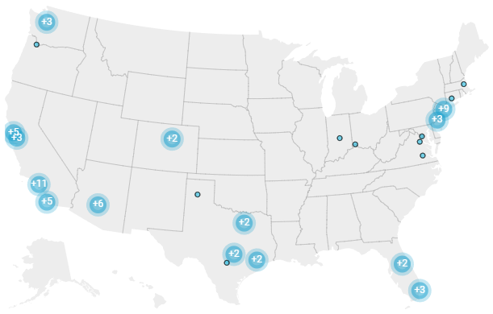
Arizona: Arizona Mills (Tempe), Biltmore Fashion Park (Phoenix), Chandler Fashion Center (Chandler), Metrocenter Mall (Phoenix), Scottsdale Fashion Square (Scottsdale), Tempe Marketplace (Tempe); California: Beverly Center (Los Angeles), Eastridge Shopping Center (San Jose), Fashion Valley Shopping Center (San Diego), FIGat7th (Los Angeles), Great Mall (Milpitas), Hollywood & Highland (Los Angeles), L.A. Live (Los Angeles), Metreon (San Francisco), Otay Ranch Town Center (Chula Vista), Pier 39 (San Francisco), Santa Monica Place (Santa Monica), Santana Row (San Jose), Sherman Oaks Galleria (Los Angeles), Stonestown Galleria (San Francisco), The Grove (Los Angeles), Westfield Century City (Los Angeles), Westfield Culver City (Culver City), Westfield Fashion Square (Los Angeles), Westfield Mission Valley (San Diego), Westfield Plaza Bonita (National City), Westfield San Francisco Centre (San Francisco), Westfield UTC (San Diego), Westfield Valley Fair Shopping Center (San Jose), Westgate Center (San Jose), Westside Pavilion Shopping Center (Los Angeles); Colorado: 16th Street Mall (Denver), Cherry Creek Shopping Center (Denver); Florida: Aventura Mall (Aventura), Dadeland Mall (Miami), Dolphin Mall (Sweetwater), The Florida Mall (Orlando), The Mall at Millenia (Orlando); Indiana: Circle Centre Mall (Indianapolis); Massachusetts: CambridgeSide (Cambridge), Prudential Center (Boston); New Jersey: Cherry Hill Mall (Cherry Hill), The Mills at Jersey Gardens (Elizabeth); New York: Brookfield Place (New York), Manhattan Mall (New York), New World Mall (Flushing), Queens Center (Elmhurst), Skyview Center (Flushing), Staten Island Mall (Staten Island), The Shops at Columbus Circle (New York); North Carolina: SouthPark (Charlotte); Oregon: Lloyd Center (Portland) , Washington Square (Portland); Pennsylvania: The Gallery at Market East (Philadelphia); Texas: Barton Creek Square (Austin), The Domain (Austin), Galleria Dallas (Dallas), NorthPark Center (Dallas), Memorial City Mall (Houston), The Galleria (Houston), North Star Mall (San Antonio), Rivercenter (San Antonio); Virginia: Fashion Centre at Pentagon City (Arlington); Washington: Bellevue Square (Bellevue), Northgate Mall (Seattle), Pacific Place (Seattle), University Village (Seattle), Westlake Center (Seattle).
United Kingdom
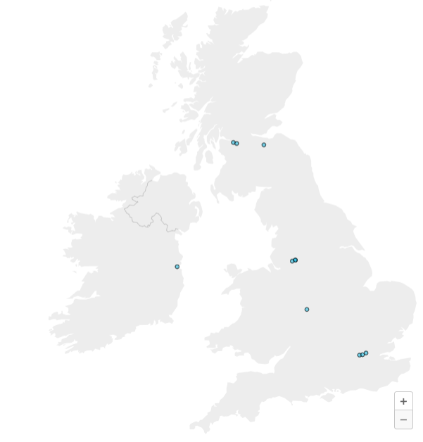
Afflecks (Manchester), Bullring (Birmingham), Covent Garden (London), Intu Braehead (Renfrew), Intu Trafford Centre (Manchester), Manchester Arndale (Manchester), Princes Square (Glasgow), Silverburn (Glasgow), Stephen’s Green Shopping Centre (Dublin), Westfield (London), Westfield - Stratford City (London).

Web Appendix E2: Descriptives and correlations in Study 1
 | Mean | SD | 1 | 2 | 3 | 4 | 5 | 6 | 7 | 8 | 9 | 10 | 11 | 12 | 13 | 14 | 15
PMRE Attributes
1. Mall access | 0.52 | 1.21
2. Mall atmosphere | 0.98 | 1.64 | 0.45
3. Cross-store assortment | 1.54 | 2.31 | 0.48 | 0.54
4. Within-store assortment | 0.57 | 1.13 | 0.27 | 0.35 | 0.50
5. Price and promotion | 0.11 | 0.74 | 0.22 | 0.26 | 0.39 | 0.29
Control Variables
6. Review length | 81.64 | 73.12 | 0.05 | 0.10 | 0.05 | 0.18 | -0.01
7. Local reviewer | 0.62 | 0.49 | -0.05 | -0.04 | -0.06 | 0.01 | -0.05 | 0.16
8. Number of reviews | 2.14 | 4.79 | 0.04 | 0.05 | 0.02 | 0.05 | 0.01 | 0.13 | 0.10
9. Review platform: TripAdvisor (vs. Yelp) | 0.72 | 0.45 | 0.13 | 0.09 | 0.15 | -0.01 | 0.06 | -0.30 | -0.44 | -0.18
10. Mall Size | 16.42 | 9.52 | -0.06 | -0.10 | 0.06 | 0.08 | 0.07 | -0.03 | -0.05 | -0.06 | 0.11
11. Population density | 0.97 | 0.82 | 0.15 | 0.05 | 0.06 | -0.02 | -0.01 | -0.10 | -0.14 | -0.02 | 0.23 | -0.01
12. Population income | 1.14 | 0.43 | -0.02 | -0.01 | -0.06 | -0.01 | -0.04 | 0.04 | 0.11 | 0.02 | -0.16 | 0.01 | -0.30
13. Mall age | 63.07 | 57.11 | 0.16 | 0.06 | 0.05 | -0.05 | -0.01 | -0.15 | -0.15 | -0.06 | 0.25 | 0.01 | 0.81 | -0.16
14. Population age | 3.66 | 0.78 | -0.11 | 0.02 | -0.10 | -0.02 | -0.03 | 0.03 | 0.03 | 0.01 | -0.11 | -0.12 | -0.57 | 0.47 | -0.44
Outcome
15. Mall satisfaction | 4.05 | 1.07 | 0.34 | 0.41 | 0.50 | 0.29 | 0.26 | -0.18 | -0.13 | -0.06 | 0.28 | 0.09 | 0.14 | -0.06 | 0.16 | -0.10
Note. N = 81,615. We include mall age as a residual in the moderator analysis, given its high correlation with population density (r = .81).

Web Appendix E3: Overview of all robustness checks and additional analysis Study 1
Type of analysis | Reason for inclusion | Main conclusion

Study 1
Weighted results based on frequency of attribute mentions | More frequently mentioned attributes could be a driver of mall satisfaction | Findings are not driven merely by mention intensity. All findings regarding mall-controlled versus tenant-controlled attributes remain unchanged.
Separate platform (TripAdvisor vs. Yelp) | Different platforms attract different user populations, rule out platform-specific biases. | Findings are similar across platforms, in both subsamples mall-controlled attributes show stronger relationships with mall satisfaction.
Random 50% split | Stability across random subsamples, no dependency on specific reviews or sample specific patterns. | The findings are consistent across the random 50% samples of the data.
Panel Specification | Controlling for unobserved, time-invariant mall characteristics. | The results remain robust controlling for mall- and location specific characteristics.
Local Reviewer | Locals may be repeat customers; non-locals may be occasional visitors. Their evaluative criteria could differ. | The results are similar for non-local and local reviewers, suggesting that their evaluation criteria do not differ.
Malls in UK vs US | Cultural, retail-structure, and economic differences could alter attribute importance. | Malls in the UK and US show similar results and importance of PMRE attributes.
Positive and Negative sentiment | Negative information often weighs more heavily than positive. This tests whether negative PMRE sentiment drive mall satisfaction more strongly. | Separate positive and negative sentiment of the PMRE attributes show similar findings, even though negative sentiment is more pronounced than positive.

Web Appendix E4: Effect size weighted by frequency
Panel A: Results Study 1 weighted by frequency
   | Model 9: Full Sample
   | Coefficient |  | SE | OR
  PMRE Attributes
  Mall access | 0.074 | ** | 0.013 | 1.077
  Mall atmosphere | 0.151 | ** | 0.009 | 1.163
  Cross-store assortment | 0.198 | ** | 0.006 | 1.219
  Within-store assortment | 0.065 | ** | 0.007 | 1.067
  Price and promotion | 0.042 | ** | 0.003 | 1.043
  Control Variables
  Review length | -0.006 | ** | 0.001 | 0.994
  Local reviewer | 0.039 |  | 0.035 | 1.039
  Number of reviews | -0.022 | ** | 0.003 | 0.979
  Review platform (TripAdvisor vs. Yelp) | 0.447 | ** | 0.068 | 1.563
  Fixed Effects
  Mall | Included
  Year | Included
  Month | Included
  Weekday | Included
  Akaike Information Criterion | 178,118.60
  Number of Shopping Malls | 79
  Number of Customer Reviews | 81,615
  Linear Combinations of Parameters
  Mall-controlled PMRE attributes | 0.141, SE = 0.005, p < .001
  Tenant-controlled PMRE attributes | 0.053, SE = 0.004, p < .001
  ΔMall- and tenant-controlled PMRE attributes | 0.088, SE = 0.008, p < .001
  Panel B: Effect size in main analysis
  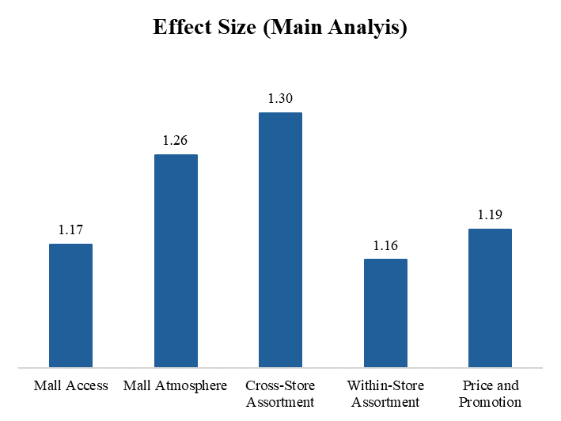
  Panel C: Effect size weighted by frequency
  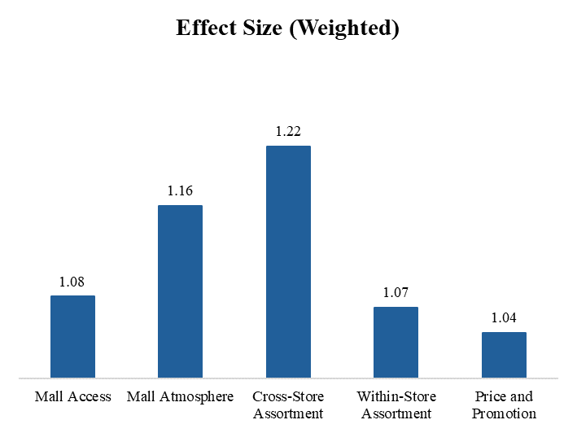

Web Appendix E5: Results with random 50% split of the data and Panel model specification
 | Model 10: 50% of data |  |  |  | Model 11: 50% of data |  |  |  |  |  | Model 12: Panel Model
 | Coefficient |  | SE | OR | Coefficient |  |  | SE |  | OR | Coefficient |  | SE | OR
PMRE Attributes
Mall access | 0.153 | ** | 0.025 | 1.165 | 0.162 | ** | 0.031 |  | 1.176 |  | 0.157 | ** | 0.027 |  | 1.170
Mall atmosphere | 0.226 | ** | 0.012 | 1.253 | 0.232 | ** | 0.016 |  | 1.261 |  | 0.229 | ** | 0.013 |  | 1.257
Cross-store assortment | 0.262 | ** | 0.007 | 1.300 | 0.260 | ** | 0.011 |  | 1.297 |  | 0.261 | ** | 0.007 |  | 1.298
Within-store assortment | 0.118 | ** | 0.016 | 1.125 | 0.170 | ** | 0.018 |  | 1.186 |  | 0.144 | ** | 0.015 |  | 1.155
Price and promotion | 0.189 | ** | 0.014 | 1.208 | 0.150 | ** | 0.020 |  | 1.162 |  | 0.170 | ** | 0.013 |  | 1.185
Control Variables
Review length | -0.006 | ** | 0.001 | 0.995 | -0.006 | ** | 0.000 |  | 0.994 |  | -0.006 | ** | 0.001 |  | 0.994
Local reviewer | 0.012 |  | 0.035 | 1.012 | 0.064 |  | 0.042 |  | 1.066 |  | 0.039 |  | 0.034 |  | 1.039
Number of reviews | -0.024 | ** | 0.003 | 0.977 | -0.020 | ** | 0.003 |  | 0.981 |  | -0.022 | ** | 0.003 |  | 0.978
Review platform (TripAdvisor vs. Yelp) | 0.454 | ** | 0.068 | 1.575 | 0.439 | ** | 0.076 |  | 1.551 |  | 0.454 | ** | 0.068 |  | 1.574
Fixed Effects
Mall | Included |  |  |  | Included |  |  |  |  |  | Included
Year | Included |  |  |  | Included |  |  |  |  |  | Included
Month | Included |  |  |  | Included |  |  |  |  |  | Included
Weekday | Included |  |  |  | Included |  |  |  |  |  | Included
Akaike Information Criterion | 88,874.38 |  |  |  | 89,194.4 |  |  |  |  |  | 178,533.70
Number of Customer Reviews | 40,636 |  |  |  | 40,979 |  |  |  |  |  | 81,615
Number of Shopping Malls | 79 |  |  |  | 79 |  |  |  |  |  | 79
Linear Combinations of Parameters
Mall-controlled attributes | 0.214, p < .001 |  |  |  | 0.218, p < .001 |  |  |  |  |  | 0.216, p < .001
Tenant-controlled attributes | 0.154, p < .001 |  |  |  | 0.160, p < .001 |  |  |  |  |  | 0.157, p < .001
ΔMall- and tenant-controlled attributes | 0.060, p < .001 |  |  |  | 0.058, p = .012 |  |  |  |  |  | 0.059, p = .001
***p < .01, *p < .05. Note: We omit the cut points to increase table readability. SE = clustered standard errors, OR = odds ratios.

Web Appendix E6: Results for local reviewers and country
 | Model 13:  Local Reviewers |  |  |  | Model 14:  Non-Local Reviewers |  |  |  |  |  | Model 15:  United States |  |  |  |  |  |  | Model 16:  United Kingdom
 | Coefficient |  | SE | OR | Coefficient |  |  | SE |  | OR | Coefficient |  | SE | OR |  |  | Coefficient |  |  |  | SE |  | OR
PMRE Attributes
Mall access | 0.157 | ** | 0.030 | 1.170 | 0.167 | ** | 0.023 |  | 1.182 |  | 0.167 | ** | 0.034 |  | 1.181 |  | 0.143 |  | ** |  |  | 0.022 |  | 1.153
Mall atmosphere | 0.223 | ** | 0.013 | 1.250 | 0.244 | ** | 0.017 |  | 1.276 |  | 0.230 | ** | 0.015 |  | 1.259 |  | 0.216 |  | ** |  |  | 0.011 |  | 1.241
Cross-store assortment | 0.259 | ** | 0.009 | 1.295 | 0.265 | ** | 0.010 |  | 1.303 |  | 0.259 | ** | 0.009 |  | 1.295 |  | 0.269 |  | ** |  |  | 0.010 |  | 1.308
Within-store assortment | 0.135 | ** | 0.015 | 1.145 | 0.165 | ** | 0.022 |  | 1.180 |  | 0.134 | ** | 0.016 |  | 1.143 |  | 0.188 |  | ** |  |  | 0.033 |  | 1.206
Price and promotion | 0.137 | ** | 0.017 | 1.147 | 0.230 | ** | 0.023 |  | 1.258 |  | 0.157 | ** | 0.014 |  | 1.170 |  | 0.229 |  | ** |  |  | 0.018 |  | 1.258
Control Variables
Review length | -0.005 | ** | 0.000 | 0.995 | -0.009 | ** | 0.001 |  | 0.991 |  | -0.005 | ** | 0.001 |  | 0.995 |  | -0.009 |  | ** |  |  | 0.001 |  | 0.991
Local reviewer |  |  |  |  |  |  |  |  |  |  | 0.040 |  | 0.037 |  | 1.041 |  | 0.058 |  |  |  |  | 0.072 |  | 1.059
Number of reviews | -0.018 | ** | 0.002 | 0.982 | -0.031 | ** | 0.006 |  | 0.970 |  | -0.019 | ** | 0.003 |  | 0.981 |  | -0.034 |  | ** |  |  | 0.010 |  | 0.967
Review platform (TripAdvisor vs. Yelp) | 0.488 | ** | 0.075 | 1.629 | 0.269 | ** | 0.092 |  | 1.309 |  | 0.485 | ** | 0.080 |  | 1.625 |  | 0.118 |  |  |  |  | 0.131 |  | 1.125
Fixed Effects
Mall | Included |  |  |  | Included |  |  |  |  |  | Included |  |  |  |  |  |  | Included
Year | Included |  |  |  | Included |  |  |  |  |  | Included |  |  |  |  |  |  | Included
Month | Included |  |  |  | Included |  |  |  |  |  | Included |  |  |  |  |  |  | Included
Weekday | Included |  |  |  | Included |  |  |  |  |  | Included |  |  |  |  |  |  | Included
Akaike Information Criterion | 112,785.80 |  |  |  | 64,929.26 |  |  |  |  |  | 136,609.00 |  |  |  |  |  |  | 41,249.63
Number of Customer Reviews | 50,218 |  |  |  | 31,397 |  |  |  |  |  | 59,758 |  |  |  |  |  |  | 21,857
Number of Shopping Malls | 79 |  |  |  | 79 |  |  |  |  |  | 79 |  |  |  |  |  |  | 79
Linear Combinations of Parameters
Mall-controlled attributes | 0.213, p < .001 |  |  |  | 0.225, p < .001 |  |  |  |  |  | 0.219, p < .001 |  |  |  |  |  |  | 0.209, p < .001
Tenant-controlled attributes | 0.136, p < .001 |  |  |  | 0.198, p < .001 |  |  |  |  |  | 0.146, p < .001 |  |  |  |  |  |  | 0.209, p < .001
ΔMall- and tenant-controlled attributes | 0.078, p < .001 |  |  |  | 0.028, p = .188 |  |  |  |  |  | 0.073, p < .001 |  |  |  |  |  |  | 0.001, p = .979

Web Appendix E7: Results for positive and negative sentiment towards the mall attributes
 | Model 17
 | Coefficient |  | SE | OR
Positive Sentiment towards PMRE Attributes
Mall access | 0.054 | * | 0.026 | 1.055
Mall atmosphere | 0.047 |  | 0.029 | 1.048
Cross-store assortment | 0.165 | ** | 0.015 | 1.179
Within-store assortment | 0.104 | ** | 0.008 | 1.110
Price and promotion | -0.014 |  | 0.040 | 0.986
Negative Sentiment towards PMRE Attributes
Mall access | -0.306 | ** | 0.044 | 0.737
Mall atmosphere | -0.594 | ** | 0.095 | 0.552
Cross-store assortment | -0.383 | ** | 0.019 | 0.682
Within-store assortment | -0.148 | ** | 0.035 | 0.863
Price and promotion | -0.335 | ** | 0.034 | 0.716
Control Variables
Review length | 0.003 | ** | 0.001 | 1.003
Local reviewer | 0.066 | * | 0.033 | 1.068
Number of reviews | -0.022 | ** | 0.003 | 0.979
Review platform (TripAdvisor vs. Yelp) | 0.539 | ** | 0.061 | 1.715
Fixed Effects
Mall | Included
Year | Included
Month | Included
Weekday | Included
Akaike Information Criterion | 175,224.20
Number of Customer Reviews | 81,615
Number of Shopping Malls | 79
Linear Combinations of Parameters
Positive sentiment towards mall-controlled attributes | 0.088, p < .001
Positive sentiment towards tenant-controlled attributes | 0.045, p = .020
ΔPositive sentiment towards mall- and tenant-controlled attributes | 0.043, p = .005
Negative sentiment towards mall-controlled attributes | -0.428, p < .001
Negative sentiment towards tenant-controlled attributes | -0.241, p < .001
ΔNegative sentiment towards mall- and tenant-controlled attributes | 0.186, p < .001
**p < .01, *p < .05. Note: We omit the cut points to increase table readability. SE = clustered standard errors, OR = odds ratios.

Web Appendix F: Additional details for Study 2
Web Appendix F1: List of all shopping malls in Study 2`
Shopping Mall | Adress | Mall Age | Mall Size | Mall Anchors | Mall Floor Area | Population Density | Population Age | Population Income | Survival | Pair
Exchange Ilford | High Rd, Ilford IG1 1RS | 34 | 90 | 5 | 300,000 | 1,379,706 | 34 | 63,585 | 1 | 1
Centrale Shopping Centre | 21 N End, Croydon CR0 1TY | 20 | 61 | 4 | 66,500 | 1,104,422 | 40 | 67,119 | 0 | 1
White Mountain Mall | 2441 Foothill Blvd, Rock Springs, WY 82901 | 47 | 40 | 8 | 330,000 | 1 | 34 | 72,385 | 1 | 2
Sunset Mall | 4001 Sunset Dr #1182, San Angelo, TX 76904 | 45 | 70 | 9 | 559,684 | 69,175 | 33 | 90,276 | 0 | 2
Fallbrook Center | 22950 Vanowen St, West Hills, CA 91307 | 62 | 42 | 6 | 880,000 | 230,212 | 45 | 119,452 | 1 | 3
Sunrise Mall | Sunrise Mall, Massapequa, NY 11758 | 50 | 63 | 5 | 1,244,386 | 325,586 | 45 | 147,558 | 0 | 3
Galleria at Crystal Run | 1 Galleria Dr, Middletown, NY 10941 | 33 | 120 | 6 | 1,100,000 | 46,978 | 38 | 79,321 | 1 | 4
Savannah Mall | 14045 Abercorn St, Savannah, GA 31419 | 33 | 110 | 5 | 962,529 | 86,784 | 36 | 76,181 | 0 | 4
Brookfield Square | 95 N Moorland Rd, Brookfield, WI 53005 | 58 | 100 | 5 | 1,090,970 | 168,616 | 42 | 106,484 | 1 | 5
Montgomery Mall | 230 Montgomery Mall, North Wales, PA 19454 | 47 | 90 | 5 | 1,102,755 | 151,452 | 45 | 126,560 | 0 | 5
Regency Square | 1420 N Parham Rd, Richmond, VA 23229 | 50 | 60 | 4 | 820,000 | 208,523 | 38 | 83,904 | 1 | 6
Military Circle Mall | Norfolk, Virginia 23502 | 54 | 65 | 6 | 963,000 | 304,483 | 38 | 76,556 | 0 | 6
Block 37 | 108 N State St, Chicago, IL 60602 | 17 | 35 | 2 | 400,000 | 755,260 | 34 | 226,276 | 1 | 7
Mazza Gallerie | 5300 Wisconsin Ave NW, Washington, DC 20015 | 46 | 18 | 3 | 300,000 | 767,167 | 45 | 240,225 | 0 | 7
Wilton Mall | 3065 NY-50, Saratoga Springs, NY 12866 | 35 | 70 | 5 | 708,000 | 40,093 | 45 | 88,689 | 1 | 8
Grand Traverse Mall | 3200 W South Airport Rd, Traverse City, MI 49684 | 32 | 70 | 5 | 598,442 | 48,519 | 43 | 82,327 | 0 | 8
The Shops at Tanforan | 1150 El Camino Real, San Bruno, CA 94066 | 54 | 105 | 4 | 969,107 | 243,744 | 39 | 112,933 | 1 | 9
Galleria White Plains | 100 Main St, White Plains, NY 10601 | 43 | 85 | 4 | 865,000 | 208,124 | 40 | 125,938 | 0 | 9
Lafayette Square Mall | 3919 Lafayette Rd, Indianapolis, IN 46254 | 57 | 78 | 4 | 1,214,300 | 191,352 | 32 | 46,693 | 1 | 10
Eastland Mall | 2740 S Hamilton Rd, Columbus, OH 43232 | 54 | 55 | 4 | 999,458 | 255,642 | 34 | 51,461 | 0 | 10
Hawthorn Mall | 122 Hawthorn Ctr, Vernon Hills, IL 60061 | 52 | 76 | 4 | 1,295,915 | 141,264 | 40 | 100,709 | 1 | 11
EastGate Mall | 4601 Eastgate Blvd, Cincinnati, OH 45245 | 44 | 55 | 4 | 1,066,654 | 106,203 | 40 | 91,393 | 0 | 11
Clock Towers Shopping Centre | Market Mall, Rugby CV21 2JR | 46 | 32 | 0 | 210,000 | 94,076 | 38 | 52,515 | 1 | 12
Wellgate Centre | Victoria Rd, [no name], Dundee DD1 2DB | 46 | 40 | 1 | 348,000 | 163,817 | 40 | 53,727 | 0 | 12
Lesley Forestside | Upper Galwally, Belfast BT8 6FX | 27 | 36 | 3 | 250,000 | 369,895 | 39 | 44,280 | 1 | 13
The Wheatsheaf Shopping Centre | Newgate, Rochdale OL16 1YL | 29 | 26 | 3 | 162,862 | 270,849 | 40 | 53,727 | 0 | 13
Miami International Mall | 1455 NW 107th Ave, Doral, FL 33172 | 43 | 130 | 4 | 1,082,555 | 376,503 | 42 | 52,003 | 1 | 14
St. Enoch Centre | 55 St Enoch Sq, Glasgow G1 4BW | 34 | 86 | 3 | 750,000 | 662,476 | 40 | 53,727 | 0 | 14
The Fashion Mall at Keystone | 8702 Keystone Crossing, Indianapolis, IN 46240 | 52 | 123 | 2 | 710,587 | 209,488 | 41 | 56,744 | 1 | 15
Queensmere Observatory | High St, Slough SL1 1LN | 54 | 111 | 3 | 595,500 | 275,248 | 40 | 63,418 | 0 | 15
Kennet Shopping | Bartholomew St, Newbury RG14 5EN | 30 | 50 | 2 | 244,000 | 88,615 | 43 | 72,630 | 1 | 16
Nicholsons Shopping Centre | Nicholsons Ln, Maidenhead SL6 1LB | 29 | 43 | 2 | 200,000 | 203,468 | 40 | 71,058 | 0 | 16
Northlake Mall | 4800 Briarcliff Rd NE, Atlanta, GA 30345 | 54 | 29 | 4 | 962,000 | 332,026 | 37 | 82,072 | 1 | 17
Neshaminy Mall | 707 Neshaminy Mall, Bensalem, PA 19020 | 56 | 40 | 4 | 1,025,297 | 267,833 | 40 | 94,744 | 0 | 17
Swansgate Shopping Centre | 18 Spring Ln, Wellingborough NN8 1EY | 48 | 50 | 4 | 252,400 | 133,917 | 40 | 50,490 | 1 | 18
Grosvenor Shopping Northampton | 2 Union Street, Northampton NN1 2EW | 48 | 50 | 4 | 320,000 | 247,564 | 40 | 51,447 | 0 | 18
Richmond Centre | Ferryquay St, Londonderry BT48 6PE | 41 | 36 | 1 | 120,000 | 101,274 | 40 | 61,290 | 1 | 19
Festival Park | Victoria, Ebbw Vale NP23 8FP | 44 | 30 | 0 | 100,000 | 111,009 | 40 | 53,727 | 0 | 19
Mall at Rockingham Park | 99 Rockingham Park Blvd, Salem, NH 03079 | 34 | 144 | 3 | 1,024,171 | 76,485 | 45 | 90,673 | 1 | 20
Crystal Mall | 850 Hartford Turnpike, Waterford, CT 06385 | 39 | 103 | 1 | 782,786 | 76,296 | 48 | 104,517 | 0 | 20
Valley View Mall | 4802 Valley View Blvd NW, Roanoke, VA 24012 | 40 | 102 | 5 | 844,193 | 102,699 | 39 | 46,381 | 1 | 21
Chilterns Shopping Centre | Frogmoor, High Wycombe HP13 5ES | 37 | 107 | 4 | 850,000 | 180,625 | 40 | 53,727 | 0 | 21
Newlands Shopping Centre | Gold St, Kettering NN16 8JA | 48 | 52 | 3 | 265,614 | 106,376 | 40 | 55,215 | 1 | 22
Castlegate Shopping Centre | High St, Stockton-on-Tees TS18 1BG | 50 | 59 | 2 | 340,000 | 305,295 | 40 | 53,727 | 0 | 22
The Potteries | 1 Quadrant Rd, Hanley, Stoke-on-Trent ST1 1PP | 37 | 90 | 3 | 561,000 | 369,917 | 38 | 41,175 | 1 | 23
Cascades Shopping Centre | Commercial Rd, Portsmouth PO1 4RL | 35 | 60 | 4 | 440,000 | 337,780 | 40 | 31,710 | 0 | 23
Piqua Center | 987 E Ash St, Piqua, OH 45356 | 37 | 27 | 2 | 504,691 | 26,081 | 41 | 50,435 | 1 | 24
Bon Accord Aberdeen | George St, Aberdeen AB25 1HZ | 34 | 40 | 2 | 630,000 | 214,463 | 40 | 53,727 | 0 | 24
Lion Walk | Lion Walk, Colchester CO1 1LX | 49 | 38 | 5 | 210,000 | 160,594 | 39 | 62,640 | 1 | 25
Adrian Mall | 1357 S Main St, Adrian, MI 49221 | 50 | 50 | 5 | 373,000 | 32,621 | 39 | 64,404 | 0 | 25
Burns Mall | Sturrock St, Kilmarnock KA1 1LT | 49 | 29 | 3 | 180,200 | 78,882 | 45 | 56,025 | 1 | 26
Alpena Mall | 2380 US-23, Alpena, MI 49707 | 42 | 30 | 3 | 182,975 | 16,786 | 48 | 56,184 | 0 | 26
South Shore Mall | 1701 Sunrise Hwy, Bay Shore, NY 11706 | 62 | 99 | 4 | 1,165,000 | 189,729 | 37 | 97,495 | 1 | 27
Boulevard Mall | 730 Alberta Dr, Amherst, NY 14226 | 62 | 80 | 5 | 904,000 | 133,649 | 38 | 100,785 | 0 | 27
TownMall of Westminster | 400 N Center St, Westminster, MD 21157 | 38 | 75 | 4 | 629,097 | 51,513 | 41 | 90,119 | 1 | 28
Burlington Center Mall | 2501 Mt Holly Rd, Burlington Township, NJ 08016 | 36 | 100 | 3 | 800,000 | 49,432 | 40 | 101,712 | 0 | 28
Westmoreland Mall | 5256 US-30, Greensburg, PA 15601 | 48 | 170 | 6 | 1,287,620 | 71,280 | 47 | 60,984 | 1 | 29
Century III Mall | 9971 Mountain View Dr, West Mifflin, PA 15122 | 40 | 200 | 6 | 1,290,000 | 55,125 | 47 | 69,027 | 0 | 29
Kukui Grove Center | Kaumualii Hwy Ste 1710, Lihue, HI 96766 | 43 | 65 | 5 | 312,000 | 18,507 | 41 | 85,843 | 1 | 30
Chambersburg Mall | 3055 Black Gap Rd, Chambersburg, PA 17202 | 41 | 64 | 5 | 454,350 | 14,710 | 42 | 97,331 | 0 | 30
Ards Shopping Centre | 22C Circular Rd, Newtownards BT23 4EU | 49 | 58 | 3 | 280,000 | 111,703 | 45 | 94,770 | 1 | 31
Cherryland Center | 1148 W South Airport Rd, Traverse City, MI 49686 | 48 | 30 | 4 | 167,505 | 31,072 | 46 | 88,756 | 0 | 31
Northfield Square | 1600 IL-50, Bourbonnais, IL 60914 | 35 | 37 | 5 | 530,325 | 61,362 | 34 | 76,860 | 1 | 32
Columbia Colonnade | 225 Columbia Mall Dr, Bloomsburg, PA 17815 | 34 | 22 | 4 | 352,544 | 19,697 | 33 | 70,273 | 0 | 32
Broadway Square Mall | 4601 S Broadway Ave, Tyler, TX 75703 | 50 | 83 | 3 | 628,796 | 50,523 | 37 | 64,510 | 1 | 33
Concord Mall (Indiana) | 3701 S Main St, Elkhart, IN 46517 | 51 | 60 | 3 | 528,300 | 38,567 | 36 | 61,151 | 0 | 33
Willowbrook Mall | 2000 Willowbrook Mall, Houston, TX 77070 | 44 | 140 | 6 | 1,510,000 | 316,428 | 35 | 67,390 | 1 | 34
Cortana Mall | 9401 Cortana Pl, Baton Rouge, LA 70815 | 48 | 110 | 6 | 1,432,889 | 97,088 | 35 | 66,655 | 0 | 34
Howard Centre | Howardsgate, Welwyn Garden City AL8 6HA | 35 | 50 | 4 | 230,000 | 145,285 | 53 | 76,680 | 1 | 35
Crystal River Mall | 1801 US-19, Crystal River, FL 34428 | 32 | 40 | 4 | 29,265 | 9,778 | 54 | 56,361 | 0 | 35
Voorhees Town Center | 2140 Voorhees Township, NJ 08043 | 55 | 25 | 2 | 664,380 | 195,706 | 44 | 100,075 | 1 | 36
Eastern Hills Mall | 4545 Transit Rd, Williamsville, NY 14221 | 53 | 55 | 4 | 996,729 | 48,600 | 48 | 113,912 | 0 | 36
Towne West Square | 4600 W Kellogg Dr, Wichita, KS 67209 | 44 | 37 | 5 | 951,447 | 153,801 | 37 | 73,186 | 1 | 37
The Esplanade (Kenner) | 1401 W Esplanade Ave, Kenner, LA 70065 | 36 | 28 | 4 | 900,000 | 113,450 | 37 | 79,639 | 0 | 37
Templars Square shopping centre | 129 pound way, Oxford OX4 3XH | 60 | 63 | 4 | 292,700 | 221,045 | 34 | 85,725 | 1 | 38
Glen Burnie Mall | 6711 Ritchie Hwy, Glen Burnie, MD 21061 | 55 | 16 | 3 | 7,203 | 80,229 | 36 | 84,574 | 0 | 38
Marketplace @ Factoria | Factoria Blvd SE, Bellevue, WA 98006 | 48 | 69 | 7 | 525,948 | 218,816 | 43 | 156,382 | 1 | 41
Hanover Mall | 1775 Washington St, Hanover, MA 02339 | 49 | 80 | 10 | 732,101 | 22,328 | 40 | 167,440 | 0 | 41
Meadows Shopping Centre | 42-47 High St, Chelmsford CM2 6FD | 33 | 39 | 1 | 176,000 | 140,501 | 33 | 69,660 | 1 | 42
Kaleidoscope at the Hub | 555 Walnut St, Des Moines, IA 50309 | 34 | 32 | 1 | 246,682 | 118,517 | 30 | 69,601 | 0 | 42
Northland Mall | 900 W Northland Ave, Appleton, WI 54914 | 56 | 30 | 3 | 189,125 | 115,486 | 37 | 61,279 | 1 | 43
Karcher Mall | 1509 Caldwell Blvd, Nampa, ID 83651 | 55 | 50 | 4 | 400,000 | 60,573 | 35 | 62,987 | 0 | 43
Bellis Fair Mall | Bellis Fair Pkwy, Bellingham, WA 98226 | 37 | 83 | 6 | 773,000 | 93,409 | 40 | 67,142 | 1 | 44
Lycoming Mall | 300 Lycoming Mall Cir, Pennsdale, PA 17756 | 45 | 85 | 6 | 834,600 | 4,830 | 42 | 74,098 | 0 | 44
Alhambra Shopping Centre | Cheapside, Barnsley S70 1SB | 34 | 41 | 4 | 981,000 | 200,262 | 34 | 46,980 | 1 | 45
Metrocenter Mall (Jackson) | 3645 US-80, Jackson, MS 39209 | 40 | 60 | 4 | 1,250,000 | 67,141 | 33 | 42,460 | 0 | 45
Heritage Mall | 1895 14th Ave SE, Albany, OR 97322 | 37 | 50 | 5 | 406,500 | 51,187 | 36 | 60,148 | 1 | 46
Midway Mall (Sherman, Texas) | 4800 Texoma Pkwy, Sherman, TX 75090 | 38 | 70 | 5 | 606,494 | 15,521 | 35 | 59,996 | 0 | 46
Pine Ridge Mall | 4155 Yellowstone Ave, Chubbuck, ID 83202 | 44 | 0 | 4 | 646,000 | 1,666 | 34 | 57,691 | 1 | 47
Northgate Mall (North Carolina) | 1058 W Club Blvd, Durham, NC 27701 | 46 | 30 | 2 | 900,000 | 103,334 | 33 | 69,905 | 0 | 47
West Oaks Mall | 9401 W Colonial Dr, Ocoee, FL 34761 | 29 | 61 | 4 | 1,077,481 | 202,998 | 35 | 72,069 | 1 | 48
Oak Hollow Mall | 921 Eastchester Dr, High Point, NC 27262 | 22 | 80 | 4 | 1,262,440 | 66,463 | 35 | 78,396 | 0 | 48
Vintage Faire Mall | 3401 Dale Rd Ste 483, Modesto, CA 95356 | 48 | 174 | 5 | 1,083,309 | 166,108 | 38 | 76,225 | 1 | 49
Paradise Valley Mall | 4568 E Cactus Rd, Phoenix, AZ 85032 | 42 | 170 | 5 | 1,152,333 | 131,354 | 37 | 77,678 | 0 | 49
Dartmouth Mall | 200 N Dartmouth Mall, Dartmouth, MA 02747 | 54 | 54 | 4 | 670,940 | 127,074 | 37 | 83,459 | 1 | 50
Pembroke Mall | 4554 Virginia Beach Blvd, Virginia Beach, VA 23462 | 56 | 48 | 4 | 623,479 | 134,717 | 34 | 76,005 | 0 | 50
Melbourne Square | 1700 W New Haven Ave, Melbourne, FL 32904 | 43 | 105 | 5 | 703,000 | 11,130 | 43 | 72,981 | 1 | 51
Phillipsburg Mall | 1200 US-22, Phillipsburg, NJ 08865 | 31 | 90 | 4 | 578,925 | 39,934 | 42 | 81,925 | 0 | 51
Lindale Mall | 4444 1st Ave NE, Cedar Rapids, IA 52402 | 65 | 108 | 3 | 687,174 | 148,374 | 36 | 63,635 | 1 | 52
Richland Mall (South Carolina) | 3400 Forest Dr, Columbia, SC 29204 | 61 | 96 | 3 | 713,992 | 96,557 | 37 | 63,808 | 0 | 52
Berkshire Mall | 1665 State Hill Rd, Wyomissing, PA 19610 | 55 | 69 | 1 | 910,000 | 194,069 | 46 | 80,781 | 1 | 53
Richmond Town Square | 691 Richmond Rd, Richmond Heights, OH 44143 | 55 | 75 | 3 | 1,017,000 | 86,347 | 49 | 90,134 | 0 | 53
Louis Joliet Mall | 3340 Mall Loop Dr, Joliet, IL 60431 | 47 | 81 | 5 | 982,659 | 157,063 | 35 | 93,941 | 1 | 54
ShoppingTown Mall | 3649 Erie Blvd E, De Witt, NY 13214 | 47 | 90 | 4 | 988,054 | 59,240 | 34 | 91,287 | 0 | 54
High Chelmer Shopping Centre | 15A Exchange Way, Chelmsford CM1 1XB | 54 | 54 | 4 | 309,000 | 138,509 | 41 | 69,660 | 1 | 55
Signal Hill Mall | 324 Signal Hill Dr, Statesville, NC 28625 | 51 | 42 | 4 | 309,100 | 28,329 | 41 | 71,321 | 0 | 55
Newgate Mall | 3651 Wall Ave, Ogden, UT 84405 | 44 | 70 | 5 | 725,148 | 205,526 | 32 | 72,393 | 1 | 56
Sunrise Mall (Corpus Christi) | 5858 S Padre Island Dr, Corpus Christi, TX 78412 | 38 | 85 | 6 | 930,538 | 127,805 | 28 | 65,328 | 0 | 56
Monroe Crossing | 2115 W Roosevelt Blvd Ste 290, Monroe, NC 28110 | 46 | 45 | 3 | 395,000 | 33,192 | 37 | 69,351 | 1 | 57
Towne Square Mall / North | 4600 Frederica St, Owensboro, KY 42301 | 45 | 52 | 3 | 437,752 | 44,539 | 38 | 70,860 | 0 | 57
Wenatchee Valley Mall | 511 Valley Mall Pkwy, East Wenatchee, WA 98802 | 52 | 58 | 4 | 340,786 | 180 | 38 | 71,093 | 1 | 58
Upper Valley Mall | 1475 Upper Valley Pike, Springfield, OH 45504 | 50 | 55 | 4 | 267,466 | 28,355 | 37 | 72,735 | 0 | 58
Hickory Point Mall | 1340 Hickory Point Dr, Forsyth, IL 62535 | 47 | 49 | 10 | 826,347 | 35,139 | 41 | 95,000 | 1 | 59
The Village at Orange | 1500 E Village Way, Orange, CA 92865 | 53 | 75 | 10 | 855,911 | 151,152 | 37 | 121,093 | 0 | 59
Manhattan Village | 3200 N Sepulveda Blvd, Manhattan Beach, CA 90266 | 44 | 60 | 2 | 648,000 | 449,199 | 43 | 153,926 | 1 | 60
Westside Pavilion | 10800 W Pico Blvd #312, Los Angeles, CA 90064 | 34 | 70 | 3 | 739,822 | 329,025 | 40 | 161,321 | 0 | 60
Kingsway Shopping Centre | 2 Emlyn St, Kingsway Centre, Newport NP20 1HY | 57 | 36 | 4 | 290,000 | 186,506 | 36 | 49,005 | 1 | 61
Mounds Mall | 2109 S Scatterfield Rd, Anderson, IN 46016 | 53 | 30 | 4 | 300,000 | 50,376 | 34 | 37,650 | 0 | 61
Charleston Town Center | 3000 Charleston Town Center, Charleston, WV 25301 | 42 | 41 | 4 | 933,979 | 64,677 | 45 | 18,415 | 1 | 62
Hudson Valley Mall | 1300 Ulster Ave, Kingston, NY 12401 | 43 | 14 | 2 | 765,704 | 22,644 | 40 | 12,401 | 0 | 62
West County Center | 80 W County Center Dr, Des Peres, MO 63131 | 56 | 150 | 4 | 1,209,649 | 173,369 | 48 | 164,531 | 1 | 63
Chesterfield Mall | 291 Chesterfield Center, Chesterfield, MO 63017 | 46 | 150 | 4 | 1,293,445 | 48,068 | 48 | 158,239 | 0 | 63
The Shops at Ithaca Mall | 40 Catherwood Rd, Ithaca, NY 14850 | 49 | 37 | 5 | 622,920 | 60,079 | 28 | 56,794 | 1 | 64
Muncie Mall | 3501 N Granville Ave, Muncie, IN 47303 | 54 | 30 | 4 | 636,000 | 63,873 | 30 | 49,467 | 0 | 64
Average closed malls |  | 43.77 | 66.64 | 4.14 | 684,685.67 | 149,461.44 | 39.02 | 80,419.11
Average surviving malls |  | 45.42 | 69.50 | 4.09 | 677,690.53 | 175,097.58 | 38.93 | 77,505.19

Web Appendix F2: Descriptives and correlations in Study 2`
 | Mean | SD | 1 | 2 | 3 | 4 | 5 | 6 | 7 | 8 | 9 | 10 | 11 | 12 | 13 | 14
PMRE Attributes
1. Mall access | 0.04 | 0.39
2. Mall atmosphere | 0.12 | 0.62 | 0.28
3. Cross-store assortment | 0.24 | 0.98 | 0.30 | 0.40
4. Within-store assortment | 0.11 | 0.49 | 0.16 | 0.26 | 0.40
5. Price and promotion | 0.02 | 0.28 | 0.12 | 0.14 | 0.22 | 0.16
Control Variables
6. Review length | 13.36 | 15.20 | 0.04 | 0.07 | 0.02 | 0.10 | 0.00
7. Number of reviews | 102.51 | 128.99 | 0.02 | 0.03 | 0.03 | 0.03 | 0.01 | 0.01
8. Mall Size | 73.09 | 37.48 | 0.01 | 0.03 | 0.02 | 0.03 | 0.01 | 0.01 | 0.03
9. Population density | 0.20 | 0.23 | 0.04 | 0.04 | 0.08 | 0.04 | 0.01 | 0.00 | 0.00 | -0.01
10. Population income | 0.79 | 0.34 | 0.03 | 0.02 | 0.02 | 0.02 | 0.01 | 0.00 | 0.07 | 0.12 | 0.12
11. Mall age | 4.46 | 0.97 | -0.02 | -0.01 | -0.01 | -0.01 | 0.01 | -0.02 | 0.01 | 0.04 | -0.33 | 0.04
12. Population age | 3.93 | 0.45 | 0.01 | 0.01 | 0.01 | 0.02 | -0.01 | 0.01 | 0.02 | 0.15 | -0.16 | 0.19 | 0.00
Outcome
13. Mall satisfaction | 3.77 | 1.32 | 0.15 | 0.24 | 0.33 | 0.19 | 0.11 | -0.14 | 0.02 | 0.08 | 0.10 | 0.07 | 0.02 | 0.02
14. Mall survival | 0.60 | 0.49 | 0.03 | 0.06 | 0.10 | 0.05 | 0.01 | -0.06 | 0.05 | 0.06 | 0.04 | 0.01 | 0.04 | -0.03 | 0.17
Note. N = 169,458.

Web Appendix F3: Robustness check for COVID-19 pandemic
 | Model 18: COVID-19 |  |  |  |  |  | Model 19: COVID-19 |  |  |  |  |  |  |  |  |  | Model 20: COVID-19
 | DV: Mall Satisfaction |  |  |  |  |  | DV: Mall Survival |  |  |  |  |  |  |  |  |  | DV: Mall Survival
 | Coefficient |  | SE | OR |  |  | Hazard Ratio |  |  |  |  |  |  |  | SE |  |  | Hazard Ratio |  |  |  | SE
Mall satisfaction |  |  |  |  |  |  |  |  |  |  |  |  |  |  |  |  |  | 0.351 | ** |  | 0.104
PMRE Attributes
Mall access | 0.177 | ** | 0.020 |  | 1.194 |  |  | 2.288 |  |  |  |  |  | 1.894 |  |  |  | 2.997 |  |  | 2.451
Mall atmosphere | 0.342 | ** | 0.015 |  | 1.408 |  |  | 0.285 |  |  | ** |  |  | 0.117 |  |  |  | 0.613 |  |  | 0.255
Cross-store assortment | 0.468 | ** | 0.019 |  | 1.597 |  |  | 0.331 |  |  | ** |  |  | 0.127 |  |  |  | 0.613 |  |  | 0.298
Within-store assortment | 0.212 | ** | 0.014 |  | 1.236 |  |  | 1.049 |  |  |  |  |  | 1.255 |  |  |  | 1.365 |  |  | 1.484
Price and promotion | 0.198 | ** | 0.028 |  | 1.219 |  |  | 0.786 |  |  |  |  |  | 1.230 |  |  |  | 1.527 |  |  | 3.031
Control Variables
Review length | -0.024 | ** | 0.001 |  | 0.976 |  |  | 0.941 |  |  | * |  |  | 0.027 |  |  |  | 0.936 | * |  | 0.026
Number of reviews | 0.000 | ** | 0.000 |  | 1.000 |  |  | 0.986 |  |  | ** |  |  | 0.005 |  |  |  | 0.987 | * |  | 0.005
Mall size | 0.004 | ** | 0.001 |  | 1.004 |  |  | 1.007 |  |  |  |  |  | 0.006 |  |  |  | 1.009 |  |  | 0.006
Population density | 0.825 | * | 0.354 |  | 2.282 |  |  | 0.399 |  |  |  |  |  | 0.426 |  |  |  | 0.555 |  |  | 0.573
Population income | 0.218 |  | 0.126 |  | 1.244 |  |  | 1.969 |  |  |  |  |  | 1.231 |  |  |  | 2.251 |  |  | 1.470
Mall age | 0.090 | * | 0.045 |  | 1.094 |  |  | 0.705 |  |  |  |  |  | 0.147 |  |  |  | 0.736 |  |  | 0.151
Population age | 0.057 |  | 0.087 |  | 1.059 |  |  | 0.688 |  |  |  |  |  | 0.303 |  |  |  | 0.714 |  |  | 0.328
Yearly reviews per mall |  |  |  |  |  |  |  | 0.998 |  |  |  |  |  | 0.002 |  |  |  | 0.999 |  |  | 0.002
Fixed Effects
Year | Included |  |  |  |  |  | Excluded |  |  |  |  |  |  |  |  |  |  | Excluded
Akaike Information Criterion | 309,362.90 |  |  |  |  |  | -236.72 |  |  |  |  |  |  |  |  |  |  | -243.70
Number of Shopping Malls | 124 |  |  |  |  |  | 124 |  |  |  |  |  |  |  |  |  |  | 124
Number of Observations | 113,649 |  |  |  |  |  | 921 |  |  |  |  |  |  |  |  |  |  | 921
Note: COVID-19 robustness excludes all reviews posted in the pandemic period of 2020-2023.

Web Appendix G: Leveraging customer reviews to gain managerial insights
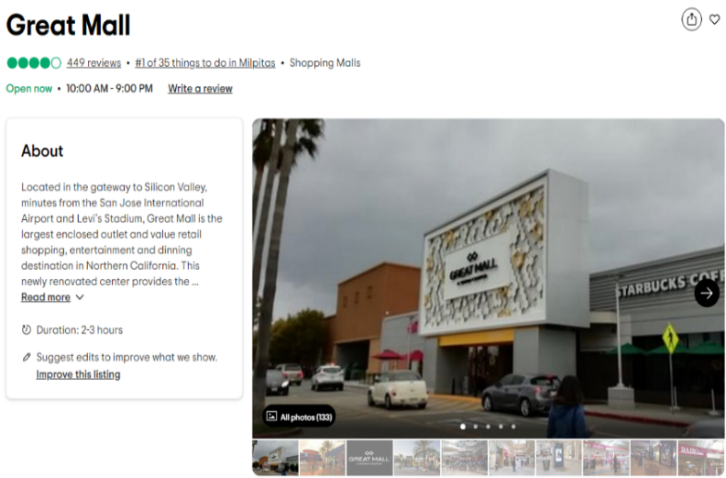
General mall information
Address: 447 Great Mall Dr, Milpitas, CA 95035, USA
Mall size (number of stores): 179
Population density: 313,893 people
Population income: $162,133
Mall age: 29 years
Population age: 35.4 years

Average sentiment towards:  Mall access 0.113  Mall atmosphere 0.229  Cross-store assortment 0.938  Within-store assortment 0.582  Price and promotion 0.363 | Effect of:  Mall access 20%  Mall atmosphere 25%  Cross-store assortment 30%  Within-store assortment 10%  Price and promotion 19%

Managerial Insights
The customer reviews of the Great Mall reveal a mixed performance of mall attributes. Customers are less positive about mall access, mall atmosphere, and cross-store assortment, while perceptions of within-store assortment are comparable to other malls. The Great Mall outperforms other malls on price and promotion. Reviews support this, with comments like, “There aren't any compelling stores here, and the compelling 'factory' stores here don't actually have any compelling inventory,” “Also an odd collection of anchor stores—Bed Bath and Beyond, Berlington, Dave & Busters?” and “Other than that, it is a huge mall with many 'insignificant' shops.” Overall, sentiment scores suggest that attributes controlled by mall management underperform, whereas those managed by tenants do well. Effects for the Great Mall, a medium-sized mall in a sparsely populated area with above-average income levels and a relatively young customer base, are as follows: mall access = 20%, mall atmosphere = 25%, cross-store assortment = 30%, within-store assortment = 10%, and price and promotion = 19%. These percentages indicate the likelihood of achieving a higher satisfaction rating with a one-point increase in customer sentiment for each PMRE attribute. Based on these findings, the management of the Great Mall should focus on enhancing cross-store assortment and mall atmosphere, while placing less emphasis on within-store assortment and price and promotion. For mall atmosphere, improvements such as better signage, lighting, and landscaping can create a more welcoming environment. For cross-store assortment, reexamining the tenant mix by recruiting diverse brands and restructuring leasing agreements to encourage a balanced blend of retailers, along with periodic tenant reviews to ensure the mix meets customer needs, will be crucial. For within-store assortment and price and promotion, further investments likely have a smaller effect on customer satisfaction.

Notes: Effects refer to the likelihood of a higher mall satisfaction rating for a one-point increase in customer sentiment towards the PMRE attribute.

References to the Web Appendix
Ailawadi, K. L., & Keller, K. L. (2004). Understanding retail branding: conceptual insights and research priorities. Journal of Retailing, 80(4), 331-342.
Benoit, K., Watanabe, K., Wang, H., Nulty, P., Obeng, A., Müller, S., & Matsuo, A. (2018). quanteda: An R package for the quantitative analysis of textual data. Journal of Open Source Software, 3(30), 774-774.
Chebat, J. C., Sirgy, M. J., & Grzeskowiak, S. (2010). How can shopping mall management best capture mall image?. Journal of Business Research, 63(7), 735-740.
Devlin, J., Chang, M.W., Lee, K., & Toutanova, K. (2019). Bert: Pre-training of Deep Bidirectional Transformers for Language Understanding. arXiv preprint arXiv:1810.04805.
Hartmann, J., Heitmann, M., Siebert, C., & Schamp, C. (2023). More than a Feeling: Accuracy and Application of Sentiment Analysis. International Journal of Research in Marketing, 40(1), 75-87.
Howard, J., & Ruder, S. (2018). Universal Language Model Fine-tuning for Text Classification. arXiv preprint arXiv:1801.06146.
Humphreys, A., & Wang, R. J. H. (2018). Automated Text Analysis for Consumer Research. Journal of Consumer Research, 44(6), 1274-1306.
Krippendorff, K. (2013). Content Analysis: An Introduction to Its Methodology. Thousand Oaks, CA: Sage.
Liu, Y., Ott, M., Goyal, N., Du, J., Joshi, M., Chen, D., Levy, O., Lewis, M., Zettlemoyer, L., & Stoyanov, V. (2019). RoBERTa: A Robustly Optimized BERT Pretraining Approach. arXiv. https://arxiv.org/abs/1907.11692
Lu, Y., Mei, Q., & Zhai, C. (2011). Investigating task performance of probabilistic topic models: an empirical study of PLSA and LDA. Information Retrieval, 14(2), 178-203.
Pennebaker, J.W., Boyd, R.L., Jordan, K., & Blackburn, K. (2015). The development and psychometric properties of LIWC2015. Austin, TX: University of Texas at Austin
Rocklage, M. D., & Fazio, R. H. (2015). The Evaluative Lexicon: Adjective use as a means of assessing and distinguishing attitude valence, extremity, and emotionality. Journal of Experimental Social Psychology, 56, 214-227.
Schoenmueller, V., Netzer, O., & Stahl, F. (2020). The Polarity of Online Reviews: Prevalence, Drivers and Implications. Journal of Marketing Research, 57(5), 853-877.
Teller, C., & Reutterer, T. (2008). The evolving concept of retail attractiveness: what makes retail agglomerations attractive when customers shop at them?. Journal of Retailing and Consumer Services, 15(3), 127-143.
Wakefield, K. L., & Baker, J. (1998). Excitement at the mall: Determinants and effects on shopping response. Journal of Retailing, 74(4), 515-539.
Yang, Y., Cer, D., Ahmad, A., Guo, M., Law, J., Constant, N., Hernandez Abrego, G., Yuan, S., Tar, C., Sung, Y.H., Strope, B., & Kurzweil, R. (2019). Multilingual Universal Sentence Encoder for Semantic Retrieval. arXiv preprint arXiv:1907.04307.

