Electronic Supplementary Information (ESI)

  - Section S1: Context analysis of LCA-based frameworks applied to the chemical industry and ammonia production
In recent times, the life cycle thinking approach has been applied as one of the key methodologies within the safe and sustainable by design (SSbD) framework. SSbD was proposed by the European Commission’s Joint Research Centre (JRC) [1] with the intent of integrating the evaluation of safety issues with environmental, social, and economic aspects in the development of novel chemicals and material. [2] In 2024, JRC published a methodological guidance [3] that integrates the framework with an evaluation of the criticality on the supply chain [4] and an estimation of the cost of environmental externalities, to inform the development of a risk-aware business strategy in the design of safe and sustainable chemicals. Other initiatives stemming from the private sector include the Ammonia Energy Association [5], which, at the time of the study, is seeking to establish an ammonia certification protocol to promote the development of a low to zero-carbon ammonia market (ISO 19870-3 standard) [6].

Section S1.1: Literature review of LCA studies on ammonia production
Numerous studies published in literature report the application of LCA methodology to evaluate and compare the environmental profile of various low-carbon NH₃ production routes [7].
Green ammonia production has been extensively investigated [8-15]; in particular, it has been found that ammonia production via HB process coupled with water electrolysis powered by renewables produces lower greenhouse gas emissions compared to the traditional SMR-based technology [9,15]. However, D’Angelo et al. [11] conducted a comprehensive evaluation of various ammonia production routes to evaluate the transgression level of Planetary Boundaries [16], highlighting the necessity to consider several impact categories to avoid burden shifting. Economic considerations also indicate that the price of green NH₃ is linked to the high cost of green H₂ [11], and the economic feasibility against the traditional process depends on the cost of electricity and natural gas [11,13]. In 2025, Fozer et al. [17] conducted a prospective life cycle assessment study (pLCA) to evaluate the evolution of the environmental performance of a novel technology for the production of e-ammonia using green hydrogen produced from alkaline water electrolysis (AWE) in the 2025-2075 timespan. The development in the background system was evaluated considering different shared socioeconomic pathways (SSPs) [18] and representative concentration pathways (RCPs), [19] while learning and scaling effects were considered to model the impacts of the foreground system. Results showed that integrating technological development after the first commercial deployment of the technology could potentially result in a further reduction of its environmental burdens, compared to only considering modifications in the background system.
Sustainability assessments of plasma-assisted small-scale ammonia production are also available in the published literature. In 2022, Osorio-Tejada et al. [20] conducted a cradle-to-site techno-environmental assessment of the production of ammonia in distributed plants next to farmers in Australia, compared with traditional centralised production; different scenarios of H₂ production -conventional SMR, high thermal plasma (HTP), and water electrolysis - and NH₃ production -conventional HB, mini-HB, and non-thermal plasma - were evaluated. Results showed that local plasma-assisted NH₃ production coupled with water electrolysis could bear lower environmental burdens compared to centralised production when powered with renewable electricity, also considering a potential further development of the novel technology. Osorio-Tejada et al. [21] also conducted an environmental and techno-economic analysis to compare the conventional HB process with innovative electrolysis-based HB and decentralised plasma-assisted NH₃, to internalise costs associated with environmental impacts of the technology using Monetary value coefficients. [22] The authors found that innovative cleaner technologies could become economically competitive with the conventional HB process when environmental costs are integrated in the assessment. Emerging plasma-driven NH₃ production companies at TRL ranging from 3 to 9 were also evaluated via commercial environmental, social, and governance (ESG) criteria and compared with conventional HB companies at different scales; [23] focusing on environmental and social pillars, the authors highlighted the potential of plasma-assisted technologies to become competitive sustainable alternatives for the production of NH₃, due to the improvements on both environmental social aspects associated with the achievement of higher TRLs. Keilani et al. also proposed a novel ESG scores calculation methodology to allow the performance evaluation of both premarket and affirmed chemical technologies, rather than companies, focusing on the comparison between the traditional HB process and an innovative technology to produce NH₃ via HTP hydrogen production and its conversion via electrified mini-HB plants. [24]
Recently, LCAs of electrochemical NH₃ production processes have also been reported in literature [25, 26]. Bicer and Dincer [25] analysed a system, powered by photovoltaic electricity, in which photoelectrochemically produced H₂ is reacted with N₂ in ambient molten salts to produce ammonia; the authors found that the technology yields about 1 kg CO₂ eq., significantly lower than 2-2.5 kg CO₂ eq. generated on average by commercial ammonia plants. D’Angelo et al. [26] conducted an environmental and economic assessment on an E-N₂R modular technology, coupled with solar panels for the supply of electrical power and a fuel cell for the recovery of hydrogen byproduct, and compared it against HB process, HB coupled with carbon capture and storage, and HB employing H₂ from electrolysis powered by solar energy; it was found that the environmental performance of the analysed system depends on the geographic location and the technology would outperform traditional HB process in all densely populated areas of the world, while remaining not economically competitive with fossil-based technologies under current policies.

  - Section S2: Life Cycle Inventory (LCI)
In the following section, a description of the procedures and calculations followed to compile inventories for the two levels of analysis of the system are reported. Full inventories and calculations are disclosed in the separate supplementary spreadsheet files SX2_FlowCell_LCIs (Level I) and SX2_NH3_LCIs (Level II).
Materials and processes not available in the Ecoinvent database were modelled by the authors. To simulate the industrial production of chemicals and polymers, the dataset “Chemical factory, organics {RER}| chemical factory construction, organics | APOS, U” was selected to model the production plant; 4E-10 units per kg of product were considered, based on Hischier et al. [27]. Furthermore, electric energy consumed was assumed to be completely converted into waste heat, as suggested in Althaus et al. [28]

S2.1: Flow cell.
In this sub-section, inventories of flow-cell components are reported. These components are not modified nor consumed during laboratory operations and are since considered perpetual for the scope of this study.

S2.1.1: Structural components.
PTFE production: Inventory of PTFE production was based on the works of Arrigoni et al., [29] and Rodriguez et al., [30] reporting data from a Dutch chemical plant located in Dordecht.
Since unreacted monomer is recirculated, only make-up flow was considered as an input to the system.
Complete LCI is reported in Table SX 2.1.
PVDF production: Inventory relative to the production of 1 kg of PVDF was extrapolated from the works of Hu et al., [31] Abbasi, [32] and Boyce et al. [33] and is reported in Table SX 2.2.
PEEK production: To compile the inventory of PEEK production, a retrosynthetic approach was adopted, based on stoichiometry of the reactions involved in the process. [34, 35]
As reported in Ullmann’s Encyclopedia of Industrial Chemistry, [36] PEEK is synthesised from the condensation of hydroquinone and 4,4’-difluorobenzophenone (4,4-DFBP), in presence of sodium carbonate.
Since no process for 4,4’-DFBP is available in Ecoinvent, a synthetic route was retrieved using ReaxysTM [37] involving the following steps:
- Synthesis of methylene dianiline (MDA) from aniline and formaldehyde; [38]
- Synthesis of 4,4’-difluorodiphenylmethane from MDA with hydrogen fluoride [39] and direct oxidation to 4,4’-DFBP [40].
As suggested by Cespi in 2024 [35], a yield of 95% was assumed for all process steps; to complete mass balance, organic residue was simulated as spent solvent for treatment and inorganic ions were considered emissions to water [41].
To account for energy consumption, average values of electricity and heat consumptions of a European chemical plant (1.2 MJ/kg and 2.0 MJ/kg of product, respectively) were selected as an estimate, as suggested by Cespi [35] and Althaus et al. [28].
LCI is reported in TABLE SX 2.3.
Flow-cell, structural components: To compile the inventory of the structural components, forming processes of materials were added to simulate the manufacture of a finished product. Polymeric materials (PTFE, PVDF, PEEK and EPDM) were associated with an injection moulding process (99.4% efficiency, as suggested by the ecoinvent database); a generic steel working process was also selected (100% efficiency, as suggested by the ecoinvent database). Primary data relative to the mass of the components were obtained in laboratory.
Waste plastic for treatment was added to complete the mass balance.
LCI is reported in TABLE SX 2.4.

S2.1.2: Electrodes
Cell electrodes are both constituted of a titanium support upon which the catalytic layer is deposited.
Cathode, support: The component was weighed in the lab (31.1 g); a generic metal working process was associated with the material to simulate the manufacture of the finished product.
Commercial anode, Ir-MMO coated: The component was weighed in the lab (40.05 g); a generic metal working process was associated to titanium to simulate the manufacture of the support.
Iridium coating mass was calculated multiplying the total surface area of the component (93.4 cm², data from laboratory) by a value of surface density (1.2 mg cm⁻²) extrapolated from the work of Gonzaga et al. [42], reporting a process for the deposition and calcination of iridium and ruthenium on a titanium support to obtain a mixed metal oxide (MMO) coated electrode.
Energy consumption of the deposition process was estimated from technical data of the electric furnace [43] used by Gonzaga et al. to produce the anode; to estimate the power consumption of the instrument, a linear correlation between power output and temperature increment was assumed, as reported in Rossi et al. [44] the power of the instrument (P) working at a temperature below the upper value was obtained multiplying P_{max} by a correction factor calculated as: ΔT_{lab}/ΔT_{max}, according to Equation 1.
P = P_{max} ∗ (ΔT_{lab}/ΔT_{max}) (1)
Due to the absence of specific process for iridium extraction in the selected database (i.e., ecoinvent), rhodium was selected as a proxy [45], as both metals are PGMs and are usually extracted together [46, 47].
Calculations and complete inventory of the electrodes is reported in TABLE SX 2.5.

S2.1.3: Membrane
Nafion™ production: Nafion™ membrane production process was modelled after the work published in 2018 by Weber et al. [41], who reported the inventory relative to a simplified process for the manufacture of a Nafion™. Information relative to the production of hexafluoropropylene (HFP) starting from the pyrolysis of TFE were extrapolated from Siegemund et al. [39]; the inventory relative to the production of the precursor HFP was compiled assuming the same energy consumption required for the production of TFE via pyrolysis, value from ecoinvent v3.10 [48].
Assuming similar energetic requirements for the polymerization process, heat and electricity consumptions were estimated from the process relative to the production of PTFE described in section S1.1.1. Complete LCI is reported in TABLE SX 2.6.
Nafion™ membrane production: To model the manufacture of the membrane, the ecoinvent process ‘Extrusion, plastic film’ (97.6% efficiency) was included in the inventory.
Data relative to area (10.2 cm²) and thickness (183 μm) were obtained from Pirrone et al. [49]; a density value (1.97 g cm⁻³) was extrapolated from Bozkurt et al. [50]; volume (0.187 cm³) and mass (0.370 g) of the membrane were calculated accordingly. Complete LCI is reported in TABLE SX 2.6.
Membrane activation: Before the assembly of the cell in laboratory, the membrane underwent an activation treatment in three heating steps, at a working temperature (T_{lab}) of 80 °C: i) in H₂O₂, 3% weight; ii) in Milli-Q water; iii) in H₂SO₄ 0.5 M [49]. For each step, the volume of the solutions was assumed equal to 100 mL. Even though the procedure was conducted in laboratory, it was considered part of the flow-cell subsystem, since it only had to be implemented once before the working cell was assembled and is not to be repeated.
Energy consumption was estimated from technical data of the heating plate [51] used in the lab, assuming electricity consumed was produced using the 2023 Italian electricity mix, the latest reported in literature [52].The electricity mix composition is reported in Figure S2.1.

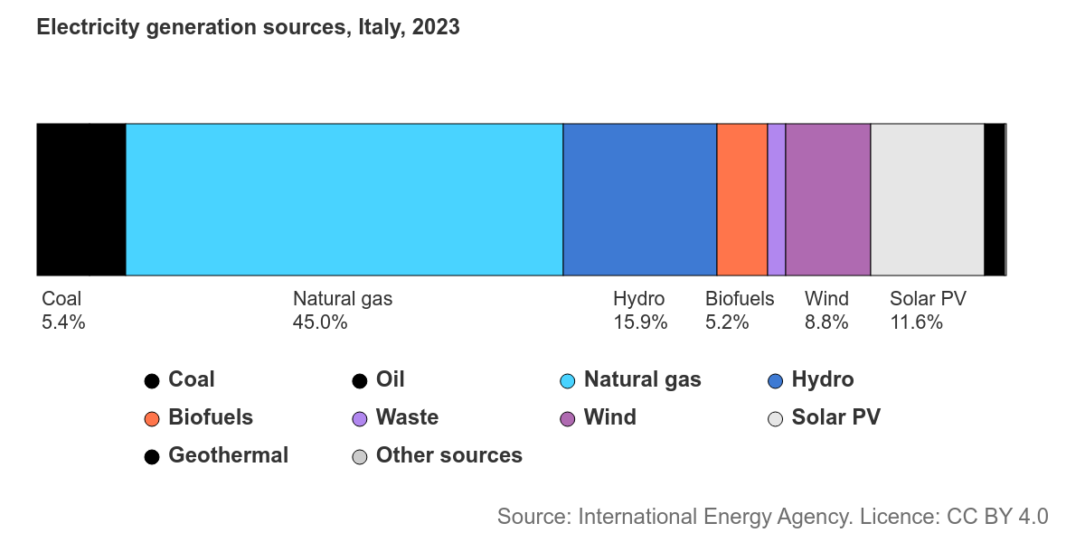
Figure S2.1: Italian electricity mix, reported by IEA, updated to 2023.
Maximum power (P_{max}) and temperature values of the instrument, reported in the technical sheet, are equal to 800 W and 300 °C, respectively, while ambient temperature of the laboratory was assumed equal to 20 °C.
Energy consumption was calculated by multiplying estimated power (P) by the time of usage of the instrument⁴⁴ according to Equation 1.
Complete calculations and full LCI are reported in TABLE SX 2.6.

S2.1.4: Active flow-cell
Full inventory for the infrastructure of the flow-cell is reported in TABLE SX 2.7. This process represents an input of the ammonia production subsystem, described in Section S2.2. Average transportation distances were also estimated, as reported in Frischknecht et al. [28], to represent the European transport of the sub-assemblies across the European region.

  - S2.2 Ammonia production, inventories
In this section, inventories relative to the ammonia production scenarios and associated laboratory procedures (catalyst preparation, electrolyte solution preparation, and membrane cleaning) are reported.
Electric energy consumed to conduct laboratory procedures and processes is assumed to be generated from the Italian energy mix, updated to 2023 [52].

S 2.2.1 Catalyst
The process consists in the preparation of a Nafion™-based ink containing MoS₂ (active phase) to be deposited on a carbon paper sheet, which is then fixated on the cathodic support; the solution is mixed at a temperature of 60 °C using a sonicator and then deposited on the support via airbrush [49].
Carbon fibre: Inventory relative to the production of carbon fibre was extrapolated from the work of Cox et al., published in 2018 [53].
Carbon paper: According to the technical sheet of the material, carbon paper sheets are made of carbon fibre treated with PTFE (20 wt%) [49, 54]. LCI is reported in TABLE SX 2.8.
Nafion™ resin solution: Inventory data relative to the ligand solution were extrapolated from technical data reported from the producer [55]. Full inventory is reported in TABLE SX 2.8.
Catalyst preparation: This process represents the laboratory operations of ink preparation and deposition on the support. Data relative to the mass of the materials were collected in the lab by direct weighing; carbon paper surface area was estimated in laboratory, while its mass was calculated from technical data reported in the technical sheet [54] and in Pirrone et al. [49].
Energy consumption of the process was estimated from technical data of the instruments used: heating plate [51], sonicator [56], and the compressor connected to the airbrush [57].
For the heating plate, T_{lab} was equal to 60 °C and the calculations were performed following the same procedure reported in section S 1.1.3.
The sonicator was assumed to work at maximum power (130 W) for the duration of the procedure.
Energy demand of the compressor was calculated using a procedure like the one employed for the heating plate, assuming a linear correlation between the pressure increment and the power of the instrument. Maximum power (P_{max}, 250 W) and pressure (Pa_{max}, 0.41 MPa) values are reported in the technical sheet of the instrument; working pressure (Pa_{lab}) was assumed to be equal to 0.25 MPa and ambient pressure was assumed to be 0.1 MPa.
To calculate power requirements, P_{max} was multiplied by the correction factor ΔPa_{lab}/ΔPa_{max} according to Equation 2.
P = P_{max} ∗ (ΔPa_{lab}/ΔPa_{max}) (2)
Calculations and complete inventory for the catalyst preparation are outlined in TABLE SX 2.9.

S2.2.2 Membrane cleaning
After each ammonia production run, the membrane was cleaned via sonication for 10 min in about 20 mL of a H₂SO₄ 1 M solution to remove residue traces of NH₃.
Energy consumption of the sonicator [56] was calculated as in section S 1.2.1.
Inventory is reported in TABLE SX 2.10.

S2.2.3 Ammonia production, laboratory reaction system
In this section, general information on inventories of the considered ammonia production scenarios is reported.
-Two electrolytic solutions were prepared in laboratory: the catholyte, which is a solution of KNO₃ (reagent, concentration 500 mg/L) and K₂SO₄ in 50 mL of ultra-pure water; the anolyte is a solution of K₂SO₄ in 50 mL of ultra-pure water.
-Energy consumption associated with the production of ammonia in laboratory is due to the electricity consumed for both conducting the electrochemical reaction and running the equipment; consumptions were estimated since no direct measurement was available.
The energy consumption of the instruments was estimated from data available on the technical sheets of the peristaltic pump [58] and the flow controller [59].
The peristaltic pump was run at a recirculation rate of 20 mL min⁻¹. Energy consumption was calculated assuming a linear correlation between the recirculation rate and the power output, multiplying the value by a correction factor calculated as the ratio between the working recirculation rate (RR_{work}) and the maximum rate (RR_{max}); an additional correction factor equal to 0.5 was applied to account for the use of 2 of the 4 available channels of the instrument, according to Equation 3:
P = P_{max} ∗ ( RR_{work}/ RR_{max}) ∗ (0.5) (3)
The mass flow controller was set at a rate of 5 mL min⁻¹. Energy consumption was estimated assuming the activation of the instrument every 100 mL, with a response time equal to 2 s; total active time (t) of the instrument was calculated as (Equation 4):
t = (V of argon, mL/100 mL) ∗ 6E-4 h (4)
Mass of inert gas (argon) was calculated from density (see chemical technical sheet) [60].
Electricity consumption (ΔE) due to the reaction was calculated multiplying the total charge (q) circulated through the system by the flow-cell voltage (ΔV), according to Equation 5:
ΔE = q ∗ ΔV (5)
The potential applied at the cathode was equal to -1.2 V, while the average measured potential at the anode was equal to 1.17 V, corresponding to a cell potential ΔV = 2.37 V.
Faradic efficiency (FE) of the process was estimated according to the following Equation 6, reported in Pirrone et al. [49]:
FE = (nNH₃ ∗ F ∗ ne⁻)/q (6)
where q is the charge expressed in Coulombs (C), nNH₃ is the quantity of ammonia produced in moles, F is the Faraday constant (96487 C mol⁻¹), and ne⁻ is the number of electrons (8 electrons per mole of ammonia produced).
-Unconverted nitrates are considered as emissions to water, to highlight the difference in nitrates abatement efficiency of the evaluated scenarios.

S2.2.4.1 Ammonia production, Scenario 2h:85%:{IT}:7y:1c:Ar. For this scenario, data relative to the mass of ammonia produced, FE of the process, and volume of inert gas consumed were measured directly in the laboratory:
- NH₃ produced: 1.51∗10⁻⁴ g
- Faradic efficiency towards NH₃: FE = 85%
- Argon consumed: 9.82∗10⁻¹ g (600 mL)
Knowing FE for NH₃, it was possible to estimate the quantity of H₂ co-produced from the reaction of electrolysis of water competing with the reduction of nitrates, considering 2 moles of electrons per mole of hydrogen produced.
Hydrogen was assumed to be vented at laboratory scale.

S2.2.4.2 Ammonia production, Scenario 50h:63%:{IT}:7y:1c:Ar. For this scenario, the following data were obtained in laboratory:
- Total charge flow: q = 331 C
- Nitrates conversion: 68%
- FE towards NH₃: FE = 63%
Kinetic data calculated in laboratory are reported in Figures S2.2-2.3.

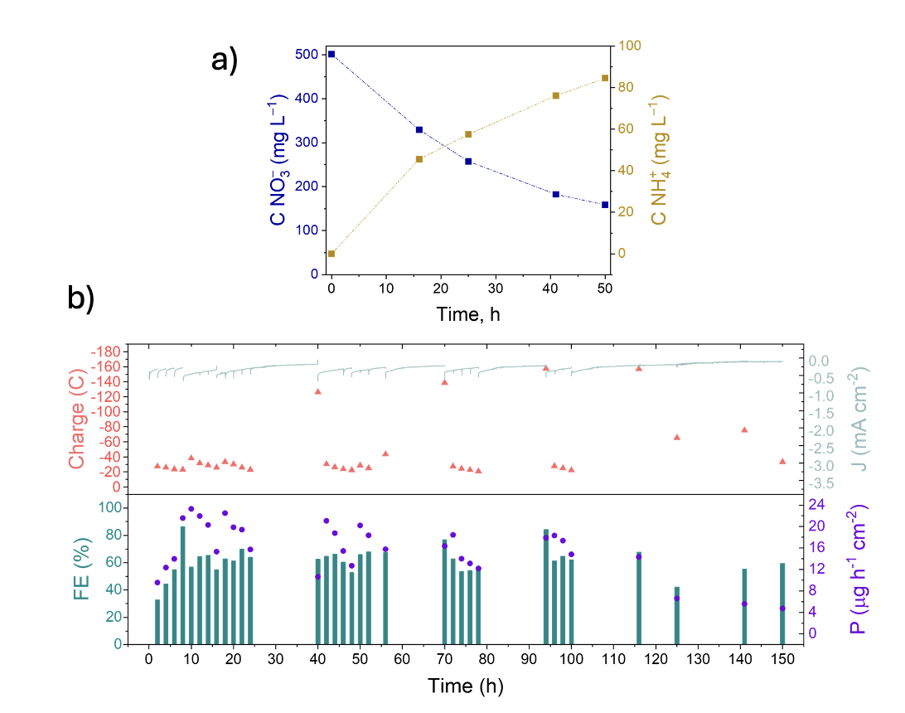
Figure S2.2: a) Kinetic and b) electrochemical data, Scenario 50h:63%:{IT}:7y:1c:Ar. Reprinted from Pirrone et al. (2025) [61] with permission.

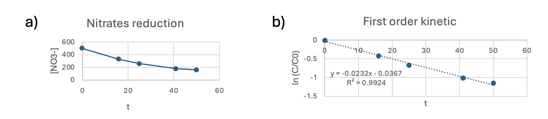
Figure S2.3: a) Nitrates concentration, duration of the experiment 50 h; b) First order kinetic extrapolated data, Scenario 50h:63%:{IT}:7y:1c:Ar.

Mass of ammonia and hydrogen produced were calculated accordingly:
- NH₃ produced: 4.71∗10⁻³ g
- H₂ produced (vent): 1.38∗10⁻³ g

S2.2.4.3 Ammonia production, Scenario 71h:63%:{IT}:7y:1c:Ar and Scenario 101h:63%:{IT}:7y:1c:Ar. For these scenarios, calculations were based on kinetic data obtained for Scenario 50h:63%:{IT}:7y:1c:Ar, assuming a constant value of 63% for FE towards NH₃ production.
Scenario 71h:63%:{IT}:7y:1c:Ar:
- Nitrates conversion: 80%
- Experiment duration: 71 h
- Mass NH₃ produced: 5.51∗10⁻³ g
- Mass H₂ produced: 1.62∗10⁻³ g
Scenario 101h:63%:{IT}:7y:1c:Ar:
- Nitrates conversion: 90%
- Experiment duration: 101 h
- Mass NH₃ produced: 6.20∗10⁻³ g
- Mass H₂ produced: 1.82∗10⁻³ g
Kinetics data are reported in Table SX 2.11; mass balance calculations are reported in Table SX 2.12; energy consumption estimations are reported in Table SX 2.13; LCIs of the four ammonia production scenarios considered are reported in Table SX 2.14.

  - S2.3 Criticality assessment in the life cycle inventories
In this section, further methodological considerations relative to the criticality assessment of NH₃ production are reported.
The CriticS method, proposed by Hackenhaar et al. [62] is aimed at calculating characterization factors for the criticality assessment of material flows in the life cycle inventory of a product. The framework relies on the supply risk (SR) and economic importance (EI) scores, according to the Study on the Critical Raw Materials for the EU, presented by (EC) in 2020. Several potential characterization factors are proposed to convert mass flows from the Bill of Materials or the life cycle inventory of a product into criticality scores. Based on this framework, the cradle-to-gate inventories of NH₃ production are analysed to individuate the elementary flows of both critical and strategic raw materials, as identified in the latest EC study published in 2023. Following the decision tree proposed by the authors, the mass values of the identified materials are multiplied by the respective 2023 SR and EI dimensionless scores and normalized to the thresholds proposed by the EC (EI_{threshold} = 2.8, SR_{threshold} = 1.0), providing a criticality-adjusted mass value that accounts for the overall value to the economy of the considered material flow. The linear scaling approach is selected to assign a higher weight to materials with higher EI and SR scores, with the aim of potentially increasing the contribution of material flows with an elevated economic value and a reduced ponderal fraction across the NH₃ production inventories. The normalization was also performed to increase the weight of CRMs that exceed both thresholds defined by the EC, since non-CRM (i.e. copper and nickel) which do not exceed threshold values, are also included in the assessment, as they have been identified as Strategic Raw Materials in the 2023 EC report. Criticality-adjusted mass (CRM_{m,adj}) is calculated for each CRM flow according to Equation 7, where mass_{m} is the mass flow of the material m in the NH₃ production inventory, and SR_{m} and EI_{m} are the criticality scores for supply risk and economic importance, respectively, of the considered material:
$CRM_{m,adj}=mass_{m}×{{SR}_{m}}/{{SR}_{threshold}}×{{EI}_{m}}/{{EI}_{threshold}}$ (7)
Consequently, for each NH₃ production sub-process, the cumulative adjusted mass flows (CRM_{sub-process}) are represented by the sum of each CRM mass flow, as reported in Equation 8:
$CRM_{sub-process}=\sum_{m=1}^{n}{mass_{m}}×{{SR}_{m}}/{{SR}_{threshold}}×{{EI}_{m}}/{{EI}_{threshold}}$(8)
CRMs for which a corresponding elementary flow is currently unavailable in ecoinvent v3.10 are excluded from the analysis, namely: bismuth, coking coal, germanium, helium, promethium, ruthenium, iridium and osmium.
Following the assessment of CRM mass within the inventory flows, the NH₃ production sub-processes are ranked on a score from 1 to 5, based on a grading procedure published by Keilani et al. to assign risk exposure and management scores to companies in an ESG rating context [24]. The application of a scoring procedure, described in the main text, allows to rank the sub-processes from highest to lowest contributor to the overall CRM flows within ammonia production inventories, in order to express the results in a relative scale to the context of the laboratory process under study. Table S2.1 reports as an example the calculated criticality scores for the 50h:63%:{IT}:7y:1c:Ar NH₃ production scenario.

Sub-process | Ar | Flow-cell | Membrane cleaning | Electrolyte solution | MoS₂ catalyst | Electricity
CRM_{sub-process} (g) | 1.6E-01 | 4.0E+00 | 4.6E-02 | 1.2E-01 | 8.6E-01 | 1.1E+00
Criticality score | 1.1 | 5.0 | 1.0 | 1.1 | 1.8 | 2.1
Table S2.1: Criticality-adjusted mass flows and criticality scores for the 50h:63%:{IT}:7y:1c:Ar NH₃ production sub-processes

Complete results of the criticality assessment are reported in the Excel® supplementary file SX3_CriticalRawMaterials_NH3_Inventories.
To account for the effects of subjectivity in the choice of different criticality weighting strategies, a sensitivity analysis is performed by selecting several CFs proposed in the CriticS method to repeat the calculation and assess the variation in the criticality-adjusted mass results for the 50h:63%:{IT}:7y:1c:Ar scenario. The scope of the assessment is to focus on the value to the economy of the material inventory flows, according to EC 2023 report [4]; consequently, only the proposed CFs that combined both the EI and SR scores of the materials were considered for the sensitivity analysis (i.e., CFs 10 to 19 in Hackenhaar et al. [62]). Criticality-adjusted mass calculations by applying different CFs are reported in the Excel® supplementary file SX3_CriticalRawMaterials_NH3_Inventories, Table SX3.6.
Results of the sensitivity analysis are discussed in Section S3.3.

Section S3: Life cycle impact assessment (LCIA) and interpretation
Complete life cycle impact assessment results for Level I and Level II, discussed in the main text, are reported in the following paragraphs.

  - Section S3.1: Flow-cell (level I)
Results reported in Table S 3.1 indicate that the overall carbon footprint of one flow cell unit is mostly caused by the emissions associated with the production of the structural components (81% contribution) and electrodes (19% contribution), while the negligible contribution of the membrane is <1% of the total. For the categories related to the resource consumption, the electrodes reveal the highest contribution, as well as for the pollution group (except for the OD and IR categories, where the structural components carry higher burdens). Toxicity categories receive the main contribution from the electrodes, in particular for the issues of HTNC and EcoF, while the structural components seem to contribute mostly to the HTC. Due to its relatively low mass compared to the overall assembly, the membrane does not significantly influence the environmental profile of the flow cell. Results considering the categories expansion are reported in Table S3.2.
The sub-assemblies are also analysed in-depth to evaluate the contribution of each material employed in their production. For the structural components, results are reported in Figure S3.1 and in Table S3.3. PTFE has the highest mass of all components (59% of the overall flow cell weight) and is the main contributor to 15 out of the 16 categories, with an average contribution of 69%. For the CC and OD categories, embodied impacts associated with PTFE represent 97% and 100% of the sub-assembly burdens, respectively, mainly due to the Scope 1 fugitive emissions of CFCs (chlorofluoro carbons) and HCFCs (hydrochlorofluorocarbons) in the production process of chlorodifluoromethane [63], precursor of tetrafluoroethylene monomer (see Figure S3.2 and Table S3.4). Stainless steel, the second main contributor to the sub-assembly, with an average of 14% across all categories, carries the highest contribution of 57% to the HTC category.

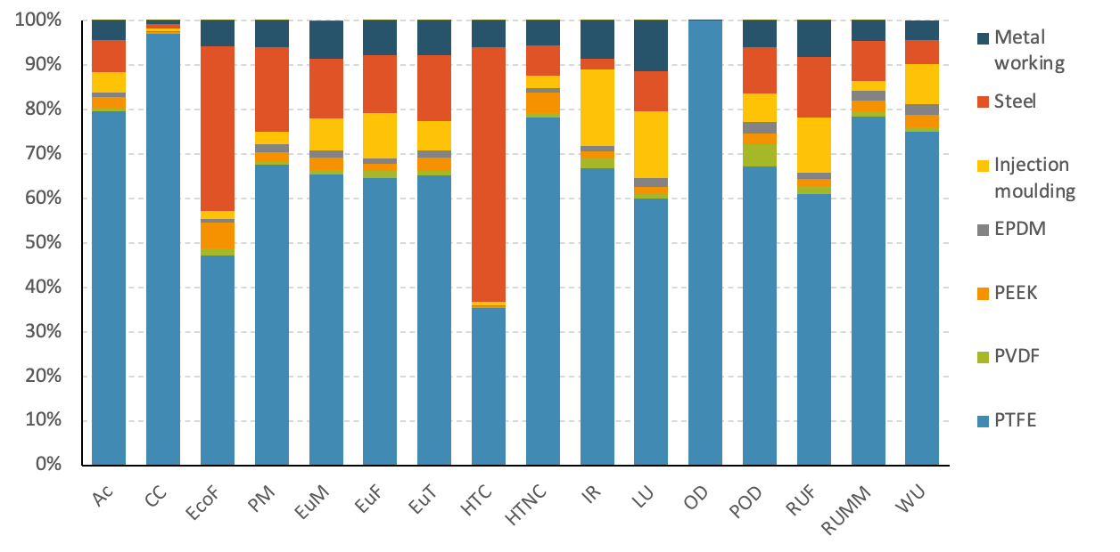
Figure S3.1: Contribution to the midpoint impacts of the materials employed in the structural components sub-assembly; method Environmental Footprint 3.1.
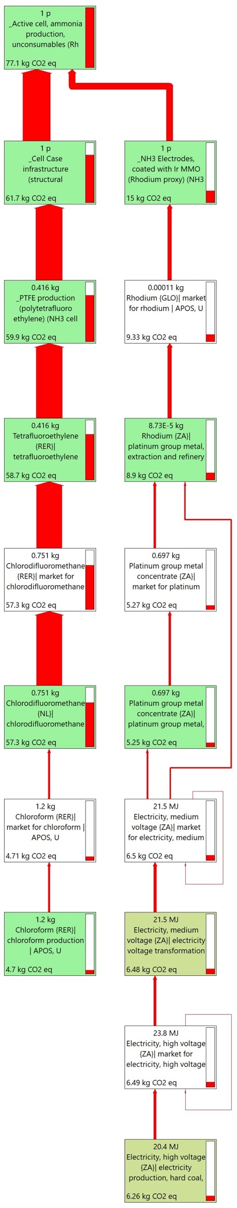
Figure S3.2: Sankey diagram describing the contribution analysis of the flow-cell carbon footprint, method EF 3.1, CC (Climate change) midpoint category.

For the electrodes sub-assembly, the iridium oxide employed in the anodic catalytic layer is the main contributor to 14 out of 16 categories (72% on average), except for HTC and OD in which Ti presented higher impacts; the environmental profile is reported in Figure S 3.3 and Table S3.5. Despite only constituting a small fraction of the electrode mass, i.e. 0.11 g out of 71 g, Ir-MMO presents elevated environmental impacts embodied in its production, mainly stemming from the energy-intensive extraction process of platinum group metals (PGMs), which are found in low concentrations in natural ores, i.e. below 10 ppm [64].
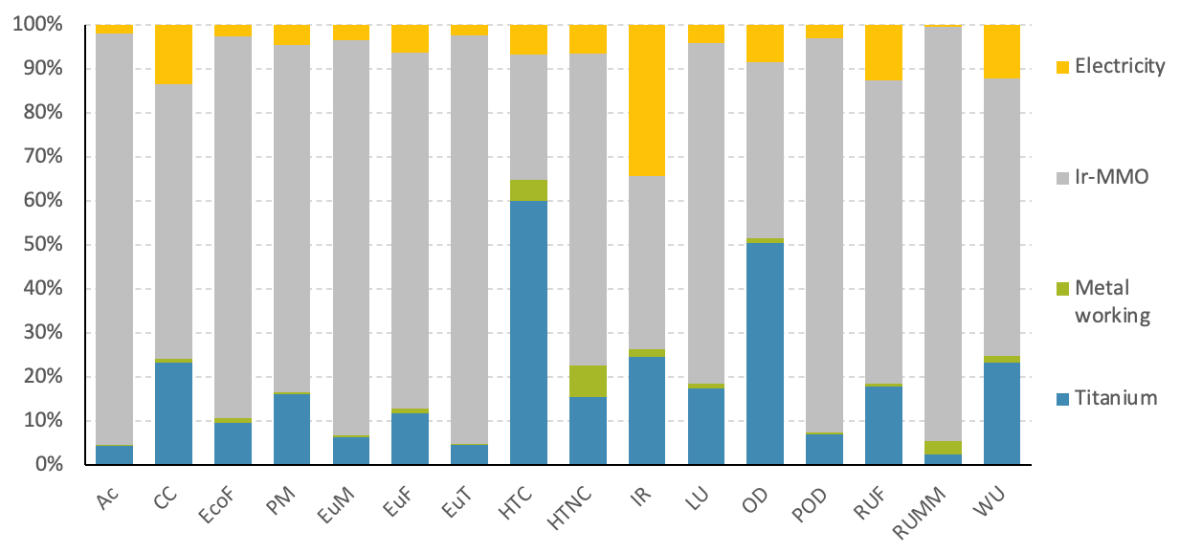
Figure S3.3: Contribution to the midpoint impacts of the materials employed in the electrodes sub-assembly; method Environmental Footprint 3.1.

Cluster | Category | Unit | Total | Structural components | Electrodes | Membrane | Freight train | Lorry
Toxicity | HTC | CTUh | 3.0E-07 | 2.3E-07 | 7.2E-08 | 7.7E-10 | 1.0E-10 | 1.0E-10
Toxicity | HTNC | CTUh | 2.7E-07 | 9.5E-08 | 1.7E-07 | 1.4E-09 | 1.0E-10 | 1.4E-10
Toxicity | EF | CTUe | 3.3E+02 | 9.5E+01 | 2.3E+02 | 1.0E+00 | 5.5E-02 | 5.6E-02
Climate change | CC | kg CO₂ eq | 7.7E+01 | 6.2E+01 | 1.5E+01 | 4.1E-01 | 7.5E-03 | 1.6E-02
Pollution | OD | kg CFC11 eq | 1.5E-03 | 1.5E-03 | 1.5E-07 | 6.0E-06 | 5.1E-12 | 5.0E-12
Pollution | PM | disease inc. | 2.2E-06 | 3.2E-07 | 1.9E-06 | 4.9E-09 | 6.3E-10 | 1.1E-09
Pollution | IR | kBq U-235 eq | 1.7E+00 | 8.9E-01 | 8.0E-01 | 4.9E-02 | 1.2E-03 | 2.9E-04
Pollution | POF | kg NMVOC eq | 2.2E-01 | 2.0E-02 | 2.0E-01 | 5.1E-04 | 6.8E-05 | 5.4E-05
Pollution | Ac | mol H⁺ eq | 5.4E-01 | 3.7E-02 | 5.0E-01 | 6.7E-04 | 5.6E-05 | 3.2E-05
Pollution | EuT | mol N eq | 8.6E-01 | 4.4E-02 | 8.2E-01 | 1.2E-03 | 2.3E-04 | 8.4E-05
Pollution | EuF | kg P eq | 1.6E-02 | 2.2E-03 | 1.4E-02 | 4.7E-05 | 2.4E-06 | 1.0E-06
Pollution | EuM | kg N eq | 6.2E-02 | 4.4E-03 | 5.7E-02 | 1.3E-04 | 2.1E-05 | 7.8E-06
Resources | LU | Pt | 1.3E+02 | 2.4E+01 | 1.0E+02 | 1.9E+00 | 7.2E-02 | 1.3E-01
Resources | WU | m³ depriv. | 5.5E+00 | 2.4E+00 | 2.8E+00 | 2.1E-01 | 1.4E-03 | 9.7E-04
Resources | RUMM | kg Sb eq | 5.2E-04 | 6.2E-05 | 4.6E-04 | 9.6E-07 | 2.5E-08 | 4.7E-08
Resources | RUF | MJ | 1.7E+02 | 3.3E+01 | 1.4E+02 | 8.0E-01 | 1.1E-01 | 2.2E-01
Table S3.1: Environmental impacts associated with the production of 1 flow-cell assembly, calculated at the midpoint level, damage categories (clustered according to Caldeira et al. [1]) method: EF 3.1. Categories: Ac (acidification); CC (climate change); EF (ecotoxicity, freshwater); EuF (eutrophication, freshwater); EuM (eutrophication, marine); EuT (eutrophication, terrestrial); HTC (human toxicity, cancer); HTNC (human toxicity, non-cancer); IR (ionising radiation); LU (land use); OD (ozone depletion); PM (particulate matter); POF (photochemical ozone formation); RUF (resource use, fossils); RUMM (resource use, minerals and metals); WU (water use).

Transportation impacts were not discussed in the main text as they were deemed negligible compared to the structural components and electrodes sub-assemblies.
Impact category | Unit | Total | Flow-cell structural components | Electrodes | Membrane
Acidification | mol H⁺ eq | 5.4E-01 | 3.7E-02 | 5.0E-01 | 6.7E-04
Climate change | kg CO₂ eq | 7.7E+01 | 6.2E+01 | 1.5E+01 | 4.1E-01
Climate change - Biogenic | kg CO₂ eq | 4.5E-02 | 2.4E-02 | 2.0E-02 | 2.1E-03
Climate change - Fossil | kg CO₂ eq | 7.7E+01 | 6.2E+01 | 1.5E+01 | 4.1E-01
Climate change - Land use and LU change | kg CO₂ eq | 2.4E-02 | 6.8E-03 | 1.7E-02 | 4.2E-04
Ecotoxicity, freshwater - part 1 | CTUe | 2.1E+02 | 7.9E+01 | 1.3E+02 | 5.6E-01
Ecotoxicity, freshwater - part 2 | CTUe | 1.2E+02 | 1.6E+01 | 1.0E+02 | 4.7E-01
Ecotoxicity, freshwater - inorganics | CTUe | 2.6E+02 | 5.2E+01 | 2.1E+02 | 7.9E-01
Ecotoxicity, freshwater - organics - p.1 | CTUe | 5.7E+01 | 3.8E+01 | 1.9E+01 | 1.5E-01
Ecotoxicity, freshwater - organics - p.2 | CTUe | 6.6E+00 | 4.4E+00 | 2.1E+00 | 9.2E-02
Particulate matter | disease inc. | 2.2E-06 | 3.2E-07 | 1.9E-06 | 4.9E-09
Eutrophication, marine | kg N eq | 6.2E-02 | 4.4E-03 | 5.7E-02 | 1.3E-04
Eutrophication, freshwater | kg P eq | 1.6E-02 | 2.2E-03 | 1.4E-02 | 4.7E-05
Eutrophication, terrestrial | mol N eq | 8.6E-01 | 4.4E-02 | 8.2E-01 | 1.2E-03
Human toxicity, cancer | CTUh | 3.0E-07 | 2.3E-07 | 7.2E-08 | 7.7E-10
Human toxicity, cancer - inorganics | CTUh | 3.2E-09 | 9.3E-10 | 2.3E-09 | 1.7E-11
Human toxicity, cancer - organics | CTUh | 3.0E-07 | 2.3E-07 | 7.0E-08 | 7.6E-10
Human toxicity, non-cancer | CTUh | 2.7E-07 | 9.5E-08 | 1.7E-07 | 1.4E-09
Human toxicity, non-cancer - inorganics | CTUh | 2.3E-07 | 6.7E-08 | 1.6E-07 | 1.2E-09
Human toxicity, non-cancer - organics | CTUh | 3.9E-08 | 2.8E-08 | 1.1E-08 | 1.8E-10
Ionising radiation | kBq U-235 eq | 1.7E+00 | 8.9E-01 | 8.0E-01 | 4.9E-02
Land use | Pt | 1.3E+02 | 2.4E+01 | 1.0E+02 | 1.9E+00
Ozone depletion | kg CFC11 eq | 1.5E-03 | 1.5E-03 | 1.5E-07 | 6.0E-06
Photochemical ozone formation | kg NMVOC eq | 2.2E-01 | 2.0E-02 | 2.0E-01 | 5.1E-04
Resource use, fossils | MJ | 1.7E+02 | 3.3E+01 | 1.4E+02 | 8.0E-01
Resource use, minerals and metals | kg Sb eq | 5.2E-04 | 6.2E-05 | 4.6E-04 | 9.6E-07
Water use | m³ depriv. | 5.5E+00 | 2.4E+00 | 2.8E+00 | 2.1E-01
Table S3.2: Environmental impacts associated with the production of 1 flow-cell assembly, calculated at the midpoint level, characterization categories; method: EF 3.1.

  - Section S3.1.1: Flow-cell structural components
Impact category | Unit | Total | PTFE | PVDF | PEEK | EPDM | Injection moulding | Steel | Metal working | Waste plastic
Acidification | mol H⁺ eq | 3.7E-02 | 3.0E-02 | 3.2E-04 | 8.7E-04 | 3.8E-04 | 1.7E-03 | 2.7E-03 | 1.6E-03 | 1.3E-06
Climate change | kg CO₂ eq | 6.2E+01 | 6.0E+01 | 6.1E-02 | 1.3E-01 | 9.2E-02 | 4.2E-01 | 6.7E-01 | 4.2E-01 | 3.8E-03
Climate change - Biogenic | kg CO₂ eq | 2.4E-02 | 1.0E-02 | 2.3E-04 | 3.0E-04 | 2.1E-04 | 1.9E-03 | 4.8E-04 | 9.9E-03 | 2.8E-07
Climate change - Fossil | kg CO₂ eq | 6.2E+01 | 6.0E+01 | 6.1E-02 | 1.3E-01 | 9.2E-02 | 4.2E-01 | 6.7E-01 | 4.1E-01 | 3.8E-03
Climate change - Land use and LU change | kg CO₂ eq | 6.8E-03 | 4.6E-03 | 1.5E-04 | 1.1E-04 | 9.6E-05 | 1.0E-03 | 2.8E-04 | 5.7E-04 | 4.2E-08
Ecotoxicity, freshwater - part 1 | CTUe | 7.9E+01 | 3.7E+01 | 3.8E-01 | 7.6E-01 | 2.0E-01 | 9.3E-01 | 3.4E+01 | 4.8E+00 | 1.1E-02
Ecotoxicity, freshwater - part 2 | CTUe | 1.6E+01 | 7.5E+00 | 1.1E+00 | 4.8E+00 | 4.9E-01 | 8.4E-01 | 6.9E-01 | 6.9E-01 | 4.1E-04
Ecotoxicity, freshwater - inorganics | CTUe | 5.2E+01 | 3.9E+01 | 1.2E+00 | 2.0E+00 | 5.9E-01 | 1.2E+00 | 5.4E+00 | 2.4E+00 | 1.1E-02
Ecotoxicity, freshwater - organics - p.1 | CTUe | 3.8E+01 | 4.5E+00 | 2.7E-01 | 1.7E-01 | 8.4E-02 | 4.5E-01 | 2.9E+01 | 3.0E+00 | 1.7E-04
Ecotoxicity, freshwater - organics - p.2 | CTUe | 4.4E+00 | 6.9E-01 | 2.1E-02 | 3.4E+00 | 1.8E-02 | 1.3E-01 | 1.0E-01 | 7.0E-02 | 2.1E-05
Particulate matter | disease inc. | 3.2E-07 | 2.2E-07 | 2.1E-09 | 6.5E-09 | 5.9E-09 | 9.3E-09 | 6.1E-08 | 1.9E-08 | 1.0E-11
Eutrophication, marine | kg N eq | 4.4E-03 | 2.9E-03 | 5.1E-05 | 1.2E-04 | 6.7E-05 | 3.2E-04 | 6.0E-04 | 3.7E-04 | 3.3E-06
Eutrophication, freshwater | kg P eq | 2.2E-03 | 1.4E-03 | 3.5E-05 | 3.7E-05 | 2.7E-05 | 2.3E-04 | 2.9E-04 | 1.7E-04 | 1.4E-08
Eutrophication, terrestrial | mol N eq | 4.4E-02 | 2.8E-02 | 4.7E-04 | 1.3E-03 | 6.8E-04 | 2.9E-03 | 6.5E-03 | 3.4E-03 | 6.3E-06
Human toxicity, cancer | CTUh | 2.3E-07 | 8.0E-08 | 2.8E-10 | 8.0E-10 | 3.7E-10 | 1.9E-09 | 1.3E-07 | 1.3E-08 | 2.0E-12
Human toxicity, cancer - inorganics | CTUh | 9.3E-10 | 5.3E-10 | 6.5E-12 | 1.7E-11 | 1.5E-11 | 4.1E-11 | 2.0E-10 | 1.2E-10 | 3.1E-13
Human toxicity, cancer - organics | CTUh | 2.3E-07 | 8.0E-08 | 2.8E-10 | 7.9E-10 | 3.5E-10 | 1.8E-09 | 1.3E-07 | 1.3E-08 | 1.7E-12
Human toxicity, non-cancer | CTUh | 9.5E-08 | 7.4E-08 | 8.7E-10 | 4.3E-09 | 8.9E-10 | 2.8E-09 | 6.4E-09 | 5.3E-09 | 1.7E-11
Human toxicity, non-cancer - inorganics | CTUh | 6.7E-08 | 4.8E-08 | 7.8E-10 | 3.5E-09 | 8.0E-10 | 2.6E-09 | 5.9E-09 | 5.1E-09 | 1.7E-11
Human toxicity, non-cancer - organics | CTUh | 2.8E-08 | 2.6E-08 | 8.6E-11 | 8.4E-10 | 8.2E-11 | 1.8E-10 | 4.5E-10 | 2.5E-10 | 2.7E-13
Ionising radiation | kBq U-235 eq | 8.9E-01 | 5.9E-01 | 2.1E-02 | 1.3E-02 | 1.1E-02 | 1.5E-01 | 2.2E-02 | 7.6E-02 | 2.1E-06
Land use | Pt | 2.4E+01 | 1.5E+01 | 2.3E-01 | 4.3E-01 | 4.5E-01 | 3.7E+00 | 2.2E+00 | 2.8E+00 | 1.3E-03
Ozone depletion | kg CFC11 eq | 1.5E-03 | 1.5E-03 | 1.8E-09 | 4.5E-09 | 3.1E-09 | 1.5E-08 | 3.5E-09 | 6.8E-09 | 2.2E-12
Photochemical ozone formation | kg NMVOC eq | 2.0E-02 | 1.4E-02 | 1.0E-03 | 4.9E-04 | 5.2E-04 | 1.3E-03 | 2.1E-03 | 1.2E-03 | 1.9E-06
Resource use, fossils | MJ | 3.3E+01 | 2.0E+01 | 6.2E-01 | 5.4E-01 | 4.4E-01 | 4.1E+00 | 4.6E+00 | 2.7E+00 | 1.9E-04
Resource use, minerals and metals | kg Sb eq | 6.2E-05 | 4.9E-05 | 7.3E-07 | 1.4E-06 | 1.4E-06 | 1.4E-06 | 5.6E-06 | 2.9E-06 | 2.8E-10
Water use | m³ depriv. | 2.4E+00 | 1.8E+00 | 2.5E-02 | 7.0E-02 | 5.7E-02 | 2.2E-01 | 1.3E-01 | 1.1E-01 | -6.6E-06
Table S3.3: Environmental impacts associated with the production of flow-cell structural components (1 unit), calculated at the midpoint level, characterization categories; method: EF 3.1
The inventory flows relative to the production of chlorodifluoromethane in the Netherlands geography were extrapolated to calculate the contribution to the CC category of the different emissions of chlorinated and fluorinated compounds; results are reported in Table S3.3.

Emissions to air | Amount | Unit | CF (kg CO₂ eq./kg substance) | kg CO₂ eq.
Chloroform | 9.997E-05 | kg | 20.6 | 0.002
Methane, chlorodifluoro-, HCFC-22 | 3.799E-03 | kg | 1960 | 7.446
Methane, dichlorodifluoro-, CFC-12 | 8.198E-04 | kg | 12500 | 10.247
Methane, dichlorofluoro-, HCFC-21 | 1.100E-05 | kg | 160 | 0.002
Methane, trichlorofluoro-, CFC-11 | 1.150E-05 | kg | 6230 | 0.072
Methane, trifluoro-, HFC-23 | 3.499E-03 | kg | 14600 | 51.086
Total emissions | 8.240E-03 | kg | / | 68.855
Table S3.4: Scope 1 emissions of CFCs and HCFCs (greenhouse gases) associated with the production of 1 kg of chlorodifluoromethane (ecoinvent process: chlorodifluoromethane {NL}| chlorodifluoromethane production | APOS, U); the associated characterization factors for the EF 3.1 method, climate change category are reported.

  - Section S3.1.2: Flow-cell electrodes
Impact category | Unit | Total | Ti | Metal working | Ir-MMO | Electricity
Acidification | mol H⁺ eq | 5.0E-01 | 2.2E-02 | 1.7E-03 | 4.7E-01 | 9.8E-03
Climate change | kg CO₂ eq | 1.5E+01 | 3.5E+00 | 1.6E-01 | 9.3E+00 | 2.0E+00
Climate change - Biogenic | kg CO₂ eq | 2.0E-02 | 6.1E-03 | 5.5E-03 | 5.1E-03 | 3.0E-03
Climate change - Fossil | kg CO₂ eq | 1.5E+01 | 3.5E+00 | 1.6E-01 | 9.3E+00 | 2.0E+00
Climate change - Land use and LU change | kg CO₂ eq | 1.7E-02 | 2.6E-03 | 1.9E-04 | 1.0E-02 | 3.8E-03
Ecotoxicity, freshwater - part 1 | CTUe | 1.3E+02 | 1.9E+01 | 1.6E+00 | 1.0E+02 | 4.4E+00
Ecotoxicity, freshwater - part 2 | CTUe | 1.0E+02 | 2.7E+00 | 1.2E+00 | 9.8E+01 | 1.7E+00
Ecotoxicity, freshwater - inorganics | CTUe | 2.1E+02 | 1.2E+01 | 2.1E+00 | 1.9E+02 | 4.5E+00
Ecotoxicity, freshwater - organics - p.1 | CTUe | 1.9E+01 | 9.2E+00 | 7.3E-01 | 8.0E+00 | 1.2E+00
Ecotoxicity, freshwater - organics - p.2 | CTUe | 2.1E+00 | 3.7E-01 | 2.3E-02 | 1.4E+00 | 3.1E-01
Particulate matter | disease inc. | 1.9E-06 | 3.0E-07 | 1.2E-08 | 1.5E-06 | 8.9E-08
Eutrophication, marine | kg N eq | 5.7E-02 | 3.7E-03 | 1.9E-04 | 5.2E-02 | 2.0E-03
Eutrophication, freshwater | kg P eq | 1.4E-02 | 1.7E-03 | 1.4E-04 | 1.1E-02 | 8.9E-04
Eutrophication, terrestrial | mol N eq | 8.2E-01 | 3.8E-02 | 2.0E-03 | 7.6E-01 | 2.0E-02
Human toxicity, cancer | CTUh | 7.2E-08 | 4.4E-08 | 3.4E-09 | 2.1E-08 | 4.9E-09
Human toxicity, cancer - inorganics | CTUh | 2.3E-09 | 6.3E-10 | 1.4E-10 | 1.4E-09 | 1.4E-10
Human toxicity, cancer - organics | CTUh | 7.0E-08 | 4.3E-08 | 3.2E-09 | 1.9E-08 | 4.8E-09
Human toxicity, non-cancer | CTUh | 1.7E-07 | 2.7E-08 | 1.3E-08 | 1.2E-07 | 1.1E-08
Human toxicity, non-cancer - inorganics | CTUh | 1.6E-07 | 2.6E-08 | 1.2E-08 | 1.1E-07 | 1.1E-08
Human toxicity, non-cancer - organics | CTUh | 1.1E-08 | 1.1E-09 | 7.7E-10 | 8.8E-09 | 4.7E-10
Ionising radiation | kBq U-235 eq | 8.0E-01 | 2.0E-01 | 1.4E-02 | 3.1E-01 | 2.7E-01
Land use | Pt | 1.0E+02 | 1.8E+01 | 1.1E+00 | 7.9E+01 | 4.4E+00
Ozone depletion | kg CFC11 eq | 1.5E-07 | 7.6E-08 | 1.7E-09 | 6.0E-08 | 1.3E-08
Photochemical ozone formation | kg NMVOC eq | 2.0E-01 | 1.4E-02 | 6.5E-04 | 1.8E-01 | 5.9E-03
Resource use, fossils | MJ | 1.4E+02 | 2.5E+01 | 9.2E-01 | 9.7E+01 | 1.8E+01
Resource use, minerals and metals | kg Sb eq | 4.6E-04 | 1.1E-05 | 1.5E-05 | 4.3E-04 | 2.0E-06
Water use | m³ depriv. | 2.8E+00 | 6.6E-01 | 4.2E-02 | 1.8E+00 | 3.5E-01
Table S3.5: Environmental impacts associated with the production of flow-cell electrodes (1 unit), calculated at the midpoint level, characterization categories; method: EF 3.1.
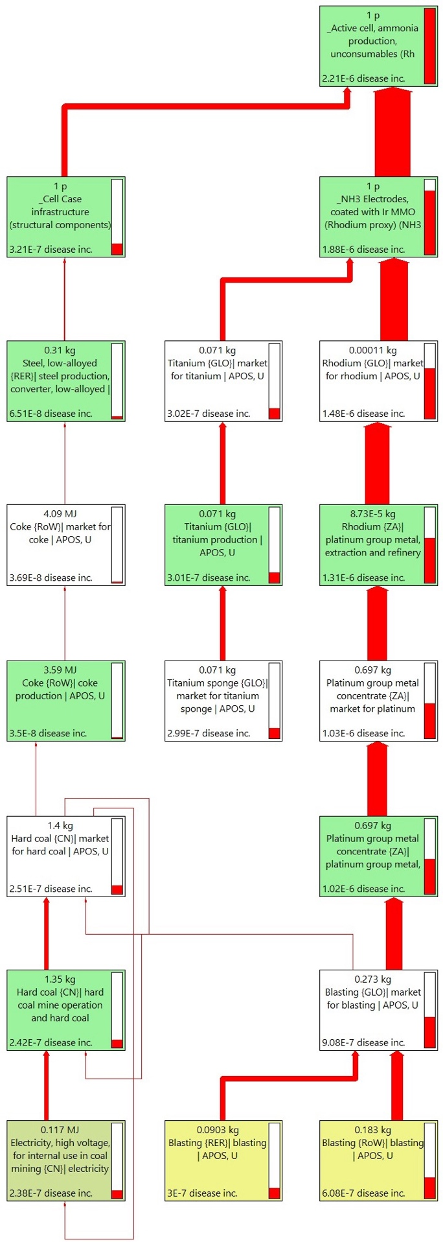
Figure S3.4: Sankey diagram describing the contribution analysis of the Flow-cell PM (particulate matter) midpoint category, method EF 3.1.
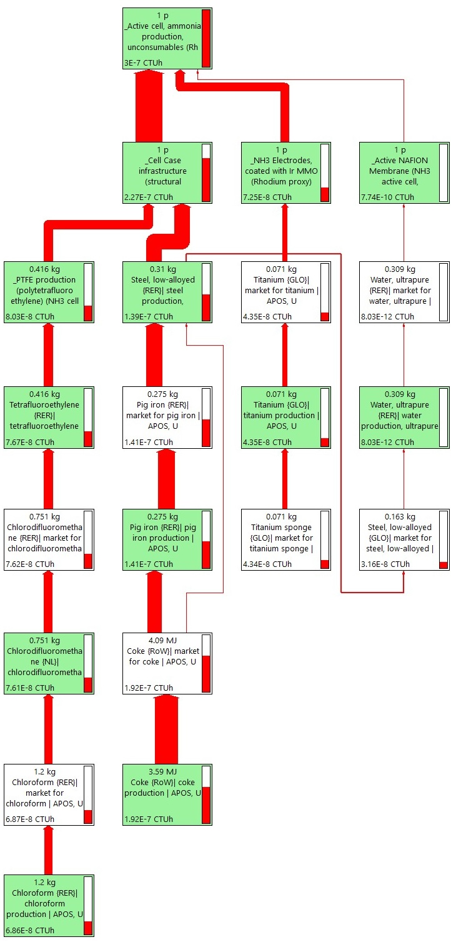
Figure S3.5: Sankey diagram describing the contribution analysis of the Flow-cell HTC (Human toxicity, cancer) midpoint category, method EF 3.1.
Further considerations in the evaluation of the electrodes sub-assembly relative to the criticality assessment of the employed materials are reported, based on the 2023 report on CRMs published by the European Commission [4]. The study indicates both supply risk and economic importance thresholds above which a raw material is identified as critical, i.e. 1.0 SR and 2.8 EI; after these considerations, both iridium and titanium metal are identified as CRMs and as strategic materials. According to the report, the main global supplier of iridium is South Africa, which occupies a share of the global market equal to 93%, carrying the highest supply risk factor among the PGMs, with an SR value around 4.0; in a work published in 2024, Bajada et al. [65] examined the production trends and forecast for iridium, estimating that the SR value for Ir could grow up to 10 by the year 2030. Titanium metal, strategic material in the defence and aerospace sector, is mainly supplied by China on a global scale, which shares 43% of the market; on a European level, the main supplier is Kazakhstan, contributing to a market share of 36%.

  - Section S3.1.3: Level I, Sensitivity analysis
Damage category | Unit | Total | Flow-cell structural components | Electrodes, Ir-MMO coating | Membrane
Total | mPt | 7.1E+00 | 4.1E+00 | 3.0E+00 | 2.8E-02
Acidification | mPt | 6.0E-01 | 4.1E-02 | 5.6E-01 | 7.4E-04
Climate change | mPt | 2.2E+00 | 1.7E+00 | 4.2E-01 | 1.1E-02
Ecotoxicity, freshwater | mPt | 1.1E-01 | 3.2E-02 | 7.8E-02 | 3.5E-04
Particulate matter | mPt | 3.3E-01 | 4.8E-02 | 2.8E-01 | 7.4E-04
Eutrophication, marine | mPt | 9.4E-02 | 6.7E-03 | 8.7E-02 | 2.0E-04
Eutrophication, freshwater | mPt | 2.9E-01 | 3.9E-02 | 2.5E-01 | 8.1E-04
Eutrophication, terrestrial | mPt | 1.8E-01 | 9.2E-03 | 1.7E-01 | 2.4E-04
Human toxicity, cancer | mPt | 3.7E-01 | 2.8E-01 | 8.9E-02 | 9.6E-04
Human toxicity, non-cancer | mPt | 3.9E-02 | 1.4E-02 | 2.5E-02 | 2.0E-04
Ionising radiation | mPt | 2.1E-02 | 1.1E-02 | 9.5E-03 | 5.8E-04
Land use | mPt | 1.2E-02 | 2.4E-03 | 9.9E-03 | 1.8E-04
Ozone depletion | mPt | 1.8E+00 | 1.8E+00 | 1.8E-04 | 7.2E-03
Photochemical ozone formation | mPt | 2.5E-01 | 2.4E-02 | 2.3E-01 | 6.0E-04
Resource use, fossils | mPt | 2.2E-01 | 4.2E-02 | 1.8E-01 | 1.0E-03
Resource use, minerals and metals | mPt | 6.2E-01 | 7.4E-02 | 5.4E-01 | 1.1E-03
Water use | mPt | 4.1E-02 | 1.8E-02 | 2.1E-02 | 1.5E-03
Table S3.6: Environmental impacts associated with the production of 1 flow-cell unit; data reported for the electrodes sub-assembly with Ir-MMO coating. Results calculated at the endpoint level; damage categories expressed as single score; unit: milli-Points (mPt). Method: EF 3.1.

Damage category | Unit | Total | Flow-cell structural components | Electrodes, without Ir-MMO | Membrane
Total | mPt | 4.5E+00 | 4.1E+00 | 3.6E-01 | 2.8E-02
Acidification | mPt | 6.7E-02 | 4.1E-02 | 2.5E-02 | 7.4E-04
Climate change | mPt | 1.8E+00 | 1.7E+00 | 1.0E-01 | 1.1E-02
Ecotoxicity, freshwater | mPt | 4.0E-02 | 3.2E-02 | 8.0E-03 | 3.5E-04
Particulate matter | mPt | 9.6E-02 | 4.8E-02 | 4.7E-02 | 7.4E-04
Eutrophication, marine | mPt | 1.3E-02 | 6.7E-03 | 5.7E-03 | 2.0E-04
Eutrophication, freshwater | mPt | 7.0E-02 | 3.9E-02 | 3.0E-02 | 8.1E-04
Eutrophication, terrestrial | mPt | 1.8E-02 | 9.2E-03 | 8.2E-03 | 2.4E-04
Human toxicity, cancer | mPt | 3.4E-01 | 2.8E-01 | 5.8E-02 | 9.6E-04
Human toxicity, non-cancer | mPt | 1.8E-02 | 1.4E-02 | 4.0E-03 | 2.0E-04
Ionising radiation | mPt | 1.4E-02 | 1.1E-02 | 2.5E-03 | 5.8E-04
Land use | mPt | 4.3E-03 | 2.4E-03 | 1.8E-03 | 1.8E-04
Ozone depletion | mPt | 1.8E+00 | 1.8E+00 | 9.4E-05 | 7.2E-03
Photochemical ozone formation | mPt | 4.1E-02 | 2.4E-02 | 1.7E-02 | 6.0E-04
Resource use, fossils | mPt | 7.6E-02 | 4.2E-02 | 3.3E-02 | 1.0E-03
Resource use, minerals and metals | mPt | 8.9E-02 | 7.4E-02 | 1.4E-02 | 1.1E-03
Water use | mPt | 2.5E-02 | 1.8E-02 | 5.1E-03 | 1.5E-03
Table S3.7: Environmental impacts associated with the production of 1 flow-cell unit; data reported for the electrodes sub-assembly without Ir-MMO coating. Results calculated at the endpoint level; damage categories expressed as single score; unit: milli-Points (mPt). Method: EF 3.1.

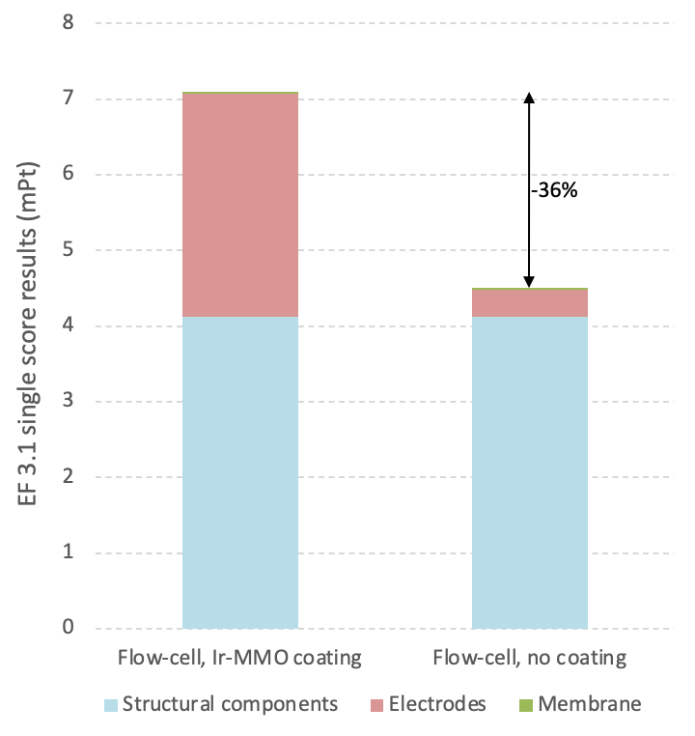
Figure S3.6: Cumulative results, flow-cell assembly, with and without Ir-MMO catalyst; unit: milli-Points (mPt); Method Environmental Footprint 3.1.

  - Section S3.2: NH₃ production (level II)
Impact category | Unit | Total | Nitrates | Ar | Flow-Cell | Membrane cleaning | Electrolyte solution | Catalyst | Electricity | Wastewater | Solid waste
Acidification | mol H⁺ eq | 3.4E+00 | 0.0E+00 | 4.0E-02 | 1.2E-01 | 4.2E-01 | 5.1E-01 | 2.1E+00 | 1.6E-01 | 1.3E-03 | 2.1E-02
Climate change | kg CO₂ eq | 6.4E+02 | 0.0E+00 | 8.0E+00 | 1.7E+01 | 5.0E+01 | 4.0E+01 | 4.6E+02 | 4.5E+01 | 2.6E-01 | 1.8E+01
Climate change - Biogenic | kg CO₂ eq | 3.6E+00 | 0.0E+00 | 5.2E-02 | 9.6E-03 | 3.4E-01 | 1.8E-01 | 2.5E+00 | 4.9E-01 | 3.5E-02 | 1.1E-02
Climate change - Fossil | kg CO₂ eq | 6.4E+02 | 0.0E+00 | 7.9E+00 | 1.7E+01 | 5.0E+01 | 4.0E+01 | 4.6E+02 | 4.4E+01 | 2.2E-01 | 1.8E+01
Climate change - Land use and LU change | kg CO₂ eq | 1.9E+00 | 0.0E+00 | 3.2E-02 | 5.3E-03 | 2.0E-01 | 3.3E-02 | 1.5E+00 | 7.3E-02 | 3.4E-04 | 4.3E-03
Ecotoxicity, freshwater | CTUe | 4.8E+03 | 0.0E+00 | 3.6E+01 | 7.0E+01 | 2.6E+02 | 1.8E+03 | 2.2E+03 | 1.6E+02 | 5.8E+01 | 2.6E+02
Ecotoxicity, freshwater - inorganics | CTUe | 3.8E+03 | 0.0E+00 | 2.3E+01 | 5.6E+01 | 1.7E+02 | 1.7E+03 | 1.5E+03 | 9.6E+01 | 5.8E+01 | 2.6E+02
Ecotoxicity, freshwater - organics | CTUe | 9.4E+02 | 0.0E+00 | 1.3E+01 | 1.4E+01 | 8.5E+01 | 6.6E+01 | 6.9E+02 | 6.1E+01 | 6.4E-01 | 5.8E+00
Particulate matter | disease inc. | 1.8E-05 | 0.0E+00 | 1.5E-07 | 4.8E-07 | 2.0E-06 | 5.2E-06 | 9.2E-06 | 8.7E-07 | 1.4E-08 | 2.3E-07
Eutrophication, marine | kg N eq | 7.3E-01 | 3.6E-02 | 7.4E-03 | 1.3E-02 | 5.3E-02 | 6.4E-02 | 5.1E-01 | 3.2E-02 | 1.1E-02 | 5.4E-03
Eutrophication, freshwater | kg P eq | 4.7E-01 | 0.0E+00 | 7.0E-03 | 3.6E-03 | 5.1E-02 | 4.4E-02 | 3.5E-01 | 1.1E-02 | 1.1E-03 | 5.1E-03
Eutrophication, terrestrial | mol N eq | 5.0E+00 | 0.0E+00 | 6.2E-02 | 1.9E-01 | 4.1E-01 | 5.4E-01 | 3.4E+00 | 3.1E-01 | 3.9E-03 | 5.1E-02
Human toxicity, cancer | CTUh | 3.0E-06 | 0.0E+00 | 4.1E-08 | 6.5E-08 | 2.7E-07 | 2.8E-07 | 2.1E-06 | 1.5E-07 | 2.9E-09 | 4.1E-08
Human toxicity, cancer - inorganics | CTUh | 7.8E-08 | 0.0E+00 | 9.2E-10 | 7.0E-10 | 6.3E-09 | 9.9E-09 | 4.8E-08 | 3.7E-09 | 2.2E-10 | 8.3E-09
Human toxicity, cancer - organics | CTUh | 2.9E-06 | 0.0E+00 | 4.0E-08 | 6.4E-08 | 2.6E-07 | 2.7E-07 | 2.1E-06 | 1.5E-07 | 2.6E-09 | 3.3E-08
Human toxicity, non-cancer | CTUh | 5.7E-06 | 0.0E+00 | 6.6E-08 | 5.8E-08 | 4.8E-07 | 8.2E-07 | 4.0E-06 | 2.5E-07 | 4.0E-08 | 5.6E-08
Human toxicity, non-cancer - inorganics | CTUh | 5.4E-06 | 0.0E+00 | 6.4E-08 | 5.0E-08 | 4.6E-07 | 7.6E-07 | 3.7E-06 | 2.3E-07 | 3.9E-08 | 5.2E-08
Human toxicity, non-cancer - organics | CTUh | 3.9E-07 | 0.0E+00 | 2.1E-09 | 8.4E-09 | 1.5E-08 | 5.1E-08 | 2.9E-07 | 1.5E-08 | 1.9E-10 | 3.2E-09
Ionising radiation | kBq U-235 eq | 2.8E+02 | 0.0E+00 | 4.9E+00 | 3.9E-01 | 3.2E+01 | 3.3E+00 | 2.3E+02 | 5.3E+00 | 4.3E-02 | 4.3E-01
Land use | Pt | 3.7E+03 | 0.0E+00 | 4.2E+01 | 2.7E+01 | 2.7E+02 | 4.2E+02 | 2.6E+03 | 2.5E+02 | 1.4E+00 | 1.8E+01
Ozone depletion | kg CFC11 eq | 1.9E-03 | 0.0E+00 | 1.2E-08 | 3.2E-04 | 3.5E-07 | 1.5E-06 | 1.6E-03 | 9.0E-08 | 5.3E-10 | 5.7E-08
Photochemical ozone formation | kg NMVOC eq | 5.2E+00 | 0.0E+00 | 2.0E-02 | 4.7E-02 | 1.4E-01 | 2.0E-01 | 4.6E+00 | 1.2E-01 | 8.6E-04 | 2.1E-02
Resource use, fossils | MJ | 1.2E+04 | 0.0E+00 | 1.8E+02 | 6.6E+01 | 1.2E+03 | 5.4E+02 | 9.0E+03 | 7.1E+02 | 2.9E+00 | 8.6E+01
Resource use, minerals and metals | kg Sb eq | 5.2E-03 | 0.0E+00 | 2.4E-05 | 1.1E-04 | 2.0E-04 | 1.0E-03 | 3.7E-03 | 9.5E-05 | 1.4E-06 | 2.5E-05
Water use | m³ depriv. | 4.1E+02 | 0.0E+00 | 1.8E+01 | 1.2E+00 | 3.5E+01 | 7.1E+01 | 2.6E+02 | 4.9E+01 | -2.8E+01 | 1.2E+00
Table S3.8: Environmental impacts associated with the production of 1 g of NH₃, scenario 2h:85%:{IT}:7y:1c:Ar. Results calculated at the midpoint level; method: EF 3.1.

Impact category | Unit | Total | Nitrates | Ar | Flow-Cell | Membrane cleaning | Electrolyte solution | Catalyst | Electricity | Wastewater | Solid waste
Acidification | mol H⁺ eq | 3.6E-01 | 0.0E+00 | 3.3E-02 | 9.6E-02 | 1.4E-02 | 1.7E-02 | 6.8E-02 | 1.3E-01 | 4.1E-05 | 6.8E-04
Climate change | kg CO₂ eq | 7.6E+01 | 0.0E+00 | 6.6E+00 | 1.4E+01 | 1.7E+00 | 1.3E+00 | 1.5E+01 | 3.7E+01 | 8.4E-03 | 5.8E-01
Climate change - Biogenic | kg CO₂ eq | 5.5E-01 | 0.0E+00 | 4.3E-02 | 7.9E-03 | 1.1E-02 | 6.0E-03 | 8.2E-02 | 4.0E-01 | 1.2E-03 | 3.7E-04
Climate change - Fossil | kg CO₂ eq | 7.5E+01 | 0.0E+00 | 6.5E+00 | 1.4E+01 | 1.6E+00 | 1.3E+00 | 1.5E+01 | 3.6E+01 | 7.3E-03 | 5.8E-01
Climate change - Land use and LU change | kg CO₂ eq | 1.5E-01 | 0.0E+00 | 2.6E-02 | 4.3E-03 | 6.7E-03 | 1.1E-03 | 5.0E-02 | 6.0E-02 | 1.1E-05 | 1.4E-04
Ecotoxicity, freshwater | CTUe | 3.6E+02 | 0.0E+00 | 3.0E+01 | 5.8E+01 | 8.5E+00 | 5.8E+01 | 7.1E+01 | 1.3E+02 | 1.9E+00 | 8.6E+00
Ecotoxicity, freshwater - inorganics | CTUe | 2.6E+02 | 0.0E+00 | 1.9E+01 | 4.6E+01 | 5.7E+00 | 5.6E+01 | 4.8E+01 | 7.9E+01 | 1.9E+00 | 8.5E+00
Ecotoxicity, freshwater - organics | CTUe | 1.0E+02 | 0.0E+00 | 1.1E+01 | 1.1E+01 | 2.8E+00 | 2.2E+00 | 2.3E+01 | 5.0E+01 | 2.1E-02 | 1.9E-01
Particulate matter | disease inc. | 1.8E-06 | 0.0E+00 | 1.3E-07 | 3.9E-07 | 6.7E-08 | 1.7E-07 | 3.0E-07 | 7.1E-07 | 4.7E-10 | 7.7E-09
Eutrophication, marine | kg N eq | 6.5E-02 | 3.8E-04 | 6.1E-03 | 1.1E-02 | 1.7E-03 | 2.1E-03 | 1.7E-02 | 2.6E-02 | 3.5E-04 | 1.8E-04
Eutrophication, freshwater | kg P eq | 3.2E-02 | 0.0E+00 | 5.8E-03 | 2.9E-03 | 1.7E-03 | 1.5E-03 | 1.1E-02 | 8.7E-03 | 3.7E-05 | 1.7E-04
Eutrophication, terrestrial | mol N eq | 6.0E-01 | 0.0E+00 | 5.1E-02 | 1.5E-01 | 1.3E-02 | 1.8E-02 | 1.1E-01 | 2.5E-01 | 1.3E-04 | 1.7E-03
Human toxicity, cancer | CTUh | 3.0E-07 | 0.0E+00 | 3.4E-08 | 5.3E-08 | 8.8E-09 | 9.1E-09 | 7.0E-08 | 1.3E-07 | 9.4E-11 | 1.4E-09
Human toxicity, cancer - inorganics | CTUh | 6.8E-09 | 0.0E+00 | 7.5E-10 | 5.8E-10 | 2.1E-10 | 3.3E-10 | 1.6E-09 | 3.0E-09 | 7.1E-12 | 2.7E-10
Human toxicity, cancer - organics | CTUh | 3.0E-07 | 0.0E+00 | 3.3E-08 | 5.3E-08 | 8.6E-09 | 8.8E-09 | 6.8E-08 | 1.2E-07 | 8.7E-11 | 1.1E-09
Human toxicity, non-cancer | CTUh | 4.8E-07 | 0.0E+00 | 5.4E-08 | 4.8E-08 | 1.6E-08 | 2.7E-08 | 1.3E-07 | 2.0E-07 | 1.3E-09 | 1.8E-09
Human toxicity, non-cancer - inorganics | CTUh | 4.5E-07 | 0.0E+00 | 5.2E-08 | 4.1E-08 | 1.5E-08 | 2.5E-08 | 1.2E-07 | 1.9E-07 | 1.3E-09 | 1.7E-09
Human toxicity, non-cancer - organics | CTUh | 3.3E-08 | 0.0E+00 | 1.8E-09 | 6.9E-09 | 5.1E-10 | 1.7E-09 | 9.5E-09 | 1.3E-08 | 6.2E-12 | 1.1E-10
Ionising radiation | kBq U-235 eq | 1.8E+01 | 0.0E+00 | 4.0E+00 | 3.2E-01 | 1.0E+00 | 1.1E-01 | 7.7E+00 | 4.3E+00 | 1.4E-03 | 1.4E-02
Land use | Pt | 3.7E+02 | 0.0E+00 | 3.5E+01 | 2.3E+01 | 8.8E+00 | 1.4E+01 | 8.7E+01 | 2.0E+02 | 4.6E-02 | 6.0E-01
Ozone depletion | kg CFC11 eq | 3.1E-04 | 0.0E+00 | 9.7E-09 | 2.6E-04 | 1.2E-08 | 5.0E-08 | 5.1E-05 | 7.4E-08 | 1.7E-11 | 1.9E-09
Photochemical ozone formation | kg NMVOC eq | 3.2E-01 | 0.0E+00 | 1.7E-02 | 3.8E-02 | 4.7E-03 | 6.5E-03 | 1.5E-01 | 1.0E-01 | 2.8E-05 | 7.0E-04
Resource use, fossils | MJ | 1.1E+03 | 0.0E+00 | 1.5E+02 | 5.4E+01 | 3.8E+01 | 1.8E+01 | 3.0E+02 | 5.8E+02 | 9.6E-02 | 2.8E+00
Resource use, minerals and metals | kg Sb eq | 3.5E-04 | 0.0E+00 | 2.0E-05 | 9.2E-05 | 6.6E-06 | 3.3E-05 | 1.2E-04 | 7.8E-05 | 4.5E-08 | 8.4E-07
Water use | m³ depriv. | 6.7E+01 | 0.0E+00 | 1.5E+01 | 9.5E-01 | 1.1E+00 | 2.3E+00 | 8.5E+00 | 4.0E+01 | -9.3E-01 | 3.8E-02
Table S3.9: Environmental impacts associated with the production of 1 g of NH₃, scenario 50h:63%:{IT}:7y:1c:Ar. Results calculated at the midpoint level; method: EF 3.1.

Impact category | Unit | Total | Nitrates | Ar | Flow-Cell | Membrane cleaning | Electrolyte solution | Catalyst | Electricity | Wastewater | Solid waste
Acidification | mol H⁺ eq | 4.0E-01 | 0.0E+00 | 4.0E-02 | 1.2E-01 | 1.2E-02 | 1.4E-02 | 5.9E-02 | 1.6E-01 | 3.5E-05 | 5.8E-04
Climate change | kg CO₂ eq | 8.5E+01 | 0.0E+00 | 8.0E+00 | 1.7E+01 | 1.4E+00 | 1.1E+00 | 1.3E+01 | 4.5E+01 | 7.2E-03 | 5.0E-01
Climate change - Biogenic | kg CO₂ eq | 6.4E-01 | 0.0E+00 | 5.2E-02 | 9.6E-03 | 9.6E-03 | 5.1E-03 | 7.0E-02 | 4.9E-01 | 9.9E-04 | 3.1E-04
Climate change - Fossil | kg CO₂ eq | 8.5E+01 | 0.0E+00 | 7.9E+00 | 1.7E+01 | 1.4E+00 | 1.1E+00 | 1.3E+01 | 4.4E+01 | 6.2E-03 | 4.9E-01
Climate change - Land use and LU change | kg CO₂ eq | 1.6E-01 | 0.0E+00 | 3.2E-02 | 5.3E-03 | 5.7E-03 | 9.4E-04 | 4.3E-02 | 7.3E-02 | 9.5E-06 | 1.2E-04
Ecotoxicity, freshwater | CTUe | 3.9E+02 | 0.0E+00 | 3.6E+01 | 7.0E+01 | 7.3E+00 | 5.0E+01 | 6.1E+01 | 1.6E+02 | 1.6E+00 | 7.4E+00
Ecotoxicity, freshwater - inorganics | CTUe | 2.8E+02 | 0.0E+00 | 2.3E+01 | 5.6E+01 | 4.9E+00 | 4.8E+01 | 4.1E+01 | 9.6E+01 | 1.6E+00 | 7.2E+00
Ecotoxicity, freshwater - organics | CTUe | 1.1E+02 | 0.0E+00 | 1.3E+01 | 1.4E+01 | 2.4E+00 | 1.8E+00 | 1.9E+01 | 6.1E+01 | 1.8E-02 | 1.6E-01
Particulate matter | disease inc. | 2.0E-06 | 0.0E+00 | 1.5E-07 | 4.8E-07 | 5.7E-08 | 1.5E-07 | 2.6E-07 | 8.6E-07 | 4.0E-10 | 6.6E-09
Eutrophication, marine | kg N eq | 7.1E-02 | 2.1E-04 | 7.4E-03 | 1.3E-02 | 1.5E-03 | 1.8E-03 | 1.4E-02 | 3.2E-02 | 3.0E-04 | 1.5E-04
Eutrophication, freshwater | kg P eq | 3.4E-02 | 0.0E+00 | 7.0E-03 | 3.6E-03 | 1.4E-03 | 1.2E-03 | 9.8E-03 | 1.1E-02 | 3.2E-05 | 1.4E-04
Eutrophication, terrestrial | mol N eq | 6.8E-01 | 0.0E+00 | 6.2E-02 | 1.9E-01 | 1.1E-02 | 1.5E-02 | 9.6E-02 | 3.0E-01 | 1.1E-04 | 1.4E-03
Human toxicity, cancer | CTUh | 3.4E-07 | 0.0E+00 | 4.1E-08 | 6.5E-08 | 7.6E-09 | 7.8E-09 | 6.0E-08 | 1.5E-07 | 8.0E-11 | 1.2E-09
Human toxicity, cancer - inorganics | CTUh | 7.4E-09 | 0.0E+00 | 9.1E-10 | 7.0E-10 | 1.8E-10 | 2.8E-10 | 1.4E-09 | 3.7E-09 | 6.1E-12 | 2.3E-10
Human toxicity, cancer - organics | CTUh | 3.3E-07 | 0.0E+00 | 4.0E-08 | 6.4E-08 | 7.4E-09 | 7.5E-09 | 5.9E-08 | 1.5E-07 | 7.4E-11 | 9.2E-10
Human toxicity, non-cancer | CTUh | 5.2E-07 | 0.0E+00 | 6.6E-08 | 5.8E-08 | 1.3E-08 | 2.3E-08 | 1.1E-07 | 2.4E-07 | 1.1E-09 | 1.6E-09
Human toxicity, non-cancer - inorganics | CTUh | 4.8E-07 | 0.0E+00 | 6.3E-08 | 5.0E-08 | 1.3E-08 | 2.1E-08 | 1.0E-07 | 2.3E-07 | 1.1E-09 | 1.5E-09
Human toxicity, non-cancer - organics | CTUh | 3.6E-08 | 0.0E+00 | 2.1E-09 | 8.4E-09 | 4.3E-10 | 1.4E-09 | 8.1E-09 | 1.5E-08 | 5.3E-12 | 9.1E-11
Ionising radiation | kBq U-235 eq | 1.8E+01 | 0.0E+00 | 4.9E+00 | 3.9E-01 | 8.9E-01 | 9.4E-02 | 6.6E+00 | 5.3E+00 | 1.2E-03 | 1.2E-02
Land use | Pt | 4.1E+02 | 0.0E+00 | 4.2E+01 | 2.7E+01 | 7.6E+00 | 1.2E+01 | 7.4E+01 | 2.5E+02 | 3.9E-02 | 5.1E-01
Ozone depletion | kg CFC11 eq | 3.6E-04 | 0.0E+00 | 1.2E-08 | 3.2E-04 | 9.9E-09 | 4.3E-08 | 4.4E-05 | 9.0E-08 | 1.5E-11 | 1.6E-09
Photochemical ozone formation | kg NMVOC eq | 3.3E-01 | 0.0E+00 | 2.0E-02 | 4.7E-02 | 4.0E-03 | 5.5E-03 | 1.3E-01 | 1.2E-01 | 2.4E-05 | 5.9E-04
Resource use, fossils | MJ | 1.3E+03 | 0.0E+00 | 1.8E+02 | 6.6E+01 | 3.2E+01 | 1.5E+01 | 2.5E+02 | 7.0E+02 | 8.2E-02 | 2.4E+00
Resource use, minerals and metals | kg Sb eq | 3.7E-04 | 0.0E+00 | 2.4E-05 | 1.1E-04 | 5.6E-06 | 2.8E-05 | 1.0E-04 | 9.5E-05 | 3.9E-08 | 7.2E-07
Water use | m³ depriv. | 7.7E+01 | 0.0E+00 | 1.8E+01 | 1.2E+00 | 9.8E-01 | 2.0E+00 | 7.3E+00 | 4.9E+01 | -8.0E-01 | 3.2E-02
Table S3.10: Environmental impacts associated with the production of 1 g of NH₃, scenario 71h:63%:{IT}:7y:1c:Ar. Results calculated at the midpoint level; method: Environmental Footprint 3.1.
Impact category | Unit | Total | Nitrates | Ar | Flow-Cell | Membrane cleaning | Electrolyte solution | Catalyst | Electricity | Wastewater | Solid waste
Acidification | mol H⁺ eq | 4.7E-01 | 0.0E+00 | 5.0E-02 | 1.5E-01 | 1.1E-02 | 1.3E-02 | 5.2E-02 | 2.0E-01 | 3.1E-05 | 5.2E-04
Climate change | kg CO₂ eq | 1.0E+02 | 0.0E+00 | 1.0E+01 | 2.1E+01 | 1.3E+00 | 1.0E+00 | 1.2E+01 | 5.7E+01 | 6.4E-03 | 4.4E-01
Climate change - Biogenic | kg CO₂ eq | 7.7E-01 | 0.0E+00 | 6.6E-02 | 1.2E-02 | 8.5E-03 | 4.5E-03 | 6.3E-02 | 6.2E-01 | 8.8E-04 | 2.8E-04
Climate change - Fossil | kg CO₂ eq | 1.0E+02 | 0.0E+00 | 1.0E+01 | 2.1E+01 | 1.2E+00 | 9.9E-01 | 1.1E+01 | 5.6E+01 | 5.5E-03 | 4.4E-01
Climate change - Land use and LU change | kg CO₂ eq | 1.8E-01 | 0.0E+00 | 4.0E-02 | 6.7E-03 | 5.1E-03 | 8.4E-04 | 3.8E-02 | 9.2E-02 | 8.5E-06 | 1.1E-04
Ecotoxicity, freshwater | CTUe | 4.5E+02 | 0.0E+00 | 4.6E+01 | 8.9E+01 | 6.5E+00 | 4.4E+01 | 5.4E+01 | 2.0E+02 | 1.5E+00 | 6.6E+00
Ecotoxicity, freshwater - inorganics | CTUe | 3.1E+02 | 0.0E+00 | 2.9E+01 | 7.1E+01 | 4.3E+00 | 4.3E+01 | 3.7E+01 | 1.2E+02 | 1.4E+00 | 6.4E+00
Ecotoxicity, freshwater - organics | CTUe | 1.3E+02 | 0.0E+00 | 1.7E+01 | 1.7E+01 | 2.1E+00 | 1.6E+00 | 1.7E+01 | 7.7E+01 | 1.6E-02 | 1.5E-01
Particulate matter | disease inc. | 2.3E-06 | 0.0E+00 | 2.0E-07 | 6.0E-07 | 5.1E-08 | 1.3E-07 | 2.3E-07 | 1.1E-06 | 3.6E-10 | 5.8E-09
Eutrophication, marine | kg N eq | 8.2E-02 | 9.1E-05 | 9.3E-03 | 1.7E-02 | 1.3E-03 | 1.6E-03 | 1.3E-02 | 4.0E-02 | 2.6E-04 | 1.3E-04
Eutrophication, freshwater | kg P eq | 3.8E-02 | 0.0E+00 | 8.8E-03 | 4.5E-03 | 1.3E-03 | 1.1E-03 | 8.7E-03 | 1.3E-02 | 2.8E-05 | 1.3E-04
Eutrophication, terrestrial | mol N eq | 8.1E-01 | 0.0E+00 | 7.8E-02 | 2.3E-01 | 1.0E-02 | 1.4E-02 | 8.6E-02 | 3.8E-01 | 9.7E-05 | 1.3E-03
Human toxicity, cancer | CTUh | 4.0E-07 | 0.0E+00 | 5.2E-08 | 8.2E-08 | 6.7E-09 | 6.9E-09 | 5.3E-08 | 1.9E-07 | 7.1E-11 | 1.0E-09
Human toxicity, cancer - inorganics | CTUh | 8.5E-09 | 0.0E+00 | 1.2E-09 | 8.9E-10 | 1.6E-10 | 2.5E-10 | 1.2E-09 | 4.7E-09 | 5.4E-12 | 2.1E-10
Human toxicity, cancer - organics | CTUh | 3.9E-07 | 0.0E+00 | 5.1E-08 | 8.1E-08 | 6.6E-09 | 6.7E-09 | 5.2E-08 | 1.9E-07 | 6.6E-11 | 8.2E-10
Human toxicity, non-cancer | CTUh | 6.0E-07 | 0.0E+00 | 8.3E-08 | 7.4E-08 | 1.2E-08 | 2.0E-08 | 1.0E-07 | 3.1E-07 | 9.9E-10 | 1.4E-09
Human toxicity, non-cancer - inorganics | CTUh | 5.6E-07 | 0.0E+00 | 8.0E-08 | 6.3E-08 | 1.2E-08 | 1.9E-08 | 9.2E-08 | 2.9E-07 | 9.9E-10 | 1.3E-09
Human toxicity, non-cancer - organics | CTUh | 4.2E-08 | 0.0E+00 | 2.7E-09 | 1.1E-08 | 3.9E-10 | 1.3E-09 | 7.2E-09 | 1.9E-08 | 4.7E-12 | 8.1E-11
Ionising radiation | kBq U-235 eq | 2.0E+01 | 0.0E+00 | 6.2E+00 | 4.9E-01 | 7.9E-01 | 8.4E-02 | 5.9E+00 | 6.7E+00 | 1.1E-03 | 1.1E-02
Land use | Pt | 4.8E+02 | 0.0E+00 | 5.3E+01 | 3.5E+01 | 6.7E+00 | 1.0E+01 | 6.6E+01 | 3.1E+02 | 3.5E-02 | 4.5E-01
Ozone depletion | kg CFC11 eq | 4.4E-04 | 0.0E+00 | 1.5E-08 | 4.0E-04 | 8.8E-09 | 3.8E-08 | 3.9E-05 | 1.1E-07 | 1.3E-11 | 1.4E-09
Photochemical ozone formation | kg NMVOC eq | 3.7E-01 | 0.0E+00 | 2.6E-02 | 5.9E-02 | 3.6E-03 | 4.9E-03 | 1.2E-01 | 1.6E-01 | 2.2E-05 | 5.3E-04
Resource use, fossils | MJ | 1.5E+03 | 0.0E+00 | 2.3E+02 | 8.3E+01 | 2.9E+01 | 1.4E+01 | 2.3E+02 | 8.9E+02 | 7.3E-02 | 2.1E+00
Resource use, minerals and metals | kg Sb eq | 4.2E-04 | 0.0E+00 | 3.1E-05 | 1.4E-04 | 5.0E-06 | 2.5E-05 | 9.2E-05 | 1.2E-04 | 3.5E-08 | 6.4E-07
Water use | m3 depriv. | 9.4E+01 | 0.0E+00 | 2.2E+01 | 1.5E+00 | 8.7E-01 | 1.8E+00 | 6.5E+00 | 6.2E+01 | -7.1E-01 | 2.9E-02
Table S3.11: Environmental impacts associated with the production of 1 g of NH₃, scenario 101h:63%:{IT}:7y:1c:Ar. Results calculated at the midpoint level; method: Environmental Footprint 3.1

Damage category | Unit | Total | Water, ultrapure | K₂SO₄ | KNO₃
Acidification | mol H⁺ eq | 7.7E-05 | 1.2E-06 | 7.6E-05 | 4.1E-07
Climate change | kg CO₂ eq | 6.1E-03 | 2.5E-04 | 5.8E-03 | 7.2E-05
Ecotoxicity, freshwater | CTUe | 2.7E-01 | 2.8E-03 | 2.7E-01 | 2.2E-03
Particulate matter | disease inc. | 8.0E-10 | 6.9E-12 | 7.9E-10 | 4.5E-12
Eutrophication, marine | kg N eq | 9.7E-06 | 2.3E-06 | 7.3E-06 | 6.4E-08
Eutrophication, freshwater | kg P eq | 6.7E-06 | 4.7E-06 | 2.0E-06 | 1.0E-08
Eutrophication, terrestrial | mol N eq | 8.4E-05 | 2.0E-06 | 8.0E-05 | 1.5E-06
Human toxicity, cancer | CTUh | 4.2E-11 | 2.6E-12 | 3.9E-11 | 3.0E-13
Human toxicity, non-cancer | CTUh | 1.2E-10 | 4.4E-12 | 1.2E-10 | 7.6E-13
Ionising radiation | kBq U-235 eq | 5.1E-04 | 1.3E-04 | 3.7E-04 | 2.3E-06
Land use | Pt | 6.4E-02 | 1.3E-03 | 6.2E-02 | 4.0E-04
Ozone depletion | kg CFC11 eq | 2.3E-10 | 2.2E-10 | 1.0E-11 | 6.6E-14
Photochemical ozone formation | kg NMVOC eq | 3.0E-05 | 6.5E-07 | 2.9E-05 | 2.5E-07
Resource use, fossils | MJ | 8.3E-02 | 5.1E-03 | 7.7E-02 | 1.0E-03
Resource use, minerals and metals | kg Sb eq | 1.5E-07 | 9.1E-10 | 1.5E-07 | 9.4E-10
Water use | m3 depriv. | 1.1E-02 | 6.5E-03 | 4.2E-03 | 2.2E-05
Table S3.12: Environmental impacts of the electrolyte solution. Method: EF 3.1.
Damage category | Unit | Total | Nitrates | Ar | Flow-Cell | Membrane cleaning | Electrolyte solution | Catalyst | Electricity | Wastewater | Solid waste
Total | mPt | 7.7E+01 | 5.4E-02 | 9.9E-01 | 1.6E+00 | 6.3E+00 | 7.2E+00 | 5.6E+01 | 3.8E+00 | -1.3E-01 | 9.9E-01
Acidification | mPt | 3.7E+00 | 0.0E+00 | 4.4E-02 | 1.3E-01 | 4.7E-01 | 5.7E-01 | 2.3E+00 | 1.8E-01 | 1.4E-03 | 2.3E-02
Climate change | mPt | 1.8E+01 | 0.0E+00 | 2.2E-01 | 4.6E-01 | 1.4E+00 | 1.1E+00 | 1.3E+01 | 1.3E+00 | 7.2E-03 | 4.9E-01
Ecotoxicity, freshwater | mPt | 1.6E+00 | 0.0E+00 | 1.2E-02 | 2.4E-02 | 8.8E-02 | 6.0E-01 | 7.3E-01 | 5.3E-02 | 2.0E-02 | 8.9E-02
Particulate matter | mPt | 2.7E+00 | 0.0E+00 | 2.3E-02 | 7.2E-02 | 3.1E-01 | 7.9E-01 | 1.4E+00 | 1.3E-01 | 2.2E-03 | 3.5E-02
Eutrophication, marine | mPt | 1.1E+00 | 5.4E-02 | 1.1E-02 | 2.0E-02 | 8.0E-02 | 9.6E-02 | 7.7E-01 | 4.8E-02 | 1.6E-02 | 8.1E-03
Eutrophication, freshwater | mPt | 8.2E+00 | 0.0E+00 | 1.2E-01 | 6.2E-02 | 8.9E-01 | 7.7E-01 | 6.1E+00 | 1.8E-01 | 2.0E-02 | 8.8E-02
Eutrophication, terrestrial | mPt | 1.0E+00 | 0.0E+00 | 1.3E-02 | 3.9E-02 | 8.6E-02 | 1.1E-01 | 7.2E-01 | 6.4E-02 | 8.1E-04 | 1.1E-02
Human toxicity, cancer | mPt | 3.7E+00 | 0.0E+00 | 5.1E-02 | 8.0E-02 | 3.3E-01 | 3.4E-01 | 2.6E+00 | 1.9E-01 | 3.5E-03 | 5.1E-02
Human toxicity, non-cancer | mPt | 8.2E-01 | 0.0E+00 | 9.4E-03 | 8.3E-03 | 6.8E-02 | 1.2E-01 | 5.7E-01 | 3.5E-02 | 5.7E-03 | 8.0E-03
Ionising radiation | mPt | 3.3E+00 | 0.0E+00 | 5.8E-02 | 4.6E-03 | 3.7E-01 | 4.0E-02 | 2.8E+00 | 6.3E-02 | 5.1E-04 | 5.1E-03
Land use | mPt | 3.6E-01 | 0.0E+00 | 4.1E-03 | 2.7E-03 | 2.6E-02 | 4.1E-02 | 2.6E-01 | 2.4E-02 | 1.4E-04 | 1.8E-03
Ozone depletion | mPt | 2.3E+00 | 0.0E+00 | 1.4E-05 | 3.8E-01 | 4.2E-04 | 1.8E-03 | 1.9E+00 | 1.1E-04 | 6.4E-07 | 6.9E-05
Photochemical ozone formation | mPt | 6.1E+00 | 0.0E+00 | 2.4E-02 | 5.5E-02 | 1.7E-01 | 2.3E-01 | 5.4E+00 | 1.5E-01 | 1.0E-03 | 2.5E-02
Resource use, fossils | mPt | 1.5E+01 | 0.0E+00 | 2.3E-01 | 8.4E-02 | 1.5E+00 | 6.9E-01 | 1.2E+01 | 9.1E-01 | 3.7E-03 | 1.1E-01
Resource use, minerals and metals | mPt | 6.1E+00 | 0.0E+00 | 2.9E-02 | 1.3E-01 | 2.4E-01 | 1.2E+00 | 4.4E+00 | 1.1E-01 | 1.6E-03 | 3.0E-02
Water use | mPt | 3.0E+00 | 0.0E+00 | 1.3E-01 | 8.6E-03 | 2.6E-01 | 5.2E-01 | 1.9E+00 | 3.6E-01 | -2.1E-01 | 8.6E-03
Table S3.13: Environmental impacts associated with the production of 1 g NH₃, scenario 2h:85%:{IT}:7y:1c:Ar. Cumulative results; damage categories expressed as single score; unit: milli-Points (mPt). Method: EF 3.1.

Damage category | Unit | Total | Nitrates | Ar | Flow-Cell | Membrane cleaning | Electrolyte solution | Catalyst | Electricity | Wastewater | Solid waste
Total | mPt | 7.5E+00 | 5.8E-04 | 8.1E-01 | 1.3E+00 | 2.1E-01 | 2.4E-01 | 1.8E+00 | 3.1E+00 | -4.2E-03 | 3.2E-02
Acidification | mPt | 4.0E-01 | 0.0E+00 | 3.6E-02 | 1.1E-01 | 1.5E-02 | 1.9E-02 | 7.6E-02 | 1.5E-01 | 4.6E-05 | 7.6E-04
Climate change | mPt | 2.1E+00 | 0.0E+00 | 1.8E-01 | 3.8E-01 | 4.6E-02 | 3.7E-02 | 4.2E-01 | 1.0E+00 | 2.3E-04 | 1.6E-02
Ecotoxicity, freshwater | mPt | 1.2E-01 | 0.0E+00 | 1.0E-02 | 2.0E-02 | 2.9E-03 | 2.0E-02 | 2.4E-02 | 4.4E-02 | 6.5E-04 | 2.9E-03
Particulate matter | mPt | 2.7E-01 | 0.0E+00 | 1.9E-02 | 5.9E-02 | 1.0E-02 | 2.6E-02 | 4.5E-02 | 1.1E-01 | 7.1E-05 | 1.2E-03
Eutrophication, marine | mPt | 9.8E-02 | 5.8E-04 | 9.2E-03 | 1.7E-02 | 2.6E-03 | 3.2E-03 | 2.5E-02 | 4.0E-02 | 5.2E-04 | 2.7E-04
Eutrophication, freshwater | mPt | 5.6E-01 | 0.0E+00 | 1.0E-01 | 5.1E-02 | 2.9E-02 | 2.5E-02 | 2.0E-01 | 1.5E-01 | 6.5E-04 | 2.9E-03
Eutrophication, terrestrial | mPt | 1.3E-01 | 0.0E+00 | 1.1E-02 | 3.2E-02 | 2.8E-03 | 3.7E-03 | 2.4E-02 | 5.3E-02 | 2.7E-05 | 3.5E-04
Human toxicity, cancer | mPt | 3.7E-01 | 0.0E+00 | 4.2E-02 | 6.6E-02 | 1.1E-02 | 1.1E-02 | 8.6E-02 | 1.6E-01 | 1.2E-04 | 1.7E-03
Human toxicity, non-cancer | mPt | 6.9E-02 | 0.0E+00 | 7.7E-03 | 6.8E-03 | 2.2E-03 | 3.8E-03 | 1.9E-02 | 2.9E-02 | 1.9E-04 | 2.6E-04
Ionising radiation | mPt | 2.1E-01 | 0.0E+00 | 4.8E-02 | 3.8E-03 | 1.2E-02 | 1.3E-03 | 9.2E-02 | 5.2E-02 | 1.7E-05 | 1.7E-04
Land use | mPt | 3.6E-02 | 0.0E+00 | 3.4E-03 | 2.2E-03 | 8.6E-04 | 1.3E-03 | 8.4E-03 | 2.0E-02 | 4.4E-06 | 5.8E-05
Ozone depletion | mPt | 3.7E-01 | 0.0E+00 | 1.2E-05 | 3.1E-01 | 1.4E-05 | 6.0E-05 | 6.2E-02 | 8.9E-05 | 2.1E-08 | 2.3E-06
Photochemical ozone formation | mPt | 3.8E-01 | 0.0E+00 | 2.0E-02 | 4.5E-02 | 5.5E-03 | 7.6E-03 | 1.8E-01 | 1.2E-01 | 3.3E-05 | 8.1E-04
Resource use, fossils | mPt | 1.5E+00 | 0.0E+00 | 1.9E-01 | 6.9E-02 | 4.9E-02 | 2.3E-02 | 3.8E-01 | 7.4E-01 | 1.2E-04 | 3.6E-03
Resource use, minerals and metals | mPt | 4.2E-01 | 0.0E+00 | 2.4E-02 | 1.1E-01 | 7.8E-03 | 3.9E-02 | 1.4E-01 | 9.2E-02 | 5.4E-05 | 9.9E-04
Water use | mPt | 5.0E-01 | 0.0E+00 | 1.1E-01 | 7.1E-03 | 8.5E-03 | 1.7E-02 | 6.3E-02 | 3.0E-01 | -6.9E-03 | 2.8E-04
Table S3.14: Environmental impacts associated with the production of 1 g NH₃, scenario 50h:63%:{IT}:7y:1c:Ar. Results calculated at the endpoint level; damage categories expressed as single score; unit: milli-Points (mPt). Method: EF 3.1.

Damage category | Unit | Total | Nitrates | Ar | Flow-Cell | Membrane cleaning | Electrolyte solution | Catalyst | Electricity | Wastewater | Solid waste
Total | mPt | 8.3E+00 | 3.1E-04 | 9.9E-01 | 1.6E+00 | 1.8E-01 | 2.0E-01 | 1.6E+00 | 3.7E+00 | -3.6E-03 | 2.8E-02
Acidification | mPt | 4.5E-01 | 0.0E+00 | 4.4E-02 | 1.3E-01 | 1.3E-02 | 1.6E-02 | 6.5E-02 | 1.8E-01 | 3.9E-05 | 6.5E-04
Climate change | mPt | 2.4E+00 | 0.0E+00 | 2.2E-01 | 4.6E-01 | 3.9E-02 | 3.1E-02 | 3.6E-01 | 1.2E+00 | 2.0E-04 | 1.4E-02
Ecotoxicity, freshwater | mPt | 1.3E-01 | 0.0E+00 | 1.2E-02 | 2.4E-02 | 2.5E-03 | 1.7E-02 | 2.1E-02 | 5.3E-02 | 5.5E-04 | 2.5E-03
Particulate matter | mPt | 3.0E-01 | 0.0E+00 | 2.3E-02 | 7.2E-02 | 8.6E-03 | 2.2E-02 | 3.9E-02 | 1.3E-01 | 6.1E-05 | 9.9E-04
Eutrophication, marine | mPt | 1.1E-01 | 3.1E-04 | 1.1E-02 | 2.0E-02 | 2.3E-03 | 2.7E-03 | 2.1E-02 | 4.8E-02 | 4.5E-04 | 2.3E-04
Eutrophication, freshwater | mPt | 5.9E-01 | 0.0E+00 | 1.2E-01 | 6.2E-02 | 2.5E-02 | 2.2E-02 | 1.7E-01 | 1.8E-01 | 5.6E-04 | 2.5E-03
Eutrophication, terrestrial | mPt | 1.4E-01 | 0.0E+00 | 1.3E-02 | 3.9E-02 | 2.4E-03 | 3.2E-03 | 2.0E-02 | 6.4E-02 | 2.3E-05 | 3.0E-04
Human toxicity, cancer | mPt | 4.2E-01 | 0.0E+00 | 5.1E-02 | 8.0E-02 | 9.3E-03 | 9.6E-03 | 7.4E-02 | 1.9E-01 | 9.9E-05 | 1.4E-03
Human toxicity, non-cancer | mPt | 7.4E-02 | 0.0E+00 | 9.4E-03 | 8.3E-03 | 1.9E-03 | 3.3E-03 | 1.6E-02 | 3.5E-02 | 1.6E-04 | 2.2E-04
Ionising radiation | mPt | 2.2E-01 | 0.0E+00 | 5.8E-02 | 4.6E-03 | 1.1E-02 | 1.1E-03 | 7.8E-02 | 6.3E-02 | 1.4E-05 | 1.4E-04
Land use | mPt | 4.0E-02 | 0.0E+00 | 4.1E-03 | 2.7E-03 | 7.3E-04 | 1.1E-03 | 7.2E-03 | 2.4E-02 | 3.8E-06 | 4.9E-05
Ozone depletion | mPt | 4.3E-01 | 0.0E+00 | 1.4E-05 | 3.8E-01 | 1.2E-05 | 5.2E-05 | 5.3E-02 | 1.1E-04 | 1.8E-08 | 1.9E-06
Photochemical ozone formation | mPt | 3.9E-01 | 0.0E+00 | 2.4E-02 | 5.5E-02 | 4.7E-03 | 6.5E-03 | 1.5E-01 | 1.5E-01 | 2.8E-05 | 7.0E-04
Resource use, fossils | mPt | 1.6E+00 | 0.0E+00 | 2.3E-01 | 8.4E-02 | 4.2E-02 | 2.0E-02 | 3.2E-01 | 9.0E-01 | 1.0E-04 | 3.1E-03
Resource use, minerals and metals | mPt | 4.4E-01 | 0.0E+00 | 2.9E-02 | 1.3E-01 | 6.7E-03 | 3.3E-02 | 1.2E-01 | 1.1E-01 | 4.6E-05 | 8.5E-04
Water use | mPt | 5.7E-01 | 0.0E+00 | 1.3E-01 | 8.6E-03 | 7.3E-03 | 1.5E-02 | 5.4E-02 | 3.6E-01 | -5.9E-03 | 2.4E-04
Table S3.15: Environmental impacts associated with the production of 1 g NH₃, scenario 71h:63%:{IT}:7y:1c:Ar. Results calculated at the endpoint level; damage categories expressed as single score; unit: milli-Points (mPt). Method: EF 3.1.

Damage category | Unit | Total | Nitrates | Ar | Flow-Cell | Membrane cleaning | Electrolyte solution | Catalyst | Electricity | Wastewater | Solid waste
Total | mPt | 9.7E+00 | 1.4E-04 | 1.2E+00 | 2.0E+00 | 1.6E-01 | 1.8E-01 | 1.4E+00 | 4.7E+00 | -3.2E-03 | 2.5E-02
Acidification | mPt | 5.3E-01 | 0.0E+00 | 5.6E-02 | 1.6E-01 | 1.2E-02 | 1.4E-02 | 5.8E-02 | 2.2E-01 | 3.5E-05 | 5.8E-04
Climate change | mPt | 2.8E+00 | 0.0E+00 | 2.8E-01 | 5.9E-01 | 3.5E-02 | 2.8E-02 | 3.2E-01 | 1.6E+00 | 1.8E-04 | 1.2E-02
Ecotoxicity, freshwater | mPt | 1.5E-01 | 0.0E+00 | 1.6E-02 | 3.0E-02 | 2.2E-03 | 1.5E-02 | 1.8E-02 | 6.7E-02 | 4.9E-04 | 2.2E-03
Particulate matter | mPt | 3.5E-01 | 0.0E+00 | 2.9E-02 | 9.0E-02 | 7.7E-03 | 2.0E-02 | 3.5E-02 | 1.6E-01 | 5.4E-05 | 8.8E-04
Eutrophication, marine | mPt | 1.2E-01 | 1.4E-04 | 1.4E-02 | 2.6E-02 | 2.0E-03 | 2.4E-03 | 1.9E-02 | 6.1E-02 | 4.0E-04 | 2.0E-04
Eutrophication, freshwater | mPt | 6.6E-01 | 0.0E+00 | 1.5E-01 | 7.8E-02 | 2.2E-02 | 1.9E-02 | 1.5E-01 | 2.3E-01 | 5.0E-04 | 2.2E-03
Eutrophication, terrestrial | mPt | 1.7E-01 | 0.0E+00 | 1.6E-02 | 4.9E-02 | 2.1E-03 | 2.8E-03 | 1.8E-02 | 8.1E-02 | 2.0E-05 | 2.7E-04
Human toxicity, cancer | mPt | 4.9E-01 | 0.0E+00 | 6.4E-02 | 1.0E-01 | 8.3E-03 | 8.6E-03 | 6.6E-02 | 2.4E-01 | 8.8E-05 | 1.3E-03
Human toxicity, non-cancer | mPt | 8.6E-02 | 0.0E+00 | 1.2E-02 | 1.1E-02 | 1.7E-03 | 2.9E-03 | 1.4E-02 | 4.4E-02 | 1.4E-04 | 2.0E-04
Ionising radiation | mPt | 2.4E-01 | 0.0E+00 | 7.4E-02 | 5.8E-03 | 9.4E-03 | 9.9E-04 | 7.0E-02 | 7.9E-02 | 1.3E-05 | 1.3E-04
Land use | mPt | 4.7E-02 | 0.0E+00 | 5.2E-03 | 3.4E-03 | 6.5E-04 | 1.0E-03 | 6.4E-03 | 3.0E-02 | 3.4E-06 | 4.4E-05
Ozone depletion | mPt | 5.3E-01 | 0.0E+00 | 1.8E-05 | 4.8E-01 | 1.1E-05 | 4.6E-05 | 4.7E-02 | 1.4E-04 | 1.6E-08 | 1.7E-06
Photochemical ozone formation | mPt | 4.3E-01 | 0.0E+00 | 3.0E-02 | 6.9E-02 | 4.2E-03 | 5.8E-03 | 1.4E-01 | 1.8E-01 | 2.5E-05 | 6.2E-04
Resource use, fossils | mPt | 1.9E+00 | 0.0E+00 | 3.0E-01 | 1.1E-01 | 3.7E-02 | 1.7E-02 | 2.9E-01 | 1.1E+00 | 9.3E-05 | 2.7E-03
Resource use, minerals and metals | mPt | 4.9E-01 | 0.0E+00 | 3.7E-02 | 1.7E-01 | 5.9E-03 | 3.0E-02 | 1.1E-01 | 1.4E-01 | 4.1E-05 | 7.6E-04
Water use | mPt | 7.0E-01 | 0.0E+00 | 1.7E-01 | 1.1E-02 | 6.5E-03 | 1.3E-02 | 4.8E-02 | 4.6E-01 | -5.2E-03 | 2.1E-04
Table S3.16: Environmental impacts associated with the production of 1 g NH₃, scenario 101h:63%:{IT}:7y:1c:Ar. Cumulative results; damage categories expressed as single score; unit: milli-Points (mPt). Method: EF 3.1.

Damage category | Unit | Total | Nitrates | Ar | Flow-Cell | Membrane cleaning | Electrolyte solution | Catalyst | Electricity | Wastewater | Solid waste
Total | mPt | 5.8E+00 | 5.8E-04 | 8.1E-01 | 1.3E+00 | 2.1E-01 | 2.4E-01 | 1.8E-01 | 3.1E+00 | -4.2E-03 | 3.2E-03
Acidification | mPt | 3.3E-01 | 0.0E+00 | 3.6E-02 | 1.1E-01 | 1.5E-02 | 1.9E-02 | 7.6E-03 | 1.5E-01 | 4.6E-05 | 7.6E-05
Climate change | mPt | 1.7E+00 | 0.0E+00 | 1.8E-01 | 3.8E-01 | 4.6E-02 | 3.7E-02 | 4.2E-02 | 1.0E+00 | 2.3E-04 | 1.6E-03
Ecotoxicity, freshwater | mPt | 9.9E-02 | 0.0E+00 | 1.0E-02 | 2.0E-02 | 2.9E-03 | 2.0E-02 | 2.4E-03 | 4.4E-02 | 6.5E-04 | 2.9E-04
Particulate matter | mPt | 2.3E-01 | 0.0E+00 | 1.9E-02 | 5.9E-02 | 1.0E-02 | 2.6E-02 | 4.5E-03 | 1.1E-01 | 7.1E-05 | 1.2E-04
Eutrophication, marine | mPt | 7.5E-02 | 5.8E-04 | 9.2E-03 | 1.7E-02 | 2.6E-03 | 3.2E-03 | 2.5E-03 | 4.0E-02 | 5.2E-04 | 2.7E-05
Eutrophication, freshwater | mPt | 3.8E-01 | 0.0E+00 | 1.0E-01 | 5.1E-02 | 2.9E-02 | 2.5E-02 | 2.0E-02 | 1.5E-01 | 6.5E-04 | 2.9E-04
Eutrophication, terrestrial | mPt | 1.0E-01 | 0.0E+00 | 1.1E-02 | 3.2E-02 | 2.8E-03 | 3.7E-03 | 2.4E-03 | 5.3E-02 | 2.7E-05 | 3.5E-05
Human toxicity, cancer | mPt | 3.0E-01 | 0.0E+00 | 4.2E-02 | 6.6E-02 | 1.1E-02 | 1.1E-02 | 8.6E-03 | 1.6E-01 | 1.2E-04 | 1.7E-04
Human toxicity, non-cancer | mPt | 5.2E-02 | 0.0E+00 | 7.7E-03 | 6.8E-03 | 2.2E-03 | 3.8E-03 | 1.9E-03 | 2.9E-02 | 1.9E-04 | 2.6E-05
Ionising radiation | mPt | 1.3E-01 | 0.0E+00 | 4.8E-02 | 3.8E-03 | 1.2E-02 | 1.3E-03 | 9.2E-03 | 5.2E-02 | 1.7E-05 | 1.7E-05
Land use | mPt | 2.8E-02 | 0.0E+00 | 3.4E-03 | 2.2E-03 | 8.6E-04 | 1.3E-03 | 8.4E-04 | 2.0E-02 | 4.4E-06 | 5.8E-06
Ozone depletion | mPt | 3.2E-01 | 0.0E+00 | 1.2E-05 | 3.1E-01 | 1.4E-05 | 6.0E-05 | 6.2E-03 | 8.9E-05 | 2.1E-08 | 2.3E-07
Photochemical ozone formation | mPt | 2.2E-01 | 0.0E+00 | 2.0E-02 | 4.5E-02 | 5.5E-03 | 7.6E-03 | 1.8E-02 | 1.2E-01 | 3.3E-05 | 8.1E-05
Resource use, fossils | mPt | 1.1E+00 | 0.0E+00 | 1.9E-01 | 6.9E-02 | 4.9E-02 | 2.3E-02 | 3.8E-02 | 7.4E-01 | 1.2E-04 | 3.6E-04
Resource use, minerals and metals | mPt | 2.9E-01 | 0.0E+00 | 2.4E-02 | 1.1E-01 | 7.8E-03 | 3.9E-02 | 1.4E-02 | 9.2E-02 | 5.4E-05 | 9.9E-05
Water use | mPt | 4.4E-01 | 0.0E+00 | 1.1E-01 | 7.1E-03 | 8.5E-03 | 1.7E-02 | 6.3E-03 | 3.0E-01 | -6.9E-03 | 2.8E-05
Table S3.17: Environmental impacts associated with the production of 1 g NH₃, scenario 50h:63%:{IT}:7y:10c:Ar. Cumulative results; damage categories expressed as single score; unit: milli-Points (mPt). Method: EF 3.1.

Damage category | Unit | Total | Nitrates | Ar | Flow-Cell | Membrane cleaning | Electrolyte solution | Catalyst | Electricity | Wastewater | Solid waste
Total | mPt | 5.6E+00 | 5.8E-04 | 8.1E-01 | 1.3E+00 | 2.1E-01 | 2.4E-01 | 1.9E-02 | 3.1E+00 | -4.2E-03 | 3.2E-04
Acidification | mPt | 3.2E-01 | 0.0E+00 | 3.6E-02 | 1.1E-01 | 1.5E-02 | 1.9E-02 | 7.6E-04 | 1.5E-01 | 4.6E-05 | 7.6E-06
Climate change | mPt | 1.7E+00 | 0.0E+00 | 1.8E-01 | 3.8E-01 | 4.6E-02 | 3.7E-02 | 4.3E-03 | 1.0E+00 | 2.4E-04 | 1.6E-04
Ecotoxicity, freshwater | mPt | 9.7E-02 | 0.0E+00 | 1.0E-02 | 2.0E-02 | 2.9E-03 | 2.0E-02 | 2.4E-04 | 4.4E-02 | 6.5E-04 | 2.9E-05
Particulate matter | mPt | 2.2E-01 | 0.0E+00 | 1.9E-02 | 5.9E-02 | 1.0E-02 | 2.6E-02 | 4.5E-04 | 1.1E-01 | 7.1E-05 | 1.2E-05
Eutrophication, marine | mPt | 7.3E-02 | 5.8E-04 | 9.2E-03 | 1.7E-02 | 2.6E-03 | 3.2E-03 | 2.5E-04 | 4.0E-02 | 5.2E-04 | 2.7E-06
Eutrophication, freshwater | mPt | 3.6E-01 | 0.0E+00 | 1.0E-01 | 5.1E-02 | 2.9E-02 | 2.5E-02 | 2.0E-03 | 1.5E-01 | 6.5E-04 | 2.9E-05
Eutrophication, terrestrial | mPt | 1.0E-01 | 0.0E+00 | 1.1E-02 | 3.2E-02 | 2.8E-03 | 3.7E-03 | 2.4E-04 | 5.3E-02 | 2.7E-05 | 3.5E-06
Human toxicity, cancer | mPt | 2.9E-01 | 0.0E+00 | 4.2E-02 | 6.6E-02 | 1.1E-02 | 1.1E-02 | 8.6E-04 | 1.6E-01 | 1.2E-04 | 1.7E-05
Human toxicity, non-cancer | mPt | 5.0E-02 | 0.0E+00 | 7.7E-03 | 6.8E-03 | 2.2E-03 | 3.8E-03 | 1.9E-04 | 2.9E-02 | 1.9E-04 | 2.6E-06
Ionising radiation | mPt | 1.2E-01 | 0.0E+00 | 4.8E-02 | 3.8E-03 | 1.2E-02 | 1.3E-03 | 9.2E-04 | 5.2E-02 | 1.7E-05 | 1.7E-06
Land use | mPt | 2.8E-02 | 0.0E+00 | 3.4E-03 | 2.2E-03 | 8.6E-04 | 1.3E-03 | 8.4E-05 | 2.0E-02 | 4.4E-06 | 5.8E-07
Ozone depletion | mPt | 3.1E-01 | 0.0E+00 | 1.2E-05 | 3.1E-01 | 1.4E-05 | 6.0E-05 | 6.2E-04 | 8.9E-05 | 2.1E-08 | 2.3E-08
Photochemical ozone formation | mPt | 2.0E-01 | 0.0E+00 | 2.0E-02 | 4.5E-02 | 5.5E-03 | 7.6E-03 | 1.8E-03 | 1.2E-01 | 3.3E-05 | 8.1E-06
Resource use, fossils | mPt | 1.1E+00 | 0.0E+00 | 1.9E-01 | 6.9E-02 | 4.9E-02 | 2.3E-02 | 3.8E-03 | 7.4E-01 | 1.2E-04 | 3.6E-05
Resource use, minerals and metals | mPt | 2.7E-01 | 0.0E+00 | 2.4E-02 | 1.1E-01 | 7.8E-03 | 3.9E-02 | 1.4E-03 | 9.3E-02 | 5.4E-05 | 9.9E-06
Water use | mPt | 4.3E-01 | 0.0E+00 | 1.1E-01 | 7.1E-03 | 8.5E-03 | 1.7E-02 | 6.3E-04 | 3.0E-01 | -6.9E-03 | 2.8E-06
Table S3.18: Environmental impacts associated with the production of 1 g NH₃, scenario 50h:63%:{IT}:7y:100c:Ar. Cumulative results; damage categories expressed as single score; unit: milli-Points (mPt). Method: EF 3.1.
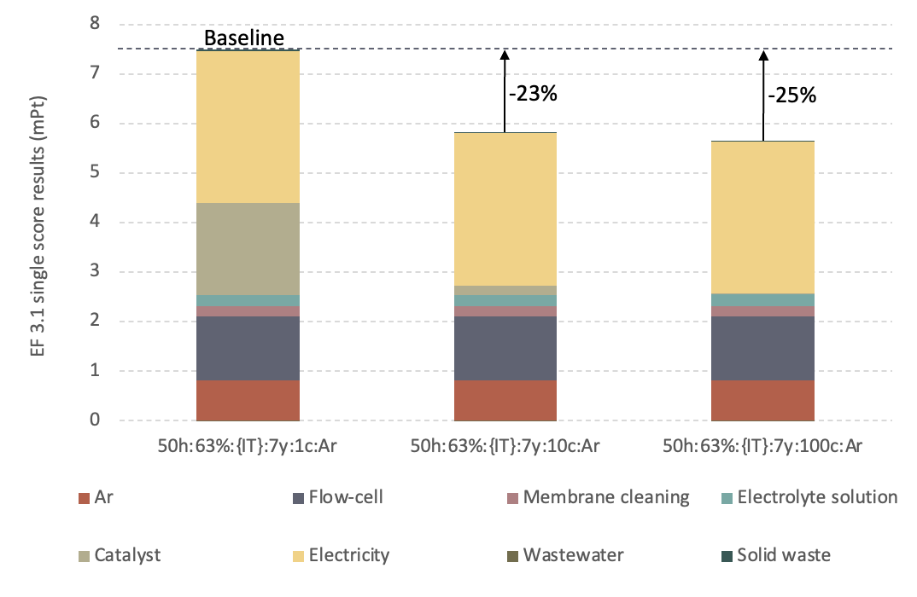
Figure S3.8: Sensitivity analysis for the 50h:63%:{IT}:7y:1c:Ar scenario; catalyst lifetime perturbations; unit: milli-Points (mPt).

Damage category | Unit | Total | Nitrates | Ar | Flow-Cell | Membrane cleaning | Electrolyte solution | Catalyst | Electricity | Wastewater | Solid waste
Total | mPt | 1.5E+01 | 5.8E-03 | 8.1E-01 | 9.0E+00 | 2.1E-01 | 2.4E-01 | 1.8E+00 | 3.1E+00 | -4.2E-03 | 3.2E-02
Acidification | mPt | 1.0E+00 | 0.0E+00 | 3.6E-02 | 7.5E-01 | 1.5E-02 | 1.9E-02 | 7.6E-02 | 1.5E-01 | 4.6E-05 | 7.6E-04
Climate change | mPt | 4.4E+00 | 0.0E+00 | 1.8E-01 | 2.7E+00 | 4.6E-02 | 3.7E-02 | 4.2E-01 | 1.0E+00 | 2.3E-04 | 1.6E-02
Ecotoxicity, freshwater | mPt | 2.4E-01 | 0.0E+00 | 1.0E-02 | 1.4E-01 | 2.9E-03 | 2.0E-02 | 2.4E-02 | 4.4E-02 | 6.5E-04 | 2.9E-03
Particulate matter | mPt | 6.2E-01 | 0.0E+00 | 1.9E-02 | 4.1E-01 | 1.0E-02 | 2.6E-02 | 4.5E-02 | 1.1E-01 | 7.1E-05 | 1.2E-03
Eutrophication, marine | mPt | 2.0E-01 | 5.8E-03 | 9.2E-03 | 1.2E-01 | 2.6E-03 | 3.2E-03 | 2.5E-02 | 4.0E-02 | 5.2E-04 | 2.7E-04
Eutrophication, freshwater | mPt | 8.7E-01 | 0.0E+00 | 1.0E-01 | 3.6E-01 | 2.9E-02 | 2.5E-02 | 2.0E-01 | 1.5E-01 | 6.5E-04 | 2.9E-03
Eutrophication, terrestrial | mPt | 3.2E-01 | 0.0E+00 | 1.1E-02 | 2.2E-01 | 2.8E-03 | 3.7E-03 | 2.4E-02 | 5.3E-02 | 2.7E-05 | 3.5E-04
Human toxicity, cancer | mPt | 7.7E-01 | 0.0E+00 | 4.2E-02 | 4.6E-01 | 1.1E-02 | 1.1E-02 | 8.6E-02 | 1.6E-01 | 1.2E-04 | 1.7E-03
Human toxicity, non-cancer | mPt | 1.1E-01 | 0.0E+00 | 7.7E-03 | 4.8E-02 | 2.2E-03 | 3.8E-03 | 1.9E-02 | 2.9E-02 | 1.9E-04 | 2.6E-04
Ionising radiation | mPt | 2.3E-01 | 0.0E+00 | 4.8E-02 | 2.6E-02 | 1.2E-02 | 1.3E-03 | 9.2E-02 | 5.2E-02 | 1.7E-05 | 1.7E-04
Land use | mPt | 4.9E-02 | 0.0E+00 | 3.4E-03 | 1.5E-02 | 8.6E-04 | 1.3E-03 | 8.4E-03 | 2.0E-02 | 4.4E-06 | 5.8E-05
Ozone depletion | mPt | 2.2E+00 | 0.0E+00 | 1.2E-05 | 2.2E+00 | 1.4E-05 | 6.0E-05 | 6.2E-02 | 8.9E-05 | 2.1E-08 | 2.3E-06
Photochemical ozone formation | mPt | 6.5E-01 | 0.0E+00 | 2.0E-02 | 3.2E-01 | 5.5E-03 | 7.6E-03 | 1.8E-01 | 1.2E-01 | 3.3E-05 | 8.1E-04
Resource use, fossils | mPt | 1.9E+00 | 0.0E+00 | 1.9E-01 | 4.8E-01 | 4.9E-02 | 2.3E-02 | 3.8E-01 | 7.4E-01 | 1.2E-04 | 3.6E-03
Resource use, minerals and metals | mPt | 1.1E+00 | 0.0E+00 | 2.4E-02 | 7.7E-01 | 7.8E-03 | 3.9E-02 | 1.4E-01 | 9.2E-02 | 5.4E-05 | 9.9E-04
Water use | mPt | 5.4E-01 | 0.0E+00 | 1.1E-01 | 4.9E-02 | 8.5E-03 | 1.7E-02 | 6.3E-02 | 3.0E-01 | -6.9E-03 | 2.8E-04
Table S3.19: Environmental impacts associated with the production of 1 g NH₃, scenario 50h:63%:{IT}:1y:1c:Ar. Results calculated at the endpoint level; damage categories expressed as single score; unit: milli-Points (mPt). Method: EF 3.1.

Damage category | Unit | Total | Nitrates | Ar | Flow-Cell | Membrane cleaning | Electrolyte solution | Catalyst | Electricity | Wastewater | Solid waste
Total | mPt | 8.0E+00 | 5.8E-04 | 8.1E-01 | 1.8E+00 | 2.1E-01 | 2.4E-01 | 1.8E+00 | 3.1E+00 | -4.2E-03 | 3.2E-02
Acidification | mPt | 4.4E-01 | 0.0E+00 | 3.6E-02 | 1.5E-01 | 1.5E-02 | 1.9E-02 | 7.6E-02 | 1.5E-01 | 4.6E-05 | 7.6E-04
Climate change | mPt | 2.3E+00 | 0.0E+00 | 1.8E-01 | 5.3E-01 | 4.6E-02 | 3.7E-02 | 4.2E-01 | 1.0E+00 | 2.3E-04 | 1.6E-02
Ecotoxicity, freshwater | mPt | 1.3E-01 | 0.0E+00 | 1.0E-02 | 2.7E-02 | 2.9E-03 | 2.0E-02 | 2.4E-02 | 4.4E-02 | 6.5E-04 | 2.9E-03
Particulate matter | mPt | 2.9E-01 | 0.0E+00 | 1.9E-02 | 8.2E-02 | 1.0E-02 | 2.6E-02 | 4.5E-02 | 1.1E-01 | 7.1E-05 | 1.2E-03
Eutrophication, marine | mPt | 1.0E-01 | 5.8E-04 | 9.2E-03 | 2.3E-02 | 2.6E-03 | 3.2E-03 | 2.5E-02 | 4.0E-02 | 5.2E-04 | 2.7E-04
Eutrophication, freshwater | mPt | 5.8E-01 | 0.0E+00 | 1.0E-01 | 7.1E-02 | 2.9E-02 | 2.5E-02 | 2.0E-01 | 1.5E-01 | 6.5E-04 | 2.9E-03
Eutrophication, terrestrial | mPt | 1.4E-01 | 0.0E+00 | 1.1E-02 | 4.5E-02 | 2.8E-03 | 3.7E-03 | 2.4E-02 | 5.3E-02 | 2.7E-05 | 3.5E-04
Human toxicity, cancer | mPt | 4.0E-01 | 0.0E+00 | 4.2E-02 | 9.2E-02 | 1.1E-02 | 1.1E-02 | 8.6E-02 | 1.6E-01 | 1.2E-04 | 1.7E-03
Human toxicity, non-cancer | mPt | 7.1E-02 | 0.0E+00 | 7.7E-03 | 9.6E-03 | 2.2E-03 | 3.8E-03 | 1.9E-02 | 2.9E-02 | 1.9E-04 | 2.6E-04
Ionising radiation | mPt | 2.1E-01 | 0.0E+00 | 4.8E-02 | 5.3E-03 | 1.2E-02 | 1.3E-03 | 9.2E-02 | 5.2E-02 | 1.7E-05 | 1.7E-04
Land use | mPt | 3.7E-02 | 0.0E+00 | 3.4E-03 | 3.1E-03 | 8.6E-04 | 1.3E-03 | 8.4E-03 | 2.0E-02 | 4.4E-06 | 5.8E-05
Ozone depletion | mPt | 5.0E-01 | 0.0E+00 | 1.2E-05 | 4.4E-01 | 1.4E-05 | 6.0E-05 | 6.2E-02 | 8.9E-05 | 2.1E-08 | 2.3E-06
Photochemical ozone formation | mPt | 3.9E-01 | 0.0E+00 | 2.0E-02 | 6.3E-02 | 5.5E-03 | 7.6E-03 | 1.8E-01 | 1.2E-01 | 3.3E-05 | 8.1E-04
Resource use, fossils | mPt | 1.5E+00 | 0.0E+00 | 1.9E-01 | 9.7E-02 | 4.9E-02 | 2.3E-02 | 3.8E-01 | 7.4E-01 | 1.2E-04 | 3.6E-03
Resource use, minerals and metals | mPt | 4.6E-01 | 0.0E+00 | 2.4E-02 | 1.5E-01 | 7.8E-03 | 3.9E-02 | 1.4E-01 | 9.2E-02 | 5.4E-05 | 9.9E-04
Water use | mPt | 5.0E-01 | 0.0E+00 | 1.1E-01 | 9.9E-03 | 8.5E-03 | 1.7E-02 | 6.3E-02 | 3.0E-01 | -6.9E-03 | 2.8E-04
Table S3.20: Environmental impacts associated with the production of 1 g NH₃, scenario 50h:63%:{IT}:5y:1c:Ar. Results calculated at the endpoint level; damage categories expressed as single score; unit: milli-Points (mPt). Method: EF 3.1.

Damage category | Unit | Total | Nitrates | Ar | Flow-Cell | Membrane cleaning | Electrolyte solution | Catalyst | Electricity | Wastewater | Solid waste
Total | mPt | 6.7E+00 | 5.8E-04 | 8.1E-01 | 4.5E-01 | 2.1E-01 | 2.4E-01 | 1.8E+00 | 3.1E+00 | -4.2E-03 | 3.2E-02
Acidification | mPt | 3.3E-01 | 0.0E+00 | 3.6E-02 | 3.7E-02 | 1.5E-02 | 1.9E-02 | 7.6E-02 | 1.5E-01 | 4.6E-05 | 7.6E-04
Climate change | mPt | 1.9E+00 | 0.0E+00 | 1.8E-01 | 1.3E-01 | 4.6E-02 | 3.7E-02 | 4.2E-01 | 1.0E+00 | 2.3E-04 | 1.6E-02
Ecotoxicity, freshwater | mPt | 1.1E-01 | 0.0E+00 | 1.0E-02 | 6.8E-03 | 2.9E-03 | 2.0E-02 | 2.4E-02 | 4.4E-02 | 6.5E-04 | 2.9E-03
Particulate matter | mPt | 2.3E-01 | 0.0E+00 | 1.9E-02 | 2.1E-02 | 1.0E-02 | 2.6E-02 | 4.5E-02 | 1.1E-01 | 7.1E-05 | 1.2E-03
Eutrophication, marine | mPt | 8.7E-02 | 5.8E-04 | 9.2E-03 | 5.8E-03 | 2.6E-03 | 3.2E-03 | 2.5E-02 | 4.0E-02 | 5.2E-04 | 2.7E-04
Eutrophication, freshwater | mPt | 5.3E-01 | 0.0E+00 | 1.0E-01 | 1.8E-02 | 2.9E-02 | 2.5E-02 | 2.0E-01 | 1.5E-01 | 6.5E-04 | 2.9E-03
Eutrophication, terrestrial | mPt | 1.1E-01 | 0.0E+00 | 1.1E-02 | 1.1E-02 | 2.8E-03 | 3.7E-03 | 2.4E-02 | 5.3E-02 | 2.7E-05 | 3.5E-04
Human toxicity, cancer | mPt | 3.3E-01 | 0.0E+00 | 4.2E-02 | 2.3E-02 | 1.1E-02 | 1.1E-02 | 8.6E-02 | 1.6E-01 | 1.2E-04 | 1.7E-03
Human toxicity, non-cancer | mPt | 6.4E-02 | 0.0E+00 | 7.7E-03 | 2.4E-03 | 2.2E-03 | 3.8E-03 | 1.9E-02 | 2.9E-02 | 1.9E-04 | 2.6E-04
Ionising radiation | mPt | 2.1E-01 | 0.0E+00 | 4.8E-02 | 1.3E-03 | 1.2E-02 | 1.3E-03 | 9.2E-02 | 5.2E-02 | 1.7E-05 | 1.7E-04
Land use | mPt | 3.4E-02 | 0.0E+00 | 3.4E-03 | 7.7E-04 | 8.6E-04 | 1.3E-03 | 8.4E-03 | 2.0E-02 | 4.4E-06 | 5.8E-05
Ozone depletion | mPt | 1.7E-01 | 0.0E+00 | 1.2E-05 | 1.1E-01 | 1.4E-05 | 6.0E-05 | 6.2E-02 | 8.9E-05 | 2.1E-08 | 2.3E-06
Photochemical ozone formation | mPt | 3.5E-01 | 0.0E+00 | 2.0E-02 | 1.6E-02 | 5.5E-03 | 7.6E-03 | 1.8E-01 | 1.2E-01 | 3.3E-05 | 8.1E-04
Resource use, fossils | mPt | 1.4E+00 | 0.0E+00 | 1.9E-01 | 2.4E-02 | 4.9E-02 | 2.3E-02 | 3.8E-01 | 7.4E-01 | 1.2E-04 | 3.6E-03
Resource use, minerals and metals | mPt | 3.5E-01 | 0.0E+00 | 2.4E-02 | 3.8E-02 | 7.8E-03 | 3.9E-02 | 1.4E-01 | 9.2E-02 | 5.4E-05 | 9.9E-04
Water use | mPt | 4.9E-01 | 0.0E+00 | 1.1E-01 | 2.5E-03 | 8.5E-03 | 1.7E-02 | 6.3E-02 | 3.0E-01 | -6.9E-03 | 2.8E-04
Table S3.21: Environmental impacts associated with the production of 1 g NH₃, scenario 50h:63%:{IT}:20y:1c:Ar. Results calculated at the endpoint level; damage categories expressed as single score; unit: milli-Points (mPt). Method: EF 3.1.

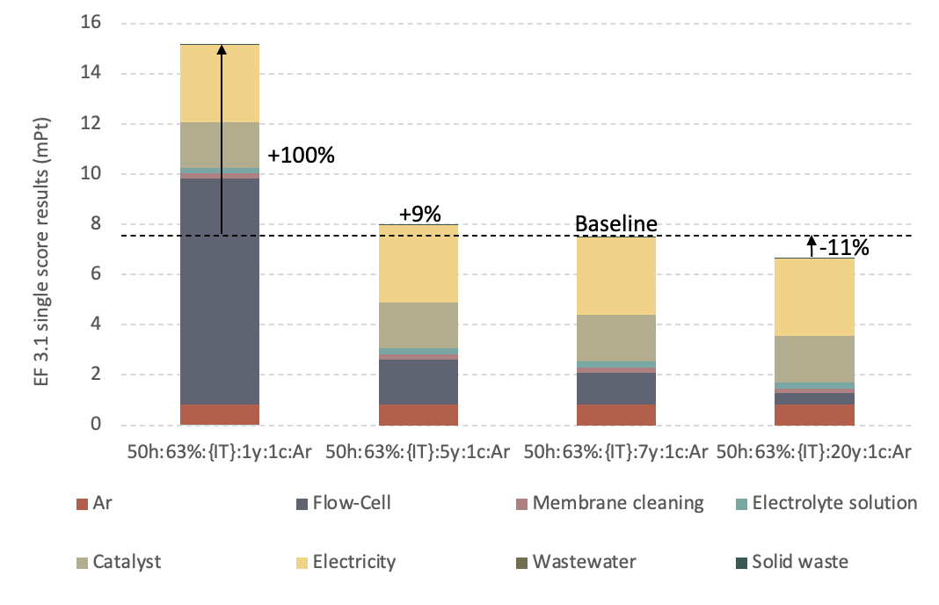
Figure S3.9: Sensitivity analysis for the 50h:63%:{IT}:7y:1c:Ar scenario; flow-cell RSL perturbations.; unit: milli-Points (mPt).

Damage category | Unit | Total | Nitrates | Ar | Flow-Cell | Membrane cleaning | Electrolyte solution | Catalyst | Electricity | Wastewater | Solid waste
Total | mPt | 6.6E+00 | 5.8E-04 | 8.1E-01 | 1.3E+00 | 2.1E-01 | 2.4E-01 | 1.8E+00 | 2.1E+00 | -4.2E-03 | 3.2E-02
Acidification | mPt | 3.5E-01 | 0.0E+00 | 3.6E-02 | 1.1E-01 | 1.5E-02 | 1.9E-02 | 7.6E-02 | 9.8E-02 | 4.6E-05 | 7.6E-04
Climate change | mPt | 1.7E+00 | 0.0E+00 | 1.8E-01 | 3.8E-01 | 4.6E-02 | 3.7E-02 | 4.2E-01 | 6.1E-01 | 2.3E-04 | 1.6E-02
Ecotoxicity, freshwater | mPt | 1.1E-01 | 0.0E+00 | 1.0E-02 | 2.0E-02 | 2.9E-03 | 2.0E-02 | 2.4E-02 | 3.5E-02 | 6.5E-04 | 2.9E-03
Particulate matter | mPt | 2.5E-01 | 0.0E+00 | 1.9E-02 | 5.9E-02 | 1.0E-02 | 2.6E-02 | 4.5E-02 | 8.8E-02 | 7.1E-05 | 1.2E-03
Eutrophication, marine | mPt | 8.4E-02 | 5.8E-04 | 9.2E-03 | 1.7E-02 | 2.6E-03 | 3.2E-03 | 2.5E-02 | 2.6E-02 | 5.2E-04 | 2.7E-04
Eutrophication, freshwater | mPt | 5.1E-01 | 0.0E+00 | 1.0E-01 | 5.1E-02 | 2.9E-02 | 2.5E-02 | 2.0E-01 | 1.0E-01 | 6.5E-04 | 2.9E-03
Eutrophication, terrestrial | mPt | 1.1E-01 | 0.0E+00 | 1.1E-02 | 3.2E-02 | 2.8E-03 | 3.7E-03 | 2.4E-02 | 3.5E-02 | 2.7E-05 | 3.5E-04
Human toxicity, cancer | mPt | 3.6E-01 | 0.0E+00 | 4.2E-02 | 6.6E-02 | 1.1E-02 | 1.1E-02 | 8.6E-02 | 1.4E-01 | 1.2E-04 | 1.7E-03
Human toxicity, non-cancer | mPt | 7.0E-02 | 0.0E+00 | 7.7E-03 | 6.8E-03 | 2.2E-03 | 3.8E-03 | 1.9E-02 | 3.0E-02 | 1.9E-04 | 2.6E-04
Ionising radiation | mPt | 1.9E-01 | 0.0E+00 | 4.8E-02 | 3.8E-03 | 1.2E-02 | 1.3E-03 | 9.2E-02 | 2.9E-02 | 1.7E-05 | 1.7E-04
Land use | mPt | 7.0E-02 | 0.0E+00 | 3.4E-03 | 2.2E-03 | 8.6E-04 | 1.3E-03 | 8.4E-03 | 5.4E-02 | 4.4E-06 | 5.8E-05
Ozone depletion | mPt | 3.7E-01 | 0.0E+00 | 1.2E-05 | 3.1E-01 | 1.4E-05 | 6.0E-05 | 6.2E-02 | 2.1E-04 | 2.1E-08 | 2.3E-06
Photochemical ozone formation | mPt | 3.3E-01 | 0.0E+00 | 2.0E-02 | 4.5E-02 | 5.5E-03 | 7.6E-03 | 1.8E-01 | 7.7E-02 | 3.3E-05 | 8.1E-04
Resource use, fossils | mPt | 1.1E+00 | 0.0E+00 | 1.9E-01 | 6.9E-02 | 4.9E-02 | 2.3E-02 | 3.8E-01 | 4.2E-01 | 1.2E-04 | 3.6E-03
Resource use, minerals and metals | mPt | 5.4E-01 | 0.0E+00 | 2.4E-02 | 1.1E-01 | 7.8E-03 | 3.9E-02 | 1.4E-01 | 2.2E-01 | 5.4E-05 | 9.9E-04
Water use | mPt | 3.7E-01 | 0.0E+00 | 1.1E-01 | 7.1E-03 | 8.5E-03 | 1.7E-02 | 6.3E-02 | 1.7E-01 | -6.9E-03 | 2.8E-04
Table S3.22: Environmental impacts associated with the production of 1 g NH₃, scenario 50h:63%:50%PV:7y:1c:Ar. Results calculated at the endpoint level; damage categories expressed as single score; unit: milli-Points (mPt). Method: EF 3.1.

Damage category | Unit | Total | Nitrates | N₂ | Flow-Cell | Membrane cleaning | Electrolyte solution | Catalyst | Electricity | Wastewater | Solid waste
Total | mPt | 6.8E+00 | 5.8E-04 | 9.1E-02 | 1.3E+00 | 2.1E-01 | 2.4E-01 | 1.8E+00 | 3.1E+00 | -4.2E-03 | 3.2E-02
Acidification | mPt | 3.7E-01 | 0.0E+00 | 4.1E-03 | 1.1E-01 | 1.5E-02 | 1.9E-02 | 7.6E-02 | 1.5E-01 | 4.6E-05 | 7.6E-04
Climate change | mPt | 2.0E+00 | 0.0E+00 | 2.0E-02 | 3.8E-01 | 4.6E-02 | 3.7E-02 | 4.2E-01 | 1.0E+00 | 2.3E-04 | 1.6E-02
Ecotoxicity, freshwater | mPt | 1.1E-01 | 0.0E+00 | 1.1E-03 | 2.0E-02 | 2.9E-03 | 2.0E-02 | 2.4E-02 | 4.4E-02 | 6.5E-04 | 2.9E-03
Particulate matter | mPt | 2.5E-01 | 0.0E+00 | 2.3E-03 | 5.9E-02 | 1.0E-02 | 2.6E-02 | 4.5E-02 | 1.1E-01 | 7.1E-05 | 1.2E-03
Eutrophication, marine | mPt | 9.0E-02 | 5.8E-04 | 1.1E-03 | 1.7E-02 | 2.6E-03 | 3.2E-03 | 2.5E-02 | 4.0E-02 | 5.2E-04 | 2.7E-04
Eutrophication, freshwater | mPt | 4.7E-01 | 0.0E+00 | 1.1E-02 | 5.1E-02 | 2.9E-02 | 2.5E-02 | 2.0E-01 | 1.5E-01 | 6.5E-04 | 2.9E-03
Eutrophication, terrestrial | mPt | 1.2E-01 | 0.0E+00 | 1.3E-03 | 3.2E-02 | 2.8E-03 | 3.7E-03 | 2.4E-02 | 5.3E-02 | 2.7E-05 | 3.5E-04
Human toxicity, cancer | mPt | 3.4E-01 | 0.0E+00 | 4.8E-03 | 6.6E-02 | 1.1E-02 | 1.1E-02 | 8.6E-02 | 1.6E-01 | 1.2E-04 | 1.7E-03
Human toxicity, non-cancer | mPt | 6.2E-02 | 0.0E+00 | 8.8E-04 | 6.8E-03 | 2.2E-03 | 3.8E-03 | 1.9E-02 | 2.9E-02 | 1.9E-04 | 2.6E-04
Ionising radiation | mPt | 1.7E-01 | 0.0E+00 | 5.4E-03 | 3.8E-03 | 1.2E-02 | 1.3E-03 | 9.2E-02 | 5.2E-02 | 1.7E-05 | 1.7E-04
Land use | mPt | 3.3E-02 | 0.0E+00 | 3.9E-04 | 2.2E-03 | 8.6E-04 | 1.3E-03 | 8.4E-03 | 2.0E-02 | 4.4E-06 | 5.8E-05
Ozone depletion | mPt | 3.7E-01 | 0.0E+00 | 1.3E-06 | 3.1E-01 | 1.4E-05 | 6.0E-05 | 6.2E-02 | 8.9E-05 | 2.1E-08 | 2.3E-06
Photochemical ozone formation | mPt | 3.6E-01 | 0.0E+00 | 2.3E-03 | 4.5E-02 | 5.5E-03 | 7.6E-03 | 1.8E-01 | 1.2E-01 | 3.3E-05 | 8.1E-04
Resource use, fossils | mPt | 1.3E+00 | 0.0E+00 | 2.1E-02 | 6.9E-02 | 4.9E-02 | 2.3E-02 | 3.8E-01 | 7.4E-01 | 1.2E-04 | 3.6E-03
Resource use, minerals and metals | mPt | 4.0E-01 | 0.0E+00 | 2.7E-03 | 1.1E-01 | 7.8E-03 | 3.9E-02 | 1.4E-01 | 9.2E-02 | 5.4E-05 | 9.9E-04
Water use | mPt | 4.0E-01 | 0.0E+00 | 1.2E-02 | 7.1E-03 | 8.5E-03 | 1.7E-02 | 6.3E-02 | 3.0E-01 | -6.9E-03 | 2.8E-04
Table S3.23: Environmental impacts associated with the production of 1 g NH₃, scenario 50h:63%:{IT}:1y:1c:N₂. Results calculated at the endpoint level; damage categories expressed as single score; unit: milli-Points (mPt). Method: EF 3.1.

Damage category | Unit | Total | Nitrates | N₂ | Flow-Cell | Membrane cleaning | Electrolyte solution | Catalyst | Electricity | Wastewater | Solid waste
Total | mPt | 3.1E+00 | 5.8E-04 | 9.1E-02 | 4.5E-01 | 2.1E-01 | 2.4E-01 | 1.8E-02 | 2.1E+00 | -4.2E-03 | 3.2E-04
Acidification | mPt | 1.7E-01 | 0.0E+00 | 4.1E-03 | 3.7E-02 | 1.5E-02 | 1.9E-02 | 7.6E-04 | 9.8E-02 | 4.6E-05 | 7.6E-06
Climate change | mPt | 8.5E-01 | 0.0E+00 | 2.0E-02 | 1.3E-01 | 4.6E-02 | 3.7E-02 | 4.2E-03 | 6.1E-01 | 2.3E-04 | 1.6E-04
Ecotoxicity, freshwater | mPt | 6.7E-02 | 0.0E+00 | 1.1E-03 | 6.8E-03 | 2.9E-03 | 2.0E-02 | 2.4E-04 | 3.5E-02 | 6.5E-04 | 2.9E-05
Particulate matter | mPt | 1.5E-01 | 0.0E+00 | 2.3E-03 | 2.1E-02 | 1.0E-02 | 2.6E-02 | 4.5E-04 | 8.8E-02 | 7.1E-05 | 1.2E-05
Eutrophication, marine | mPt | 4.0E-02 | 5.8E-04 | 1.1E-03 | 5.8E-03 | 2.6E-03 | 3.2E-03 | 2.5E-04 | 2.6E-02 | 5.2E-04 | 2.7E-06
Eutrophication, freshwater | mPt | 1.9E-01 | 0.0E+00 | 1.1E-02 | 1.8E-02 | 2.9E-02 | 2.5E-02 | 2.0E-03 | 1.0E-01 | 6.5E-04 | 2.9E-05
Eutrophication, terrestrial | mPt | 5.4E-02 | 0.0E+00 | 1.3E-03 | 1.1E-02 | 2.8E-03 | 3.7E-03 | 2.4E-04 | 3.5E-02 | 2.7E-05 | 3.5E-06
Human toxicity, cancer | mPt | 1.9E-01 | 0.0E+00 | 4.8E-03 | 2.3E-02 | 1.1E-02 | 1.1E-02 | 8.6E-04 | 1.4E-01 | 1.2E-04 | 1.7E-05
Human toxicity, non-cancer | mPt | 4.0E-02 | 0.0E+00 | 8.8E-04 | 2.4E-03 | 2.2E-03 | 3.8E-03 | 1.9E-04 | 3.0E-02 | 1.9E-04 | 2.6E-06
Ionising radiation | mPt | 5.0E-02 | 0.0E+00 | 5.4E-03 | 1.3E-03 | 1.2E-02 | 1.3E-03 | 9.2E-04 | 2.9E-02 | 1.7E-05 | 1.7E-06
Land use | mPt | 5.7E-02 | 0.0E+00 | 3.9E-04 | 7.7E-04 | 8.6E-04 | 1.3E-03 | 8.4E-05 | 5.4E-02 | 4.4E-06 | 5.8E-07
Ozone depletion | mPt | 1.1E-01 | 0.0E+00 | 1.3E-06 | 1.1E-01 | 1.4E-05 | 6.0E-05 | 6.2E-04 | 2.1E-04 | 2.1E-08 | 2.3E-08
Photochemical ozone formation | mPt | 1.1E-01 | 0.0E+00 | 2.3E-03 | 1.6E-02 | 5.5E-03 | 7.6E-03 | 1.8E-03 | 7.7E-02 | 3.3E-05 | 8.1E-06
Resource use, fossils | mPt | 5.5E-01 | 0.0E+00 | 2.1E-02 | 2.4E-02 | 4.9E-02 | 2.3E-02 | 3.8E-03 | 4.2E-01 | 1.2E-04 | 3.6E-05
Resource use, minerals and metals | mPt | 3.0E-01 | 0.0E+00 | 2.7E-03 | 3.8E-02 | 7.8E-03 | 3.9E-02 | 1.4E-03 | 2.2E-01 | 5.4E-05 | 9.9E-06
Water use | mPt | 2.1E-01 | 0.0E+00 | 1.2E-02 | 2.5E-03 | 8.5E-03 | 1.7E-02 | 6.3E-04 | 1.7E-01 | -6.9E-03 | 2.8E-06
Table S3.24: Environmental impacts associated with the production of 1 g NH₃, scenario 50h:63%:{IT}:20y:100c:N₂. Results calculated at the endpoint level; damage categories expressed as single score; unit: milli-Points (mPt). Method: EF 3.1.

The sensitivity of the 50h:63%:{IT}:7y:1c:Ar scenario to the electricity inputs was further tested to assess the effect of different electricity production mixes to the overall impacts of the NH₃ production process. As reported in the main text, the average European energy mix was included in the assessment and modelled through the ecoinvent “Electricity, medium voltage | Market group for electricity {RER} | APOS, U” reference process (Scenario 50h:63%:{RER}:7y:1c:Ar). Two hypothetical electricity mixes were also modelled, to represent the fully renewable production of electricity from wind in Denmark (scenario 50h:63%:100%DK-Wind:7y:1c:Ar) and the fully renewable Norwegian hydroelectric production (scenario 50h:63%:100%NO-Hydro:7y:1c:Ar). To conduct the analysis, the ecoinvent processes relative to the electricity mixes of Denmark and Norway were modified by maintaining only the energy sources of interest, i.e. respectively wind and hydroelectric, and rescaling their contribution to 100% of the total production. Inventories are reported in Tables S3.25 and S3.26.

ecoinvent process | Amount | Unit
Electricity, high voltage {DK}| electricity production, wind, <1MW turbine, onshore | APOS, U | 4.0E-01 | kWh
Electricity, high voltage {DK}| electricity production, wind, >3MW turbine, onshore | APOS, U | 9.8E-02 | kWh
Electricity, high voltage {DK}| electricity production, wind, 1-3MW turbine, offshore | APOS, U | 2.2E-01 | kWh
Electricity, high voltage {DK}| electricity production, wind, 1-3MW turbine, onshore | APOS, U | 2.8E-01 | kWh
Table S3.25: LCI for the production of 1kWh of high voltage electricity from wind in Denmark, employed in sensitivity scenario 50h:63%:100%DK-Wind:7y:1c:Ar.

ecoinvent process | Amount | Unit
Electricity, high voltage {NO}| electricity production, hydro, pumped storage | APOS, U | 4.7E-03 | kWh
Electricity, high voltage {NO}| electricity production, hydro, reservoir, alpine region | APOS, U | 1.0E+00 | kWh
Table S3.26: LCI for the production of 1kWh of high voltage electricity from wind in Denmark, employed in sensitivity scenario 50h:63%:100%NO-Hydro:7y:1c:Ar.

Single score results, reported in Table S3.27 and in Figure S3.10, show that employing an average European mix would lead to a 5% increase in the cumulative impacts of the NH₃ production process compared to operating in Italy, while employing 100% renewable mixes based on wind and hydroelectric power would lead to a cumulative impacts reduction of 35% and 38%, respectively; Table S3.28 reports single score results relative the consumption of electricity for the assessed sensitivity scenarios. Italian electricity mix relies on a higher share of natural gas compared to the European average, leading to a higher carbon footprint, while the European average mix relies on a higher share of nuclear and coal, leading to increased impacts e.g. in the IR, RUF and RUMM categories.

Damage category | Unit | 50h electricity consumption, RER mix | 50h electricity consumption, 100% wind mix | 50h electricity consumption, 100% hydro mix
Total | mPt | 7.9E+00 | 4.9E+00 | 4.6E+00
Nitrates | mPt | 5.8E-04 | 5.8E-04 | 5.8E-04
Inert gas | mPt | 8.1E-01 | 8.1E-01 | 8.1E-01
Flow cell | mPt | 1.3E+00 | 1.3E+00 | 1.3E+00
Membrane cleaning | mPt | 2.1E-01 | 2.1E-01 | 2.1E-01
Electrolyte solution | mPt | 2.4E-01 | 2.4E-01 | 2.4E-01
Catalyst | mPt | 1.8E+00 | 1.8E+00 | 1.8E+00
Electricity | mPt | 3.5E+00 | 4.5E-01 | 1.7E-01
Wastewater | mPt | -4.2E-03 | -4.2E-03 | -4.2E-03
Solid waste | mPt | 3.2E-02 | 3.2E-02 | 3.2E-02
Table S3.27: Environmental impacts associated with the production of 1 g NH₃, scenarios 50h:63%:{RER}:7y:1c:Ar, 50h:63%:100%DK-Wind:7y:1c:Ar and 50h:63%:100%NO-Hydro:7y:1c:Ar. Results calculated at the endpoint level; damage categories expressed as single score; unit: milli-Points (mPt). Method: EF 3.1.

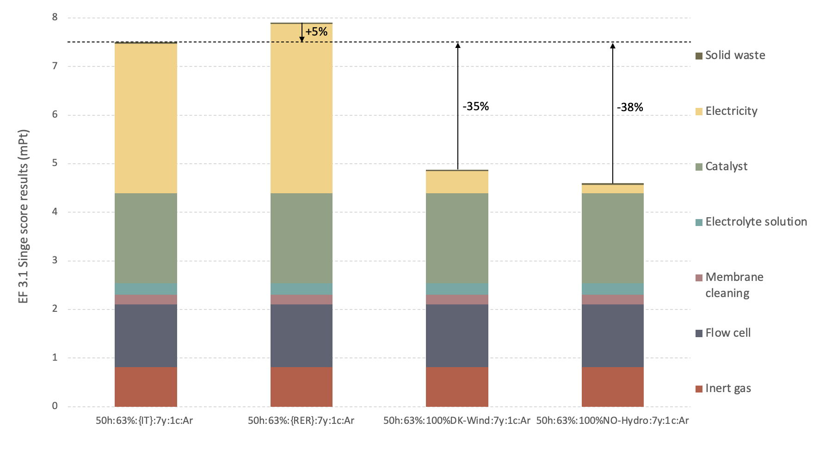
Figure S3.10: Environmental impacts associated with the production of 1 g NH₃, scenarios 50h:63%:{IT}:7y:1c:Ar, 50h:63%:{RER}:7y:1c:Ar, 50h:63%:100%DK-Wind:7y:1c:Ar and 50h:63%:100%NO-Hydro:7y:1c:Ar; damage categories expressed as single score; unit: milli-Points (mPt). Method: EF 3.1.

Damage category | Unit | 50h electricity consumption, RER mix | 50h electricity consumption, 100% wind mix | 50h electricity consumption, 100% hydro mix
Total | mPt | 3.5E+00 | 4.5E-01 | 1.7E-01
Acidification | mPt | 1.8E-01 | 1.8E-02 | 6.9E-03
Climate change | mPt | 8.6E-01 | 5.9E-02 | 3.4E-02
Ecotoxicity, freshwater | mPt | 4.9E-02 | 1.5E-02 | 6.7E-03
Particulate matter | mPt | 9.1E-02 | 2.2E-02 | 1.2E-02
Eutrophication, marine | mPt | 4.4E-02 | 3.2E-03 | 1.5E-03
Eutrophication, freshwater | mPt | 4.9E-01 | 2.1E-02 | 7.2E-03
Eutrophication, terrestrial | mPt | 5.1E-02 | 4.8E-03 | 2.3E-03
Human toxicity, cancer | mPt | 2.0E-01 | 7.6E-02 | 1.6E-02
Human toxicity, non-cancer | mPt | 3.7E-02 | 1.8E-02 | 5.9E-03
Ionising radiation | mPt | 2.4E-01 | 9.6E-04 | 6.0E-04
Land use | mPt | 1.6E-02 | 2.8E-03 | -2.1E-04
Ozone depletion | mPt | 5.5E-05 | 4.5E-06 | 7.1E-07
Photochemical ozone formation | mPt | 9.3E-02 | 9.0E-03 | 4.2E-03
Resource use, fossils | mPt | 9.2E-01 | 2.3E-02 | 8.9E-03
Resource use, minerals and metals | mPt | 1.1E-01 | 1.7E-01 | 5.2E-02
Water use | mPt | 1.0E-01 | 5.5E-03 | 1.4E-02
Table S3.28: Environmental impacts associated with the consumption of electricity for the production of 1 g NH₃, scenarios 50h:63%:{RER}:7y:1c:Ar, 50h:63%:100%DK-Wind:7y:1c:Ar and 50h:63%:100%NO-Hydro:7y:1c:Ar; damage categories expressed as single score; unit: milli-Points (mPt). Method: EF 3.1.
The climate change impacts of ammonia production routes and sensitivity scenarios are discussed below. As reported in Figure S3.11, scenario 2h:85%:{IT}:7y:1c:Ar entails the highest carbon footprint per FU among the analysed NH₃ production routes, mainly associated with the substitution of the catalyst (72% contribution). As described for the single score results, scenario 50h:63%:{IT}:7y:1c:Ar entails a 90% reduction in CO₂ eq. emissions, with increased contributions from electricity consumption (49%) and the flow cell assembly (18%), and a reduced contribution from the catalyst (20%). Further increases in the contribution from the electricity consumption in scenarios 71h:63%:{IT}:7y:1c:Ar and 101h:63%:{IT}:7y:1c:Ar (52% and 57%, respectively) lead and increase in the carbon footprint of the process. The calculated point value for scenario 71h:63%:{IT}:7y:1c:Ar is, however, within the calculated standard deviation for process 50h:63%:{IT}:7y:1c:Ar. Results of the Monte Carlo analyses are reported in Section S3.5.

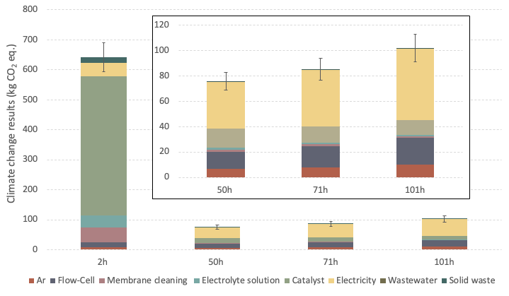
Figure S3.11: Carbon footprint of modelled NH₃ production scenarios at laboratory scale, FU = 1 g of NH₃; unit: kg CO₂ eq. Method: EF 3.1.

Figure S3.12 reports the climate change results for the sensitivity analysis of the 50h scenario. As for the cumulative impacts expressed as a single score, the most significant reduction in the carbon footprint (60%) is associated with the best-case scenario, 50h:63%:{IT}:20y:100c:N₂, which optimizes the use of the catalyst and of the flow cell.
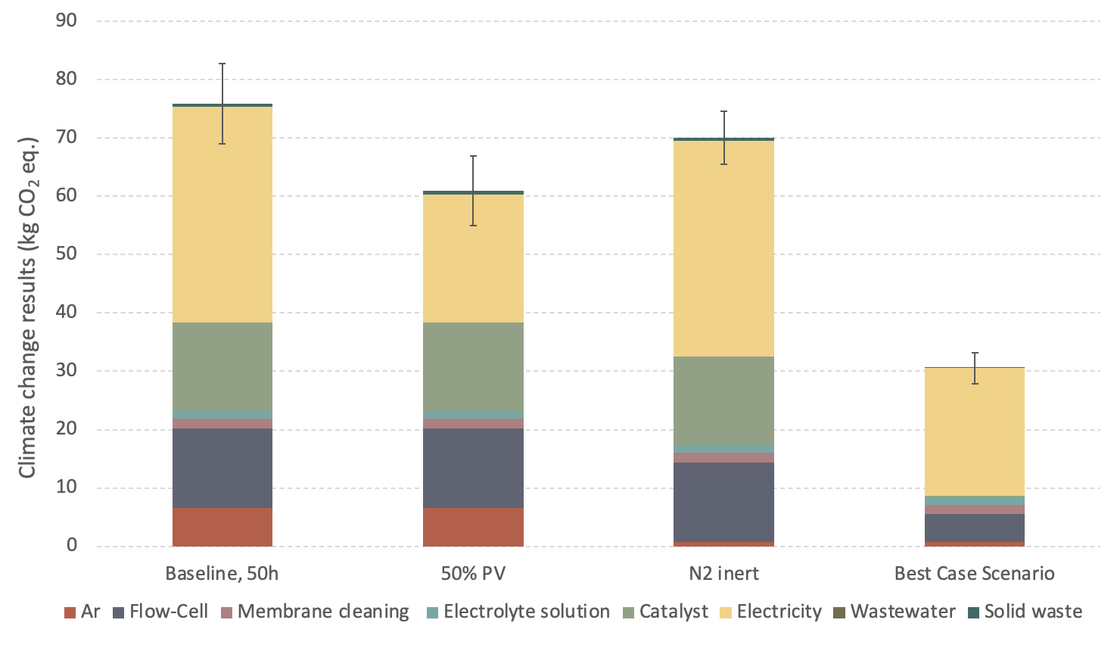
Figure S3.12: Sensitivity analysis performed on the carbon footprint of scenario 50h:63%:{IT}:7y:1c:Ar, FU = 1 g NH₃; unit: kg CO₂ eq. Method EF 3.1.

The calculated coefficient of variation (results reported below in section S3.5) for the assessed scenarios can assume values above 1000% for the categories of Ecotoxicity – inorganics, Human toxicity (cancer and non-cancer) – inorganics and Water Use (see Tables S3.70-S3.76), meaning that the standard deviations calculated for the considered categories exceeds the mean value by one order of magnitude. In the computation of a cumulative single score, the uncertainty propagates throughout the considered categories, hampering the quantitative comparability of the obtained results among the assessed scenarios. For this reason, further results are calculated excluding these categories from the computation of the single score, as reported in the main text, section 2.2.2. Single score results with error bars for the assessed NH₃ production and sensitivity scenarios are plotted in Figures S3.13 and S3.14 (see also Tables S3.77-S3.78).
Single score results for NH₃ production scenarios, calculated with the modified EF 3.1 method, show the same trend observed with the cumulative results calculated including all available EF 3.1 categories; i.e., increasing the reaction time from 2 h to 50 h leads to a 91% reduction of cumulative impacts per g of produced NH₃, while a further increase in the reaction time to 71 h and 101 h leads to increased impacts by 10% and 29%, respectively. Calculated standard deviations for scenarios 50h:63%:{IT}:7y:1c:Ar and 71h:63%:{IT}:7y:1c:Ar after performing 1000 Monte Carlo iterations overlap, whereas the point value calculated for scenario 101h:63%:{IT}:7y:1c:Ar is outside one standard deviation calculated for scenario 50h:63%:{IT}:7y:1c:Ar.

Figure S3.13: Modified single score results of modelled NH₃ production scenarios at laboratory scale, FU = 1 g of NH₃; unit: milli-Points (mPt). Method: EF 3.1, excluding (eco)toxicity and water use categories.
As for the sensitivity analysis performed on the 50h:63%:{IT}:7y:1c:Ar scenario, the best case scenario 50h:63%:50%PV:20y:100c:N₂ entails the highest reduction in cumulative impacts at 59%, with the calculated point value lying outside of the standard deviation calculated for scenario 50h:63%:{IT}:7y:1c:Ar.

Figure S3.14: Sensitivity analysis performed on the single score results of scenario 50h:63%:{IT}:7y:1c:Ar, FU = 1 g NH₃; unit: milli-Points (mPt). Method EF 3.1, excluding (eco)toxicity and water use categories.

The contribution analysis for scenario 50h:63%:{IT}:7y:1c:Ar is also conducted on the calculated single score results obtained with the modified EF 3.1 method (see Figure S3.15). Results confirm that the highest contribution is associated with the consumption of electricity to power the reaction, followed by the production of the MoS₂ catalyst and the flow cell. Standard deviations calculated after performing Monte Carlo simulations for each sub-process (see Table S3.79) do not overlap for the three highest contributors, confirming the highest cumulative impacts are associated with the consumption of electricity.
Figure S3.15: Contribution analysis for Scenario 50h:63%:{IT}:7y:1c:Ar, single score results; unit: milli-Points (mPt). Method EF 3.1, modified to exclude (eco)toxicity – Inorganics and Water Use categories.

  - Section S3.3: Cost of externalities and criticality assessment
Weighting factor (SSbD 2024) | Unit
0.35 | €2019/mol H+ eq.
0.1 | €2019/kg CO₂ eq.
0.0000395 | €2019/CTUe
728000 | €2019/disease incidence
3.27 | €2019/kg N eq.
1.95 | €2019/kg P eq.
/ | €2019/mol N eq.
166000 | €2019/CTUh
919000 | €2019/CTUh
/ | €2019/kBq U235 eq.
0.000178 | €2019/pt
55.5 | €2019/kg CFC-11 eq.
1.2 | €2019/kg NMVOC eq.
/ | €2019/MJ
/ | €2019/kg Sb eq.
0.00508 | €2019/m³ water eq. of deprived water
Table S3.29: Monetary value coefficients (MVC), as reported in Abbate et al. [3] and Gama Caldas et al. [66]
Scenario | 2h:85%:{IT}:7y:1c:Ar | 50h:63%:{IT}:7y:1c:Ar | 71h:63%:{IT}:7y:1c:Ar | 101h:63%:{IT}:7y:1c:Ar
 | Value | Value | Value | Value | Unit
Total | 9.7E+01 | 1.1E+01 | 1.2E+01 | 1.4E+01 | €
Nitrates | 1.2E-01 | 1.2E-03 | 6.7E-04 | 3.0E-04 | €
Ar | 1.2E+00 | 9.5E-01 | 1.2E+00 | 1.5E+00 | €
Flow-Cell | 2.2E+00 | 1.8E+00 | 2.2E+00 | 2.8E+00 | €
Membrane cleaning | 7.8E+00 | 2.6E-01 | 2.2E-01 | 2.0E-01 | €
Electrolyte solution | 9.8E+00 | 3.2E-01 | 2.8E-01 | 2.5E-01 | €
Catalyst | 6.8E+01 | 2.2E+00 | 1.9E+00 | 1.7E+00 | €
Electricity | 6.0E+00 | 4.9E+00 | 6.0E+00 | 7.6E+00 | €
Wastewater | -3.0E-02 | -9.9E-04 | -8.5E-04 | -7.5E-04 | €
Solid waste | 2.1E+00 | 6.8E-02 | 5.8E-02 | 5.2E-02 | €
Table S3.30: Monetization of externalities in € for the evaluated NH₃ production scenarios (FU = 1 g NH₃); focus on the sub-processes.

Scenario | 2h:85%:{IT}:7y:1c:Ar | 50h:63%:{IT}:7y:1c:Ar | 71h:63%:{IT}:7y:1c:Ar | 101h:63%:{IT}:7y:1c:Ar
Category | € | € | € | €
Ac | 1.2E+00 | 1.3E-01 | 1.4E-01 | 1.7E-01
CC | 6.4E+01 | 7.6E+00 | 8.5E+00 | 1.0E+01
EcoF | 1.9E-01 | 1.4E-02 | 1.5E-02 | 1.8E-02
PM | 1.3E+01 | 1.3E+00 | 1.4E+00 | 1.7E+00
EuM | 2.4E+00 | 2.1E-01 | 2.3E-01 | 2.7E-01
EuF | 9.2E-01 | 6.3E-02 | 6.6E-02 | 7.4E-02
HTC | 5.0E-01 | 5.0E-02 | 5.6E-02 | 6.6E-02
HTNC | 5.3E+00 | 4.4E-01 | 4.8E-01 | 5.5E-01
LU | 6.5E-01 | 6.6E-02 | 7.3E-02 | 8.6E-02
OD | 1.0E-01 | 1.7E-02 | 2.0E-02 | 2.4E-02
POF | 6.2E+00 | 3.9E-01 | 4.0E-01 | 4.4E-01
WU | 2.1E+00 | 3.4E-01 | 3.9E-01 | 4.8E-01
TOTAL | 9.7E+01 | 1.1E+01 | 1.2E+01 | 1.4E+01
Table S3.31: Monetization of externalities in € for the evaluated NH₃ production scenarios (FU = 1 g NH₃); focus on the impact categories. Categories: Ac (acidification); CC (climate change); EcoF (ecotoxicity, freshwater); EuF (eutrophication, freshwater); EuM (eutrophication, marine); EuT (eutrophication, terrestrial); HTC (human toxicity, cancer); HTNC (human toxicity, non-cancer); IR (ionising radiation); LU (land use); OD (ozone depletion); PM (particulate matter); POF (photochemical ozone formation); RUF (resource use, fossils); RUMM (resource use, minerals and metals); WU (water use).
Figure S3.16: Monetization of externalities in € for the evaluated NH₃ production scenarios (FU = 1 g NH₃); focus on the impact categories, percentage contribution.

Scenario | 50h:63%:{IT}:7y:1c:Ar | 50h:63%:{IT}:7y:1c:N₂ | 50h:63%:50%PV:7y:1c:Ar | 50h:63%:50%PV:20y:100c:N₂
 | Value | Value | Value | Value | Unit
Total | 1.1E+01 | 9.8E+00 | 8.9E+00 | 4.6E+00 | €
Nitrates | 1.2E-03 | 1.2E-03 | 1.2E-03 | 1.2E-03 | €
Ar | 9.5E-01 | 1.1E-01 | 9.5E-01 | 1.1E-01 | €
Flow-Cell | 1.8E+00 | 1.8E+00 | 1.8E+00 | 6.5E-01 | €
Membrane cleaning | 2.6E-01 | 2.6E-01 | 2.6E-01 | 2.6E-01 | €
Electrolyte solution | 3.2E-01 | 3.2E-01 | 3.2E-01 | 3.2E-01 | €
Catalyst | 2.2E+00 | 2.2E+00 | 2.2E+00 | 2.2E-02 | €
Electricity | 4.9E+00 | 4.9E+00 | 2.8E+00 | 2.5E+00 | €
Wastewater | -9.9E-04 | -9.9E-04 | -9.9E-04 | 7.7E-01 | €
Solid waste | 6.8E-02 | 6.8E-02 | 6.8E-02 | -9.9E-04 | €
Table S3.32: Monetization of externalities in €: sensitivity analysis for scenario 50h:63%:{IT}:7y:1c:Ar (FU = 1 g NH₃).

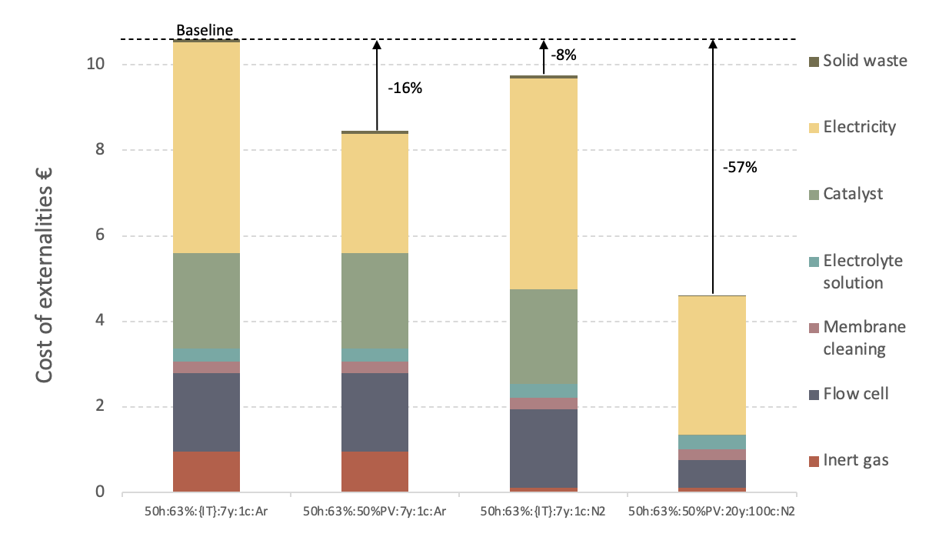
Figure S3.17: Monetization of externalities in €: sensitivity analysis for scenario 50h:63%:{IT}:7y:1c:Ar (FU = 1 g NH₃).

Regarding the estimation of the CRM inventory flows of NH₃ production scenarios, the solid waste and wastewater sent to treatment were excluded from the evaluation and assignment of a score as they entailed a minor contribution to the overall CRM consumption (<1% in terms of mass) and do not represent a sub-process under control of the technology developers. Results are reported in Tables SX 3.1-SX 3.5 of the supplementary Excel® sheets disclosed as a separate file named SX3_CriticalRawMaterials_NH3_Inventories. Criticality scores (CS) for scenario 50h:63%:{IT}:7y:1c:Ar were plotted against environmental impact results for EF 3.1 categories and reported below in Figures S3.18-3.33.
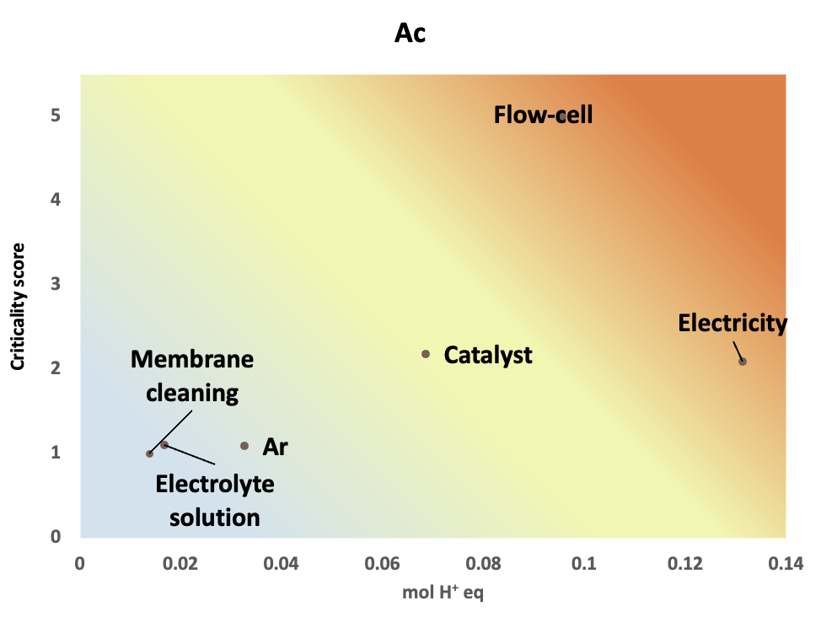
Figure S3.18: Scenario 50h:63%:{IT}:7y:1c:Ar: Criticality scores plotted against acidification (Ac) category results.
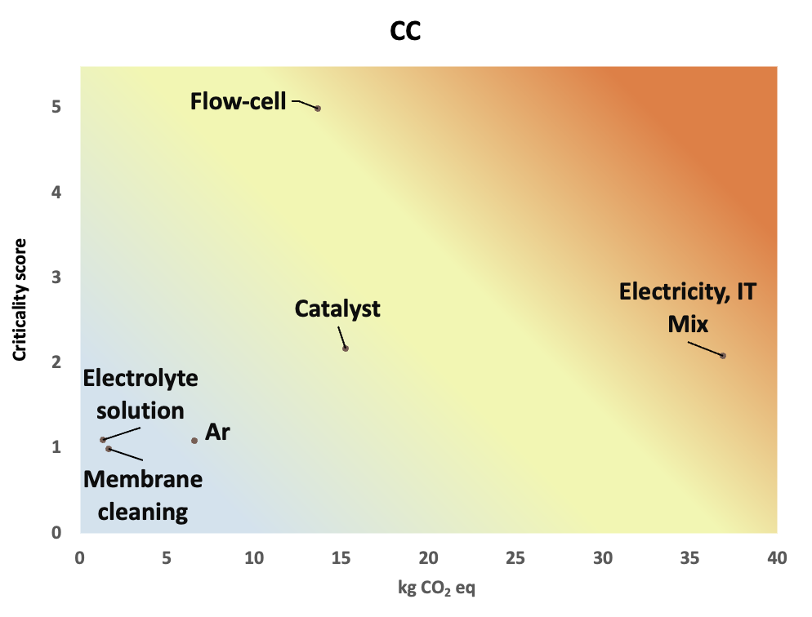
Figure S3.19: Scenario 50h:63%:{IT}:7y:1c:Ar: Criticality scores plotted against climate change (CC) category results.
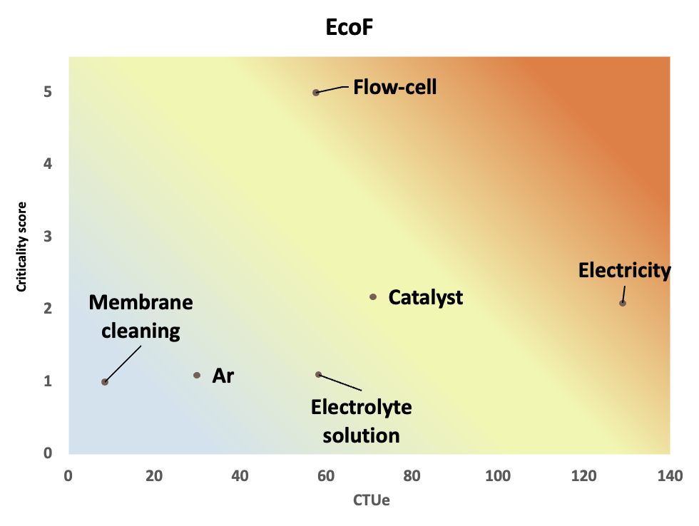
Figure S3.20: Scenario 50h:63%:{IT}:7y:1c:Ar: Criticality scores plotted against eutrophication, freshwater (EF) category results.
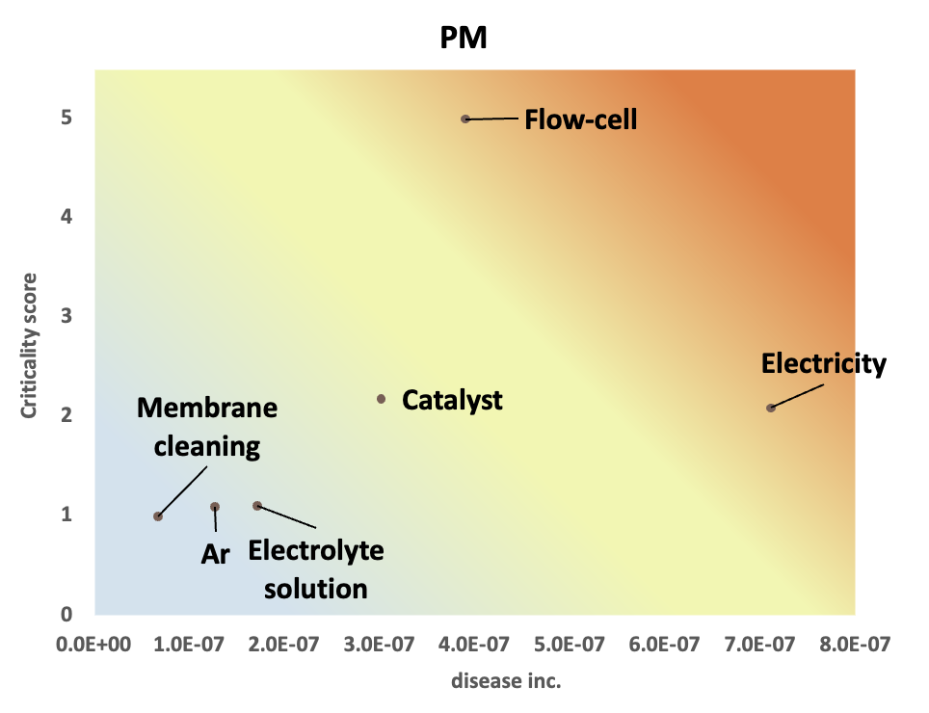
Figure S3.21: Scenario 50h:63%:{IT}:7y:1c:Ar: Criticality scores plotted against particulate matter (PM) category results.
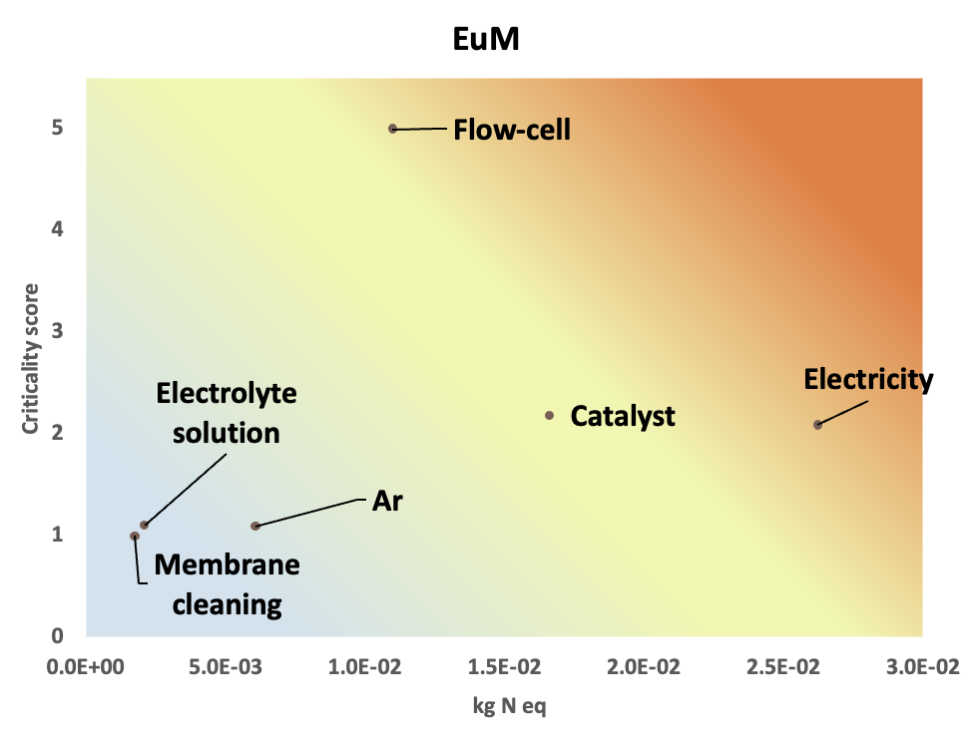
Figure S3.22: Scenario 50h:63%:{IT}:7y:1c:Ar: Criticality scores plotted against eutrophication, marine (EuM) category results.
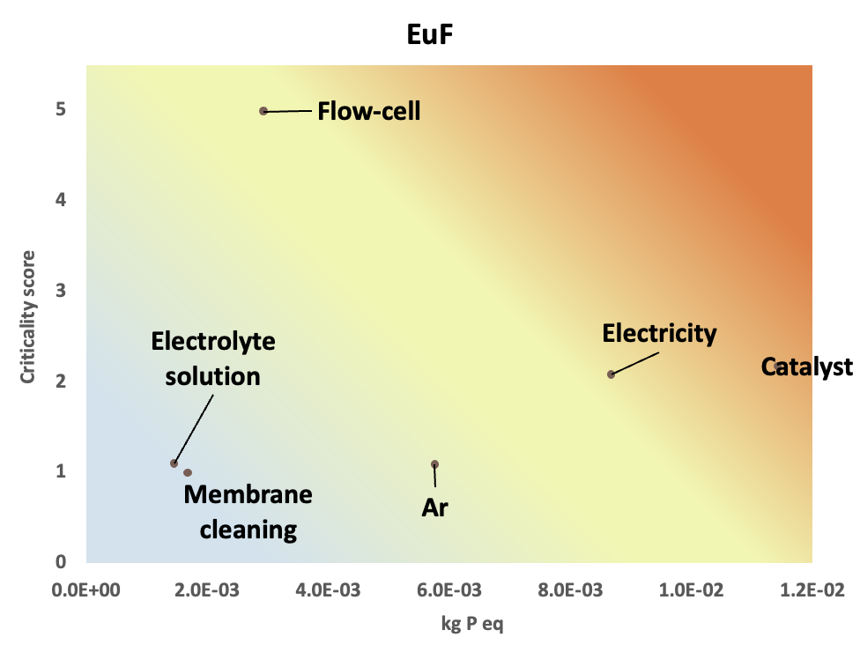
Figure S3.23: Scenario 50h:63%:{IT}:7y:1c:Ar: Criticality scores plotted against eutrophication, freshwater (EuF) category results.
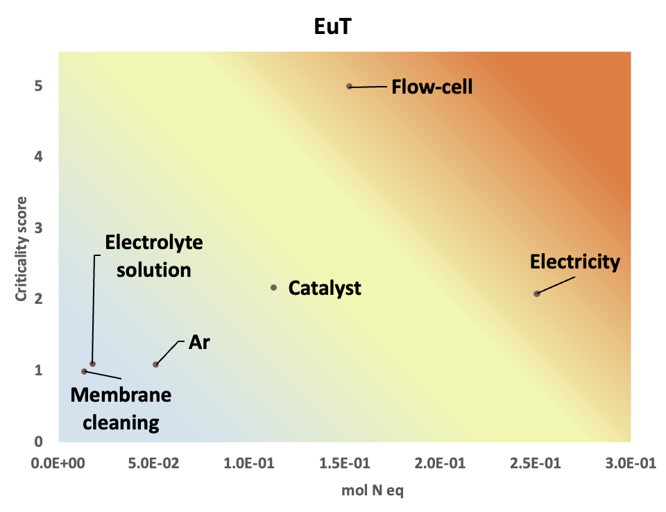
Figure S3.24: Scenario 50h:63%:{IT}:7y:1c:Ar: Criticality scores plotted against eutrophication, terrestrial (EuT) category results.
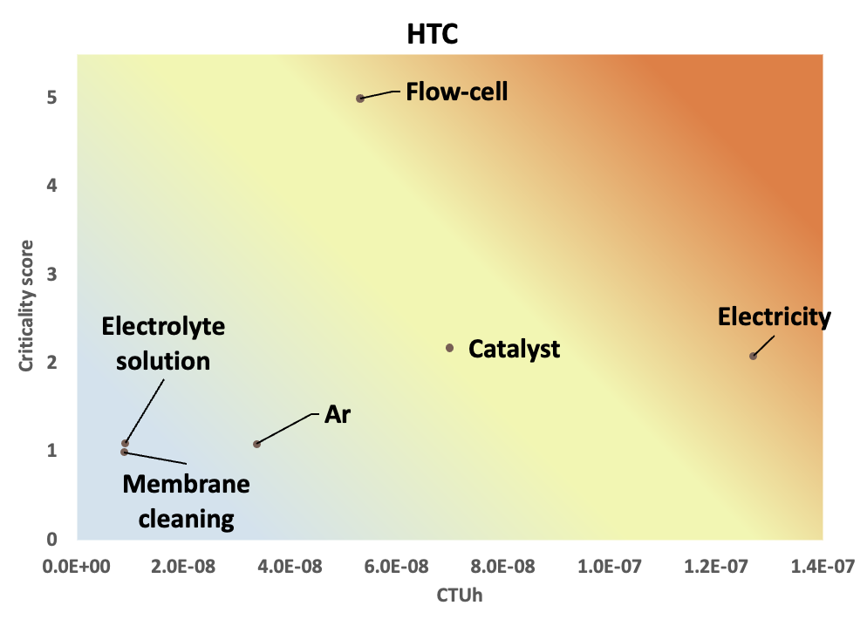
Figure S3.25: Scenario 50h:63%:{IT}:7y:1c:Ar: Criticality scores plotted against human toxicity, cancer (HTC) category results.
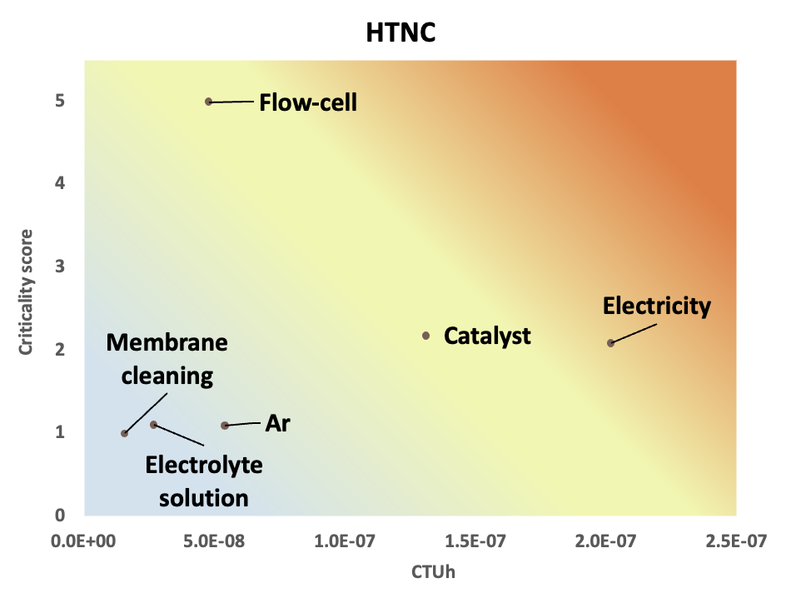
Figure S3.26: Scenario 50h:63%:{IT}:7y:1c:Ar: Criticality scores plotted against human toxicity, on-cancer (HTNC) category results.
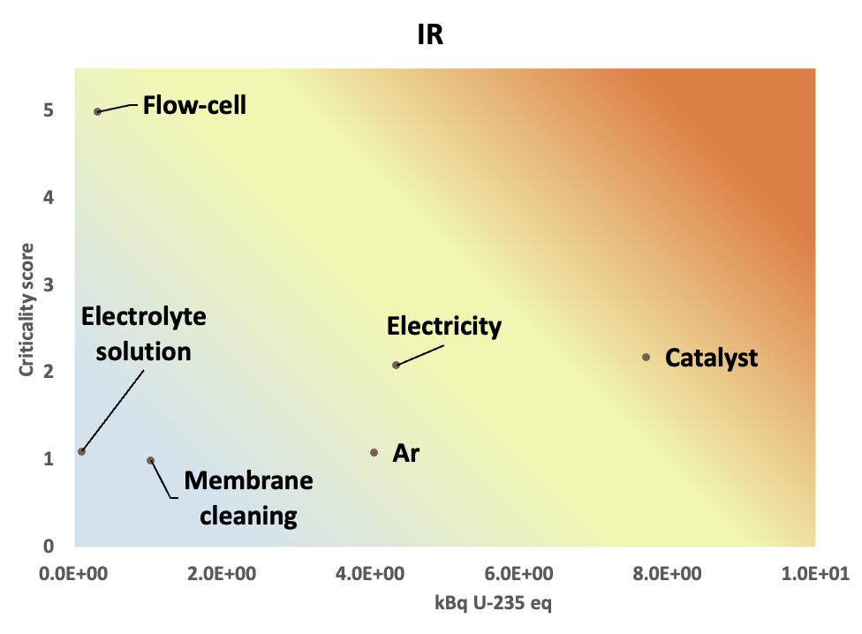Figure S3.27: Scenario 50h:63%:{IT}:7y:1c:Ar: Criticality scores plotted against ionising radiation (IR). category results.
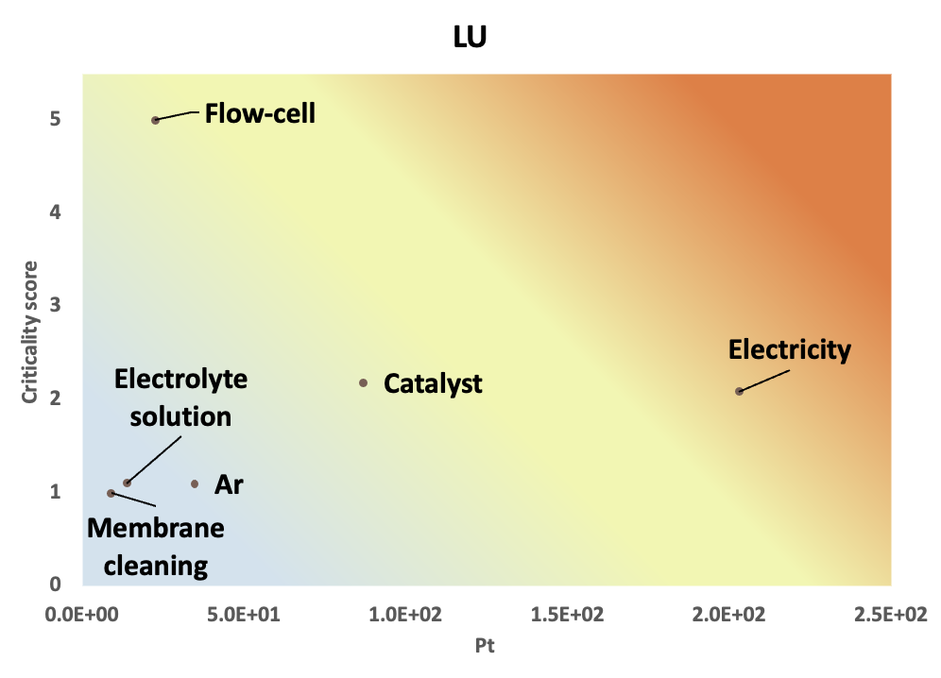
Figure S3.28: Scenario 50h:63%:{IT}:7y:1c:Ar: Criticality scores plotted against land use (LU) category results.
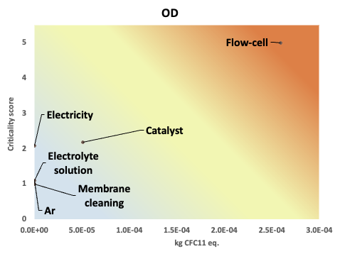
Figure S3.29: Scenario 50h:63%:{IT}:7y:1c:Ar: Criticality scores plotted against ozone depletion (OD) category results.
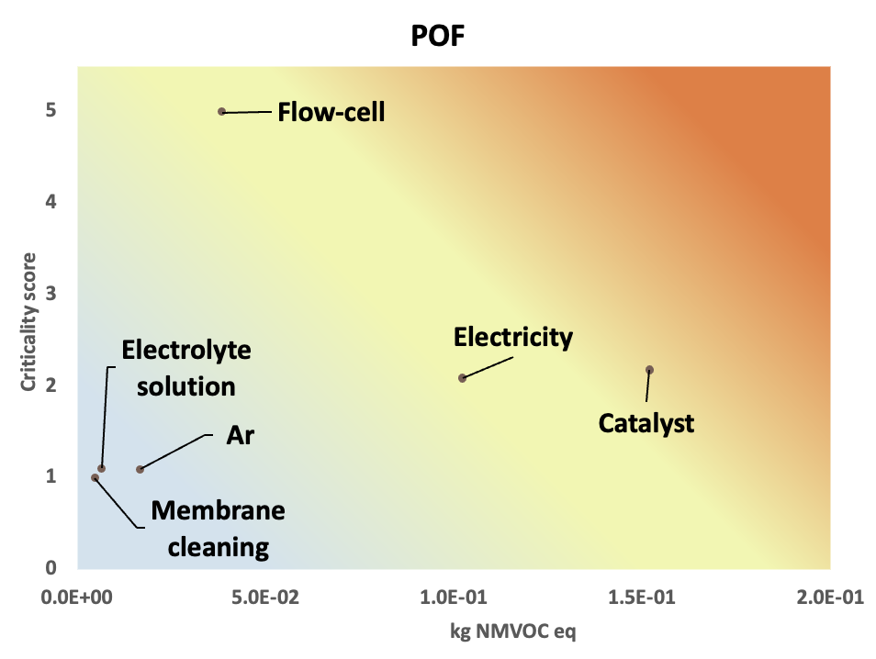
Figure S3.30: Scenario 50h:63%:{IT}:7y:1c:Ar: Criticality scores plotted against photochemical ozone formation (POF) category results.
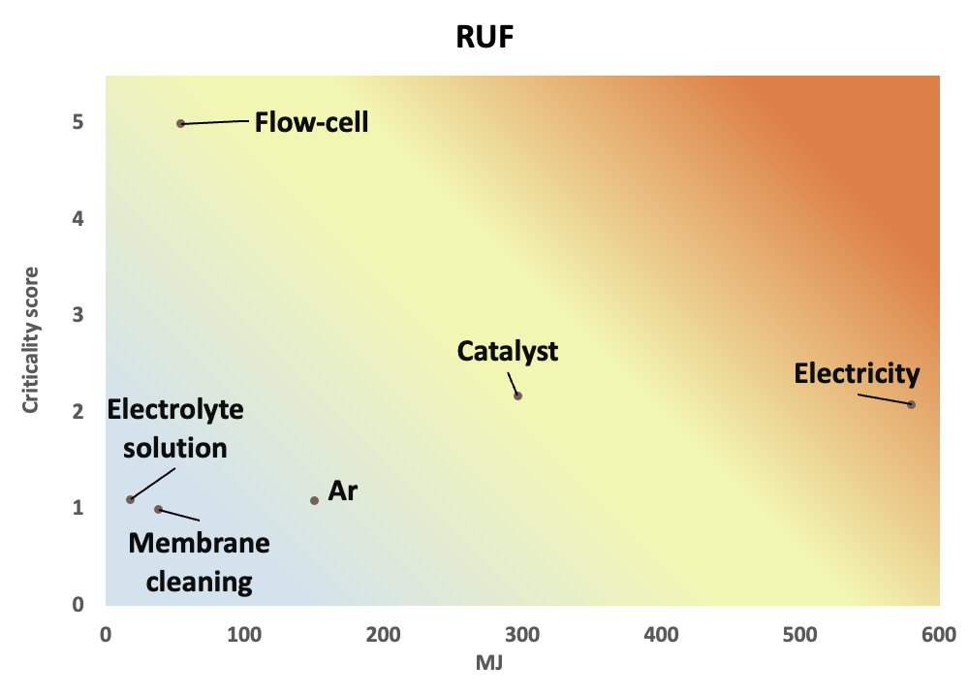
Figure S3.31: Scenario 50h:63%:{IT}:7y:1c:Ar: Criticality scores plotted against resource use, fossils (RUF) category results.
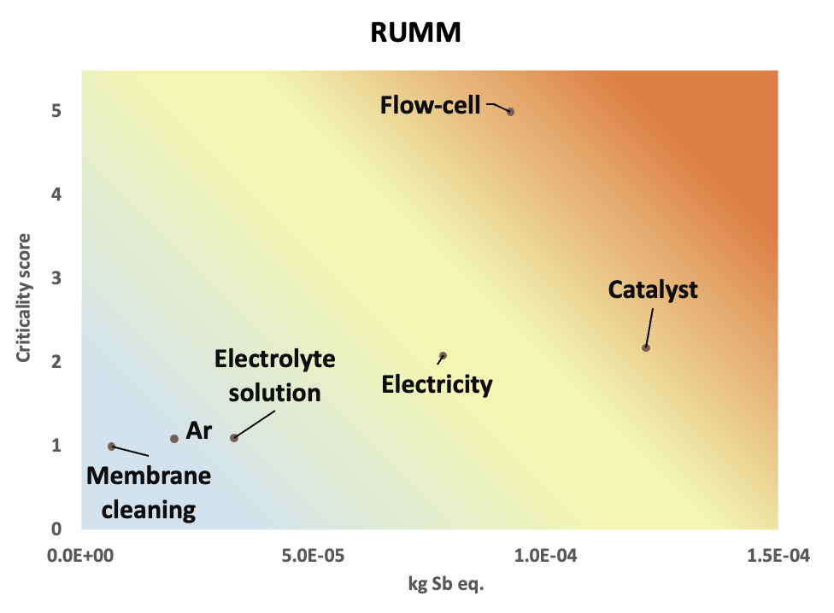
Figure S3.32: Scenario 50h:63%:{IT}:7y:1c:Ar: Criticality scores plotted against resource use, minerals and metals (RUMM) category results.
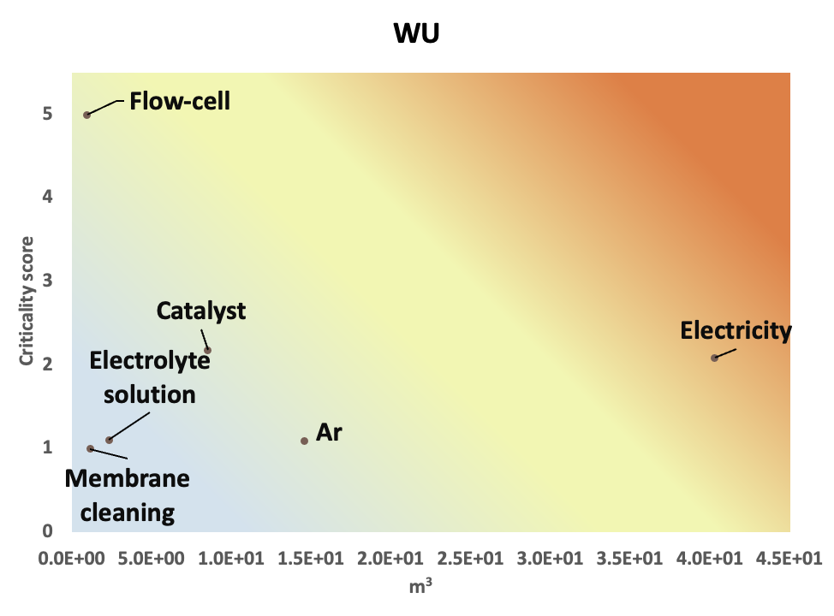
Figure S3.33: Scenario 50h:63%:{IT}:7y:1c:Ar: Criticality scores plotted against water use (WU) category results.

The consumption of electricity reports the highest impacts on 11 out of 16 categories, reporting a criticality score equal to 1.9; the flow-cell, contributing for the majority of the overall CRMs consumption, is the highest contributor to the Ac and OD categories, while reporting the lowest contribution to the WU category and second lowest to the LU category.

Section S3.3.1: Criticality-adjusted mass flows, sensitivity analysis
The results of the sensitivity analysis conducted to evaluate the selection of different CFs for the critical mass flows in the inventory of the 50h:63%:{IT}:7y:1c:Ar are reported below, in Table S3.29 and in Figure S3.34.

Sensitivity scenario →  Sub-process ↓ | 50h, NO CF | 50h, CF12 BASELINE | 50h, CF10 | 50h, CF11 | 50h, CF13 | 50h, CF14 | 50h, CF15 | 50h, CF16 | 50h, CF17 | 50h, CF18 | 50h, CF19 | Unit
Total | 3.2E+02 | 5.5E+02 | 1.5E+03 | 1.3E+02 | 1.5E+03 | 1.8E+02 | 4.4E+02 | 2.7E+02 | 2.9E+02 | 4.6E+02 | 1.7E+02 | g
Ar | 6.3E+00 | 1.3E+01 | 3.6E+01 | 6.2E+00 | 3.4E+01 | 4.1E+00 | 1.2E+01 | 3.9E+00 | 4.6E+00 | 1.2E+01 | 3.5E+00 | g
Flow cell | 2.0E+02 | 3.3E+02 | 9.1E+02 | 6.0E+01 | 8.5E+02 | 1.0E+02 | 2.4E+02 | 1.8E+02 | 1.9E+02 | 2.5E+02 | 1.0E+02 | g
Membrane cleaning | 2.9E+00 | 5.4E+00 | 1.5E+01 | 1.8E+00 | 1.5E+01 | 1.8E+00 | 5.5E+00 | 1.9E+00 | 2.2E+00 | 5.7E+00 | 1.6E+00 | g
Electrolyte solution | 7.8E+00 | 1.4E+01 | 3.9E+01 | 5.8E+00 | 4.0E+01 | 4.8E+00 | 1.2E+01 | 4.5E+00 | 5.5E+00 | 1.3E+01 | 4.1E+00 | g
MoS₂ catalyst | 6.0E+01 | 1.0E+02 | 2.8E+02 | 2.8E+01 | 2.7E+02 | 3.3E+01 | 7.8E+01 | 4.7E+01 | 5.1E+01 | 8.2E+01 | 3.1E+01 | g
Electricity | 4.8E+01 | 9.3E+01 | 2.6E+02 | 3.1E+01 | 2.5E+02 | 3.0E+01 | 9.5E+01 | 3.4E+01 | 3.8E+01 | 9.9E+01 | 2.8E+01 | g

Table S3.33: Mass flows of critical raw materials in the life cycle inventory of NH₃ production, Scenario 50h:63%:{IT}:7y:1c:Ar. Scenario “50h, NO CF” represents raw material flows without the application of any characterization factor; scenario “50h, CF12 BASELINE” adopts the CF calculated as reported in Equation (7), Section S2.3, and is selected as the preferred option to assess the criticality of the calculated inventory flows. The other reported sensitivity scenarios are presented to explore how results change as an effect of different weighting methodologies.
The equations adopted to calculate the selected CFs are reported in Hackenhaar et al., 2025 [62] and in Table SX3.6, Excel® supplementary file SX3_CriticalRawMaterials_NH3_Inventories.
All results are expressed in grams of consumed CRMs.
Figure S3.34: Percentage contribution of the NH₃ production sub-process to the overall consumption of CRMs; sensitivity analysis for Scenario 50h:63%:{IT}:7y:1c:Ar. CFs are extrapolated from the work of Hackenhaar et al. [62].

Results of the sensitivity analysis reported in Figure S3.30 show that the flow cell presents the highest contribution to the overall consumption of CRMs with an average of 58%, regardless of the adopted CF, followed by the production of the MoS₂ catalyst (18% average) and the consumption of electricity (17% average). In the context of the assessed electrochemical NH₃ production lab-scale process, the sensitivity analysis confirms that the manufacture of the flow cell mostly contributes to the depletion of CRMs, mainly associated with the consumption of fluorspar, material carrying the highest mass flow value in the NH₃ inventory. Calculated results therefore confirm the higher contribution of the mass term, compared to the EI and SR scores of the assessed material inventory flows.

Section S3.4: ReCiPe 2016 (H)/v 1.11 results
ReCiPe 2016 (H)/v 1.11 [67] method was adopted to extend the analysis on a global level across 18 midpoint issue-focused and 3 endpoint receptor-focused categories, under a hierarchical perspective assumed as representative of the societal organization in which the process is being developed [68].The manufacture of the flow-cell and the production of NH₃ were analysed both on a midpoint and on an endpoint level.

Section 3.4.1: Flow cell (Level I)
Similarly to the results calculated with the EF 3.1 method, the structural components report the highest contribution to the burdens in the categories associated with global warming and stratospheric ozone depletion, entailing higher impacts also in the ionizing radiation and terrestrial ecotoxicity categories. For the other considered issues, the electrodes sub-assembly accounts for the highest contribution, while the membrane contributes less than 1% on average across categories, with the highest contribution equal to 4% for water consumption. On an endpoint level (Table S3.29), the electrodes report the highest impacts for human health, ecosystems and resource consumption, with the structural components bearing a significant contribution for all categories (39% average). Cumulative results expressed as a single score are collected in Table S3.30 and show that the electrodes sub-assembly implies the highest contribution to the overall environmental profile, different from the EF 3.1 cumulative results, that show a higher overall contribution for the structural components. This difference between the ReCiPe 2016 and EF 3.1 is associated with the different normalization and weighting methods and factors applied in the two impact assessment methods.
Impact category | Unit | Total | Structural components | Electrodes | Membrane
Global warming | kg CO₂ eq | 7.5E+01 | 6.0E+01 | 1.5E+01 | 4.1E-01
Stratospheric ozone depletion | kg CFC11 eq | 1.6E-03 | 1.6E-03 | 1.8E-05 | 6.7E-06
Ionizing radiation | kBq Co-60 eq | 1.6E+00 | 8.3E-01 | 7.0E-01 | 3.4E-02
Ozone formation, Human health | kg NOx eq | 1.6E-01 | 1.1E-02 | 1.4E-01 | 2.8E-04
Fine particulate matter formation | kg PM2.5 eq | 1.1E-01 | 9.6E-03 | 1.0E-01 | 1.6E-04
Ozone formation, Terrestrial ecosystems | kg NOx eq | 1.6E-01 | 1.2E-02 | 1.5E-01 | 3.1E-04
Terrestrial acidification | kg SO₂ eq | 3.8E-01 | 2.6E-02 | 3.5E-01 | 4.6E-04
Freshwater eutrophication | kg P eq | 2.1E-02 | 2.6E-03 | 1.8E-02 | 5.7E-05
Marine eutrophication | kg N eq | 8.7E-04 | 2.6E-04 | 6.0E-04 | 1.3E-05
Terrestrial ecotoxicity | kg 1,4-DCB | 3.3E+02 | 2.0E+02 | 1.3E+02 | 1.4E+00
Freshwater ecotoxicity | kg 1,4-DCB | 5.9E+00 | 4.6E-01 | 5.4E+00 | 1.1E-02
Marine ecotoxicity | kg 1,4-DCB | 8.0E+00 | 9.2E-01 | 7.1E+00 | 1.5E-02
Human carcinogenic toxicity | kg 1,4-DCB | 1.2E+01 | 3.9E+00 | 8.3E+00 | 2.8E-02
Human non-carcinogenic toxicity | kg 1,4-DCB | 2.2E+02 | 1.2E+01 | 2.1E+02 | 1.9E-01
Land use | m²a crop eq | 5.5E+00 | 2.2E-01 | 5.3E+00 | 1.6E-02
Mineral resource scarcity | kg Cu eq | 1.2E+00 | 6.8E-02 | 1.2E+00 | 4.7E-04
Fossil resource scarcity | kg oil eq | 6.5E+00 | 2.0E+00 | 4.4E+00 | 5.9E-02
Water consumption | m³ | 1.7E-01 | 7.8E-02 | 8.3E-02 | 5.8E-03
Table S3.34: Midpoint environmental impacts associated with the manufacture of the flow-cell (1p); ReCiPe 2016 midpoint (H)/v 1.13 impact assessment method.

Damage category | Unit | Total | Structural components | Electrodes | Membrane
Human health | DALY | 2.3E-04 | 7.8E-05 | 1.5E-04 | 6.2E-07
Ecosystems | species.yr | 3.8E-07 | 1.8E-07 | 2.0E-07 | 1.5E-09
Resources | USD2013 | 1.8E+00 | 6.4E-01 | 1.1E+00 | 2.1E-02
Table S3.35: Endpoint environmental impacts associated with the manufacture of the flow-cell (1p); ReCiPe 2016 endpoint (H)/ World (H)v 1.13 impact assessment method.

Damage category | Unit | Total | Structural components | Electrodes | Membrane
Total | Pt | 4.0E+00 | 1.4E+00 | 2.6E+00 | 1.1E-02
Global warming, Human health | Pt | 1.2E+00 | 9.2E-01 | 2.4E-01 | 6.3E-03
Global warming, Terrestrial ecosystems | Pt | 5.7E-02 | 4.5E-02 | 1.2E-02 | 3.1E-04
Global warming, Freshwater ecosystems | Pt | 1.6E-06 | 1.2E-06 | 3.2E-07 | 8.4E-09
Stratospheric ozone depletion | Pt | 1.5E-02 | 1.4E-02 | 1.6E-04 | 6.0E-05
Ionizing radiation | Pt | 2.2E-04 | 1.2E-04 | 1.0E-04 | 4.8E-06
Ozone formation, Human health | Pt | 2.4E-03 | 1.6E-04 | 2.2E-03 | 4.3E-06
Fine particulate matter formation | Pt | 1.2E+00 | 1.0E-01 | 1.1E+00 | 1.6E-03
Ozone formation, Terrestrial ecosystems | Pt | 5.6E-03 | 4.1E-04 | 5.2E-03 | 1.1E-05
Terrestrial acidification | Pt | 2.2E-02 | 1.5E-03 | 2.0E-02 | 2.6E-05
Freshwater eutrophication | Pt | 3.7E-03 | 4.7E-04 | 3.3E-03 | 1.0E-05
Marine eutrophication | Pt | 4.0E-07 | 1.2E-07 | 2.7E-07 | 5.9E-09
Terrestrial ecotoxicity | Pt | 1.0E-03 | 6.2E-04 | 3.9E-04 | 4.3E-06
Freshwater ecotoxicity | Pt | 1.1E-03 | 8.6E-05 | 1.0E-03 | 2.0E-06
Marine ecotoxicity | Pt | 2.3E-04 | 2.6E-05 | 2.0E-04 | 4.3E-07
Human carcinogenic toxicity | Pt | 6.8E-01 | 2.2E-01 | 4.6E-01 | 1.5E-03
Human non-carcinogenic toxicity | Pt | 8.3E-01 | 4.5E-02 | 7.8E-01 | 7.1E-04
Land use | Pt | 1.3E-02 | 5.2E-04 | 1.3E-02 | 3.8E-05
Mineral resource scarcity | Pt | 2.0E-03 | 1.1E-04 | 1.9E-03 | 7.7E-07
Fossil resource scarcity | Pt | 1.1E-02 | 4.4E-03 | 6.1E-03 | 1.5E-04
Water consumption, Human health | Pt | 3.7E-03 | 2.1E-03 | 1.5E-03 | 1.6E-04
Water consumption, Terrestrial ecosystem | Pt | 4.6E-04 | 2.0E-04 | 2.5E-04 | 1.1E-05
Water consumption, Aquatic ecosystems | Pt | 4.5E-08 | 1.1E-08 | 3.3E-08 | 7.2E-10
Table S3.36: Cumulative environmental impacts associated with the manufacture of the flow-cell (1p); ReCiPe 2016 endpoint (H)/World (H/A), v 1.13 impact assessment method; unit: Points (Pt).

Impact category | Unit | Total | Nitrates | Ar | Flow-Cell | Membrane cleaning | Electrolyte solution | Catalyst | Electricity | Wastewater | Hazardous waste
Global warming | kg CO₂ eq | 6.5E+02 | 0.0E+00 | 8.1E+00 | 1.6E+01 | 5.1E+01 | 4.1E+01 | 4.7E+02 | 4.6E+01 | 2.7E-01 | 1.8E+01
Stratospheric ozone depletion | kg CFC11 eq | 2.4E-03 | 0.0E+00 | 4.2E-06 | 3.5E-04 | 2.8E-05 | 1.3E-05 | 2.0E-03 | 3.0E-05 | 1.1E-06 | 3.5E-06
Ionizing radiation | kBq Co-60 eq | 2.6E+02 | 0.0E+00 | 4.6E+00 | 3.5E-01 | 2.9E+01 | 3.1E+00 | 2.2E+02 | 5.2E+00 | 4.0E-02 | 4.1E-01
Ozone formation, Human health | kg NOx eq | 1.7E+00 | 0.0E+00 | 1.4E-02 | 3.4E-02 | 9.3E-02 | 1.3E-01 | 1.4E+00 | 7.3E-02 | 6.3E-04 | 1.3E-02
Fine particulate matter formation | kg PM2.5 eq | 8.9E-01 | 0.0E+00 | 1.1E-02 | 2.5E-02 | 1.1E-01 | 1.2E-01 | 5.8E-01 | 3.9E-02 | 3.1E-04 | 5.2E-03
Ozone formation, Terrestrial ecosystems | kg NOx eq | 2.2E+00 | 0.0E+00 | 1.5E-02 | 3.5E-02 | 9.7E-02 | 1.3E-01 | 1.8E+00 | 7.9E-02 | 6.5E-04 | 1.4E-02
Terrestrial acidification | kg SO₂ eq | 2.3E+00 | 0.0E+00 | 2.7E-02 | 8.1E-02 | 3.0E-01 | 3.6E-01 | 1.4E+00 | 1.1E-01 | 8.0E-04 | 1.3E-02
Freshwater eutrophication | kg P eq | 5.1E-01 | 0.0E+00 | 7.5E-03 | 4.5E-03 | 5.4E-02 | 4.7E-02 | 3.7E-01 | 1.3E-02 | 1.6E-03 | 5.6E-03
Marine eutrophication | kg N eq | 1.0E-01 | 1.1E-02 | 6.8E-04 | 1.9E-04 | 5.8E-03 | 5.5E-03 | 7.1E-02 | 2.3E-03 | 3.1E-03 | 3.4E-04
Terrestrial ecotoxicity | kg 1,4-DCB | 5.0E+03 | 0.0E+00 | 6.0E+01 | 7.1E+01 | 4.7E+02 | 9.1E+02 | 3.2E+03 | 2.8E+02 | 6.6E+00 | 5.6E+01
Freshwater ecotoxicity | kg 1,4-DCB | 4.2E+01 | 0.0E+00 | 4.4E-01 | 1.3E+00 | 3.0E+00 | 4.8E+00 | 3.0E+01 | 1.8E+00 | 2.5E-02 | 3.6E-01
Marine ecotoxicity | kg 1,4-DCB | 6.0E+01 | 0.0E+00 | 6.5E-01 | 1.7E+00 | 4.5E+00 | 7.0E+00 | 4.3E+01 | 2.7E+00 | 4.0E-02 | 5.4E-01
Human carcinogenic toxicity | kg 1,4-DCB | 9.2E+01 | 0.0E+00 | 1.1E+00 | 2.6E+00 | 7.8E+00 | 1.6E+01 | 5.7E+01 | 4.5E+00 | 1.4E-01 | 3.2E+00
Human non-carcinogenic toxicity | kg 1,4-DCB | 9.5E+02 | 0.0E+00 | 1.2E+01 | 4.7E+01 | 8.1E+01 | 9.4E+01 | 6.7E+02 | 3.6E+01 | 2.2E+00 | 8.6E+00
Land use | m²a crop eq | 7.5E+01 | 0.0E+00 | 4.1E-01 | 1.2E+00 | 2.6E+00 | 2.8E+00 | 6.6E+01 | 2.4E+00 | 9.1E-03 | 1.4E-01
Mineral resource scarcity | kg Cu eq | 2.4E+00 | 0.0E+00 | 1.7E-02 | 2.7E-01 | 1.3E-01 | 3.7E-01 | 1.6E+00 | 6.5E-02 | 2.0E-03 | 1.7E-02
Fossil resource scarcity | kg oil eq | 1.6E+02 | 0.0E+00 | 2.3E+00 | 1.4E+00 | 1.4E+01 | 1.1E+01 | 1.2E+02 | 1.5E+01 | 5.1E-02 | 1.8E+00
Water consumption | m³ | 1.4E+01 | 0.0E+00 | 5.1E-01 | 3.6E-02 | 1.4E+00 | 1.5E+00 | 1.0E+01 | 1.3E+00 | -6.6E-01 | 3.8E-02
Section S3.4.2: Ammonia production (Level II)
Table S3.37: Midpoint environmental impacts associated with the production of NH₃, scenario 2h:85%:{IT}:7y:1c:Ar (1 g); ReCiPe 2016 midpoint (H)/World (H) v 1.13 impact assessment method.

Impact category | Unit | Total | Nitrates | Ar | Flow-Cell | Membrane cleaning | Electrolyte solution | Catalyst | Electricity | Wastewater | Hazardous waste
Global warming | kg CO₂ eq | 7.7E+01 | 0.0E+00 | 6.7E+00 | 1.3E+01 | 1.7E+00 | 1.3E+00 | 1.5E+01 | 3.8E+01 | 8.9E-03 | 5.8E-01
Stratospheric ozone depletion | kg CFC11 eq | 3.8E-04 | 0.0E+00 | 3.5E-06 | 2.9E-04 | 9.1E-07 | 4.4E-07 | 6.5E-05 | 2.4E-05 | 3.5E-08 | 1.1E-07
Ionizing radiation | kBq Co-60 eq | 1.7E+01 | 0.0E+00 | 3.8E+00 | 2.9E-01 | 9.7E-01 | 1.0E-01 | 7.2E+00 | 4.2E+00 | 1.3E-03 | 1.3E-02
Ozone formation, Human health | kg NOx eq | 1.5E-01 | 0.0E+00 | 1.2E-02 | 2.8E-02 | 3.1E-03 | 4.1E-03 | 4.6E-02 | 6.0E-02 | 2.1E-05 | 4.1E-04
Fine particulate matter formation | kg PM2.5 eq | 8.8E-02 | 0.0E+00 | 9.2E-03 | 2.0E-02 | 3.6E-03 | 4.0E-03 | 1.9E-02 | 3.2E-02 | 1.0E-05 | 1.7E-04
Ozone formation, Terrestrial ecosystems | kg NOx eq | 1.7E-01 | 0.0E+00 | 1.2E-02 | 2.8E-02 | 3.2E-03 | 4.3E-03 | 6.0E-02 | 6.4E-02 | 2.1E-05 | 4.5E-04
Terrestrial acidification | kg SO₂ eq | 2.5E-01 | 0.0E+00 | 2.2E-02 | 6.7E-02 | 9.9E-03 | 1.2E-02 | 4.7E-02 | 8.9E-02 | 2.6E-05 | 4.4E-04
Freshwater eutrophication | kg P eq | 3.6E-02 | 0.0E+00 | 6.2E-03 | 3.7E-03 | 1.8E-03 | 1.5E-03 | 1.2E-02 | 1.0E-02 | 5.1E-05 | 1.8E-04
Marine eutrophication | kg N eq | 5.6E-03 | 1.1E-04 | 5.6E-04 | 1.5E-04 | 1.9E-04 | 1.8E-04 | 2.3E-03 | 1.9E-03 | 1.0E-04 | 1.1E-05
Terrestrial ecotoxicity | kg 1,4-DCB | 4.9E+02 | 0.0E+00 | 5.0E+01 | 5.8E+01 | 1.6E+01 | 3.0E+01 | 1.0E+02 | 2.3E+02 | 2.2E-01 | 1.8E+00
Freshwater ecotoxicity | kg 1,4-DCB | 4.2E+00 | 0.0E+00 | 3.6E-01 | 1.0E+00 | 1.0E-01 | 1.6E-01 | 9.8E-01 | 1.5E+00 | 8.3E-04 | 1.2E-02
Marine ecotoxicity | kg 1,4-DCB | 6.0E+00 | 0.0E+00 | 5.4E-01 | 1.4E+00 | 1.5E-01 | 2.3E-01 | 1.4E+00 | 2.2E+00 | 1.3E-03 | 1.8E-02
Human carcinogenic toxicity | kg 1,4-DCB | 9.5E+00 | 0.0E+00 | 9.2E-01 | 2.2E+00 | 2.6E-01 | 5.1E-01 | 1.9E+00 | 3.7E+00 | 4.7E-03 | 1.1E-01
Human non-carcinogenic toxicity | kg 1,4-DCB | 1.1E+02 | 0.0E+00 | 9.6E+00 | 3.8E+01 | 2.7E+00 | 3.1E+00 | 2.2E+01 | 2.9E+01 | 7.3E-02 | 2.8E-01
Land use | m²a crop eq | 5.6E+00 | 0.0E+00 | 3.4E-01 | 9.7E-01 | 8.5E-02 | 9.1E-02 | 2.2E+00 | 2.0E+00 | 3.0E-04 | 4.5E-03
Mineral resource scarcity | kg Cu eq | 3.6E-01 | 0.0E+00 | 1.4E-02 | 2.2E-01 | 4.1E-03 | 1.2E-02 | 5.2E-02 | 5.3E-02 | 6.6E-05 | 5.6E-04
Fossil resource scarcity | kg oil eq | 2.0E+01 | 0.0E+00 | 1.9E+00 | 1.1E+00 | 4.7E-01 | 3.8E-01 | 3.8E+00 | 1.2E+01 | 1.7E-03 | 6.0E-02
Water consumption | m³ | 1.9E+00 | 0.0E+00 | 4.2E-01 | 2.9E-02 | 4.6E-02 | 5.0E-02 | 3.4E-01 | 1.0E+00 | -2.2E-02 | 1.2E-03
Table S3.38: Midpoint environmental impacts associated with the production of NH₃, scenario 50h:63%:{IT}:7y:1c:Ar (1 g); ReCiPe 2016 midpoint (H)/World (H) v 1.13 impact assessment method.

Impact category | Unit | Total | Nitrates | Ar | Flow-Cell | Membrane cleaning | Electrolyte solution | Catalyst | Electricity | Wastewater | Hazardous waste
Global warming | kg CO₂ eq | 8.6E+01 | 0.0E+00 | 8.1E+00 | 1.6E+01 | 1.4E+00 | 1.1E+00 | 1.3E+01 | 4.6E+01 | 7.6E-03 | 5.0E-01
Stratospheric ozone depletion | kg CFC11 eq | 4.4E-04 | 0.0E+00 | 4.2E-06 | 3.5E-04 | 7.8E-07 | 3.8E-07 | 5.6E-05 | 3.0E-05 | 3.0E-08 | 9.8E-08
Ionizing radiation | kBq Co-60 eq | 1.7E+01 | 0.0E+00 | 4.6E+00 | 3.5E-01 | 8.3E-01 | 8.6E-02 | 6.1E+00 | 5.1E+00 | 1.1E-03 | 1.1E-02
Ozone formation, Human health | kg NOx eq | 1.7E-01 | 0.0E+00 | 1.4E-02 | 3.4E-02 | 2.6E-03 | 3.5E-03 | 3.9E-02 | 7.3E-02 | 1.8E-05 | 3.5E-04
Fine particulate matter formation | kg PM2.5 eq | 9.7E-02 | 0.0E+00 | 1.1E-02 | 2.5E-02 | 3.1E-03 | 3.4E-03 | 1.6E-02 | 3.8E-02 | 8.8E-06 | 1.5E-04
Ozone formation, Terrestrial ecosystems | kg NOx eq | 1.9E-01 | 0.0E+00 | 1.5E-02 | 3.4E-02 | 2.7E-03 | 3.7E-03 | 5.1E-02 | 7.8E-02 | 1.8E-05 | 3.8E-04
Terrestrial acidification | kg SO₂ eq | 2.8E-01 | 0.0E+00 | 2.7E-02 | 8.1E-02 | 8.5E-03 | 1.0E-02 | 4.0E-02 | 1.1E-01 | 2.3E-05 | 3.8E-04
Freshwater eutrophication | kg P eq | 3.8E-02 | 0.0E+00 | 7.5E-03 | 4.5E-03 | 1.5E-03 | 1.3E-03 | 1.0E-02 | 1.2E-02 | 4.4E-05 | 1.6E-04
Marine eutrophication | kg N eq | 5.7E-03 | 6.1E-05 | 6.8E-04 | 1.9E-04 | 1.6E-04 | 1.5E-04 | 2.0E-03 | 2.3E-03 | 8.6E-05 | 9.5E-06
Terrestrial ecotoxicity | kg 1,4-DCB | 5.4E+02 | 0.0E+00 | 6.0E+01 | 7.1E+01 | 1.3E+01 | 2.5E+01 | 9.0E+01 | 2.8E+02 | 1.8E-01 | 1.6E+00
Freshwater ecotoxicity | kg 1,4-DCB | 4.6E+00 | 0.0E+00 | 4.4E-01 | 1.3E+00 | 8.5E-02 | 1.4E-01 | 8.4E-01 | 1.8E+00 | 7.1E-04 | 1.0E-02
Marine ecotoxicity | kg 1,4-DCB | 6.6E+00 | 0.0E+00 | 6.5E-01 | 1.7E+00 | 1.3E-01 | 2.0E-01 | 1.2E+00 | 2.7E+00 | 1.1E-03 | 1.5E-02
Human carcinogenic toxicity | kg 1,4-DCB | 1.1E+01 | 0.0E+00 | 1.1E+00 | 2.6E+00 | 2.2E-01 | 4.4E-01 | 1.6E+00 | 4.5E+00 | 4.0E-03 | 9.0E-02
Human non-carcinogenic toxicity | kg 1,4-DCB | 1.2E+02 | 0.0E+00 | 1.2E+01 | 4.7E+01 | 2.3E+00 | 2.6E+00 | 1.9E+01 | 3.5E+01 | 6.2E-02 | 2.4E-01
Land use | m²a crop eq | 6.0E+00 | 0.0E+00 | 4.1E-01 | 1.2E+00 | 7.3E-02 | 7.8E-02 | 1.9E+00 | 2.4E+00 | 2.6E-04 | 3.9E-03
Mineral resource scarcity | kg Cu eq | 4.1E-01 | 0.0E+00 | 1.7E-02 | 2.7E-01 | 3.5E-03 | 1.0E-02 | 4.4E-02 | 6.5E-02 | 5.7E-05 | 4.8E-04
Fossil resource scarcity | kg oil eq | 2.2E+01 | 0.0E+00 | 2.3E+00 | 1.4E+00 | 4.0E-01 | 3.2E-01 | 3.3E+00 | 1.5E+01 | 1.4E-03 | 5.1E-02
Water consumption | m³ | 2.2E+00 | 0.0E+00 | 5.1E-01 | 3.5E-02 | 4.0E-02 | 4.3E-02 | 2.9E-01 | 1.3E+00 | -1.8E-02 | 1.1E-03
Table S3.39: Midpoint environmental impacts associated with the production of NH₃, scenario 71h:63%:{IT}:7y:1c:Ar (1 g); ReCiPe 2016 midpoint (H)/World (H) v 1.11 impact assessment method.

Impact category | Unit | Total | Nitrates | Ar | Flow-Cell | Membrane cleaning | Electrolyte solution | Catalyst | Electricity | Wastewater | Hazardous waste
Global warming | kg CO₂ eq | 1.0E+02 | 0.0E+00 | 1.0E+01 | 2.0E+01 | 1.3E+00 | 1.0E+00 | 1.2E+01 | 5.8E+01 | 6.8E-03 | 4.4E-01
Stratospheric ozone depletion | kg CFC11 eq | 5.4E-04 | 0.0E+00 | 5.3E-06 | 4.5E-04 | 6.9E-07 | 3.4E-07 | 5.0E-05 | 3.7E-05 | 2.7E-08 | 8.7E-08
Ionizing radiation | kBq Co-60 eq | 1.9E+01 | 0.0E+00 | 5.8E+00 | 4.5E-01 | 7.3E-01 | 7.6E-02 | 5.5E+00 | 6.5E+00 | 1.0E-03 | 1.0E-02
Ozone formation, Human health | kg NOx eq | 1.9E-01 | 0.0E+00 | 1.8E-02 | 4.2E-02 | 2.3E-03 | 3.2E-03 | 3.5E-02 | 9.2E-02 | 1.6E-05 | 3.1E-04
Fine particulate matter formation | kg PM2.5 eq | 1.1E-01 | 0.0E+00 | 1.4E-02 | 3.1E-02 | 2.7E-03 | 3.0E-03 | 1.4E-02 | 4.8E-02 | 7.8E-06 | 1.3E-04
Ozone formation, Terrestrial ecosystems | kg NOx eq | 2.1E-01 | 0.0E+00 | 1.9E-02 | 4.4E-02 | 2.4E-03 | 3.3E-03 | 4.5E-02 | 9.9E-02 | 1.6E-05 | 3.4E-04
Terrestrial acidification | kg SO₂ eq | 3.3E-01 | 0.0E+00 | 3.5E-02 | 1.0E-01 | 7.6E-03 | 9.1E-03 | 3.6E-02 | 1.4E-01 | 2.0E-05 | 3.3E-04
Freshwater eutrophication | kg P eq | 4.3E-02 | 0.0E+00 | 9.5E-03 | 5.7E-03 | 1.4E-03 | 1.2E-03 | 9.3E-03 | 1.6E-02 | 3.9E-05 | 1.4E-04
Marine eutrophication | kg N eq | 6.2E-03 | 2.7E-05 | 8.6E-04 | 2.4E-04 | 1.4E-04 | 1.4E-04 | 1.8E-03 | 2.9E-03 | 7.6E-05 | 8.5E-06
Terrestrial ecotoxicity | kg 1,4-DCB | 6.3E+02 | 0.0E+00 | 7.6E+01 | 9.0E+01 | 1.2E+01 | 2.3E+01 | 8.0E+01 | 3.5E+02 | 1.6E-01 | 1.4E+00
Freshwater ecotoxicity | kg 1,4-DCB | 5.4E+00 | 0.0E+00 | 5.5E-01 | 1.6E+00 | 7.6E-02 | 1.2E-01 | 7.5E-01 | 2.3E+00 | 6.3E-04 | 9.0E-03
Marine ecotoxicity | kg 1,4-DCB | 7.8E+00 | 0.0E+00 | 8.2E-01 | 2.2E+00 | 1.1E-01 | 1.7E-01 | 1.1E+00 | 3.4E+00 | 1.0E-03 | 1.3E-02
Human carcinogenic toxicity | kg 1,4-DCB | 1.3E+01 | 0.0E+00 | 1.4E+00 | 3.3E+00 | 2.0E-01 | 3.9E-01 | 1.4E+00 | 5.7E+00 | 3.5E-03 | 8.0E-02
Human non-carcinogenic toxicity | kg 1,4-DCB | 1.4E+02 | 0.0E+00 | 1.5E+01 | 5.9E+01 | 2.0E+00 | 2.3E+00 | 1.7E+01 | 4.5E+01 | 5.5E-02 | 2.2E-01
Land use | m²a crop eq | 6.9E+00 | 0.0E+00 | 5.2E-01 | 1.5E+00 | 6.5E-02 | 6.9E-02 | 1.6E+00 | 3.1E+00 | 2.3E-04 | 3.4E-03
Mineral resource scarcity | kg Cu eq | 4.9E-01 | 0.0E+00 | 2.2E-02 | 3.4E-01 | 3.1E-03 | 9.3E-03 | 3.9E-02 | 8.2E-02 | 5.0E-05 | 4.3E-04
Fossil resource scarcity | kg oil eq | 2.7E+01 | 0.0E+00 | 2.9E+00 | 1.8E+00 | 3.6E-01 | 2.9E-01 | 2.9E+00 | 1.8E+01 | 1.3E-03 | 4.6E-02
Water consumption | m³ | 2.6E+00 | 0.0E+00 | 6.5E-01 | 4.5E-02 | 3.5E-02 | 3.8E-02 | 2.5E-01 | 1.6E+00 | -1.6E-02 | 9.5E-04
Table S3.40: Midpoint environmental impacts associated with the production of NH₃, scenario 101h:63%:{IT}:7y:1c:Ar (1 g); ReCiPe 2016 middpoint (H)/v 1.13 impact assessment method.

Damage category | Unit | Total | Nitrates | Ar | Flow-Cell | Membrane cleaning | Electrolyte solution | Catalyst | Electricity | Wastewater | Hazardous waste
Human health | DALY | 1.7E-03 | 1.7E-03 | 0.0E+00 | 2.2E-05 | 5.0E-05 | 1.6E-04 | 1.9E-04 | 1.2E-03 | 9.3E-05 | -3.8E-08
Ecosystems | species.yr | 3.8E-06 | 3.8E-06 | 1.8E-11 | 4.6E-08 | 8.3E-08 | 3.0E-07 | 3.0E-07 | 2.8E-06 | 2.1E-07 | -6.7E-09
Resources | USD2013 | 4.1E+01 | 4.1E+01 | 0.0E+00 | 5.3E-01 | 3.8E-01 | 3.2E+00 | 3.9E+00 | 2.8E+01 | 4.9E+00 | 1.6E-02
Table S3.41: Endpoint environmental impacts associated with the production of NH₃, scenario 2h:85%:{IT}:7y:1c:Ar (1 g); ReCiPe 2016 endpoint (H)/World (H/A) v 1.13 impact assessment method.

Damage category | Unit | Total | Nitrates | Ar | Flow-Cell | Membrane cleaning | Electrolyte solution | Catalyst | Electricity | Wastewater | Hazardous waste
Human health | DALY | 1.9E-04 | 0.0E+00 | 1.8E-05 | 4.1E-05 | 5.3E-06 | 6.3E-06 | 3.8E-05 | 7.6E-05 | -1.3E-09 | 1.1E-06
Ecosystems | species.yr | 3.9E-07 | 1.9E-13 | 3.7E-08 | 6.8E-08 | 9.8E-09 | 9.9E-09 | 9.2E-08 | 1.7E-07 | -2.2E-10 | 2.0E-09
Resources | USD2013 | 5.9E+00 | 0.0E+00 | 4.3E-01 | 3.1E-01 | 1.1E-01 | 1.3E-01 | 9.1E-01 | 4.0E+00 | 5.2E-04 | 2.4E-02
Table S3.42: Endpoint environmental impacts associated with the production of NH₃, scenario 50h:63%:{IT}:7y:1c:Ar (1 g); ReCiPe 2016 endpoint (H)/World (H/A) v 1.13 impact assessment method.

Damage category | Unit | Total | Nitrates | Ar | Flow-Cell | Membrane cleaning | Electrolyte solution | Catalyst | Electricity | Wastewater | Hazardous waste
Human health | DALY | 2.1E-04 | 0.0E+00 | 2.2E-05 | 5.0E-05 | 4.6E-06 | 5.4E-06 | 3.2E-05 | 9.2E-05 | -1.1E-09 | 9.1E-07
Ecosystems | species.yr | 4.3E-07 | 1.0E-13 | 4.5E-08 | 8.3E-08 | 8.4E-09 | 8.4E-09 | 7.9E-08 | 2.1E-07 | -1.9E-10 | 1.7E-09
Resources | USD2013 | 6.7E+00 | 0.0E+00 | 5.3E-01 | 3.8E-01 | 9.1E-02 | 1.1E-01 | 7.8E-01 | 4.8E+00 | 4.5E-04 | 2.0E-02
Table S3.43: Endpoint environmental impacts associated with the production of NH₃, scenario 71h:63%:{IT}:7y:1c:Ar (1 g); ReCiPe 2016 endpoint (H)/World (H/A) v 1.13 impact assessment method.

Damage category | Unit | Total | Nitrates | Ar | Flow-Cell | Membrane cleaning | Electrolyte solution | Catalyst | Electricity | Wastewater | Hazardous waste
Human health | DALY | 2.5E-04 | 0.0E+00 | 2.8E-05 | 6.4E-05 | 4.1E-06 | 4.8E-06 | 2.9E-05 | 1.2E-04 | -9.5E-10 | 8.1E-07
Ecosystems | species.yr | 5.1E-07 | 4.6E-14 | 5.7E-08 | 1.0E-07 | 7.4E-09 | 7.5E-09 | 7.0E-08 | 2.6E-07 | -1.7E-10 | 1.5E-09
Resources | USD2013 | 8.1E+00 | 0.0E+00 | 6.7E-01 | 4.8E-01 | 8.1E-02 | 9.7E-02 | 7.0E-01 | 6.1E+00 | 4.0E-04 | 1.8E-02
Table S3.44: Endpoint environmental impacts associated with the production of NH₃, scenario 101h:63%:{IT}:7y:1c:Ar (1 g); ReCiPe 2016 endpoint (H)/World (H/A) v 1.13 impact assessment method.

Damage category | Unit | Total | Nitrates | Ar | Flow-Cell | Membrane cleaning | Electrolyte solution | Catalyst | Electricity | Wastewater | Hazardous waste
Total | Pt | 3.0E+01 | 4.9E-06 | 3.8E-01 | 8.6E-01 | 2.8E+00 | 3.3E+00 | 2.0E+01 | 1.6E+00 | -2.3E-03 | 5.6E-01
Human health | Pt | 2.8E+01 | 0.0E+00 | 3.7E-01 | 8.4E-01 | 2.7E+00 | 3.2E+00 | 1.9E+01 | 1.5E+00 | -6.4E-04 | 5.4E-01
Ecosystems | Pt | 1.0E+00 | 4.9E-06 | 1.2E-02 | 2.2E-02 | 8.0E-02 | 8.1E-02 | 7.6E-01 | 5.6E-02 | -1.8E-03 | 1.6E-02
Resources | Pt | 3.0E-01 | 0.0E+00 | 3.8E-03 | 2.7E-03 | 2.3E-02 | 2.8E-02 | 2.0E-01 | 3.5E-02 | 1.1E-04 | 5.2E-03
Table S3.45: Cumulative environmental impacts associated with the production of NH₃, scenario 2h:85%:{IT}:7y:1c:Ar (1 g); ReCiPe 2016 endpoint (H)/World (H/A) v 1.13 impact assessment method; unit: Points (Pt).

Damage category | Unit | Total | Nitrates | Ar | Flow-Cell | Membrane cleaning | Electrolyte solution | Catalyst | Electricity | Wastewater | Hazardous waste
Total | Pt | 3.2E+00 | 5.2E-08 | 3.1E-01 | 7.1E-01 | 9.2E-02 | 1.1E-01 | 6.6E-01 | 1.3E+00 | -7.6E-05 | 1.8E-02
Human health | Pt | 3.1E+00 | 0.0E+00 | 3.0E-01 | 6.9E-01 | 8.9E-02 | 1.0E-01 | 6.3E-01 | 1.3E+00 | -2.1E-05 | 1.8E-02
Ecosystems | Pt | 1.0E-01 | 5.2E-08 | 1.0E-02 | 1.8E-02 | 2.6E-03 | 2.7E-03 | 2.5E-02 | 4.6E-02 | -5.9E-05 | 5.4E-04
Resources | Pt | 4.2E-02 | 0.0E+00 | 3.1E-03 | 2.2E-03 | 7.6E-04 | 9.1E-04 | 6.5E-03 | 2.8E-02 | 3.7E-06 | 1.7E-04
Table S3.46: Cumulative environmental impacts associated with the production of NH₃, scenario 50h:63%:{IT}:7y:1c:Ar (1 g); ReCiPe 2016 endpoint (H)/World (H/A) v 1.13 impact assessment method; unit: Points (Pt).

Damage category | Unit | Total | Nitrates | Ar | Flow-Cell | Membrane cleaning | Electrolyte solution | Catalyst | Electricity | Wastewater | Hazardous waste
Total | Pt | 3.6E+00 | 2.8E-08 | 3.8E-01 | 8.6E-01 | 7.9E-02 | 9.2E-02 | 5.7E-01 | 1.6E+00 | -6.5E-05 | 1.6E-02
Human health | Pt | 3.5E+00 | 0.0E+00 | 3.6E-01 | 8.4E-01 | 7.6E-02 | 8.9E-02 | 5.4E-01 | 1.5E+00 | -1.8E-05 | 1.5E-02
Ecosystems | Pt | 1.2E-01 | 2.8E-08 | 1.2E-02 | 2.2E-02 | 2.3E-03 | 2.3E-03 | 2.1E-02 | 5.5E-02 | -5.1E-05 | 4.6E-04
Resources | Pt | 4.8E-02 | 0.0E+00 | 3.8E-03 | 2.7E-03 | 6.5E-04 | 7.8E-04 | 5.6E-03 | 3.5E-02 | 3.2E-06 | 1.5E-04
Table S3.47: Cumulative environmental impacts associated with the production of NH₃, scenario 71h:63%:{IT}:7y:1c:Ar (1 g); ReCiPe 2016 endpoint (H)/World (H/A) v 1.13 impact assessment method; unit: Points (Pt).

Damage category | Unit | Total | Nitrates | Ar | Flow-Cell | Membrane cleaning | Electrolyte solution | Catalyst | Electricity | Wastewater | Hazardous waste
Total | Pt | 4.3E+00 | 1.2E-08 | 4.8E-01 | 1.1E+00 | 7.0E-02 | 8.2E-02 | 5.0E-01 | 2.1E+00 | -5.8E-05 | 1.4E-02
Human health | Pt | 4.1E+00 | 0.0E+00 | 4.6E-01 | 1.1E+00 | 6.8E-02 | 7.9E-02 | 4.8E-01 | 1.9E+00 | -1.6E-05 | 1.4E-02
Ecosystems | Pt | 1.4E-01 | 1.2E-08 | 1.6E-02 | 2.8E-02 | 2.0E-03 | 2.0E-03 | 1.9E-02 | 7.0E-02 | -4.5E-05 | 4.1E-04
Resources | Pt | 5.8E-02 | 0.0E+00 | 4.8E-03 | 3.4E-03 | 5.8E-04 | 6.9E-04 | 5.0E-03 | 4.4E-02 | 2.8E-06 | 1.3E-04
Table S3.48: Cumulative environmental impacts associated with the production of NH₃, scenario 101h:63%:{IT}:7y:1c:Ar (1 g); ReCiPe 2016 endpoint (H)/World (H/A) v 1.13 impact assessment method; unit: Points (Pt).

Damage category | Unit | Total | Nitrates | Ar | Flow-Cell | Membrane cleaning | Electrolyte solution | Catalyst | Electricity | Wastewater | Hazardous waste
Total | Pt | 2.9E+00 | 5.2E-08 | 3.1E-01 | 7.1E-01 | 9.2E-02 | 1.1E-01 | 6.6E-01 | 9.6E-01 | -7.6E-05 | 1.8E-02
Human health | Pt | 2.7E+00 | 0.0E+00 | 3.0E-01 | 6.9E-01 | 8.9E-02 | 1.0E-01 | 6.3E-01 | 9.1E-01 | -2.1E-05 | 1.8E-02
Ecosystems | Pt | 9.0E-02 | 5.2E-08 | 1.0E-02 | 1.8E-02 | 2.6E-03 | 2.7E-03 | 2.5E-02 | 3.1E-02 | -5.9E-05 | 5.4E-04
Resources | Pt | 3.0E-02 | 0.0E+00 | 3.1E-03 | 2.2E-03 | 7.6E-04 | 9.1E-04 | 6.5E-03 | 1.6E-02 | 3.7E-06 | 1.7E-04
Table S3.49: Cumulative environmental impacts associated with the production of NH₃, sensitivity scenario 50h:63%:50%PV:7y:1c:Ar (1 g); ReCiPe 2016 endpoint (H)/World (H/A) v 1.13 impact assessment method; unit: Points (Pt).

Damage category | Unit | Total | Nitrates | Ar | Flow-Cell | Membrane cleaning | Electrolyte solution | Catalyst | Electricity | Wastewater | Hazardous waste
Total | Pt | 3.0E+00 | 5.2E-08 | 3.5E-02 | 7.1E-01 | 9.2E-02 | 1.1E-01 | 6.6E-01 | 1.3E+00 | -7.6E-05 | 1.8E-02
Human health | Pt | 2.8E+00 | 0.0E+00 | 3.4E-02 | 6.9E-01 | 8.9E-02 | 1.0E-01 | 6.3E-01 | 1.3E+00 | -2.1E-05 | 1.8E-02
Ecosystems | Pt | 9.6E-02 | 5.2E-08 | 1.1E-03 | 1.8E-02 | 2.6E-03 | 2.7E-03 | 2.5E-02 | 4.6E-02 | -5.9E-05 | 5.4E-04
Resources | Pt | 3.9E-02 | 0.0E+00 | 3.3E-04 | 2.2E-03 | 7.6E-04 | 9.1E-04 | 6.5E-03 | 2.8E-02 | 3.7E-06 | 1.7E-04
Table S3.50: Cumulative environmental impacts associated with the production of NH₃, sensitivity scenario 50h:63%:{IT}:7y:1c:N₂ (1 g); ReCiPe 2016 endpoint (H)/World (H/A) v 1.13 impact assessment method; unit: Points (Pt).

Damage category | Unit | Total | Nitrates | Ar | Flow-Cell | Membrane cleaning | Electrolyte solution | Catalyst | Electricity | Wastewater | Hazardous waste
Total | Pt | 1.4E+00 | 5.2E-08 | 3.5E-02 | 2.5E-01 | 9.2E-02 | 1.1E-01 | 6.6E-03 | 9.6E-01 | -7.6E-05 | 1.8E-04
Human health | Pt | 1.4E+00 | 0.0E+00 | 3.4E-02 | 2.4E-01 | 8.9E-02 | 1.0E-01 | 6.3E-03 | 9.1E-01 | -2.1E-05 | 1.8E-04
Ecosystems | Pt | 4.4E-02 | 5.2E-08 | 1.1E-03 | 6.4E-03 | 2.6E-03 | 2.7E-03 | 2.5E-04 | 3.1E-02 | -5.9E-05 | 5.4E-06
Resources | Pt | 1.9E-02 | 0.0E+00 | 3.3E-04 | 7.8E-04 | 7.6E-04 | 9.1E-04 | 6.5E-05 | 1.6E-02 | 3.7E-06 | 1.7E-06
Table S3.51: Cumulative environmental impacts associated with the production of NH₃, sensitivity scenario 50h:63%:{IT}:20y:100c:N₂ (1 g); ReCiPe 2016 endpoint (H)/World (H/A) v 1.11 impact assessment method; unit: Points (Pt).

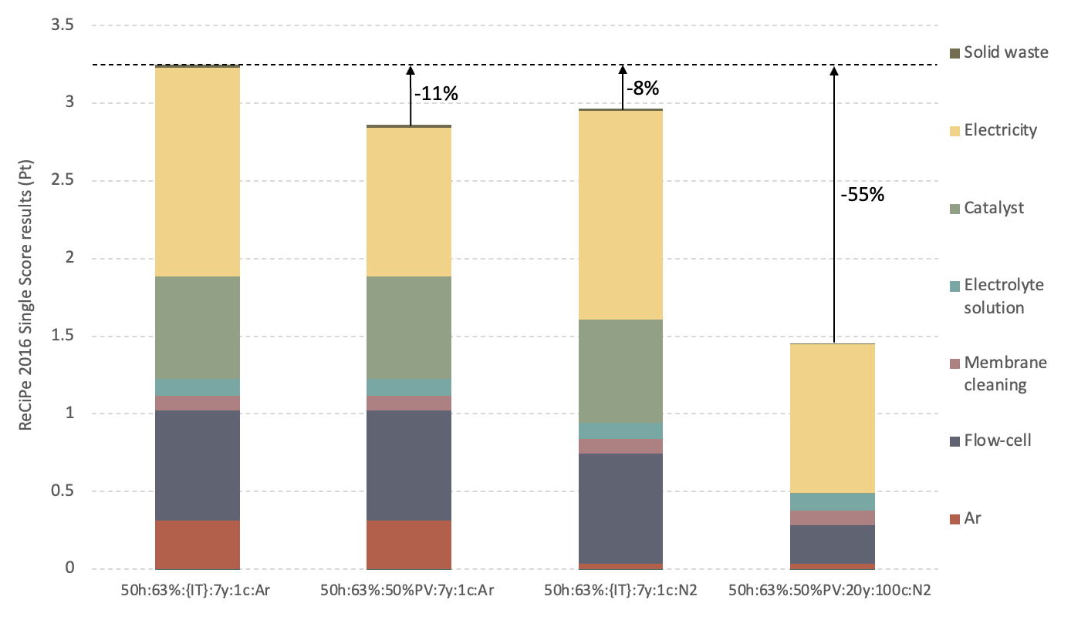
Figure S3.35: Sensitivity analysis on the 50h:63%:{IT}:7y:1c:Ar scenario, cumulative impacts; ReCiPe 2016 endpoint (H)/World (H/A) v 1.11 impact assessment method; unit: Points (Pt).

  - Section S3.5: Uncertainty analysis
To conduct the uncertainty analysis, the Pedigree Matrix proposed by Weidema and Wesneas [69] was adopted to assign representativeness scores to the modelled processes. Following the methodology suggested by Goedkoop et al. [70], a basic uncertainty was also considered for all processes, corresponding to a geometric standard deviation of 1.05 for material and energy inputs and 1.50 for inorganic emissions to water (e.g. nitrates emitted to water during the laboratory production of NH₃) and VOC emissions to air. In this section, scores are reported in Tables S3.46-3.58.

  - Section S3.5.1: Flow-cell
PTFE production | Reliability | Completeness | Temporal correlation | Geographical correlation | Technological correlation
Tetrafluoroethylene | 3 | 4 | 2 | 2 | 2
Chemical plant | 3 | 4 | 4 | 2 | 2
Electricity | 3 | 4 | 2 | 2 | 2
Heat, in plant | 3 | 4 | 2 | 2 | 2
Waste heat (air emissions) | 3 | 4 | 2 | 2 | 2
Table S3.52: Pedigree matrix of the production of PTFE.

PVDF production | Reliability | Completeness | Temporal correlation | Geographical correlation | Technological correlation
Trichloroethylene | 4 | 4 | 1 | 5 | 4
Hydrogen fluoride | 4 | 4 | 1 | 5 | 4
Ultrapure water | 4 | 4 | 1 | 5 | 4
Hydrogen | 4 | 4 | 1 | 5 | 4
Butene | 4 | 4 | 1 | 5 | 4
Sodium boron hydrate | 4 | 4 | 1 | 5 | 4
Decarbonized water | 4 | 4 | 1 | 5 | 4
Acetic acid | 4 | 4 | 1 | 5 | 4
Chemical plant | 3 | 4 | 4 | 2 | 2
Electricity | 4 | 4 | 1 | 5 | 4
Emissions to air and water | 4 | 4 | 1 | 1 | 1
Table S3.53: Pedigree matrix of the production of PVDF.
PEEK production | Reliability | Completeness | Temporal correlation | Geographical correlation | Technological correlation
Hydroquinone | 4 | 4 | 1 | 5 | 1
Sodium carbonate | 4 | 4 | 1 | 5 | 3
Hydrofluoric acid | 4 | 4 | 3 | 5 | 4
Sodium nitrite | 4 | 4 | 5 | 5 | 4
Oxygen | 4 | 4 | 5 | 5 | 4
Aniline | 4 | 4 | 5 | 5 | 4
Formaldehyde | 4 | 4 | 5 | 5 | 4
Hydrochloric acid | 4 | 4 | 5 | 5 | 4
Sodium hydroxide | 4 | 4 | 5 | 5 | 4
Chemical plant | 3 | 4 | 4 | 2 | 2
Electricity | 4 | 4 | 5 | 3 | 4
Heat, in plant | 4 | 4 | 5 | 3 | 4
Emissions to air and water | 4 | 2 | 5 | 1 | 1
Spent solvent mixture | 4 | 2 | 5 | 2 | 4
Table S3.54: Pedigree matrix of the production of PEEK.

Flow-cell, structural components | Reliability | Completeness | Temporal correlation | Geographical correlation | Technological correlation
PTFE | 2 | 1 | 1 | 1 | 1
PVDF | 2 | 1 | 1 | 1 | 1
PEEK | 2 | 1 | 1 | 1 | 1
EPDM | 2 | 1 | 1 | 1 | 1
Polymers forming | 2 | 1 | 1 | 2 | 3
Steel | 1 | 1 | 1 | 1 | 1
Steel forming | 1 | 1 | 1 | 2 | 2
Plastic waste | 2 | 1 | 1 | 1 | 3
Table S3.55: Pedigree matrix of the flow-cell structural components sub-assembly.

Electrodes | Reliability | Completeness | Temporal correlation | Geographical correlation | Technological correlation
Titanium | 1 | 1 | 1 | 4 | 1
Titanium manufacture | 1 | 1 | 1 | 4 | 3
Iridium | 3 | 4 | 2 | 4 | 3
Electricity | 3 | 4 | 2 | 4 | 3
Table S3.56: Pedigree matrix of the flow-cell electrodes sub-assembly.
Nafion production | Reliability | Completeness | Temporal correlation | Geographical correlation | Technological correlation
Tetrafluoroethylene | 3 | 4 | 2 | 2 | 2
Sulfur trioxide | 3 | 4 | 2 | 2 | 2
Sodium hypochlorite | 3 | 4 | 2 | 2 | 2
Sodium hydroxide | 3 | 4 | 2 | 2 | 2
Sodium carbonate | 3 | 4 | 2 | 2 | 2
Chemical plant | 3 | 4 | 2 | 2 | 2
Electricity | 3 | 4 | 2 | 2 | 2
Heat, in plant | 3 | 4 | 2 | 2 | 2
Emissions to air and water | 3 | 4 | 2 | 2 | 2
Spent solvent mixture | 3 | 4 | 2 | 2 | 2
Table S3.57: Pedigree matrix of the production of Nafion®.

Nafion® membrane | Reliability | Completeness | Temporal correlation | Geographical correlation | Technological correlation
Nafion® | 3 | 4 | 2 | 2 | 3
Nafion® forming | 3 | 4 | 2 | 2 | 3
Plastic residue | 3 | 4 | 2 | 2 | 3
Table S3.58: Pedigree matrix of the Nafion® membrane sub-assembly.

Membrane activation | Reliability | Completeness | Temporal correlation | Geographical correlation | Technological correlation
Milli-Q water | 3 | 2 | 1 | 2 | 1
Hydrogen peroxide | 3 | 2 | 1 | 2 | 1
Sulfuric acid | 3 | 2 | 1 | 2 | 1
Electricity | 3 | 2 | 1 | 1 | 3
Wastewater | 3 | 2 | 1 | 2 | 4
Table S3.59: Pedigree matrix of the Nafion® membrane activation.
  - Section S3.5.2: NH₃ production
Carbon paper | Reliability | Completeness | Temporal correlation | Geographical correlation | Technological correlation
Carbon fibre | 2 | 1 | 1 | 2 | 1
PTFE | 2 | 1 | 1 | 2 | 1
Impregnation process | 2 | 1 | 1 | 4 | 3
Table S3.60: Pedigree matrix of carbon paper sheet production.

Nafion® resin solution | Reliability | Completeness | Temporal correlation | Geographical correlation | Technological correlation
Nafion® | 2 | 1 | 1 | 2 | 1
Water | 2 | 1 | 1 | 2 | 1
Isopropanol | 2 | 1 | 1 | 2 | 1
Table S3.61: Pedigree matrix of Nafion® resin solution.

MoS₂ catalyst | Reliability | Completeness | Temporal correlation | Geographical correlation | Technological correlation
Molybdenite | 1 | 2 | 1 | 1 | 1
Carbon Black | 1 | 2 | 1 | 1 | 1
Nafion resin solution | 1 | 2 | 1 | 1 | 1
Ethanol | 1 | 2 | 1 | 1 | 1
Carbon paper | 2 | 2 | 1 | 1 | 1
Electricity | 3 | 2 | 1 | 1 | 3
Ethanol, VOC | 3 | 2 | 1 | 1 | 1
Table S3.62: Pedigree matrix of MoS₂ catalyst laboratory production.

Membrane cleaning | Reliability | Completeness | Temporal correlation | Geographical correlation | Technological correlation
Ultrapure water | 3 | 2 | 1 | 1 | 1
Sulfuric acid | 3 | 2 | 1 | 1 | 1
Electricity | 3 | 2 | 1 | 1 | 3
Wastewater | 3 | 2 | 1 | 1 | 4
Table S3.63: Pedigree matrix of the membrane cleaning process.
NH₃ production | Reliability | Completeness | Temporal correlation | Geographical correlation | Technological correlation
Ultrapure water | 1 | 1 | 1 | 1 | 1
Potassium nitrate | 1 | 1 | 1 | 1 | 1
Potassium sulfate | 1 | 1 | 1 | 1 | 1
Argon | 2 | 1 | 1 | 2 | 1
Elettricità | 3 | 2 | 1 | 1 | 2
Nitrates emissions to water | 3 | 2 | 1 | 1 | 1
Air emissions | 2 | 1 | 1 | 1 | 1
Wastewater | 1 | 2 | 1 | 2 | 1
Solid waste | 3 | 2 | 1 | 1 | 3
Table S3.64: Pedigree matrix of the NH₃ production process.

  - Section S3.5.3: Monte Carlo analysis results
The Monte Carlo analysis was conducted for 1000 runs with a confidence interval of 95% to compare impact assessment results of the production of 10 mg of NH₃ for scenario 50h:63%:{IT}:7y:1c:Ar (A) and scenario 71h:63%:{IT}:7y:1c:Ar (B), using the EF 3.1 method; the evaluation considered all impact categories to ensure a comprehensive overview. Results, reported in Table S3.59 and Figure S3.27, showed that scenario 50h:63%:{IT}:7y:1c:Ar had lower impacts than 71h:63%:{IT}:7y:1c:Ar for 13 out of 25 impact categories in over 90% of the runs and for 17 out of 25 categories in over 80% of the runs. For the POF category, scenario 50h:63%:{IT}:7y:1c:Ar had lower impacts than 71h:63%:{IT}:7y:1c:Ar in 635 of the total runs, while for the categories HTC, HTNC, EF, and WU the Monte Carlo results did not report significant differences between the two scenarios. In particular, scenario 50h:63%:{IT}:7y:1c:Ar had lower impacts in only 50% of the runs for categories EF - inorganics, HTC – inorganics, and HTNC – inorganics; in contrast, for the “organics” categories, 50h:63%:{IT}:7y:1c:Ar resulted into lower impacts than 71h:63%:{IT}:7y:1c:Ar in 90% of the runs.
Impact category | A >= B | Mean | Median | SD | CV | 2.5% | 97.5% | SEM
Acidification | 0.6 % | -0.000357 | -0.000356 | 0.00015 | -42.1 % | -0.000668 | -0.0000654 | 0.00000475
Climate change | 5.6 % | -0.0786 | -0.0779 | 0.0491 | -62.5 % | -0.181 | 0.0132 | 0.00155
Climate change - Biogenic | 13.6 % | -0.000619 | -0.000611 | 0.000597 | -96.4 % | -0.0019 | 0.000459 | 0.0000189
Climate change - Fossil | 5.4 % | -0.0778 | -0.0771 | 0.0485 | -62.3 % | -0.178 | 0.0128 | 0.00153
Climate change - Land use and LU change | 8 % | -0.000167 | -0.000156 | 0.000136 | -81.4 % | -0.000471 | 0.0000645 | 0.00000429
Ecotoxicity, freshwater | 46.1 % | -0.206 | -0.129 | 3.85 | -1.87E3 % | -9.36 | 8.33 | 0.122
Ecotoxicity, freshwater - inorganics | 47.6 % | -0.109 | -0.0598 | 3.84 | -3.53E3 % | -9.16 | 8.47 | 0.122
Ecotoxicity, freshwater - organics | 7 % | -0.0967 | -0.0956 | 0.0683 | -70.7 % | -0.249 | 0.0243 | 0.00216
Eutrophication, freshwater | 1.3 % | -0.0000207 | -0.000018 | 0.0000148 | -71.5 % | -0.0000592 | -1.73E-06 | 4.68E-07
Eutrophication, marine | 6 % | -0.0000519 | -0.0000506 | 0.0000338 | -65 % | -0.000121 | 0.0000118 | 0.00000107
Eutrophication, terrestrial | 1.5 % | -0.000656 | -0.000636 | 0.000322 | -49 % | -0.00131 | -0.00004 | 0.0000102
Human toxicity, cancer | 50.8 % | 4.74E-10 | 2.91E-10 | 7.72E-08 | 1.63E4 % | -1.67E-07 | 1.72E-07 | 2.44E-09
Human toxicity, cancer - inorganics | 51 % | 7.35E-10 | 4.24E-10 | 7.72E-08 | 1.05E4 % | -1.67E-07 | 1.71E-07 | 2.44E-09
Human toxicity, cancer - organics | 1.2 % | -2.6E-10 | -2.5E-10 | 1.35E-10 | -51.7 % | -5.71E-10 | -2.37E-11 | 4.26E-12
Human toxicity, non-cancer | 51.3 % | 8.62E-08 | 7.59E-08 | 0.00000915 | 1.06E4 % | -0.00002 | 0.0000203 | 2.89E-07
Human toxicity, non-cancer - inorganics | 51.3 % | 8.62E-08 | 7.59E-08 | 0.00000915 | 1.06E4 % | -0.00002 | 0.0000203 | 2.89E-07
Human toxicity, non-cancer - organics | 11.6 % | -2.54E-11 | -2.47E-11 | 2.19E-11 | -86.1 % | -7.26E-11 | 1.42E-11 | 6.93E-13
Ionising radiation | 7.6 % | -0.0203 | -0.0159 | 0.0231 | -113 % | -0.0886 | 0.0053 | 0.000729
Land use | 17.3 % | -0.574 | -0.542 | 0.639 | -111 % | -1.89 | 0.648 | 0.0202
Ozone depletion | 0 % | -4.83E-07 | -4.37E-07 | 2.15E-07 | -44.6 % | -1.02E-06 | -1.98E-07 | 6.81E-09
Particulate matter | 6.4 % | -1.66E-09 | -1.66E-09 | 1.09E-09 | -65.6 % | -3.89E-09 | 3.48E-10 | 3.45E-11
Photochemical ozone formation | 36.7 % | -0.0000536 | -0.0000505 | 0.000144 | -269 % | -0.000355 | 0.000216 | 0.00000455
Resource use, fossils | 9.1 % | -1.1 | -1.09 | 0.838 | -75.8 % | -2.86 | 0.465 | 0.0265
Resource use, minerals and metals | 10.8 % | -2.5E-07 | -2.41E-07 | 2.16E-07 | -86.4 % | -7.22E-07 | 0.00000015 | 6.83E-09
Water use | 47.8 % | 0.157 | -0.14 | 8.41 | 5.35E3 % | -15.7 | 21 | 0.266
Table S3.65: Results of the uncertainty analysis conducted with the Monte Carlo method, 95% confidence interval, 1000 runs; A = 50h:63%:{IT}:7y:1c:Ar, B = 71h:63%:{IT}:7y:1c:Ar; impact assessment method: Environmental Footprint 3.1.

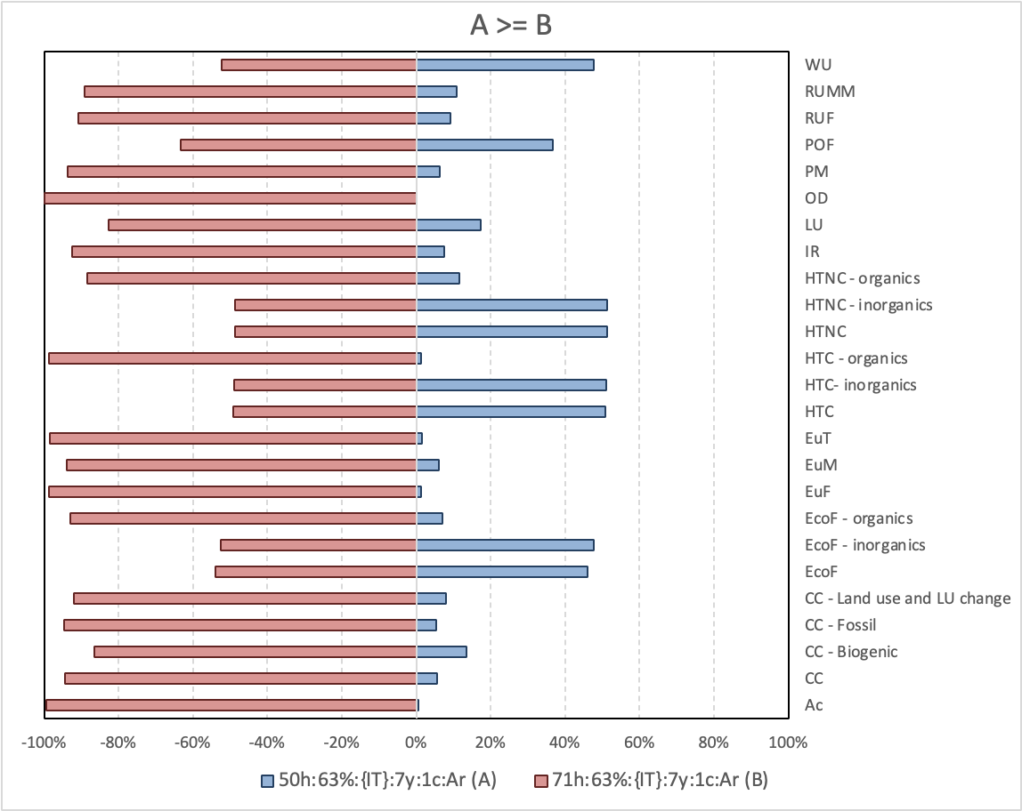
Figure S3.36: Results of the Monte Carlo simulation conducted to compare scenario 50h:63%:{IT}:7y:1c:Ar (A) to scenario 71h:63%:{IT}:7y:1c:Ar (B); impact assessment method: Environmental Footprint 3.1. Categories: Ac (acidification); CC (climate change); EcoF (ecotoxicity, freshwater); EuF (eutrophication, freshwater); EuM (eutrophication, marine); EuT (eutrophication, terrestrial); HTC (human toxicity, cancer); HTNC (human toxicity, non-cancer); IR (ionising radiation); LU (land use); OD (ozone depletion); PM (particulate matter); POF (photochemical ozone formation); RUF (resource use, fossils); RUMM (resource use, minerals and metals); WU (water use).

Following uncertainty results, human toxicity categories were further investigated for scenarios 50h:63%:{IT}:7y:1c:Ar and 71h:63%:{IT}:7y:1c:Ar to individuate the highest contributing inventory flows. For both scenarios, over 30% of HTC-inorganics category impacts were associated with the emissions of chromium (VI) in water compartments, mainly throughout the electricity consumption inventory flows, while for the HTNC-inorganics category the emissions to air of mercury (II) contributed to over 30% of impacts; results are reported in Tables S3.60-3.63.

Substance | Compartment | Unit | Total | Ar | Flow-cell | Membrane cleaning | Electrolyte solution | MoS₂ catalyst | Electricity | Wastewater | Solid waste
Total of all compartments |  | % | 100 | 12.9 | 9.9 | 2.6 | 5.7 | 20.2 | 43.9 | 0.1 | 4.7
Remaining substances |  | % | 3 | 0.3 | 0.1 | 0.1 | 0.1 | 1.4 | 1.1 | 0.1 | 0.0
Chromium (VI) | Water | % | 32 | 3.7 | 2.9 | 0.8 | 1.3 | 6.0 | 14.6 | 0.0 | 3.2
Nickel (II) | Air | % | 17 | 1.3 | 1.3 | 0.5 | 1.4 | 3.9 | 8.7 | 0.0 | 0.1
Mercury (II) | Air | % | 17 | 3.5 | 2.9 | 0.4 | 0.7 | 3.0 | 6.6 | 0.0 | 0.1
Arsenic, ion | Air | % | 10 | 0.8 | 0.9 | 0.3 | 1.0 | 2.2 | 4.7 | 0.0 | 0.0
Arsenic, ion | Water | % | 8 | 2.5 | 0.5 | 0.2 | 0.2 | 1.3 | 2.9 | 0.0 | 0.0
Lead (II) | Air | % | 4 | 0.3 | 0.4 | 0.1 | 0.4 | 1.0 | 2.1 | 0.0 | 0.0
Nickel (II) | Water | % | 4 | 0.3 | 0.6 | 0.1 | 0.1 | 0.6 | 1.5 | 0.0 | 1.3
Cadmium (II) | Air | % | 3 | 0.2 | 0.2 | 0.1 | 0.3 | 0.6 | 1.3 | 0.0 | 0.0
Chromium (VI) | Air | % | 1 | 0.1 | 0.1 | 0.0 | 0.2 | 0.2 | 0.4 | 0.0 | 0.0
Table S3.66: Scenario 50h:63%:{IT}:7y:1c:Ar: Human toxicity, cancer – inorganics, elementary flows percentage contribution; FU = 1 g NH₃.

Substance | Compartment | Unit | Total | Ar | Flow-cell | Membrane cleaning | Electrolyte solution | MoS₂ catalyst | Electricity | Wastewater | Solid waste
Total of all compartments |  | % | 100 | 13.4 | 10.5 | 2.8 | 6.5 | 23.0 | 43.0 | 0.3 | 0.4
Remaining substances |  | % | 4 | 0.3 | 0.6 | 0.1 | 0.2 | 0.7 | 1.6 | 0.1 | 0.2
Mercury (II) | Air | % | 30.2 | 6.1 | 5.2 | 0.7 | 1.2 | 5.2 | 11.6 | 0.0 | 0.1
Lead (II) | Air | % | 23.2 | 1.8 | 2.0 | 0.7 | 2.3 | 5.1 | 11.1 | 0.0 | 0.1
Cadmium (II) | Air | % | 11 | 0.8 | 0.8 | 0.3 | 1.1 | 2.4 | 5.1 | 0.0 | 0.0
Arsenic, ion | Air | % | 10 | 0.8 | 0.9 | 0.3 | 1.0 | 2.3 | 4.9 | 0.0 | 0.0
Arsenic, ion | Water | % | 9 | 2.7 | 0.6 | 0.2 | 0.3 | 1.5 | 3.2 | 0.0 | 0.0
Lead (II) | Soil | % | 4 | 0.3 | 0.1 | 0.1 | 0.1 | 2.1 | 1.3 | 0.1 | 0.0
Cadmium (II) | Soil | % | 4 | 0.3 | 0.1 | 0.1 | 0.1 | 2.0 | 1.4 | 0.0 | 0.0
Silver (I) | Air | % | 2 | 0.0 | 0.0 | 0.1 | 0.0 | 0.6 | 1.6 | 0.0 | 0.0
Zinc (II) | Soil | % | 2 | 0.2 | 0.1 | 0.1 | 0.1 | 0.9 | 0.9 | 0.1 | 0.0
Zinc (II) | Air | % | 1 | 0.1 | 0.1 | 0.1 | 0.3 | 0.2 | 0.3 | 0.0 | 0.0
Table S3.67: Scenario 50h:63%:{IT}:7y:1c:Ar: Human toxicity, non-cancer – inorganics, elementary flows percentage contribution; FU = 1 g NH₃.

Substance | Compartment | Unit | Total | Ar | Flow-cell | Membrane cleaning | Electrolyte solution | MoS₂ Catalyst | Electricity | Wastewater | Solid waste
Total of all compartments |  | % | 100 | 14.3 | 11.0 | 2.0 | 4.4 | 15.8 | 48.7 | 0.1 | 3.7
Remaining substances |  | % | 2.9 | 0.3 | 0.1 | 0.1 | 0.1 | 1.1 | 1.2 | 0.1 | 0.0
Chromium (VI) | Water | % | 32.3 | 4.1 | 3.2 | 0.6 | 1.0 | 4.7 | 16.2 | 0.0 | 2.5
Mercury (II) | Air | % | 17.6 | 3.8 | 3.3 | 0.3 | 0.5 | 2.3 | 7.3 | 0.0 | 0.0
Nickel (II) | Air | % | 17.1 | 1.4 | 1.4 | 0.4 | 1.1 | 3.1 | 9.7 | 0.0 | 0.1
Arsenic, ion | Air | % | 9.9 | 0.9 | 1.0 | 0.2 | 0.8 | 1.7 | 5.2 | 0.0 | 0.0
Arsenic, ion | Water | % | 7.9 | 2.7 | 0.6 | 0.1 | 0.2 | 1.0 | 3.2 | 0.0 | 0.0
Lead (II) | Air | % | 4.4 | 0.4 | 0.4 | 0.1 | 0.3 | 0.8 | 2.3 | 0.0 | 0.0
Nickel (II) | Water | % | 4.2 | 0.3 | 0.6 | 0.1 | 0.1 | 0.5 | 1.6 | 0.0 | 1.0
Cadmium (II) | Air | % | 2.7 | 0.2 | 0.2 | 0.1 | 0.2 | 0.5 | 1.5 | 0.0 | 0.0
Chromium (VI) | Air | % | 1.0 | 0.1 | 0.1 | 0.0 | 0.1 | 0.2 | 0.4 | 0.0 | 0.0
Table S3.68: Scenario 71h:63%:{IT}:7y:1c:Ar: Human toxicity, cancer – inorganics, elementary flows percentage contribution; FU = 1 g NH₃.

Substance | Compartment | Unit | Total | Ar | Flow-cell | Membrane cleaning | Electrolyte solution | MoS₂ catalyst | Electricity | Wastewater | Solid waste
Total of all compartments |  | % | 100 | 14.9 | 11.7 | 2.2 | 5.1 | 17.9 | 47.7 | 0.3 | 0.3
Remaining substances |  | % | 3.8 | 0.3 | 0.7 | 0.1 | 0.1 | 0.6 | 1.7 | 0.1 | 0.1
Mercury (II) | Air | % | 31.1 | 6.8 | 5.8 | 0.5 | 0.9 | 4.1 | 12.9 | 0.0 | 0.1
Lead (II) | Air | % | 23.0 | 2.0 | 2.3 | 0.5 | 1.8 | 4.0 | 12.3 | 0.0 | 0.1
Cadmium (II) | Air | % | 10.4 | 0.9 | 0.9 | 0.3 | 0.8 | 1.9 | 5.7 | 0.0 | 0.0
Arsenic, ion | Air | % | 10.2 | 0.9 | 1.0 | 0.2 | 0.8 | 1.8 | 5.4 | 0.0 | 0.0
Arsenic, ion | Water | % | 8.8 | 3.0 | 0.7 | 0.1 | 0.2 | 1.1 | 3.6 | 0.0 | 0.0
Lead (II) | Soil | % | 3.7 | 0.3 | 0.1 | 0.1 | 0.1 | 1.6 | 1.4 | 0.1 | 0.0
Cadmium (II) | Soil | % | 3.6 | 0.3 | 0.1 | 0.1 | 0.0 | 1.6 | 1.5 | 0.0 | 0.0
Silver (I) | Air | % | 2.3 | 0.0 | 0.0 | 0.1 | 0.0 | 0.5 | 1.8 | 0.0 | 0.0
Zinc (II) | Soil | % | 2.2 | 0.3 | 0.1 | 0.1 | 0.1 | 0.7 | 1.0 | 0.1 | 0.0
Zinc (II) | Air | % | 1.1 | 0.1 | 0.2 | 0.1 | 0.2 | 0.1 | 0.4 | 0.0 | 0.0
Table S3.69: Scenario 71h:63%:{IT}:7y:1c:Ar: Human toxicity, non-cancer – inorganics, elementary flows percentage contribution; FU = 1 g NH₃.

Uncertainty associated with scenarios 50h:63%:{IT}:7y:1c:Ar (A) and 71h:63%:{IT}:7y:1c:Ar (B) was also evaluated for endpoint results calculated with the ReCiPe 2016 method; results of the Monte Carlo simulation are reported in Table S3.64 and Figure S3.28. Scenario 50h:63%:{IT}:7y:1c:Ar reported lower potential damages for the resources category in 85% of the runs and for the ecosystems category in 80% of the runs, while the human health category again reported the highest uncertainty with the 50h:63%:{IT}:7y:1c:Ar scenario resulting in lower damages in 70% of the runs.

Damage category | A >= B | Mean | Median | SD | CV | 2.5% | 97.5% | SEM
Ecosystems | 19.60% | -3.73E-10 | -2.79E-10 | 6.09E-10 | -163 % | -1.8E-09 | 6.81E-10 | 1.93E-11
Human health | 29.60% | -1.74E-07 | -1.36E-07 | 5.22E-07 | -300 % | -1.37E-06 | 9.32E-07 | 1.65E-08
Resources | 14.80% | -0.006 | -0.00608 | 0.00573 | -95.6 % | -0.0182 | 0.00426 | 0.000181
Table S3.65: Results of the uncertainty analysis conducted with the Monte Carlo method, 1000 runs; A = 50h:63%:{IT}:7y:1c:Ar, B = 71h:63%:{IT}:7y:1c:Ar; impact assessment method: ReCiPe 2016 endpoint (H)/World (H/A), v 1.11.

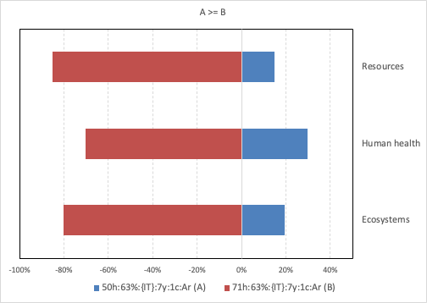
Figure S3.37: Results of the Monte Carlo simulation conducted to compare scenario 50h:63%:{IT}:7y:1c:Ar (A) to scenario 71h:63%:{IT}:7y:1c:Ar (B); damage assessment method: ReCiPe 2016 endpoint (H)/World (H/A), v 1.11.

Damage category | Unit | Mean | Median | SD | CV | 2.5% | 97.5% | SEM
Acidification | mol H+ eq | 3.4E+00 | 3.4E+00 | 2.5E-01 | 7% | 2.9E+00 | 3.9E+00 | 7.9E-03
Climate change | kg CO2 eq | 6.4E+02 | 6.4E+02 | 4.7E+01 | 7% | 5.6E+02 | 7.5E+02 | 1.5E+00
Ecotoxicity, freshwater | CTUe | 4.8E+03 | 5.0E+03 | 1.3E+04 | 275 % | -2.3E+04 | 3.0E+04 | 4.2E+02
Eutrophication, freshwater | kg P eq | 4.6E-01 | 4.0E-01 | 2.4E-01 | 51% | 2.1E-01 | 1.0E+00 | 7.5E-03
Eutrophication, marine | kg N eq | 7.3E-01 | 7.2E-01 | 6.9E-02 | 10% | 6.1E-01 | 8.8E-01 | 2.2E-03
Eutrophication, terrestrial | mol N eq | 5.0E+00 | 5.0E+00 | 4.3E-01 | 9% | 4.3E+00 | 5.9E+00 | 1.4E-02
Human toxicity, cancer | CTUh | 4.5E-06 | 1.1E-05 | 1.8E-04 | 3890% | -3.6E-04 | 3.5E-04 | 5.6E-06
Human toxicity, non-cancer | CTUh | 1.9E-04 | 7.4E-04 | 2.1E-02 | 11300% | -4.3E-02 | 4.1E-02 | 6.6E-04
Ionising radiation | kBq U-235 eq | 2.7E+02 | 2.0E+02 | 2.7E+02 | 97% | 9.6E+01 | 8.7E+02 | 8.4E+00
Land use | Pt | 4.0E+03 | 3.4E+03 | 6.3E+03 | 156% | -7.7E+03 | 1.9E+04 | 2.0E+02
Ozone depletion | kg CFC11 eq | 1.9E-03 | 1.8E-03 | 5.5E-04 | 29% | 1.1E-03 | 3.2E-03 | 1.8E-05
Particulate matter | disease inc. | 1.6E-05 | 1.6E-05 | 1.6E-06 | 10% | 1.4E-05 | 2.0E-05 | 5.0E-08
Photochemical ozone formation | kg NMVOC eq | 5.2E+00 | 5.2E+00 | 7.9E-01 | 15% | 3.9E+00 | 7.1E+00 | 2.5E-02
Resource use, fossils | MJ | 1.2E+04 | 1.2E+04 | 1.6E+03 | 14% | 9.0E+03 | 1.5E+04 | 5.2E+01
Resource use, minerals and metals | kg Sb eq | 5.1E-03 | 5.0E-03 | 6.5E-04 | 13% | 4.2E-03 | 6.8E-03 | 2.1E-05
Water use | m3 depriv. | 8.8E+02 | 1.9E+03 | 1.8E+04 | 2080% | -3.8E+04 | 3.5E+04 | 5.8E+02
Table S3.70: Results of the uncertainty analysis conducted with the Monte Carlo method, 1000 runs. Scenario 2h:85%:{IT}:7y:1c:Ar; impact assessment method: EF 3.1.

Damage category | Unit | Mean | Median | SD | CV | 2.5% | 97.5% | SEM
Acidification | mol H+ eq | 3.6E-01 | 3.6E-01 | 2.9E-02 | 8% | 3.1E-01 | 4.2E-01 | 9.2E-04
Climate change | kg CO2 eq | 7.6E+01 | 7.5E+01 | 6.9E+00 | 9% | 6.4E+01 | 9.1E+01 | 2.2E-01
Ecotoxicity, freshwater | CTUe | 4.3E+02 | 4.1E+02 | 2.2E+03 | 502 % | -4.0E+03 | 4.9E+03 | 6.9E+01
Eutrophication, freshwater | kg P eq | 3.2E-02 | 2.9E-02 | 1.4E-02 | 43% | 1.6E-02 | 7.2E-02 | 4.4E-04
Eutrophication, marine | kg N eq | 6.4E-02 | 6.4E-02 | 5.7E-03 | 9% | 5.4E-02 | 7.7E-02 | 1.8E-04
Eutrophication, terrestrial | mol N eq | 6.0E-01 | 5.9E-01 | 5.6E-02 | 9% | 5.0E-01 | 7.1E-01 | 1.8E-03
Human toxicity, cancer | CTUh | 1.7E-06 | 2.4E-06 | 2.8E-05 | 1610% | -5.6E-05 | 5.9E-05 | 8.7E-07
Human toxicity, non-cancer | CTUh | 1.7E-04 | 2.1E-04 | 3.3E-03 | 1940% | -6.6E-03 | 6.8E-03 | 1.0E-04
Ionising radiation | kBq U-235 eq | 1.8E+01 | 1.4E+01 | 1.7E+01 | 95% | 6.3E+00 | 5.9E+01 | 5.4E-01
Land use | Pt | 3.7E+02 | 3.6E+02 | 2.0E+02 | 53% | 1.0E+01 | 8.0E+02 | 6.2E+00
Ozone depletion | kg CFC11 eq | 3.1E-04 | 2.9E-04 | 1.1E-04 | 37% | 1.5E-04 | 5.7E-04 | 3.6E-06
Particulate matter | disease inc. | 1.7E-06 | 1.6E-06 | 1.7E-07 | 10% | 1.4E-06 | 2.0E-06 | 5.3E-09
Photochemical ozone formation | kg NMVOC eq | 3.2E-01 | 3.2E-01 | 3.3E-02 | 10% | 2.6E-01 | 3.9E-01 | 1.0E-03
Resource use, fossils | MJ | 1.1E+03 | 1.1E+03 | 1.4E+02 | 12% | 9.1E+02 | 1.4E+03 | 4.3E+00
Resource use, minerals and metals | kg Sb eq | 3.5E-04 | 3.5E-04 | 3.9E-05 | 11% | 2.9E-04 | 4.5E-04 | 1.2E-06
Water use | m3 depriv. | 2.0E+02 | 5.9E+02 | 5.3E+03 | 2670% | -1.1E+04 | 9.6E+03 | 1.7E+02
Table S3.71: Results of the uncertainty analysis conducted with the Monte Carlo method, 1000 runs. Scenario 50h:63%:{IT}:7y:1c:Ar; impact assessment method: EF 3.1.

Damage category | Unit | Mean | Median | SD | CV | 2.5% | 97.5% | SEM
Acidification | mol H+ eq | 4.0E-01 | 4.0E-01 | 3.7E-02 | 9% | 3.4E-01 | 4.9E-01 | 1.2E-03
Climate change | kg CO2 eq | 8.6E+01 | 8.5E+01 | 8.6E+00 | 10% | 7.1E+01 | 1.0E+02 | 2.7E-01
Ecotoxicity, freshwater | CTUe | 2.9E+02 | 3.2E+02 | 2.9E+03 | 1010% | -6.4E+03 | 5.8E+03 | 9.2E+01
Eutrophication, freshwater | kg P eq | 3.3E-02 | 2.9E-02 | 1.6E-02 | 50% | 1.5E-02 | 7.6E-02 | 5.1E-04
Eutrophication, marine | kg N eq | 7.1E-02 | 7.0E-02 | 7.6E-03 | 11% | 5.9E-02 | 8.9E-02 | 2.4E-04
Eutrophication, terrestrial | mol N eq | 6.8E-01 | 6.7E-01 | 7.6E-02 | 11% | 5.5E-01 | 8.5E-01 | 2.4E-03
Human toxicity, cancer | CTUh | 7.8E-07 | 1.1E-06 | 3.8E-05 | 4890% | -7.8E-05 | 7.5E-05 | 1.2E-06
Human toxicity, non-cancer | CTUh | 4.7E-05 | 1.2E-04 | 4.5E-03 | 9560% | -9.1E-03 | 8.9E-03 | 1.4E-04
Ionising radiation | kBq U-235 eq | 1.8E+01 | 1.2E+01 | 1.9E+01 | 107% | 5.5E+00 | 7.2E+01 | 6.1E-01
Land use | Pt | 4.1E+02 | 4.0E+02 | 1.8E+02 | 44% | 8.2E+01 | 8.0E+02 | 5.6E+00
Ozone depletion | kg CFC11 eq | 3.6E-04 | 3.3E-04 | 1.4E-04 | 38% | 1.8E-04 | 7.4E-04 | 4.3E-06
Particulate matter | disease inc. | 1.8E-06 | 1.8E-06 | 2.2E-07 | 12% | 1.5E-06 | 2.3E-06 | 6.9E-09
Photochemical ozone formation | kg NMVOC eq | 3.3E-01 | 3.3E-01 | 3.8E-02 | 12% | 2.6E-01 | 4.2E-01 | 1.2E-03
Resource use, fossils | MJ | 1.3E+03 | 1.2E+03 | 1.7E+02 | 14% | 9.7E+02 | 1.6E+03 | 5.5E+00
Resource use, minerals and metals | kg Sb eq | 3.7E-04 | 3.6E-04 | 4.3E-05 | 12% | 3.0E-04 | 4.6E-04 | 1.4E-06
Water use | m3 depriv. | 2.1E+02 | 8.4E+02 | 6.8E+03 | 3160% | -1.4E+04 | 1.2E+04 | 2.1E+02
Table S3.72: Results of the uncertainty analysis conducted with the Monte Carlo method, 1000 runs. Scenario 71h:63%:{IT}:7y:1c:Ar; impact assessment method: EF 3.1.

Damage category | Unit | Mean | Median | SD | CV | 2.5% | 97.5% | SEM
Acidification | mol H+ eq | 4.7E-01 | 4.7E-01 | 4.5E-02 | 9% | 4.0E-01 | 5.7E-01 | 1.4E-03
Climate change | kg CO2 eq | 1.0E+02 | 1.0E+02 | 1.1E+01 | 11% | 8.3E+01 | 1.3E+02 | 3.5E-01
Ecotoxicity, freshwater | CTUe | 5.4E+02 | 5.3E+02 | 3.7E+03 | 691% | -6.2E+03 | 7.9E+03 | 1.2E+02
Eutrophication, freshwater | kg P eq | 3.8E-02 | 3.5E-02 | 1.6E-02 | 44% | 1.8E-02 | 7.9E-02 | 5.2E-04
Eutrophication, marine | kg N eq | 8.2E-02 | 8.1E-02 | 8.9E-03 | 11% | 6.6E-02 | 1.0E-01 | 2.8E-04
Eutrophication, terrestrial | mol N eq | 8.0E-01 | 7.9E-01 | 8.9E-02 | 11% | 6.5E-01 | 1.0E+00 | 2.8E-03
Human toxicity, cancer | CTUh | 1.8E-06 | 1.6E-06 | 4.7E-05 | 2580% | -8.8E-05 | 1.1E-04 | 1.5E-06
Human toxicity, non-cancer | CTUh | 1.7E-04 | 6.5E-05 | 5.6E-03 | 3230% | -1.1E-02 | 1.3E-02 | 1.8E-04
Ionising radiation | kBq U-235 eq | 2.1E+01 | 1.4E+01 | 2.7E+01 | 130% | 6.1E+00 | 7.6E+01 | 8.5E-01
Land use | Pt | 4.9E+02 | 4.8E+02 | 1.6E+02 | 34% | 1.7E+02 | 8.3E+02 | 5.2E+00
Ozone depletion | kg CFC11 eq | 4.4E-04 | 4.1E-04 | 1.7E-04 | 38% | 2.0E-04 | 8.6E-04 | 5.3E-06
Particulate matter | disease inc. | 2.2E-06 | 2.1E-06 | 2.7E-07 | 13% | 1.8E-06 | 2.8E-06 | 8.6E-09
Photochemical ozone formation | kg NMVOC eq | 3.7E-01 | 3.6E-01 | 4.1E-02 | 11% | 2.9E-01 | 4.6E-01 | 1.3E-03
Resource use, fossils | MJ | 1.5E+03 | 1.4E+03 | 2.1E+02 | 14% | 1.1E+03 | 1.9E+03 | 6.7E+00
Resource use, minerals and metals | kg Sb eq | 4.1E-04 | 4.1E-04 | 5.0E-05 | 12% | 3.3E-04 | 5.2E-04 | 1.6E-06
Water use | m3 depriv. | 8.7E+01 | 8.9E+02 | 8.8E+03 | 10100% | -2.0E+04 | 1.4E+04 | 2.8E+02
Table S3.73: Results of the uncertainty analysis conducted with the Monte Carlo method, 1000 runs. Scenario 101h:63%:{IT}:7y:1c:Ar; impact assessment method: EF 3.1.

Damage category | Unit | Mean | Median | SD | CV | 2.5% | 97.5% | SEM
Acidification | mol H+ eq | 3.2E-01 | 3.1E-01 | 2.8E-02 | 9% | 2.7E-01 | 3.8E-01 | 8.8E-04
Climate change | kg CO2 eq | 6.1E+01 | 6.1E+01 | 6.0E+00 | 10% | 5.1E+01 | 7.5E+01 | 1.9E-01
Ecotoxicity, freshwater | CTUe | 3.8E+02 | 3.3E+02 | 1.7E+03 | 439% | -2.9E+03 | 3.7E+03 | 5.3E+01
Eutrophication, freshwater | kg P eq | 2.9E-02 | 2.6E-02 | 1.4E-02 | 47% | 1.4E-02 | 6.7E-02 | 4.4E-04
Eutrophication, marine | kg N eq | 5.6E-02 | 5.5E-02 | 5.4E-03 | 10% | 4.6E-02 | 6.7E-02 | 1.7E-04
Eutrophication, terrestrial | mol N eq | 5.2E-01 | 5.1E-01 | 5.3E-02 | 10% | 4.2E-01 | 6.3E-01 | 1.7E-03
Human toxicity, cancer | CTUh | -3.8E-07 | -2.0E-07 | 2.1E-05 | -5450% | -4.0E-05 | 4.3E-05 | 6.6E-07
Human toxicity, non-cancer | CTUh | -7.7E-05 | -6.0E-05 | 2.5E-03 | -3190% | -4.8E-03 | 5.1E-03 | 7.8E-05
Ionising radiation | kBq U-235 eq | 1.6E+01 | 1.1E+01 | 1.5E+01 | 96% | 4.8E+00 | 6.1E+01 | 4.7E-01
Land use | Pt | 7.2E+02 | 7.1E+02 | 2.8E+02 | 39% | 2.0E+02 | 1.3E+03 | 8.8E+00
Ozone depletion | kg CFC11 eq | 3.2E-04 | 2.9E-04 | 1.2E-04 | 39% | 1.6E-04 | 6.1E-04 | 3.9E-06
Particulate matter | disease inc. | 1.5E-06 | 1.5E-06 | 2.0E-07 | 13% | 1.2E-06 | 2.0E-06 | 6.3E-09
Photochemical ozone formation | kg NMVOC eq | 2.9E-01 | 2.8E-01 | 3.1E-02 | 11% | 2.3E-01 | 3.6E-01 | 9.9E-04
Resource use, fossils | MJ | 8.9E+02 | 8.8E+02 | 1.2E+02 | 14% | 7.0E+02 | 1.2E+03 | 3.9E+00
Resource use, minerals and metals | kg Sb eq | 4.6E-04 | 4.5E-04 | 5.9E-05 | 13% | 3.6E-04 | 6.0E-04 | 1.9E-06
Water use | m3 depriv. | -1.1E+01 | 3.3E+02 | 3.4E+03 | -31600% | -6.9E+03 | 5.8E+03 | 1.1E+02
Table S3.74: Results of the uncertainty analysis conducted with the Monte Carlo method, 1000 runs. Senstivitiy scenario 50h:63%:50%PV:7y:1c:Ar; impact assessment method: EF 3.1.

Damage category | Unit | Mean | Median | SD | CV | 2.5% | 97.5% | SEM
Acidification | mol H+ eq | 3.3E-01 | 3.3E-01 | 2.0E-02 | 6% | 2.9E-01 | 3.7E-01 | 6.3E-04
Climate change | kg CO2 eq | 7.0E+01 | 7.0E+01 | 4.6E+00 | 7% | 6.1E+01 | 8.0E+01 | 1.4E-01
Ecotoxicity, freshwater | CTUe | 2.9E+02 | 3.3E+02 | 2.2E+03 | 777% | -3.9E+03 | 4.6E+03 | 7.1E+01
Eutrophication, freshwater | kg P eq | 2.7E-02 | 2.4E-02 | 1.2E-02 | 45% | 1.3E-02 | 6.0E-02 | 3.9E-04
Eutrophication, marine | kg N eq | 5.9E-02 | 5.9E-02 | 4.3E-03 | 7% | 5.2E-02 | 6.9E-02 | 1.4E-04
Eutrophication, terrestrial | mol N eq | 5.5E-01 | 5.5E-01 | 4.5E-02 | 8% | 4.7E-01 | 6.5E-01 | 1.4E-03
Human toxicity, cancer | CTUh | -4.0E-08 | -6.3E-07 | 3.1E-05 | -76100% | -6.0E-05 | 5.8E-05 | 9.7E-07
Human toxicity, non-cancer | CTUh | -4.0E-05 | -1.1E-04 | 3.7E-03 | -9070% | -7.1E-03 | 7.0E-03 | 1.2E-04
Ionising radiation | kBq U-235 eq | 1.5E+01 | 9.5E+00 | 2.0E+01 | 134% | 4.6E+00 | 6.0E+01 | 6.2E-01
Land use | Pt | 3.4E+02 | 3.3E+02 | 2.0E+02 | 57% | -1.1E+01 | 7.6E+02 | 6.2E+00
Ozone depletion | kg CFC11 eq | 3.1E-04 | 2.9E-04 | 1.1E-04 | 37% | 1.5E-04 | 5.9E-04 | 3.6E-06
Particulate matter | disease inc. | 1.6E-06 | 1.5E-06 | 1.5E-07 | 10% | 1.3E-06 | 1.9E-06 | 4.8E-09
Photochemical ozone formation | kg NMVOC eq | 3.1E-01 | 3.1E-01 | 3.2E-02 | 10% | 2.5E-01 | 3.8E-01 | 1.0E-03
Resource use, fossils | MJ | 1.0E+03 | 1.0E+03 | 9.1E+01 | 9% | 8.6E+02 | 1.2E+03 | 2.9E+00
Resource use, minerals and metals | kg Sb eq | 3.4E-04 | 3.3E-04 | 3.8E-05 | 11% | 2.8E-04 | 4.2E-04 | 1.2E-06
Water use | m3 depriv. | 1.6E+02 | 6.2E+02 | 5.5E+03 | 3450% | -1.2E+04 | 9.6E+03 | 1.7E+02
Table S3.75: Results of the uncertainty analysis conducted with the Monte Carlo method, 1000 runs. Senstivitiy scenario 50h:63%:{IT}:7y:1c:N₂; impact assessment method: EF 3.1.

Damage category | Unit | Mean | Median | SD | CV | 2.5% | 97.5% | SEM
Acidification | mol H+ eq | 1.6E-01 | 1.6E-01 | 1.2E-02 | 8% | 1.3E-01 | 1.8E-01 | 3.8E-04
Climate change | kg CO2 eq | 3.1E+01 | 3.0E+01 | 2.7E+00 | 9% | 2.6E+01 | 3.6E+01 | 8.4E-02
Ecotoxicity, freshwater | CTUe | 1.8E+02 | 2.0E+02 | 1.1E+03 | 620% | -2.3E+03 | 2.4E+03 | 3.5E+01
Eutrophication, freshwater | kg P eq | 1.1E-02 | 1.0E-02 | 1.8E-02 | 157% | 6.0E-03 | 2.1E-02 | 5.7E-04
Eutrophication, marine | kg N eq | 2.6E-02 | 2.6E-02 | 2.3E-03 | 9% | 2.2E-02 | 3.1E-02 | 7.3E-05
Eutrophication, terrestrial | mol N eq | 2.6E-01 | 2.6E-01 | 2.4E-02 | 9% | 2.1E-01 | 3.1E-01 | 7.7E-04
Human toxicity, cancer | CTUh | 4.1E-07 | 5.8E-07 | 1.4E-05 | 3450% | -2.7E-05 | 3.1E-05 | 4.5E-07
Human toxicity, non-cancer | CTUh | 3.1E-05 | 3.5E-05 | 1.7E-03 | 5530% | -3.2E-03 | 3.6E-03 | 5.3E-05
Ionising radiation | kBq U-235 eq | 4.2E+00 | 3.2E+00 | 3.5E+00 | 82% | 1.5E+00 | 1.3E+01 | 1.1E-01
Land use | Pt | 5.8E+02 | 5.5E+02 | 2.0E+02 | 34% | 3.1E+02 | 1.1E+03 | 6.3E+00
Ozone depletion | kg CFC11 eq | 9.0E-05 | 8.3E-05 | 3.5E-05 | 39% | 4.3E-05 | 1.8E-04 | 1.1E-06
Particulate matter | disease inc. | 8.9E-07 | 8.7E-07 | 1.4E-07 | 15% | 7.0E-07 | 1.2E-06 | 4.3E-09
Photochemical ozone formation | kg NMVOC eq | 9.4E-02 | 9.3E-02 | 1.1E-02 | 12% | 7.5E-02 | 1.2E-01 | 3.4E-04
Resource use, fossils | MJ | 4.3E+02 | 4.2E+02 | 4.4E+01 | 10% | 3.5E+02 | 5.2E+02 | 1.4E+00
Resource use, minerals and metals | kg Sb eq | 2.6E-04 | 2.5E-04 | 5.1E-05 | 20% | 1.8E-04 | 3.8E-04 | 1.6E-06
Water use | m3 depriv. | 6.6E+01 | 2.0E+02 | 2.9E+03 | 4450% | -6.0E+03 | 5.4E+03 | 9.3E+01
Table S3.76: Results of the uncertainty analysis conducted with the Monte Carlo method, 1000 runs. Senstivity scenario 50h:63%:50%PV:20y:100c:N₂; impact assessment method: EF 3.1.
Scenario | Unit | Mean | Median | SD | CV | 2.5% | 97.5% | SEM
2h | Pt | 1.1E-01 | 2.4E-01 | 3.2E+00 | 2970% | -6.4E+00 | 6.3E+00 | 1.0E-01
50h | Pt | 3.4E-02 | 4.6E-02 | 5.0E-01 | 1470% | -1.0E+00 | 1.1E+00 | 1.6E-02
71h | Pt | 1.7E-02 | 2.7E-02 | 7.0E-01 | 4240% | -1.4E+00 | 1.4E+00 | 2.2E-02
101h | Pt | 3.6E-02 | 2.0E-02 | 8.5E-01 | 2370% | -1.7E+00 | 1.9E+00 | 2.7E-02
50h-50%PV | Pt | -5.8E-03 | -6.7E-03 | 3.8E-01 | -6550% | -7.4E-01 | 7.9E-01 | 1.2E-02
50h-N2 | Pt | 1.3E-03 | -3.7E-03 | 5.6E-01 | 42500% | -1.1E+00 | 1.1E+00 | 1.8E-02
50h-BCS | Pt | 8.0E-03 | 9.3E-03 | 2.6E-01 | 3210% | -5.0E-01 | 5.5E-01 | 8.2E-03
Table S3.77: Results of the uncertainty analysis conducted with the Monte Carlo method, 1000 runs; (eco)toxicity – inorganics and water use categories included in the calculation. Ammonia production scenarios and sensitivity analysis for the 50h scenario; unit: Points (Pt). Impact assessment method: EF 3.1, expressed as a single score after normalization and weighting.
The issue of the uncertainty associated with (eco)toxicity and water use categories has been discussed in previously published literature; Rosenbaum et al. [71] reported that toxicity categories, i.e. Ecotoxicity freshwater, Human toxicity (cancer), and Human toxicity (non-cancer) have intrinsically high uncertainty ranges, spanning two to three orders of magnitude; high in impact assessment results for toxicity categories has also been individuated by Rossi et al [72] and Bedogni et al. [73]. Regarding water use, Järvio et al. [74] noted how, during Monte Carlo runs, inputs and outputs of water are sampled independently from each other, potentially resulting into not respected mass balances and negative calculated values.

Scenario | Unit | Mean | Median | SD | CV | 2.5% | 97.5% | SEM
2h | Pt | 6.8E-02 | 6.7E-02 | 7.7E-03 | 11% | 5.7E-02 | 8.6E-02 | 2.4E-04
50h | Pt | 6.4E-03 | 6.3E-03 | 6.0E-04 | 9% | 5.4E-03 | 7.8E-03 | 1.9E-05
71h | Pt | 7.1E-03 | 7.0E-03 | 7.8E-04 | 11% | 5.9E-03 | 8.8E-03 | 2.5E-05
101h | Pt | 8.3E-03 | 8.1E-03 | 9.5E-04 | 12% | 6.7E-03 | 1.1E-02 | 3.0E-05
50h-50%PV | Pt | 5.6E-03 | 5.5E-03 | 5.8E-04 | 10% | 4.7E-03 | 7.0E-03 | 1.8E-05
50h-N2 | Pt | 5.9E-03 | 5.8E-03 | 4.8E-04 | 8.18% | 5.2E-03 | 6.8E-03 | 1.5E-05
50h-BCS | Pt | 2.6E-03 | 2.6E-03 | 2.3E-04 | 8.96% | 2.2E-03 | 3.1E-03 | 7.4E-06
Table S3.78: Results of the uncertainty analysis conducted with the Monte Carlo method, 1000 runs; (eco)toxicity – inorganics and water use categories excluded from the calculation. Ammonia production scenarios and sensitivity analysis for the 50h scenario; unit: Points (Pt). Impact assessment method: EF 3.1 excluding (eco)toxicity and water use, expressed as a single score after normalization and weighting.
Sub-process | Unit | Nominal value | SD
Ar | mPt | 6.4E-01 | 2.7E-01
Flow-Cell | mPt | 1.2E+00 | 2.2E-01
Membrane cleaning | mPt | 1.8E-01 | 3.0E-02
Electrolyte solution | mPt | 1.8E-01 | 4.3E-02
Catalyst | mPt | 1.7E+00 | 2.1E-01
Electricity | mPt | 2.5E+00 | 1.8E-01
Table S3.79: Contribution analysis for Scenario 50h:63%:{IT}:7y:1c:Ar; nominal values calculated for each subprocess with the EF 3.1 modified method, excluding (eco)toxicity and water use, expressed as a single score after normalization and weighting. Standard deviations are calculated after 1000 iterations of Monte Carlo simulations performed for each subprocess; unit: milli-Points (mPt).

References

[1] C. Caldeira, R. Farcal, I. Garmendia Aguirre, L. Mancini, D. Tosches, A. Amelio, K. Rasmussen, H. Rauscher, J. Riego Sintes, S. Sala, Safe and Sustainable by Design chemicals and materials - Framework for the definition of criteria and evaluation procedure for chemicals and materials, Publications Office of the European Union, Luxembourg, 2022. https://data.europa.eu/doi/10.2760/487955

[2] R. Cucciniello, D. Cespi, M. Riccardi, E. Neri, F. Passarini and F. M. Pulselli, Green Chem. 25 (2023), 5922–5935. https://doi.org/10.1039/D2GC03707F

[3] E. Abbate, I. Garmendia Aguirre, G. Bracalente, L. Mancini, D. Tosches, K. Rasmussen, M. J. Bennett, H. Rauscher and S. Sala, Safe and Sustainable by Design chemicals and materials – Methodological Guidance, Publications Office of the European Union, Luxembourg, 2024.
https://data.europa.eu/doi/10.2760/28450

[4] M. Grohol and C. Veeh, Study on the Critical Raw Materials for the EU 2023 – Final Report, Publications Office of the European Union, Luxembourg, 2023. https://data.europa.eu/doi/10.2873/725585

[5] Ammonia Energy Association. https://ammoniaenergy.org/, (accessed May 2025).

[6] ISO/NP 19870-3 Hydrogen Technologies — Methodology for Determining the Greenhouse Gas Emissions Associated with the Hydrogen Supply Chain — Part 3: Part 3: Emissions Associated with the Production and Transport of Ammonia up to Delivery Gate and the Conversion of Ammonia into Hydrogen and its Transport to Consumption Gate, https://isme.me/en/project/show/iso:proj:88688, (accessed June 2025).

[7] A. M. O. Mohamed, I.G. Economou and Y. Bicer, Current Opinion in Green and Sustainable Chemistry, 49 (2024), 100947. https://doi.org/10.1016/j.cogsc.2024.100947

[8] Y. Bicer, I. Dincer, G. Vezina and F. Raso, Environ. Manage., 59 (2017), 842–855.
https://doi.org/10.1007/s00267-017-0831-6

[9] Y. Bicer, I. Dincer, C. Zamfirescu, G. Vezina and F. Raso, J. Clean. Prod. 135 (2016), 1379–1395.
https://doi.org/10.1016/j.jclepro.2016.07.023

[10] T. I. Serrano-Arévalo, C. A. Padilla-Esquivel, L.G. Hernández-Pérez, F. A. Díaz-Alvarado, C. Ramírez Márquez and J. M. Ponce-Ortega, ACS Sustain. Chem. Eng., 12 (2024), 12652–12669.
https://doi.org/10.1021/acs.iecr.5c02274

[11] S. C. D’Angelo, S. Cobo, V. Tulus, A. Nabera, A. J. Martín, J. Pérez-Ramírez and G. Guillén-Gosálbez, ACS Sustainable Chem. Eng. 9 (2021), 9740–9749. https://doi.org/10.1021/acssuschemeng.1c01915

[12] S. C. D’Angelo, J. Mache and G. Guillén-Gosálbez, ACS Sustainable Chem. Eng. 11 (2023),
17718-17727. https://doi.org/10.1021/acssuschemeng.3c05246

[13] S. Vinardell, P. Nicolas, A. M. Sastre, J. L. Cortina and C. Valderrama, ACS Sustainable Chem. Eng. 11 (2023), 15975–15983. https://doi.org/10.1021/acssuschemeng.3c04694

[14] P. Mayer, A. Ramirez, G. Pezzella, B. Winter, S. Mani Sarathy, J. Gascon and A. Bardow, iScience 26 (2023), 107389. https://doi.org/10.1016/j.isci.2023.107389

[15] K. Lee, X. Liu, P. Vyawahare, P. Sun, A. Elgowainy and M. Wang, Green Chem., 24 (2022), 4830–4844. https://doi.org/10.1039/D2GC00843B

[16] W. Steffen, K. Richardson, J. Rockström, I. fetzer, E. M. Bennett, R. Biggs, S. R. Carpenter, W. De Vries, C. A. De Wit, C. Folke, D. Gerten, J. Heinke, G. M. Mace, L. M. Persson, V. Ramanathan, B. Reyers and S. Sörlin, Science, 2015, 347, 1259855. 10.1126/science.1259855

[17] D. Fozer, M. Owsianiak, and M. Z. Hauschild, Renewable and Sustainable Energy Reviews 213 (2025), 115481. https://doi.org/10.1016/j.rser.2025.115481

[18] K. Riahi, D. P. van Vuuren, E. Kriegler, J. Edmonds, B. C. O’Neill, S. Fujimori, N. Bauer, K. Calvin, R. Dellink, O. Fricko, W. Lutz, A. Popp, J. C. Cuaresma, S. KC, M. Leimbach, L. Jiang, T. Kram, S. Rao, J: Emmerling, K. Ebi, T. Hasegawa, P. Havlik, F. Humpenöder, L. A. Da Silva, S. Smith,E. Stehfest, V. Bosetti, J. Eom, D. Gernaat, T. Masui, J. Rogelj, J. Strefler, L. Drouet, V. Krey, G. Luderer, M. Harmsen, K. Yakahashi, L. Baumstark, J. C. Doelman, M. Kainuma, Z. Klimont, G. Marangoni, H. Lotze-Campenn, M. Obersteiner, A. Tabeau and M. Tavoni, Global Environmental Change 42 (2017), 153–168. https://doi.org/10.1016/j.gloenvcha.2016.05.009

[19] L. Yang, J. C. Shi, W. Y. Chen, J. Glynn and B. Ó Gallachóir, Advances in Climate Change Research, 12 (2021), 858–870. https://doi.org/10.1016/j.accre.2021.09.002

[20] J. Osorio-Tejada, N. N. Tran, and V. Hessel, S. Tot. En. (826) 2022, 154162. https://doi.org/10.1016/j.scitotenv.2022.154162

[21] J. L. Osorio-Tejada, E. Rebrov and V. Hessel, Int. J. Life Cycle Assess. 28 (2023), 1590–1603. https://doi.org/10.1007/s11367-023-02187-5

[22] A. M. Amadei, V. De Laurentiis, and S. Sala, J. Clean. Prod., 329 (2021), 129668. https://doi.org/10.1016/j.jclepro.2021.129668

[23] L. Yu, A. Keliani, N. N. Tran, M. Escribà-Gelonch, M. Goodsite, S. Sandhu, H. Sandhu and V. Hessel, RSC Sustainability, 2025, 3, 1102-1113. https://doi.org/10.1039/D4SU00423J

[24] A. Keilani, M. Y. Arshad, L. Yu, J. L. Osorio-tejada, H. Gruber-Woefler, N. N. Tran and V. Hessel, ACS Sustain. Chem. Eng., 13 (2025), 8342-8362. https://doi.org/10.1021/acssuschemeng.5c01752

[25] Y. Bicer and I. Dincer, ACS Sustain. Chem. Eng. 5 (2017), 8035–8043. https://doi.org/10.1021/acssuschemeng.7b01638

[26] S. C. D’Angelo, A. J. Martín, S. Cobo, D. Freire Ordóñez, G. Guillén-Gosálbez and J. Pérez-Ramírez, Energy Environ. Sci. 16 (2023), 3314–3330. https://doi.org/10.1039/D2EE02683J

[27] R. Hischier, S. Hellweg, C. Capello, and A. Primas, Int. J. Life Cycle Assess., 10 (2005), 59–67. https://doi.org/10.1065/lca2004.10.181.7

[28] R. Frischknecht, N. Jungbluth, H.-J Althaus, R. Hischeier, G. Doka, R. Dones, T. Heck, S. Hellweg, G. Wernet, T. Nemecek, G. Rebitzer and M. Spielmann, Overview and Methodology. Data v2.0 (2007). ecoinvent report No. 1, Swiss Centre for Life Cycle Inventories, Dübendorf, 2007. https://lca-net.com/files/Overview_and_methodology.pdf

[29] A. Arrigoni, V. Arosio, A. B. Peressut, S. Latorrata and G. Dotelli, Clean Techn., 4 (2022), 132–148. https://doi.org/10.3390/cleantechnol4010009

[30] M. A. Rodriguez, T. van Dril and S. Gamboa Palacios, Decarbonisation options for the Dordecht chemical cluster, PBL Netherlands Environmental Assessment Agency, TNO, The Hague, 2021. https://www.pbl.nl/en/publications/decarbonisation-options-for-the-dordrecht-chemical-cluster

[31] X. Hu, A. K. J. An and S. S. Chopra, ACS Sustain. Chem. Eng., 10 (2022), 5708–5718. https://doi.org/10.1021/acssuschemeng.1c07852

[32] S. Ali Abbasi, Exergetic Life Cycle Assessment of Electrospun Polyvinylidene Fluoride Nanofibers, University of South Florida, 2014.

[33] C. Bradford Boyce, US Pat., 20090018377A1, 2009.

[34] T. Langhorst, B. Winter, D. Roskosch and A. Bardow, ACS Sustain. Chem. Eng., 11 (2023), 6600–6609. https://doi.org/10.1021/acssuschemeng.2c07624

[35] D. Cespi, Green Chem., 26 (2024), 9554-9568. https://doi.org/10.1039/D4GC01372G

[36] D. Parker, J. Bussink, H. T. van de gramperl, G. W. Wheatley, E.-U. Dorf, E. Ostlinning, K. Reinking, F. Schubert, O. Jünger and R. Wagener, Polymers, high temperature, in Ullmann’s Encyclopedia of Industrial Chemistry, Wiley-VGH Verlag GmbH & Co. KGaA, Weinheim, 2012.

[37] ReaxysTM. https://www.reaxys.com/, (accessed January 2025).

[38] M. Salzinger, and J. A. Lercher, Green Chem., 13 (2011), 149–155. https://doi.org/10.1039/C0GC00428F

[39] G. Siegemund, W. Schwertfeger, A. Feiring, B. Smart, F. Behr, H. Vogel, B. McKusick and P Kirsch, Fluorine Compounds, Organic, in Ullmann’s Encyclopedia of Industrial Chemistry Wiley-VCH Verlag GmbH & Co. KGaA, Weinheim, 2016.

[40] H. Rögl and M. Ungerand, US Pat., 7687668B2, 2010.

[41] S. Weber, J. F. Peters, M. Baumann, and M. Weil, Environ Sci. Technol., 2018, 52, 10864–10873. https://doi.org/10.1021/acs.est.8b02073

[42] I. M. D. Gonzaga, A. R. Dória, V. M. Vasconcelos, F. M. Souza, M. C. dos Santos, P. Hammer, M. A. Rodrigo, K. I. B. Eguiluz and G. R. Salazar-Banda, Journal of Electroanalytical Chemistry, 874 (2020), 114460. https://doi.org/10.1016/j.jelechem.2020.114460

[43] EDG 3PS muffle model 3000. https://edg.com.br/images/manuais/forno-vulcano/Manual-3000-1-1.pdf, (accessed January 2025).

[44] E. Rossi, D. Cespi, I. Maggiore, L. Setti and F. Passarini, Environ. Sci. Pollut. Research, 2024, https://doi.org/10.1007/s11356-024-34068-1

[45] T. M. Gulotta, R. Salomone, G. Mondello, G. Saija, F. Lanuzza and N. Briguglio, S. Tot. En., 901 (2023), 166007.

[46] L. J. Snowden-Swan, K. A. Spies, G. J. Lee, and Y. Zhu, Biomass Bioenergy, 86 (2016), 136–145. https://doi.org/10.1016/j.biombioe.2016.01.019

[47] International Platinum Group Metals Association, https://ipa-news.com/, (accessed February 2025)

[48] Ecoinvent Centre (formerly Swiss Centre for Life Cycle Inventories), Ecoinvent v3.10 Database, 2024

[49] N. Pirrone, S. Garcia-Ballesteros, S. Hernández and F. Bella, Electrochim. Acta, 493 (2024), 144415. https://doi.org/10.1016/j.electacta.2024.144415

[50] K. Bozkurt, L. Akyalçın, and S. Kjelstrup, Int. J. Hydrogen Energy, 48 (2023), 1501–1513. https://doi.org/10.1016/j.ijhydene.2022.09.302

[51] Velp Scientifica AREC.X 7 Velp system with VTF thermoregulator. https://www.velp.com/en-ww/arecx-digital-ceramic-hot-plate-stirrer.aspx, (accessed January 2025).

[52] International Energy Agency: Italy 2023, https://www.iea.org/countries/italy/energy-mix, (accessed February 2025).

[53] B. Cox, W. Jemiolo, and C. Mutel, Transp. Res. D. Transp. Environ., 58 (2018), 1–13. https://doi.org/10.1016/j.trd.2017.10.017

[54] Toray Carbon Paper. https://www.fuelcellstore.com/gas-diffusion-layers/carbon-paper/toray-carbon-paper-060?sort=rating&order=DESC&limit=15, (accessed December 2024).

[55] Nafion perfluorinated resin solution, https://www.sigmaaldrich.com/IT/it/product/aldrich/527084, (accessed December 2024).

[56] Vibra cell vcx 130. https://www.fishersci.it/shop/products/vcx-130pb-ultrasonicprocessor/11763729, (accessed January 2025).

[57] Iwata Power Jet Plus Tubular 110-120V Airbrush Compressor. https://www.iwata-airbrush.com/power-jet-plus-tubular.html, (accessed February 2025).

[58] Ismatec RegIo ICC Indipendent. https://darwin-microfluidics.com/products/reglo-icc-independent-channel-control-pump, (accessed February 2025).

[59] Mass flow controller. https://www.bronkhorst.com/int/products/gas-flow/el-flow-select/f-201cv/, (accessed February 2025).

[60] Gas Argon, https://www.siad.com/it/gas-argon, (accessed February 2025).

[61] N. Pirrone, S. Garcia-Ballesteros, J. Amici, M. Castellino, S. Hernández and F. Bella, Journal of Energy Chemistry, 107 (2025), 599-611. https://dx.doi.org/10.1016/j.jechem.2025.03.072

[62] I. Hackenhaar, G. Moraga. G. Thomassen, S. E. Taelman and T. M. Bachmann, Int. J. Life Cycle Assess., 30 (2025), 749-769. https://doi.org/10.1007/s11367-025-02439-6

[63] United States Environmental Protection Agency: Ozone-depleting substances, https://www.epa.gov/ozone-layer-protection/ozone-depleting-substances, (accessed May 2025).

[64] S. Kang, T. Ouchi and T. H. Okabe, Metallurgical and Materials Transactions B, 55 (2024), 32–52. https://doi.org/10.1007/s11663-023-02880-8

[65] M. A. Bajada, M. Tschulkow, and G. Vilé, Cell Reports Sustainability, 2 (2024), 100286. 10.1016/j.crsus.2024.100286

[66] M. Gama Caldas, U. Eynard, C. Spiliotopoulos, G. Blengini, F. Alfieri, L. Mancini, F. Mathieux and F. Ardente, Review of the MEErP - Methodology for Ecodesign of Energy-Related Products, Publications Office of the European Union, Luxembourg, 2024. https://data.europa.eu/doi/10.2760/24524, JRC136406.

[67] M. A. J. Huijbregts, Z. J. N. Steinmann, P. M. F. Elshout, G. Stam, F. Verones, M. Vieira, M. Zijp, A. Hollander and R. van Zelm, Int. J. Life Cycle Assess., 22 (2017), 138-147. https://doi.org/10.1007/s11367-016-1246-y

[68] M, Thompson, R. Ellis, and A. Wildavsky, Cultural Theory, Westview, Boulder, 1990.

[69] B. P. Weidema and M. S. Wesnaes, J. Clean. Prod., 4 (1996), 158-174. https://doi.org/10.1016/S0959-6526(96)00043-1

[70] M. Goedkoop, M. Oele, J. Leijting, T. Ponsioen and E. Meijer, Introduction to LCA with SimaPro, Pré Sustainability, 2016.

[71]: R.K. Rosenbaum, T.M. Bachmann, L.S. Gold, M.A.J. Huijbregts, O. Jolliet, R. Juraske, A. Koehler, H. Larsen, M. MacLeod, M. Margni, T.E. McKone, J. Payet, M. Schumacher, D. van de Meent and M.Z. Hauschild, Int, J. Life Cycle Assess. 13 (2008), 532-546. https://doi.org/10.1007/s11367-008-0038-4

[72] E. Rossi, F. Arfelli, L. Barani, D. Cespi, L. Ciacci and F. Passarini, Sci. Tot. En. 955 (2024), 177289. https://doi.org/10.1016/j.scitotenv.2024.177289

[73] F. Bedogni, E. Rossi, F. Arfelli, D. Cespi and F. Passarini, J. Clean. Prod. 524 (2025), 146525. https://doi.org/10.1016/j.jclepro.2025.146525

[74] N. Järviö, N.-L. Maljanen, Y. Kobayashi, T. Ryynänen and H. L. Tuomisto, Sci. Tot. En. 776 (2021), 145764. https://doi.org/10.1016/j.scitotenv.2021.145764

