Not just a technique! An experimental approach to refine the definition of the bipolar anvil reduction in the Uluzzian

Davide Delpiano¹, Giulia Marciani¹, Jacopo Conforti¹, Serena Lombardo, Matteo Rossini, Marcos César Pereira Santos, Stefano Benazzi, Marco Peresani *², Adriana Moroni²

*Corresponding author
¹ Sharing first name, these authors equally contributed to the paper.
² Sharing last name, these authors equally contributed to the paper.

Supplementary Information SI.1

Table of contents

1. Presentation of research groups, sites and raw materials 2
2. Attributes 5
3. Results of the experiments 7
3.1 Morphometrical features of the products 7
3.2 Productivity of the experiments 14
3.3 Residual cores 17
3.4 Productivity of experiments in relation with the physical features of raw materials and the degree of reduction 18
3.5 Relationship with hammers and research groups/knappers 21
4. The use of bipolar through time and space: bibliographic review 26
5. References 43

Presentation of research groups, sites and raw materials
Broion-Research group Ferrara
Riparo Broion lies in the Berici Mounts, a carbonatic karst plateau on the southern fringe of the Venetian pre-Alps in the Alpine foreland, in North-Eastern Italy. The site is located in the northern part of the Berici eastern slope (135 m a.s.l.), along a steep cliff face connecting the top of Mount Brosimo (327 m.a.s.l.) to the plain. The shelter is 10 m long, 6 m deep and 17 m in height. It is part of a complex of sites including two other cavities, a smaller one named Grotta del Buso Doppio del Broion and a deeper pit, called Grotta del Broion. In 1984, unauthorised excavators removed sediment from the surface, creating a series of pits and trenches. The first archaeological research was carried out by Prof Alberto Broglio from 1998 to 2008, subsequent excavation campaigns took place between 2015 and 2021 under the direction of Marco Peresani and Matteo Romandini. The site has revealed a Pleistocene sequence with faunal remains and Middle to Upper Palaeolithic lithic and bone industries (De Stefani et al. 2005). The Middle Palaeolithic sequence, which remains partially unpublished, is recorded in Units 13, 11, 9 and 4+7 (Romandini et al. 2020). Although Units 2 and 3 exhibited minimum evidence for anthropogenic activities, the upper Unit 1 was split into seven subunits (layers), designated from bottom to top as 1g to 1a. These layers showed the following cultural sequence: Uluzzian (layers 1e-1f-1g), Gravettian (1c-1d) and Early Epigravettian (1a-1b). Uluzzian was 14C dated to 38.900±1000 on a bone exhibiting traces of anthropic modification (Peresani et al. 2019).
For the experimental activities, raw materials utilised were predominantly sourced from the Lessini mountains, a chert-rich region located approximately 40 km west of Broion. The primary lithic assemblage in Broion is derived from the fine-grained, high-quality chert found in the Maiolica and Scaglia Rossa formations, which are predominantly exposed in the Lessini Mountains and, to a lesser extent, between southern Berici Mounts and Euganei Hills, about 15 km south of the site (Peresani et al. 2019). However, cherts from the Cretaceous limestone regions were also used for experimentation purposes. The peculiarity of the bipolar reduction method in Broion is the use of flake blanks, which were likely produced using freehand percussion techniques and brought to the site in a reduced state. Furthermore, evidence of bipolar reduction applied to modified tools such as end-scrapers and backed knives suggests the practice of recycling and overexploitation of the raw material (Peresani et al. 2019). Therefore, in the experiments, flake blanks that had already undergone direct percussion, typically involving a simple unifacial method aimed at producing large, thick flakes or flakes with knapped or natural backs, were used. Subsequently, some of these blanks were further retouched to produce backed tools or scrapers, intended for use with the bipolar technique. Finally, due to the high rate of bladelets and spalls resulting from the bipolar technique within the Broion 1f-1g assemblage, a distinct reduction aimed at obtaining small, elongated products was applied, trying to take advantage of blanks’ volumetry or, if necessary, applying simple strategies to manage edges and volumes.

La Fabbrica-Research group Pisa
Grotta La Fabbrica (Parco Regionale della Maremma, Grosseto, Central Italy) opens 7 meters above the coastal plain on a massive limestone cliff (Lat. N. 42°39’14’’, Long. W 1°23’24’’). Following preliminary exploration in 1964-65, systematic excavations were conducted between 1969 and 1973 under the direction of C. Tozzi from the University of Pisa (Pitti et al. 1976). Despite numerous reworked deposits, portions of the significant stratigraphic sequence were preserved, including Late Mousterian (layer 1), Uluzzian (layer 2), (layers 3-4) and a small remnant of a layer almost destroyed by erosion, containing Gravettian and Epigravettian materials. A second excavation campaign took place between 2007 and 2011, aimed at identifying additional stratigraphic units useful for dating (Dini and Tozzi 2012; Lombardo 2016). The same stratigraphic sequence was identified (Mousterian, US 24; Uluzzian, UUSS 23, 17b; Protoaurignacian, UUSS 20, 21, 22, 17a) and Mousterian and Uluzzian layers were dated using the OSL method (Mousterian: 44±2.1 ka; Uluzzian: 40±1.6 ka, Villa et al. 2018).
In the experimental activity, raw materials were selected based on the size and morphometric characteristics, reflecting those found in the archaeological record. Milky quartz was sourced from the numerous veins embedded in the Uccellina Mountains formations. Radiolarites, as well as sandstone and granite pebbles used as anvils and hammers, were collected from the gravelly Ombrone Riverbed and banks, and to a lesser extent, from the Albegna River. The majority of radiolarite pebbles and quartz blocks exhibit poor knapping properties, corroborating observations made in the archaeological record. Factors such as irregular morphology, inner fracture plans permeated of manganese or iron oxides, and a coarse texture often complicated the successful execution of productive knapping via free-hand direct percussion. In our experimental activity, this technique was initially employed to exploit a portion of the blocks and pebbles to pursue knapping by bipolar percussion on an anvil. Bipolar percussion was also utilised during the initial stages of exploitation. Natural dihedrals present on the core served as guides for directing the flaking process, avoiding the need for their trimming before bipolar reduction. Cores frequently fragmented during the final step, with only a few instances involving continued exploitation until complete exhaustion of individual portions, resulting in "multiplication" of residues.

Castelcivita-Research groups Siena and Bologna
The cave of Castelcivita (Castelcivita, Salerno, Campania, Southern Italy) opens at the foot of the Alburni massif, near the right bank of the Calore River, at 94 m a.s.l. (Lat 0°29'44.28959049''N; Long 015°12'33.19838469''E.). Systematic excavations have been conducted since 1975 by the Research Unit of Prehistory and Anthropology of the University of Siena. These investigations, which took place between 1975 and 1988, focused on the cave entrance, revealing a ~2.60 m thick archaeological deposit across an area of ~14 m² (Gambassini 1997). The sedimentary succession of Castelcivita provides a significant cultural record, including Late/Final Mousterian (layers cgr, gar, and lower-rsi; layer cgr: 45,194 – 41,510 cal. BP 95% and 47,401–44,085 cal. BP 95%), Uluzzian (layers upper-rsi, pie, rpi, and rsa”, this latter dated to 41,846–40,952 cal. BP 95% - Wood et al., 2012) and Protoaurignacian (layers rsa’, gic and ars). The sequence is capped by a multi-layered flowstone with volcanic ash layers attributed to the Campanian Ignimbrite (39.85 ± 0.14 ka BP Giaccio et al. 2017).
For the experimental trials, raw materials such as chert, radiolarite, siliceous limestone, and quartzarenite were sourced from secondary deposits in the riverbed and terraces of the Calore River, within ~10 km of the Castelcivita site. The selection of blocks for experimentation was based on their size and morphometric characteristics, mirroring those of the archaeological specimens.
The experimental activity assessed the knapping quality of Castelcivita’s raw materials. Cobble and pebble collections from the Calore riverbed revealed compromised quality due to inner fracture planes (cleavages) and inhomogeneous granulometry, with fine-grained areas interspersed with coarser regions containing inclusions (i.e., cleavages). Moreover, the same block often showed inhomogeneous granulometry, with areas of fine-grained composition juxtaposed with coarser-grained regions containing inclusions. During our experimental session, these physical features produced an uneven distribution of force, resulting in the fragmentation of the block along internal planes. Following the same procedure identified in the archaeological assemblage, each fragment was subjected to an independent reduction sequence. The presence of several fissure planes in the block is typically indicative of unsuitable raw material, proved advantageous in this particular instance, as the sharp angles of the fragments served as an effective guide crest for directing the flaking activity.

Attributes
Starting blanks documented traits
Experiment identification code | Running ID
Lithological composition | Chert, radiolarite, quartz-arenite, quartz, sandstone
Metrical attributes of the initial raw block | Height (maximum dimension), width, thickness, weight
Elongation index | Height/width
Carenage index | Width/Thickness
Raw material type | Pebble, block, flake
Original volumetry | Flat, polyhedron, flat-convex, globular, triangular prism, truncated pyramid/frustum, irregular
Roundness | Angular, sub-angular, rounded
Presence of internal planes | Yes/No
Texture | Fine-grained, fine/medium-grained, medium-grained, coarse-grained
Knapper's name
Number(s) of hammerstones and anvils utilised
Hammerstones and anvil
Lithological composition | Sandstone, granite, silicified limestone, Macigno sandstone, limestone, igneous rock, quartzite
Metrical attributes | Height (maximum dimension), width, thickness, weight
Shape | Ellipsoidal, Spheroid, Rod, Irregular, Ellipsoidal flat-convex, flat-convex, flat
Hardness | Soft/hard
Table SI.1.1: List of attributes recorded on starting blanks.

Technological analysis
Identification number | Running ID
Experiment-specific identification code | Same as the initial blank
Degree of integrity | Integer, distal, lateral, mesial, proximal, composite fragment
Metrical attributes | Length, width, thickness (along the technological axis or considering the longest dimension as lenght)
Technological-categories | Core, flake (length/width ratio ranging from 0 to 2), blade (length/width ratio exceeding 2) bladelet (referring to blades with a width ≤ 12 mm), backed flake, spall (an elongated element detached from a lateral ridge of a flake-core), chunk (a fragmented, altered or unorientable piece)
For each debitage blank >10mm
Cortex coverage | 0, 1-25%, 26-50%, 51-75%, 76-99%, 100%
Cortex position | Proximal, lateral, lateral back, mesial, distal, transversal, semi-total, total
Cross-section shape | Trapezoidal, rectangular, triangular, semi-circular, linear, irregular
Longitudinal profile of the ventral face | Straight, concave, convex, wavy
Orientation of dorsal scars (including the detached piece) | unidirectional, bidirectional, perpendicular (for removals on the same debitage surface), orthogonal (for removals on different and orthogonal debitage surfaces) convergent, centripetal
Distal end | Feathered, hinged, broken, plunging
For each residual core
Metrical attributes | Length, width, thickness. Cores are technologically oriented in accordance with the distal end serving as the primary striking platform and the most utilised face, typically exhibiting the latest removals, being designated as the main core face. Measurements were taken in accordance with this orientation whenever feasible; otherwise, the longest dimension was conventionally considered as the length.
Debitage phase | 1, 2, 3 (acknowledging a new phase commencing after each core reorientation or any activity that interrupted the debitage progression, such as management activity)
Volumetry of the final block | Flat, flat parallelepiped, polygonal, triangular prism, truncated pyramid/frustum, trapeze prism, irregular
Number of reductions on a given blank | Numerical
Number and specification of axes employed | Short, long
Order of axes utilisation
Number of exploited faces | Numerical
Level of exploitation | Low, medium, exhausted
Gesture/motion employed | Axial, tangential
Primary objective of debitage | Flakes, blades, bladelets
Direction of the scars | Unidirectional, bidirectional, perpendicular, convergent, centripetal
Table SI.1.2: List of attributes recorded on debitage blanks and residual cores.

- Results of the experiments

3.1 Morphometrical features of the products
 | Backed flake | Blades | Bladelets | Flakes | Spalls
N | 72 | 43 | 231 | 595 | 55
Min | 6 | 24 | 5 | 4 | 11
Max | 56 | 76 | 38 | 54 | 43
Mean | 20.66667 | 40.4186 | 18.08225 | 16.57143 | 25.90909
Std. error | 1.243764 | 1.798619 | 0.4100065 | 0.3252553 | 1.014797
Variance | 111.3803 | 139.1063 | 38.83234 | 62.94565 | 56.63973
Stand. Dev. | 10.55369 | 11.79433 | 6.23156 | 7.933829 | 7.525937
Median | 18 | 38 | 17 | 14 | 24
25 prcntil | 13 | 31 | 13 | 11 | 19
75 prcntil | 24.75 | 47 | 22 | 20 | 31
Skewness | 1.526205 | 1.236714 | 0.7965398 | 1.614395 | 0.3611672
Kurtosis | 2.827218 | 1.444197 | 0.1327753 | 3.460745 | -0.6212203
Table SI.1.3: Summary statistics of the technological products’ length (only the integer products have been selected).

 | Blacked flakes | Blades | Bladelets | Flakes | Spalls
Backed flakes |  | 8.19E-14 | 0.2223 | 0.0003369 | 6.93E-05
Blades | 8.19E-14 |  | 2.788E-23 | 1.782E-24 | 4.258E-10
Bladelets | 0.2223 | 2.788E-23 |  | 6.173E-06 | 1.911E-11
Flakes | 0.0003369 | 1.782E-24 | 6.173E-06 |  | 6.602E-16
Spalls | 6.93E-05 | 4.258E-10 | 1.911E-11 | 6.602E-16
Table SI.1.4: Mann-Whitney pairwise test of the products’ length; the raw p value is shown. Only backed flakes and bladelets are not significantly different.

 | Blacked flakes | Blades | Bladelets | Flakes | Spalls
N | 100 | 66 | 370 | 846 | 91
Min | 6 | 12 | 1 | 2 | 2
Max | 37 | 27 | 12 | 42 | 17
Mean | 14.77 | 16.10606 | 6.478378 | 13.48582 | 7.527473
Std. error | 0.6452398 | 0.4159572 | 0.1352187 | 0.1959889 | 0.3367374
Variance | 41.63343 | 11.41935 | 6.765114 | 32.49625 | 10.31868
Stand. dev | 6.452398 | 3.379252 | 2.600983 | 5.700548 | 3.21227
Median | 14 | 15 | 6 | 12 | 7
25 prcntil | 10 | 13.75 | 4 | 10 | 5
75 prcntil | 19 | 18 | 8 | 16 | 10
Skewness | 0.9704249 | 1.183566 | 0.4047701 | 1.328428 | 0.7091704
Kurtosis | 0.9345913 | 0.970965 | -0.6809467 | 2.322304 | 0.07772969
Table SI.1.5: Summary statistics of the technological products’ width (the lateral and composite fragments have been discarded).

 | Blacked flakes | Blades | Bladelets | Flakes | Spalls
Backed flakes |  | 0.009403 | 1.048E-36 | 0.0661 | 9.696E-18
Blades | 0.009403 |  | 1.692E-38 | 1.316E-08 | 1.083E-23
Bladelets | 1.048E-36 | 1.692E-38 |  | 1.96E-109 | 0.009702
Flakes | 0.0661 | 1.316E-08 | 1.96E-109 |  | 1.667E-26
Spalls | 9.696E-18 | 1.083E-23 | 0.009702 | 1.667E-26
Table SI.1.6: Mann-Whitney pairwise test of the products’ width; the raw p value is shown. Only backed flakes and flakes are not significantly different.

 | Blacked flakes | Blades | Bladelets |  | Flakes | Spalls
N | 105 | 69 | 382 |  | 942 | 92
Min | 1 | 2 | 0 |  | 0 | 1
Max | 24 | 24 | 12 |  | 28 | 13
Mean | 4.990476 | 7.304348 | 2.811518 |  | 3.552123 | 4.532609
Std. error | 0.3548449 | 0.4543549 | 0.09291265 |  | 0.08975419 | 0.2325882
Variance | 13.22106 | 14.24425 | 3.297715 |  | 7.588577 | 4.976947
Stand. dev | 3.636078 | 3.774155 | 1.815961 |  | 2.754737 | 2.230907
Median | 4 | 6 | 2 |  | 3 | 4
25 prcntil | 3 | 5 | 2 |  | 2 | 3
75 prcntil | 6 | 9 | 4 |  | 4 | 6
Skewness | 2.475416 | 1.639193 | 1.516953 |  | 2.342586 | 1.367277
Kurtosis | 8.710368 | 4.495265 | 3.292477 |  | 10.31266 | 3.057833
Table SI.1.7: Summary statistics of the technological products’ thickness.

 | Blacked flakes | Blades | Bladelets | Flakes | Spalls
Backed flakes |  | 5.997E-07 | 1.503E-13 | 2.789E-07 | 0.9384
Blades | 5.997E-07 |  | 4.261E-27 | 5.78E-21 | 3.642E-08
Bladelets | 1.503E-13 | 4.261E-27 |  | 3.284E-05 | 1.65E-14
Flakes | 2.789E-07 | 5.78E-21 | 3.284E-05 |  | 1.978E-07
Spalls | 0.9384 | 3.642E-08 | 1.65E-14 | 1.978E-07
Table SI.1.8: Mann-Whitney pairwise test of the products’ thickness; the raw p value is shown. Only backed flakes and spalls are not significantly different.

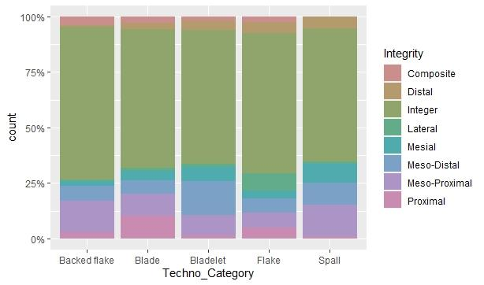
Figure SI.1.1: Integrity of the debitage products.
The majority of the pieces are intact, but spalls, bladelets, and blades are more prone to breakage during flaking, particularly in the distal portion. Backed flakes and other flakes are the pieces that are less prone to being broken (possibly due to their greater robustness). Although χ2 raw residuals show these tendencies, the p value (p = 0.59517) indicates that these differences are not statistically significant.

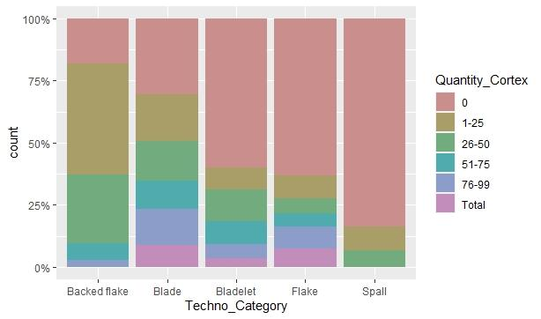
Figure SI.1.2: extent of cortex of the debitage products
Blades and flakes can be produced at the onset of core exploitation, while spalls are only produced in the middle of the debitage (most of the time from flakes). Almost ¾ of blades show a portion of cortex, because the production of these bigger products is related to the first phases of exploitation of the cores. In fact, ⅓ of blades have more than 50% of surface covered by cortex. Also, the backed flakes show a high percentage of cortex because this type typically features a cortical backed side. The correlation between the amount of cortical surface and techno-categories is statistically significant (χ² test p value: 2.2411E-45).

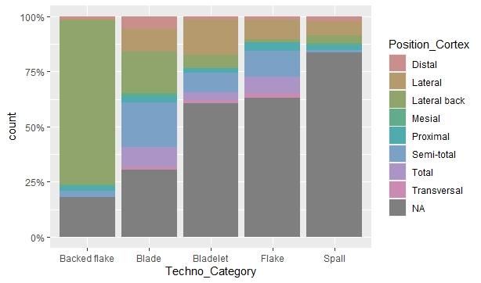
Figure SI.1.3: position of cortex of the debitage products.
Backed flakes often owns a cortical back, as well as some blades. Bladelets, and to a lesser extent blades and flakes, tend to preserve cortical portions on a lateral surface. Blades confirm to be the type of product with the most cortical surface. Other localisations are less common.

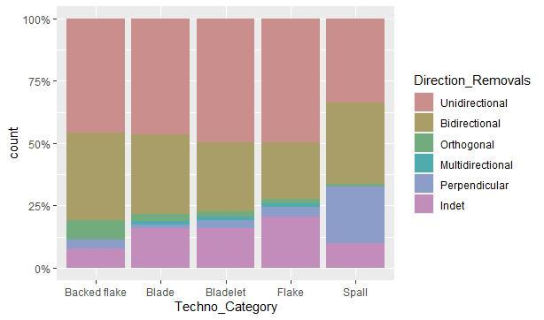
Figure SI.1.4: orientation of dorsal scars of the debitage products
The majority of the debitage products present unidirectional and bidirectional removals, aligning with the use of the bipolar technique on anvil, which results in a double blow (one from the hammerstone and the other from the anvil). Spalls, in particular, show a high frequency of perpendicular removals, indicating prior management of the guiding rib during their production. The correlation between direction of removals and techno-categories is statistically significant (χ2 test p value: 3.3674E-12).

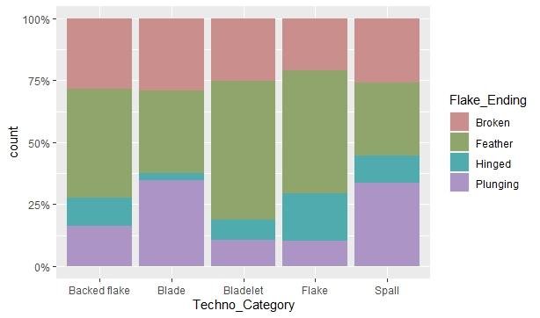
Figure SI.1.5: type of distal end of the debitage products
Spalls and blades are the pieces that show the majority of plunged endings. Flakes show many hinged endings, bladelets tend to have a feather ending. Despite these differences, all debitage products generally show a similar degree of broken ending. The correlation between type of distal end and techno-categories is statistically significant (χ2 test p value: 3.7202E-19).

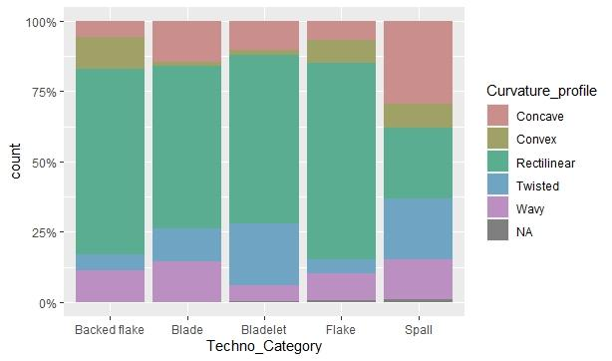
Figure SI.1.6: longitudinal profile of the ventral face of the debitage products
Most of the pieces show a rectilinear profile, which is indicative of the use of the bipolar technique on anvil. Elongated products (bladelets, spalls, and blades) commonly feature a twisted profile. Among these, spalls frequently display a concave shape. The correlation between longitudinal profile and techno-categories is statistically significant (χ2 test p value: 7.718E-35).

3.2 Productivity of the experiments
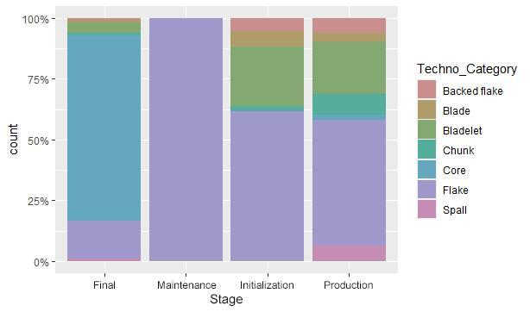
Figure SI.1.7: type of products obtained in the different stages of core exploitation.
Blades and bladelets are obtained from the outset of core exploitation, whereas spalls typically emerge only after a full production stage. Maintenance activities, though infrequent, result in the production of flakes. The correlation between techno-categories and stage of exploitation is statistically significant (χ2 test p value: 3.4603E-216).

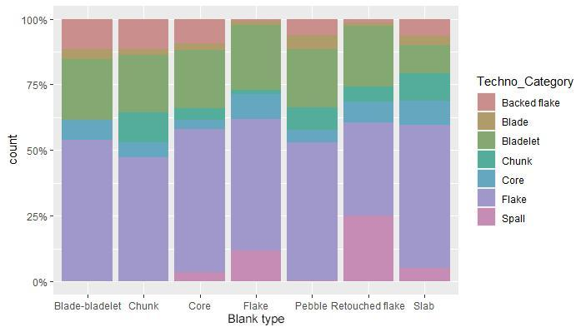
Figure SI.1.8: type of products obtained for different types of initial blank.
While spalls are mostly obtained by the reduction of flakes and retouched flakes, few other differences are noted, albeit statistically significant (χ2 test p value = 1.4548E-41).

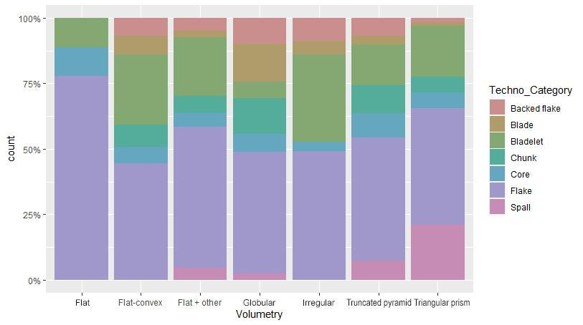
Figure SI.1.9: type of products obtained for different volumetry of initial blank.
Flat blanks predominantly yield flakes, whereas spalls are mainly produced from truncated pyramid, frustum, or triangular prism blanks. Bladelets, on the other hand, are obtained from various blank shapes except for globular ones, which are more likely to produce blades. The correlation between techno-categories and volumetry of initial blank is statistically significant (χ2 test p value: 4.7427E-19).

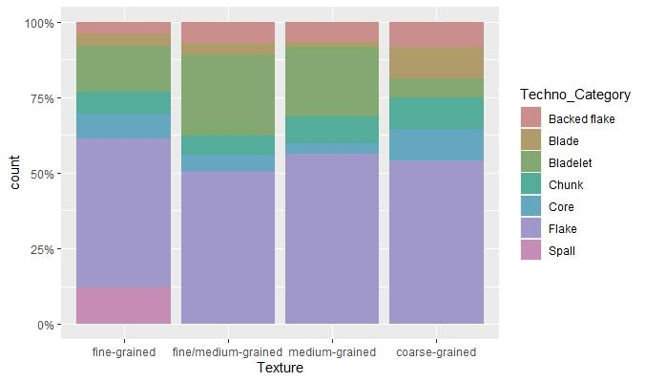
Figure SI.1.10: type of products obtained for different raw material textures of the initial blank.
With coarse grained materials, bladelets are nearly absent, but there are relatively many blades. In contrast, bladelets and spalls increase with medium and fine-grained materials. The correlation between raw material texture and techno-categories is statistically significant (χ2 test p value: 1.7674E-30).

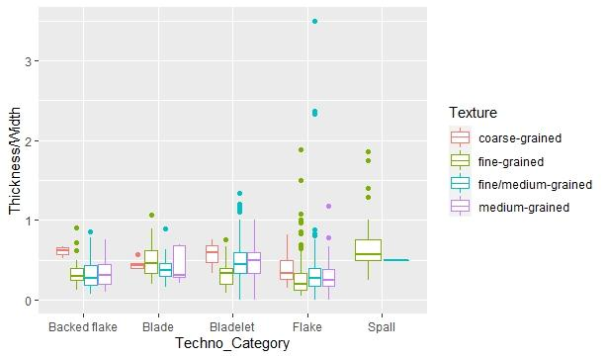
Figure SI.1.11: thickness/width ratio of the products by type and texture of raw materials.

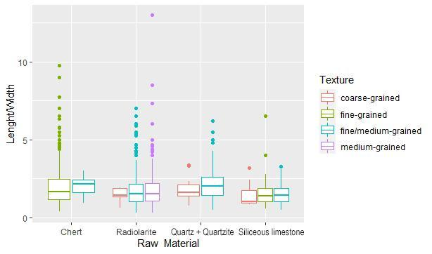
Figure SI.1.12: laminarity index of products by raw material type and texture.

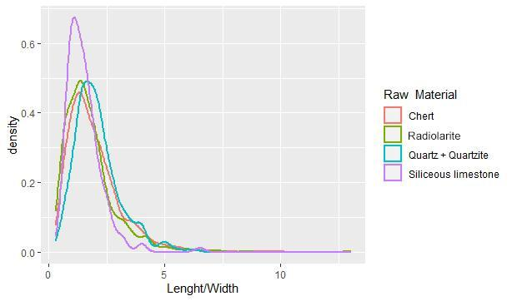
Figure SI.1.13: density plot showing the laminarity of products by raw material type.

3.3 Residual cores

 | Ferrara |  |  | Pisa |  |  | Siena
 | l | w | t | l | w | t | l | w | t
Cores | n = 35 |  |  | n = 43 |  |  | n = 38
min | 13 | 9 | 3 | 9 | 6 | 4 | 17 | 9 | 4
max | 44 | 42 | 20 | 49 | 43 | 29 | 55 | 40 | 29
mean | 28.7 | 22.0 | 8.5 | 26.9 | 19.0 | 10.7 | 30.7 | 23.7 | 13.7
Table SI.1.9: minimum, mean and maximum size (length, width and thickness) of the residual cores shown based on the three different laboratories. Kruskall-Wallis tests for equal medians show that there are no significant differences between the three populations according to length (p = 0.1257), while there are differences in width (p = 0.01885) and thickness (p = 0.0002384).

3.4 Productivity of experiments in relation with the physical features of raw materials and the degree of reduction
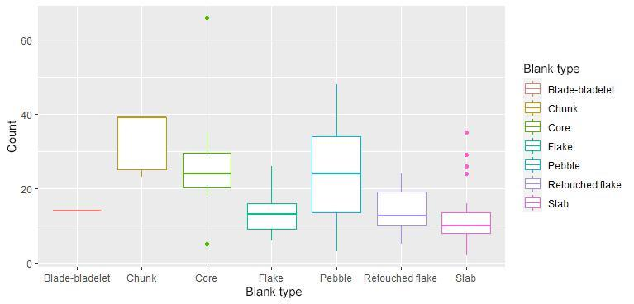
Figure SI.1.14: number of products obtained by experiments depending on the type of initial blank. Flakes and slabs (smallest/thinnest blanks?) have low productivity, while pebbles, cores and chunks the higher. There is a significant difference between sample medians (p = 0.0001905).

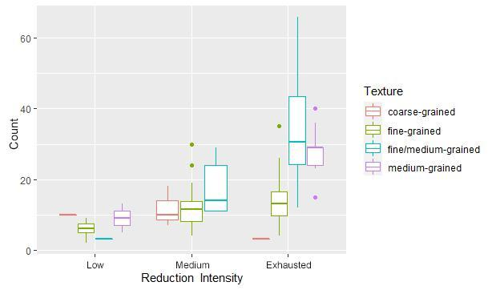
Figure SI.1.15: number of products obtained by experiments, categorised by reduction intensity and the texture of raw material. Coarse-grained materials consistently yield few artefacts, regardless of reduction intensity. In contrast, medium and fine/medium-grained materials show greater effectiveness in production. There is a significant difference between sample medians (p = 2.363E-07).

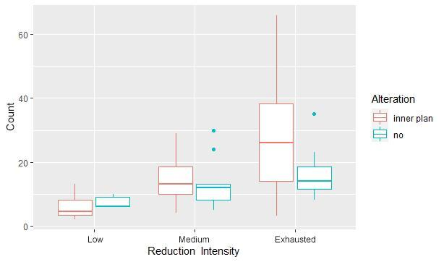
Figure SI.1.16: number of products obtained by experiments categorised by reduction intensity and the alteration of the knapped blank. Alteration does not significantly impact productivity. Internal fractures likely guide the production of artefacts, leading to a higher number when the core is fissured. However, the difference is significant when only the exhausted cores are taken into account (p = 0.02621), while it is not significant if all the cores are considered (p = 0.07762).

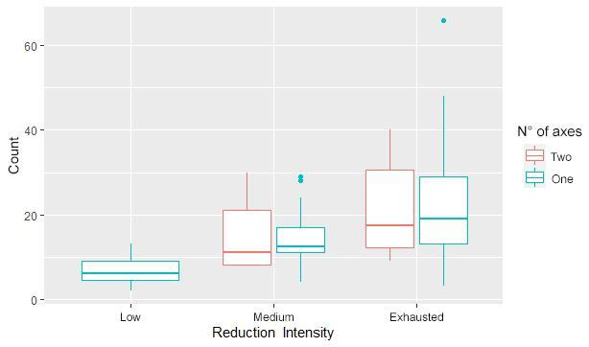

Figure SI.1.17: number of products obtained from experiments categorised by reduction intensity and the number of axes exploited. There is no significant difference in productivity when one or two axes are exploited (p = 0.2312).

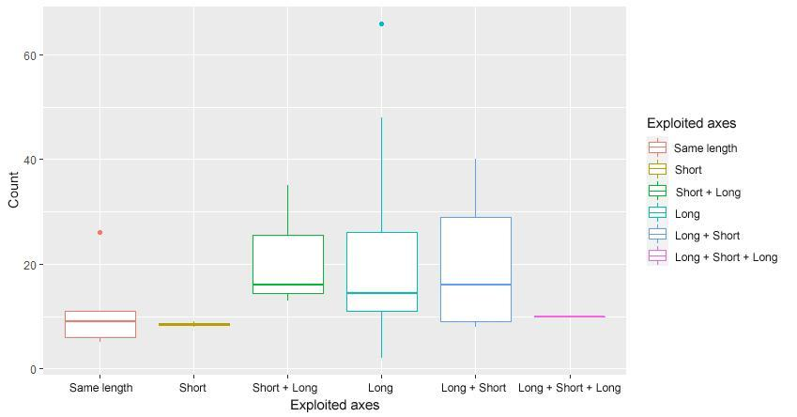
Figure SI.1.18: number of products obtained by experiments categorised by the type/order of axes exploited. There is no significant difference between sample medians (p = 0.296).

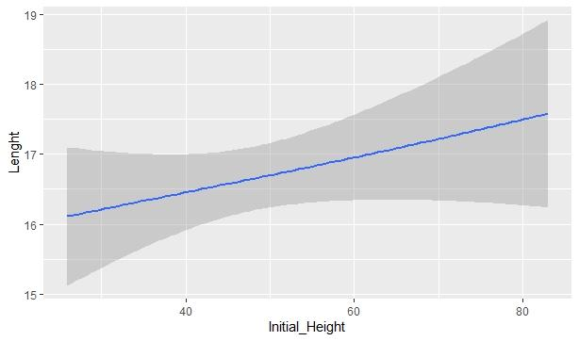
Figure SI.1.19: length of products categorised by the length of the initial blank.
Longer cores tend to produce slightly longer artefacts. (Linear r correlation test: p = 0.0018442).

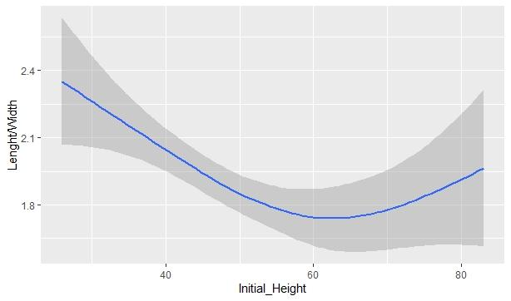
Figure SI.1.20: laminarity of products categorised by the length of the initial blank.
Conversely to length, longer cores do not necessarily produce more laminar artefacts; rather, the opposite is observed (Linear r correlation test: p = 0.0028255). This indicates that as length increases, the width of the products also increases.
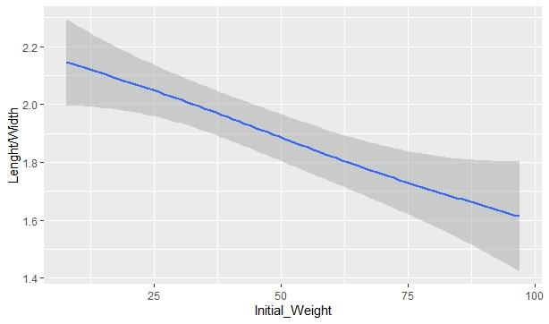
Figure SI.1.21: laminarity of products depending on the weight of the initial blank.
Similarly to the figure above, heavier initial cores tend to produce less elongated artefacts, probably due to the fact that the larger cores tend to be more prone to shattering and fragmentation during knapping (Linear r correlation test: p = 0.036009).

3.5 Relationship with hammers and research groups/knappers

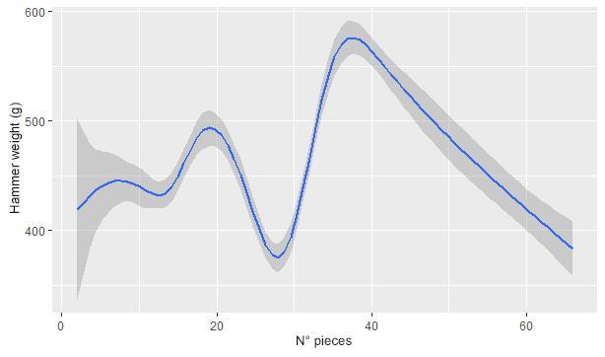
Figure SI.1.22: productivity of experiments in respect of the weight of the used hammer.
There is no correlation between the number of pieces obtained and the weight of the hammer (Linear r correlation test: p = 0.30727).

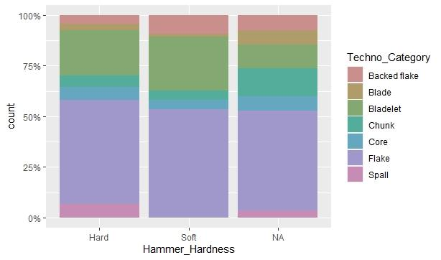
Figure SI.1.23: type of products obtained in respect to the hardness of the hammer.
Soft hammers produce a few more bladelets and backed flakes but no spalls. The correlation is statistically significant (p = 9.9317E-05); however, this is a biased data, since for reduction of flakes only hard hammers have been used.

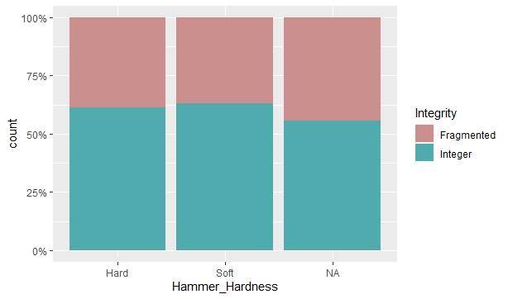
Figure SI.1.24: integrity of products obtained by soft and hard hammers.
No significant differences are recorded (p = 0.55313).

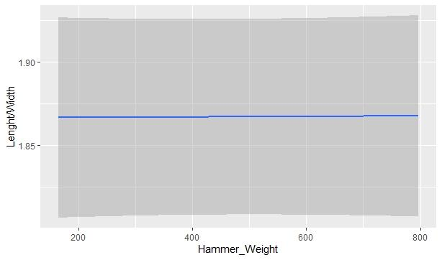
Figure SI.1.25: laminarity of products in respect to the weight of the used hammer.
No significant correlation has been recorded (Linear r correlation test: p = 0.73243).

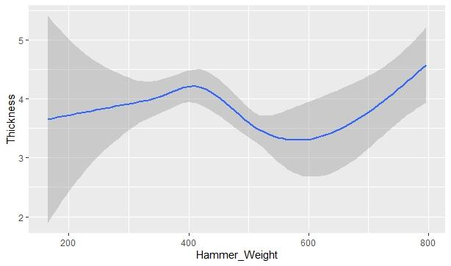
Figure SI.1.26: thickness of products in respect to the weight of the used hammers.
No significant correlation has been recorded (Linear r correlation test: p = 0.69578).

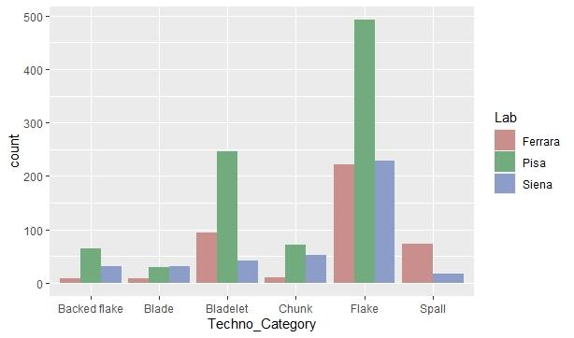
Figure SI.1.27: Quantity and type of products obtained by the three different research groups (with the third group including Siena and Bologna). There are significant differences in the production of some techno-categories of artefacts across the groups (p = 9.6046E-57).

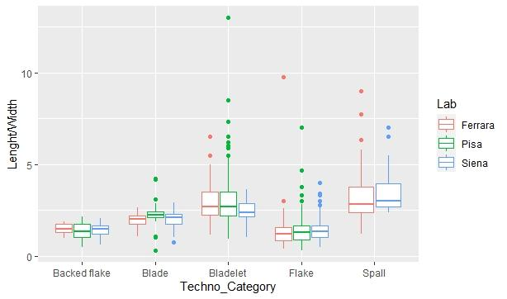
Figure SI.1.28: laminarity of the different types of products obtained by the three different groups (with the third group include Siena and Bologna). When considering only the research groups, there is no significant difference between the sample medians (p = 0.0527).

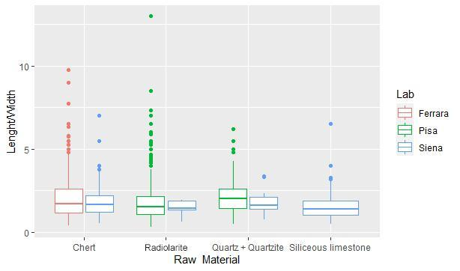
Figure SI.1.29: laminarity of products obtained by the three different research groups depending on the raw material (with the third group include Siena and Bologna).

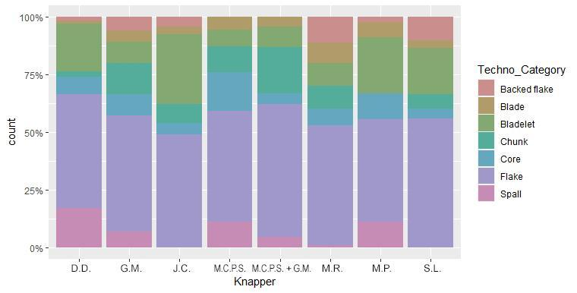
Figure SI.1.30: ratio of the type of products obtained by the different knappers. There are significant differences in the production of some techno-categories of artefacts (p = 2.2716E-59).

The use of bipolar through time and space: bibliographic review
In this work, an extensive bibliographic database has been established, containing a wide range of archaeological and ethnographic evidence documenting the use of the bipolar technique (Tabs. SI.1.10, 11, SI.4). To streamline the analysis, we compiled an Excel table (Supplementary Information SI.4) that includes information for each record, which may pertain to one more site. Additionally, archaeological and ethnographic data are summarised in two tables (Tabs. SI.1.10, 11) and visualised maps (Figs. 25, 26). The collected information covers geographical location, chronological framework, raw materials used, dimensions and shapes of the exploited blanks, adopted gesture(s) and the possible use of specific bipolar methods, objective(s) of the bipolar exploitation, bibliographic references, and any pertinent additional notes that aid in classifying bipolar percussion in individual cases. A maximum of 33 potential fields were available for data entry. To streamline and standardise the raw material types, we organised them into lithological groups based on shared characteristics of their formations (Kooyman 2001). These aggregated lithological groups comprise sedimentary, cherts, volcanics, metamorphic, and Minerals. Such categorisation serves to present spatial geological characteristics in a more accessible manner (Asch 2005; Hartmann and Moosdorf 2012). In instances where multiple types of raw material were indicated, we opted to the most frequently utilised material for each site and/or area on the corresponding maps (Figs. 25, 26). Although the objective of the bipolar technique varied across individual sites, often serving multiple purposes, we emphasised the primary product category in the graphical representation on the maps. This approach provides the most representative application of the bipolar technique at each specific site (information is available in the table of Supplementary Information SI.4).
This comprehensive compilation encompassed a total of 144 archaeological cases, including both scientific works concerning the lithic industries of individual sites (104), as well as papers analysing multiple sites within broader geographical areas (40) (Tab. SI.1.10, SI.4, Fig. 25). In contrast to previous works that adopted a more generalised selection approach (Horta et al. 2022), our study focused exclusively to cases where the bipolar technique is directly linked to lithic exploitation. The sites in our database span a wide range of geographic locations and chronological periods. Geographically, the sites are dispersed across Africa (27), Asia (19), North-Central America (7), South America (27), Oceania (4), and Europe (60). Within Europe, a detailed breakdown reveals specific regions such as Western (13), Eastern (9), Northern (4), and Mediterranean Europe (34). The predominance of European (mostly), South American and African evidence, reflects both the mismatch and accessibility of research works, as well as the authors' greater familiarity with these regions.
The earliest evidence for the use of the bipolar technique dates back to the Late Pliocene, approximately 3.3 million years ago, at Lomekwi (Harmand et al. 2015). Subsequently, its usage is well attested throughout the Pleistocene phases and extends into the Holocene, with usage continuing beyond the Metal Ages (e.g. Furestier, 2010; Piliciauskas and Osipowicz, 2010), and into more recent periods (e.g., Berman et al. 1999; Prous et al. 2014; Banegas et al. 2018). Chronologically, the majority of the analysed evidence falls within the Late Pleistocene (LP, 73) or the Holocene (H, 60). Although less numerous, examples from older periods are also well-represented (32), datable to the Middle (MP) or Early Pleistocene (EP), including several sites that can be dated to 1 million years ago or older (Tab. 1, Fig. 25, SI.4). The cases under examination exhibit a substantial range of exploited raw materials, showcasing significant variability. Mineral hydrothermal rocks [Quartz (75), Chalcedony (9), Agate (3), and Hematite (2)] demonstrate notable utilisation. Volcanic rocks [Obsidian (13), Basalt (8), Andesite (4), Rhyolite (6), Lava (4), Tuff (2), Dolerite (2), Silexite (1), Granite (1), Diorite (1), Basanite (1), Gabbro (1), Phonolite (2), Trachy-phonolite (1), and Volcanic Rocks (1)] are also prevalent. Moreover, metamorphic rocks [Quartzite (27), Hornfels (3), Gneiss (2), and Schist (1)] have been observed. Cherts, encompassing Flint (49), Chert (37), Radiolarite (7), Jasper (3), and Lydite (1), as well as other sedimentary rocks [Limestone/Siliceous limestone (14), Silcrete (5), Sandstone (2), Quartzarenite (1), Dolomite (1), Mudstone (1), Siltstone (1), Lutite (1), Fossilised Wood (1), Local Siliceous Rocks (1)]. At many sites (69), the bipolar technique has been applied to multiple raw materials, underscoring the versatility and flexibility of this technique in exploiting disparate different lithic resources (SI.4). Among these, quartz and siliceous materials defined as flint or chert are the most frequently encountered in bipolar exploitation. Additionally, quartzite enjoys significant representation (SI.4). Upon analysing the raw materials most commonly exploited for bipolar percussion, it becomes evident that mineral resources (55) and siliceous raw materials defined as "cherts" (58) are prevalent in most of the cases (Tab. SI.1.10, SI.4, Fig. 25). Conversely, metamorphic rocks, while often attested, are comparatively limited (8), trailing behind volcanic rocks (16). While cherts recur primarily in European contexts, mineral resources, particularly quartz, are mainly prevalent in South American and African industries (Tab. SI.1.10, SI.4, Fig. 25). The utilisation of various blanks in the archaeological record is characterised by a considerable range in terms of their composition, encompassing pebbles (75), cobbles (17), vein (9), blocks (7), crystals/geodes (9), slabs and other tabular blanks (6), round-shaped nodules (9), clasts (2), exhausted cores (6), flakes (18), blades/bladelets (8), retouched tools (4), chunks (1), free-hand direct percussion products/residues (1), older patinated knapped artefacts (1), and indeterminates/indeterminable (31). However, the specifics regarding their nature remain elusive in many cases. Nevertheless, it is noteworthy that pebbles consistently emerge as the most recurring blank category associated with this technique. Interestingly, bipolar knapping has been applied to various blank types within the same site in some instances (47). While the larger blanks were occasionally exploited (19), nearly half of the studies (70) highlight a correlation between the utilisation of the bipolar technique and the smaller size of blanks (SI.4). The exclusive use of the bipolar method for larger blanks is rare, occurring in only six cases, with a stronger association found with smaller blank sizes (13). The application of bipolar percussion through an axial gesture is the most frequent prevalent technique (106) among the cases analysed. Less frequent occurrences involve the use of a tangential gesture (14), though this could be partly due to the difficulties in distinguishing cores and products produced with this method, which often exhibit features similar to those from freehand direct percussion (Callahan, 1987). Furthermore, in several cases (15) evidence suggests the use of multiple bipolar knapping methods, including various volume management, types of percussion and objectives. In slightly less than a quarter of the cases (36) the gesture employed for bipolar percussion remains unspecified (SI.4). In most cases (103), bipolar knapping is generally associated with multiple uses or types of products (SI.4). Additionally, at numerous sites (47) this technique is employed as a preliminary step prior to actual exploitation, serving to open pebbles (29), break the larger blocks and/or assess the quality of the raw material (17). The analysis reveals a variety of bipolar products with distinct features (SI.4). Among the primary aims of bipolar knapping, the most commonly produced pieces are generic flakes (63), followed by thin flakes (40) and thick flakes (17). Elongated products [elongated flakes (26), generic blade-bladelets (25), batonnets/spalls (11), thick bladelets (5), sharp-edges bladelets (3), and small bladelets (20)] are found in many contests, although they are the primary focus at only a limited number of locations (19) (Tab. SI.1.10, SI.4, Fig. 25). A comprehensive exploration of the uses of bipolar percussion reveals that in many cases (19) the production of non-orientable fragments classified as chunks seems to be a genuine goal of this exploitation, albeit not the primary one. In at least nine cases the exploitation seems to be connected to the production of microliths for throwing weapons (e.g., de la Pena, 2015; Wedage et al. 2019). Less frequently observed is the use of bipolar knapping for the arrangement of core convexities (2). Within our bibliographic review (SI.4), we found nine instances where percussion on an anvil was employed for the façonnage or the retouch of tools; in four examples, it is linked to the façonnage of pieces that, once polished, serve as axes (e.g., Prous et al. 2014). Additionally, three cases demonstrate the use of bipolar percussion for retouching backed tools, spanning from the African Late MSA-Early LSA (Bushozi et al. 2020) and the Late Middle Palaeolithic (Delpiano et al. 2019) to the Uluzzian (Sano et al. 2019) and the final phases of the Epigravettian (Duches et al. 2018). This includes a recent case where bipolar percussion was used for thinning or arranging other retouched tools (Vadillo Conesa et al. 2021). While these examples highlight the application of bipolar percussion in the retouching and shaping of tools, they represent only a fraction of such instances. Numerous other cases likely exist where bipolar percussion was similarly employed. However, for the purpose of this paper, it was deemed more appropriate to focus primarily on the evidence pertaining to the use of bipolar percussion in the debitage. Nonetheless, these examples underscore the versatility and broad potential of the bipolar technique in meeting various functional needs. The relationship between bipolar percussion and residual exploitation is a relatively underexplored topic in the bibliography analysed for this paper (only 24 examples) to a lack of explicit mention of such use in numerous publications. Although the co-occurrence of bipolar knapping and the interpretation of certain pieces as intermediate tools for working organic materials (bone, antler, and wood) is frequently noted (38) (SI.4), its implications remain uncertain. Only a few studies (e.g., Distel, 1972/73; Langejans, 2012) suggest the possible use of these pieces as intermediate tools. In contrast, many other examples interpret the evidence of bipolar knapping and the “splintered pieces" as wedges/gouges as distinct and unrelated components (e.g., Donnart et al. 2009; Porraz et al. 2016; Vadillo Conessa et al. 2021). In many other cases the association between these two artefact types, instead, seems rather generic (e.g., Kaczanowska et al. 2010), probably stemming from the uncertainties that characterised the interpretation of bipolar artefacts until recent years.
In the context of our literature review, alongside the examination of archaeological examples, a limited number of ethnographic studies (16) were also analysed (Tab. SI.1.11, SI.4, Fig. 26).
These particular cases predominantly originate from three continents: South America (7), Africa (4) and Oceania (3).
Regarding the composition of the utilised raw materials [Quartz (5), Agate (2), Chalcedony (1), Quartzite (2), Gneiss (1), Diabase (1), Silexite (1), Chert (2), and Sandstone (1)], mineral resources prevail in the most of sites (7). It should be noted, however, that in several cases information pertaining to the raw material employed in bipolar knapping remains unavailable (Tab. SI.1.11, SI.4, Fig. 26).
The available data on the type and size of the exploited blanks is even more limited (SI.4). Although some studies include photographic documentation, most lack details on blank type (10) and size (12). This scarcity often stems from the reliance on antiquated ethnographic studies (e.g., Roth, 1924; Morice, 1895), which are often difficult to access and typically cited only secondarily (Shott, 1989), or from the fact that detailed accounts of bipolar knapping are not usually the main focus of these studies. When details are available, pebbles and cobbles (3) are the most frequently used, with small-sized blanks (4) also being common.
Regarding the technique, bipolar percussion is most commonly applied using an axial gesture (13 cases), while a tangential gesture is observed in two cases, one of which reports both methods. Notable observations include the types of individuals who use this technique and their reasons for its application (e.g., Sillitoe and Hardy, 2003). Additionally, they have documented the devices adopted by knappers (such as strips of bark or grass wrapped around the core), as well as the variety of anvils employed (encompassing the placement of the core on the ground, mortars, wooden trunks or even hoe tips). Furthermore, preliminary treatments of raw materials, such as immersion in water or heat treatment, have been recorded (SI.4).
In most cases, generic flakes are the primary target of bipolar exploitation (9), followed by thin (4) and thick flakes (2) (Tab. SI.1.11, SI.4, Fig. 26). In three cases, multiple types of flakes are reported (SI.4). However, in a singular case (Lake Kopiago - Papua New Guinea), bipolar bladelets are produced alongside flakes. Although in some cases (4) bipolar knapping seems connected to the production of shapeless fragments, it is never the primary objective of the debitage, according to the archaeological evidence. Bipolar products are generally used as cutting edges in a wide variety of tools and functions (SI.4). Additionally, in some cases, there are instances where these products serve as initial blanks for the creation of polished ornaments (Migliacio 2006). In one case (Distel 1972/73), the primary objective of bipolar exploitation appears to be the acquisition of blanks for use as intermediate tools.
Upon analysis of these data, several general trends emerge. These include the exploitation of small-sized blanks, the predominance of axial gestures, the prevalence of flakes, and the frequent association of the bipolar technique with the production of flakes and mineral resources. However, the bipolar knapping cannot be confined to a singular pattern that encompasses raw material-methods of exploitation-goals. The variability across chronological periods and contextual factors—such as geographical area, raw materials, site typology, and subsistence strategies—results in a broad range of practices and objectives. This diversity inevitably influences the methods and aims of bipolar production.
N. | Site | Country | Chronology | Lithological group |  | Main bipolar goal |  | References
1 | Debert | Canada | LP - 10.6 ka |  | Minerals |  | Flakes | Goodyear 1993
2 | Several sites | United States | LP/H - 13-9 ka |  | Cherts |  | Flakes | Morgan et al. 2015
3 | Canada Century site | Canada | H - 3000-2000 BC |  | Cherts |  | Thin flakes | Lennox 1990
4 | Hoko River | United States | H - 2500 BP |  | Minerals |  | Thin flakes | Flenniken 1981
5 | Teotihuacan | Messico | H - 2-1.3 ka |  | Volcanics |  | Flakes | Carballo 2011
6 | Escalante | United States | H - 2-0.6 ka |  | Volcanics |  | Flakes | Goodyear 1993; Stafford 1981
7 | Three Dog | Bahamas | H - 1.2-0.1 ka |  | Cherts |  | Thin flakes | Berman et al. 1999
8 | Pedra Furada | Brazil | LP/H - 30-8 ka |  | Minerals |  | Thick flakes | Parenti 2001; Boeda 2014; Boeda et al. 2014b, 2016
9 | Sitio do Meio | Brazil | LP/H - 30-8 ka |  | Minerals |  | Flakes | Boeda et al. 2014a, 2016; Aimola et al. 2014
10 | Tira Peia | Brazil | LP/H - 20-10 ka |  | Minerals |  | Thick flakes | Lahaye et al. 2013; Lourdeau 2019
11 | Lapo do Santo | Brazil | LP/H - 12.5-1 ka |  | Minerals |  | Thin flakes | Pugliese 2007; Moreno de Sousa and de Mello Araujo 2018
12 | Several sites | Brazil | LP/H - 12-8 ka |  | Minerals |  | Thick flakes | Prous 2019
13 | Pedra Pintada, Gavião, Pequiá | Brazil | LP/H - 12.4-9 ka |  | Minerals |  | Thin flakes | Duarte-Talim 2019
14 | Several sites | Brazil | LP/H - 12-8 ka |  | Minerals |  | Thin flakes | Lourdeau 2010; Prous et al. 2010, 2014
15 | Several sites | Brazil | LP/H - 11-1 ka |  | Minerals |  | Flakes | Prous 1991; Prous et al. 2014
16 | Buritizeiro | Brazil | H - 10.5-6 ka |  | Minerals |  | Flakes | Bassi Alves 2012
17 | Bibocas V-VI | Brazil | H - 10.4-6 ka |  | Minerals |  | Flakes | Bassi Alves 2012
18 | Lapa das Boleiras | Brazil | H - 10-4.2 ka |  | Minerals |  | Thin flakes | Pugliese 2007
19 | Several sites | Brazil | H - 8-3 ka |  | Minerals |  | Thick flakes | Pagli et al. 2016
20 | Several sites | Brazil | H - 7-0.5 ka |  | Minerals |  | Thin flakes | Lima 1991; Souza 2013; Prous et al. 2014
21 | Several sites | Argentina | H - 7-0.5 ka |  | Volcanics |  | Flakes | Banegas et al. 2018
22 | Several sites | Argentina | H - 7-0.5 ka |  | Cherts |  | Flakes | Banegas et al. 2018
23 | Several sites | Ecuador | H - 3-1 ka |  | Volcanics |  | Thick flakes | Jackson and Donald 1987
24 | Several sites | Guyana | H - 3-1 ka |  | Minerals |  | Flakes | Rostain 1995
25 | Rodriguez III | Brazil | H - 3-0.5 ka |  | Minerals |  | Flakes | Faustino 2019
26 | Several sites | Brazil | H - 3-0.5 ka |  | Minerals |  | Flakes | Prous et al. 2014
27 | Several sites | Brazil | H - 2.2-1.4 ka |  | Volcanics |  | Flakes | Rodet et al. 2013; Duarte-Talim 2012
28 | Several sites | Brazil | H - 2-0.5 ka |  | Minerals |  | Elongated products | Prous et al. 2010; Pereira Santos et al. 2016; Milheira and DeBlasis 2013
29 | Several sites | Brazil | H - 2-0.5 ka |  | Cherts |  | Façonnage | Prous et al. 2014; Costa 2003
30 | Several sites | Brazil | H - 2-0.4 ka |  | Minerals |  | Façonnage | Prous et al. 2014; Souza 2013
31 | Maranga | Peri | H - 1.8-0.4 ka |  | Volcanics |  | Flakes | Pérez et al. 2020
32 | Several sites | Brazil | H - 1.7-0.2 ka |  | Minerals |  | Elongated products | Prous et al. 2014; Rodrigues and Gardiman 2016
33 | Several sites | Peru | H - 1.6-0.5 ka |  | Cherts |  | Flakes | Downey 2010
34 | Porto de Santarem | Brazil | H - 1.2-0.4 ka |  | Minerals |  | Flakes | Araujo da Silva and Pahl Schaan 2021
35 | Dmanisi | Georgia | EP - 1.81-1.6 Ma |  | Minerals |  | Flakes | de Lumley et al. 2005
36 | Pirro Nord | Italy | EP - 1.5-1.2 Ma |  | Cherts |  | Flakes | Arzarello et al. 2016
37 | Fuente Nueva, Barranco Leon | Spain | EP - 1.4-1.2 Ma |  | Sedimentary |  | Thin flakes | Moyano et al. 2011
38 | Ca' Belvedere di Monte Poggiolo | Italy | EP - 1 Ma |  | Sedimentary |  | Thick flakes | Arzarello et al. 2016
39 | Untermassfeld | Germany | EP - 1 Ma |  | Cherts |  | Flakes | Roebroeks et al., 2018
40 | Vallparadis | Spain | EP/MP - 0.98-0.83 Ma |  | Minerals |  | Thick flakes | Garcia and Silva 2013, Garcia et al. 2013
41 | Sierra de Atapuerca | Spain | EP/MP - > 800 ka |  | Quartz |  | Flakes | Ollé et al. 2013
42 | Baıraki | Moldávia | EP/MP - 800-450 k |  | Cherts |  | Thick flakes | Anissutkine et al. 2019
43 | Pont-de-Lavaud | France | EP/MP - Lower Paleolithic |  | Minerals |  | Thick flakes | de Lombera-Hermida et al. 2016
44 | Tunel Wielki Cave | Poland | MP - 563-478 ka |  | Cherts |  | Thick flakes | Kot et al. 2022
45 | Schöningen | Germany | MP - 478-424 k |  | Cherts |  | Thin flakes | Van Kolfschoten et al. 2015
46 | La Cansaladeta | Spain | MP - 424-374 ka |  | Minerals |  | Thin flakes | Yesilova et al. 2021
47 | Medzhibozh 1 | Ukraine | MP - 373-399 ka |  | Metamorphics |  | Flakes | Stepanchuk et al. 2021
48 | Torre dell’Alto | Italy | LP - Middle Palaeolithic |  | Sedimentary |  | Thick flakes | Ranaldo et al. 2022a, b
49 | La Chaise- de- Vouthon | France | LP - Middle Palaeolithic |  | Metamorphics |  | Flakes | Matilla 2010
50 | Grotta Guattari, Grotta Breuil | Italy | LP - Middle Palaeolithic |  | Cherts |  | Thick flakes | Bietti et al. 2010
51 | Bosses | France | LP - Middle Palaeolithic |  | Minerals |  | Flakes | Mourre 1996, 2004; Jarry et al. 2004; Mourre et al. 2010
52 | Champ Grand | France | LP - Middle Palaeolithic - Mousterian |  | Minerals |  | Flakes | Nicoud 2010
53 | Tares | France | LP - Middle Palaeolithic - Mousterian |  | Cherts |  | Thick flakes | Faivre et al. 2010
54 | Grotta di Fumane - layer A9 | Italy | LP - Middle Palaeolithic - Mousterian - 47.6 ka |  | Cherts |  | Façonnage | Delpiano et al. 2019
55 | Bacho Kiro - layer I/level 11 | Bulgaria | LP - Initial Upper Palaeolithic - 44.8-42.6 ka |  | Cherts |  | Thin flakes | Tsanova 2006
56 | Klissoura | Greece | LP - Uluzzian - 40-39 ka | Cherts |  | Elongated products |  | Sitlivy 2016;  Kaczanowska et al. 2010
57 | Riparo Broion - 1f, 1g | Italy | LP - Uluzzian | Cherts |  | Elongated products |  | Peresani et al. 2019
58 | Grotta di Fumane - layer A3 | Italy | LP - Uluzzian | Cherts |  | Flakes |  | Peresani et al. 2016
59 | Grotta La Fabbrica - layer 2 | Italy | LP - Uluzzian | Cherts |  | Flakes |  | Villa et al. 2018
60 | Colle Rotondo | Italy | LP - Uluzzian | Cherts |  | Flakes |  | Villa et al. 2018
61 | Grotta di Castelcivita - layers upper-rsi, pie, rpi, rsa’’ | Italy | LP - Uluzzian | Cherts |  | Flakes |  | Rossini et al. 2022
62 | Grotta Roccia San Sebastiano | Italy | LP - Uluzzian | Cherts |  | Thin flakes |  | Collina et al. 2020
63 | Grotta-Riparo di Uluzzo C - layer C-D-E, SUs 3, 15, 17 | Italy | LP - Uluzzian | Cherts |  | Thin Flakes |  | Silvestrini et al. 2021
64 | Grotta del Cavallo - layer III | Italy | LP - Uluzzian | Sedimentary |  | Elongated products |  | Moroni et al. 2018; Sano et al. 2019
65 | Grotta Barbara | Italy | LP - Aurignacian | Cherts |  | Thin flakes |  | D’Angelo and Mussi 2005
66 | Grotta del Fossellone | Italy | LP - Aurignacian | Cherts |  | Flakes |  | Bietti et al. 2010
67 | Grotta La Fabbrica - layers 3-4 | Italy | LP - Aurignacian | Cherts |  | Flakes |  | Dini et al. 2012
68 | Klissoura - layers IV, IIId-g, IIIa-c | Greece | LP - Aurignacian - 37.5-30 ka | Cherts |  | Thin flakes |  | Kaczanowska et al. 2010
69 | El Palomar | Spain | LP - Gravettian | Cherts |  | Thin flakes |  | de la Pena Alonso and Vega-Toscano 2012, 2013
70 | Kalavan 1 | Armenia | LP - 14 ka | Volcanics |  | Elongated products |  | Montoya et al. 2013
71 | Riparo Salvini, Riparo Palidoro | Italy | LP - Epigravettian | Cherts |  | Elongated products |  | Bietti et al. 2010
72 | Dalmeri rockshelter | Italy | LP - Late Epigravettian | Cherts |  | Façonnage |  | Duches et al. 2018
73 | Grotta della Serratura-layer 10 | Italy | LP - Final Epigravettian | Cherts |  | Elongated products |  | Ricci et al. 2019; Vadillo Conesa et al. 2021
74 | La Tourasse - (Layer C-D) | France | LP - Azilien - Dryas 3 - Boreal | Cherts |  | Flakes |  | Orliac 1972
75 | Klissoura - layers II a-d, 3-5 | Greece | LP/H - Epigravettian (14 ka) / Mesolithic (10 ka) | Cherts |  | Thin flakes |  | Kaczanowska et al. 2010
76 | Riparo Fredian, La Murella XIII | Italy | LP/H - Final Epigravettian -Sauveterrian | Cherts |  | Flakes |  | Lombardo 2020; Lombardo and Tozzi 2023; Conforti et al. 2021
77 | Several sites | Portugal | LP/H - Upper Palaeolithic- Mesolithic | Cherts |  | Elongated products |  | Almeida 2007; Aubry et al. 1997; Zilhao et al. 1997
78 | Several sites | France | LP/H - Epipaleolithic-Mesolithic- Neolithic | Cherts |  | Thick flakes |  | Guyodo and Marchand 2005
79 | Lepenski Vir | Serbia | H - Mesolithic | Cherts |  | Flakes |  | Mitrovic 2018, 2022
80 | Vlasac I | Serbia | H - Mesolithic | Metamorphics |  | Flakes |  | Mitrovic 2018, 2022
81 | Font del Ros | Spain | H - Mesolithic - 10.2-8.4 ka | Cherts |  | Flakes |  | Roda Gilabert et al. 2015
82 | Several sites | Netherlands | H - Late Mesolithic-Early Neolithic 5-3,4 ka | Cherts |  | Flakes |  | Devriendt 2011
83 | Several sites | Sweden- Finland | H - Mesolithic-Neolithic | Minerals |  | Flakes |  | Knutsson et al. 2015
84 | Several sites | Sweden | H - Mesolithic- Neolithic | Minerals |  | Thin flakes |  | Callahan 1987
85 | Several sites | Norway | H - Mesolithic- Neolithic | Volcanics |  | Flakes |  | Ballin 1999
86 | Trasanello cementificio | Italy | H - Early- Middle Neolithic | Cherts |  | Thin flakes |  | Conforti and Parisi 2018
87 | A Guaita | France | H - Early- Middle- Recent Neolithic - 6th-4th millenium BC | Minerals |  | Elongated products |  | Lorenzi et al. 2021
88 | Tivulaghjiu | France | H - Middle Neolithic - end of 5th millennium BC | Volcanics |  | Thin flakes |  | Tramoni et al. 2007; Costa 2001
89 | Beg ar Loued, Guernic | France | H - Late-final Neolithic | Cherts |  | Thick flakes |  | Donnart et al. 2009
90 | Several sites | Polonia | H - Late Neolithic 2700 BC | Cherts |  | Flakes |  | Januszek 2010
91 | Sollacaro - I Calanchi- Sapar'alta / Piani di U Grecu | France | H - Final Neolithic - end of 3th millennium BC | Volcanics |  | Thin flakes |  | Remincourt et al. 2016; Costa 2001
92 | Several sites | France | H - Copper Age - Bell Beaker culture | Cherts |  | Flakes |  | Furestier 2010
93 | Coppa Nevigata | Italy | H - Bronze Age | Cherts |  | Flakes |  | Vilmercati 2022
94 | Several sites | Lithuania | H - Late Bronze Age- Iron Age - 1ka BC-1 AD | Cherts |  | Thin flakes |  | Piliciauskas and Osipowicz 2010
95 | Lomekwi 3 | Kenya | Late Pliocene - 3.3 Ma | Volcanics |  | Flakes |  | Harmand et al. 2015
96 | Sterkfontein M5, Swartkrans M1 | South Africa | EP - 2.2-1.7 Ma | Minerals |  | Flakes |  | Caruana 2017
97 | Omo site 123 | Ethiopia | EP - Olduwan - 2 Ma | Cherts |  | Flakes |  | de la Torre 2004
98 | Fejej FJ-Ia | Ethiopia | EP - Olduwan - 1,9 Ma | Minerals |  | Flakes |  | Barsky et al. 2011
99 | HWK EE | Tanzania | EP - Late Olduwan | Metamorphics |  | Flakes |  | de la Torre and Mora 2018b
100 | Rietputs 15 | South Africa | EP - 1.7–1.2 Ma | Volcanics |  | Thick flakes |  | Kuman and Gibbon 2017
101 | Several sites | Tanzania | EP - Lower Palaeolithic | Minerals |  | Flakes |  | Diez-Martin et al. 2009a, 2010; Gurtov et al. 2014;
102 | EF-HR | Tanzania | EP - Early Acheulean | Metamorphics |  | Flakes |  | de la Torre and Mora 2018a
103 | Thomas Quarry I-L1 | Morocco | EP - Acheulean | Cherts |  | Elongated products |  | Gallotti et al. 2020
104 | Melka Kunture - Garba III | Ethiopia | MP - Early MSA | Volcanics |  | Flakes |  | Mussi et al. 2014
105 | Several sites | Africa | MP/LP - MSA | Minerals |  | Thin flakes |  | de la Pena 2015
106 | Leba Cave | Angola | MP/LP - MSA | Cherts |  | Thin flakes |  | de Matos and Pereira 2020
107 | Mnaraeka | Tanzania | MP/LP - MSA | Minerals |  | Thin flakes |  | Beyin and Ryano 2020
108 | Mumba Rockshelter Bed VIA | Tanzania | LP - MSA - 131-63 ka | Minerals |  | Flakes |  | Bushozi et al. 2020
109 | Ounjougou | Mali | LP - MSA | Minerals |  | Flakes |  | Soriano et al. 2010a, 2010b
110 | Putslaagte 8 - layers F14-1, C 23-20 | South Africa | LP - MSA/ Howiesons Poort/ Late MSA - MIS 5-3 - 81-33 ka | Metamorphics |  | Thin flakes |  | Mackay et al. 2015
111 | Mumba Rockshelter Bed V | Tanzania | LP - Late MSA/Early LSA - 65-45 ka | Minerals |  | Thick flakes |  | Diez-Martin et al. 2009b; Bushozi et al. 2020
112 | Border Cave - layers 2BS LR-1BS LR | South Africa | LP - Final MSA/Early LS A - 49-42 ka | Minerals |  | Flakes |  | Villa et al. 2012
113 | Kisese II rockshelter | Tanzania | LP - MSA/LSA - 45-4 ka | Minerals |  | Flakes |  | Tryon et al. 2018
114 | Loiyangalani | Tanzania | LP - Late MSA | Minerals |  | Thin flakes |  | Maìllo-Fernandez et al. 2019
115 | Sibudu | South Africa | LP - MSA - Howiesons Poort | Minerals |  | Flakes |  | de la Pena and Wadley 2014, 2017; Langejans 2012
116 | Gotera - GOT-10 | Ethiopia | LP - MSA - MIS 3 | Minerals |  | Flakes |  | Fusco and Spinapolice 2022
117 | Siphiso Shelter and Sibebe Shelter | Swaziland | LP - MSA/ LSA | Minerals |  | Elongated products |  | Barham 1987
118 | Sehonghong - Layers RFS-BARF | Lesotho | LP - Late Pleistocene - 35-12 ka | Minerals |  | Thin flakes |  | Pargeter et al. 2017
119 | Putslaagte 8 layers C19-8 | South Africa | LP - Early LSA/Robberg/Early Holocene - 25- <17 ka | Metamorphics |  | Thin flakes |  | Mackay et al. 2015
120 | Eland Bay Cave - MOS1 | South Africa | LP - LSA - Robberg - 14605-14278 cal BP | Minerals |  | Elongated products |  | Porraz et al. 2016
121 | Bizhat Ruhama | Israel | EP - Olduwan - 1.6-1.2 Ma | Cherts |  | Thin flakes |  | Zaidner 2013
122 | Xiaochangliang | China | EP - Lower Paleolithic | Cherts |  | Elongated products |  | Yang et al. 2016
123 | Dursunlu | Turkey | EP/MP - Early to Middle Pleistocene | Volcanics |  | Thin flakes |  | Slimak et al. 2008; Gulec et al. 2009
124 | Fengshudao | China | EP/MP - 803 ka | Sedimentary |  | Thin flakes |  | Wang et al. 2014
125 | Chou-Kou-Tien/ Zhoukoudian | China | MP - Lower Palaeolithic | Minerals |  | Flakes |  | Breuil 1932; Li 2016
126 | Toka | India | MP/LP - Middle to Late Pleistocene | Metamorphics |  | Flakes |  | Chauhan 2007
127 | Mugharet el-Zuttiyeh | Israel | MP/LP - ∼260–106 ka | Cherts |  | Elongated products |  | Malinsky-Buller 2016
128 | Liang Bua | Indonesia | LP - 95-17 ka | Volcanics |  | Flakes |  | Moore et al. 2009
129 | JWP 20, 21, 23 | India | LP - 77-34 ka | Sedimentary |  | Thin flakes |  | Clarkson et al. 2012; Wedage et al. 2019
130 | Mughr el-Hamamah | Jordan | LP - 45-39 ka | Cherts |  | Thin flakes |  | Stutz et al. 2015
131 | Üçağızlı | Turkey | LP - 42–29 ka | Cherts |  | Elongated products |  | Kuhn et al. 2009
132 | Batadomba-Lena | Sri Lanka | LP - ∼36-20 ka cal BP | Minerals |  | Thin flakes |  | Lewis et al. 2014; Perera et al. 2011
133 | Shuidonggou locality 7 | China | LP - Initial Upper Palaeolithic - 30-23 ka | Cherts |  | Thin flakes |  | Niu et al. 2016
134 | Several sites | India | LP - Upper Paleolithic | Cherts |  | Elongated products |  | Jones and Pal 2009
135 | Huayang site | China | LP - 14 ka | Minerals |  | Thin flakes |  | Yue et al. 2020
136 | Fa-Hien Lena Cave | Sri Lanka | LP/H - 48-4 ka | Minerals |  | Thin flakes |  | Wedage et al. 2019
137 | Jwalapuram 9 rockshekter | India | LP/H - 35 ka-Holocene | Sedimentary |  | Elongated products |  | Clarkson et al. 2009, 2012; Wedage et al. 2019
138 | Kültepe I | Azerbaijan | H - Neolithic- Chalcolithic | Volcanics |  | Flakes |  | Marro et al. 2019
139 | Bone Cave | Tasmania | LP - 29-post 18 ka | Minerals |  | Thin flakes |  | Cosgrove 1999
140 | Jerimalai | East Timor | LP/H - 42-2 ka BP | Cherts |  | Thin flakes |  | Marwick et al. 2016
141 | Kun-Kundurnku | Australia | H - Holocene | Minerals |  | Flakes |  | Hiscock 2015
142 | Henry lawson Drive Rockshelter | Australia | H - 1 ka | Cherts |  | Flakes |  | Hiscock 2003, 2015
143 | Panga ya Saidi layers 1-19 | Kenya | LP/H - MSA/ LSA - ∼78-post 8 ka | Quartz |  | Flakes |  | Shipton et al. 2018
144 | Xiamabei layers 6 | China | LP - 40 ka | Cherts |  | Elongated products |  | Wang et al. 2022
Table. SI.1.10: Archaeological evidence of bipolar knapping (detailed information in SI.4).

N. | Site | Country | Lithological group | Main  bipolar goal | References
1 | Several sites | Canada | Nd | Thick flakes | Shott 1989; Morice 1895; Teit 1900
2 | Eastern Waiwai | Brazil | Sedimentary | Flakes | Prous 2009; Prous et al. 2014
3 | Baniwà | Brazil | Metamorphics | Flakes | Prous 2009; Prous et al. 2014; Menestrino and Mentz Ribeiro 1995
4 | Several sites | Brazil | Minerals | Flakes | Migliacio 2006
5 | Desana | Colombia | Minerals | Flakes | Prous et al. 2014; Reichel-Dolmatoff 1997; Prous et al. 2010
6 | Several sites (Xeta people) | Brazil | Volcanics | Flakes | Shott 1989; Miller 1979
7 | Several sites (Gulena people) | Guyana | Nd | Flakes | Shott 1989; Roth 1924
8 | Several sites | Perù | Minerals | Intermediate tools | Distel 1972/73
9 | Several sites | Namibia- Angola | Metamorphics | Thin flakes | Hayden 1980; Shott 1989; Mac Calman and Grobbellar 1965
10 | Several sites | Tanzania | Minerals | Flakes | Hayden 1980; Shott 1989; Masao 1982
11 | Several sites | Zimbabwe | Nd | Thick flakes | Shott 1989; Robinson 1938
12 | Konso people | Ethiopia | Minerals | Thin flakes | Brandt and Weedman 2002; Brandt et al. 2016
13 | Several sites | India | Minerals | Thin flakes | Kosambi 1967; Hayden 1980
14 | Several sites | Papua-New Guinea | Cherts | Flakes | White 1968; Strathern 1969; Sillitoe 1982; Shott 1989
15 | Several sites | Papua-New Guinea | Cherts | Flakes | Sillitoe and Hardy 2003
16 | Several sites | Australia | Minerals | Thin flakes | Hayden 1980; White 1968; McCarthy et al., 1946
Table. SI.1.11: Ethnographic evidence of bipolar knapping (detailed information in SI.4).

References
Aimola, G., Andrade, C., Mota, L., & Parenti, F. (2014). Final Pleistocene and Early Holocene at Sitio do Meio, Piauí - Brazil: stratigraphy and comparison with Pedra Furada. Journal of Lithic Studies, 1(2). https://doi.org/10.2218/jls.v1i2.1125
Almeida, F. (2007). The production of lithic barbs in the context of the core vs tool dichotomy: the portuguese Upper Paleolithic case (S.-P. McPherron, Ed.; Tools versus Cores, pp. 127–142). Cambridge Scholars Publishing.
Anissutkine, N. K., Tchepalyga, А. L., & Kolavenko, S. I. (2019). Baïraki – un site du Paléolithique inférieur sur le territoire de la Plaine d’Europe orientale. L’Anthropologie, 123(2), 233–256. https://doi.org/10.1016/j.anthro.2019.06.003
Araujo da Silva, T. S., & Pahl Schaan, D. (2021). Entre esprits, gestes et pierres : chaîne opératoire lithique sur le site de Porto de Santarém, Amazonie. L’Anthropologie, 125(2), 102869. https://doi.org/10.1016/j.anthro.2021.102869
Arzarello, M., De Weyer, L., & Peretto, C. (2016). The first European peopling and the Italian case: Peculiarities and “opportunism.” Quaternary International, 393, 41–50. https://doi.org/10.1016/j.quaint.2015.11.005
Asch, K. (2005). The 1:5 Million International Geological Map of Europe and Adjacent Areas, Final Version for the Internet, BGR, Hannover.
Aubry, T., Zilhão, J., Almeida, F., & Fontugne, M. (1997). Production d’armatures microlithiques pendant le Paléolithique Supérieur et le Mésolithique du Portugal. II Congreso de Arqueologia Peninsular. Zamora, Fundaciòn Rei Afonso Henriques. Paleolitico y Epipaleolitico, 259–272.
Banegas, A., Bonomo, M., & Gómez Otero, J. (2018). Bipolar flaking as a component of a supraregional lithic resource base: A comparative study of cores from the Pampean and Northcentral Patagonian Atlantic coasts (Argentina). Journal of Lithic Studies, 5(2).
Barham, L. S. (1987). The Bipolar Technique in Southern Africa: A Replication Experiment. The South African Archaeological Bulletin, 42(145), 45. https://doi.org/10.2307/3887773
Barsky, D., Chapon-Sao, C., Bahain, J. J., Beyene, Y., Cauche, D., Celiberti, V., Desclaux, E., De Lumley, H., De Lumley, M. A., Marchal, F., Moullé, P. E., & Pleurdeau, D. (2011). The Early Oldowan Stone-Tool assemblage from Fejej Fj-1a, Ethiopia. Journal of African Archaeology, 9(2), 207–224. https://doi.org/10.3213/2191-5784-10196
Bassi Alves, L. F. (2012). Tecnologia lítica: análise diacrônica dos níveis mais antigos do sítio arqueológico Bibocas II, Jequitaí - MG [Master thesis, Universidade Federal de Minas Gerais]. https://repositorio.ufmg.br/handle/1843/BUOS-9L2FSQ
Berman, M. J., Sievert, A. K., & Whyte, T. R. (1999). Form and Function of Bipolar Lithic Artifacts from the Three Dog Site, San Salvador, Bahamas. Latin American Antiquity, 10(4), 415–432. https://doi.org/10.2307/971965
Beyin, A., & Ryano, K. P. (2020). Filling the Void: a Study of Sites Characterized by Levallois and Blade Technologies in the Kilwa Basin, Coastal Tanzania. Journal of Paleolithic Archaeology, 3(4), 1048–1094. https://doi.org/10.1007/s41982-020-00070-5
Bietti, A., Cancellieri, E., Corinaldesi, C., Grimaldi, S., & Spinapolice, E. (2010). La percussion sur enclume en Italie centrale tyrrhénienne. PALEO, “Entre le marteau e l’enclume…” numéro spécial, 143–180.
Ballin, T. B. (1999). Bipolar Cores in Southern Norway: Classification, Chronology and Geography. Lithics, 20, 13–22.
Boëda, E., Clemente-Conte, I., Fontugne, M., Lahaye, C., Pino, M., Felice, G. D., Guidon, N., Hoeltz, S., Lourdeau, A., Pagli, M., Pessis, A.-M., Viana, S., Da Costa, A., & Douville, E. (2014). A new late Pleistocene archaeological sequence in South America: the Vale da Pedra Furada (Piauí, Brazil). Antiquity, 88(341), 927–941. https://doi.org/10.1017/S0003598X00050845
Boëda, E., Lourdeau, A., Lahaye C, Daltrini Felice, G., Viana, S., Clemente-Conte, I., Pino, M., Fontugne, M., Hoeltz, S., Guidon, N., Pessis, A., Da Costa, A., & Pagli, M. (2014). The late-pleistocene industries of Piauí, Brazil: New data. Paleoamerican Odyssey.
Brandt, S., Weedman, K., & Shipley, J. (2016, April 12). Woman the Toolmaker: Hideworking and Stone Tool Use in Konso, Ethiopia [Video recording]. In Archaeological method and practice. Archaeological Methods & Practice.
Brandt, Steven. A., & Weedman, K. (2002). The ethnoarchaeology of hide working and stone tool use in Konso, Southern Ethiopia: an introduction. In F. Audoin-Rouzeau & S. Beyries (Eds.), XXlle rencontres internationales d’archeoloqie et d’histoire d’Antibes (pp. 113–129). Editions APDCA.
Breuil, H. (1932). Le gisement à Sinanthropus de Chou-Kou-Tien (Chine) et ses vestiges de feu et d’industrie. Anthropos H. 1./2, 1–10.
Bushozi, P. M., Skinner, A., & de Luque, L. (2020). The Middle Stone Age (MSA) Technological Patterns, Innovations, and Behavioral Changes at Bed VIA of Mumba Rockshelter, Northern Tanzania. African Archaeological Review, 37(2), 293–310. https://doi.org/10.1007/s10437-019-09360-y
Callahan, E. (1987). An evaluation of the lithic technology in middle Sweden during the Mesolithic and Neolithic. Societas Archaeologica Upsaliensis.
Carballo, D. M., Paredes Cetino, R. Nestor., Martin, A. J., & Universidad Nacional Autónoma de México. Instituto de Investigaciones Antropológicas. (2011). Obsidian and the Teotihuacan state: weaponry and ritual production at the Moon Pyramid (Vol. 21). University of Pittsburgh Center for Comparative Archaeology.
Caruana, M. V. (2017). Lithic Production Strategies in the Oldowan Assemblages from Sterkfontein Member 5 and Swartkrans Member 1, Gauteng Province, South Africa. Source: Journal of African Archaeology, 15(1), 1–19. https://doi.org/10.2307/26505470
Chauhan, P. R. (2007). Soanian cores and core-tools from Toka, Northern India: Towards a new typo-technological organization. Journal of Anthropological Archaeology, 26(3), 412–441. https://doi.org/10.1016/J.JAA.2007.01.001
Clarkson, C., Jones, S., & Harris, C. (2012). Continuity and change in the lithic industries of the Jurreru Valley, India, before and after the Toba eruption. Quaternary International, 258, 165–179. https://doi.org/10.1016/j.quaint.2011.11.007
Clarkson, C., Petraglia, M., Korisettar, R., Haslam, M., Boivin, N., Crowther, A., Ditchfield, P., Fuller, D., Miracle, P., Harris, C., Connell, K., James, H., & Koshy, J. (2009). The oldest and longest enduring microlithic sequence in India: 35 000 years of modern human occupation and change at the Jwalapuram Locality 9 rockshelter. Antiquity, 83, 326–348.
Collina, C., Marciani, G., Martini, I., Donadio, C., Repola, L., Bortolini, E., Arrighi, S., Badino, F., Figus, C., Lugli, F., Oxilia, G., Romandini, M., Silvestrini, S., Piperno, M., & Benazzi, S. (2020). Refining the Uluzzian through a new lithic assemblage from Roccia San Sebastiano (Mondragone, southern Italy). Quaternary International, 551, 150–168. https://doi.org/10.1016/j.quaint.2020.03.056
Conforti, J., Fioravanti, S., Notini, P., & Tozzi, C. (2021). La Murella XIII, un sito sauveterriano (?) sul fondovalle del Serchio (Castelnuovo di Garfagnana, Toscana). Atti Soc. Tosc. Sci. Nat., Mem., Serie A, 128, 61–77. https://doi.org/10.2424/ASTSN.M.2021.20
Conforti, J., & Parisi, M. (2018). L’industria litica del villaggio trincerato di Trasanello (Matera) durante il Neolitico antico e medio : analisi tecno-economica preliminare. Rivista Di Scienze Preistoriche, LXVIII, 35–64.
Cosgrove, R. (1999). Forty-Two Degrees South: The Archaeology of Late Pleistocene Tasmania. Journal of World Prehistory, 13(4).
Costa, L. J. (2001). Espaces et productions lithiques taillées en Corse (9ème-2ème millénaire cal. BC) [PhD thesis, Université Paris X]. In http://www.theses.fr. http://www.theses.fr/2001PA100137
D’Angelo, E., & Mussi, M. (2005). Galets et lamelles de l’Aurignacien du Latium (Italie centrale): le cas de Grotta Barbara. In Productions lamellaires attribuées à l’Aurignacien: chaînes opératoires et perspectives technoculturelles (Vol. 1, pp. 313–322).
de la Peña, P. (2015). The interpretation of bipolar knapping in African stone age studies. Current Anthropology, 56(6), 911–923. https://doi.org/10.1086/684071
de La Peña, P., & Vega Toscano, G. (2012). Flaking technology strategies in Early Upper Paleolithic levels from the Southeastern Iberian Peninsula. In A. Pastoors & M. Peresani (Eds.), Flakes not blades: the role of flake production at the Onset of Upper Palaeolithic in Europe (Vol. 5, pp. 51–68). Wissenschaftliche Schriften des Neanderthal Museums.
de la Pena, P., & Vega Toscano, G. (2013). The Early Upper Palaeolithic puzzle in Mediterranean Iberia Das Frühe Jungpaläolithikum im mediterranen Spanien. Quartär, 60, 85–106. https://doi.org/10.7485/QU60_4
de La Peña, P., & Wadley, L. (2014). Quartz Knapping Strategies in the Howiesons Poort at Sibudu (KwaZulu-Natal, South Africa). PLoS ONE, 9(7). https://doi.org/10.1371/journal.pone.0101534
de la Peña, P., & Wadley, L. (2017). Technological variability at Sibudu Cave: The end of Howiesons Poort and reduced mobility strategies after 62,000 years ago. PLoS ONE, 12(10). https://doi.org/10.1371/journal.pone.0185845
de la Torre, I. (2004). Omo revisited: Evaluating the technological skills of Pliocene Hominids. In Current Anthropology (Vol. 45, Issue 4, pp. 439–465). University of Chicago Press. https://doi.org/10.1086/422079
de la Torre, I., & Mora, R. (2018). Technological behaviour in the early Acheulean of EF-HR (Olduvai Gorge, Tanzania). Journal of Human Evolution, 120, 329–377. https://doi.org/10.1016/j.jhevol.2018.01.003
De Lombera-Hermida, A., Rodríguez-Álvarez, X. P., Peña, L., Sala-Ramos, R., Despriée, J., Moncel, M. H., Gourcimault, G., Voinchet, P., & Falguères, C. (2016). The lithic assemblage from Pont-de-Lavaud (Indre, France) and the role of the bipolar-on-anvil technique in the Lower and Early Middle Pleistocene technology. Journal of Anthropological Archaeology, 41, 159–184. https://doi.org/10.1016/J.JAA.2015.12.002
de Lumley, H., Nioradzé, M., Barsky, D., Cauche, D., Celiberti, V., Nioradzé, G., Notter, O., Zvania, D., & Lordkipanidze, D. (2005). Les industries lithiques préoldowayennes du début Pléistocène inférieur du site de Dmanissi en Géorgie. L’Anthropologie, 109(1), 1–182. https://doi.org/10.1016/j.anthro.2005.02.011
de Matos, D., & Pereira, T. (2020). Middle Stone Age lithic assemblages from Leba Cave (Southwest Angola). Journal of Archaeological Science: Reports, 32. https://doi.org/10.1016/j.jasrep.2020.102413
De Stefani, M., Gurioli, F., & Ziggiotti, S. (2005). De Stefani, M., Gurioli, F., & Ziggiotti, S. (2005). Il Paleolitico superiore del Riparo del Broion nei Colli Berici (Vicenza). Rivista Di Scienze Preistoriche, Suppl. 1, 93–108.
Delpiano, D., Zupancich, A., & Peresani, M. (2019). Innovative Neanderthals: Results from an integrated analytical approach applied to backed stone tools. Journal of Archaeological Science, 110. https://doi.org/10.1016/j.jas.2019.105011
Devriendt, I. (2011). Bipolar pieces: a question of function, raw material availability, or skill? A case study of the Neolithic sites at Swifterbant (the Netherlands). Lithic Technology, 36(2), 177–188.
Diez-Martín, F., Sánchez, P., Domínguez-Rodrigo, M., Mabulla, A., & Barba, R. (2009a). Were Olduvai Hominins making butchering tools or battering tools? Analysis of a recently excavated lithic assemblage from BK (Bed II, Olduvai Gorge, Tanzania). Journal of Anthropological Archaeology, 28(3), 274–289. https://doi.org/10.1016/j.jaa.2009.03.001
Diez-Martín, F., Domínguez-Rodrigo, M., Sánchez, P., Mabulla, A. Z. P., Tarriño, A., Barba, R., Prendergast, M. E., & de Luque, L. (2009b). The Middle to Later Stone Age Technological Transition in East Africa. New Data from Mumba Rockshelter Bed V (Tanzania) and their Implications for the Origin of Modern Human Behavior. Journal of African Archaeology, 7(2), 147–173.
Diez-Martín, F., Sanchez, P., Domínguez-Rodrigo, M., Mabulla, A. Z. P., Bunn, H. T., Ashley, G. M., Barba, R., & Baquedano, E. (2010). New insights into hominin lithic activities at FLK North Bed I, Olduvai Gorge, Tanzania. Quaternary Research, 74(3), 376–387. https://doi.org/10.1016/j.yqres.2010.07.019
Dini, M., Baills, H., Conforti, J., & Tozzi, C. (2012). Le Protoaurignacien de la Grotte La Fabbrica (Grosseto, Italie) dans le contexte de l’arc nord méditerranéen. Anthropologie, 116(4), 550–574. https://doi.org/10.1016/j.anthro.2012.10.003
Dini, M., & Conforti, J. (2011). Lo sfruttamento del quarzo nel Musteriano, Uluzziano e Aurignaziano di Grotta la Fabbrica (Grosseto, Italia). Rivista Di Scienze Preistoriche, LXI, 21–38.
Dini, M. & Tozzi, C. (2012) La transizione paleolitico medio – Paleolitico superiore nella Grotta La Fabbrica (Grosseto - Toscana). In Atti Soc Tosc Sci Nat, Mem, Serie A 117–119:17–25. https://doi. org/10. 2424/ ASTSN.M. 2012. 24
Donnart, K., Naudinot, N., & Le Clézio, L. (2009). Approche expérimentale du débitage bipolaire sur enclume: Caractérisation des produits et analyse des outils de production. In Bulletin de la Societe Prehistorique Francaise (Vol. 106, Issue 3, pp. 517–533). Societe Prehistorique Francaise. https://doi.org/10.3406/bspf.2009.13873
Downey, J. T. (2010). Working With Expedient Lithic Technologies in the Northern Highlands of Peru. Vis-à-Vis: Explorations in Anthropology, 10(2), 77–95. https://vav.library.utoronto.ca/index.php/vav/article/view/12341
Duarte-Talim, D. L. (2019). (Re)visitando a Amazônia: Serra dos Carajás e Monte Alegre, estado do Pará: análise tecnológica das indústrias líticas dos sítios antigos da passagem pleistoceno-holoceno e do holoceno inicial [PhD thesis, Universidade Federal de Minas Gerais]. https://repositorio.ufmg.br/handle/1843/39559
Duches, R., Peresani, M., & Pasetti, P. (2018). Success of a flexible behavior. Considerations on the manufacture of Late Epigravettian lithic projectile implements according to experimental tests. Archaeological and Anthropological Sciences, 10(7), 1617–1643. https://doi.org/10.1007/s12520-017-0473-x
Faivre, J.-P., Geneste, J.-M., & Turq, A. (2010). La fracturation en split, une technique de production dans l’industrie lithique des Tares (Sourzac, Dordogne). PALEO, “Entre le marteau et l’enclume...” Numéro spécial, 133–142. https://doi.org/10.4000/paleo.1944
Faustino, R. T. S. (2019). A indústria lítica do Sítio Arqueológico Rodrigues III, município de Araçoiaba, PE : formas de produção dos artefatos em cristais de quartzo hialino [Master thesis, Universidade Federal de Pernambuco]. https://1library.org/document/zp23mr7y-industria-arqueologico-rodrigues-municipio-aracoiaba-producao-artefatos-cristais.html
Flenniken, J. J. (1981). Replicative System Analysis: a Model Applied To the Vein Quartz Artifacts from the Hoko River Site. Reports of Investigations No. 59, Hoko River Archaeological Project. WSU, Laboratory of Anthropology.
Furestier, & Robin. (2010). La percussion directe dure au campaniforme: modalités d’application et difficultés d’interprétation. PALEO, “Entre le marteau et l’enclume...” Numéro spécial, 189–200. https://doi.org/10.4000/PALEO.1986
Fusco, M., & Spinapolice, E. (2022). Nuove evidenze dell’uso della tecnica bipolare nella Middle Stone Age (MSA) dell’Africa orientale. La Tecnica Bipolare. Produzione, Prodotti e Funzione Dei Manufatti Litici. Bipolar Technique. Production, Products and Function of Lithic Artefacts. IX IAPP, DAFIST, 18–20.
Gallotti, R., Mohib, A., Fernandes, P., El Graoui, M., Lefèvre, D., & Raynal, J. P. (2020). Dedicated core-on-anvil production of bladelet-like fakes in the Acheulean at Thomas Quarry I - L1 (Casablanca, Morocco). Scientific Reports, 10(1). https://doi.org/10.1038/S41598-020-65903-3
Gambassini, P. (1997). Il Paleolitico di Castelcivita Culture e Ambiente. Electa.
Garcia, A., & Silva, B. J. da. (2013). Arqueologia experimental aplicada ao estudo das boleadeiras pré-coloniais da região platina. Cadernos Do LEPAARQ, 10(19), 89–120. https://doi.org/10.15210/LEPAARQ.V10I19.1966
Garcia, J., Martínez, K., & Carbonell, E. (2013). The Early Pleistocene stone tools from Vallparadís (Barcelona, Spain): Rethinking the European Mode 1. Quaternary International, 316, 94–114. https://doi.org/10.1016/j.quaint.2013.09.038
Giaccio, B., Hajdas, I., Isaia, R., Deino, A., & Nomade, S. (2017). High-precision 14C and 40Ar/39Ar dating of the Campanian Ignimbrite (Y-5) reconciles the time-scales of climatic-cultural processes at 40 ka. Scientific Reports 2017 7:1, 7(1), 1–10. https://doi.org/10.1038/srep45940
Goodyear, A. C. (1993). Tool Kit Entropy and Bipolar Reduction: A Study of Interassemblage Lithic Variability among Paleo-Indian Sites in the Northeastern United States. North American Archaeologist, 14(1), 1–23. https://doi.org/10.2190/HN4D-3MNN-5NRX-QPC8
Güleç, E., White, T., Kuhn, S., Özer, I., Saǧır, M., Yılmaz, H., & Howell, F. C. (2009). The Lower Pleistocene lithic assemblage from Dursunlu (Konya), central Anatolia, Turkey. Antiquity, 83(319), 11–22. https://doi.org/10.1017/S0003598X00098057
Gurtov, A. N., & Eren, M. I. (2014). Lower Paleolithic bipolar reduction and hominin selection of quartz at Olduvai Gorge, Tanzania: What’s the connection? Quaternary International, 322–323, 285–291. https://doi.org/10.1016/j.quaint.2013.08.010
Guyodo, J. N., & Marchand, G. (2005). La percussion bipolaire sur enclume dans l’Ouest de la France de lafin du Paléolithique au Chalcolithique: une lecture économique et sociale. Bulletin de La Societe Prehistorique Francaise, 102(3), 539–549. https://doi.org/10.3406/bspf.2005.13141
Harmand, S., Lewis, J. E., Feibel, C. S., Lepre, C. J., Prat, S., Lenoble, A., Boës, X., Quinn, R. L., Brenet, M., Arroyo, A., Taylor, N., Clément, S., Daver, G., Brugal, J. P., Leakey, L., Mortlock, R. A., Wright, J. D., Lokorodi, S., Kirwa, C., … Roche, H. (2015a). 3.3-million-year-old stone tools from Lomekwi 3, West Turkana, Kenya. Nature, 521(7552), 310–315. https://doi.org/10.1038/nature14464
Harmand, S., Lewis, J. E., Feibel, C. S., Lepre, C. J., Prat, S., Lenoble, A., Boës, X., Quinn, R. L., Brenet, M., Arroyo, A., Taylor, N., Clément, S., Daver, G., Brugal, J.-P., Leakey, L., Mortlock, R. A., Wright, J. D., Lokorodi, S., Kirwa, C., … Roche, H. (2015b). 3.3-million-year-old stone tools from Lomekwi 3, West Turkana, Kenya. Nature, 521, 310–315. https://doi.org/10.1038/nature14464
Hartmann, J., & Moosdorf, N. (2012). The new global lithological map database GLiM: A representation of rock properties at the Earth surface. Geochemistry, Geophysics, Geosystems, 13(12). https://doi.org/10.1029/2012GC004370
Hayden, B. (1980). Confusion in the bipolar world: bashed pebbles and splintered pieces. Lithic Technology, 9, 2–7.
Hiscock, P. (2003). Quantitative exploration of size variation and the extent of reduction in Sydney Basin assemblages: A tale from the Henry Lawson Drive rockshelter. Australian Archaeology, 57, 64–74. https://doi.org/10.1080/03122417.2003.11681763
Hiscock, P. (2015). Dynamics of knapping with bipolar techniques: Modeling transitions and the implications of variability. Lithic Technology, 40(4), 342–348. https://doi.org/10.1179/2051618515Y.0000000021
Horta, P., Bicho, N., & Cascalheira, J. (2022). Lithic bipolar methods as an adaptive strategy through space and time. Journal of Archaeological Science: Reports, 41. https://doi.org/10.1016/j.jasrep.2021.103263
Jackson, D. (1987). Percusión Bipolar en Instrumentos Líticos Tempranos de La Costa Del Ecuador | PDF | Edad de Piedra | Herramientas. Gaceta Arqueologica Andina, 14(IV), 6–9.
Januszek, K. (2010). Small Polished flint tools in Rzucewo culture in Poland. Archaeologia Baltica, 13, 69–79.
Jarry, M., Bertran, P., Cologne, D., Lelouvrier, L.-A., & Mourre, V. (2004). Le gisement palèolithique moyen ancien des bosses à Lamagdelaine (Lot, France). In P. Van Peer, D. Bonjean, & P. Semal (Eds.), Actes du XIVe congrès UISPP session 5: Paléolithique moyen (pp. 177–185).
Jones, S. C., & Pal, J. N. (2009). The Palaeolithic of the Middle Son valley, north-central India: Changes in hominin lithic technology and behaviour during the Upper Pleistocene. Journal of Anthropological Archaeology, 28(3), 323–341. https://doi.org/10.1016/J.JAA.2009.05.003
Kaczanowska, M., Kozlowski, J. K., & Sobczyk, K. (2010). Upper Palaeolithic human occupations and material culture at Klissoura Cave 1. Eurasian Prehistory, 7(2), 133–285.
Knutsson, H., Knutsson, K., Taipale, N., Tallavaara, M., & Darmark, K. (2015). How shattered flakes were used: Micro-wear analysis of quartz flake fragments. Journal of Archaeological Science: Reports, 2, 517–531. https://doi.org/10.1016/J.JASREP.2015.04.008
Kooyman, B. P. (2001). Understanding Stone Tools and Archaeological Sites. In Understanding Stone Tools and Archaeological Sites. University of Calgary Press. https://doi.org/10.2307/J.CTV6GQS13
Kosambi, D. D. (1967). Living Prehistory in India. Scientific American, 216(2), 104–112. https://doi.org/10.1038/scientificamerican0267-104
Kot, M., Berto, C., Krajcarz, M.T.,Moskal‑delHoyo M., Gryczewska N., Szymanek M., Marciszak M., Stefaniak K., Zarzecka‑Szubińska K., Lipecki G., Wertz K., Madeyska T., 2022 Frontiers of the Lower Palaeolithic expansion in Europe: Tunel Wielki Cave (Poland). Sci Rep 12, 16355. https://doi.org/10.1038/s41598-022-20582-0
Kuhn, S. L., Stiner, M. C., Güleç, E., Özer, I., Yılmaz, H., Baykara, I., Açıkkol, A., Goldberg, P., Molina, K. M., Ünay, E., & Suata-Alpaslan, F. (2009). The early Upper Paleolithic occupations at Üçağızlı Cave (Hatay, Turkey). Journal of Human Evolution, 56(2), 87–113. https://doi.org/10.1016/j.jhevol.2008.07.014
Kuman, K., & Gibbon, R. J. (2018). The Rietputs 15 site and Early Acheulean in South Africa. Quaternary International, 480, 4–15. https://doi.org/10.1016/j.quaint.2016.12.031
Lahaye, C., Hernandez, M., Boëda, E., Felice, G. D., Guidon, N., Hoeltz, S., Lourdeau, A., Pagli, M., Pessis, A.-M., Rasse, M., & Viana, S. (2013). Human occupation in South America by 20,000 BC: the Toca da Tira Peia site, Piauí, Brazil. Journal of Archaeological Science, 40(6), 2840–2847. https://doi.org/10.1016/j.jas.2013.02.019
Langejans, G. H. J. (2012). Middle Stone Age pièces esquillées from Sibudu Cave, South Africa: an initial micro-residue study. Journal of Archaeological Science, 39(6), 1694–1704. https://doi.org/10.1016/j.jas.2011.12.036
Lennox, P. A. (1990). The Canada Century site: A Lamoka component located on the Niagara Peninsula, Ontario. Ontario Archaeology, 51, 17–29.
Lewis, L., Perera, N., & Petraglia, M. (2014). First technological comparison of Southern African Howiesons Poort and South Asian Microlithic industries: An exploration of inter-regional variability in microlithic assemblages. Quaternary International, 350, 7–25. https://doi.org/10.1016/j.quaint.2014.09.013
Li, F. (2016). An experimental study of bipolar reduction at Zhoukoudian locality 1, north China. Quaternary International, 400, 23–29. https://doi.org/10.1016/J.QUAINT.2015.08.064
Lima, T. A. (1991). Dos mariscos aos peixes: um estudo zooarqueológico de mudança de subsistência na pré-história do Rio de Janeiro. Universidade de São Paulo, Brasil.
Lombardo, S. (2016). Le nuove indagini a Grotta La Fabbrica (2007-2011). Analisi tecno-tipologica delle industrie litiche provenienti dai livelli in posto. [Bachelor Thesis]. University of Pisa.
Lombardo, S. (2019). Analisi tecno-economica dell’industria epigravettiana di Riparo Fredian (Molazzana - Lucca) [Master thesis]. University of Pisa.
Lombardo, S., & Tozzi, C. (2023). L’Epigravettiano finale di Riparo Fredian (Molazzana, LU). Analisi tecno-economica dell’industria litica. Atti Soc. Tosc. Sci. Nat., Mem., Serie A, 130, 19–33.
Lorenzi, F., Dubar, M., Nicollet, C., Zamagni, B., & Conforti, J. (2021). Économies des populations néolithiques de Corse: Apport de l’étude typo-technologique du matériel en pierre polie et du macro-outillage du site de A Guaita (Morsiglia, Haute-Corse). Bulletin de La Société Préhistorique Française, 118(2), 323–362.
Lourdeau, A. (2011). Le technocomplexe Itaparica : définition techno-fonctionnelle des industries à pièces façonnées unifacialement à une face plane dans le centre et le nord-est du Brésil pendant la transition Pléistocène- Holocène et l’Holocène ancien. Bulletin de La Société Préhistorique Française, 576–578.
Mac Calman, H.-R., & Grobbellar, B.-J. (1965). Preliminary Report of Two Stone-Working OvaTjimba Groups in the Northern Kaokoveld of South West Africa. Cimbebasia, 13, 1–39.
Mackay, A., Jacobs, Z., & Steele, T. E. (2015). Pleistocene Archaeology and Chronology of Putslaagte 8 (PL8) Rockshelter, Western Cape, South Africa. South Africa Source: Journal of African Archaeology, 13(1), 71–98. https://doi.org/10.3213/2191
Maíllo-Fernández, J. M., Solano-Megías, I., Mabulla, A. Z. P., Arriaza, M. C., & Bower, J. F. R. (2019). Lithic Technology at Loiyangalani, a Late Middle Stone Age Site in the Serengeti, Tanzania. African Archaeological Review, 36(2), 291–315. https://doi.org/10.1007/s10437-019-09340-2
Malinsky-Buller, A. (2016). The Muddle in the Middle Pleistocene: The Lower–Middle Paleolithic Transition from the Levantine Perspective. Journal of World Prehistory, 29(1), 1–78. https://doi.org/10.1007/s10963-016-9092-1
Marro, C., Bakhshaliyev, V., Berthon, R., & Thomalsky, J. (2019). New light on the Late Prehistory of the South Caucasus: Data from the recent excavation campaigns at Kültepe I in Nakhchivan, Azerbaijan (2012-2018). Paléorient, 45–1, 81–113. https://doi.org/10.4000/paleorient.589
Marwick, B., Clarkson, C., O’Connor, S., & Collins, S. (2016). Early modern human lithic technology from Jerimalai, East Timor. Journal of Human Evolution, 101, 45–64. https://doi.org/10.1016/j.jhevol.2016.09.004
Masao, F.-T. (1982). On possible use of unshaped flakes: An ethno‐historical approach from central Tanzania. Ethnos, 47(3–4), 262–270. https://doi.org/10.1080/00141844.1982.9981244
Matilla, K. (2010). La Chaise-de-Vouthon (Charente), Fouilles P. David (1936-1961) et fouilles A. Debénath (1967-1983): un exemple de débitage bipolaire sur enclume. PALEO, “Entre le marteau et l’enclume...” Numéro spécial, 63–74.
McCarthy F. D., Bramell E. and Noone H. V. V. (1946) The Stone implements of Australia. Australian Museum Memoir 9: 1-94 doi:10.3853/j.0067-1967.9.1946.515
Migliacio M. C. (2006). O Doméstico e o Ritual: cotidiano Xaray no Alto Paraguai até o século XVI. Biblioteca Digital de Teses e Dissertações da Universidade de São Paulo.
Milheira, R. G., & de Blasis, P. (2013). Ocupação do território Guarani no litoral sul-catarinense. Cuadernos Del Instituto Nacional de Antropología y Pensamiento Latino Americano–Series Especiales, 1(4), 148–160.
Miller, T.-O. (1979). Stonework of the Xêtá Indians of Brazil. In B. Hayden (Ed.), Lithic Use-Wear Analysis (pp. 401–407). Academic Press.
Mitrovic, M. (2022). La tecnica bipolare nel Mesolitico delle Porte di Ferro. La Tecnica Bipolare. Produzione, Prodotti e Funzione Dei Manufatti Litici. Bipolar Technique. Production, Products and Function of Lithic Artefacts. IX IAPP, DAFIST, 40–41.
Mitrović, M. M. (2018). Knapped stone industries in the Iron Gates Mesolithic (Индустрије окресаног камена у мезолиту Ђердапа) [PhD Thesis]. In Универзитет у Београду. University of Belgrade, Serbia.
Montoya, C., Balasescu, A., Joannin, S., Ollivier, V., Liagre, J., Nahapetyan, S., Ghukasyan, R., Colonge, D., Gasparyan, B., & Chataigner, C. (2013). The Upper Palaeolithic site of Kalavan 1 (Armenia): An Epigravettian settlement in the Lesser Caucasus. Journal of Human Evolution, 65(5), 621–640. https://doi.org/10.1016/j.jhevol.2013.07.011
Moore, M. W., Sutikna, T., Jatmiko, Morwood, M. J., & Brumm, A. (2009). Continuities in stone flaking technology at Liang Bua, Flores, Indonesia. Journal of Human Evolution, 57(5), 503–526. https://doi.org/10.1016/j.jhevol.2008.10.006
Moreno de Sousa, J. C., & Araujo, A. G. de M. (2018). Microliths and Polished Stone Tools during the Pleistocene-Holocene Transition and Early Holocene in South America: The Lagoa Santa Lithic Industry. PaleoAmerica, 4(3), 219–238. https://doi.org/10.1080/20555563.2018.1531350
Morgan, B. , Eren, M. I. , Khreisheh, N. , Hill, G. , & Bradley, B. (2015). Clovis Bipolar Lithic Reduction at Paleo Crossing, Ohio: A Reinterpretation Based on the Examination of Experimental Replications. In T. Jennings & A. Smallwood (Eds.), Clovis: On the Edge of a New Understanding, College Station: Texas A&M Press (pp. 121–144).
Morice, A.-G. (1895). Notes archaeological, industrial and sociological on the Western Dénés (Vol. 4).
Moroni, A., Ronchitelli, A., Arrighi, S., Aureli, D., Bailey, A. E., Boscato, P., Boschin, F., Capecchi, G., Crezzini, J., Douka, K., Marciani, G., Panetta, D., Ranaldo, F., Ricci, S., Scaramucci, S., Spagnolo, V., Benazzi, S., & Gambassini, P. (2018). Grotta del Cavallo (Apulia – Southern Italy). The Uluzzian in the mirror. Journal of Anthropological Sciences, 96, 1–36. https://doi.org/10.4436/jass.89003
Mourre, V. (1996). Le débitage sur enclume au Paléolithique inferieur et moyen. Techniques methodes at schemas conceptuels. DEA, 1–55.
Mourre, V. (2004). Le débitage sur enclume au Paléolithique moyen dans le Sud-Ouest de la France. In P. Van Peer, D., Bonjean, & P. Semal (Eds.), Actes du XIVe congrès UISPP session 5: Paléolithique moyen (pp. 29–38). BAR S1239.
Mourre, V., Jarry, M., Colonge, D., & Lelouvier, L.-A. (2010). Le débitage sur enclume aux Bosses (Lamagdelaine, Lot, France). PALEO, “Entre le marteau et l’enclume...”Numéro spécial, 49–62. https://doi.org/10.4000/PALEO.1894
Moyano, I. T., Barsky, D., Cauche, D., Celiberti, V., Grégoire, S., Lebegue, F., Moncel, M. H., & de Lumley, H. (2011). The archaic stone tool industry from Barranco León and Fuente Nueva 3, (Orce, Spain): Evidence of the earliest hominin presence in southern Europe. Quaternary International, 243(1), 80–91. https://doi.org/10.1016/j.quaint.2010.12.011
Mussi, M., Altamura, F., Macchiarelli, R., Melis, R. T., & Spinapolice, E. E. (2014). Garba III (Melka Kunture, Ethiopia): a MSA site with archaic Homo sapiens remains revisited. Quaternary International, 343, 28–39. https://doi.org/10.1016/J.QUAINT.2013.08.028
Nicoud, E. (2010). Les chaînes opératoires sur galets en roches volcaniques et quartz dans l’industrie lithique du gisement Moustérien de Champ Grand (Saint-Maurice-sur-Loire, Loire). PALEO, “Entre le marteau et l’enclume...” Special issue, 127–141.
Niu, D., Pei, S., Zhang, S., Zhou, Z., Wang, H., & Gao, X. (2016). The Initial Upper Palaeolithic in Northwest China: New evidence of cultural variability and change from Shuidonggou locality 7. Quaternary International, 400, 111–119. https://doi.org/10.1016/j.quaint.2015.09.028
Ollé, A., Mosquera, M., Rodríguez, X. P., de Lombera-Hermida, A., García-Antón, M. D., García-Medrano, P., Peña, L., Menéndez, L., Navazo, M., Terradillos, M., Bargalló, A., Márquez, B., Sala, R., & Carbonell, E. (2013). The Early and Middle Pleistocene technological record from Sierra de Atapuerca (Burgos, Spain). Quaternary International, 295, 138–167. https://doi.org/10.1016/j.quaint.2011.11.009
Orliac, M. (1972). Fouille à la grotte de Tourasse (Saint-Martory Garonne): premiers résultat: 1965-1970. Revue de Comminges LXXXV (1), 4-37.
Pagli M., De Oliveira, L., & Lourdeau A. (2016). Proposta de sequência tecnocultural da Serra da Capivara (Piauí) do Pleistoceno final ao Holoceno recente. Revista Cadernos Do Ceom, 29, 243–267.
Parenti, F. (2001). Le gisement Quaternaire de Pedra Furada (Piauí Brésil). Stratigraphie, Chronologie Évolution Culturelle. Editions Recherches et Civilisations, Paris.
Pargeter, J., & Duke, H. (2015). EVOLUTIONARY PERSPECTIVES ON BIPOLAR TECHNOLOGY. Lithic Technology, 40(4), 313–315. https://doi.org/10.1179/2051618515Y.0000000014
Perera, N., Kourampas, N., Simpson, I. A., Deraniyagala, S. U., Bulbeck, D., Kamminga, J., Perera, J., Fuller, D. Q., Szabó, K., & Oliveira, N. V. (2011). People of the ancient rainforest: Late Pleistocene foragers at the Batadomba-lena rockshelter, Sri Lanka. Journal of Human Evolution, 61(3), 254–269. https://doi.org/10.1016/j.jhevol.2011.04.001
Peresani, M., Bertola, S., Delpiano, D., Benazzi, S., & Romandini, M. (2019). The Uluzzian in the north of Italy: insights around the new evidence at Riparo Broion. Archaeological and Anthropological Sciences, 11(7), 3503–3536. https://doi.org/10.1007/s12520-018-0770-z
Pérez, A., Uceda, S., Boëda, E., Silva, E., Carrión, L., Romero, R., Ramos, M. P., & Babot, P. (2020). Cobbles, tools, and plants: Techno-functional variability within lithic industries of complex societies in Central Coast, Peru (~1800–400 BP). Journal of Archaeological Science: Reports, 34, 102584. https://doi.org/10.1016/j.jasrep.2020.102584
Piličiauskas, G., & Osipowicz, G. (2010). The processing and use of flint in the metal ages. A few cases from the Kernavė and Naudvaris sites in Lithuania. Archaeologia Baltica, 13, 110–125. https://www.researchgate.net/publication/259583519
Pitti, C., Tozzi, C., & Sorrentino, C. (1976). L’industria di tipo paleolitico superiore arcaico della Grotta la Fabbrica (Grosseto): nota preliminare. Atti Della Società Toscana Di Scienze Naturali, LXXXIII, 174–201.
Porraz, G., Igreja, M., Schmidt, P., & Parkington, J. (2016). A shape to the microlithic Robberg from Elands Bay Cave (South Africa). Southern African Humanities, 29, 203–247.
Prous, A. (1991). Indústria lítica de Santana do Riacho: tecnologia, tipologia e traceologia - Matérias primas. Arquivos Do Museu de História Natural Da UFMG, Belo Horizonte, 12, 211–271.
Prous, A. (2009). «Les râpes Baniwa et Wai Wai, derniers instruments de pierre taillée indigènes d’Amérique du Sud». In F. Sternke, L. Eigeland, & L. Costa (Eds.), Non-Flint Raw Material Use in Prehistory. BAR International Series: Vol. (pp. 123–132).
Prous, A. (2019). Arqueologia Brasileira, 1st edn. Archaeo; Carlini & Caniato Editorial, Cuiabá, MT.
Prous, A., Alonso, M., Souza, G. N. de, Lima, A. P., & Amoreli, F. (2010). La place et les caractéristiques du débitage sur enclume («bipolaire») dans les industries brésiliennes. Paléo, Numéro spécial, Actes du Symposium Entre le Marteau et l’Enclume, Toulouse 2004, 201–219. https://doi.org/10.4000/PALEO.1996
Prous, A., Souza, G. N., & Lima, A. P. (2014). A importância do lascamento sobre bigorna nas indústrias líticas do Brasil. Arquivos Do Museu de Historia Natural, 21, 1–197.
Pugliese Junior, F. A. (2007). Os líticos de Lagoa Santa: um estudo sobre organização tecnológica de caçadores-coletores do Brasil Central [Master thesis, Universidade de São Paulo]. https://doi.org/10.11606/D.71.2008.tde-10042008-110501
Ranaldo, F., Klempererovà, H., Massafra, D., Eramo, G., Monno, S., Kitagawa, K., & Strafella, S. (2022). La tecnica bipolare su incudine nel Paleolitico di Porto Selvaggio. La Tecnica Bipolare. Produzione, Prodotti e Funzione Dei Manufatti Litici. Bipolar Technique. Production, Products and Function of Lithic Artefacts. IX IAPP, DAFIST, 23–24.
Ranaldo, F., Massafra, D., & Kitagawa, K. (2022). Neanderthals of Porto Selvaggio in southern Italy: lithic industry of Grotta Torre dell’Alto (Nardò, Lecce). Journal of Quaternary Science, 37(2), 257–267. https://doi.org/10.1002/JQS.3378
Reichel-Dolmatoff, G. (1997). Chamanes de la selva pluvial: ensayos sobre los Indios Tukano del Noroeste amazónico. Asociación Con El Programa Coama, Colombia, Y La Fundación Gaia, Londres, Colombia.
Remincourt, M., Cesari, J., & Tramoni, P. (2016). L’industrie lithique taillée de la couche B du gisement d’I Calanchi à Sollacaro (Corse-du-Sud). De La Tombe Au Territoire & Actualité de La Recherche. Actes Des 11e Rencontres Méridionales de Préhistoire Récente, 329–344.
Ricci, G., Vadillo Conesa, M., & Martini, F. (2019). Through diachronic discontinuities and regionalization: The contribution of the analysis of the lithic industries from Grotta della Serratura (Strata 10-9) in the definition of Epigravettian in the southern Italian peninsula. Journal of Archaeological Science: Reports, 24, 175–191. https://doi.org/10.1016/J.JASREP.2018.11.038
Roda Gilabert, X., Mora, R., & Martínez-Moreno, J. (2015). Identifying bipolar knapping in the Mesolithic site of Font del Ros (Northeast Iberia). Phil. Trans. R. Soc. B, 370. https://doi.org/10.1098/RSTB.2014.0354
Rodet, M. J., Duarte -Talim, D., & Abrahaan, L. (2013). Experimentações da percussão sobre bigorna no cristal de quartzo. Revista Espinhaço, 2(2), 147–152.
Rodrigues, I. M. M., & Gardiman, G. G. (2016). Fora das grandes aldeias: o sítio Vereda III e suas informações complementares sobre sistemas de ocupação de grupos portadores de cerâmica associada à tradição Aratu-Sapucaí. Revista Do Museu de Arqueologia e Etnologia, 27, 103–110. https://doi.org/10.11606/issn.2448-1750.revmae.2016.137284
Roebroeks, W., Gaudzinski-Windheuser, S., Baales, M., Kahlke, R.-D., 2018. Uneven data quality and the earliest occupation of Europe—the case of Untermassfeld (Germany). J. Paleolithic Archaeol. 1, 5–31. https://doi.org/10.1007/s41982-017-0003-5
Romandini, M., Crezzini, M., Bortolini, J., Boscato, E., Boschin, P., Carrera, F., Nannini, L., Tagliacozzo, N., Terlato, A., Arrighi, G., Badino, S., Figus, F., Lugli, C., Marciani, F., & Oxilia, G. (2020). Macromammal and bird assemblages across the Late Middle to Upper Palaeolithic transition in Italy: an extended zooarchaeological review. Quaternary International, 551, 118–223. https://doi.org/10.1016/j.quaint.2019.11.008
Rossini, M., Marciani, G., Arrighi, S., Pereira Santos, M. C., Spagnolo, V., Ronchitelli, A., Benazzi, S., & Moroni, A. (2022). Less is more! Uluzzian technical behaviour at the cave site of Castelcivita (southern Italy). Journal of Archaeological Science: Reports, 44. https://doi.org/10.1016/j.jasrep.2022.103494
Rostain, S. (1995). L’occupation amérindienne ancienne du littoral de Guyane (Vol. 1) [PhD thesis]. http://www.theses.fr
Roth, W. E. (1924). An introductory study of the arts, crafts, and customs of the Guiana Indians. Annual Report of the Bureau of American Ethnology, 38, 25–745.
Sano, K., Arrighi, S., Stani, C., Aureli, D., Boschin, F., Fiore, I., Spagnolo, V., Ricci, S., Crezzini, J., Boscato, P., Gala, M., Tagliacozzo, A., Birarda, G., Vaccari, L., Ronchitelli, A., Moroni, A., & Benazzi, S. (2019). The earliest evidence for mechanically delivered projectile weapons in Europe. Nature Ecology & Evolution, 3(10), 1409–1414. https://doi.org/10.1038/s41559-019-0990-3
Shipton, C., Roberts, P., Archer, W., Armitage, S. J., Bita, C., Blinkhorn, J., Courtney-Mustaphi, C., Crowther, A., Curtis, R., Errico, F. D., Douka, K., Faulkner, P., Groucutt, H. S., Helm, R., Herries, A. I. R., Jembe, S., Kourampas, N., Lee-Thorp, J., Marchant, R., … Boivin, N. (2018). 78,000-year-old record of Middle and Later Stone Age innovation in an East African tropical forest. Nature Communications 2018 9:1, 9(1), 1–8. https://doi.org/10.1038/s41467-018-04057-3
Shott, M. J. (1989). Bipolar Industries: Ethnographic Evidence and Archaeological Implications. North American Archaeologist, 10(1), 1–24. https://doi.org/10.2190/aakd-x5y1-89h6-ngjw
Sillitoe, P. (1982). The Lithic Technology of a Papua New Guinea Highland People. The Artefacts, 7, 19–38.
Sillitoe, P., & Hardy, K. (2003). Living Lithics: ethnoarchaeology in Highland Papua New Guinea. Antiquity, 77(297), 555–566. https://doi.org/10.1017/S0003598X00092619
Silvestrini, S., Romandini, M., Marciani, G., Arrighi, S., Carrera, L., Fiorini, A., López-García, J. M., Lugli, F., Ranaldo, F., Slon, V., Tassoni, L., Higgins, O. A., Bortolini, E., Curci, A., Meyer, M., Meyer, M. C., Oxilia, G., Zerboni, A., Benazzi, S., & Spinapolice, E. E. (2021). Integrated multidisciplinary ecological analysis from the Uluzzian settlement at the Uluzzo C Rock Shelter, south-eastern Italy. Journal of Quaternary Science, 37(2), 235–256. https://doi.org/10.1002/jqs.3341
Sitlivy, V. (2016). Technological variability of the middle-to-upper paleolithic transition: Examples from the Balkans and neighbouring regions. In Vertebrate Paleobiology and Paleoanthropology (Issue 9789402408737, pp. 229–265). Springer. https://doi.org/10.1007/978-94-024-0874-4_14
Slimak, L. (2008). The Neronian and the historical structure of cultural shifts from Middle to Upper Palaeolithic in Mediterranean France. Journal of Archaeological Science, 35(8), 2204–2214. https://doi.org/10.1016/j.jas.2008.02.005
Soriano, S., Rasse, M., Tribolo, C., & Huysecom, E. (2010). Ounjougou: a long Middle Stone Age sequence in the Dogon country (Mali). In West African Archaeology: New developments, new perspectives (BAR S2164, p. 170). Archaeopress.
Soriano, S., Robert, A., & Huysecom, É. (2010). Percussion bipolaire sur enclume: choix ou contrainte ? L’exemple du Paléolithique d’Ounjougou (Pays dogon, Mali). PALEO, “Entre le marteau et l’enclume...” Numéro spécial, 123–132. https://doi.org/10.4000/PALEO.1962
Souza, G. N. de. (2013). Estudo das lâminas de pedra polidas do Brasil: diversidades regionais e culturais (G. Balint, B. Antala, C. Carty, J.-M. A. Mabieme, I. B. Amar, & A. Kaplanova, Eds.) [PhD thesis, Universidade de São Paulo]. https://doi.org/10.2/JQUERY.MIN.JS
Stafford, C.-R. (1981). Bipolar Débitage from Escalante, South-Central Arizona: Flake Production and Utilization.
Stepanchuk, V., Ryzhov, S., Veklych, Y., Naumenko, O., Matviishyna, Z., & Karmazynenko, S. (2021). The Lower Palaeolithic assemblage of Medzhibozh 1 layer III (Ukraine) and its palaeoenvironmental context. Materiale Şi Cercetãri Arheologice (Serie Nouã), 1(1), 37–69. https://doi.org/10.3406/mcarh.2021.2202
Stutz, A. J., Shea, J. J., Rech, J. A., Pigati, J. S., Wilson, J., Belmaker, M., Albert, R. M., Arpin, T., Cabanes, D., Clark, J. L., Hartman, G., Hourani, F., White, C. E., & Nilsson Stutz, L. (2015). Early Upper Paleolithic chronology in the Levant: New ABOx-SC accelerator mass spectrometry results from the Mughr el-Hamamah Site, Jordan. Journal of Human Evolution, 85, 157–173. https://doi.org/10.1016/j.jhevol.2015.04.008
Teit, J. (1900). The Thompson Indians of British Columbia. American Museum of Natural History Memoirs, 2, 163–392. https://digitallibrary.amnh.org/handle/2246/13
Tramoni, P., D’Anna, A., Pasquet, A., Milanini, J. L., & Chessa, R. (2007). Le site de Tivulaghju (Porto-Vecchio, Corse-du-Sud) et les coffres mégalithiques du sud de la Corse, nouvelles données. Bulletin de La Société Préhistorique Française, 104(2), 245–274. https://doi.org/10.3406/BSPF.2007.13557
Tryon, C. A., Lewis, J. E., Ranhorn, K. L., Kwekason, A., Alex, B., Laird, M. F., Marean, C. W., Niespolo, E., Nivens, J., & Mabulla, A. Z. P. (2018). Middle and Later Stone Age chronology of Kisese II rockshelter (UNESCO World Heritage Kondoa Rock-Art Sites), Tanzania. PLoS ONE, 13(2). https://doi.org/10.1371/journal.pone.0192029
Tsanova, T. (2006). Les débuts du Paléolithique supérieur dans l’Est des Balkans. Réflexion à partir de l’étude taphonomique et techno-économique des ensembles lithiques des sites de Bacho Kiro (couche 11), Temnata (couches VI et 4) et Kozarnika (niveau VII) [PhD thesis, Université Bordeaux 1]. https://theses.hal.science/tel-00541845
Vadillo Conesa, M., Ricci, G., Bencomo Viala, M., Aura Tortosa, J. E., & Martini, F. (2021). A Review of Splintered Pieces from Two Lithic Assemblages in Mediterranean Europe: Grotta Della Serratura (Marina di Camerota, Italy) and Cueva de Nerja (Málaga, Spain). Lithic Technology, 46(4), 270–285. https://doi.org/10.1080/01977261.2021.1924477
Van Kolfschoten, T., Parfitt, S. A., Serangeli, J., & Bello, S. M. (2015). Lower Paleolithic bone tools from the ‘Spear Horizon’ at Schöningen (Germany). Journal of Human Evolution, 89, 226–263. https://doi.org/10.1016/j.jhevol.2015.09.012
Villa, P., Pollarolo, L., Conforti, J., Marra, F., Biagioni, C., Degano, I., Lucejko, J. J., Tozzi, C., Pennacchioni, M., Zanchetta, G., Nicosia, C., Martini, M., Sibilia, E., & Panzeri, L. (2018). From Neandertals to modern humans: New data on the Uluzzian. PLoS ONE, 13(5). https://doi.org/10.1371/journal.pone.0196786
Villa, P., Soriano, S., Tsanova, T., Degano, I., Higham, T. F. G., D’Errico, F., Backwell, L., Lucejko, J. J., Colombini, M. P., & Beaumont, P. B. (2012). Border Cave and the beginning of the Later Stone Age in South Africa. Proceedings of the National Academy of Sciences of the United States of America, 109(33), 13208–13213. https://doi.org/10.1073/pnas.1202629109
Vilmercati, M. (2022). La tecnica bipolare per la produzione di manufatti litici nell’abitato dell’età del bronzo di Coppa Nevigata (Manfredonia, FG): tecnologia ed intended use. La Tecnica Bipolare. Produzione, Prodotti e Funzione Dei Manufatti Litici. Bipolar Technique. Production, Products and Function of Lithic Artefacts. IX IAPP, DAFIST, 47–48.
Wang, F. G., Yang, S. X., Ge, J. Y., Ollé, A., Zhao, K. L., Yue, J. P., Rosso, D. E., Douka, K., Guan, Y., Li, W. Y., Yang, H. Y., Liu, L. Q., Xie, F., Guo, Z. T., Zhu, R. X., Deng, C. L., d’Errico, F., & Petraglia, M. (2022). Innovative ochre processing and tool use in China 40,000 years ago. Nature 2022 603:7900, 603(7900), 284–289. https://doi.org/10.1038/s41586-022-04445-2
Wang, W., Bae, C. J., Huang, S., Huang, X., Tian, F., Mo, J., Huang, Z., Huang, C., Xie, S., & Li, D. (2014). Middle Pleistocene bifaces from Fengshudao (Bose Basin, Guangxi, China). Journal of Human Evolution, 69(1), 110–122. https://doi.org/10.1016/J.JHEVOL.2013.11.002
Wedage, O., Picin, A., Blinkhorn, J., Douka, K., Deraniyagala, S., Kourampas, N., Perera, N., Simpson, I., Boivin, N., Petraglia, M., & Roberts, P. (2019). Microliths in the South Asian rainforest ~45-4 ka: New insights from Fa-Hien Lena Cave, Sri Lanka. PLoS ONE, 14(10). https://doi.org/10.1371/journal.pone.0222606
White, J. P. (1968). Fabricators, Outils écaillés or Scalar Cores? Mankind, 6(12), 658–666. https://doi.org/10.1111/J.1835-9310.1968.TB00759.X
Wood, R. E., Douka, K., Boscato, P., Haesaerts, P., Sinitsyn, A., Higham, T.F.G. (2012) Testing the ABOx-SC method: Dating known-age charcoals associated with the Campanian Ignimbrite. Quat Geochr 9:16–26. https:// doi. org/ 10. 1016/j. quageo. 2012. 02. 003
Yang, S. X., Hou, Y. M., Yue, J. P., Petraglia, M. D., Deng, C. L., & Zhu, R. X. (2016). The lithic assemblages of Xiaochangliang, Nihewan Basin: Implications for Early Pleistocene hominin behaviour in North China. PLoS One, 11(5). https://doi.org/10.1371/JOURNAL.PONE.0155793
Yeşilova, G. C., Ollé, A., & Vergès, J. M. (2021). Is a spatial investigation possible without long-distance refit/conjoin? Application to the MIS 11 lithic assemblage of levels E and J from La Cansaladeta site (Tarragona, Spain). Archaeological and Anthropological Sciences, 13(9), 1–40. https://doi.org/10.1007/S12520-021-01384-3/TABLES/12
Yue, J. P., Li, Y. Q., Zhang, Y. X., & Yang, S. X. (2020). Lithic raw material economy at the Huayang site in Northeast China: localization and diversification as adaptive strategies in the Late Glacial. Archaeological and Anthropological Sciences, 12(6). https://doi.org/10.1007/S12520-020-01067-5
Zaidner, Y. (2013). Adaptive Flexibility of Oldowan Hominins: Secondary Use of Flakes at Bizat Ruhama, Israel. PLoS ONE, 8(6). https://doi.org/10.1371/journal.pone.0066851
Zilhão, J., Aubry, T., & Almeida, F. (1997). L’utilisation du quartz pendant la transition Gravettien-Solutréen au Portugal. Préhistoire Anthropologie Méditerranéennes, 6, 289–303.

