Supplementary Material for
Magnetic properties of Ge, Re and Cr substituted Fe₅SiB₂
M. Casadei^{a,b}, M.M. Isahª, R. Cabassi^{b}, G. Trevisi^{b}, S. Fabbrici^{b}, M. Belli^{b}, C.De Julián Fernández^{b}, G. Allodi^{c}, V. Fournée^{d}, S. Sanna^{a,*}, F. Albertini^{b}

ª Department of Physics, University of Bologna, viale Berti Pichat 6/2, Bologna, Italy
^{b} IMEM-CNR, Via delle Scienze 37, Parma, Italy
^{c} Department of Mathematical, Physical and Computer Science, University of Parma, Parco Area delle Scienze 7/A, Parma, Italy
^{d} Institut Jean Lamour, Campus Artem, 2 allée André Guinier, 54011 Nancy, France

Rietveld refinement results
Fe5SiB2 R_{wp}=18.9 | Wyckoff position | x | y | z
Fe1 | 4c | 0.0 | 0.0 | 0.0
Fe2 | 16l | 0.1689(9) | 0.6688(9) | 0.1367(7)
Si | 4a | 0.0 | 0.0 | 0.25
B | 8h | 0.6205(9) | 0.1197(9) | 0.0

Fe5Si0.75Ge0.25B2 R_{wp}=19.7 | Wyckoff position | x | y | z
Fe1 | 4c | 0.0 | 0.0 | 0.0
Fe2 | 16l | 0.1697(7) | 0.6697(7) | 0.1391(5)
Si | 4a | 0.0 | 0.0 | 0.25
Ge | 4a | 0.0 | 0.0 | 0.25
B | 8h | 0.6197(9) | 0.1197(9) | 0.0

Fe4.75Re0.25SiB2 R_{wp}= 10.8 | Wyckoff position | x | y | z
Fe1 | 4c | 0.0 | 0.0 | 0.0
Fe2 | 16l | 0.1688(1) | 0.6688(1) | 0.1386(2)
Re1 | 4c | 0.0 | 0.0 | 0.0
Re2 | 16l | 0.1688 | 0.6688 | 0.1386(2)
Si | 4a | 0.0 | 0.0 | 0.25
B | 8h | 0.6073(7) | 0.1073(7) | 0.0

Fe4.75Cr0.25SiB2 R_{wp}=13.1 | Wyckoff position | x | y | z
Fe1 | 4c | 0.0 | 0.0 | 0.0
Fe2 | 16l | 0.1682(1) | 0.6682(1) | 0.1394(1)
Cr1 | 4c | 0.0 | 0.0 | 0.0
Cr2 | 16l | 0.1682(1) | 0.6682(1) | 0.1394(1)
Si | 4a | 0.0 | 0.0 | 0.25
B | 8h | 0.6300(8) | 0.1300(8) | 0.0
Table S1: Rietveld refinement results.
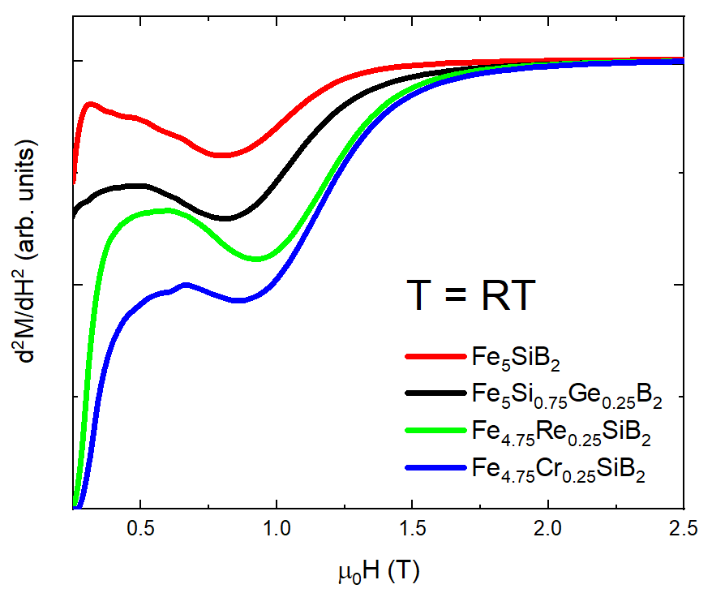
Fig S1: SPD curves of d²M/dH² as a function of applied field for Fe₅SiB₂ and Ge, Re and Cr substituted samples at room temperature. The position of peak corresponds to the anisotropy field of the material.
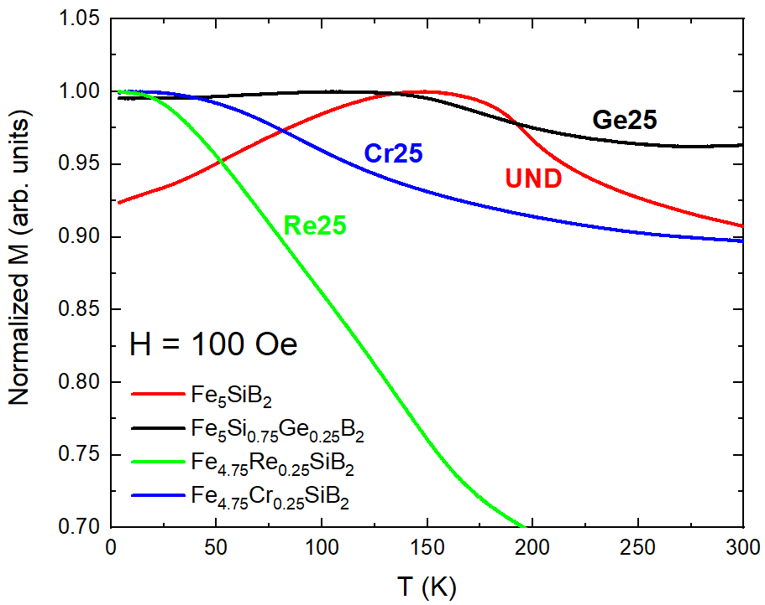
Fig S2: Low field (100 Oe) magnetization curves for Fe₅SiB₂ and Ge, Re and Cr substituted samples as a function of temperature. Notice how the undoped and Ge doped samples show peaks at different temperatures, corresponding to the spin reorientation temperature, while Re and Cr doped samples have a monotonous behavior.

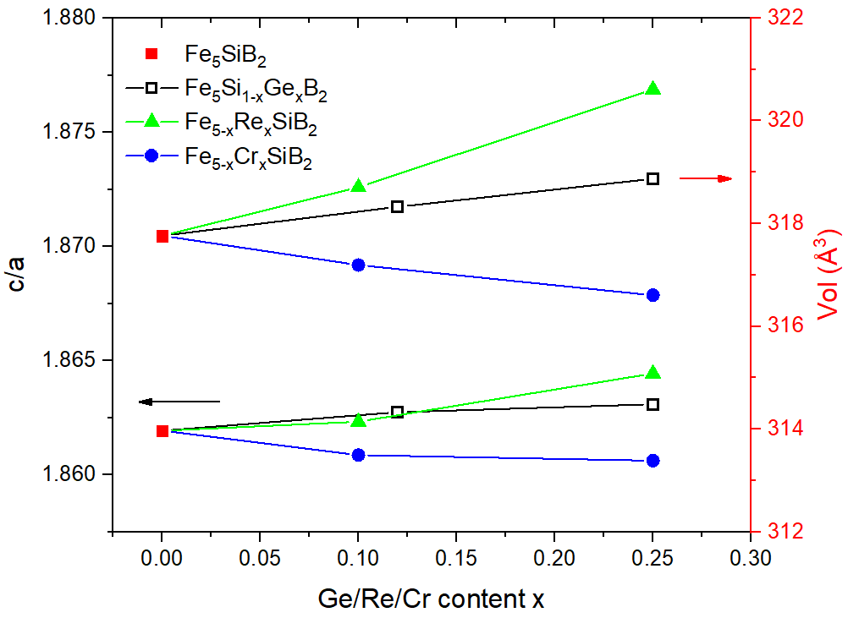
Fig S3: c/a ratio and cell volume as a function of elemental substitution.

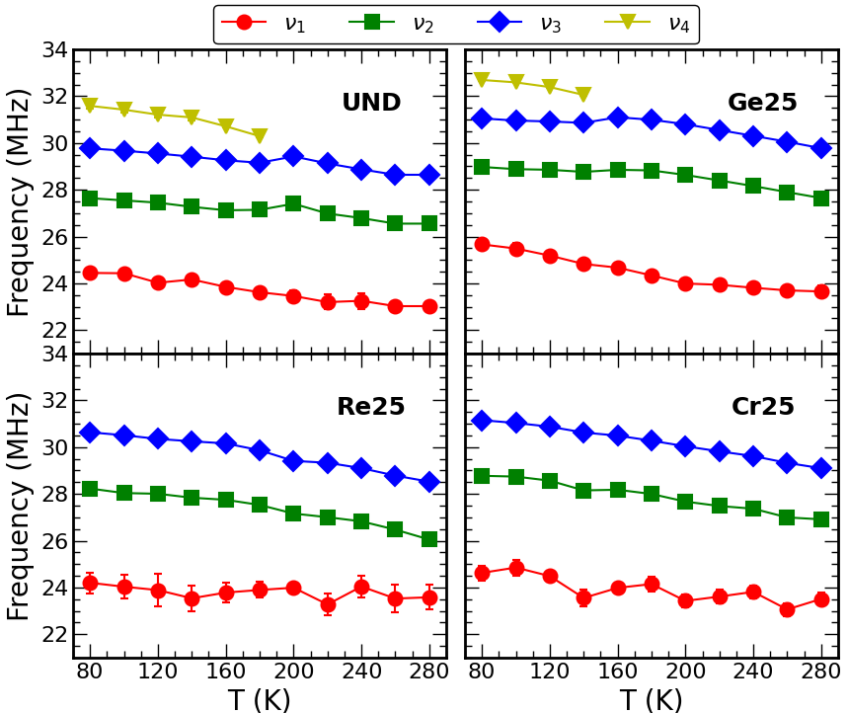
Fig S4: Frequencies of the Gaussian components needed to fit the spectra at different temperatures for a) undoped, b) Ge doped, c) Re doped and d) Cr doped samples with the maximum content of substituting elements.

Evidence for ¹¹B NMR
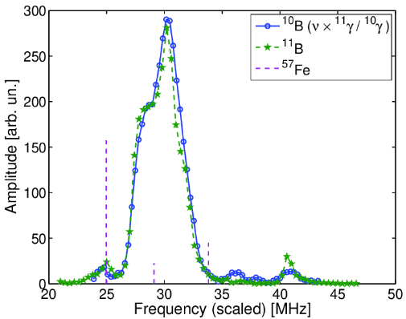
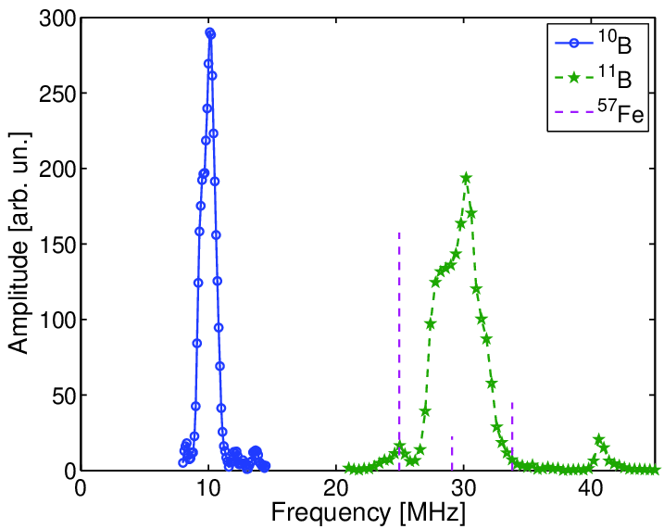
The experimental proof that the reported MNR signals are due to the ¹¹B resonance is provided by the occurrence of replica spectra for the ¹⁰B isotope. As both isotopes experience the same hyperfine field, their resonance frequency are scaled by their gyromagnetic ratio, γ₁₁/2π = 13.66 MHz/T and γ₁₀/2π = 4.5743 MHz/T for ¹¹B and ¹⁰B, respectively.
Figure S5: a) Zero-field NMR frequency spectrum of ¹⁰B (bullets) and ¹¹B stars of undoped Fe₅SiB₂ at 77 K. b) The two spectra overlaid, with the ¹¹B spectrum unscaled, and frequencies of the ¹⁰B spectral points multiplied by γ₁₁/γ₁₀ = 2.986, where γ₁₀, γ₁₁ are the gyromagnetic ratios of the ¹⁰B and ¹¹B boron isotopes, respectively. In both panels, the dashed vertical lines mark the ⁵⁷Fe resonance frequencies predicted from the ⁵⁷Fe Moessbauer spectra of Wäppling et al. [7].
a)
b)
Model for the NMR spectral shape
Here we outline a simple model for the shapes of the ¹¹B NMR spectra. The model assumes an anisotropic hyperfine interaction
$ν=\sqrt{\left(A_{x}^{2}\cos^{2}{ϕ+A_{x}^{2}\sin^{2}{ϕ}}\right)\sin^{2}{θ+A_{x}^{2}\cos^{2}{θ}}}$
where θ, φ are the polar angles of the spin relative to the crystal axes, and a random orientation of the spin inside a domain wall, whereby the solid angle is spanned with uniform probability. The spectral weight g(ν) thus coincides with the solid angle portion corresponding to a resonance frequency ν . In the presence of a cylindrical hyperfine tensor (A_{x} = A_{y}) the spectral density can be calculated analytically as
$g\left(ν\right)=\frac{1}{|\frac{dν}{d cosθ}|}= \frac{ν}{\sqrt{(ν^{2}-A_{x}^{2})(A_{z}^{2}-A_{x}^{2})}}$
showing a powder singularity at ν = A_{x} . The latter, however, is smeared out in practice by any source of inhomogeneity in the hyperfine coupling. In the general case, a numerical integration is needed to calculate g(ν) and a powder singularity does not show up for non degenerate hyperfine tensor components A_{x} ≠ A_{y} ≠ A_{z}.
In Fig. S6 we show a fit of the spectrum of the undoped compound well above the spin reorientation (T = 280K) to the model sketched above, where the inhomogeneity of the hyperfine coupling is accounted for by an incoherent Gaussian broadening (i.e. the convolution of the calculated spectrum with a Gaussian distribution). The fit reproduces the skew lineshape of the spectrum with reasonable accuracy, yielding best fit parameters A_{x} = A_{y} =29.27(5) MHz, A_{z} =25.19(2) MHz and Gaussian broadening σ =0.93(3) MHz at this particular temperature in this sample. Fits of similar quality are obtained for the Ge sample above the reorientation transition and for the other samples not showing it.
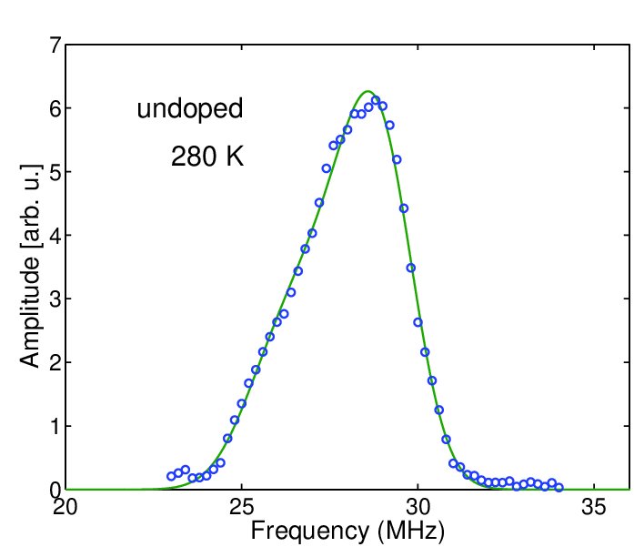
Figure S6: Zero-field NMR spectrum of the undoped sample at 280K, and its best fit to an isotropic angular spin spin distribution in the presence of an anistropic hyperfine coupling, as discussed in the text.

