Molinari et al, Electronic Supplementary Material

Supplementary Table S1. TruSight Oncology 500 (TSO500) DNA panel gene list

ABL1 | BCR | CHEK1 | EPHA7 | FGF4 | GSK3B | IL7R | MAP3K1 | NF2 | PIK3CA | RAD51D | SMAD4 | TGFBR2
ABL2 | BIRC3 | CHEK2 | EPHB1 | FGF5 | H3F3A | INHA | MAP3K13 | NFE2L2 | PIK3CB | RAD52 | SMARCA4 | TMEM127
ACVR1 | BLM | CIC | ERBB2 | FGF6 | H3F3B | INHBA | MAP3K14 | NFKBIA | PIK3CD | RAD54L | SMARCB1 | TMPRSS2
ACVR1B | BMPR1A | CREBBP | ERBB3 | FGF7 | H3F3C | INPP4A | MAP3K4 | NKX2-1 | PIK3CG | RAF1 | SMARCD1 | TNFAIP3
AKT1 | BRAF | CRKL | ERBB4 | FGF8 | HGF | INPP4B | MAPK1 | NKX3-1 | PIK3R1 | RANBP2 | SMC1A | TNFRSF14
AKT2 | BRCA1 | CRLF2 | ERCC1 | FGF9 | HIST1H1C | INSR | MAPK3 | NOTCH1 | PIK3R2 | RARA | SMC3 | TOP1
AKT3 | BRCA2 | CSF1R | ERCC2 | FGFR1 | HIST1H2BD | IRF2 | MAX | NOTCH2 | PIK3R3 | RASA1 | SMO | TOP2A
ALK | BRD4 | CSF3R | ERCC3 | FGFR2 | HIST1H3A | IRF4 | MCL1 | NOTCH3 | PIM1 | RB1 | SNCAIP | TP53
ALOX12B | BRIP1 | CSNK1A1 | ERCC4 | FGFR3 | HIST1H3B | IRS1 | MDC1 | NOTCH4 | PLCG2 | RBM10 | SOCS1 | TP63
ANKRD11 | BTG1 | CTCF | ERCC5 | FGFR4 | HIST1H3C | IRS2 | MDM2 | NPM1 | PLK2 | RECQL4 | SOX10 | TRAF2
ANKRD26 | BTK | CTLA4 | ERG | FH | HIST1H3D | JAK1 | MDM4 | NRAS | PMAIP1 | REL | SOX17 | TRAF7
APC | C11orf30 | CTNNA1 | ERRFI1 | FLCN | HIST1H3E | JAK2 | MED12 | NRG1 | PMS1 | RET | SOX2 | TSC1
AR | CALR | CTNNB1 | ESR1 | FLI1 | HIST1H3F | JAK3 | MEF2B | NSD1 | PMS2 | RFWD2 | SOX9 | TSC2
ARAF | CARD11 | CUL3 | ETS1 | FLT1 | HIST1H3G | JUN | MEN1 | NTRK1 | PNRC1 | RHEB | SPEN | TSHR
ARFRP1 | CASP8 | CUX1 | ETV1 | FLT3 | HIST1H3H | KAT6A | MET | NTRK2 | POLD1 | RHOA | SPOP | U2AF1
ARID1A | CBFB | CXCR4 | ETV4 | FLT4 | HIST1H3I | KDM5A | MGA | NTRK3 | POLE | RICTOR | SPTA1 | VEGFA
ARID1B | CBL | CYLD | ETV5 | FOXA1 | HIST1H3J | KDM5C | MITF | NUP93 | PPARG | RIT1 | SRC | VHL
ARID2 | CCND1 | DAXX | ETV6 | FOXL2 | HIST2H3A | KDM6A | MLH1 | NUTM1 | PPM1D | RNF43 | SRSF2 | VTCN1
ARID5B | CCND2 | DCUN1D1 | EWSR1 | FOXO1 | HIST2H3C | KDR | MLL | PAK1 | PPP2R1A | ROS1 | STAG1 | WISP3
ASXL1 | CCND3 | DDR2 | EZH2 | FOXP1 | HIST2H3D | KEAP1 | MLLT3 | PAK3 | PPP2R2A | RPS6KA4 | STAG2 | WT1
ASXL2 | CCNE1 | DDX41 | FAM123B | FRS2 | HIST3H3 | KEL | MPL | PAK7 | PPP6C | RPS6KB1 | STAT3 | XIAP
ATM | CD274 | DHX15 | FAM175A | FUBP1 | HLA-A | KIF5B | MRE11A | PALB2 | PRDM1 | RPS6KB2 | STAT4 | XPO1
ATR | CD276 | DICER1 | FAM46C | FYN | HLA-B | KIT | MSH2 | PARK2 | PREX2 | RPTOR | STAT5A | XRCC2
ATRX | CD74 | DIS3 | FANCA | GABRA6 | HLA-C | KLF4 | MSH3 | PARP1 | PRKAR1A | RUNX1 | STAT5B | YAP1
AURKA | CD79A | DNAJB1 | FANCC | GATA1 | HNF1A | KLHL6 | MSH6 | PAX3 | PRKCI | RUNX1T1 | STK11 | YES1
AURKB | CD79B | DNMT1 | FANCD2 | GATA2 | HNRNPK | KMT2B | MST1 | PAX5 | PRKDC | RYBP | STK40 | ZBTB2
AXIN1 | CDC73 | DNMT3A | FANCE | GATA3 | HOXB13 | KMT2C | MST1R | PAX7 | PRSS8 | SDHA | SUFU | ZBTB7A
AXIN2 | CDH1 | DNMT3B | FANCF | GATA4 | HRAS | KMT2D | MTOR | PAX8 | PTCH1 | SDHAF2 | SUZ12 | ZFHX3
AXL | CDK12 | DOT1L | FANCG | GATA6 | HSD3B1 | KRAS | MUTYH | PBRM1 | PTEN | SDHB | SYK | ZNF217
B2M | CDK4 | E2F3 | FANCI | GEN1 | HSP90AA1 | LAMP1 | MYB | PDCD1 | PTPN11 | SDHC | TAF1 | ZNF703
BAP1 | CDK6 | EED | FANCL | GID4 | ICOSLG | LATS1 | MYC | PDCD1LG2 | PTPRD | SDHD | TBX3 | ZRSR2
BARD1 | CDK8 | EGFL7 | FAS | GLI1 | ID3 | LATS2 | MYCL1 | PDGFRA | PTPRS | SETBP1 | TCEB1
BBC3 | CDKN1A | EGFR | FAT1 | GNA11 | IDH1 | LMO1 | MYCN | PDGFRB | PTPRT | SETD2 | TCF3
BCL10 | CDKN1B | EIF1AX | FBXW7 | GNA13 | IDH2 | LRP1B | MYD88 | PDK1 | QKI | SF3B1 | TCF7L2
BCL2 | CDKN2A | EIF4A2 | FGF1 | GNAQ | IFNGR1 | LYN | MYOD1 | PDPK1 | RAB35 | SH2B3 | TERC
BCL2L1 | CDKN2B | EIF4E | FGF10 | GNAS | IGF1 | LZTR1 | NAB2 | PGR | RAC1 | SH2D1A | TERT
BCL2L11 | CDKN2C | EML4 | FGF14 | GPR124 | IGF1R | MAGI2 | NBN | PHF6 | RAD21 | SHQ1 | TET1
BCL2L2 | CEBPA | EP300 | FGF19 | GPS2 | IGF2 | MALT1 | NCOA3 | PHOX2B | RAD50 | SLIT2 | TET2
BCL6 | CENPA | EPCAM | FGF2 | GREM1 | IKBKE | MAP2K1 | NCOR1 | PIK3C2B | RAD51 | SLX4 | TFE3
BCOR | CHD2 | EPHA3 | FGF23 | GRIN2A | IKZF1 | MAP2K2 | NEGR1 | PIK3C2G | RAD51B | SMAD2 | TFRC
BCORL1 | CHD4 | EPHA5 | FGF3 | GRM3 | IL10 | MAP2K4 | NF1 | PIK3C3 | RAD51C | SMAD3 | TGFBR1

Supplementary Table S2. Data of genomic instability in the case series
Molecular features | Pen B  (n=14) (%) |  | Pen A  (n=13)(%) |  |  | Total  (n=27) (%) |  | p-value
TMB
Median [IQ-IIIQ] | 5.2 [2.4 - 11.1] |  |  | 8 [4.8 - 25.3] |  | 5.7 [4 - 12.7] |  | 0.120
min-max | 0.8 - 79.1 |  |  | 0.8 - 110.5 |  | 0.8 - 110.5
< 10 | 10 (71.4) |  |  | 8 (61.5) |  | 18 (66.7) |  | 0.695
≥ 10 | 4 (28.6) |  |  | 5 (38.5) |  | 9 (33.3) |  | 0.695
MSI
Median [IQ-IIIQ] | 2.6 [1.8 - 3.8] |  |  | 2.8 [1.8 - 22.3] |  | 2.6 [1.8 - 4.8] |  | 0.423
min-max | 0 - 43.0 |  |  | 0.9 - 70.4 |  | 0 - 70.4
≤ 20% | 13 (92.9) |  |  | 9 (69.2) |  | 22 (81.5) |  | 0.165
> 20% | 1 (7.1) |  |  | 4 (30.8) |  | 5 (18.5) |  | 0.165

Supplementary Figure S1. Kaplan-Meier survival analysis of disease-free survival for 4 patient clusters obtained from the pathway instability analysis, as well as for EGC patients grouped according to Kodama classification.
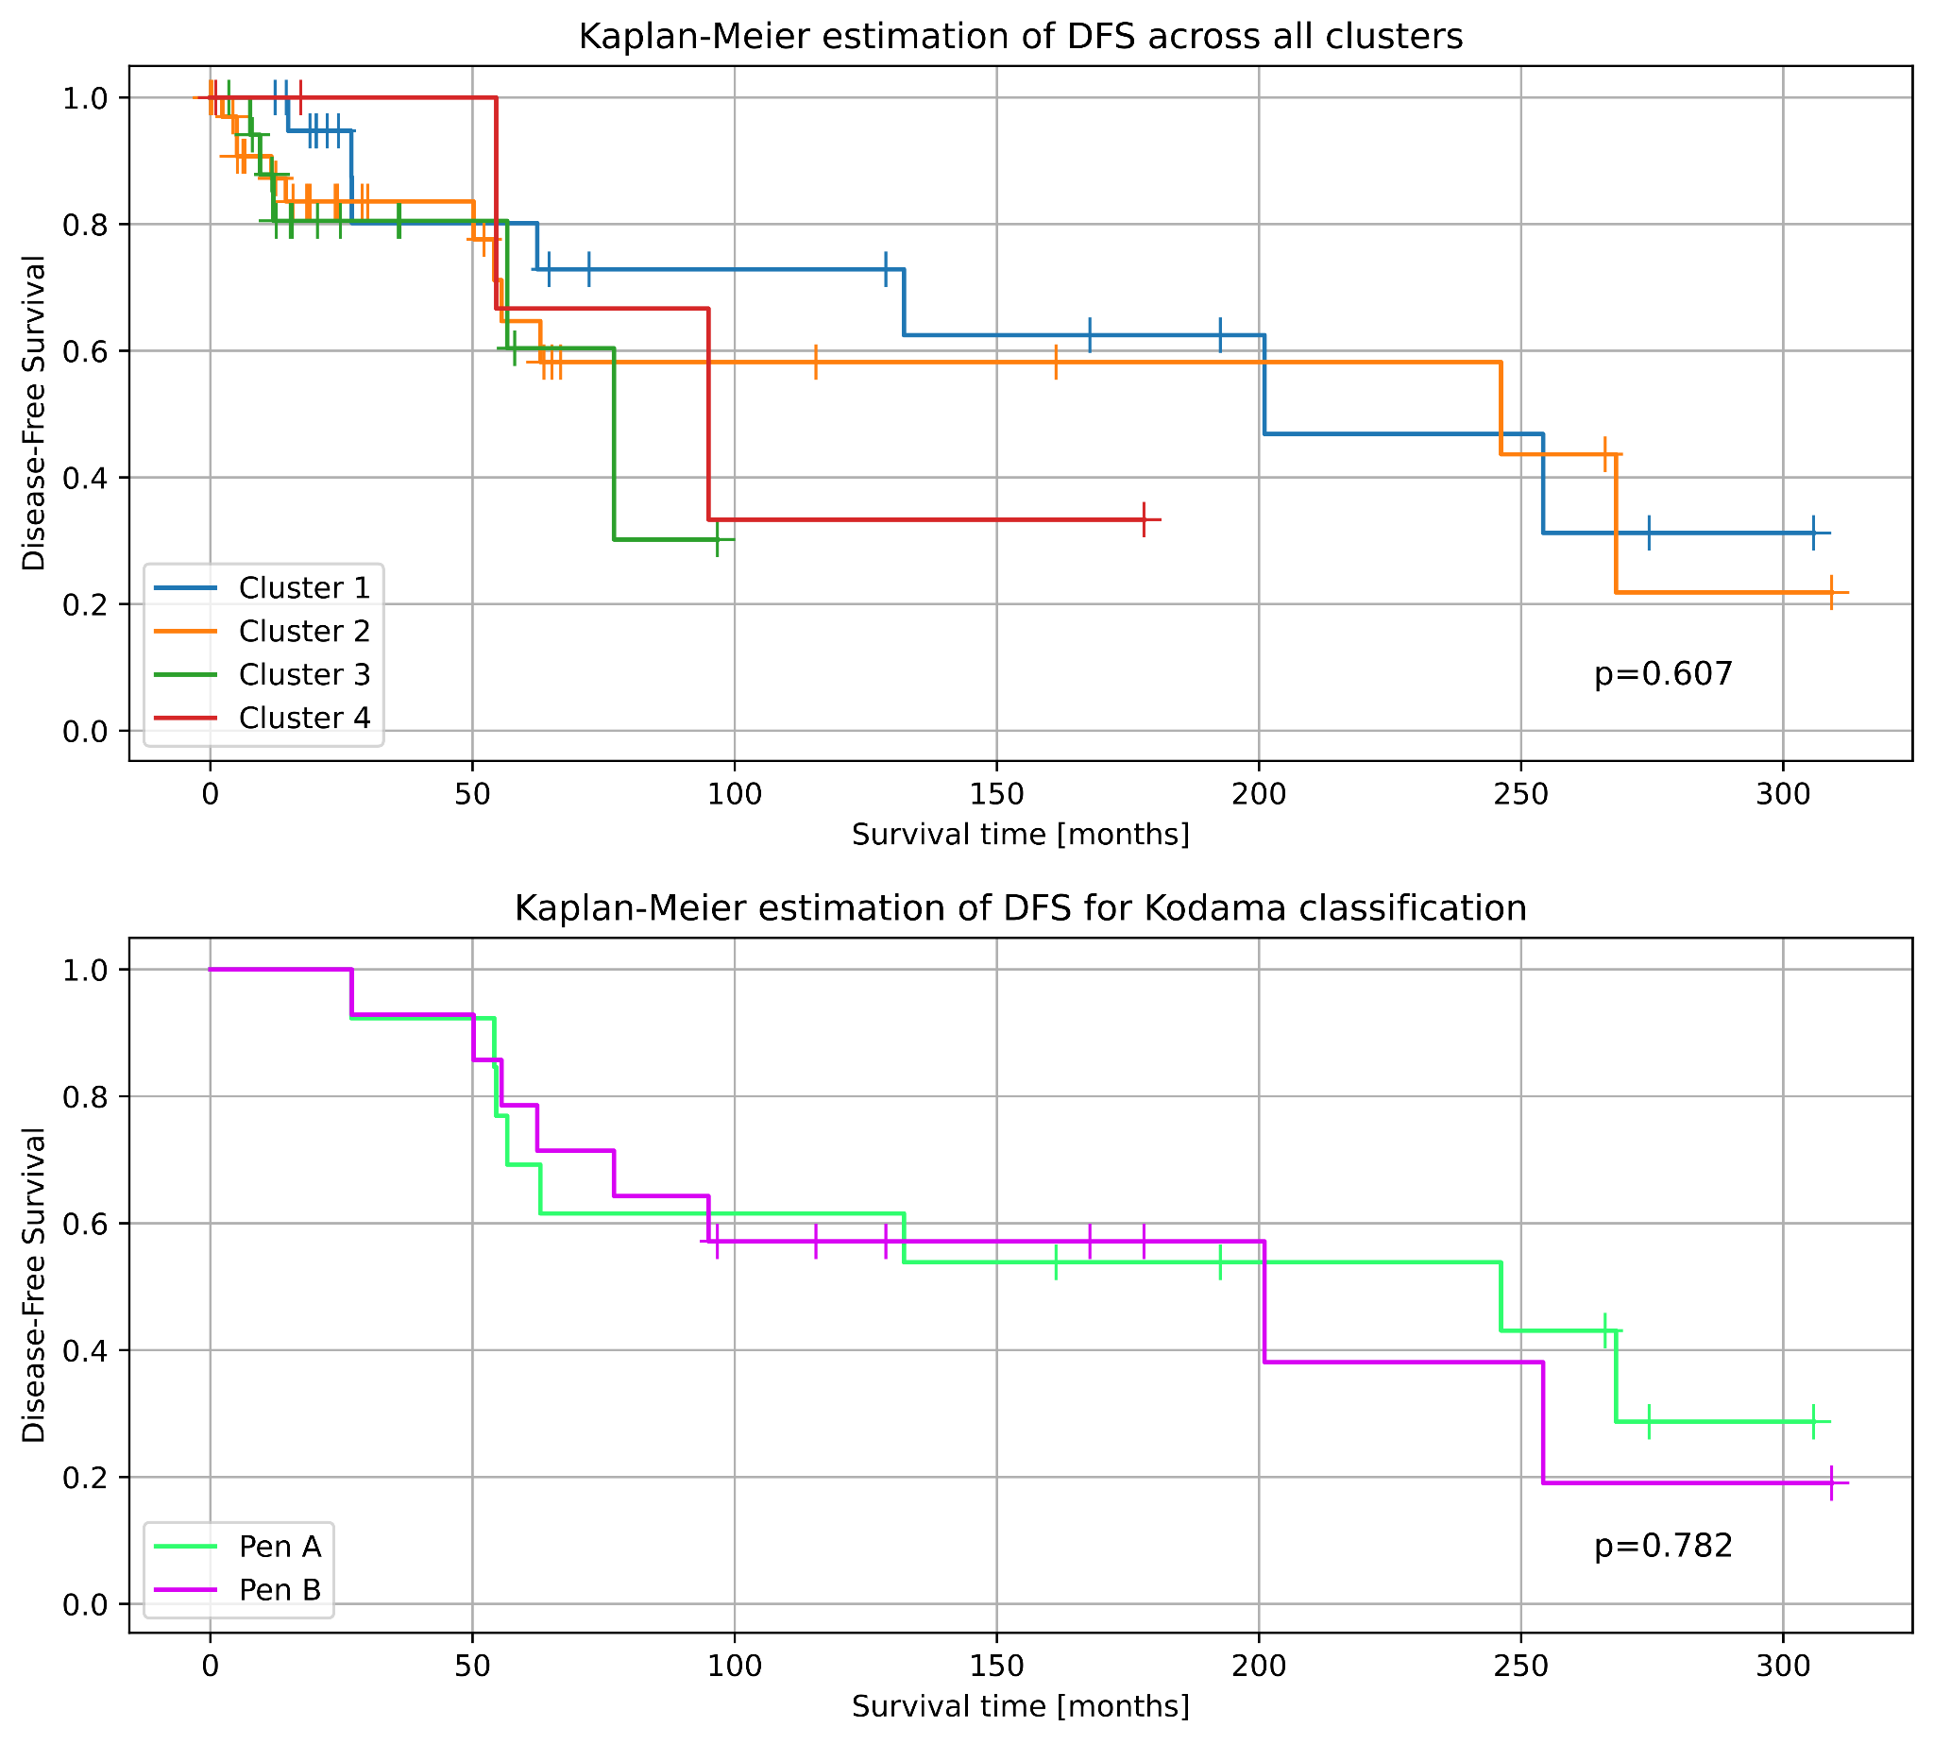
Supplementary Table S3: Results of the Wilcoxon rank-sum test comparing PI scores of individual pathways across TMB and MSI classes, Kodama classification and relapse status. Benjamini-Hochberg correction with FDR=0.05 was applied, but uncorrected p-values are also reported in the table. Furthermore, information on which genes from the TSO500 gene panel are present in each of the tested pathways is provided. Due to the large size of the table, it is made available in the Zenodo repository: https://zenodo.org/doi/10.5281/zenodo.10816958

Supplementary Table S4. Clinico-pathological characteristics of EGC from the present case series and TCGA – PanCancer Atlas cohort. Upper-middle tumors correspond in cardia, fundus and body localization and a lower localization corresponds with an antrum tumor. Regarding pathological classification of TCGA tumors: Intestinal Type STAD, Tubular STAD and Papillary STAD are compared with “intestinal” EGC tumors; Diffuse Type STAD and Signet Ring Cell Carcinomas are associated with “diffuse” EGCs and STAD Not Specified are considerate as “other”.

Characteristics | EGC  (n=27) (%) | TCGA-EGC (n=54) (%) | Total (n=81) (%) | p-value
Age at diagnosis (yrs)
Mean +- S.D.ª | 67.0 +- 11.7 | 70.3 +- 10.5 | 69.2 +- 11.0 | 0.172
Min-max | 41 – 87 | 45 – 90 | 41 – 90 | 0.172
Gender
F | 15 (55.56) | 17 (31.48) | 32 (39.51) | 0.037
M | 12 (44.44) | 37 (68.52) | 49 (60.49) | 0.037
Tumor location
Upper-middle | 13 (48.15) | 38 (70.37) | 51 (62.96) | 0.015
Lower | 14 (51.85) | 12 (22.22) | 26 (32.10) | 0.015
Other | 0 (0) | 4 (7.41) | 4 (4.94) | 0.015
Lauren classification
Intestinal | 23 (85.19) | 25 (46.30) | 48 (59.26) | 0.487
Diffuse or mixed | 4 (14.81) | 7 (12.96) | 11 (13.58) | 0.487
Other | 0 (0) | 22 (40.74) | 22 (27.16) | 0.487
Grade
G1 + G2 | 14 (51.85) | 33 (61.11) | 47 (58.02) | 0.716
G3 | 12 (44.44) | 19 (35.19) | 31 (38.27) | 0.716
Unknown | 1 (3.70) | 2 (3.70) | 3 (3.70) | 0.716
pN status
pN0 | 19 (70.37) | 51 (94.44) | 70 (86.42) | 0.003
pN+ | 8 (29.63) | 3 (5.56) | 11 (13.58) | 0.003
TMB^{b} Status
≤ 10 | 18 (66.67) | 36 (66.67) | 54 (66.67) | 1
> 10 | 9 (33.33) | 18 (33.33) | 27 (33.33) | 1
MSI^{c} Status
< 20% | 22 (81.48) | 46 (85.19) | 68 (83.95) | 0.669
≥ 20% | 5 (18.52) | 8 (14.81) | 13 (16.05) | 0.669

ªS.D.: standard deviation
^{b}TMB: Tumor mutational burden
^{c}MSI: microsatellite instability

Supplementary Table S5: Significantly disrupted pathways for each of the 4 clusters identified with t-SNE dimension reduction and DBSCAN clustering algorithm. The distribution of pathways between the clusters was performed using the Wilcoxon rank-sum test with Benjamini-Hochberg correction (FDR=0.5), and the q-values reported. Furthermore, the corresponding Reactome Top Level pathway for each significant pathway is indicated. The table is available in the Zenodo repository: https://zenodo.org/doi/10.5281/zenodo.1081695

Supplementary Table S6. Top 10 most commonly altered genes in the combined cohort of EGC and eGC-TCGA patients (n=81) for each of the 4 clusters identified by the pathway instability analysis and overall. Relative mutation frequency, indicating the percentage of patients within the cluster with at least 1 non-benign variation for a given gene, is given in parentheses. Mutation frequencies of multiple characteristic genes (TP53, ARID1A, RHOA) vary between the clusters, demonstrating different mutational landscapes.

 | Cluster 1 (%) | Cluster 2 (%) | Cluster 3 (%) | Cluster 4 (%) | Overall Distribution (%)
1. | TP53 (100.0) | ARID1A (44.44) | TP53 (100.0) | RHOA (100.0) | TP53 (50.62)
2. | SPTA1 (22.73) | LRP1B (30.56) | LRP1B (33.33) | TP53 (20.0) | ARID1A (29.63)
3. | LRP1B (18.18) | KMT2D (27.78) | EPHA5 (33.33) | RNF43 (20.0) | LRP1B (25.93)
4. | ARID1A (18.18) | KMT2C (25.0) | RNF43 (27.78) | FBXW7 (20.0) | SPTA1 (18.52)
5. | APC (13.64) | SPTA1 (22.22) | AR (27.78) | KMT2B (20.0) | KMT2C (17.28)
6. | CARD11 (13.64) | FLT4 (22.22) | GRIN2A (27.78) | SPEN (20.0) | RNF43 (17.28)
7. | HGF (13.64) | RNF43 (22.22) | FBXW7 (27.78) | NBN (20.0) | PTPRT (17.28)
8. | PIK3CD (9.09) | HLA-B (19.44) | APC (22.22) | FAT1 (20.0) | PTPRS (17.28)
9. | GATA3 (9.09) | ERBB3 (19.44) | PTPRT (22.22) | BRCA2 (20.0) | APC (16.05)
10. | PTPRD (9.09) | PTPRT (19.44) | JAK1 (22.22) | RAD50 (20.0) | KMT2D (14.81)

Pathway Instability Analysis
The PI score for a given pathway (p) is calculated by summing the normalized mutation rates (nMR_{n}) of member genes (n) of the said pathway and dividing this sum by the number of member genes in a pathway (N_{p}). Normalized mutation rate for a gene is just the count of detected non-benign variants of that gene in a sample divided by the gene's CDS length in kbps which we obtain from Ensembl/Biomart (https://www.ensembl.org/biomart/martview/). In our implementation, we multiply the normalized mutation rates of genes with their raw CNV value (CNV_{n}) if it is larger than 1, otherwise with its inverse:
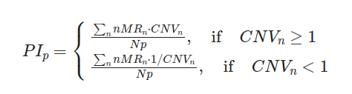

The original implementation of the PI score by Zolotovskaia et al does not consider CNV data. However, we propose that including CNV information presents an improvement to the PI score, as deviations from the normal copy number of the pathway's constituent genes contribute to increased disruption (i.e. instability) of the pathway.
Due to the hierarchical structure of the Reactome pathway database, individual pathways are grouped to one or more Top Level Pathways which represent a broad category of biological functions or processes. Using rbioapi 0.8 [Rezwani et al., doi: 10.1093/bioinformatics/btac172], corresponding Top Level Pathways were assigned to each of the 218 pathways identified by the enrichment analysis. Using the Wilcoxon rank-sum test, PI-score distribution of pathways grouped according to their Top Level Pathways was compared between relapsed and non-relapsed patients (TCGA-EGC dataset), and Pen A and Pen B patients (EGC dataset). For the case of TCGA-EGC patients, only those genes which are available in the TSO500 gene panel were used to calculate the PI scores.

References
Zolotovskaia, Marianna A., Maxim I. Sorokin, Sergey A. Roumiantsev, Nikolay M. Borisov, and Anton A. Buzdin. “Pathway Instability Is an Effective New Mutation-Based Type of Cancer Biomarkers.” Frontiers in Oncology 8 (January 4, 2019): 658. https://doi.org/10.3389/fonc.2018.00658.
Rezwani et al., doi: 10.1093/bioinformatics/btac172

