SUPPLEMENTARY MATERIALS

1. DIAGNOSTIC CRITERIA

Questions

PICO 1

Pubmed: # 4072

Search: obesity and (BMI or waist or "body fat" or "body composition" or "lean mass") and (diabetes or cardiovascular or cancer or mortality or "sleep apnea" or steato-hepatitis) Filters: Randomized Controlled Trial
(("obeses"[All Fields] OR "obesity"[MeSH Terms] OR "obesity"[All Fields] OR "obese"[All Fields] OR "obesities"[All Fields] OR "obesity s"[All Fields]) AND ("BMI"[All Fields] OR ("waist"[All Fields] OR "waists"[All Fields]) OR "body fat"[All Fields] OR "body composition"[All Fields] OR "lean mass"[All Fields]) AND ("diabete"[All Fields] OR "diabetes mellitus"[MeSH Terms] OR ("diabetes"[All Fields] AND "mellitus"[All Fields]) OR "diabetes mellitus"[All Fields] OR "diabetes"[All Fields] OR "diabetes insipidus"[MeSH Terms] OR ("diabetes"[All Fields] AND "insipidus"[All Fields]) OR "diabetes insipidus"[All Fields] OR "diabetic"[All Fields] OR "diabetics"[All Fields] OR "diabets"[All Fields] OR ("cardiovascular system"[MeSH Terms] OR ("cardiovascular"[All Fields] AND "system"[All Fields]) OR "cardiovascular system"[All Fields] OR "cardiovascular"[All Fields] OR "cardiovasculars"[All Fields]) OR ("cancer s"[All Fields] OR "cancerated"[All Fields] OR "canceration"[All Fields] OR "cancerization"[All Fields] OR "cancerized"[All Fields] OR "cancerous"[All Fields] OR "neoplasms"[MeSH Terms] OR "neoplasms"[All Fields] OR "cancer"[All Fields] OR "cancers"[All Fields]) OR ("mortality"[MeSH Terms] OR "mortality"[All Fields] OR "mortalities"[All Fields] OR "mortality"[MeSH Subheading]) OR "sleep apnea"[All Fields] OR "steato-hepatitis"[All Fields])) AND (randomizedcontrolledtrial[Filter])
Translations
obesity: "obeses"[All Fields] OR "obesity"[MeSH Terms] OR "obesity"[All Fields] OR "obese"[All Fields] OR "obesities"[All Fields] OR "obesity's"[All Fields]
waist: "waist"[All Fields] OR "waists"[All Fields]
diabetes: "diabete"[All Fields] OR "diabetes mellitus"[MeSH Terms] OR ("diabetes"[All Fields] AND "mellitus"[All Fields]) OR "diabetes mellitus"[All Fields] OR "diabetes"[All Fields] OR "diabetes insipidus"[MeSH Terms] OR ("diabetes"[All Fields] AND "insipidus"[All Fields]) OR "diabetes insipidus"[All Fields] OR "diabetic"[All Fields] OR "diabetics"[All Fields] OR "diabets"[All Fields]
cardiovascular: "cardiovascular system"[MeSH Terms] OR ("cardiovascular"[All Fields] AND "system"[All Fields]) OR "cardiovascular system"[All Fields] OR "cardiovascular"[All Fields] OR "cardiovasculars"[All Fields]
cancer: "cancer's"[All Fields] OR "cancerated"[All Fields] OR "canceration"[All Fields] OR "cancerization"[All Fields] OR "cancerized"[All Fields] OR "cancerous"[All Fields] OR "neoplasms"[MeSH Terms] OR "neoplasms"[All Fields] OR "cancer"[All Fields] OR "cancers"[All Fields]
mortality: "mortality"[MeSH Terms] OR "mortality"[All Fields] OR "mortalities"[All Fields] OR "mortality"[Subheading]

Tables

Table 1 – Accuracy of different anthropometric indexes (BMI≥ 30 kg/m²; waist circumference ≥88/102 cm in men and women respectively, WTH≥0.95/0.80 in men and women respectively; WtHR≥ 0.50) in obesity diagnosis (DEXA: fat mass ≥ 25/35% in men and women respectively).

Name (number of subjects) | Categories | BMI |  |  |  |  |  |  | Waist circumference
 |  | Sens. | Spec. | PPV | NPV | CC | FP | FN | Sens. | Spec. | PPV | NPV | CC | FP | FN
Hayman^{8§}  (1,394) | Total | 0.74 | 0.65 | 0.74 | 0.65 | 70.2 | 15.1 | 14.7 | - | - | - | - | - | - | -
Hayman^{8§}  (1,394) | Women | 0.77 | 0.76 | 0.83 | 0.74 | 76.4 | 10.1 | 13.5 | - | - | - | - | - | - | -
Hayman^{8§}  (1,394) | Men | 0.73 | 0.62 | 0.71 | 0.64 | 68.0 | 16.9 | 15.1 | - | - | - | - | - | - | -
Alammar^{9§}  (942) | Total | - | - | - | - | - | - | - | - | - | - | - | - | - | -
Alammar^{9§}  (942) | Women | 0.55 | 0.93 | - | - | - | - | - | - | - | - | - | - | - | -
Alammar^{9§}  (942) | Men | 0.34 | 0.98 | - | - | - | - | - | - | - | - | - | - | - | -
Alqarn^{10§}  (319)* | Total | - | - | - | - | - | - | - | - | - | - | - | - | - | -
Alqarn^{10§}  (319)* | Women | 0.57 | 0.88 | 0.99 | 0.12 | 58.6 | - | - | - | - | - | - | - | - | -
Alqarn^{10§}  (319)* | Men | 0.48 | 1.00 | 1.00 | 0.23 | 55.2 | - | - | - | - | - | - | - | - | -
Batsis^{13§}  (4,984)** | Total | - | - | - | - | - | - | - | - | - | - | - | - | - | -
Batsis^{13§}  (4,984)** | Women | 0.38 | 0.98 | 0.99 | 0.88 | 45.1 | - | - | 0.80 | 0.85 | 0.98 | 0.66 | 81.0 | - | -
Batsis^{13§}  (4,984)** | Men | 0.33 | 0.99 | 0.99 | 0.17 | 41.0 | - | - | 0.60 | 0.95 | 0.99 | 0.74 | 64.2 | - | -
Porto^{12§}  (3,822) | Total | 0.47 | 0.93 | 0.57 | 0.90 | 85.8 | 5.8 | 8.3 | - | - | - | - | - | - | -
Porto^{12§}  (3,822) | Women | - | - | - | - | - | - | - | - | - | - | - | - | - | -
Porto^{12§}  (3,822) | Men | - | - | - | - | - | - | - | - | - | - | - | - | - | -
Vasconcelos^{5§}  (180) | Total |  |  |  |  |  |  |  | - | - | - | - | - | - | -
Vasconcelos^{5§}  (180) | Women | 0.29 | 1.00 | - | - | 32.5 | 0.0 | 67.5 | - | - | - | - | - | - | -
Vasconcelos^{5§}  (180) | Men | 0.32 | 0.97 | - | - | 66.6 | 1.7 | 21.7 | - | - | - | - | - | - | -
Zwierzchowska^{11§}  (87) | Total | - | - | - | - | - | - | - | - | - | - | - | - | - | -
Zwierzchowska^{11§}  (87) | Women | 0.90 | 0.74 | - | - | - | - | - | 0.99 | 0.58 | - | - | - | - | -
Zwierzchowska^{11§}  (87) | Men | - | - | - | - | - | - | - | - | - | - | - | - | - | -
Name  (# pts) | Categories | BMI |  |  |  |  |  |  | WtHR
Zwierzchowska^{11§}  (87) | Total | - | - | - | - | - | - | - | - | - | - | - | - | - | -
Zwierzchowska^{11§}  (87) | Women | 0.90 | 0.74 | - | - | - | - | - | 1.00 | 0.84 | - | - | - | - | -
Zwierzchowska^{11§}  (87) | Men | - | - | - | - | - | - | - | - | - | - | - | - | - | -
Sens.: Sensibility; Spec.: Specificity; PPV: positive predictive value; NPV: negative predictive value; CC: Correctly classified: %; FP: False positives; FN: False negatives. WTH: waist to hip ratio; WtHR: Waist to height ratio.

Table 2 – Predictive value of single anthropometric indexes for different obesity – related comorbidities. Relative risk for every incremental point of single parameters. Analysis performed on epidemiological analysis of clinical trials.

First author | n. subjects | BMI  (kg/m²) |  | Waist circumference (cm) |  | Waist to hip ratio |  | Waist to height ratio |  | Fat mass  (%)
 |  | OR/AUC | 95%, CI | OR/AUC | 95%, CI | OR/AUC | 95%, CI | OR/AUC | 95%, CI | OR/AUC | 95%, CI
Diabetes
Bray¹⁷  Men  Women | Placebo  108 | 1.41  0.98 | [1.10;4.82]  [0.71;1.35] | 1.69  1.02 | [1.14;2.51]  [0.75;1.40] | 1.44  1.31 | [1.00;2.07]  [0.98;1.75] | 1.49  0.98 | [1.07;2.07]  [0.71;1.35] | 1.48**  1.28 | [1.02;2.14]  [0.96;1.70]
Bray¹⁷  Men  Women | Metformin  112 | 1.56  0.95 | [0.86;2.82]  [0.66;1.39] | 1.49  1.03 | [0.79;2.84]  [0.71;1.49] | 1.38  1.17 | [0.87;2.19]  [0.83;1.65] | 1.66  1.00 | [0.90;3.05]  [0.72;1.38] | 1.67**  1.16 | [0.95;2.93]  [0.82;1.64]
Bray¹⁷  Men  Women | Lifestyle  111 | 1.37  1.57 | [0.60;3.14]  [1.02;2.43] | 1.50  1.43 | [0.69;3.25]  [0.89;2.29] | 3.47  1.31 | [1.36;8.89]  [0.89;1.93] | 1.65  1.57 | [0.78;3.48]  [1.02;2.43] | 1.61**  1.40 | [0.82;3.15]  [0.92;2.14]
Cardiovascular events (MACE)
Franek¹⁴ | 4,592* | 1.06 | [0.98;1.15] | 1.12 | [1.02;1.22] | 1.11 | [1.05;1.21] | - | - | - | -
German⁷ | 10,251 | 0.97 | [0.91;1.03] | 1.07 | [1.01;1.13] | - | - | - | - | - | -
Rådholm¹⁶ | 11,125 | 1.09 | [1.04;1.14] | 1.15 | [1.09;1.21] | 1.09 | [1.04;1.15] | 1.16 | [1.11;1.22] | - | -
Kadakia¹⁵ | 6,560 | 1.09 | [0.92;1.29] | 1.17 | [1.01;1.37]
Cardiovascular mortality
Franek¹⁴ | 4,592 | 1.05 | [0.93;1.17] | 1.11 | [1.00;1.24] | 1.19 | [1.04;1.36] | - | - | - | -
Rådholm¹⁶ | 11,125 | 1.07 | [1.00;1.15] | 1.15 | [1.09;1.21] | 1.12 | [1.04;1.21] | 1.19 | [1.11;1.27]
Hearth failure
Franek¹⁴ | 4,592 | 1.33 | [1.17;1.50] | 1.34 | [1.16;1.54] | 1.13 | [1.00;1.28] | - | - | - | -
German⁷ | 10,251 | 1.24 | [1.14;1.36] | 1.41 | [1.28;1.54] | - | - | - | - | - | -
All -cause mortality
Franek¹⁴ | 4,592 | 1.05 | [0.96;1.15] | 1.10 | [1.00;1.20] | 1.08 | [1.00;1.18] | - | - | - | -
German⁷ | 10,251 | 1.04 | [0.97;1.12] | 1.18 | [1.10;1.27] | - | - | - | - | - | -
*Data available only for the placebo group; **Abdominal TC; Bold character: p<0.05

Table 3 – Main features of clinical trials included. Panel A (accuracy); panel B (risk of complications).

A

 |  | Mean parameters at entry
First name | Follow-up  (anni) | Age  (years) | BMI  (kg/m²) | Waist circumference (cm) | Waist to hip ratio | Waist to height ratio | Study features |  | Primary endpoint
Bray¹⁷ | 3,2 | 53 | 32,8 | M:108 / F:102 | M:0,99 / F:0,88 | M:0,62 / F:0,62 | Case study derived from the Diabetes Prevention Program trial; subjects with BMI≥25 kg/m² and IFG and/or IGT |  | Incidence of diabetes
Franek¹⁴ | 5,4 | 66 | 32,3 | M:111 / F:107 | M:1,02 / F:0,95 | NR | Case study derived from REWIND trial; subjects with BMI≥25 kg/m² and diabetes |  | MACE, all-cause mortality; hearth failure
German⁷ | 3,7 | 63 | 32,2 | NR | NR | NR | Case study derived from ACCORD trial; subjects with BMI≥25 kg/m2 and diabetes |  | MACE, all-cause mortality; hearth failure
Rådholm¹⁶ | 9,0 | 66 | 28,2 | M:100 / F:95 | M:1,0 / F:0,9 | M:0,59 / F:0,58 | Case study derived from ADVANCE ed ADVANCE-ON trials; subjects with BMI≥25 kg/m2 and diabetes |  | MACE
Kadakia¹⁵ | 1,0 | 64 | 28,3 | All: 101 | NR | NR | Case study derived from MERLIN-TIMI 36 trial; subjects with BMI≥25 kg/m2 and previous CV events. |  | MACE

B

 | Mean parameters at entry
First name | Age  (media/range; years) | BMI  (kg/m²) | Waist circumference (cm) | Waist to hip ratio | Waist to height ratio | Study features |  | Primary endpoint
Hayman^{8§}  (1,394) | NR / 20-79 | NR | NR | NR | NR | Working age people |  | BMI accuracy
Alammar^{9§}  (942) | 56 / 18-94 | 27,1 | NR | NR | NR | Adults subjects enrolled in Saudi Arabia (Primary care) |  | BMI accuracy
Alqarn^{10§}  (319)* | < 60 (NR) | NR | NR | NR | NR | Adults subjects enrolled in Saudi Arabia (Primary care) |  | BMI accuracy
Batsis^{13§}  (4,984)** | ≥60 (NR) | 28,2 | NR | NR | NR | NHANES Study 1999-2004; subjects ≥60 years of age |  | BMI accuracy
Porto^{12§}  (3,822) | 37 (24-49) | 26,5 | NR | NR | NR | Military men |  | BMI accuracy
Vasconcelos^{5§}  (180) | 68 (NR) | 26,9 | NR | NR | NR | Healthy elderly people. |  | BMI accuracy
Zwierzchowska^{11§}  (87) | 62 (40-80) | 28,5 | 94 | 0,88 | 0,59 | Women ≥40 years of age |  | Anthropometric indexes accuracy

MACE: Major CArdiovascular Events

Table 4 –GRADE assessment of the quality of retrieved evidence.

Certainty assessment |  |  |  |  |  |  | Summary of findings
Participants  (studies)  Follow up | Risk of bias | Inconsistency | Indirectness | Imprecision | Publication bias | Overall certainty of evidence | Study event rates (%) |  | Relative effect  (95% CI) | Anticipated absolute effect
 |  |  |  |  |  |  | With PBO | With BMI 30-35 | Relative effect  (95% CI) | Risk with PBO | Risk difference with BMI 30-35
Diagnostic accuracy
32,859  (5 observ.) | serious | not serious | not serious | not serious | none | ⨁⨁--  Lowª | - | - | - | - | -
Risk of diabetes
331  (1 observ.) | seriousª | not serious | not serious | very serious | none | ⨁---  Very low ^{a,b} | - | - | - | - | -
Risk of cardiovascular events
32,528  (4 observ.) | seriousª | not serious | not serious | not serious | none | ⨁⨁--  Lowª | - | - | - | - | -
Cardiovascular mortality
15,717  (2 observ.) | seriousª | not serious | not serious | not serious | none | ⨁⨁--  Lowª | - | - | - | - | -
Hearth failure
14,843  (2 observ.) | seriousª | not serious | not serious | not serious | none | ⨁⨁--  Lowª | - | - | - | - | -
All – cause mortality
14,843  (2 observ.) | seriousª | not serious | not serious | not serious | none | ⨁⨁--  Lowª | - | - | - | - | -
a. observational studies: b. data derived from one single study.

Figures

Figure 1 – Metanalysis of odds ratio for incident diabetes.

BMI

Waist circumference

Waist-to-Height ratio

Fat mass

Waist-to- hip ratio

Figure 2 – Metanalysis of odds ratio for incident MACE.

BMI

Waist circumference
Waist-to-Hip ratio

Figure 3 – Metanalysis of odds ratio for cardiovascular death risk.

BMI
Waist circumference

Waist-to-Hip ratio
Figure 4 – Metanalysis of odds ratio for hospitalisation for hearth failure.

BMI

Waist circumference

Figure 5 – Metanalysis of odds ratio for all-cause mortality risk.

BMI

Waist circumference
PICO 2

Pubmed: # 4072

Search: obesity and (BMI or waist or "body fat" or "body composition" or "lean mass") and (DEXA or TC) Filters: Randomized Controlled Trial
(("obeses"[All Fields] OR "obesity"[MeSH Terms] OR "obesity"[All Fields] OR "obese"[All Fields] OR "obesities"[All Fields] OR "obesity s"[All Fields]) AND ("BMI"[All Fields] OR ("waist"[All Fields] OR "waists"[All Fields]) OR "body fat"[All Fields] OR "body composition"[All Fields] OR "lean mass"[All Fields]) AND ("diabete"[All Fields] OR "diabetes mellitus"[MeSH Terms] OR ("diabetes"[All Fields] AND "mellitus"[All Fields]) OR "diabetes mellitus"[All Fields] OR "diabetes"[All Fields] OR "diabetes insipidus"[MeSH Terms] OR ("diabetes"[All Fields] AND "insipidus"[All Fields]) OR "diabetes insipidus"[All Fields] OR "diabetic"[All Fields] OR "diabetics"[All Fields] OR "diabets"[All Fields] OR ("cardiovascular system"[MeSH Terms] OR ("cardiovascular"[All Fields] AND "system"[All Fields]) OR "cardiovascular system"[All Fields] OR "cardiovascular"[All Fields] OR "cardiovasculars"[All Fields]) OR ("cancer s"[All Fields] OR "cancerated"[All Fields] OR "canceration"[All Fields] OR "cancerization"[All Fields] OR "cancerized"[All Fields] OR "cancerous"[All Fields] OR "neoplasms"[MeSH Terms] OR "neoplasms"[All Fields] OR "cancer"[All Fields] OR "cancers"[All Fields]) OR ("mortality"[MeSH Terms] OR "mortality"[All Fields] OR "mortalities"[All Fields] OR "mortality"[MeSH Subheading]) OR "sleep apnea"[All Fields] OR "steato-hepatitis"[All Fields])) AND (randomizedcontrolledtrial[Filter])
Translations
obesity: "obeses"[All Fields] OR "obesity"[MeSH Terms] OR "obesity"[All Fields] OR "obese"[All Fields] OR "obesities"[All Fields] OR "obesity's"[All Fields]
waist: "waist"[All Fields] OR "waists"[All Fields]
diabetes: "diabete"[All Fields] OR "diabetes mellitus"[MeSH Terms] OR ("diabetes"[All Fields] AND "mellitus"[All Fields]) OR "diabetes mellitus"[All Fields] OR "diabetes"[All Fields] OR "diabetes insipidus"[MeSH Terms] OR ("diabetes"[All Fields] AND "insipidus"[All Fields]) OR "diabetes insipidus"[All Fields] OR "diabetic"[All Fields] OR "diabetics"[All Fields] OR "diabets"[All Fields]
cardiovascular: "cardiovascular system"[MeSH Terms] OR ("cardiovascular"[All Fields] AND "system"[All Fields]) OR "cardiovascular system"[All Fields] OR "cardiovascular"[All Fields] OR "cardiovasculars"[All Fields]
cancer: "cancer's"[All Fields] OR "cancerated"[All Fields] OR "canceration"[All Fields] OR "cancerization"[All Fields] OR "cancerized"[All Fields] OR "cancerous"[All Fields] OR "neoplasms"[MeSH Terms] OR "neoplasms"[All Fields] OR "cancer"[All Fields] OR "cancers"[All Fields]
mortality: "mortality"[MeSH Terms] OR "mortality"[All Fields] OR "mortalities"[All Fields] OR "mortality"[Subheading]

Tables

Table 5 – Predictive value of single anthropometric indexes for different obesity – related comorbidities. Relative risk for every incremental point of single parameters. Analysis performed on RCT or sub-analysis of clinical trials.

First author | n. pts | Body Fat (%; visceral)
 |  | OR | 95%, CI
 |  | Risk of incident diabetes
Bray¹⁷  Men  Women | Placebo  108 | 1.48  1.28 | [1.02;2.14]  [0.96;1.70]
Bray¹⁷  Men  Women | Metformin  112 | 1.67  1.16 | [0.95;2.93]  [0.82;1.64]
Bray¹⁷  Men  Women | Lifestyle  111 | 1.61  1.40 | [0.82;3.15]  [0.92;2.14]

Table 6 – Main features of clinical trials included.

 |  | Mean parameters at entry |  |  |  |  |  | OR/AUC | 95%, CI
First author | Follow-up  (years) | Age  (years) | BMI  (kg/m²) | Waist circumference (cm) | Waist-to-Hip ratio | Waist-to-Height ratio | Study features |  | Primary endpoint
Bray¹⁷ | 3,2 | 53 | 32,8 | M:108 / F:102 | M:0,99 / F:0,88 | M:0,62 / F:0,62 | Case study derived from the Diabetes Prevention Program trial; subjects with BMI≥25 kg/m2 and IGT. |  | Incident diabetes

Table 7 – GRADE assessment of the quality of retrieved evidence.

Certainty assessment |  |  |  |  |  |  | Summary of findings
Participants  (studies)  Follow up (CI) | Risk of bias | Inconsistency | Indirectness | Imprecision | Publication bias | Overall certainty of evidence | Study event rates (%) |  | Relative effect  (95% CI) | Anticipated absolute effect
 |  |  |  |  |  |  | With PBO | With BMI 30-35 | Relative effect  (95% CI) | Risk with PBO | Risk difference with BMI 30-35
Diagnostic accuracy
331  (1 obser.) | seriousª | not serious | not serious | very serious^{b} | none | ⨁---  very low^{a,b} | - | - | - | - | -

Pharmacoeconomic evidence - PICO 1-2

Search string (until 21/05/2025)

Pubmed: # 4072

Search: obesity and (BMI or waist or "body fat" or "body composition" or "lean mass") and (diabetes or cardiovascular or cancer or mortality or "sleep apnea" or steato-hepatitis) and economic. Filters: Randomized Controlled Trial
(("obeses"[All Fields] OR "obesity"[MeSH Terms] OR "obesity"[All Fields] OR "obese"[All Fields] OR "obesities"[All Fields] OR "obesity s"[All Fields]) AND ("BMI"[All Fields] OR ("waist"[All Fields] OR "waists"[All Fields]) OR "body fat"[All Fields] OR "body composition"[All Fields] OR "lean mass"[All Fields]) AND ("diabete"[All Fields] OR "diabetes mellitus"[MeSH Terms] OR ("diabetes"[All Fields] AND "mellitus"[All Fields]) OR "diabetes mellitus"[All Fields] OR "diabetes"[All Fields] OR "diabetes insipidus"[MeSH Terms] OR ("diabetes"[All Fields] AND "insipidus"[All Fields]) OR "diabetes insipidus"[All Fields] OR "diabetic"[All Fields] OR "diabetics"[All Fields] OR "diabets"[All Fields] OR ("cardiovascular system"[MeSH Terms] OR ("cardiovascular"[All Fields] AND "system"[All Fields]) OR "cardiovascular system"[All Fields] OR "cardiovascular"[All Fields] OR "cardiovasculars"[All Fields]) OR ("cancer s"[All Fields] OR "cancerated"[All Fields] OR "canceration"[All Fields] OR "cancerization"[All Fields] OR "cancerized"[All Fields] OR "cancerous"[All Fields] OR "neoplasms"[MeSH Terms] OR "neoplasms"[All Fields] OR "cancer"[All Fields] OR "cancers"[All Fields]) OR ("mortality"[MeSH Terms] OR "mortality"[All Fields] OR "mortalities"[All Fields] OR "mortality"[MeSH Subheading]) OR "sleep apnea"[All Fields] OR "steato-hepatitis"[All Fields])) AND (randomizedcontrolledtrial[Filter])
Translations
obesity: "obeses"[All Fields] OR "obesity"[MeSH Terms] OR "obesity"[All Fields] OR "obese"[All Fields] OR "obesities"[All Fields] OR "obesity's"[All Fields]
waist: "waist"[All Fields] OR "waists"[All Fields]
diabetes: "diabete"[All Fields] OR "diabetes mellitus"[MeSH Terms] OR ("diabetes"[All Fields] AND "mellitus"[All Fields]) OR "diabetes mellitus"[All Fields] OR "diabetes"[All Fields] OR "diabetes insipidus"[MeSH Terms] OR ("diabetes"[All Fields] AND "insipidus"[All Fields]) OR "diabetes insipidus"[All Fields] OR "diabetic"[All Fields] OR "diabetics"[All Fields] OR "diabets"[All Fields]
cardiovascular: "cardiovascular system"[MeSH Terms] OR ("cardiovascular"[All Fields] AND "system"[All Fields]) OR "cardiovascular system"[All Fields] OR "cardiovascular"[All Fields] OR "cardiovasculars"[All Fields]
cancer: "cancer's"[All Fields] OR "cancerated"[All Fields] OR "canceration"[All Fields] OR "cancerization"[All Fields] OR "cancerized"[All Fields] OR "cancerous"[All Fields] OR "neoplasms"[MeSH Terms] OR "neoplasms"[All Fields] OR "cancer"[All Fields] OR "cancers"[All Fields]
mortality: "mortality"[MeSH Terms] OR "mortality"[All Fields] OR "mortalities"[All Fields] OR "mortality"[Subheading]

No studies found.

PICO 3-6

Search string (until 19/03/2025): (Overweight or Obesity) AND (ketogenic or very-low-calorie or Mediterranean or balanced diet)

Pubmed: #1,061:
(("overweight"[MeSH Terms] OR "overweight"[All Fields] OR "overweighted"[All Fields] OR "overweightness"[All Fields] OR "overweights"[All Fields] OR ("obeses"[All Fields] OR "obesity"[MeSH Terms] OR "obesity"[All Fields] OR "obese"[All Fields] OR "obesities"[All Fields] OR "obesity s"[All Fields])) AND ("ketogenic"[All Fields] OR ("very-low"[All Fields] AND ("calorie"[All Fields] OR "calories"[All Fields] OR "calory"[All Fields])) OR ("mediterranean"[All Fields] OR "mediterraneans"[All Fields]) OR (("balance"[All Fields] OR "balanced"[All Fields] OR "balances"[All Fields] OR "balancing"[All Fields]) AND ("diet"[MeSH Terms] OR "diet"[All Fields])))) AND (randomizedcontrolledtrial[Filter])
Translations
Overweight: "overweight"[MeSH Terms] OR "overweight"[All Fields] OR "overweighted"[All Fields] OR "overweightness"[All Fields] OR "overweights"[All Fields]
Obesity: "obeses"[All Fields] OR "obesity"[MeSH Terms] OR "obesity"[All Fields] OR "obese"[All Fields] OR "obesities"[All Fields] OR "obesity's"[All Fields]
calorie: "calorie"[All Fields] OR "calories"[All Fields] OR "calory"[All Fields]
Mediterranean: "mediterranean"[All Fields] OR "mediterranean's"[All Fields] OR "mediterraneans"[All Fields]
balanced: "balance"[All Fields] OR "balanced"[All Fields] OR "balances"[All Fields] OR "balancing"[All Fields]
diet: "diet"[MeSH Terms] OR "diet"[All Fields]
Embase: #436:
('overweight'/exp OR overweight OR 'obesity'/exp OR obesity) AND (ketogenic OR 'very-low calorie' OR ('very low' AND ('calorie'/exp OR calorie)) OR 'mediterranean'/exp OR mediterranean OR 'balanced diet'/exp OR 'balanced diet' OR (balanced AND ('diet'/exp OR diet))) AND [embase]/lim NOT ([embase]/lim AND [medline]/lim) AND 'randomized controlled trial'/de

No studies were retrieved.

Figures

PICO 3
Figure 6 – Comparison between structured education programs and unstructured education programs on BMI (WMD) at study end.

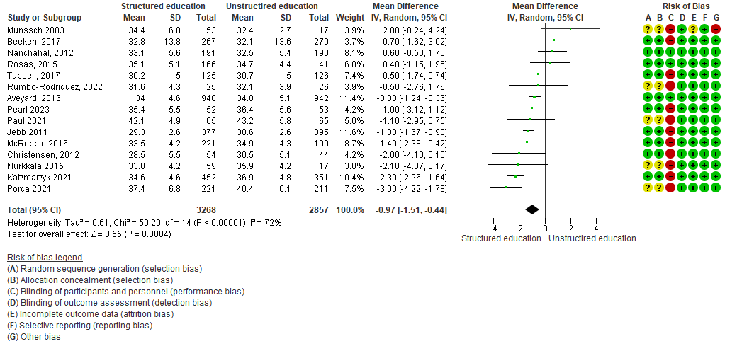
Figure 7 – Comparison between structured education programs and unstructured education programs on waist circumference (WC) at study end.
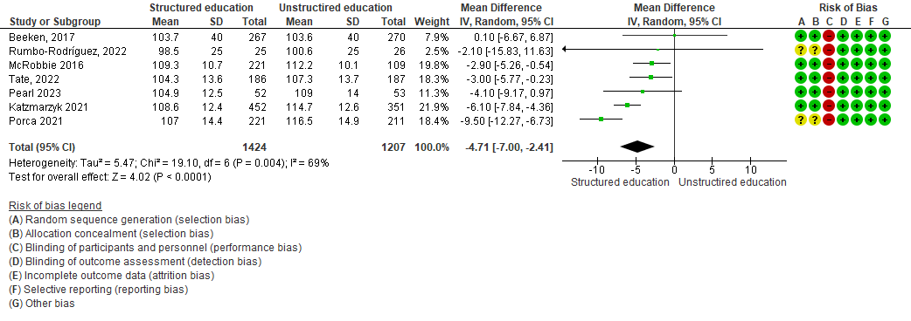

Figure 8 – Comparison between structured education programs and unstructured education programs on percentage weight loss (TBWL%; WMD) at study end.
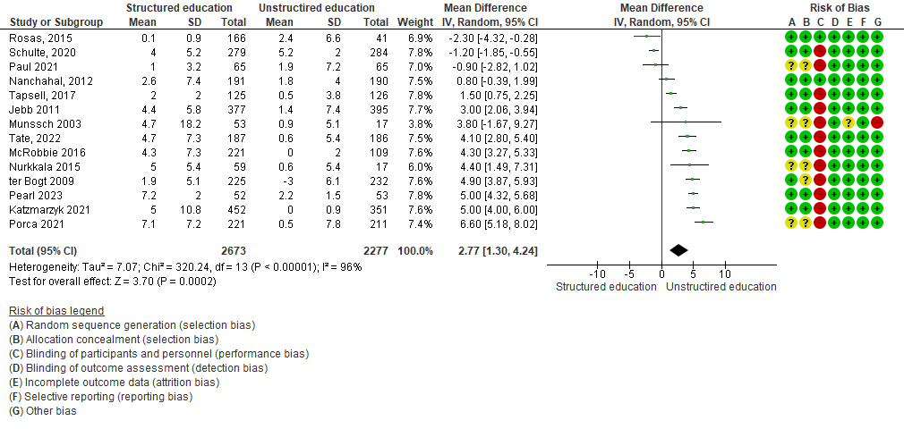

Figure 9 – Comparison between structured education programs and unstructured education programs on probability (OR) to reach 5% (Panel A) and 10% (Panel B) weight loss from baseline at study end.
A
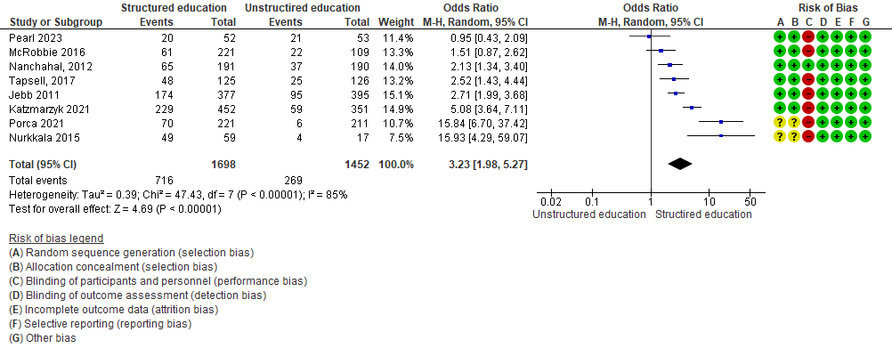
B
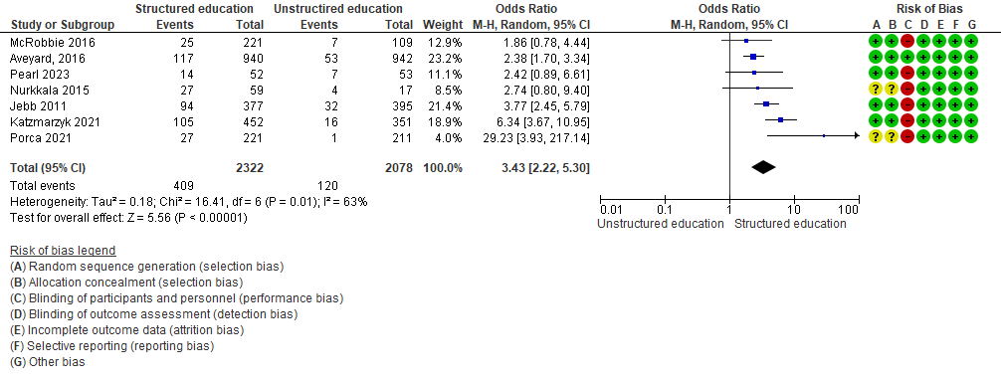
Figure 10 - Comparison between structured education programs and unstructured education programs on percentage fat mass loss (WMD) at study end.
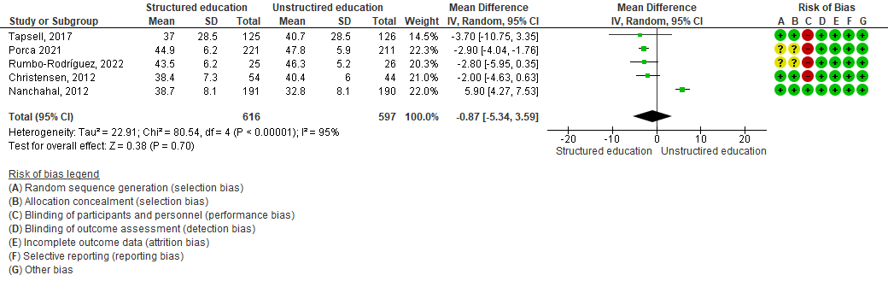

PICO 4

Figure 11 – Comparison between cognitive behavioural therapy and other kinds of educational programs on BMI (WMD) at study end.

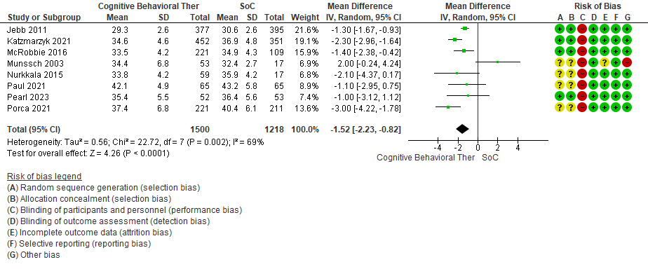
Figure 12 – Comparison between cognitive behavioural therapy and other kinds of educational programs on waist circumference (WMD) at study end.

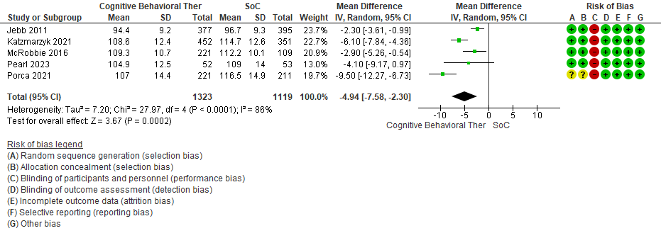

Figure 13 – Comparison between cognitive behavioral therapy and other kinds of educational programs on percentage weight loss (WMD) at study end.

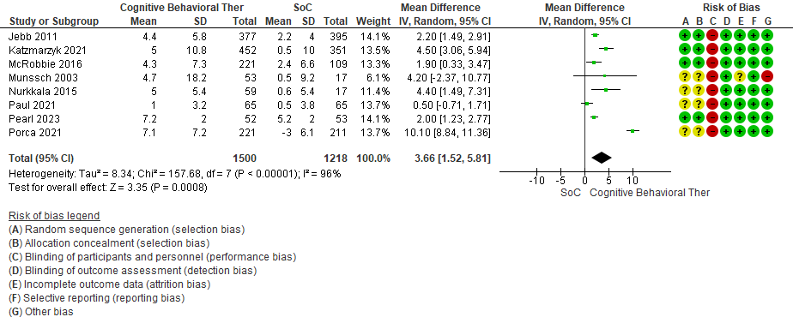

Figure 14 – Comparison between cognitive behavioural therapy and other kinds of educational programs on probability (OR) to reach 5% (Panel A) and 10% (Panel B) weight loss from baseline at study end.

A

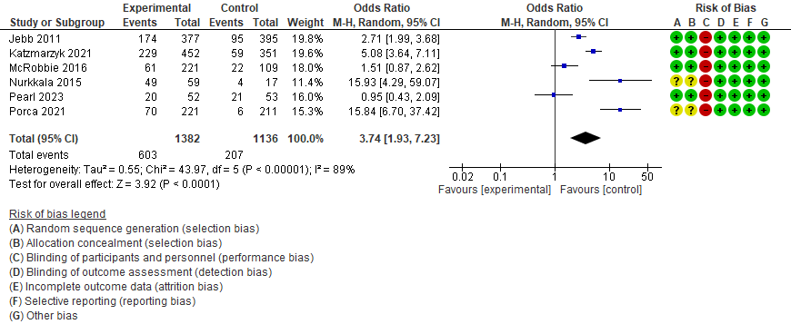
B
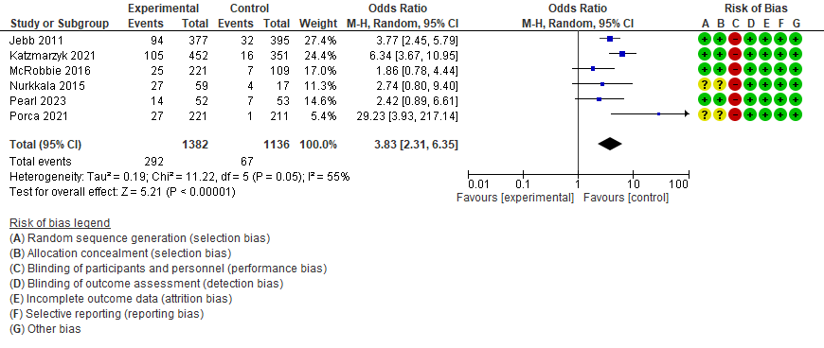

PICO 5
Figure 15 – Comparison between ketogenic and Mediterranean diets on fat mass percentage at study end.
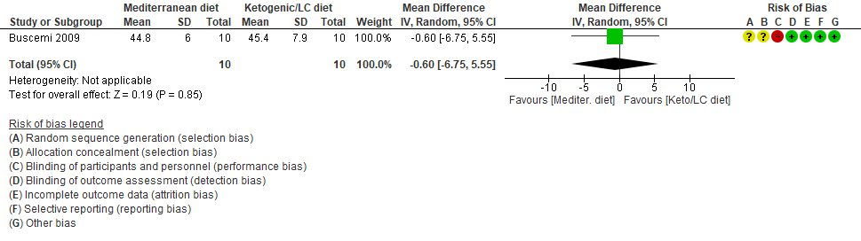
Figure 16 – Comparison between ketogenic and Mediterranean diets on BMI at study end.

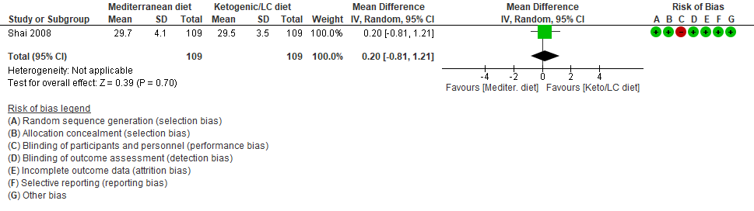
Figure 17 – Comparison between ketogenic and Mediterranean diets on waist circumference at study end.

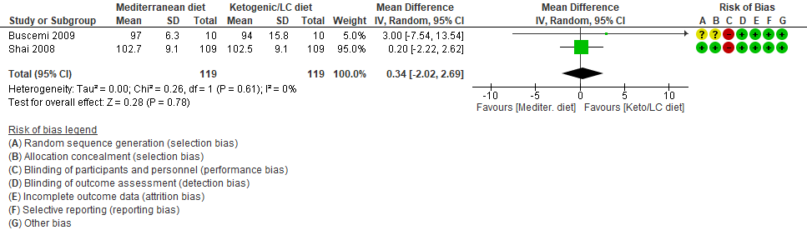
Figure 18 – Comparison between ketogenic and Mediterranean diets on percentage weight loss at study end.
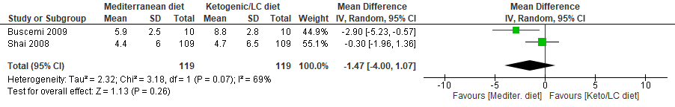

PICO 6
Figure 19 – Comparison between educational programs including combined physical exercises (aerobic and resistance) and educational programs including aerobic exercises, on BMI (WMD) at study end.
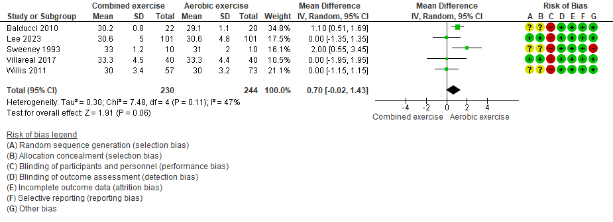

Figure 20 – Comparison between educational programs including combined physical exercises (aerobic and resistance) and educational programs including aerobic exercises, on waist circumference (WMD) at study end.
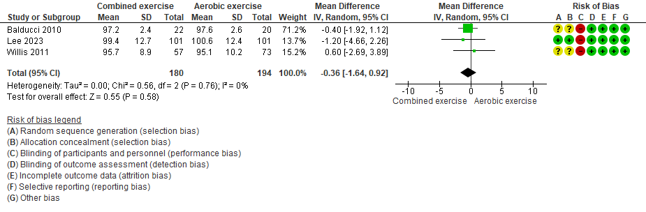
Figure 21 – Comparison between educational programs including combined physical exercises (aerobic and resistance) and educational programs including aerobic exercises, on fat mass percentage at study end.

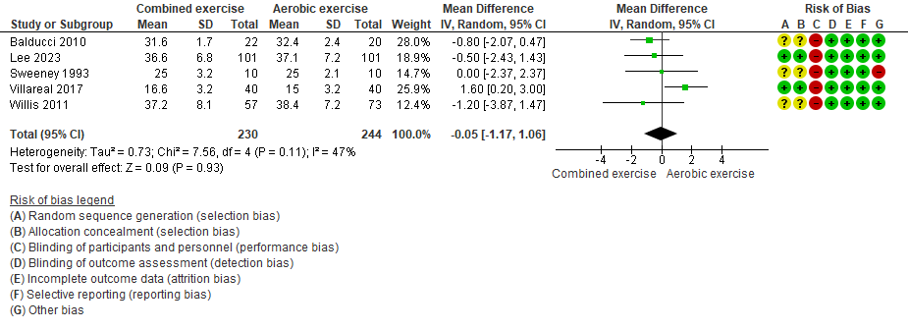

Tables

Table 8- PICO 3: main features of included studies.

N | Study Name | Intervention | Comparator | N. pat.  Interv. | N. pat.  Comp. | Trial duration  (weeks) | BMI min.  (Kg/m²) | BMI max.  (Kg/m²) | Age max.  (years) | Mean BMI  (Kg/m²) | Mean Age  (years)
1 | Aveyard³¹ | Structured education | Unstructured education | 940 | 942 | 52 | 25 | NR | NR | 34,9 | 56
2 | Beeken³² | Structured education | Unstructured education | 267 | 270 | 104 | 30 | NR | NR | 35,0 | 60
3 | Christensen³³ | Structured education | Unstructured education | 54 | 44 | 52 | 25 | NR | NR | 30,5 | NR
4 | Jebb²³ | Cognitive behavioral therapy | Unstructured education | 377 | 395 | 52 | 27 | 35 | NR | 31,4 | 47
5 | Katzmarzyk²⁴ | Cognitive behavioral therapy | Unstructured education | 452 | 351 | 104 | 30 | 50 | 75 | 37,0 | 49
6 | McRobbie²⁵ | Cognitive behavioral therapy | Unstructured education | 221 | 109 | 52 | 28 | 45 | NR | 35,3 | 46
7 | Munssch²⁶ | Cognitive behavioral therapy | Unstructured education | 53 | 17 | 52 | 30 | NR | NR | 36,0 | 45
8 | Nanchahal³⁴ | Structured education | Unstructured education | 191 | 190 | 52 | 25 | NR | NR | 33,5 | 49
9 | Nurkkala²⁷ | Cognitive behavioral therapy | Unstructured education | 59 | 17 | 156 | 30 | NR | 65 | 34,3 | 46
10 | Paul²⁸ | Cognitive behavioral therapy | Unstructured education | 65 | 65 | 52 | 30 | NR | 65 | 43,0 | 42
11 | Pearl²⁹ | Cognitive behavioral therapy | Unstructured education | 52 | 53 | 72 | 27 | NR | NR | 38,0 | 49
12 | Porca³⁰ | Cognitive behavioral therapy | Unstructured education | 221 | 211 | 52 | 30 | NR | 77 | 39,9 | 49
13 | Rosas³⁵ | Structured education | Unstructured education | 166 | 41 | 104 | 30 | 60 | NR | 35,6 | 47
14 | Rumbo-Rodríguez³⁶ | Structured education | Unstructured education | 25 | 26 | 104 | 25 | NR | NR | 32,4 | 65
15 | Schulte³⁷ | Structured education | Unstructured education | 279 | 284 | 52 | 27 | 35 | NR | 37,1 | 55
16 | Tapsell³⁸ | Structured education | Unstructured education | 125 | 126 | 52 | 25 | 40 | 54 | 32,0 | 45
17 | Tate³⁹ | Structured education | Unstructured education | 187 | 186 | 52 | 25 | 45 | 75 | 33,8 | NR
18 | ter Bogt⁴⁰ | Structured education | Unstructured education | 225 | 232 | 156 | 25 | NR | 70 | 29,5 | 56

Table 9– PICO 4: main features of included studies.
N | Study Name | Intervention | Comparator | N. pat.  Interv. | N. pat.  Comp. | Trial duration  (weeks) | BMI min.  (Kg/m²) | BMI max.  (Kg/m²) | Age max.  (years) | Mean BMI  (Kg/m²) | Mean Age  (years)
1 | Jebb²³ | CBT | SoC | 377 | 395 | 52 | 27 | 35 | NR | 31,4 | 47,0
2 | Katzmarzyk²⁴ | CBT | SoC | 452 | 351 | 26 | 30 | 50 | 75 | 37,0 | 49,0
3 | McRobbie²⁵ | CBT | SoC | 221 | 109 | 8 | 28 | 45 | NR | 35,3 | 46,0
4 | Munssch²⁶ | CBT | SoC | 53 | 17 | 16 | 30 | NR | NR | 36,0 | 45,2
5 | Nurkkala²⁷ | CBT | SoC | 59 | 17 | 48 | 30 | NR | 65 | 34,3 | 46,0
6 | Paul²⁸ | CBT | SoC | 65 | 65 | 10 | 30 | NR | 65 | 43,0 | 41,7
7 | Pearl²⁹ | CBT | SoC | 52 | 53 | 20 | 27 | NR | NR | 38,0 | 49,0
8 | Porca³⁰ | CBT | SoC | 221 | 211 | 6 | 30 | NR | 77 | 39,9 | 48,8

CBT: cognitive behavioral therapy; SoC: Standard of Care.

Table 10 – PICO 5: main features of included studies.
N | Study Name | Intervention | Comparator | N. pat.  Interv. | N. pat.  Comp. | Trial duration  (weeks) | BMI min.  (Kg/m²) | BMI max.  (Kg/m²) | Age max.  (years) | Mean BMI  (Kg/m²) | Mean Age  (years)
1 | Buscemi⁵¹ | Ketogenic diet | Mediterranean diet | 10 | 10 | 8 | 27 | 35 | 50,00 | 34,2 | 38,00
2 | Shai⁵² | Ketogenic diet | Mediterranean diet | 109 | 109 | 104 | 27 | NR | 65,00 | 31,0 | 52,00

Table 11– PICO 6: main features of included studies.
N | Study Name | Intervention | Comparator | N. pat.  Interv. | N. pat.  Comp. | Trial duration  (weeks) | BMI min.  (Kg/m²) | BMI max.  (Kg/m²) | Age max.  (years) | Mean BMI  (Kg/m²) | Mean Age  (years)
1 | Balducci | Combined physical exercise | Aerobic exercise | 22 | 20 | 52 | 27 | 40 | 75 | 30,0 | 62,50
2 | Lee | Combined physical exercise | Aerobic exercise | 101 | 101 | 52 | 25 | 40 | 70 | 31,1 | 50,50
3 | Ramos-Campo | Combined physical exercise | Aerobic exercise | 30 | 30 | 24 | 30 | 35 | 50 | NR | 38,00
4 | Sweeney | Combined physical exercise | Aerobic exercise | 10 | 10 | 26 | NR | NR | NR | 36,0 | 36,00
5 | Villareal | Combined physical exercise | Aerobic exercise | 40 | 40 | 26 | 30 | NR | NR | 35,8 | 70,00
6 | Willis | Combined physical exercise | Aerobic exercise | 57 | 73 | 36 | 25 | 35 | 70 | NR | NR

Table 12 – GRADE assessment of the quality of retrieved evidence.

Certainty assessment |  |  |  |  |  |  | Summary of findings
Participants  (studies)  follow up | Risk of bias | Inconsistency | Indirectness | Imprecision | Publication bias | Overall certainty of evidence | Study event rates (%) |  | Relative effect  (95% CI) | Anticipated absolute effect
 |  |  |  |  |  |  | With comparison | With intervention | Relative effect  (95% CI) | Risk with comparison | Risk difference between comparison and intervention
PICO 3 - BMI
6125  (15 RCT) | seriousª | serious^{b} | not serious | not serious | strong association | ⨁⨁⨁-  Moderate^{a,b} | 2857 | 3268 | - | - | MD 0.97 fewer  (from 1.51 fewer to 0.44 fewer)
PICO 4 - BMI
2718  (8 RCT) | seriousª | serious^{b} | not serious | not serious | strong association | ⨁⨁⨁-  Moderate^{a,b} | 1218 | 1500 | - | - | MD 1.52 fewer  (from 2.23 fewer to 0.82 fewer)
PICO 5 - BMI
218  (2 RCT) | seriousª | not serious | not serious | very serious^{c} | none | ⨁⨁⨁-  Very low^{a,c} | 119 | 119 | - | - | MD 0.20 fewer  (from 0.81 fewer to 1.21 higher)
PICO 6 – BMI
474  (5 RCTs) | seriousª | not serious | not serious | serious^{c} | none | ⨁⨁◯◯  Low^{a,c} | 244 | 230 | - | - | MD 0.7 higher  (from 0.02 fewer to 1.43 higher)

a) Studies with bias (open label); b) High heterogeneity I²>50%; c) Studies including few subjects.
Pharmacoeconomic evidence

Search string (until 19/03/2025): (economic or cost or cost-saving or cost-effectiveness) AND (Overweight or Obesity) AND (ketogenic or very-low-calorie or Mediterranean or balanced diet)

Pubmed: #612:
Search: (economic or cost or cost-saving or cost-effectiveness) AND (Overweight or Obesity) AND (ketogenic or very-low-calorie or Mediterranean or balanced diet)
("economical"[All Fields] OR "economics"[MeSH Terms] OR "economics"[All Fields] OR "economic"[All Fields] OR "economically"[All Fields] OR "economics"[MeSH Subheading] OR "economization"[All Fields] OR "economize"[All Fields] OR "economized"[All Fields] OR "economizes"[All Fields] OR "economizing"[All Fields] OR ("economics"[MeSH Subheading] OR "economics"[All Fields] OR "cost"[All Fields] OR "costs and cost analysis"[MeSH Terms] OR ("costs"[All Fields] AND "cost"[All Fields] AND "analysis"[All Fields]) OR "costs and cost analysis"[All Fields]) OR ("cost savings"[MeSH Terms] OR ("cost"[All Fields] AND "savings"[All Fields]) OR "cost savings"[All Fields] OR ("cost"[All Fields] AND "saving"[All Fields]) OR "cost saving"[All Fields]) OR ("cost effectiveness analysis"[MeSH Terms] OR ("cost effectiveness"[All Fields] AND "analysis"[All Fields]) OR "cost effectiveness analysis"[All Fields] OR ("cost"[All Fields] AND "effectiveness"[All Fields]) OR "cost effectiveness"[All Fields])) AND ("overweight"[MeSH Terms] OR "overweight"[All Fields] OR "overweighted"[All Fields] OR "overweightness"[All Fields] OR "overweights"[All Fields] OR ("obeses"[All Fields] OR "obesity"[MeSH Terms] OR "obesity"[All Fields] OR "obese"[All Fields] OR "obesities"[All Fields] OR "obesity s"[All Fields])) AND ("ketogenic"[All Fields] OR "very-low-calorie"[All Fields] OR ("mediterranean"[All Fields] OR "mediterraneans"[All Fields]) OR (("balance"[All Fields] OR "balanced"[All Fields] OR "balances"[All Fields] OR "balancing"[All Fields]) AND ("diet"[MeSH Terms] OR "diet"[All Fields])))
Translations
economic: "economical"[All Fields] OR "economics"[MeSH Terms] OR "economics"[All Fields] OR "economic"[All Fields] OR "economically"[All Fields] OR "economics"[Subheading] OR "economization"[All Fields] OR "economize"[All Fields] OR "economized"[All Fields] OR "economizes"[All Fields] OR "economizing"[All Fields]
cost: "economics"[Subheading] OR "economics"[All Fields] OR "cost"[All Fields] OR "costs and cost analysis"[MeSH Terms] OR ("costs"[All Fields] AND "cost"[All Fields] AND "analysis"[All Fields]) OR "costs and cost analysis"[All Fields]
cost-saving: "cost savings"[MeSH Terms] OR ("cost"[All Fields] AND "savings"[All Fields]) OR "cost savings"[All Fields] OR ("cost"[All Fields] AND "saving"[All Fields]) OR "cost saving"[All Fields]
cost-effectiveness: "cost-effectiveness analysis"[MeSH Terms] OR ("cost-effectiveness"[All Fields] AND "analysis"[All Fields]) OR "cost-effectiveness analysis"[All Fields] OR ("cost"[All Fields] AND "effectiveness"[All Fields]) OR "cost effectiveness"[All Fields]
Overweight: "overweight"[MeSH Terms] OR "overweight"[All Fields] OR "overweighted"[All Fields] OR "overweightness"[All Fields] OR "overweights"[All Fields]
Obesity: "obeses"[All Fields] OR "obesity"[MeSH Terms] OR "obesity"[All Fields] OR "obese"[All Fields] OR "obesities"[All Fields] OR "obesity's"[All Fields]
Mediterranean: "mediterranean"[All Fields] OR "mediterranean's"[All Fields] OR "mediterraneans"[All Fields]
balanced: "balance"[All Fields] OR "balanced"[All Fields] OR "balances"[All Fields] OR "balancing"[All Fields]
diet: "diet"[MeSH Terms] OR "diet"[All Fields]

GRADE evaluation of single critical outcome

Table 17
PICO 7
 | Certainty assessment |  |  |  |  |  |  |  |  |  |  | № subjects |  |  | Effect |  | Overall certainty of evidence
 | Participants  (studies)  follow up | Study design | Risk of bias | Inconsistency |  | Indirectness |  |  | Imprecision |  | Other considerations | Intervention |  | Comparator | Relative  (95% CI) | Absolute  (95% CI)
 | Weight loss- Liraglutide
 | 62  (1 RCT) | RCT | Not serious | Not serious |  | Not serious |  |  | Very seriousª |  | Strong association | 23 |  | 39 | - | MD 13.9 higher  (from 10.8 higher to 17.0 higher) | ⨁⨁◯◯  Low
 | Weight loss - Semaglutide
91  (1 RCT) |  | RCT | Not serious |  | Not serious |  | Not serious | Very seriousª |  | Strong association |  |  | 26 | 65 | - | MD 4.1 higher (from 0.6 higher to 7.5 higher) |  | ⨁⨁⨁◯  Low
a) data derived from a single study including few subjects.

PICO 8
Certainty assessment |  |  |  |  |  |  | Summary of findings
Participants  (studies)  follow up | Risk of bias | Inconsistency | Indirectness | Imprecision | Publication bias | Overall certainty of evidence | Study event rates (%) |  | Relative effect  (95% CI) | Anticipated absolute effect
 |  |  |  |  |  |  | With comparison | With intervention | Relative effect  (95% CI) | Risk with comparison | Risk difference between comparison and intervention
Total body weight loss (%) – All theraphies (vs placebo/no theraphy/lifestyle)
21251  (13 RCT) | serious | serious | not serious | not serious | strong association | ⨁⨁⨁◯  Moderate | 10423 | 10828 | - | - | MD 7.53 higher  (from 4.97 higher to 10.09 higher)

PICO 9
Certainty assessment |  |  |  |  |  |  | Summary of findings
Participants (studies)  Follow up | Risk of bias | Inconsistency | Indirectness | Imprecision | Publication bias | Overall certainty of evidence | Study event rates (%) |  | Relative effect  (95% CI) | Anticipated absolute effect
 |  |  |  |  |  |  | With comparison | With intervention | Relative effect  (95% CI) | Risk with comparison | Risk difference between comparison and intervention
Total body weight loss (%) – All strategies (NMA)
31,110  (64 RCT) | serious | serious | Not serious | Not serious | Strong association | ⨁⨁⨁◯  Moderate | 13285 | 17825 | - | - | MD 7.75 higher  (from 6.38 higher to 9.11 higher)
CI: Confidence interval; MD: Mean difference; OR: Odds ratio;

PICO 10
Certainty assessment |  |  |  |  |  |  | Sintesi dei risultati
Parteicipants (studies)  Follow up | Risk of bias | Inconsistency | Indirectness | Imprecision | Publication bias | Overall certainty of evidence | Study event rates (%) |  | Relative effect  (95% CI) | Absoulte anticipated effect
 |  |  |  |  |  |  | With comparison | With intervention | Relative effect  (95% CI) | Risk with PBO | Difference with BMI 30-35
Total body weight loss (%) – All strategies (NMA)
754  (5 RCT) | serious | serious | Not serious | Not serious | Strrong association | ⨁⨁⨁◯  Moderate | 275 | 479 | - | - | MD 18.37 higher  (from 13.23 higher to 23.5 higher)
CI: Confidence interval; MD: Mean difference; OR: Odds ratio;
a. Randomization and allocation often inadequately reported. b. Small sample size. c. High heterogeneity (I²> 50%). d. Data derived from a single study. e. Open label studies.

PICO 11

Certainty assessment |  |  |  |  |  |  | № of patients |  | Effect |  | Certainty | Importance
№ of studies | Study design | Risk of bias | Inconsistency | Indirectness | Imprecision | Other considerations | Weight loss | control | Relative  (95% CI) | Absolute  (95% CI) | Certainty | Importance
Depression
16 | randomised trials | serious | not serious | not serious | not serious | none | 99/16405 (0.6%) | 88/12619 (0.7%) | OR 0.72  (0.54 to 0.97) | 2 fewer per 1.000  (from 3 fewer to 0 fewer) | ⨁⨁⨁◯  Moderate

CI: confidence interval; MD: mean difference; OR: odds ratio;
a. Small number of events
b. Significant Heterogeneityc. Funnel plot does not rule out publication bias

