Appendix A: LDA procedure and Topics description

A.1. Data pre-processing and definition of the corpus
The original data, obtained from Scopus.com, were stored in an Excel file comprising 1,175 rows and 15 columns. Each row corresponds to a selected abstract. Key variables used in the analysis include the abstract text, the year of publication, and the number of citations.
Before calculating the topic models, we pre-processed the data. Specifically, we constructed a text corpus by uploading 1,175 abstracts. Consistent with prior research (e.g., Schmitt et al., 2022; Vaid et al., 2023), we excluded keywords and titles associated with the published papers. The texts were then tokenized, lowercased, and stripped of numbers, punctuation, and special characters.
We further removed standard English stopwords as well as a set of domain-specific, low-informational terms such as purpose, paper, objective, study, research, theory, findings, can, also, based, approach, implications, results, data, author, and authors. Based on the cleaned texts, we constructed a document-term matrix (DTM) of dimensions 1,175 abstracts by 11,062 unique tokens. To reduce computational complexity, only tokens with a minimum frequency threshold of p = 0.01 were retained. This DTM served as the input for the Latent Dirichlet Allocation (LDA) algorithm.
R packages used to clean text or to visualize data include quanteda, lubridate, tm, stringr.

A.2. Selection of the optimal number of topics
We employed the R package topicmodels (Grün & Hornik, 2011) to estimate Latent Dirichlet Allocation (LDA) topic models. Additionally, we used the ldatuning package to compute fit indices that assist in determining the optimal number of topics (Nikita & Nikita, 2016).
LDA assumes that each word in a document is generated from a mixture model, where the components represent topics modeled as multinomial distributions (Blei et al., 2003; Wedel & Kannan, 2016). The core idea is that documents are composed of latent topics, each defined by a probability distribution over words. Words can appear in multiple topics, each with a different probability, and topics are conceptualized as weighted vectors of words, each reflecting a distinct semantic “concept” (Grimmer & Stewart, 2013; DiMaggio et al., 2013).
Importantly, LDA is a partially unsupervised technique, as it requires the researcher to specify the number of topics in advance. As DiMaggio et al. (2013) highlight, there is no definitive statistical test to determine the optimal number of topics. Instead, researchers must assess the various solutions provided by the algorithm and select the one that offers the most coherent and interpretable structure of the data (Hannigan et al., 2019). Given the aim of our study—namely, to offer an initial synthesis of the literature related to the concept of stewardship—we adopted a parsimonious approach to topic modeling.
In line with the suggestions of literature (e.g., Rashid, 2024; DiMaggio, Nag and Blei, 2013; Hanningan et al., 2019) we integrated a statistical perspective based on the analysis of the fit indexes provided by the package ldatuning (namely, Cao Juan, Griffiths, Arun and Deveaud. See: Nikita & Nikita, 2016) with a qualitative inspection of each solution to find the number of topics that provides semantically meaningful interpretation (see also Chang et al., 2009). Specifically, we relied on the following metrics to guide the selection of the optimal number of topics:
- Cao Juan calculates the average cosine similarity between topics. As the number of topics increases, the similarity among them typically rises, resulting in higher values. Therefore, lower values of the Cao Juan index indicate more distinct and well-separated topics, suggesting a better solution.
- Arun uses symmetric Kullback-Leibler (KL) divergence between the document-topic and topic-word distributions, aiming to balance topic granularity and interpretability. Lower values suggest a model with a meaningful structure and distinct topic representation.
- Griffiths relies on the log-likelihood of the data given the model. Higher values indicate a better model fit. Empirically, this index often exhibits a plateau or elbow at the optimal number of topics—a pattern we also observed in our data.
- Deveaud is based on Jensen-Shannon divergence between topic-word distributions and seeks to maximize the distance between topics. Higher values correspond to more coherent and well-separated topics.
We allowed the number of topics to vary between 2 and 150. A minimum of two topics is required to perform topic modeling, while in principle there is no strict upper limit. However, in line with the purpose of conducting an integrative review, we initially limited the search to 150 topics, as higher values tend to yield diminishing returns in terms of interpretability and analytical value. This procedure resulted in the configuration of the four index curves shown in Figure A.1.

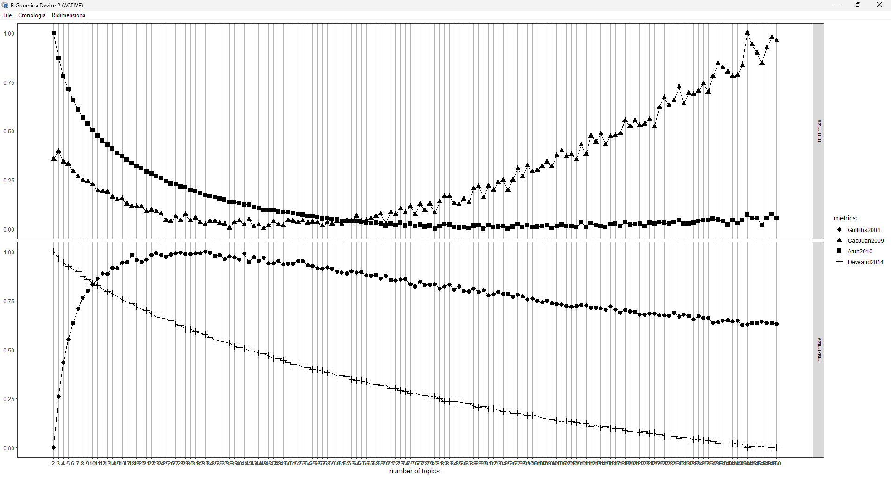
Figure A.1: LDAtuning results

Figure A.1 does not reveal convergence among the four fit indices, leaving the question of the optimal number of topics unresolved. Moreover, the only two indices that exhibit a clear maximum or minimum—namely, Cao Juan and the perplexity-based index by Griffiths—suggest inconsistent and excessively high numbers of topics as optimal. Adopting these indications would lead to an overly complex representation of the literature on stewardship, which would be misaligned with the goal of providing a coherent and integrative review. For this reason, we closely examined topic model solutions ranging from 2 to 20 topics. Specifically, we analyzed the most cited papers within each topic to hermeneutically interpret the overarching themes associated with each solution. Each author independently conducted this interpretive analysis, after which we engaged in collaborative discussion to compare and synthesize the interpretations emerging from the 2- to 20-topic models.
This approach aligns with the recommendations of Rashid et al. (2024), DiMaggio et al. (2013), and Hannigan et al. (2019), who emphasize the importance of complementing statistical model selection criteria with qualitative, interpretive assessment. Notably, Hannigan et al. (2019) point out that topic models optimized solely for statistical fit may produce less semantically meaningful results (see also Chang et al., 2009). Similarly, DiMaggio et al. (2013) underscore that no statistical test can definitively determine the optimal number of topics; rather, it is up to the researcher to select the solution that yields the most conceptually clear and analytically useful representation of the data. Following this mixed-method evaluation, the authors ultimately reached a consensus on a 10-topic solution.

A.3. Labeling of topics
The 10-topic solution provides the 10 (topics) X 1175 (abstracts) theta matrix of probabilities of each abstract to be included in each topic. Thus, we assigned each paper to the topic based on the highest probability of matching said topic (matrix theta; Blei et al., 2003). The 10-topic solution provides also the 10 (topics) X 11062 (tokens) beta matrix of probabilities of each token (word in the corpus) to be included in the topics.
Using the theta matrix, we identified the most representative documents associated with each topic. Subsequently, based on the beta matrix derived from the ten-topic solution of the LDA model, we extracted the ten most salient terms for each topic. Specifically, we extracted the most frequent terms using the terms function from the topicmodels R package. By hermeneutically analyzing the top-ranked texts and interpreting them in light of the most relevant terms extracted, we assigned an interpretive label—or topic title—to each of the ten topics.
The complete set of the ten keywords with the highest probability is provided in Table A.1., while Table 2 in the main text offers sample references for each topic.

Topic 1 | Topic 2 | Topic 3 | Topic 4 | Topic 5 | Topic 6 | Topic 7 | Topic 8 | Topic 9 | Topic 10
ethical | leadership | institutional | change | behavior | brand | tourism | csr | reporting | ceo
leadership | community | investors | climate | innovation | consumers | forest | reporting | quality | duality
values | heritage | investment | energy | employees | marketing | global | community | disclosure | directors
capital | leaders | funds | effects | orientation | brands | health | company | earnings | ceos
human | change | decisions | eco | involvement | reporting | supply | local | standards | structure
businesses | education | nonprofit | network | commitment | visitors | certification | place | accountability | executive
ethics | identity | fund | system | High | initiatives | water | review | audit | compensation
tourism | vision | responsible | adoption | strategic | consumer | chain | reports | auditors | listed
trust | values | mechanisms | equity | Culture | recreation | services | emissions | directors | size
behaviour | knowledge | code | strategy | employee | heritage | sector | language | measurement | effects
Table A.1.: Most important keywords per topic

As a result of this procedure, we labeled each topic as follows: 1. Values-based Leadership, 2. Responsible Leadership, 3. Stewardship Governance, 4. Fostering Innovation, 5. Psychological Ownership, 6. Human Purpose, 7. Environment and Society, 8. Stimulating Positive Change, 9. Accountability, and 10. Organizational Performance.

A.4. Topic specificity analysis
We assessed the quality of our ten-topic solution by examining both internal consistency and between-topic overlap, using the ten most salient terms per topic as reported in Table A.1. More specifically, we conducted the analysis of semantic coherence (Hashmi et al., 2025; Pennington, Socher and Manning, 2014), granularity (Ganguli and Sengupta, 2023; Todri, Adamopoulos and Andrews, 2022), and entropy/specificity (Blei, Ng and Jordan, 2003; Kim, Lee and McCulloch, 2024; Lee and Kang, 2018). By considering all three dimensions together provides a reliable assessment of both the interpretive quality and the structural soundness of the model, striking a balance between coherence within topics and separation across topics. This multidimensional approach allows for a more robust and nuanced evaluation of topic modeling solutions.

A.4.1. Semantic coherence
We first analyzed semantic coherence of topics based on the sample keywords of Table A.1. (Hashmi et al., 2025; Pennington, Socher and Manning, 2014). This analysis employes the pre-trained word embedding lexicon such as Global Vectors for Word Representation (GloVe. See Pennington et al., 2014; Shankar and Parsana, 2022). GloVe maps words into dense vector spaces where semantically similar words are positioned close together. By computing the average pairwise cosine similarity (e.g.: Ghojogh et al., 2022) between the top-N words of each topic using GloVe vectors, one can estimate how semantically consistent or meaningful the topic is. This method provides a simple yet effective unsupervised measure of topic coherence that aligns well with human judgments, particularly in scenarios where labeled coherence data is unavailable. Figure A.2. display semantic coherence of topics in descending order.
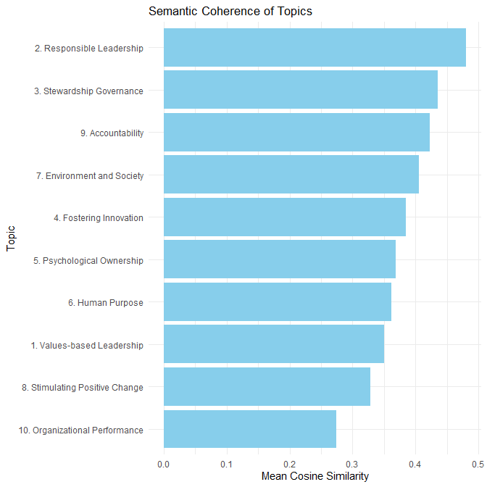
Figure A.2: Semantic coherence of topics.

Semantic coherence measures how semantically similar the top words within each topic are, typically based on their vector representations in a word embedding space such as GloVe. Higher values indicate that the top words of a topic are more closely related in meaning, suggesting a more interpretable and meaningful topic (Shankar and Parsana, 2022). In our case, topic 10. Organizational Performance has a low score, indicating that the top words within a topic are only loosely related, potentially making the topic harder to interpret. Topics 2. Responsible Leadership, 3. Stewardship Governance, and 9. Accountability are characterized by large scores, indicating that the keywords in these topics are strongly related and thus more likely to represent a coherent concept. The other topics are characterized by moderate coherence, suggesting that they are semantically meaningful but may include noise or mixed themes.

A.4.2. Granularity
The granularity of a topic model is the extent to which topics capture distinct semantic regions of the vocabulary (Ganguli and Sengupta, 2023; Todri, Adamopoulos and Andrews, 2022). In this case, pairwise Jaccard similarity between the top-N words of each topic can be used. The Jaccard index quantifies the proportion of shared words between two topics relative to their union. A high average Jaccard similarity across topics suggests low granularity, indicating that topics may be overlapping or redundant. Conversely, a low average Jaccard similarity implies high granularity, suggesting well-separated, specific topics. This metric provides a simple and interpretable way to complement coherence scores by revealing redundancy and lexical overlap in topic models. Average granularity (i.e., 1 - Jaccard distance) resulted in .987, indicating very high granularity, meaning that the top words associated with each topic overlap very little or, in other words, that they are nearly disjoint sets. The lighter or white hues in the heatmap of Figure A.3 correspond to minimal levels of topic overlap, indicating low shared content among topics.

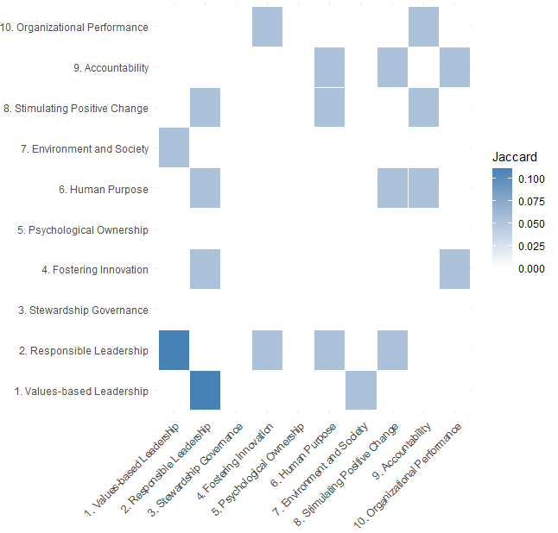
Figure A.3: Pairwise Jaccard similarities between topics.

The Jaccard similarity index, which captures how many words the topics have in common, can be also used to display a dendrogram that visualizes the lexical similarity between the 10 topics. Specifically, in the resulting dendrogram of Figure A.4 each topic occupies a bottom-most label, i.e. a leaf of the tree. The height of a branch indicates the Jaccard distance between the merged topics or clusters, graphically displaying lexically similar topics (i.e. topics sharing many of the same top words) with short branches, while tall branches mean little overlap, corresponding to lexically distinct topics. Consistent to previous analyses, closely clustered topics (namely, lexically similar topics) are absent, while the tree is characterized by distant branches, that represent topics that are thematically distinct, as indicated by their disjoint vocabularies.

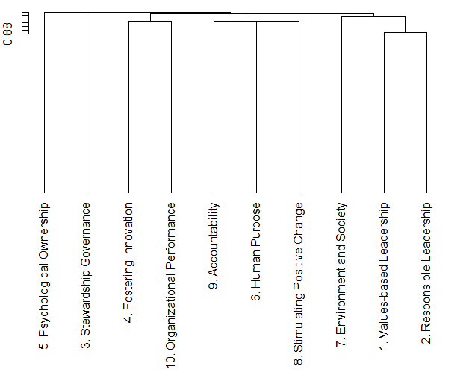
Figure A.4: Dendrogram of Topics (based on Jaccard distance).

As a further analysis, we propose a graph-based representation of the topics’ overlapping configuration. More specifically, we defined a graph with the ten topics as nodes, while two nodes are linked by an edge in the resulting network only if they share more than 10% of their top words (corresponding to a Jaccard similarity above .1). Choosing this threshold balances inclusiveness and interpretability. In fact, on the one side, this choice allows connections between topics that share a non-negligible but limited number of top keywords, filtering out weaker or incidental overlaps. Moreover, it helps highlight moderate to strong lexical relationships while avoiding excessive noise that would result from setting the threshold too low (e.g., 0.01), which would produce a dense and potentially uninterpretable graph; on the other side, this threshold is not so high as to exclude all connections, since there is still room to capture meaningful thematic bridges between topics without requiring near-identical word sets.
This facilitates a clearer visualization of the semantic structure and grouping tendencies within the topic model, retaining topic pairs with a meaningful degree of lexical similarity while avoiding spurious links due to minimal word overlap. The resulting graph is reported in Figure A.5.

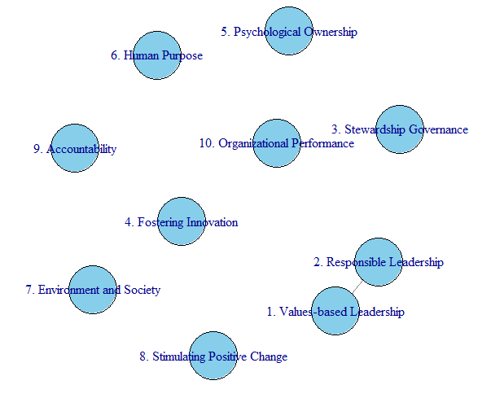
Figure A.5: Topic Connection Graph (Jaccard distance >.1).

A.4.3. Entropy and specificity
Entropy and specificity are two key metrics used to analyze the distribution and distinctiveness of words across topics in topic modeling (Blei, Ng and Jordan, 2003; Kim, Lee and McCulloch, 2024; Lee and Kang, 2018). These metrics help in interpreting topics and identifying words that are representative or ambiguous within the model.
Specifically, entropy measures uncertainty or randomness in the assignment of a word across multiple topics. A high entropy value indicates that a word is more evenly distributed among topics, implying it is less informative for distinguishing a specific topic. Conversely, low entropy suggests that the word is strongly associated with fewer topics. Specificity, often derived from entropy, quantifies how uniquely a word belongs to a particular topic; higher specificity means the word is more exclusive to that topic, serving as a strong topical marker.
In our case, we calculated an entropy value of .1065 is very low, suggesting that the top words for each topic are highly concentrated and do not appear frequently across multiple topics. This indicates high lexical distinctiveness, meaning each topic is characterized by a relatively unique vocabulary. Moreover, a specificity score, resulted as .9679, suggests that the top keywords are very well differentiated and strongly associated with their respective topics. This supports the idea that the model yields well-defined and non-overlapping thematic groupings. In combination, these values indicate that our 10-topic model provides clear and distinct topics, with little lexical overlap and allows highly interpretability, assuming the semantic coherence of the topics is also high. Figure A.5. displays the configuration of entropy and specificity scores.

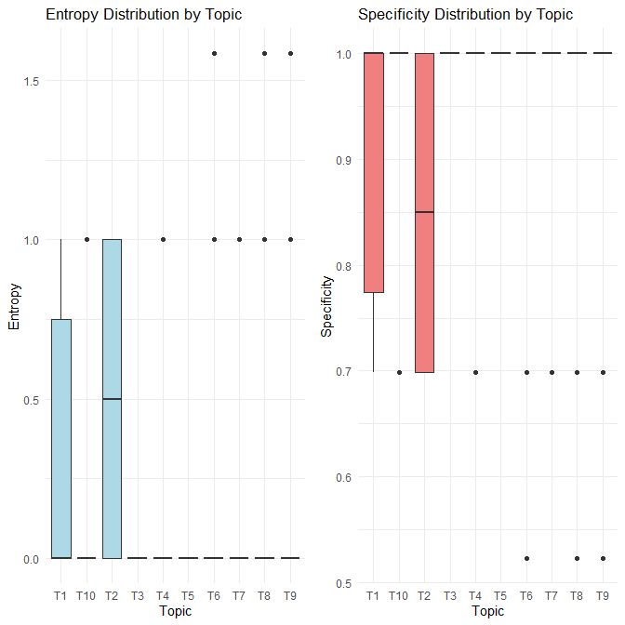

Figure A.5: Entropy and specificity scores.

A.5. Temporal dynamics
Although a detailed analysis of the temporal dynamics of the ten topics falls outside the scope of this paper, we provide a descriptive overview of two key quantitative indicators associated with each topic. Specifically, our dataset includes both the year of publication and the number of citations for each of the 1,175 abstracts analyzed. As previously noted, the 10-topic solution yields a 10 (topics) × 1,175 (abstracts) document-topic probability matrix (theta), which enables the assignment of each abstract to a single topic based on the highest probability score. This classification formed the basis for the two graphical representations presented in Figure A.6. More specifically:
- By aggregating the number of papers published per year within each topic, we generated a graphical representation of publication trends over time, as shown in the time series plot in Figure A.6.a;
- By summing the number of citations received by papers associated with each topic, we produced a graphical representation of citation dynamics, as displayed in Figure A.6.b.

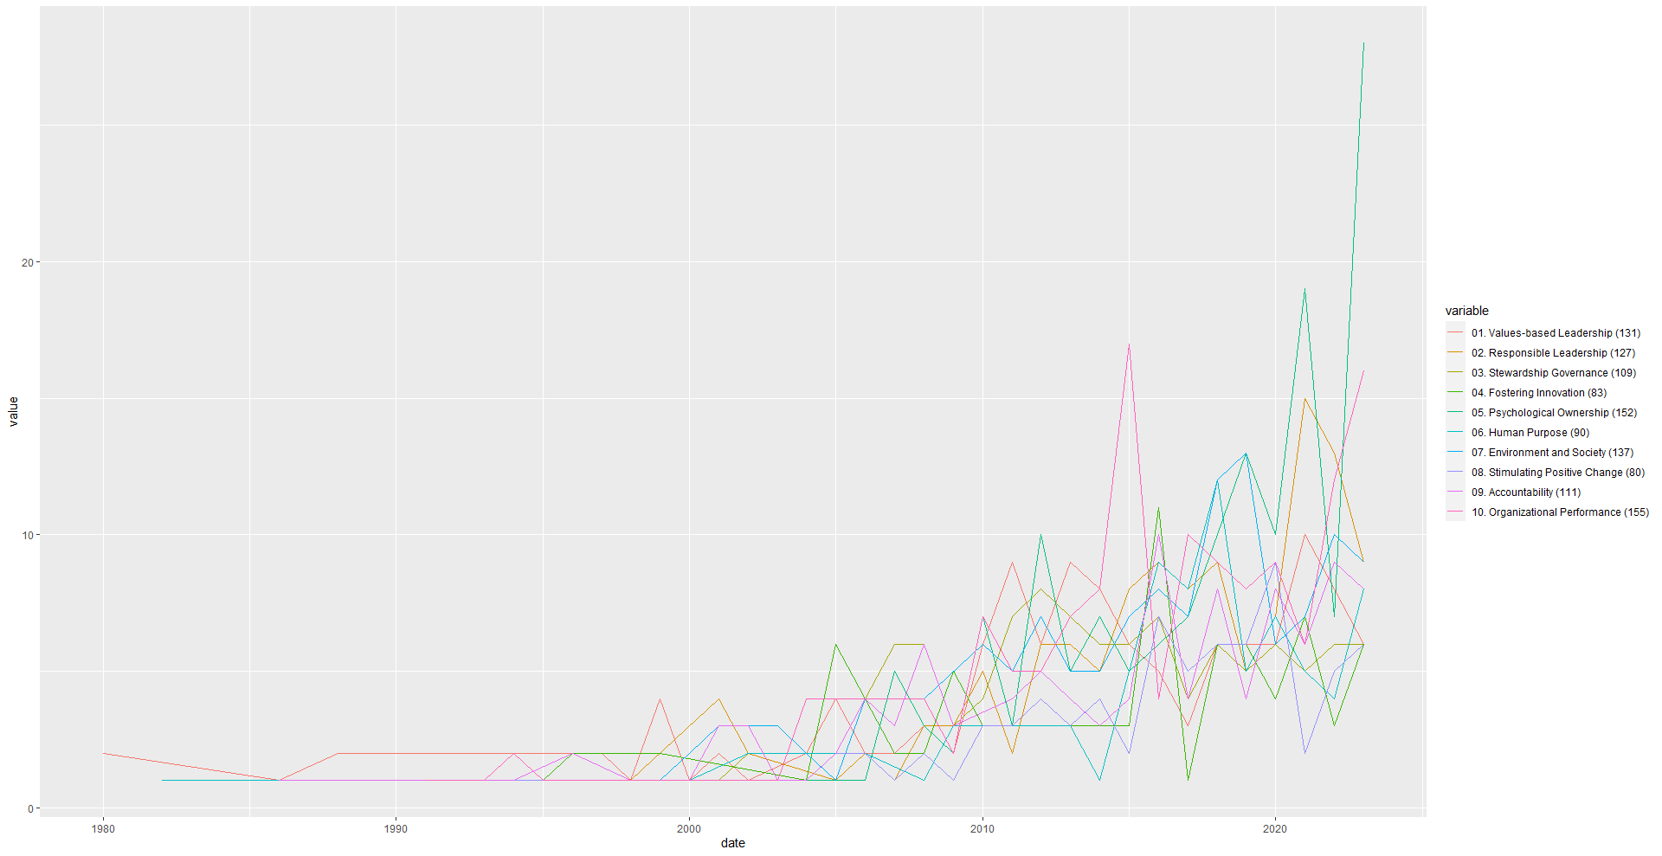 | 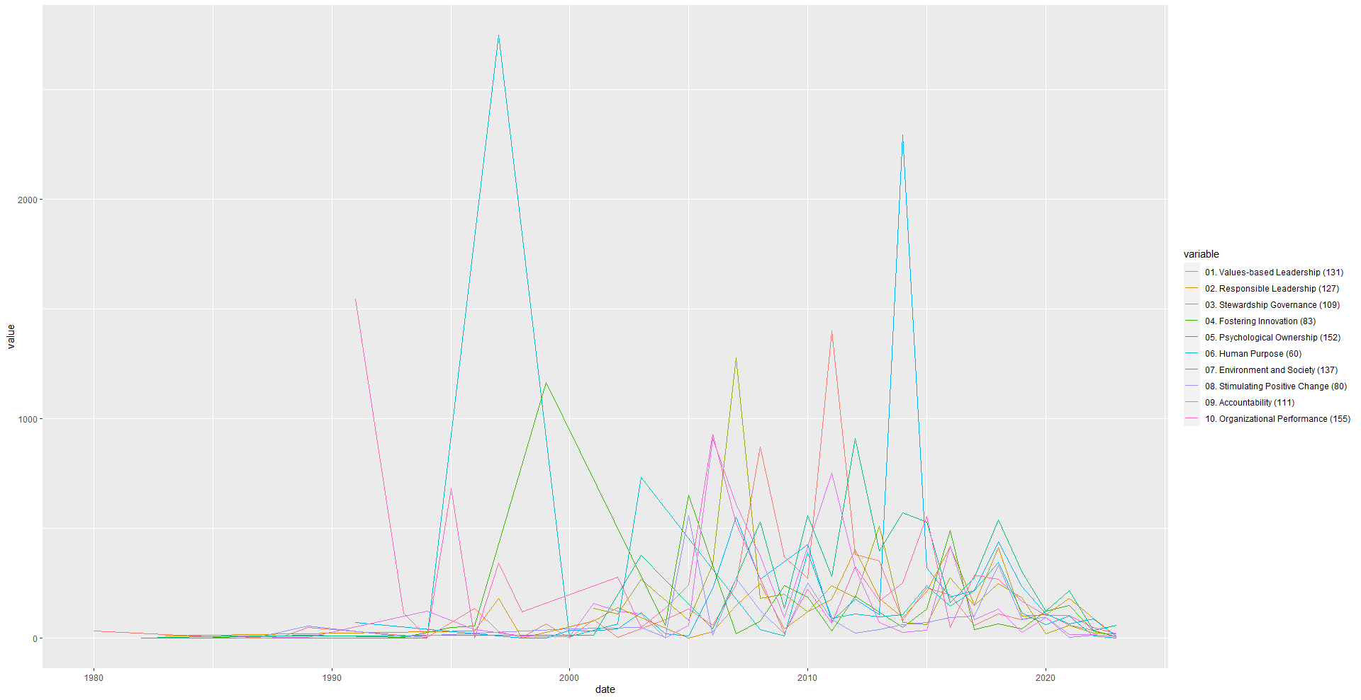
Figure A.6.a: The time-series of published papers per topic | Figure A.6.b: The time-series of citations per topic

It is important to note that citation counts are inherently biased by the publication date of the papers—topics that have emerged more recently may appear less cited simply due to their limited exposure time. Reinterpreting the notions of “hot” and “cold” topics introduced by Antons et al. (2016) and Rashid et al. (2023), we adopted two key quantitative indicators to assess topic relevance: (1) the number of papers associated with each topic and (2) the total number of citations those papers have received to date.
In this framework, the number of papers attributed to each topic (i.e., as derived from the theta matrix) can be interpreted as a measure of the topic’s importance in the broader discourse on stewardship. Similarly, the cumulative citation count per topic may be seen as a proxy for performance, capturing the extent to which a topic has stimulated scholarly attention and debate. By combining these two dimensions, we developed a performance–importance matrix, which is presented in the paper as Figure 1.

References
Blei, D. M., Ng, A. Y., & Jordan, M. I. (2003). Latent Dirichlet Allocation. Journal of Machine Learning Research, 3, 993–1022.
Ganguli, I., Sil, J., & Sengupta, N. (2023). Nonparametric method of topic identification using granularity concept and graph-based modeling. Neural Computing and Applications, 35(2), 1055-1075.
Ghojogh, B., Crowley, M., Karray, F., & Ghodsi, A. (2022). Variational autoencoders. In Elements of Dimensionality Reduction and Manifold Learning (pp. 563-576). Cham: Springer International Publishing.
Hashmi, E., Altaf, A., Anwar, M. W., Jamal, M. H., & Bajwa, U. I. (2025). BI-SENT: bilingual aspect-based sentiment analysis of COVID-19 Tweets in Urdu language. PloS one, 20(6), e0317562.
Kim, S., Lee, S., & McCulloch, R. (2024). A topic-based segmentation model for identifying segment-level drivers of star ratings from unstructured text reviews. Journal of Marketing Research, 61(6), 1132-1151.
Lee, H., & Kang, P. (2018). Identifying core topics in technology and innovation management studies: A topic model approach. The Journal of Technology Transfer, 43(5), 1291-1317.
Pennington, J., Socher, R., & Manning, C. D. (2014). GloVe: Global Vectors for Word Representation. Proceedings of the 2014 Conference on Empirical Methods in Natural Language Processing (EMNLP), 1532–1543.
Shankar, V., & Parsana, S. (2022). An overview and empirical comparison of natural language processing (NLP) models and an introduction to and empirical application of autoencoder models in marketing. Journal of the Academy of Marketing Science, 50(6), 1324-1350.
Todri, V., Adamopoulos, P., & Andrews, M. (2022). Is distance really dead in the online world? The moderating role of geographical distance on the effectiveness of electronic word of mouth. Journal of Marketing, 86(4), 118-140.

