SUPPLEMENTARY INFORMATION

Albumin-On-A-Chip: development of a patient-specific sensing surface for personalized screening
Marta Nugnes¹, Maurizio Baldassarre², Paolo Caraceni^{2,3}, Marina Naldi^{1,4}* Manuela Bartolini¹*
¹ Department of Pharmacy and Biotechnology, Alma Mater Studiorum University of Bologna, Bologna, Italy.
² Unit of Semeiotics, Liver and Alcohol-related Diseases, IRCCS Azienda Ospedaliero-Universitaria di Bologna, Bologna, Italy.
³ Department of Medical and Surgical Sciences, Alma Mater Studiorum University of Bologna, Bologna, Italy.
⁴ Center for Applied Biomedical Research (CRBA), University of Bologna, Bologna, Bologna, Italy

Table of Contents
Figure S1. Optimization of experimental parameters for HA capture………………………...……………..page 1
Figure S2. Representative surface regeneration cycle…………………………………………...…………….page 2
Figure S3. HA-sensorchip validation…………………………………………………………………………….page 3
Figure S4. Representative interaction studies on TEICO and HA……………………………………………page 4
Table S1. Relative abundances of native and altered forms of HA in hospitalized ACLF patients and age-matched healthy controls as determined by LC-ESI-MS analysis…………………………………......……..page 5
Table S2. Patient-specific albumin binding capacity in ACLF patients and age-matched healthy controls (CTRL)………………………………………………………………….………………………………..........……..page 6
Table S3. Relative abundances of native and altered forms of HA in diabetic patients without renal damage and with renal damage as determined by LC-ESI-MS analysis…………………….……………........……..page 7
Table S4. Patient-specific albumin binding capacity in T2DM patients without renal impairment (T2DM-DKD) and with renal impairment (T2DM+DKD)………………………………………….……………….. page 8

a | b | c

Figure S1. Optimization of experimental parameters for HA capture. Optimization of (a) HA concentration in the capturing solution, (b) flow rate for HA capture, and (c) contact time between HA and sensing surface. The level of capture (RU at plateau) was monitored as various parameters changed to assess capture efficiency.

Figure S2. Representative sensorgram showing a capture-regeneration-capture sequence of the sensing surface. The first capture cycle of HA produces a stable plateau, followed by a regeneration step that restores the baseline to the starting level (black dashed line), indicating that no detectable loss of the covalently immobilized antibody occurs during surface regeneration. A subsequent capture step yields a response comparable to the first (red dashed line), demonstrating that the sensing surface's capture capacity is preserved after regeneration.

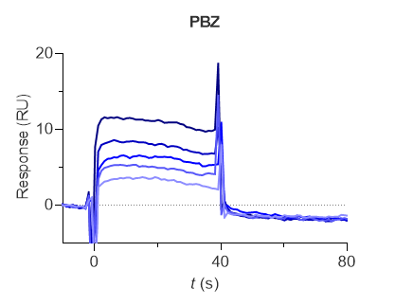  (a) | 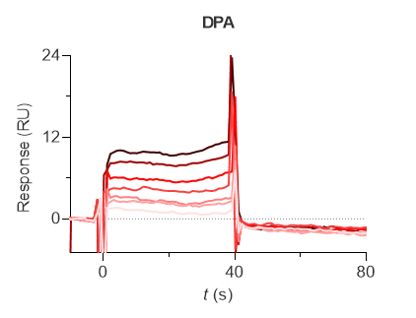  (b) | 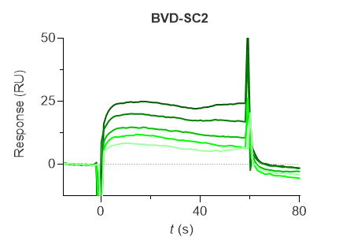  (C)
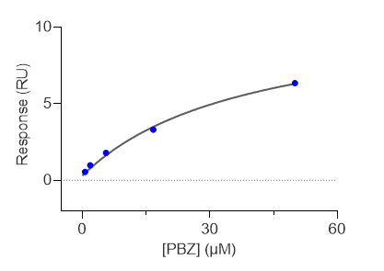  (d) | 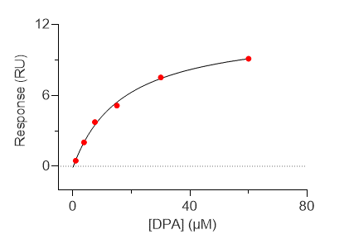  (e) | 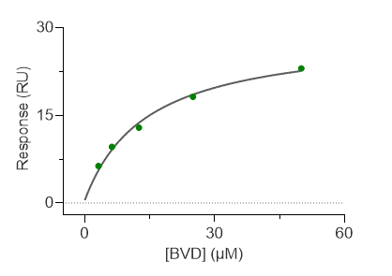  (f)
Fig. S3. HA-sensorchip validation. Representative SPR sensorgrams (a, b and c) and isothermal binding curves fitted to the 1:1 isotherm binding model (d, e and f) for the three selected reference compounds to HA captured by the antibody immobilized on chip surfaces. a and d represent PBZ-HA binding, increasing concentrations (0.620, 1.85, 5.56, 16.7, and 50.0 μM) are denoted by different shades of blue (from light to dark), data obtained with SC-1; b and e represent DPA-HA binding, increasing concentrations (0.940, 1.88, 3.75, 7.50, 15.0, and 30.0 μM) are denoted by different shades of red (from light to dark), data obtained with SC-1; c and f represent BVD-HA binding, increasing concentrations (3.13, 6.25, 12.5, 25.0, and 50.0 μM) are denoted by different shades of green (from light to dark), data obtained with SC-2.

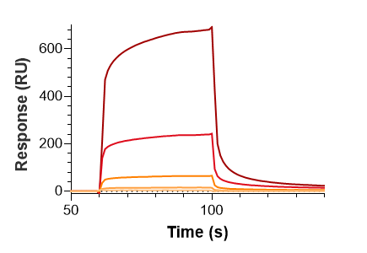  (a) | 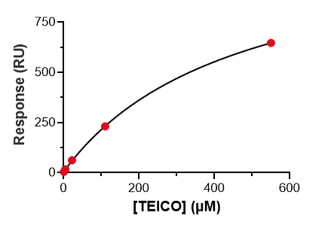  (b)
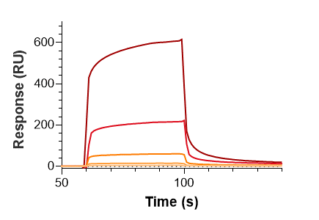  (c) | 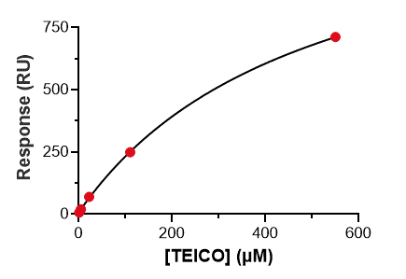  (d)
Fig. S4. Representative binding studies on TEICO and HA from a control subject (a, b) and from an ACLF patient (c, d). Double-referenced sensorgrams (a, c) and Req values fitted to the 1:1 isotherm binding model (b, d) are reported. TEICO has been tested at increasing concentrations (0.880, 4.40, 22.0, 110, and 550 μM) as denoted by different shades of red (from light to dark).

Table S1. Relative abundances (%) of native and altered forms of HA in patients hospitalized with acute-on-chronic liver failure (ACLF, n=6) and age-matched healthy controls (CTRL, n=6) determined by LC-ESI-MS analysis. Data are reported as median and interquartile range.

 | Relative Abundance (%)
HA | CTRL | ACLF | p-value
HA | n = 6 | n = 6
nHA | 43.1 (40.8 - 44.9) | 8.5 (8.1 - 9.2) | 0.001
HMA | 55.6 (52.5 - 57.5) | 14.8 (13.3 - 16.3) | 0.001
HNA1 | 37.9 (35.5 - 41.3) | 87.9 (83.3 - 87.9) | 0.001
HNA2 | 6.8 (6.4 - 7.2) | 1.6 (1 - 2.8) | 0.001
Trunc. HA | 6.0 (5.9 - 6.4) | 6.3 (5.5 - 8.8) | 0.485
Glyc. HA | 11.6 (10.7 - 12.1) | 23.0 (19.7 - 24.7) | 0.001
tHA concentration | 4.5 (4.5 - 4.5) | 2.6 (2.1 - 2.8) | 0.002
nHA: native form of HA; HMA: HA forms with Cys34 reduced; HNA1: HA forms with Cys34 cysteinylated; HNA2: HA forms with Cys34 irreversibly oxidized; Trunc. HA: HA forms truncated at the C- and N-terminus; Glyc. HA: glycated HA forms; tHA: HA plasma concentration assessed by bromocresol green colorimetric assay.

Table S2. Patient-specific albumin binding capacity at the three high-affinity binding sites expressed as K_{D} values for PBZ (marker of Sudlow Site I), DPA (marker of Sudlow Site II), and BVD (marker of Site III). Patient-specific albumin binding capacity toward TEICO is also reported. Analyses were performed on plasma from 6 patients hospitalized with acute-on-chronic liver failure (ACLF) and from 6 age-matched healthy controls (CTRL). Results are expressed as average K_{D} value and standard deviation (SD) derived from two independent experiments.

 | PBZ | DPA | BVD | TEICO
 | K_{D} (µM) ± SD | K_{D} (µM) ± SD | K_{D} (µM) ± SD | K_{D} (µM) ± SD
CTRL-01 | 20.9 ± 1.7 | 3.98 ± 0.6 | 21.9 ± 2.9 | 476 ± 29
CTRL-02 | 32.9 ± 2.2 | 2.35 ± 0.6 | 19.9 ± 2.2 | 447 ± 35
CTRL-03 | 44. 7 ± 3.3 | 7.73 ± 0.7 | 29.2 ± 2.1 | 496 ± 15
CTRL-04 | 42.3 ± 6.9 | 5.08 ± 1.0 | 22.4 ± 1. 8 | 457 ± 5
CTRL-05 | 20.0 ± 2.3 | 13.2 ± 2.2 | 29.3 ± 1.2 | 481 ± 13
CTRL-06 | 22.9 ± 3.2 | 2.35 ± 0.8 | 27.6 ± 1.2 | 481 ± 17
ACLF-01 | 28.5 ± 1.4 | 5.67 ± 1.8 | 27.7 ± 1.0 | 510 ± 29
ACLF-02 | 14.3 ± 1.8 | 3.69 ± 1.0 | 32.3 ± 0.8 | 539 ± 1
ACLF-03 | 20.6 ± 1.0 | 9.13 ± 1.3 | 37.7 ± 2. 7 | 545 ± 12
ACLF-04 | 16.9 ± 3.0 | 7.84 ± 1.5 | 21.5 ± 3.4 | 542 ± 5
ACLF-05 | 11.8 ± 2.4 | 8.29 ± 2.3 | 24.4 ± 0.8 | 561 ± 12
ACLF-06 | 11.6 ± 1.0 | 1.49 ± 0.5 | 31.2 ± 1.0 | 512 ± 3

Table S3. Relative abundance (%) of native and altered forms of HA in diabetic patients without renal damage (T2DM-DKD; n=10) and with renal damage (T2DM+DKD; n=10) determined by LC-ESI-MS analysis. Data are reported as median and interquartile range.

 | Relative Abundance (%)
HA forms | DM-DKD | DM+DKD | p-value
HA forms | n = 10 | n = 10
nHA | 58.5 (57.1 - 59.2) | 51.7 (45.0 - 55.1) | <0.001
HMA | 75.7 (74.5 - 78.25) | 67.5 (60.8 - 69.0) | <0.001
HNA1 | 16.8 (14.4 - 17.6) | 24.8 (23.2 - 33.1) | <0.001
HNA2 | 8.6 (8.5 - 8.7) | 8.3 (6.9 - 8.4) | 0.043
Trunc. HA | 6.8 (5.6 - 7.9) | 4.8 (4.5 - 5.2) | 0.019
Glyc. HA | 11.6 (10.7 - 12.5) | 14.3 (12.9 - 16.9) | 0.089
tHA concentration | 4.3 (4.3 - 4.4) | 3.9 (3.4 - 4.1) | <0.001
nHA: native form of HA; HMA: HA forms with Cys34 reduced; HNA1: HA forms with Cys34 cysteinylated; HNA2: HA forms with Cys34 irreversibly oxidized; Trunc. HA: HA forms truncated at the C- and N-terminus; Glyc. HA: glycated HA forms; tHA: HA plasma concentration assessed by bromocresol green colorimetric assay.

Table S4. Patient-specific albumin binding capacity toward TEICO. Analyses were performed on plasma from 10 patients with diabetes mellitus without renal impairment (T2DM-DKD) and from 10 patients with renal impairment (T2DM+DKD). Results are expressed as average K_{D} value and standard deviation (SD) derived from two independent experiments.
Patient code | T2DM-DKD
Patient code | K_{D} (µM) ± SD
DM-DKD-01 | 464 ± 9
DM-DKD-02 | 466 ± 9
DM-DKD-03 | 397 ± 22
DM-DKD-04 | 465 ± 16
DM-DKD-05 | 384 ± 8
DM-DKD-06 | 377 ± 11
DM-DKD-07 | 472 ± 23
DM-DKD-08 | 451 ± 5
DM-DKD-09 | 463 ± 12
DM-DKD-10 | 396 ± 35
DM+DKD-01 | 457 ± 9
DM+DKD-02 | 467 ± 3
DM+DKD-03 | 455 ± 5
DM+DKD-04 | 340 ± 5
DM+DKD-05 | 469 ± 8
DM+DKD-06 | 447 ± 4
DM+DKD-07 | 477 ± 5
DM+DKD-08 | 447 ± 4
DM+DKD-09 | 397 ± 5
DM+DKD-10 | 434 ± 9

