Supplementary material

Supplementary Table 1: PSMA PET Imaging protocols
Center | PET/CT or PET/MR system(s) | Tracer(s) | Post injection time (hours)
Freiburg, Germany | GEMINI TF TOF 64, GEMINI TF 16 Big Bore and Vereos (all from Philips, The Netherlands) | 68Ga-PSMA-11  18F-PSMA-1007 | 68Ga-PSMA-11: 1  18F-PSMA-1007: 2
Limassol, Cyprus | Discovery IQ PET/CT system (GE, United States) | 18F-PSMA-1007 | 2
Sydney, Australia | Biograph PET/64-slice CT (Siemens, Germany)  Ingenuity/64-slice CT (Phillips, The Netherlands) | 68Ga-PSMA-11 | >1
Hannover, Germany | Biograph PET/128-slice CT (Siemens, Germany) | 68Ga-PSMA-11 | 1
LMU Munich, Germany | Siemens Biograph 64 (Siemens, Germany)  Discovery 690 (GE, United States) | 68Ga-PSMA-11  18F-PSMA-1007 | 1
TUM Munich, Germany | Biograph mCT / 128 slice CT  Biograph mMR, ( both Siemens, Germany) | 68Ga-PSMA-11  18F-PSMA-1007  18F-rhPSMA-7  18F-rhPSMA-7.3 | 68Ga-PSMA-11: 1  18F-PSMA-1007: 1.5  18F-rhPSMA-7: 1  18F-rhPSMA-7.3: 1
Bologna, Italy | Discovery MI and Discovery 710 (both GE, United States) | 68Ga-PSMA-11 | 1
Zürich, Switzerland | PET/MR: SIGNA PET/MR. PET/CT: Discovery MI and Discovery VCT 690 (all GE, United States) | 68Ga-PSMA-11 | 1
Ulm, Germany | Biograph mCT / 40 slice CT  Biograph mMR (both Siemens, Germany) | 68Ga-PSMA-11  18F-siPSMA-14 | 68Ga-PSMA-11: 1  18F-siPSMA-14: 1.5
Bern University Hospital, Inselspital, Berne, Switzerland | Biograph Vision Quarda (Siemens, Germany)  Siemens Biograph 64 (Siemens, Germany | 68Ga-PSMA-11  18F-PSMA-1007 | 68Ga-PSMA-11: 1  18F-PSMA-1007: 2
Heidelberg, Germany | Biograph mCT Flow scanner  Biograph 6 PET/CT scanner  Biograph 20 mCT scanner  (all Siemens, Germany) | 68Ga-PSMA-11  18F-PSMA-1007 | 68Ga-PSMA-11: 1  18F-siPSMA-14: 1.5
PET: positron emission tomography, CT: computed tomography, MR: magnetic resonance imaging, LMU: Ludwig-Maximilians-Universität, TUM: Technische Universität München, PSMA: prostate-specific membrane antigen

Supplementary Table 2. Salvage RT protocols
Center | Dose to fossa (EQD2, α/β=1.6 Gy) | Indication (and field) for sRT to elective pelvic lymphatics | Dose to elective pelvic lymphatics and PET positive pelvic LN (EQD2, α/β=1.6 Gy) | Indication (and duration) of androgen deprivation therapy
Freiburg, Germany | Dose to fossa (R0): 64 Gy  Dose to fossa (R1): 66-68 Gy  Dose to local recurrence in PET: 68-72 Gy | pN+ status in surgery (whole-pelvis)  Positive pelvic LNs in PSMA- PET/CT (whole-pelvis) | Elective pelvic lymphatics: 42.5-47.6 Gy  PET positive pelvic LN: 50-60 Gy | pN+ status (0-24 mo)  PSA prior to sRT > 0.7 ng/ml (6 mo)  Positive pelvic LNs in PET (6-24 mo)  + individual decision (e.g depending on comorbidities)
Limassol, Cyprus | Dose to fossa (R0): 66 Gy  Dose to fossa (R1): 71.2 Gy (hypofractionated physical dose: 62.5Gy in 2.5Gy)  Dose to local recurrence in PET: 70-72 Gy | pN+ status in surgery (whole-pelvis)  Positive pelvic LNs in PSMA-PET/CT (whole-pelvis) | Elective pelvic lymphatics: 50 Gy  PET positive pelvic LN: 66.7 Gy (physical dose: 60 Gy in 2.4 Gy) | pN+ status (<18 mo)  pT3 or Gleason score 8-10 (<12 mo)  Positive pelvic LNs in PET (<12 mo)  + individual decision (e.g depending on comorbidities)
Sydney, Australia | Local recurrence in PET: 70 Gy to local recurrence and 64 Gy to the rest of the fossa  No local recurrence in PET: 68 Gy to the entire fossa | pN+ status in surgery (whole-pelvis)  Positive pelvic LNs in PSMA-PET/CT (whole-pelvis) | Elective pelvic lymphatics (+/-) including the PET positive nodes: 54-56 Gy | Positive pelvic LNs in PET (6 mo)  + individual decision (e.g depending on comorbidities)
Hannover, Germany | Dose to fossa (R0): 66 Gy  Dose to fossa (R1): 68-72 Gy  Dose to local recurrence in PET: 68-74 Gy | pN+ status in surgery (whole-pelvis)  Positive pelvic LNs in PSMA-PET/CT (whole-pelvis) | Elective pelvic lymphatics: 50 Gy  PET positive pelvic LN: SIB Boost 57.5 Gy in 2.3 Gy | No androgen deprivation therapy was given
LMU Munich, Germany | Dose to fossa: 66 Gy  (in case of whole pelvis RT: 64.75 Gy)  Dose to local recurrence: 70 Gy (in case of whole pelvis RT: 72.2 Gy) | pN+ status in surgery (whole- pelvis)  positive pelvic LNs in PSMA-PET/CT (whole-pelvis) | Elective pelvic lymphatics: 46.75 Gy  PET-positive LNs: 64.75 Gy | Positive pelvic LNs in PET (6-24 mo)  positive local recurrence in PET (6-24 mo)  PSA prior to sRT > 0.7 ng/ml and Gleason score 8-10 (6-24 mo)  + individual decision (depending on comorbidities, Gleason score, PSA prior to sRT)
TUM Munich, Germany | Dose to fossa: 68 Gy  Dose to local recurrence in PET: 82.88 Gy (SIB, 76.5 Gy in fractions of 2.25 Gy) | pN+ status in surgery, lymph node dissection with <10 lymph nodes, or risk for lymph node involvement of ≥20% (whole-pelvis)  Positive pelvic LNs in PSMA-PET/CT (whole-pelvis) | Elective pelvic lymphatics: 47.04 Gy (50.4 Gy in fractions of 1.8 Gy)  PET positive pelvic LN: 60.76 Gy (SIB, 58.8 Gy in fractions of 2.1 Gy) or 65.71 Gy (SIB, 61.6 Gy in fractions of 2.2 Gy) | PSA prior to sRT > 0.7 ng/ml (6-24 mo)  + individual decision (tumor conference)
Bologna, Italy | Dose to fossa: 66-70 Gy  None of the patients had a PET positive recurrence in the fossa | Positive pelvic LNs in PSMA-PET/CT (half/ whole pelvis) | Elective pelvic lymphatics (+/-) including the PET positive nodes:  half-pelvis: 45-50 Gy  whole-pelvis: 45-60 Gy | Positive pelvic LNs in PET (6-24 mo)  + individual decision (e.g depending on comorbidities
Zürich, Switzerland | Dose to the fossa: 66 Gy  Dose to local recurrence: 72-74 Gy | Positive pelvic LNs in PSMA-PET/CT (whole pelvis) | Elective pelvic lymphatics 45-50.4Gy.  PET positive pelvic LN: SIB Boost 56Gy or SBRT Boost with 2x5Gy (calculated to the 65%-80% Isodose) | Individual decision when:  - cN1 in PSMA-PET  - Initially pT3b/4 and ISUP > 4  - Initially pT3b/4 and PSA > 0.7 ng/ml  - Initially ≥ pT2 and R1  - ADT 6-24 mo
Ulm, Germany | Dose to fossa: 72 Gy | Positive pelvic LNs in PSMA  PET/CT (whole pelvis) | Elective pelvic lymphatics: 51 Gy  PET-positive nodes: 64-66 Gy | Positive pelvic nodes: 2 years ADT  PET/CT-N0: individual decision: PSA > 0.7 and or Gleason score 8-10 (6-24 mo)
Bern University Hospital, Switzerland | Dose to the fossa: 66 Gy  Dose to local recurrence: 72-74 Gy | Positive pelvic LNs in PSMA-PET/CT (whole pelvis) | Elective pelvic lymphatics: 50.4Gy.  PET positive pelvic LN with SIB to 64.4 Gy | ADT for 6 mo offered if:  - Pre-sRT PSA > 0.6 ng/ml  - Evidence of Macroscopic disease within prostate bed  - N1 in PSMA PET
Heidelberg, Germany | Dose to fossa: 68-70 Gy  Dose to local recurrence in PET: 70-81.8 Gy (depending on site of relapse) | pN+ status in surgery, lymph node dissection with <10 lymph nodes and risk for lymph node involvement of ≥ 20% (whole-pelvis)  Positive pelvic LNs in PSMA-PET/CT (whole-pelvis) | Elective pelvic lymphatics: 43.9 Gy (51 Gy in 34 fractions)  PET positive pelvic LN: SIB Boost 57.8 Gy (61.2 Gy in 34 fractions) | pN+ status (24 mo)  Positive pelvic LNs in PET (24 mo)  PSA prior to sRT >0.7 ng/ml (6-24 mo)  + individual decision (e.g depending on comorbidities)
EQD2: Equivalent Dose in 2Gy Fractions, Gy: Grey, sRT: salvage radio therapy, PET: positron emission tomography, LN: lymph node, LMU: Ludwig-Maximilians-Universität, TUM: Technische Universität München, R0 R1: resection status, SIB: simultaneous integrated boost , pN: pathological status of regional lymph node metastases, CT: computed tomography, SBRT: Stereotactic body radiotherapy, PSA prostate-specific antigen, pT: pathological staging of size and extend of the tumor, cN: clinical status of regional lymph node metastases, ISUP: International Society of Urological Pathology, ADT: Androgen deprivation therapy

Supplementary Table 3. Follow-up concepts
Center | Frequency of PSA tests | Indication for re-staging with diagnostic imaging after sRT | Imaging used for re-staging after sRT
Freiburg, Germany | Every 3 mo in the first 2 yr after sRT. Then every 6 mo for the next 3 yr and then 6-12 mo | Biochemical recurrence (as defined in the manuscript)  In case of one negative PSMA-PET/CT after sRT: at PSA levels of approximately 1 ng/ml or yearly (according to the treating physician) | Preferably, PSMA-PET/CT scans
Limassol, Cyprus | Every 3 mo in the first 2 yr after sRT. Then every 6 mo for the next year, yearly thereafter | Biochemical recurrence (as defined in the manuscript)  No use of imaging modalities unless PSA rise | Preferably, PSMA-PET/CT scans
Sydney, Australia | Every 6 mo | Biochemical recurrence (defined as PSA >0.2 ng/ml) | PSMA-PET/CT scans
Hannover, Germany | Every 3 mo for 5 yr | Biochemical recurrence (as defined in the manuscript) | Preferably, PSMA-PET/CT scans
LMU Munich, Germany | Every 3 mo | Biochemical recurrence (as defined in the manuscript)  No use of imaging modalities unless PSA rise | Preferably, PSMA-PET/CT scans
TUM Munich, Germany | Every 3 mo in the first 2 yr after sRT. Then every 6 mo for the next 3 yr and then 6-12 mo | Biochemical recurrence (as defined in the manuscript) | Preferably, PSMA-PET/CT scans
Bologna, Italy | Every 3 mo in the first 2 yr after sRT. Then every 6 mo for the next year, yearly thereafter. | Biochemical recurrence (as defined in the manuscript)  No use of imaging modalities unless PSA rise | Preferably, PSMA-PET/CT scans
Zürich, Switzerland | Every 3 mo | Biochemical recurrence (as defined in the manuscript) | Preferably, PSMA-PET/CT or -PET/MRI scans
Ulm, Germany | Every 3 mo in the first 2 yr after sRT. Then every 3-12 mo for the next 5 yr | Biochemical recurrence (as defined in the manuscript) | Preferably, PSMA-PET/CT scans
Bern University Hospital, Bern, Switzerland | Every 3 mo in first year after sRT then every 6 mo for 3 yr and once per year till 5 yr. | Biochemical recurrence (as defined in the manuscript) | Preferably, PSMA-PET/CT scans
Heidelberg, Germany | Every 3 mo in the first 2 yr after sRT. Then every 6 mo for the next 3 yr and then 6-12 mo | Biochemical recurrence (as defined in the manuscript) | Preferably, PSMA-PET/CT scans
sRT: salvage radio therapy, LMU: Ludwig-Maximilians-Universität, TUM: Technische Universität München, PSMA: prostate-specific membrane antigen, PET: positron emission tomography, CT: computed tomography, PSA prostate-specific antigen

Supplementary Table 4: Influence of PSMA for staging on PSA relapse or death
Weight | months | HR | 95% CI |  |  | p-value
unweighted | 0-12 | 0.63 | 0.37 | - | 1.10 | 0.104
unweighted | 12-18 | 1.02 | 0.43 | - | 2.43 | 0.969
unweighted | 18-24 | 0.35 | 0.16 | - | 0.77 | 0.009
unweighted | 24-30 | 0.97 | 0.42 | - | 2.26 | 0.947
unweighted | 30-36 | 3.12 | 1.15 | - | 8.42 | 0.025
Treatment weight | 0-12 | 0.51 | 0.28 | - | 0.93 | 0.027
Treatment weight | 12-18 | 1.36 | 0.52 | - | 3.55 | 0.526
Treatment weight | 18-24 | 0.32 | 0.14 | - | 0.75 | 0.009
Treatment weight | 24-30 | 0.99 | 0.41 | - | 2.37 | 0.976
Treatment weight | 30-36 | 1.93 | 0.64 | - | 5.77 | 0.241
Treatment and censoring weight | 0-12 | 0.50 | 0.27 | - | 0.92 | 0.026
Treatment and censoring weight | 12-18 | 1.34 | 0.51 | - | 3.50 | 0.552
Treatment and censoring weight | 18-24 | 0.31 | 0.13 | - | 0.73 | 0.007
Treatment and censoring weight | 24-30 | 0.94 | 0.39 | - | 2.28 | 0.897
Treatment and censoring weight | 30-36 | 1.77 | 0.58 | - | 5.39 | 0.318
HR: hazard ratio, CI: confidence interval

Relative effect of PSMA-PET for staging on biochemical relapse or death estimated by Cox models per year after end of radio therapy. Treatment weight refers to entropy balancing of the two cohorts at baseline. Treatment and censoring weights try to account for imbalance which occurs over time due to selective censoring of certain patient groups. A hazard ratio of 1 is interpreted as no effect.

Supplementary Table 5: Sensitivity analysis
Relative effect of PSMA-PET on biochemical relapse or death estimated as sensitivity analysis on the study population excluding patients receiving androgen deprivation therapy (ADT) or excluding patients which did not receive radio therapy to the prostatic fossa. A hazard ratio of one is interpreted as no effect.
Sensitivity analysis | Weight | months | HR | 95%CI |  |  | p-value
Patients with ADT  excluded | unweighted | 0-12 | 0.66 | 0.37 | - | 1.17 | 0.156
Patients with ADT  excluded | unweighted | 12-18 | 1.13 | 0.47 | - | 2.75 | 0.782
Patients with ADT  excluded | unweighted | 18-24 | 0.37 | 0.16 | - | 0.85 | 0.019
Patients with ADT  excluded | unweighted | 24-30 | 1.08 | 0.46 | - | 2.54 | 0.863
Patients with ADT  excluded | unweighted | 30-36 | 2.26 | 0.78 | - | 6.59 | 0.135
Patients with ADT  excluded | Treatment and censoring weight | 0-12 | 0.54 | 0.29 | - | 0.98 | 0.044
Patients with ADT  excluded | Treatment and censoring weight | 12-18 | 1.38 | 0.51 | - | 3.69 | 0.524
Patients with ADT  excluded | Treatment and censoring weight | 18-24 | 0.34 | 0.14 | - | 0.82 | 0.016
Patients with ADT  excluded | Treatment and censoring weight | 24-30 | 0.96 | 0.39 | - | 2.37 | 0.930
Patients with ADT  excluded | Treatment and censoring weight | 30-36 | 1.39 | 0.42 | - | 4.64 | 0.593
Patients without RT to the prostatic fossa excluded | unweighted | 0-12 | 0.60 | 0.35 | - | 1.06 | 0.078
Patients without RT to the prostatic fossa excluded | unweighted | 12-18 | 1.04 | 0.44 | - | 2.49 | 0.923
Patients without RT to the prostatic fossa excluded | unweighted | 18-24 | 0.36 | 0.16 | - | 0.79 | 0.011
Patients without RT to the prostatic fossa excluded | unweighted | 24-30 | 1.01 | 0.43 | - | 2.34 | 0.989
Patients without RT to the prostatic fossa excluded | unweighted | 30-36 | 3.02 | 1.11 | - | 8.22 | 0.031
Patients without RT to the prostatic fossa excluded | Treatment and censoring weight | 0-12 | 0.48 | 0.26 | - | 0.89 | 0.020
Patients without RT to the prostatic fossa excluded | Treatment and censoring weight | 12-18 | 1.40 | 0.54 | - | 3.67 | 0.490
Patients without RT to the prostatic fossa excluded | Treatment and censoring weight | 18-24 | 0.32 | 0.14 | - | 0.75 | 0.009
Patients without RT to the prostatic fossa excluded | Treatment and censoring weight | 24-30 | 0.98 | 0.41 | - | 2.36 | 0.964
Patients without RT to the prostatic fossa excluded | Treatment and censoring weight | 30-36 | 1.66 | 0.54 | - | 5.10 | 0.379
HR: Hazard ratio, CI: confidence interval, ADT: androgen derivation therapy, RT: radio therapy

Supplementary Figure 1: Flowchart: exclusion of patients main analysis
1892 eligible patients
479 missing stratification variables
498 PSA before sRT higher than 0.5 ng/ml
4 pT stage = 4
16 R stage not 0 or 1
89 pN stage not 0
717 patients
87 age not in the range of 48-75 years
2 time to relapse or information of relapse missing

Stratification variables were age at radio therapy, ISUP score, PSA before sRT, PSA persistence, pT stage at surgery, and R stage.

Supplement Figure 2: covariate balance after treatment weighting with entropy balancing weights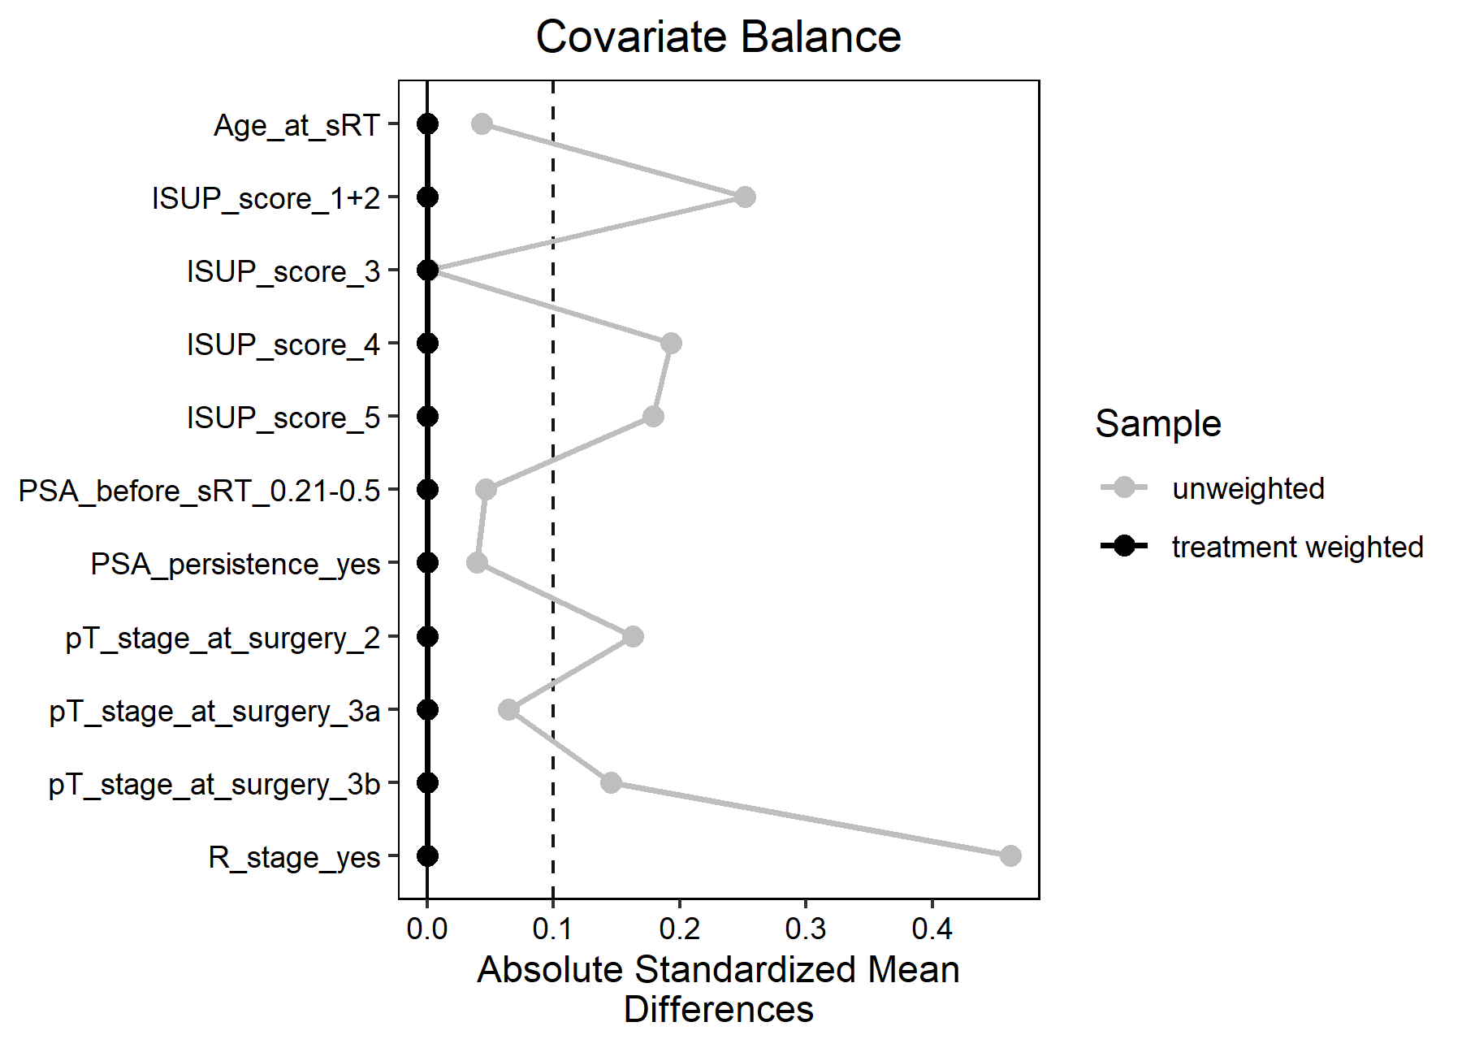
Covariate balance after entropy balancing score (black). The dashed line at 0.1 marks the threshold which is considered as unbalanced.

Graphical Abstract
