Valorizing constituents of cashew nut shell liquid towards the sustainable development of new drugs against Chagas disease

Laís Flávia Nunes Lemes^{1,2}, George E. Magoulas³, Andressa Souza de Oliveira⁷, Emile Barrias^{4,5}, Luciana de Camargo Nascente⁷, Renato Granado⁴, Sara Teixeira de Macedo Silva⁸, Nikolaos Assimomytis³, Wanderley de Souza^{,5}, Maria Laura Bolognesi*⁶, Luiz Antonio Soares Romeiro*^{1,7}, Theodora Calogeropoulou*³
(1) Tropical Medicine Center, Faculty of Medicine, University of Brasília, Campus Universitário Darcy Ribeiro, 70910-900, Brasília, DF, Brazil;
(2) Catholic University of Brasilia, QS 07, Lote 01, EPCT, Águas Claras, 71966-700, Brasília, DF, Brazil;
(3) Institute of Chemical Biology, National Hellenic Research Foundation, 48 Vassileos Constantinou Avenue, 11635 Athens, Greece.
(4) Laboratory of Metrology Applied to Life Sciences, National Institute of Metrology, Quality and Technology - Inmetro, Rua Santa Alexandrina, 416, Rio Comprido, 20261-232, Rio de Janeiro, Brazil .
(5) Instituto de Biofísica Carlos Chagas Filho, Universidade Federal do Rio de Janeiro, Avenida Carlos Chagas Filho s/n, Ilha do Fundão, 21941-900, Rio de Janeiro, Brazil;
(6) Department of Pharmacy and Biotechnology, Alma Mater Studiorum - University of Bologna, Via Belmeloro 6, 40126 Bologna, Italy.
(7) Department of Pharmacy, Faculty of Health Sciences, University of Brasília, Campus Universitário Darcy Ribeiro, 70910-900, Brasília, DF, Brazil.
(8) Centro Nacional de Biologia Estrutural e Bioimagem, Centro de Ciências da Saúde (CCS), Universidade Federal do Rio de Janeiro, Universidade Federal do Rio de Janeiro, Avenida Carlos Chagas Filho s/n, Ilha do Fundão, 21941-902 Rio de Janeiro, Brazil

ABSTRACT: Six new ether phospholipid analogues encompassing natural constituents from cashew nut shell liquid as the lipid portion were synthesized in an effort to valorize by-products of the cashew industry towards the generation of potent compounds against Chagas disease. Anacardic acids, cardanols, and cardols were used as the lipid portions, and choline as the polar head group. The compounds were evaluated for their in vitro antiparasitic activity against different developmental stages of Trypanosoma cruzi. Compounds 16 and 17 were found more to be the most potent against T. cruzi epimastigotes, trypomastigotes, and intracellular amastigotes exhibiting selectivity indices against the latter 32-fold and 7-fold higher than current drug benznidazole, respectively. Hence, four out of six analogues can be considered as hit-compounds towards the sustainable development of new treatments for Chagas disease, based on inexpensive agro-waste material.

KEYWORDS: cashew nut shell liquid, ether phospholipids, antiparasitic activity, Trypanosoma cruzi, ultrastructural studies

Chagas disease, a potentially life-threatening condition also known as American trypanosomiasis, is endemic mainly in countries of Latin America where the vast majority of the 6-7 million annual cases worldwide are encountered. It affects most people in rural areas due to poor sanitation and limited access to healthcare. During the last decades, the extensive mobility of the world’s population resulted in new cases in previously unaffected urban regions of the developed world., It is alarming that approximately 238,000 cases were reported in 2012 only in the United States.
This neglected tropical disease (NTD) is caused by the Trypanosoma cruzi protozoan parasites, and its clinical manifestation involves two stages. The acute phase is, in most cases, asymptomatic or with very few symptoms, and parasites are detected mainly in the blood. If untreated, 30-40 % of the patients with acute phase progress to the chronic phase, which develops a few weeks later, in which the parasite load is mainly detected in the heart and the digestive system. The most severe impact of the disease is chronic chagasic cardiomyopathy (CCC) which affects almost 30 % of the patients.
Currently, the only approved drugs available for the treatment of Chagas disease are nifurtimox and benznidazole. However, both drugs show limited efficacy against the chronic stage of the disease and they are accompanied by severe adverse reactions such as peripheral neuropathy, skin reactions or gastrointestinal disorders., As a consequence, a large number of patients are forced to discontinue their treatment. Hence, there is an urgent need for new, more efficacious drugs.⁻
On top of that, Chagas disease ranks among the most evident health inequalities in South America. Although living in the three largest economies (Argentina, Brazil, and Mexico), more than 90 % of patients do not have access to nifurtimox and benznidazole treatment, including T. cruzi–infected pregnant women at risk of vertical transmission and congenitally infected newborns. Thus, there is a clear need to create a sustainable and robust agenda for investigating new treatments.
With these concepts in mind, Bolognesi and Romeiro started a drug discovery project aimed to develop new molecules that could address the sustainability requirements of the NTD field., By embracing the emerging waste-to-pharma concepts, they explored the possibility of developing new bioactive compounds starting from cashew nutshell liquid (CNSL). CNSL is an inexpensive and a largely available waste of cashew industry that could be easily used as biomass reagent for chemical transformation and semisynthetic approaches. In addition, the long chain phenols contained in CNSL show interesting biological profiles, such as antioxidant, anticancer, anti-inflammatory, or antinociceptive activity. In particular, CNSL consists of anacardic acids (1) (60-65 %), cardanols (2) and cardols (3) (Figure 1). These phenolic derivatives bear a lipophilic pentadecyl chain in meta position with respect to the hydroxyl function, which may be saturated, or mono-, di- or tri-olefinic., Interestingly, the bis-unsaturated anacardic acid 1 (n = 2) isolated from leaves of Schinus terebinthifolius and its hydrogenated derivative 1 (n = 0) were shown to possess activity against trypomastigote forms of T. cruzi with IC₅₀ values of 8.3 and 9.0 μM, respectively. More recently, further CNSL derivatives were developed in an effort to treat neurodegenerative and metabolic diseases.
Ether phospholipids are a class of compounds with well-established chemotherapeutic activity against Trypanosomatids. A significant number of related compounds have been synthesized and tested, with the most prominent representative being miltefosine (Figure 1), which is the only oral treatment for visceral and cutaneous leishmaniasis. Intriguingly, miltefosine also exhibits in vitro and in vivo activity against T. cruzi. Aiming to exploit CNSL as a renewable, inexpensive starting material towards valuable bioactive compounds, we incorporated its phenolic constituents in the lipid portion of alkylphosphocholines. Thus, six new ether phospholipid derivatives were synthesized, and their antiparasitic activity was evaluated against T. cruzi in different developmental stages. The new derivatives can be categorized into two groups, namely group I, in which the phosphocholine head group is attached directly to a phenol substituted by a 15-carbon aliphatic chain, and group II in which a shorter octyl spacer is introduced between the substituted phenyl ring and the phosphocholine moiety (Figure 1).
Figure 1. Structures of CNSL constituents (1-3), miltefosine and general structures I and II of the synthesized compounds of the current manuscript.

- RESULTS AND DISCUSSION
Chemistry. The starting CNSL constituents (1-3) were obtained from the cashew nut shells. Thus, natural CNSL was extracted from cashew nut shells in a Soxhlet extraction system with EtOH (40 wt % based on the nut shells). The mixture of anacardic acids (1) was then separated from other phenolic components by precipitation as calcium anacardates mixture, upon treatment with calcium hydroxide followed by acidification and liquid-liquid extraction (80 wt % based on applied mass). The cardols mixture (3) was obtained from the natural or technical CNSL extracts by silica gel column chromatography (20 wt % based on applied mass). The cardanols mixture (2) was derived from commercially available distilled technical CNSL. The latter contains mainly cardanols (2) formed by the decarboxylation of anacardic acids (1) upon heating the cashew nuts at temperatures over 180 °C to obtain CNSL. The aliphatic alcohols 7-9 used in the synthesis of phospholipids 16-18 were synthesized from the CNSL constituents 1 – 3, as previously reported.
Thus, methylation of individual mixtures of anacardic acids (1), or cardanols (2) or cardols (3) using iodomethane in acetone and subsequent purification afforded the unsaturated methyl O-methylanacardates (4), or O-methylated cardanols (5) or cardol derivatives (6), which upon oxidative cleavage through ozonolysis followed by reduction of the secondary ozonide with sodium borohydride furnished the corresponding alcohols 7-9 (Scheme 1).
Scheme 1. Synthesis of alcohols 7-9. Reagents and conditions. (i) MeI, K₂CO₃, acetone, 25 °C, 24 h, 80-90 %. (ii) a) O₃/O₂, DCM/MeOH (1:1), - 70 °C, 60 min, b) NaBH₄, MeOH; rt, 18 h, 75-80 %.
Additionally, hydrogenation of the mixture of anacardic acids 1 in the presence of Pd/C gave 10 bearing the fully saturated pentadecyl chain in 70 % yield which upon acid-catalyzed esterification afforded the known methyl anacardate 11 (Scheme 2).^{12,} Furthermore, the commercially available saturated cardanol 12 was subjected to an ortho-specific Mg-mediated formylation reaction to yield 13 in 84 % yield (Scheme 2). Finally, compound 13 was transformed through a Pinnick-type oxidation reaction to the anacardic acid derivative 14, in 89 % yield, which upon Fischer esterification afforded methyl ester 15 in 90 % yield, as previously described.²⁴
Scheme 2. Synthesis of methyl anacardates 11 and 15. Reagents and conditions. (i) H₂, Pd/C (10 % w/w), EtOH, 25 °C, 6 h, 70 %; (ii) MeOH, H₂SO₄, 70 °C, 16 h, 80 %; (iii) MgBr₂, Et₃N, HO(CH₂O)_{n}H, THF, 80 °C, 8 h, 84 %; (iv) NaClO₂ (aq.), NaH₂PO₄ (aq.), DMSO, DCM, rt, 16 h, 89 %; (v) MeOH, H₂SO₄, 70 °C, 16 h, 90 %.
The synthesis of the new ether phospholipids 16-21 (Scheme 3) was realized using a procedure established by Calogeropoulou and coworkers,,, which involves a three-step protocol: a) phosphorylation of the aliphatic alcohols 7-9 or phenols 11 and 15 with POCl₃ in THF in the presence of Et₃N to furnish the corresponding phosphoric acids after hydrolysis; (b) transformation of the phosphoric acids to the corresponding pyridinium salts; and finally (c) reaction with choline p-toluenesulfonate in the presence of 1-(mesitylene-2-sulfonyl)-3-nitro-1H-1,2,4-triazole (MSNT) as condensing agent.
Scheme 3. Synthesis of ether phospholipids 16-21. Reagents and conditions. (i) a) POCl₃, Et₃N and THF, 0 °C, 15 min then H₂O, 15 min; b) pyridine, 45 °C, 2.5 h; c) pyridine, choline p-toluenesulfonate, MSNT, 0 °C then rt, 24 h.
Evaluation of in vitro antiparasitic activity.
In vitro antiparasitic activity against T. cruzi. The in vitro activity of compounds 16-21 was evaluated initially against T. cruzi (Y strain) epimastigotes at 24 h, 48 h, and 72 h (Table 1). The highest inhibition was observed after treatment for 72 h (Table 1). It is apparent that the compounds bearing the phosphocholine moiety attached to the aliphatic alcohol (16-18) are, in general, more active against this developmental parasite stage compared to compounds 19-21, where the head group is attached to a phenol. In particular, cardanol derivative 17, bearing no additional substituents (-CO₂Me or -OMe) on the phenyl ring exhibited the highest activity with an IC₅₀ value of 0.61 ± 0.08 μM at 72 h. Interestingly, 17 was ~25fold more potent than the reference drug benznidazole. The introduction of an electron-withdrawing substituent at C2 (as in anacardic acid derivative 16) resulted in some reduction in activity; however, 16 maintained its superiority over benznidazole, being ~5fold more potent. Conversely, the introduction of an electron donating group (OMe) at C5 (as in cardol derivative 18) resulted in further reduction in activity; however, compound 18 was still ~3fold more potent than benznidazole. Concerning compounds 19-21, only compound 20 showed interesting activity confirming the observation that the introduction of electron-withdrawing substituents on the aromatic ring is detrimental to the activity in group II compounds.
Table 1. In vitro evaluation of the antiparasitic activity against T. cruzi epimastigotes.
Compound |  | IC₅₀ª (μΜ) ± SD^{b}
Compound | 24 h | 48 h | 72 h
16 | 4.95 ± 0.0 | 4.72 ± 0.9 | 3.30 ± 0.1
17 | 3.30 ± 0.2 | 1.30 ± 0.3 | 0.61 ± 0.1
18 | 7.75 ± 0.3 | 6.8 ± 0.8 | 5.5 ± 0.1
19 | >50 | >50 | 39.7 ± 1.9
20 | 3.85 ± 0.9 | 2.89 ± 0.4 | 2.75 ± 0.6
21 | 25.5 ± 1.8 | 22.9 ± 1.1 | 21.4 ± 1.9
Benznidazole | 30.3 ± 1.2 | 23.1 ± 0.9 | 15.2 ± 1.4
ª IC₅₀: 50 % inhibitory concentration; ^{b} SD: standard deviation.
Subsequently, the most potent derivatives 16-18 and 20 were evaluated against two clinically relevant forms (intracellular amastigotes and infective trypomastigotes, Table 2). Gratifyingly, when tested against T. cruzi intracellular amastigotes cultured in HFF-1 cells, all compounds were more potent than the clinical standard benznidazole. They showed IC₅₀ values in the range of 0.17 to 1.9 μM while benznidazole, tested in parallel, possessed an IC₅₀ equal to 4.8±1.4 μM. To assess whether the potency of the new compounds was accompanied by a low cytotoxicity, derivatives 16-18 and 20 were evaluated in vitro in two human cell lines, namely in HepG2, to evaluate the risk of hepatotoxicity and in HFF-1, the host cell for the intracellular parasite (Table 2). All the tested compounds presented in vitro toxicity similar to benznidazole against both mammalian lines; however, their selectivity indices (SIs) were from 2- to 35fold higher than the control, with compound 16 exhibiting a remarkable SI of 208 (for HFF-1). In general compounds 16-18 and 20 were slightly more toxic against HepG2 than HFF-1 cells. In particular compounds 18 and 20 were the least toxic against HepG2 exhibiting IC₅₀ = 30.3 ± 1.8 and IC₅₀ = 29.5 ± 2.2 μM, respectively. Finally, the selected derivatives 16-18 and 20 were tested against T. cruzi trypomastigotes at various concentrations (1 µM, 3 µM, 5 µM, and 10 µM). In all cases, loss of viability was observed from the lowest concentration tested, while all the compounds (except 20 LD₅₀ >10 µM) present LD₅₀ values similar to benznidazole ranging between 4.2 – 8.7 μΜ (Table 2).
Table 2. In vitro evaluation of the antiparasitic activity against T. cruzi intracellular amastigotes, cytotoxicity against HFF-1 and HepG2 cells, selectivity indices and viability of T. cruzi trypomastigotes.
Compound | IC₅₀ª (μΜ) ± SD^{b}  amastigotes  (72 h) | CC₅₀^{c} (μΜ) ± SD  (72 h) |  | SI^{d} | SIe | LD₅₀^{f} (μΜ) ± SD  trypomastigotes  (24 h)
Compound | IC₅₀ª (μΜ) ± SD^{b}  amastigotes  (72 h) | HFF-1 | HepG2 | SI^{d} | SIe | LD₅₀^{f} (μΜ) ± SD  trypomastigotes  (24 h)
16 | 0.17±0.1 | 34.3±2.1 | 28.3±2.0 | 201.8 | 166.5 | 6.7±2.3
17 | 0.67 ±0.5 | 29.7±3.1 | 21.1±3.5 | 44.4 | 31.5 | 4.2±1.7
18 | 1.2±0.8 | 33.3±0.9 | 30.3±1.8 | 27.8 | 25.3 | 8.7±0.8
20 | 1.9±1.1 | 25.1±2.3 | 29.5±2.2 | 13.2 | 15.5 | >10
Benznidazole | 4.8±1.4 | 30.8±1.8 | 35.3±3.3 | 6.4 | 7.4 | 5.9±1.4
ª IC₅₀: 50 % inhibitory concentration; ^{b} SD: standard deviation; ^{c} CC₅₀: 50 % cytotoxic concentration; ^{d}SI: selectivity index, given by the ratio between CC₅₀ in HFF1 cells and IC₅₀ in intracellular amastigotes; ^{e}SI: selectivity index, given by the ratio between CC₅₀ in HepG2 cells and IC₅₀ in intracellular amastigotes; ^{f}LD₅₀: 50 % lethal concentration.
Effects on T. cruzi morphology and ultrastructure. Since compounds 16-18 and 20 showed promising activity against T. cruzi, we set out to assess their effect on the morphology of T. cruzi epimastigotes and trypomastigotes using scanning electron microscopy (SEM). Thus, T. cruzi epimastigotes were treated with the compounds for 48 h at concentrations equal to the respective IC₅₀ values, while T. cruzi trypomastigotes were treated for 24 h at concentrations equivalent to the LD₅₀ values (Figure 2). In particular, in epimastigotes, severe morphological changes were induced upon treatment with the compounds. The rounding of the cell body was noticed without a concomitant reduction in the size of the flagellum in about 80 % of the cases. In addition, the wrinkling of the plasma membrane (when compared to the control) and the presence of vesicles were noted, which could result from cell debris or exocytosed vesicles (Figure 2). Furthermore, in trypomastigotes, after 24 h of compound treatment, intense vesiculation adhered to the cell body could be observed, regardless of the compound used, accompanied by wrinkling of the plasma membrane (Figure S1).
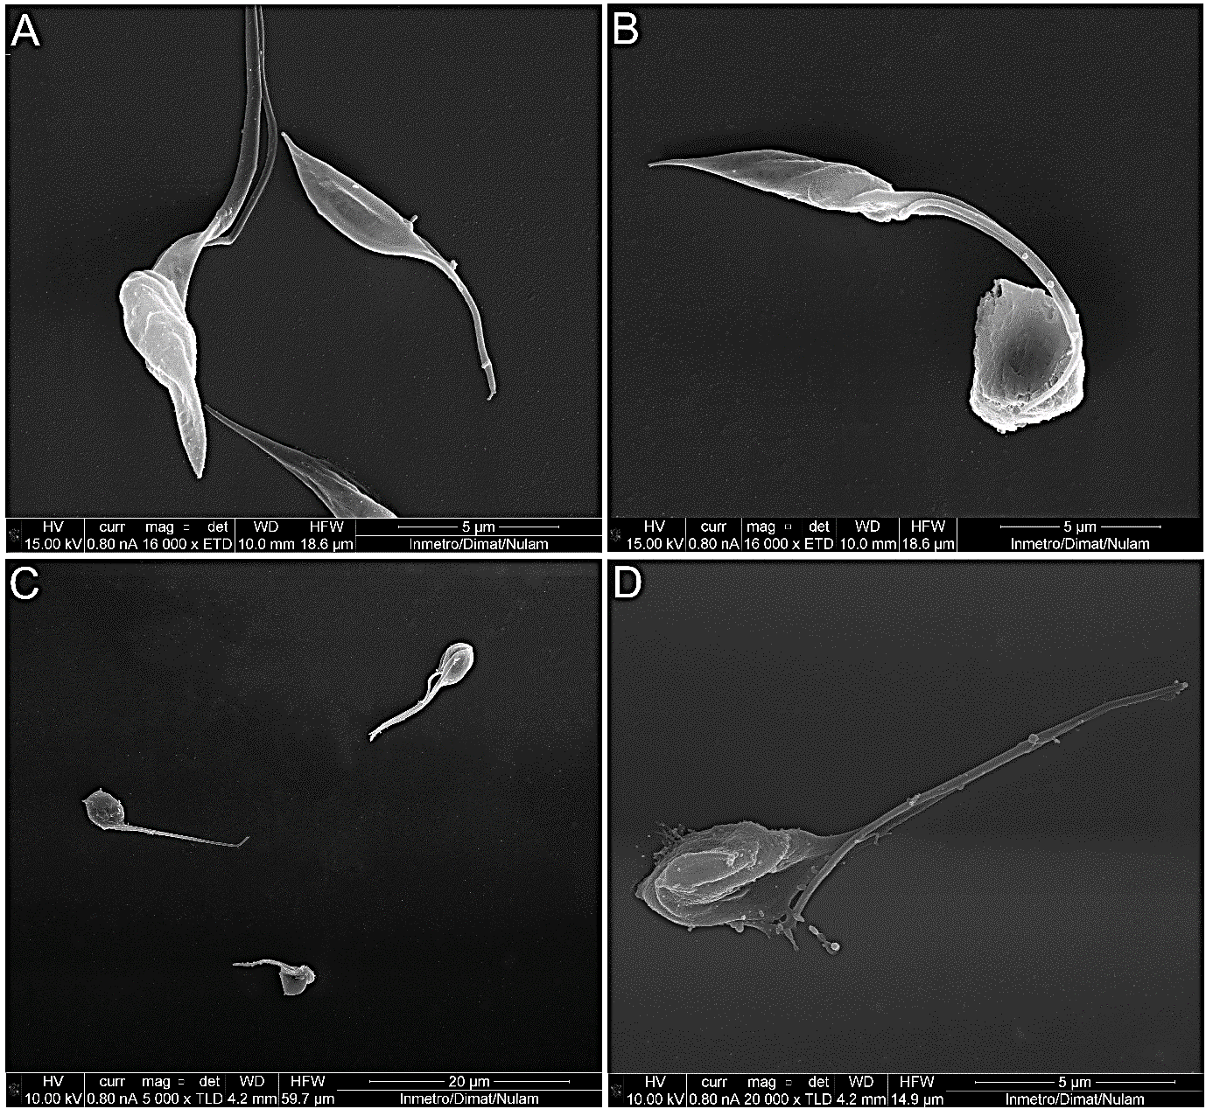
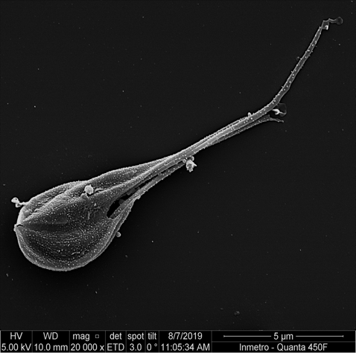
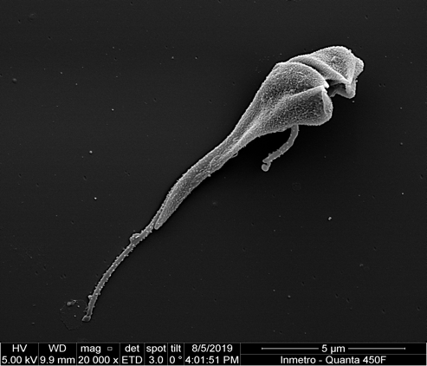
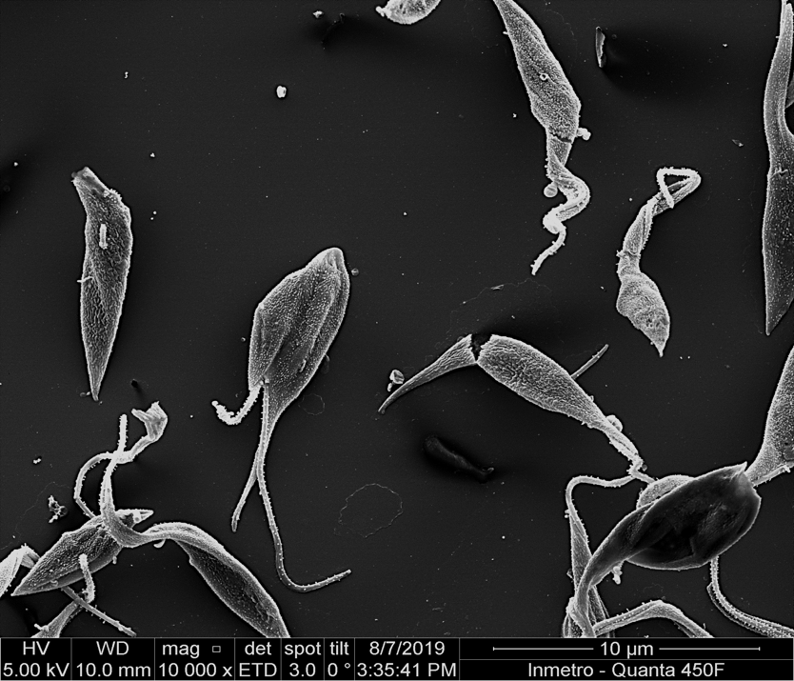
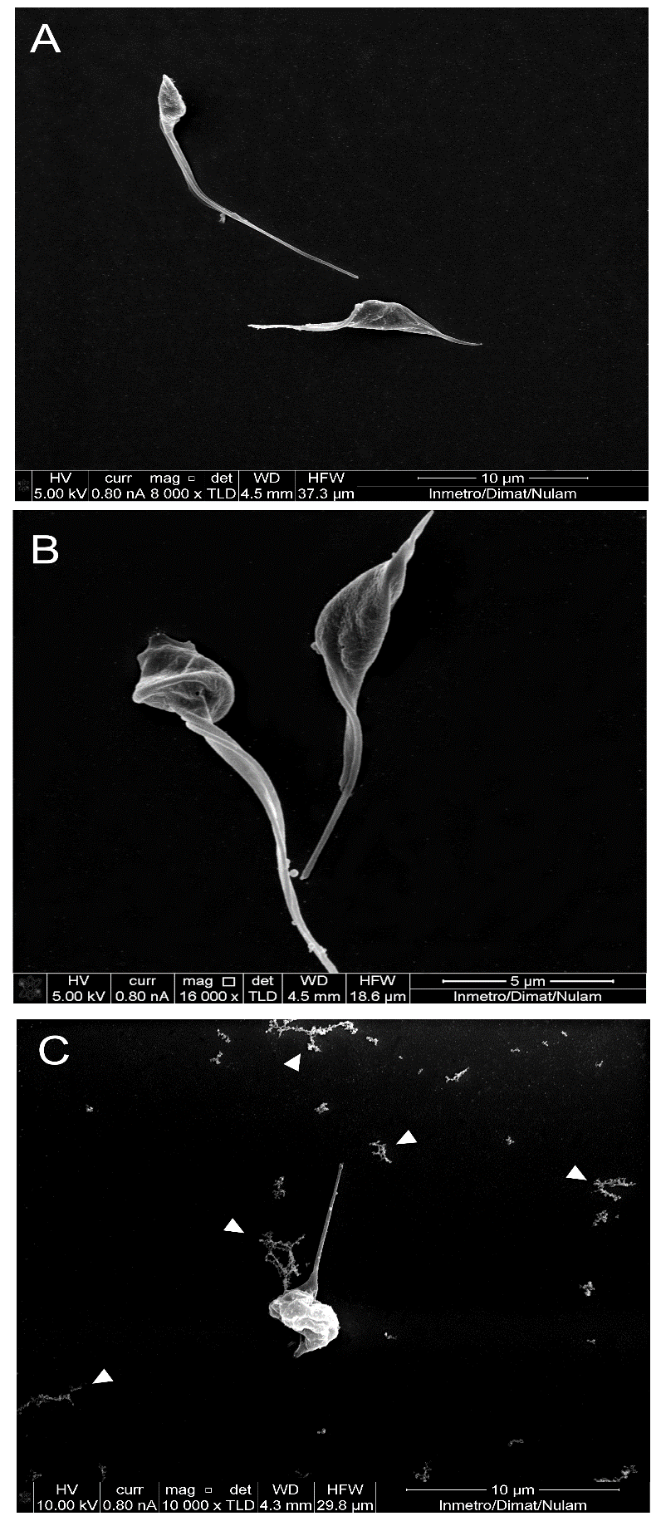
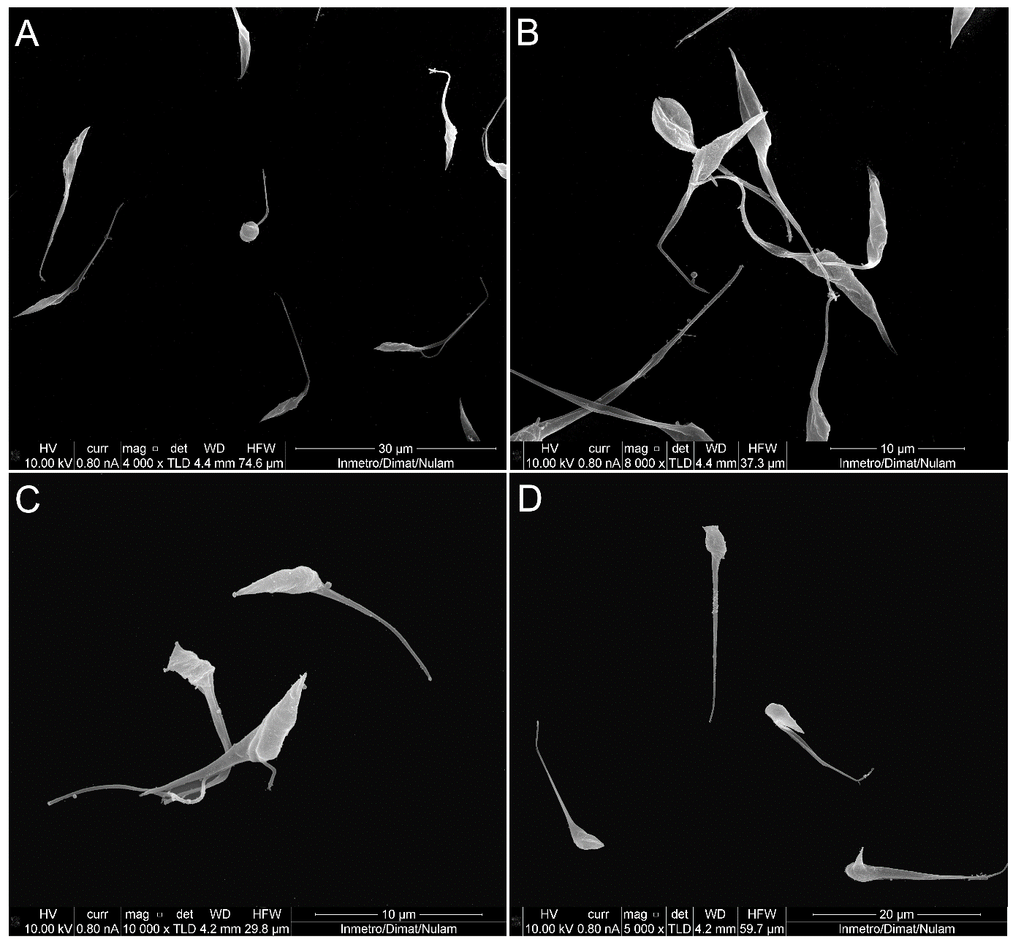
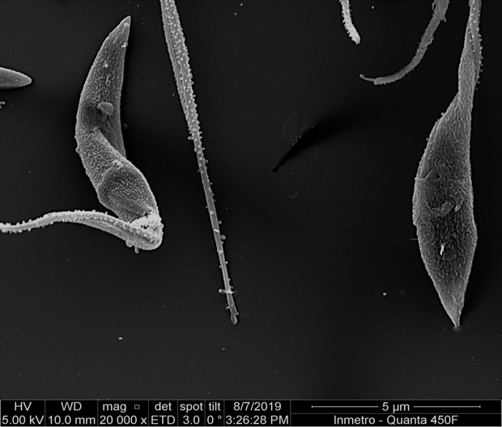
A
B
C
D
E
F
F’

Figure 2. Scanning electron microscopy of epimastigotes treated with IC₅₀ concentrations of 16-18 and 20 for 48 h. (A) untreated cells with an elongated cell body and a single tapered flagellum; (B) epimastigotes treated with 16 demonstrate change in cell body morphology, undivided rounded bodies and multiple flagella (arrow); (C) epimastigotes treated with 17 demonstrate multiple flagella (arrows); (D) epimastigotes treated with 18 show vesicles (arrowhead); (E): epimastigotes treated with 20 show rounded body (arrowhead); (F): epimastigotes treated with 20 demonstrate undivided cell body (F) and an intense vesiculation (inset F’). Bar = 1 µm.
Furthermore, transmission electron microscopy (TEM) was used to investigate the effects of 16-18 and 20 on the ultrastructure of T. cruzi epimastigotes after 48 h of treatment with IC₅₀ concentrations of the compounds. In particular, membrane profiles are evident inside organelles such as the kinetoplast (Figure 3G - arrow) and mitochondria (Figure 3F - arrow). Membrane detachments were observed in the flagellum membrane (Figure 3D – F-asterisks). Poor organization of the Golgi complex (Figure 3C - arrowhead and Figure 3E - arrowhead) can also be observed as well as the presence of autophagic vacuoles (Figure 3B - asterisk).
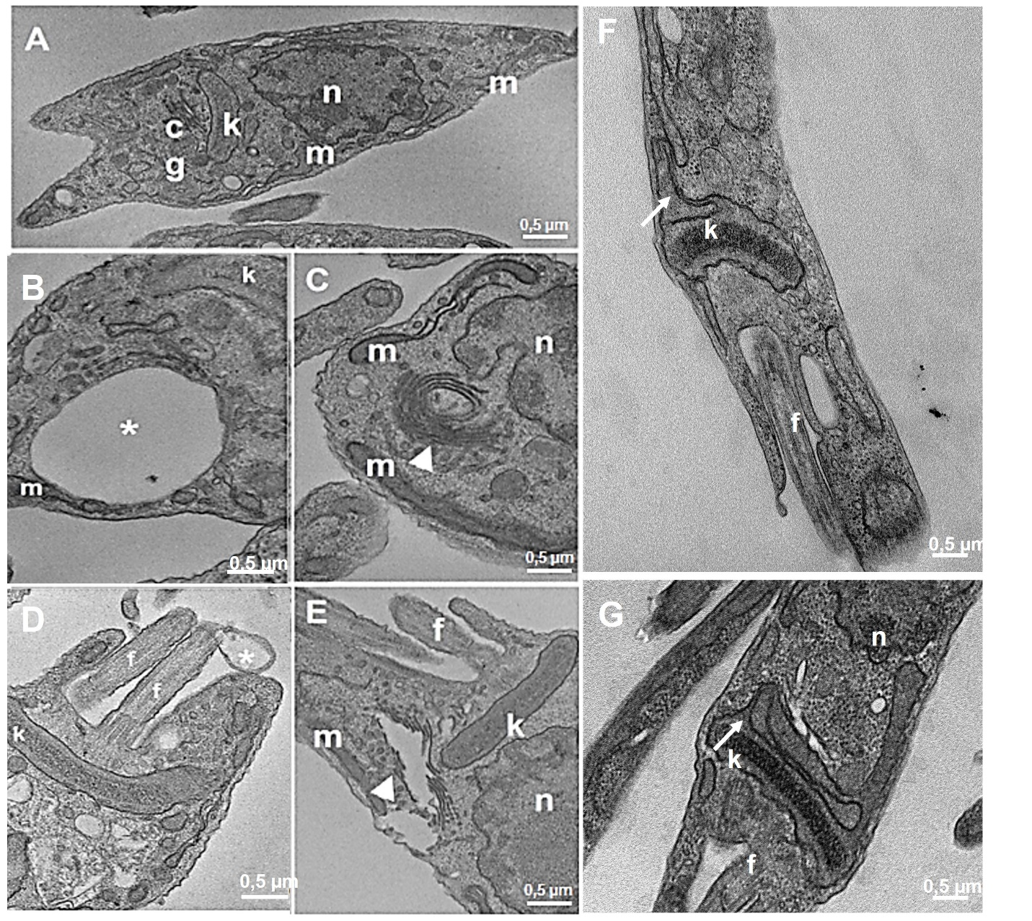
Figure 3. Transmission electron microscopy of treated epimastigotes 16-18 and 20 for 48 h. (A) untreated control has a single nucleus, containing the condensed heterochromatin near the nuclear envelope and around the nucleus, the bar-shaped kinetoplast near the flagellum, and a single mitochondrion; (B) epimastigotes treated with 16 showing vacuole similar to autophagic vacuole (asterisk); (C) epimastigotes treated with 17 demonstrate poor organization of the Golgi complex (arrowhead); (D) epimastigotes treated with 18 present flagellar membrane detachment (F-asterisks); (E) epimastigotes treated with 16 demonstrate poor organization of the Golgi complex (arrowhead); (F) epimastigotes treated with 20 show membrane and mitochondrial swelling profiles (arrow); (G) epimastigotes treated with 20 show membranes inside kinetoplast (arrow). N = nuclei; K = kinetoplast; CG = Golgi Complex; F = flagellum; V = vacuole; M = mitochondria; k = kinetoplast. Bars = 0.5 µm.

Finally, the ultrastructural changes in intracellular amastigotes after 24 h treatment with IC₅₀ concentrations of 16-18 and 20 were studied. All the compounds induced similar changes; some parasites appear without significant ultrastructural changes, while others in the same cell are almost totally destroyed (Figure S2). As observed in epimastigotes, the Golgi complex is also poorly organized (Figure S2 D – asterisk). Vacuoles similar to autophagic vacuoles were also observed inside the parasites (Figure S2 E – arrowhead). Another ultrastructural alteration commonly observed was the presence of parasites presenting multiple kinetoplasts with little compacted KDNA (characteristic of the kinetoplast of trypomastigotes). These observations are clear indications of cell cycle abnormalities. Notably, the host cells did not show any ultrastructural changes (Figure S2).
Production of Reactive Oxygen Species and analysis of mitochondrial membrane potential (ΔΨm). To gain insight into the mechanism of action of the most potent compounds, the production of reactive oxygen species (ROS) and the imbalance of the mitochondrial inner membrane potential (ΔΨ_{m}) were investigated. Thus, T. cruzi epimastigotes were incubated for 48 h with IC₅₀ concentrations of 16-18 and 20 or camptothecin (50 μM) (a topoisomerase I inhibitor that is well known to increase ROS production in T. cruzi epimastigotes). All four compounds were able to promote an increase in ROS levels by 18-24 % compared to the untreated control group (Figure 4A). These rates were slightly higher than those obtained in the presence of camptothecin (about 15 %). Furthermore, to determine membrane depolarization (ΔΨm), epimastigotes were treated with IC₅₀ concentrations of 16-18 and 20 for 48 h. As shown in Figure 4B, ΔΨm was altered following treatment with the four tested APLs, resulting in approximately 40 % drop over the untreated group. Throughout the analysis, the potential was very similar between the parasites treated with these compounds. The results above indicate that the production of ROS and mitochondrial inner membrane depolarization have significant contributions to the activity of the compounds against T. cruzi.
Figure 4: (A) Analysis of ROS production in epimastigotes treated with 16-18 and 20 for 48 hours. Compared to the control, an increase in ROS levels was observed in treated parasites, p < 0.001. (B) The mitochondrial membrane potential analysis shows the significant reduction of ΔΨm obtained in the treated parasites. Data are the average of three independent experiments run in triplicate.
Effects on cell cycle. Cell cycle progression was investigated by flow cytometry, considering the increase in the number of cells that exhibit division abnormalities in the SEM images upon treatment with 16-18 and 20 (Figure 5). Thus, treatment of epimastigotes with IC₅₀ concentrations of 16-18 and 20 for 72 h resulted in an increase by 30 % of the number of parasites in G2/M compared to the control group, which could be attributed to an arrest of the cell cycle at the G₂ checkpoint (Figure 5). In control cells, most epimastigotes were in the G1 phase, as expected.
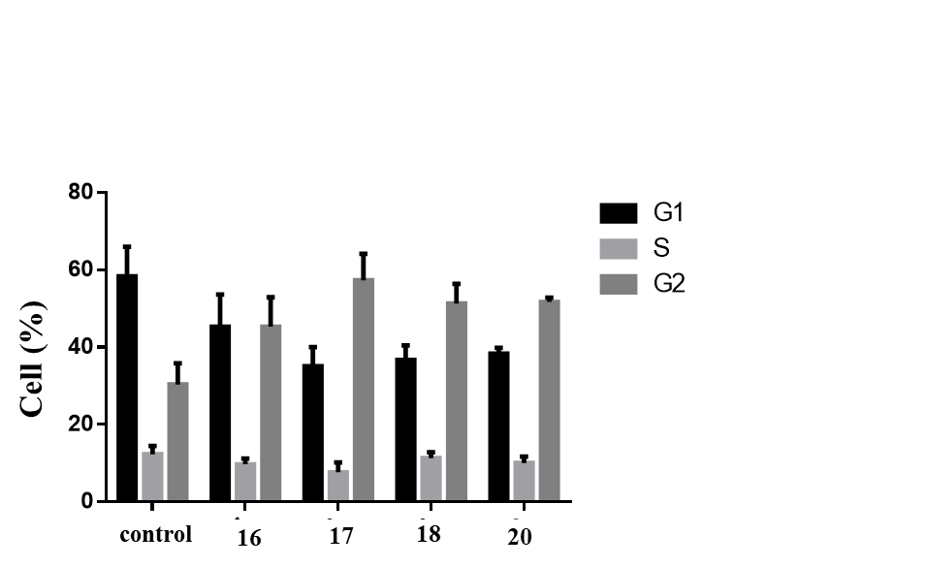
Figure 5: Cell cycle progression after treatment with 16-18 and 20. Control cells showed a typical pattern of DNA amount throughout the cell cycle: most parasites are in G1, generating a higher peak, followed by a sharp slope representing cells in S and, finally, a peak smaller than G1 representing the cells in G2. Two-way ANOVA and Bonferroni post-tests were performed considering p < 0.01.
Assessment of cell death by apoptosis. To assess whether the cell death caused by 16-18 treatment in T. cruzi is due to apoptosis, epimastigotes were treated with IC₅₀ concentrations of 16-18 for 48 h and then incubated with the Click-it Tunnel Alexa 488 kit (widely used in in situ assay for the detection of apoptosis). A 5fold increase of positive cells was observed comparing the treated epimastigotes with the untreated control, with derivative 17 inducing the highest increase in labeling (Figure 6).
Figure 6: Analysis of the process of cell death by apoptosis in epimastigotes treated with 16-18. (A) Percentage of epimastigotes labeled for apoptosis showing a significant increase in labeling in treated parasites. (B) Qualitative images of treated epimastigotes labeled with click-it Tunnel Alexa-488. Data are the mean of three independent experiments, each run in triplicate (p < 0.05).
Taken together, these results indicate that epimastigote treatment with compounds 16-18 and 20 interferes with their proliferation.
In silico analysis
In silico DMPK is one of the generic criteria of hit selection set by the Drugs for Neglected Diseases initiative (DNDi). Thus, compounds 16, 17, 19-21 were analyzed using the SwissADME and pkCSM tools. The values of the predicted parameters are presented in Tables S1 and S2 and Figure S3 in Supporting information. The calculated properties suggest that compound 17 has high solubility and good intestinal absorption, while 16 has moderate solubility and moderate intestinal absorption. The calculations showed limited passage through the BBB for all the compounds. Furthermore, all compounds were considered as probable substrates and inhibitors of P glycoprotein, but they did not show the characteristics of CYP enzyme inhibitors.

CONCLUSIONS
In conclusion, six new ether phospholipids 16-21 were synthesized using as starting materials anacardic acid, cardanol, or cardol derivatives isolated from cashew nut shell liquid (CNSL), a by-product of the cashew industry. These analogues were tested for their antiparasitic activity in vitro against different developmental stages of T. cruzi and were effective on the epimastigote, trypomastigotes, and amastigotes life stages. The structure-activity relationship studies revealed that the most potent compounds (16-18) bear a octyl oligomethylene spacer between the phosphocholine polar head group and the benzene ring in the lipid portion. Among the derivatives bearing a head group directly attached to a phenolic hydroxyl (compounds 19-21), the unsubstituted cardol derivative 20 showed interesting activity against T. cruzi epimastigotes and amastigotes. Moreover, compounds 16-18 and 20 showed better activity against T. cruzi epimastigotes compared to benznidazole, the drug used for the treatment of Chagas disease, the most potent being the cardol derivative 17 (IC₅₀ = 0.61 μM). More importantly, they exhibited low-micromolar activity against the clinically relevant, intracellular amastigote form of T. cruzi cultured in mammalian HFF-1 cells. Thanks to a higher antiparasitic activity, 16-18 and 20 showed selectivity indices higher than benznidazole. Notably, 16 shows a promising activity (IC₅₀ = 0.17 μM) and selectivity (SI = 201.8) profile, outperforming benznidazole both in terms of activity (IC₅₀ = 0.61 μM) and selectivity (SI = 6.4). Finally, compounds 16-18 were also active against T. cruzi trypomastigotes with LD₅₀ values <10 μΜ. Studies on the mechanism of action of the compounds indicated that the production of ROS and mitochondrial inner membrane depolarization have significant contributions to their activity against T. cruzi, in addition to interfering with the parasite proliferation. The Drugs for Neglected Diseases initiative (DNDi) has defined disease-specific “hit-criteria” for compounds for Chagas disease.³⁷ In particular, a compound is considered a hit when it can be obtained in less than 8 synthetic steps, exhibits an IC₅₀ value lower than 10 μM for intracellular amastigotes and has a selectivity index of at least 10.³⁷ Thus, compounds 16-18 and 20 can be considered hit compounds that merit further optimization studies for developing new more efficacious compounds against Chagas disease, with the view of exploiting and valorizing CSNL as a sustainable starting material.

- METHODS
General. All the commercially available reagents and solvents were used as purchased from Sigma–Aldrich®, PanReac®, and Tedia®. All solvents were dried according to standard procedures prior to use. The cardanol mixture was purchased from Resibras (Fortaleza, Brazil). The oxidative cleavages were performed using a Brasil Ozônio BrO₃-HA ozonizer, and the catalytic hydrogenations were performed using a Parr Shaker Hydrogenation Apparatus 3916. Reactions were monitored by analytical thin‐layer chromatography (TLC), plates (5.0 x 1.5 cm) silica gel (Kieselgel 60 F254) with a fluorescent indicator UV 254 nm. Developed plates were air‐dried and analyzed under a UV lamp (UV 254/365 nm). Spots were visualized with PMA stain. Chromatographic purification was performed with silica gel G60 (70-230 mesh and 230-400 mesh, SILICYCLE®) or Merck silica gel 60 (230–400 mesh). NMR spectra were recorded on Bruker Avance DRX500 or DRX300 or Varian NMR spectrometers. ¹H NMR spectra were recorded at 600 or 500, or 300 MHz, ¹³C NMR spectra at 150 or 125, or 75 MHz. ³¹P NMR were recorded at 121.44 MHz. Chemical shifts (δ) are reported in parts per million (ppm) relative to residual solvent peaks as internal reference, and coupling constants (J) are reported in hertz (Hz). ³¹P spectra are referenced to the instrument internal standard. Mass spectra were recorded on a HPLC-LCQ Fleet instrument of Thermo Scientific, by positive or negative electrospray ionization (ES⁺ or ES⁻). HRMS spectra were recorded in the APCI or ESI mode, on UPLC-MSn Orbitrap Velos-Thermo spectrometer of Thermo Sientific. Compound 12 was purchased from Sigma–Aldrich® with 90 % purity and it was recrystallized from hexane prior to use. Analysis of the purity of the final compounds was performed on a Thermo Scientific HPLC SPECTRA SYSTEM using a Thermo Scientific SPECTRASYSTEM UV2000 detector and an Atlantis® HILIC analytical column (3 μm; 100 mm × 4.6 mm) using the following HPLC analytical methods : Method A: elution system 80% CH₃CN/20 % ammonium formate aqueous solution 100 mM, isocratic, flow rate 1 mL/min, injection volume 20 μL, UV detection at 230 nm; Method B: elution system 85 % acetonitrile/15% ammonium formate aqueous solution 100 mM, isocratic, flow rate 1 mL/min, injection volume 20 μL, UV detection at 230 nm. The purity of all final compounds was >95 %.
General procedure for the synthesis of ether phospholipids 16-21. To an ice-cold solution of POCl₃ (1.6 equiv) in THF (0.2 M), a mixture of the appropriate alcohol or 8 or 9 or 11^{12,31} or 15²⁴ (1 equiv, 1 mmol) and Et₃N (1.8 equiv) in THF (0.15 M) was added dropwise. The reaction mixture was stirred at this temperature until the consumption of alcohol (checked by TLC). Then, water was added and stirring was continued for 30 min. The aqueous layer was extracted with EtOAc and then with CH₂Cl₂. The combined organic extracts were washed with brine and dried over Na₂SO₄ and the solvent was evaporated in vacuo to afford the corresponding phosphoric acid derivative, which was converted to its corresponding pyridinium salt upon addition of anhydrous pyridine and stirring for 2.5 h at 55 °C. After cooling to room temperature, the solvent was evaporated in vacuo and pyridine (5 mL) was added to the residue. To the resulting solution was added 1-(mesitylene-2-sulfonyl)-3-nitro-1H-1,2,4-triazole (MSNT) (1.8 equiv) followed by choline p-toluenesulfonate (1.4 equiv) portion wise over 15 min. The reaction mixture was stirred at rt for 24 h. Subsequently, the reaction was hydrolyzed by the addition of 2-propanol/H₂O (7:3) and the mixture was stirred for 0.5 h, the solvent was evaporated in vacuo and the residue was subjected to flash column chromatography (CH₂Cl₂/MeOH/NH₄OH 95:5:0.5 → 60:40:0.5) to afford the desired phospholipid derivative.
8-(3-methoxy-2(methoxycarbonyl)phenyl)octyl(2-(trimethylammonio)ethyl) phosphate (16). Compound 16 was prepared using alcohol 7 (0.08 g, 0.271 mmol), choline p-toluenesulfonate (0.105 g, 0.38 mmol) and MSNT (0.15 g, 0.49 mmol) according to the general method described above. White gummy solid, 0.048 g (40 % yield); ¹H NMR (600 MHz, CD₃OD): δ 7.30 (t, J = 8.0 Hz, 1H), 6.88 (d, J = 8.0 Hz, 1H), 6.84 (d, J = 8.0 Hz, 1H), 4.27-4.22 (m, 2H), 3.89-3.85 (m, 2H), 3.85 (s, 3H), 3.80 (s, 3H), 3.63-3.60 (m, 2H), 3.21 (s, 9H), 2.52 (t, J = 8.1 Hz, 2H), 1.66-1.60 (m, 2H), 1.59-1.53 (m, 2H), 1.42-1.30 (m, 8H); ¹³C NMR (75 MHz, CD₃OD): δ 170.8, 157.8, 142.2, 131.6, 124.8, 122.6, 109.7, 67.45 (m), 66.9 (d, J_{CP} = 5.9 Hz), 60.2 (d, J_{CP} = 5.0 Hz), 56.4, 54.75, 54.7, 54.6, 52.6, 34.4, 32.3, 31.9 (d, J_{CP} = 7.2 Hz), 30.42, 30.4, 30.3, 26.9; ³¹P NMR (121 MHz, CD₃OD): δ -0.06; MS (ESI) m/z: 460.24 [M+H]⁺, 482.22 [M+Na]⁺, 498.20 [M+K]⁺; ESI-HRMS (m/z): [M+Na]⁺ calcd. for C₂₂H₃₈O₇NPNa 482.2278; found 482.2277; HPLC: Method A, t_{R =} 6.96 min, purity = 97.64%.
8-(3-methoxyphenyl)octyl (2-trimethylammonio)ethyl phosphate (17). Compound 17 was prepared using alcohol 8 (0.095 g, 0.42 mmol), choline p-toluenesulfonate (0.16 g, 0.59 mmol) and MSNT (0.23 g, 0.76 mmol) according to the general method described above. White gummy solid, 0.023 g (15 % yield); ¹H NMR (600 MHz, CD₃OD): δ 7.15 (t, J = 7.5 Hz, 1H), 6.75-6.69 (m, 3H), 4.24 (brs, 2H), 3.87 (q, J = 6.3 Hz, 2H), 3.76 (s, 3H), 3.62 (brs, 2H), 3.21 (s, 9H), 2.56 (t, J = 7.5 Hz, 2H), 1.66-1.57 (m, 4H), 1.41-1.30 (m, 8H); ¹³C NMR (75 MHz, CD₃OD): δ 161.1, 145.6, 130.2, 121.8, 115.1, 112.0, 67.45 (m), 66.9 (d, J_{CP} = 5.9 Hz), 60.2 (d, J_{CP} = 5.0 Hz), 55.5, 54.75, 54.7, 54.6, 36.9, 32.6, 31.9 (d, J_{CP} = 7.2 Hz) , 30.6, 30.4, 30.3, 26.9; ³¹P NMR (121 MHz, CD₃OD): δ -0.03; MS (ESI) m/z: 402.24 [M+H]⁺, 424.22 [M+Na]⁺, 440.19 [M+K]⁺; ESI-HRMS (m/z): [M+Na]⁺ calcd. for C₂₀H₃₆O₅NPNa 424.2223; found 424.2220, [M+H]⁺ calcd. for C₂₀H₃₇O₅NP 402.2404; found 402.2402; HPLC: Method A, t_{R =} 6.68 min, purity = 98.3%.

8-(3,5-dimethoxyphenyl)octyl (2-(trimethylammonio)ethyl) phosphate (18). Compound 18 was prepared using alcohol 9 (0.1 g, 0.38 mmol), choline p-toluenesulfonate (0.15 g, 0.53 mmol) and MSNT (0.2 g, 0.68 mmol) according to the general method described above. White gummy solid, 0.064 g (39 % yield); ¹H NMR (600 MHz, CD₃OD): δ 6.29 (s, 2H), 6.24 (s, 1H), 4.24-4.19 (m, 2H), 3.83 (q, J = 6.6 Hz, 2H), 3.70 (s, 6H), 3.60-3.56 (m, 2H), 3.18 (s, 9H), 2.49 (t, J = 7.8 Hz, 2H), 1.63-1.52 (m, 4H), 1.38-1.26 (m, 8H); ¹³C NMR (150 MHz, CD₃OD): δ 162.2 (two C), 141.4, 107.5 (two C), 98.6, 67.5 (m), 66.9 (d, J_{CP} = 5.9 Hz), 60.2 (d, J_{CP} = 5.0 Hz), 55.6 (two C), 54.7, 54.69, 54.66, 37.2, 32.5, 31.8 (d, J_{CP} = 7.2 Hz), 30.6, 30.4, 30.3, 26.9; ³¹P NMR (121 MHz, CD₃OD): δ -0.07; APCI-HRMS (m/z): [M+H]⁺ calcd. for C₂₁H₃₉O₆NP 432.2510; found 432.2507; HPLC: Method A, t_{R =} 6.56 min, purity = 97.54%.

(2-methoxycarbonyl-3-pentadecyl)phenyl (2-(trimethylammonio)ethyl) phosphate (19). Compound 19 was prepared using phenol 11 (0.08 g, 0.22 mmol), choline p-toluenesulfonate (0.085 g, 0.31 mmol) and MSNT (0.119 g, 0.40 mmol) according to the general procedure described above. White gummy solid, 0.032 g (28 % yield); ¹H NMR (600 MHz, CD₃OD): δ 7.44 (d, J = 7.8 Hz, 1H), 7.30 (t, J = 7.8 Hz, 1H), 6.98 (d, J = 7.8 Hz, 1H), 4.36-4.27 (m, 2H), 3.90 (s, 3H), 3.64-3.50 (m, 2H), 3.14 (s, 9H), 2.56 (t, J = 7.8 Hz, 2H), 1.61-1.47 (m, 2H), 1.37-1.23 (m, 24H), 0.90 (t, J = 6.5 Hz, 3H); ¹³C NMR (75 MHz, CD₃OD): δ 168.1 (d, J_{CP} = 0.7 Hz), 154.2 (d, J_{CP} = 5.9 Hz), 151.4 (d, J_{CP} = 0.9 Hz), 132.8, 124.8, 122.9 (d, J_{CP} = 2.7 Hz), 121.3 (d, J_{CP} = 6.5 Hz), 68.0 (m), 61.7 (d, J_{CP} = 5.6 Hz), 55.3, 55.2, 55.16, 52.9 (d, J_{CP} = 1.9 Hz), 37.5, 33.6, 32.7, 31.4, 31.3, 31.27, 31.2, 31.0, 24.3, 15.0; ³¹P NMR (121 MHz, CD₃OD): δ -6.42; MS (ESI) m/z: 550.24 [M+Na]⁺; ESI-HRMS (m/z): [M+Na]⁺ calcd. for C₂₈H₅₀O₆NPNa 550.3268; found 550.3258; HPLC: Method B, t_{R =} 7.18 min, purity = 99.41%.
3-pentadecyphenyl (2-(trimethylammonio)ethyl phosphate (20). Compound 20 was prepared using phenol 12 (0.08 g, 0.267 mmol), choline p-toluenesulfonate (0.1 g, 0.37 mmol) and MSNT (0.14 g, 0.48 mmol) according to the general procedure described above. White gummy solid, 0.065 g (52 % yield); ¹H NMR (600 MHz, CD₃OD): δ 7.19 (t, J = 7.8 Hz, 1H), 7.08 (s, 1H), 7.04 (d, J = 7.8 Hz,1H), 6.91 (d, J = 7.8 Hz, 1H), 4.38-4.29 (m, 2H), 3.65 - 3.59 (m, 2H), 3.17 (s, 9H), 2.58 (t, J = 7.5 Hz, 2H), 1.66-1.54 (m, 2H), 1.39-1.24 (m, 24H), 0.90 (t, J = 7.2 Hz, 3H); ¹³C NMR (75 MHz, CD₃OD): δ 154.0 (d, J_{CP} = 6.8 Hz), 145.8, 130.1, 124.7, 121.1 (d, J_{CP} = 5.0 Hz), 118.4 (d, J_{CP} = 4.8 Hz), 67.3 (m), 60.9 (d, J_{CP} = 5.3 Hz), 54.7, 54.6, 54.5, 36.9, 33.4, 32.7, 30.8 (five C), 30.7 (three C), 30.6, 30.5, 23.8, 14.5; ³¹P NMR (121 MHz, CD₃OD): δ -5.64; MS (ESI) m/z: 470.40 [M+H]⁺, 492.25 [M+Na]⁺, 939.27 [2M+H]⁺, 961.41[2M+Na]⁺; ESI-HRMS (m/z): [M+Na]⁺ calcd. for C₂₆H₄₈O₄NPNa 492.3213; found 492.3200; HPLC: Method B, t_{R =} 7.13 min, purity = 96.87%.
(2-methoxycarbonyl-5-pentadecyl)phenyl (2-(trimethylammonio)ethyl) phosphate (21). Compound 21 was prepared using phenol 15 (0.06 g, 0.165 mmol), choline p-toluenesulfonate (0.063 g, 0.23 mmol) and MSNT (0.089 g, 0.30 mmol) according to the general procedure described above. White gummy solid, 0.042 g (48 % yield); ¹H NMR (600 MHz, CD₃OD): δ 7.73 (d, J = 8.0 Hz, 1H), 7.44 (s, 1H), 6.98 (d, J = 8.0 Hz, 2H), 4.54-4.43 (m, 2H), 3.85 (s, 3H), 3.76-3.70 (m, 2H), 3.25 (s, 9H), 2.64 (t, J = 7.7 Hz, 2H), 1.69-1.59 (m, 2H), 1.40 - 1.27 (m, 24H), 0.90 (t, J = 6.9 Hz, 3H); ¹³C NMR (75 MHz, CD₃OD): δ 167.5 (d, J_{CP} = 0.7 Hz), 153.6 (d, J_{CP} = 5.9 Hz), 150.8 (d, J_{CP} = 0.9 Hz), 132.2, 124.2, 122.3 (d, J_{CP} = 2.7 Hz), 120.8 (d, J_{CP} = 6.5 Hz), 67.5 (m), 61.1 (d, J_{CP} = 5.6 Hz), 54.7, 54.6, 54.5, 52.3 (d, J_{CP} = 1.9 Hz), 36.9, 33.1, 32.1, 30.8 (three C), 30.75 (four C), 30.7, 30.6, 30.5, 23.7, 14.5; ³¹P NMR (121 MHz, CD₃OD) δ: -6.02; MS (ESI) m/z: 550.28 [M+Na]⁺; ESI-HRMS (m/z): [M+Na]⁺ calcd. for C₂₈H₅₀O₆NPNa 550.3268; found 550.3258; HPLC: Method B, t_{R =} 6.55 min, purity = 98.03%.
Samples. The ether phospholipid derivatives tested 16-21 were solubilized in DMSO at 10 mM concentration and the stock solutions were stored at -20 °C.
Parasite strain and cell cultures. The Y strain of T. cruzi was used in three developmental stages (epimastigote, trypomastigote and intracellular amastigote) throughout this study. Epimastigote forms were cultivated in LIT (Liver Infusion Tryptose) medium supplemented with 10 % fetal bovine serum (Gibco). The trypomastigotes were derived from the supernatants of LLC-MK2 strain (ATCC, CCL-7). HEPG2 (ATCC HB8065) from human hepatocarcinoma and LLC-MK2 cells were grown in RPMI 1640 medium with penicillin (100U/mL), streptomycin (130 mg/L) and supplemented with 10 % fetal bovine serum (FBS) at 37 °C and an atmosphere of 5 % CO₂. The same protocol was used for the HFF-1 strain; however, it was grown in Dulbecco's Modified Eagle's Medium (DMEM Hight) with 4 mM L-glutamine and 4500 mg/L glucose.
Evaluation of the antiproliferative activity of compounds in the epimastigote stage of T. cruzi. The antiproliferative assay with epimastigote forms was performed using flow cytometer BD Accuri™ C6 Plus, with fluid rate in the “slow” option and volume of 20 µl. For the antiproliferative assay, epimastigote cell counts were performed with three independent experiments, run in triplicate, for all compounds. 3x10⁶ epimastigotes were distributed in 6-well plates in LIT medium supplemented with 10 % FBS. Twenty-four hours later, different concentrations of compounds were added namely: 0.1 µM, 1 µM, 3 µM, 5 µM, 10 µM, 30 µM and 50 µM for compounds 16-21 or benznidazole (control) and the epimastigotes were incubated in an oven at 28 °C for up to 72 h. Readings were performed daily. To determine the IC₅₀ values the results for the control and the different compound treatments were compared using the GraphPad Prism 7 program.
Evaluation of the viability of T. cruzi trypomastigote. To evaluate the viability of T. cruzi trypomastigotes for the determination of LD₅₀ (a dose capable of causing death in 50 % of the trypomastigote population), trypomastigotes were collected from infected LLC-MK2 culture for seven days (Y strain trypomastigote release phase). Cells were counted in a Neubauer chamber and 1x10⁷ cells were treated with 16-18 and 20 at 1 µM, 3 µM, 5 µM and 10 µM concentrations for 24 h. Then, the cells were incubated with propidium iodide (PI-Thermo Life Science), 1 mg/mL for 5 minutes, for later analysis in flow cytometry. As a positive control, trypomastigotes were incubated with 0.1 % saponin (Sigma Aldrich) in RPMI medium. The experiments were carried out in triplicate.
Antiproliferative effect in amastigote culture. Trypomastigotes were used to obtain intracellular amastigotes in HFF-1 culture (1:10). After differentiation to amastigotes developmental stage, compounds 16-18 and 20 or benznidazole were added at concentrations: 0.05 µM, 0.1 µM; 0.50 µM; 1.00 µM, 10.0 µM, 30.0 µM and 50 µM. The host cells and amastigotes were marked with Hoescht 33342 (1:5000) and analyzed by Leica 6000B optical microscope. Growth inhibition of intracellular amastigotes forms were determined by nucleus counting. The results were expressed as the number of amastigotes in host cells infected compared to untreated control.
Cytotoxicity assay in HFF-11 and HepG2 cells. The cytotoxicity effects of 16-18 and 20 against HepG2 or HFF-1 cells was evaluated by resazurin reduction assay (Thermo). For the assays, 1x10⁴ cells were plated in 96-well clear plates (TPP), adhered for 24 h, washed and treated with the compounds 16-18 and 20. The concentrations used were: 0.5 µM, 1 µM, 3 µM, 5 µM, 10 µM, 30 µM and 50 µM 72 h, containing a final volume of 200 µL in each well (stock compounds were diluted in culture medium for treatment). These concentrations were defined from the results obtained in tests carried out on lines previously. In addition, untreated cells (for control) and cells fixed with 4 % paraformaldehyde (for control of non-viable cells) were plated. After treatment with the compounds, the plates were incubated at 37 ºC and 5 % CO₂. At the determined times, 20 µL of resazurin were applied to each well and the plate was again incubated for another 4 h, under the same conditions as above for reagent action. Then, absorbance readings were taken at 570 nm and 600 nm. Each condition of the experiment was performed in triplicate, in three independent experiments.
Ultrastructural changes by Scanning Electron Microscopy (SEM). Control and treated epimastigotes (IC₅₀ concentrations of 16-18 and 20 for 48 h) and trypomastigotes (IC₅₀ concentrations of 16-18 and 20 for 24 h) were washed with PBS pH 7.2 and fixed with solution 2.5 % glutaraldehyde in 0.1 M sodium cacodylate buffer and 0.5 % sucrose. After fixation, samples were transferred to glass coverslips treated with Poly-L-lysine (0.1 mg/mL) to adhesion for 20 min. The samples were washed and then ﬁxed and post ﬁxed as described above. Afterwards, they were dehydrated in increasing concentrations of series of ethanol (30 %, 50 %, 70 %, 90 % and twice at 100 %) for 10 min each series. The sample were then dried in the critical point equipment (LEICA EM CPD030), and sputtered with 5-10 nm platinum layer (LEICA EM SCD 500) and observed under scanning electron microscope (FEI Quanta- operating at 5Kv).
Ultrastructural changes by Transmission Electron Microscopy (TEM). Control and treated epimastigotes (with IC₅₀ concentrations of 16-18 and 20 for 48 h) and HFF1 cells infected with amastigotes (with IC₅₀ concentrations of 16-18 and 20 for 24 h) were washed with PBS pH 7.2 and fixed with 2.5 % glutaraldehyde (Type 1-SEM) in 0.1 M sodium cacodylate buffer (Sigma Aldrich), pH 7.2 and nascent formaldehyde 4 % (EMS), pH 7.4. After fixation, the samples were washed three times with 0.1 M sodium cacodylate buffer, and post-fixed for 40 minutes in 1 % osmium tetroxide (EMS) and 1.25 % potassium ferrocyanide in the dark. The samples were dehydrated in increasing series of acetone (Merck). Finally, the samples were embedded in epoxy resin (Polybed 812) “trimmed”, cut in an ultramicrotome (Leica UC6), and these sections were contrasted for 40 minutes with 5 % uranyl acetate in distilled water and 5 minutes with lead citrate. After all the processing, the samples were observed in a transmission electron microscope FEI Spirit, operating at 80 KV.
Production of Reactive Oxygen Species: Εpimastigotes (1 × 10⁶ cells/mL) were incubated in LIT supplemented with 10 % FBS and after 24 h of growth they were treated with compounds 16-18 and 20 (IC₅₀ concentrations) for 48 h. As a control, the same cell number of epimastigotes was incubated, for the same time, with 50 μM of camptothecin. Approximately 2.5 × 10⁷ cells were incubated in 10 μg/mL H2DCFDA in PBS for 1 h at 28 °C. Oligomycin (10 μM) was used as a positive control for ROS production. ROS levels were analyzed with a SpectraMax M2/M2 spectrofluorometer (Molecular Devices, United States) using an excitation wavelength of 507 nm and an emission wavelength of 530 nm. Three independent experiments in triplicate were performed.
Analysis of mitochondrial membrane potential (ΔΨm): Epimastigotes treated with compounds 16-18 and 20 at IC₅₀ concentration for 48 h were suspended in reaction medium (125 mM sucrose, 65 mM KCl, 10 mM HEPES / K + (pH 7.2), 2 mM Pi, 1 mM MgCl₂ and 500 μM EGTA). Approximately 1 × 10⁷ cells were incubated in 10 μg/mL JC-1. As a positive control of ΔΨm depolarization, 1 μM FCCP (N-[4-(trifluoromethoxy)phenyl]carbonohydrazonoyl dicyanide) was used. Readings were taken every minute for a period of 30 min using a SpectraMax M2/M2 spectrofluorometer (Molecular Devices, United States), using an excitation wavelength of 507 nm and emission wavelengths of 530 and 590 nm. At the end of the reading period, 2 μM of FCCP was added to the treated and untreated cells to decrease the ΔΨm. Three independent experiments run in triplicate were performed.
Cell cycle analysis by flow cytometry: To analyze the T. cruzi cell cycle progression during treatment with 16-18 and 20, the parasites were fixed in 1 mL of 0.25 % formaldehyde in PBS for 5 min, then washed and resuspended in cold 70% ethanol for 30 minutes. min. Subsequently, the cells were washed and incubated with 5 µM of SYTOX® Green (Invitrogen, USA) for 30 min at room temperature. Analyses were performed using a BD Accuri C6 flow cytometer (Becton Dickinson Bioscience BDB, San Jose, CA, USA) and data were analyzed using the BD Accuri C6 software. This analysis was performed by two independent experiments.
Analysis of cell death by apoptosis: T. cruzi epimastigotes treated with IC₅₀ concentration of 16-18 and 20 for 48 h were taken to a process of death by apoptosis. Apoptosis was then deceted by using the Clickit Tunnel Alexa-488 kit for flow cytometry, according to the manufacturer's instructions (Thermo). Subsequently, the analyses were performed using a BD Accuri C6 flow cytometer (Becton Dickinson Bioscience BDB, San Jose, CA, USA) and the data were analyzed using the BD Accuri C6 software. This analysis was performed by two independent experiments. The same experiment was observed in a Zeiss axiobserver fluorescence microscope.
Statistical analyses. Statistical analyzes were performed using GraphPad Prism 7 software (GraphPad Software Inc., USA). Statistical signiﬁcance of differences among the groups was assessed using the analysis of variance test (ANOVA). Values of p ≤ 0.05 were considered significant. Mean and standard deviation were determined from three independently performed assays. IC₅₀, LD₅₀ and CC₅₀ were calculated using the same program.

- ASSOCIATED CONTENT
Supporting information
SEM of T. cruzi trypomastigotes treated with compounds 16-18. In silico ADME-Tox profiling. Experimental procedures and full characterization of the intermediates. Copies of ¹H, ¹³C, ³¹P NMR and HRMS spectra and HPLC chromatograms of all final compounds.

- AUTHORS INFORMATION
Corresponding Author
Maria Laura Bolognesi (MLB)– Department of Pharmacy and Biotechnology, Alma Mater Studiorum - University of Bologna, Via Belmeloro 6, 40126 Bologna, Italy; http://orcid.org/0000-0002-1289-5361; Email: marialaura.bolognesi@unibo.it*
Luiz Antonio Soares Romeiro (LASR) – Tropical Medicine Center and Department of Pharmacy, Faculties of Medicine and Health Sciences, University of Brasília, Campus Universitário Darcy Ribeiro, 70910-900, Brasília, DF, Brazil; https://orcid.org/0000-0001-5679-0820; Email: luizromeiro@unb.br*
Theodora Calogeropoulou (TC) – Institute of Chemical Biology, National Hellenic Research Foundation, 48 Vassileos Constantinou Avenue, 11635 Athens, Greece; https://orcid.org/0000-0002-3369-5393; Email: tcalog@eie.gr*

Authors
Laís Flávia Nunes Lemes (LFNL) – Tropical Medicine Center, Faculty of Medicine, University of Brasília, Campus Universitário Darcy Ribeiro, 70910-900, Brasília, DF, Brazil and Catholic University of Brasilia, QS 07, Lote 01, EPCT, Águas Claras, 71966-700, Brasília, DF, Brazil; https://orcid.org/0000-0002-2904-5291; Email: lais.lemes@p.ucb.br
George E. Magoulas (GEM) – Institute of Chemical Biology, National Hellenic Research Foundation, 48 Vassileos Constantinou Avenue, 11635 Athens, Greece; https://orcid.org/0000-0003-1884-0772; Email: gmagoulas@eie.gr.
Andressa Souza de Oliveira (ASO) – Department of Pharmacy, Faculty of Health Sciences, University of Brasília, Campus Universitário Darcy Ribeiro, 70910-900, Brasília, DF, Brazil; https://orcid.org/0000-0001-5508-1184; Email: Andressa901@gmail.com
Emile Barrias (EM) – Instituto Nacional de Ciência e Tecnologia em Biologia Estrutural e Bioimagens and Instituto de Biofísica Carlos Chagas Filho, Universidade Federal do Rio de Janeiro, Avenida Carlos Chagas Filho s/n, Ilha do Fundão, 21941-900 Rio de Janeiro, Brazil; orcid; https://orcid.org/0000-0002-6071-6946; Email:emilebarrias@gmail.com; esbarrias@inmetro.gov.br
Luciana de Camargo Nascente (LCN) – Department of Pharmacy, Faculty of Health Sciences, University of Brasília, Campus Universitário Darcy Ribeiro, 70910-900, Brasília, DF, Brazil; https://orcid.org/0000-0001-7288-1730; Email: lcnascente@gmail.com
Renato Granado (RG) – Instituto de Biofísica Carlos Chagas Filho, Universidade Federal do Rio de Janeiro, Avenida Carlos Chagas Filho s/n, Ilha do Fundão, 21941-900, Rio de Janeiro, Brazil; orcid; https://orcid.org/0000-0001-7702-3188; Email: renatogranado123@gmail.com
Sara Teixeira de Macedo Silva (STMS) – Centro Nacional de Biologia Estrutural e Bioimagem, Centro de Ciências da Saúde (CCS), Universidade Federal do Rio de Janeiro, Avenida Carlos Chagas Filho s/n, Ilha do Fundão, 21941-902 Rio de Janeiro, Brazil; orcid; https://orcid.org/0000-0002-3234-7688; Email:sara.cenabio@gmail.com;
Nikolaos Assimomytis (NA) – Institute of Chemical Biology, National Hellenic Research Foundation, 48 Vassileos Constantinou Avenue, 11635 Athens, Greece; orcid; https://orcid.org/0000-0003-3589-9995; Email: nasimomytis@uniwa.gr
Wanderley de Souza (WS) – Instituto Nacional de Ciência e Tecnologia em Biologia Estrutural e Bioimagens and Instituto de Biofísica Carlos Chagas Filho, Universidade Federal do Rio de Janeiro, Avenida Carlos Chagas Filho s/n, Ilha do Fundão, 21941-900 Rio de Janeiro, Brazil; https://orcid.org/ 0000-0002-1895-1299; Email: wsouza@biof.ufrj.br.

All authors have given approval to the final version of the manuscript.

Notes
The authors declare no competing financial interest.

- ACKNOWLEDGMENTS
GEM and TC acknowledge support of this work by the project “OPENSCREEN-GR: An Open-Access Research Infrastructure of Chemical Biology and Target-Based Screening Technologies for Human and Animal Health Agriculture and the Environment” “(2018–2020)” (MIS) 5002691 which is implemented under the Action “Reinforcement of the Research and Innovation Infrastructure”, funded by the Operational Programme “Competitiveness, Entrepreneurship and Innovation” (NSRF 2014-2020) and co-financed by Greece and the European Union (European Regional Development Fund). LASR and MLB gratefully acknowledge support from National Council of Technological and Scientific Development (CNPq #401864/2013-8 (PVE), #312709/2017-0 (DT-2), and #308486/2020-0 (DT-2)). WS, EM, RG and STMS acknowledge Faperj, CNPq, and Finep to support this work. Dr. Theano Fotopoulou (NHRF) is greatly acknowledged for her assistance with HPLC analyses.

- REFERENCES

() Lidani, K.C.F., Andrade, F.A., Bavia, L., Damasceno, F.S., Beltrame, M.H., Messias-Reason, I.J., Sandri, T.L. (2019) Chagas Disease: From Discovery to a Worldwide Health Problem. Front Public Health. 7, Article 166. https://doi.org/10.3389/fpubh.2019.00166.
() Bern, C., Messenger, L.A., Whitman, J.D., Maguire, J.H. (2020) Chagas Disease in the United States: a Public Health Approach. Clin Microbiol. Rev. 33, e00023-19. https://doi.org/10.1128/CMR.00023-19
() Manne-Goehler, J., Umeh, C.A., Montgomery, S.P., Wirtz, V.J. (2016) Estimating the Burden of Chagas Disease in the United States. PLoS Negl Trop Dis. 10 (11), Article e0005033. https://doi.org/10.1371/journal.pntd.0005033
() Pérez-Molina, J.A., Molina, I. (2018) Chagas disease. The Lancet 391, 82–94. https://doi.org/10.1016/S0140-6736(17)31612-4
() Marin-Neto, J.A, Simões, M.V., Sarabanda Á.V.L. (1999) Chagas’ heart disease. Arq. Bras. Cardiol. 72, 247–263. https://doi.org/10.1590/S0066-782X1999000300001
() Martín-Escolano, J., Marín, C., Rosales, M.J., Tsaousis, A.D., Medina-Carmona, E., Martín-Escolano, R. (2022) An Updated View of the Trypanosoma cruzi Life Cycle: Intervention Points for an Effective Treatment. ACS Infect. Dis. 8, 1107–1115. https://doi.org/10.1021/acsinfecdis.2c00123
() Crespillo-Andújar, C., Venanzi-Rullo, E., López-Vélez, R., Monge-Maillo, B., Norman, F., López-Polín, A., Pérez-Molina, J.A. (2018) Safety Profile of Benznidazole in the Treatment of Chronic Chagas Disease: Experience of a Referral Centre and Systematic Literature Review with Meta-Analysis. Drug Saf. 13, 1–14. https://doi.org/10.1007/s40264-018-0696-5
() Bhattacharya, A., Corbeil, A., do Monte-Neto, R.L., Fernandez-Prada, C. (2020) Of Drugs and Trypanosomatids: New Tools and Knowledge to Reduce Bottlenecks in Drug Discovery. Genes 11, 722. https://doi.org/10.3390/genes11070722
() Villalta, F., Rachakonda, G. (2019) Advances in preclinical approaches to Chagas disease drug discovery. Expert Opin. Drug Discovery 14, 1161−1174. https://doi.org/10.1080/17460441.2019.1652593
() Martín-Escolano, J., Medina-Carmona, E., Martín-Escolano, R. (2020) Chagas Disease: Current View of an Ancient and Global Chemotherapy Challenge. ACS Infect. Dis. 6, 2830-2843. https://doi.org/10.1021/acsinfecdis.0c00353
() Pinheiro, E., Brum-Soares, L., Reis, R., Cubides, J.-C. (2017). Chagas disease: review of needs, neglect, and obstacles to treatment access in Latin America. Rev. Soc. Bras. Med. Trop. 50(3). https://doi.org/10.1590/0037-8682-0433-2016
() Cerone, M., Uliassi, E., Prati, F., Ebiloma, G.U., Lemgruber, L., Bergamini, C., Watson, D.G., de A.M.Ferreira, T., Roth Cardoso, G.S.H., Soares Romeiro, L.A., de Koning, H.P., Bolognesi, M.L. (2019). Discovery of Sustainable Drugs for Neglected Tropical Diseases: Cashew Nut Shell Liquid (CNSL)-Based Hybrids Target Mitochondrial Function and ATP Production in Trypanosoma brucei. ChemMedChem, 14, 621-635. https://doi.org/10.1002/cmdc.201800790
() Bolognesi,, M.L. (2019) Sustainable anti-trypanosomatid drugs: An aspirational goal for medicinal chemistry. Ann. Rep. Med. Chem. 52, 153-176. https://doi.org/10.1016/bs.armc.2019.05.003
() Espro, C., Paone, E., Mauriello, F., Gotti, R., Uliassi, E., Bolognesi, M.L., Rodríguez-Padrón, D., Luque, R. (2021) Sustainable production of pharmaceutical, nutraceutical and bioactive compounds from biomass and waste. Chem Soc. Rev. 50, 11191-11207. https://doi.org/10.1039/D1CS00524C
() Fox K.; Luque R.; Soares Romeiro L.A.; Bolognesi M.L. (2021) New Biomass Reagents for the Synthesis of Bioactive Compounds. Topics in Medicinal Chemistry 38, 373-389. https://doi.org/10.1007/7355_2021_118
() Kubo, I., Masuoka, N., Ha, T.J., Tsujimoto, K. (2006) Antioxidant activity of anacardic acids. Food Chem. 99, 555-562. https://doi.org/10.1016/j.foodchem.2005.08.023
() Xiu, Y.L., Zhao, Y., Gou, W.F., Chen, S., Takano, Y., Zheng, H.C. (2014) Anacardic acid enhances the proliferation of human ovarian cancer cells. PLoS ONE 9, Article e99361. https://doi.org/10.1371/journal.pone.0099361
() Gomes Júnior, A.L., Islam, M.T., Nicolau, L.A.D. Miranda de Souza, L.K., de Souza Lopes Araújo, T., Lopes de Oliveira, G.A., de Melo Nogueira, K., da Silva Lopes, L., Medeiros, J-V.R. Mubarak, M.S., de Carvalho Melo-Cavalcante, A.A. (2020) Anti-Inflammatory, Antinociceptive, and Antioxidant Properties of Anacardic Acid in Experimental Models. ACS Omega 5, 19506–19515. https://doi.org/10.1021/acsomega.0c01775
() Nagabhushana, K.S., Ravindranath, B. (1995) Efficient medium-scale chromatographic group separation of anacardic acids from solvent-extracted cashew nut (Anacardium-occidentale) shell liquid. J. Agric. Food Chem. 43, 2381-2383. https://doi.org/10.1021/jf00057a012
() Trevisan, M.T.S., Pfundstein, B., Haubner, R., Würtele, G., Spiegelhalder, B., Bartsch, H., Owen, R.W. (2006) Characterization of alkyl phenols in cashew (Anacardium occidentale) products and assay of their antioxidant capacity. Food Chem. Toxicol. 44, 188-197. https://doi.org/10.1016/j.fct.2005.06.012
() Mubofu, E.B., Mgaya, J.E. (2018) Chemical Valorization of Cashew Nut Shell Waste. Top. Curr. Chem. 376, 1-15. https://doi.org/10.1007/s41061-017-0177-9
() Umehara,E., Costa Silva, T.A., Mendes,V.M., Guadagnin, R.C., Sartorelli, P., Tempone, A. GLago, J. H. G. (2020) Differential lethal action of C17:2 and C17:0 anacardic acid derivatives in Trypanosoma cruzi – A mechanistic study, Bioorg. Chem. 102, 104068. https://doi.org//10.1016/j.bioorg.2020.104068.
() Uliassi;E., Souza de Oliveira. A., de Camargo Nascente, L., Soares Romeiro, L.A., Bolognesi, M.L. (2021) Cashew nut shell liquid (Cnsl) as a source of drugs for Alzheimer’s disease. Molecules 26, 5441. https://doi.org/10.3390/molecules26185441
() Sahin, C., Magomedova, L., Ferreira, T.A.M., Liu, J., Tiefenbach, J., Alves, P.S., Queiroz, F.J.G., de Oliveira, A.S., Bhattacharyya, M., Grouleff, J., Nogueira, P.C.N., Silveira, E.R., Moreira, D.C., de Almeida Leite, J.R.S., Brand, G.D., Uehling, D., Poda, G., Krause, H., Cummins, C.L., Luiz A. S. Romeiro, L.A.S. (2022) Phenolic Lipids Derived from Cashew Nut Shell Liquid to Treat Metabolic Diseases. J. Med. Chem. 65, 1961-1978. https://doi.org/10.1021/acs.jmedchem.1c01542
() Chazapi, E. Magoulas, G.E., Prousis, K.C., Calogeropoulou, T. (2021) Phospholipid Analogues as Chemotherapeutic Agents Against Trypanosomatids. Curr. Pharm. Des. 27, 1790-1806. 10.2174/1381612826666201210115340
() Gulin, J.E.N., Bisio, M.M.C., Rocco, D., Altcheh, J., Solana, M.E., García-Bournissen, F. (2022) Miltefosine and benznidazole combination improve anti-Trypanosoma cruzi in vitro and in vivo efficacy. Front Cell Infect Microbiol. 12, 855119. https://doi.org/10.3389/fcimb.2022.855119
() Dendena, B., Corsi, S. (2014) Cashew, from seed to market: a review. Agron. Sustain. Dev. 34, 753–772. https://doi.org/10.1007/s13593-014-0240-7
() Rossi, M., Freschi, M., de Camargo Nascente,L., Salerno, A., de Melo Viana Teixeira, S., Nachon, F., Chantegreil, F., Soukup, O., Prchal, L., Malaguti, M., Bergamini, C., Bartolini, M., Angeloni, C., Hrelia, S., Soares Romeiro, L. A., Bolognesi, M. L. (2021) Sustainable Drug Discovery of Multi-Target-Directed Ligands for Alzheimer’s Disease. J. Med. Chem. 64, 4972-4990. https://doi.org/10.1021/acs.jmedchem.1c00048
() Soares Romeiro, L.A., da Costa Nunes, J.L., de Oliveira Miranda, C., Cardoso, G.S.H.R., de Oliveira, A.S., Gandini, A., Kobrlova, T., Soukup, O., Rossi, M., Senger, J., Jung, M., Gervasoni, S., Vistoli, G., Petralla, S., Massenzio, F., Monti, B., Bolognesi, M.L. (2019) Novel Sustainable-by-Design HDAC Inhibitors for the Treatment of Alzheimer’s Disease. ACS Med. Chem. Lett. 10, 671-676. https://doi.org/10.1021/acsmedchemlett.9b00071
() Swamy, M.M.M., Murai, Y., Ohno, Y., Jojima, K., Kihara, A., Mitsutake, S., Igarashi,Y., Yu, J. Yao, M., Suga, S., Anetai, M., Monde, K. (2018) Structure-inspired design of a sphingolipid mimic sphingosine-1-phosphate receptor agonist from a naturally occurring sphingomyelin synthase inhibitor. Chem. Commun. 54, 12758-12761. https://doi.org/10.1039/C8CC05595E
() Krishnamoorthy Lalitha, K., Siva Prasad,Y., Uma Maheswari,C., Vellaisamy Sridharan, V., John, G., Nagarajan, S. (2015) Stimuli responsive hydrogels derived from a renewable resource: synthesis, self-assembly in water and application in drug delivery. J. Mater. Chem. B, 3, 5560-5568. https://doi.org/10.1039/C5TB00864F
() Avlonitis, N., Lekka, E., Detsi, A., Koufaki, M., Calogeropoulou, T., Scoulica, E., Siapi, E., Kyrikou, I., Mavromoustakos, T., Tsotinis, A., Golic Grdadolnik, S., Makriyannis, A. (2003) Antileishmanial Ring-Substituted Ether Phospholipids. J. Med. Chem. 46, 755-67. https://doi.org/10.1021/jm020972c
() Calogeropoulou, T., Angelou, P., Detsi, A., Fragiadaki, I., Scoulica, E. (2008) Design and synthesis of potent antileishmanial cycloalkylidene-substituted ether phospholipid derivatives. J. Med. Chem. 51, 897-908. https://doi.org/10.1021/jm701166b
() Magoulas, G.E., Afroudakis, P., Georgikopoulou, K., Roussaki, M., Borsari, C., Fotopoulou, T., Santarem, N., Barrias, E., Tejera Nevado, P., Hachenberg, J., Bifeld, E., Ellinger, B., Kuzikov, M., Fragiadaki, I., Scoulica, E., Clos, J., Gul, S., Costi, M.P., de Souza, W., Prousis, K.C., Cordeiro da Silva, A., Calogeropoulou, T. (2021) Design, Synthesis and Antiparasitic Evaluation of Click Phospholipids. Molecules, 26, 4204. https://doi.org/10.3390/molecules26144204
() Papanastasiou, I., Prousis, K.C., Georgikopoulou, K., Pavlidis, T., Scoulica, E., Kolocouris, N., Calogeropoulou, T. (2010). Design and synthesis of new adamantyl-substituted antileishmanial ether phospholipids. Bioorg. Med. Chem. Lett. 20, 5484–5487. https://doi.org/10.1016/j.bmcl.2010.07.078
() Zuma A.A., Mendes I.C., Reignault L.C., Elias M.C., de Souza W., Machado C.R., Motta M.C. (2014) How Trypanosoma cruzi handles cell cycle arrest promoted by camptothecin, a topoisomerase I inhibitor. Mol Biochem Parasitol. 193, 93-100. https://doi:10.1016/j.molbiopara.2014.02.001.
() Katsuno, K., Burrows, J. N., Duncan, K., van Huijsduijnen, R.H., Kaneko, T., Kita, K., Mowbray, C. E., Schmatz, D., Warner, P., Slingsby, B. T. (2015) Hit and lead criteria in drug discovery for infectious diseases of the developing world. Nat. Rev. Drug Discovery 14, 751-758. https://doi.org/10.1038/nrd4683
() Reynolds, E.S. (1963) The use of lead citrate at high pH as an electron-opaque stain in electron microscopy. J Cell Biol. 17, 208-212. https://doi:10.1083/jcb.17.1.208. For Table of Contents Use Only

