Supplementary Material
Tuning the properties and thermal treatment of Aquivion®/oxide hybrid catalysts for the one-pot production of γ-valerolactone from furfuryl alcohol
Michele Offidaniª, Alessandro Allegri*ª, Anna Saottaª, Francesca Liuzziª, Alice S. Cattaneo^{b}, Claudio Oldani^{b}, Andrea Brigliadori^{c}, Simona Ortelli^{c}, Giuseppe Fornasariª, Stefania Albonetti*ª, Nikolaos Dimitratos*ª
ª Department of Industrial Chemistry, C3-Centre for Chemical Catalysis, CIRI-FRAME, Alma Mater Studiorum – University of Bologna, Via Piero Gobetti 85, 40129, Bologna (Italy)
E-mail: nikolaos.dimitratos@unibo.it, stefania.albonetti@unibo.it, alessandro.allegri2@unibo.it
^{b} Syensqo R&D Centre, Viale Lombardia 20, 20021 Bollate (Italy)
^{c} CNR-ISSMC, Institute of Science, Technology and Sustainability for Ceramics, National Research Council of Italy, Via Granarolo, 64, 48018 Faenza (Italy)

Abbreviations
AnL: Angelica Lactones;
BAS: Brønsted Acid Sites;
CTH: Catalytic Transfer Hydrogenation;
FAL: Furfuryl Alcohol;
FPE: Furfuryl Isopropyl Ether;
FU: Furfural;
GVL: Gamma-Valerolactone;
IPL: Isopropyl Levulinate;
LAS: Lewis Acid Sites;
SFD: Spray Freeze-Drying;
SSA: Specific Surface Area;

Experimental Procedures

ZrO₂ synthesis
While the silica and titania-based composites were prepared using a widely utilized and commercially available oxides, the zirconia were synthesized in-house. Firstly, a zirconium oxynitrate (ZrO(NO₃)₂ • 2H₂O) solution was prepared by dissolving 24.27g of solid in 325g of warm water. Afterward, a 5M ammonia solution was prepared by diluting the concentrated solution. The Zr-containing solution was then added dropwise to the ammonia solution to keep the pH at a more constant level (≈9–10). The suspension was then heated to 100°C and refluxed for 48 hours, while maintaining the pH constant through a continuous addition of concentrating ammonia. After the digestion, the solid was recovered through filtration, washed with 1.5M ammonia solution and dried at 100°C overnight. The calcination step was then studied, by calcining the dried material at different temperatures in the 450-600 °C range, and then recording the XRD pattern of each sample (Figure S1). The XRD patterns show an amorphous structure up to 500 °C, characterized by two very broad diffraction peaks, one in the 20-37 °2θ and one in the 40-70 °2θ. On the contrary, samples calcined at 550 °C and 600 °C display a well-formed and clearly defined crystalline structure, with each peak clearly corresponding with one of those of tetragonal zirconia. The BET areas reported in Figure S2 confirm this behaviour, showing a sharp decrease between the uncalcined zirconium hydroxide sample and the zirconia sample calcined at 450 °C, then once again between 500 °C and 550 °C.

Figure S1. XRD patterns of the synthesized zirconia calcined at different temperatures. “CSXXX” stands for “Calcined in Static air at XXX °C”. In green, the reference pattern of tetragonal zirconia from PDF 50-1089.

Figure S2. Effect of the calcination temperature on the BET Specific Surface Area of the synthesized zirconia.
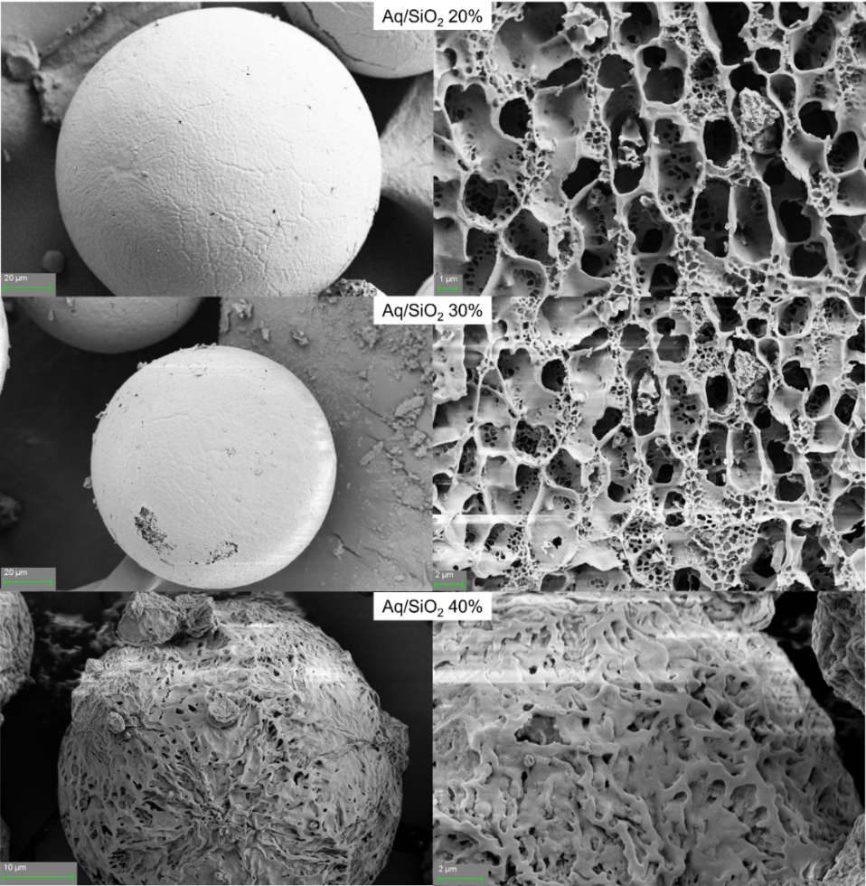
Figure S3. SEM images of Aquivion/Silica spray-freeze dried composites at different polymer contents. On the left are images at low magnification of the granular structure, while on the right are images at higher magnification to show the finer structure.
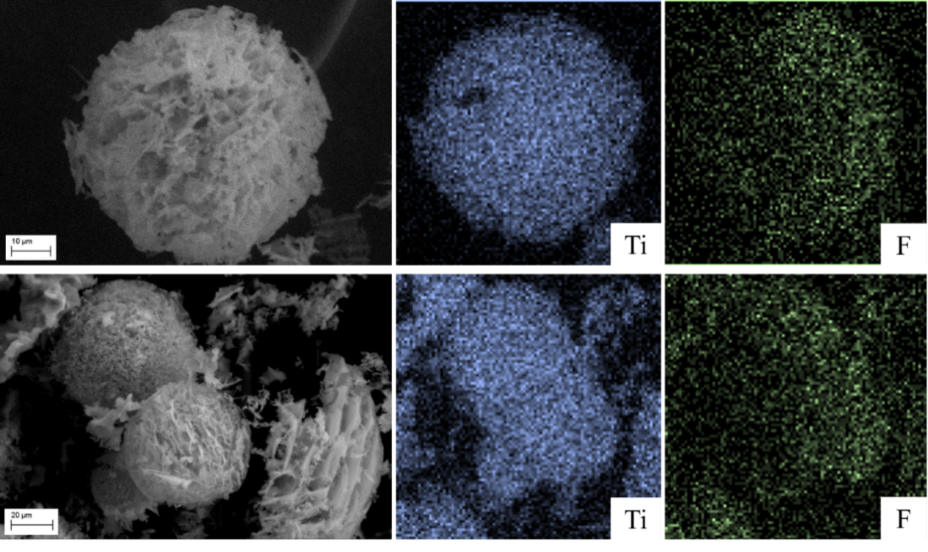
Figure S4. SEM Imaging and SEM-EDX mapping of Ti and F for Aq/TiO₂ 30% (above) and Aq/TiO₂ 30% calcined at 200 °C (below).

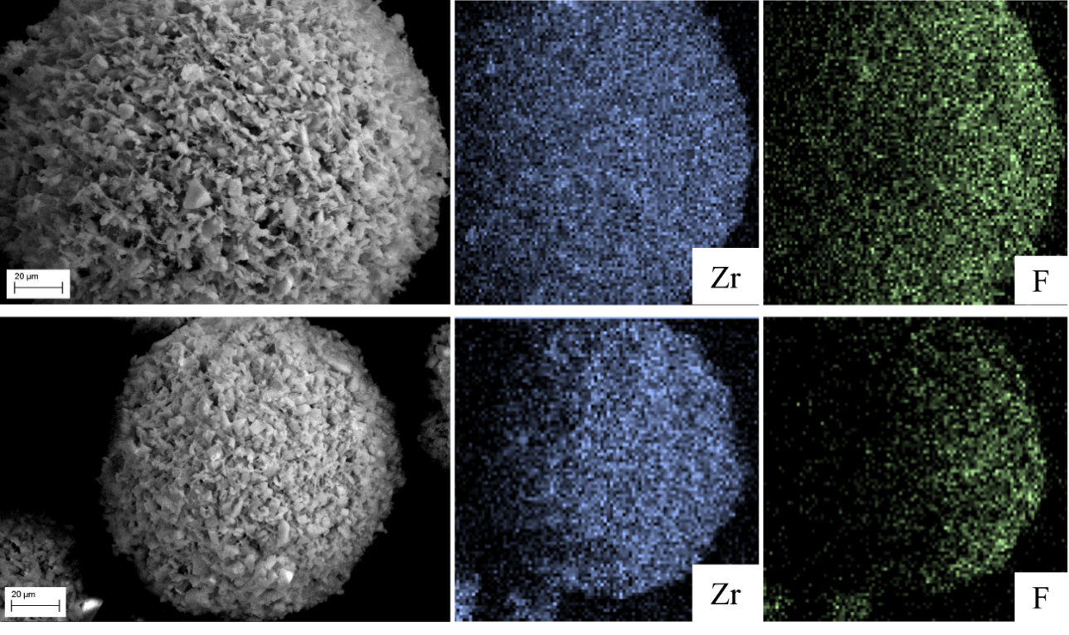
Figure S5. SEM Imaging and SEM-EDX mapping of Zr and F for Aq/ZrO₂ 30% (above) and Aq/ZrO₂ 30% calcined at 200 °C (below).

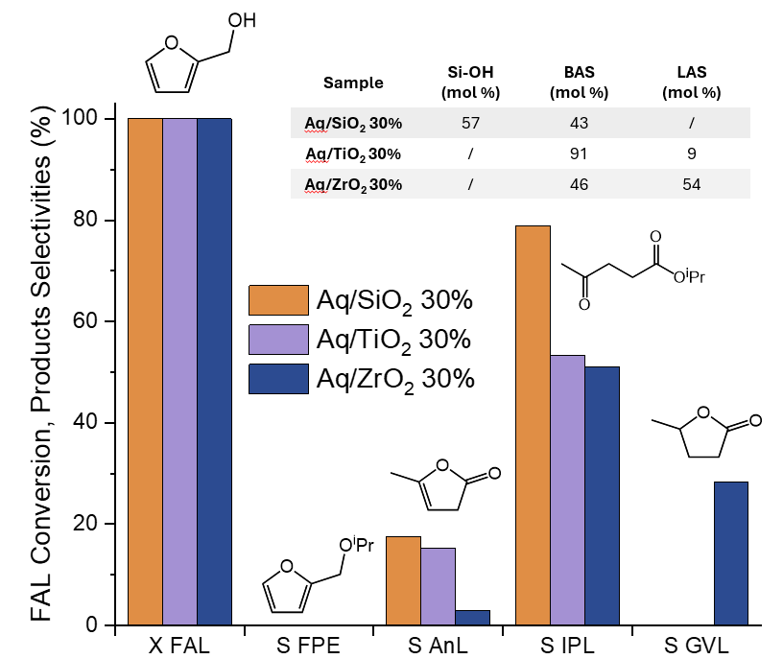
Figure S6. Effect of the metal oxide on the catalytic performances of Aquivion®-based composites®, as previously reported [40]. X: conversion; S: selectivity; Reaction conditions: 1 mmol of FAL; FAL/BAS = 100 mol/mol; 15 mL of isopropanol; N₂ pressure of 10 bar; Reaction temperature of 180 °C; Reaction time of 2 h.
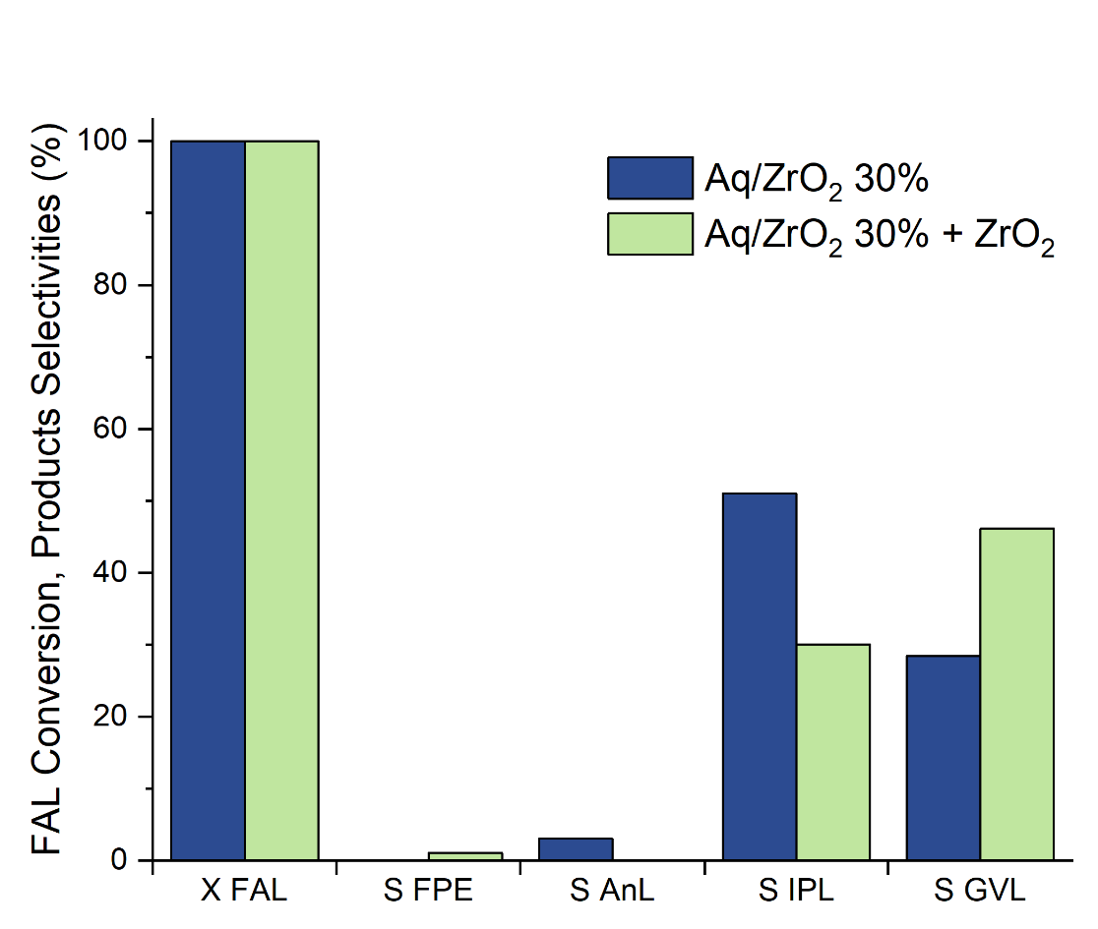
Figure S7. Comparison between catalytic activity of Aq/ZrO₂ 30% composite and a 50:50 physical mixture of Aq/ZrO₂ 30% with tetragonal ZrO₂ (28 mg of catalyst and 28 mg of zirconia). X: conversion; S: selectivity; Reaction conditions: 1 mmol of FAL; FAL/BAS = 100 mol/mol; 15 mL of isopropanol; N₂ pressure of 10 bar; Reaction temperature of 180 °C; Reaction time of 2 h.

Turnover Number (TON) calculated separately on BAS and LAS taking into account the steps in which the two different acid sites are necessary to promote the transformation. Also, IPL moles were considered twice in the calculation of TON, since they require two catalytic events for their formation (first the conversion of FAL to FPE, then the hydrolytic ring opening of FPE to IPL). GVL was also considered in the calculation of TON over BAS, since its formation requires first the production of either AnL or IPL. Since there are two possible pathways for its formation, either via IPL through two BAS-promoted steps or via AnL through one BAS-promoted step, its contribution was mediated and considered 1.5 times. The final LAS-promoted step necessary for the formation of GVL was not considered in the TON over BAS.
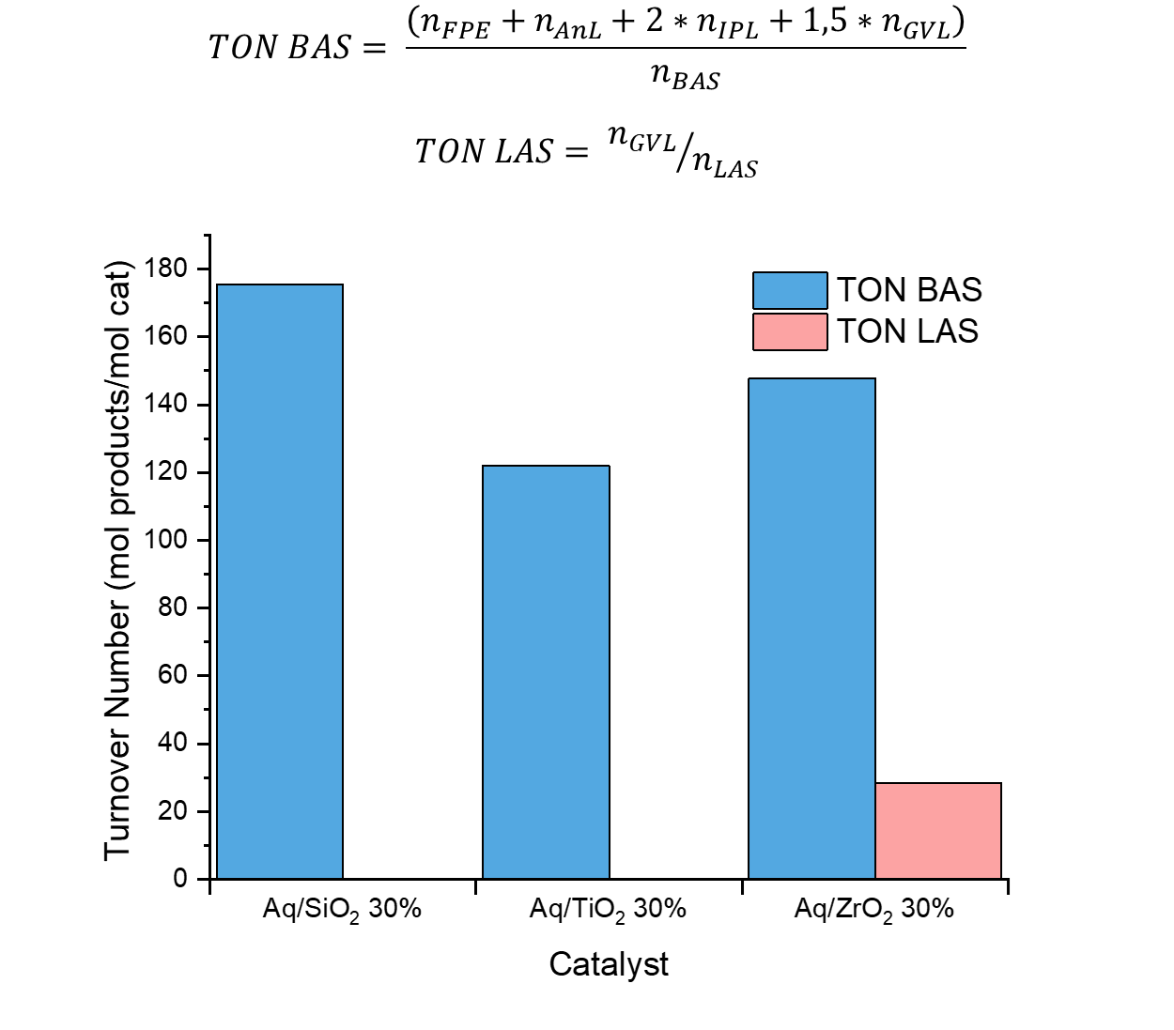
Figure S8. Turnover Number (TON) calculated on BAS and LAS taking into account the steps in which the two different acidic sites are necessary for the production of each compound; Reaction conditions: 1 mmol of FAL; FAL/BAS = 100 mol/mol; 15 mL of isopropanol; N₂ pressure of 10 bar; Reaction temperature of 180 °C; Reaction time of 2 h.
Figure S9. Turnover Frequency (TOF) calculated on BAS and LAS dividing the respective TON by the reaction time (h); Reaction conditions: 1 mmol of FAL; FAL/BAS = 100 mol/mol; 15 mL of isopropanol; N₂ pressure of 10 bar; Reaction temperature of 180 °C; Reaction time of 2 h.

