Supporting Information

Cryogenic gas sorption in high free volume glassy polymers: thermodynamic modeling and permeability correlations
Roberta Di Carloª, Lucia Caraceniª, Virginia Signoriniª, Matteo Minelliª

ª Department of Civil, Chemical, Environmental and Material Engineering, Alma Mater Studiorum - University of Bologna, via Terracini 28, 40131, Bologna, Italy

Table 1S: Sanchez-Lacombe and non-equilibrium SL equations of state [1,2]
Pure component i
$$M_{i}$$ | Molar mass of component i
$$ρ_{i}$$ | Density of component i
$$v_{i}^{*}$$ | Molar volume of a lattice cell of component i | $$v_{i}^{*}=\frac{RT_{I}^{*}}{p_{i}^{*}}$$
$$r_{i}^{0}$$ | Number of lattice cells occupied by a molecule of pure component i | $$r_{i}^{0}=\frac{M_{i}}{ρ_{i}^{*}v_{i}^{*}}$$
$$ω_{i}$$ | Mass fraction of i
$$φ_{i}$$ | Volume fraction of component i at close packed conditions | $$φ_{i}=\frac{{ω_{i}}/{ρ_{i}^{*}}}{\sum_{i}^{N}{{ω_{i}}/{ρ_{i}^{*}}}}$$
$$ε_{i}$$ | Non-bonded interaction energy between two lattice cells occupied by component i
L | Mobility coefficient
$$L_{0}$$ | Infinite dilution mobility coefficient
β | Plasticization factor
α | Thermodynamic factor
$${\tilde{T}}_{i}$$ | Reduced temperature of component i | $${\tilde{T}}_{i}=\frac{T}{T_{i}^{*}}$$
$${\tilde{p}}_{i}$$ | Reduced pressure of component i | $${\tilde{p}}_{i}=\frac{p}{p_{i}^{*}}$$
$${\tilde{ρ}}_{i}$$ | Reduced density of component i | $${\tilde{ρ}}_{i}=\frac{ρ_{i}}{ρ_{i}^{*}}$$
Multicomponent mixtures
$$k_{ij}$$ | Binary interaction parameter between components i and j
$$ρ^{*}$$ | Characteristic density of the mixture | $$\frac{1}{ρ^{*}}=\sum_{i}^{N}{\frac{ω_{i}}{ρ_{i}^{*}}}$$
$$p^{*}$$ | Characteristic pressure of the mixture | $$p^{*}=\sum_{i}^{N}{φ_{i}p_{i}^{*}}-\sum_{i}^{N-1}{\sum_{j>i}^{N}{φ_{i}φ_{j}Δp_{ij}^{*}}}$$
$$∆p_{ij}^{*}$$ | Binary parameter | $$∆p_{ij}^{*}=p_{i}^{*}+p_{j}^{*}-2(1-k_{ij})\sqrt{p_{i}^{*}p_{j}^{*}}$$
$$T^{*}$$ | Characteristic temperature of the mixture | $$T^{*}=\frac{p^{*}}{r} \sum_{i}^{N}{x_{i}r_{i}^{0}}\frac{T_{i}^{*}}{p_{i}^{*}}$$
$$v^{*}$$ | Average close-packed molar volume in the mixture | $$v^{*}=\frac{T^{*}R}{p^{*}}$$
$$r_{i}$$ | Number of lattice cells occupied by a molecule in the mixture | $$r_{i}=\frac{r_{i}^{0}v_{i}^{*}}{v^{*}}$$
$$\tilde{T}$$ | Reduced temperature of the mixture | $$\tilde{T}=\frac{T}{T^{*}}$$
$$\tilde{p}$$ | Reduced pressure of the mixture | $$\tilde{p}=\frac{p}{p^{*}}$$
$$\tilde{ρ}$$ | Reduced density of the mixture | $$\tilde{ρ}=\frac{ρ}{ρ^{*}}$$

Table 2S: Chemical structures of polymers used in the thermodynamic modeling
Polymer | Chemical Structure
PIM-1 | 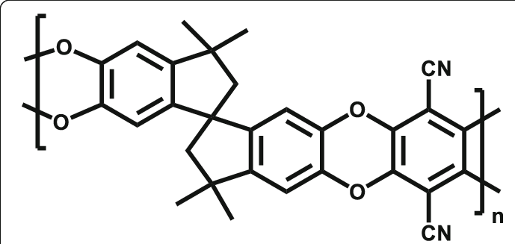
PIM-7 | 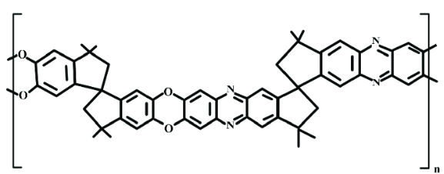
PIM-6FDA-OH | 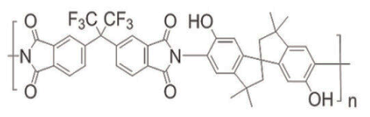
PIM-EA-TB | 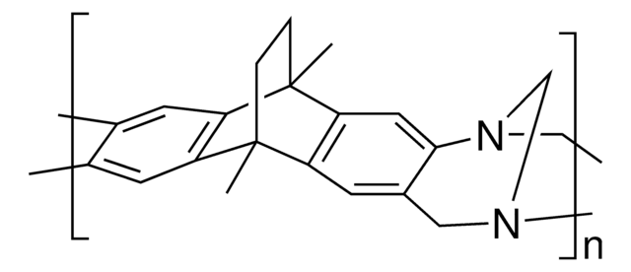
AF1600/AF2400 | 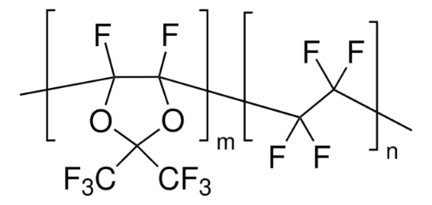
P-84 | 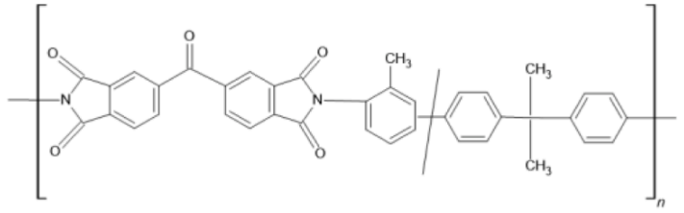
Matrimid | 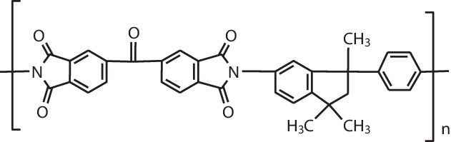
PTMSP | 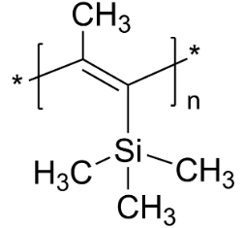
CANAL-Me-iPr | 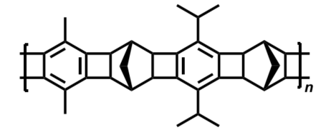
PMMA | 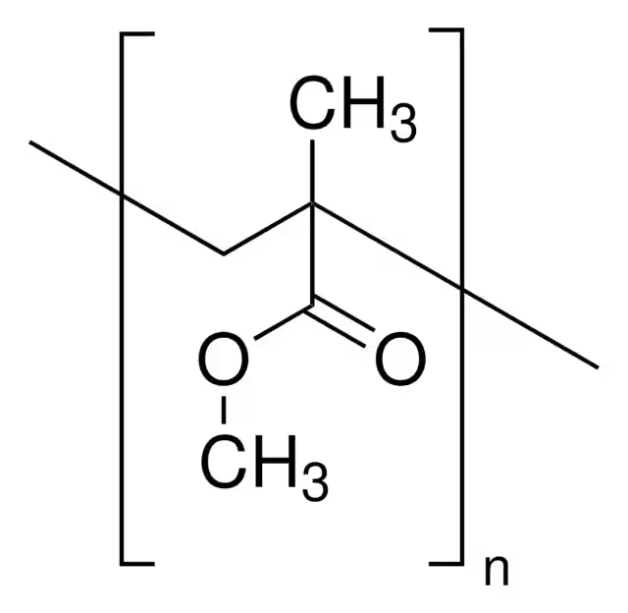
PVC | 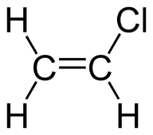
PPO | 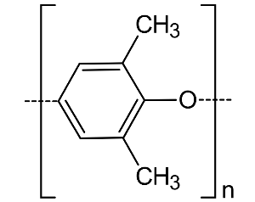
PMP | 
PSF | 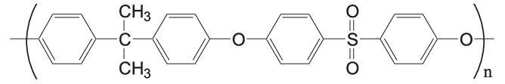
PP | 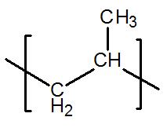
PS | 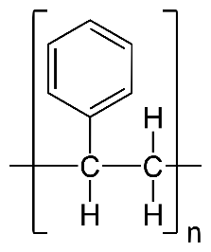

Gas solubility in PIM-6FDA-OH
Figure 1S, Solubility isotherms used to estimate the characteristic parameters of PIM-6FDA-OH. Experimental data from [3,4]. Curves are from NELF calculations.

Gas solubility in PIM-EA-TB
Figure 2S, Solubility isotherms used to estimate the characteristic parameters of PIM-EA-TB. Experimental data from [5]. Curves are from NELF calculations

Gas solubility in PIM-TMN-Trip
Figure 3S, Solubility isotherms used to estimate the characteristic parameters of PIM-TMN-Trip. Experimental data from [5]. Curves are from NELF calculations.

Gas solubility in Canal-Me-iPr
Figure 4S, Solubility isotherms used to estimate the characteristic parameters of Canal-Me-iPr. Experimental data from [6]. Curves are from NELF calculations

Cryogenic sorption Analysis through BET method
The free volume of various polymers was determined through the analysis of nitrogen sorption isotherms measured at 77 K. Although sorption isotherms are typically used to study the porosity of materials, their analysis can also be used to derive the fractional free volume (FFV) and the gas concentration within the polymer at a given partial pressure.
Standard probe for adsorption studies includes nitrogen at 77 K and Argon at 87 K, due to their ease of handling (liquid nitrogen and ice are readily available) and their complementary characterization properties. Nitrogen primarily characterizes mesopores and macropores (>2 nm), while Argon is particularly useful to describe micropores. The present study aims at a comparative evaluation of accessible free volume rather than a detailed pore-size distribution analysis, therefore only nitrogen has been considered.
Sorption measurements were performed using a Surface Area and Pore Size Analyzer, based on a volumetric method. The amount of gas sorbed was determined from the pressure change in a calibrated volume by comparison with the expected value in the absence of polymer sample. During the analysis, the temperature of the sample holder is maintained constant, typically near the normal boiling point of the adsorbate gas.
Prior to measurement, polymer samples were degassed under vacuum to remove contaminants and residual moisture. To improve degassing efficiency, the sample can be gently heated, provided that the temperature does not exceed the polymer’s glass transition temperature (T_{g}), since exceeding this limit could lead in some cases to partial crystallization and alter its sorption properties.
During analysis, the sample cell is immersed in a liquid nitrogen Dewar (at 77 K) and exposed to a nitrogen flow at approximately 1 bar. The polymer progressively sorbs nitrogen as the relative pressure (p/p₀) increases, where p is the equilibrium sorption pressure and p₀ is the saturation vapor pressure of nitrogen at the experimental temperature. The relative pressure is gradually increased from 0 to 1, followed by the desorption phase.
The Brunauer–Emmett–Teller (BET) theory, developed in 1938, is the most widely used model for determining the specific surface area of porous and microporous solids from physical adsorption of gases at low temperatures. The BET model extends the Langmuir theory—which assumes adsorption limited to a monolayer—by allowing for the formation of multiple adsorption layers on the material surface.

The Langmuir model is based on the following assumptions:
- All adsorption sites have the same energy for the adsorbate.
- Adsorption at one site occurs independently of neighboring sites.
- The adsorbate forms a single monolayer, with each site accommodating only one molecule.
The BET model further assumes that:
- Gas molecules absorb on the solid in an infinite number of layers.
- The various layers do not interact with one another.
- The same theoretical model applies to each layer.

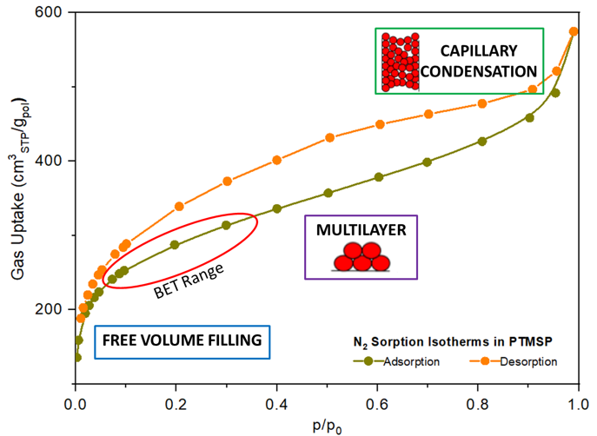
C₀
Figure 5S: Nitrogen sorption and desorption in PTMSP at 77K complemented with the description of the polymer filling.
From the experimental cryogenic adsorption data, BET isotherms are constructed, representing the amount of adsorbed gas as a function of the relative pressure. The BET equation is expressed as:
$$\frac{1}{V\left[\left(\frac{p_{0}}{p}\right)-1\right]}=\frac{1}{V_{m}C}+\frac{C-1}{V_{m}C}\left(\frac{p_{0}}{p}\right)$$ | (1.1)
where $V$is the volume of gas adsorbed at equilibrium pressure $p$, $V_{m}$is the monolayer capacity, and $C$is the BET constant related to the adsorption energy.
The linear region of the BET plot—typically between $p/p_{0}=0.05$and $0.35$—is used to determine the slope and intercept, from which $V_{m}$and $C$are calculated. The specific surface area $S_{BET}$can be calculated using the equation:
$$S_{BET}=\frac{V_{m}N_{a}A_{m}}{M_{v}}$$ | (1.2)
where $N_{A}$is Avogadro’s number, $σ$is the molecular cross-sectional area of the adsorbate (0.162 nm² for N₂), and $V_{m}^{STP}$is the molar volume of gas at standard conditions.
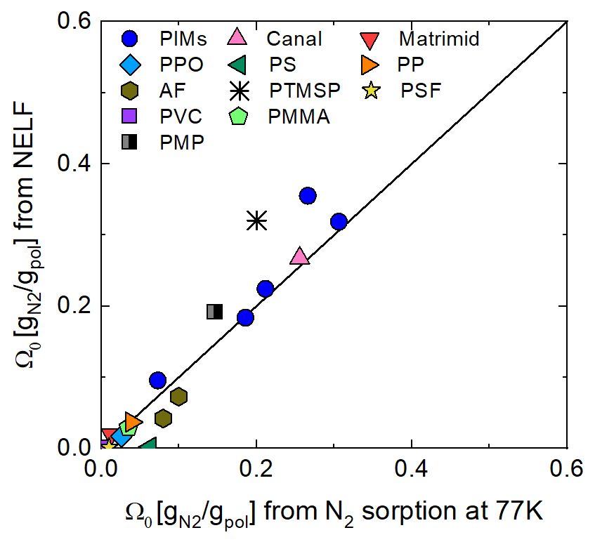
Figure 6S: Parity plot comparison between Ω₀, the initial gas concentration in the polymer, calculated from N₂ sorption isotherm at 77K and from NELF model

Table 3S: Free volume fraction (FFV) of the investigated polymers evaluated using the Bondi method [7,8] (with a coefficient of 1.3 and recalculated with 1.45) and obtained from Lattice Fluid (LF-EoS) measurements and N₂ sorption at 77 K.
Polymers | FFV Bondi with 1.3 | Recalculated FFV Bondi with 1.45 | FFV from LF | FFV from N₂ sorption at 77K
PIM-1 | 0.26 | 0.20 | 0.22 | 0.25
PIM-7 | 0.29 | 0.22 | 0.26 | 0.31
PIM-6FDA-OH | 0.23 | 0.16 | 0.11 | 0.10
PIM-EA-TB | 0.28 | 0.21 | 0.38 | 0.40
PIM-TMN-Trip | 0.31 | 0.25 | 0.36 | 0.37
AF1600 | 0.29 | 0.25 | 0.11 | 0.18
AF2400 | 0.31 | 0.27 | 0.15 | 0.21
Matrimid | 0.18 | 0.10 | 0.04 | 0.02
PTMSP | 0.29 | 0.22 | 0.32 | 0.32
CANAL-Me-iPr | 0.27 | 0.20 | 0.34 | 0.34
PMP | 0.22 | 0.15 | 0.17 | 0.14
PPO | 0.10 | 0.11 | 0.03 | 0.04
PP | 0.05 | 0.12 | 0.04 | 0.04
PS | 0.13 | 0.05 | 0.04 | 0.07
PSF | 0.14 | 0.08 | 0.02 | 0.02
PVC | 0.16 | 0.05 | 0.005 | 0.003
PMMA | 0.01 | 0.04 | 0.04 | 0.05

Reference
[1] I.C. Sanchez, R.H. Lacombe, Statistical Thermodynamics of Polymer Solutions, Macromolecules 11 (1978) 1145–1156. https://doi.org/10.1021/ma60066a017.
[2] M. Minelli, M.G. De Angelis, An equation of state (EoS) based model for the fluid solubility in semicrystalline polymers, Fluid Phase Equilibria 367 (2014) 173–181. https://doi.org/10.1016/j.fluid.2014.01.024.
[3] X. Ma, R. Swaidan, Y. Belmabkhout, Y. Zhu, E. Litwiller, M. Jouiad, I. Pinnau, Y. Han, Synthesis and Gas Transport Properties of Hydroxyl-Functionalized Polyimides with Intrinsic Microporosity, Macromolecules 45 (2012) 3841–3849. https://doi.org/10.1021/ma300549m.
[4] S. Yi, X. Ma, I. Pinnau, W.J. Koros, A high-performance hydroxyl-functionalized polymer of intrinsic microporosity for an environmentally attractive membrane-based approach to decontamination of sour natural gas, J. Mater. Chem. A 3 (2015) 22794–22806. https://doi.org/10.1039/C5TA05928C.
[5] M. Lanč, K. Pilnáček, C.R. Mason, P.M. Budd, Y. Rogan, R. Malpass-Evans, M. Carta, B.C. Gándara, N.B. McKeown, J.C. Jansen, O. Vopička, K. Friess, Gas sorption in polymers of intrinsic microporosity: The difference between solubility coefficients determined via time-lag and direct sorption experiments, J. Membr. Sci. 570–571 (2019) 522–536. https://doi.org/10.1016/j.memsci.2018.10.048.
[6] H.W.H. Lai, F.M. Benedetti, Z. Jin, Y.C. Teo, A.X. Wu, M.G.D. Angelis, Z.P. Smith, Y. Xia, Tuning the Molecular Weights, Chain Packing, and Gas-Transport Properties of CANAL Ladder Polymers by Short Alkyl Substitutions, Macromolecules 52 (2019) 6294–6302. https://doi.org/10.1021/acs.macromol.9b01155.
[7] D.W. Van Krevelen, Properties of Polymers: Their Correlation with Chemical Structure; their numerical estimation and prediction from additive group contribution., Elvisier (1997).
[8] J.Y. Park, D.R. Paul, Correlation and prediction of gas permeability in glassy polymer membrane materials via a modified free volume based group contribution method, J. Membr. Sci. 125 (1997) 23–39. https://doi.org/10.1016/S0376-7388(96)00061-0.

