Exploring the conformational space of the mobile flap in Sporosarcina pasteurii urease by cryo-electron microscopy

Luca Mazzei*^{‡[a]}, Giancarlo Tria ^{‡[b] [d]}, Stefano Ciurli, ^{[a]} Michele Cianci *^{[c]}

^{[a]} Laboratory of Bioinorganic Chemistry, Department of Pharmacy and Biotechnology (FaBiT), University of Bologna, I-40138 Bologna (Italy)
^{[b]} Florence Center for Electron Nanoscopy (FloCEN), c/o Chemistry Department “Ugo Schiff”, University of Florence, I-50019 Sesto Fiorentino (FI) (Italy)
^{[c]} Department of Agricultural, Food and Environmental Sciences, Polytechnic University of Marche, I-60131 Ancona (Italy)
^{[d]} National Research Council, Institute of Cristallography URT Caserta c/o University of Campania “Luigi Vanvitelli”, I-81100 Caserta (Italy)

‡ these authors contributed equally
* corresponding authors

Luca Mazzei ORCID: 0000-0003-1335-9365 e-mail: luca.mazzei2@unibo.it
Giancarlo Tria ORCID: 0000-0003-4736-471X e-mail: giancarlo.tria@cnr.it
Stefano Ciurli ORCID: 0000-0001-9557-926X e-mail: stefano.ciurli@unibo.it
Michele Cianci ORCID: 0000-0001-5607-6061 e-mail: m.cianci@univpm.it

SUPPLEMENTARY INFORMATION

Table 1-SI. Cryo-EM data collection, refinement and validation statistics.
 | Native SPU  (EMD-51450)  (PDB code: 9GML) | NBPTO-inhibited SPU  (EMD-51478)  (PDB code: 9GNR)
Data collection and processing
Voltage (kV) | 200 | 300
Magnification (kx) | 150 | 165
Detector | TS Falcon 3 | Gatan K3
Electron exposure (e⁻/Å²) | ~30 | ~30
Frames | 30 | 32
Exposure time (s) | 25.58 | 3.2
Pixel size (Å) | 0.96 | 0.827
Defocus range (μm) | [-0.8,-2.2], step 0.2 | [-0.8,-2.2], step 0.2
Pixel size (Å) | 0.96 | 0.827
Tilted stage (°) | [0, 40], step 10 | [0;30]
Movies | 3035 | 7785
Initial particle images (no.) | 807538 | 1459548
Final particle images (no.) | 90461 | 163588
Map resolution (Å) (FSC=0.143) | 3.12 | 2.92
Symmetry imposed | C3 | C3
B-factor | -134 | -113
Box
Lengths (Å) | 114.13, 80.22, 81.05 | 90.24, 108.48, 80.64
Angles (°) | 90.00, 90.00, 90.00 | 90.00, 90.00, 90.00
Supplied Resolution (Å) | 2.9 | 3.4
Resolution Estimates (Å) | Masked Unmasked | Masked Unmasked
d FSC model (0/0.143/0.5) | 2.2/2.8/3.0 2.2/2.8/3.0 | 3.3/3.5/4.1 3.3/3.5/4.1
Map min/max/mean | -0.35/0.68/0.01 | -0.33/1.33/0.03
Refinement
Composition
Chains | 3 | 3
Atoms | 6052 (Hydrogens: 0) | 6054 (Hydrogens: 0)
Protein residues | 792 | 792
Water molecules | 2 | 0
Ligands | NI: 2 | NI: 2; 2PA: 1
RMSD
Bond lengths (Å) (# > 4 σ) | 0.003 (0) | 0.003 (0)
Bond angles (°) (# > 4 σ) | 0.677 (3) | 0.570 (0)
MolProbity score | 1.81 | 2.25
Clash score | 11.19 | 9.11
Ramachandran plot (%)
Outliers | 0.13 | 0.13
Allowed | 3.58 | 3.45
Favored | 96.29 | 96.42
Rama-Z (Ramachandran plot Z-score, RMSD)
whole | -0.23 (0.30) | 0.42 (0.30)
helix | 0.71 (0.35) | 1.19 (0.37)
sheet | 1.10 (0.55) | 0.50 (0.48)
loop | -0.91 (0.30) | -0.13 (0.30)
Rotamer outliers (%) | 0.00 | 4.98
Cbeta outliers (%) | 0.00 | 0.00
Cis proline/general | 8.1/0.0 | 8.1/0.0
Twisted proline/general | 0.0/0.0 | 0.0/0.0
CaBLAM outliers (%) | 3.33 | 2.56
ADP (B-factors)
Iso/Aniso (#) | 6052/0 | 6054/0
min/max/mean
Protein | 31.72/135.83/83.68 | 29.70/184.84/67.15
Ligand | 103.59/144.55/123.30 | 51.74/102.30/73.23
Occupancy
Mean | 1.00 | 1.00
occ = 1 (%) | 100.00 | 100.00
0 < occ < 1 (%) | 0.00 | 0.00
occ > 1 (%) | 0.00 | 0.00
Model vs. Data
CC (mask) | 0.81 | 0.89
CC (box) | 0.90 | 0.93
CC (peaks) | 0.80 | 0.85
CC (main chain) | 0.82 | 0.88
CC (side chains) | 0.80 | 0.87

Table 2-SI. Backbone RMSD of the Cryo-EM of SPU in the native form and bound to DAP calculated with respect to the X-ray crystal structures of native SPU (PDB code 4CEU) ^{[1]} and bound to DAP (PDB code 6RKG) ^{[2]}. All values are reported in Å.

 | Native SPU (9GML)
 | 4CEU  (native) | 6RKG (DAP-bound)
α | 0.744 | 1.167
β | 0.723 | 0.679
γ | 0.549 | 0.532
 | DAP-bound SPU (9GNR)
 | 4CEU  (native) | 6RKG  (DAP-bound)
α | 0.387 | 0.557
β | 0.448 | 0.447
γ | 0.357 | 0.345

Figure 1-SI. Coulomb densities for the helix-turn-helix region for native (A, B, and C) and DAP-bound (D, E, and F) ureases. The densities shown are: (A and D) after 3D refinement contoured at 3.5 rmsd; phenix auto_sharpen maps (B and E) contoured at 1.5 rmsd, and LocScale maps (C and F) contoured at 5 rmsd. Figure was generated using ChimeraX ^{[3]}.

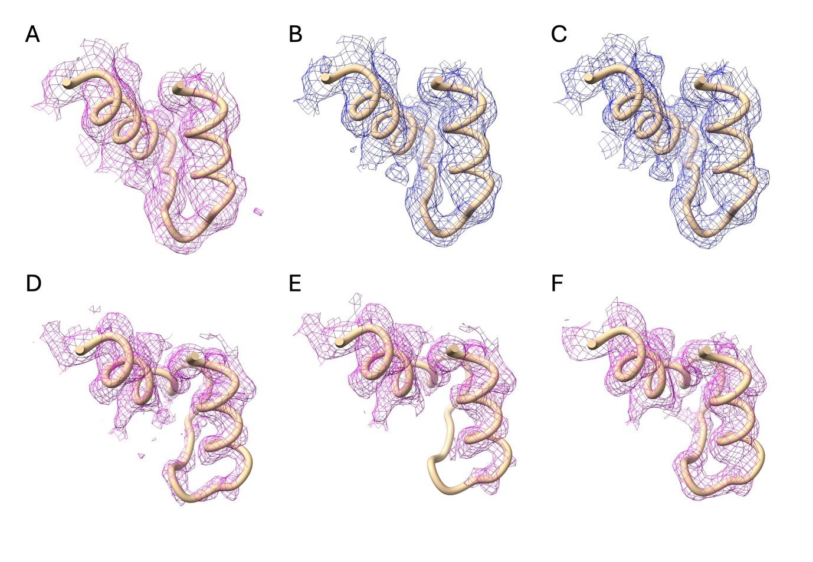

Figure 2-SI. Mobile flap of SPU. One (αβγ) asymmetric unit of the cryo-EM structures of native (A) and DAP-bound (B) SPU colored according to the Atomic Displacement Position (ADP) normalized to the averaged values (red: ADP > 1.5; white: 0.6 < ADP < 1.5; blue: ADP < 0.6).

References

[1] S. Benini, M. Cianci, L. Mazzei, S. Ciurli, J. Biol. Inorg. Chem. 2014, 19, 1243-1261.
[2] L. Mazzei, M. Cianci, S. Benini, S. Ciurli, Chem. Eur. J. 2019, 25, 12145-12158.
[3] E. C. Meng, T. D. Goddard, E. F. Pettersen, G. S. Couch, Z. J. Pearson, J. H. Morris, T. E. Ferrin, Protein Science 2023, 32, e4792.

