Supplementary Materials
Text S1 - Laboratory procedures for amplification and library preparation
Each sample was amplified in triplicate in a total mix volume of 20 μL, consisting of 10 μL MiFi™ Master Mix (Meridian Bioscience), 0.16 μL Bovine Serum Albumin (BSA; 20 mg/mL, Thermo Scientific), 5.84 μL of UltraPure™ Distilled Water (Invitrogen), 1 μL of 10 μM forward primer, 1 μL of 10 μM reverse primer and 2 μL of DNA template. To distinguish each eDNA sample and minimize cross-contamination and/or tag switching during sequencing, forward and reverse primers carried unique 8 bp tags. The PCR profile included an initial denaturation at 94°C for 5 mins, 40 cycles consisting of denaturation at 94°C for 1 min, annealing at 54°C for 1 min and extension at 72°C for 1 min, and a final extension step of 72°C for 5 mins.
The three PCR replicates were pooled and visualized on a 2% agarose gel stained with SYBRsafe to ensure the correct amplification of the target fragment.
PCR purification was performed with a size selection magnetic bead clean-up protocol (1x ratio; Bronner & Quail 2019) on 30 μL of PCR product. The beads clean-up aimed to remove non-target bands, such as primer dimers (<100 bp). Purified PCR products were normalised and pooled in equimolar concentrations, according to the total DNA concentration calculated through a Qubit™ 4.0 fluorometer with a Qubit™ dsDNA HS Assay Kit (Invitrogen). Pooled PCR products were analysed using the TapeStation 4200 and High Sensitivity D1000 ScreenTape (Agilent, U.S.A.) to check DNA fragment size. End-repair, adapter ligation and library PCR amplification were performed using the NEXTFLEX® Rapid DNA-Seq Kit 2.0 by PerkinElmer (1 μg) according to the manufacturer’s protocol. The fragment lengths were checked with the TapeStation to visualize potential secondary products (e.g., adaptor dimers) that were subsequently removed by another 1x ratio magnetic bead clean-up. The library was then quantified with qPCR on a Rotor-Gene Q (Qiagen), using the NEBNext® Library Quant Kit for Illumina® (New England Biolabs) and then diluted to 1 nM according to qPCR concentrations. The final library and PhiX Control were quantified using qPCR before sequencing. Finally, the library was sequenced at 85 pM with 20% PhiX Control on an Illumina® iSeq™ 100 using v2 reagents (300-cycle) (Illumina Inc.). During the sequencing run, our samples were sequenced alongside samples from another eDNA project carried out in the Indo-Pacific Ocean.

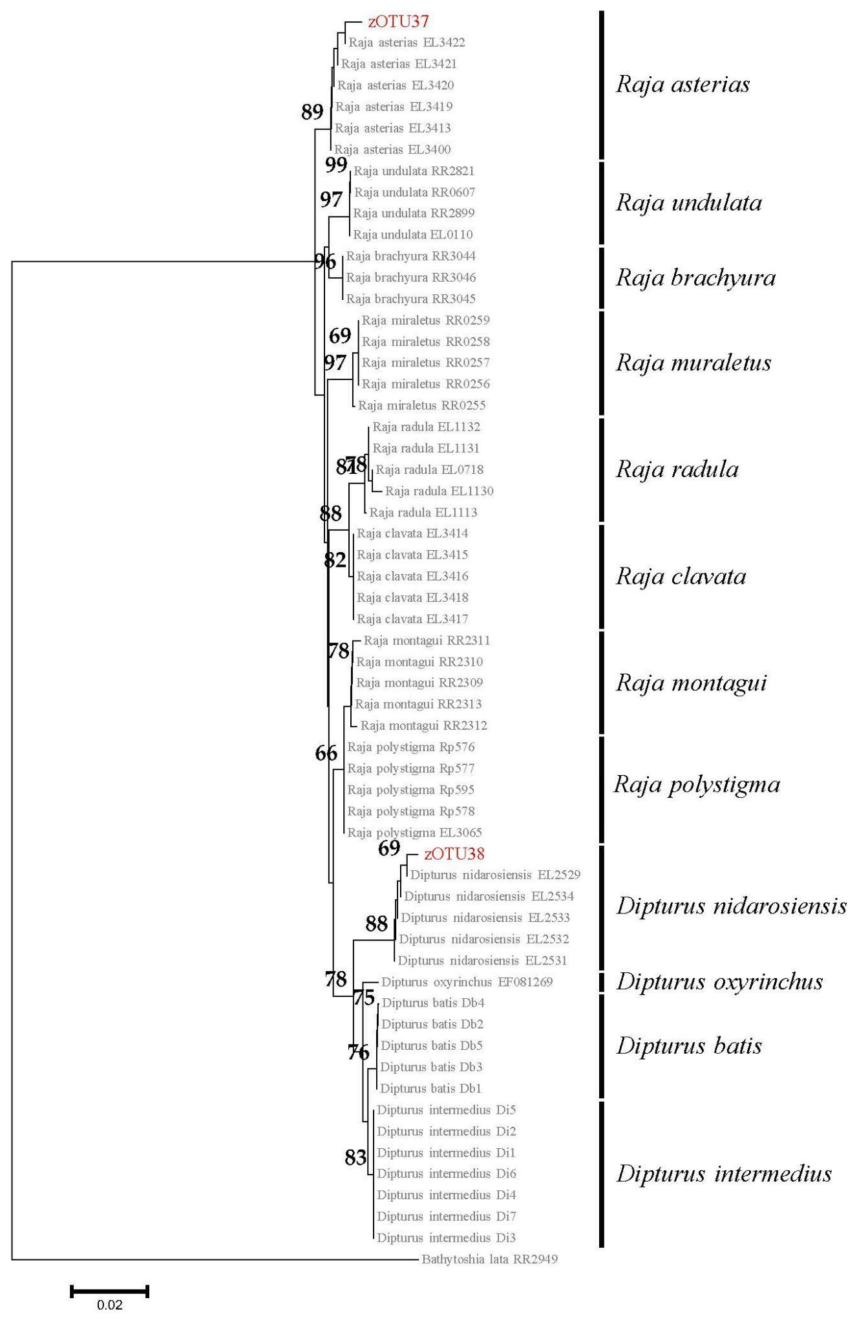
Figure S1 – Neighbour-Joining (NJ) phylogenetic tree of elasmobranch species belonging to the genera Raja and Dipturus based on the 12S marker. Unresolved zOTUs are highlighted in red. Bootstrap values >60% are shown near nodes. Scale bar is given. The bar in the right shows the results of the ASAP species delimitation analysis.
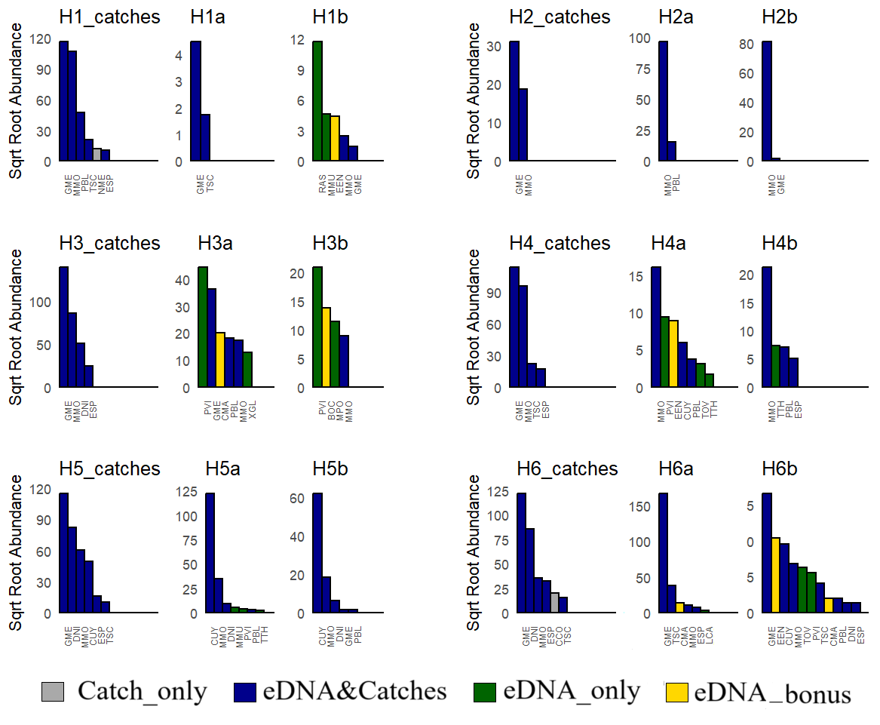
Figure S2 Square root-transformed read count and total weight of catches for all species in each of the 12 samples. Grey indicates caught species not detected by eDNA analyses (Catch_only); dark blue indicates species detected both in the catch and via eDNA ("eDNA&Catches"); green indicates species detected exclusively through eDNA ("eDNA_only"); yellow represents species unlikely to be captured by deep longlines, detected solely through eDNA ("eDNA_bonus"). Species codes correspond to those listed in Table S6.

Table S1 - Setting coordinates, hauling coordinates, depth range, setting time and relative Day/Night period of the six longline hauls in the southern Adriatic Sea (FAO Geographical Sub-Area 18 – Southern Adriatic Sea).
Haul | Setting start | Setting end | Hauling start | Hauling end | Depth range (m) | Setting time (hh:mm) | Hauling time (hh:mm) | Day/Night
1 | 41.670°N,  17.294°E | 41.627°N,  17.383°E | 41.665°N,  17.297°E | 41.646°N,  17.352°E | 1016 – 1096 | 4:56 – 6:05 | 10:05 – 13:20 | Day
2 | 41.522°N,  17.572°E | 41.499°N,  17.612°E | 41.518°N,  17.558°E | 41.507°N,  17.581°E | 1100 – 1114 | 14:59 – 15:36 | 18:00 – 19:41 | Day
3 | 41.388°N,  17.897°E | 41.374°N,  17.936°E | 41.351°N,  17.890°E | 41.342°N,  17.900°E | 1147 – 1138 | 21:26 – 22:00 | 07:10 – 09:09 | Night
4 | 41.201°N,  17.845°E | 41.219°N,  17.789°E | 41.195°N,  17.856°E | 41.200°N,  17.826°E | 1035 – 1029 | 10:30 – 11:06 | 16:03 – 18:00 | Day
5 | 41.359°N,  17.563°E | 41.397°N,  17.506°E | 41.371°N,  17.539°E | 41.386°N,  17.522°E | 1124 – 1065 | 19:26 – 20:24 | 4:53 – 07:00 | Night
6 | 41.554°N,  17.354°E | 41.586°N,  17.302°E | 41.564°N,  17.345°E | 41.574°N,  17.319°E | 900 - 935 | 08:16 – 08:55 | 13:07 – 14:56 | Day

Table S2 – List of newly 85 sequenced specimens for 12S marker belonging to 14 cartilaginous and 5 bony fish species.
GenBank accession numbers | BOLD Process ID | Sample ID | Class | Species
- | GULP004-19 | EL1632 | Elasmobranchii | Centrophorus uyato
- | GULP005-19 | EL1633 | Elasmobranchii | Centrophorus uyato
- | GULP006-19 | EL1634 | Elasmobranchii | Centrophorus uyato
- | GULP007-19 | EL1635 | Elasmobranchii | Centrophorus uyato
- | GULP008-19 | EL1636 | Elasmobranchii | Centrophorus uyato
- | ELAMB175-25 | Db1 | Elasmobranchii | Dipturus batis
- | ELAMB176-25 | Db2 | Elasmobranchii | Dipturus batis
- | ELAMB177-25 | Db3 | Elasmobranchii | Dipturus batis
- | ELAMB178-25 | Db4 | Elasmobranchii | Dipturus batis
- | ELAMB179-25 | Db5 | Elasmobranchii | Dipturus batis
- | ELAMB180-25 | Di1 | Elasmobranchii | Dipturus intermedius
- | ELAMB181-25 | Di2 | Elasmobranchii | Dipturus intermedius
- | ELAMB182-25 | Di3 | Elasmobranchii | Dipturus intermedius
- | ELAMB183-25 | Di4 | Elasmobranchii | Dipturus intermedius
- | ELAMB184-25 | Di5 | Elasmobranchii | Dipturus intermedius
- | ELAMB185-25 | Di6 | Elasmobranchii | Dipturus intermedius
- | ELAMB186-25 | Di7 | Elasmobranchii | Dipturus intermedius
- | ELAMB124-23 | EL2531 | Elasmobranchii | Dipturus nidarosiensis
- | ELAMB132-25 | ELA2529 | Elasmobranchii | Dipturus nidarosiensis
- | ELAMB133-25 | ELA2532 | Elasmobranchii | Dipturus nidarosiensis
- | ELAMB134-25 | ELA2533 | Elasmobranchii | Dipturus nidarosiensis
- | ELAMB135-25 | ELA2534 | Elasmobranchii | Dipturus nidarosiensis
- | ELAMB136-25 | ELA2525 | Elasmobranchii | Etmopterus spinax
- | ELAMB137-25 | ELA2526 | Elasmobranchii | Etmopterus spinax
- | ELAMB138-25 | ELA2527 | Elasmobranchii | Etmopterus spinax
- | ELAME535-09 | SS0302 | Elasmobranchii | Mustelus mustelus
- | ELAME536-09 | SS0303 | Elasmobranchii | Mustelus mustelus
- | ELAME537-09 | SS0304 | Elasmobranchii | Mustelus mustelus
- | ELAME538-09 | SS0305 | Elasmobranchii | Mustelus mustelus
- | ELAME539-09 | SS0306 | Elasmobranchii | Mustelus mustelus
- | ELAMB158-25 | ELA3400 | Elasmobranchii | Raja asterias
- | ELAMB159-25 | ELA3413 | Elasmobranchii | Raja asterias
- | ELAMB160-25 | ELA3419 | Elasmobranchii | Raja asterias
- | ELAMB161-25 | ELA3420 | Elasmobranchii | Raja asterias
- | ELAMB162-25 | ELA3421 | Elasmobranchii | Raja asterias
- | ELAMB163-25 | ELA3422 | Elasmobranchii | Raja asterias
- | ELAME1124-11 | RR3044 | Elasmobranchii | Raja brachyura
- | ELAME1125-11 | RR3045 | Elasmobranchii | Raja brachyura
- | ELAME1126-11 | RR3046 | Elasmobranchii | Raja brachyura
- | ELAMB164-25 | ELA3414 | Elasmobranchii | Raja clavata
- | ELAMB165-25 | ELA3415 | Elasmobranchii | Raja clavata
- | ELAMB166-25 | ELA3416 | Elasmobranchii | Raja clavata
- | ELAMB167-25 | ELA3417 | Elasmobranchii | Raja clavata
- | ELAMB168-25 | ELA3418 | Elasmobranchii | Raja clavata
- | ELAME035-09 | RR0255 | Elasmobranchii | Raja miraletus
- | ELAME036-09 | RR0256 | Elasmobranchii | Raja miraletus
- | ELAME037-09 | RR0257 | Elasmobranchii | Raja miraletus
- | ELAME038-09 | RR0258 | Elasmobranchii | Raja miraletus
- | ELAME039-09 | RR0259 | Elasmobranchii | Raja miraletus
 | ELAME847-09 | RR002309 | Elasmobranchii | Raja montagui
 | ELAME848-09 | RR002310 | Elasmobranchii | Raja montagui
- | ELAME849-09 | RR002311 | Elasmobranchii | Raja montagui
- | ELAME850-09 | RR002312 | Elasmobranchii | Raja montagui
- | ELAME851-09 | RR002313 | Elasmobranchii | Raja montagui
- | ELAMB187-25 | Rp576 | Elasmobranchii | Raja polystigma
- | ELAMB188-25 | Rp577 | Elasmobranchii | Raja polystigma
- | ELAMB189-25 | Rp578 | Elasmobranchii | Raja polystigma
- | ELAMB190-25 | Rp595 | Elasmobranchii | Raja polystigma
- | ELAMB038-23 | EL1113 | Elasmobranchii | Raja radula
- | ELAMO040-15 | EL0718 | Elasmobranchii | Raja radula
- | ELAMB191-25 | EL1130 | Elasmobranchii | Raja radula
- | ELAMB192-25 | EL1131 | Elasmobranchii | Raja radula
- | ELAMB193-25 | EL1132 | Elasmobranchii | Raja radula
- | ELAMB113-23 | RR000607 | Elasmobranchii | Raja undulata
- | ELAMO031-15 | EL0110 | Elasmobranchii | Raja undulata
- | ELAME177-09 | RR002821 | Elasmobranchii | Raja undulata
- | ELAMO052-15 | RR002899 | Elasmobranchii | Raja undulata
PV267380 | - | G120 | Teleostei | Conger conger
PV267381 | - | G121 | Teleostei | Conger conger
PV267386 | - | G84 | Teleostei | Mora moro
PV267387 | - | G85 | Teleostei | Mora moro
PV267388 | - | G86 | Teleostei | Mora moro
PV267389 | - | G87 | Teleostei | Mora moro
PV267390 | - | G88 | Teleostei | Mora moro
PV267382 | - | G44 | Teleostei | Nettastoma melanurum
PV267383 | - | G45 | Teleostei | Nettastoma melanurum
PV267377 | - | G115 | Teleostei | Phycis blennoides
PV267378 | - | G117 | Teleostei | Phycis blennoides
PV267379 | - | G118 | Teleostei | Phycis blennoides
PV267384 | - | G72 | Teleostei | Phycis blennoides
PV267374 | - | G108 | Teleostei | Trachyrincus scabrus
PV267375 | - | G110 | Teleostei | Trachyrincus scabrus
PV267376 | - | G111 | Teleostei | Trachyrincus scabrus
PV267385 | - | G83 | Teleostei | Trachyrincus scabrus
PV267391 | - | G98 | Teleostei | Trachyrincus scabrus

Table S3 - Number of individuals (N) and total weight (Kg) per haul of the fish species caught by the demersal longline survey.
Class | Species | Haul 1  N  (Kg) | Haul 2  N  (Kg) | Haul 3  N  (Kg) | Haul 4  N  (Kg) | Haul 5  N  (Kg) | Haul 6  N  (Kg)
Elasmobranchii | Galeus melastomus | 55 (13.57) | 4  (0.96) | 47  (19.49) | 59  (12.88) | 63  (13.21) | 62  (14.90)
Elasmobranchii | Etmopterus spinax | 1  (0.12) | 0 | 3  (0.624) | 1  (0.30) | 1  (0.27) | 3  (1.06)
Elasmobranchii | Dipturus nidarosiensis | 0 | 0 | 3  (2.59) | 0 | 1  (6.80) | 1  (7.3)
Elasmobranchii | Centrophorus uyato | 0 | 0 | 0 | 0 | 1  (2.45) | 0
Actinopteri | Mora moro | 39 (11.40) | 1  (0.35) | 22  (7.40) | 25  (9.19) | 11  (3.68) | 5  (1.28)
Actinopteri | Phycis blennoides | 4  (2.23) | 0 | 0 | 0 | 0 | 0
Actinopteri | Trachirhyncus scabrus | 2  (0.43) | 0 | 0 | 2  (0.49) | 1  (0.1) | 1  (0.25)
Actinopteri | Nettastoma melanura | 1  (0.14) | 0 | 0 | 0 | 0 | 0
Actinopteri | Conger conger | 0 | 0 | 0 | 0 | 0 | 2  (4.04)
 | Total number individuals per haul (biomass in Kg) | 102  (27.89) | 5  (1.31) | 75  (30.10) | 87  (22.86) | 78  (26.51) | 74  (29.19)

Table S4 - List of species detected by eDNA metabarcoding during the longline survey, annotated with the total number of reads, the total sites detected, the IUCN information and the distribution and habitat of each species (from “Mediterranea region” when possible).
Class | Order | Family | Genus/Species | Code | Total reads | Total sites detected | IUCN Red List Conservation Status in the Mediterranean | Distribution & habitat (https://www.iucnredlist.org/)
Chondrichthyes |  |  |  |  | 51379 | 6
 | Carcharhiniformes |  |  |  | 29563 | 5
 |  | Scyliorhinidae |  |  | 29507 | 5
 |  |  | Galeus melastomus | GME | 29507 | 5 | Least concern | Marine Deep Benthic - Continental Slope/Bathyl Zone. Depth range: 55-2000m.
 |  | Triakidae |  |  | 56 | 2
 |  |  | Mustelus mustelus | MMU | 56 | 2 | Vulnerable | Marine Neritic, Marine Deep Benthic - Continental Slope/Bathyl Zone. Depth range: 5-438m.
 | Myliobatiformes |  |  |  | 2536 | 4
 |  | Dasyatidae |  |  |  | 4
 |  |  | Pteroplatytrygon violacea | PVI | 2536 | 4 | Least concern | Marine Neritic - Pelagic, Marine Oceanic - Epipelagic, Mesopelagic. Depth range: 0 - 381m
 | Rajiformes |  |  |  | 270 | 4
 |  | Rajidae |  |  | 270 | 4
 |  |  | Raja asterias | RAS | 137 | 1 | Near Threatened | Marine Neritic. Depth range: 0 -200m
 |  |  | Dipturus nidarosiensis | DNI | 133 | 3 | Near Threatened | Marine Deep Benthic - Continental Slope/Bathyl Zone. Depth range: 125 -1573m
 | Squaliformes |  |  |  | 19010 | 4
 |  | Centrophoridae |  |  | 18928 | 4
 |  |  | Centrophorus uyato | CUY | 18928 | 4 | Vulnerable | Marine Oceanic - Epipelagic, Mesopelagic, Bathypelagic - Marine Deep Benthic - Continental Slope/Bathyl Zone. Depth range: 210-1400m
 |  | Etmopteridae |  |  | 82 | 3
 |  |  | Etmopterus spinax | ESP | 82 | 3 | Least concern | Marine Oceanic - Mesopelagic, Bathypelagic - Marine Deep Benthic - Continental Slope/Bathyl Zone. Depth range: 300-2490m
Actinopterygii |  |  |  |  | 22528 | 6
 | Blenniiformes |  |  |  | 190 | 1
 |  | Blenniidae |  |  |  | 1
 |  |  | Blennius ocellaris | BOC | 190 | 1 | Least concern | Marine Neritic. Depth range: 10-150m
 | Carangiformes |  |  |  | 98 | 3
 |  | Carangidae |  |  | 98 | 3
 |  |  | Trachinotus ovatus | TOV | 50 | 2 | Least concern | Marine Neritic. Depth range:50-200m
 | Clupeiformes |  |  |  | 205 | 3
 |  | Engraulidae |  |  |  | 3
 |  |  | Engraulis encrasicolus | EEN | 205 | 3 | Least concern | Marine Neritic - Pelagic, Marine Oceanic - Epipelagic. Depth range: 0-400m
 | Gadiformes |  |  |  | 20933 | 6
 |  | Gadidae |  |  | 129 | 1
 |  |  | Micromesistius poutassou | MPO | 129 | 1 | Least concern | Marine Oceanic - Epipelagic, Mesopelagic - Marine Deep Benthic - Continental Slope/Bathyal Zone. Depth range: 150-3000m
 |  | Macrouridae |  |  | 1512 | 2
 |  |  | Trachyrincus scabrus | TSC | 1512 | 2 | Least concern | Marine Neritic, Marine Oceanic - Mesopelagic, Bathypelagic - Marine Deep Benthic - Continental Slope/Bathyl Zone. Depth range: 300-1700m
 |  | Moridae |  |  | 18644 | 6
 |  |  | Mora moro | MMO | 18644 | 6 | Least concern | Marine Neritic, Marine Oceanic - Epipelagic, Mesopelagic, Bathypelagic - Marine Deep Benthic - Continental Slope/Bathyl Zone. Depth range: 450-2500m
 |  | Phycidae |  |  | 648 | 6
 |  |  | Phycis blennoides | PBL | 648 | 6 | Least concern | Marine Neritic, Marine Oceanic - Epipelagic, Mesopelagic, Bathypelagic - Marine Deep Benthic - Continental Slope/Bathyl Zone. Depth range: 10-1308m
 | Istiophoriformes |  |  |  | 162 | 1
 |  | Xiphiidae |  |  |  | 1
 |  |  | Xiphias gladius | XGL | 162 | 1 | Least concern | Marine Neritic, Marine Oceanic - Epipelagic, Mesopelagic, Bathypelagic. Depth range: 0-800m
 | Myctophiformes |  |  |  | 863 | 3
 |  | Myctophidae |  |  |  | 3
 |  |  | Ceratoscopelus maderensis | CMA | 601 | 3 | Least concern | Marine Oceanic - Mesopelagic. Depth range: 0-1300m
 | Scombriformes |  |  |  | 77 | 3
 |  | Scombridae |  |  | 62 | 2
 |  |  | Thunnus thynnus | TTH | 62 | 2 | Endangered | Marine Neritic - Pelagic. Depth range: 0-500m
 |  | Trichiuridae |  |  | 15 | 1
 |  |  | Lepidopus caudatus | LCA | 15 | 1 | Least concern | Marine Oceanic - Epipelagic, Marine Oceanic - Mesopelagic. Depth range:100-620m

Table S5 - PERMANOVA Analysis results: the preprocessing and raw data, distance matrix method and tested groups are reported for each run. (a) refers to tests based on square-root transformed data; (b) refers to tests using relative abundance. Significant values are in bold.
a)
Method | Bray Curtis | Preprocessing | sqrt | Groups | Day_Night
 | Df | SumOfSqs | R2 | F | Pr(>F)
Model | 1 | 0.39690012 | 0.104931303 | 1.17232681 | 0.2944
Residual | 10 | 3.385575736 | 0.895068697 | NA | NA
Total | 11 | 3.782475856 | 1 | NA | NA

b)
Method | Bray Curtis | Preprocessing | relative | Groups | Day_Night
 | Df | SumOfSqs | R2 | F | Pr(>F)
Model | 1 | 0.74138674 | 0.187278816 | 2.30434274 | 0.0414
Residual | 10 | 3.217345787 | 0.812721184 | NA | NA
Total | 11 | 3.958732527 | 1 | NA | NA

Table S6. Post-Hoc analysis on significant PERMANOVA result obtained with relative abundance data (see Table S5b): the preprocessing and raw data, distance matrix method and tested groups are reported for each run. Significant values are reported in bold.
Method | Bray Curtis | Preprocessing | relative | Groups | Day_Night
pairs | Df | SumsOfSqs | F.Model | R2 | p.value | p.adjusted
Day vs Night | 1 | 0.741387 | 2.30434274 | 0.187279 | 0.038 | 0.038

