Supplementary figures and tables
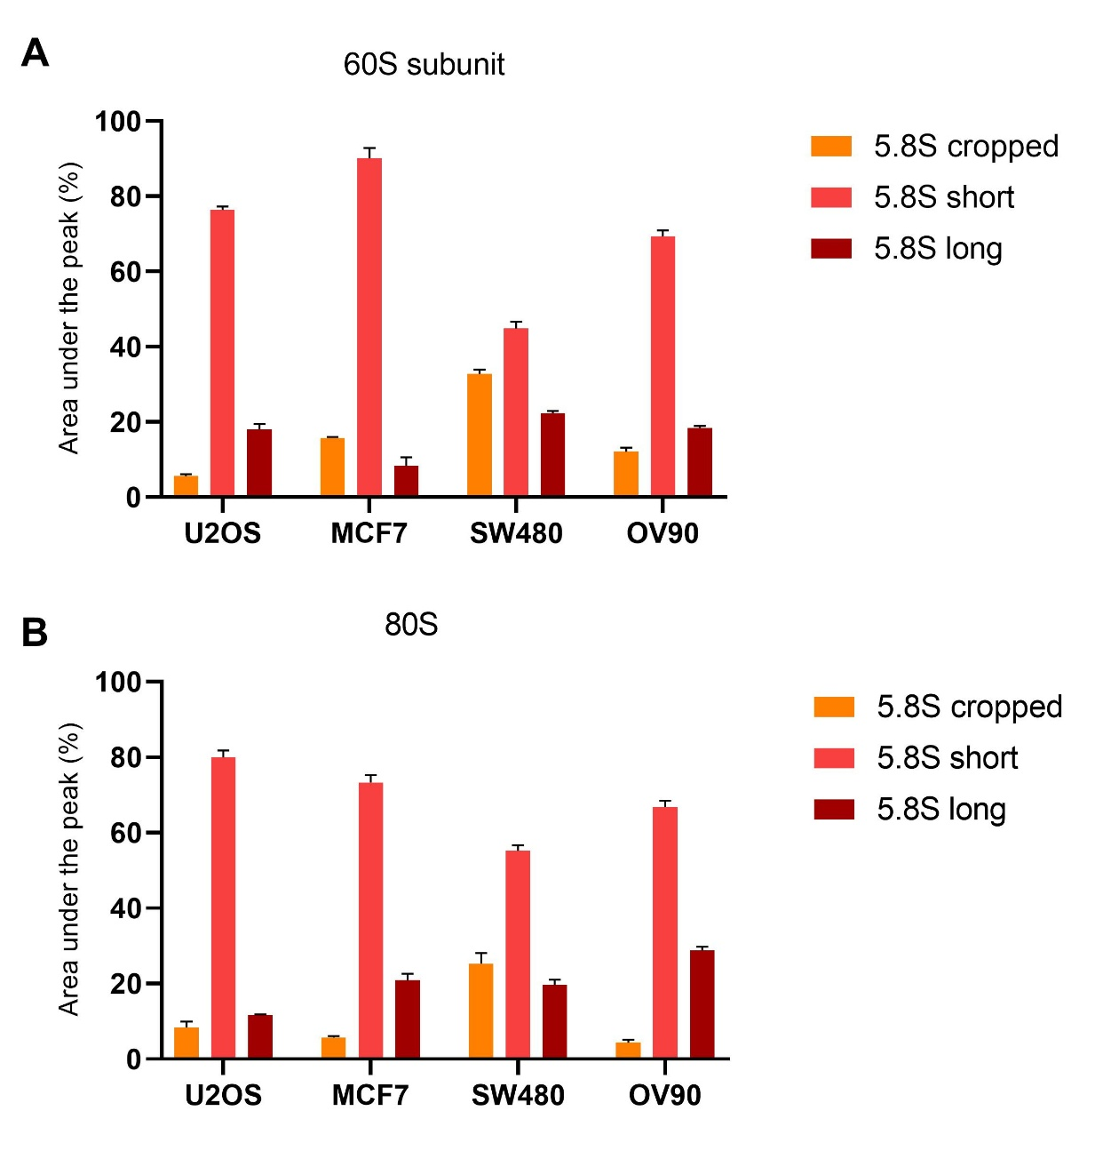
Supplementary figure S1. 5.8S isoforms representation in ribosomal 60S and 80S subunits. Polysomal fractioning of U2OS, MCF7, SW480 and OV90 cell lines and 5.8S rRNA isoforms analysis in RNA purified from the fraction containing 60S and 80S subunits. A Relative abundance of the three isoforms in free 60S subunit is mostly similar to what observed in polysomes for U2OS, MCF7 and OV90, while SW480 showed an increased amount of cropped form compared to actively translating ribosomes. B Relative abundance of the three forms of 5.8S rRNA in fraction containing 80S monosomes. SW480 cell line present a distribution that is intermediate between what observed in 60S subunit and in polysomes. The difference between the distribution of the three forms between 60S subunits and polysomes is statistically significant (p=0.0231) and was determined using Chi square test.

Paramenter | Num. | 5.8S cropped |  | 5.8S short |  | 5.8S long
 |  | Mean±SD | p | Mean±SD | p | Mean±SD | p
Average value | 134 | 2,36 | 1,65 | 0,87 | 0,1 | 1,6 | 0,81
Age |  |  | 0,131 |  | 0,637 |  | 0,065
<50 | 22 | 1.98±1.55 |  | 0,87±0,07 |  | 1,79±0,83
≥50 | 105 | 2.52±1.67 |  | 0,87±0,1 |  | 1,49±0,73
T |  |  | 0,622 |  | 0,489 |  | 0,588
T1 | 63 | 2,3±1,66 |  | 0,87±0,1 |  | 1,6±0,76
T2 | 48 | 2,55±1,68 |  | 0,86±0,09 |  | 1,56±0,71
T3 | 6 | 2,79±1,33 |  | 0,9±0,07 |  | 1,11±0,79
T4 | 7 | 2,63±1,86 |  | 0,86±0,08 |  | 1,58±0,87
N |  |  | 0,968 |  | 0,198 |  | 0,202
N0 | 53 | 2,5±1,87 |  | 0,85±0,1 |  | 1,66±0,82
N+ | 65 | 2,3±1,48 |  | 0,88±0,09 |  | 1,49±0,7
G |  |  | 0,016* |  | 0,011* |  | 0,901
1 | 16 | 1,64±1,05 |  | 0,91±0,06 |  | 1,6±0,9
2 | 47 | 2,28±1,73 |  | 0,88±0,11 |  | 1,53±0,74
3 | 61 | 2,78±1,65 |  | 0,85±0,08 |  | 1,57±0,72
Estrogen receptor status |  |  | 0,748 |  | 0,007* |  | 0,027*
Negative | 36 | 2,71±2,04 |  | 0,83±0,1 |  | 1,76±0,74
Positive | 89 | 2,35±1,47 |  | 0,88±0,09 |  | 1,46±0,75
Progesteron receptor status |  |  | 0,492 |  | 0,392 |  | 0,23
Negative | 60 | 2,43±1,82 |  | 0,86±0,1 |  | 1,63±0,72
Positive | 65 | 2,48±1,5 |  | 0,88±0,09 |  | 1,47±0,78
HER2 |  |  | 0,089 |  | 0,539 |  | 0,485
Negative | 93 | 2,55±1,55 |  | 0,87±0,08 |  | 1,51±0,74
Positive | 32 | 2,19±1,93 |  | 0,87±0,12 |  | 1,66±0,80
Ki67-LI |  |  | 0,169 |  | 0,015* |  | 0,446
<20% | 47 | 2,1±1,27 |  | 0,9±0,07 |  | 1,49±0,7
>20% | 78 | 2,67±1,82 |  | 0,85±0,1 |  | 1,59±0,78
Molecular classification |  |  | 0,329 |  | 0,029* |  | 0,12
Luminal A | 41 | 2,15±1,29 |  | 0,89±0,06 |  | 1,48±0,67
Luminal B | 48 | 2,52±1,6 |  | 0,88±0,1 |  | 1,45±0,81
HER2 + | 14 | 2,32±2,33 |  | 0,83±0,13 |  | 1,95±0,78
Triple negative | 22 | 2,96±1,85 |  | 0,83±0,08 |  | 1,65±0,70
Supplementary table 1. 5.8S rRNA forms levels correlated with clinical and pathological parameters of the studied series. Tumors’ 5.8S rRNA levels are expressed as fold change on 5.8S rRNA levels of reference RNA. SD, standard deviation; n, number; p, p value; T, size of the tumor; N lymph node involvement; G, grade of the tumor; Ki67-LI, labelling index. * identifies statistically significant association with p<0.05.

 | Factor | Hazard Ratio (95%CI) | p value
5.8S cropped | N | 1,219 | 0,757
5.8S cropped | T | 2,468 | 0,007*
5.8S cropped | G | 1,277 | 0,605
5.8S cropped | Progesteron receptor status | 0,567 | 0,325
5.8S cropped | Ki67-LI | 0,993 | 0,993
5.8S cropped | HER2 | 2,777 | 0,122
5.8S cropped | 5.8S cropped | 0,275 | 0,097
5.8S short | N | 0,991 | 0,989
5.8S short | T | 3,124 | 0,003*
5.8S short | G | 1,198 | 0,719
5.8S short | Progesteron receptor status | 0,395 | 0,129
5.8S short | Ki67-LI | 1,73 | 0,512
5.8S short | HER2 | 1,44 | 0,628
5.8S short | 5.8S short | 0,177 | 0,039*
5.8S long | N | 0,966 | 0,958
5.8S long | T | 2,395 | 0,01*
5.8S long | G | 1,075 | 0,881
5.8S long | Progesteron receptor status | 0,621 | 0,431
5.8S long | Ki67-LI | 1,68 | 0,521
5.8S long | HER2 | 2,294 | 0,241
5.8S long | 5.8S long | 2,009 | 0,286

Supplementary table 2. Multivariate analyses for the three 5.8S forms and clinical and bio-pathological parameters in estrogen positive breast cancer tissue. T, size of the tumor; N lymph node involvement; G, grade of the tumor; Ki67-LI, labelling index. * identifies statistically significant association with p<0.05. Multivariate analyses were performed according to the Cox Proportional Hazards Model.

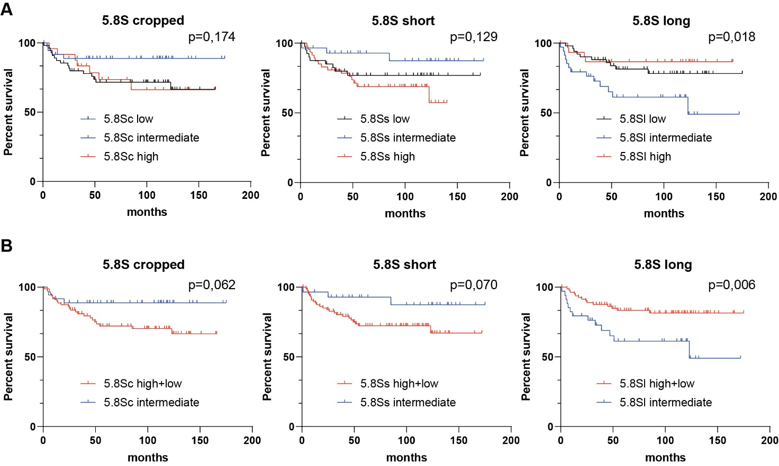
Supplementary figure S2. Disease free survival analysis of breast cancer patients stratified according to 5.8S isoforms level. A Patients (N=117) divided in three groups according to the best cutoff for each 5.8S parameter. This stratification showed significant worse prognosis for patients expressing intermediate values of 5.8S long. B From the stratification in three groups, patients expressing extreme values (high and low) for each 5.8S isoforms are grouped and compared with the patients expressing intermediate values in disease free survival analysis. Statistically significant association with prognosis results for 5.8S long isoform.

