Supplementary Materials for manuscript
Monika Bender, Vincenzo Romei, Paul Sauseng: Slow theta tACS of the right parietal cortex enhances visual working memory capacity

Detailed results from experiment 1
In experiment 1 no significant main effects or any significant interactions were obtained. Table S1 gives a detailed overview of the obtained results.
Table S1: overview of results obtained by a three-way repeated-measures ANOVA in experiment 1.
Effect | F | df | p | η²
Stimulation (4Hz, 7Hz) | .94 | 1/17 | .346 | .052
Hemifield (left, right) | .20 | 1/17 | .660 | .012
Memory Load (4,5,6) | 1.47 | 2/34 | .247° | .080
Stimulation*Hemifield | 1.08 | 1/17 | .314 | .060
Stimulation*Memory Load | .62 | 2/34 | .544 | .035
Hemifield*Memory Load | 1.2 | 2/34 | .315 | .066
Stimulation*Hemifield*Load | .11 | 2/34 | .899 | .006
°corrected for violation of sphericity
As demonstrated in table S1 effect sizes are in the range of small to medium. However, the sample size in experiment 1 does not seem large enough for medium sized effects to reach significance.

Comparison of effects between experiment 1, experiment 2 and Wolinski et al. (2018)
In Wolinski et al. (2018) two effects in the experimental montage condition have been particularly emphasised and reported: a main effect for Stimulation, and an interaction between Stimulation and Hemifield. In experiment 2 of the current study an interaction between Stimulation, Hemifield and Memory Load has been reported. To compare these effects across all studies and experiments please see supplementary Table S2.
Table S2: Comparison of effects from Wolinski et al.’s (2018) study and experiment 1 and 2 from the current study.
Effect | Wolinski et al. (2018) | Experiment 1 | Experiment 2
Stimulation (4Hz, 7Hz) | F_{1/15}=5.70, p=.03, η²=.275 | F_{1/17}=.94, p=.346, η²=.052 | F_{1/13}=4.40, p=.046, η²=.253
Stimulation*Hemifield | F_{1/15}=9.53, p=.008, η²=.389 | F_{1/17}=1.08, p=.314, η²=.06 | F_{1/13}=3.39, p=.089, η²=.207
Stimulation*Hemifield*Memory Load (4,5,6) | n.s. | F_{2/34}=.11, p=.899, η²=.006 | F_{2/26}=3.48, p=.046, η²=.211

As evident from Table S2 effect sizes for main effect Stimulation and the interaction between Stimulation and Hemifield are very high and comparable between the Wolinski et al. (2018) study and experiment 2 of the current study. As mentioned above, effect sizes for these terms were only medium sized in experiment 1.

Analysis of HIT and FA rates in experiment 2
Equivalent to data analysis in Wolinski et al. (2018) sham-corrected k-estimates were also used in the current study, i.e. HIT and FA rates were z-transformed, subtracted from each other and multiplied by set size; then the difference values between 4Hz tACS and sham stimulation and 7Hz tACS and sham were submitted to statistical analysis. This way comparability with Wolinski et al.’s (2018) study is best. For the sake of completeness and to demonstrate that effects reported in experiment 2 of the current study are not biased by any ceiling effects in conditions with low memory load, we hereby report analyses on un-processed HIT and FA rates.
For HIT rate results for the three-way repeated measures ANOVA were very similar to the ones reported for k-values in the manuscript. We found a significant interaction between factors STIMULATION (4Hz, sham, 7Hz) and HEMIFIELD (F_{2/26}=5.54, p=.01), a significant three-way interaction STIMULATION*HEMIFIELD*MEMORY LOAD (F_{4/52}=2.73, p=.039). Moreover, there was a rather trivial main effect for factor MEMORY LOAD (F_{2/26}=24.18, p=.000). No other main effects or interactions were significant (STIMULATION: F_{2/26}=0.31, p=.74; HEMIFIELD: F_{1/13}=3.54, p=.083; STIMULATION*MEMORY LOAD: F_{4/52}=0.94, p=.447; MEMORY LOAD*HEMIFIELD: F_{2/26}=1.19, p=.321). As can be seen in Figure S1, similar to k-values HIT rates also show a hemifield specific stimulation effect particularly for memory load 6. We find a modulation of HIT rate in the hypothesised direction (with 4Hz tACS leading to higher performance and 7Hz stimulation to reduced performance compared to sham) only for the hemifield contralateral to the stimulation site. It is also evident from the figure that even in memory load condition 4 participants were not performing at ceiling level. Therefore, it is rather unlikely that memory load specific effects were predominantly observed for memory load 6 due to ceiling effects at lower loads.
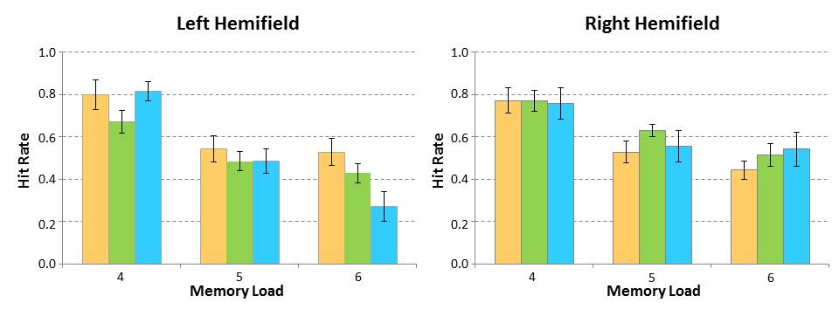
Figure S1: HIT rates as a function of stimulation condition and visual hemifield. Apricot bars represent 4Hz tACS, green bars sham stimulation and blue bars stand for 7Hz tACS. Error bars represent SEM.

Another three-way repeated measures ANOVA was run for FA rates (see Fig. S2). The only significant effect obtained was a main effect for MEMORY LOAD (F_{2/26}=7.00, p=.004). No further main effects or interactions were significant for false alarms (STIMULATION: F_{2/26}=.75, p=.484; HEMIFIELD: F_{1/13}=.92, p=.355; STIMULATION*MEMORY LOAD: F_{4/52}=1.48, p=.222; STIMULATION*HEMIFIELD: F_{2/26}=.04, p=.959; MEMORY LOAD*HEMIFIELD: F_{2/26}=.97, p=.362; STIMULATION*HEMIFIELD*MEMORY LOAD: F_{4/52}=.29, p=.885).
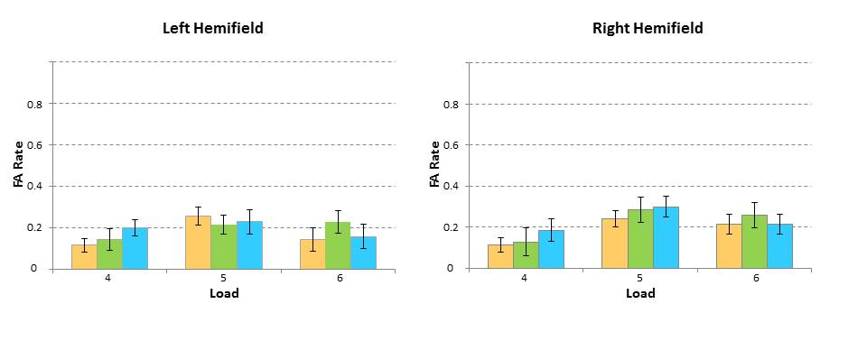
Figure S2: False Alarms (FA) rates as a function of stimulation condition and visual hemifield. Apricot bars represent 4Hz tACS, green bars sham stimulation and blue bars stand for 7Hz tACS. Error bars represent SEM.

Electric field distribution estimation
NIC 2.0 software (Neuroelectrics®) was used to estimate electric field distribution on cortical level (see Miranda et al. 2013 for technical details). A caveat in applying this estimation here, however, is that electrode size is not taken into account, as in the current study the stimulation electrode over P4 was 19.6 cm² whereas the three return electrodes were only 4.9 cm² large. This means that current density was smaller under the stimulation electrode at P4 than estimated by NIC 2.0, and consequently, field strength was somewhat smaller than suggested by Fig. 1a and 1b. However, this bias holds true for both experiments.
NIC 2.0 software does not allow modelling the field distribution in subcortical brain regions. Therefore, we can only assume that in contrast to Wolinski et al. (2018) there should be a smaller likelihood of subcortical brain regions having been stimulated with the electrode montage used in the current study.

