Supplementary material

The volume of food ingested during oral acute exposure was strongly influenced by the concentration of biopesticide in the solution (β = -0.6113 ± 0.1139 SE, z = -5.365, p < 0.001). Therefore, the main conclusions of the manuscript were drawn using data from females that consumed more than 50% of the offered volume.
Subsequently, ingestion level was treated as a categorical variable to evaluate whether survival probability differed across levels. All pairwise comparisons resulted in p-values > 0.05, indicating that ingestion level did not affect the response within each concentration. Accordingly, models for oral exposure were fitted using the full dataset.
For survival data, mortality increased with biopesticide concentration (β = 0.5725 ± 0.1718 SE, z = 3.332, p = 0.00086; Figure S1), resulting in an LC20 of 2.87% (95% CI: 1.00-7.31). biopesticide. The LC50 could not be estimated within the tested concentration range, as model predictions indicated a median lethal concentration above 20%.
For reproductive responses, biopesticide concentration did not affect the number of eggs laid (χ² = 9.943, df = 13, p = 0.699; Figure S2a) or the pupation rate (χ² = 17.337, df = 13, p = 0.184; Figure S2b).

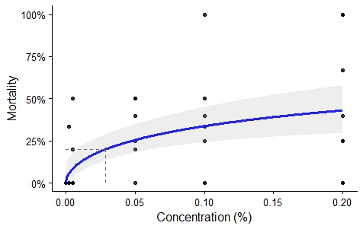
Figure S1. Mortality curve for E. larvarum adult females following oral exposure to oil-based biopesticide. The shaded gray area indicates the 95% confidence interval of the fitted model (blue line). Dots represent the raw data per cage. The dashed line indicates LC20. The dose–response curve was fitted using individual-level binary data of mortality for all individuals and cage as random effect.

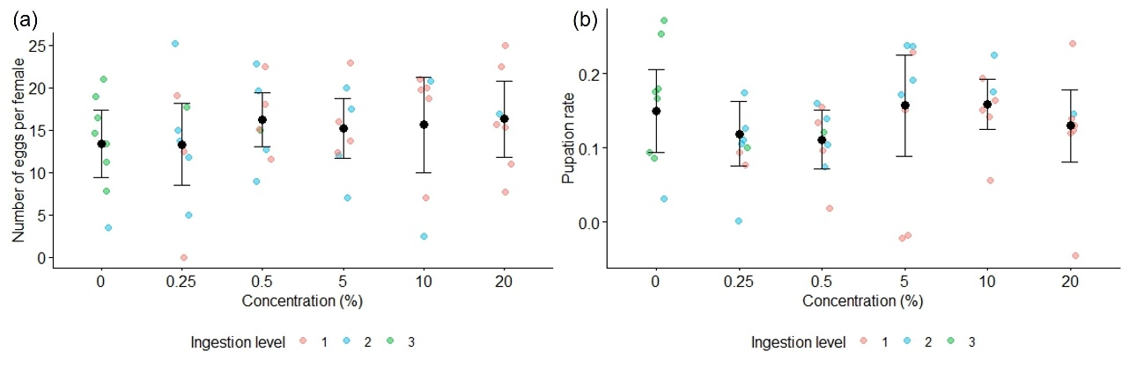
Figure S2. Reproductive responses of E. larvarum after oral exposure of mated females. All females were included. Dots represent the raw data per cage, black error bars indicate the model-estimated means ± 95% confidence intervals, and colors represent the ingestion level of the offered solution: 1 = consumed <50% of the volume, 2 = consumed >50%, and 3 = consumed 100% of the offered solution. (a) Number of eggs laid per female; (b) Proportion of eggs reaching the pupal stage.

