Supplementary File
SGLT2-Inhibitors in Diabetic Patients with Severe Aortic Stenosis and
Cardiac Damage undergoing Transcatheter Aortic Valve Implantation (TAVI)

Authors: Pasquale Paolisso MD, PhD^{a•}, Marta Belmonte MD^{b,c•}, Emanuele Gallinoro MD, PhDª, Roberto Scarsini MD, PhD^{d}, Luca Bergamaschi MDe, Leonardo Portolan MD^{d}, Matteo Armillotta MDe, Giuseppe Esposito MD^{f}, Elisabetta Moscarella MD^{g,h}, Giovanni Benfari MD, PhD^{d}, Claudio Montalto MD^{f}, Monika Shumkova, MD^{b}, Elayne Kelen de Oliveira MD^{b,c}, Francesco Angeli MDe, Mateusz Orzalkiewicz MDe, Margherita Fabroni MD^{d}, Nurcan Baydaroglu MD^{f}, Andrea Raffaele Munafò MD^{f}, Daniele Oreste D’Atri MD^{i}, Matteo Casenghi MD^{j}, Lucia Scisciola PhD^{k}, Michelangela Barbieri MD, PhD^{k}, Raffaele Marfella MD, PhD^{k}, Felice Gragnano MD, PhD^{g,h}, Edoardo Conte MDª, Dario Pellegrini MD^{i}, Alfonso Ielasi MD^{i}, Daniele Andreini MDª, Martin Penicka MD^{b}, Jacopo Andrea Oreglia MD^{f}, Paolo Calabrò MD, PhD^{g,h}, Antonio Bartorelli MDª, Carmine Pizzi MDe, Tullio Palmerini MDe, Marc Vanderheyden MD^{b}, Francesco Saia MDe, Flavio Ribichini MD^{d}, Emanuele Barbato MD, PhD^{j,l}

Affiliations:
- Clinical Cardiology and Cardiovascular Imaging Unit, IRCCS, Galeazzi-Sant'Ambrogio Hospital, Milan, Italy; Department of Biomedical and Clinical Sciences, University of Milan, Milan, Italy.
- Cardiovascular Center Aalst, OLV-Clinic, Aalst, Belgium.
- Dept. of Advanced Biomedical Sciences, University Federico II, Naples, Italy.
- Cardiovascular Department, Azienda Ospedaliero Universitaria Integrata di Verona, Verona, Italy.
- Unit of Cardiology, Department of Experimental, Diagnostic and Specialty Medicine-DIMES, University of Bologna, Sant'Orsola-Malpighi Hospital, IRCCS, Bologna, Italy.
- Interventional Cardiology Unit, De Gasperis Cardio Center, Niguarda Hospital, Milan, Italy.
- Division of Cardiology, A.O.R.N. “Sant’Anna e San Sebastiano”, Caserta, Italy.
- Department of Translational Medical Sciences, University of Campania ‘Luigi Vanvitelli’, Naples, Italy.
- Cardiology Division, IRCCS Galeazzi-Sant'Ambrogio Hospital, Milan, Italy.
- Division of Cardiology, Sant'Andrea Hospital, Rome, Italy.
- Department of Advanced Medical and Surgical Sciences, University of Campania “Luigi Vanvitelli”, Naples, Italy.
- Department of Clinical and Molecular Medicine, Sapienza University of Rome, Rome, Italy.

• The first two authors contributed equally to this work.

Corresponding authors:
Emanuele Barbato MD, PhD, FESC
Department of Clinical and Molecular Medicine, Sapienza University of Rome, Roma, Italy
Email: emanuele.barbato@uniroma1.it

EXTENDED METHODS
Data collection and definition of diabetes mellitus
For each patient, demographic and baseline clinical data were collected, including age, sex, anthropometric data, cardiovascular risk factors, family history of cardiovascular disease, history of comorbidities, and discharge therapy. Pre-existing type 2 diabetes mellitus (T2DM) was defined as known type 2 diabetes mellitus at the time of discharge irrespective of the therapeutic management (diet and lifestyle measures alone or additional administration of oral glucose-lowering medication and insulin)(1).

Transthoracic echocardiography
Comprehensive Transthoracic echocardiography (TTE) was performed by qualified cardiac imagers with >5 years of experience in cardiac imaging, as part of routine clinical practice using a high-quality ultrasound system (GE Vivid E9, E95 or S70, GE Healthcare Horten, Norway or Epiq 7C, Affiniti 70C, Philips Healthcare, Eindhoven, The Netherlands). Echocardiographic examinations were performed following the recommendations of the American Society of Echocardiography and the European Association of Cardiovascular Imaging (2). If patients were in sinus rhythm, 3 cardiac cycles were averaged for all measures, whereas for those in atrial fibrillation, 5 cardiac cycles were averaged.
Pulsed wave Doppler was used to measure the E- and A-wave peak velocities from the mitral inflow profile according to guidelines (3). The early diastolic velocity of the mitral annulus (e’) was obtained by Doppler tissue imaging at the lateral and septal aspects of the annulus and then averaged for each patient. The total E/e’ ratio was then calculated. Left atrial (LA) volume was measured using the biplane Simpson method and was indexed to body surface area (BSA) - left atrial volume indexed, LAVi (2). Left ventricular ejection fraction (LVEF) was estimated by the Simpson biplane method. Left ventricular (LV) mass was calculated with the corrected formula of the American Society of Echocardiography (ASE) and was indexed to BSA (2). LV diastolic dysfunction was assessed and graded according to American Society of Echocardiography guidelines (3). Systolic pulmonary arterial pressure (PASP) was derived from the peak velocity of the regurgitant jet of tricuspid regurgitation and the estimated right atrial pressure (4). The DTI-derived tricuspid lateral annular systolic velocity wave (S’) and tricuspid annular plane systolic excursion (TAPSE) were measured to assess the right ventricular (RV) longitudinal systolic function (2). The severity of aortic, mitral, and tricuspid regurgitation was determined using a multi-parametric approach, as recommended by the guidelines (4,5).
The hemodynamic parameters of aortic stenosis (AS) severity included peak aortic jet velocity (V_{peak}), mean transvalvular gradient obtained with the simplified Bernoulli equation, aortic valve area (AVA) calculated by the continuity equation and indexed to body surface area (AVAi) (6). The stroke volume was calculated by multiplying the area of the left ventricular outflow tract (LVOT) by the outflow tract time-velocity integral and indexed to the BSA (2). According to current guidelines, high gradient (HG) AS was defined as peak transvalvular velocity ≥4 m/s, transvalvular mean gradient (MG) ≥40 mmHg, and AVA ≤ 1 cm² in a regular flow state [LVEF>50% and stroke volume index (SVi) ≥35 ml/m²]. Low flow-low gradient (LF-LG) AS was defined as AVA≤1 cm², but transvalvular mean gradient (MG) <40 mmHg and peak transvalvular velocity <4 m/s in a low flow state (SVi<35 ml/m²). In patients with LF-LG AS, severity was confirmed with low-dose dobutamine stress echocardiography and/or cardiac computed tomography, as appropriate (7,8).
The extent of extra-valvular cardiac damage (EVCD) was categorized into 5 stages according to a model described by Genereux et al. (9). In detail, the EVCD was categorized into 5 stages, as follows: i) stage 0 - no cardiac damage; ii) stage 1 - left ventricular damage, as defined by left ventricular mass index (LVMi) > 115 g/m² (male) or > 95 g/m² (female), E/E’ > 14, LVEF <50%; iii) stage 2: left atrial or mitral damage, as defined by left atrial volume index > 34 ml/m², moderate to severe mitral regurgitation, atrial fibrillation; iv) stage 3: pulmonary vasculature or tricuspid damage, as defined by pulmonary artery systolic pressure (PASP) ≥ 60 mmHg, moderate to severe tricuspid regurgitation; v) stage 4: right ventricular damage, as defined by TAPSE <17 mm, S’ <9.5 cm/s, and fractional area change <35%. Patients were hierarchically classified in one given stage (the worst one) if at least one of the criteria of that stage was met. In this study EVCD was also dichotomized in Genereux stages 0-2 (isolated left heart dysfunction) and Genereux stages 3-4 (right heart involvement, advanced EVCD), as previously reported (10,11). LV recovery was defined as an EF improvement ≥10% associated with a decrease ≥20% of LVMi and/or a decrease ≥20% of left ventricular end-diastolic volume (LVEDV) at short-term follow-up after TAVI (8,12-15). Delta variations of the following echocardiographic parameters (LVEF, LVEDV, LAVi, TAPSE, PASP) were defined as the follow-up versus baseline changes of these echocardiographic parameters in SGLT2i versus no-SGLT2i users.

Procedures
For transcatheter aortic valve implantation (TAVI), right femoral access for valve delivery and left femoral or radial access for aortic root angiography were first obtained. In patients undergoing balloon-expandable valve implantation, the left femoral vein was cannulated to place a stimulating catheter in the right ventricle, whereas for self-expandable valve, pacing was performed over the wire. The main femoral access was pre-closed with two suture-based vascular closure devices (ProGlide, Abbott, Abbott Park, Illinois).
The TAVI delivery sheath was inserted into the main access using a stiff wire. Then a Judkins Left 4 (JL4) guiding catheter was introduced in the TAVI delivery sheath to cannulate the left coronary artery to perform the invasive physiological assessment. Afterward, using an Amplatz left (AL 1) catheter and a standard straight-tipped metallic wire, the aortic valve was crossed; the catheter advanced into the LV, and the straight-tipped wire was removed for an exchange length J-shaped wire. A pigtail catheter was placed in exchange for the catheter in the LV and directed toward the LV apex. At this time, simultaneous pressure assessment in the LV and aorta allows for measurement and recording of the transvalvular gradient. Subsequently, a pre-shaped stiff wire (Safari XS, Boston ScientificTM) was inserted into the LV through the pigtail catheter. Pre-dilation of the aortic valve was routinely performed in case of self-expandable valve implantation. The transcatheter valve was then delivered over the pre-shaped stiff wire, advanced through the aortic valve using a pigtail, previously placed in the non-coronary cusp as reference. The valve was then deployed, and the delivery system retracted. A pigtail was advanced into the left ventricle over the pre-shaped stiff wire to assess the transvalvular gradient. An aortic root angiogram was performed to assess the result. Whenever needed, the valve was post-dilated.

Clinical Outcomes
Pre-specified endpoints were all-cause mortality, cardiovascular deaths, heart failure, and the composite one (major adverse cardiovascular events, MACE). All-cause mortality included all causes of death for the population during the follow-up. Cardiovascular mortality consisted of deaths resulting from an AMI, sudden cardiac death, heart failure, stroke, and other cardiovascular causes. Heart failure, both with preserved and reduced ejection fraction, was diagnosed according to current ESC guidelines (16). Heart failure re-hospitalization was evaluated according to the ESC Guidelines and consisted of unscheduled hospital admission for a primary diagnosis of HF in which the patient presented typical signs, symptoms, and diagnostic testing consistent with the diagnosis of HF and consequently received HF-directed therapy (17). MACE was defined as a composite of cardiovascular mortality and non-fatal heart failure hospitalization (17). Clinical and procedural endpoints were defined in accordance with Valve Academic Research Consortium 3 (18).
REFERENCES
1. Marx N, Federici M, Schütt K et al. 2023 ESC Guidelines for the management of cardiovascular disease in patients with diabetes. Eur Heart J 2023;44:4043-4140.
2. Lang RM, Badano LP, Mor-Avi V et al. Recommendations for cardiac chamber quantification by echocardiography in adults: an update from the American Society of Echocardiography and the European Association of Cardiovascular Imaging. Eur Heart J Cardiovasc Imaging 2015;16:233-70.
3. Nagueh SF, Smiseth OA, Appleton CP et al. Recommendations for the Evaluation of Left Ventricular Diastolic Function by Echocardiography: An Update from the American Society of Echocardiography and the European Association of Cardiovascular Imaging. J Am Soc Echocardiogr 2016;29:277-314.
4. Lancellotti P, Tribouilloy C, Hagendorff A et al. Recommendations for the echocardiographic assessment of native valvular regurgitation: an executive summary from the European Association of Cardiovascular Imaging. Eur Heart J Cardiovasc Imaging 2013;14:611-644.
5. Zoghbi WA, Enriquez-Sarano M, Foster E et al. Recommendations for evaluation of the severity of native valvular regurgitation with two-dimensional and Doppler echocardiography. J Am Soc Echocardiogr 2003;16:777-802.
6. Baumgartner HC, Hung JC-C, Bermejo J et al. Recommendations on the echocardiographic assessment of aortic valve stenosis: a focused update from the European Association of Cardiovascular Imaging and the American Society of Echocardiography. Eur Heart J Cardiovasc Imaging 2017;18:254-275.
7. Vahanian A, Beyersdorf F, Praz F et al. 2021 ESC/EACTS Guidelines for the management of valvular heart disease. Eur Heart J 2022;43:561-632.
8. Dweck MR, Loganath K, Bing R et al. Multi-modality imaging in aortic stenosis: an EACVI clinical consensus document. Eur Heart J Cardiovasc Imaging 2023;24:1430-1443.
9. Généreux P, Pibarot P, Redfors B et al. Staging classification of aortic stenosis based on the extent of cardiac damage. Eur Heart J 2017;38:3351-3358.
10. Scarsini R, Gallinoro E, Ancona MB et al. Characterisation of coronary microvascular dysfunction in patients with severe aortic stenosis undergoing TAVI. EuroIntervention 2024;20:e289-e300.
11. Nakase M, Tomii D, Heg D et al. Long-Term Impact of Cardiac Damage Following Transcatheter Aortic Valve Replacement. JACC: Cardiovascular Interventions 2024;17:992-1003.
12. Witberg G, Levi A, Talmor-Barkan Y et al. Outcomes and predictors of left ventricle recovery in patients with severe left ventricular dysfunction undergoing transcatheter aortic valve implantation. EuroIntervention 2024;20:e487-e495.
13. Kim JB, Kobayashi Y, Kuznetsova T et al. Cytokines profile of reverse cardiac remodeling following transcatheter aortic valve replacement. Int J Cardiol 2018;270:83-88.
14. Gastl M, Behm P, Haberkorn S et al. Role of T2 mapping in left ventricular reverse remodeling after TAVR. Int J Cardiol 2018;266:262-268.
15. Huang L, Lai X, Xu L, Zeng Z, Xia H. Left ventricular reverse remodeling after transcatheter aortic valve replacement for predominant aortic stenosis and mixed aortic valve disease. J Clin Ultrasound 2023;51:1453-1460.
16. McDonagh TA, Metra M, Adamo M et al. 2021 ESC Guidelines for the diagnosis and treatment of acute and chronic heart failure: Developed by the Task Force for the diagnosis and treatment of acute and chronic heart failure of the European Society of Cardiology (ESC). With the special contribution of the Heart Failure Association (HFA) of the ESC. Eur J Heart Fail 2022;24:4-131.
17. Hicks KA, Mahaffey KW, Mehran R et al. 2017 Cardiovascular and Stroke Endpoint Definitions for Clinical Trials. Circulation 2018;137:961-972.
18. Généreux P, Piazza N, Alu MC et al. Valve Academic Research Consortium 3: Updated Endpoint Definitions for Aortic Valve Clinical Research. J Am Coll Cardiol 2021;77:2717-2746.

SUPPLEMENTARY TABLES
Supplementary Table 1. Number of patients per year included in the study, stratified in SGLT2i versus no-SGLT2i users.

 | Total  (N = 311) | SGLT2i users  (N = 74) |  | No-SGLT2i users  (N = 237)
Year of inclusion
2020, n (%) | 66 (21.2) | 7 (9.5) |  | 59 (24.9)
2021, n (%) | 80 (25.7) | 10 (13.5) |  | 70 (29.5)
2022, n (%) | 89 (28.6) | 29 (39.2) |  | 60 (25.3)
2023, n (%) | 76 (24.4) | 28 (37.8) |  | 48 (20.3)

Categorical variables as number (%). Abbreviations: SGLT2i=sodium/glucose cotransporter 2 inhibitors.

Supplementary Table 2. Procedural characteristics of the study population, stratified in SGLT2i versus no-SGLT2i users.
 | Total  (N = 311) | SGLT2i  users  (N = 74) | No-SGLT2i  users  (N = 237) | P-value
Transfemoral vascular access, n (%) | 299 (96.1) | 72 (97.3) | 227 (95.8) | 0.554
Valve-in-valve procedure, n (%) | 18 (5.8) | 7 (9.5) | 11 (4.6) | 0.121
Valve Type, n (%)  Balloon expandable, n (%)  Self-expandable, n (%) | 179 (57.6)  132 (42.4) | 54 (73)  20 (27) | 125 (52.7)  112 (47.3) | 0.002
Procedural Time, min | 97 [75 – 125] | 100 [84 – 127] | 95 [70 – 121] | 0.067
Contrast dose, ml | 118 [89 - 150] | 115 [88 - 132] | 120 [90 - 150] | 0.201
Significant PVL, n (%)• | 3 (0.96) | 1 (1.3) | 2 (0.84) | 0.696
Permanent Pacemaker implantation | 24 (7.7) | 5 (6.8) | 19 (8) | 0.723
Vascular complications, n (%)  Minor  Major | 21 (6.8)  7 (2.3) | 4 (5.4)  2 (2.7) | 17 (7.2)  5 (2.1) | 0.836
Neurologic complications, n (%)  TIA  Stroke | 5 (1.6)  2 (0.6) | 0 (0)  0 (0) | 5 (2.1)  2 (0.8) | 0.327
Bleeding Type (VARC-3), n (%)  1, n (%)  2, n (%)  3, n (%) | 14 (4.5)  10 (3.2)  5 (1.6) | 4 (5.4)  0 (0)  1 (1.4) | 10 (4.2)  10 (4.2)  4 (1.7) | 0.333

Continuous variables are presented as mean±SD or as median [IQR]; while categorical variables as number (%). Abbreviations: SGLT2i=sodium/glucose cotransporter 2 inhibitors; PVL=paravalvular leak; TIA=transient ischemic attack; VARC-3= Valve Academic Research Consortium 3.
• more than mild PVL.
Supplementary Table 3. Medical therapy at discharge of the study population, stratified in SGLT2i versus no-SGLT2i users.

 | Total  (N = 311) | SGLT2i  users  (N = 74) | No-SGLT2i  users  (N = 237) | P-value
Antiplatelets, n (%) | 209 (67.2) | 44 (59.5) | 165 (69.6) | 0.104
Anticoagulation, n (%) | 134 (43.1) | 36 (48.6) | 98 (41.4) | 0.268
RAASi, n (%) | 162 (52) | 37 (50) | 125 (52.7) | 0.680
ARNI, n (%) | 28 (9) | 10 (13.5) | 18 (7.6) | 0.120
MRA, n (%) | 121 (38.9) | 35 (47.3) | 86 (36.3) | 0.090
B-blockers, n (%) | 197 (63.3) | 51 (68.9) | 146 (61.6) | 0.254
Statins, n (%) | 244 (78.5) | 62 (83.8) | 182 (76.8) | 0.202
Glucose-lowering agents
Metformin, n (%) | 132 (42.4) | 31 (41.9) | 101 (42.6) | 0.912
Sulfonylureas, n (%) | 48 (15.4) | 10 (13.5) | 38 (16) | 0.601
DPP-4 Inhibitors, n (%) | 35 (11.3) | 7 (9.5) | 28 (11.8) | 0.576
GLP-1 Agonist, n (%) | 16 (5.1) | 6 (8.1) | 10 (4.2) | 0.186
Insulin sc., n (%) | 115 (37) | 22 (29.7) | 93 (39.2) | 0.139
Lifestyle and diet alone | 9 (2.9) | - | 9 (3.8) | -

Categorical variables as number (%).
Abbreviations: SGLT2i=sodium/glucose cotransporter 2 inhibitors; RAASi=renin-angiotensin-aldosterone system inhibitors; ARNI=angiotensin receptor/neprilysin inhibitor; MRA=mineralocorticoid receptor antagonists; DPP-4 = dipeptidyl peptidase-4; GLP-1 = glucagon-like peptide-1; sc. = subcutaneous.

Supplementary Table 4. Baseline characteristics of the sub-group of patients with available comprehensive echocardiographic assessment at follow-up compared to the overall study population.

 | Patients with echo  available at FU  (N = 224) | Patients without echo  available at FU  (N = 87) | P-value
Baseline characteristics
Age, years | 80 [76 – 83] | 81 [75 – 85] | 0.160
Male Sex, n (%) | 148 (66.1) | 60 (69) | 0.626
BMI, kg/m² | 26.6 [23.9 – 30.2] | 25.1 [23.5 – 28.1] | 0.063
Hypertension, n (%) | 184 (82.1) | 77 (88.5) | 0.170
Dyslipidemia, n (%) | 180 (80.4) | 70 (80.5) | 0.984
COPD, n (%) | 43 (19.2) | 22 (25.3) | 0.236
CKD, n (%) | 129 (57.6) | 41 (47.1) | 0.096
Cancer, n (%) | 30 (13.4) | 10 (11.5) | 0.653
AF, n (%) | 102 (45.5) | 34 (39.1) | 0.303
Previous HF hospitalization | 81 (36.2) | 33 (37.9) | 0.771
CAD, n (%) | 144 (64.3) | 55 (63.2) | 0.860
Previous PCI, n (%) | 89 (39.7) | 43 (49.4) | 0.121
Previous CABG, n (%) | 42 (18.8) | 15 (17.2) | 0.758
Previous MV surgery, n (%) | 1 (0.5) | 1 (1.1) | 0.486
Previous SAVR, n (%) | 11 (4.9) | 5 (5.7) | 0.764
LVEF | 38 [31 – 45] | 37 [29 – 43] | 0.199
LF-LG AS | 131 (58.5) | 45 (51.7) | 0.280
Extra-valvular Cardiac Damage Staging, n (%) |  |  | 0.792
Stage 1 | 32 (14.3) | 16 (18.4)
Stage 2 | 100 (44.6) | 35 (40.2)
Stage 3 | 36 (16.1) | 15 (17.2)
Stage 4 | 56 (25) | 21 (24.1)

Continuous variables are presented as mean±SD or as median [IQR]; while categorical variables as number (%). Abbreviations: SGLT2i=sodium/glucose cotransporter 2 inhibitors; BMI=body mass index; COPD=chronic obstructive pulmonary disease; CKD=chronic kidney disease with 30<GFR<60 ml/min; AF=atrial fibrillation; HF=heart failure; CAD=coronary artery disease; PCI=percutaneous coronary intervention; CABG=coronary artery bypass graft; MV=mitral valve; SAVR=surgical aortic valve replacement.

Supplementary Table 5. Pre- and post-TAVI echocardiographic characteristics of patients with available comprehensive echocardiographic assessment at follow-up (N=224), stratified in SGLT2i and no-SGLT2i users.

 | SGLT2i  users  (N = 55) |  |  | No-SGLT2i  users  (N = 169) |  |  | Post-TAVI  SGLT2i vs no-SGLT2i
 | Pre-TAVI | Post-TAVI | p-value | Pre-TAVI | Post-TAVI | p-value | p-value
LVEDV, (mL) | 152.5 ± 54.1 | 135.5 ± 34 | <0.001 | 149.7 ± 53.8 | 136 ± 45.6 | <0.001 | 0.553
LVEDVi, (mL/ m²) | 79.3 ± 26.7 | 74.5 ± 26.9 | 0.012 | 80.1 ± 26.6 | 73.7 ± 23.5 | 0.011 | 0.962
LV Mass, g | 260.8 ± 63.1 | 249.8 ± 47.8 | 0.019 | 243.6 ± 57.6 | 231.5 ± 61.4 | 0.004 | 0.022
LV Mass index, g/m² | 136 ± 33.7 | 130.2 ± 26.2 | 0.008 | 132.1 ± 31.9 | 125.3 ± 34.4 | 0.010 | 0.195
BP LVEF, (%) | 35 [29 - 44] | 45 [38 – 50] | <0.001 | 39 [32 - 45] | 44 [36 – 50] | <0.001 | 0.744
LAV, (ml) | 92.5 ± 40.4 | 85.3 ± 25.7 | 0.230 | 90.5 ± 26.2 | 94.7 ± 31 | 0.771 | 0.230
LAVi, (ml/m²) | 48 ± 18.8 | 47 ± 16.2 | 0.061 | 50 ± 14.2 | 50.7 ± 16.5 | 0.469 | 0.061
E/e’ mean | 17.7 ± 7 | 14.9 ± 7.3 | 0.123 | 18.4 ± 6.7 | 16.3 ± 6.4 | 0.578 | 0.203
Significant MR•, n (%) | 6 (10.9) | 3 (5.5) | 0.297 | 10 (5.9) | 8 (4.7) | 0.628 | 0.829
Significant TR•, n (%) | 1 (2) | 1 (1.8) | 0.832 | 5 (3) | 7 (4.7) | 0.233 | 0.747
TAPSE, (mm) | 19 [18 - 22] | 20 [18 - 21] | 0.322 | 19 [16 – 21] | 20 [16 - 22] | 0.276 | 0.835
PASP, mmHg | 40 [35 - 50] | 32 [27 - 35] | <0.001 | 42 [33 - 55] | 36 [30 - 46] | 0.010 | 0.001

Continuous variables are presented as mean±SD or as median [IQR]; while categorical variables as number (%). Abbreviations: SGLT2i=sodium/glucose cotransporter 2 inhibitors; LV=left ventricle; LVEDVi=left ventricular end-diastolic volume indexed; LVEF=left ventricular ejection fraction; BP=biplane; LAVi=left atrial volume indexed; MR=mitral regurgitation; TR=tricuspid regurgitation; TAPSE=tricuspid annular plane systolic excursion; PASP=pulmonary artery systolic pressure.
• ≥ moderate MR/TR.

Supplementary Table 6. Cardiac damage staging transition and LV recovery at after TAVI of patients with available comprehensive echocardiographic assessment at follow-up (N=224), stratified in SGLT2i versus no-SGLT2i users.

 | SGLT2i  users  (N = 55) | No-SGLT2i  users  (N = 169) | P-value
Cardiac Damage Staging, n (%) |  |  | 0.378
Stage 0 | 3 (5.5) | 4 (2.4)
Stage 1 | 8 (14.5) | 21 (12.4)
Stage 2 | 31 (56.4) | 83 (49.1)
Stage 3 | 7 (12.7) | 26 (15.4)
Stage 4 | 6 (10.9) | 35 (20.7)
Left vs right chambers cardiac damage staging, n (%) |  |  | 0.112
Stage 1-2, n (%) | 39 (70.9) | 104 (61.5)
Stage 3-4, n (%) | 13 (23.6) | 61 (36.1)
Cardiac Damage staging progression | 4 (7.3) | 36 (21.3) | 0.018
Cardiac Damage staging stable or improved | 51 (92.7) | 133 (78.7)
Cardiac Damage staging stable | 34 (61.8) | 96 (56.8)
Cardiac Damage staging improved | 17 (30.9) | 37 (21.9)
Delta LVEF, % | 9 [5 – 14] | 5 [0 – 12] | 0.002
LV recovery | 26 (47.3) | 53 (31.4) | 0.032
LV recovery in patients with LVEF ≤30% | 14/20 (70) | 18/45 (40) | 0.026

Continuous variables are presented as mean±SD or as median [IQR]; while categorical variables as number (%). Abbreviations: SGLT2i=sodium/glucose cotransporter 2 inhibitors; LV=left ventricle; LVEF=left ventricular ejection fraction; BP=biplane.

Supplementary Table 7. Clinical outcomes of the study population stratified in SGLT2i versus no-SGLT2i-users.

 | Total  (N = 311) | SGLT2i  Users  (N = 74) | No-SGLT2i  users  (N = 237) | P-value
Primary Endpoint
MACE, n (%) | 123 (39.5) | 11 (14.9) | 112 (47.3) | <0.001
Secondary End points
All-cause deaths, n (%) | 99 (31.8) | 7 (9.5) | 92 (38.8) | <0.001
Cardiovascular-death, n (%) | 59 (19) | 5 (6.8) | 54 (22.8) | 0.002
HF Re-Hospitalization, n (%) | 66 (21.2) | 7 (9.5) | 59 (24.9) | 0.005
>1 HF Re-hospitalization, n (%) | 18 (5.8) | 2 (2.7) | 16 (6.8) | 0.193
PCI, n (%) | 20 (6.4) | 4 (5.4) | 16 (6.8) | 0.680

Abbreviations: SGLT2i=sodium/glucose cotransporter 2 inhibitors; MACE=major adverse cardiovascular events; HF=heart failure; PCI=primary percutaneous coronary intervention.

Supplementary Table 8. Univariable and multivariable analysis testing predictors of MACE, all-cause death, and HF hospitalization at 1-year follow-up.

 | MACE |  |  |  |  |  | All-cause death |  |  |  |  |  | HF Hospitalization
 | Univariate  analysis |  |  | Multivariate  analysis |  |  | Univariate  analysis |  |  | Multivariate  analysis |  |  | Univariate  analysis |  |  | Multivariate  analysis
Variables | HR | 95%CI | p-value | HR | 95%CI | p-value | HR | 95%CI | p-value | HR | 95% CI | p-value | HR | 95%CI | p-value | HR | 95% CI | p-value
Age | 1.05 | 1.01 - 1.09 | 0.030 | 1.01 | 0.94 - 1.06 | 0.956 | 1.05 | 0.99 - 1.10 | 0.076 | 0.98 | 0.90 - 1.05 | 0.494 | 1.04 | 0.98 - 1.09 | 0.215 | - | - | -
Gender, male | 1.37 | 0.86 - 2.18 | 0.185 | - | - | - | 1.20 | 0.68 – 2.11 | 0.523 | - | - | - | 1.29 | 0.70 – 2.41 | 0.411 | - | - | -
BMI | 1.01 | 0.96 - 1.05 | 0.771 | - | - | - | 1.01 | 0.95-1.06 | 0.832 | - | - | - | 1.01 | 0.95 – 1.07 | 0.737 | - | - | -
Hypertension | 1.27 | 0.65 - 2.47 | 0.484 | - | - | - | 1.81 | 0.72 - 4.54 | 0.209 | - | - | - | 1.21 | 0.51 – 2.86 | 0.670 | - | - | -
Dyslipidemia | 0.67 | 0.43 - 1.12 | 0.123 | - | - | - | 0.62 | 0.34 – 1.14 | 0.124 | - | - | - | 0.65 | 0.33 – 1.29 | 0.214 | - | - | -
COPD | 0.98 | 0.54 - 1.69 | 0.892 | - | - | - | 1.16 | 0.62 – 2.22 | 0.644 | - | - | - | 0.75 | 0.43 – 1.68 | 0.478 | - | - | -
CKD | 1.77 | 1.09 - 2.86 | 0.020 | 1.42 | 0.66 - 3.05 | 0.369 | 1.79 | 1.00 – 3.19 | 0.050 | 2.14 | 0.87 – 5.23 | 0.097 | 2.05 | 1.07 – 3.93 | 0.031 | 1.27 | 0.52 – 3.13 | 0.601
AF | 1.25 | 0.80 - 1.97 | 0.335 | - | - | - | 1.14 | 0.67 – 1.96 | 0.641 | - | - | - | 1.44 | 0.79 – 2.61 | 0.236 | - | - | -
CAD | 0.77 | 0.51 - 1.22 | 0.260 | - | - | - | 0.97 | 0.55 – 1.70 | 0.902 | - | - | - | 0.84 | 0.45 – 1.52 | 0.539 | - | - | -
Creatinine | 1.64 | 1.12 - 2.42 | 0.013 | 1.32 | 0.69 - 2.51 | 0.405 | 1.41 | 0.88 – 2.24 | 0.158 | - | - | - | 1.79 | 1.10 – 2.95 | 0.021 | 1.47 | 0.70 – 3.08 | 0.311
HbA1c | 1.01 | 0.98 - 1.03 | 0.832 | - | - | - | 1.01 | 0.98 – 1.04 | 0.580 | - | - | - | 0.99 | 0.97 – 1.03 | 0.934 | - | - | -
LF-LG AS Phenotype | 1.60 | 0.98 - 2.58 | 0.057 | 2.25 | 1.17 - 3.34 | 0.016 | 1.36 | 0.77 – 2.39 | 0.288 | - | - | - | 2.09 | 1.07 – 4.06 | 0.031 | 2.22 | 1.01 – 4.94 | 0.050
EVCD Staging 3-4 | 2.23 | 1.41 - 3.53 | <0.001 | 1.38 | 0.69 - 2.69 | 0.378 | 2.22 | 1.28 -3.87 | 0.005 | 1.73 | 0.79 – 3.76 | 0.167 | 4.14 | 2.13 – 8.06 | <0.001 | 2.01 | 0.85 – 4.77 | 0.114
TAPSE | 0.96 | 0.90 – 1.03 | 0.222 | - | - | - | 0.96 | 0.88 – 1.04 | 0.342 | - | - | - | 0.95 | 0.88 – 1.03 | 0.201 | - | - | -
PASP | 1.01 | 0.99 - 1.03 | 0.265 | - | - | - | 1.01 | 0.98 - 1.03 | 0.621 | - | - | - | 1.02 | 0.99 - 1.05 | 0.074 | 1.02 | 0.98 – 1.03 | 0.893
LV recovery | 0.49 | 0.25 – 0.95 | 0.034 | 0.52 | 0.27 - 1.02 | 0.059 | 0.35 | 0.22 – 0.87 | 0.026 | 0.43 | 0.31 – 0.96 | 0.041 | 0.53 | 0.23 - 1.13 | 0.090 | 0.61 | 0.29 – 1.36 | 0.221
Significant MR | 1.38 | 0.83 – 2.30 | 0.219 | - | - | - | 1.51 | 0.82 – 2.73 | 0.185 | - | - | - | 1.65 | 0.86 – 3.16 | 0.133 | - | - | -
Significant TR | 1.61 | 0.95 – 2.69 | 0.077 | 1.39 | 0.63 - 3.05 | 0.417 | 1.49 | 0.81 – 2.81 | 0.207 | - | - | - | 2.83 | 1.52 – 5.24 | 0.001 | 1.16 | 0.48 – 2.84 | 0.743
Balloon Expandable | 1.61 | 1.02 - 2.53 | 0.041 | 1.60 | 0.89 - 2.86 | 0.119 | 1.32 | 0.76 – 2.27 | 0.322 | - | - | - | 2.10 | 0.93 – 3.83 | 0.117 | - | - | -
MRA | 1.01 | 0.63 - 1.59 | 0.996 | - | - | - | 0.91 | 0.51 – 1.58 | 0.714 | - | - | - | 1.16 | 0.63 – 2.12 | 0.639 | - | - | -
B-blockers | 0.82 | 0.52 - 1.30 | 0.390 | - | - | - | 1.22 | 0.68 – 2.17 | 0.508 | - | - | - | 0.67 | 0.36 – 1.20 | 0.174 | - | - | -
RAASi | 0.94 | 0.59 - 1.47 | 0.769 | - | - | - | 0.72 | 0.43 – 1.23 | 0.711 | - | - | - | 1.38 | 0.75 – 2.55 | 0.299 | - | - | -
ARNI | 0.53 | 0.21 – 1.44 | 0.210 | - | - | - | 0.28 | 0.29 – 1.35 | 0.107 | - | - | - | 0.71 | 0.23 – 2.29 | 0.565 | - | - | -
SGLT2-I | 0.43 | 0.26 – 0.71 | 0.004 | 0.48 | 0.26 – 0.95 | 0.038 | 0.31 | 0.23 – 0.69 | 0.007 | 0.46 | 0.26 – 0.99 | 0.043 | 0.56 | 0.23 – 0.99 | 0.045 | 0.38 | 0.16 – 0.92 | 0.035

Abbreviations: MACE=major adverse cardiovascular events; HF=heart failure; BMI=body mass index; COPD= chronic obstructive pulmonary disease; CKD=chronic kidney disease; AF=atrial fibrillation; CAD=coronary artery disease; HbA1c=glycated hemoglobin; LF-LG= low flow low gradient; EVCD= extra-valvular cardiac damage; TAPSE=tricuspid annular plane systolic excursion; PASP=systolic pulmonary artery pressure; MR=mitral regurgitation; TR=tricuspid regurgitation; MRA=mineralocorticoid receptor antagonists; ARNI=angiotensin receptor/neprilysin inhibitor; SGLT2i=sodium/glucose cotransporter 2 inhibitors.

Supplementary Table 9. Clinical outcomes in patients of patients with available comprehensive echocardiographic assessment at follow-up (N=224) with and without LV recovery, stratified in SGLT2i and no-SGLT2i users.

 | SGLT2i  users  (N = 55) |  |  | No-SGLT2i  users  (N = 169)
 | LV-recovery  N=26 | No LV-recovery  N=29 | p-value | LV-recovery  N=53 | No LV-recovery  N=116 | p-value
Primary Endpoint
MACE, n (%) | 3 (11.5) | 5 (17.2) | 0.549 | 19 (35.8) | 64 (55.2) | 0.020
Secondary Endpoints
All-cause deaths, n (%) | 3 (11.5) | 2 (6.9) | 0.550 | 14 (26.4) | 45 (38.8) | 0.117
Cardiovascular-death, n (%) | 2 (7.7) | 1 (3.4) | 0.489 | 9 (17) | 28 (24.1) | 0.297
HF Re-Hospitalization, n (%) | 0 (0) | 4 (13.8) | 0.049 | 14 (26.4) | 36 (31) | 0.542
PCI, n (%) | 2 (7.7) | 2 (6.9) | 0.910 | 5 (9.4) | 9 (7.8) | 0.714

Abbreviations: SGLT2i=sodium/glucose cotransporter 2 inhibitors; MACE=major adverse cardiovascular events; HF=heart failure; PCI=primary percutaneous coronary intervention.

SUPPLEMENTARY FIGURE LEGEND
Supplementary Figure 1. Study Flow chart.
Abbreviations: TAVI= transcatheter aortic valve implantation; SGLT2i=sodium/glucose cotransporter 2 inhibitors; echo=echocardiographic; FU=follow-up; eGFR=estimated glomerular filtration rate; LVEF=left ventricular ejection fraction.

Supplementary Figure 2. Baseline versus follow-up echocardiographic data (LVEF, LVEDVi, LV Mass, LAVi, TAPSE, PASP) stratified in SGLT2i versus no-SGLT2i users.
Abbreviations: SGLT2i=sodium/glucose cotransporter 2 inhibitors; LV=left ventricle; LVEDVi=left ventricular end-diastolic volume indexed; LVEF=left ventricular ejection fraction; BP=biplane; LAVi=left atrial volume indexed; TAPSE=tricuspid annular plane systolic excursion; PASP=pulmonary artery systolic pressure.

Supplementary Figure 3. Sensitivity analysis showing the Kaplan-Meier survival curves of SGLT2i (red curve) versus no-SGLT2i users (blue curve) excluding patients (n=9) treated with lifestyle and diet alone. Panel A: MACE. Panel B: all-cause death; Panel C: hospitalization due to heart failure.
Abbreviations: SGLT2i=sodium-glucose co-transporter 2 inhibitors; MACE = major adverse cardiovascular event; HF=heart failure.

Supplementary Figure 4. Landmark analysis at 1-month (Panels A-B-C) and 1-year (Panels D-E-F) follow-up for the cumulative incidence of MACE (Panel A and D), all-cause death (Panel B and E), and Heart Failure hospitalization (Panel C and F).
Abbreviations: SGLT2i=sodium/glucose cotransporter 2 inhibitors; MACE=major adverse cardiovascular events; HF=heart failure.

Supplementary Figure 5. Predicted probability of MACEs of SGLT2i versus no-SGLT2i users, according to the left ventricular ejection fraction at baseline, presented as a continuous variable.
Abbreviations: SGLT2i=sodium/glucose cotransporter 2 inhibitors; MACE=major adverse cardiovascular events; LVEF=left ventricular ejection fraction.

SUPPLEMENTARY FIGURE
Supplementary Figure 1.
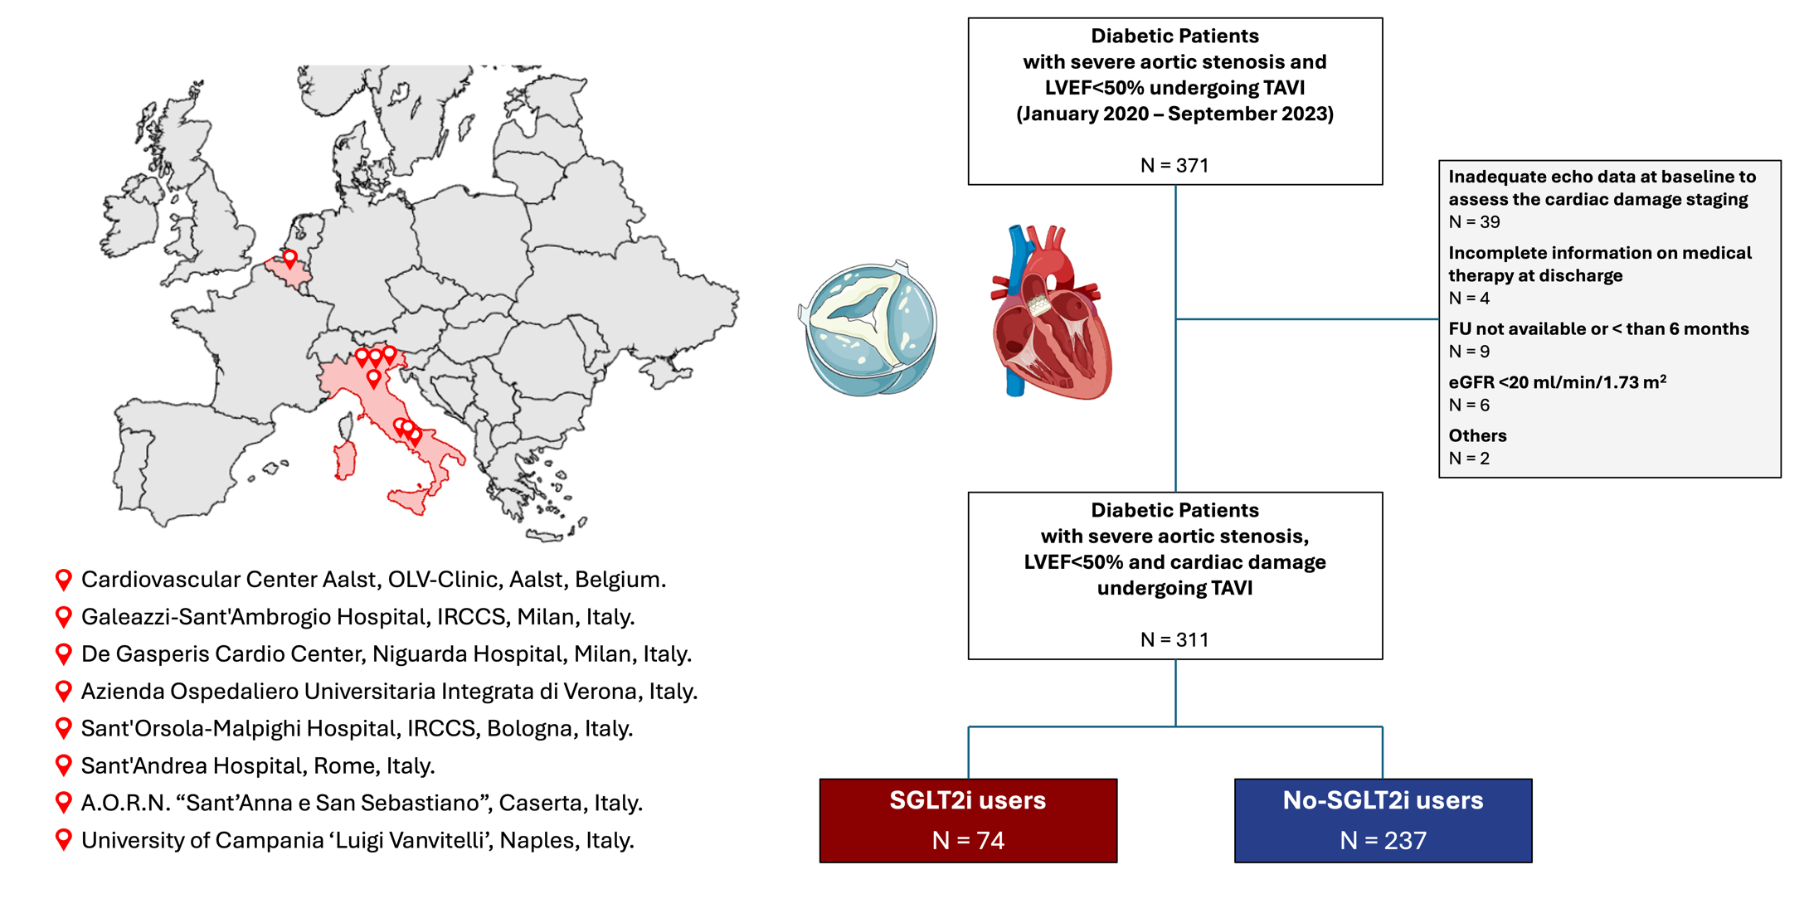
Supplementary Figure 2.

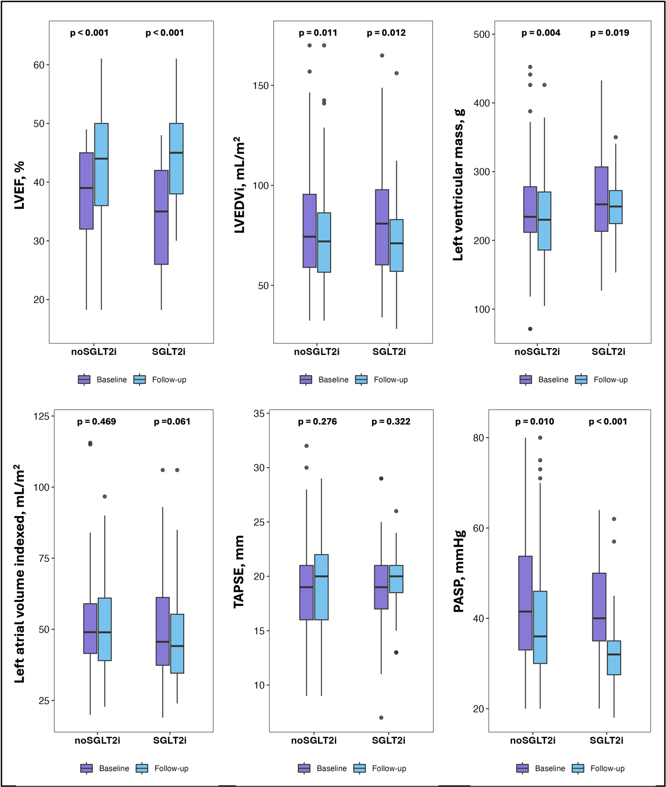

Supplementary Figure 3.

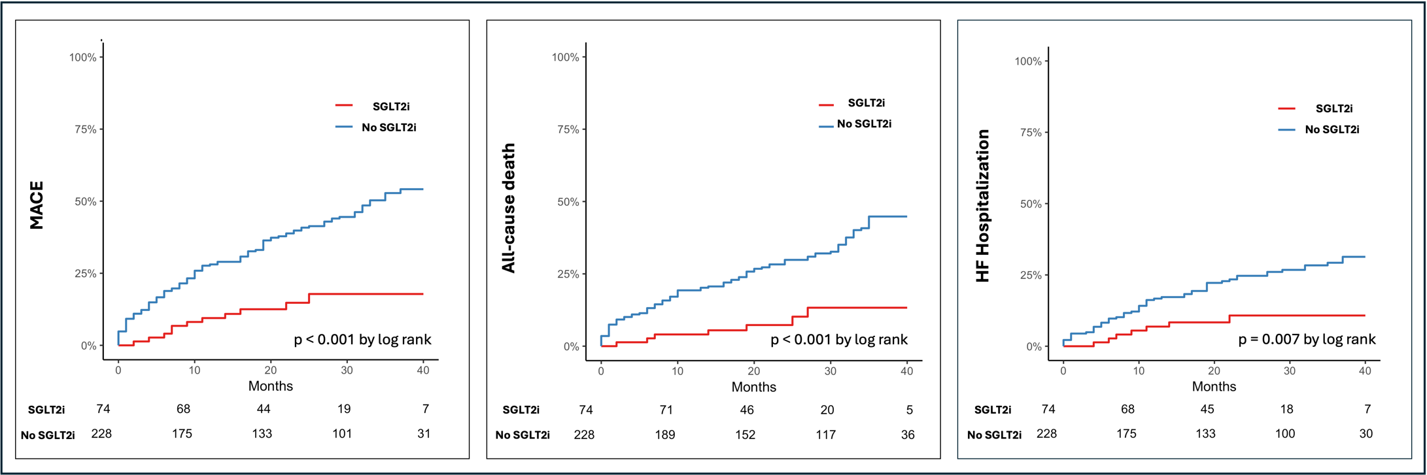
Supplementary Figure 4.

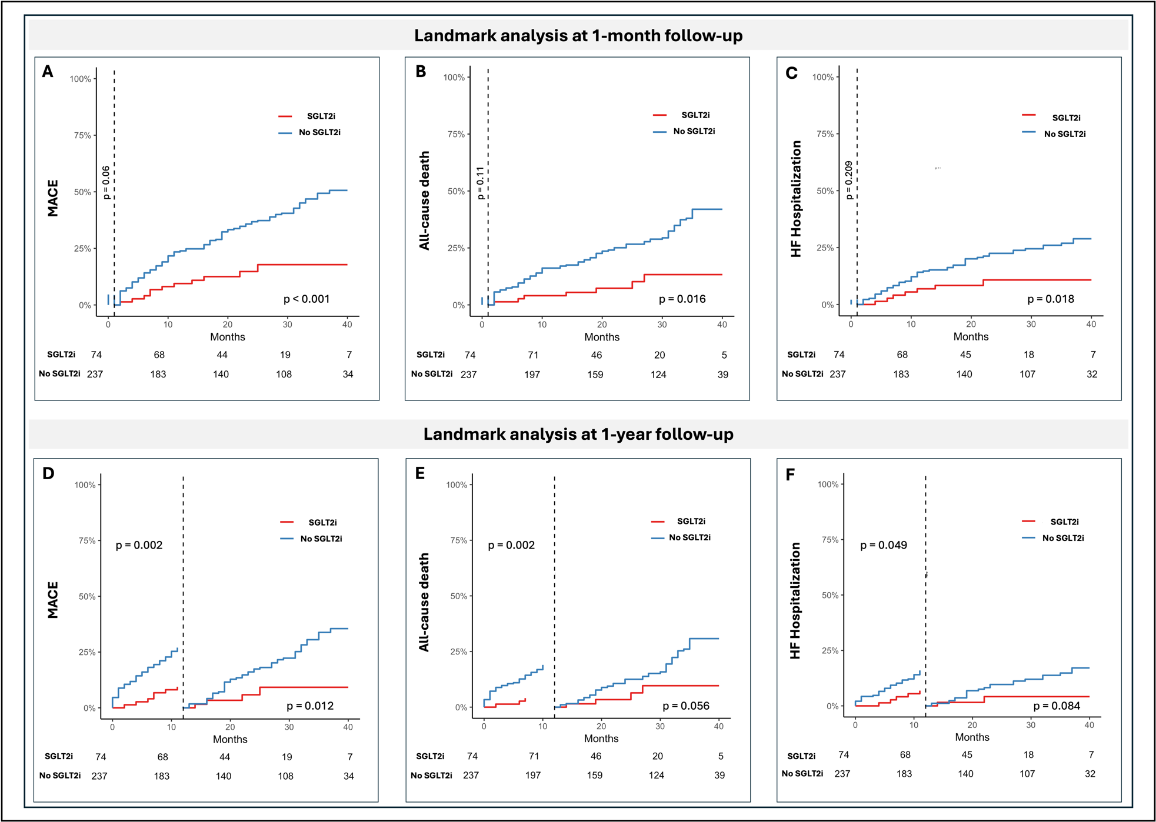
Supplementary Figure 5.
