Supplementary Materials

Supplementary Figure S1:

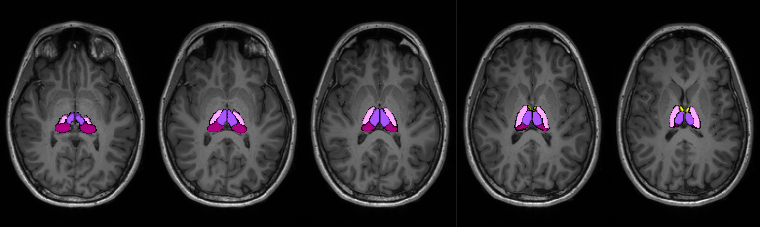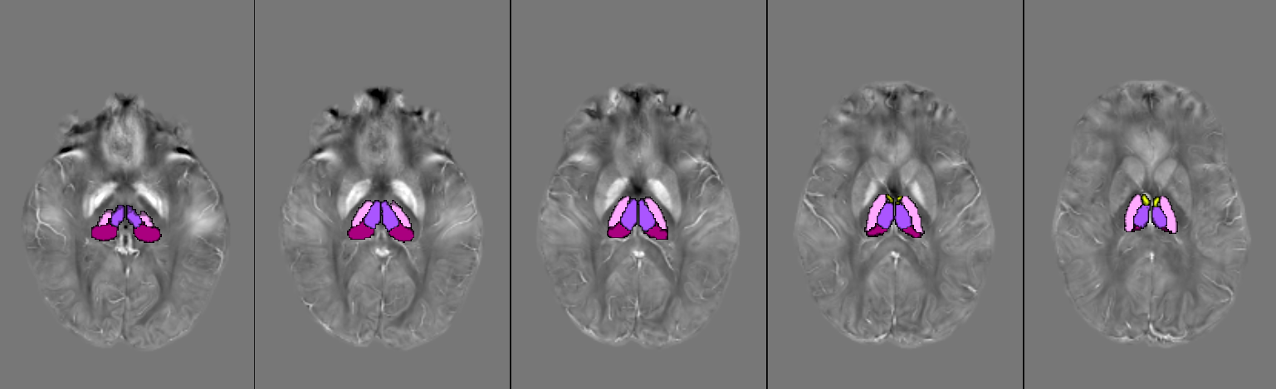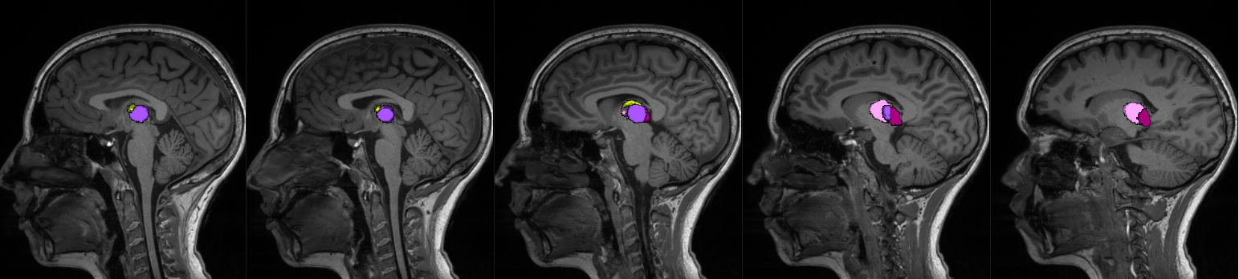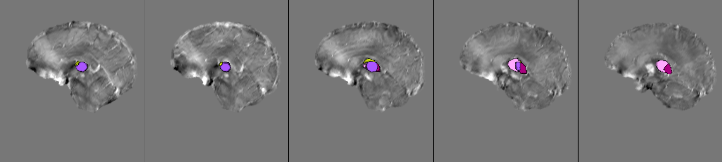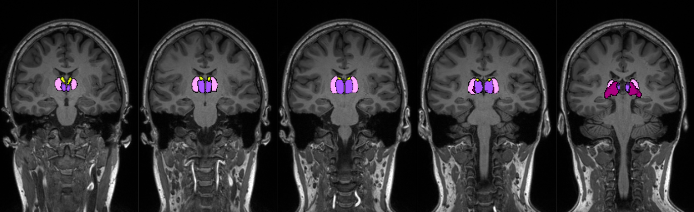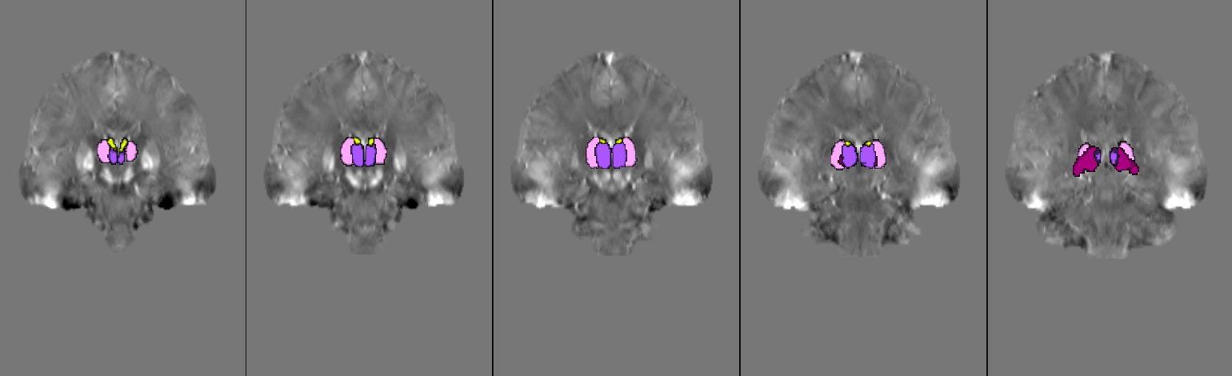
Thalamic segmentation (Anterior, Medial, Ventral and Pulvinar nuclei)
QSM
A
B
MPRAGE

Thalamic segmentation in anterior, medial, ventral and pulvinar nuclei overlaid on MPRAGE (A) and QSM (B) images of a representative subject of the study cohort (F/27yo). The colour-coding for thalamic nuclei segmentation is provided in Supplementary Tab. S4 (B).Thalamic nuclei segmentation was performed using the template from Brun, et al. (2022)

Supplementary Figure S2:

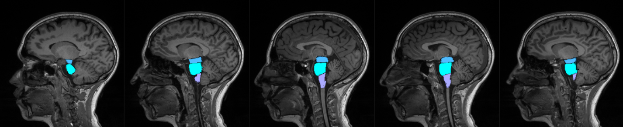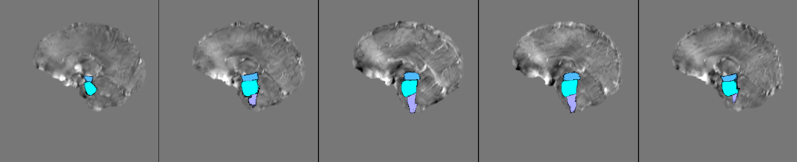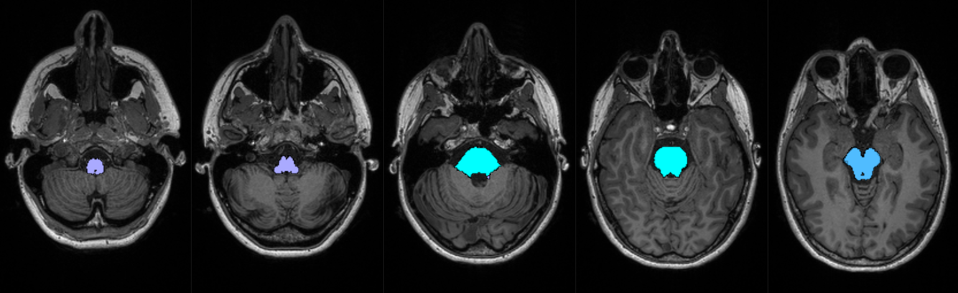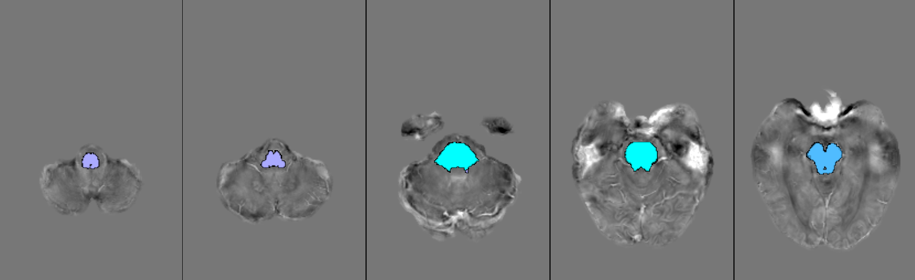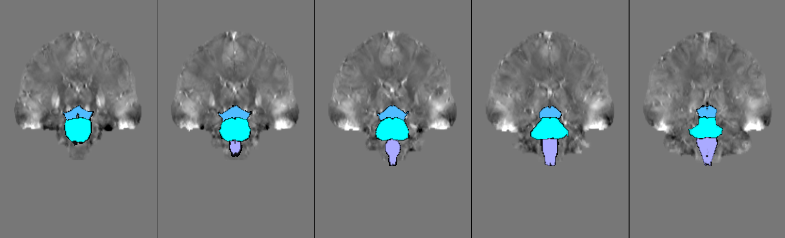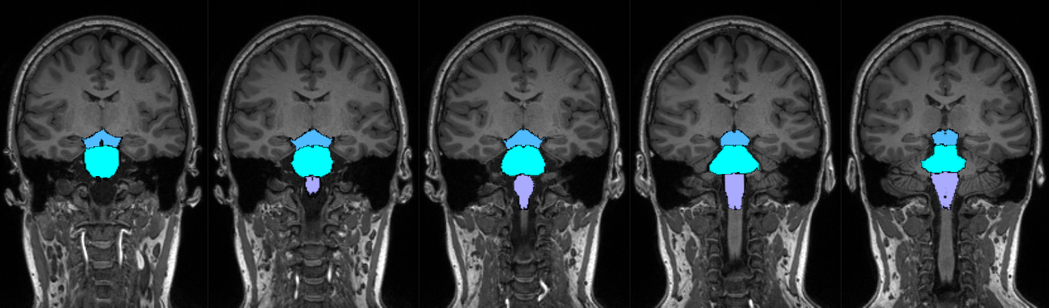
Brainstem segmentation (Midbrain, Pons, Medulla)
MPRAGE
QSM
A
B

Brainstem segmentation in midbrain, pons and medulla from FreeSurfer, overlaid on MPRAGE (A)and QSM (B) images of a representative subject of the study cohort (F/27yo). See Supplementary Tab. S4 (C) for the colour-coding used in the brainstem segmentation.

Supplementary Table S1:

 |  | Median χ (ppm)
 |  | HC | DM1 | E1 | E2
Frontal L | PrCG | -0.020 ± 0.008 | -0.015 ± 0.008 | -0.016 ± 0.008 | -0.014 ± 0.008
Frontal L | CMFG | -0.020 ± 0.006 | -0.013 ± 0.006 | -0.016 ± 0.005 | -0.011 ± 0.006
Frontal L | PCG | -0.022 ± 0.009 | -0.018 ± 0.011 | -0.014 ± 0.011 | -0.020 ± 0.010
Frontal L | PT | -0.013 ± 0.008 | 0.000 ± 0.009 | 0.001 ± 0.009 | 0.000 ± 0.009
Parietal L | PoCG | -0.016 ± 0.010 | -0.010 ± 0.011 | -0.007 ± 0.009 | -0.010 ± 0.010
Parietal L | IPG | -0.010 ± 0.009 | -0.002 ± 0.008 | -0.000 ± 0.010 | -0.004 ± 0.007
Parietal L | SMG | -0.010 ± 0.008 | 0.002 ± 0.009 | 0.005 ± 0.008 | 0.001 ± 0.007
Temporal L | TTG | 0.007 ± 0.013 | 0.021 ± 0.009 | 0.019 ± 0.008 | 0.024 ± 0.010
Cingulate C | PCC | -0.035 ± 0.008 | -0.029 ± 0.007 | -0.026 ± 0.006 | -0.031 ± 0.008
Cingulate C | ICG | -0.004 ± 0.012 | 0.005 ± 0.011 | 0.008 ± 0.009 | 0.002 ± 0.008
 |  | Volume (a.u.)
 |  | HC | DM1 | E1 | E2
Frontal L | PrCG | 1.134 ± 0.049 | 1.033 ± 0.054 | 1.022 ± 0.023 | 1.062 ± 0.078
Frontal L | CMFG | 0.491 ± 0.046 | 0.450 ± 0.036 | 0.445 ± 0.034 | 0.452 ± 0.034
Frontal L | PCG | 0.321 ± 0.014 | 0.298 ± 0.021 | 0.309 ± 0.017 | 0.289 ± 0.016
Frontal L | PT | 0.330 ± 0.034 | 0.314 ± 0.032 | 0.309 ± 0.028 | 0.321 ± 0.038
Parietal L | PoCG | 0.802 ± 0.051 | 0.749 ± 0.053 | 0.755 ± 0.046 | 0.749 ± 0.072
Parietal L | IPG | 1.164 ± 0.088 | 1.066 ± 0.084 | 1.019 ± 0.046 | 1.095 ± 0.090
Parietal L | SMG | 0.947 ± 0.054 | 0.860 ± 0.056 | 0.845 ± 0.056 | 0.874 ± 0.044
Temporal L | TTG | 0.093 ± 0.009 | 0.081 ± 0.010 | 0.090 ± 0.009 | 0.080 ± 0.006
Cingulate C | PCC | 0.251 ± 0.021 | 0.259 ± 0.015 | 0.262 ± 0.021 | 0.256 ± 0.014
Cingulate C | ICG | 0.219 ± 0.017 | 0.219 ± 0.015 | 0.218 ± 0.012 | 0.219 ± 0.019

Median χ (top) and volume (bottom) values (median ± mean absolute deviation) in HC, DM1, E1 and E2 groups in the analyzed cortical gyri. Median χ is expressed in parts per million (ppm). Volumes were corrected by total intracranial volume using the proportional method, so they are in arbitrary units (a.u.). (L = lobe; C= cortex; G = Gyrus; PrCG = PreCentral G; CMFG = Caudal Middle Frontal G; PCG = ParaCentral G; PT = Pars Triangularis; PoCG = PostCentral G; IPG = Inferior Parietal G; SMG = SupraMarginal G; TTG = Transverse Temporal G; PCC = Posterior Cingulate Cortex; ICG = Isthmus of the Cingulate Gyrus)

Supplementary Table S2:

 | Median χ (ppm)
 | HC | DM1 |  | E1 | E2
Cau | 0.026 ± 0.011 | 0.026 ± 0.010 | 0.026 ± 0.012 |  | 0.026 ± 0.010
Acc | 0.004 ± 0.017 | 0.004 ± 0.021 | -0.003 ± 0.022 |  | 0.006 ± 0.021
Put | 0.023 ± 0.016 | 0.020 ± 0.016 | 0.025 ± 0.015 |  | 0.017 ± 0.015
GP | 0.100 ± 0.021 | 0.080 ± 0.023 | 0.085 ± 0.026 |  | 0.078 ± 0.020
SN | 0.060 ± 0.020 | 0.060 ± 0.022 | 0.072 ± 0.018 |  | 0.056 ± 0.020
RN | 0.041 ± 0.026 | 0.058 ± 0.018 | 0.069 ± 0.028 |  | 0.050 ± 0.013
Th | -0.027 ± 0.013 | -0.011 ± 0.017 | -0.018 ± 0.020 |  | -0.011 ± 0.019
Hipp | -0.032 ± 0.008 | -0.024 ± 0.013 | -0.023 ± 0.012 |  | -0.029 ± 0.014
Amy | -0.045 ± 0.011 | -0.037 ± 0.010 | -0.037 ± 0.008 |  | -0.037 ± 0.011
DN | 0.030 ± 0.020 | 0.032 ± 0.017 | 0.038 ± 0.020 |  | 0.032 ± 0.011
Br | -0.049 ± 0.010 | -0.038 ± 0.011 |  | -0.035 ± 0.011 | -0.039 ± 0.009
 | Volume (a.u.)
 | HC | DM1 |  | E1 | E2
Cau | 0.211 ± 0.016 | 0.213 ± 0.016 | 0.207 ± 0.010 |  | 0.228 ± 0.018
Acc | 0.022 ± 0.004 | 0.021 ± 0.002 | 0.020 ± 0.004 |  | 0.021 ± 0.002
Put | 0.242 ± 0.015 | 0.236 ± 0.017 | 0.238 ± 0.018 |  | 0.235 ± 0.017
GP | 0.082 ± 0.005 | 0.088 ± 0.006 | 0.088 ± 0.010 |  | 0.088 ± 0.005
SN | 0.030 ± 0.002 | 0.031 ± 0.002 | 0.031 ± 0.003 |  | 0.031 ± 0.002
RN | 0.013 ± 0.001 | 0.013 ± 0.001 | 0.013 ± 0.001 |  | 0.013 ± 0.001
Th | 0.488 ± 0.022 | 0.490 ± 0.023 | 0.497 ± 0.027 |  | 0.487 ± 0.025
Hipp | 0.247 ± 0.015 | 0.248 ± 0.019 | 0.267 ± 0.019 |  | 0.245 ± 0.017
Amy | 0.077 ± 0.013 | 0.085 ± 0.008 | 0.088 ± 0.008 |  | 0.083 ± 0.009
DN | 0.030 ± 0.003 | 0.032 ± 0.003 | 0.032 ± 0.002 |  | 0.033 ± 0.004
Br | 2.282 ± 0.102 | 2.325 ± 0.207 | 2.244 ± 0.220 |  | 2.378 ± 0.165

Median χ (top) and volume (bottom) values (median ± mean absolute deviation) in HC, DM1, E1 and E2 groups in the analyzed subcortical structures. Median χ is expressed in parts per million (ppm). Volumes were corrected by total intracranial volume using the proportional method, so they are in arbitrary units (a.u.). (Cau = Caudate; Acc = Accumbens; Put = Putamen; GP = Globus Pallidus; SN = Substantia Nigra; RN = Red Nucleus; Th = Thalamus; Hipp = Hippocampus; Amy = Amygdala; DN = Dentate Nucleus; Br = Brainstem)

Supplementary Figure S3:
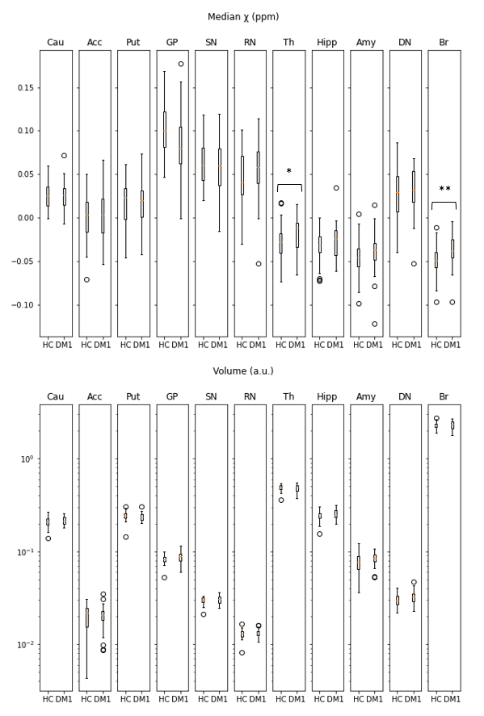
A
B
Bar plots of χ (A) and volume (B) distributions of the analyzed subcortical structures.
Median χ is expressed in parts per million (ppm). Volumes were corrected by total intracranial volume using the proportional method, so they are in arbitrary units (a.u.). VOI-based analysis was performed (Kruskal-Wallis test, * p < .05, ** p < .01) (Cau = Caudate; Acc = Accumbens; Put = Putamen; GP = Globus Pallidus; SN = Substantia Nigra; RN = Red Nucleus; Th= Thalamus; Hipp = Hippocampus; Amy = Amygdala; DN = Dentate Nucleus; Br = Brainstem)
Supplementary Table S3:

 |  | Median χ (ppm)
 |  | HC | DM1 |  | E1 | E2
Thalamus | Anterior | -0.033 ± 0.010 | -0.030 ± 0.021 | -0.031 ± 0.024 |  | -0.028 ± 0.017
Thalamus | Medial | -0.039 ± 0.011 | -0.031 ± 0.018 | -0.032 ± 0.023 |  | -0.029 ± 0.018
Thalamus | Ventral | -0.037 ± 0.014 | -0.021 ± 0.013 | -0.021 ± 0.012 |  | -0.024 ± 0.012
Thalamus | Pulvinar | 0.008 ± 0.012 | 0.023 ± 0.019 | 0.020 ± 0.017 |  | 0.029 ± 0.021
Thalamus | Total | -0.027 ± 0.013 | -0.011 ± 0.017 | -0.018 ± 0.020 |  | -0.011 ± 0.019
Brainstem | Midbrain | -0.029 ± 0.010 | -0.021 ± 0.014 | -0.017 ± 0.009 |  | -0.027 ± 0.011
Brainstem | Pons | -0.054 ± 0.010 | -0.046 ± 0.011 | -0.043 ± 0.013 |  | -0.046 ± 0.008
Brainstem | Medulla | -0.042 ± 0.007 | -0.029 ± 0.012 | -0.030 ± 0.010 |  | -0.029 ± 0.015
Brainstem | Total | -0.049 ± 0.010 | -0.038 ± 0.011 | -0.035 ± 0.011 |  | -0.039 ± 0.009

Median χ values (median ± mean absolute deviation) in HC, DM1, E1 and E2 groups in thalamic nuclei (anterior, medial, ventral and pulvinar) and brainstem sub-structures (midbrain, pons, medulla). Median χ is expressed in parts per million (ppm). ‘Total’ refers to the entire structure (thalamus and brainstem, respectively)

Supplementary Table S4:

 |  | Color | RGB | Brain area
A | Subcortical structures |  | 252,247,21 | Putamen Nucleus
 | Subcortical structures |  | 212,56,201 | Pallidus Nucleus
 |  |  | 221,173,204 | Thalamus
 |  |  | 233,35,195 | Nucleus Accumbens
 |  |  | 255,127,101 | Caudate Nucleus
 |  |  | 106,250,192 | Amygdala
 |  |  | 16,252,156 | Hippocampus
B | Thalamic nuclei |  | 91,74,194 | Medial Nuclei
 |  |  | 253,199,243 | Ventral Nuclei
 |  |  | 246,250,64 | Anterior Nuclei
 |  |  | 194,24,133 | Pulvinar
C | Brainstem structures |  | 58,176,248 | Midbrain
 | Brainstem structures |  | 189,195,251 | Medulla
 |  |  | 189,250,251 | Pons
D | RN, SN and DN |  | 209,227,41 | Red Nucleus
 |  |  | 36,144,49 | Substantia Nigra
 |  |  | 96,21,247 | Dentate Nucleus

Reference

Brun G, Testud B, Girard OM, Lehmann P, de Rochefort L, Besson P, Massire A, Ridley B, Girard N, Guye M, Ranjeva JP, Le Troter A. Automatic segmentation of deep grey nuclei using a high-resolution 7T magnetic resonance imaging atlas-Quantification of T1 values in healthy volunteers. Eur J Neurosci. 2022 Jan;55(2):438-460. doi: 10.1111/ejn.15575. Epub 2022 Jan 7. PMID: 34939245.
MR image processing
In all the processing steps below, the subject’s images are masked using FSL bet so that only brain voxels are taken into consideration.
Atlas construction
Thalamic nuclei. The 7TAMIbrain atlas of Brun and colleagues⁵³ was used to define 4 thalamic nuclei. It is not registered to MNI152 space.
Subthalamic nuclei. All the healthy control images in the study were registered to the standard MNI152 image volume in two stages. Each subject's QSM magnitude image (0.5x0.5x1 mm) was registered to his or her MPRAGE image volume (1x1x1 mm) using ANTs with default options. The result was registered to MNI152 space by rigid registration of the MPRAGE volume to the standard MNI152 T1 weighted image, using FSL tool flirt with options ‘-searchrx -90 90 -searchry -90 90 -searchrz -90 90 -noresampblur’. The average QSM magnitude map in MNI152 space was thus created and used for the manual definition of subthalamic nuclei masks as described in the Methods.

Segmentation
FreeSurfer. Segmentation of cortical and brainstem structures was performed using freesurfer v.6, with default settings apart from the use of the option ‘-brainstem-structures’.
First. The FSL utility First was run as follows:
run_first_all -d -m auto -i sub-01_T1w.nii.gz -s L_Accu,L_Amyg,L_Caud,L_Hipp,L_Pall,L_Puta,L_Thal,L_Late,R_Accu,R_Amyg,R_Caud,R_Hipp,R_Pall,R_Puta,R_Thal,R_Late -o $output_directory/sub-01/T1

Intrasubject registration
For each subject, the QSM magnitude image volume was linearly registered with the MPRAGE image volume using FSL tool flirt with default options.

ROI definition
Cortical ROIs and deep grey matter ROIs. These were available from the FreeSurfer and First segmentations in the subject’s own T1W space in which statistical calculations were performed.
Thalamic nuclei ROIs. Following the procedure recommended by Brun and colleagues, the 7TAMIbrain volume was registered to each subject’s T1-weighted brain image using ANTs, as follows:
antsRegistrationSyN.sh -d 3 -m 7TAMI_T1w_30.nii.gz -f sub-01_T1w.nii.gz -o 7TAMI_2_subject_SyN
The registration parameters were used to take the atlas to the subject’s native space:
antsApplyTransforms -d 3 -e 0 -i 7TAMI_DGN.nii.gz -r sub-01_T1w.nii.gz -o DGN_mask_subj.nii.gz -t 7TAMI_2_subject_SyN1Warp.nii.gz -t 7TAMI_2_subject_SyN0GenericAffine.mat -n NearestNeighbor
Subthalamic nuclei ROIs. The MPRAGE image volume was non-linearly registered to the standard MNI152 T1 weighted image in two stages, first using FSL flirt and then FSL fnirt
flirt -in sub-01_T1w.nii.gz -ref MNI152_brain -omat T1_to_MNI_lin_sub-01.mat -out T1_brain_MNI_lin_sub-01.nii.gz -searchrx -90 90 -searchry -90 90 -searchrz -90 90 -noresampblur
convert_xfm -omat MNI_to_T1_lin_sub-01.mat -inverse T1_to_MNI_lin_sub-01.mat
fnirt --ref=sub-01_T1w.nii.gz --in= MNI152_brain --aff=MNI_to_T1_lin_sub-01.mat --cout=MNI_to_T1_warp_sub-01.nii.gz
The inverse transformation was applied to take ROIs in MNI space to subject’s native space (for example, for left substantia nigra):
applywarp --ref=sub-01_T1w.nii.gz --in=ROI_L-SN --warp= MNI_to_T1_lin_sub-01.nii.gz --out= MNI_to_T1_lin_sub-01.nii.gz --interp=nn

