Appendix S1
Detailed exome material and methods and Comprehensive Clinical Data of the Cohort
- Detailed exome methodology and bioinformatic pipeline
- Comprehensive clinical, neurodevelopmental, EEG, and neuroimaging data of the cohort
Trio-based whole-exome sequencing
Genomic DNA was isolated from 2 ml of peripheral blood using the QIAamp DNA Blood Midi kit (Qiagen, Cases 1 and 2) or MagCore Genomic DNA Whole Blood Kit (RBC Bioscience, Case 3). This DNA was then enriched with the IDT - xGen Exome Research Panel V2 Target Regions (Illumina Technologies, Cases 1 and 2) or TWIST Human Core Exome Kit (TWIST Bioscience, Case 3). Whole exome sequencing (trio-WES) was performed as previously described [13]. Libraries were prepared from both parental and patient DNA (Cases 1 and 2) or patient only (Case 3) and subsequently sequenced on NovaSeq 6000 Illumina sequencers. The resulting sequencing data were processed using commercial tools that implemented the GATK Best Practices pipeline. Variant annotation was carried out using analytical pipelines that incorporated publicly available tools and custom scripts, including Ensembl-VEP v.107. For further analysis, exonic and donor/acceptor splicing variants were considered. Priority was given to rare variants with a frequency of less than 1% in public databases such as the 1000 Genomes Project, NHLBI Exome Variant Server, and the Genome Aggregation Database (GnomAD). These prioritized variants also met specific criteria: a genomic evolutionary rate profiling (GERP score >2), predicted impact on protein function via in silico tools (SIFT, PolyPhen-2, Mutation Taster), and presence in clinical databases (ClinVar). Synonymous variants were excluded from consideration. Candidate de novo, biallelic, and X-linked hemizygous coding variants were prioritized based on inheritance and rarity criteria, and subsequently evaluated according to ACMG guidelines to determine their clinical relevance. Validation of the resulting variants, determination of their parental origin, and family segregation studies were all performed using traditional Sanger sequencing.
Comprehensive Clinical Data of the Cohort
Case 1
The patient is a 23 years-old female, born at term to healthy, non- consanguineous parents via caesarean section. Early motor and speech milestones were acquired within normal limits throughout infancy. Past medical history included measles infection without complications and precocious puberty treated pharmacologically. At 4 years and 6 months of age she experienced a long afebrile bilateral tonic-clonic seizure (BTCS) while awake, followed by a second episode on the same day. She was started on valproate without control: within a few weeks, seizures increased to up to 40 per day, including persisting GTCS, tonic, atonic, myoclonic/hemiclonic and atypical absence episodes, frequently occurring in clusters. Moreover, psychomotor regression occurred within a month from the onset (loss of language skills, incontinence and impaired feeding autonomy).
Polytherapy with various attempted combination (Fig.1), offered transient partial reduction in seizure frequency. Neuropsychological evaluations during childhood indicated progressive cognitive decline, with borderline intellectual functioning. Inter-ictal EEG showed generalized slow spike-and-wave complexes (approximately 2-2.5 Hz) and bursts of generalized polyspikes. Electroclinical data prompted the diagnosis of LGS and the introduction of felbamate with favorable response (5-6 episodes/day, only atypical absence).
Although she experienced marked developmental regression in her early years, the patient gradually regained functional abilities once seizure control improved. She underwent extensive therapeutic interventions, including speech and language therapy, neuropsychomotor rehabilitation, occupational and music therapy, which continued into her late adolescence. Despite progress, the patient continues to show emotional lability and mild intellectual disability (WAIS full-scale IQ: 67 at age 17). She has achieved partial independence in activities of daily living, although supervision remains necessary, and difficulties persist with money management and planning tasks.
Between ages 6 and 15 the patient experienced generally infrequent and usually brief seizures, consisting mainly of short absence episodes or myoclonic jerks, often triggered by sleep deprivation, stress, or therapeutic adjustments. From 16 to 19 years, seizures persisted with occasional clusters of atypical absences, myoclonic seizures (approximately 10 episodes per cluster) and GTCS (1-2 episodes per year). Overall, seizure control improved following the introduction of felbamate, with subsequent dose adjustments, leading to a final maintenance dose of 2.1 g/day.
At last follow-up, parents reported persistence of clusters of atypical absences lasting a few seconds, predominantly occurring under emotional stress. The most re-cent EEG, performed at age 22, demonstrated a well-organized background activity with diffuse epileptiform abnormalities, enhanced by hyperventilation. Polysomnography revealed nonspecific and epileptiform electroencephalographic abnormalities, predominantly localized in the anterior regions with a tendency to spread, evident during relaxed wakefulness and NREM sleep, with increasing frequency as sleep progressed.
Case 2
The patient is a 20 years-old male, born at term after an uneventful pregnancy. Auxological parameters at birth were appropriate for gestational age. Psychomotor development progressed within normal limits until 18 months of age, when stagnation of expressive language became evident. Subsequently, relational and communicative difficulties emerged, accompanied by stereotyped behavior and selective interests, leading to a diagnosis of ASD. He attended school with dedicated support, maintaining overall good autonomy. Seizure onset occurred at 8 years of age, as focal seizures with impaired awareness, featuring autonomic manifestations and motor signs. The course later progressed to atypical absences and to a brief tonic seizure, preceded by autonomic symptoms. No further episodes occurred after the initiation of levetiracetam (up to 1750 mg/day) at 10 years of age, which was discontinued at 14. The patient remained in remission for approximately five years, but experienced seizure recurrence at 18 years of age.
In the most recent period, the patient’s mother reported increased fatigue and worsening behavioral symptoms. Stereotypies had become more pronounced, and caregivers observed global regression and reduced attention span. Frequent self-talking was also noted. These manifestations were considered either potential adverse effects or indicators of suboptimal seizure control, prompting the discontinuation of levetiracetam and its replacement with lamotrigine (up to 200 mg/day).
Following this therapeutic adjustment, no further critical episodes have been observed to date. At the age of 13, neuropsychological testing (WAIS) showed a Full-Scale IQ of 74, consistent with borderline intellectual functioning.
EEG evolution was characterized by bilateral posterior epileptiform abnormalities with sleep activation and tendency to left-sided diffusion during childhood, later evolving into focal paroxysmal abnormalities during both wakefulness and sleep, associated with right temporal slowing, atypical fast rhythms, and a photoparoxysmal response at 15 years of age. The most recent EEG, performed at 20 years of age, continued to demonstrate bilateral posterior epileptiform abnormalities with diffuse propagation tendency.
Case 3
The patient is a 13 years-old female, born from spontaneous delivery after an unremarkable pregnancy at 42 weeks of gestational age. Auxological parameters at birth were normal. At 2 years of age, the patient experienced a febrile generalized seizure, which led to the initiation of levetiracetam. By 3 years of age, she developed afebrile GTCS, tonic, atonic and myoclonic seizures. As drug resistance emerged, a polytherapy regimen was introduced, including valproate, sulthiame, ethosuximide, lamotrigine and intermittent methylprednisolone pulses. Seizure freedom was achieved at 4 years of age through a combination therapy with lamotrigine (300 mg/day) and ethosuximide (1000 mg/day). Beyond the epileptic manifestations, a marked NDD was evident, characterized by severe intellectual and language impairment. Neurocognitive assessment performed at 5 years of age using the Entwicklungstest 6 Monate bis 6 Jahre - Revision (ET 6-6-R) revealed global developmental delays, with severely below-average performance across all assessed domains, including gross and fine motor skills, cognitive functioning, language development, socio-emotional skills and drawing ability. EEG follow-up, initiated at 4 years of age, revealed bilateral frontal irregular spike-wave discharges with a maximum duration of 10 seconds, predominantly accentuated during sleep. Subsequent recordings showed a predominance of right frontal sharp waves, which diffusely spread to the contralateral homologous region, along with occasional generalized sharp waves occurring in irregular bursts. From 8 years of age onward, EEGs consistently demonstrated bifrontal spike-wave discharges during sleep, a pattern that persisted during the most recent follow-up at 13 years of age. Ophthalmological comorbidities were also noted, namely hyperopia, astigmatism, and strabismus.

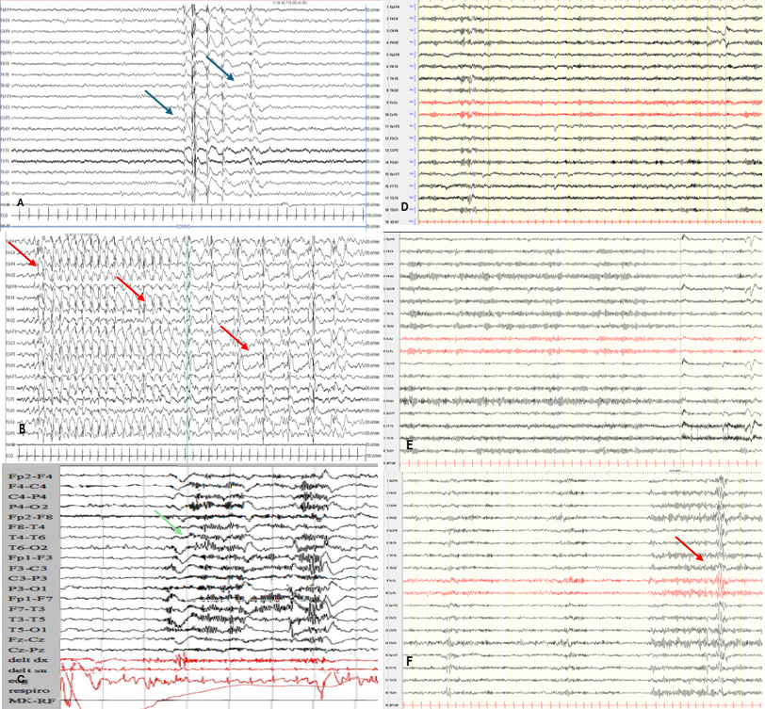
Figure S1. The longitudinal course of Case #1 EEG recordings obtained at different ages (A-B: 5y; C: 8y; D-E-F: 22 years-old), which document the evolution of electroclinical features over time
During sleep onset, polyspikes were followed by brief generalized flattening (1–2 s) with subtle diffuse fast rhythmic activity (blue arrows – A). During wakefulness, atypical absences were observed, beginning with 3 Hz spike-wave activity, followed by slowing to 1.5–2 Hz and subsequent periodic generalized polyspike-wave discharges (red arrows – B). Sleep onset immediately followed by diffuse fast rhythmic activity consistent with a tonic seizure pattern, without associated motor manifestations (green arrow – C). Subsequently a well-organized background activity with aspecific diffuse epileptiform abnormalities (red arrows – F).

