Online Appendix

Contents
S1 – Definition and Construction of the Indices 3
Table S1.1 – Indices employed in the cluster analysis 3
S2 - Distribution of Indices 4
Figure S2.1 - Index histograms 4
Table S2.1 - Summary Statistics for the Standardized Indices 4
Table S2.2 - Shapiro–Wilk W test for normal data 5
Table S2.3 - Shapiro–Francia W test for normal data 5
Figure S2.2 - Box plots 5
S3 - Correlations among Indices 6
Figure S3.1 - Scatterplot matrix for standardized indices 6
Table S3.1 - Correlation Coefficients with P-values 6
S4 – Agglomeration Method and Proximity Measure 8
Figure S4.1 – Dendrograms based on Average Linkage and Ward's Linkage Criteria 9
S5 – Number of Clusters 10
Figure S5.1 - Dendrograms using Ward's Linkage 10
Table S5.1 - Duda/Hart Stopping Rule Results 11
S6 - Descriptive Statistics of Roles 12
Table S6.1 - Distribution of Local Experience by Role (Percentages & Counts) 12
Figure S6.1 - Distribution of Local Experience by Parliamentary Role (Pie Charts) 13
Table S6.2 - Distribution of Parachuted by Role (Percentages & Counts) 13
Figure S6.2 - Distribution of Parachuted by Parliamentary Role (Pie Charts) 14
Table S6.3 - Distribution of Tenure by Role (Percentages & Counts) 15
Figure S6.3 - Distribution of Tenure by Parliamentary Role (Pie Charts) 15
Table S6.4 - Distribution of Legislative Office by Role (Percentages & Counts) 15
Figure S6.4 - Distribution of Legislative Office by Parliamentary Role (Pie Charts) 16
Table S6.5 - Distribution of Governmental Office by Role (Percentages & Counts) 16
Figure S6.5 - Distribution of Governmental Office by Parliamentary Role (Pie Charts) 16
S7 - Multinomial Logit Models for Career Outcomes 17
Table S7.1 - Predicted probabilities of career outcomes by parliamentary role 17
Table S7.2 - Multinomial logit estimates for career outcomes (relative risk ratios) 18
Table S7.3 — Full raw coefficients for career outcomes 19
Table S7.4a - Reduced multinomial logit models for career outcomes: Reelected only 20
Table S7.4b - Reduced multinomial logit models for career outcomes: Legislative office 21
Table S7.4c - Reduced multinomial logit models for career outcomes: Government office 22
Table S7.5 - Binary logit robustness check: re-election 23
S8 - Multinomial Logit Models for Parliamentary Role Adoption 24
Table S8.1 – Average marginal effects from the M-Logit model of parliamentary roles 24
Table S8.2 - Full raw coefficients for parliamentary role adoption 25
Table S8.3a. - Reduced multinomial logit models for parliamentary role adoption: Constituency Members 26
Table S8.3b - Reduced multinomial logit models for parliamentary role adoption: Show Horses 27
References 28

S1 – Definition and Construction of the Indices

This section defines the four indices employed in the cluster analysis. Following Strøm’s (1997: 161–64) strategic approach, these indicators capture four types of parliamentary activity through which deputies may allocate their scarce resources, under the institutional constraints they face, in pursuit of different career outcomes. These indices, named the index of territoriality (IT), the index of specialization (IS), the index of productivity (IP) and the index of visibility (IV), are later used to conduct the cluster analysis (see Appendix S2, S3, S4 and S5). Specifically:

- The territoriality index (IT) captures the extent to which an MP’s written questions (WPQ_{d}) focus on issues concerning the member’s electoral district out of the total number of written questions submitted by that MP (WPQ_{tot}).
- The specialization index (IS) captures the extent to which an MP’s written questions are concentrated in a limited set of policy issues, identified through the CAP coding scheme, by comparing the number of written questions asked on each issue (WPQ_{ti}) with the deputy’s average number of written questions per issue ($\overline{{WPQ}_{ti}}$).
- The productivity index (IP) captures the bill productivity of each deputy relative to their party peers and is constructed by normalizing the number of bills (BILL_{d}) introduced by each deputy against the total number of bills (BILL_{party}) introduced by the deputy’s party.
- The visibility index (IV) captures each deputy's press visibility relative to their party peers and is constructed by normalizing the number of press releases issued by each deputy (ANSA_{d}) against the total number of press releases issued by the deputy’s party (ANSA_{party}).

The goal of these indices is to measure the degree of localism, specialization, bill activism, and media presence for each deputy. For the IT and IS indices, data come from Russo’s (2022) replication materials. By contrast, bill data were retrieved from dati.camera.it, while press releases were collected from ANSA, Italy’s leading news agency. The formulas used to construct the indices are reported below in Table S1.1.

Table S1.1 – Indices employed in the cluster analysis
Index of territoriality:
Index of specialization:
Index of productivity:
Index of visibility:

S2 - Distribution of Indices

This section provides an overview of the distributional characteristics of the four standardized indices (zIP, zIS, zIT, zIV) used in the cluster analysis. The visual representations (histograms and box plots) in Figure S2.1 illustrate the distribution for each indicator.

Figure S2.1 - Index histograms
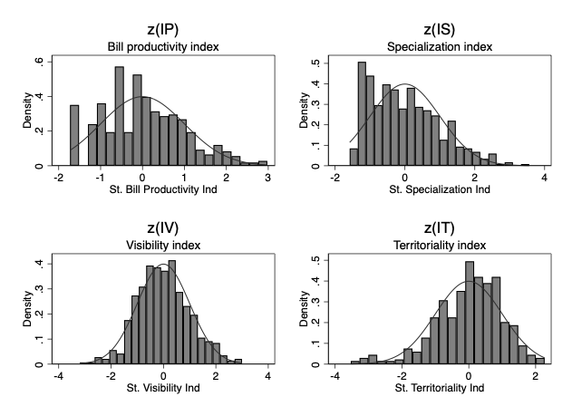

Table S2.1 presents the summary statistics for the standardized indices. As expected from standardization, all indices have a mean very close to zero and a standard deviation very close to one. The skewness values indicate that zIP, zIS, and zIT are positively skewed, while zIV shows a slight negative skew. Kurtosis values provide further insight into the shape of their distributions.

Table S2.1 - Summary Statistics for the Standardized Indices
Index | Mean | Standard Deviation | Skewness | Kurtosis
zip | -2.5915e-09 | 1 | .337 | 2.816
zis | -1.7347e-10 | 1 | .668 | 2.879
zit | -9.8470e-11 | .999 | -.731 | 3.923
ziv | 6.0014e-10 | .999 | .159 | 3.067

To formally assess normality, two statistical tests were conducted: the Shapiro-Wilk W test and the Shapiro-Francia W' test for normal data (Table S2.2 and Table S2.3, respectively). Both tests consistently indicate that zIP (Bill Productivity), zIS (Specialization), and zIT (Territoriality) significantly deviate from a normal distribution (p-values for all three are 0.00). In contrast, the zIV (Visibility) index does not significantly deviate from normality according to either the Shapiro-Wilk test (p=0.313) or the Shapiro-Francia test (p=0.286).

Table S2.2 - Shapiro–Wilk W test for normal data
Variable | Obs | W | V | z | Prob>z
zip | 506 | 0.988 | 4.074 | 3.379 | 0.000
zis | 506 | 0.948 | 17.685 | 6.909 | 0.000
zit | 506 | 0.968 | 10.810 | 5.725 | 0.000
ziv | 506 | 0.996 | 1.225 | 0.488 | 0.313

Table S2.3 - Shapiro–Francia W test for normal data
Variable | Obs | W | V | z | Prob>z
zip | 506 | 0.995 | 1.737 | 1.213 | 0.113
zis | 506 | 0.945 | 18.267 | 6.378 | 0.000
zit | 506 | 0.968 | 11.486 | 5.359 | 0.000
ziv | 506 | 0.996 | 1.293 | 0.564 | 0.286

Figure S2.2 presents box plots for each standardized indicator, which visually confirm the presence of outliers across all four indices, represented by individual points extending beyond the whiskers. The elongated whiskers and distant points for these three indices indicate data points that lie far from the majority of the observations, underscoring the necessity of a clustering method that is robust to such extreme values.

Figure S2.2 - Box plots
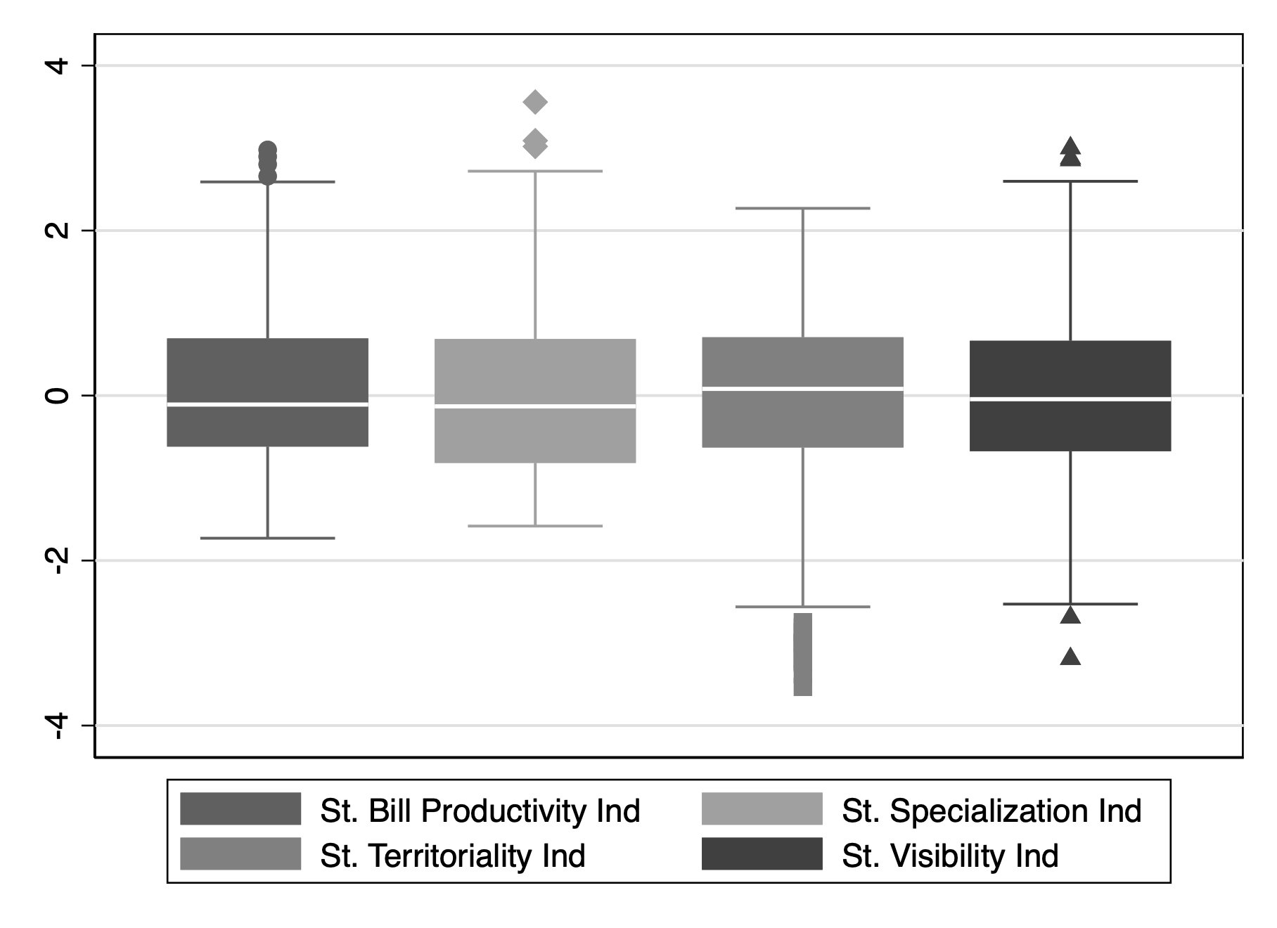

S3 - Correlations among Indices

This section details the correlations among the four standardized indicators (zIP, zIS, zIT, zIV) used in the cluster analysis. Figure S3.1 presents a scatter plot matrix illustrating the pairwise relationships between all standardized indicators. Visually, the plots show clusters of points forming a central concentration, indicating a general absence of strong linear correlations between each pair of variables.

Figure S3.1 - Scatterplot matrix for standardized indices
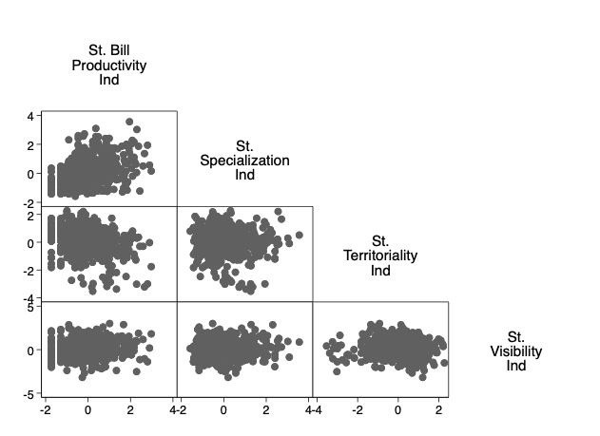
Table S3.1 provides the Pearson correlation coefficients and their associated p-values. As observed in the scatter plots, the numerical correlations confirm generally weak linear relationships among the indicators. For instance, the correlation between zIS (Specialization) and zIT (Territoriality) is extremely weak (r = 0.005, p = 0.913), indicating no linear relationship. While some correlations are statistically significant, such as between zIP (Bill Productivity) and zIS (Specialization) (r = 0.411, p = 0.000), or zIP and zIV (Visibility) (r = 0.122, p = 0.006), and zIT (Territoriality) and zIV (Visibility) (r = -0.112, p = 0.012), none of these relationships are particularly strong, with all absolute r-values remaining below 0.5. The strongest correlation observed is between zIP and zIS, suggesting only a moderate positive relationship.

Table S3.1 - Correlation Coefficients with P-values
 | z(ip) | z(is) | z(it) | z(iv)
z(ip)  (sig) | 1.000
z(is)  (sig) | 0.411  (0.000) | 1.000
z(it)  (sig) | -0.270  (0.000) | 0.005  (0.913) | 1.000
z(iv)  (sig) | 0.123  (0.006) | 0.046  (0.303) | -0.112  (0.012) | 1.000

In conclusion, Figure S3.1 and Table S3.1 indicate there are no strong linear correlations among the indicators.

S4 – Agglomeration Method and Proximity Measure

This section details the rationale behind the selection of specific methods for the cluster analysis, namely the Ward algorithm for agglomeration and the squared Euclidean distance as the proximity measure. To justify these choices, the section begins with a brief overview of the function and purpose of cluster analysis.

Generally, cluster analysis operates by grouping units based on their spatial location within a multidimensional space, where the number of dimensions corresponds to the indicators employed (Everitt et al. 2011; Romesburg 2004). In this study, each unit of analysis (i.e., a deputy) is represented in this space as a four-dimensional vector, corresponding to the total number of standardized indices employed (i.e., zIP, zIS, zIT and zIV).
The choice of a distance metric determines in what way units are grouped within a multidimensional space. Considering two deputies, x and y, their distance d(x,y) can be calculated using various formulas, such as Euclidean, Manhattan, or Mahalanobis, with the choice depending on the nature (qualitative or quantitative) and distribution of the variables. The Euclidean distance is the most widely used (Punj and Stewart 1983) and is recommended over the Mahalanobis distance when variables are uncorrelated. Conversely, the Manhattan distance is preferable for variables on an ordinal scale (Du et al. 2017).
For the present analysis, given the observed absence of correlation among the standardized indices (Appendix – S3), the squared Euclidean distance proved to be the most suitable choice. Accordingly, a distance matrix was computed that includes all possible pairwise distances d(x,y) among the units of the population within a p-dimensional space. Each distance was calculated using the following formula:

$$d(x,y)= \sum_{p=1}^{p}{(x_{p}- y_{p})}$$

For the agglomeration criterion, the most common methods were considered: single linkage, complete linkage, average linkage, and Ward’s variance minimization. These differ in how clusters are merged (Romesburg 2004). Single linkage is most suitable when data form chains, whereas complete linkage, average linkage, and Ward’s method perform better when data cluster around central nodes (Kuiper and Fisher 1975). Because Figure S3.1 indicates clustering around nodes, single linkage was excluded. Complete linkage was also discarded because Ward’s method is generally better suited to producing compact, roughly spherical clusters by minimizing within-cluster variance (Von Eye et al. 2004).
Between Ward’s method and average linkage, the agglomeration processes produced by both approaches were compared to identify the most robust and interpretable solution for this dataset. Figure S4.1 presents the two dendrograms produced using these linkage methods. In a dendrogram, each merge represents a clustering step, and the height of the merge point on the y-axis (based on the L2 squared dissimilarity measure) indicates the distance or dissimilarity at which clusters or observations are joined.

Figure S4.1 – Dendrograms based on Average Linkage and Ward's Linkage Criteria
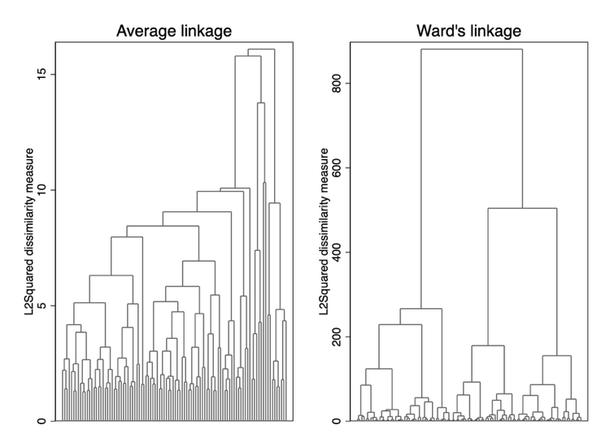

The dendrogram generated using average linkage exhibits a chaining-like pattern, whereby clusters tend to grow through the sequential addition of single observations or small groups (Stanberry 2013). Such patterns produce long, straggly clusters that are difficult to interpret and do not clearly delineate natural groupings. In contrast, the dendrogram produced with Ward’s method displays a much clearer and more interpretable structure.
This difference arises from the way the two algorithms handle outliers. From an estimation perspective, average linkage tends to isolate anomalous values into smaller clusters (Williams et al. 1971). Conversely, Ward’s method tends to incorporate outliers into existing clusters rather than separating them. Specifically, Ward’s method, guided by the principle of variance minimization, tends to produce more spherical clusters across the p dimensions than complete linkage (Von Eye et al. 2004). For these reasons, and to achieve a more accurate interpretation of each cluster, the cluster analysis was conducted using Ward’s linkage method. To further address outliers, as detailed in Section 5 of the manuscript, the k-means algorithm was subsequently applied.

S5 – Number of Clusters

This section describes how the optimal number of clusters was determined. The procedure followed the application of Ward’s agglomeration criterion with squared Euclidean distances, described previously in Section S4. A dual approach was used to determine the optimal number of clusters: first, a visual inspection of the dendrogram; and second, the application of the Duda/Hart Stopping Rule (Duda and Hart 1973). This combined strategy made it possible to identify a robust number of distinct parliamentary roles in the dataset (Romesburg 2004).

The visual inspection of the Ward’s linkage dendrogram (Figure S5.1) provides initial insights into the potential number of clusters. In the dendrogram, a prominent vertical break is observed, particularly around the dissimilarity measure of approximately 500, which clearly separates the population into two major branches. Further examination of these branches reveals additional noticeable vertical breaks at lower dissimilarity levels that could indicate a three-cluster solution. Overall, the dendrogram therefore points to either a two- or a three-cluster solution as the most stable and interpretable candidate.

Figure S5.1 - Dendrograms using Ward's Linkage
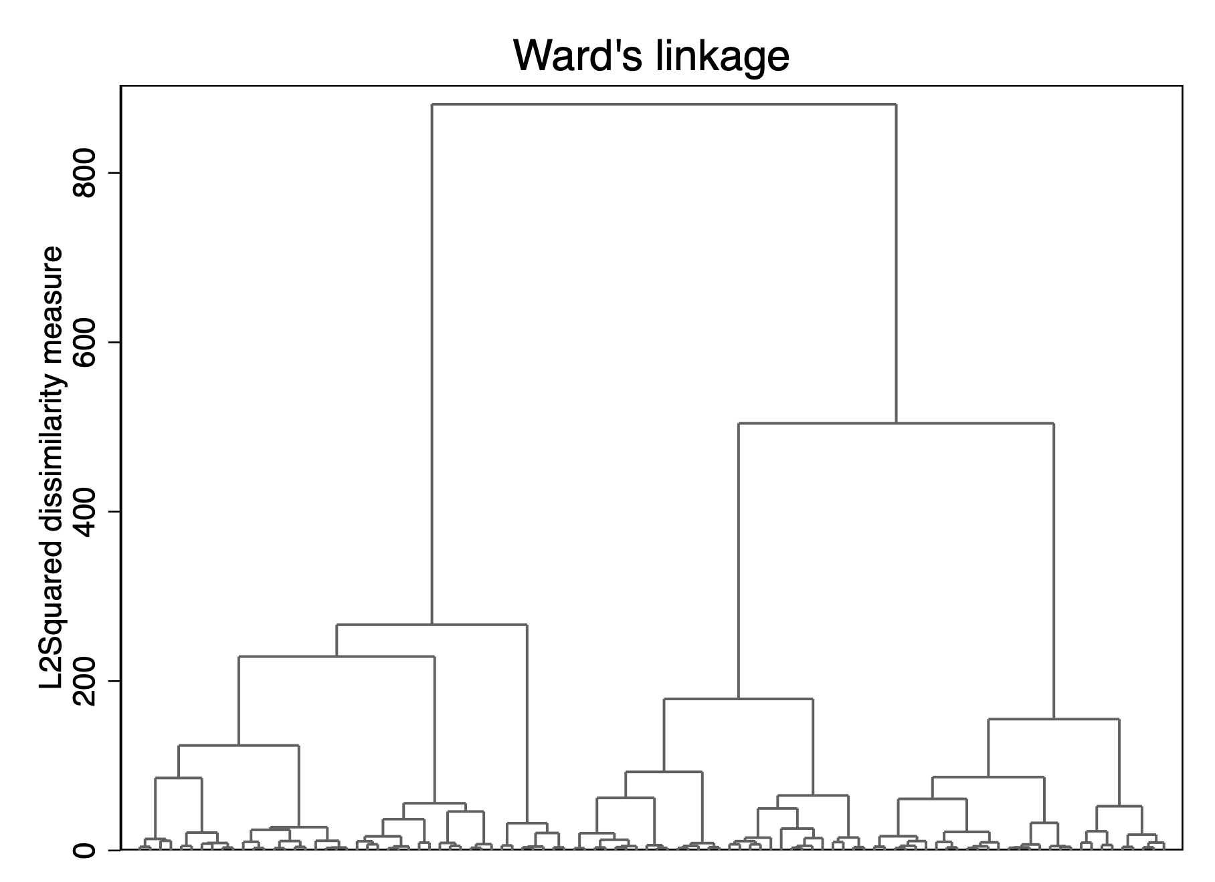

To quantitatively corroborate the visual insights from the dendrogram and determine the optimal number of clusters k, the Duda/Hart Stopping Rule was applied.
The Duda/Hart Stopping Rule (Table S5.1) is an established and robust technique that provides a statistical test for the identification of the optimal number of clusters (Milligan and Cooper 1985). This rule is evaluated through the Je(2) / Je(1) ratio and an associated pseudo-T2 value. According to this criterion, a large Je(2) / Je(1) index value combined with a small pseudo-T2 value indicates distinct clustering (Duda and Hart 1973).

Table S5.1 - Duda/Hart Stopping Rule Results
Number of clusters | Duda/Hart pseudo Je(2)/Je(1) | T-squared
1 | .782 | 140.557
2 | .733 | 113.363
3 | .790 | 50.681
4 | .752 | 57.215
5 | .754 | 53.723
6 | .763 | 44.707
7 | .718 | 41.219
8 | .655 | 37.921
9 | .743 | 30.426
10 | .561 | 50.948
11 | .768 | 27.437
12 | .569 | 34.034
13 | .670 | 31.065
14 | .782 | 18.636
15 | .679 | 25.564
Examining Table S5.1, we observe that the Je(2) / Je(1) ratio reaches its highest value (0.790) on the row corresponding to 3 clusters. Crucially, at this same point (i.e., when considering the transition to four clusters from three), the pseudo-T2 value (50.681) is the smallest among the initial splits, representing a significant drop from previous values (e.g., 140.56 for k=2 and 113.36 for k=3). Taken together, these values indicate that the three-cluster solution provides the clearest and most distinct partition of the data.
Synthesizing this statistical evidence with the visual inspection of the Ward’s linkage dendrogram, the three-cluster solution was therefore retained.

S6 - Descriptive Statistics of Roles

This section provides descriptive statistics for each of the three parliamentary roles identified through cluster analysis: Constituency Members, Specialists, and Show Horses. These statistics serve to further illustrate the distinct profiles of each cluster. The section first describes the features of Constituency Members by analyzing whether deputies who adopt this role exhibit a stronger connection with their constituency. It then considers the roles of Specialists and Show Horses to examine whether these roles are more frequently selected by deputies with greater political experience.

To deepen the interpretation of the Constituency Members role, in line with previous research (Russo 2022), two key variables are examined: “local experience” and “parachuted.” The parachuted variable is defined as a dummy indicator, taking a value of 1 if a deputy was not born in the same region in which they were elected, and 0 otherwise. The local experience variable is also a dummy, assigned a value of 1 for deputies who held a position in local or regional politics prior to their parliamentary tenure, and 0 otherwise. Both variables seek to capture a direct measure of pre-parliamentary engagement at the sub-national level (e.g., Best and Vogel 2012). Data for the “parachuted” variable were sourced from the official records of the Italian Chamber of Deputies (dati.camera.it), while the “local experience” variable was taken from Russo’s (2022) replication material. Theoretically, deputies adopting the Constituency Member role are expected to exhibit a stronger connection to their local base (Best and Vogel 2012; Rozenberg 2020; Russo 2022). Therefore, this role is expected to be associated with significantly higher values for “local experience” and comparatively lower values for the “parachuted” variable.

The analysis of the “local experience” variable supports these expectations (Table S6.1 and Figure S6.1). Among Constituency Members, 65.1% possessed prior local or regional political experience, a share higher than the overall average of 53.6% across all deputies. While 60.4% of Show Horses also had previous local experience, this figure remains lower than that of Constituency Members and stands in contrast to Specialists, among whom only 37.3% had such a background. These findings suggest that deputies adopting the Constituency Member role are more likely to have a background in local politics, reinforcing their distinct orientation toward constituency-level engagement compared to their Specialist and Show Horse counterparts.

Table S6.1 - Distribution of Local Experience by Role (Percentages & Counts)
Local exp. / Role | Specialists | Const.Members | Show.Horses | Total %
Without.Local-exp | 62.7% | 34.9% | 39.6% | 46.4%
With.Local-exp | 37.3% | 65.1% | 60.4% | 53.6%
Total % | 100.0% | 100.0% | 100.0% | 100.0%
N | 185 | 172 | 149 | 506

Figure S6.1 - Distribution of Local Experience by Parliamentary Role (Pie Charts)
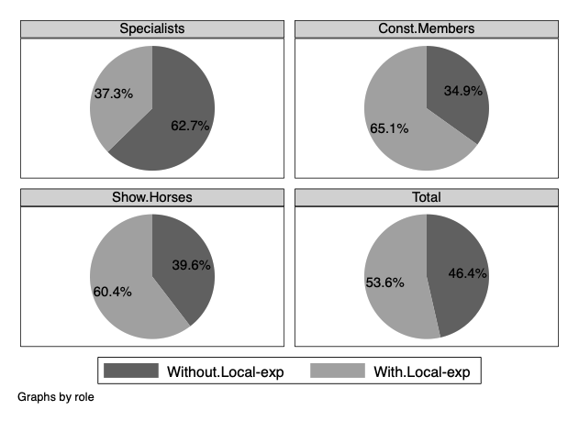

Complementing these findings, the analysis of the "parachuted" variable corroborates the localized nature of the Constituency Member role (Table S6.2 and Figure S6.2). As anticipated, Constituency Members exhibit the lowest proportion of "parachuted" deputies, with only 13.4% not being born in their elected region. This figure is notably lower than the overall average of 20.6% for all deputies. In contrast, Specialists show a "parachuted" rate of 24.9%, and Show Horses are at 23.5%. These results collectively indicate that Constituency Members are more likely to be locally embedded, both through prior experience and by being native to their electoral district, thereby solidifying their distinct profile as representatives connected to their constituencies (e.g., Searing 1994).

Table S6.2 - Distribution of Parachuted by Role (Percentages & Counts)
Parachuted / Role | Specialists | Const.Members | Show.Horses | Total %
No Parachuted | 75.1% | 86.6% | 76.5% | 79.4%
Parachuted | 24.9% | 13.4% | 23.5% | 20.6%
Total % | 100.0% | 100.0% | 100.0% | 100.0%
N | 185 | 172 | 149 | 506

Figure S6.2 - Distribution of Parachuted by Parliamentary Role (Pie Charts)
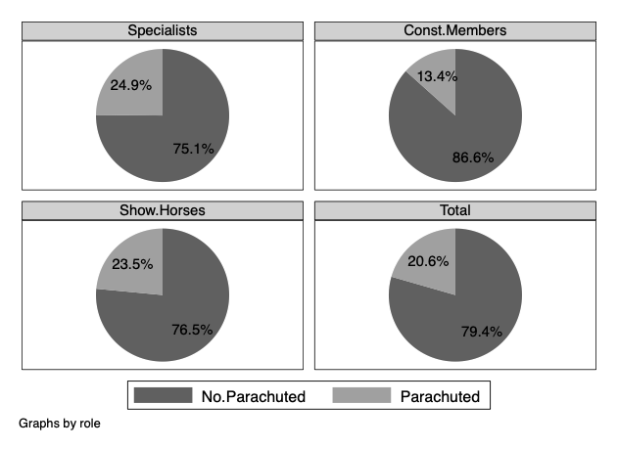

In the following tables and figures, I examine the roles of Specialists and Show Horses, focusing on their relationship with parliamentary tenure and the holding of legislative or governmental offices. The tenure variable is defined as the number of parliamentary mandates served by the deputy. For this descriptive analysis, tenure is treated as a categorical variable, distinguishing four specific categories based on its distribution: tenure = 1, tenure = 2, tenure = 3, and tenure ≥ 4. The legislative office variable is a dummy indicator, taking a value of 1 for deputies holding a formal legislative position (e.g., Chairman, Vice-Chairman, Quaestor or Secretary of the Chamber; Chairman, Vice-Chairman or Secretary of a legislative committee; or Chairman or Vice-Chairman of a parliamentary group). Similarly, the governmental office variable is a dummy, assigned a value of 1 for deputies holding a ministerial or junior ministerial position (Viceministro or Sottosegretario). All data for these variables were sourced from the official records of the Italian Chamber of Deputies (dati.camera.it).

The analysis of tenure (Table S6.3 and Figure S6.3) shows that the largest proportion of deputies across all roles are newcomers (Tenure = 1), yet notable differences emerge in the distribution of more experienced members. Constituency Members show the highest percentage of newcomers (55.2%). Conversely, Show Horses exhibit the highest proportion of highly tenured deputies (18.1% with four or more mandates, compared to 9.2% for Specialists and 5.8% for Constituency Members), suggesting that this role may indeed be adopted by more senior members who reduce their direct parliamentary work in favor of public visibility. Specialists show a more balanced distribution across tenure levels, with a slightly higher representation in the Tenure = 2 and Tenure = 3 categories than Constituency Members.

Table S6.3 - Distribution of Tenure by Role (Percentages & Counts)
Tenure / Role | Specialists | Const.Members | Show.Horses | Total %
Tenure=1 | 41.1% | 55.2% | 39.6% | 45.5%
Tenure=2 | 37.8% | 32.0% | 27.5% | 32.8%
Tenure=3 | 11.9% | 7.0% | 14.8% | 11.1%
Tenure≥4 | 9.2% | 5.8% | 18.1% | 10.7%
Total % | 100.0% | 100.0% | 100.0% | 100.0%
N | 185 | 172 | 149 | 506

Figure S6.3 - Distribution of Tenure by Parliamentary Role (Pie Charts)
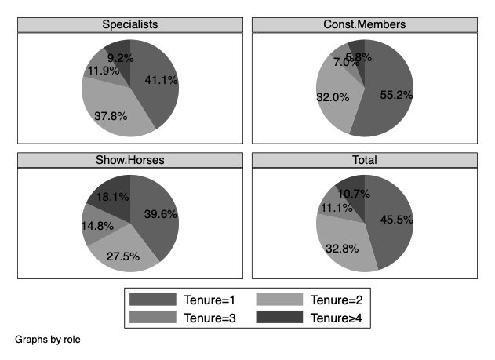

Regarding legislative office (Table S6.4 and Figure S6.4), the findings show that 28.1% of Specialists hold a legislative office, which is considerably higher than the 14.0% among Constituency Members and 20.8% among Show Horses. This indicates that deputies in the Specialist role are indeed more likely to occupy formal positions within the legislative structure, reinforcing their expertise and influence in parliamentary processes.

Table S6.4 - Distribution of Legislative Office by Role (Percentages & Counts)
Parliamentary Office T0 / Role | Specialists | Const.Members | Show.Horses | Total %
No. ParlOff.t0 | 71.9% | 86.0% | 79.2% | 78.9%
Parl.Office.t0 | 28.1% | 14.0% | 20.8% | 21.1%
Total % | 100.0% | 100.0% | 100.0% | 100.0%
N | 185 | 172 | 149 | 506

Figure S6.4 - Distribution of Legislative Office by Parliamentary Role (Pie Charts)
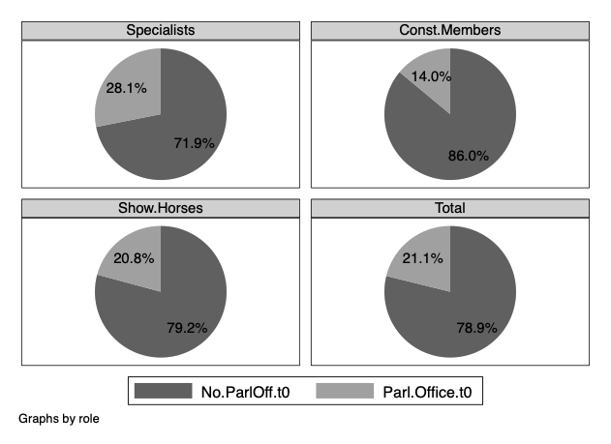

Finally, the distribution of governmental office holders (Table S6.5 and Figure S6.5) further differentiates the roles. As suggested by Payne (1980), Show Horses exhibit a substantially higher proportion of deputies holding governmental office, with 14.1% of this group serving as Ministers or Junior Ministers. This is a stark contrast to Specialists (1.1%) and Constituency Members (1.7%), and significantly higher than the overall average of 5.1%.

Table S6.5 - Distribution of Governmental Office by Role (Percentages & Counts)
Government Office T0 / Role | Specialists | Const.Members | Show.Horses | Total %
No.GovOff.t0 | 98.9% | 98.3% | 85.9% | 94.9%
Gov.Office.t0 | 1.1% | 1.7% | 14.1% | 5.1%
Total % | 100.0% | 100.0% | 100.0% | 100.0%
N | 185 | 172 | 149 | 506

Figure S6.5 - Distribution of Governmental Office by Parliamentary Role (Pie Charts)
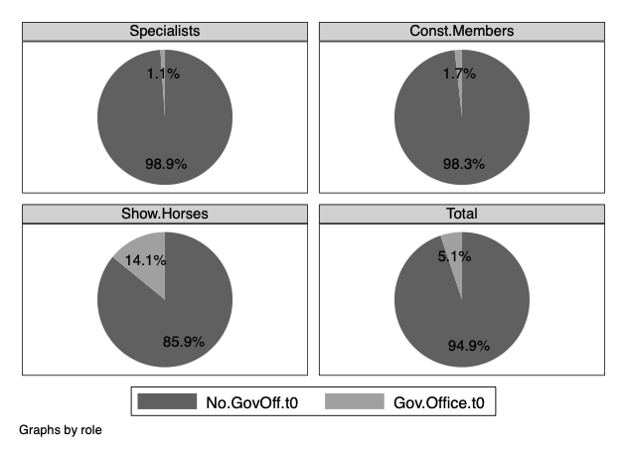

S7 - Multinomial Logit Models for Career Outcomes

This section reports additional results for the multinomial logit model in which the dependent variable is career outcome. In the manuscript, the model is presented graphically through predicted probabilities. The tables below provide the numerical estimates underlying the figure and report alternative specifications. The dependent variable is coded as a mutually exclusive and hierarchical outcome: 0 = not re-elected, 1 = re-elected without office, 2 = legislative office, and 3 = governmental office. Deputies who were re-elected and subsequently attained legislative or governmental office are assigned to the highest career outcome they achieved. The reference outcome is no re-election, and the reference parliamentary role is Specialists.

Table S7.1 reports the predicted probabilities corresponding to Figure 2 in the manuscript. These estimates show the probability of each career outcome for Specialists, Constituency Members, and Show Horses, holding the model specification constant.

Table S7.1 - Predicted probabilities of career outcomes by parliamentary role
Role | No reelection | Reelected only | Legislative office t+1 | Government office t+1
Specialists | 0.638  (0.034) | 0.071  (0.022) | 0.195  (0.038) | 0.096  (0.030)
Constituency Members | 0.624  (0.041) | 0.088  (0.022) | 0.210  (0.037) | 0.078  (0.015)
Show Horses | 0.604  (0.034) | 0.092  (0.028) | 0.236  (0.037) | 0.069  (0.019)
Observations 506 506 |  |  | 506 | 506
Note: Base outcome = No reelection. Base role = Specialists. Predicted probabilities are margins computed after the fully controlled multinomial logit model. Standard errors clustered by constituency in parentheses.
Table S7.2 reports the same multinomial logit model in relative risk ratio form. These estimates are included for transparency and comparability. The table should be read alongside Figure 2 and Table S7.1, which provide a more direct substantive interpretation of the results. The reference outcome is no re-election, and the reference parliamentary role is Specialists.

Table S7.2 - Multinomial logit estimates for career outcomes (relative risk ratios)
Variable | Reelected only | Legislative  Office t+1 | Government  Office t+1
Constituency Members | 1.275  (0.574) | 1.102  (0.448) | 0.825  (0.369)
Show Horses | 1.371  (0.548) | 1.287  (0.321) | 0.753  (0.345)
Local experience | 1.097  (0.355) | 1.362*  (0.247) | 1.609  (0.926)
Parachuted | 1.039  (0.383) | 1.040  (0.267) | 0.985  (0.250)
Tenure | 0.995  (0.184) | 0.921  (0.095) | 0.877  (0.089)
Legislative office t0 | 1.825*  (0.605) | 1.326  (0.286) | 2.030  (1.111)
Government office t0 | 0.673  (0.415) | 0.286*  (0.196) | 1.637  (0.979)
Graduated | 0.818  (0.257) | 1.181  (0.265) | 2.177  (1.118)
Female | 1.148  (0.269) | 1.372  (0.280) | 0.868  (0.291)
Party controls | ✓ | ✓ | ✓
Observations 506
Log pseudolikelihood -504.793
Pseudo R2 0.0340
Note: Base outcome = No reelection. Base role = Specialists. Standard errors in parentheses. Party dummies are included in the model but omitted from the table display. Standard errors are clustered by constituency. *** p<0.01, ** p<0.05, * p<0.10
Table S7.3 reports the full raw coefficients of the career-outcome multinomial logit model. As in the main specification, party controls are included but omitted from the table display. The reference outcome is no re-election, and the reference parliamentary role is Specialists.

Table S7.3 — Full raw coefficients for career outcomes
Variable | Reelected  only | Legislative office t+1 | Government office t+1
Constituency Members | 0.243  (0.450) | 0.097  (0.406) | -0.193  (0.447)
Show Horses | 0.316  (0.400) | 0.252  (0.250) | -0.284  (0.458)
Local experience | 0.093  (0.323) | 0.309*  (0.181) | 0.475  (0.575)
Parachuted | 0.038  (0.368) | 0.039  (0.256) | -0.016  (0.253)
Tenure | -0.006  (0.185) | -0.083  (0.103) | -0.131  (0.102)
Legislative office t0 | 0.602*  (0.332) | 0.282  (0.215) | 0.708  (0.547)
Government office t0 | -0.396  (0.616) | -1.253*  (0.687) | 0.493  (0.598)
Graduated | -0.201  (0.314) | 0.167  (0.224) | 0.778  (0.513)
Female | 0.138  (0.235) | 0.317  (0.204) | -0.142  (0.335)
Constant | -16.620***  (0.787) | -0.922  (0.667) | -3.053***  (1.134)
Party controls | ✓ | ✓ | ✓
Observations 506
Log pseudolikelihood -504.793
Pseudo R2 0.0340
Note: Base outcome = No reelection. Base role = Specialists. Standard errors clustered by constituency in parentheses. *** p<0.01, ** p<0.05, * p<0.10.
Tables S7.4a, S7.4B and S7.4c report reduced multinomial logit specifications for the career-outcome model. These specifications address concerns about the main model complexity and degrees of freedom. Model 1 includes only parliamentary role membership, Model 2 adds party controls, and Model 3 adds the core political-experience controls used in the main analysis. The reference outcome is no re-election, and the reference parliamentary role is Specialists. Across these specifications, the role coefficients remain statistically insignificant, supporting the conclusion that the null finding is not an artefact of the fully controlled model. Specifically:

- Table S7.4a reports the reduced specifications for the “re-elected only” outcome.
- Table S7.4b reports the reduced specifications for the legislative-office outcome.
- Table S7.4c reports the reduced specifications for the governmental-office outcome.

Table S7.4a - Reduced multinomial logit models for career outcomes: Reelected only
Variable | Model 1:  Role only | Model 2:  Role + party dummies | Model 3:  Role + controls + party dummies
Constituency Members | 0.241  (0.464) | 0.209  (0.429) | 0.248  (0.453)
Show Horses | 0.334  (0.366) | 0.229  (0.406) | 0.303  (0.402)
Local experience |  |  | 0.068  (0.310)
Parachuted |  |  | 0.024  (0.369)
Tenure |  |  | -0.008  (0.184)
Legislative office t0 |  |  | 0.595*  (0.321)
Government office t0 |  |  | -0.410  (0.597)
Party controls | No | ✓ | ✓
Observations | 506 | 506 | 506
Log pseudolikelihood | -522.085 | -513.706 | -508.097
Pseudo R2 | 0.0010 | 0.0170 | 0.0277
Note: Base outcome = No reelection. Base role = Specialists. Standard errors clustered by constituency in parentheses. Party dummies are omitted from the table display. *** p<0.01, ** p<0.05, * p<0.10.

Table S7.4b - Reduced multinomial logit models for career outcomes: Legislative office
Variable | Model 1: Role only | Model 2: Role + party dummies | Model 3:  Role + controls + party dummies
Constituency Members | 0.044  (0.345) | 0.124  (0.398) | 0.106  (0.400)
Show Horses | 0.119  (0.166) | 0.123  (0.226) | 0.240  (0.235)
Local experience |  |  | 0.208  (0.191)
Parachuted |  |  | 0.039  (0.258)
Tenure |  |  | -0.082  (0.102)
Legislative office t0 |  |  | 0.309  (0.213)
Government office t0 |  |  | -1.217*  (0.689)
Party controls | No | ✓ | ✓
Observations | 506 | 506 | 506
Log pseudolikelihood | -522.085 | -513.706 | -508.097
Pseudo R2 | 0.0010 | 0.0170 | 0.0277
Note: Base outcome = No reelection. Base role = Specialists. Standard errors clustered by constituency in parentheses. Party dummies are omitted from the table display. *** p<0.01, ** p<0.05, * p<0.10.

Table S7.4c - Reduced multinomial logit models for career outcomes: Government office
Variable | Model 1:  Role only | Model 2:  Role + party dummies | Model 3:  Role + controls + party dummies
Constituency Members | -0.036  (0.331) | -0.180  (0.387) | -0.184  (0.437)
Show Horses | -0.115  (0.318) | -0.202  (0.367) | -0.233  (0.441)
Local experience |  |  | 0.431  (0.562)
Parachuted |  |  | 0.003  (0.273)
Tenure |  |  | -0.115  (0.095)
Legislative office t0 |  |  | 0.722  (0.521)
Government office t0 |  |  | 0.531  (0.563)
Party controls | No | ✓ | ✓
Observations | 506 | 506 | 506
Log pseudolikelihood | -522.085 | -513.706 | -508.097
Pseudo R2 | 0.0010 | 0.0170 | 0.0277
Note: Base outcome = No reelection. Base role = Specialists. Standard errors clustered by constituency in parentheses. Party dummies are omitted from the table display. *** p<0.01, ** p<0.05, * p<0.10.
Table S7.5 reports a binary logit robustness check in which the dependent variable is re-election. This model addresses the concern that deputies who attain legislative or governmental office are also re-elected. In this specification, the dependent variable equals 1 for all deputies returned to the Chamber in the 18th legislature, including those who subsequently attained legislative or governmental office, and 0 otherwise. The reference parliamentary role is Specialists. The results confirm that role membership does not significantly predict re-election.

Table S7.5 - Binary logit robustness check: re-election
Variable | Logit coefficient | Average marginal effect
Constituency Members | 0.075  (0.281) | 0.017  (0.064)
Show Horses | 0.170  (0.151) | 0.039  (0.035)
Local experience | 0.283  (0.211) | 0.065  (0.049)
Parachuted | 0.026  (0.181) | 0.006  (0.041)
Tenure | -0.073  (0.089) | -0.017  (0.020)
Legislative office t0 | 0.446**  (0.215) | 0.102**  (0.048)
Government office t0 | -0.514  (0.366) | -0.118  (0.083)
Graduated | 0.199  (0.193) | 0.046  (0.044)
Female | 0.181  (0.179) | 0.041  (0.041)
Constant | -0.858  (0.649)
Party controls | ✓ | ✓
Observations | 506 | 506
Log pseudolikelihood | -329.368
Pseudo R2 | 0.0165
Note: Base role = Specialists. Standard errors clustered by constituency in parentheses. Party dummies are included in the model but omitted from the table display. *** p<0.01, ** p<0.05, * p<0.10.

S8 - Multinomial Logit Models for Parliamentary Role Adoption
This section reports additional results for the multinomial logit model in which parliamentary role is the dependent variable. In the manuscript, the results are presented graphically through average marginal effects in Figure 3. Table S8.1 reports the numerical estimates underlying that figure. Tables S8.2, S8.3a and S8.3b report the full raw coefficients and reduced specifications.

Table S8.1 reports the average marginal effects corresponding to Figure 3 in the manuscript

Table S8.1 – Average marginal effects from the M-Logit model of parliamentary roles
Variable | Constituency  members | Show Horses | Specialists
Local experience | 0.08**  (0.04) | -0.03  (0.05) | -0.05  (0.06)
Parachuted | -0.13***  (0.05) | 0.04  (0.04) | 0.09**  (0.04)
Tenure | -0.05***  (0.02) | 0.04**  (0.02) | 0.02  (0.02)
Previous legislative office | -0.04  (0.04) | -0.03  (0.03) | 0.07  (0.05)
Previous governmental office | -0.19*  (0.11) | 0.31***  (0.07) | -0.12  (0.08)
Graduated | -0.01  (0.03) | 0.03  (0.04) | -0.02  (0.03)
Female | 0.05**  (0.02) | -0.06**  (0.03) | 0.01  (0.03)
Party controls | ✓ | ✓ | ✓
Observations 506
Log pseudolikelihood -414.790
Pseudo R² 0.2512
Note: Average marginal effects from a multinomial logit model. The dependent variable is parliamentary role. Standard errors clustered by constituency in parentheses. Party dummies are included but omitted from the table display. *** p<0.01, ** p<0.05, * p<0.10.
Table S8.2 reports the full raw coefficients from the same role-adoption multinomial logit model. These coefficients are included for transparency and to provide the complete model output. The reference category is Specialists, and party controls are included but omitted from the table display.

Table S8.2 - Full raw coefficients for parliamentary role adoption
Variable | Constituency Members |  | Show Horses
Local experience | 0.511  (0.379) |  | 0.140  (0.470)
Parachuted | -0.887**  (0.359) |  | -0.337  (0.330)
Tenure | -0.271*  (0.144) |  | 0.045  (0.131)
Legislative office t0 | -0.536  (0.377) |  | -0.517  (0.400)
Government office t0 | 0.095  (0.767) |  | 1.949***  (0.575)
Graduated | 0.094  (0.223) |  | 0.258  (0.326)
Female | 0.082  (0.229) |  | -0.343  (0.285)
Constant | -1.359  (1.090) |  | -1.994*  (1.023)
Party controls | ✓ |  | ✓
Observations | 506 | 506
Log pseudolikelihood | -414.790 | -414.790
Pseudo R2 | 0.2512 | 0.2512
Note: Base role = Specialists. Standard errors clustered by constituency in parentheses. *** p<0.01, ** p<0.05, * p<0.10.
Tables S8.3a and S8.3b report reduced specifications for the role-adoption model. These models examine whether the results are sensitive to the inclusion of socio-demographic controls and party controls. Model 1 includes only core political-experience predictors, Model 2 adds graduation and gender but excludes party controls, and Model 3 corresponds to the full specification with party controls.

Specifically:
- Table S8.3a reports the reduced specifications for the probability of adopting the Constituency Member role rather than the Specialist role.
- Table S8.3b reports the reduced specifications for the probability of adopting the Show Horse role rather than the Specialist role.

Table S8.3a. - Reduced multinomial logit models for parliamentary role adoption: Constituency Members
Variable | Model 1 | Model 2 | Model 3:  Full model
Local experience | 1.098***  (0.188) | 1.241***  (0.173) | 0.511  (0.379)
Parachuted | -0.603**  (0.304) | -0.640**  (0.311) | -0.887**  (0.359)
Tenure | -0.202*  (0.113) | -0.205*  (0.116) | -0.271*  (0.144)
Legislative office t0 | -1.663***  (0.336) | -1.651***  (0.328) | -0.536  (0.377)
Government office t0 | 0.788  (0.886) | 0.670  (0.911) | 0.095  (0.767)
Graduated |  | 0.239  (0.184) | 0.094  (0.223)
Female |  | 0.653***  (0.162) | 0.082  (0.229)
Constant | 1.045***  (0.378) | 0.593  (0.431) | -1.359  (1.090)
Party controls | No | No | Yes
Observations | 506 | 506 | 506
Log pseudolikelihood | -486.404 | -481.654 | -414.790
Pseudo R2 | 0.1219 | 0.1304 | 0.2512
Note: Base role = Specialists. Standard errors clustered by constituency in parentheses. Party dummies are omitted from the table display. *** p<0.01, ** p<0.05, * p<0.10.

Table S8.3b - Reduced multinomial logit models for parliamentary role adoption: Show Horses
Variable | Model 1 | Model 2 | Model 3:  Full model
Local experience | 0.904***  (0.242) | 0.980***  (0.244) | 0.140  (0.470)
Parachuted | 0.038  (0.297) | 0.000  (0.303) | -0.337  (0.330)
Tenure | 0.153*  (0.093) | 0.149  (0.100) | 0.045  (0.131)
Legislative office t0 | -1.621***  (0.394) | -1.639***  (0.386) | -0.517  (0.400)
Government office t0 | 2.726***  (0.613) | 2.618***  (0.628) | 1.949***  (0.575)
Graduated |  | 0.419  (0.305) | 0.258  (0.326)
Female |  | 0.280  (0.213) | -0.343  (0.285)
Constant | 0.086  (0.462) | -0.297  (0.530) | -1.994*  (1.023)
Party controls | No | No | Yes
Observations | 506 | 506 | 506
Log pseudolikelihood | -486.404 | -481.654 | -414.790
Pseudo R2 | 0.1219 | 0.1304 | 0.2512
Note: Base role = Specialists. Standard errors clustered by constituency in parentheses. Party dummies are omitted from the table display. *** p<0.01, ** p<0.05, * p<0.10.

References

Best H and Vogel L (2012) The Emergence and Transformation of Representative Roles. In M. Blomgren, & O. Rozenberg. In Parliamentary Roles in Modern Legislatures. London-New York: Routledge, pp. 37–65.
Cochran WG (1954) Some Methods for Strengthening the Common χ 2 Tests. Biometrics 10(4), 417–451.
Du X et al. (2017) Water Quality Assessment with Hierarchical Cluster Analysis Based on Mahalanobis Distance. Environmental Monitoring and Assessment 189(7), 335.
Duda RO and Hart PE (1973) Pattern Classification and Scene Analysis. A Wiley-Interscience Publication.
Everitt B et al. (2011) Cluster Analysis, 5th Editio John Wiley & Sons. Chichester: John Wiley & Sons.
Kuiper FK and Fisher L (1975) 391: A Monte Carlo Comparison of Six Clustering Procedures. Biometrics 777–783.
Milligan GW and Cooper MC (1985) An Examination of Procedures for Determining the Number of Clusters in a Data Set. Psychometrika 50(2), 159–179.
Payne J (1980) Show Horses & Work Horses in the United States House of Representatives. Polity 12(3), 428–456.
Punj G and Stewart DW (1983) Cluster Analysis in Marketing Research: Review and Suggestions for Application. Journal of Marketing Research 20(2), 134–148.
Romesburg C (2004) Cluster analysis for researchers. Belmont: Lifetime Learning Publication.
Rozenberg O (2020) The French Parliament and the European Union: Backbenchers Blues. Springer.
Russo F (2013) Gli Onorevoli. Cosa Fanno e Come ci Rappresentano i Nostri Parlamentari. Bologna: Il Mulino.
Russo F (2022) MPs’ Roles and Representation Orientations, Incentives and Behaviours in Italy. London-New York: Routledge.
Searing D (1994) Westminster’s world: understanding political roles. Cambridge: Harvard University Press.
Stanberry L (2013) Clustering, Hierarchical. In W Dubitzky et al. (eds), Encyclopedia of Systems Biology. New York, NY: Springer New York, pp. 427–429.
Strøm K (1997) Rules, Reasons and Routines: Legislative Roles in Parliamentary Democracies. The Journal of Legislative Studies 3(1), 155–174.
Von Eye A, Mun EY and Indurkhya A (2004) Typifying Developmental Trajectories-A Decision Making Perspective. Psychological Test and Assessment Modeling 46(1), 65.
Williams W, Clifford H and Lance G (1971) Group-Size Dependence: A Rationale for Choice between Numerical Classifications. The Computer Journal 14(2), 157–162.
Woshinsky, O (1973) The French Deputy. Lexington-Toronto-London: Lexington Books.

